Setup
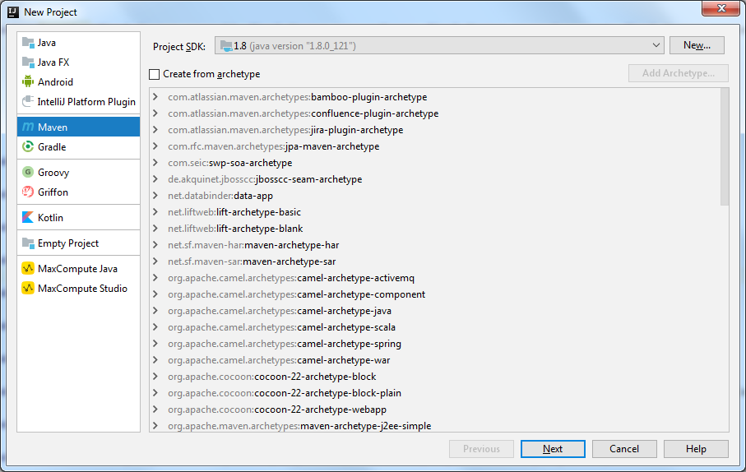
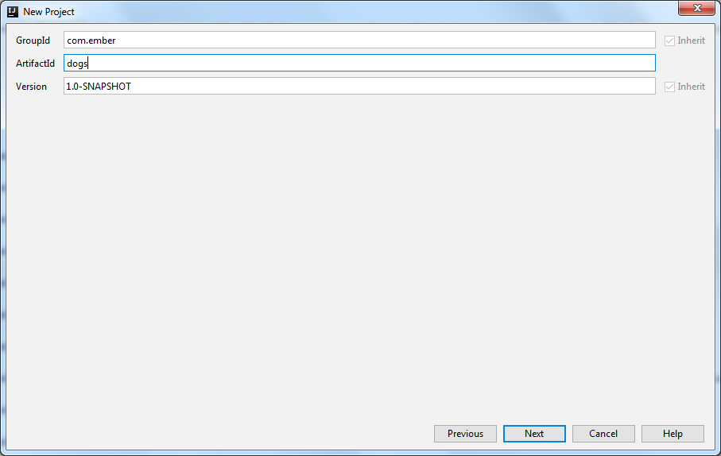
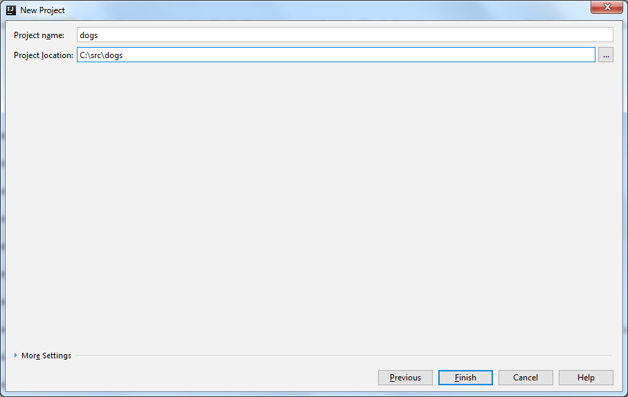
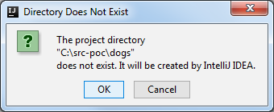
On the Project window, right-click on the java folder and select New – Package. Enter com.ember.dogs
NOTE: Packages are a way to organize software in a logical way. There are two main types of them “org” and “com” for open source organizations and corporations. There are no rules about the package you use but I think com.ember is cool
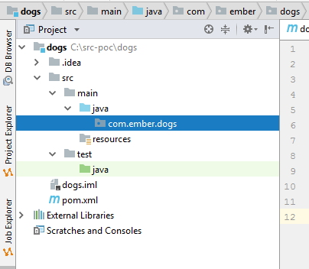
On the package select New – Class to create the BarkingDog class
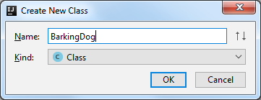
Let’s create the BarkingDog class and the bark method. We’ll create a “fake” or “stub” method just to make sure things are properly configured. Use the following code:
package com.ember.dogs;
public class BarkingDog {
public boolean bark(boolean barking, int hourOfDay) {
return true;
}
}
Build the Project using the Build menu (CTRL-F9). It should be successful even if nothing happens.

Dependencies
When we started the project we selected maven. Maven is a tool that is used to manage dependencies on your code. In other words, if your code needs a library that somebody else wrote you need to include it in your project to use. We’ll start adding some dependencies we will need.
Double-click the pom.xml file to edit
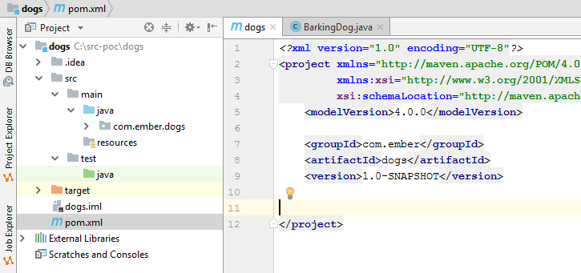
Add the junit dependency so your xml file looks as follows:
<?xml version="1.0" encoding="UTF-8"?>
<project xmlns="http://maven.apache.org/POM/4.0.0"
xmlns:xsi="http://www.w3.org/2001/XMLSchema-instance"
xsi:schemaLocation="http://maven.apache.org/POM/4.0.0 http://maven.apache.org/xsd/maven-4.0.0.xsd">
<modelVersion>4.0.0</modelVersion>
<groupId>com.ember</groupId>
<artifactId>dogs</artifactId>
<version>1.0-SNAPSHOT</version>
<dependencies>
<dependency>
<groupId>junit</groupId>
<artifactId>junit</artifactId>
<version>4.12</version>
</dependency>
</dependencies>
</project>

Creating Tests
Let’s try something slightly different. We’ll create tests for the code we are about to write. We’ll use the samples they provided. Select the BarkingDog class on the editor box and press CTRL-SHIFT-T. You should see a popup dialog that shows the option to create a new Test
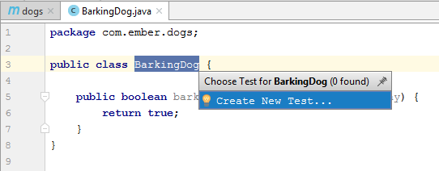
There are many tools we can use to write test code but we will use jUnit4. Enter the following settings:
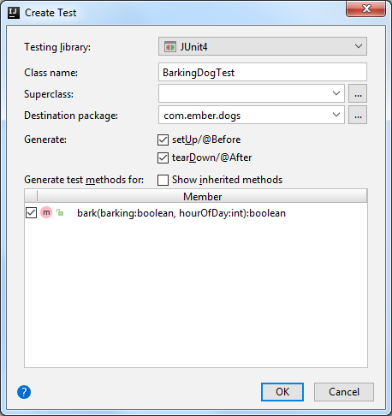
After you click OK you will see a new class in the test folder that looks like the following:
package com.ember.dogs;
import org.junit.After;
import org.junit.Before;
import org.junit.Test;
import static org.junit.Assert.*;
public class BarkingDogTest {
@Before
public void setUp() throws Exception {
}
@After
public void tearDown() throws Exception {
}
@Test
public void bark() {
}
}

Each method that is annotated with a @Test indicates it is a test condition. We’ll create the conditions that were in the description of the problem. Enter the following code for the test class
package com.ember.dogs;
import org.junit.After;
import org.junit.Before;
import org.junit.Test;
import static org.junit.Assert.*;
public class BarkingDogTest {
BarkingDog dog;
@Before
public void setUp() throws Exception {
dog = new BarkingDog();
}
@After
public void tearDown() throws Exception {
}
@Test
public void testDogBarkingTooEarly() {
boolean wakeUp = dog.bark(true, 1);
assertTrue("Dog's barking too late, time to wake up", wakeUp);
}
@Test
public void testDogIsNotBarkingTooEarly() {
boolean wakeUp = dog.bark(false, 2);
assertFalse("Dog is not barking. Keep sleeping", wakeUp);
}
@Test
public void testDogBarksDuringTheDay() {
boolean wakeUp = dog.bark(true, 8);
assertFalse("Dog is not barking. No problem", wakeUp);
}
@Test
public void testInvalidNegativeHour() {
boolean wakeUp = dog.bark(true, -1);
assertFalse("Dog is not barking. Not a valid hour", wakeUp);
}
@Test
public void testInvalidPositiveHour() {
boolean wakeUp = dog.bark(true, 24);
assertFalse("Dog is not barking. Not a valid hour", wakeUp);
}
}

Run the test cases to verify that the code is NOT working yet (remember we have not written any code). Right-click on the test class and select Run BarkingDogTest. You can use CTRL-SHIFT-F10 too.
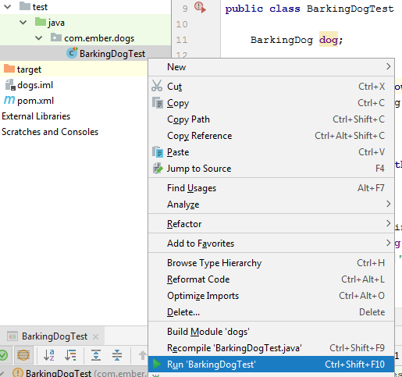
On the run section you will see that one test passed (it was luck) but the rest failed:
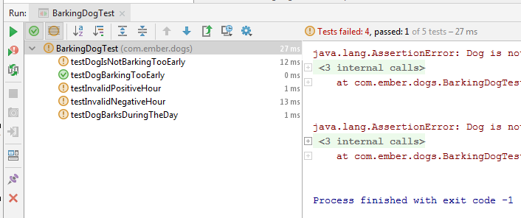

Time to Write the Code
I didn’t read carefully the instructions but the first parameter indicates if the dog is barking already. The code should look like the following:
package com.ember.dogs;
public class BarkingDog {
public boolean bark(boolean barking, int hourOfDay) {
// Invalid hour
if (hourOfDay < 0 || hourOfDay > 23) {
return false;
}
// Dog's not barking
if (!barking) {
return false;
}
// If we reached here the dog is barking, check the hours
if (hourOfDay < 8 || hourOfDay > 22) {
return true;
}
else {
return false;
}
}
}
Run your test cases and you’ll verify it is working as expected: CTRL-SHIFT-F10
