http://localhost:8888/s1rates/default

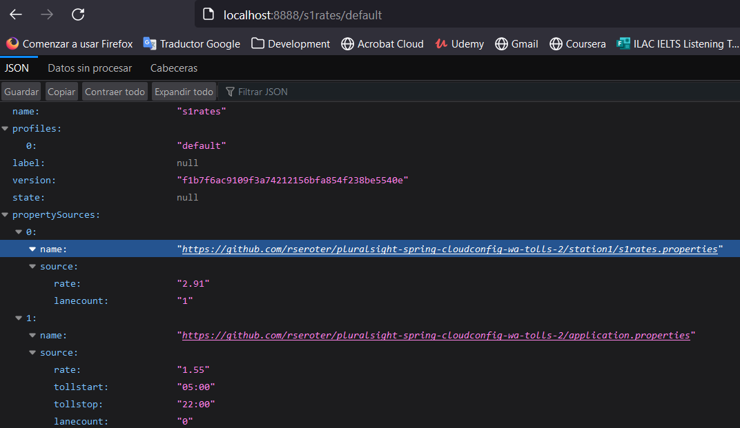
http://localhost:8888/s1rates/dev
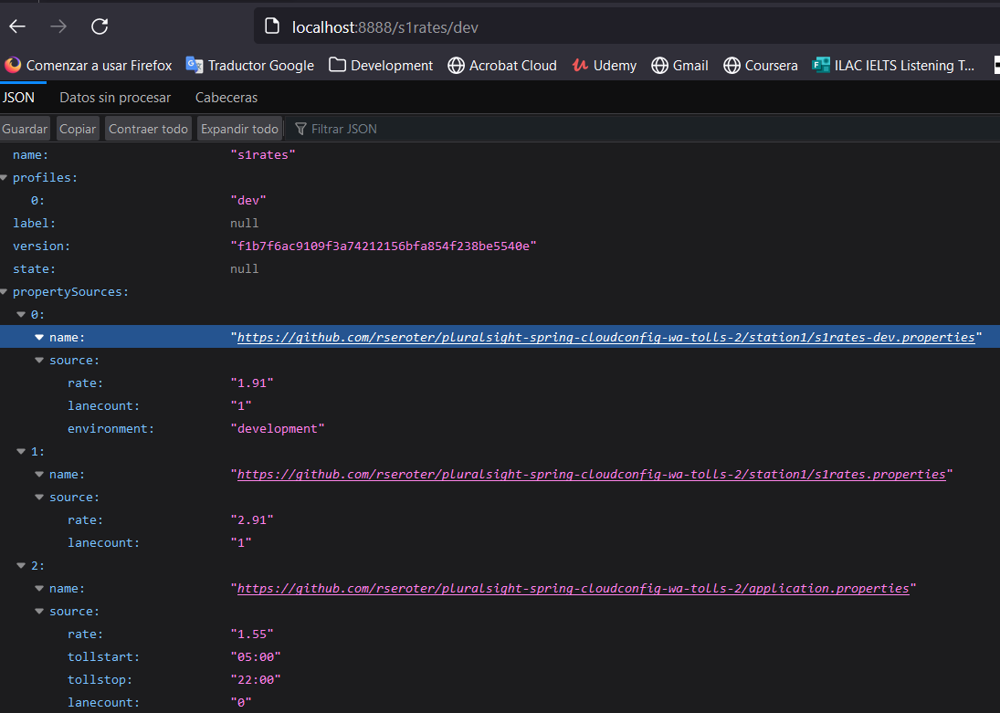
http://localhost:8888/s1rates/perf/main
Busca en un repositorio alterno (definido en application.yml)
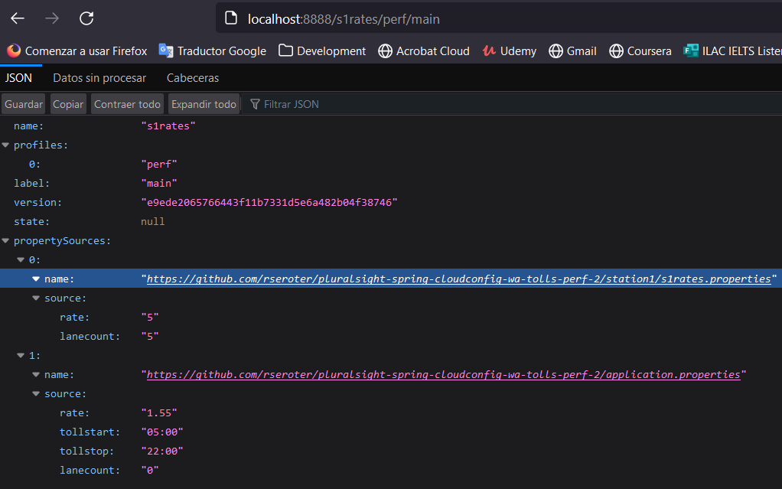
The client (http://localhost:8887/rate) consuming the properties of the configuration server (http://localhost:8888/s1rates/main)
