CAPSTONE PROJECT
CHAPTER 5 - TESTING, RESULTS & EVALUATION
Project Title | CampusBook: a lecturer consultation booking system for CTU Training Solutions
Group Members | Willem Gerber  Oscar Khumalo  Thomas du Plessis  Lebohang Tlaitlai  Gerhardus van den Berg
Module | Software Engineering 2 (SPM622)
Lecturer / Supervisor | Jabulile Mashibini
Week / Stage | Week 4
Submission Date | Friday 23 October 2026

5.1 Introduction
This chapter shows how CampusBook was tested and what the tests found It checks the working app against the functional and non-functional requirements from Chapter 3
The tests were run on 22 October 2026 on the main branch at commit e9ab578 It contains the login Slots API Bookings API database and email services the Book a slot page the My bookings page and the Lecturer slots page that Tom merged on 22 October The tests found defects so the fixes were made in the working copy and every failed test was run again The results show the retest and the failure before the fix
This chapter includes the student survey results The user testing with students and a lecturer is planned for Week 5 and its results are added in the final version

5.2 Test Strategy
Testing followed the Test Plan in folder 06 Tests were written for every requirement before they were run and each test has an expected result and an actual result in the Test Cases and Results workbook
Table 5.1 Test levels
Level | What was tested | Tool
API tests | Every route with valid and invalid input and wrong roles | Node script
Integration tests | API and database and the reminder job and the email preview | Node script and SQL
Browser tests | Pages and journeys and route protection at 375 and 1366 pixels | Playwright and Chromium
Security checks | Role checks and forged tokens and other users records and password storage | Node script and SQL
Performance checks | Page load and API response times | Browser and script timings

Table 5.2 Test environment
Item | Detail
Application | Branch main at commit e9ab578
Back end and database | Node.js 22 and Express with MariaDB 10.11 built from schema.sql and seed.sql
Front end | React 18 and Vite 5 production build
Browser | Chromium through Playwright at 375 x 800 and 1366 x 768
Test data | Seven made up users on the campusbook.test domain
Email | Preview mode so emails print to the server log

The MariaDB server was used in place of MySQL because it runs the same SQL and the same transactions and row locks A final run on MySQL on the demo laptop is planned in Week 5
The browser tests were run on the production build Every failed test was first run on the merged code to record the defect and then run again after the fix The fixes are in the working copy and are not committed to GitHub yet
Willem Gerber led the testing and ran the tests Each developer checks and retests the defects in their own files
Acceptance criteria
- Every Must requirement has a test with an actual result
- Every failed test has a defect with an owner
- No open defect stops a student from booking a consultation

5.3 Test Cases and Results
36 test cases were written and linked to the requirements in the Requirements Traceability Matrix The full steps test data and actual results are in Group-3_Test_Cases_and_Results.xlsx
Table 5.3 Summary of test results
Result after the fixes | Number of tests
Pass | 35
Fail | 0
Not run (needs real students) | 1
Total | 36

Table 5.4 All test cases and results
Test | Requirement | What was tested | Result
TC-01 | FR-01 | Login | Pass
TC-02 | FR-02 | Role checks on the server | Pass
TC-03 | FR-03 | Lecturer manages own slots | Pass
TC-04 | FR-04 | Student views open slots | Pass
TC-05 | FR-05 | Book a slot | Pass
TC-06 | FR-06 | Change and cancel a booking | Pass
TC-07 | FR-07 | No double booking | Pass
TC-08a | FR-08 | Confirmation email | Pass
TC-08b | FR-08 | Reminder email | Pass
TC-09 | FR-09 | Booking history | Pass
TC-10 | NFR-01 | First time student books in under 2 minutes | Not Run
TC-11 | NFR-02 | Main pages load in under 3 seconds | Pass
TC-12 | NFR-03 | Phone and laptop layout | Pass
TC-13 | NFR-04 | Passwords stored as bcrypt hashes | Pass
TC-14 | NFR-05 | Users cannot reach other records | Pass
TC-15 | NFR-06 | Only needed data is stored | Pass
TC-16 | NFR-07 | Errors explain what to fix (API) | Pass
TC-16b | NFR-07 | Errors on screen and kept input | Pass
TC-17 | FR-05 | Book a missing past or taken slot | Pass
TC-18 | FR-03 | Slot validation rules | Pass
TC-19 | FR-03 | Booked slot cannot be edited or removed | Pass
TC-20 | FR-03 | Removing a slot keeps history | Pass
TC-21 | FR-02 | Bad ids bad JSON and unknown routes | Pass
TC-22 | FR-01 | Forged expired and garbage tokens | Pass
TC-23 | NFR-02 | Health check | Pass
TC-24 | NFR-02 | API response time for the slot list | Pass
TC-25 | FR-03 and FR-09 | Lecturer publishes a slot from the page | Pass
TC-26 | FR-08 | Reminder not sent for a cancelled booking | Pass
TC-27 | FR-02 | Pages protected by login and role | Pass
TC-28 | NFR-07 | Expired or invalid session | Pass
TC-29 | FR-06 | Change a booking from the page | Pass
TC-30 | Security (extra) | Repeated wrong passwords are limited | Pass
TC-31 | FR-07 | Database refuses a second confirmed booking | Pass
TC-32 | FR-04 | Times shown on the Book a slot page | Pass
TC-33 | FR-03 | Lecturer removes a slot from the page | Pass
TC-34 | FR-03 | Lecturer edits a slot from the page | Pass

Key results
- Double booking (TC-07) Eight booking requests for one slot were sent at the same moment from three students One booking was created and the other seven were refused with the message Sorry that slot is no longer available The database also refuses a second confirmed booking on its own (TC-31)
- Access control (TC-02 and TC-14) Wrong roles get 403 and missing tokens get 401 and a student cannot cancel or change another students booking
- Emails (TC-08a and TC-08b) The confirmation goes to the student and the lecturer and a due reminder is sent and marked sent A cancelled booking leaves no reminder to send (TC-26)
- Passwords (TC-13) All seven stored passwords are 60 character bcrypt hashes
- Slot rules (TC-18 to TC-20) Bad times and past dates and overlaps are refused and a booked slot cannot be edited or removed and removing a slot keeps its booking history
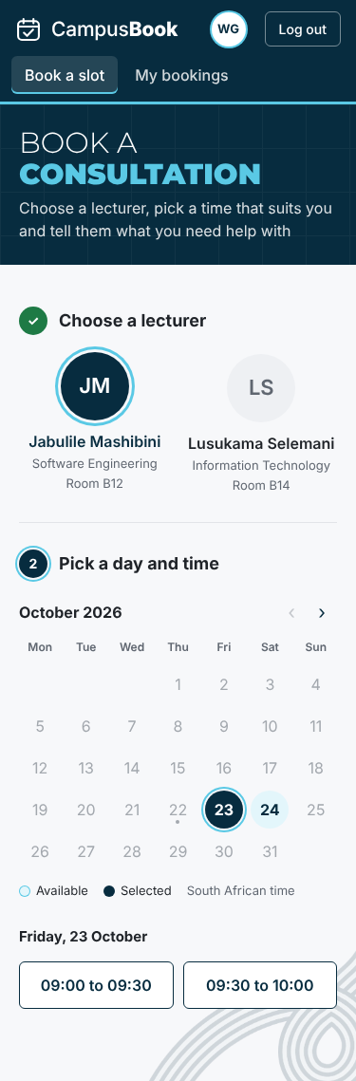  Book a slot on a phone | 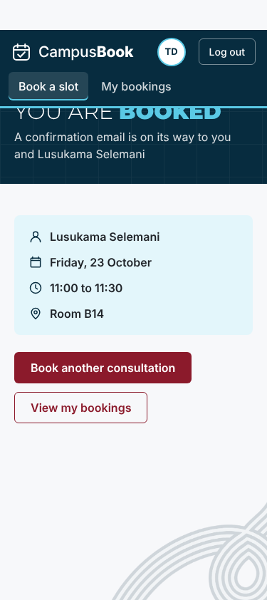  Booking confirmed on a phone | 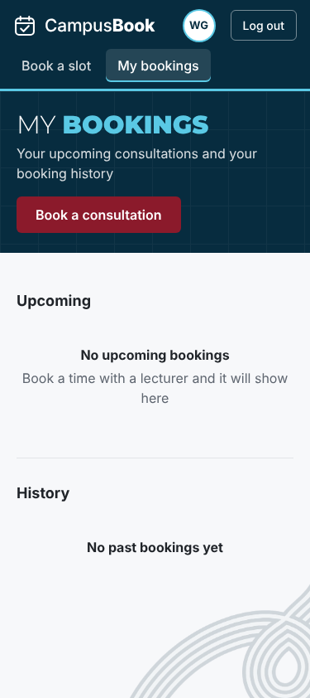  My bookings on a phone
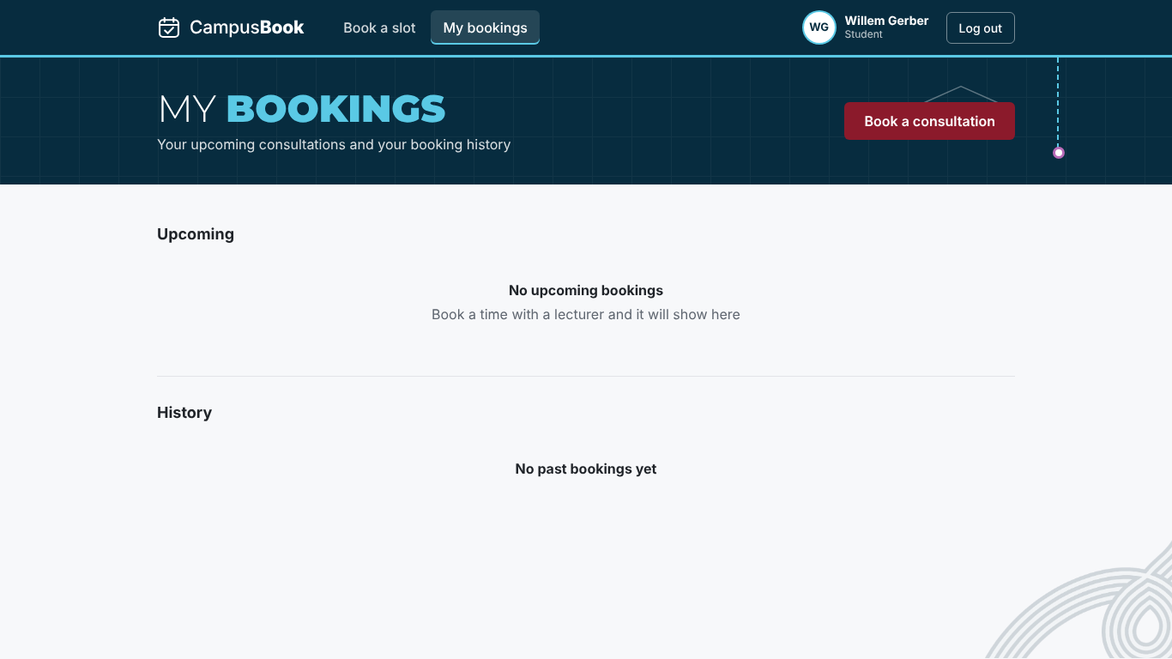

5.4 Defects and Corrections
On the merged code 6 tests failed and one was blocked and every failure is logged in Group-3_Defect_Log.xlsx 10 defects were logged in total 1 was fixed earlier 9 are fixed in the working copy and passed the retest and 0 are open Tables 5.3 and 5.4 show the results after the fixes
Table 5.5 Defect summary
ID | Feature | Defect | Severity | Status
D-01 | Bookings API and My bookings | Booking dates came back as time zone shifted dates because the raw slot_date was returned so a booking could show on the wrong day | High | Closed
D-02 | Book a slot page | Time buttons show only "to" and the confirm panel shows "undefined to undefined" because the page reads start and end but the Slots API sends startTime and endTime | High | Fixed
D-03 | Lecturer slots page | The merged page does not work with the Slots API: it calls /api/slots/my but the route is /api/slots/mine so the list shows That API route does not exist and it sends start and end but the API needs startTime and endTime so publishing fails (FR-03 and FR-09) | High | Fixed
D-04 | My bookings page | No change button although the API supports changing a booking (FR-06) | Medium | Fixed
D-05 | Session handling | An expired or invalid token leaves the user on the page with an error and the old token is kept instead of going to the login page | Medium | Fixed
D-06 | Login security | There is no limit on repeated wrong passwords so 40 attempts in a row were all answered | Medium | Fixed
D-07 | Documentation | Chapter 4 says the reminder scheduler runs every 15 minutes but the code runs it every minute | Low | Fixed
D-08 | Book a slot page | After a failed booking the reason box is hidden until a time is chosen again although the typed text is kept | Low | Fixed
D-10 | Lecturer slots page | The page can publish and remove slots but has no way to edit a slot although the API supports editing (FR-03) | Medium | Fixed
D-09 | Route protection | A logged in user who opens the other roles page is sent to the login page and not to their own home page | Low | Fixed

D-01 Booking dates shifted by the time zone (closed)
While building My bookings the dates of some bookings were one day out The query returned the raw database date and the server turned it into a date with a time zone so the day could move The query now returns the date as text with DATE_FORMAT (commit 87cefdb) The retest shows the same date that is stored in the database (TC-05 and TC-09)
D-02 Missing times on the Book a slot page (fixed)
The browser test showed time buttons that only said to and a confirm panel that said undefined to undefined The Book a slot page reads start and end but the Slots API sends startTime and endTime so the page had nothing to show The booking itself still worked The fix maps the two names when the slots are loaded and is three lines in BookSlot.jsx With the fix the buttons show 09:00 to 09:30 and 09:30 to 10:00 The retest passed
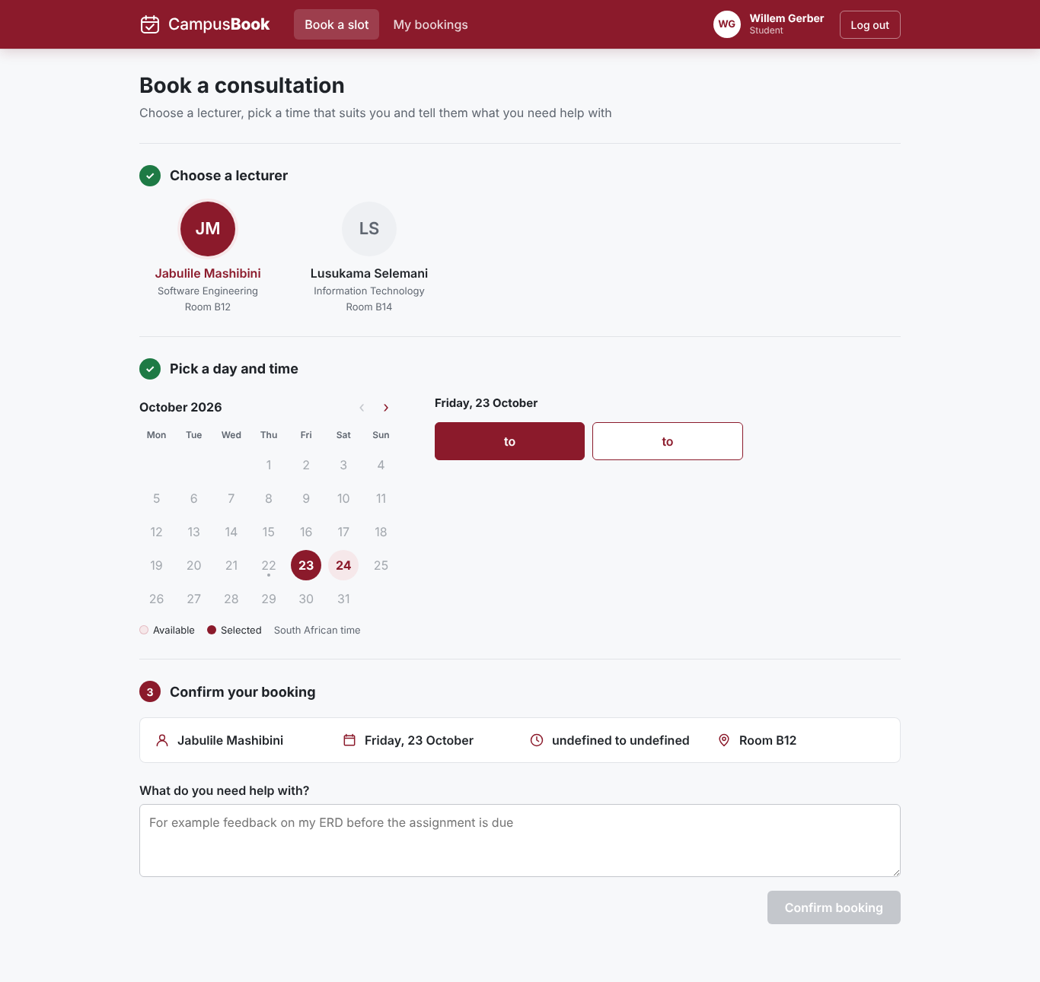  Before the fix | 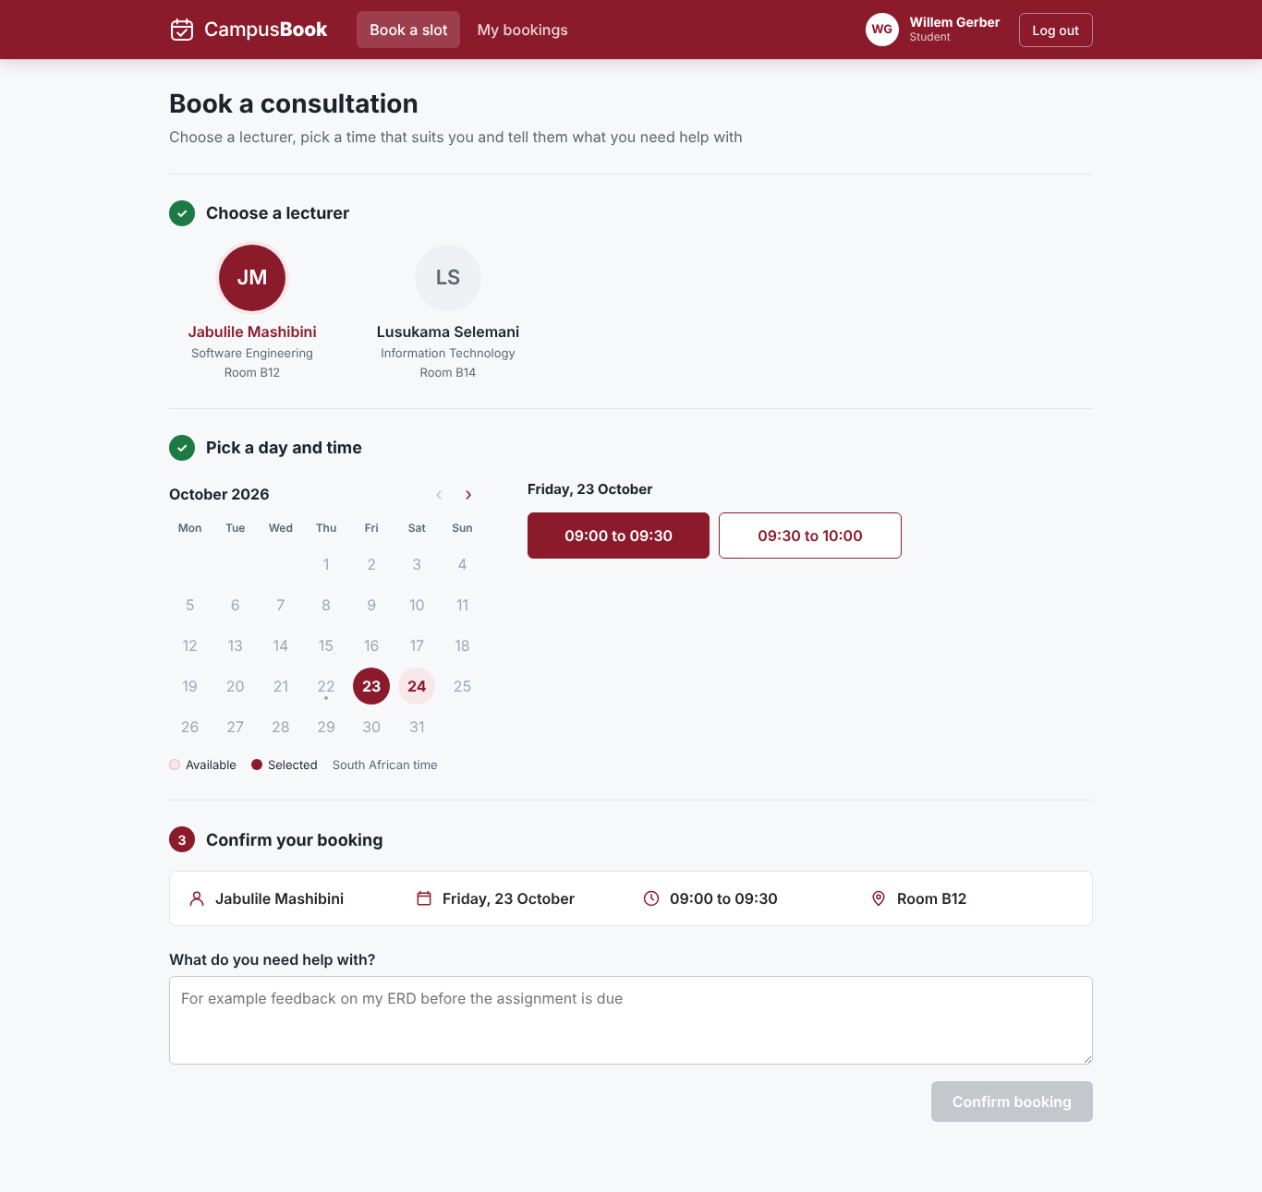  After the fix
D-03 Lecturer slots page does not work with the Slots API (fixed)
Thomas merged the Lecturer slots page on 22 October When it was tested the page showed That API route does not exist because it asks for /api/slots/my and the route is /api/slots/mine Publishing a slot failed with Enter a valid start time because the page sends start and end and the API needs startTime and endTime Nothing was saved The fix is four lines in LecturerSlots.jsx With the fix the page lists the slots and publishing and removing a slot both work The retest passed and an Edit button was also added for D-10
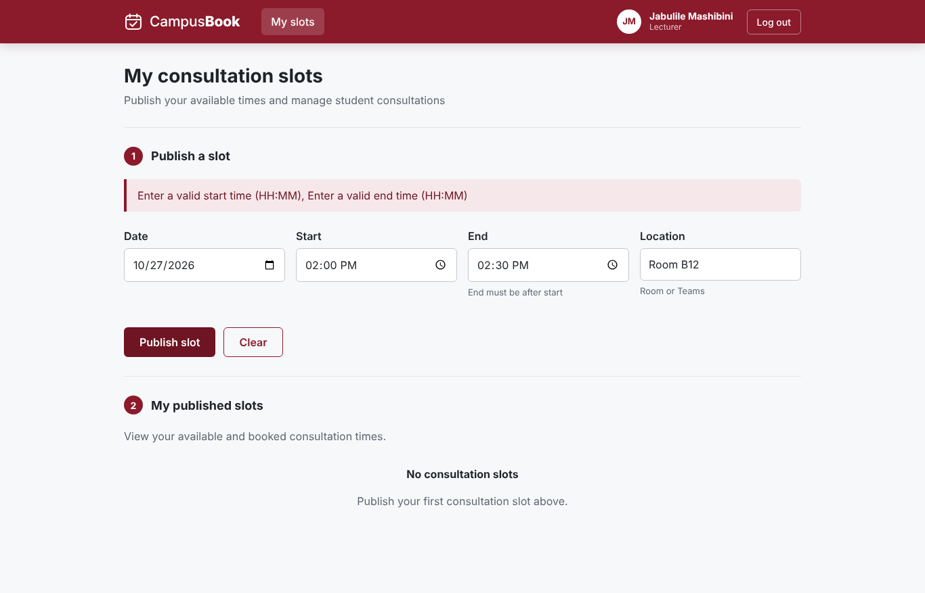  Merged code | 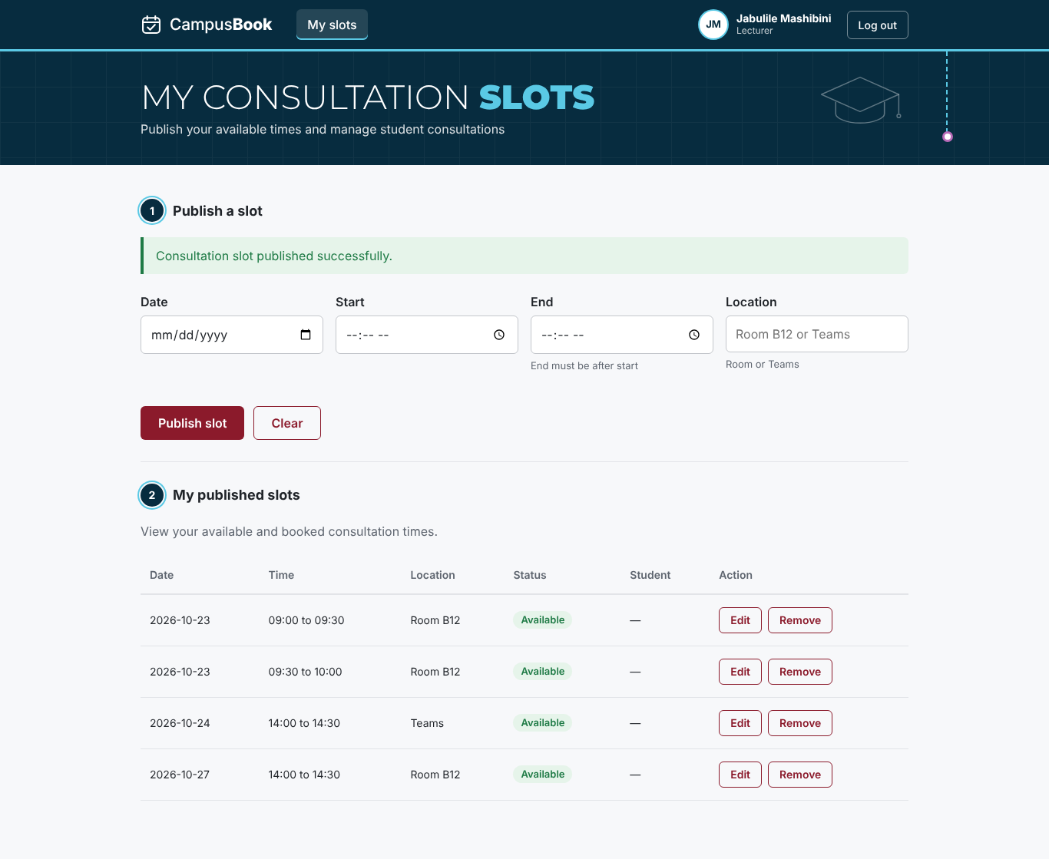  With the fix
D-04 to D-10 other defects (fixed)
- D-04 My bookings had no change button so a Change time button was added that lists the other open times of that lecturer and moves the booking (TC-29)
- D-05 An expired session stayed on the page so the app now clears the login and shows the login page with the message Your session has ended (TC-28)
- D-06 Repeated wrong passwords were not limited so the login now answers 429 after 10 wrong passwords in 15 minutes and other accounts are not affected (TC-30)
- D-08 The reason box was hidden after a failed booking so the confirm step now stays on screen unless the slot was taken (TC-16b)
- D-09 A user opening the other roles page was sent to the login page so they now go to their own home page (TC-27)
- D-10 The Lecturer slots page had no edit option so an Edit button was added (TC-34)
- D-07 The Chapter 4 text said the reminder job runs every 15 minutes but the code runs it every minute so the text now says every minute The architecture diagram label should be checked in the final dissertation
Open defects
- No defects are open The fixes are in the working copy and must be committed and pushed so that the GitHub version matches this chapter
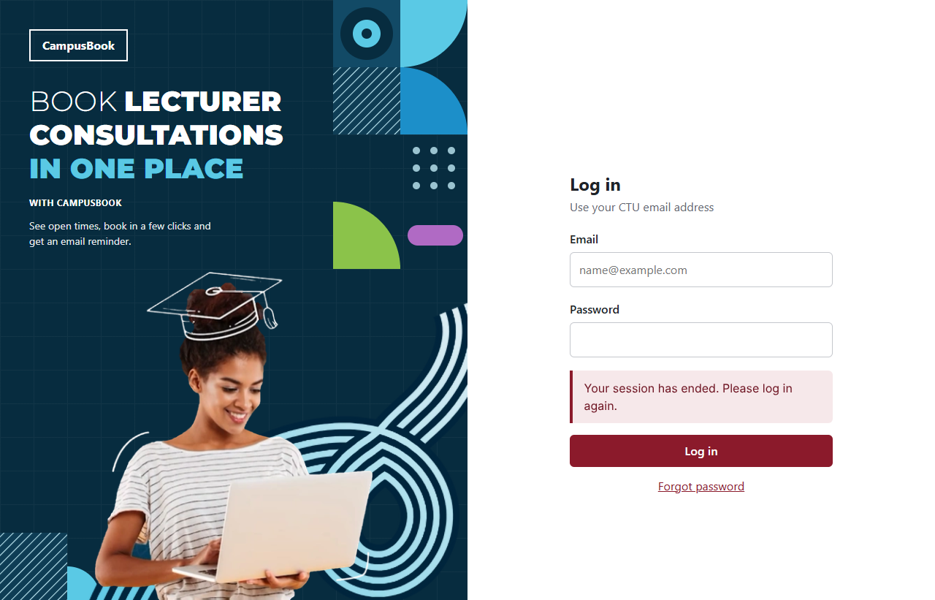

5.5 Performance / Usability Evaluation
Table 5.6 Performance and layout measurements (NFR-02 and NFR-03 and NFR-01)
Check | Target | Measured | Result
Login page load (phone and laptop) | Under 3000 ms | 78 ms and 78 ms | Pass
Book page after login | Under 3000 ms | 248 ms and 220 ms | Pass
My bookings page | Under 3000 ms | 380 ms and 372 ms | Pass
API slot list over 20 requests | Under 500 ms | Median 5 ms and slowest 8 ms | Pass
Sideways scrolling at 375 and 1366 pixels | None on every page | None on all 5 pages tested | Pass
Scripted booking journey on a phone | Under 120 seconds | 1.8 seconds | Indicative only

The times were measured on the team test set up with the API and the database on the same machine so they leave out the network delay of a real campus connection They show that the pages themselves are light The built page script is about 239 kB
The scripted journey shows that the booking flow has few steps and no waiting The real answer for NFR-01 needs first time students and a stopwatch so the timed test is part of the Week 5 user testing
Usability check against the ten heuristics (Nielsen 1994)
Table 5.7 Heuristic check
Heuristic | Evidence from the app
Visibility of system status | A confirmation page after booking and a success notice after cancelling and the booking steps are numbered
Match with the real world | Plain words such as Book a consultation and Cancel booking and dates written out in full
User control and freedom | Cancelling asks for a second click with Keep it and Yes cancel
Error prevention | The confirm button stays disabled until a reason is typed and booked slots cannot be picked
Help users recover from errors | Messages say what to fix such as Enter a valid email address and Sorry that slot is no longer available
Consistency | One theme and the same buttons and alerts on every page
Problems found and fixed | No change button (D-04) and a hidden reason box after an error (D-08) and no redirect on an expired session (D-05)

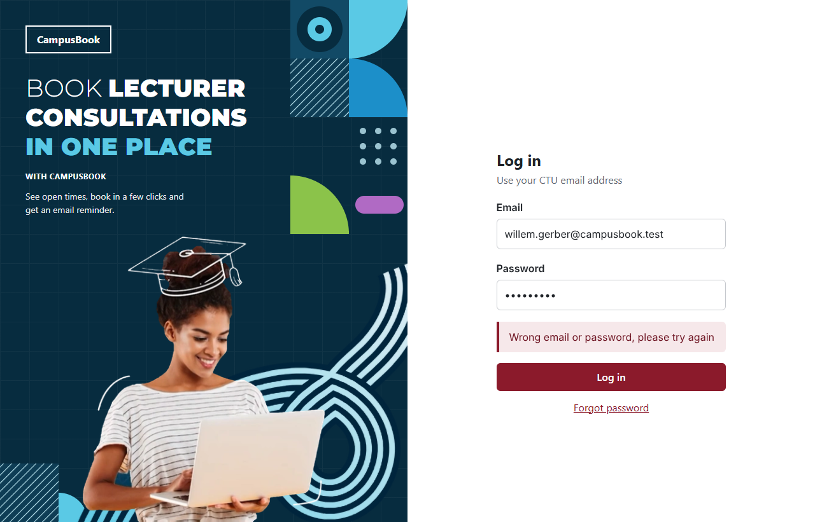  Login error with the email kept | 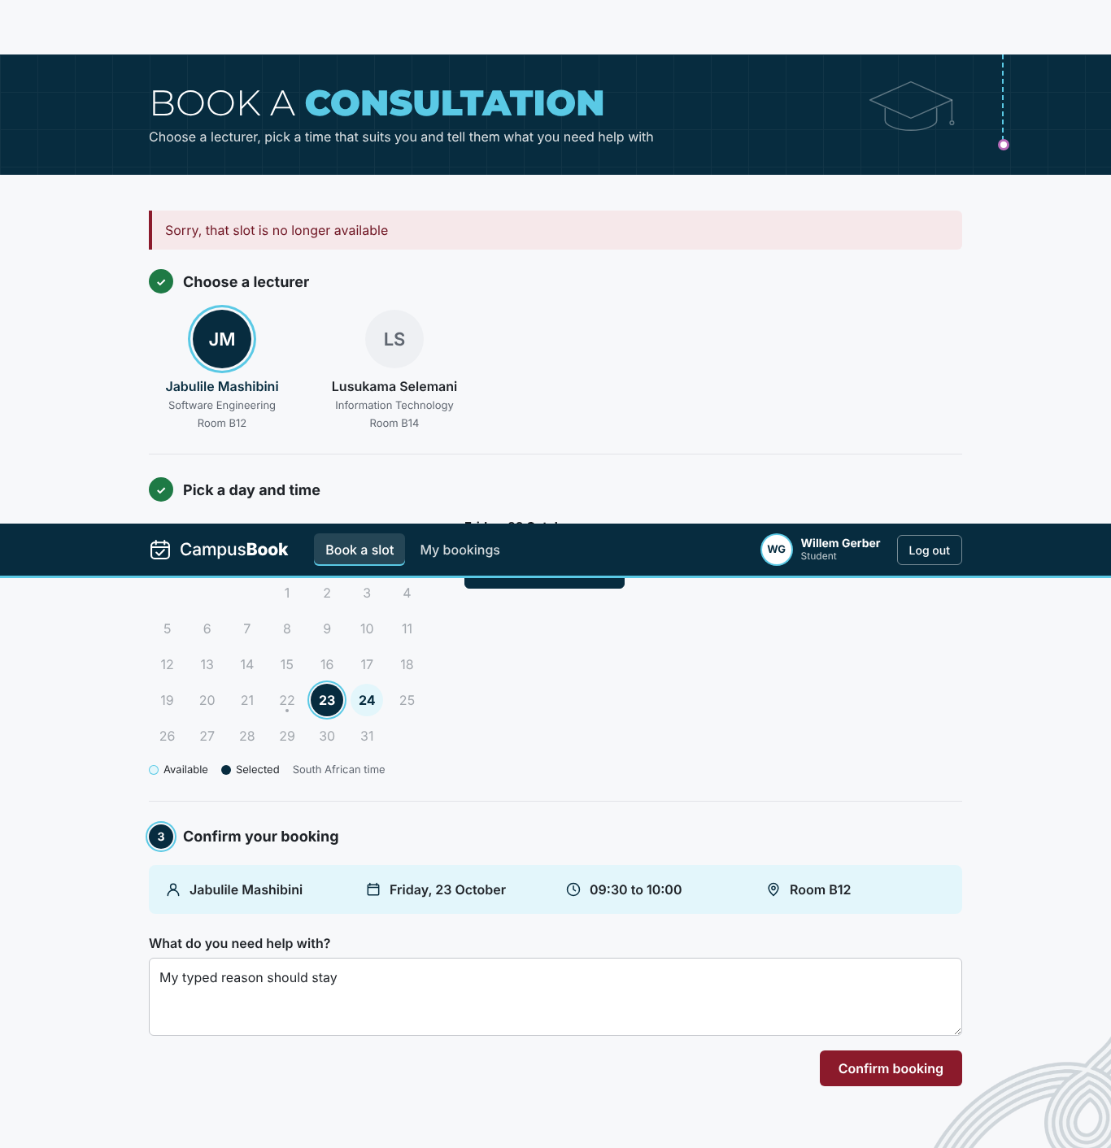  Slot taken message

5.6 Requirements Evaluation
Table 5.8 compares the app at commit e9ab578 with each requirement from Chapter 3 This is the result after the fixes Met means the tests passed and Partially Met means part of the requirement still needs work
Table 5.8 Requirements evaluation
ID | Requirement | Result | Notes
FR-01 | Students and lecturers log in with their email and password | Met | Login works for both roles and bad details give one general error
FR-02 | The system checks the user role so students and lecturers only reach their own pages and actions | Met | Role checks on every route and page
FR-03 | Lecturers publish edit and remove their own future consultation slots | Met | API and page work. Slots are published and edited and removed from the page after the D-03 and D-10 fixes
FR-04 | Students view the open slots of a chosen lecturer | Met | Slots listed correctly and the times show after the D-02 fix
FR-05 | Students book an open slot and give a short reason for the visit | Met | Booking saved and confirmation shown
FR-06 | Students change or cancel their own upcoming bookings | Met | Cancel and change both work in the page after the D-04 fix
FR-07 | The system stops two students booking the same slot | Met | 8 simultaneous requests gave one booking
FR-08 | The system sends an email confirmation after booking and a reminder before the meeting | Met | Confirmation and reminder work in preview mode. Real SMTP delivery is still to be tested on the demo laptop
FR-09 | Students see their own booking history and lecturers see the bookings for their slots | Met | Student page and lecturer page both show the bookings after the D-03 fix
NFR-01 | A first-time student completes a booking in under 2 minutes | Partially Met | Scripted journey took 1.8 seconds. The timed test with students is planned for Week 5
NFR-02 | The main pages load within 3 seconds in the team test set up | Met | Slowest page load was 389 ms and slowest API call 19 ms
NFR-03 | Every page works on a phone at 375 pixels wide and on a laptop at 1366 pixels wide | Met | No sideways scrolling on all five pages at both widths
NFR-04 | Passwords are stored as bcrypt hashes and never as plain text | Met | All 7 stored passwords are bcrypt hashes and repeated wrong passwords are limited after the D-06 fix
NFR-05 | Each user can only see their own bookings or the bookings for their own slots | Met | Other users records were refused in every test
NFR-06 | Only the data needed for logging in and booking is stored with made-up data during development | Met | Five tables and no sensitive columns and all users on the test domain
NFR-07 | Errors explain what to fix and the form keeps what the user already typed | Met | Plain messages and typed text kept and a clear message when the session ends after the D-05 and D-08 fixes

9 of the 9 functional requirements and 6 of the 7 non-functional requirements are fully met and none are unmet
The only requirement that is not fully met is NFR-01 because the timed test with first time students is planned for Week 5 FR-08 was tested with the email preview and real email delivery is tested on the demo laptop in Week 5

5.7 User / Stakeholder Feedback
The student survey was answered by 13 students on 22 October 2026 The survey was anonymous and the raw answers are in Group-3_Survey_Responses.xlsx in folder 06 The target of at least 10 students was met
Table 5.9 Student survey results (13 students)
Question | Result
Needed to meet a lecturer in the last 3 months | 11 of 13 needed to at least once (10 said 1 to 2 times and 1 said 3 to 5 times)
How they arrange a consultation now | Teams 11 and asking in class 5 and going to the office 3 and WhatsApp 2
How easy it is now (1 hard to 5 easy) | Average 3.2 and 4 of 13 gave 1 or 2
Gave up on a consultation because of the problems | 7 of 13 said yes
Time from first asking to a confirmed time | 1 to 2 days for 10 of 13 and the same day for 3
Hardest time to get a consultation | Before tests 8 and before assignment deadlines 6 and normal weeks 3 and always hard 1
Device they would use to book | Phone 7 and laptop 6
Would use an online booking system (1 to 5) | Average 4.2 and 9 of 13 gave 4 or 5

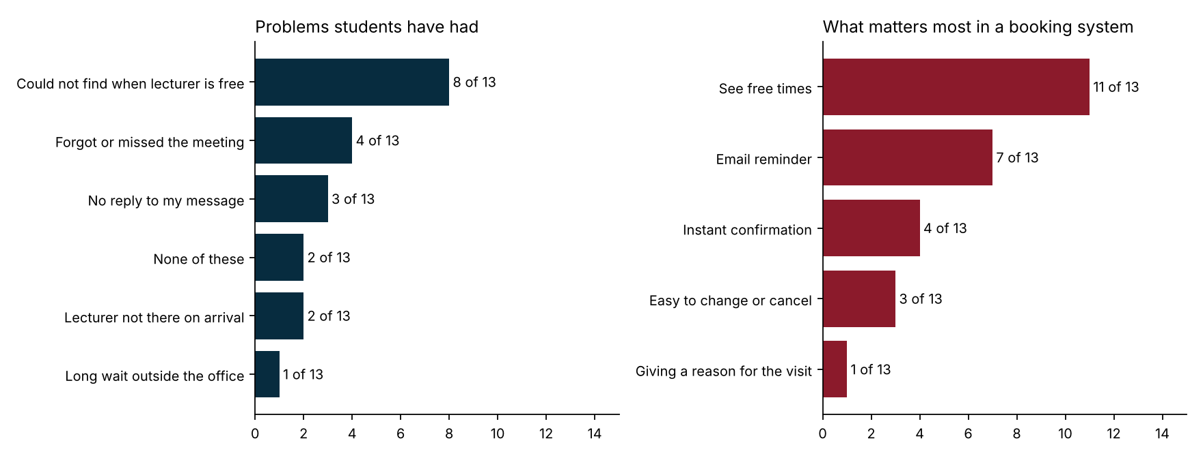
What the survey means for CampusBook
- The biggest problem is not knowing when a lecturer is free (8 of 13) and the most wanted feature is seeing free times (11 of 13) This is what the Book a slot page does
- Email reminders were chosen by 7 of 13 and 4 students had forgotten or missed a meeting so the reminder job (FR-08) answers a real need
- Instant confirmation was chosen by 4 and changing or cancelling by 3 which supports the confirmation email and the Change time and Cancel booking buttons
- Phone and laptop were almost equal (7 and 6) which supports testing both at 375 and 1366 pixels wide (NFR-03)
- Pressure is highest before tests and assignment deadlines so the demo and the user testing should use busy times as the example
The survey has limits It has 13 answers from one campus so it shows what these students said and not all students No lecturers answered it and the lecturer feedback is still to be collected during the user testing in Week 5
Table 5.10 Feedback sources
Feedback source | What it will show | When
Student survey (13 answers) | Current problems and what students want | Done and shown above
User testing with students and a lecturer | Time to complete a booking and problems seen and comments | Week 5 (by Monday 26 October)
Supervisor feedback on this chapter | Corrections to the tests and the chapter | After the Week 4 submission

5.8 Chapter Summary
The tests show that the booking journey works from login to confirmation on a phone and a laptop and that two students can never hold the same slot 35 of 36 tests pass after the fixes and the one test not run needs real students
Testing found real problems at the joins between the pages and the API The Lecturer slots page and the Book a slot page did not read the Slots API correctly and My bookings had no change button These and the other defects are fixed in the working copy and each fix was retested The fixes must be committed and pushed and the tests run once more on the GitHub version before the final submission on 29 October
The student survey (13 answers) supports the need for the system and the features chosen User testing results will complete this chapter in Week 5

