CAPSTONE PROJECT
INDIVIDUAL CONTRIBUTION FORM
Project Title | CampusBook: a lecturer consultation booking system for CTU Training Solutions
Group Members | Willem Gerber  Oscar Khumalo  Thomas du Plessis  Lebohang Tlaitlai  Gerhardus van den Berg
Module | Software Engineering 2 (SPM622)
Lecturer / Supervisor | Jabulile Mashibini
Week / Stage | Week 4
Submission Date | Friday 23 October 2026

Student Details
Name: Willem Gerber Student No.: 20230257 Group: SE2 Group 3

Contribution Summary
Area | What I did
Research | Chapter 1 Introduction and helped with the Chapter 2 literature review and matrix
Design | Architecture diagram technology stack and the shared page template (header logo theme and page parts)
Coding | Back-end set up login and role checks (server.js routes/auth.js middleware)  Bookings API with change cancel history and no double booking  Book a slot page and My bookings page with the phone layout
Testing | Test Plan and 36 test cases and Defect Log and Traceability Matrix (folder 06) and fixes for the defects found
Documentation | Project charter work plan and ethics form  Compiled the Week 1 2 and 3 submissions Chapter 5 with the survey results and the CTU layout for Chapter 4.6 and 4.7 (Week 4)
Project management | Group Lead and Scrum Master: GitHub repository and a branch for each member  Reviewed and merged pull requests and made the task sign-up sheet
Presentation | Demo data and demo laptop and the final dissertation and submission (Week 5)

Git / Evidence References
Commit or file | Date | What it shows
dcb7cd2 and 092dd77 | 15 Oct | Repository and project structure
88460f8 | 19 Oct | Back-end folders schema and seed scripts and diagrams
6f458c7 | 20 Oct | Header layout theme login middleware and Bookings API
590e891 | 21 Oct | Booking error handling routes and Book a slot page
87cefdb | 22 Oct | My bookings page and phone layout
Pull requests #1 and #3 and #6 | 20 to 22 Oct | Reviewed and merged

Peer Confirmation
Member | Accurate (Yes or No) | Signature | Date
Thomas du Plessis | Yes | 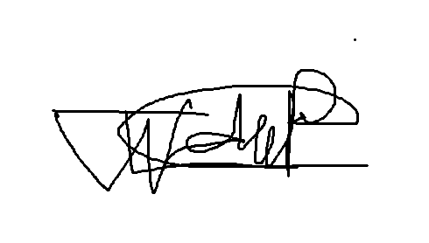 | 2026/10/22

Student Declaration
I confirm that the information above accurately reflects my contribution
Name | Signature | Date
Willem Gerber | 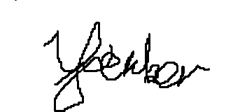 | 2026/10/22

