CAPSTONE PROJECT
GROUP 3 WEEK 4 SUBMISSION
Project Title | CampusBook: a lecturer consultation booking system for CTU Training Solutions
Group Members | Willem Gerber  Oscar Khumalo  Thomas du Plessis  Lebohang Tlaitlai  Gerhardus van den Berg
Module | Software Engineering 2 (SPM622)
Lecturer / Supervisor | Jabulile Mashibini
Week / Stage | Week 4
Submission Date | Friday 23 October 2026
GitHub link: https://github.com/Gerber-W/SPM_Group_Project
Walkthrough video link: https://drive.google.com/file/d/1gqTjvlM1voM251VoqNVl4DCuNHFxj_xs/view?usp=drive_web
This document holds the Week 4 work of SE2 Group 3
- Chapters 1 to 5 of the dissertation and the Chapter 6 outline
- Appendix A Test Plan
- Appendix B Test cases and results and the Defect Log and the Requirements Traceability Matrix
- Appendix C Weekly Progress Report and the Project Schedule and Sprint Backlog and the Risk Issue and Change Register
- Appendix D Group Declaration and the Individual Contribution Forms
- Appendix E Final Submission Checklist and the Project Attendance Register
- Appendix F Demo Script
- Appendix G Presentation Slides

Chapter 1 Introduction

1.1 Background of the Study
Consultations give students time with a lecturer outside class to ask questions get feedback and work through problems Research shows this support is often under used and that the reasons are usually practical rather than academic (Griffin, 2014)
At CTU Training Solutions arranging a consultation is informal Students send an email a Teams or WhatsApp message or simply knock on the lecturer door during posted hours Each lecturer handles this differently and nobody has a clear view of who is available who is coming or which meetings took place
Other sectors have solved a similar problem with online booking in healthcare web based appointment systems have reduced no-shows and waiting times and saved staff time (Zhao, 2017) and automated reminders improve attendance even further (Guy, 2012) With 96% of South African households owning a mobile phone (Statistics South Africa, 2024) a booking system that works well on a phone can reach almost every student

1.2 Problem Statement
CTU Training Solutions has no single reliable way for students to book consultations with lecturers Requests are spread across email Teams WhatsApp and walk-ins so students wait outside offices messages go unanswered and meetings are missed or double-booked Lecturers cannot plan their time because they do not know who is coming or why the problem peaks before tests and assignment deadlines exactly when students need help most
It affects students who need academic support and lecturers who juggle requests from several channels Our group has experienced this first hand our lecturer reviewed the proposal and agreed it addresses a real need and a short student survey will show how widespread it is

1.3 Research Aim
To design develop and evaluate CampusBook a web based system that lets CTU students book change and cancel consultations and lets lecturers manage their availability so that fewer consultations are missed or left unplanned

1.4 Research Objectives
1. Analyse how consultations are arranged today through a survey of at least 10 students by 21 October 2026
2. Compare at least three existing scheduling systems on their features strengths and limitations by 19 October 2026
3. Design and develop a web system with all six must-have features working on a live database by 23 October 2026
4. Test the system so that every must-have test case passes a booking takes under 2 minutes and pages load within 3 seconds
5. Evaluate the system with at least 5 students and 1 lecturer with 80% or more rating it easy to use

1.5 Research Questions
1. How do students and lecturers at CTU arrange consultations now and what problems do they face?
2. What do existing scheduling systems offer and what do they lack for a campus setting?
3. How can a web system let students book consultations and lecturers manage their time?
4. Does the system meet its functional and non-functional requirements?
5. Do students and lecturers find the system easy to use and useful?

1.6 Proposed Software Solution
CampusBook is a responsive web application with two roles Lecturers publish their weekly consultation slots and see who has booked and why Students browse open slots book one with a short reason for the visit and get an email reminder before the meeting The six must have features are:
1. Login with separate student and lecturer roles
2. Lecturers publish weekly consultation slots
3. Students book change or cancel a slot with a reason for the visit
4. Email confirmation and a reminder before each booking
5. Booking history for students and lecturers
6. Mobile friendly design

1.7 Scope
In scope | Out of scope
One CTU campus | Other campuses or institutions
Student and lecturer roles | Admin reporting dashboards
Six must have features with email reminders | Video calls SMS and native mobile apps
Test data created by the team | Links to CTU live student systems

1.8 Significance of the Study
- Students can see when lecturers are free get confirmed bookings and stop wasting trips before assessments
- Lecturers control their consultation time and know in advance who is coming and why
- CTU Training Solutions gains a low-cost tool that supports student success and evidence on whether online booking works as well on campus as it does in healthcare

1.9 Chapter Summary
This chapter explained why consultations at CTU Training Solutions are hard to arrange and who the problem affects It set the aim the five objectives and the five research questions and described CampusBook with its six must have features and what is in and out of scope Chapter 2 now reviews existing research and similar systems

Chapter 2 Literature Review

2.1 Introduction
This chapter reviews research on why students under use consultations and how online booking and reminders help in other sectors It then compares Microsoft Bookings Calendly and Moodle Scheduler and reviews the technology chosen for CampusBook before stating the research gap

2.2 Existing Research
Consultations are under used Griffin (2014) surveyed undergraduate students at a large American university and found that most of the factors that stop students attending office hours are outside the lecturer control The one exception was feedback: students who found it useful came back more often A summary of similar survey work found that 66% of more than 600 students had never attended office hours for a course and only 8% went more than once a month (Weimer, 2015) Both sources show the problem clearly but they focus on student attitudes rather than on how meetings are arranged and neither tests a tool that makes booking easier
Online booking works in healthcare Zhao (2017) reviewed 21 web based medical appointment systems Online booking cut no shows with one system reporting 2% for web bookings against 8% for phone bookings and it also shortened waiting times raised satisfaction and reduced staff workload The review warns that providers worry about losing control of their schedules a concern lecturers are likely to share Guy (2012) add that automated reminders increase attendance These studies come from healthcare where appointments are more formal than a quick consultation so the idea still needs testing in education
People use systems that are useful and easy The Technology Acceptance Model suggests that people adopt a system when they find it useful and easy to use (Davis, 1989) Nielsen (1994) usability heuristics turn this into practical design rules such as always showing a clear confirmation and stopping a student from booking a slot that is already taken

2.3 Existing or Similar Systems
Microsoft Bookings offers a booking page that syncs with Outlook sends email reminders and creates Teams meetings It comes with Microsoft 365 business and education plans but SMS reminders only work in North America and the UK and need an extra Teams Premium licence Microsoft It is built for businesses serving customers so it has no idea of students lecturers or modules and setting it up needs administrator access
Calendly is a popular polished scheduling tool Its free plan allows only one event type and one calendar and reminders need the Standard plan at 10 US dollars per lecturer per month Calendly Students would need a separate link for every lecturer and booking data would sit with a third party
Moodle Scheduler is a Moodle plugin that lets teachers create slots for students to book with reminders booking limits and attendance tracking (Moodle, 2017) It suits teaching well but it only works inside one course needs an administrator to install it and is only an option for institutions that run Moodle
 | Microsoft Bookings | Calendly | Moodle Scheduler | CampusBook
Lecturer sets slots | Yes | Yes | Yes | Yes
Student books and cancels | Yes | Yes | Yes | Yes
Free reminders | Email only | No paid plan | Yes | Yes email
Student and lecturer roles | No | No | Course roles | Yes
All lecturers in one place | Yes | No | No per course | Yes
Extra cost | Microsoft 365 licence | Per lecturer | Needs Moodle | None
Set up effort | Admin sets up a booking page | Each lecturer signs up | Admin installs it then added per course | Set up once for the campus
Where data is kept | Microsoft 365 tenant | Calendly servers | Moodle server | CTU server
Works on a phone | Yes in the browser | Yes browser and app | Through Moodle | Yes built for phones first
Main drawback | Business focus | Cost and data privacy | Tied to one course | Must be maintained

Lessons for CampusBook All three systems handle the basic act of booking well so CampusBook copies what works: clear open slots instant confirmation and reminders Where they fall short is fit Microsoft Bookings and Calendly are designed for businesses and Calendly charges per lecturer for reminders Moodle Scheduler fits teaching but stays inside a single course CTU current mix of email Teams WhatsApp and walk ins costs nothing but offers no shared view of availability and no record of meetings

2.4 Technology Review
The chosen tools are among the most widely used in the 2025 Stack Overflow Developer Survey so documentation and help are easy to find (Stack Overflow, 2025)
CampusBook stores names email addresses and booking details which counts as personal information under the Protection of Personal Information Act (Republic of South Africa, 2013) The system will collect only what it needs hash all passwords show each user only their own bookings and use made up data during development
Part | Choice | Why | Alternative
Front end | React | Builds pages from reusable components Meta used by about 45% of developers | Plain HTML and JavaScript harder to keep consistent
Back end | Node.js and Express | One language JavaScript across the whole team used by about 49% of developers | ASP.NET which adds a second language
Database | MySQL | Relational tables for users slots and bookings and the team already knows it | PostgreSQL more popular at about 56% but less familiar to us
Reminders | Email | Free and reaches everyone | SMS which costs per message
Method | Scrum | Sprints of a month or less with a review after each (Schwaber and Sutherland, 2020) which fits our weekly deadlines | Waterfall too rigid for weekly feedback

2.5 Research Gap
Research shows that consultations help students but are under used (Griffin, 2014) and that online booking with reminders reduces missed appointments in healthcare (Guy, 2012; Zhao, 2017) Existing tools serve businesses or single Moodle courses well but none gives CTU students one place to book any lecturer free of licence costs

2.6 Conceptual / Technical Direction
Two ideas guide the design From the Technology Acceptance Model every screen must make booking quicker than sending a message or students and lecturers will not switch (Davis, 1989) From the healthcare studies confirmations and reminders are what reduce missed meetings so they are core features rather than extras (Guy, 2012; Zhao, 2017) Lecturers keep full control of their own slots which answers the loss of control concern raised by Zhao (2017)
Technically CampusBook follows a simple three-tier design The React front end runs in the browser the Express API handles logins slots and bookings and the MySQL database stores the data with rules that stop a slot being booked twice A scheduled task sends reminder emails before each consultation

2.7 Chapter Summary
Research shows that consultations help students but are under used and that online booking with reminders reduces missed appointments in healthcare The three systems reviewed handle booking well but none gives CTU students one place to book any lecturer free of licence costs Chapter 3 turns these ideas into requirements and a method

Chapter 3 Requirements and Methodology

3.1 Introduction
This chapter sets out who will use CampusBook what it must do and how the team will build it It covers the stakeholders the functional and non-functional requirements how the requirements were gathered the Scrum method the user stories the architecture and the ethical privacy and security considerations

3.2 Stakeholders and Users
Stakeholder | What they need from CampusBook | Access
Students | See open consultation times book change or cancel a slot and get a reminder before the meeting | Student account
Lecturers | Publish their available times and see who is coming and why | Lecturer account
CTU Training Solutions | Better planned consultations and more support for students before assessments | No admin dashboard in this version
Project supervisor | Review the requirements ethics and each weekly submission | Review only
Development team | Design build and test the system using made-up data | Development environment

3.3 Functional Requirements
ID | Requirement | Priority
FR-01 | Students and lecturers log in with their email and password | Must
FR-02 | The system checks the user role so students and lecturers only reach their own pages and actions | Must
FR-03 | Lecturers publish edit and remove their own future consultation slots | Must
FR-04 | Students view the open slots of a chosen lecturer | Must
FR-05 | Students book an open slot and give a short reason for the visit | Must
FR-06 | Students change or cancel their own upcoming bookings | Must
FR-07 | The system stops two students booking the same slot | Must
FR-08 | The system sends an email confirmation after booking and a reminder before the meeting | Must
FR-09 | Students see their own booking history and lecturers see the bookings for their slots | Must

3.4 Non-Functional Requirements
ID | Requirement | Priority
NFR-01 | A first-time student completes a booking in under 2 minutes | Must
NFR-02 | The main pages load within 3 seconds in the team test set up | Must
NFR-03 | Every page works on a phone at 375 pixels wide and on a laptop at 1366 pixels wide | Must
NFR-04 | Passwords are stored as bcrypt hashes and never as plain text | Must
NFR-05 | Each user can only see their own bookings or the bookings for their own slots | Must
NFR-06 | Only the data needed for logging in and booking is stored with made-up data during development | Must
NFR-07 | Errors explain what to fix and the form keeps what the user already typed | Should

3.5 Requirements Gathering
The first requirements came from four sources Our own experience of booking consultations at CTU feedback from our lecturer on the proposal the research comparison of Microsoft Bookings Calendly and Moodle Scheduler The features the three systems share became core requirements and the gaps they leave such as one place for every lecturer and free reminders shaped what makes CampusBook different
An anonymous survey of at least 10 CTU students will check how students book consultations now and what problems they run into the results will confirm or adjust these requirements

3.6 Development Methodology
The team uses Scrum with one week sprints where each sprint ends with a review so the next one can improve on it (Schwaber and Sutherland, 2020)
Sprint | Focus | Ends with
Sprint 0  16 to 19 Oct | Requirements SRS system design wireframes and repository set up | Week 3 submission
Sprint 1  20 to 23 Oct | Build the six must-have features and run the first tests | Week 4 submission
Sprint 2  24 to 29 Oct | User testing bug fixes final dissertation and presentation | Final submission and live demo

 | Scrum | Waterfall
Feedback | Used every week | Mostly at the end
Changing requirements | Added to the next sprint | Hard once a phase is done
Risk | Problems show up early | Problems show up late in testing
Fit for this project | Matches the weekly deadlines | Too rigid for a two-week build

3.7 Use Cases / User Stories
ID | User story | Requirements
US-01 | As a student I want to see open slots so I can get help without messaging each lecturer | FR-04
US-02 | As a student I want to book a slot with a reason so the lecturer knows what I need | FR-05 and FR-07
US-03 | As a student I want to change or cancel my booking so my plans stay up to date | FR-06
US-04 | As a lecturer I want to publish and manage my slots so I control my own time | FR-03
US-05 | As a lecturer I want to see who booked and why so I can prepare for the meeting | FR-09
US-06 | As a student or lecturer I want a confirmation and a reminder so no meeting is forgotten | FR-08

The main use case is booking a slot a student logs in chooses a lecturer and an open slot adds a reason and confirms the system checks that the slot is still open saves the booking and sends the confirmation If another student took the slot first the student is asked to choose another time

3.8 System Architecture
CampusBook uses a three tier design The React front end runs in the browser the Express API handles logins slots and bookings and the MySQL database stores the data with rules that stop a slot being booked twice A scheduled task sends reminder emails before each consultation The full architecture diagram is in Chapter 4 section 4.2

3.9 Ethical, Privacy and Security Considerations
- Only made-up users and bookings are used during development never real CTU records
- The survey and user testing are voluntary with consent first and anonymous results as set out in Appendix B
- Research files are kept in a private folder and deleted once the project is marked
- Only the data needed for logging in and booking is collected in line with POPIA (Republic of South Africa, 2013)
- Passwords are hashed every request is checked for a valid token and role and all input is validated on the server
- A unique key in the database stops a slot ever having two confirmed bookings

3.10 Chapter Summary
This chapter listed the stakeholders the functional and non-functional requirements and the Scrum method the team follows It also set out how privacy and security are handled Chapter 4 turns these requirements into the system design

Chapter 4 System Design and Development

4.1 Introduction
This chapter shows how CampusBook is designed It covers the architecture the UML diagrams the database design and the user interface wireframes followed by the technology stack and the repository structure

4.2 System Architecture
CampusBook uses a three tier architecture The client tier is a React web app that runs in the browser on a phone or laptop The application tier is a Node.js and Express API that holds all business rules The data tier is a MySQL database Splitting the system this way keeps the interface the rules and the data separate so each team member can work on one tier without breaking the others
Every request from the browser goes to the API over HTTPS as JSON Middleware checks the login token and the user role and validates the input before any route runs the auth slot and booking routes then read and write the database A scheduler runs every minute finds bookings that are due a reminder and sends them through the email service Booking confirmations are sent straight after a booking is saved
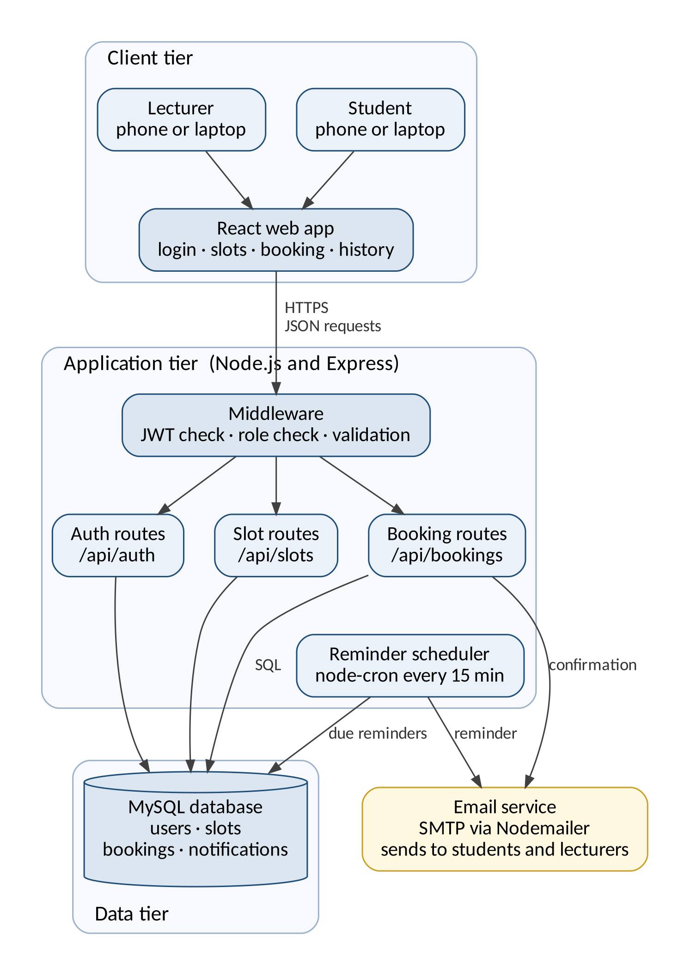

4.3 UML Design
Use case diagram
The use case diagram shows what each user can do Students view open slots book change and cancel bookings Lecturers publish edit and remove slots and see upcoming bookings Both log in and view their booking history Booking a slot always includes sending a confirmation and reminder through the email service
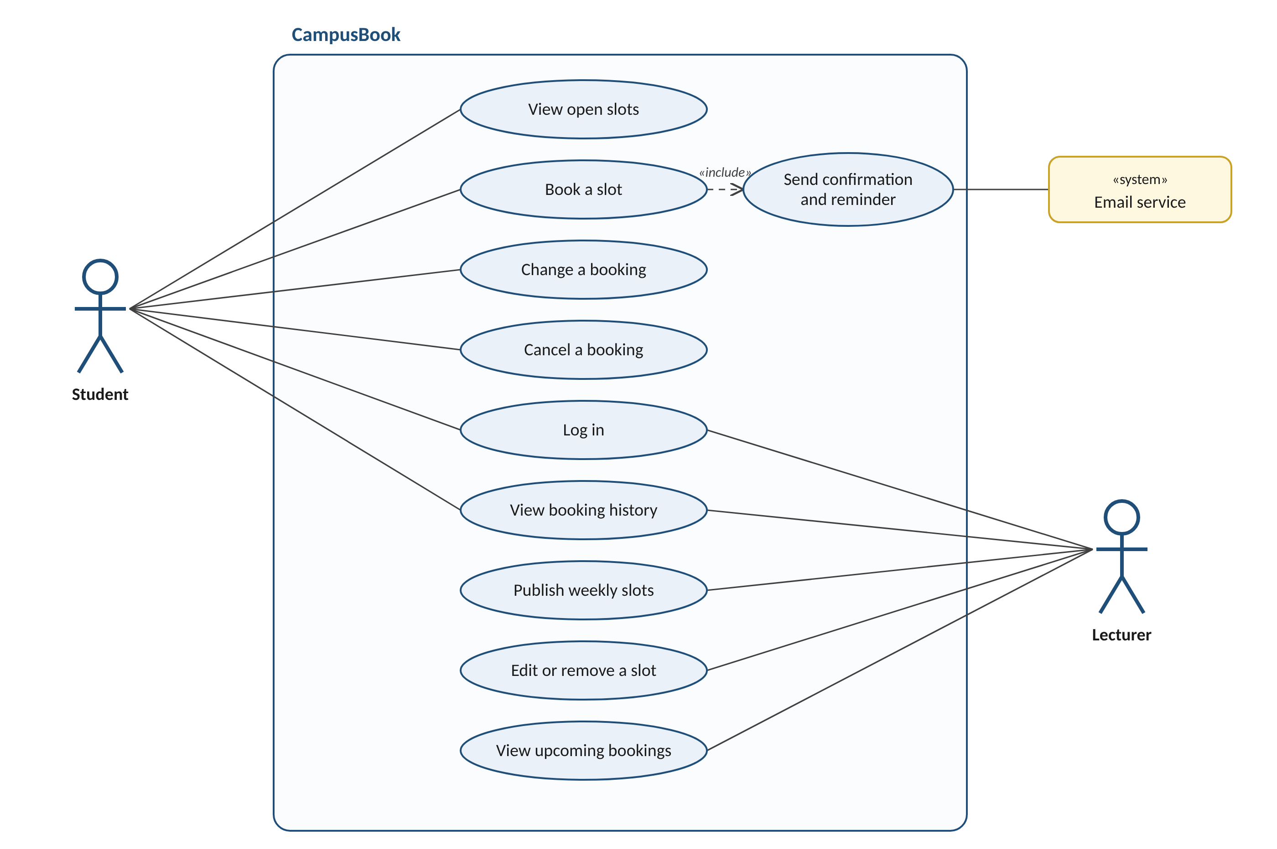
Class diagram
The class diagram shows the main objects in the system Student and Lecturer both inherit from User which holds the login details A lecturer publishes many consultation slots and a slot holds at most one active booking Each booking triggers one or more notifications such as the confirmation and the reminder
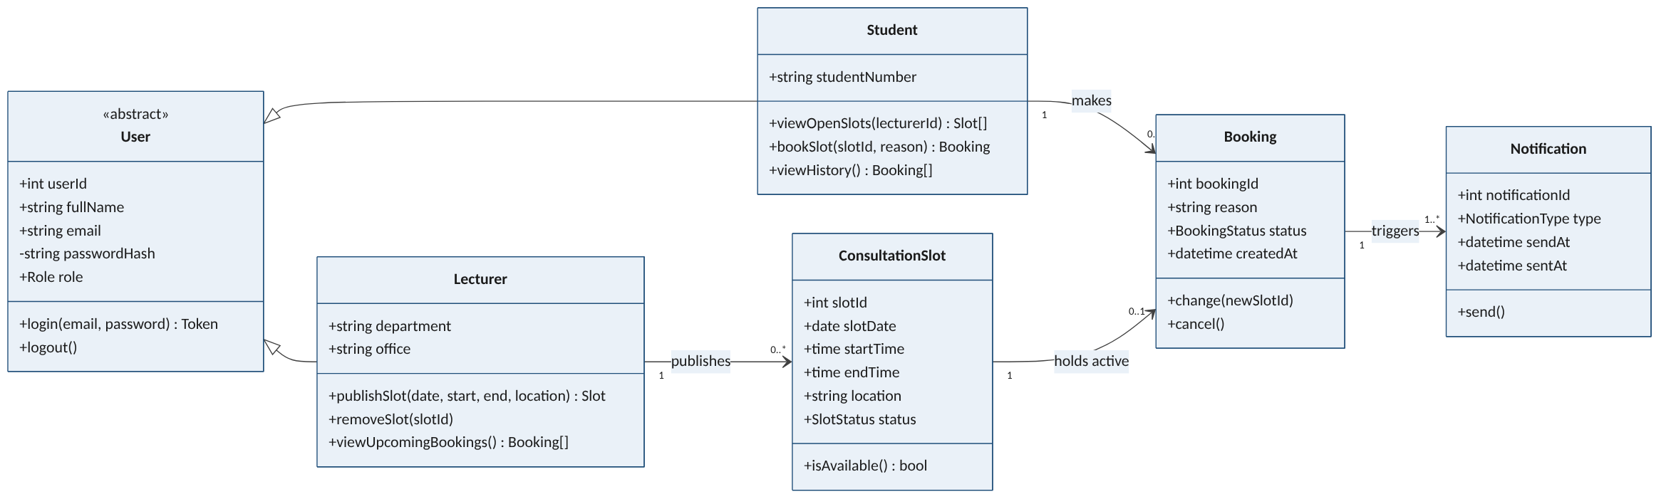
Activity diagram
The activity diagram follows a student booking a consultation It shows the two key decisions If no suitable slot is open the student can check another week or lecturer If another student takes the slot first the system shows a message and refreshes the list instead of creating a double booking
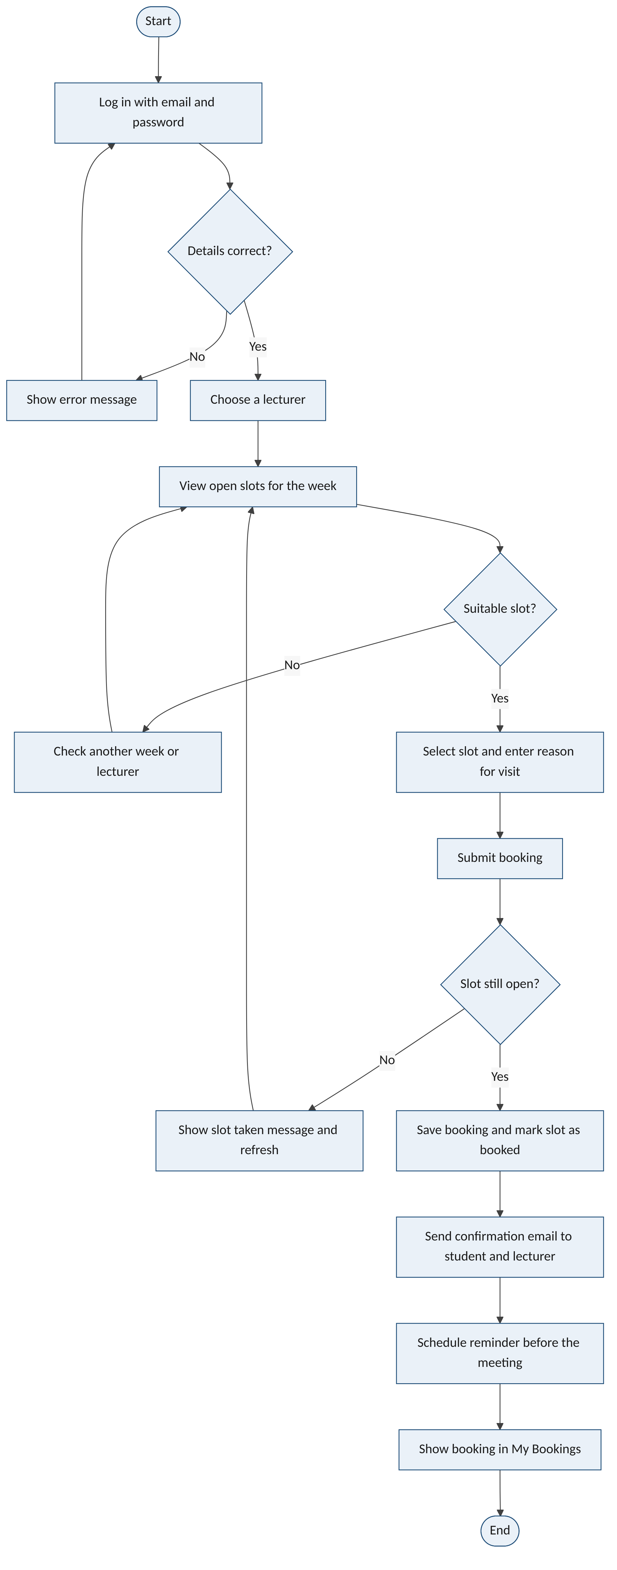
Sequence diagram
The sequence diagram shows the messages behind a booking The API locks the slot row inside a database transaction so two students pressing book at the same moment cannot both succeed If the slot is open the booking is saved the confirmation email is sent and the student sees a confirmation If not the transaction is rolled back and the student is told the slot was taken
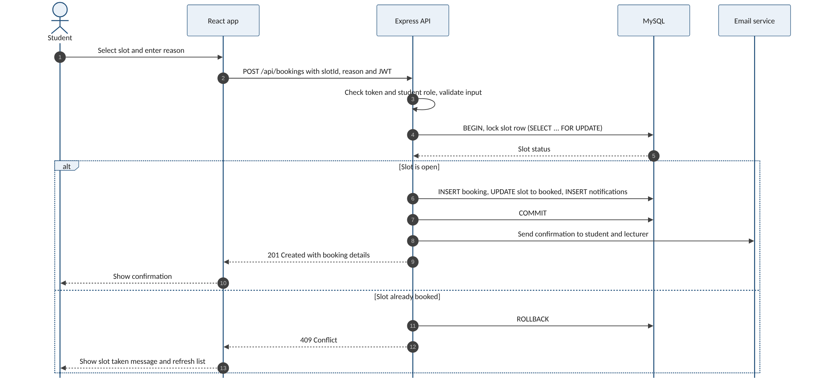

4.4 Database Design
The database stores users lecturer details consultation slots bookings and notifications The ERD below shows the five tables their keys and how they relate
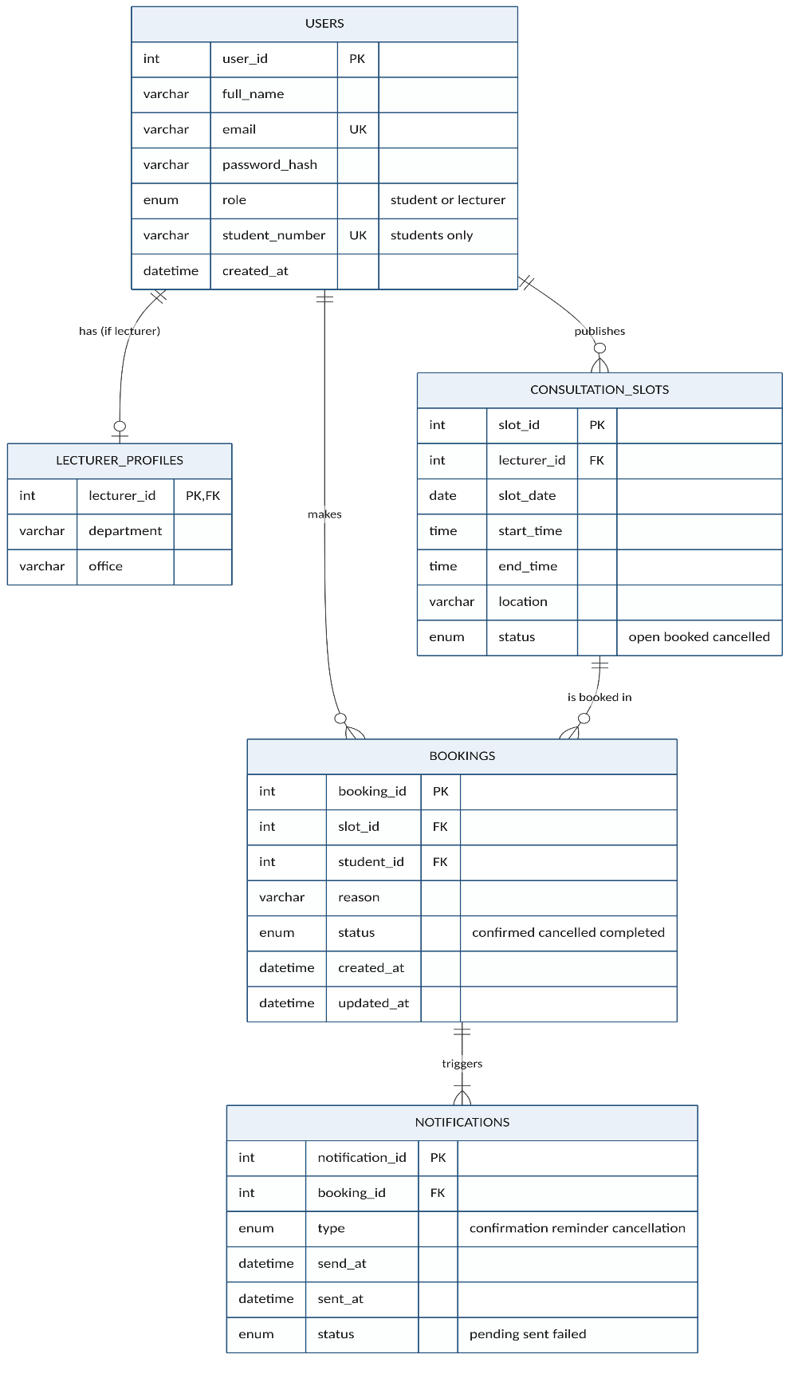
Relationships and cardinality
Relationship | Cardinality | Meaning
users to lecturer_profiles | One to zero or one | Only lecturers have a profile
users to consultation_slots | One to many | A lecturer publishes many slots
users to bookings | One to many | A student makes many bookings
consultation_slots to bookings | One to many | A slot can be booked again after a cancellation but only one booking is active at a time
bookings to notifications | One to one or more | Each booking has a confirmation and a reminder

Data dictionary
Column | Type | Null | Key | Description
users
user_id | INT UNSIGNED | No | PK | Unique number for each user
full_name | VARCHAR(120) | No |  | Name shown in the app
email | VARCHAR(150) | No | Unique | Used to log in and receive emails
password_hash | VARCHAR(255) | No |  | bcrypt hash never the real password
role | ENUM | No |  | student or lecturer
student_number | VARCHAR(20) | Yes | Unique | Required for students only
lecturer_profiles
lecturer_id | INT UNSIGNED | No | PK and FK | Links to users
department | VARCHAR(100) | No |  | Department the lecturer belongs to
office | VARCHAR(50) | Yes |  | Office or room
consultation_slots
slot_id | INT UNSIGNED | No | PK | Unique number for each slot
lecturer_id | INT UNSIGNED | No | FK | Lecturer who owns the slot
slot_date | DATE | No |  | Day of the consultation
start_time and end_time | TIME | No |  | End must be after start
location | VARCHAR(100) | No |  | Room or Teams
status | ENUM | No |  | open booked or cancelled
bookings
booking_id | INT UNSIGNED | No | PK | Unique number for each booking
slot_id | INT UNSIGNED | No | FK | Slot that was booked
student_id | INT UNSIGNED | No | FK | Student who booked
reason | VARCHAR(255) | No |  | Reason for the visit
status | ENUM | No |  | confirmed cancelled or completed
active_slot_id | INT UNSIGNED | Yes | Unique | Filled only while confirmed stops double booking
notifications
notification_id | INT UNSIGNED | No | PK | Unique number for each email
booking_id | INT UNSIGNED | No | FK | Booking the email belongs to
type | ENUM | No |  | confirmation reminder or cancellation
send_at and sent_at | DATETIME | sent_at only |  | When it is due and when it was sent
status | ENUM | No |  | pending sent or failed

Normalisation
The design is in third normal form Every table has a single column primary key and every other column depends only on that key Lecturer details sit in their own table so they are not repeated for students Lecturer and student names are stored once in users and joined when needed so changing a name never leaves old copies behind Notifications are kept apart from bookings so that one booking can have several emails without repeating booking data
Security and integrity
- Foreign keys stop a booking pointing at a slot or student that does not exist
- A unique key on active_slot_id means a slot can only ever have one confirmed booking
- Check constraints make sure end times are after start times and that students have a student number
- Passwords are stored as bcrypt hashes and each user can only reach their own bookings through the API
- Only made-up data is used during development in line with POPIA
SQL scripts
The full scripts are in the repository at database/schema.sql and database/seed.sql The part that prevents double booking is shown below
CREATE TABLE bookings (
booking_id INT UNSIGNED NOT NULL AUTO_INCREMENT,
slot_id INT UNSIGNED NOT NULL,
student_id INT UNSIGNED NOT NULL,
reason VARCHAR(255) NOT NULL,
status ENUM('confirmed','cancelled','completed') DEFAULT 'confirmed',
active_slot_id INT UNSIGNED AS (IF(status = 'confirmed', slot_id, NULL)) STORED,
PRIMARY KEY (booking_id),
UNIQUE KEY uq_one_active_booking_per_slot (active_slot_id),
CONSTRAINT fk_booking_slot FOREIGN KEY (slot_id) REFERENCES consultation_slots (slot_id),
CONSTRAINT fk_booking_student FOREIGN KEY (student_id) REFERENCES users (user_id)
);

4.5 User Interface Design
The screens below are low fidelity wireframes that show the layout and flow of each page before it is built in React in Week 4 The numbered markers point to the design choices explained under each screen The layout follows the usability heuristics from Chapter 2 (Nielsen, 1994) and keeps every task to as few steps as possible so that booking is quicker than sending a message (Davis, 1989)
Login
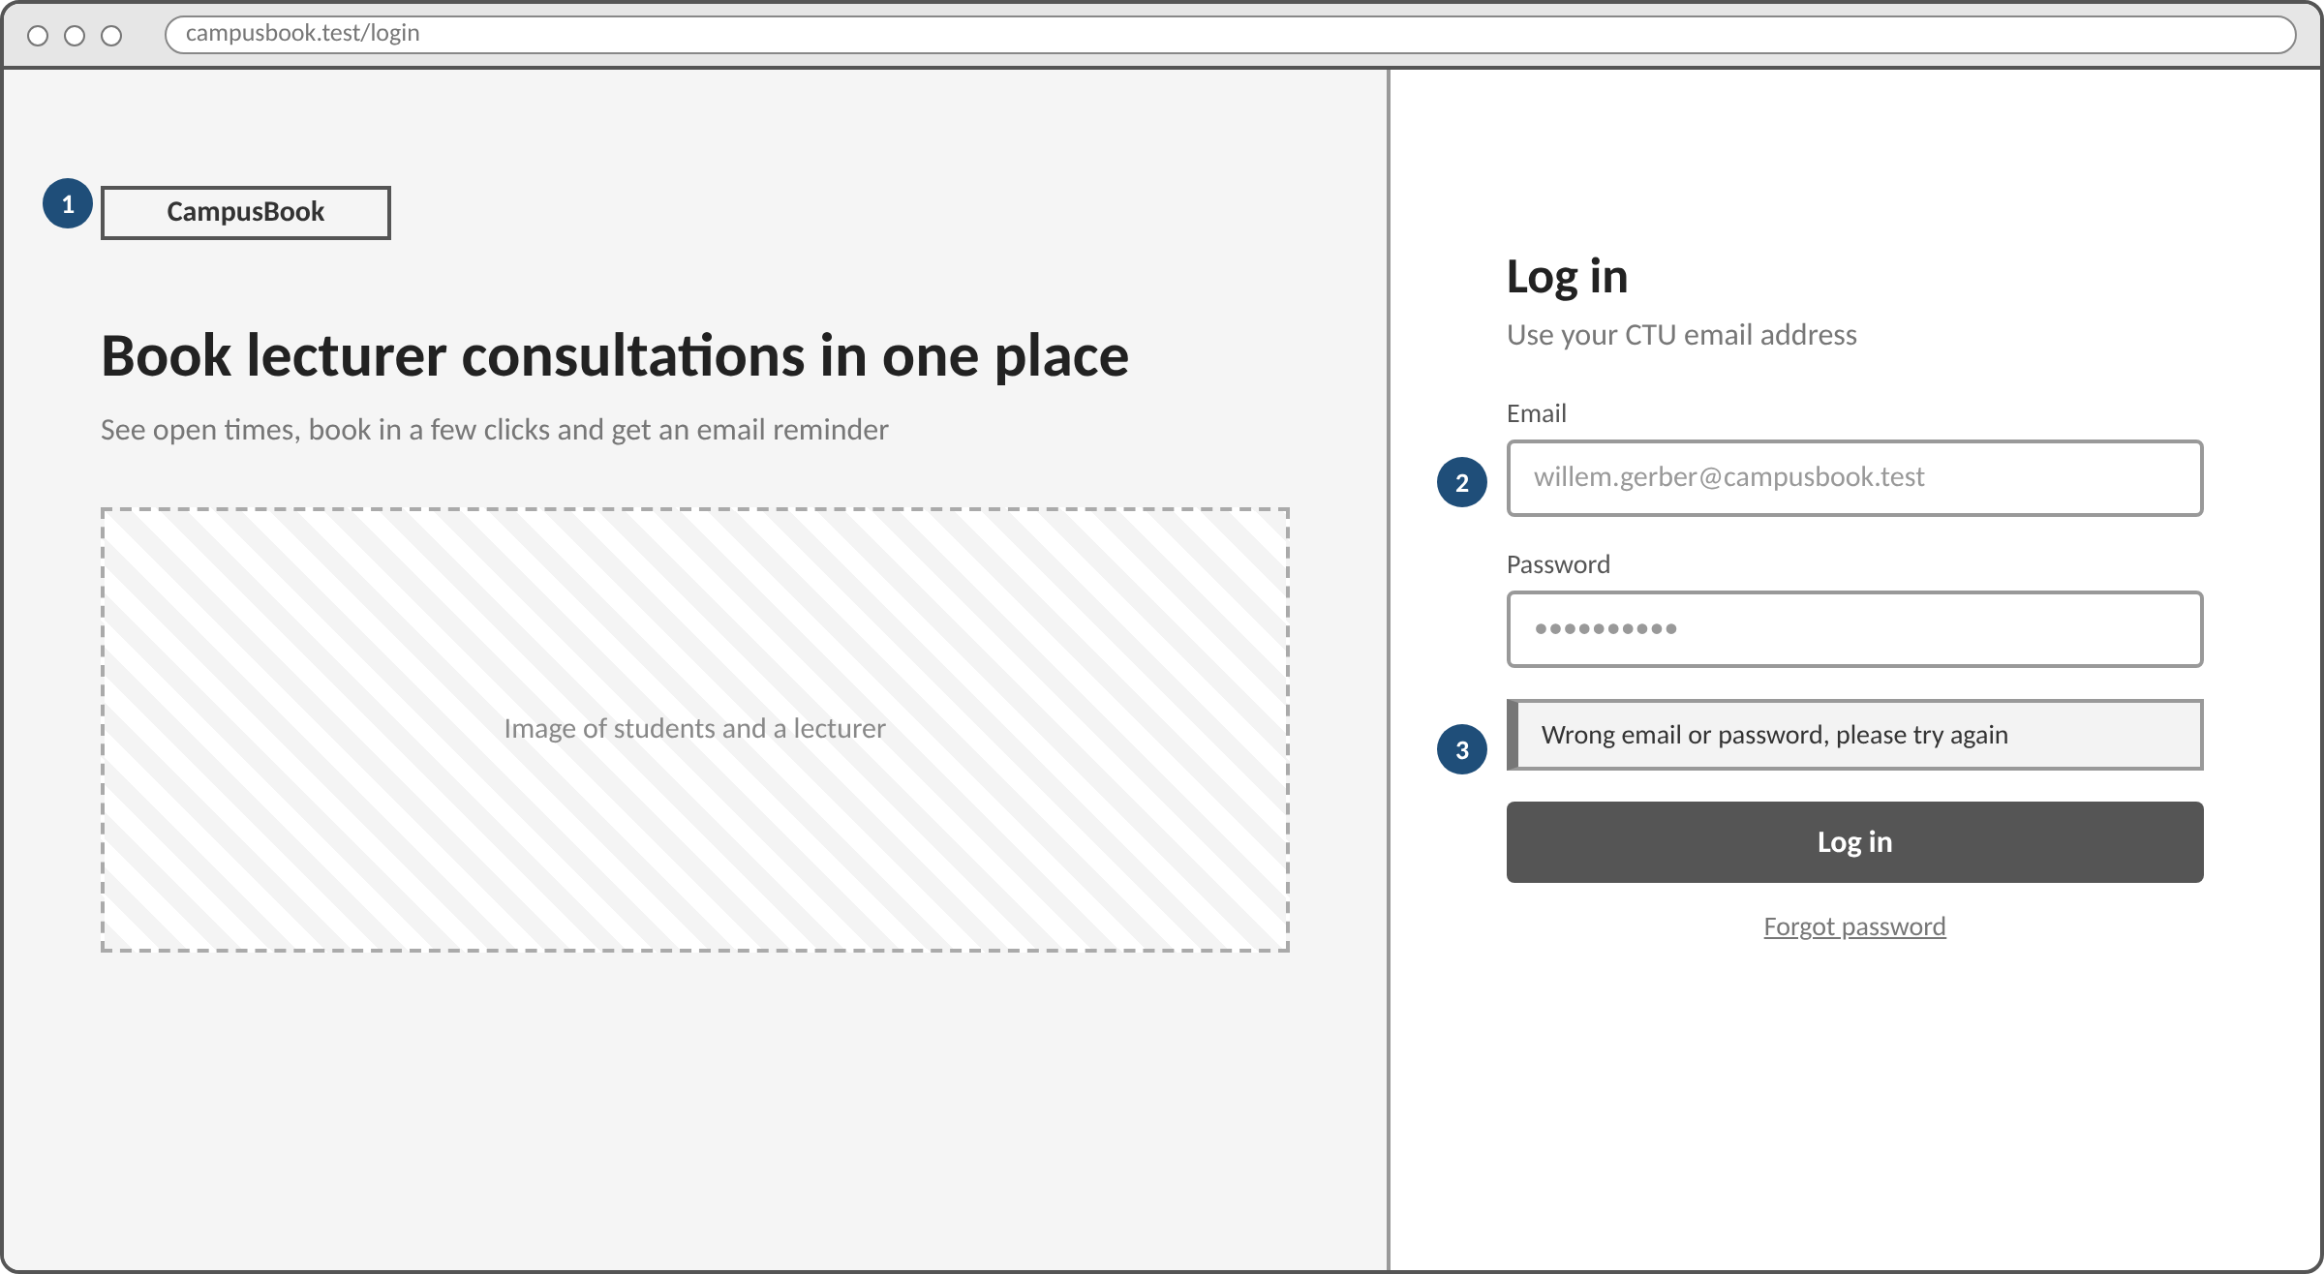
1. The left side explains in one line what CampusBook does so new users know they are in the right place
2. Labels sit above each field and the email field hints that a CTU address is needed
3. Errors appear in plain words right above the button so users can recognise and recover from a mistake
Student booking screen
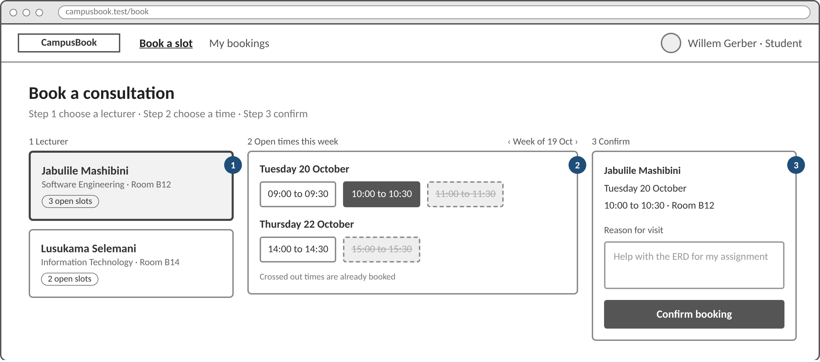
1. Lecturer cards show the department room and number of open slots so students can choose quickly
2. Open times are grouped by day and times that are already taken are crossed out instead of hidden which prevents errors
3. A summary repeats the lecturer date time and place before the student confirms and the reason for the visit is required
Lecturer slots screen
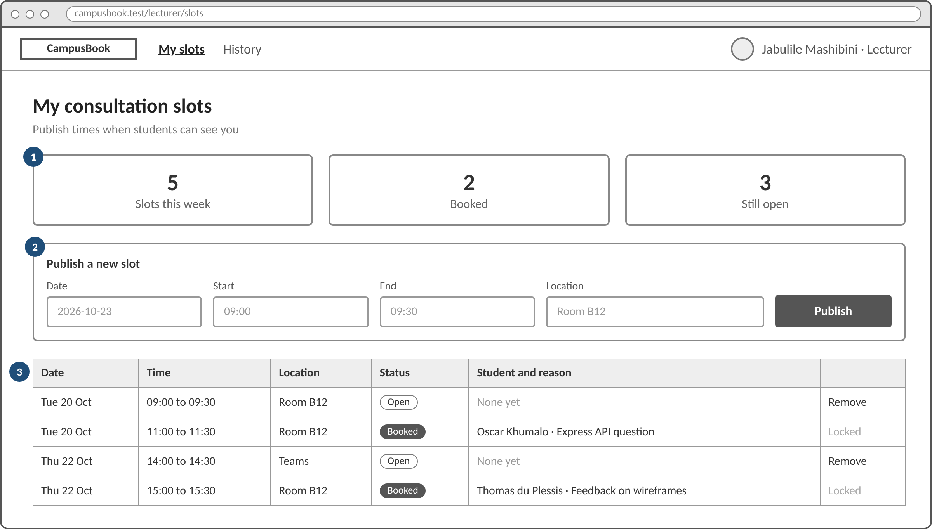
1. Three counters show the week at a glance so lecturers always know the status of the system
2. A new slot is published with four fields on one line which keeps the most common lecturer task short
3. The table lists every slot with the student and reason and booked slots are locked so a confirmed meeting cannot be removed by accident
My bookings on a phone
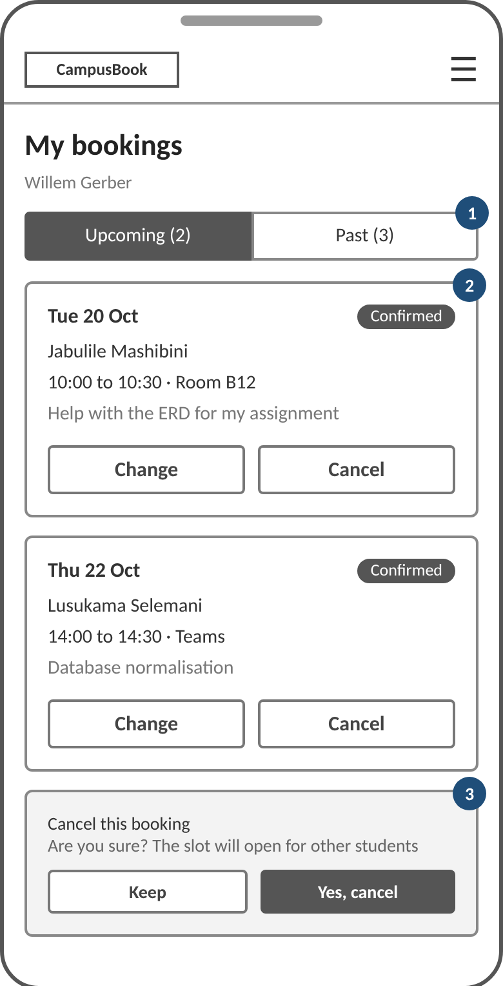
1. Upcoming and past bookings sit in two tabs so the list stays short on a small screen
2. Each card shows the date lecturer time place and reason with large buttons that are easy to tap
3. Cancelling asks for confirmation first and explains that the slot will open for other students

4.6 Development Environment
CampusBook was built with a small set of tools that suit a secure and simple consultation booking system
Area | Tools | What they do
Languages | JavaScript  HTML  CSS  SQL | JavaScript runs the frontend and the backend  HTML gives the page structure  CSS controls the look and the small screen layout  SQL creates and reads the database tables
Frontend | React  Vite  React Router | React gives reusable parts for login booking and lecturer slots  Vite is the fast dev server  React Router moves between pages and blocks pages by role
Backend | Node.js  Express | Node.js runs JavaScript on the server  Express handles the REST API for login slots and bookings and talks to the database
IDE | Visual Studio Code | Used to write and organise the code  The built in terminal installs packages runs both servers and runs Git commands
Database | MySQL 8 | Stores accounts slots bookings and notifications  Keys and constraints link the records and stop double bookings
Libraries | bcryptjs  jsonwebtoken  Nodemailer  node-cron | bcryptjs hashes passwords  JSON Web Tokens handle login and roles  Nodemailer sends emails  node-cron runs the reminder job
Services | SMTP  GitHub | SMTP sends booking confirmations and reminders  Both servers run locally for testing  GitHub stores and shares the source code
Version control | Git  GitHub | Each member works on their own branch  Changes are committed pushed and merged through pull requests  This shows who did what and keeps the latest CampusBook version

4.7 Implementation
This section shows how the main features of CampusBook work in the running system
The system uses React for the frontend
Node.js and Express for the backend and MySQL for users slots and bookings
The screenshots follow the login the student booking flow and the lecturer slot pages and also show errors found during testing and how they were fixed
Repository structure
CampusBook/
backend/
Express REST API (routes middleware services jobs db.js server.js)
frontend/
React web app (pages Login BookSlot MyBookings LecturerSlots)
database/
schema.sql and seed.sql
docs/
diagrams and wireframes

Login
Desktop login
The login page on a desktop screen
The left side introduces CampusBook and the right side has the email and password fields
There is a login button and a forgot password link under the form
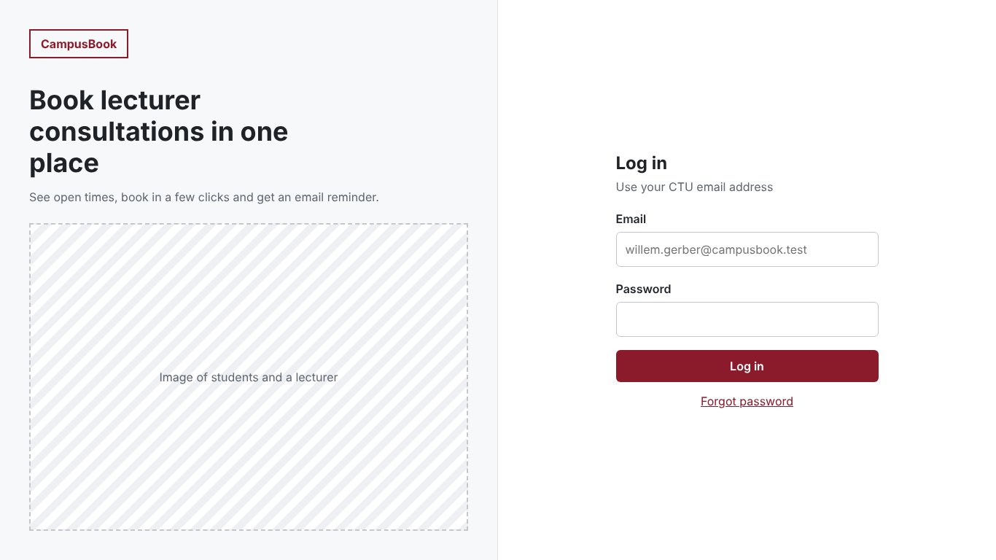
Wrong login details
The message shown when the email or password is wrong
The user can try again
The message does not say which one was wrong
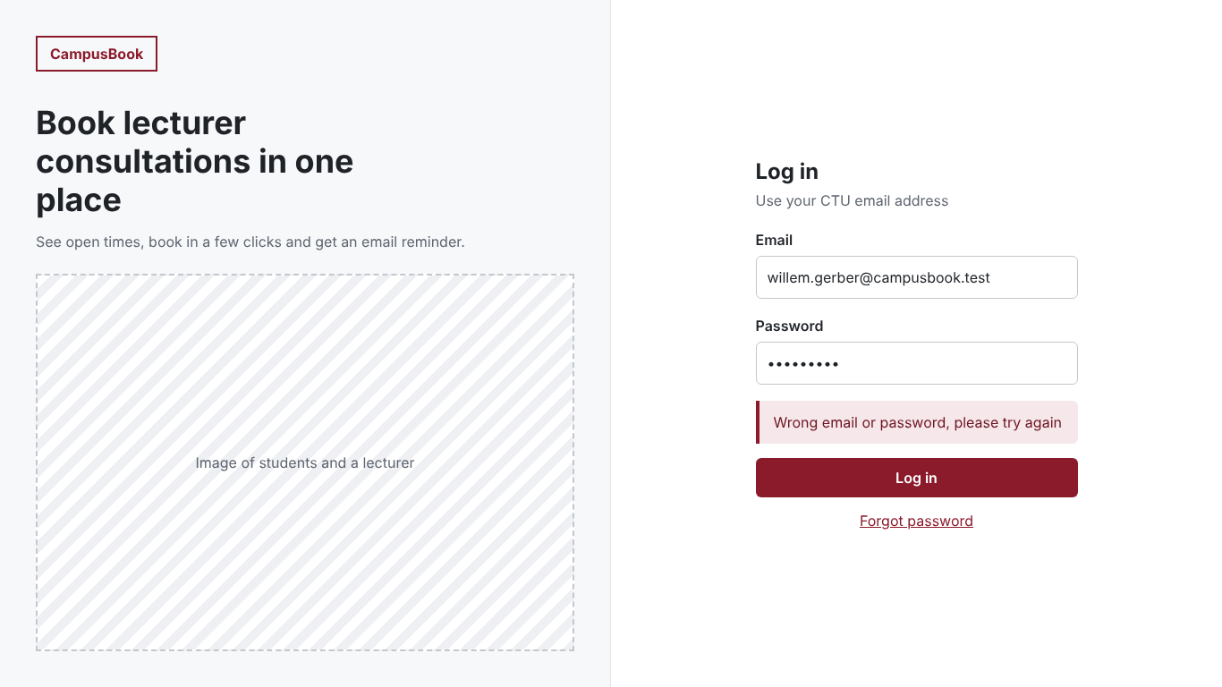
Session expired
When a session ends the user goes back to the login page with a message to log in again
This makes sure protected pages need a valid login
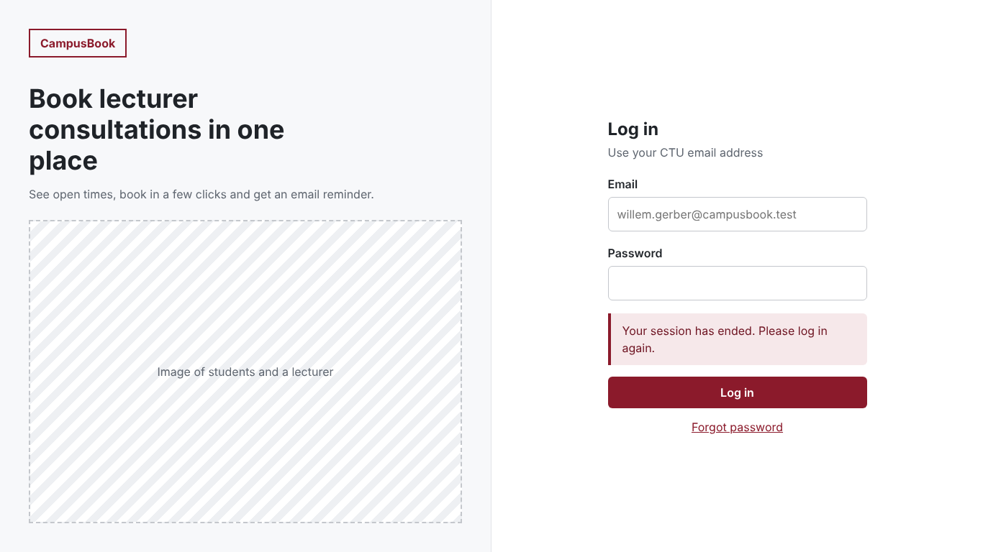
Mobile pages
The login booking calendar and booking confirmation pages on a phone
The layout stacks vertically so the form and the times stay easy to use on a small screen
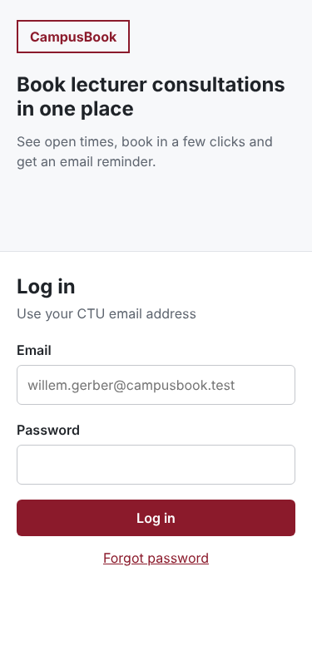 | 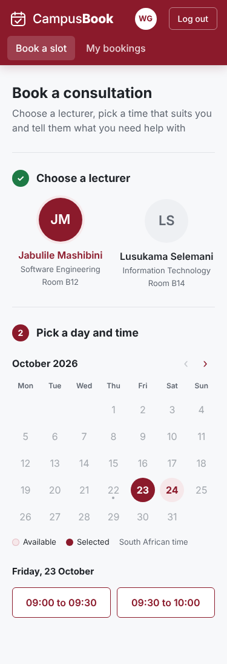 | 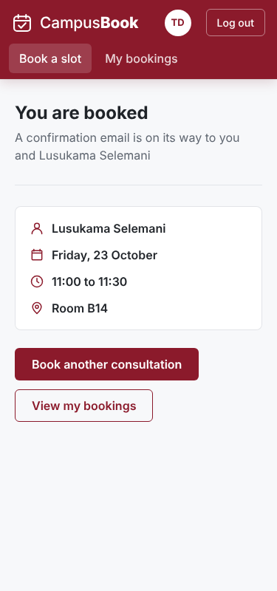
Student booking
Desktop booking page
The student picks a lecturer a date and a time
The summary shows the lecturer date time and location and a reason box explains the purpose before the booking is confirmed
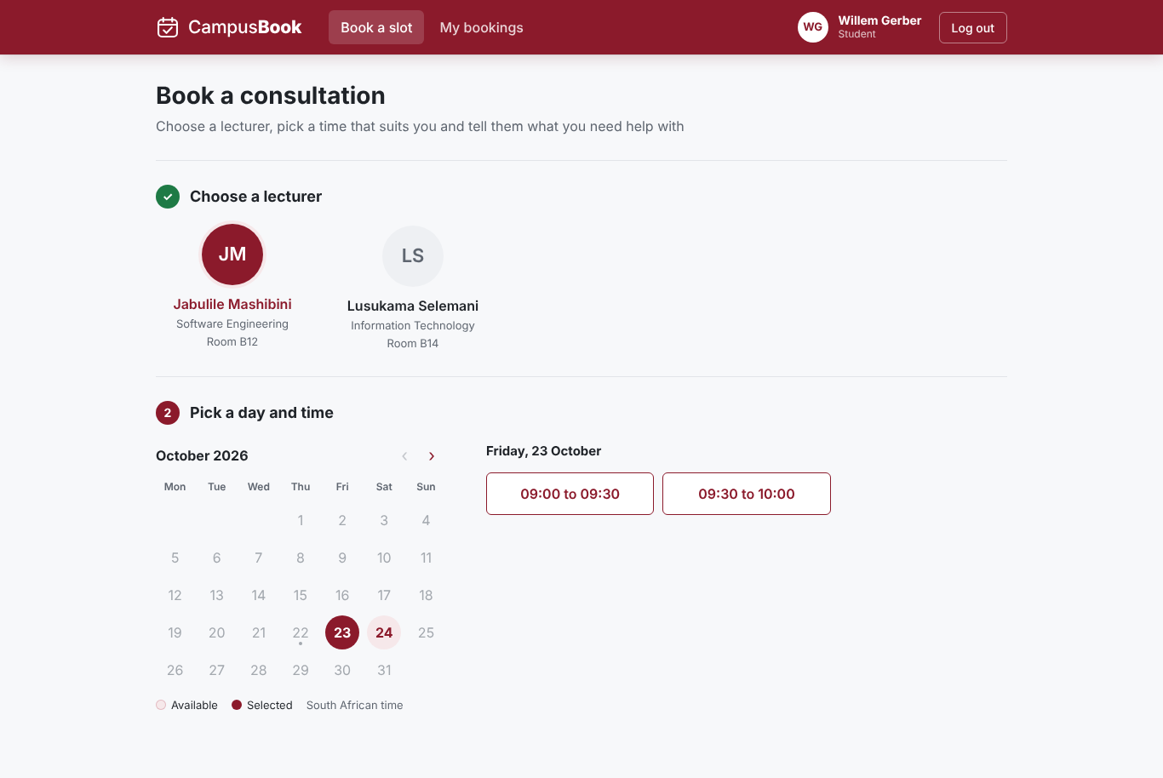
Times displayed correctly
The available times show correctly and the booking summary matches the selected slot
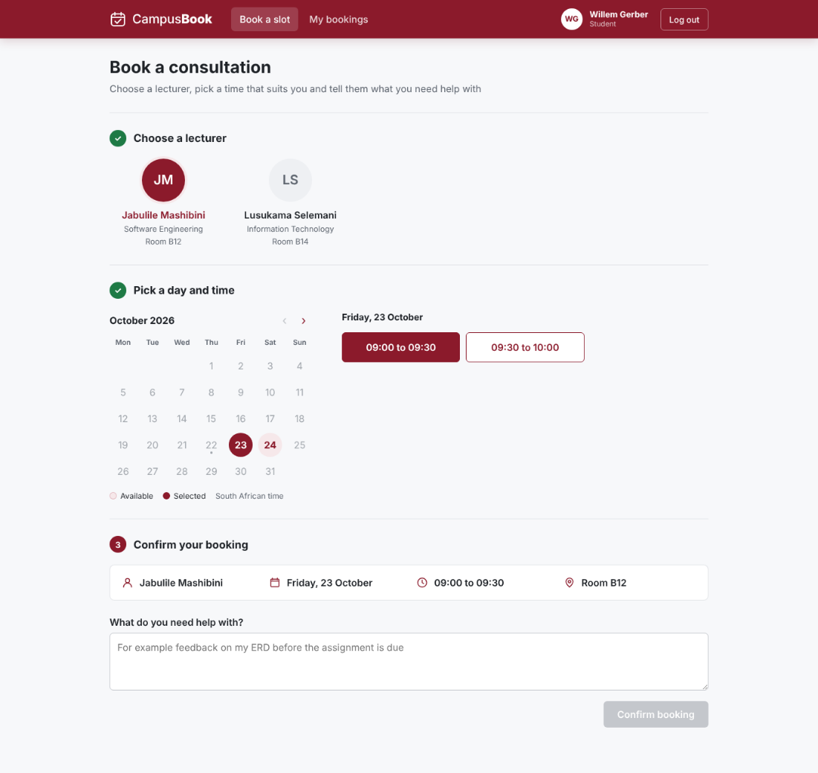
Availability after a booking
After a slot is taken only the free time is still offered for that date
The form keeps the reason the student typed
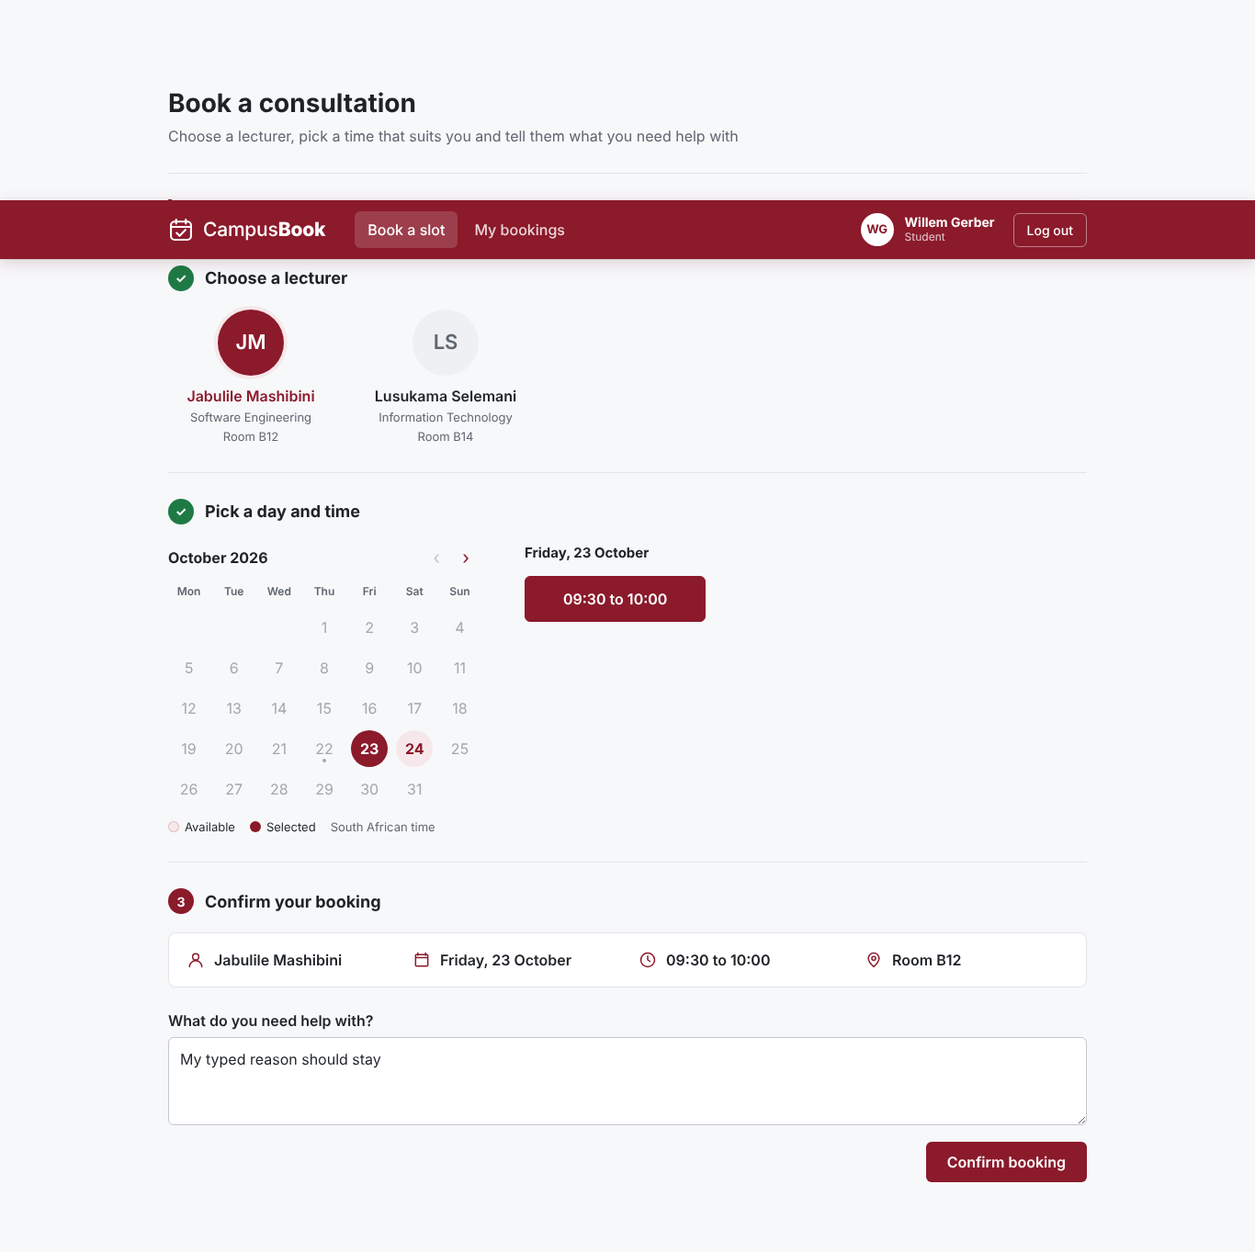
My bookings
Desktop my bookings
Upcoming bookings and history are shown in two sections with a button to book again
When there are none a message says so
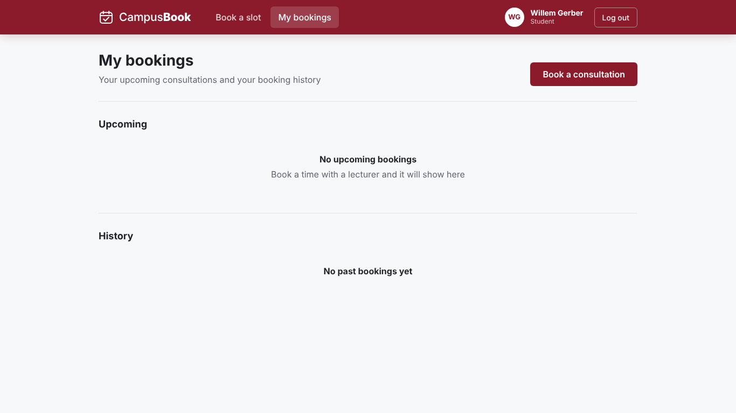
Mobile my bookings
The same page on a phone with upcoming and past sections and a button for a new booking
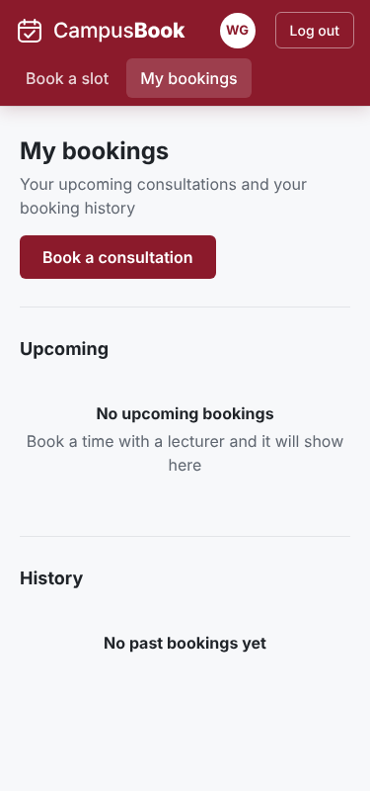
Moving a booking
The student picks another time from the dropdown and presses Move Booking to change an existing consultation
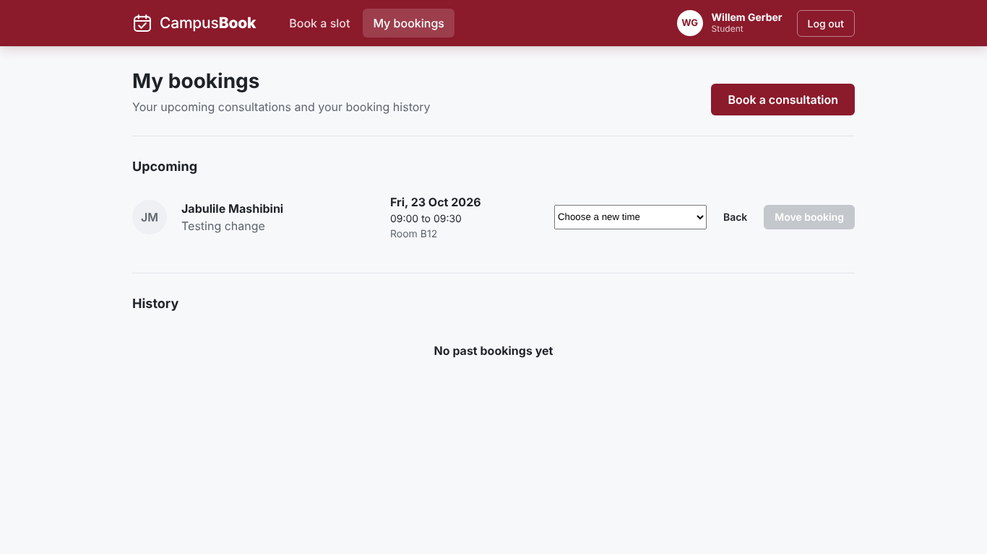
Lecturer slots
Slot published
The lecturer page after slots are published
The table shows date time location and status with Edit and Remove buttons
A green message confirms the new slot
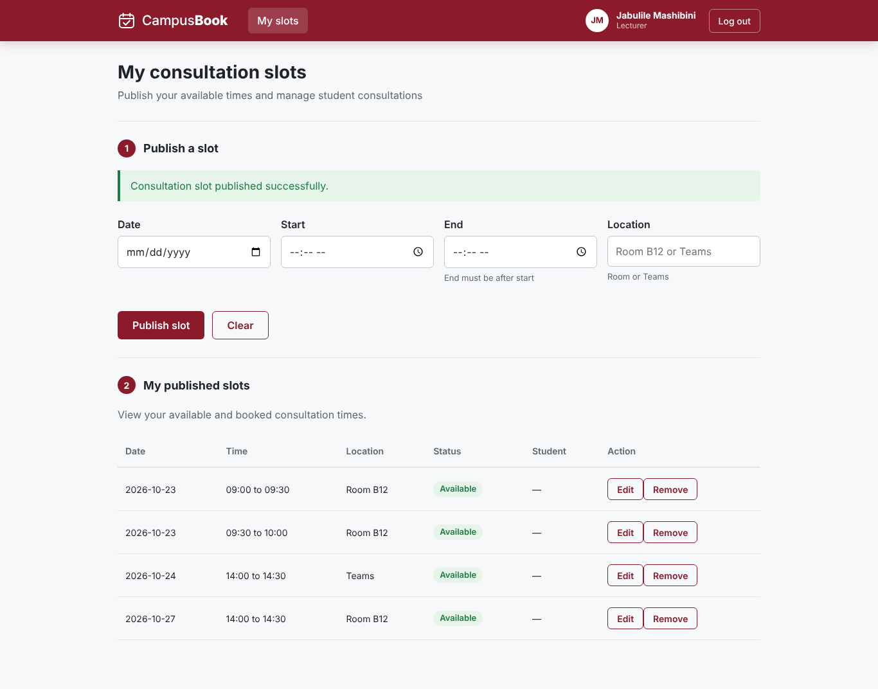
Slot updated
A slot for 27 October 2026 was changed to Room C3
A green message confirms the update and the table shows the new location
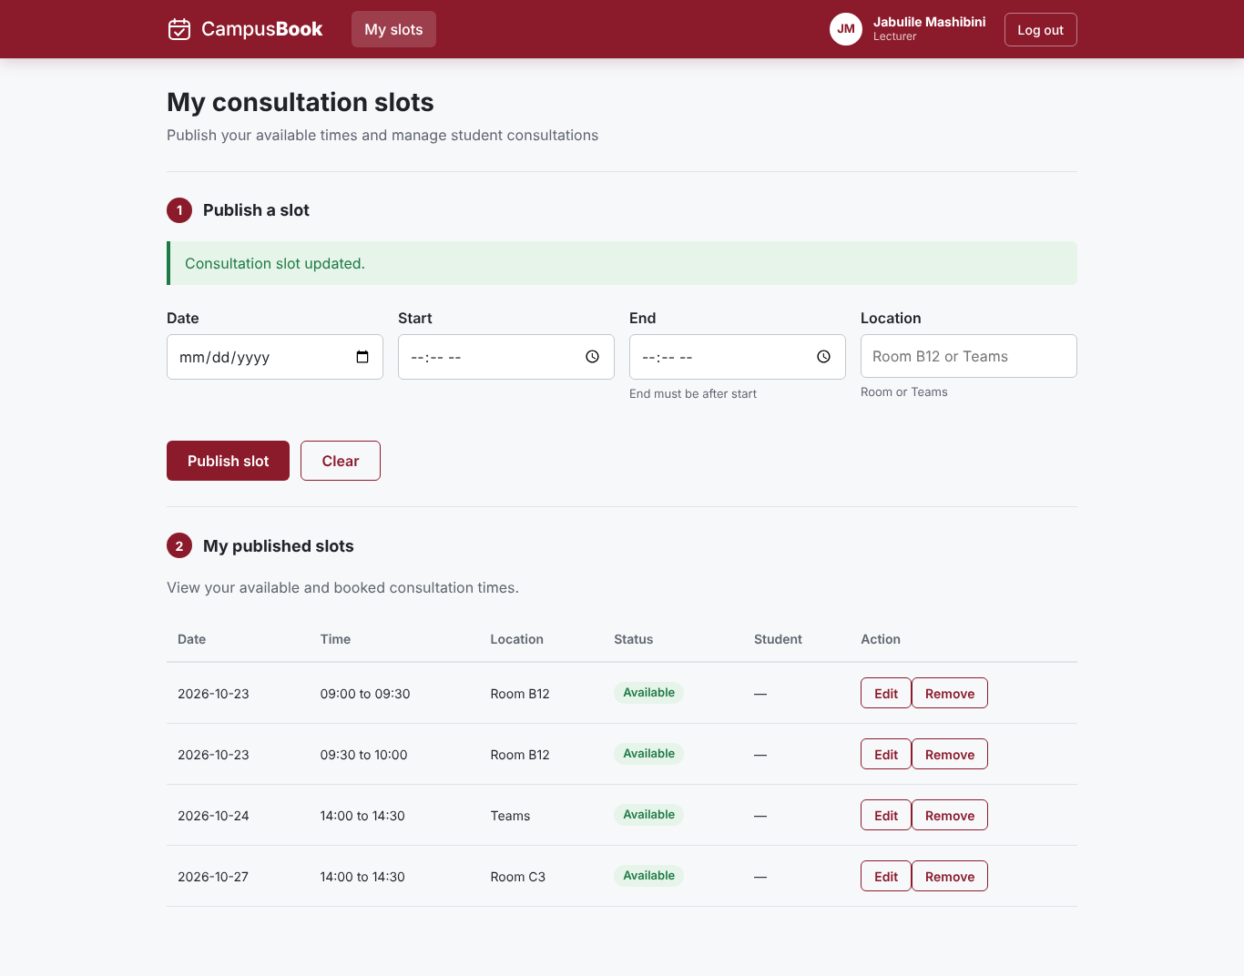
Errors found and fixed
Time display error
Earlier the time buttons only showed the word to and the summary showed undefined to undefined
The time values were missing in the frontend
This was found in testing and fixed
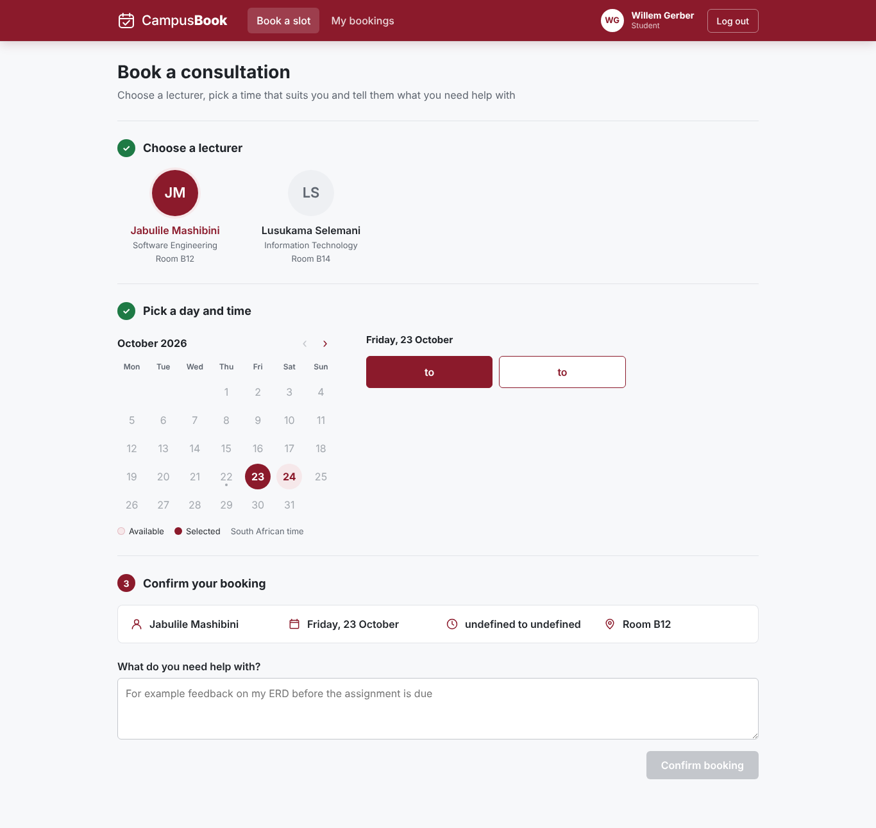
Slot route error
The page showed that the slot route did not exist
The lecturer page still opened but slots could not be loaded or published
This was a backend integration issue and it was corrected
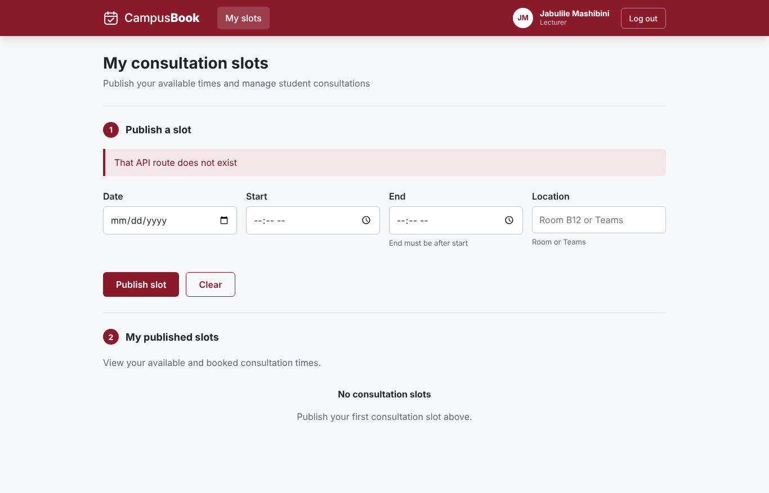
Earlier lecturer page
Lecturer page on mobile before slots
An early phone view with the navigation and a coming soon message before slot management was built
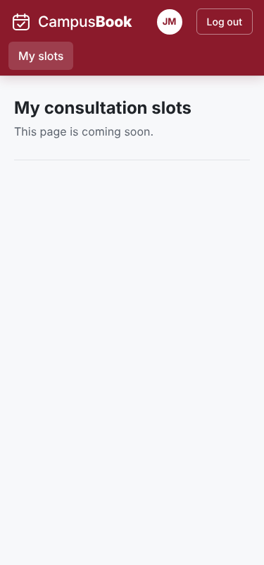
Lecturer page on desktop before slots
An early desktop view with the same coming soon message
It shows the layout before the slot features were added
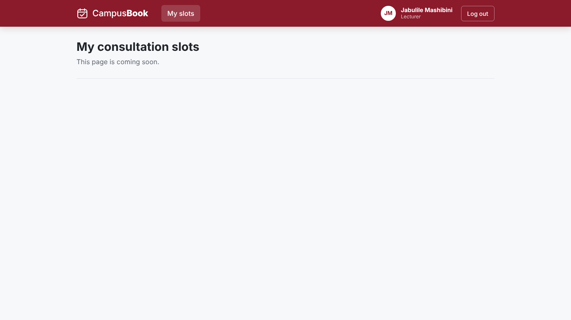
Summary of 4.7
The screenshots show login booking changing bookings and slot management working together between students and lecturers
They also show errors that were found and fixed during development

4.8 Version Control
The source code of CampusBook is kept in one GitHub repository with a main branch that always holds the working version and a branch for each member
Members commit their own work and open a pull request and another member reviews it before it is merged into main
This keeps the history clear and shows who did what
Commit or pull request | Date | Member | What it holds
dcb7cd2 and 092dd77 | 15 Oct | Willem Gerber | Repository and project structure
88460f8 | 19 Oct | Willem Gerber | Back-end folders and schema and seed scripts and diagrams
6f458c7 and pull request #1 | 20 Oct | Willem Gerber | Back-end set up and login and middleware and Bookings API
fe19ea8 and pull request #2 | 21 Oct | Lebohang Tlaitlai | React set up and Login page
5682abf and pull request #3 | 21 Oct | Oscar Khumalo | Database connection and email reminders
590e891 | 21 Oct | Willem Gerber | Booking error handling and Book a slot page
e9b5f3e and pull request #4 | 22 Oct | Lebohang Tlaitlai | Slots API
87cefdb | 22 Oct | Willem Gerber | My bookings page and phone layout
c2ecca1 and pull request #6 | 22 Oct | Thomas du Plessis | Lecturer slots page

The fixes found in testing are applied in a working copy and are committed in a pull request after review

4.9 Chapter Summary
Chapter 4 showed how CampusBook was designed and built
The architecture and the diagrams and the wireframes were turned into a React front end and an Express back end with a MySQL database
All the planned pages work for students and lecturers and the screenshots in 4.7 show them running
Version control with GitHub kept the work of the group clear
Chapter 5 tests the system against the requirements and reports the results

Chapter 5 Testing Results and Evaluation

5.1 Introduction
This chapter shows how CampusBook was tested and what the tests found It checks the working app against the functional and non-functional requirements from Chapter 3
The tests were run on 22 October 2026 on the main branch at commit e9ab578 It contains the login Slots API Bookings API database and email services the Book a slot page the My bookings page and the Lecturer slots page that Tom merged on 22 October The tests found defects so the fixes were made in the working copy and every failed test was run again The results show the retest and the failure before the fix
This chapter includes the student survey results The user testing with students and a lecturer is planned for Week 5 and its results are added in the final version

5.2 Test Strategy
Testing followed the Test Plan in folder 06 Tests were written for every requirement before they were run and each test has an expected result and an actual result in the Test Cases and Results workbook
Table 5.1 Test levels
Level | What was tested | Tool
API tests | Every route with valid and invalid input and wrong roles | Node script
Integration tests | API and database and the reminder job and the email preview | Node script and SQL
Browser tests | Pages and journeys and route protection at 375 and 1366 pixels | Playwright and Chromium
Security checks | Role checks and forged tokens and other users records and password storage | Node script and SQL
Performance checks | Page load and API response times | Browser and script timings

Table 5.2 Test environment
Item | Detail
Application | Branch main at commit e9ab578
Back end and database | Node.js 22 and Express with MariaDB 10.11 built from schema.sql and seed.sql
Front end | React 18 and Vite 5 production build
Browser | Chromium through Playwright at 375 x 800 and 1366 x 768
Test data | Seven made up users on the campusbook.test domain
Email | Preview mode so emails print to the server log

The MariaDB server was used in place of MySQL because it runs the same SQL and the same transactions and row locks A final run on MySQL on the demo laptop is planned in Week 5
The browser tests were run on the production build Every failed test was first run on the merged code to record the defect and then run again after the fix The fixes are in the working copy and are not committed to GitHub yet
Willem Gerber led the testing and ran the tests Each developer checks and retests the defects in their own files
Acceptance criteria
- Every Must requirement has a test with an actual result
- Every failed test has a defect with an owner
- No open defect stops a student from booking a consultation

5.3 Test Cases and Results
36 test cases were written and linked to the requirements in the Requirements Traceability Matrix The full steps test data and actual results are in Group-3_Test_Cases_and_Results.xlsx
Table 5.3 Summary of test results
Result after the fixes | Number of tests
Pass | 35
Fail | 0
Not run (needs real students) | 1
Total | 36

Table 5.4 All test cases and results
Test | Requirement | What was tested | Result
TC-01 | FR-01 | Login | Pass
TC-02 | FR-02 | Role checks on the server | Pass
TC-03 | FR-03 | Lecturer manages own slots | Pass
TC-04 | FR-04 | Student views open slots | Pass
TC-05 | FR-05 | Book a slot | Pass
TC-06 | FR-06 | Change and cancel a booking | Pass
TC-07 | FR-07 | No double booking | Pass
TC-08a | FR-08 | Confirmation email | Pass
TC-08b | FR-08 | Reminder email | Pass
TC-09 | FR-09 | Booking history | Pass
TC-10 | NFR-01 | First time student books in under 2 minutes | Not Run
TC-11 | NFR-02 | Main pages load in under 3 seconds | Pass
TC-12 | NFR-03 | Phone and laptop layout | Pass
TC-13 | NFR-04 | Passwords stored as bcrypt hashes | Pass
TC-14 | NFR-05 | Users cannot reach other records | Pass
TC-15 | NFR-06 | Only needed data is stored | Pass
TC-16 | NFR-07 | Errors explain what to fix (API) | Pass
TC-16b | NFR-07 | Errors on screen and kept input | Pass
TC-17 | FR-05 | Book a missing past or taken slot | Pass
TC-18 | FR-03 | Slot validation rules | Pass
TC-19 | FR-03 | Booked slot cannot be edited or removed | Pass
TC-20 | FR-03 | Removing a slot keeps history | Pass
TC-21 | FR-02 | Bad ids bad JSON and unknown routes | Pass
TC-22 | FR-01 | Forged expired and garbage tokens | Pass
TC-23 | NFR-02 | Health check | Pass
TC-24 | NFR-02 | API response time for the slot list | Pass
TC-25 | FR-03 and FR-09 | Lecturer publishes a slot from the page | Pass
TC-26 | FR-08 | Reminder not sent for a cancelled booking | Pass
TC-27 | FR-02 | Pages protected by login and role | Pass
TC-28 | NFR-07 | Expired or invalid session | Pass
TC-29 | FR-06 | Change a booking from the page | Pass
TC-30 | Security (extra) | Repeated wrong passwords are limited | Pass
TC-31 | FR-07 | Database refuses a second confirmed booking | Pass
TC-32 | FR-04 | Times shown on the Book a slot page | Pass
TC-33 | FR-03 | Lecturer removes a slot from the page | Pass
TC-34 | FR-03 | Lecturer edits a slot from the page | Pass

Key results
- Double booking (TC-07) Eight booking requests for one slot were sent at the same moment from three students One booking was created and the other seven were refused with the message Sorry that slot is no longer available The database also refuses a second confirmed booking on its own (TC-31)
- Access control (TC-02 and TC-14) Wrong roles get 403 and missing tokens get 401 and a student cannot cancel or change another students booking
- Emails (TC-08a and TC-08b) The confirmation goes to the student and the lecturer and a due reminder is sent and marked sent A cancelled booking leaves no reminder to send (TC-26)
- Passwords (TC-13) All seven stored passwords are 60 character bcrypt hashes
- Slot rules (TC-18 to TC-20) Bad times and past dates and overlaps are refused and a booked slot cannot be edited or removed and removing a slot keeps its booking history
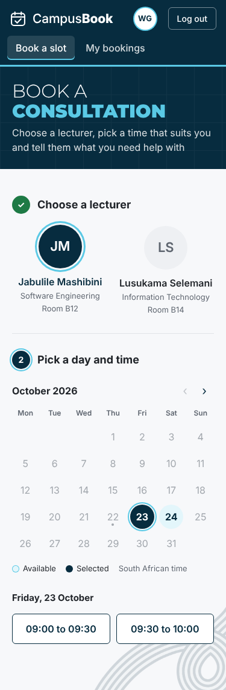  Book a slot on a phone | 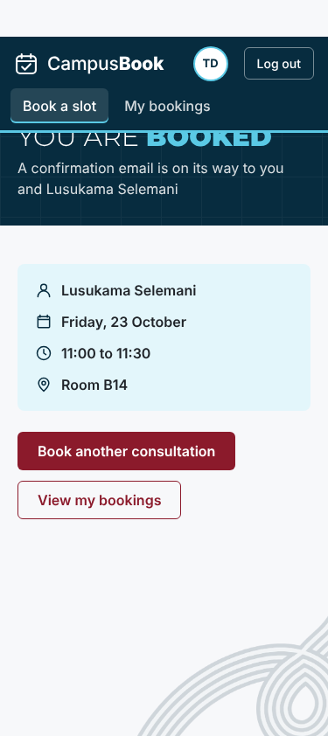  Booking confirmed on a phone | 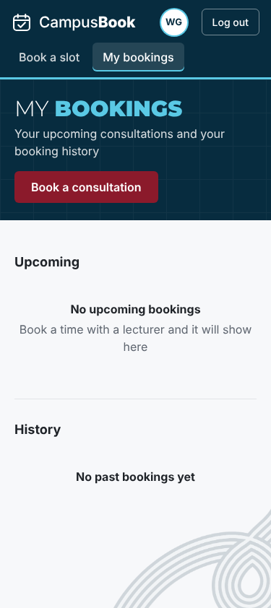  My bookings on a phone
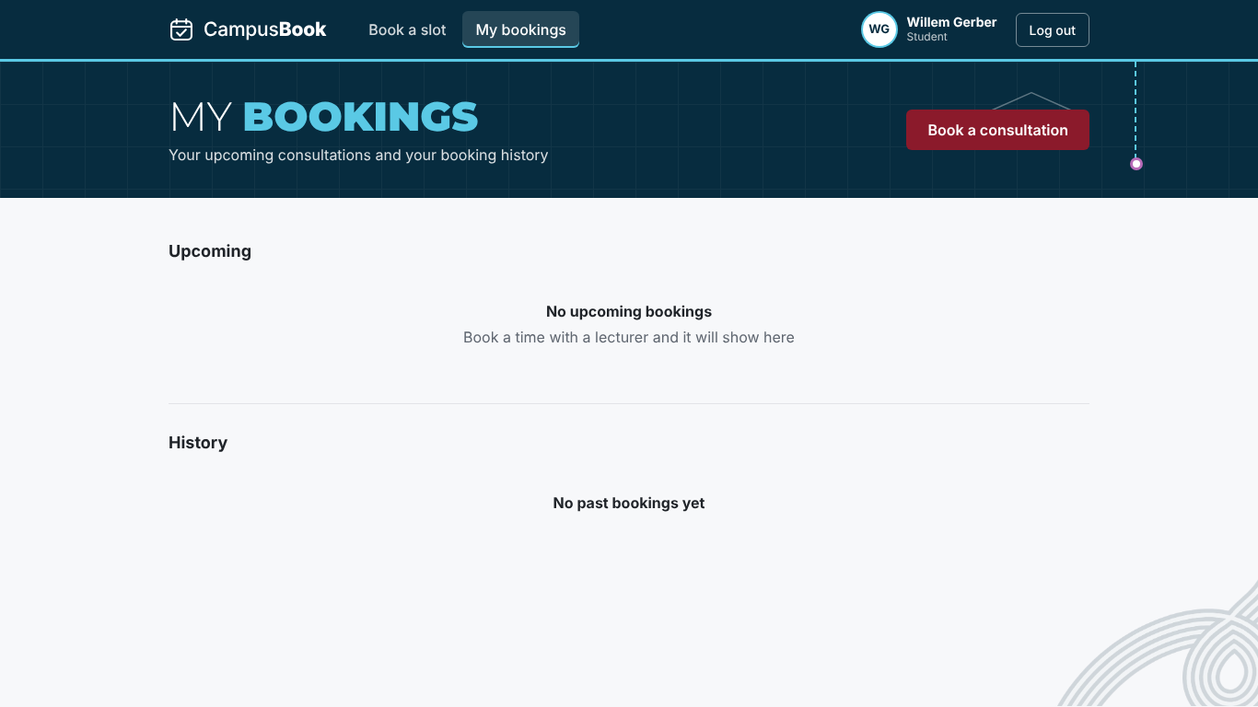

5.4 Defects and Corrections
On the merged code 6 tests failed and one was blocked and every failure is logged in Group-3_Defect_Log.xlsx 10 defects were logged in total 1 was fixed earlier 9 are fixed in the working copy and passed the retest and 0 are open Tables 5.3 and 5.4 show the results after the fixes
Table 5.5 Defect summary
ID | Feature | Defect | Severity | Status
D-01 | Bookings API and My bookings | Booking dates came back as time zone shifted dates because the raw slot_date was returned so a booking could show on the wrong day | High | Closed
D-02 | Book a slot page | Time buttons show only "to" and the confirm panel shows "undefined to undefined" because the page reads start and end but the Slots API sends startTime and endTime | High | Fixed
D-03 | Lecturer slots page | The merged page does not work with the Slots API: it calls /api/slots/my but the route is /api/slots/mine so the list shows That API route does not exist and it sends start and end but the API needs startTime and endTime so publishing fails (FR-03 and FR-09) | High | Fixed
D-04 | My bookings page | No change button although the API supports changing a booking (FR-06) | Medium | Fixed
D-05 | Session handling | An expired or invalid token leaves the user on the page with an error and the old token is kept instead of going to the login page | Medium | Fixed
D-06 | Login security | There is no limit on repeated wrong passwords so 40 attempts in a row were all answered | Medium | Fixed
D-07 | Documentation | Chapter 4 says the reminder scheduler runs every 15 minutes but the code runs it every minute | Low | Fixed
D-08 | Book a slot page | After a failed booking the reason box is hidden until a time is chosen again although the typed text is kept | Low | Fixed
D-10 | Lecturer slots page | The page can publish and remove slots but has no way to edit a slot although the API supports editing (FR-03) | Medium | Fixed
D-09 | Route protection | A logged in user who opens the other roles page is sent to the login page and not to their own home page | Low | Fixed

D-01 Booking dates shifted by the time zone (closed)
While building My bookings the dates of some bookings were one day out The query returned the raw database date and the server turned it into a date with a time zone so the day could move The query now returns the date as text with DATE_FORMAT (commit 87cefdb) The retest shows the same date that is stored in the database (TC-05 and TC-09)
D-02 Missing times on the Book a slot page (fixed)
The browser test showed time buttons that only said to and a confirm panel that said undefined to undefined The Book a slot page reads start and end but the Slots API sends startTime and endTime so the page had nothing to show The booking itself still worked The fix maps the two names when the slots are loaded and is three lines in BookSlot.jsx With the fix the buttons show 09:00 to 09:30 and 09:30 to 10:00 The retest passed
Before the fix | 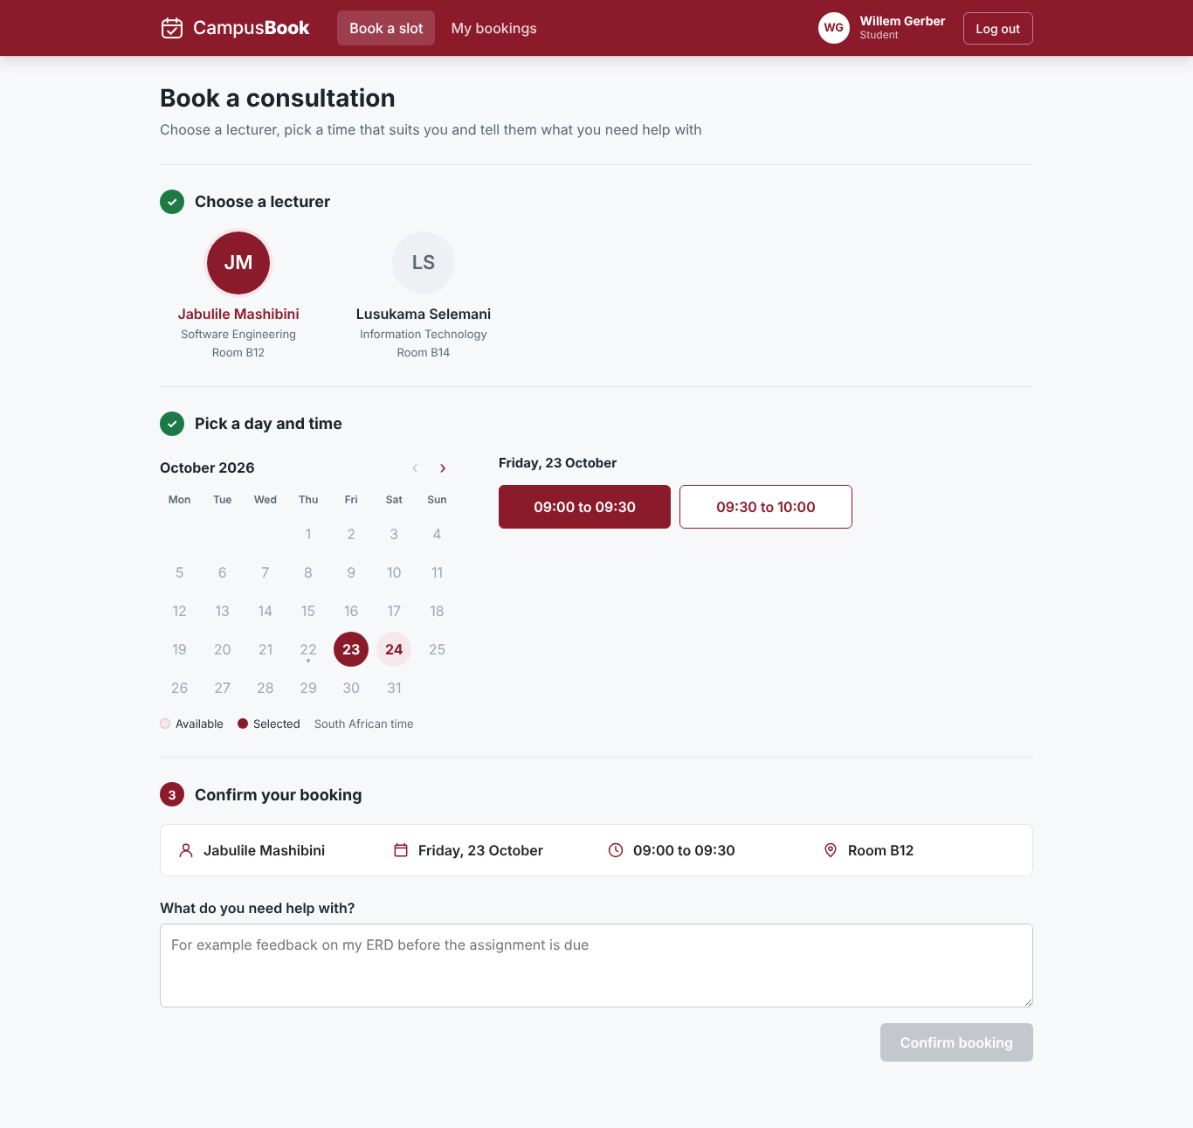  After the fix
D-03 Lecturer slots page does not work with the Slots API (fixed)
Thomas merged the Lecturer slots page on 22 October When it was tested the page showed That API route does not exist because it asks for /api/slots/my and the route is /api/slots/mine Publishing a slot failed with Enter a valid start time because the page sends start and end and the API needs startTime and endTime Nothing was saved The fix is four lines in LecturerSlots.jsx With the fix the page lists the slots and publishing and removing a slot both work The retest passed and an Edit button was also added for D-10
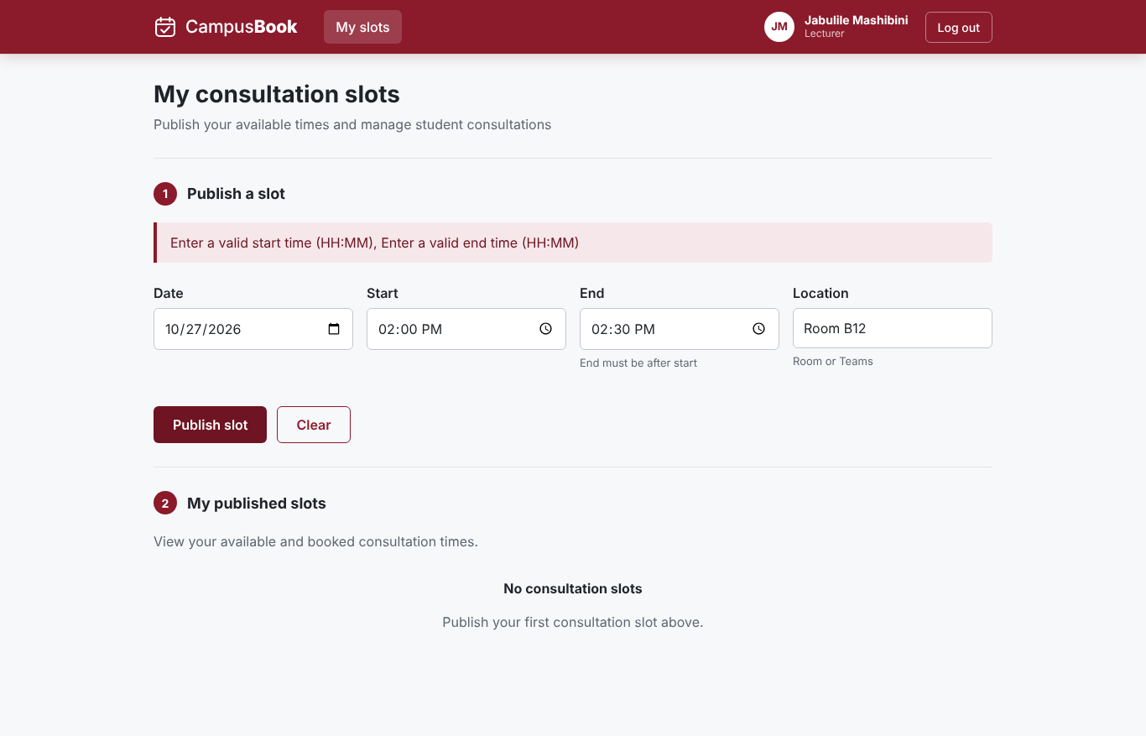  Merged code | 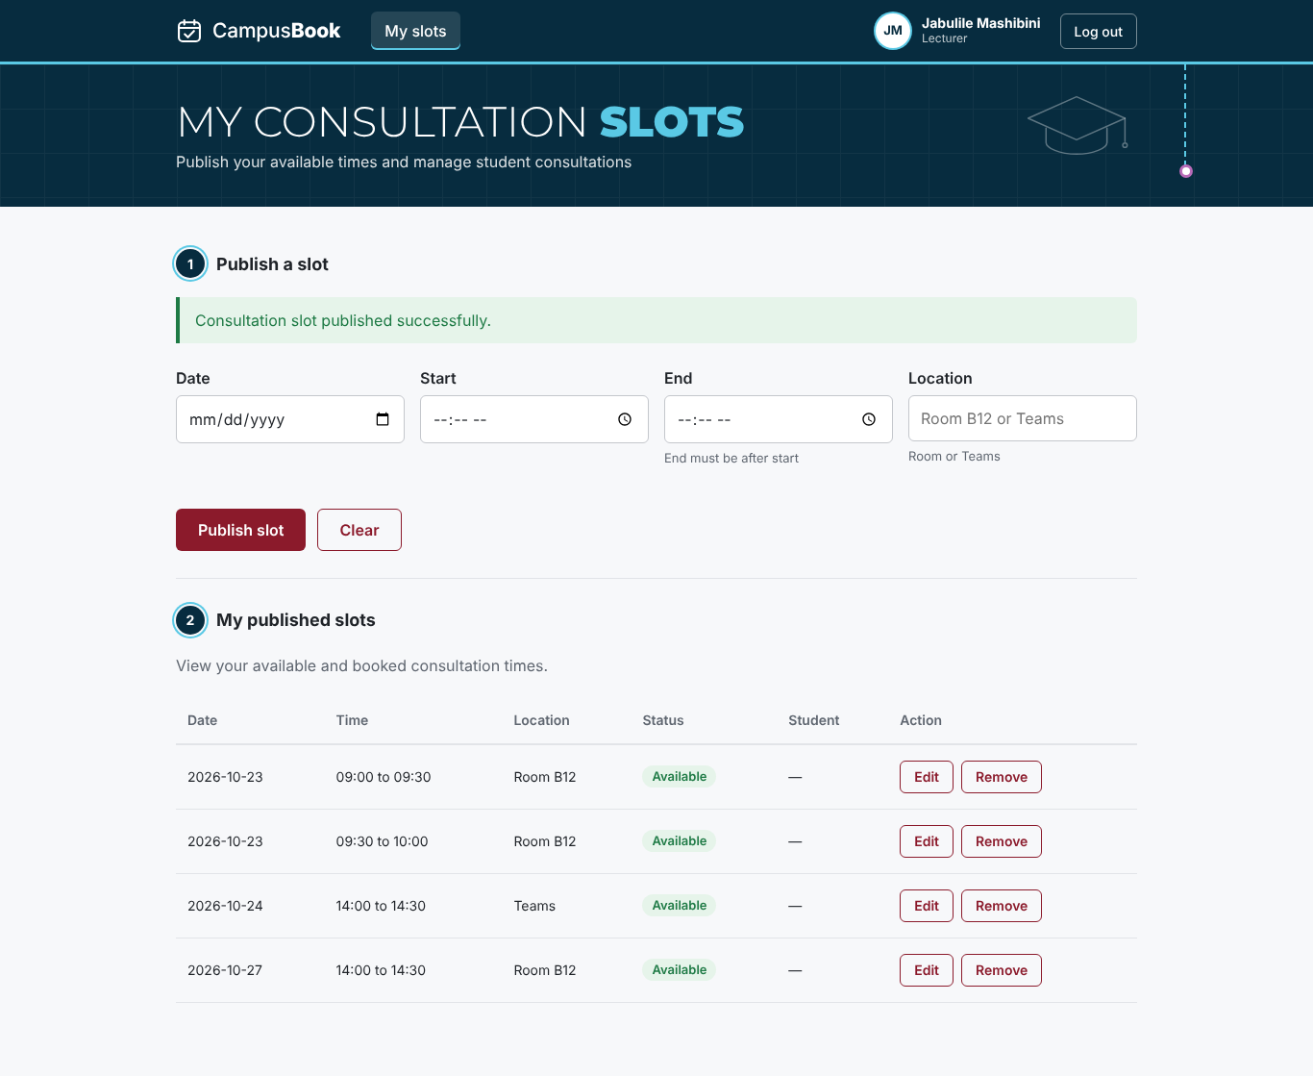  With the fix
D-04 to D-10 other defects (fixed)
- D-04 My bookings had no change button so a Change time button was added that lists the other open times of that lecturer and moves the booking (TC-29)
- D-05 An expired session stayed on the page so the app now clears the login and shows the login page with the message Your session has ended (TC-28)
- D-06 Repeated wrong passwords were not limited so the login now answers 429 after 10 wrong passwords in 15 minutes and other accounts are not affected (TC-30)
- D-08 The reason box was hidden after a failed booking so the confirm step now stays on screen unless the slot was taken (TC-16b)
- D-09 A user opening the other roles page was sent to the login page so they now go to their own home page (TC-27)
- D-10 The Lecturer slots page had no edit option so an Edit button was added (TC-34)
- D-07 The Chapter 4 text said the reminder job runs every 15 minutes but the code runs it every minute so the text now says every minute The architecture diagram label should be checked in the final dissertation
Open defects
- No defects are open The fixes are in the working copy and must be committed and pushed so that the GitHub version matches this chapter
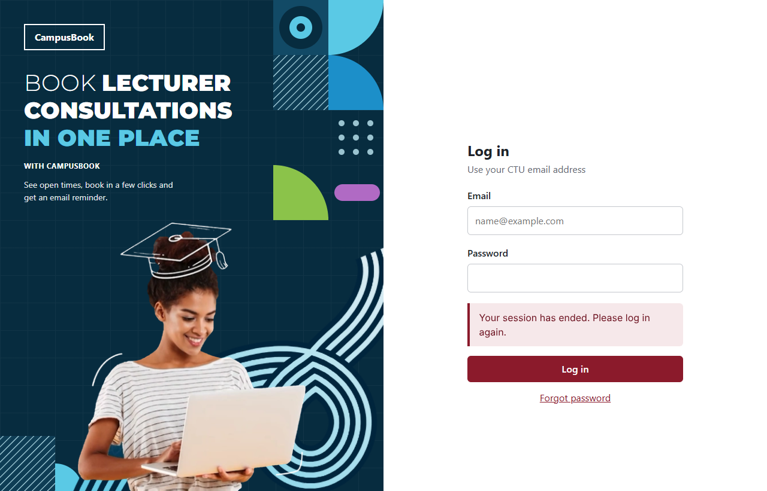

5.5 Performance / Usability Evaluation
Table 5.6 Performance and layout measurements (NFR-02 and NFR-03 and NFR-01)
Check | Target | Measured | Result
Login page load (phone and laptop) | Under 3000 ms | 78 ms and 78 ms | Pass
Book page after login | Under 3000 ms | 248 ms and 220 ms | Pass
My bookings page | Under 3000 ms | 380 ms and 372 ms | Pass
API slot list over 20 requests | Under 500 ms | Median 5 ms and slowest 8 ms | Pass
Sideways scrolling at 375 and 1366 pixels | None on every page | None on all 5 pages tested | Pass
Scripted booking journey on a phone | Under 120 seconds | 1.8 seconds | Indicative only

The times were measured on the team test set up with the API and the database on the same machine so they leave out the network delay of a real campus connection They show that the pages themselves are light The built page script is about 239 kB
The scripted journey shows that the booking flow has few steps and no waiting The real answer for NFR-01 needs first time students and a stopwatch so the timed test is part of the Week 5 user testing
Usability check against the ten heuristics (Nielsen 1994)
Table 5.7 Heuristic check
Heuristic | Evidence from the app
Visibility of system status | A confirmation page after booking and a success notice after cancelling and the booking steps are numbered
Match with the real world | Plain words such as Book a consultation and Cancel booking and dates written out in full
User control and freedom | Cancelling asks for a second click with Keep it and Yes cancel
Error prevention | The confirm button stays disabled until a reason is typed and booked slots cannot be picked
Help users recover from errors | Messages say what to fix such as Enter a valid email address and Sorry that slot is no longer available
Consistency | One theme and the same buttons and alerts on every page
Problems found and fixed | No change button (D-04) and a hidden reason box after an error (D-08) and no redirect on an expired session (D-05)

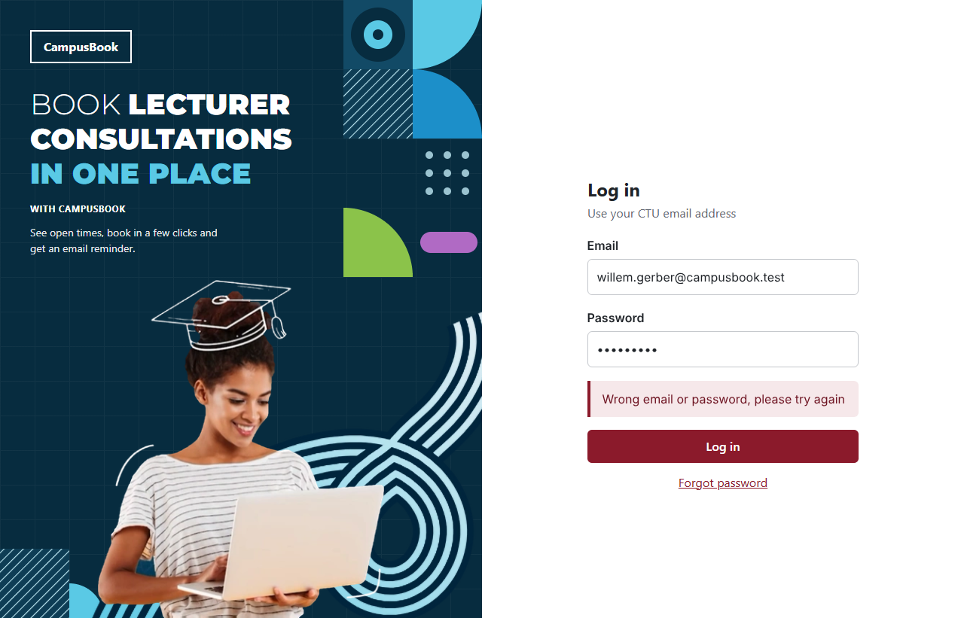  Login error with the email kept | 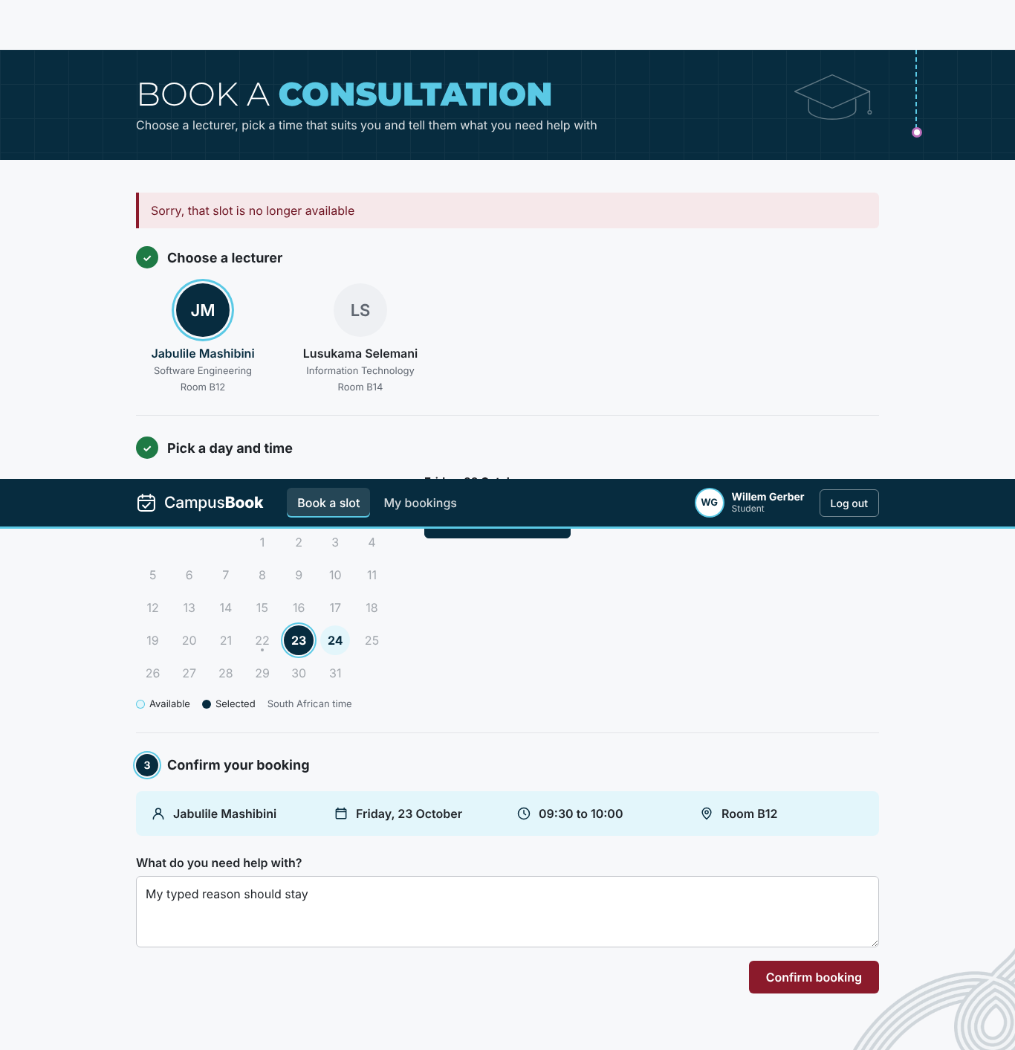  Slot taken message

5.6 Requirements Evaluation
Table 5.8 compares the app at commit e9ab578 with each requirement from Chapter 3 This is the result after the fixes Met means the tests passed and Partially Met means part of the requirement still needs work
Table 5.8 Requirements evaluation
ID | Requirement | Result | Notes
FR-01 | Students and lecturers log in with their email and password | Met | Login works for both roles and bad details give one general error
FR-02 | The system checks the user role so students and lecturers only reach their own pages and actions | Met | Role checks on every route and page
FR-03 | Lecturers publish edit and remove their own future consultation slots | Met | API and page work. Slots are published and edited and removed from the page after the D-03 and D-10 fixes
FR-04 | Students view the open slots of a chosen lecturer | Met | Slots listed correctly and the times show after the D-02 fix
FR-05 | Students book an open slot and give a short reason for the visit | Met | Booking saved and confirmation shown
FR-06 | Students change or cancel their own upcoming bookings | Met | Cancel and change both work in the page after the D-04 fix
FR-07 | The system stops two students booking the same slot | Met | 8 simultaneous requests gave one booking
FR-08 | The system sends an email confirmation after booking and a reminder before the meeting | Met | Confirmation and reminder work in preview mode. Real SMTP delivery is still to be tested on the demo laptop
FR-09 | Students see their own booking history and lecturers see the bookings for their slots | Met | Student page and lecturer page both show the bookings after the D-03 fix
NFR-01 | A first-time student completes a booking in under 2 minutes | Partially Met | Scripted journey took 1.8 seconds. The timed test with students is planned for Week 5
NFR-02 | The main pages load within 3 seconds in the team test set up | Met | Slowest page load was 389 ms and slowest API call 19 ms
NFR-03 | Every page works on a phone at 375 pixels wide and on a laptop at 1366 pixels wide | Met | No sideways scrolling on all five pages at both widths
NFR-04 | Passwords are stored as bcrypt hashes and never as plain text | Met | All 7 stored passwords are bcrypt hashes and repeated wrong passwords are limited after the D-06 fix
NFR-05 | Each user can only see their own bookings or the bookings for their own slots | Met | Other users records were refused in every test
NFR-06 | Only the data needed for logging in and booking is stored with made-up data during development | Met | Five tables and no sensitive columns and all users on the test domain
NFR-07 | Errors explain what to fix and the form keeps what the user already typed | Met | Plain messages and typed text kept and a clear message when the session ends after the D-05 and D-08 fixes

9 of the 9 functional requirements and 6 of the 7 non-functional requirements are fully met and none are unmet
The only requirement that is not fully met is NFR-01 because the timed test with first time students is planned for Week 5 FR-08 was tested with the email preview and real email delivery is tested on the demo laptop in Week 5

5.7 User / Stakeholder Feedback
The student survey was answered by 13 students on 22 October 2026 The survey was anonymous and the raw answers are in Group-3_Survey_Responses.xlsx in folder 06 The target of at least 10 students was met
Table 5.9 Student survey results (13 students)
Question | Result
Needed to meet a lecturer in the last 3 months | 11 of 13 needed to at least once (10 said 1 to 2 times and 1 said 3 to 5 times)
How they arrange a consultation now | Teams 11 and asking in class 5 and going to the office 3 and WhatsApp 2
How easy it is now (1 hard to 5 easy) | Average 3.2 and 4 of 13 gave 1 or 2
Gave up on a consultation because of the problems | 7 of 13 said yes
Time from first asking to a confirmed time | 1 to 2 days for 10 of 13 and the same day for 3
Hardest time to get a consultation | Before tests 8 and before assignment deadlines 6 and normal weeks 3 and always hard 1
Device they would use to book | Phone 7 and laptop 6
Would use an online booking system (1 to 5) | Average 4.2 and 9 of 13 gave 4 or 5

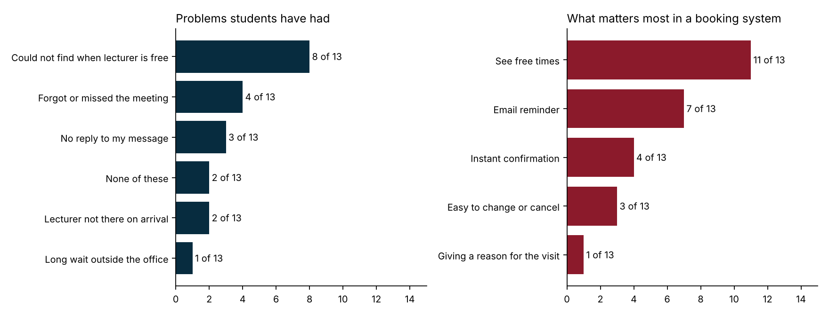
What the survey means for CampusBook
- The biggest problem is not knowing when a lecturer is free (8 of 13) and the most wanted feature is seeing free times (11 of 13) This is what the Book a slot page does
- Email reminders were chosen by 7 of 13 and 4 students had forgotten or missed a meeting so the reminder job (FR-08) answers a real need
- Instant confirmation was chosen by 4 and changing or cancelling by 3 which supports the confirmation email and the Change time and Cancel booking buttons
- Phone and laptop were almost equal (7 and 6) which supports testing both at 375 and 1366 pixels wide (NFR-03)
- Pressure is highest before tests and assignment deadlines so the demo and the user testing should use busy times as the example
The survey has limits It has 13 answers from one campus so it shows what these students said and not all students No lecturers answered it and the lecturer feedback is still to be collected during the user testing in Week 5
Table 5.10 Feedback sources
Feedback source | What it will show | When
Student survey (13 answers) | Current problems and what students want | Done and shown above
User testing with students and a lecturer | Time to complete a booking and problems seen and comments | Week 5 (by Monday 26 October)
Supervisor feedback on this chapter | Corrections to the tests and the chapter | After the Week 4 submission

5.8 Chapter Summary
The tests show that the booking journey works from login to confirmation on a phone and a laptop and that two students can never hold the same slot 35 of 36 tests pass after the fixes and the one test not run needs real students
Testing found real problems at the joins between the pages and the API The Lecturer slots page and the Book a slot page did not read the Slots API correctly and My bookings had no change button These and the other defects are fixed in the working copy and each fix was retested The fixes must be committed and pushed and the tests run once more on the GitHub version before the final submission on 29 October
The student survey (13 answers) supports the need for the system and the features chosen User testing results will complete this chapter in Week 5

Chapter 6 Conclusion and Recommendations (Outline)

6.1 Introduction
This chapter closes the dissertation It will say what CampusBook set out to do and what was found and what should happen next
This outline lists what each section will contain and which evidence it will use
The full chapter is written in Week 5 once the user testing is finished

6.2 Answers to the Research Questions
Each of the five research questions from Chapter 1 gets a short answer with the evidence behind it
Research question | What the answer will say | Evidence
1 How are consultations arranged now and what problems do students face | Requests are spread across email Teams WhatsApp and walk ins and the 13 student answers show the problems that matter most | Chapter 1 and Chapter 5 section 5.7 and Survey_Responses.xlsx
2 What do existing systems offer and what do they lack for a campus | The compared systems cover booking but not a simple CTU setup with roles and email reminders in one place | Chapter 2 and the Literature Review Matrix
3 How can a web system let students book and lecturers manage time | CampusBook has six must have features working for students and lecturers on a phone and a laptop | Chapter 4 sections 4.5 to 4.7
4 Does the system meet its requirements | 35 of 36 tests pass and all must have requirements are Met except the timed test with first time students that waits for Week 5 | Chapter 5 and the Test Cases and Defect Log and Traceability Matrix
5 Do students and lecturers find it easy and useful | To be answered from the user testing with students and a lecturer in Week 5 | User testing notes and ratings (Week 5)

6.3 Objectives Evaluated
Objective from Chapter 1 | Result so far | Still to add
1 Survey of at least 10 students by 21 October | Met with 13 answers on 22 October | Nothing
2 Compare at least three existing systems by 19 October | Met in Chapter 2 | Nothing
3 Build all six must have features on a live database by 23 October | Met with all 8 coding tasks merged (Lecturer slots page merged on 22 October) | Nothing
4 Every must have test case passes and a booking takes under 2 minutes and pages load within 3 seconds | 35 of 36 tests pass and the scripted booking took 1.8 seconds | Timed test with first time students
5 Evaluate with at least 5 students and 1 lecturer and 80 percent rating it easy | Not done yet | User testing in Week 5 with 5 students and 1 lecturer

6.4 What Worked and What Did Not
This section will be short and honest
- What worked - the shared page template and the pull request reviews and the task sign up sheet and fixing defects found by the browser tests the same day
- What did not - the Lecturer slots page was merged late and did not match the Slots API so ten defects were logged and fixed - two tasks were picked by more members than needed and one member had no commits
- What we would change - agree the API field names before coding and test every merged page the same day

6.5 Limitations
- One campus and one group of 13 student survey answers and no lecturer answered the survey
- Tests ran on MariaDB with test data and the real email delivery needs checking on the demo laptop
- The timed test with first time students is only done in Week 5
- No admin dashboard and no video calls and no SMS (out of scope in Chapter 1)

6.6 Recommendations and Future Work
- Give CTU a pilot with one department and collect real booking numbers
- Add an admin view and calendar sync and SMS reminders
- Add automated tests to the build so every pull request is checked
- Move the app to a hosted server with a real email service and HTTPS

6.7 Conclusion
The final paragraph will say that CampusBook solves the consultation booking problem for CTU students and lecturers in the tested setting and that the Week 5 user testing confirms how easy it is to use

6.8 Chapter Summary
This chapter answers the research questions and checks the objectives and gives the limits and next steps of the project
It ends the dissertation

Appendix A Test Plan

1. Test Objectives
The test plan shows that CampusBook meets the nine functional and seven non-functional requirements in the SRS and that the must have features work together on a phone and a laptop
- Show that a student can log in book change and cancel a consultation and that a lecturer can manage slots
- Show that two students can never hold the same slot even when they book at the same moment
- Show that users only reach their own data and that passwords are stored safely
- Show that the main pages load in under 3 seconds and work at 375 and 1366 pixels wide
- Find defects early and record each one in the Defect Log until it is fixed and retested
- Show that every requirement is linked to at least one test in the Requirements Traceability Matrix

2. Scope
Included
- Back-end API routes for login slots and bookings (routes/auth.js slots.js and bookings.js)
- Role and token checks (middleware/auth.js) and input checks (middleware/validate.js)
- Confirmation and reminder emails (services/mailer.js and jobs/reminders.js)
- Database rules in schema.sql including the unique key that blocks double booking
- Front-end pages Login and Book a slot and My bookings and the Lecturer slots page and route protection
- Phone and laptop layouts and page load times
Not included in this round
- Real email delivery through an SMTP service (emails are checked in the preview mode)
- Timed tests and feedback with real students and a lecturer (planned for Week 5 user testing)
- Load testing with many users and testing on a real phone (the phone size is tested in the browser)

3. Test Environment
Item | Detail
Application version | Branch main at commit e9ab578 on 22 October 2026 and again after the fixes for D-02 to D-10 in the working copy
Back end | Node.js 22 with Express and mysql2 on port 4100
Database | MariaDB 10.11 (MySQL compatible) built from database/schema.sql and seed.sql
Front end | React 18 and Vite 5 production build served by vite preview
Browser and sizes | Chromium driven by Playwright at 375 x 800 (phone) and 1366 x 768 (laptop)
Test data | Seven made up users on the campusbook.test domain and five seeded slots (password CampusBook123)
Email | Preview mode with no SMTP host so emails print to the server log
Test scripts | test_scripts/api_tests.js and test_scripts/ui_tests.js in folder 06

The two scripts are kept in folder 06 as the record of what was run

4. Test Types
Test type | What it covers | Tool
Unit and API | Every route with valid and invalid input and wrong roles | Node script calling the API
Integration | API with database and emails and the reminder job | Node script and SQL checks
System and UI | Full journeys in the browser and route protection | Playwright with Chromium
Security | Role checks and forged tokens and access to other records and password storage | Node script and SQL checks
Performance | Page load times and API response times | Browser and script timings
Usability | Phone and laptop layouts and error messages and a scripted journey | Playwright and a heuristic check
Acceptance | User testing with real students and a lecturer | Planned for Week 5

5. Entry and Exit Criteria
Entry criteria
- Code for the feature is merged into main
- The database builds cleanly from the two SQL scripts
- The API starts and the health check answers
Exit criteria
- Every Must requirement has at least one test with an actual result
- Every failed test has a defect in the Defect Log
- No open defect stops the main booking journey
- Open defects have an owner and a plan before the final submission

6. Roles and Responsibilities
Member | Testing role
Willem Gerber | Test lead and Group Lead. Wrote the Test Plan and test cases and ran the tests and kept the Defect Log and the Traceability Matrix
Oscar Khumalo | Checks and retests fixes for the database connection and the email and reminder services
Lebohang Tlaitlai | Checks and retests fixes for the Slots API and the Login page and the student survey
Thomas du Plessis | Builds and retests the Lecturer slots page
Gerhardus van den Berg | Checks the schema and the test data

7. Defect Management
Each failed test becomes a row in the Defect Log with a date and the feature and a description and a severity and a priority and the owner
Severity | Meaning
Critical | The app stops or data is lost or another users data is exposed
High | A Must feature does not work or is missing
Medium | A feature works but with a clear problem or a missing part
Low | A small usability or wording problem

The status moves from Open to In Progress to Fixed to Retest to Closed The developer who owns the file fixes the defect then the test is run again and the result is written in the Retest Result column
Priority follows the demo plan so anything that breaks the booking journey is fixed first

Appendix B Test Results
Test cases and results
Test ID | Feature | Expected Result | Status
TC-01 | Login | Valid logins return a token and role. Wrong password and unknown email give the same general error | Pass
TC-02 | Role checks on the server | Wrong role gets 403 and no token gets 401 | Pass
TC-03 | Lecturer manages own slots | Owner can publish edit and remove. Another lecturer gets 404 | Pass
TC-04 | Student views open slots | Only future slots with status open are listed | Pass
TC-05 | Book a slot | Booking saved with student slot and reason and the slot becomes booked | Pass
TC-06 | Change and cancel a booking | Old slot opens after a change and after a cancel. Second cancel is refused | Pass
TC-07 | No double booking | Exactly one confirmed booking and the rest get the slot taken message | Pass
TC-08a | Confirmation email | Confirmation to the student and a notice to the lecturer and the confirmation is marked sent | Pass
TC-08b | Reminder email | Reminder sent to student and lecturer and marked sent | Pass
TC-09 | Booking history | Each user sees only their own records and cancelled bookings stay in the history | Pass
TC-10 | First time student books in under 2 minutes | Under 120 seconds with real students | Not Run
TC-11 | Main pages load in under 3 seconds | Each page loads in under 3000 ms | Pass
TC-12 | Phone and laptop layout | No sideways scrolling on any page | Pass
TC-13 | Passwords stored as bcrypt hashes | Only 60 character bcrypt hashes and login uses bcrypt compare | Pass
TC-14 | Users cannot reach other records | All refused with 404 and nothing changes | Pass
TC-15 | Only needed data is stored | No sensitive columns and every user is on the test email domain | Pass
TC-16 | Errors explain what to fix (API) | 400 with a plain message and nothing saved | Pass
TC-16b | Errors on screen and kept input | Plain messages and the typed text is kept | Pass
TC-17 | Book a missing past or taken slot | 409 with Sorry that slot is no longer available | Pass
TC-18 | Slot validation rules | Refused with a message that says what to fix | Pass
TC-19 | Booked slot cannot be edited or removed | 409 for both | Pass
TC-20 | Removing a slot keeps history | Slot marked cancelled and history kept and publishing again reopens it | Pass
TC-21 | Bad ids bad JSON and unknown routes | 400 or 404 with a clear message and no server error | Pass
TC-22 | Forged expired and garbage tokens | All refused with 401 | Pass
TC-23 | Health check | 200 and ok true | Pass
TC-24 | API response time for the slot list | Under 500 ms for every request | Pass
TC-25 | Lecturer publishes a slot from the page | The page lists the lecturer slots and publishing saves the slot | Pass
TC-26 | Reminder not sent for a cancelled booking | No reminder left to send | Pass
TC-27 | Pages protected by login and role | Visitors go to login and each role is sent to their own home page | Pass
TC-28 | Expired or invalid session | User is sent to the login page with a clear message | Pass
TC-29 | Change a booking from the page | A change button is offered next to cancel and moving the booking works | Pass
TC-30 | Repeated wrong passwords are limited | The attempts are blocked after several failures and other accounts are not affected | Pass
TC-31 | Database refuses a second confirmed booking | Insert fails with a duplicate key error | Pass
TC-32 | Times shown on the Book a slot page | Each time button shows the start and end like 09:00 to 09:30 | Pass
TC-33 | Lecturer removes a slot from the page | The slot is removed and the list updates | Pass
TC-34 | Lecturer edits a slot from the page | The page offers an edit option and the change is saved | Pass

Defect Log
Defect ID | Feature | Description | Severity | Status | Retest Result
D-01 | Bookings API and My bookings | Booking dates came back as time zone shifted dates because the raw slot_date was returned so a booking could show on the wrong day | High | Closed | Pass: dates match the stored dates (TC-05 and TC-09)
D-02 | Book a slot page | Time buttons show only "to" and the confirm panel shows "undefined to undefined" because the page reads start and end but the Slots API sends startTime and endTime | High | Fixed | Pass: 09:00 to 09:30 and 09:30 to 10:00 (TC-32)
D-03 | Lecturer slots page | The merged page does not work with the Slots API: it calls /api/slots/my but the route is /api/slots/mine so the list shows That API route does not exist and it sends start and end but the API needs startTime and endTime so publishing fails (FR-03 and FR-09) | High | Fixed | Pass: the list shows the slots and publish and remove both work (TC-25 and TC-33)
D-04 | My bookings page | No change button although the API supports changing a booking (FR-06) | Medium | Fixed | Pass: the booking moved and the notice showed (TC-29)
D-05 | Session handling | An expired or invalid token leaves the user on the page with an error and the old token is kept instead of going to the login page | Medium | Fixed | Pass (TC-28)
D-06 | Login security | There is no limit on repeated wrong passwords so 40 attempts in a row were all answered | Medium | Fixed | Pass: attempts 11 and 12 gave 429 and another account still logged in (TC-30)
D-07 | Documentation | Chapter 4 says the reminder scheduler runs every 15 minutes but the code runs it every minute | Low | Fixed | Pass: the text matches jobs/reminders.js
D-08 | Book a slot page | After a failed booking the reason box is hidden until a time is chosen again although the typed text is kept | Low | Fixed | Pass (TC-16b)
D-10 | Lecturer slots page | The page can publish and remove slots but has no way to edit a slot although the API supports editing (FR-03) | Medium | Fixed | Pass: the new location was saved (TC-34)
D-09 | Route protection | A logged in user who opens the other roles page is sent to the login page and not to their own home page | Low | Fixed | Pass (TC-27)

Requirements Traceability Matrix
Requirement ID | Requirement Description | Type | Priority | Test Case ID | Final Status
FR-01 | Students and lecturers log in with their email and password | Functional | Must | TC-01 and TC-22 | Met
FR-02 | The system checks the user role so students and lecturers only reach their own pages and actions | Functional | Must | TC-02 and TC-21 and TC-27 | Met
FR-03 | Lecturers publish edit and remove their own future consultation slots | Functional | Must | TC-03 and TC-18 and TC-19 and TC-20 and TC-25 and TC-33 and TC-34 | Met
FR-04 | Students view the open slots of a chosen lecturer | Functional | Must | TC-04 and TC-32 | Met
FR-05 | Students book an open slot and give a short reason for the visit | Functional | Must | TC-05 and TC-17 | Met
FR-06 | Students change or cancel their own upcoming bookings | Functional | Must | TC-06 and TC-29 | Met
FR-07 | The system stops two students booking the same slot | Functional | Must | TC-07 and TC-31 | Met
FR-08 | The system sends an email confirmation after booking and a reminder before the meeting | Functional | Must | TC-08a and TC-08b and TC-26 | Met
FR-09 | Students see their own booking history and lecturers see the bookings for their slots | Functional | Must | TC-09 and TC-25 | Met
NFR-01 | A first-time student completes a booking in under 2 minutes | Non-Functional | Must | TC-10 | Partially Met
NFR-02 | The main pages load within 3 seconds in the team test set up | Non-Functional | Must | TC-11 and TC-23 and TC-24 | Met
NFR-03 | Every page works on a phone at 375 pixels wide and on a laptop at 1366 pixels wide | Non-Functional | Must | TC-12 | Met
NFR-04 | Passwords are stored as bcrypt hashes and never as plain text | Non-Functional | Must | TC-13 and TC-30 | Met
NFR-05 | Each user can only see their own bookings or the bookings for their own slots | Non-Functional | Must | TC-14 and TC-09 | Met
NFR-06 | Only the data needed for logging in and booking is stored with made-up data during development | Non-Functional | Must | TC-15 | Met
NFR-07 | Errors explain what to fix and the form keeps what the user already typed | Non-Functional | Should | TC-16 and TC-16b and TC-28 | Met

Appendix C Weekly Progress Report

Week / Date
Week 4 Sprint 1 from Tuesday 20 to Friday 23 October 2026
Status as at Saturday 24 October 2026

Planned Work
- Back-end set up with login and role checks
- Database connection plus the confirmation and reminder emails
- Slots API and Bookings API with no double booking
- React app with the Login page Book a slot page Lecturer slots page and My bookings page that all work on a phone
- Student survey testing workbooks and the Chapter 4 and Chapter 5 sections
- Demo Script and a 3 to 5 minute video for the Friday 23 October 12pm submission

Completed Work
Work | Who | Evidence on GitHub
Back-end set up login and role checks | Willem Gerber | Commit 6f458c7 on 20 Oct (server.js routes/auth.js middleware)
React app routes and Login page | Lebohang Tlaitlai | Commit fe19ea8 and pull request #2 on 21 Oct
Bookings API and Book a slot page | Willem Gerber | Commits 6f458c7 and 590e891 on 20 and 21 Oct (routes/bookings.js pages/BookSlot.jsx)
Database connection and email reminders | Oscar Khumalo | Commit 5682abf and pull request #3 on 21 Oct (db.js mailer.js reminders.js)
Slots API | Lebohang Tlaitlai | Commit e9b5f3e and pull request #4 on 22 Oct (routes/slots.js)
My bookings page and phone layout | Willem Gerber | Commit 87cefdb on 22 Oct (pages/MyBookings.jsx)
Lecturer slots page | Thomas du Plessis | Commit c2ecca1 and pull request #6 on 22 Oct (pages/LecturerSlots.jsx)
Test Plan and test cases and Defect Log and Chapter 5 | Willem Gerber | Group-3 files in folder 06 and test_scripts and evidence
Task sign-up sheet for Week 4 and Week 5 | Willem Gerber | Group-3_Pick_Your_Tasks.docx shared with the group

All 8 coding tasks are merged into main and the Test Plan and test cases and Defect Log and Traceability Matrix and Chapter 5 are written (folder 06) The student survey got 13 answers and is in Chapter 5 and Tom wrote Chapter 4.6 and 4.7 with 18 screenshots and it is now in the CTU layout

Individual Contributions
Member | This week
Willem Gerber | GitHub branches and reviews the shared page template back-end set up and login Bookings API Book a slot page My bookings page and phone layout task sheet testing and the Chapter 5
Oscar Khumalo | Database connection confirmation and reminder emails (pull request #3) and his contribution form and Group Declaration signed
Thomas du Plessis | Lecturer slots page (commit c2ecca1 and pull request #6) Chapter 4.6 and 4.7 with screenshots then the slide outline and Demo Script
Lebohang Tlaitlai | React set up and Login page Slots API (pull requests #2 and #4) and the student survey
Gerhardus van den Berg | No Week 4 task picked yet

Challenges / Issues
- The Lecturer slots page was merged after the code deadline on Thursday 22 October (commit c2ecca1 and pull request #6) and testing then found it did not work with the Slots API
- Testing logged 10 defects and all 10 are fixed and retested (35 of 36 tests pass and 1 needs real students) The fixes and the new navy and cyan design were added after testing
- Supervisor approval for the survey and user testing still needs to be confirmed
- Dates from MySQL shifted by the time zone and this was fixed in routes/bookings.js
- Members need MySQL installed on their own laptops to run the app

Next Week Plan
Action | Owner | Due
Back-end fixes and security check | Willem Gerber | Mon 26 Oct
Front-end fixes and polish | Willem Gerber | Mon 26 Oct
User testing with 5 students and 1 lecturer | Not picked yet | Mon 26 Oct
Final Chapter 5 | Oscar Khumalo | Mon 26 Oct
Chapter 6 Conclusion and Recommendations | Lebohang Tlaitlai | Mon 26 Oct
Demo data and demo laptop | Willem Gerber | Tue 27 Oct
Final slides and backup demo video | Thomas du Plessis | Tue 27 Oct
Final dissertation and submission | Willem Gerber | Wed 28 Oct
Practice runs and the live presentation | All | 27 to 29 Oct

Supervisor Feedback
________________________________________________________________________________
________________________________________________________________________________

Sign-off
Group Representative: Willem Gerber Supervisor: ____________________ Date: __________

Appendix C Project Schedule and Risk Register
Project Schedule and Sprint Backlog
Task ID | Task / User Story | Owner | Due Date | Status
T01 | Chapter 1 Introduction | Willem Gerber | 19 Oct 2026 | Complete
T02 | Chapter 2 Literature review and matrix | Willem Gerber | 19 Oct 2026 | Complete
T03 | Chapter 3 Requirements and methodology | Willem Gerber | 19 Oct 2026 | Complete
T04 | Chapter 4 UML architecture and wireframes | Willem Gerber | 19 Oct 2026 | Complete
T05 | Database design and SQL scripts | Willem Gerber | 19 Oct 2026 | Complete
T06 | Project charter ethics form and work plan | Willem Gerber | 19 Oct 2026 | Complete
T07 | GitHub repository set up and first commits | All members | 19 Oct 2026 | Complete
T08 | Back-end set up and login | Willem Gerber | 20 Oct 2026 | Complete
T09 | Slots API | Lebohang Tlaitlai | 22 Oct 2026 | Complete
T10 | Bookings API | Willem Gerber | 21 Oct 2026 | Complete
T11 | Database and emails | Oscar Khumalo | 21 Oct 2026 | Complete
T12 | Front-end set up and Login page | Lebohang Tlaitlai | 21 Oct 2026 | Complete
T13 | Book a slot page | Willem Gerber | 21 Oct 2026 | Complete
T14 | Lecturer slots page | Thomas du Plessis | 22 Oct 2026 | Complete
T15 | My bookings page and phone layout | Willem Gerber | 22 Oct 2026 | Complete
T16 | Student survey | Gerhardus van den Berg | 22 Oct 2026 | Complete
T17 | Testing workbooks and test cases | Willem Gerber | 23 Oct 2026 | Complete
T18 | Chapter 5 and Chapter 4 sections 4.6 to 4.8 | All members | 23 Oct 2026 | Complete
T19 | Demo script and demo video | All members | 23 Oct 2026 | Complete
T20 | Back-end fixes and security check | Willem Gerber | 26 Oct 2026 | Complete
T21 | Front-end fixes and polish | Lebohang Tlaitlai | 26 Oct 2026 | Complete
T22 | User testing with 5 students and 1 lecturer | Testing team | 26 Oct 2026 | Not Started
T23 | Final Chapter 5 and Chapter 6 | All members | 26 Oct 2026 | Not Started
T24 | Demo data demo laptop and backup video | All members | 27 Oct 2026 | Not Started
T25 | Final slides and practice runs | All members | 28 Oct 2026 | Not Started
T26 | Final dissertation and submission | Willem Gerber | 29 Oct 2026 | Not Started

Risk Issue and Change Register
ID | Type | Description | Owner | Status
R-01 | Risk | Not enough time to build all six features | Willem Gerber | Open
R-02 | Risk | Work falls on one or two members | Willem Gerber | Open
R-03 | Risk | Some members are new to React or Express | Oscar Khumalo and Thomas du Plessis | Open
R-04 | Risk | Too few survey or test participants | Lebohang Tlaitlai | Resolved
R-05 | Risk | Email reminders not working in time | Oscar Khumalo | In Progress
R-06 | Risk | Double booking or one user seeing another user data | Oscar Khumalo | In Progress
I-01 | Issue | Survey target was 10 students | Willem Gerber | Resolved
I-02 | Issue | Supervisor approval for the survey and user testing | Willem Gerber | Open
I-03 | Issue | First commits from every member | All members | Resolved
C-01 | Change | Lecturer interviews replaced by lecturer feedback on the proposal (No formal interviews were held) | Willem Gerber | Resolved
C-02 | Change | Survey target set to at least 10 students everywhere (Two different numbers were used) | Willem Gerber | Resolved
C-03 | Change | App screenshots replaced by wireframes (The app is built in Week 4) | Willem Gerber | Resolved
C-04 | Change | Test set up for the page load target written down (Makes NFR-02 repeatable) | Willem Gerber | Open

Appendix D Group Declaration and Roles

Academic and Contribution Declaration
We declare that the submitted work is our group's own work, sources are acknowledged, and each member's contribution is recorded accurately.
We the members of SE2 Group 3 declare that CampusBook and the dissertation are our own work
Every source we used is referenced in Harvard style and each member contribution is recorded in our Individual Contribution Forms and in our GitHub commits

Member Roles
Full name | Student number | Role | Main responsibilities
Willem Gerber | 20230257 | Group Lead and Scrum Master | Stand ups GitHub set up and reviews back-end login and bookings Book a slot and My bookings pages compiling and submitting
Oscar Khumalo | 20230279 | Back-end developer | Requirements database connection and email reminders Chapter 4.8 and Chapter 5
Thomas du Plessis | 20230260 | Front-end developer | Wireframes use case and activity diagrams Lecturer slots page Chapter 4.6 and 4.7 slides and demo video
Lebohang Tlaitlai | 20233068 | Testing and research lead | Literature review Chapter 3 and SRS student survey React set up Login page Slots API and Chapter 6
Gerhardus van den Berg |  | Database developer | ERD class diagram MySQL schema and test data

Signatures
Name | Signature | Date
Willem Gerber |  | 2026/10/22
Oscar Khumalo | B.O Khumalo | 2026/10/23
Thomas du Plessis | 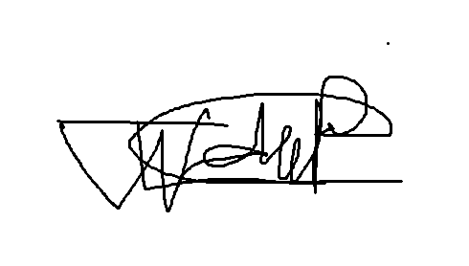 | 2026/10/22
Lebohang Tlaitlai | LN.Tlaitlai | 2026/10/22
Gerhardus van den Berg

Individual Contribution Form Willem

Student Details
Name: Willem Gerber Student No.: 20230257 Group: SE2 Group 3

Contribution Summary
Area | What I did
Research | Chapter 1 Introduction and helped with the Chapter 2 literature review and matrix
Design | Architecture diagram technology stack and the shared page template (header logo theme and page parts)
Coding | Back-end set up login and role checks (server.js routes/auth.js middleware)  Bookings API with change cancel history and no double booking  Book a slot page and My bookings page with the phone layout
Testing | Test Plan and 36 test cases and Defect Log and Traceability Matrix (folder 06) and fixes for the defects found
Documentation | Project charter work plan and ethics form  Compiled the Week 1 2 and 3 submissions Chapter 5 with the survey results and the CTU layout for Chapter 4.6 and 4.7 (Week 4)
Project management | Group Lead and Scrum Master: GitHub repository and a branch for each member  Reviewed and merged pull requests and made the task sign-up sheet
Presentation | Demo data and demo laptop and the final dissertation and submission (Week 5)

Git / Evidence References
Commit or file | Date | What it shows
dcb7cd2 and 092dd77 | 15 Oct | Repository and project structure
88460f8 | 19 Oct | Back-end folders schema and seed scripts and diagrams
6f458c7 | 20 Oct | Header layout theme login middleware and Bookings API
590e891 | 21 Oct | Booking error handling routes and Book a slot page
87cefdb | 22 Oct | My bookings page and phone layout
Pull requests #1 and #3 and #6 | 20 to 22 Oct | Reviewed and merged

Peer Confirmation
Member | Accurate (Yes or No) | Signature | Date
Thomas du Plessis | Yes |  | 2026/10/22

Student Declaration
I confirm that the information above accurately reflects my contribution
Name | Signature | Date
Willem Gerber |  | 2026/10/22

Individual Contribution Form Thomas

Student Details
Name: Thomas du Plessis Student No.: 20230260 Group: SE2 Group 3

Contribution Summary
Area | What I did
Design | Wireframes plus the use case and activity diagrams
Coding | Lecturer slots page (commit c2ecca1)
Documentation | Chapter 4.6 Development environment and 4.7 Implementation with 18 screenshots
Presentation | Slide outline Demo Script and video plus the final slides and backup video (Week 5)

Git / Evidence References
Commit or file | Date | What it shows
docs/wireframes | Week 3 | Login Book a slot Lecturer and phone wireframes
docs/diagrams/usecase.png and activity.png | Week 3 | Use case and activity diagrams
c2ecca1 | 22 Oct | Add lecturer consultation slots page
Pull request #6 | 22 Oct | Reviewed and merged

Peer Confirmation
Member | Accurate (Yes or No) | Signature | Date
Willem Gerber | yes |  | 2026/10/22

Student Declaration
I confirm that the information above accurately reflects my contribution
Name | Signature | Date
Thomas du Plessis |  | 2026/10/22

Individual Contribution Form Oscar

Student Details
Name: Oscar Khumalo Student No.: 20230279 Group: SE2 Group 3

Contribution Summary
Area | What I did
Research | Functional and non-functional requirements for Chapter 3 and the SRS
Design | Sequence diagram
Coding | Database connection (db.js) plus the confirmation and reminder emails (mailer.js and reminders.js)
Documentation | Chapter 4.8 Version control and the final Chapter 5 (Week 5)

Git / Evidence References
Commit or file | Date | What it shows
5682abf | 21 Oct | Database and email reminder services
Pull request #3 | 21 Oct | Merged into main
docs/diagrams/sequence.png | Week 3 | Sequence diagram

Peer Confirmation
Member | Accurate (Yes or No) | Signature | Date
Willem Gerber | Yes |  | 2026/10/24

Student Declaration
I confirm that the information above accurately reflects my contribution
Name | Signature | Date
Oscar Khumalo | B.O Khumalo | 2026/10/23

Individual Contribution Form Lebohang

Student Details
Name: Lebohang Tlaitlai Student No.: 20233068 Group: SE2 Group 3

Contribution Summary
Area | What I did
Research | Literature review and the student survey
Requirements | Chapter 3 and the SRS
Coding | React app set up page routes and the Login page  Slots API for lecturers and students (routes/slots.js)
Documentation | Chapter 6 outline and Chapter 6 Conclusion and Recommendations (Week 5)

Git / Evidence References
Commit or file | Date | What it shows
fe19ea8 | 21 Oct | Set up React app routes and Login page
e9b5f3e | 22 Oct | Add Slots API routes
Pull requests #2 and #4 | 21 and 22 Oct | Merged into main

Peer Confirmation
Member | Accurate (Yes or No) | Signature | Date
Willem Gerber | Yes |  | 2026/10/22

Student Declaration
I confirm that the information above accurately reflects my contribution
Name | Signature | Date
Lebohang Tlaitlai | LN.Tlaitlai | 2026/10/22

Individual Contribution Form Gerhardus

Student Details
Name: Gerhardus van den Berg Student No.: ____________ Group: SE2 Group 3

Contribution Summary
Area | What I did
Design | ERD and class diagram
Database | MySQL schema and test data scripts

Git / Evidence References
Commit or file | Date | What it shows
docs/diagrams/erd.png and class.png | Week 3 | ERD and class diagram
database/schema.sql and seed.sql | Week 3 | Schema and test data

Peer Confirmation
Member | Accurate (Yes or No) | Signature | Date

Student Declaration
I confirm that the information above accurately reflects my contribution
Name | Signature | Date
Gerhardus van den Berg

Appendix E Final Submission Checklist and Attendance
Final Submission Checklist
No. | Requirement | Status | Evidence / File
1 | Problem clearly defined | Complete | Chapter 1 Problem Statement (Group-3_Week3.pdf)
2 | Research aim written | Complete | Chapter 1 Research Aim (Group-3_Week3.pdf)
3 | Measurable objectives | Complete | Chapter 1 Research Objectives (Group-3_Week3.pdf)
4 | Aligned research questions | Complete | Chapter 1 Research Questions (Group-3_Week3.pdf)
5 | Literature review completed | Complete | Chapter 2 and Appendix C Literature Review Matrix (Group-3_Week3.pdf)
6 | Research gap identified | Complete | Chapter 2 Research Gap (Group-3_Week3.pdf)
7 | Methodology documented | Complete | Chapter 3 (Group-3_Week3.pdf)
8 | Functional requirements | Complete | Chapter 3 and Appendix D SRS (Group-3_Week3.pdf)
9 | Non-functional requirements | Complete | Chapter 3 and Appendix D SRS (Group-3_Week3.pdf)
10 | System diagrams | Complete | Chapter 4 and CampusBook/docs/diagrams
11 | Database design where applicable | Complete | ERD in Chapter 4 and CampusBook/database/schema.sql
12 | Application developed | Complete | All 8 coding tasks merged on GitHub and the fixes after testing still need to be committed
13 | Version control evidence | Complete | Group-3_Git_Evidence.docx and screenshots (folder 10) and Chapter 4.8 (GitHub branches, commits and pull requests #1 to #7)
14 | Application tested | In Progress | Test Plan done and the tests passed after the fixes and user testing with 5 students and 1 lecturer still to do
15 | Test cases and results | Complete | Test_Cases_and_Results.xlsx and Defect_Log.xlsx (folder 06)
16 | Evaluation against requirements | In Progress | Chapter 5 with the survey and Requirements_Traceability_Matrix.xlsx (user test results still to add in Week 5)
17 | Research questions answered | Not Started | Chapter 6
18 | Objectives evaluated | Not Started | Chapter 6
19 | Limitations discussed | Not Started | Chapter 6
20 | Recommendations and future work | Not Started | Chapter 6
21 | References completed | In Progress | Reference list in Group-3_Week3.pdf and new sources to add
22 | Appendices included | In Progress | Appendices A to E in Group-3_Week3.pdf
23 | Demo readiness confirmed | In Progress | Demo Script and slides drafted (folder 11) and the backup video is ready and the demo laptop check is on Tue 27 Oct

Project Attendance Register
Date | Full Name | Task Completed
15 Oct 2026 | Willem Gerber | Repository and project structure (commits dcb7cd2 and 092dd77)
19 Oct 2026 | Willem Gerber | Back-end folders schema seed scripts and diagrams (commit 88460f8)
20 Oct 2026 | Willem Gerber | Header layout theme login middleware and Bookings API (commit 6f458c7 and pull request #1)
21 Oct 2026 | Lebohang Tlaitlai | React app routes and Login page (commit fe19ea8 and pull request #2)
21 Oct 2026 | Willem Gerber | Booking error handling routes and Book a slot page (commit 590e891)
21 Oct 2026 | Oscar Khumalo | Database and email reminder services (commit 5682abf)
21 Oct 2026 | Willem Gerber | Reviewed and merged pull request #3
22 Oct 2026 | Lebohang Tlaitlai | Slots API routes (commit e9b5f3e and pull request #4 merged at 07:50)
22 Oct 2026 | Willem Gerber | My bookings page and phone layout (commit 87cefdb)
22 Oct 2026 | Thomas du Plessis | Lecturer slots page (commit c2ecca1 and pull request #6 merged at 14:56)
22 Oct 2026 | Willem Gerber | Reviewed and merged pull request #6
23 Oct 2026 | Oscar Khumalo | Improved booking and reminder email status handling (commit 5aff8cb)
23 Oct 2026 | Oscar Khumalo | Merged main into the Oscar branch (commit bfc98b0)
24 Oct 2026 | Lebohang Tlaitlai | Frontend login page fixed and Backend polishes (commit a72413d and pull request #7)

Appendix F Demo Script

1. Opening

Good day. We are Group 3 and our project is CampusBook, a consultation booking system for CTU Training Solutions.
Our members are Willem Gerber, Oscar Khumalo, Thomas du Plessis, Lebohang Tlaitlai and Gerhardus van den Berg.
Today we explain the problem, show the student and lecturer journeys live and share our testing evidence.

2. Problem and Objectives

At CTU, consultations are arranged through Teams, email, WhatsApp or by visiting a lecturer. Students do not know when a lecturer is free and lecturers struggle to organise appointments.
We surveyed 13 students. 11 needed a consultation in the last 3 months, 7 gave up because of the problems and 9 said they would use an online booking system.
CampusBook gives one place where lecturers publish consultation slots and students book, change or cancel them.
Our objectives were to study how consultations work now, compare existing systems, build the essential features, test performance and security, and evaluate ease of use with students and lecturers.

3. Architecture / Design

CampusBook has three tiers. The React frontend uses Vite and React Router. The Node.js and Express backend handles login, slots, bookings and reminders. A MySQL database stores users, lecturer profiles, slots, bookings and notifications.
Logins use JWT tokens and passwords are stored as bcrypt hashes. The system checks the role on every route so students and lecturers only reach their own pages. Nodemailer sends confirmation emails and node-cron sends the reminders.
Show the architecture diagram and then the ERD and point out how users, slots and bookings link together.

4. Live Demonstration Flow

Follow these steps in order. Keep each step to about 30 seconds.
Step | What to do | What the audience should see
1 | Open CampusBook and log in as a lecturer | The lecturer lands on My Consultation Slots
2 | Publish a slot with a future date, start and end time and a location | A success message and the new slot in the list
3 | Edit an available slot | The updated slot. Explain that booked slots cannot be edited or removed
4 | Log out and log in as a student, then open Book a Consultation | The lecturer list and the available dates
5 | Pick a lecturer, date and time, enter a reason and confirm | A confirmation with lecturer, date, time and location
6 | Open My Bookings, then change or cancel the booking | The booking list and slot availability update
7 | Show the phone-sized layout and a wrong password or expired session message | The page fits the phone and the message explains what to do

If there is time, explain test TC-07: 8 simultaneous requests for one slot gave 1 booking and 7 refusals. Do not run the load test live.

5. Testing Evidence

We wrote 36 test cases. 35 passed, none failed and one was not run: the timed test of a first-time student booking, which is planned with real students in Week 5.
Testing found 10 defects. All were fixed and retested. Two important ones were a wrong route on the lecturer slots page (/api/slots/mine) and consultation times showing as "undefined". We also fixed rescheduling, expired sessions and login rate limiting.
Security tests showed that wrong roles are refused, passwords are bcrypt hashes and a slot cannot be booked twice. The slowest page loaded in 389 ms against a 3 second target and the pages work on phone and laptop sizes.
The survey result shows that students want the system. It is not the usability test, which is done in Week 5.

6. Conclusion

CampusBook brings consultation booking and lecturer availability into one web application. Login, slot management, booking, reminders and the phone layout all work and were tested.
Still to do: confirm the fixes on the final GitHub version, test real email delivery and MySQL on the demonstration laptop, and finish user testing with students and lecturers.
Future ideas are links to CTU student systems and calendar synchronisation. Thank you. We are happy to take questions.

7. Backup Plan

Keep a 3 to 5 minute screen recording ready. It shows publishing a slot, student login, a booking, My Bookings and one error message. The group walkthrough video can be used for this.
- Keep screenshots and the test data on the laptop
- Start the database, backend and frontend before the presentation and test them
- If the internet or a service fails, play the recording and use the screenshots
- Tell the audience it is a recording and do not say it is live
- Keep passwords and JWT secrets out of screenshots and the recording

Appendix G Presentation Slides
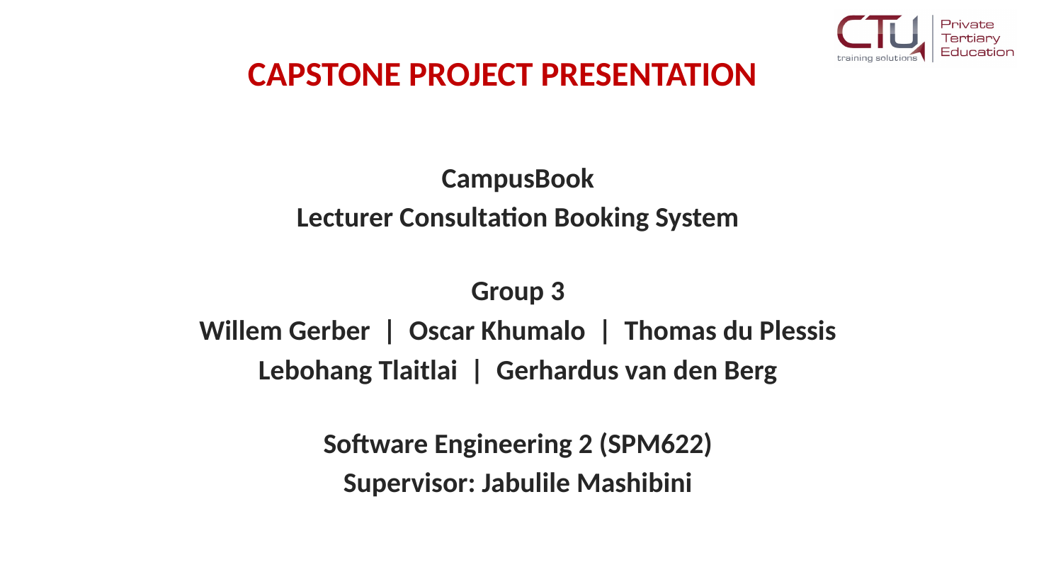 | 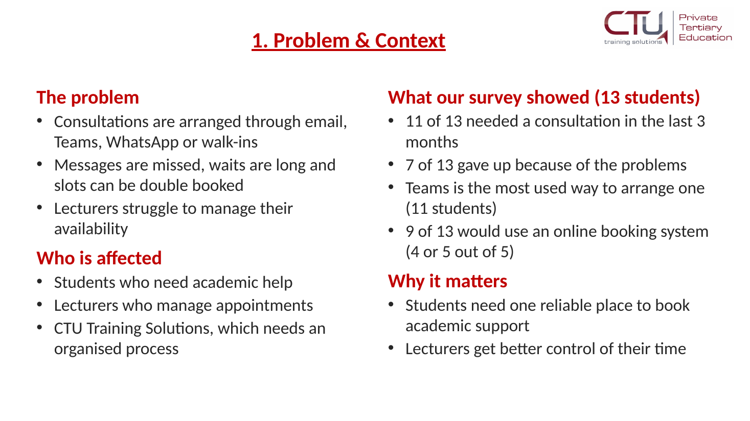
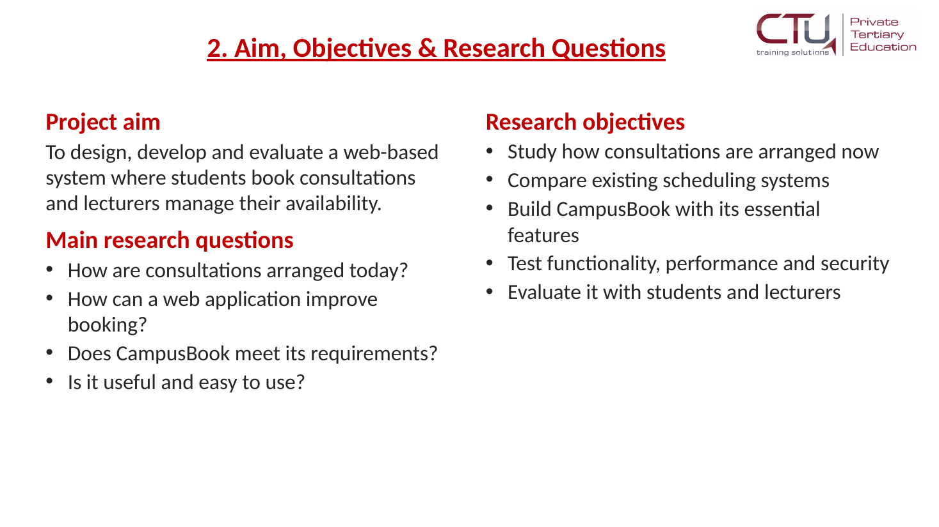 | 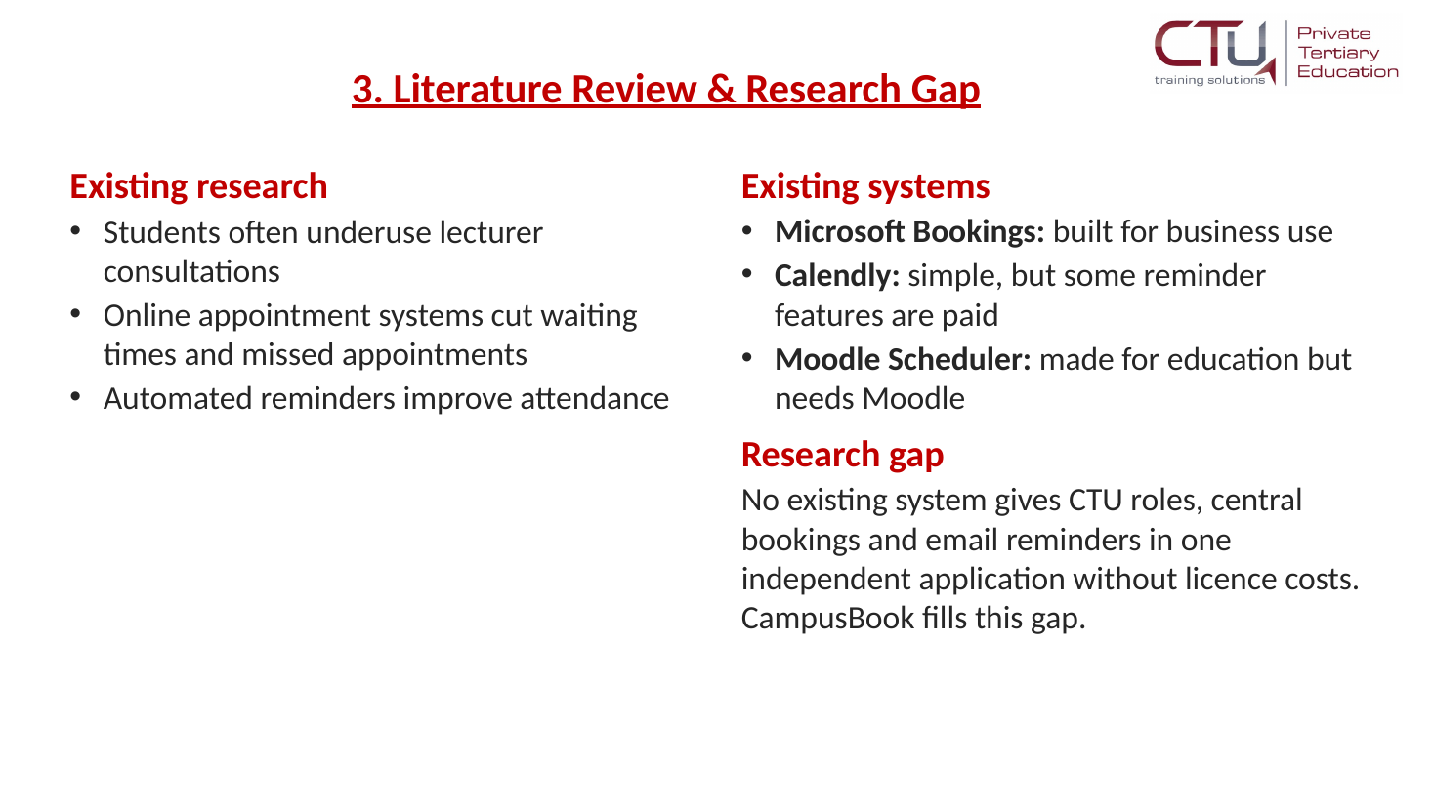
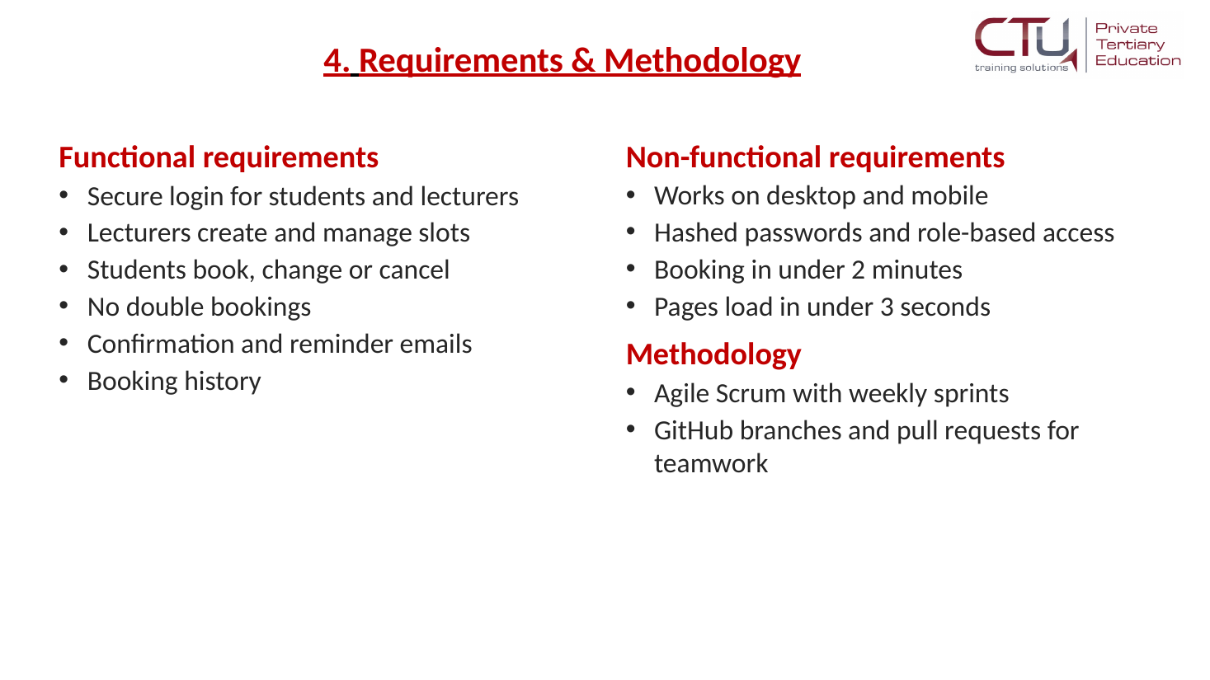 | 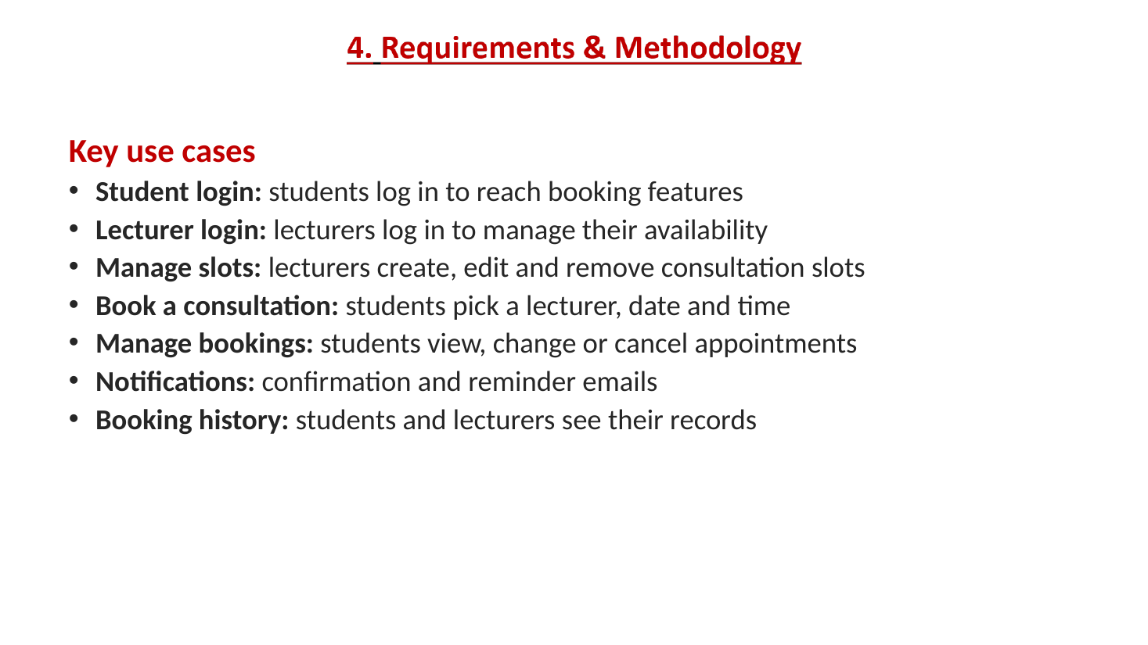
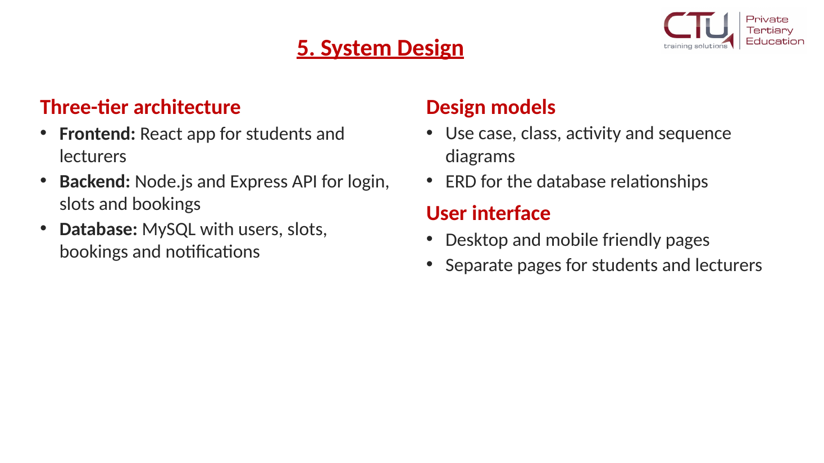 | 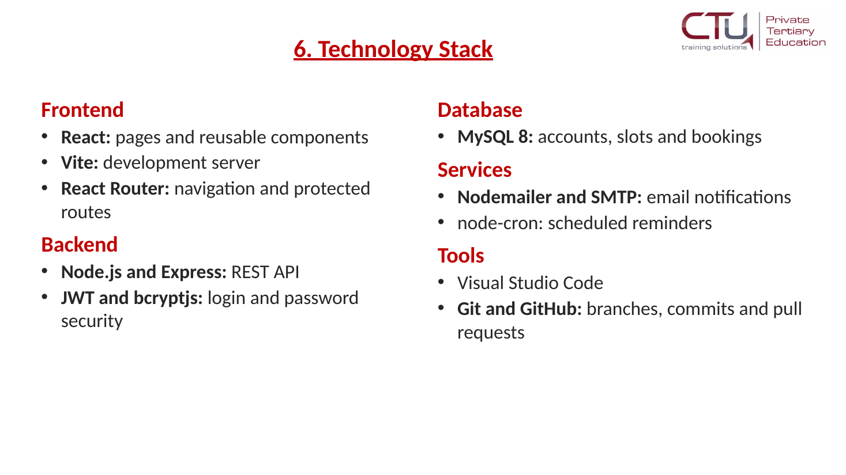
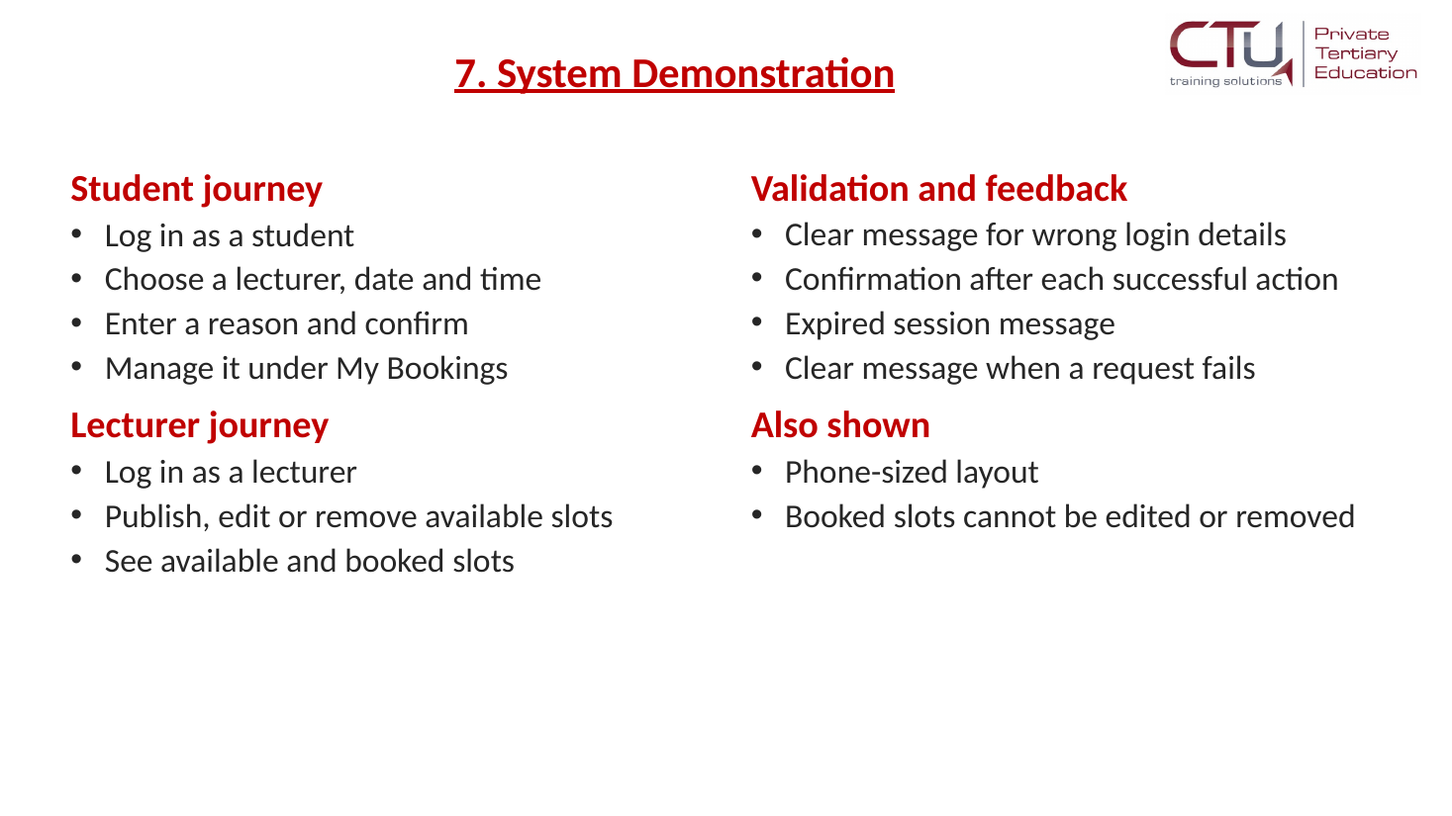 | 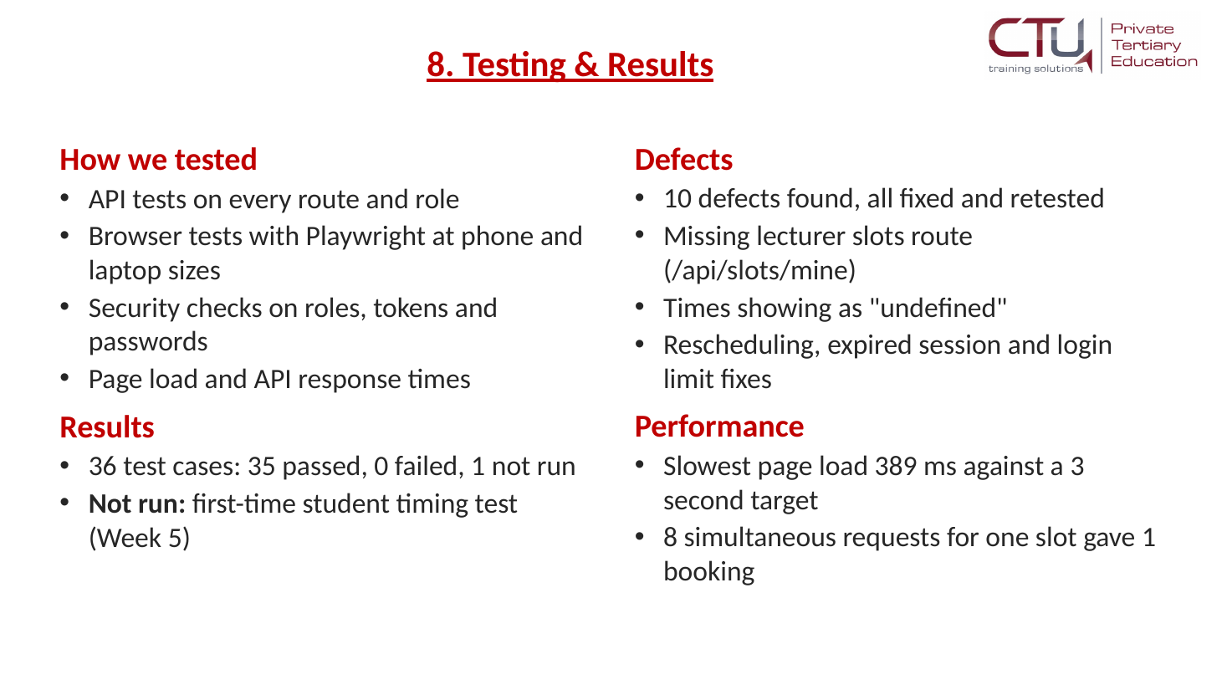
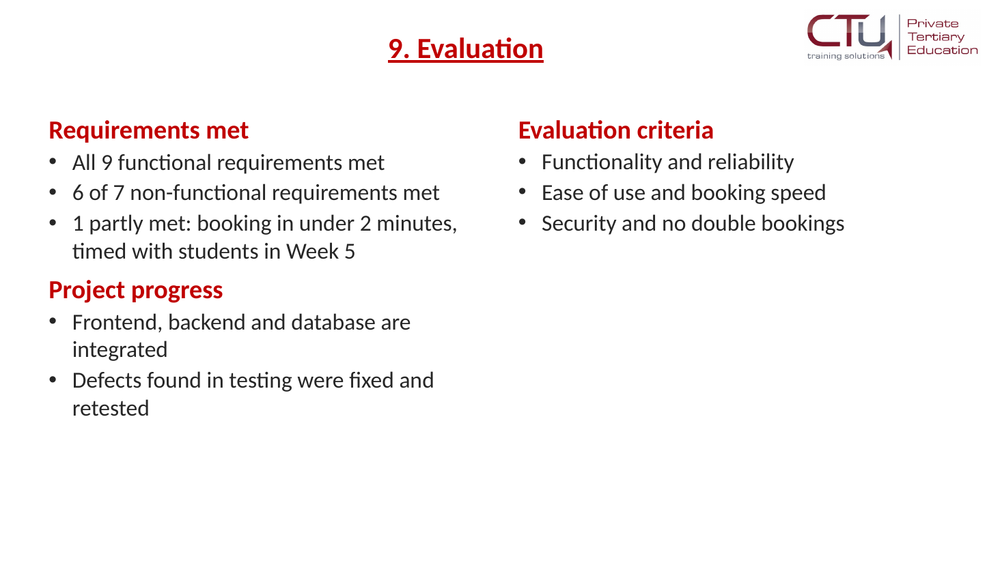 | 