CAPSTONE PROJECT
GIT AND VERSION CONTROL EVIDENCE
Project Title | CampusBook: a lecturer consultation booking system for CTU Training Solutions
Group Members | Willem Gerber  Oscar Khumalo  Thomas du Plessis  Lebohang Tlaitlai  Gerhardus van den Berg
Module | Software Engineering 2 (SPM622)
Lecturer / Supervisor | Jabulile Mashibini
Week / Stage | Week 4
Submission Date | Saturday 24 October 2026

1. Repository
The CampusBook source code is kept in a GitHub repository and every member of the group works on their own branch and merges through pull requests
This evidence was taken from the real repository history on Saturday 24 October 2026
Item | Detail
Repository | https://github.com/Gerber-W/SPM_Group_Project
README | README.md in the root of the repository
Default branch | main
Commits | 23 commits and 7 pull requests between 15 and 24 October 2026

2. Branches
The group uses one branch per member plus main
Changes reach main only through a pull request
Branch | Owner | Last commit | Date | Purpose
main | Group | 7f6fbd6 | 24 Oct | Latest working version of CampusBook
Willem | Willem Gerber | 6f458c7 | 20 Oct | Same as main on 20 Oct (no own commits)
Naledi | Lebohang Tlaitlai | a72413d | 24 Oct | Login page and slots API
Oscar | Oscar Khumalo | bfc98b0 | 23 Oct | Database and email reminders
Tom | Thomas du Plessis | c2ecca1 | 22 Oct | Lecturer consultation slots page
Gerhard | Gerhardus van den Berg | 6f458c7 | 20 Oct | No work pushed yet
Testing/Update | Group | 7b9d507 | 20 Oct | Testing update (no own commits)

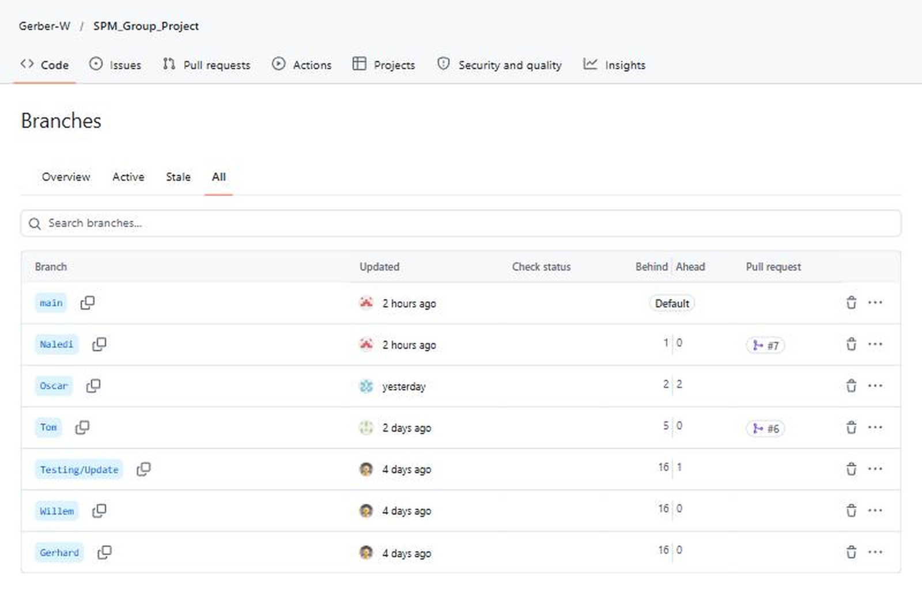

3. Commit History
The commit history shows 23 commits from 15 to 24 October 2026
The messages describe the change in each commit
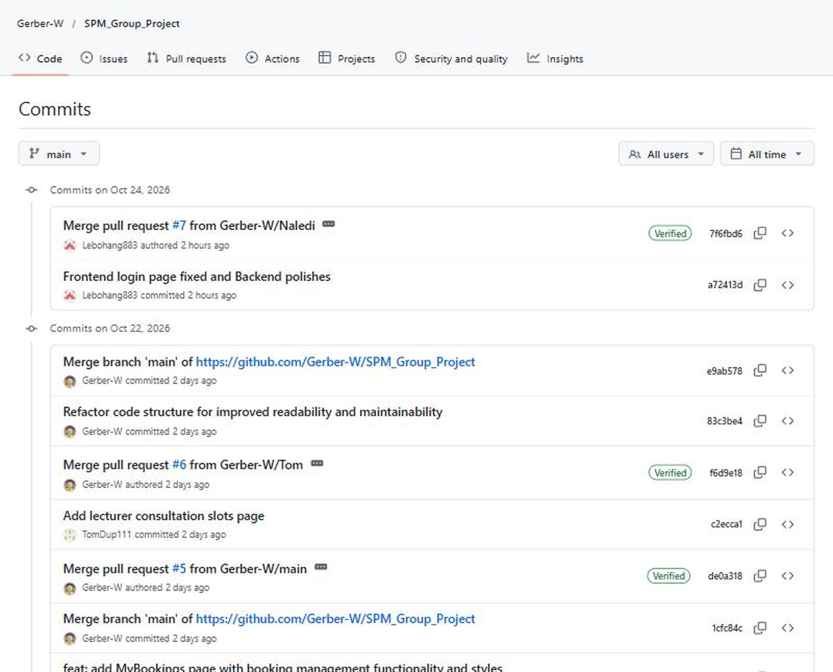

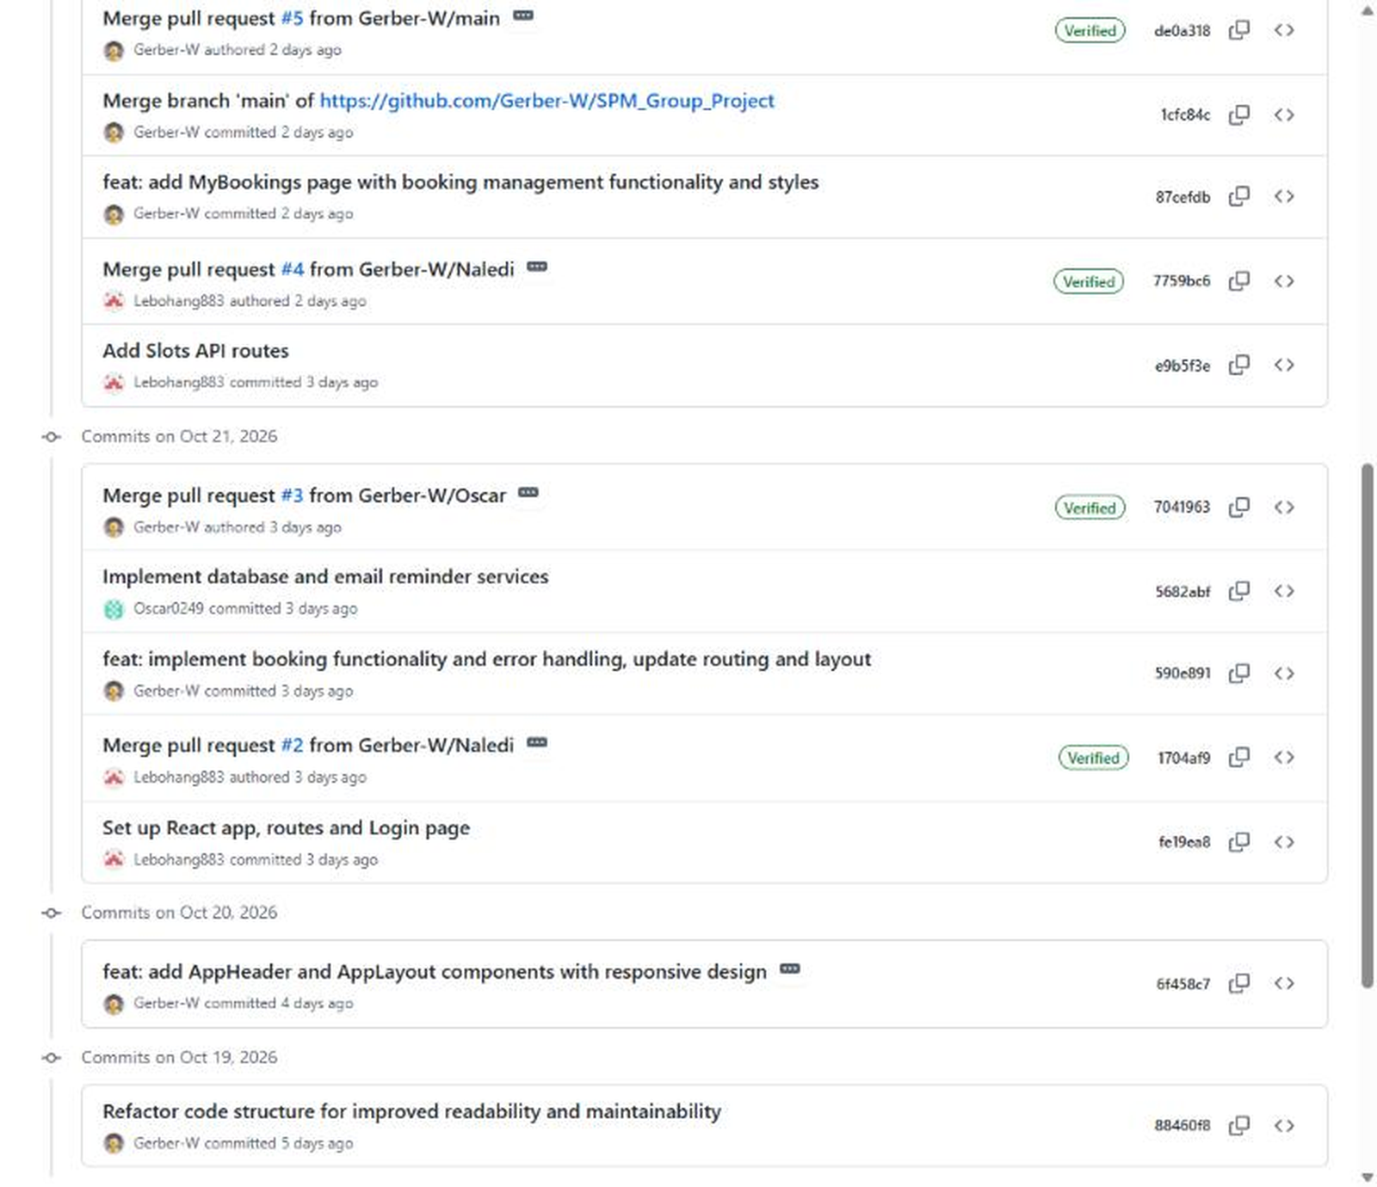

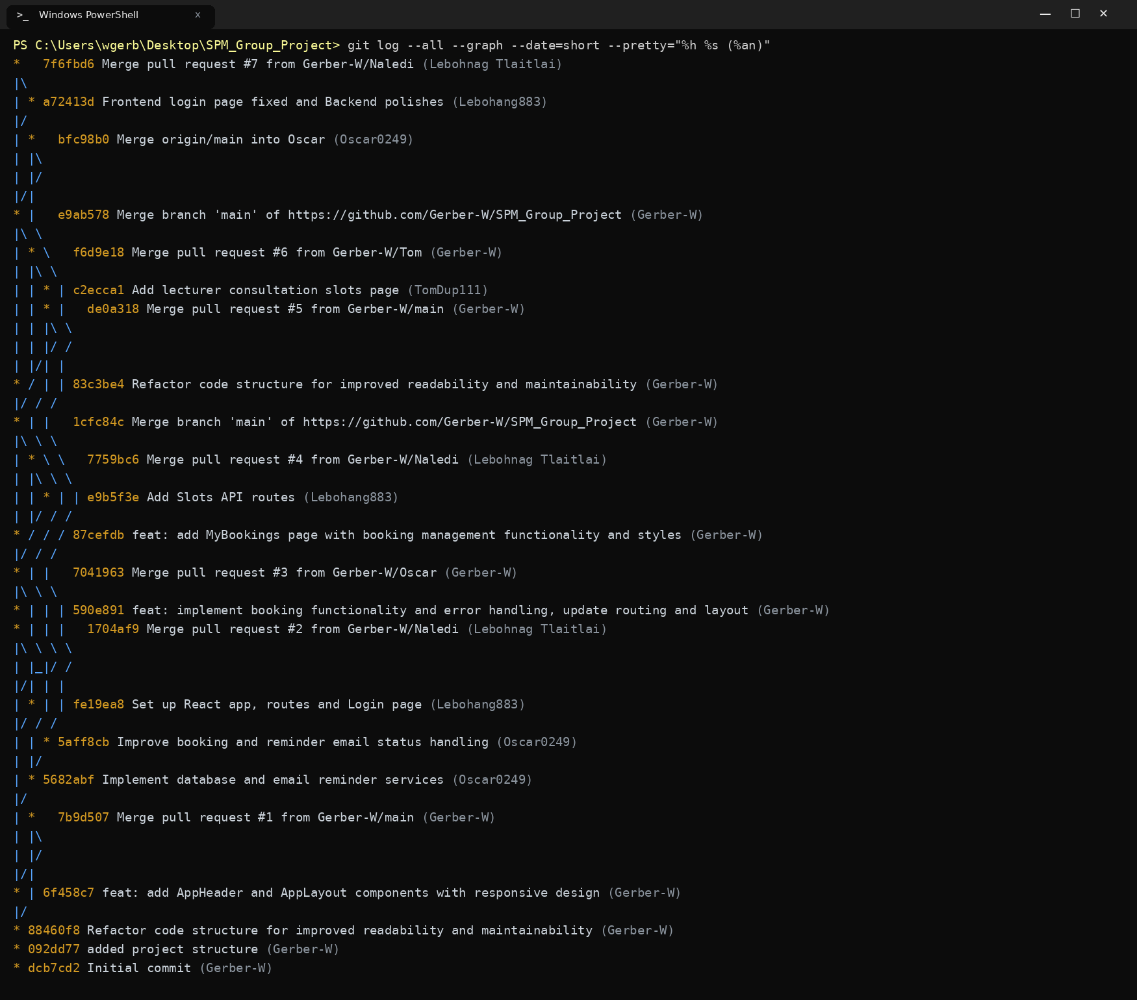

4. Pull Requests
Seven pull requests were opened and merged into main
Each one brings the work of a member branch into the shared code
PR | Title | From branch | Merged by | Date
#1 | feat: add AppHeader and AppLayout components with responsive design | main | Willem Gerber | 20 Oct
#2 | Set up React app, routes and Login page | Naledi | Lebohang Tlaitlai | 21 Oct
#3 | Implement database and email reminder services | Oscar | Willem Gerber | 21 Oct
#4 | Add Slots API routes | Naledi | Lebohang Tlaitlai | 22 Oct
#5 | Set up React app, routes, and implement booking functionality | main | Willem Gerber | 22 Oct
#6 | Tom (lecturer consultation slots page) | Tom | Willem Gerber | 22 Oct
#7 | Frontend login page fixed and Backend polishes | Naledi | Lebohang Tlaitlai | 24 Oct

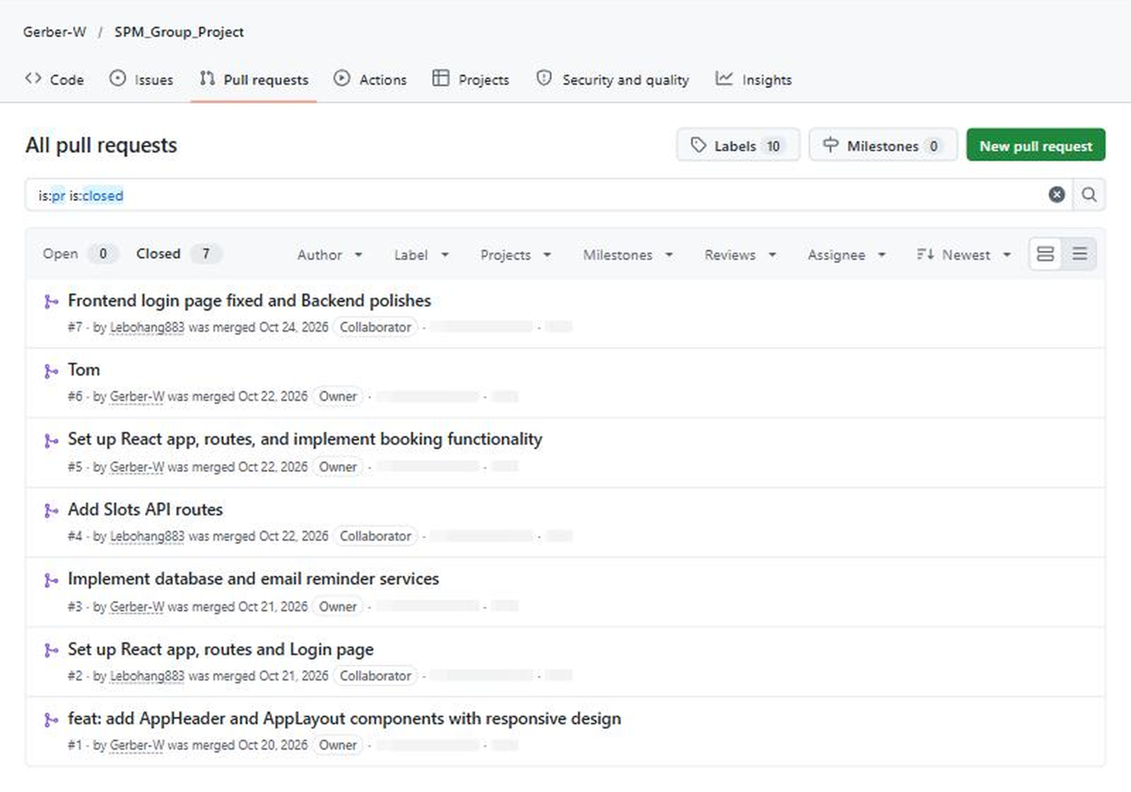

5. Contribution by Member
The table shows the commits each member made on their own branch
Merge commits are not counted
Member | GitHub name | Commits | Work in the commits
Willem Gerber | Gerber-W | 13 | Project structure and layout and booking page and My Bookings page and refactoring and pull request merges
Lebohang Tlaitlai | Lebohang883 | 3 | React setup and login page and slots API routes and login page fix
Oscar Khumalo | Oscar0249 | 3 | Database and email reminder services and booking status handling
Thomas du Plessis | TomDup111 | 1 | Lecturer consultation slots page
Gerhardus van den Berg | Gerhard | 0 | No commits yet

