CAPSTONE PROJECT
INDIVIDUAL CONTRIBUTION FORM
Project Title | CampusBook: a lecturer consultation booking system for CTU Training Solutions
Group Members | Willem Gerber  Oscar Khumalo  Thomas du Plessis  Lebohang Tlaitlai  Gerhardus van den Berg
Module | Software Engineering 2 (SPM622)
Lecturer / Supervisor | Jabulile Mashibini
Week / Stage | Week 5 Final submission
Submission Date | Thursday 29 October 2026

Student Details
Name: Thomas du Plessis Student No.: 20230260 Group: SE2 Group 3

Contribution Summary
Area | What I did
Design | Wireframes plus the use case and activity diagrams
Coding | Lecturer slots page (commit c2ecca1)
Documentation | Chapter 4.6 Implementation (development environment)
Presentation | First slide deck, the Demo Script and the demo and backup video (Week 4) and slides 14, 15 and 17 in the final presentation (Week 5)

Git / Evidence References
Commit or file | Date | What it shows
docs/wireframes | Week 3 | Login Book a slot Lecturer and phone wireframes
docs/diagrams/usecase.png and activity.png | Week 3 | Use case and activity diagrams
c2ecca1 | 22 Oct | Add lecturer consultation slots page
Pull request #6 | 22 Oct | Reviewed and merged

Peer Confirmation
Member | Accurate (Yes or No) | Signature | Date
Willem Gerber | yes |  | 2026/10/29

Student Declaration
I confirm that the information above accurately reflects my contribution
Name | Signature | Date
Thomas du Plessis | 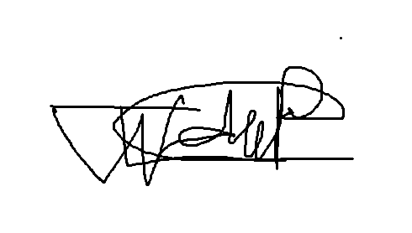 | 2026/10/22

