CAPSTONE PROJECT
FINAL DISSERTATION
Project Title | CampusBook: a lecturer consultation booking system for CTU Training Solutions
Group Members | Willem Gerber  Oscar Khumalo  Thomas du Plessis  Lebohang Tlaitlai  Gerhardus van den Berg
Module | Software Engineering 2 (SPM622)
Lecturer / Supervisor | Jabulile Mashibini
Week / Stage | Week 5 Final submission
Submission Date | Thursday 29 October 2026
GitHub link: https://github.com/Gerber-W/SPM_Group_Project
Walkthrough video link: https://drive.google.com/drive/folders/18qZABsN0nJubNOR73QvzfHRyokvyM1ht
Declaration of Originality
We the members of SE2 Group 3 declare that this dissertation CampusBook a lecturer consultation booking system for CTU Training Solutions is our own work Where the work of others has been used it has been acknowledged and referenced in the text and in the reference list This work has not been submitted for any other module or qualification
Name | Student number | Signature | Date
Willem Gerber | 20230257 |  | 2026/10/29
Oscar Khumalo | 20230279 | 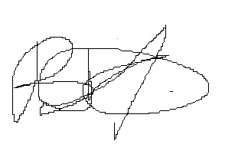 | 2026/10/29
Thomas du Plessis | 20230260 |  | 2026/10/29
Lebohang Tlaitlai | 20233068 |  | 2026/10/29
Gerhardus van den Berg | 20230240 |  | 2026/10/29

Acknowledgements
We thank our lecturer for the guidance and feedback given on every weekly submission of this project Their comments on the proposal shaped the scope of CampusBook and helped us keep the work focused
We also thank the students who answered our survey and the students and lecturers who took part in the user testing Their answers and comments showed us what students need and where the system could be better
Finally we thank CTU Training Solutions for the time and the facilities that made this project possible
Abstract
Students at CTU Training Solutions arrange consultations with lecturers through Teams messages WhatsApp requests in class and walk-ins so nobody can see when a lecturer is free and meetings are missed or double-booked A survey of 13 students confirmed the problem 8 could not tell when a lecturer was free 10 waited one to two days for a confirmed time and 7 had given up on getting a consultation
This project designed developed and evaluated CampusBook a responsive web application where lecturers publish the times they are free and students book change and cancel consultations with a short reason for the visit The system uses a React front end a Node.js and Express API and a MySQL database Confirmation and reminder emails are sent with Nodemailer and a database transaction with a row lock and a unique key stops two students booking the same slot
The team worked in one-week Scrum sprints and used GitHub branches and pull requests 36 test cases were linked to the requirements and all 10 defects found in testing were fixed and retested All 9 functional requirements were met the slowest page loaded in 389 ms and eight booking requests sent for one slot at the same moment produced one booking In user testing with 4 students and 2 lecturers 4 of the 6 users rated CampusBook easy to use The students averaged 4.5 out of 5 and the lecturers 2.5 which shows that the lecturer page is the main area to improve
Keywords: consultation booking, web application, lecturer availability, scheduling, Scrum
Table of Contents
Declaration of Originality i
Acknowledgements ii
Abstract iii
List of Figures vii
List of Tables ix
List of Abbreviations and Acronyms x
Chapter 1 Introduction 1
1.1 Background 1
1.2 Problem Statement 1
1.3 Aim 1
1.4 Objectives 2
1.5 Research Questions 2
Chapter 2 Literature Review 4
2.1 Introduction 4
2.2 Review of Related Literature 4
2.3 Review of Similar Systems 4
2.4 Review of Technologies 5
2.5 Research Gap 6
2.6 Conclusion 7
Chapter 3 Requirements and Methodology 8
3.1 Introduction 8
3.2 Stakeholder Identification 8
3.3 Requirements Gathering 8
3.4 Functional Requirements 9
3.5 Non-Functional Requirements 9
3.6 Use Cases and User Stories 9
3.7 Methodology (Agile Scrum) 10
3.8 Ethics and Privacy 10
3.9 Security 11
Chapter 4 System Design, Implementation and Version Control 12
4.1 Introduction 12
4.2 System Architecture 12
4.3 UML Design 13
4.4 Database Design 17
4.5 User Interface Design 21
4.6 Implementation 25
4.7 Working System 26
4.8 Version Control and Team Development 43
Chapter 5 Testing, Results and Evaluation 51
5.1 Test Plan 51
5.2 Test Cases and Results 52
5.3 Defect Log 55
5.4 Non-Functional Requirement Evaluation 59
5.5 Requirements Traceability Matrix 60
5.6 Stakeholder and User Feedback 61
5.7 Evaluation Against Requirements 64
5.8 Conclusion 66
Chapter 6 Conclusion and Recommendations 67
6.1 Introduction 67
6.2 Summary of the Study 67
6.3 Achievement of Objectives 68
6.4 Answers to Research Questions 68
6.5 Limitations 70
6.6 Recommendations and Future Work 70
6.7 Conclusion 71
References 73
Appendices 75
Appendix A Test Plan 76
Appendix B Ethical Clearance and Consent 79
Appendix C Test Cases and Defect Log 80
Appendix D Project Schedule and Risk Register 82
Appendix E Group Declaration and Contribution Forms 83
Appendix F Attendance Register 89
Appendix G Demo Script 90
Appendix H Presentation Slides 93
List of Figures
Figure 4.1 CampusBook three tier architecture 13
Figure 4.2 Use case diagram 14
Figure 4.3 Class diagram 15
Figure 4.4 Activity diagram for booking a consultation 16
Figure 4.5 Sequence diagram for booking a slot 17
Figure 4.6 Entity relationship diagram 18
Figure 4.7 Login wireframe 22
Figure 4.8 Student booking screen wireframe 23
Figure 4.9 Lecturer slots screen wireframe 24
Figure 4.10 My bookings wireframe on a phone 25
Figure 4.11 CampusBook login page 27
Figure 4.12 Lecturer slots page 28
Figure 4.13 Student booking page 29
Figure 4.14 Student My bookings page 30
Figure 4.15 SMTP test email 31
Figure 4.16 Test email sent through the CampusBook mailer module 32
Figure 4.17 Desktop login 34
Figure 4.18 Wrong login details 34
Figure 4.19 Session expired message 35
Figure 4.20 Mobile login, booking calendar and confirmation pages 36
Figure 4.21 Desktop booking page 37
Figure 4.22 Times displayed correctly 37
Figure 4.23 Availability after a booking 38
Figure 4.24 Desktop My bookings 38
Figure 4.25 My bookings on a phone 39
Figure 4.26 Moving a booking 39
Figure 4.27 Slot published 40
Figure 4.28 Slot updated 40
Figure 4.29 Time display error 41
Figure 4.30 Slot route error 42
Figure 4.31 Lecturer page on a phone before the slots were added 43
Figure 4.32 Lecturer page on a desktop before the slots were added 43
Figure 4.33 GitHub repository overview 44
Figure 4.34 Pull Request #4 Slots API routes 44
Figure 4.35 Pull Request #6 Lecturer consultation slots 45
Figure 4.36 Pull Request #3 Database and email reminder services 46
Figure 4.37 Branches overview 47
Figure 4.38 Overall commit history 49
Figure 5.1 Booking a slot on a phone 54
Figure 5.2 My bookings page with no bookings 55
Figure 5.3 Time buttons before and after the D-02 fix 57
Figure 5.4 Lecturer slots page before and after the D-03 fix 58
Figure 5.5 Session ended message after the D-05 fix 59
Figure 5.6 Login error and slot taken messages 60
Figure 5.7 Student survey results 62
List of Tables
Table 1.1 Scope of CampusBook 3
Table 2.1 Existing systems compared with CampusBook 5
Table 2.2 Technology choices for CampusBook 6
Table 3.1 Stakeholders and what they need 8
Table 3.2 Functional requirements 9
Table 3.3 Non-functional requirements 9
Table 3.4 User stories 9
Table 3.5 Sprint plan 10
Table 3.6 Scrum compared with Waterfall 10
Table 4.1 Relationships and cardinality 19
Table 4.2 Data dictionary 20
Table 4.3 Development tools 26
Table 4.4 Key commits and pull requests 50
Table 5.1 Test levels 51
Table 5.2 Test environment 51
Table 5.3 Summary of test results 52
Table 5.4 All test cases and results 53
Table 5.5 Defect summary 56
Table 5.6 Performance and layout measurements 59
Table 5.7 Heuristic check (Nielsen, 1994) 60
Table 5.8 Requirements traceability matrix 61
Table 5.9 Student survey results (13 students) 62
Table 5.10 Feedback sources 63
Table 5.11 User testing results 63
Table 5.12 Requirements evaluation 65
Table 6.1 Achievement of objectives 68
List of Abbreviations and Acronyms
Abbreviation | Meaning
API | Application Programming Interface
CSS | Cascading Style Sheets
CTU | CTU Training Solutions
ERD | Entity Relationship Diagram
FK | Foreign Key
FR | Functional Requirement
HTML | HyperText Markup Language
HTTP / HTTPS | HyperText Transfer Protocol (Secure)
IDE | Integrated Development Environment
JSON | JavaScript Object Notation
ms | Milliseconds
NFR | Non-Functional Requirement
PK | Primary Key
POPIA | Protection of Personal Information Act
PR | Pull Request
REST | Representational State Transfer
RTM | Requirements Traceability Matrix
SMS | Short Message Service
SMTP | Simple Mail Transfer Protocol
SQL | Structured Query Language
SRS | Software Requirements Specification
TC | Test Case
UML | Unified Modelling Language
US | User Story

Chapter 1 Introduction

1.1 Background
Consultations give students time with a lecturer outside class to ask questions get feedback and work through problems Research shows this support is often under used and that the reasons are usually practical rather than academic (Griffin, 2014)
At CTU Training Solutions arranging a consultation is informal Students send an email a Teams or WhatsApp message or simply knock on the lecturer door during posted hours Each lecturer handles this differently and nobody has a clear view of who is available who is coming or which meetings took place
Other sectors have solved a similar problem with online booking in healthcare web based appointment systems have reduced no-shows and waiting times and saved staff time (Zhao, 2017) and automated reminders improve attendance even further (Guy, 2012) With 96% of South African households owning a mobile phone (Statistics South Africa, 2024) a booking system that works well on a phone can reach almost every student

1.2 Problem Statement
CTU Training Solutions has no single reliable way for students to book consultations with lecturers Requests are spread across email Teams WhatsApp and walk-ins so students wait outside offices messages go unanswered and meetings are missed or double-booked Lecturers cannot plan their time because they do not know who is coming or why the problem peaks before tests and assignment deadlines exactly when students need help most
It affects students who need academic support and lecturers who juggle requests from several channels Our group has experienced this first hand our lecturer reviewed the proposal and agreed it addresses a real need and a short student survey showed how widespread it is

1.3 Aim
To design develop and evaluate CampusBook a web based system that lets CTU students book change and cancel consultations and lets lecturers manage their availability so that fewer consultations are missed or left unplanned

1.4 Objectives
1. Analyse how consultations are arranged today through a survey of at least 10 students by 21 October 2026
2. Compare at least three existing scheduling systems on their features strengths and limitations by 19 October 2026
3. Design and develop a web system with all six must-have features working on a live database by 23 October 2026
4. Test the system so that every must-have test case passes a booking takes under 2 minutes and pages load within 3 seconds
5. Evaluate the system with at least 5 students and 1 lecturer with 80% or more rating it easy to use

1.5 Research Questions
1. How do students and lecturers at CTU arrange consultations now and what problems do they face?
2. What do existing scheduling systems offer and what do they lack for a campus setting?
3. How can a web system let students book consultations and lecturers manage their time?
4. Does the system meet its functional and non-functional requirements?
5. Do students and lecturers find the system easy to use and useful?

Proposed Software Solution
CampusBook is a responsive web application with two roles Lecturers publish their weekly consultation slots and see who has booked and why Students browse open slots book one with a short reason for the visit and get an email reminder before the meeting The six must have features are:
1. Login with separate student and lecturer roles
2. Lecturers publish weekly consultation slots
3. Students book change or cancel a slot with a reason for the visit
4. Email confirmation and a reminder before each booking
5. Booking history for students and lecturers
6. Mobile friendly design

Scope
Table 1.1 Scope of CampusBook
In scope | Out of scope
One CTU campus | Other campuses or institutions
Student and lecturer roles | Admin reporting dashboards
Six must have features with email reminders | Video calls SMS and native mobile apps
Test data created by the team | Links to CTU live student systems

Significance of the Study
- Students can see when lecturers are free get confirmed bookings and stop wasting trips before assessments
- Lecturers control their consultation time and know in advance who is coming and why
- CTU Training Solutions gains a low-cost tool that supports student success and evidence on whether online booking works as well on campus as it does in healthcare

Chapter Summary
This chapter explained why consultations at CTU Training Solutions are hard to arrange and who the problem affects It set the aim the five objectives and the five research questions and described CampusBook with its six must have features and what is in and out of scope Chapter 2 now reviews existing research and similar systems

Chapter 2 Literature Review

2.1 Introduction
This chapter reviews research on why students under use consultations and how online booking and reminders help in other sectors It then compares Microsoft Bookings Calendly and Moodle Scheduler and reviews the technology chosen for CampusBook before stating the research gap

2.2 Review of Related Literature
Consultations are under used Griffin (2014) surveyed undergraduate students at a large American university and found that most of the factors that stop students attending office hours are outside the lecturer control The one exception was feedback: students who found it useful came back more often A summary of similar survey work found that 66% of more than 600 students had never attended office hours for a course and only 8% went more than once a month (Weimer, 2015) Both sources show the problem clearly but they focus on student attitudes rather than on how meetings are arranged and neither tests a tool that makes booking easier
Online booking works in healthcare Zhao (2017) reviewed 21 web based medical appointment systems Online booking cut no shows with one system reporting 2% for web bookings against 8% for phone bookings and it also shortened waiting times raised satisfaction and reduced staff workload The review warns that providers worry about losing control of their schedules a concern lecturers are likely to share Guy (2012) add that automated reminders increase attendance These studies come from healthcare where appointments are more formal than a quick consultation so the idea still needs testing in education
People use systems that are useful and easy The Technology Acceptance Model suggests that people adopt a system when they find it useful and easy to use (Davis, 1989) Nielsen (1994) usability heuristics turn this into practical design rules such as always showing a clear confirmation and stopping a student from booking a slot that is already taken

2.3 Review of Similar Systems
Microsoft Bookings offers a booking page that syncs with Outlook sends email reminders and creates Teams meetings It comes with Microsoft 365 business and education plans but SMS reminders only work in North America and the UK and need an extra Teams Premium licence (Microsoft, 2025) It is built for businesses serving customers so it has no idea of students lecturers or modules and setting it up needs administrator access
Calendly is a popular polished scheduling tool Its free plan allows only one event type and one calendar and reminders need the Standard plan at 10 US dollars per lecturer per month (Calendly, 2025) Students would need a separate link for every lecturer and booking data would sit with a third party
Moodle Scheduler is a Moodle plugin that lets teachers create slots for students to book with reminders booking limits and attendance tracking (Moodle, 2017) It suits teaching well but it only works inside one course needs an administrator to install it and is only an option for institutions that run Moodle
Table 2.1 Existing systems compared with CampusBook
 | Microsoft Bookings | Calendly | Moodle Scheduler | CampusBook
Lecturer sets slots | Yes | Yes | Yes | Yes
Student books and cancels | Yes | Yes | Yes | Yes
Free reminders | Email only | No paid plan | Yes | Yes email
Student and lecturer roles | No | No | Course roles | Yes
All lecturers in one place | Yes | No | No per course | Yes
Extra cost | Microsoft 365 licence | Per lecturer | Needs Moodle | None
Set up effort | Admin sets up a booking page | Each lecturer signs up | Admin installs it then added per course | Set up once for the campus
Where data is kept | Microsoft 365 tenant | Calendly servers | Moodle server | CTU server
Works on a phone | Yes in the browser | Yes browser and app | Through Moodle | Yes built for phones first
Main drawback | Business focus | Cost and data privacy | Tied to one course | Must be maintained

Lessons for CampusBook All three systems handle the basic act of booking well so CampusBook copies what works: clear open slots instant confirmation and reminders Where they fall short is fit Microsoft Bookings and Calendly are designed for businesses and Calendly charges per lecturer for reminders Moodle Scheduler fits teaching but stays inside a single course CTU current mix of email Teams WhatsApp and walk ins costs nothing but offers no shared view of availability and no record of meetings

2.4 Review of Technologies
The chosen tools are among the most widely used in the 2025 Stack Overflow Developer Survey so documentation and help are easy to find (Stack Overflow, 2025)
CampusBook stores names email addresses and booking details which counts as personal information under the Protection of Personal Information Act (Republic of South Africa, 2013) The system collects only what it needs hashes all passwords shows each user only their own bookings and used made up data during development
Table 2.2 Technology choices for CampusBook
Part | Choice | Why | Alternative
Front end | React | Builds pages from reusable components Meta used by about 45% of developers | Plain HTML and JavaScript harder to keep consistent
Back end | Node.js and Express | One language JavaScript across the whole team used by about 49% of developers | ASP.NET which adds a second language
Database | MySQL | Relational tables for users slots and bookings and the team already knows it | PostgreSQL more popular at about 56% but less familiar to us
Reminders | Email | Free and reaches everyone | SMS which costs per message
Method | Scrum | Sprints of a month or less with a review after each (Schwaber and Sutherland, 2020) which fits our weekly deadlines | Waterfall too rigid for weekly feedback

2.5 Research Gap
Research shows that consultations help students but are under used (Griffin, 2014) and that online booking with reminders reduces missed appointments in healthcare (Guy, 2012; Zhao, 2017) Existing tools serve businesses or single Moodle courses well but none gives CTU students one place to book any lecturer free of licence costs

Conceptual and Technical Direction
Two ideas guide the design From the Technology Acceptance Model every screen must make booking quicker than sending a message or students and lecturers will not switch (Davis, 1989) From the healthcare studies confirmations and reminders are what reduce missed meetings so they are core features rather than extras (Guy, 2012; Zhao, 2017) Lecturers keep full control of their own slots which answers the loss of control concern raised by Zhao (2017)
Technically CampusBook follows a simple three-tier design The React front end runs in the browser the Express API handles logins slots and bookings and the MySQL database stores the data with rules that stop a slot being booked twice A scheduled task sends reminder emails before each consultation

2.6 Conclusion
Research shows that consultations help students but are under used and that online booking with reminders reduces missed appointments in healthcare The three systems reviewed handle booking well but none gives CTU students one place to book any lecturer free of licence costs Chapter 3 turns these ideas into requirements and a method

Chapter 3 Requirements and Methodology

3.1 Introduction
This chapter sets out who will use CampusBook what it must do and how the team built it It covers the stakeholders the functional and non-functional requirements how the requirements were gathered the Scrum method the user stories the architecture and the ethical privacy and security considerations

3.2 Stakeholder Identification
Table 3.1 Stakeholders and what they need
Stakeholder | What they need from CampusBook | Access
Students | See open consultation times book change or cancel a slot and get a reminder before the meeting | Student account
Lecturers | Publish their available times and see who is coming and why | Lecturer account
CTU Training Solutions | Better planned consultations and more support for students before assessments | No admin dashboard in this version
Project supervisor | Review the requirements ethics and each weekly submission | Review only
Development team | Design build and test the system using made-up data | Development environment

3.3 Requirements Gathering
The first requirements came from three sources Our own experience of booking consultations at CTU feedback from our lecturer on the proposal the research comparison of Microsoft Bookings Calendly and Moodle Scheduler The features the three systems share became core requirements and the gaps they leave such as one place for every lecturer and free reminders shaped what makes CampusBook different
An anonymous survey of 13 CTU students checked how students book consultations now and what problems they run into and the results confirmed these requirements (Chapter 5)

3.4 Functional Requirements
Table 3.2 Functional requirements
ID | Requirement | Priority
FR-01 | Students and lecturers log in with their email and password | Must
FR-02 | The system checks the user role so students and lecturers only reach their own pages and actions | Must
FR-03 | Lecturers publish edit and remove their own future consultation slots | Must
FR-04 | Students view the open slots of a chosen lecturer | Must
FR-05 | Students book an open slot and give a short reason for the visit | Must
FR-06 | Students change or cancel their own upcoming bookings | Must
FR-07 | The system stops two students booking the same slot | Must
FR-08 | The system sends an email confirmation after booking and a reminder before the meeting | Must
FR-09 | Students see their own booking history and lecturers see the bookings for their slots | Must

3.5 Non-Functional Requirements
Table 3.3 Non-functional requirements
ID | Requirement | Priority
NFR-01 | A first-time student completes a booking in under 2 minutes | Must
NFR-02 | The main pages load within 3 seconds in the team test set up | Must
NFR-03 | Every page works on a phone at 375 pixels wide and on a laptop at 1366 pixels wide | Must
NFR-04 | Passwords are stored as bcrypt hashes and never as plain text | Must
NFR-05 | Each user can only see their own bookings or the bookings for their own slots | Must
NFR-06 | Only the data needed for logging in and booking is stored with made-up data during development | Must
NFR-07 | Errors explain what to fix and the form keeps what the user already typed | Should

3.6 Use Cases and User Stories
Table 3.4 User stories
ID | User story | Requirements
US-01 | As a student I want to see open slots so I can get help without messaging each lecturer | FR-04
US-02 | As a student I want to book a slot with a reason so the lecturer knows what I need | FR-05 and FR-07
US-03 | As a student I want to change or cancel my booking so my plans stay up to date | FR-06
US-04 | As a lecturer I want to publish and manage my slots so I control my own time | FR-03
US-05 | As a lecturer I want to see who booked and why so I can prepare for the meeting | FR-09
US-06 | As a student or lecturer I want a confirmation and a reminder so no meeting is forgotten | FR-08

The main use case is booking a slot a student logs in chooses a lecturer and an open slot adds a reason and confirms the system checks that the slot is still open saves the booking and sends the confirmation If another student took the slot first the student is asked to choose another time

3.7 Methodology (Agile Scrum)
The team uses Scrum with one week sprints where each sprint ends with a review so the next one can improve on it (Schwaber and Sutherland, 2020)
Table 3.5 Sprint plan
Sprint | Focus | Ends with
Sprint 0  16 to 19 Oct | Requirements SRS system design wireframes and repository set up | Week 3 submission
Sprint 1  20 to 23 Oct | Build the six must-have features and run the first tests | Week 4 submission
Sprint 2  24 to 29 Oct | User testing bug fixes final dissertation and presentation | Final submission and live demo

Table 3.6 Scrum compared with Waterfall
 | Scrum | Waterfall
Feedback | Used every week | Mostly at the end
Changing requirements | Added to the next sprint | Hard once a phase is done
Risk | Problems show up early | Problems show up late in testing
Fit for this project | Matches the weekly deadlines | Too rigid for a two-week build

Planned System Architecture
CampusBook uses a three tier design The React front end runs in the browser the Express API handles logins slots and bookings and the MySQL database stores the data with rules that stop a slot being booked twice A scheduled task sends reminder emails before each consultation The full architecture diagram is in Chapter 4 section 4.2

3.8 Ethics and Privacy
- Only made-up users and bookings are used during development never real CTU records
- The survey and user testing are voluntary with consent first and anonymous results as set out in Appendix B
- Research files are kept in a private folder and deleted once the project is marked
- Only the data needed for logging in and booking is collected in line with POPIA (Republic of South Africa, 2013)

3.9 Security
Security was designed in from the start and checked again in testing (Chapter 5)
- Passwords are hashed every request is checked for a valid token and role and all input is validated on the server
- A unique key in the database stops a slot ever having two confirmed bookings
- After 10 wrong passwords in 15 minutes the login refuses more tries for a while and an expired session sends the user back to the login page

Chapter Summary
This chapter listed the stakeholders the functional and non-functional requirements and the Scrum method the team follows It also set out how privacy and security are handled Chapter 4 turns these requirements into the system design

Chapter 4 System Design, Implementation and Version Control

4.1 Introduction
This chapter shows how CampusBook is designed It covers the architecture the UML diagrams the database design and the user interface wireframes followed by the technology stack and the repository structure

4.2 System Architecture
CampusBook uses a three tier architecture The client tier is a React web app that runs in the browser on a phone or laptop The application tier is a Node.js and Express API that holds all business rules The data tier is a MySQL database Splitting the system this way keeps the interface the rules and the data separate so each team member can work on one tier without breaking the others
Every request from the browser goes to the API over HTTPS as JSON Middleware checks the login token and the user role and validates the input before any route runs the auth slot and booking routes then read and write the database A scheduler runs every minute finds bookings that are due a reminder and sends them through the email service Booking confirmations are sent straight after a booking is saved
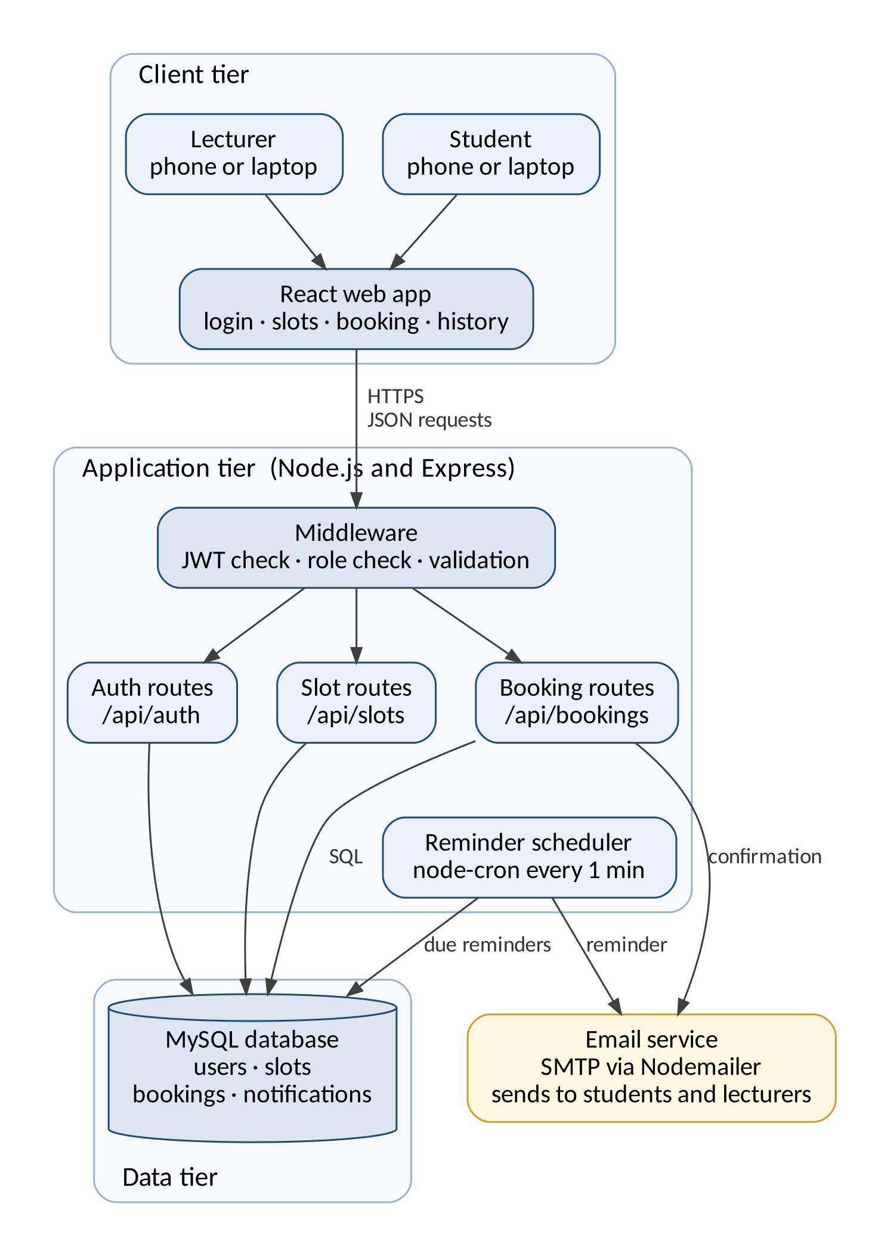
Figure 4.1 CampusBook three tier architecture

4.3 UML Design
Use case diagram
The use case diagram shows what each user can do Students view open slots book change and cancel bookings Lecturers publish edit and remove slots and see upcoming bookings Both log in and view their booking history Booking a slot always includes sending a confirmation and reminder through the email service
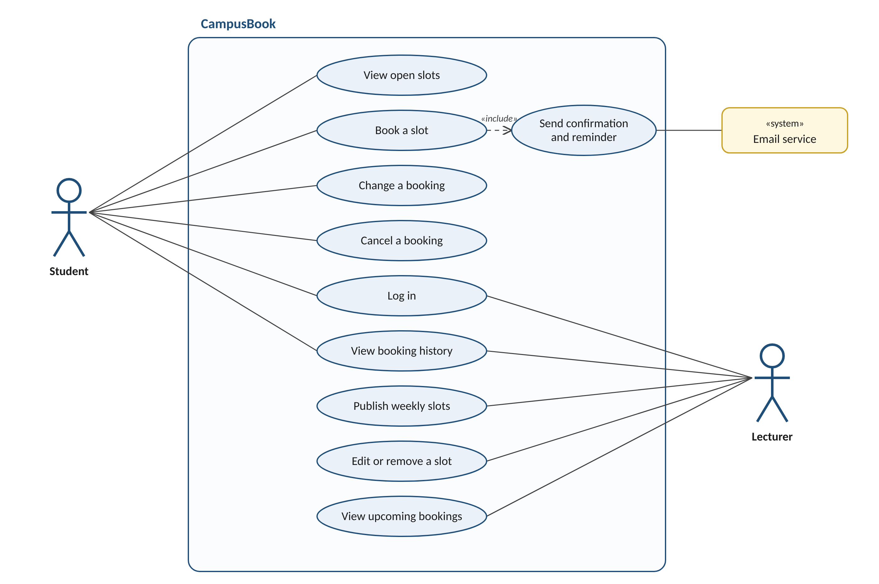
Figure 4.2 Use case diagram
Class diagram
The class diagram shows the main objects in the system Student and Lecturer both inherit from User which holds the login details A lecturer publishes many consultation slots and a slot holds at most one active booking Each booking triggers one or more notifications such as the confirmation and the reminder
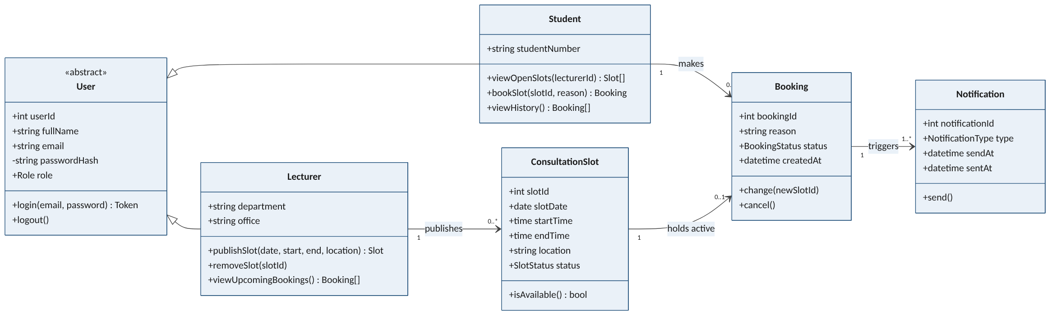
Figure 4.3 Class diagram
Activity diagram
The activity diagram follows a student booking a consultation It shows the two key decisions If no suitable slot is open the student can check another week or lecturer If another student takes the slot first the system shows a message and refreshes the list instead of creating a double booking
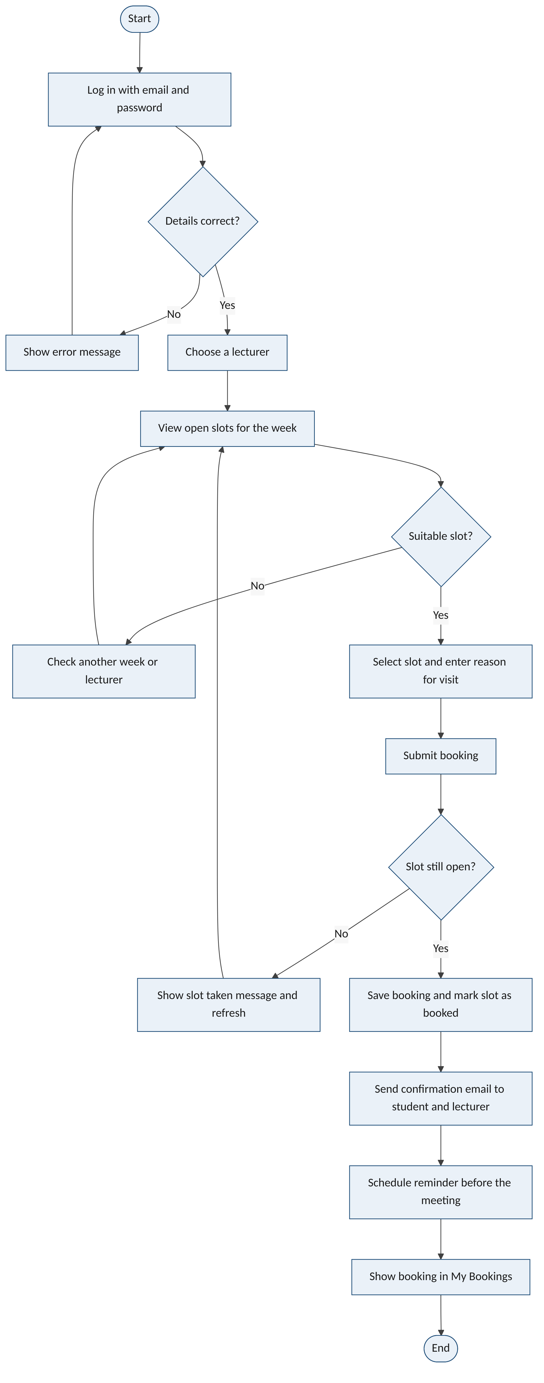
Figure 4.4 Activity diagram for booking a consultation
Sequence diagram
The sequence diagram shows the messages behind a booking The API locks the slot row inside a database transaction so two students pressing book at the same moment cannot both succeed If the slot is open the booking is saved the confirmation email is sent and the student sees a confirmation If not the transaction is rolled back and the student is told the slot was taken
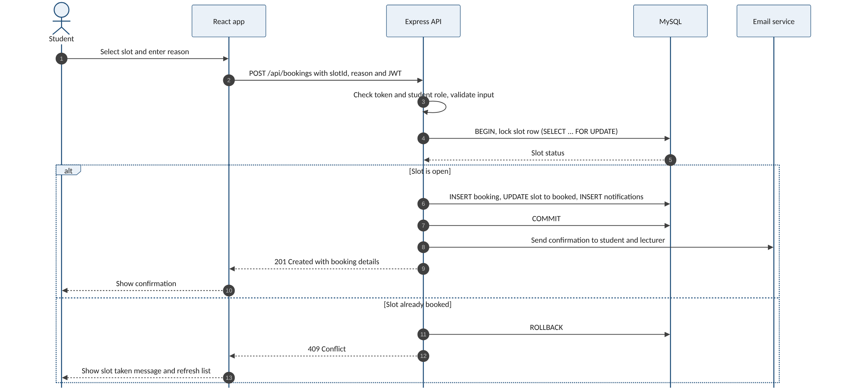
Figure 4.5 Sequence diagram for booking a slot

4.4 Database Design
The database stores users lecturer details consultation slots bookings and notifications The ERD below shows the five tables their keys and how they relate
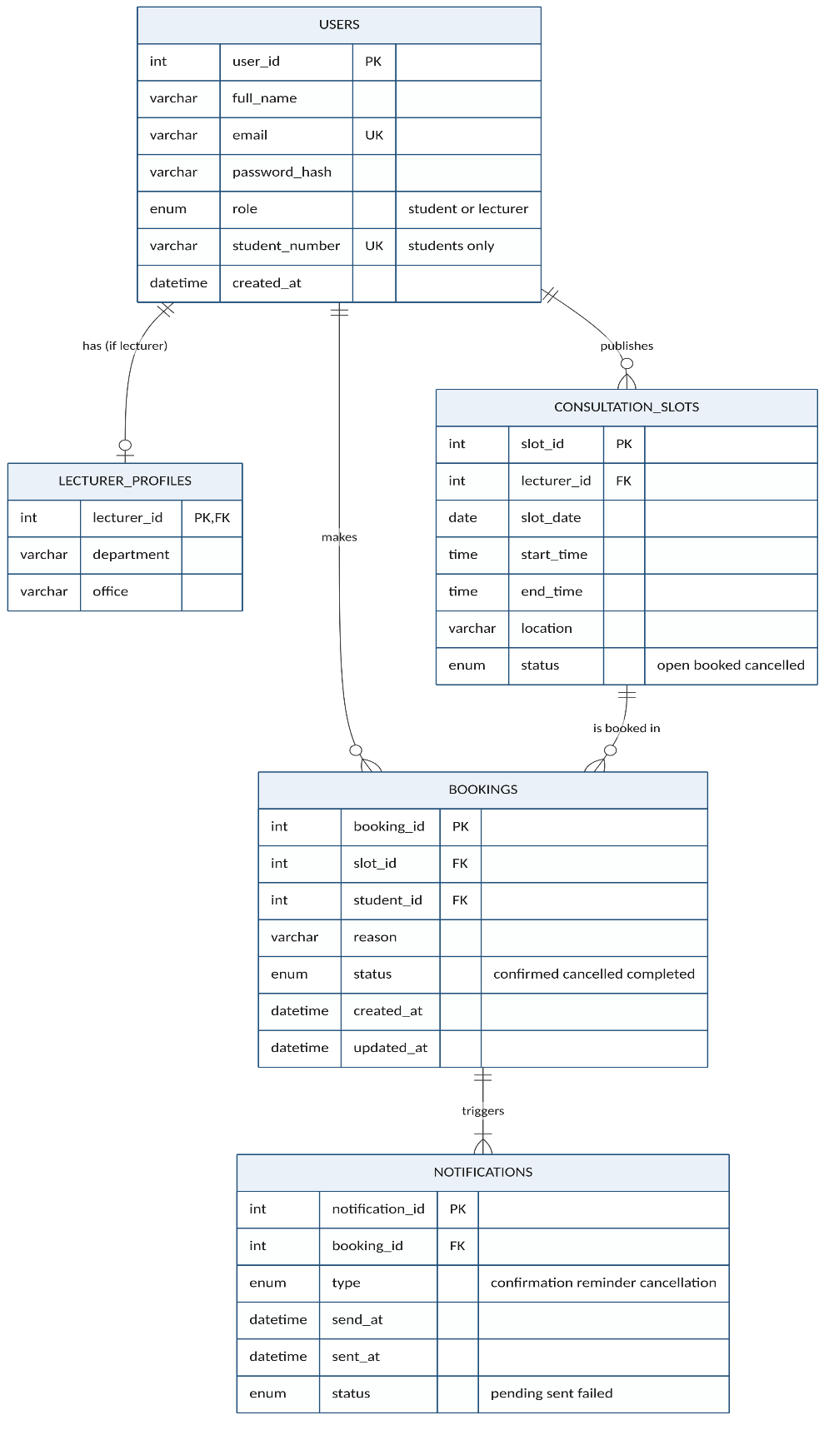
Figure 4.6 Entity relationship diagram
Relationships and cardinality
Table 4.1 Relationships and cardinality
Relationship | Cardinality | Meaning
users to lecturer_profiles | One to zero or one | Only lecturers have a profile
users to consultation_slots | One to many | A lecturer publishes many slots
users to bookings | One to many | A student makes many bookings
consultation_slots to bookings | One to many | A slot can be booked again after a cancellation but only one booking is active at a time
bookings to notifications | One to one or more | Each booking has a confirmation and a reminder

Data dictionary
Table 4.2 Data dictionary
Column | Type | Null | Key | Description
users
user_id | INT UNSIGNED | No | PK | Unique number for each user
full_name | VARCHAR(120) | No |  | Name shown in the app
email | VARCHAR(150) | No | Unique | Used to log in and receive emails
password_hash | VARCHAR(255) | No |  | bcrypt hash never the real password
role | ENUM | No |  | student or lecturer
student_number | VARCHAR(20) | Yes | Unique | Required for students only
lecturer_profiles
lecturer_id | INT UNSIGNED | No | PK and FK | Links to users
department | VARCHAR(100) | No |  | Department the lecturer belongs to
office | VARCHAR(50) | Yes |  | Office or room
consultation_slots
slot_id | INT UNSIGNED | No | PK | Unique number for each slot
lecturer_id | INT UNSIGNED | No | FK | Lecturer who owns the slot
slot_date | DATE | No |  | Day of the consultation
start_time and end_time | TIME | No |  | End must be after start
location | VARCHAR(100) | No |  | Room or Teams
status | ENUM | No |  | open booked or cancelled
bookings
booking_id | INT UNSIGNED | No | PK | Unique number for each booking
slot_id | INT UNSIGNED | No | FK | Slot that was booked
student_id | INT UNSIGNED | No | FK | Student who booked
reason | VARCHAR(255) | No |  | Reason for the visit
status | ENUM | No |  | confirmed cancelled or completed
active_slot_id | INT UNSIGNED | Yes | Unique | Filled only while confirmed stops double booking
notifications
notification_id | INT UNSIGNED | No | PK | Unique number for each email
booking_id | INT UNSIGNED | No | FK | Booking the email belongs to
type | ENUM | No |  | confirmation reminder or cancellation
send_at and sent_at | DATETIME | sent_at only |  | When it is due and when it was sent
status | ENUM | No |  | pending sent or failed

Normalisation
The design is in third normal form Every table has a single column primary key and every other column depends only on that key Lecturer details sit in their own table so they are not repeated for students Lecturer and student names are stored once in users and joined when needed so changing a name never leaves old copies behind Notifications are kept apart from bookings so that one booking can have several emails without repeating booking data
Security and integrity
- Foreign keys stop a booking pointing at a slot or student that does not exist
- A unique key on active_slot_id means a slot can only ever have one confirmed booking
- Check constraints make sure end times are after start times and that students have a student number
- Passwords are stored as bcrypt hashes and each user can only reach their own bookings through the API
- Only made-up data is used during development in line with POPIA
SQL scripts
The full scripts are in the repository at database/schema.sql and database/seed.sql The part that prevents double booking is shown below
CREATE TABLE bookings (
booking_id INT UNSIGNED NOT NULL AUTO_INCREMENT,
slot_id INT UNSIGNED NOT NULL,
student_id INT UNSIGNED NOT NULL,
reason VARCHAR(255) NOT NULL,
status ENUM('confirmed','cancelled','completed') DEFAULT 'confirmed',
active_slot_id INT UNSIGNED AS (IF(status = 'confirmed', slot_id, NULL)) STORED,
PRIMARY KEY (booking_id),
UNIQUE KEY uq_one_active_booking_per_slot (active_slot_id),
CONSTRAINT fk_booking_slot FOREIGN KEY (slot_id) REFERENCES consultation_slots (slot_id),
CONSTRAINT fk_booking_student FOREIGN KEY (student_id) REFERENCES users (user_id)
);

4.5 User Interface Design
The screens below are low fidelity wireframes that show the layout and flow of each page before it was built in React in Week 4 The numbered markers point to the design choices explained under each screen The layout follows the usability heuristics from Chapter 2 (Nielsen, 1994) and keeps every task to as few steps as possible so that booking is quicker than sending a message (Davis, 1989)
Login
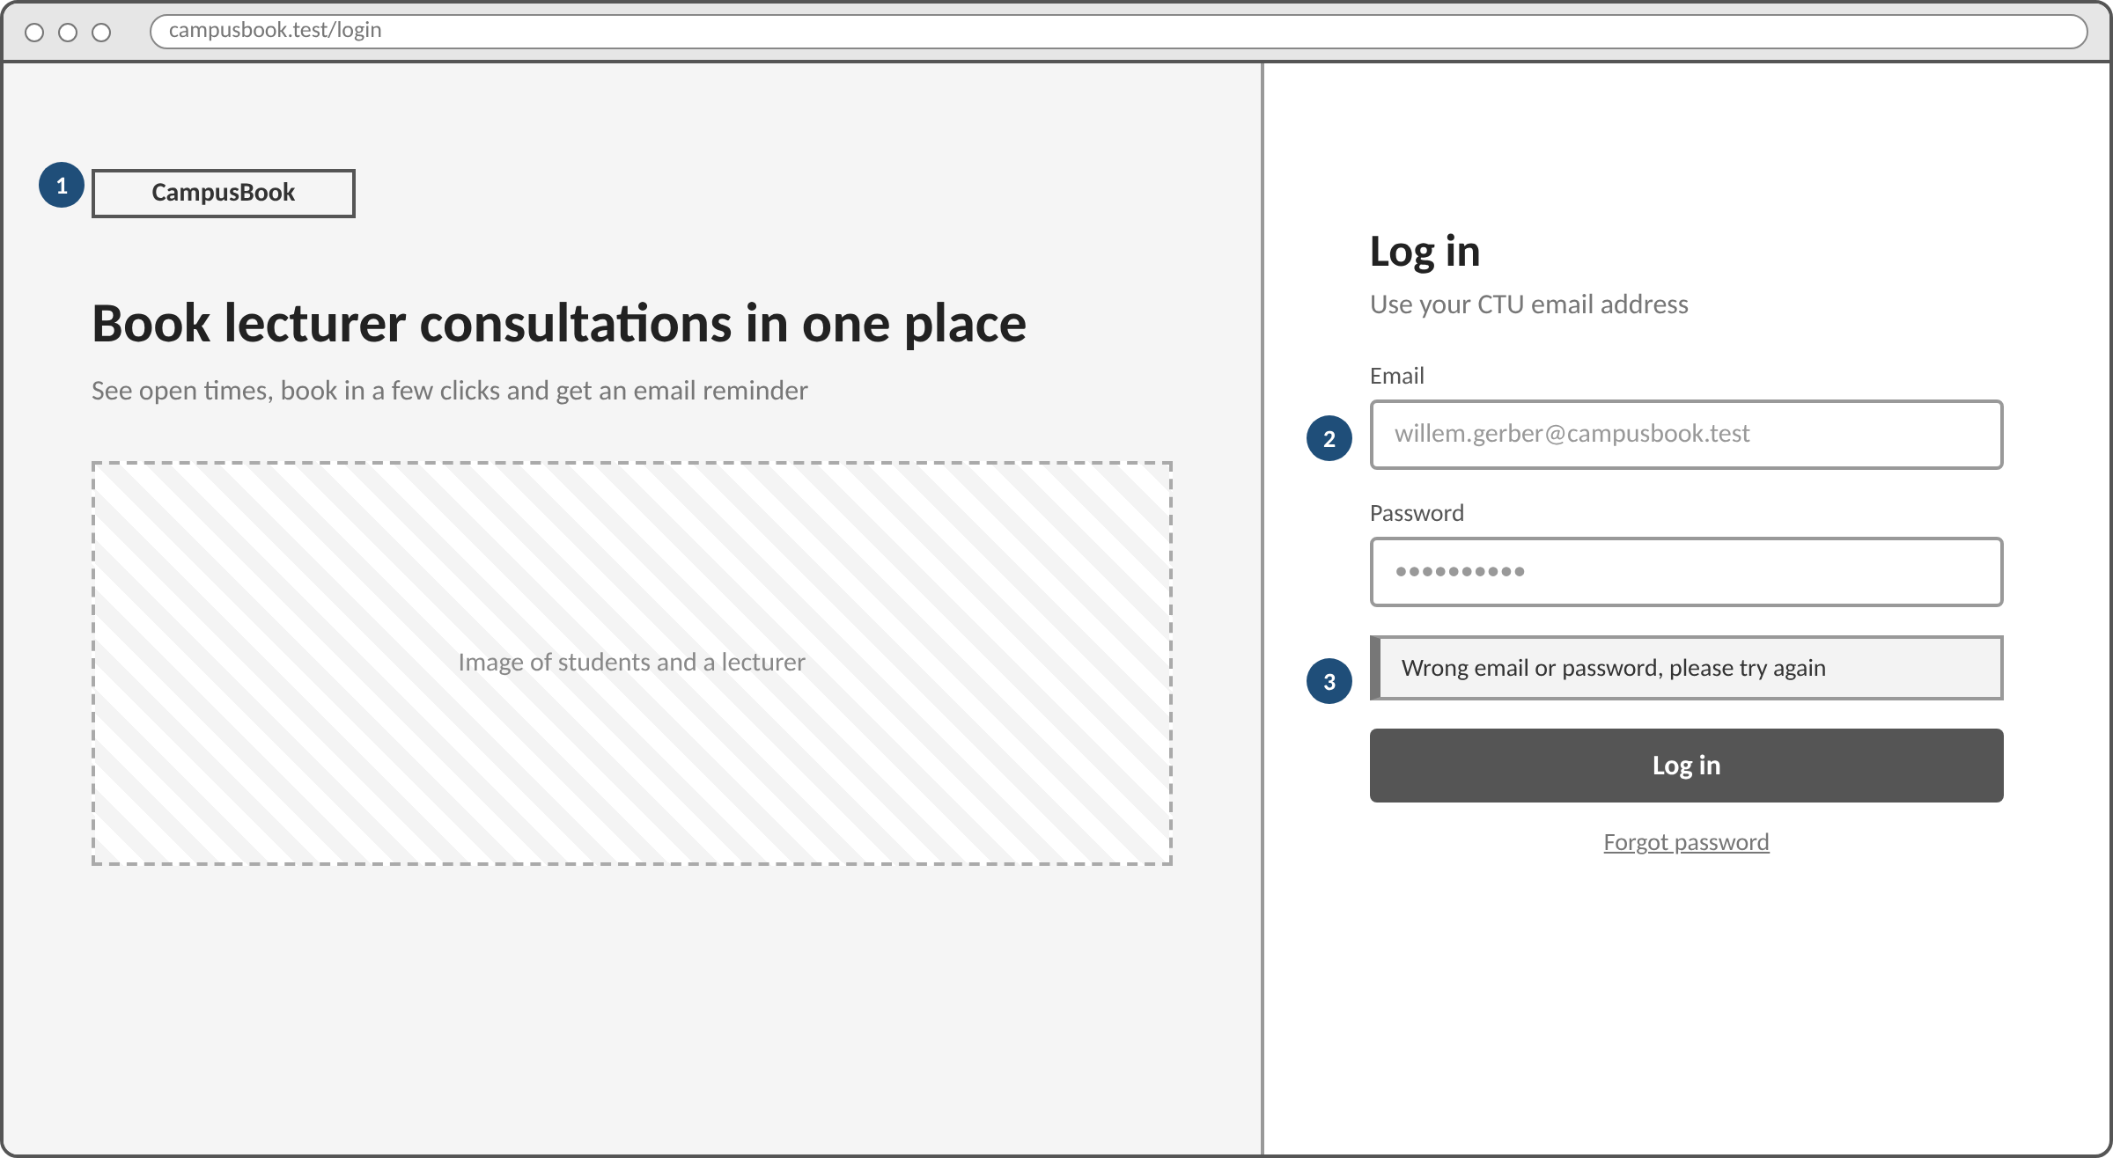
Figure 4.7 Login wireframe
1. The left side explains in one line what CampusBook does so new users know they are in the right place
2. Labels sit above each field and the email field hints that a CTU address is needed
3. Errors appear in plain words right above the button so users can recognise and recover from a mistake
Student booking screen
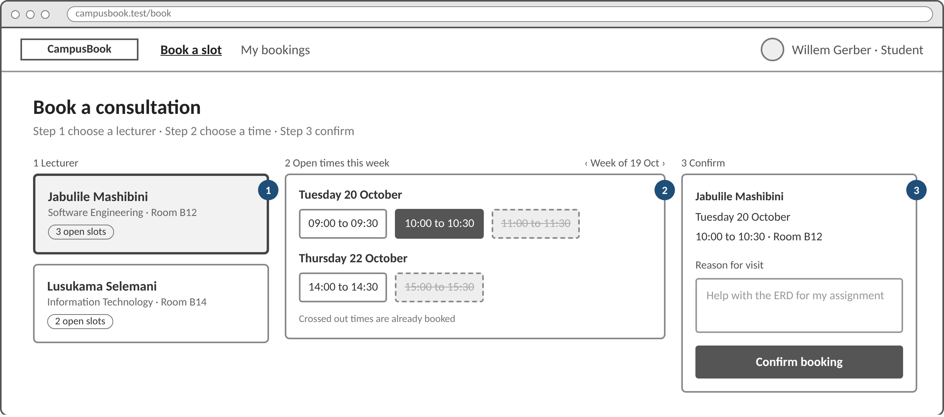
Figure 4.8 Student booking screen wireframe
1. Lecturer cards show the department room and number of open slots so students can choose quickly
2. Open times are grouped by day and times that are already taken are crossed out instead of hidden which prevents errors
3. A summary repeats the lecturer date time and place before the student confirms and the reason for the visit is required
Lecturer slots screen
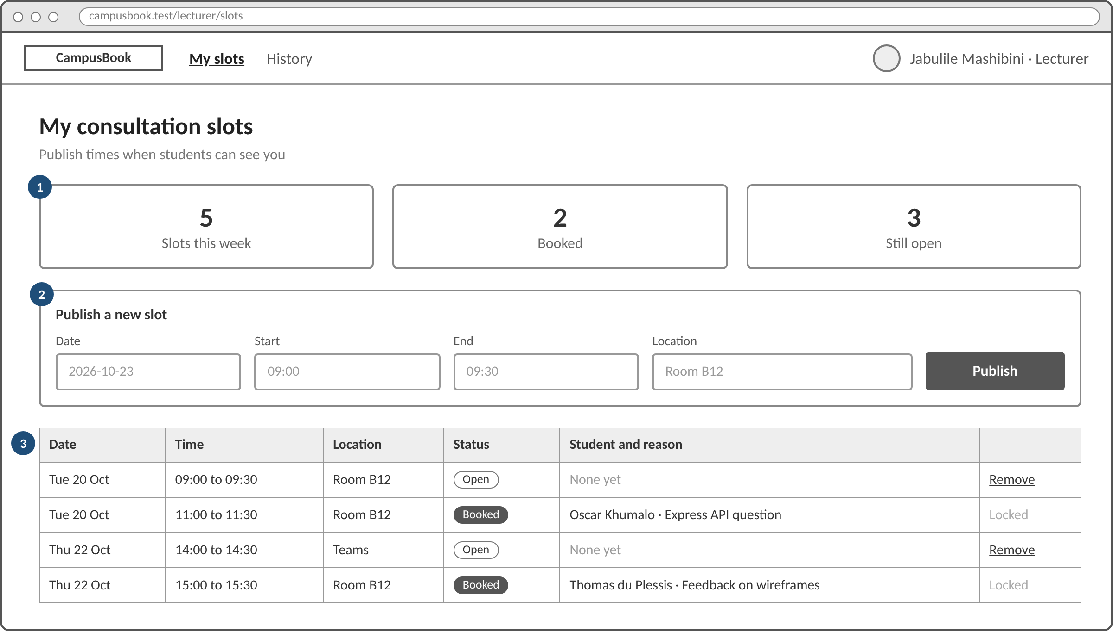
Figure 4.9 Lecturer slots screen wireframe
1. Three counters show the week at a glance so lecturers always know the status of the system
2. A new slot is published with four fields on one line which keeps the most common lecturer task short
3. The table lists every slot with the student and reason and booked slots are locked so a confirmed meeting cannot be removed by accident
My bookings on a phone
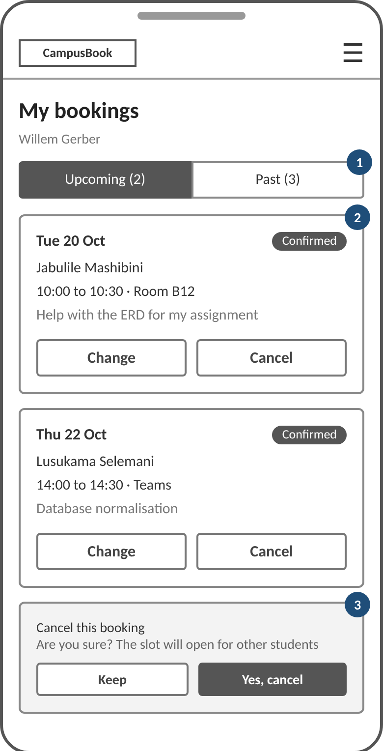
Figure 4.10 My bookings wireframe on a phone
1. Upcoming and past bookings sit in two tabs so the list stays short on a small screen
2. Each card shows the date lecturer time place and reason with large buttons that are easy to tap
3. Cancelling asks for confirmation first and explains that the slot will open for other students

4.6 Implementation
CampusBook was built with a small set of tools that suit a secure and simple consultation booking system
Table 4.3 Development tools
Area | Tools | What they do
Languages | JavaScript  HTML  CSS  SQL | JavaScript runs the frontend and the backend  HTML gives the page structure  CSS controls the look and the small screen layout  SQL creates and reads the database tables
Frontend | React  Vite  React Router | React gives reusable parts for login booking and lecturer slots  Vite is the fast dev server  React Router moves between pages and blocks pages by role
Backend | Node.js  Express | Node.js runs JavaScript on the server  Express handles the REST API for login slots and bookings and talks to the database
IDE | Visual Studio Code | Used to write and organise the code  The built in terminal installs packages runs both servers and runs Git commands
Database | MySQL 8 | Stores accounts slots bookings and notifications  Keys and constraints link the records and stop double bookings
Libraries | bcryptjs  jsonwebtoken  Nodemailer  node-cron | bcryptjs hashes passwords  JSON Web Tokens handle login and roles  Nodemailer sends emails  node-cron runs the reminder job
Services | SMTP  GitHub | SMTP sends booking confirmations and reminders  Both servers run locally for testing  GitHub stores and shares the source code
Version control | Git  GitHub | Each member works on their own branch  Changes are committed pushed and merged through pull requests  This shows who did what and keeps the latest CampusBook version

4.7 Working System
CampusBook is a web-based lecturer consultation booking system developed using React for the frontend, Node.js and Express for the backend, and MySQL for data storage. It provides separate functions for students and lecturers: students can find available consultation times and manage bookings, while lecturers can publish and manage their availability. The modules communicate through a REST API and work together to support the main consultation-booking workflow.
Authentication and Login Module
The authentication module allows students and lecturers to access the system using their login credentials. The application distinguishes between the two user roles so that each user can access the functionality relevant to them. The backend uses authentication and role-based middleware to protect restricted API endpoints. The booking routes require an authenticated user, while specific operations are restricted to students or lecturers.
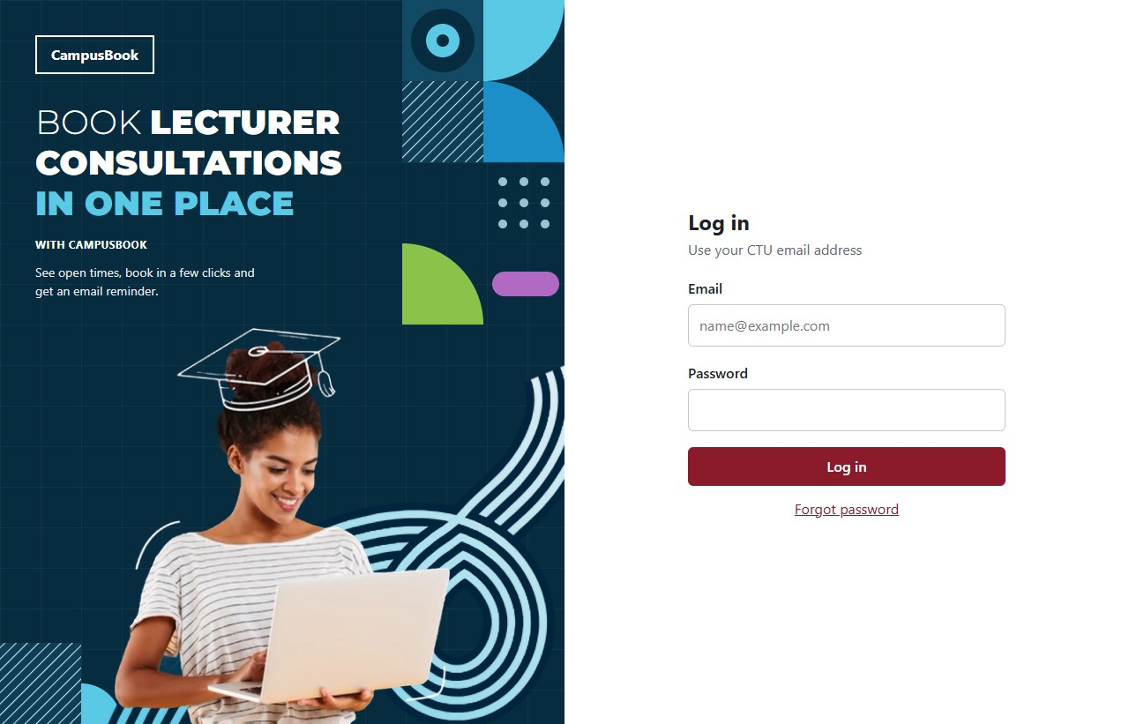
Figure 4.11 CampusBook login page
Code snippet: Protected booking routes
const express = require('express');
const pool = require('../db');
const { requireAuth, requireRole } = require('../middleware/auth');
const { isId, isText, validateBody } = require('../middleware/validate');
const mailer = require('../services/mailer');
const router = express.Router();
router.use(requireAuth);
const REMINDER_MINUTES = Number(process.env.REMINDER_MINUTES_BEFORE || 60);

This code applies the authentication middleware to the booking routes. It helps ensure that booking operations are not accessible to unauthenticated users.
Consultation Slot Management Module
The consultation slot management module enables lecturers to publish consultation times and manage their availability. Students can view available slots and select a suitable time for a consultation.
The backend stores slot information in the consultation_slots table. Each slot is associated with a lecturer, date, start time, end time, location and status. The slot status indicates whether the slot is open, booked or cancelled. This module supports the main objective of providing a centralised method for displaying and managing lecturer consultation availability.
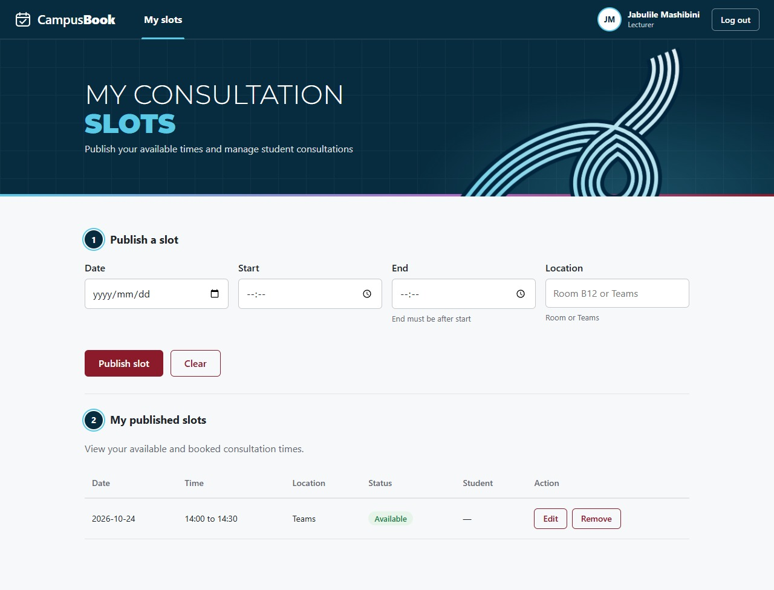
Figure 4.12 Lecturer slots page
Code snippet: Slot time and overlap validation (backend/src/routes/slots.js)
async function checkSlotTime(db, lecturerId, slot, ignoreId = 0) {
if (slot.end <= slot.start) throw httpError(400, 'The end time must be after the start time');
const [[{ isFuture }]] = await db.query('SELECT TIMESTAMP(?, ?) > NOW() AS isFuture', [slot.date, slot.start]);
if (!isFuture) throw httpError(400, 'Choose a time in the future');
const [overlap] = await db.query(
`SELECT slot_id FROM consultation_slots
WHERE lecturer_id = ? AND slot_date = ? AND status <> 'cancelled' AND slot_id <> ?
AND start_time < ? AND end_time > ?
LIMIT 1`,
[lecturerId, slot.date, ignoreId, slot.end, slot.start]
);
if (overlap.length) throw httpError(409, 'This overlaps another one of your slots');
}

Student Booking Module
The student booking module allows a student to select an available consultation slot and provide a short reason for the visit. The backend checks that the slot exists, is still open and starts in the future. The booking operation runs inside a database transaction and locks the slot row while it is processed, helping prevent two students from booking the same time. A database uniqueness constraint also protects against duplicate bookings.
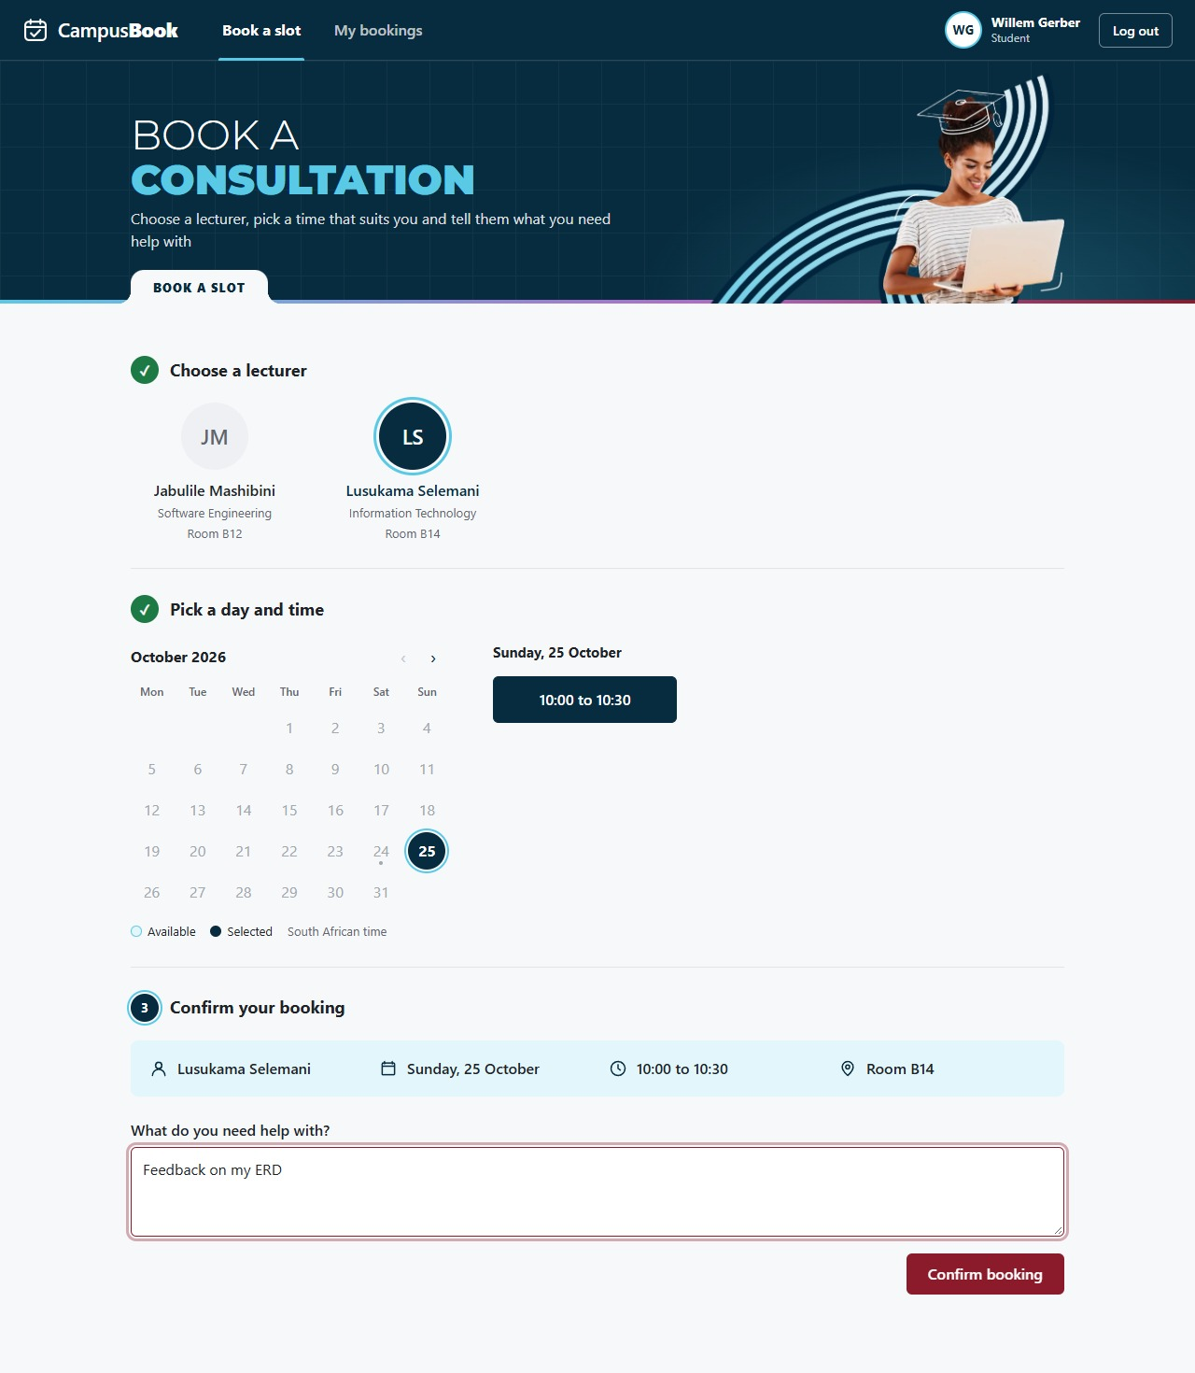
Figure 4.13 Student booking page
Code snippet: Booking availability validation
async function bookSlot(conn, slotId, studentId, reason) {
const slot = await lockSlot(conn, slotId);
if (!slot || slot.status !== 'open' || !slot.isFuture) throw httpError(409, SLOT_TAKEN);
const [result] = await conn
.query('INSERT INTO bookings (slot_id, student_id, reason) VALUES (?, ?, ?)', [slotId, studentId, reason])
.catch(err => { throw err.code === 'ER_DUP_ENTRY' ? httpError(409, SLOT_TAKEN) : err; });
await conn.query("UPDATE consultation_slots SET status = 'booked' WHERE slot_id = ?", [slotId]);
await conn.query(
`INSERT INTO notifications (booking_id, type, send_at) VALUES
(?, 'confirmation', NOW()),
(?, 'reminder', TIMESTAMP(?, ?) - INTERVAL ? MINUTE)`,
[result.insertId, result.insertId, slot.date, slot.start, REMINDER_MINUTES]
);
return { bookingId: result.insertId, slot };
}

This code verifies that the requested slot exists, is open and has not already passed. If these conditions are not satisfied, the booking is rejected. Otherwise it saves the booking, marks the slot as booked and creates the confirmation and reminder notifications.
Booking History and Management Module
The booking management module allows students to view their bookings. Lecturers can also retrieve bookings associated with their consultation slots. The backend provides separate endpoints for student and lecturer booking information. These functions help users keep track of scheduled consultations and manage changes when necessary.
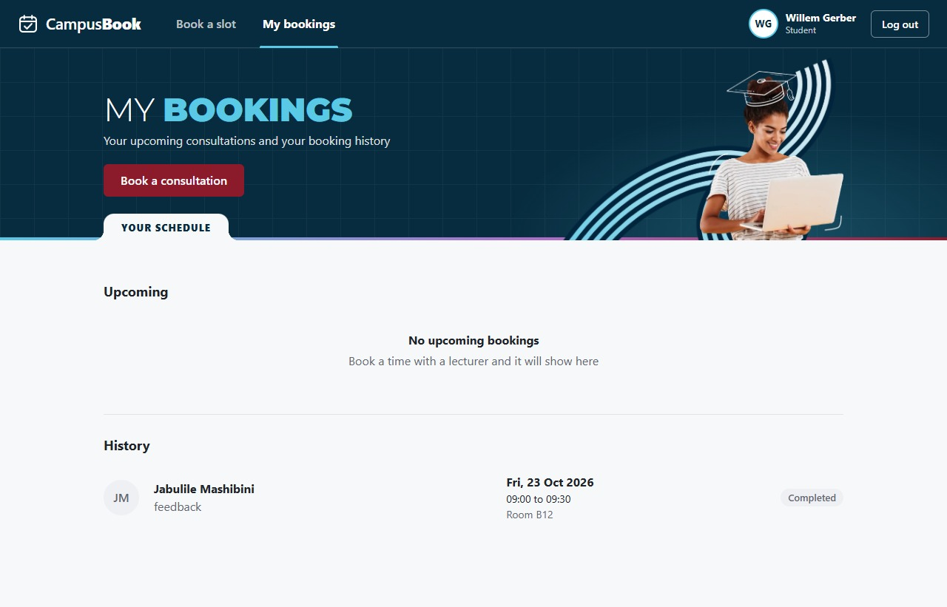
Figure 4.14 Student My bookings page
Code snippet: Retrieving student bookings
router.get('/mine', requireRole('student'), async (req, res, next) => {
try {
const [rows] = await pool.query(
`SELECT ${BOOKING_COLUMNS}, u.full_name AS lecturerName
FROM bookings b
JOIN consultation_slots s ON s.slot_id = b.slot_id
JOIN users u ON u.user_id = s.lecturer_id
WHERE b.student_id = ?
ORDER BY s.slot_date DESC, s.start_time DESC`,
[req.user.id]
);
res.json(toBookingList(rows));
} catch (err) {
next(err);
}
});

The route restricts access to students. It retrieves the booking information from the database and returns the results to the frontend.
Database Connectivity Module
The database module connects the Express backend to MySQL. It provides a reusable connection pool that allows different parts of the backend to execute database queries.
The database contains tables for users, lecturer profiles, consultation slots, bookings and notifications. Relationships between these tables associate students with bookings and lecturers with consultation slots.
Code snippet: Creating the database connection pool
const path = require('path');
require('dotenv').config({
path: path.resolve(__dirname, '../.env'),
});
const mysql = require('mysql2/promise');
const pool = mysql.createPool({
host: process.env.DB_HOST || 'localhost',
port: Number(process.env.DB_PORT || 3306),
database: process.env.DB_NAME || 'campusbook',
user: process.env.DB_USER || 'root',
password: process.env.DB_PASSWORD || '',
waitForConnections: true,
connectionLimit: 10,
queueLimit: 0,
});
module.exports = pool;

The connection settings are read from environment variables rather than being permanently written into the source code. The exported pool is reused by backend routes that need to access MySQL.
The database connection was tested successfully during development.
Email Notification and Reminder Module
The email module uses Nodemailer to send booking-related emails through an SMTP server. These messages are intended to inform students and lecturers about bookings and provide reminders before scheduled consultations.
The system records notification information in the notifications table, including the notification type, scheduled send time, delivery status and time sent. The reminder job uses node-cron to periodically check for reminders that are due.
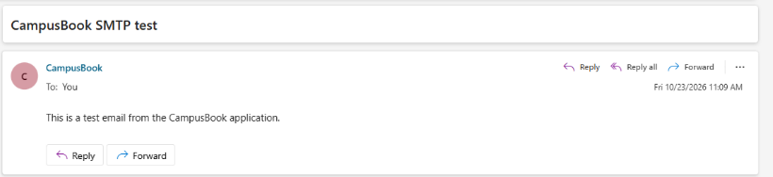
Figure 4.15 SMTP test email
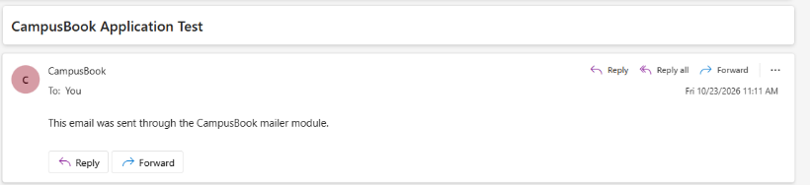
Figure 4.16 Test email sent through the CampusBook mailer module
The SMTP connection and the mailer module were tested successfully with a test email.
Code snippet: Sending a booking confirmation
async function sendEmail(to, subject, text) {
try {
await mailer.sendMail(to, subject, text);
} catch (err) {
console.error(`Email to ${to} failed: ${err.message}`);
}
}
async function emailBoth(user, slot, subject, studentMessage, lecturerMessage) {
await Promise.all([
sendEmail(user.email, subject, studentMessage),
sendEmail(slot.lecturerEmail, subject, lecturerMessage),
]);
}
async function markConfirmationSent(bookingId) {
await pool.query(
"UPDATE notifications SET status = 'sent', sent_at = NOW() WHERE booking_id = ? AND type = 'confirmation'",
[bookingId]
);
}

This illustrates how the booking route sends messages to both the student and lecturer and then marks the confirmation as sent in the notifications table. A failed email is logged and does not stop the booking.
User Interface and Responsive Design
The React frontend provides the pages through which students and lecturers interact with CampusBook. The interface is intended to make consultation management accessible through a web browser and to support use on mobile devices.
The pages correspond to the main user activities, including logging in, selecting and booking a consultation slot, managing bookings and publishing lecturer availability.
Summary of the key modules
The key modules work together to support CampusBook’s consultation-booking workflow. The React frontend provides role-specific pages, the Express backend validates requests and enforces authentication and access control, and MySQL stores user, slot, booking and notification data. The Slots API validates time ranges, future dates and overlaps, while the booking routes protect slot availability, update slot status and provide booking history. Nodemailer and the scheduled reminder job support email communication with students and lecturers.
Implementation Screenshots
This section shows how the main features of CampusBook work in the running system
The system uses React for the frontend with Node.js and Express for the backend and MySQL for users slots and bookings
The screenshots follow the login the student booking flow and the lecturer slot pages and also show errors found during testing and how they were fixed
Repository structure
CampusBook/
backend/

Express REST API (routes middleware services jobs db.js server.js)
frontend/
React web app (pages Login BookSlot MyBookings LecturerSlots)
database/
schema.sql and seed.sql
docs/

diagrams and wireframes

Login
Desktop login
The login page on a desktop screen
The left side introduces CampusBook and the right side has the email and password fields
There is a login button and a forgot password link under the form
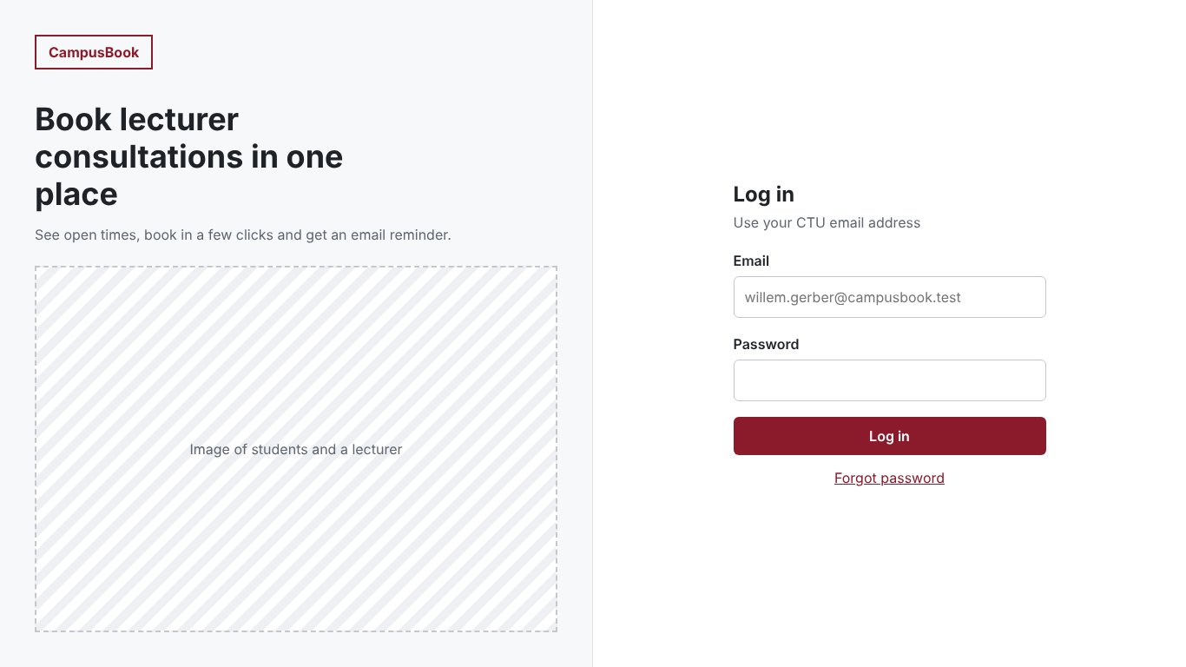
Figure 4.17 Desktop login
Wrong login details
The message shown when the email or password is wrong
The user can try again
The message does not say which one was wrong
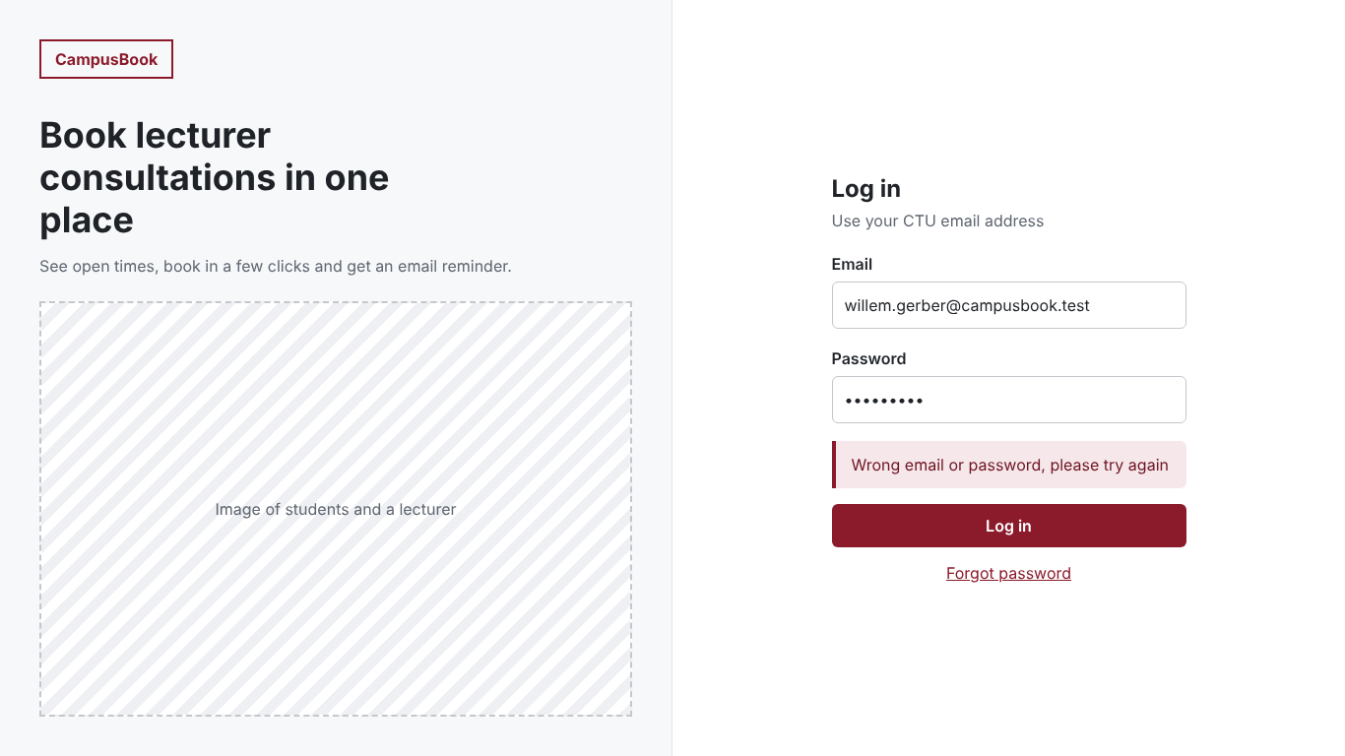
Figure 4.18 Wrong login details
Session expired
When a session ends the user goes back to the login page with a message to log in again
This makes sure protected pages need a valid login
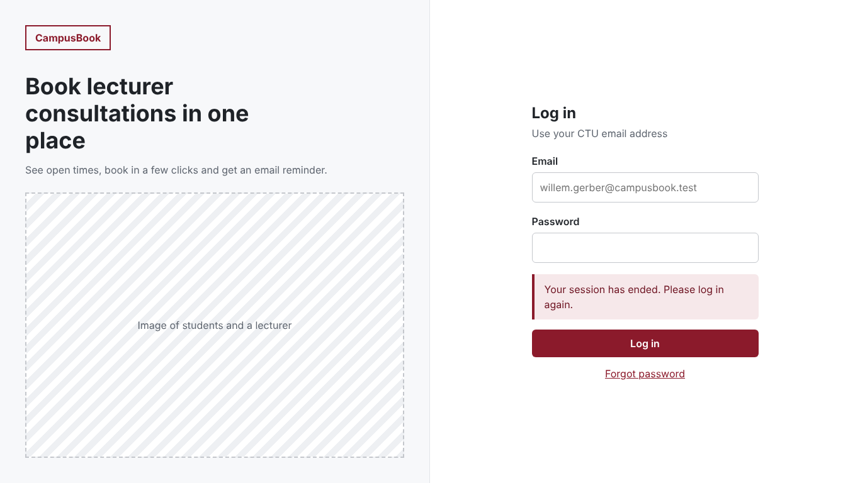
Figure 4.19 Session expired message
Mobile pages
The login booking calendar and booking confirmation pages on a phone
The layout stacks vertically so the form and the times stay easy to use on a small screen
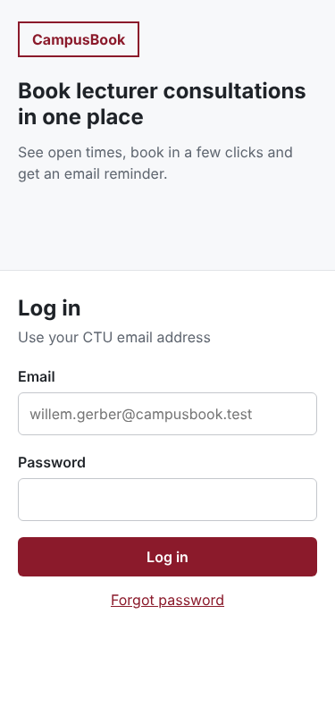 | 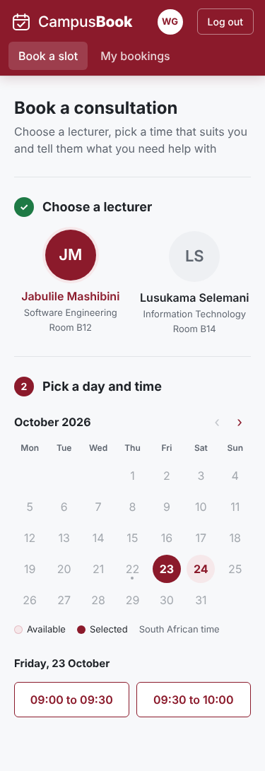 | 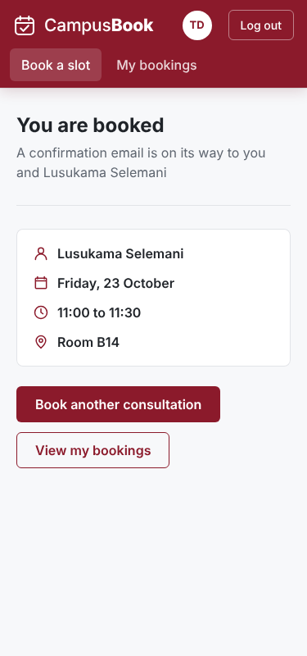
Figure 4.20 Mobile login, booking calendar and confirmation pages
Student booking
Desktop booking page
The student picks a lecturer a date and a time
The summary shows the lecturer date time and location and a reason box explains the purpose before the booking is confirmed
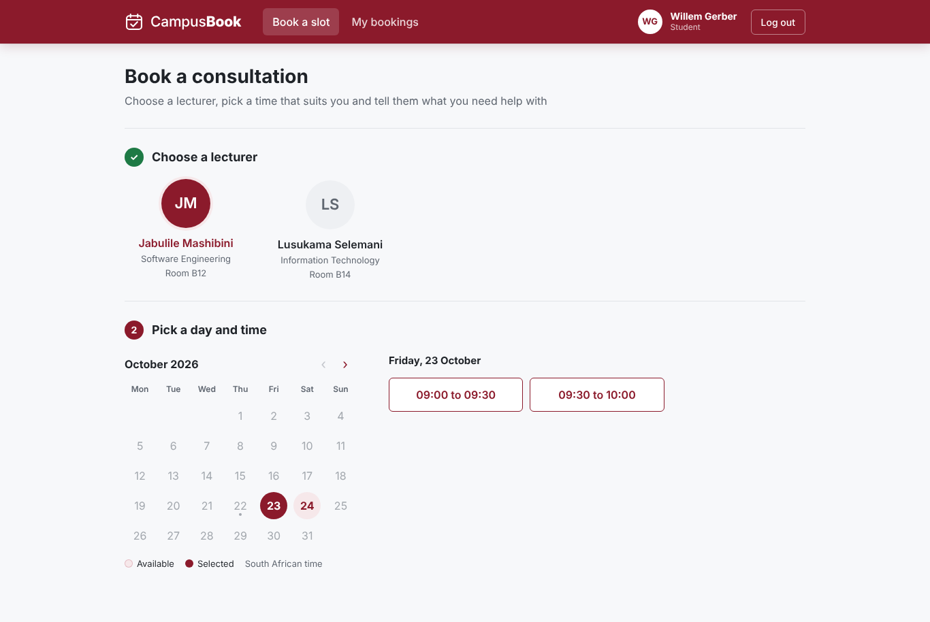
Figure 4.21 Desktop booking page
Times displayed correctly
The available times show correctly and the booking summary matches the selected slot
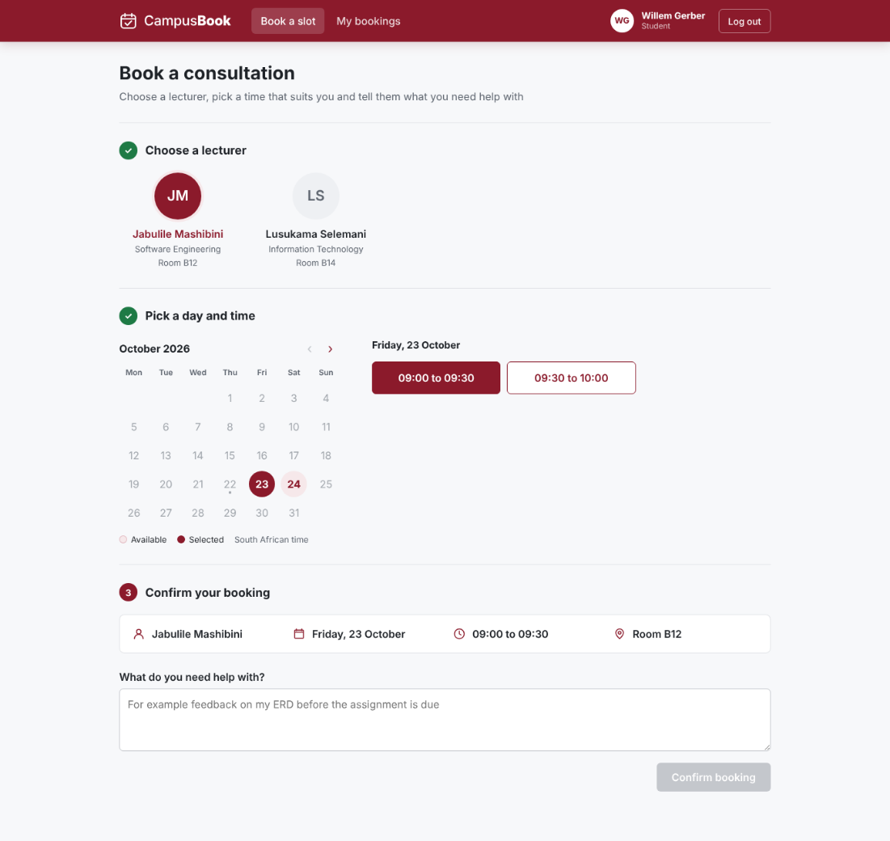
Figure 4.22 Times displayed correctly
Availability after a booking
After a slot is taken only the free time is still offered for that date
The form keeps the reason the student typed
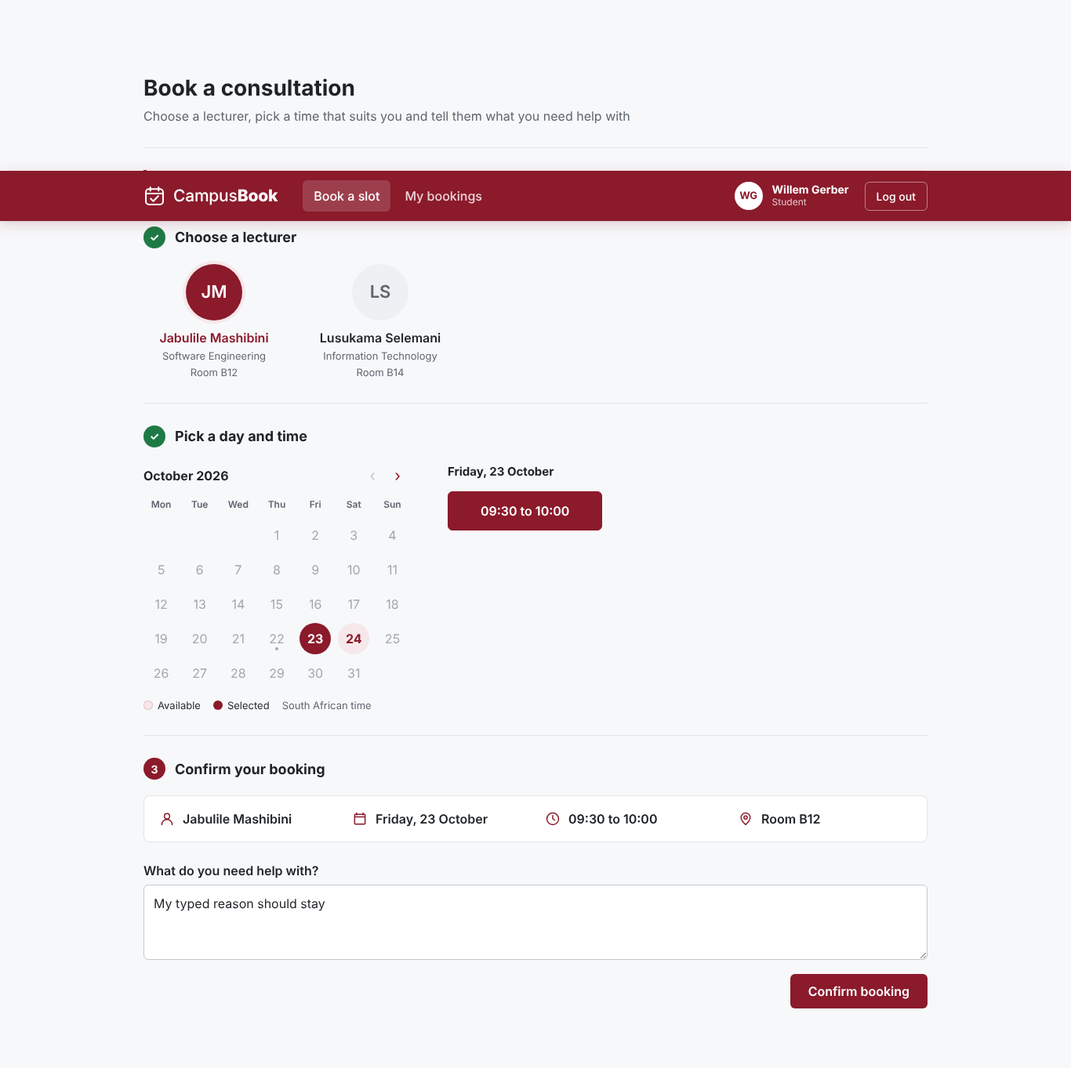
Figure 4.23 Availability after a booking
My bookings
Desktop my bookings
Upcoming bookings and history are shown in two sections with a button to book again
When there are none a message says so
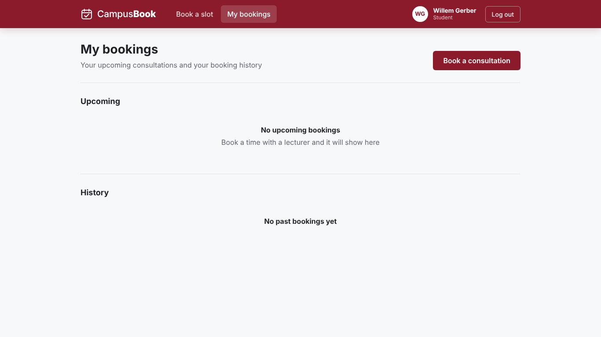
Figure 4.24 Desktop My bookings
Mobile my bookings
The same page on a phone with upcoming and past sections and a button for a new booking
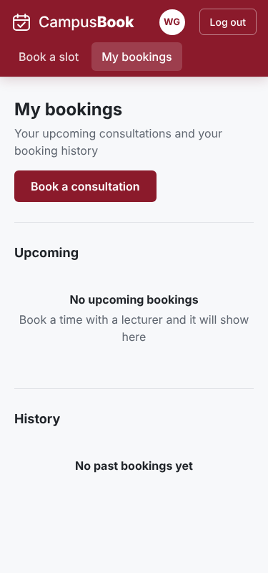
Figure 4.25 My bookings on a phone
Moving a booking
The student picks another time from the dropdown and presses Move Booking to change an existing consultation
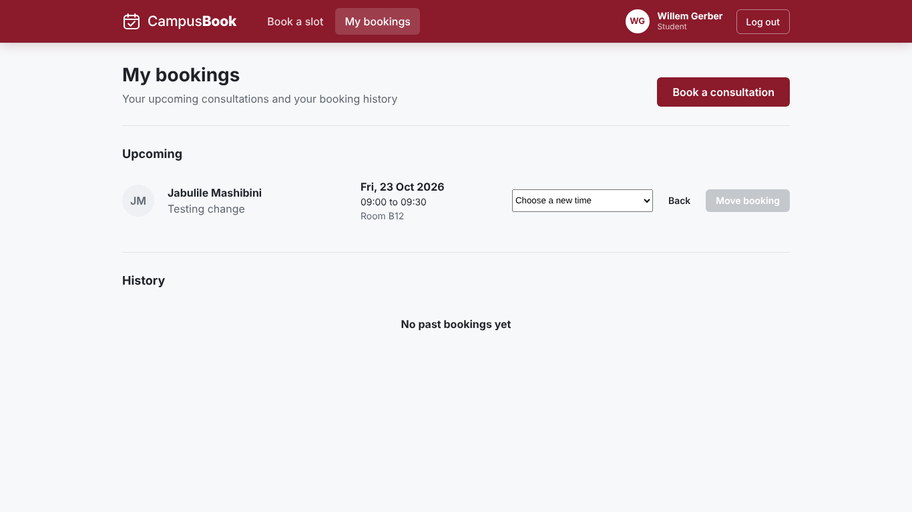
Figure 4.26 Moving a booking
Lecturer slots
Slot published
The lecturer page after slots are published
The table shows date time location and status with Edit and Remove buttons
A green message confirms the new slot
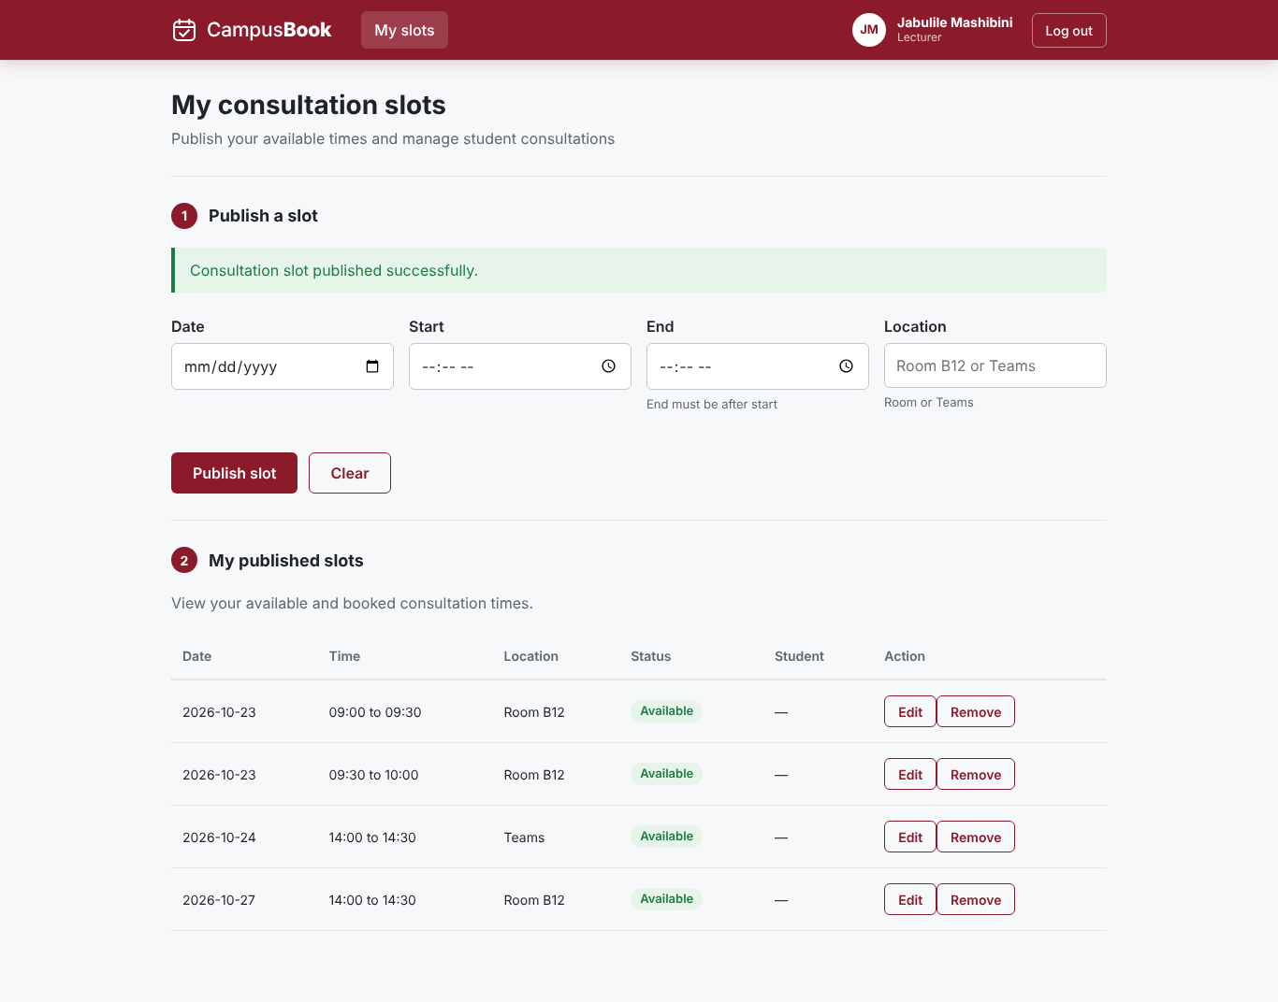
Figure 4.27 Slot published
Slot updated
A slot for 27 October 2026 was changed to Room C3
A green message confirms the update and the table shows the new location
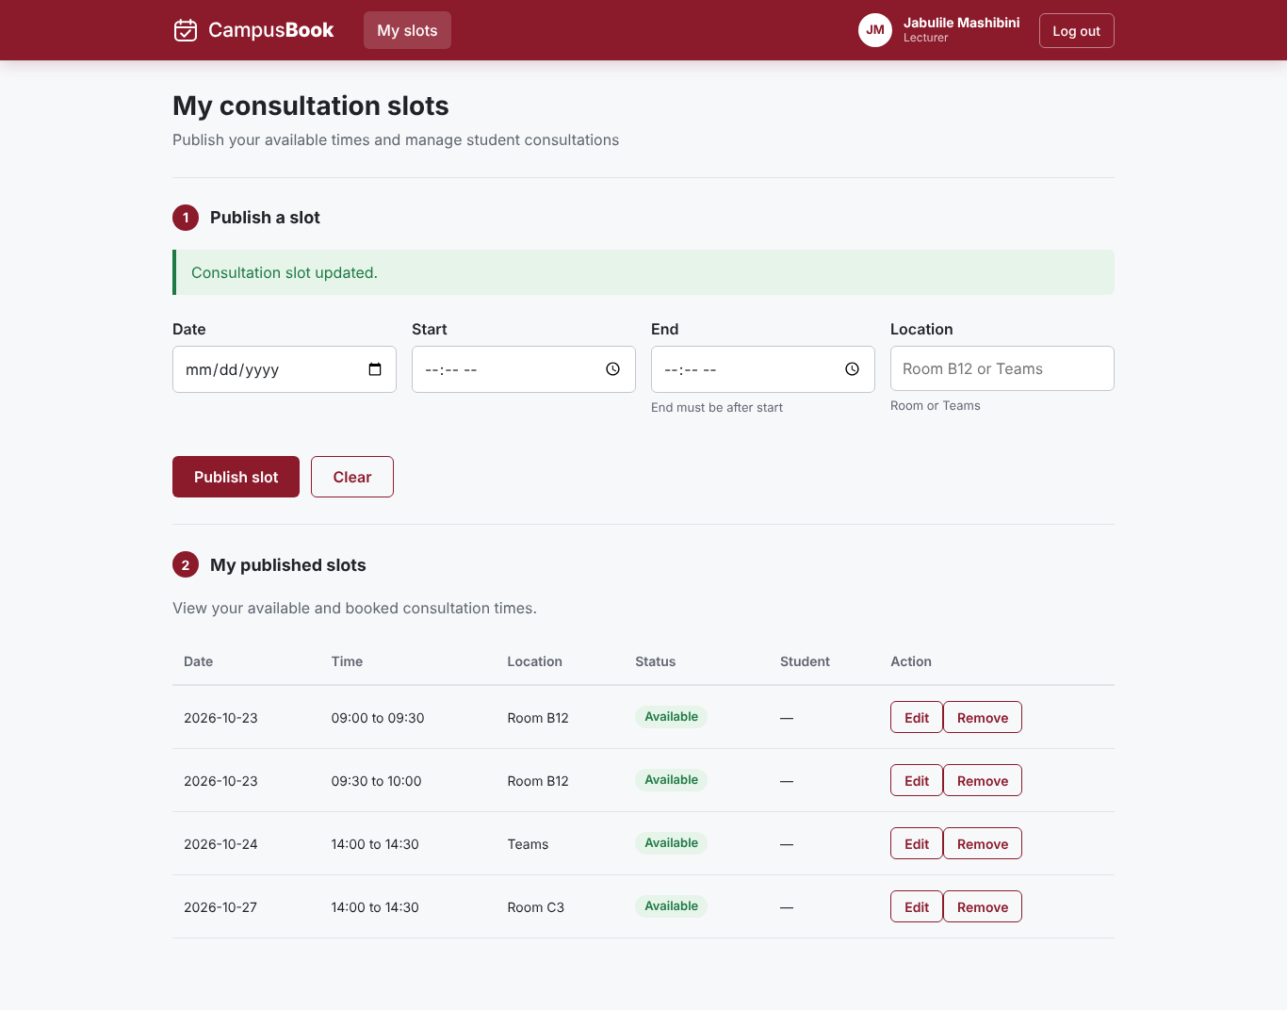
Figure 4.28 Slot updated
Errors found and fixed
Time display error
Earlier the time buttons only showed the word to and the summary showed undefined to undefined
The time values were missing in the frontend
This was found in testing and fixed
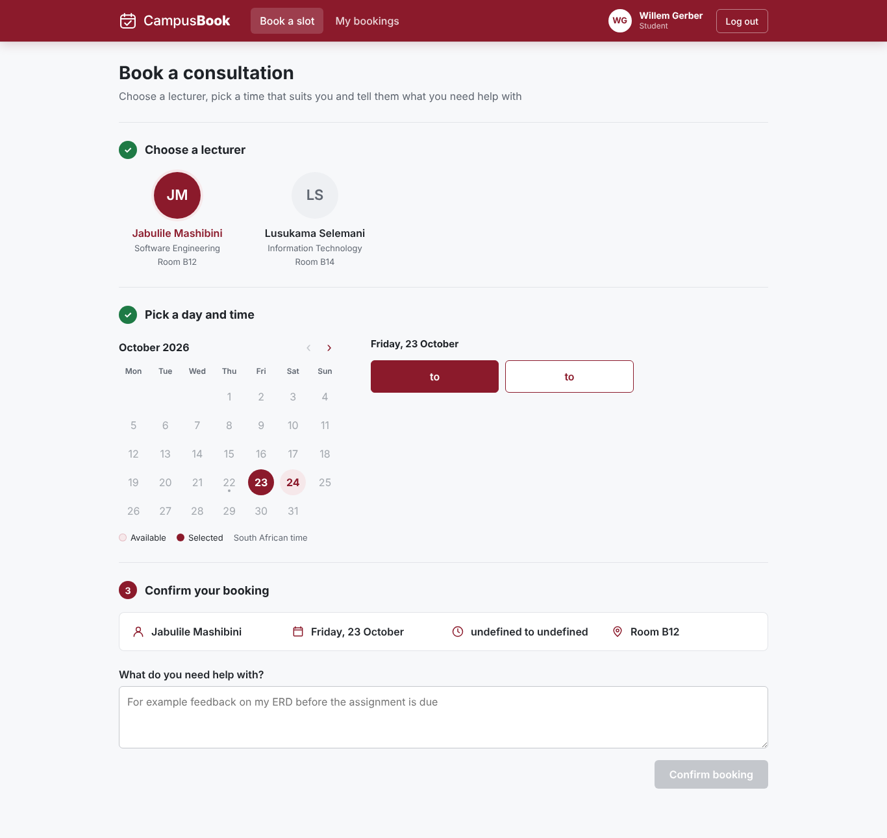
Figure 4.29 Time display error
Slot route error
The page showed that the slot route did not exist
The lecturer page still opened but slots could not be loaded or published
This was a backend integration issue and it was corrected
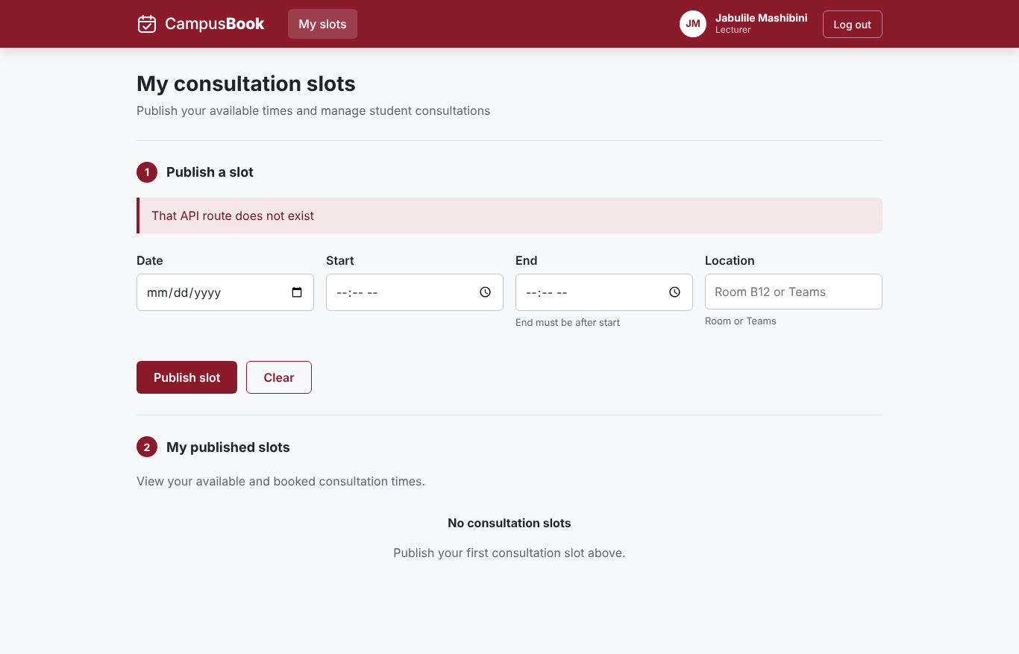
Figure 4.30 Slot route error
Earlier lecturer page
Lecturer page on mobile before slots
An early phone view with the navigation and a coming soon message before slot management was built
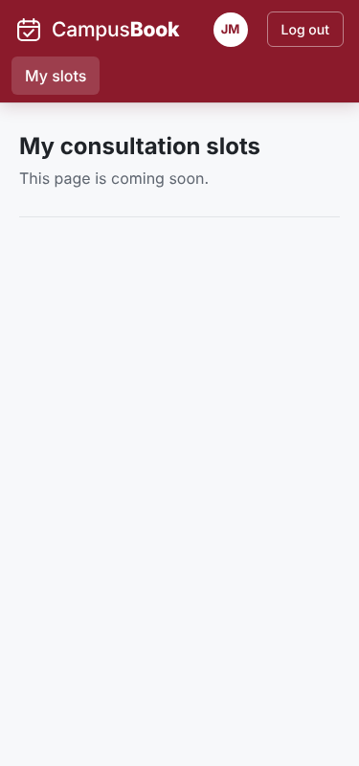
Figure 4.31 Lecturer page on a phone before the slots were added
Lecturer page on desktop before slots
An early desktop view with the same coming soon message
It shows the layout before the slot features were added
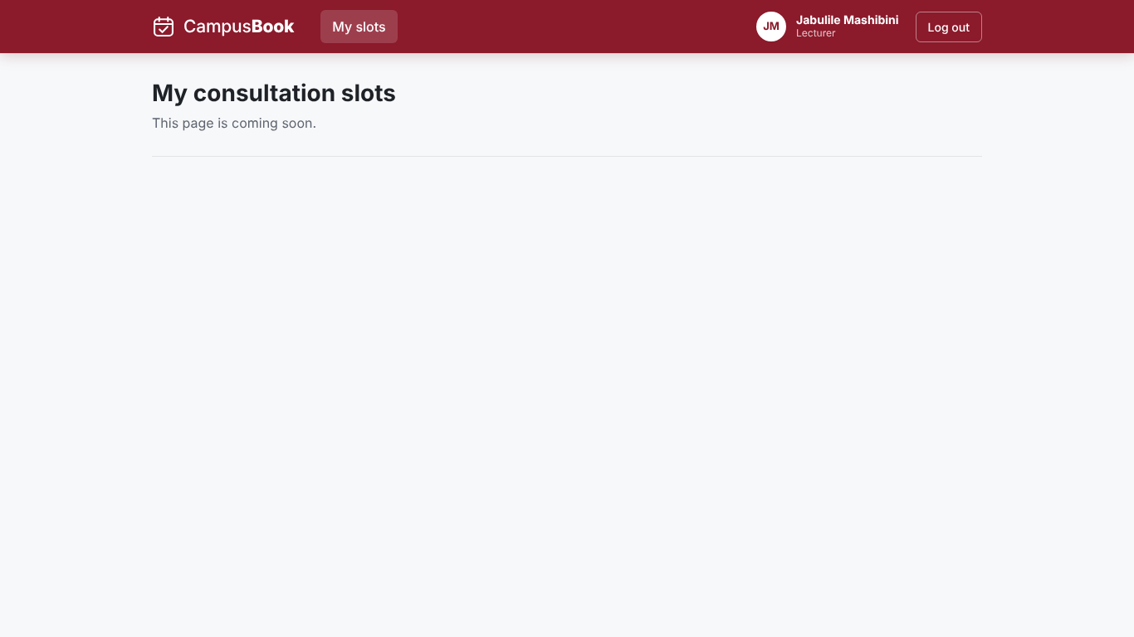
Figure 4.32 Lecturer page on a desktop before the slots were added
Summary of 4.7
The screenshots show login booking changing bookings and slot management working together between students and lecturers
They also show errors that were found and fixed during development

4.8 Version Control and Team Development
GitHub was used to manage development of the CampusBook lecturer consultation booking system. The team worked in a shared repository and used branches and pull requests to organise changes, review contributions and merge work into shared branches. Commit history and pull-request records provide evidence of how the application developed over time and how team members contributed.
GitHub repository overview
The repository overview provides a central location for the project source code, branches, commits and pull requests.
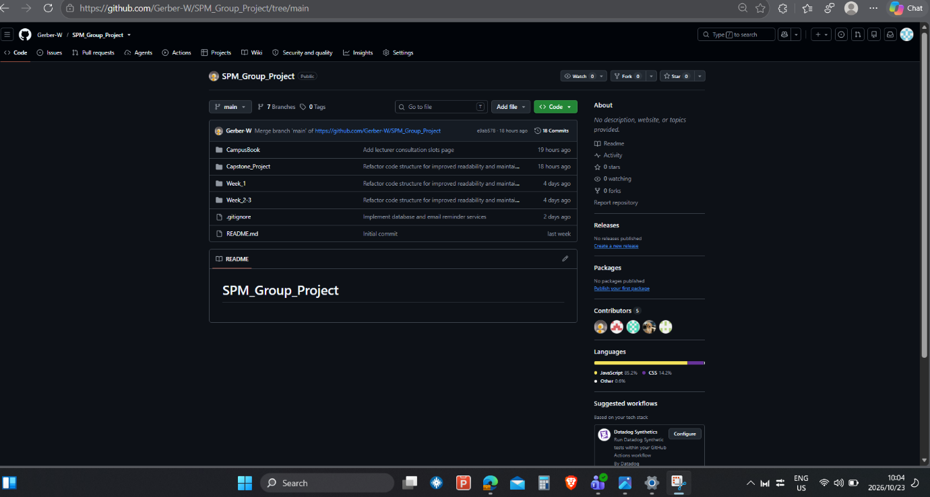
Figure 4.33 GitHub repository overview
Pull Request #4: Slots API Routes
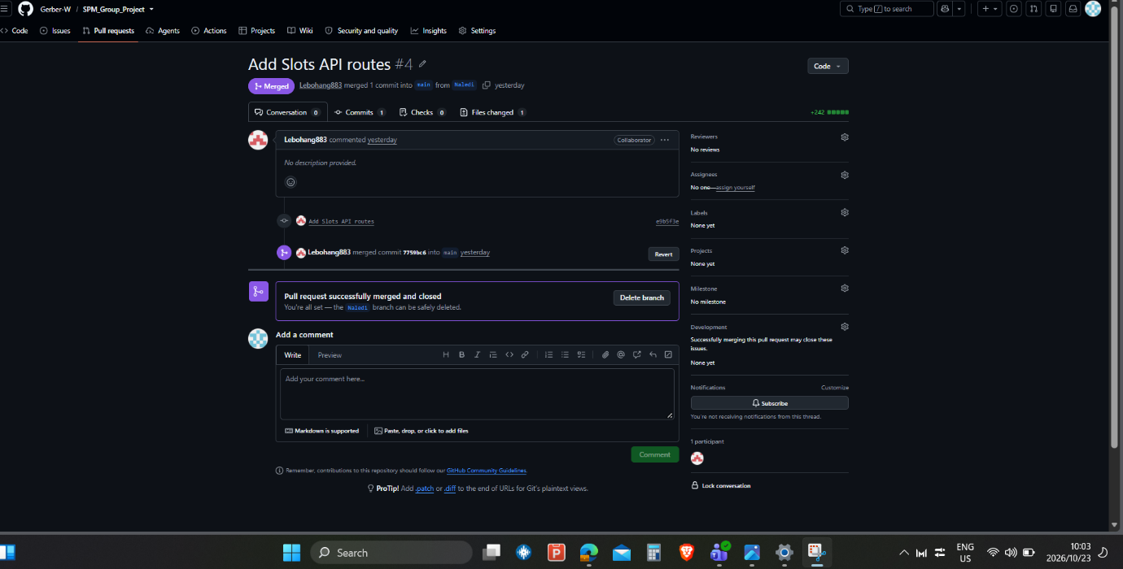
Figure 4.34 Pull Request #4 Slots API routes
Pull Request #4, titled “Add Slots API routes,” submitted changes from the Naledi branch and was merged into main by Lebohang883. The pull request records one commit and one changed file. It provides evidence of the Slots API being added to the shared codebase.
Pull Request #6: Lecturer Consultation Slots
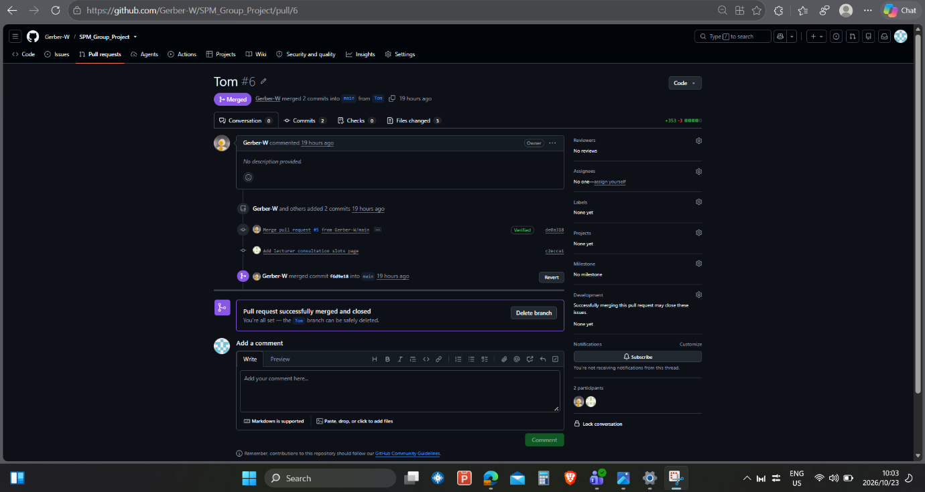
Figure 4.35 Pull Request #6 Lecturer consultation slots
Pull Request #6, titled “Tom,” records two commits from the Tom branch merged into main by Gerber-W. The pull request shows three changed files and provides evidence of development work on the lecturer consultation-slots page.
Pull Request #3: Database and Email Reminder Services
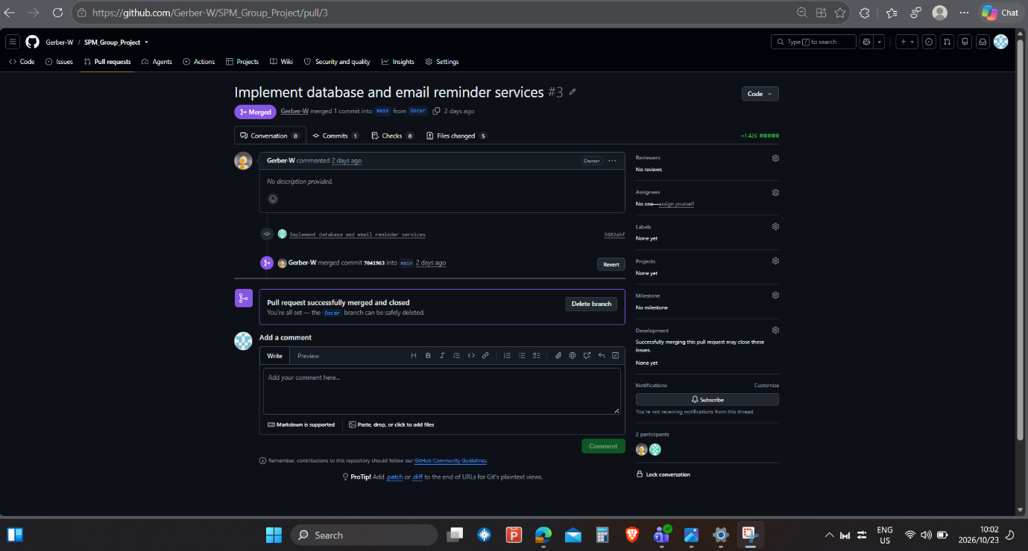
Figure 4.36 Pull Request #3 Database and email reminder services
Database and email work is documented in Pull Request #3, which includes commit 5682abf, “Implement database and email reminder services,” from the Oscar branch. The work includes the reusable MySQL connection module (db.js), the mailer service (mailer.js) and the reminder scheduler (reminders.js). This provides traceable evidence of the implementation through both a pull request and a descriptive commit.
Branches Overview
The repository's branches, commit history and pull requests provide evidence of the team's development activity and individual contributions. The records also show that the team used branches and pull requests to integrate changes into the main branch.
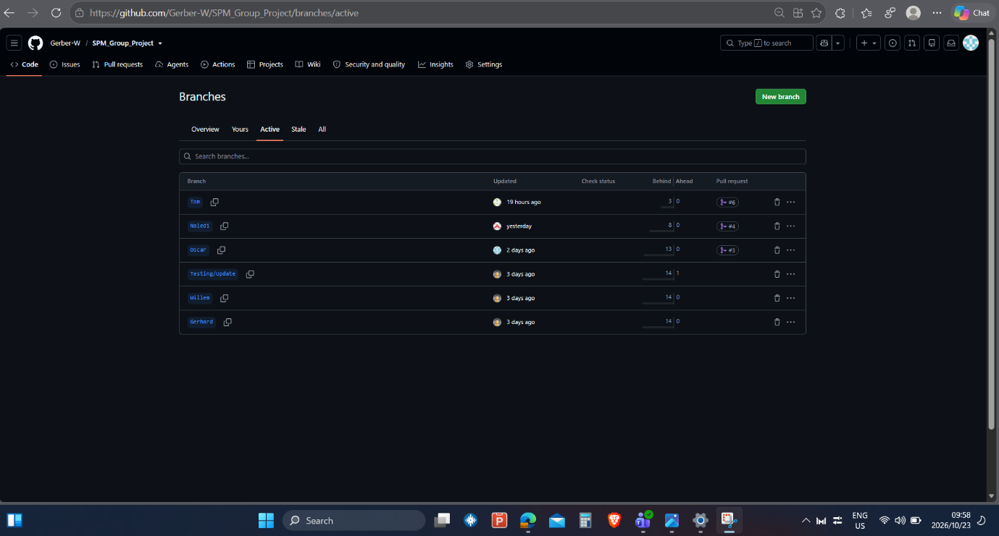
Figure 4.37 Branches overview
Overall Commit History
These commits recorded changes to the CampusBook project through descriptive commit messages and timestamps. The repository also contained seven branches, allowing team members to organise their development work separately. The commit history provided evidence of project progress and helped identify individual contributions and the integration of changes into the main branch.
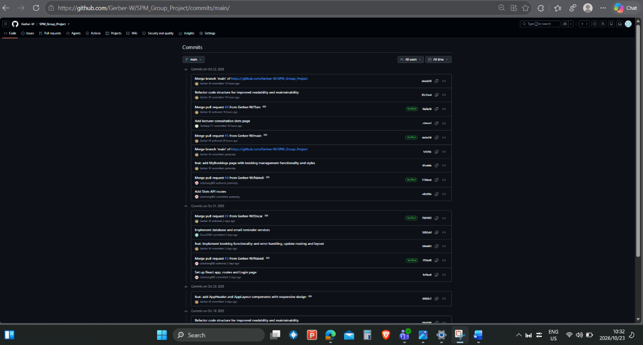
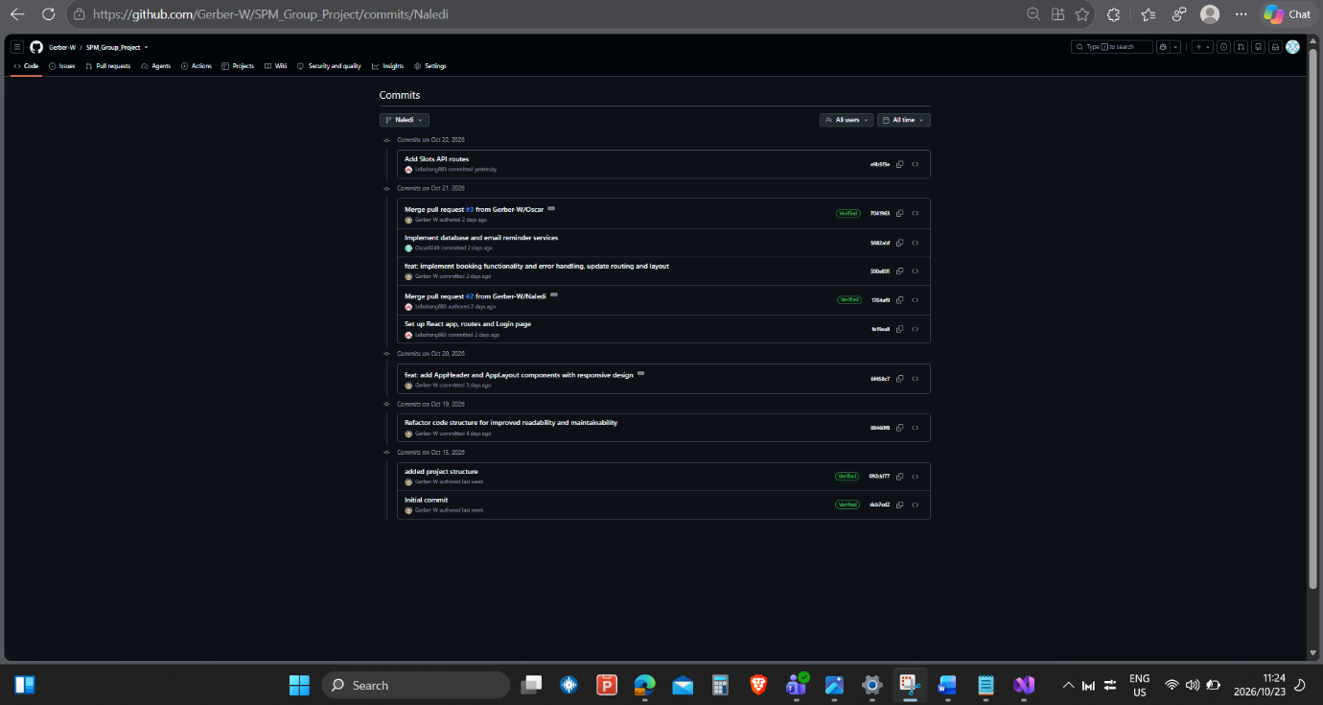
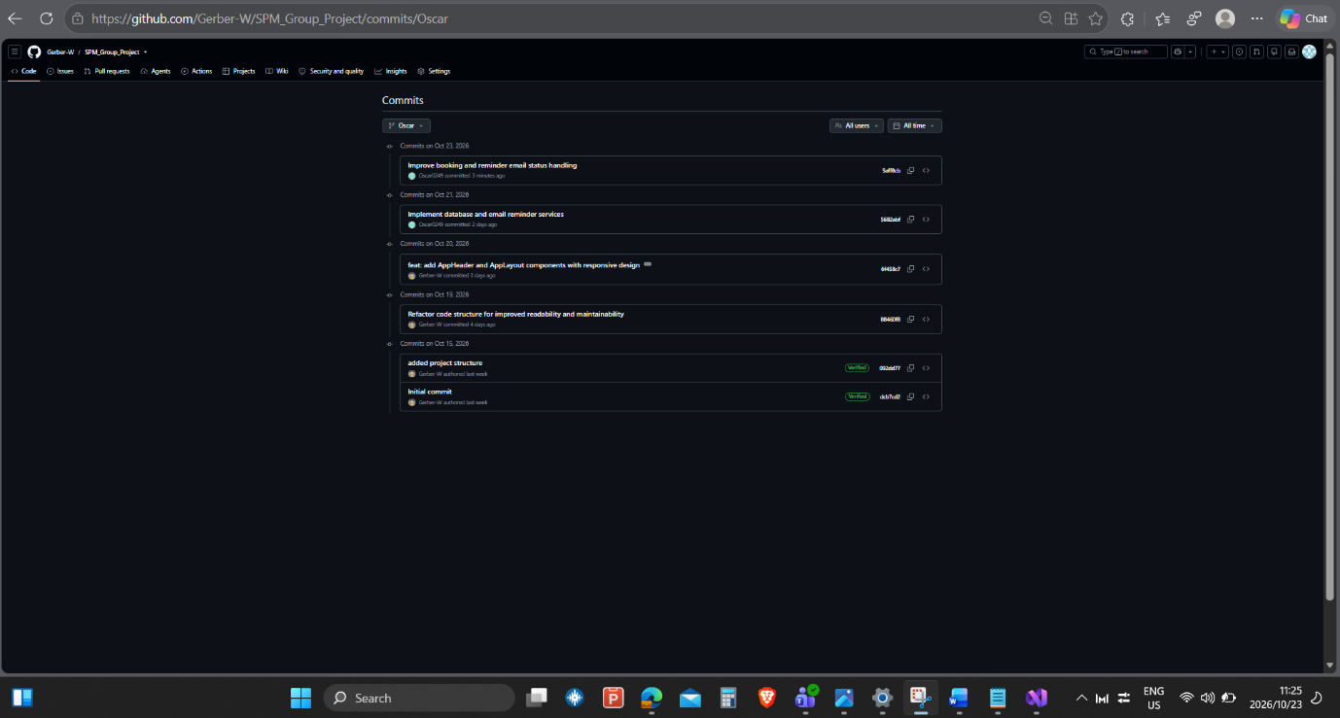
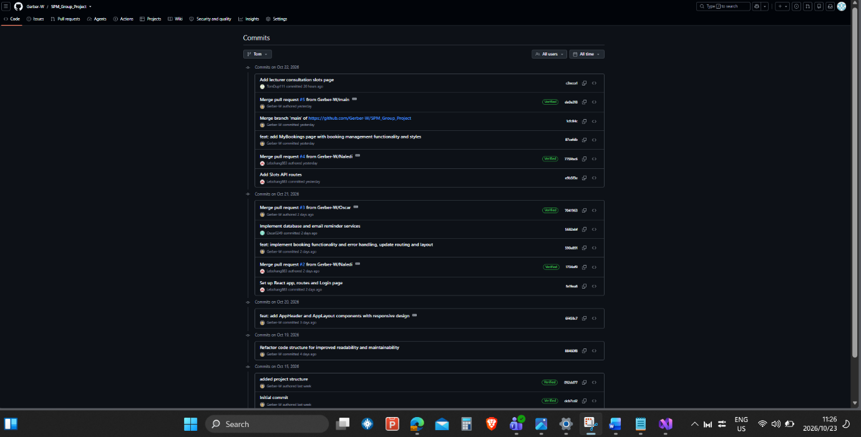
Figure 4.38 Overall commit history
Commits and Pull Requests
The source code of CampusBook is kept in one GitHub repository with a main branch that always holds the working version and a branch for each member
Members commit their own work and open a pull request and another member reviews it before it is merged into main
This keeps the history clear and shows who did what
Table 4.4 Key commits and pull requests
Commit or pull request | Date | Member | What it holds
dcb7cd2 and 092dd77 | 15 Oct | Willem Gerber | Repository and project structure
88460f8 | 19 Oct | Willem Gerber | Back-end folders and schema and seed scripts and diagrams
6f458c7 and pull request #1 | 20 Oct | Willem Gerber | Back-end set up and login and middleware and Bookings API
fe19ea8 and pull request #2 | 21 Oct | Lebohang Tlaitlai | React set up and Login page
5682abf and pull request #3 | 21 Oct | Oscar Khumalo | Database connection and email reminders
590e891 | 21 Oct | Willem Gerber | Booking error handling and Book a slot page
e9b5f3e and pull request #4 | 22 Oct | Lebohang Tlaitlai | Slots API
87cefdb | 22 Oct | Willem Gerber | My bookings page and phone layout
c2ecca1 and pull request #6 | 22 Oct | Thomas du Plessis | Lecturer slots page

The fixes found in testing were committed through a pull request and merged into main after review

Chapter Summary
Chapter 4 showed how CampusBook was designed and built
The architecture and the diagrams and the wireframes were turned into a React front end and an Express back end with a MySQL database
All the planned pages work for students and lecturers and the screenshots in 4.7 show them running
Version control with GitHub kept the work of the group clear
Chapter 5 tests the system against the requirements and reports the results

Chapter 5 Testing, Results and Evaluation

5.1 Test Plan
This chapter shows how CampusBook was tested and what the tests found It checks the working app against the functional and non-functional requirements from Chapter 3
The tests were run on 22 October 2026 on the main branch at commit e9ab578 It contains the login Slots API Bookings API database and email services the Book a slot page the My bookings page and the Lecturer slots page that Thomas merged on 22 October The tests found defects so the fixes were made and every failed test was run again The results show the retest and the failure before the fix
This chapter includes the student survey results and the user testing with 4 students and 2 lecturers on 28 October 2026

Test Strategy
Testing followed the Test Plan in folder 06 Tests were written for every requirement before they were run and each test has an expected result and an actual result in the Test Cases and Results workbook
Table 5.1 Test levels
Level | What was tested | Tool
API tests | Every route with valid and invalid input and wrong roles | Node script
Integration tests | API and database and the reminder job and the email preview | Node script and SQL
Browser tests | Pages and journeys and route protection at 375 and 1366 pixels | Playwright and Chromium
Security checks | Role checks and forged tokens and other users records and password storage | Node script and SQL
Performance checks | Page load and API response times | Browser and script timings

Table 5.2 Test environment
Item | Detail
Application | Branch main at commit e9ab578
Back end and database | Node.js 22 and Express with MariaDB 10.11 built from schema.sql and seed.sql
Front end | React 18 and Vite 5 production build
Browser | Chromium through Playwright at 375 x 800 and 1366 x 768
Test data | Seven made up users on the campusbook.test domain
Email | Preview mode so emails print to the server log

The MariaDB server was used in place of MySQL because it runs the same SQL and the same transactions and row locks A final run on MySQL on the demonstration laptop gave the same results
The browser tests were run on the production build Every failed test was first run on the merged code to record the defect and then run again after the fix The fixes were then committed and pushed to the main branch on GitHub
Willem Gerber led the testing and ran the tests Each developer checks and retests the defects in their own files
Acceptance criteria
- Every Must requirement has a test with an actual result
- Every failed test has a defect with an owner
- No open defect stops a student from booking a consultation

5.2 Test Cases and Results
36 test cases were written and linked to the requirements in the Requirements Traceability Matrix The full steps test data and actual results are in Group-3_Test_Cases_and_Results.xlsx
Table 5.3 Summary of test results
Result after the fixes | Number of tests
Pass | 35
Fail | 0
Not run (bookings not timed in the user testing) | 1
Total | 36

Table 5.4 All test cases and results
Test | Requirement | What was tested | Result
TC-01 | FR-01 | Login | Pass
TC-02 | FR-02 | Role checks on the server | Pass
TC-03 | FR-03 | Lecturer manages own slots | Pass
TC-04 | FR-04 | Student views open slots | Pass
TC-05 | FR-05 | Book a slot | Pass
TC-06 | FR-06 | Change and cancel a booking | Pass
TC-07 | FR-07 | No double booking | Pass
TC-08a | FR-08 | Confirmation email | Pass
TC-08b | FR-08 | Reminder email | Pass
TC-09 | FR-09 | Booking history | Pass
TC-10 | NFR-01 | First time student books in under 2 minutes | Not Run
TC-11 | NFR-02 | Main pages load in under 3 seconds | Pass
TC-12 | NFR-03 | Phone and laptop layout | Pass
TC-13 | NFR-04 | Passwords stored as bcrypt hashes | Pass
TC-14 | NFR-05 | Users cannot reach other records | Pass
TC-15 | NFR-06 | Only needed data is stored | Pass
TC-16 | NFR-07 | Errors explain what to fix (API) | Pass
TC-16b | NFR-07 | Errors on screen and kept input | Pass
TC-17 | FR-05 | Book a missing past or taken slot | Pass
TC-18 | FR-03 | Slot validation rules | Pass
TC-19 | FR-03 | Booked slot cannot be edited or removed | Pass
TC-20 | FR-03 | Removing a slot keeps history | Pass
TC-21 | FR-02 | Bad ids bad JSON and unknown routes | Pass
TC-22 | FR-01 | Forged expired and garbage tokens | Pass
TC-23 | NFR-02 | Health check | Pass
TC-24 | NFR-02 | API response time for the slot list | Pass
TC-25 | FR-03 and FR-09 | Lecturer publishes a slot from the page | Pass
TC-26 | FR-08 | Reminder not sent for a cancelled booking | Pass
TC-27 | FR-02 | Pages protected by login and role | Pass
TC-28 | NFR-07 | Expired or invalid session | Pass
TC-29 | FR-06 | Change a booking from the page | Pass
TC-30 | Security (extra) | Repeated wrong passwords are limited | Pass
TC-31 | FR-07 | Database refuses a second confirmed booking | Pass
TC-32 | FR-04 | Times shown on the Book a slot page | Pass
TC-33 | FR-03 | Lecturer removes a slot from the page | Pass
TC-34 | FR-03 | Lecturer edits a slot from the page | Pass

Key results
- Double booking (TC-07) Eight booking requests for one slot were sent at the same moment from three students One booking was created and the other seven were refused with the message Sorry that slot is no longer available The database also refuses a second confirmed booking on its own (TC-31)
- Access control (TC-02 and TC-14) Wrong roles get 403 and missing tokens get 401 and a student cannot cancel or change another student’s booking
- Emails (TC-08a and TC-08b) The confirmation goes to the student and the lecturer and a due reminder is sent and marked sent A cancelled booking leaves no reminder to send (TC-26)
- Passwords (TC-13) All seven stored passwords are 60 character bcrypt hashes
- Slot rules (TC-18 to TC-20) Bad times and past dates and overlaps are refused and a booked slot cannot be edited or removed and removing a slot keeps its booking history
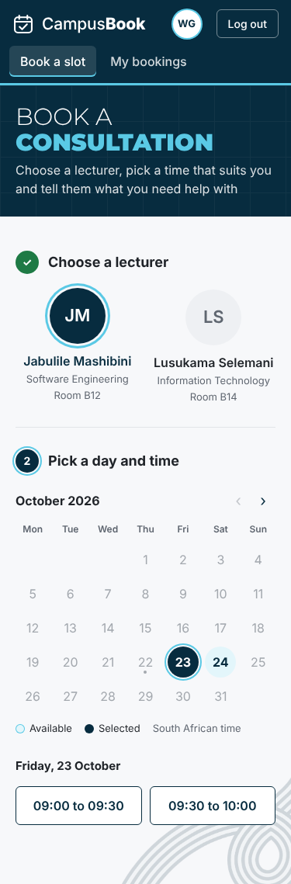  Book a slot on a phone | 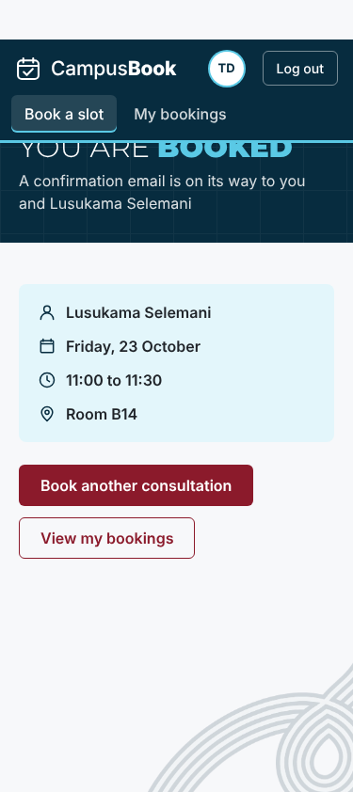  Booking confirmed on a phone | 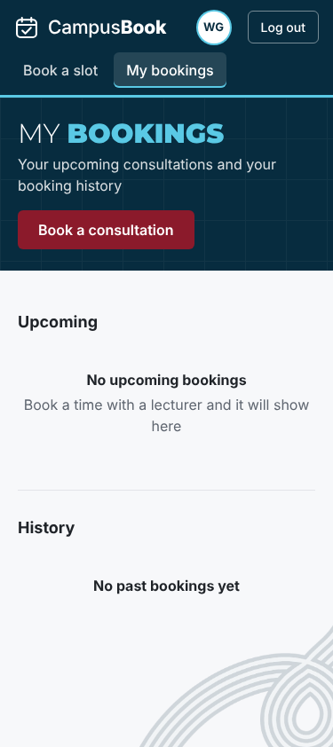  My bookings on a phone
Figure 5.1 Booking a slot on a phone
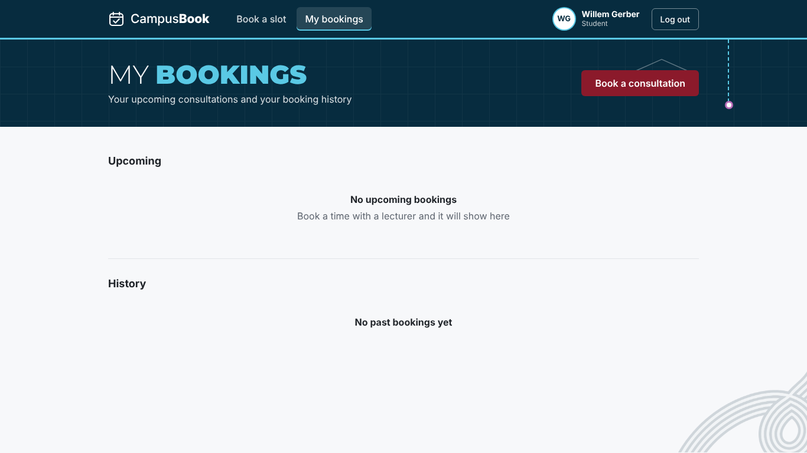
Figure 5.2 My bookings page with no bookings

5.3 Defect Log
On the merged code 6 tests failed and one was blocked and every failure is logged in Group-3_Defect_Log.xlsx 10 defects were logged in total 1 was fixed earlier 9 were fixed after testing and passed the retest and 0 are open Tables 5.3 and 5.4 show the results after the fixes
Table 5.5 Defect summary
ID | Feature | Defect | Severity | Status
D-01 | Bookings API and My bookings | Booking dates came back as time zone shifted dates because the raw slot_date was returned so a booking could show on the wrong day | High | Closed
D-02 | Book a slot page | Time buttons show only "to" and the confirm panel shows "undefined to undefined" because the page reads start and end but the Slots API sends startTime and endTime | High | Fixed
D-03 | Lecturer slots page | The merged page does not work with the Slots API: it calls /api/slots/my but the route is /api/slots/mine so the list shows That API route does not exist and it sends start and end but the API needs startTime and endTime so publishing fails (FR-03 and FR-09) | High | Fixed
D-04 | My bookings page | No change button although the API supports changing a booking (FR-06) | Medium | Fixed
D-05 | Session handling | An expired or invalid token leaves the user on the page with an error and the old token is kept instead of going to the login page | Medium | Fixed
D-06 | Login security | There is no limit on repeated wrong passwords so 40 attempts in a row were all answered | Medium | Fixed
D-07 | Documentation | Chapter 4 says the reminder scheduler runs every 15 minutes but the code runs it every minute | Low | Fixed
D-08 | Book a slot page | After a failed booking the reason box is hidden until a time is chosen again although the typed text is kept | Low | Fixed
D-10 | Lecturer slots page | The page can publish and remove slots but has no way to edit a slot although the API supports editing (FR-03) | Medium | Fixed
D-09 | Route protection | A logged in user who opens the other roles page is sent to the login page and not to their own home page | Low | Fixed

D-01 Booking dates shifted by the time zone (closed)
While building My bookings the dates of some bookings were one day out The query returned the raw database date and the server turned it into a date with a time zone so the day could move The query now returns the date as text with DATE_FORMAT (commit 87cefdb) The retest shows the same date that is stored in the database (TC-05 and TC-09)
D-02 Missing times on the Book a slot page (fixed)
The browser test showed time buttons that only said to and a confirm panel that said undefined to undefined The Book a slot page reads start and end but the Slots API sends startTime and endTime so the page had nothing to show The booking itself still worked The fix maps the two names when the slots are loaded and is three lines in BookSlot.jsx With the fix the buttons show 09:00 to 09:30 and 09:30 to 10:00 The retest passed
Before the fix | 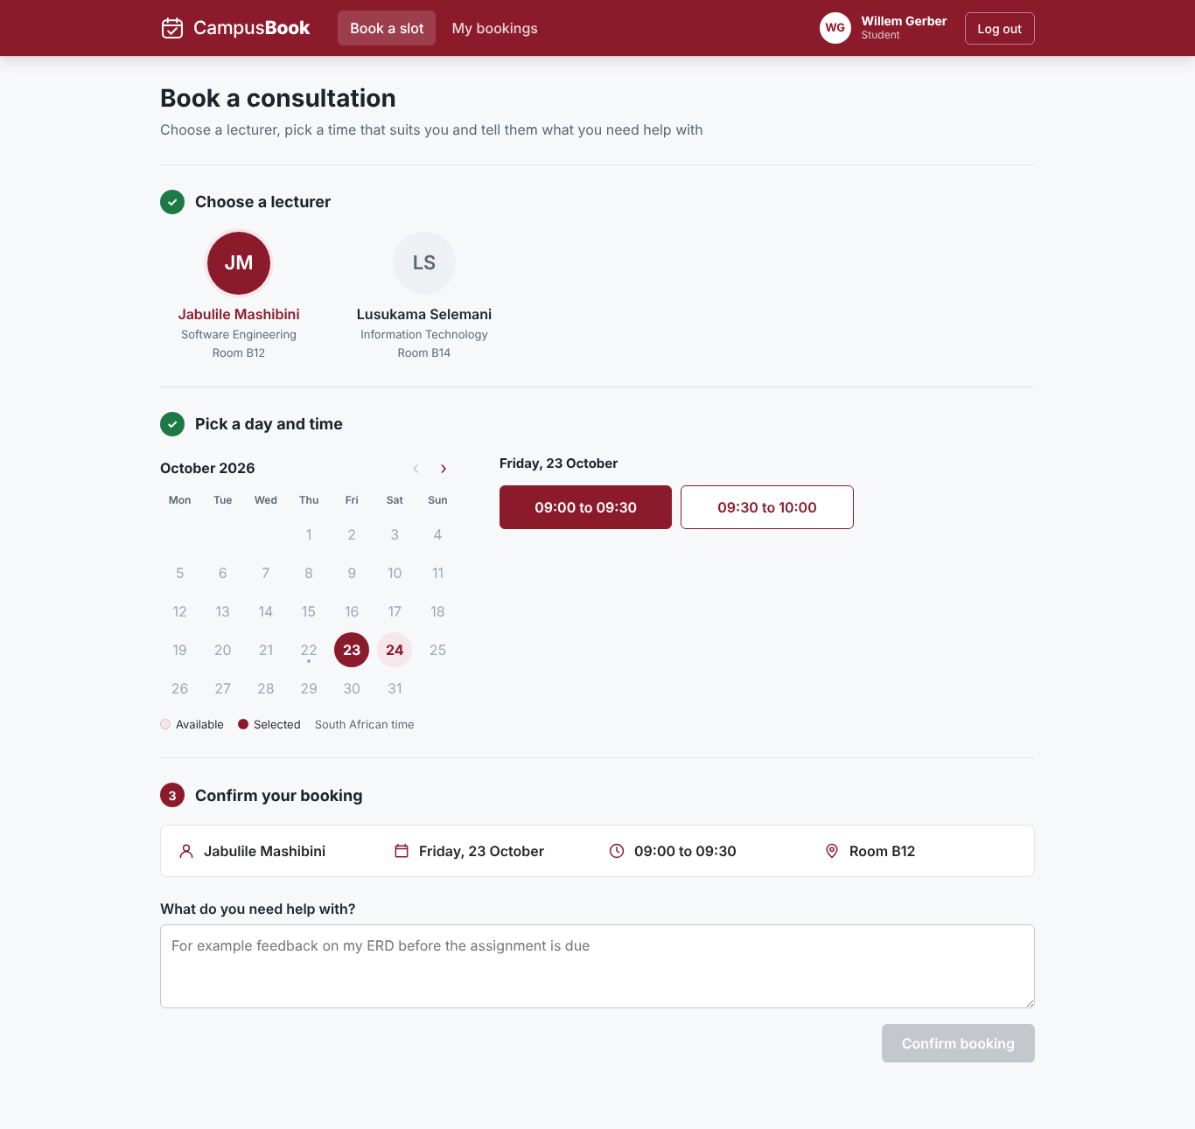  After the fix
Figure 5.3 Time buttons before and after the D-02 fix
D-03 Lecturer slots page does not work with the Slots API (fixed)
Thomas merged the Lecturer slots page on 22 October When it was tested the page showed That API route does not exist because it asks for /api/slots/my and the route is /api/slots/mine Publishing a slot failed with Enter a valid start time because the page sends start and end and the API needs startTime and endTime Nothing was saved The fix is four lines in LecturerSlots.jsx With the fix the page lists the slots and publishing and removing a slot both work The retest passed and an Edit button was also added for D-10
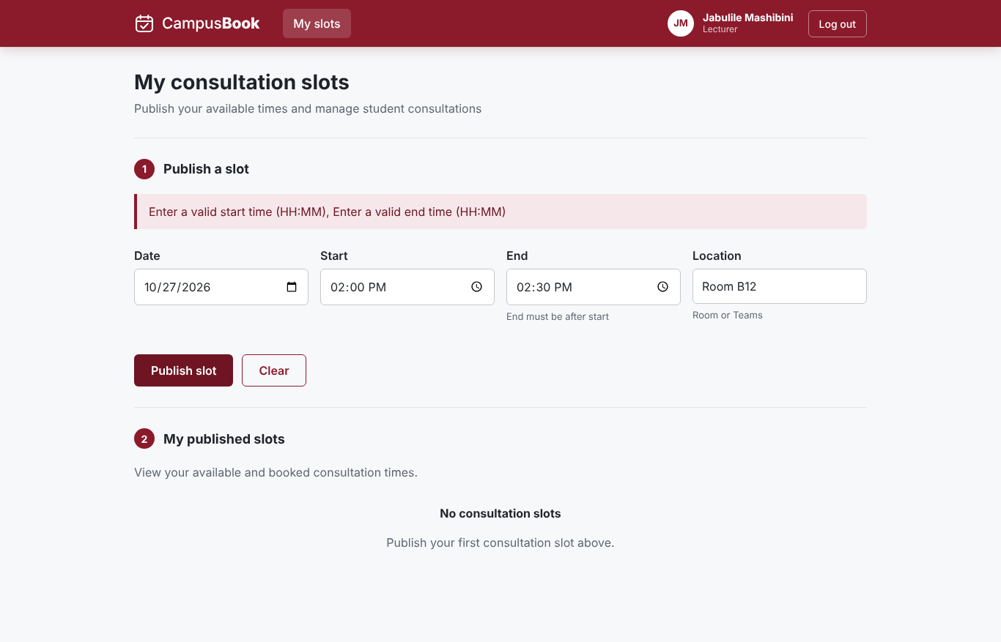  Merged code | 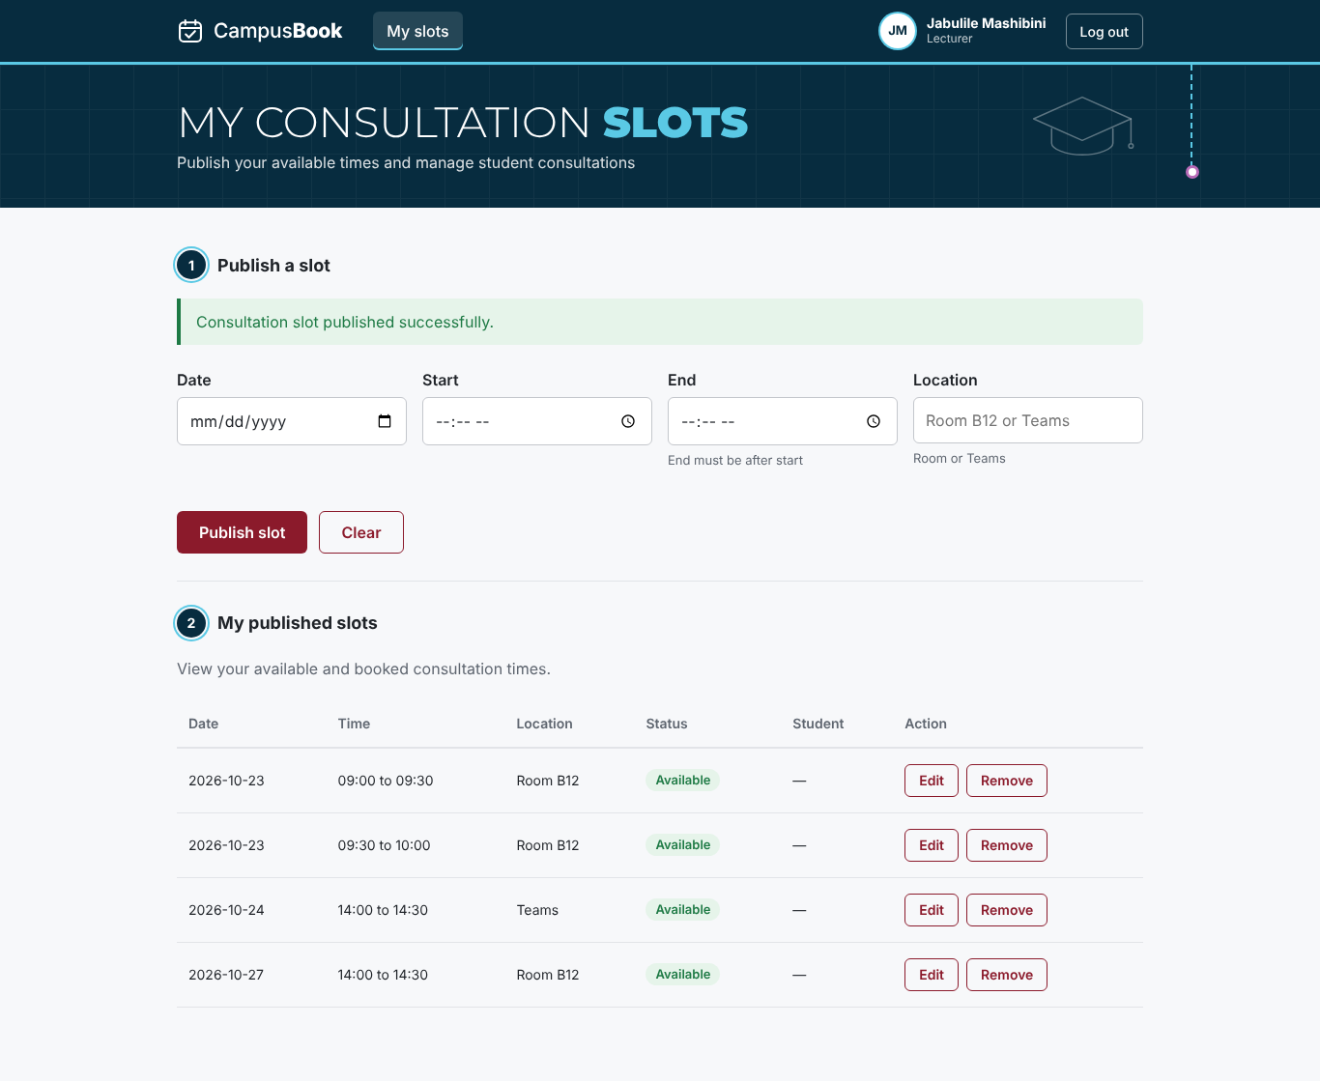  With the fix
Figure 5.4 Lecturer slots page before and after the D-03 fix
D-04 to D-10 other defects (fixed)
- D-04 My bookings had no change button so a Change time button was added that lists the other open times of that lecturer and moves the booking (TC-29)
- D-05 An expired session stayed on the page so the app now clears the login and shows the login page with the message Your session has ended (TC-28)
- D-06 Repeated wrong passwords were not limited so the login now answers 429 after 10 wrong passwords in 15 minutes and other accounts are not affected (TC-30)
- D-08 The reason box was hidden after a failed booking so the confirm step now stays on screen unless the slot was taken (TC-16b)
- D-09 A user opening the other roles page was sent to the login page so they now go to their own home page (TC-27)
- D-10 The Lecturer slots page had no edit option so an Edit button was added (TC-34)
- D-07 The Chapter 4 text said the reminder job runs every 15 minutes but the code runs it every minute so the text now says every minute and the label in the architecture diagram (Figure 4.1) now matches the code
Open defects
- No defects are open and the fixed code is on the main branch on GitHub
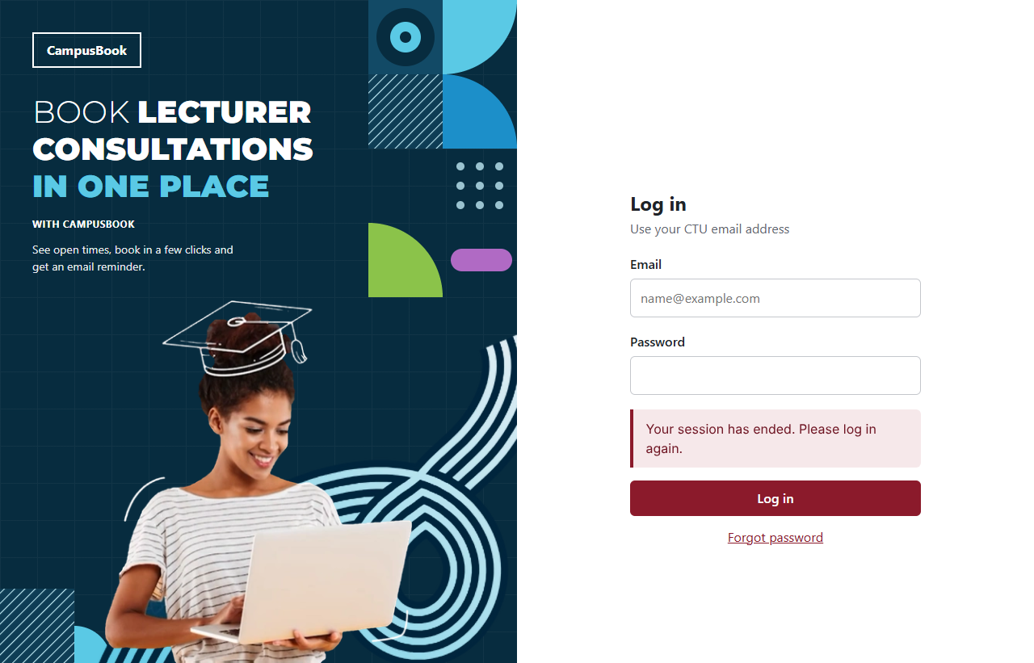
Figure 5.5 Session ended message after the D-05 fix

5.4 Non-Functional Requirement Evaluation
Table 5.6 Performance and layout measurements
Check | Target | Measured | Result
Login page load (phone and laptop) | Under 3000 ms | 78 ms and 78 ms | Pass
Book page after login | Under 3000 ms | 248 ms and 220 ms | Pass
My bookings page | Under 3000 ms | 380 ms and 372 ms | Pass
API slot list over 20 requests | Under 500 ms | Median 5 ms and slowest 8 ms | Pass
Sideways scrolling at 375 and 1366 pixels | None on every page | None on all 5 pages tested | Pass
Scripted booking journey on a phone | Under 120 seconds | 1.8 seconds | Indicative only

The times were measured on the team test set up with the API and the database on the same machine so they leave out the network delay of a real campus connection They show that the pages themselves are light The built page script is about 239 kB
The scripted journey shows that the booking flow has few steps and no waiting The real answer for NFR-01 needs first time students and a stopwatch so the timed test was planned for the user testing but the bookings were not timed there (section 5.6)
Usability check against the ten heuristics (Nielsen, 1994)
Table 5.7 Heuristic check (Nielsen, 1994)
Heuristic | Evidence from the app
Visibility of system status | A confirmation page after booking and a success notice after cancelling and the booking steps are numbered
Match with the real world | Plain words such as Book a consultation and Cancel booking and dates written out in full
User control and freedom | Cancelling asks for a second click with Keep it and Yes cancel
Error prevention | The confirm button stays disabled until a reason is typed and booked slots cannot be picked
Help users recover from errors | Messages say what to fix such as Enter a valid email address and Sorry that slot is no longer available
Consistency | One theme and the same buttons and alerts on every page
Problems found and fixed | No change button (D-04) and a hidden reason box after an error (D-08) and no redirect on an expired session (D-05)

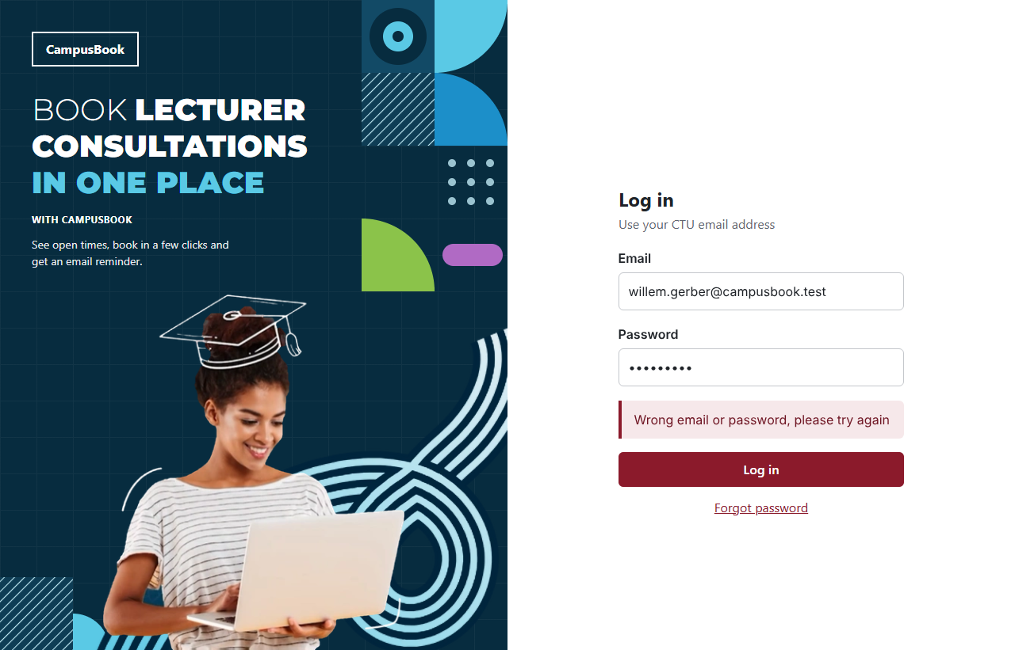  Login error with the email kept | 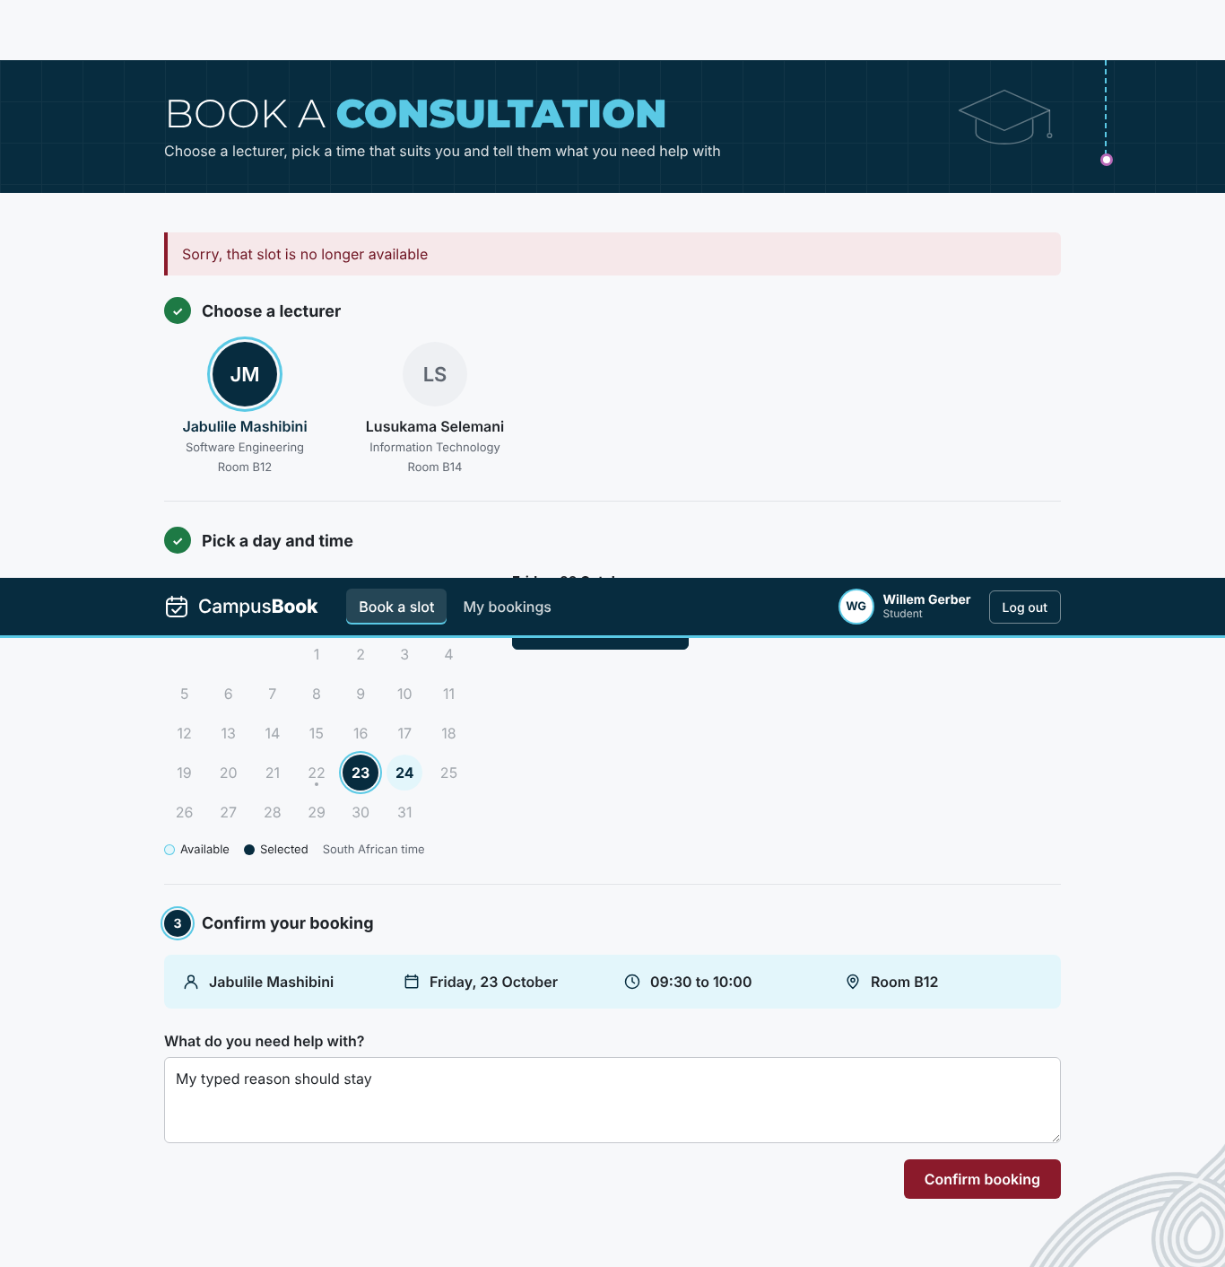  Slot taken message
Figure 5.6 Login error and slot taken messages

5.5 Requirements Traceability Matrix
The traceability matrix links every requirement from Chapter 3 to the part of the system that delivers it and the test cases that check it so no requirement is left without a test The full matrix is in Group-3_Requirements_Traceability_Matrix.xlsx in folder 06
Table 5.8 Requirements traceability matrix
ID | Requirement | Design or component | Test cases | Result
FR-01 | Students and lecturers log in with their email and password | routes/auth.js and Login.jsx | TC-01 and TC-22 | Pass
FR-02 | The system checks the user role so students and lecturers only reach their own pages and actions | middleware/auth.js and ProtectedRoute.jsx | TC-02 and TC-21 and TC-27 | Pass
FR-03 | Lecturers publish edit and remove their own future consultation slots | routes/slots.js and LecturerSlots.jsx | TC-03 and TC-18 and TC-19 and TC-20 and TC-25 and TC-33 and TC-34 | Pass
FR-04 | Students view the open slots of a chosen lecturer | routes/slots.js and BookSlot.jsx | TC-04 and TC-32 | Pass
FR-05 | Students book an open slot and give a short reason for the visit | routes/bookings.js and BookSlot.jsx | TC-05 and TC-17 | Pass
FR-06 | Students change or cancel their own upcoming bookings | routes/bookings.js and MyBookings.jsx | TC-06 and TC-29 | Pass
FR-07 | The system stops two students booking the same slot | bookings.js transaction and unique active_slot_id | TC-07 and TC-31 | Pass
FR-08 | The system sends an email confirmation after booking and a reminder before the meeting | services/mailer.js and jobs/reminders.js | TC-08a and TC-08b and TC-26 | Pass
FR-09 | Students see their own booking history and lecturers see the bookings for their slots | routes/bookings.js and MyBookings.jsx | TC-09 and TC-25 | Pass
NFR-01 | A first-time student completes a booking in under 2 minutes | BookSlot.jsx three step flow | TC-10 | Not run
NFR-02 | The main pages load within 3 seconds in the team test set up | Vite production build | TC-11 and TC-23 and TC-24 | Pass
NFR-03 | Every page works on a phone at 375 pixels wide and on a laptop at 1366 pixels wide | CSS container queries and responsive header | TC-12 | Pass
NFR-04 | Passwords are stored as bcrypt hashes and never as plain text | routes/auth.js and the seed script | TC-13 and TC-30 | Pass
NFR-05 | Each user can only see their own bookings or the bookings for their own slots | user_id checks in every query | TC-14 and TC-09 | Pass
NFR-06 | Only the data needed for logging in and booking is stored with made-up data during development | database/schema.sql and seed.sql | TC-15 | Pass
NFR-07 | Errors explain what to fix and the form keeps what the user already typed | middleware/validate.js and the page alerts | TC-16 and TC-16b and TC-28 | Pass

Every functional and non-functional requirement is traced to at least one test case and each test case is traced back to a requirement in Table 5.4

5.6 Stakeholder and User Feedback
The student survey was answered by 13 students on 22 October 2026 The survey was anonymous and the raw answers are in Group-3_Survey_Responses.xlsx in folder 06 The target of at least 10 students was met
Table 5.9 Student survey results (13 students)
Question | Result
Needed to meet a lecturer in the last 3 months | 11 of 13 needed to at least once (10 said 1 to 2 times and 1 said 3 to 5 times)
How they arrange a consultation now | Teams 11 and asking in class 5 and going to the office 3 and WhatsApp 2
How easy it is now (1 hard to 5 easy) | Average 3.2 and 4 of 13 gave 1 or 2
Gave up on a consultation because of the problems | 7 of 13 said yes
Time from first asking to a confirmed time | 1 to 2 days for 10 of 13 and the same day for 3
Hardest time to get a consultation | Before tests 8 and before assignment deadlines 6 and normal weeks 3 and always hard 1
Device they would use to book | Phone 7 and laptop 6
Would use an online booking system (1 to 5) | Average 4.2 and 9 of 13 gave 4 or 5

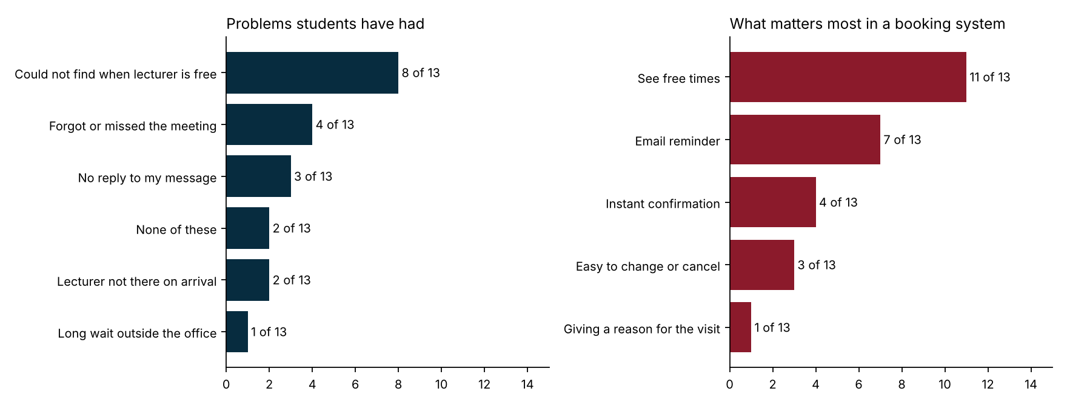
Figure 5.7 Student survey results
What the survey means for CampusBook
- The biggest problem is not knowing when a lecturer is free (8 of 13) and the most wanted feature is seeing free times (11 of 13) This is what the Book a slot page does
- Email reminders were chosen by 7 of 13 and 4 students had forgotten or missed a meeting so the reminder job (FR-08) answers a real need
- Instant confirmation was chosen by 4 and changing or cancelling by 3 which supports the confirmation email and the Change time and Cancel booking buttons
- Phone and laptop were almost equal (7 and 6) which supports testing both at 375 and 1366 pixels wide (NFR-03)
- Pressure is highest before tests and assignment deadlines so the busy weeks before tests are when CampusBook matters most
The survey has limits It has 13 answers from one campus so it shows what these students said and not all students No lecturers answered it so the lecturer view comes from the user testing below
Table 5.10 Feedback sources
Feedback source | What it shows | When
Student survey (13 answers) | Current problems and what students want | 22 October 2026
User testing with students and a lecturer | Time to complete a booking and problems seen and comments | 28 October 2026
Supervisor feedback on this chapter | Corrections to the tests and the chapter | After the Week 4 submission

User Testing
The user testing was done on 28 October 2026 with 4 students and 2 lecturers who used CampusBook on their own and then answered a Google Form The target was 5 students and 1 lecturer so the lecturer target was met and the student group was one short Each tester is recorded only as S1 to S4 or L1 and L2 Students were asked to log in find an open slot book it and reach the confirmation and lecturers were asked to create or manage their slots Each tester rated how easy the task was from 1 (very difficult) to 5 (very easy) and how likely they are to use CampusBook instead of Teams or WhatsApp from 1 (very unlikely) to 5 (very likely) The bookings were not timed
Table 5.11 User testing results
Tester | Role | Task done | Task ease (1 to 5) | Would use it (1 to 5) | Suggestion
S1 | Student | Booked and the confirmation was clear | 5 | 4 | Nothing
S2 | Student | Booked and the confirmation was clear | 5 | 3 | Nothing
S3 | Student | Booked and the confirmation was clear | 4 | 5 | A weekly view of all upcoming consultations and a notification when a lecturer adds new times
S4 | Student | Booked and the confirmation was clear | 4 | 3 | Improve the look and make the navigation clearer
L1 | Lecturer | Created and managed slots | 3 | 2 | Add a chat or call feature
L2 | Lecturer | Created and managed slots | 2 | 5 | More features
Average |  | 6 of 6 completed the task | 3.83 | 3.67

4 of the 6 testers (66.7%) rated the task easy or very easy which is below the 80% target The four students were positive with an average of 4.50 out of 5 and all four said it was easy to find a slot and understand the details and that the booking confirmation was clear The two lecturers could create and manage slots but rated the task 3 and 2 (average 2.50) so the Lecturer slots page needs clearer navigation and should be checked by watching lecturers use it
Willingness to use CampusBook instead of Teams or WhatsApp averaged 3.67 out of 5 and 3 of the 6 testers gave 4 or 5 The suggestions were a weekly view of upcoming consultations with a notification when a lecturer adds new times clearer navigation a chat or call feature and more features in general Two testers suggested no change

5.7 Evaluation Against Requirements
Table 5.12 compares the app at commit e9ab578 with each requirement from Chapter 3 This is the result after the fixes Met means the tests passed and Partially Met means part of the requirement still needs work
Table 5.12 Requirements evaluation
ID | Requirement | Result | Notes
FR-01 | Students and lecturers log in with their email and password | Met | Login works for both roles and bad details give one general error
FR-02 | The system checks the user role so students and lecturers only reach their own pages and actions | Met | Role checks on every route and page
FR-03 | Lecturers publish edit and remove their own future consultation slots | Met | API and page work. Slots are published and edited and removed from the page after the D-03 and D-10 fixes
FR-04 | Students view the open slots of a chosen lecturer | Met | Slots listed correctly and the times show after the D-02 fix
FR-05 | Students book an open slot and give a short reason for the visit | Met | Booking saved and confirmation shown
FR-06 | Students change or cancel their own upcoming bookings | Met | Cancel and change both work in the page after the D-04 fix
FR-07 | The system stops two students booking the same slot | Met | 8 simultaneous requests gave one booking
FR-08 | The system sends an email confirmation after booking and a reminder before the meeting | Met | Confirmation and reminder work in preview mode and an SMTP test email was received on 23 October The booking emails also arrived on the demonstration laptop
FR-09 | Students see their own booking history and lecturers see the bookings for their slots | Met | Student page and lecturer page both show the bookings after the D-03 fix
NFR-01 | A first-time student completes a booking in under 2 minutes | Partially Met | Scripted journey took 1.8 seconds The bookings were not timed in the user testing on 28 October
NFR-02 | The main pages load within 3 seconds in the team test set up | Met | Slowest page load was 389 ms and slowest API call 19 ms
NFR-03 | Every page works on a phone at 375 pixels wide and on a laptop at 1366 pixels wide | Met | No sideways scrolling on all five pages at both widths
NFR-04 | Passwords are stored as bcrypt hashes and never as plain text | Met | All 7 stored passwords are bcrypt hashes and repeated wrong passwords are limited after the D-06 fix
NFR-05 | Each user can only see their own bookings or the bookings for their own slots | Met | Other users records were refused in every test
NFR-06 | Only the data needed for logging in and booking is stored with made-up data during development | Met | Five tables and no sensitive columns and all users on the test domain
NFR-07 | Errors explain what to fix and the form keeps what the user already typed | Met | Plain messages and typed text kept and a clear message when the session ends after the D-05 and D-08 fixes

9 of the 9 functional requirements and 6 of the 7 non-functional requirements are fully met and none are unmet
The only requirement that is not fully met is NFR-01 because the bookings were not timed in the user testing All four students booked a consultation and said the confirmation was clear but there is no time to compare with the 2 minute target FR-08 was tested with the email preview and an SMTP test email was sent and received on 23 October (Chapter 4 section 4.7) and the booking emails arrived on the demonstration laptop

5.8 Conclusion
The tests show that the booking journey works from login to confirmation on a phone and a laptop and that two students can never hold the same slot 35 of 36 tests pass after the fixes and the one test not run is the timed booking test
Testing found real problems at the joins between the pages and the API The Lecturer slots page and the Book a slot page did not read the Slots API correctly and My bookings had no change button These and the other defects were fixed and each fix was retested and the fixed code was merged into the main branch
The student survey (13 answers) supports the need for the system and the features chosen and in the user testing 4 of the 6 users rated CampusBook easy to use with the students more positive than the lecturers

Chapter 6 Conclusion and Recommendations

6.1 Introduction
This chapter concludes the CampusBook project, which was proposed to address the difficulty of arranging lecturer consultations through separate channels such as email, Microsoft Teams, WhatsApp and walk-in requests. When availability and requests are scattered across these channels, students may wait for responses or be uncertain whether a meeting has been confirmed.
Lecturers may also have difficulty maintaining a consistent view of upcoming consultations and the reasons students need assistance. The aim of CampusBook is to design, develop and evaluate a web-based consultation booking system that enables students to book, change and cancel consultation appointments while lecturers manage their available time slots. The project focuses on one CTU campus and a browser-based application. It does not include live integration with CTU systems, SMS notifications, video calls or a native mobile application.

6.2 Summary of the Study
The project identified a practical need for a central place where students can view available consultation slots and manage their bookings without relying on long message exchanges. The literature review considered Microsoft Bookings, Calendly and Moodle Scheduler.
These systems demonstrate that online scheduling can organise availability and appointments, but their fit depends on institutional requirements and the surrounding learning or business environment. CampusBook focuses on a defined campus use case rather than attempting to replace a full institutional timetable or learning-management system.
The system was built and tested in Week 4. All eight coding tasks were merged into the main branch, and 36 test cases were written and linked to the requirements. After the fixes, 35 of the 36 tests passed. The one test not run is the timed booking test, because the bookings were not timed in the user testing on 28 October. Testing logged 10 defects and all 10 were fixed and retested. Eight booking requests sent for one slot at the same moment produced one booking, which shows that two students cannot hold the same slot. The pages loaded in under 400 ms in the team test set-up against a target of 3 seconds.
The group also learned what worked and what did not. The shared page template, the pull request reviews and the task sign-up sheet worked well. The Lecturer slots page was merged late and did not match the Slots API, because the page and the API used different field names, and this was only found when the merged code was tested. In future the group would agree the API field names before coding and test every merged page against the API.

6.3 Achievement of Objectives
The table below compares the five objectives from Chapter 1 with the evidence from Chapters 4 and 5.
Table 6.1 Achievement of objectives
Objective | Result | Evidence
1 Study how consultations are arranged now with at least 10 students | Achieved | 13 students answered the survey on 22 October so the target was met (Chapter 5 section 5.6)
2 Compare at least three existing scheduling systems | Achieved | Microsoft Bookings, Calendly and Moodle Scheduler were compared on features, strengths and limitations (Chapter 2)
3 Design and develop a web system with all six must-have features on a live database | Achieved | All eight coding tasks were merged into main and all 9 functional requirements were met in testing (Chapters 4 and 5)
4 Test the system so every must-have test case passes, a booking takes under 2 minutes and pages load within 3 seconds | Mostly achieved | 35 of 36 tests passed after the fixes and the pages loaded in under 400 ms. The bookings were not timed in the user testing, so the 2 minute target is not confirmed (Chapter 5)
5 Evaluate the system with at least 5 students and 1 lecturer with 80% or more rating it easy to use | Partly achieved | 6 users tested (4 students and 2 lecturers) and 4 of the 6 (66.7%) rated CampusBook easy to use against a target of 80%. Students averaged 4.50 and lecturers 2.50 out of 5 (Chapter 5 section 5.6)

So three of the five objectives were achieved, the fourth was mostly achieved and the fifth was partly achieved.

6.4 Answers to Research Questions
How do students and lecturers at CTU arrange consultations now and what problems do they face?
Among 13 respondents, Teams was the most selected current method (11/13, 84.6%), followed by asking in class (5, 38.5%), office visits (3, 23.1%) and WhatsApp (2, 15.4%); none selected email. Unclear lecturer availability was the leading problem (8/13, 61.5%), followed by missed meetings (4, 30.8%) and no reply (3, 23.1%). Ten respondents (76.9%) reported a one-to-two-day wait for confirmation, and seven (53.8%) had given up seeking a consultation.
What do existing scheduling systems offer and what do they lack for a campus setting?
Microsoft Bookings, Calendly and Moodle Scheduler all let someone publish time slots and let others book them, so basic booking is already well covered. Their weakness is fit and cost for a campus. Microsoft Bookings is built for businesses, has no concept of students or modules, and needs administrator set-up. Calendly charges per lecturer for reminders and each lecturer gives a separate link, with the data held by a third party. None of them gives CTU students one free place to book any lecturer, which is the gap CampusBook was built to fill.
How can a web system let students book consultations and lecturers manage their time?
CampusBook does this with a React front end, a Node.js and Express API, and a MySQL database. Users log in with a role. Lecturers publish, edit and remove their own future slots, and students see a lecturer’s open slots and book one with a reason for the visit. The server enforces the rules: slots cannot be in the past or overlap, and a slot that is already booked cannot be edited or removed by the lecturer. A database row lock and a unique key on the active booking stop two students taking the same slot. Confirmation and reminder emails are sent with Nodemailer, and both roles can see their booking history.
Does the system meet its functional and non-functional requirements?
Mostly yes. After the fixes, all 9 functional requirements and 6 of the 7 non-functional requirements were fully met and none were unmet. NFR-01 is only partly met: the scripted booking journey took 1.8 seconds, but the bookings were not timed in the user testing, so the two-minute target for first-time students is not confirmed. Testing found 6 failures and one blocked test on the merged code, and the 10 defects logged were all fixed and retested. Passwords are stored as bcrypt hashes, wrong roles are refused with 403 and missing tokens with 401, and repeated wrong passwords are limited. Confirmation and reminder emails were tested in preview mode, and an SMTP test email was received on 23 October (Chapter 4 section 4.7), and the booking emails arrived on the demonstration laptop.
Do students and lecturers find the system easy to use and useful?
Partly. The user testing on 28 October with 4 students and 2 lecturers answers this question. 4 of the 6 users (66.7%) rated CampusBook easy or very easy to use, which is below the 80% target. All four students found it easy to find a slot, said the booking confirmation was clear and rated the task 4.50 out of 5 on average. Both lecturers could create and manage slots but rated the task 3 and 2, so the lecturer page needs clearer navigation. Willingness to use CampusBook instead of Teams or WhatsApp averaged 3.67 out of 5. The survey adds stated interest from a wider group. Nine of 13 respondents (69.2%) gave a likelihood-to-use rating of 4 or 5 out of 5, and eight (61.5%) gave a rating of 5. Seeing a lecturer’s free times was the most selected desired feature (11/13, 84.6%), followed by an email reminder (7/13, 53.8%). These findings suggest that respondents see potential value in the proposed system, and the booking journey itself needs few steps.

6.5 Limitations
Limited institutional scope: CampusBook was designed for one CTU campus and does not establish whether the same workflow will suit other campuses or departments.
Small sample: The survey had 13 student answers from one campus and no lecturer answered it, so it shows what these students said and not what all students and lecturers think. The user testing had only six participants, 4 students and 2 lecturers, which is one student short of the target, and the bookings were not timed.
Time limit: The system was built and tested in about two weeks by five members, so the user testing was short and was done in the final week.
Test environment: The performance times were measured with the API and the database on the same machine, so they leave out the network delay of a real campus connection.
Email dependency: Confirmation and reminder delivery depends on SMTP configuration and external email service availability. Messages may be delayed, rejected or classified as spam.
Scope exclusions: There is no admin dashboard, no SMS, no video calls and no link to CTU student systems because these were outside the scope set in Chapter 1.

6.6 Recommendations and Future Work
Keep testing on the main branch. Run the full set of tests again whenever new work is merged, so that the version on GitHub always matches the tested system.
Improve email observability and recovery. Record the outcome for each recipient separately, log SMTP failures without exposing passwords or message secrets, and implement a controlled retry process. This will help distinguish a student email success from a lecturer email failure.
Make usability changes based on evidence. Prioritise features supported by the actual survey: clear visibility of available times (selected by 11 of 13 respondents), reliable confirmation and email reminders (selected by 7 of 13), and a straightforward way to change or cancel a booking (selected by 3 of 13). Then validate the changes in a separate prototype usability evaluation.
Improve the lecturer page. The two lecturers rated their task 3 and 2 out of 5 while the students averaged 4.50, so the Lecturer slots page needs clearer navigation. Watch lecturers use it and fix what slows them down.
Add automated tests. Run the test cases automatically on every pull request so that a page that does not match the API is caught before it is merged.
Run a pilot. Give one CTU department a pilot and collect real booking numbers before wider use.

Future Work
Additional notification options, such as SMS or other approved channels, while retaining a reliable email fallback.
Optional online meeting links for consultations that do not require in-person attendance. Video calls were excluded from the current scope.
Links to CTU student systems and calendar synchronisation, so that bookings appear in a lecturer’s or student’s own calendar.
A weekly calendar view of upcoming consultations and a notification when a lecturer adds new free times, both asked for in the user testing.
An admin view so that CTU staff can see bookings across lecturers and manage users.
A hosted version on a real server with HTTPS and a real email service.

6.7 Conclusion
CampusBook was developed in response to a coordination problem: consultation requests can be spread across several communication channels, making lecturer availability, booking confirmation and appointment history difficult to manage consistently. The 13 Google Forms responses provide preliminary support for this problem: 8 respondents (61.5%) could not find out when the lecturer was free, and 7 (53.8%) said they had given up on getting a consultation because of these types of problems. A focused web-based workflow could bring these activities together by allowing lecturers to publish slots and students to create and manage bookings in one place.
The project went on to build that workflow. Students and lecturers log in, lecturers publish slots, students book with a reason, and both receive email confirmations and reminders. In testing, 35 of 36 tests passed after the fixes and two students could never hold the same slot. In the user testing with 4 students and 2 lecturers, all four students rated the system easy to use, while the lower lecturer ratings show that the lecturer page is the next thing to improve. Overall, CampusBook offers a scoped and tested foundation for lecturer consultation booking.

References
Calendly (2025) Calendly pricing. Available at: https://calendly.com/pricing (Accessed: 19 October 2026).
Davis, F.D. (1989) ‘Perceived usefulness, perceived ease of use, and user acceptance of information technology’, MIS Quarterly, 13(3), pp. 319–340.
Griffin, W., Cohen, S.D., Berndtson, R., Burson, K.M., Camper, K.M., Chen, Y. and Smith, M.A. (2014) ‘Starting the conversation: an exploratory study of factors that influence student office hour use’, College Teaching, 62(3), pp. 94–99.
Guy, R., Hocking, J., Wand, H., Stott, S., Ali, H. and Kaldor, J. (2012) ‘How effective are short message service reminders at increasing clinic attendance? A meta-analysis and systematic review’, Health Services Research, 47(2), pp. 614–632.
Microsoft (2025) Microsoft Bookings service description. Available at: https://learn.microsoft.com/en-us/office365/servicedescriptions/microsoft-bookings-service-description (Accessed: 19 October 2026).
Moodle (2017) Scheduler module. MoodleDocs. Available at: https://docs.moodle.org/en/Scheduler_module (Accessed: 19 October 2026).
Nielsen, J. (1994) 10 usability heuristics for user interface design. Nielsen Norman Group. Available at: https://www.nngroup.com/articles/ten-usability-heuristics/ (Accessed: 22 October 2026).
Republic of South Africa (2013) Protection of Personal Information Act 4 of 2013. Government Gazette 37067. Pretoria: Government Printer.
Schwaber, K. and Sutherland, J. (2020) The Scrum guide. Available at: https://scrumguides.org/scrum-guide.html (Accessed: 16 October 2026).
Stack Overflow (2025) 2025 Stack Overflow developer survey. Available at: https://survey.stackoverflow.co/2025/ (Accessed: 19 October 2026).
Statistics South Africa (2024) General Household Survey 2023. Statistical release P0318. Pretoria: Statistics South Africa.
Weimer, M. (2015) ‘Why students don’t attend office hours’, The Teaching Professor, 21 January. Available at: https://www.teachingprofessor.com/articles/teaching-professor-blog/students-dont-attend-office-hours (Accessed: 19 October 2026).
Zhao, P., Yoo, I., Lavoie, J., Lavoie, B.J. and Simoes, E. (2017) ‘Web-based medical appointment systems: a systematic review’, Journal of Medical Internet Research, 19(4), e134.

Appendices
The appendices hold the supporting documents for this dissertation
- Appendix A Test Plan
- Appendix B Ethical Clearance and Consent
- Appendix C Test Cases and Defect Log
- Appendix D Project Schedule and Risk Register
- Appendix E Group Declaration and Contribution Forms
- Appendix F Attendance Register
- Appendix G Demo Script
- Appendix H Presentation Slides

Appendix A Test Plan

1. Test Objectives
The test plan shows that CampusBook meets the nine functional and seven non-functional requirements in the SRS and that the must have features work together on a phone and a laptop
- Show that a student can log in book change and cancel a consultation and that a lecturer can manage slots
- Show that two students can never hold the same slot even when they book at the same moment
- Show that users only reach their own data and that passwords are stored safely
- Show that the main pages load in under 3 seconds and work at 375 and 1366 pixels wide
- Find defects early and record each one in the Defect Log until it is fixed and retested
- Show that every requirement is linked to at least one test in the Requirements Traceability Matrix

2. Scope
Included
- Back-end API routes for login slots and bookings (routes/auth.js slots.js and bookings.js)
- Role and token checks (middleware/auth.js) and input checks (middleware/validate.js)
- Confirmation and reminder emails (services/mailer.js and jobs/reminders.js)
- Database rules in schema.sql including the unique key that blocks double booking
- Front-end pages Login and Book a slot and My bookings and the Lecturer slots page and route protection
- Phone and laptop layouts and page load times
Not included in this round
- Real email delivery through an SMTP service (emails are checked in the preview mode)
- Timed bookings with real students (the user testing on 28 October with 4 students and 2 lecturers collected ratings and comments)
- Load testing with many users and testing on a real phone (the phone size is tested in the browser)

3. Test Environment
Item | Detail
Application version | Branch main at commit e9ab578 on 22 October 2026 and again after the fixes for D-02 to D-10
Back end | Node.js 22 with Express and mysql2 on port 4100
Database | MariaDB 10.11 (MySQL compatible) built from database/schema.sql and seed.sql
Front end | React 18 and Vite 5 production build served by vite preview
Browser and sizes | Chromium driven by Playwright at 375 x 800 (phone) and 1366 x 768 (laptop)
Test data | Seven made up users on the campusbook.test domain and five seeded slots
Email | Preview mode with no SMTP host so emails print to the server log
Test scripts | test_scripts/api_tests.js and test_scripts/ui_tests.js in folder 06

The two scripts are kept in folder 06 as the record of what was run

4. Test Types
Test type | What it covers | Tool
Unit and API | Every route with valid and invalid input and wrong roles | Node script calling the API
Integration | API with database and emails and the reminder job | Node script and SQL checks
System and UI | Full journeys in the browser and route protection | Playwright with Chromium
Security | Role checks and forged tokens and access to other records and password storage | Node script and SQL checks
Performance | Page load times and API response times | Browser and script timings
Usability | Phone and laptop layouts and error messages and a scripted journey | Playwright and a heuristic check
Acceptance | User testing with real students and a lecturer | Done on 28 October with a Google Form (bookings not timed)

5. Entry and Exit Criteria
Entry criteria
- Code for the feature is merged into main
- The database builds cleanly from the two SQL scripts
- The API starts and the health check answers
Exit criteria
- Every Must requirement has at least one test with an actual result
- Every failed test has a defect in the Defect Log
- No open defect stops the main booking journey
- Every defect is fixed and retested before the final submission

6. Roles and Responsibilities
Member | Testing role
Willem Gerber | Test lead and Group Lead. Wrote the Test Plan and test cases and ran the tests and kept the Defect Log and the Traceability Matrix
Oscar Khumalo | Checks and retests fixes for the database connection and the email and reminder services
Lebohang Tlaitlai | Checks and retests fixes for the Slots API and the Login page and the student survey
Thomas du Plessis | Builds and retests the Lecturer slots page
Gerhardus van den Berg | Checks the schema and the test data

7. Defect Management
Each failed test becomes a row in the Defect Log with a date and the feature and a description and a severity and a priority and the owner
Severity | Meaning
Critical | The app stops or data is lost or another users data is exposed
High | A Must feature does not work or is missing
Medium | A feature works but with a clear problem or a missing part
Low | A small usability or wording problem

The developer who owns the file fixes the defect then the test is run again and the result is written in the Retest Result column before the defect is closed
Priority follows the demo plan so anything that breaks the booking journey is fixed first

Appendix B Ethical Clearance and Consent

Project Title
CampusBook: a lecturer consultation booking system for CTU Training Solutions

Data / Participants
Activity | Involved | Details
Personal data | Yes | Names emails and bookings with only made-up data during development
Interviews | No | No formal interviews and our lecturer reviewed the proposal
Survey | Yes | Anonymous student survey done on 22 October 2026 and answered by 13 CTU students with no names or student numbers
User testing | Yes | 4 students and 2 lecturers on 28 October with a short anonymous Google Form

Ethical Considerations
- Consent: every participant gets a short information sheet and takes part voluntarily and can stop at any time
User testing participants sign a consent form and survey participants tick a consent box before starting
- Privacy and confidentiality: survey answers are anonymous and testing notes use codes such as S1 instead of names
Results are only reported as totals or anonymous quotes
- Secure data handling: research data is kept in a private password-protected folder and deleted once the project is marked
- Data minimisation: the system only collects what it needs and hashes passwords and shows users only their own bookings in line with POPIA

Confirmation
☐ No human participant data required ☒ Ethical considerations reviewed ☒ Additional approval required
Human participant data was collected in the anonymous student survey (13 answers) and again in the user testing on 28 October (4 students and 2 lecturers) and the supervisor approved both before they started

Supervisor Sign-off
Supervisor: Jabulile Mashibini Signature: __________ Date: __________
________________________________________________________________________________
________________________________________________________________________________

Appendix C Test Cases and Defect Log
Test cases and results
Test ID | Feature | Expected Result | Status
TC-01 | Login | Valid logins return a token and role. Wrong password and unknown email give the same general error | Pass
TC-02 | Role checks on the server | Wrong role gets 403 and no token gets 401 | Pass
TC-03 | Lecturer manages own slots | Owner can publish edit and remove. Another lecturer gets 404 | Pass
TC-04 | Student views open slots | Only future slots with status open are listed | Pass
TC-05 | Book a slot | Booking saved with student slot and reason and the slot becomes booked | Pass
TC-06 | Change and cancel a booking | Old slot opens after a change and after a cancel. Second cancel is refused | Pass
TC-07 | No double booking | Exactly one confirmed booking and the rest get the slot taken message | Pass
TC-08a | Confirmation email | Confirmation to the student and a notice to the lecturer and the confirmation is marked sent | Pass
TC-08b | Reminder email | Reminder sent to student and lecturer and marked sent | Pass
TC-09 | Booking history | Each user sees only their own records and cancelled bookings stay in the history | Pass
TC-10 | First time student books in under 2 minutes | Under 120 seconds with real students | Not Run
TC-11 | Main pages load in under 3 seconds | Each page loads in under 3000 ms | Pass
TC-12 | Phone and laptop layout | No sideways scrolling on any page | Pass
TC-13 | Passwords stored as bcrypt hashes | Only 60 character bcrypt hashes and login uses bcrypt compare | Pass
TC-14 | Users cannot reach other records | All refused with 404 and nothing changes | Pass
TC-15 | Only needed data is stored | No sensitive columns and every user is on the test email domain | Pass
TC-16 | Errors explain what to fix (API) | 400 with a plain message and nothing saved | Pass
TC-16b | Errors on screen and kept input | Plain messages and the typed text is kept | Pass
TC-17 | Book a missing past or taken slot | 409 with Sorry that slot is no longer available | Pass
TC-18 | Slot validation rules | Refused with a message that says what to fix | Pass
TC-19 | Booked slot cannot be edited or removed | 409 for both | Pass
TC-20 | Removing a slot keeps history | Slot marked cancelled and history kept and publishing again reopens it | Pass
TC-21 | Bad ids bad JSON and unknown routes | 400 or 404 with a clear message and no server error | Pass
TC-22 | Forged expired and garbage tokens | All refused with 401 | Pass
TC-23 | Health check | 200 and ok true | Pass
TC-24 | API response time for the slot list | Under 500 ms for every request | Pass
TC-25 | Lecturer publishes a slot from the page | The page lists the lecturer slots and publishing saves the slot | Pass
TC-26 | Reminder not sent for a cancelled booking | No reminder left to send | Pass
TC-27 | Pages protected by login and role | Visitors go to login and each role is sent to their own home page | Pass
TC-28 | Expired or invalid session | User is sent to the login page with a clear message | Pass
TC-29 | Change a booking from the page | A change button is offered next to cancel and moving the booking works | Pass
TC-30 | Repeated wrong passwords are limited | The attempts are blocked after several failures and other accounts are not affected | Pass
TC-31 | Database refuses a second confirmed booking | Insert fails with a duplicate key error | Pass
TC-32 | Times shown on the Book a slot page | Each time button shows the start and end like 09:00 to 09:30 | Pass
TC-33 | Lecturer removes a slot from the page | The slot is removed and the list updates | Pass
TC-34 | Lecturer edits a slot from the page | The page offers an edit option and the change is saved | Pass

Defect log
Defect ID | Feature | Description | Severity | Status | Retest Result
D-01 | Bookings API and My bookings | Booking dates came back as time zone shifted dates because the raw slot_date was returned so a booking could show on the wrong day | High | Closed | Pass: dates match the stored dates (TC-05 and TC-09)
D-02 | Book a slot page | Time buttons show only "to" and the confirm panel shows "undefined to undefined" because the page reads start and end but the Slots API sends startTime and endTime | High | Fixed | Pass: 09:00 to 09:30 and 09:30 to 10:00 (TC-32)
D-03 | Lecturer slots page | The merged page does not work with the Slots API: it calls /api/slots/my but the route is /api/slots/mine so the list shows That API route does not exist and it sends start and end but the API needs startTime and endTime so publishing fails (FR-03 and FR-09) | High | Fixed | Pass: the list shows the slots and publish and remove both work (TC-25 and TC-33)
D-04 | My bookings page | No change button although the API supports changing a booking (FR-06) | Medium | Fixed | Pass: the booking moved and the notice showed (TC-29)
D-05 | Session handling | An expired or invalid token leaves the user on the page with an error and the old token is kept instead of going to the login page | Medium | Fixed | Pass (TC-28)
D-06 | Login security | There is no limit on repeated wrong passwords so 40 attempts in a row were all answered | Medium | Fixed | Pass: attempts 11 and 12 gave 429 and another account still logged in (TC-30)
D-07 | Documentation | Chapter 4 says the reminder scheduler runs every 15 minutes but the code runs it every minute | Low | Fixed | Pass: the text matches jobs/reminders.js
D-08 | Book a slot page | After a failed booking the reason box is hidden until a time is chosen again although the typed text is kept | Low | Fixed | Pass (TC-16b)
D-10 | Lecturer slots page | The page can publish and remove slots but has no way to edit a slot although the API supports editing (FR-03) | Medium | Fixed | Pass: the new location was saved (TC-34)
D-09 | Route protection | A logged in user who opens the other roles page is sent to the login page and not to their own home page | Low | Fixed | Pass (TC-27)

Appendix D Project Schedule and Risk Register
Project schedule and sprint backlog
Task ID | Task / User Story | Owner | Due Date | Status
T01 | Chapter 1 Introduction | All members | 19 Oct 2026 | Complete
T02 | Chapter 2 Literature review and matrix | All members | 19 Oct 2026 | Complete
T03 | Chapter 3 Requirements and methodology | All members | 19 Oct 2026 | Complete
T04 | Chapter 4 UML architecture and wireframes | All members | 19 Oct 2026 | Complete
T05 | Database design and SQL scripts | Gerhardus van den Berg | 19 Oct 2026 | Complete
T06 | Project charter ethics form and work plan | Willem Gerber | 19 Oct 2026 | Complete
T07 | GitHub repository set up and first commits | All members | 19 Oct 2026 | Complete
T08 | Back-end set up and login | Willem Gerber | 20 Oct 2026 | Complete
T09 | Slots API | Lebohang Tlaitlai | 22 Oct 2026 | Complete
T10 | Bookings API | Willem Gerber | 21 Oct 2026 | Complete
T11 | Database and emails | Oscar Khumalo | 21 Oct 2026 | Complete
T12 | Front-end set up and Login page | Lebohang Tlaitlai | 21 Oct 2026 | Complete
T13 | Book a slot page | Willem Gerber | 21 Oct 2026 | Complete
T14 | Lecturer slots page | Thomas du Plessis | 22 Oct 2026 | Complete
T15 | My bookings page and phone layout | Willem Gerber | 22 Oct 2026 | Complete
T16 | Student survey | Gerhardus van den Berg | 22 Oct 2026 | Complete
T17 | Testing workbooks and test cases | Willem Gerber | 23 Oct 2026 | Complete
T18 | Chapter 5 and Chapter 4 sections 4.6 to 4.8 | All members | 23 Oct 2026 | Complete
T19 | Demo script and demo video | All members | 23 Oct 2026 | Complete
T20 | Back-end fixes and security check | Willem Gerber | 26 Oct 2026 | Complete
T21 | Front-end fixes and polish | Lebohang Tlaitlai | 26 Oct 2026 | Complete
T22 | User testing with 4 students and 2 lecturers | Oscar Khumalo | 28 Oct 2026 | Complete
T23 | Final Chapter 5 and Chapter 6 | All members | 26 Oct 2026 | Complete
T24 | Demo data demo laptop and backup video | All members | 27 Oct 2026 | Complete
T25 | Final slides and practice runs | All members | 28 Oct 2026 | Complete
T26 | Final dissertation and submission | Willem Gerber | 29 Oct 2026 | Complete

Risk issue and change register
ID | Type | Description | Owner | Status
R-01 | Risk | Not enough time to build all six features | Willem Gerber | Resolved
R-02 | Risk | Work falls on one or two members | Willem Gerber | Resolved
R-03 | Risk | Some members are new to React or Express | Oscar Khumalo and Thomas du Plessis | Resolved
R-04 | Risk | Too few survey or test participants | Lebohang Tlaitlai | Resolved
R-05 | Risk | Email reminders not working in time | Oscar Khumalo | Resolved
R-06 | Risk | Double booking or one user seeing another user data | Oscar Khumalo | Resolved
I-01 | Issue | Survey target was 10 students | Willem Gerber | Resolved
I-02 | Issue | Supervisor approval for the survey and user testing | Willem Gerber | Resolved
I-03 | Issue | First commits from every member | All members | Resolved
C-01 | Change | Lecturer interviews replaced by lecturer feedback on the proposal (No formal interviews were held) | Willem Gerber | Resolved
C-02 | Change | Survey target set to at least 10 students everywhere (Two different numbers were used) | Willem Gerber | Resolved
C-03 | Change | App screenshots replaced by wireframes (The app is built in Week 4) | Willem Gerber | Resolved
C-04 | Change | Test set up for the page load target written down (Makes NFR-02 repeatable) | Willem Gerber | Resolved

Appendix E Group Declaration and Contribution Forms

Academic and Contribution Declaration
We the members of SE2 Group 3 declare that CampusBook and the dissertation are our own work
Every source we used is referenced in Harvard style and each member contribution is recorded in our Individual Contribution Forms and in our GitHub commits

Member Roles
Full name | Student number | Role | Main responsibilities
Willem Gerber | 20230257 | Group Lead and Scrum Master | Stand-ups, GitHub and reviews, back-end login and bookings, Book a slot and My bookings pages, and compiling the submissions
Oscar Khumalo | 20230279 | Back-end developer | Requirements database connection and email reminders Chapter 4.7 and 4.8 and Chapter 5
Thomas du Plessis | 20230260 | Front-end developer | Wireframes use case and activity diagrams Lecturer slots page Chapter 4.6 slides and demo video
Lebohang Tlaitlai | 20233068 | Testing and research lead | Literature review Chapter 3 and SRS student survey React set up Login page Slots API and Chapter 6
Gerhardus van den Berg | 20230240 | Database developer | ERD class diagram database design and SQL scripts (schema and test data) and presentation slides 5 to 7

Signatures
Name | Signature | Date
Willem Gerber |  | 2026/10/29
Oscar Khumalo | B.O Khumalo | 2026/10/29
Thomas du Plessis | 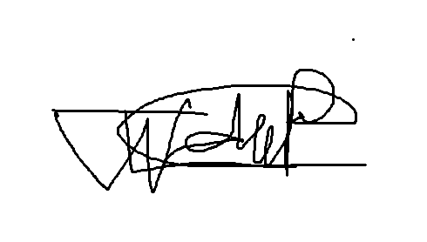 | 2026/10/29
Lebohang Tlaitlai | LN.Tlaitlai | 2026/10/29
Gerhardus van den Berg |  | 2026/10/29

Individual Contribution Form Willem

Student Details
Name: Willem Gerber Student No.: 20230257 Group: SE2 Group 3

Contribution Summary
Area | What I did
Research | Chapter 1 Introduction and help with the Chapter 2 literature review
Design | Architecture diagram and the shared page template
Coding | Back-end set up with login and role checks, the Bookings API, and the Book a slot and My bookings pages
Testing | Test Plan, test cases, Defect Log and fixes
Documentation | Project charter, ethics form and compiling the submissions and final dissertation
Project management | Group Lead and Scrum Master, GitHub set-up and pull request reviews
Presentation | Slides 1 to 4 in the final presentation (Week 5)

Git / Evidence References
Commit or file | Date | What it shows
dcb7cd2 | 15 Oct | Repository set up
6f458c7 and 590e891 | 20 and 21 Oct | Login, Bookings API and Book a slot page
87cefdb | 22 Oct | My bookings page

Peer Confirmation
Member | Accurate (Yes or No) | Signature | Date
Thomas du Plessis | Yes |  | 2026/10/29
Oscar Khumalo | Yes | B.O Khumalo | 2026/10/29
Lebohang Tlaitlai | Yes | LN.Tlaitlai | 2026/10/29
Gerhardus van den Berg | Yes |  | 2026/10/29

Student Declaration
I confirm that the information above accurately reflects my contribution
Name | Signature | Date
Willem Gerber |  | 2026/10/29

Individual Contribution Form Oscar

Student Details
Name: Oscar Khumalo Student No.: 20230279 Group: SE2 Group 3

Contribution Summary
Area | What I did
Research | Functional and non-functional requirements for Chapter 3 and the SRS
Design | Sequence diagram
Coding | Database connection (db.js) plus the confirmation and reminder emails (mailer.js and reminders.js)
Documentation | Chapter 4.7 Working System (key modules) and 4.8 Version Control with screenshots (Week 4) and the final Chapter 5 (Week 5)
Testing | User testing with 4 students and 2 lecturers on 28 October using a Google Form and the user testing results for Chapter 5 (Week 5)
Presentation | Slides 11 to 13 in the final presentation (Week 5)

Git / Evidence References
Commit or file | Date | What it shows
5682abf | 21 Oct | Database and email reminder services
Pull request #3 | 21 Oct | Merged into main
docs/diagrams/sequence.png | Week 3 | Sequence diagram

Peer Confirmation
Member | Accurate (Yes or No) | Signature | Date
Willem Gerber | Yes |  | 2026/10/29
Thomas du Plessis | Yes |  | 2026/10/29
Lebohang Tlaitlai | Yes | LN.Tlaitlai | 2026/10/29
Gerhardus van den Berg | Yes |  | 2026/10/29

Student Declaration
I confirm that the information above accurately reflects my contribution
Name | Signature | Date
Oscar Khumalo | B.O Khumalo | 2026/10/29

Individual Contribution Form Thomas

Student Details
Name: Thomas du Plessis Student No.: 20230260 Group: SE2 Group 3

Contribution Summary
Area | What I did
Design | Wireframes plus the use case and activity diagrams
Coding | Lecturer slots page (commit c2ecca1)
Documentation | Chapter 4.6 Implementation (development environment)
Presentation | First slide deck, the Demo Script and the demo and backup video (Week 4) and slides 14, 15 and 17 in the final presentation (Week 5)

Git / Evidence References
Commit or file | Date | What it shows
docs/wireframes | Week 3 | Login Book a slot Lecturer and phone wireframes
docs/diagrams/usecase.png and activity.png | Week 3 | Use case and activity diagrams
c2ecca1 | 22 Oct | Add lecturer consultation slots page
Pull request #6 | 22 Oct | Reviewed and merged

Peer Confirmation
Member | Accurate (Yes or No) | Signature | Date
Willem Gerber | Yes |  | 2026/10/29
Oscar Khumalo | Yes | B.O Khumalo | 2026/10/29
Lebohang Tlaitlai | Yes | LN.Tlaitlai | 2026/10/29
Gerhardus van den Berg | Yes |  | 2026/10/29

Student Declaration
I confirm that the information above accurately reflects my contribution
Name | Signature | Date
Thomas du Plessis |  | 2026/10/29

Individual Contribution Form Lebohang

Student Details
Name: Lebohang Tlaitlai Student No.: 20233068 Group: SE2 Group 3

Contribution Summary
Area | What I did
Research | Literature review and the student survey
Requirements | Chapter 3 and the SRS
Coding | React app set up page routes and the Login page  Slots API for lecturers and students (routes/slots.js)
Documentation | Chapter 6 Conclusion and Recommendations
Presentation | Slides 8 to 10 in the final presentation and driving the app in the live demo (Week 5)

Git / Evidence References
Commit or file | Date | What it shows
fe19ea8 | 21 Oct | Set up React app routes and Login page
e9b5f3e | 22 Oct | Add Slots API routes
Pull requests #2 and #4 | 21 and 22 Oct | Merged into main

Peer Confirmation
Member | Accurate (Yes or No) | Signature | Date
Willem Gerber | Yes |  | 2026/10/29
Oscar Khumalo | Yes | B.O Khumalo | 2026/10/29
Thomas du Plessis | Yes |  | 2026/10/29
Gerhardus van den Berg | Yes |  | 2026/10/29

Student Declaration
I confirm that the information above accurately reflects my contribution
Name | Signature | Date
Lebohang Tlaitlai | LN.Tlaitlai | 2026/10/29

Individual Contribution Form Gerhardus

Student Details
Name: Gerhardus van den Berg Student No.: 20230240 Group: SE2 Group 3

Contribution Summary
Area | What I did
Design | ERD and class diagram used in Chapter 4.3 UML Design and 4.4 Database Design
Database | Database design and SQL scripts (task T05): MySQL schema (schema.sql) and the test data (seed.sql)
Documentation | Team work on Chapters 1 to 4 (tasks T01 to T04)
Testing | The seed.sql test data used for the 36 test cases and the live demo
Presentation | Slides 5 to 7 in the final presentation (Week 5)

Git / Evidence References
Commit or file | Date | What it shows
docs/diagrams/erd.png and class.png | Week 3 | ERD and class diagram
database/schema.sql and seed.sql | Week 3 | Schema and test data

Peer Confirmation
Member | Accurate (Yes or No) | Signature | Date
Willem Gerber | Yes |  | 2026/10/29
Oscar Khumalo | Yes | B.O Khumalo | 2026/10/29
Thomas du Plessis | Yes |  | 2026/10/29
Lebohang Tlaitlai | Yes | LN.Tlaitlai | 2026/10/29

Student Declaration
I confirm that the information above accurately reflects my contribution
Name | Signature | Date
Gerhardus van den Berg |  | 2026/10/29

Appendix F Attendance Register
Project attendance register
Date | Full Name | Task Completed
15 Oct 2026 | Willem Gerber | Repository and project structure (commits dcb7cd2 and 092dd77)
19 Oct 2026 | Willem Gerber | Back-end folders schema seed scripts and diagrams (commit 88460f8)
20 Oct 2026 | Willem Gerber | Header layout theme login middleware and Bookings API (commit 6f458c7 and pull request #1)
21 Oct 2026 | Lebohang Tlaitlai | React app routes and Login page (commit fe19ea8 and pull request #2)
21 Oct 2026 | Willem Gerber | Booking error handling routes and Book a slot page (commit 590e891)
21 Oct 2026 | Oscar Khumalo | Database and email reminder services (commit 5682abf)
21 Oct 2026 | Willem Gerber | Reviewed and merged pull request #3
22 Oct 2026 | Lebohang Tlaitlai | Slots API routes (commit e9b5f3e and pull request #4 merged at 07:50)
22 Oct 2026 | Willem Gerber | My bookings page and phone layout (commit 87cefdb)
22 Oct 2026 | Thomas du Plessis | Lecturer slots page (commit c2ecca1 and pull request #6 merged at 14:56)
22 Oct 2026 | Willem Gerber | Reviewed and merged pull request #6
23 Oct 2026 | Oscar Khumalo | Improved booking and reminder email status handling (commit 5aff8cb)
23 Oct 2026 | Oscar Khumalo | Merged main into the Oscar branch (commit bfc98b0)
24 Oct 2026 | Lebohang Tlaitlai | Frontend login page fixed and Backend polishes (commit a72413d and pull request #7)

Appendix G Demo Script

1. Opening

Good day. We are Group 3 and our project is CampusBook, a consultation booking system for CTU Training Solutions.
Our members are Willem Gerber, Oscar Khumalo, Thomas du Plessis, Lebohang Tlaitlai and Gerhardus van den Berg.
Today we explain the problem, show the student and lecturer journeys live and share our testing evidence.

2. Problem and Objectives

At CTU, consultations are arranged through Teams, email, WhatsApp or by visiting a lecturer. Students do not know when a lecturer is free and lecturers struggle to organise appointments.
We surveyed 13 students. 11 needed a consultation in the last 3 months, 7 gave up because of the problems and 9 said they would use an online booking system.
CampusBook gives one place where lecturers publish consultation slots and students book, change or cancel them.
Our objectives were to study how consultations work now, compare existing systems, build the essential features, test performance and security, and evaluate ease of use with students and lecturers.

3. Architecture / Design

CampusBook has three tiers. The React frontend uses Vite and React Router. The Node.js and Express backend handles login, slots, bookings and reminders. A MySQL database stores users, lecturer profiles, slots, bookings and notifications.
Logins use JWT tokens and passwords are stored as bcrypt hashes. The system checks the role on every route so students and lecturers only reach their own pages. Nodemailer sends confirmation emails and node-cron sends the reminders.
Show the architecture diagram and then the ERD and point out how users, slots and bookings link together.

4. Live Demonstration Flow

Follow these steps in order. Keep each step to about 30 seconds.
Step | What to do | What the audience should see
1 | Open CampusBook and log in as a lecturer | The lecturer lands on My Consultation Slots
2 | Publish a slot with a future date, start and end time and a location | A success message and the new slot in the list
3 | Edit an available slot | The updated slot. Explain that booked slots cannot be edited or removed
4 | Log out and log in as a student, then open Book a Consultation | The lecturer list and the available dates
5 | Pick a lecturer, date and time, enter a reason and confirm | A confirmation with lecturer, date, time and location
6 | Open My Bookings, then change or cancel the booking | The booking list and slot availability update
7 | Show the phone-sized layout and a wrong password or expired session message | The page fits the phone and the message explains what to do

If there is time, explain test TC-07: 8 simultaneous requests for one slot gave 1 booking and 7 refusals. Do not run the load test live.

5. Testing Evidence

We wrote 36 test cases. 35 passed, none failed and one was not run: the timed test of a first-time student booking, because the bookings were not timed in the user testing.
Testing found 10 defects. All were fixed and retested. Two important ones were a wrong route on the lecturer slots page (/api/slots/mine) and consultation times showing as "undefined". We also fixed rescheduling, expired sessions and login rate limiting.
Security tests showed that wrong roles are refused, passwords are bcrypt hashes and a slot cannot be booked twice. The slowest page loaded in 389 ms against a 3 second target and the pages work on phone and laptop sizes.
The survey result shows that students want the system. In the user testing on 28 October with 4 students and 2 lecturers, 4 of the 6 rated CampusBook easy to use.

6. Conclusion

CampusBook brings consultation booking and lecturer availability into one web application. Login, slot management, booking, reminders and the phone layout all work and were tested.
Future ideas are links to CTU student systems and calendar synchronisation. Thank you. We are happy to take questions.

7. Backup Plan

Keep a 3 to 5 minute screen recording ready. It shows publishing a slot, student login, a booking, My Bookings and one error message. The group walkthrough video can be used for this.
- Keep screenshots and the test data on the laptop
- Start the database, backend and frontend before the presentation and test them
- If the internet or a service fails, play the recording and use the screenshots
- Tell the audience it is a recording and do not say it is live
- Keep passwords and JWT secrets out of screenshots and the recording

Appendix H Presentation Slides
 | 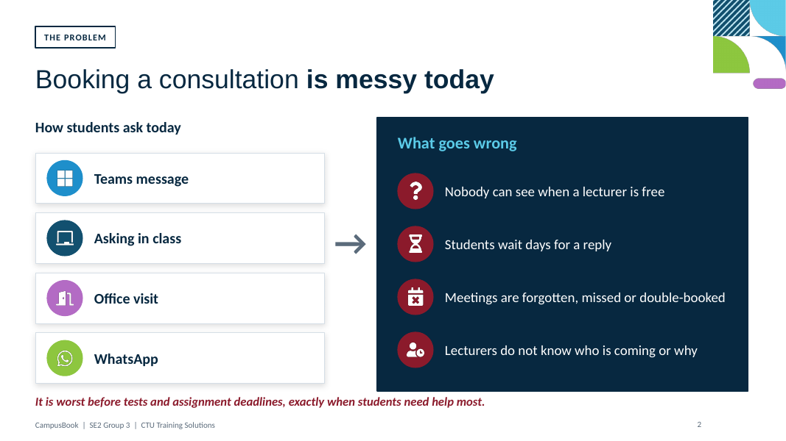
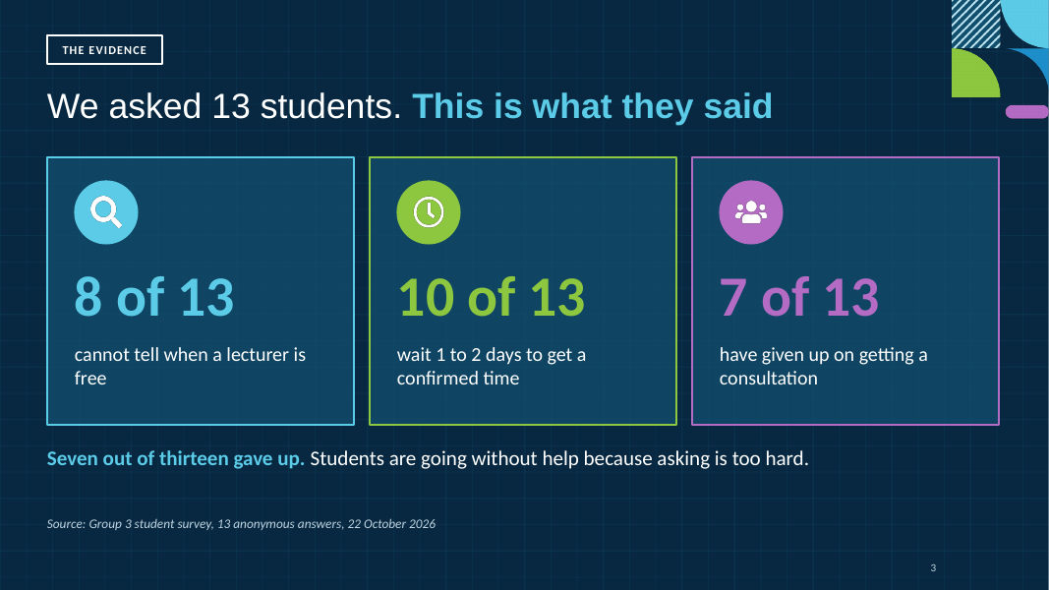 | 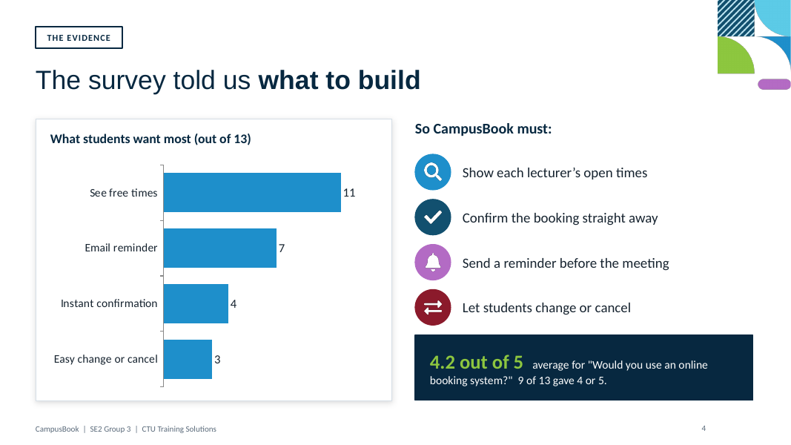
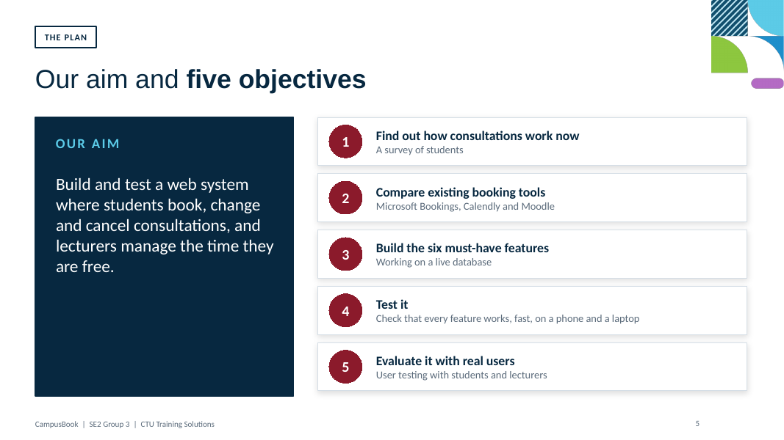 | 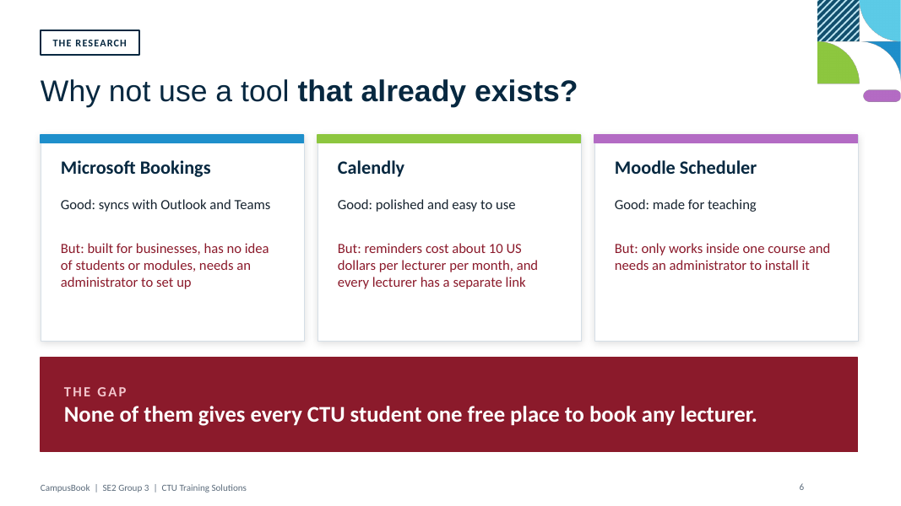
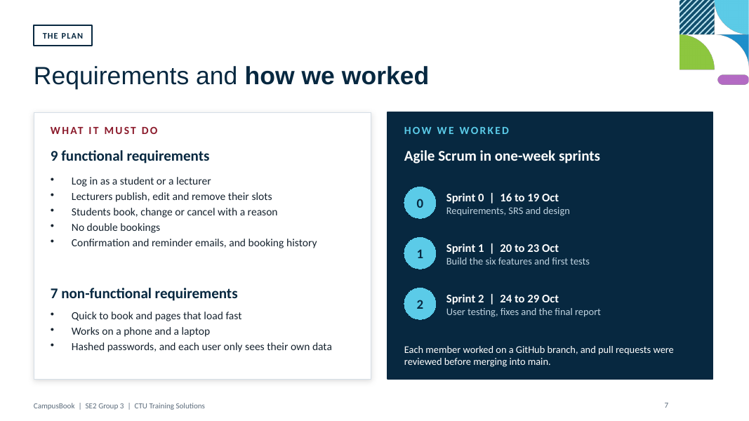 | 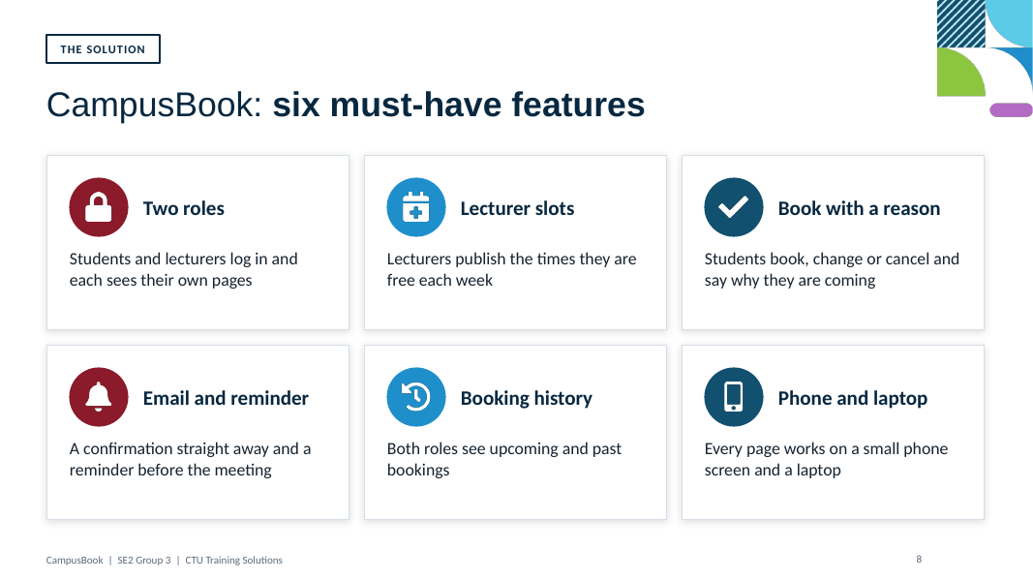
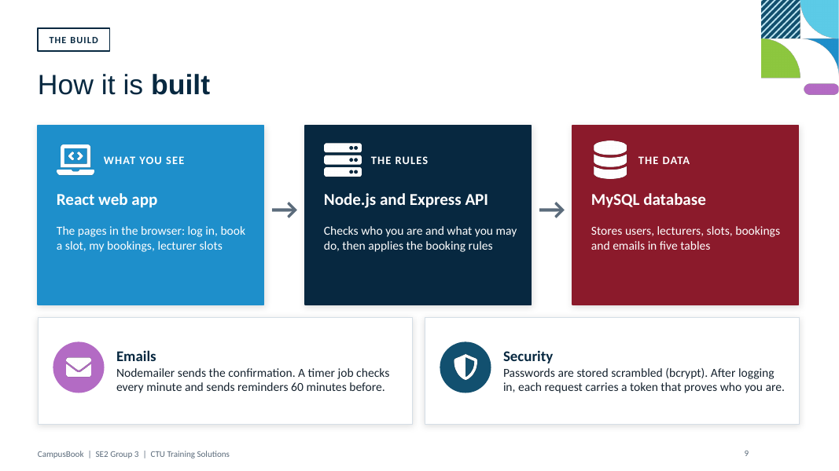 | 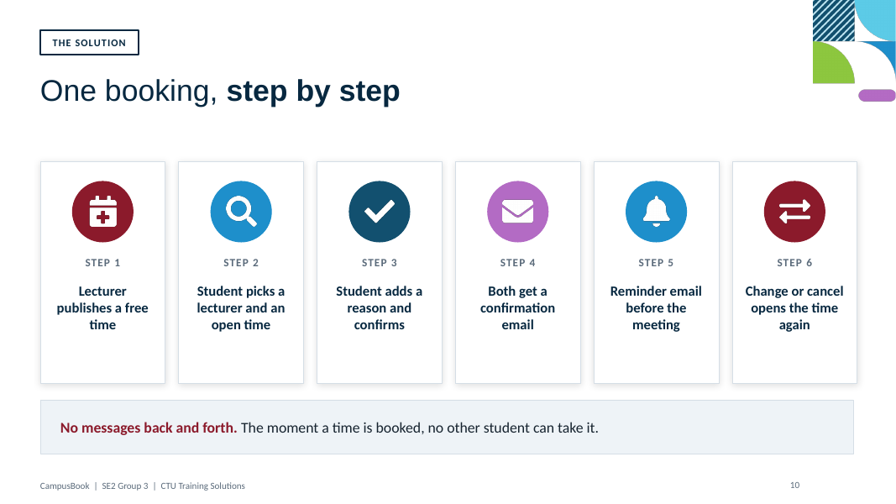
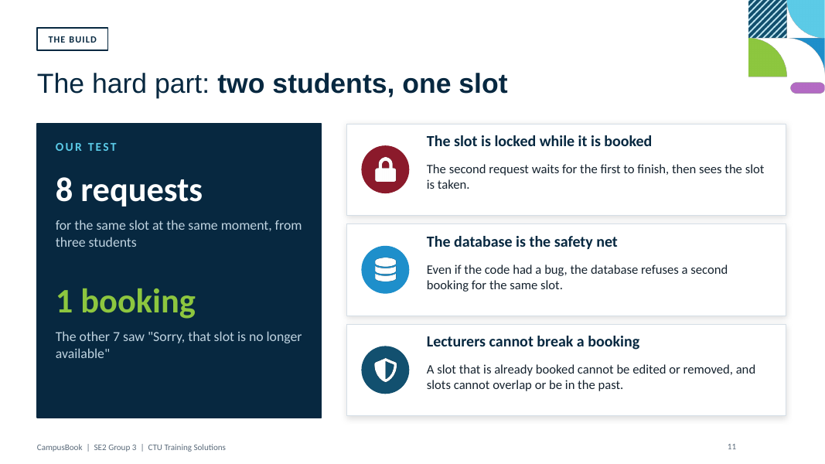 | 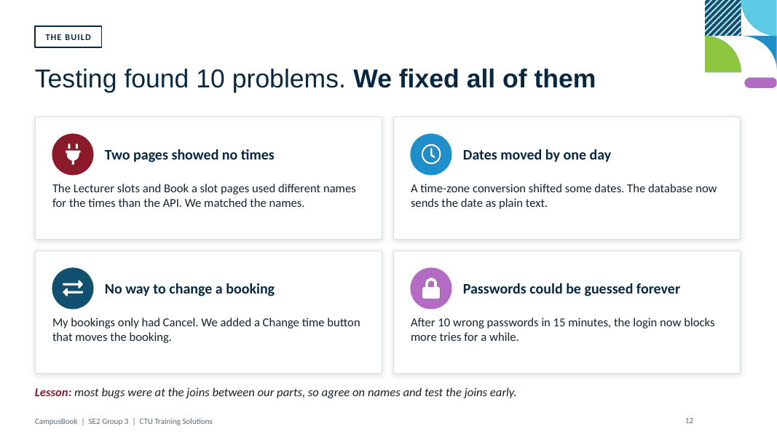
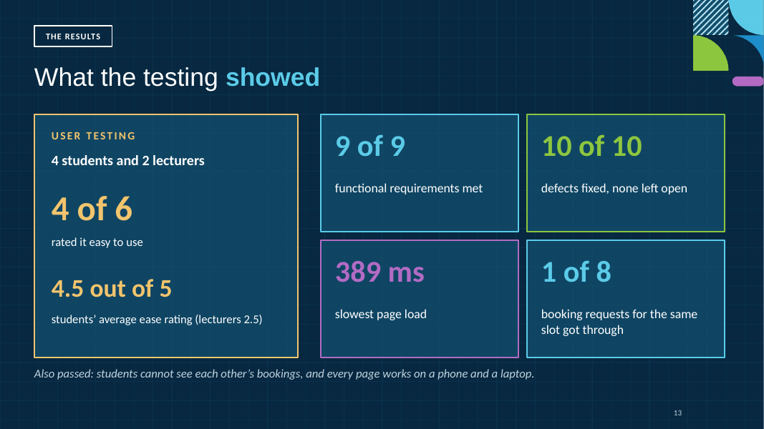 | 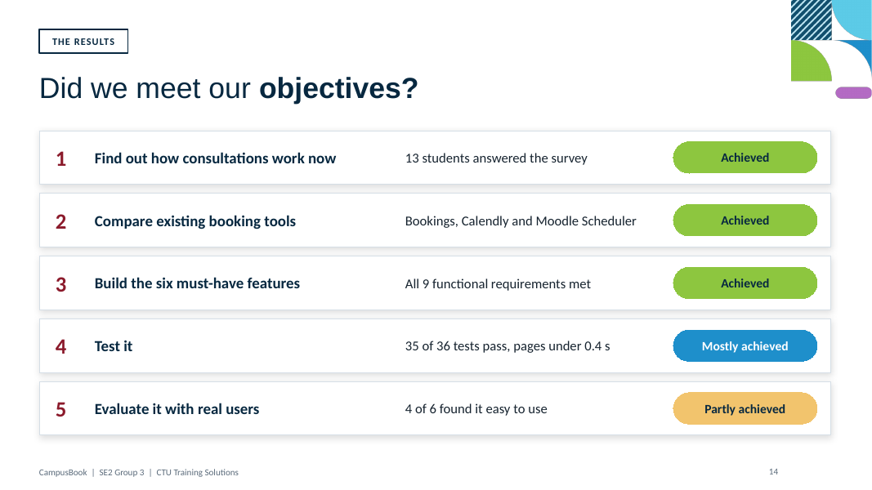
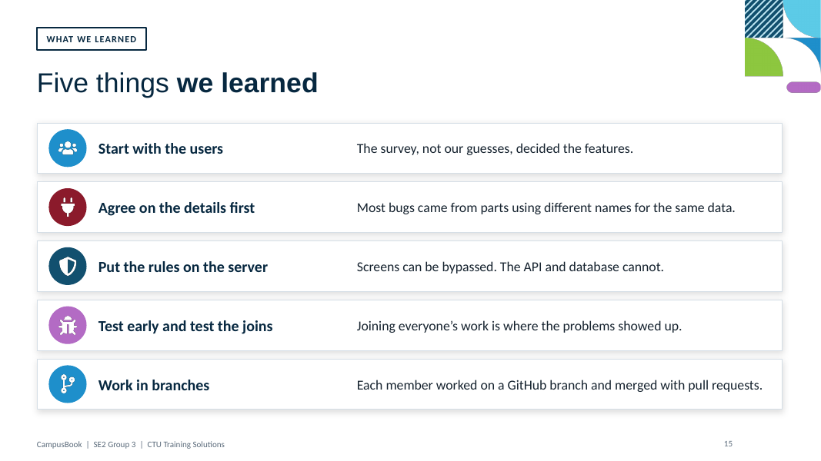 | 