CAPSTONE PROJECT
DATABASE DESIGN DOCUMENT
Student / Group Template
Project Title | CampusBook: a lecturer consultation booking system for CTU Training Solutions
Group Members | Willem Gerber  Oscar Khumalo  Thomas du Plessis  Lebohang Tlaitlai  Gerhardus van den Berg
Module | Software Engineering 2 (SPM622)
Lecturer / Supervisor | Jabulile Mashibini
Week / Stage | Week 3
Submission Date | Monday 19 October 2026

Database Purpose
Explain what information the database must support.
The database stores users lecturer details consultation slots bookings and notifications for CampusBook It is a MySQL database with five tables and rules that stop a slot ever having two confirmed bookings

Entity-Relationship Diagram
Insert the ERD and explain cardinalities.
The database stores users lecturer details consultation slots bookings and notifications The ERD below shows the five tables their keys and how they relate
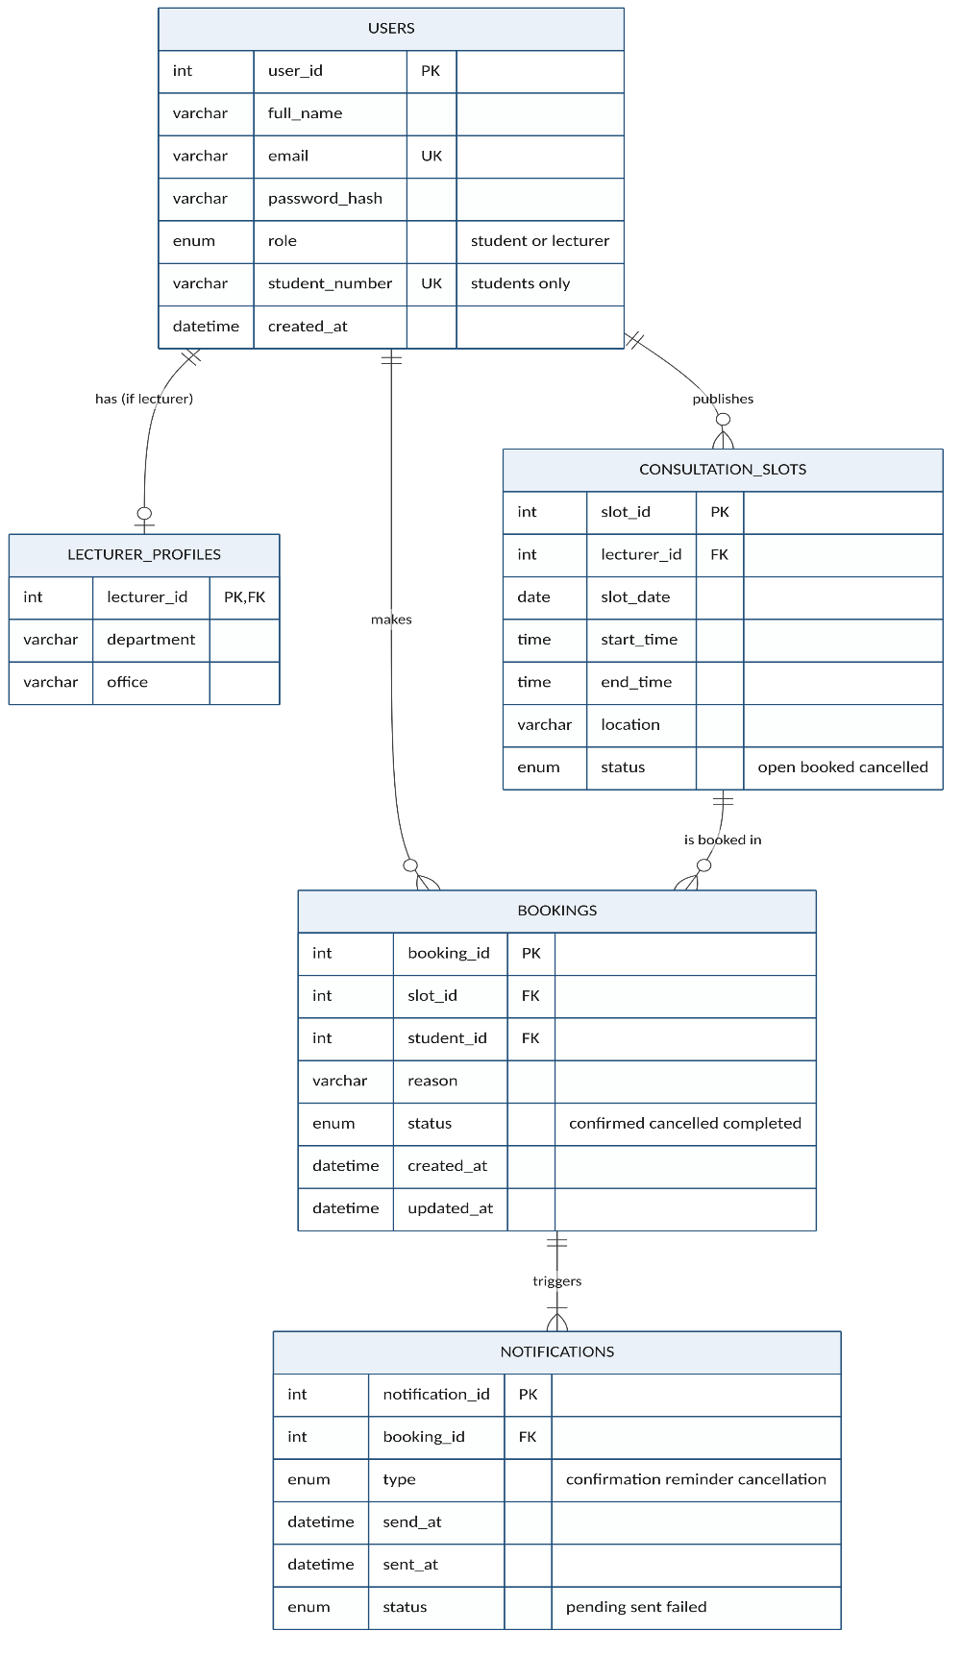
Relationships and cardinality
Relationship | Cardinality | Meaning
users to lecturer_profiles | One to zero or one | Only lecturers have a profile
users to consultation_slots | One to many | A lecturer publishes many slots
users to bookings | One to many | A student makes many bookings
consultation_slots to bookings | One to many | A slot can be booked again after a cancellation but only one booking is active at a time
bookings to notifications | One to one or more | Each booking has a confirmation and a reminder

Data Dictionary
For each table, document column name, data type, size, nullability, key and description.
Column | Type | Null | Key | Description
users
user_id | INT UNSIGNED | No | PK | Unique number for each user
full_name | VARCHAR(120) | No |  | Name shown in the app
email | VARCHAR(150) | No | Unique | Used to log in and receive emails
password_hash | VARCHAR(255) | No |  | bcrypt hash never the real password
role | ENUM | No |  | student or lecturer
student_number | VARCHAR(20) | Yes | Unique | Required for students only
lecturer_profiles
lecturer_id | INT UNSIGNED | No | PK and FK | Links to users
department | VARCHAR(100) | No |  | Department the lecturer belongs to
office | VARCHAR(50) | Yes |  | Office or room
consultation_slots
slot_id | INT UNSIGNED | No | PK | Unique number for each slot
lecturer_id | INT UNSIGNED | No | FK | Lecturer who owns the slot
slot_date | DATE | No |  | Day of the consultation
start_time and end_time | TIME | No |  | End must be after start
location | VARCHAR(100) | No |  | Room or Teams
status | ENUM | No |  | open booked or cancelled
bookings
booking_id | INT UNSIGNED | No | PK | Unique number for each booking
slot_id | INT UNSIGNED | No | FK | Slot that was booked
student_id | INT UNSIGNED | No | FK | Student who booked
reason | VARCHAR(255) | No |  | Reason for the visit
status | ENUM | No |  | confirmed cancelled or completed
active_slot_id | INT UNSIGNED | Yes | Unique | Filled only while confirmed stops double booking
notifications
notification_id | INT UNSIGNED | No | PK | Unique number for each email
booking_id | INT UNSIGNED | No | FK | Booking the email belongs to
type | ENUM | No |  | confirmation reminder or cancellation
send_at and sent_at | DATETIME | sent_at only |  | When it is due and when it was sent
status | ENUM | No |  | pending sent or failed

Normalisation
Explain how duplication and update anomalies were reduced.
The design is in third normal form Every table has a single column primary key and every other column depends only on that key Lecturer details sit in their own table so they are not repeated for students Lecturer and student names are stored once in users and joined when needed so changing a name never leaves old copies behind Notifications are kept apart from bookings so that one booking can have several emails without repeating booking data

Security and Integrity
Explain constraints, validation, access control, backups and sensitive data handling.
- Foreign keys stop a booking pointing at a slot or student that does not exist
- A unique key on active_slot_id means a slot can only ever have one confirmed booking
- Check constraints make sure end times are after start times and that students have a student number
- Passwords are stored as bcrypt hashes and each user can only reach their own bookings through the API
- Only made-up data is used during development in line with POPIA

SQL Scripts
Reference the schema and seed scripts stored in the project repository.
The full scripts are in the repository at database/schema.sql and database/seed.sql The part that prevents double booking is shown below
CREATE TABLE bookings (
booking_id INT UNSIGNED NOT NULL AUTO_INCREMENT,
slot_id INT UNSIGNED NOT NULL,
student_id INT UNSIGNED NOT NULL,
reason VARCHAR(255) NOT NULL,
status ENUM('confirmed','cancelled','completed') DEFAULT 'confirmed',
active_slot_id INT UNSIGNED AS (IF(status = 'confirmed', slot_id, NULL)) STORED,
PRIMARY KEY (booking_id),
UNIQUE KEY uq_one_active_booking_per_slot (active_slot_id),
CONSTRAINT fk_booking_slot FOREIGN KEY (slot_id) REFERENCES consultation_slots (slot_id),
CONSTRAINT fk_booking_student FOREIGN KEY (student_id) REFERENCES users (user_id)
);

