CAPSTONE PROJECT
CHAPTER 4 - SYSTEM DESIGN & DEVELOPMENT
Student / Group Template
Project Title | CampusBook: a lecturer consultation booking system for CTU Training Solutions
Group Members | Willem Gerber  Oscar Khumalo  Thomas du Plessis  Lebohang Tlaitlai  Gerhardus van den Berg
Module | Software Engineering 2 (SPM622)
Lecturer / Supervisor | Jabulile Mashibini
Week / Stage | Week 3 (sections 4.6 to 4.8 to follow in Week 4)
Submission Date | Monday 19 October 2026

4.1 Introduction
Explain the purpose of the design and implementation chapter.
This chapter shows how CampusBook is designed It covers the architecture the UML diagrams the database design and the user interface wireframes followed by the technology stack and the repository structure

4.2 System Architecture
Present and explain the architecture diagram, components and data flow.
CampusBook uses a three tier architecture The client tier is a React web app that runs in the browser on a phone or laptop The application tier is a Node.js and Express API that holds all business rules The data tier is a MySQL database Splitting the system this way keeps the interface the rules and the data separate so each team member can work on one tier without breaking the others
Every request from the browser goes to the API over HTTPS as JSON Middleware checks the login token and the user role and validates the input before any route runs the auth slot and booking routes then read and write the database A scheduler runs every 15 minutes finds bookings that are due a reminder and sends them through the email service Booking confirmations are sent straight after a booking is saved
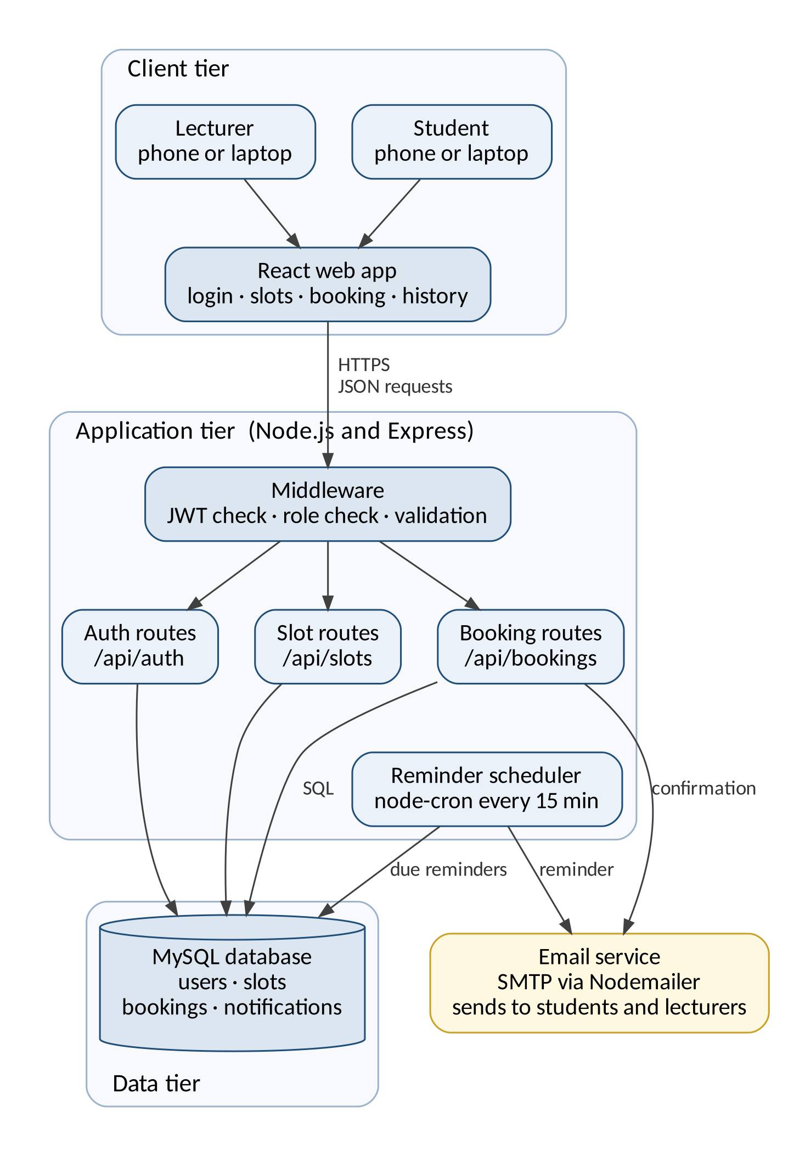

4.3 UML Design
Include and explain relevant use case, class, activity and sequence diagrams.
Use case diagram
The use case diagram shows what each user can do Students view open slots book change and cancel bookings Lecturers publish edit and remove slots and see upcoming bookings Both log in and view their booking history Booking a slot always includes sending a confirmation and reminder through the email service
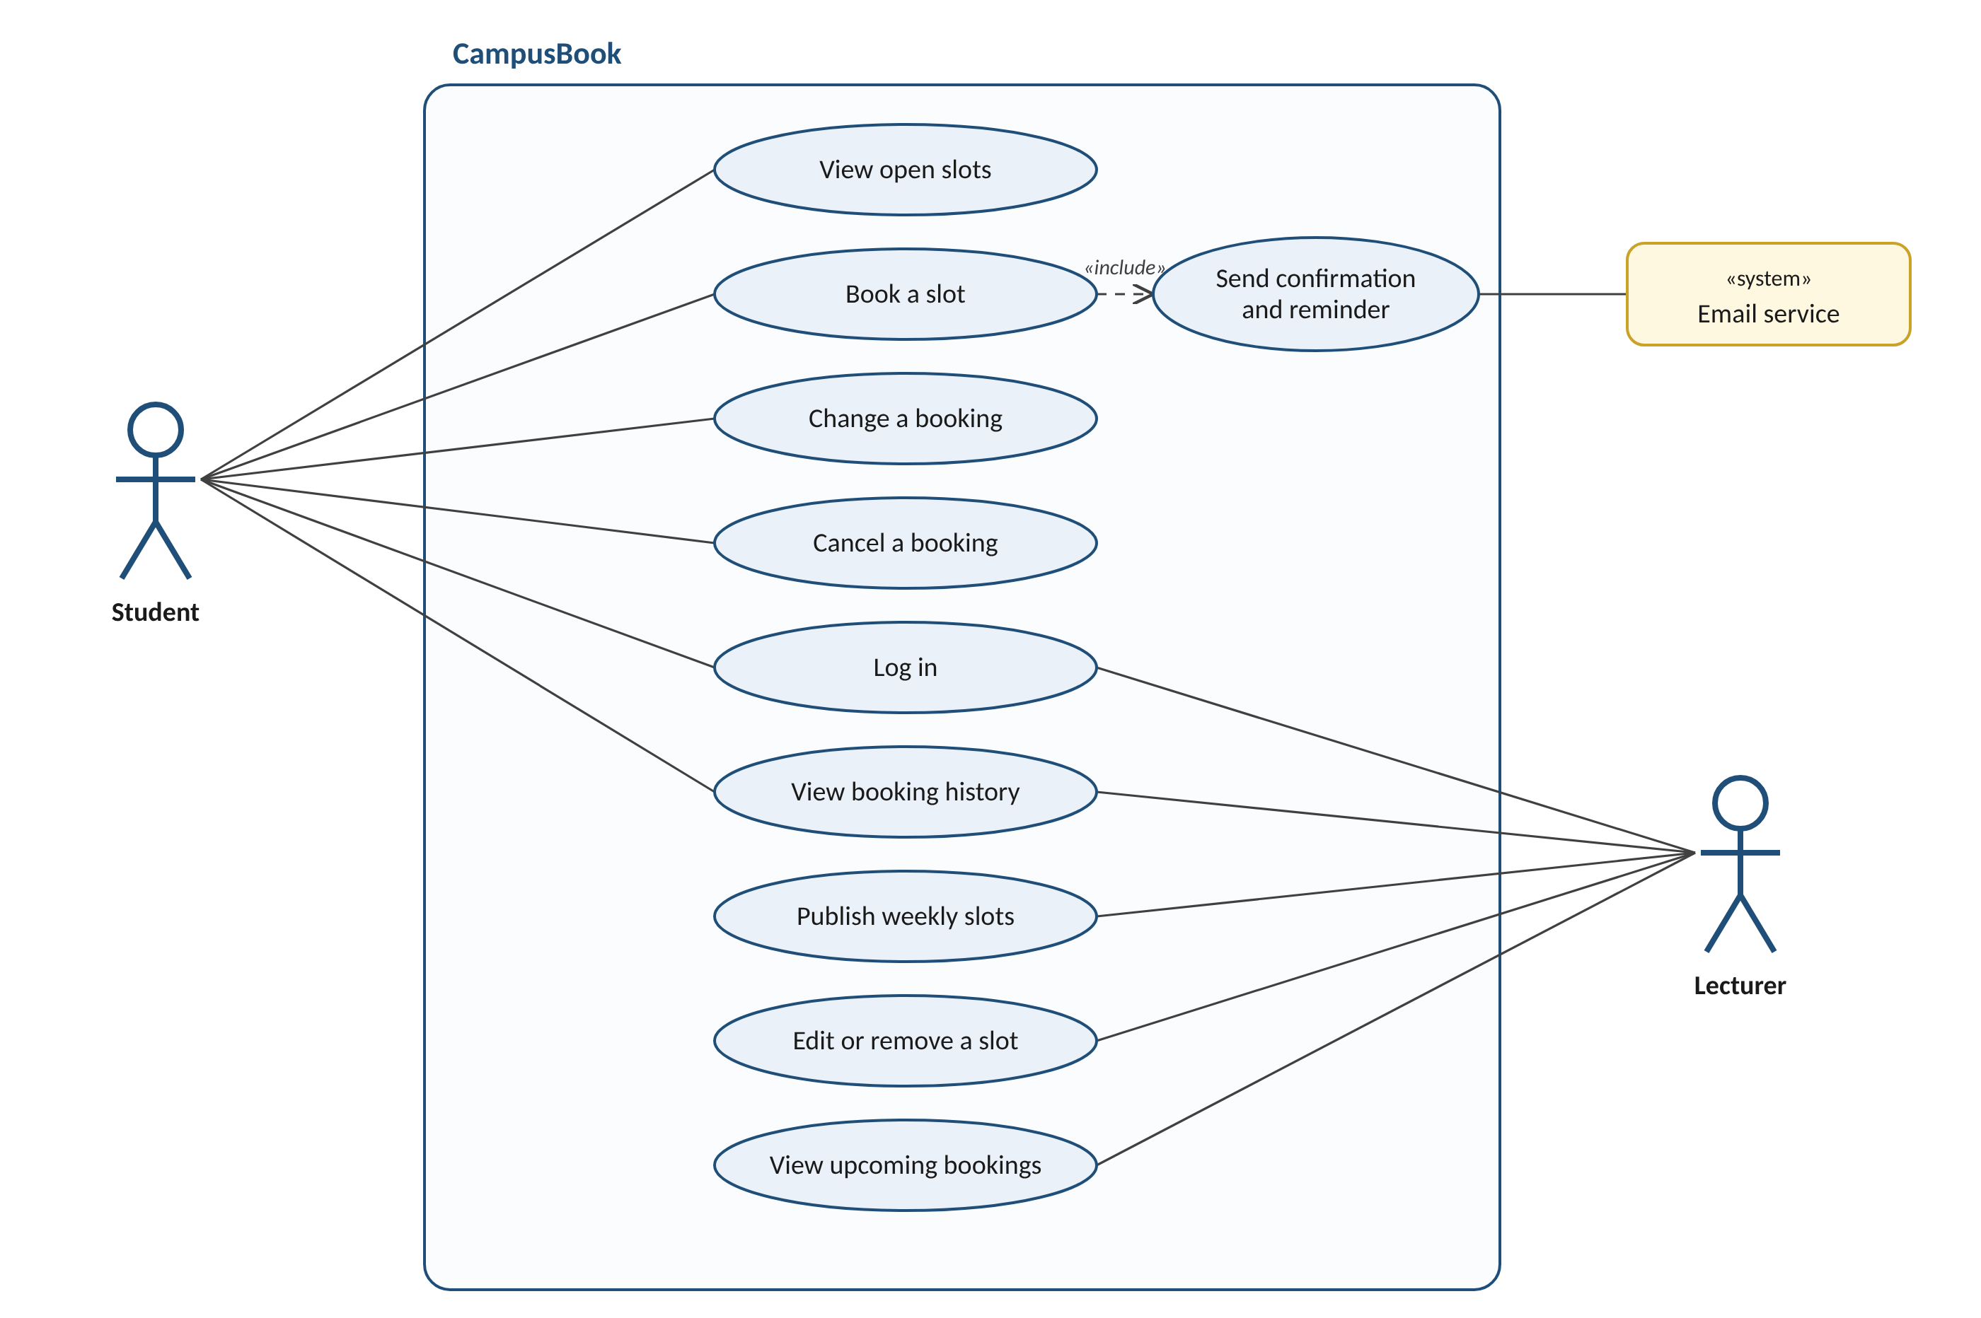
Class diagram
The class diagram shows the main objects in the system Student and Lecturer both inherit from User which holds the login details A lecturer publishes many consultation slots and a slot holds at most one active booking Each booking triggers one or more notifications such as the confirmation and the reminder
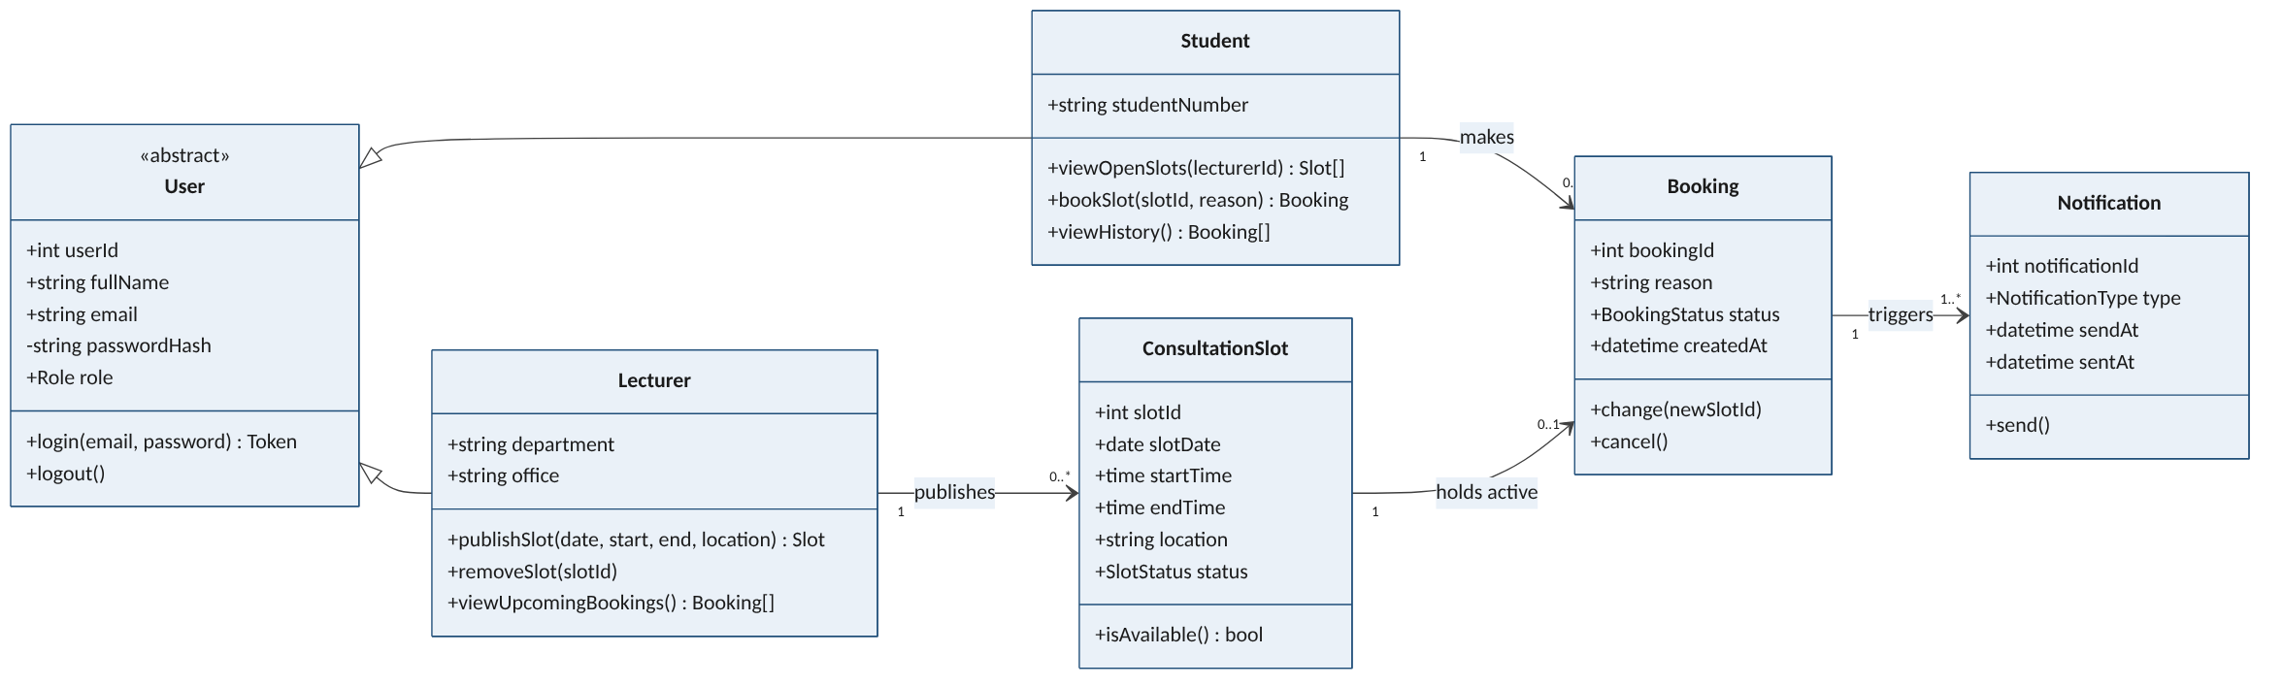
Activity diagram
The activity diagram follows a student booking a consultation It shows the two key decisions If no suitable slot is open the student can check another week or lecturer If another student takes the slot first the system shows a message and refreshes the list instead of creating a double booking
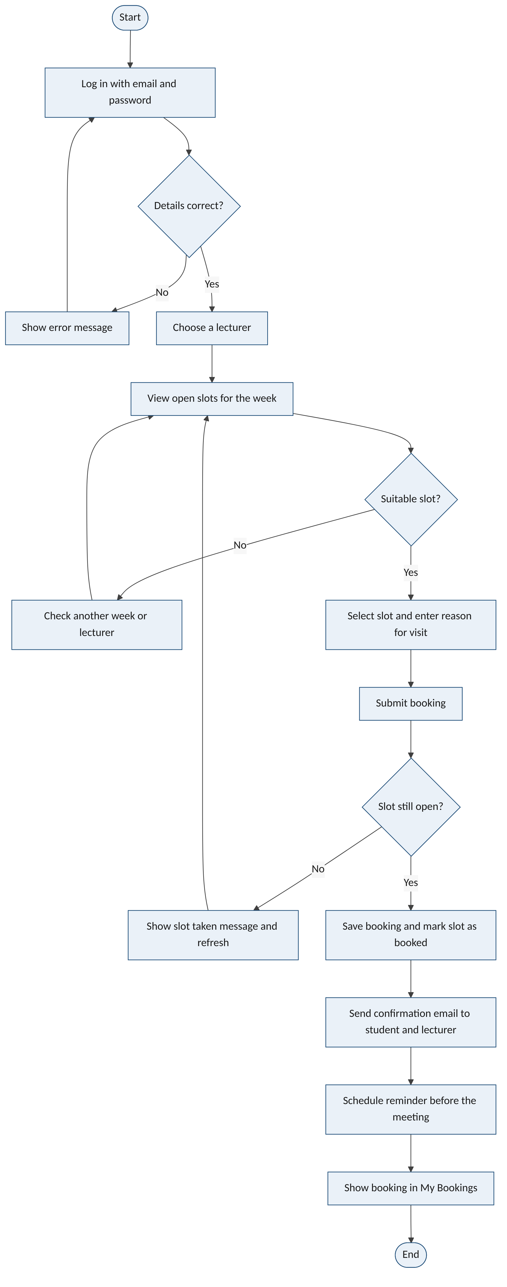
Sequence diagram
The sequence diagram shows the messages behind a booking The API locks the slot row inside a database transaction so two students pressing book at the same moment cannot both succeed If the slot is open the booking is saved the confirmation email is sent and the student sees a confirmation If not the transaction is rolled back and the student is told the slot was taken
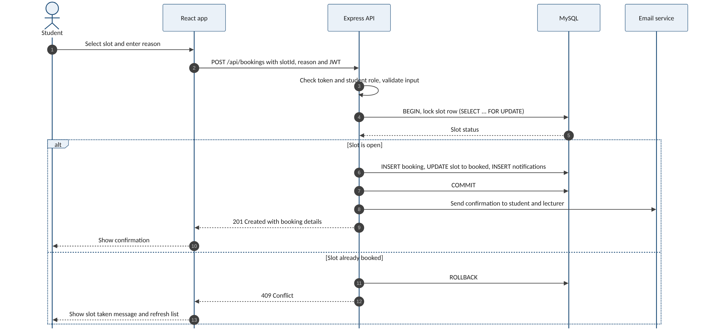

4.4 Database Design
Present ERD, entities, attributes, keys, relationships and normalisation where applicable.
The database stores users lecturer details consultation slots bookings and notifications The ERD below shows the five tables their keys and how they relate
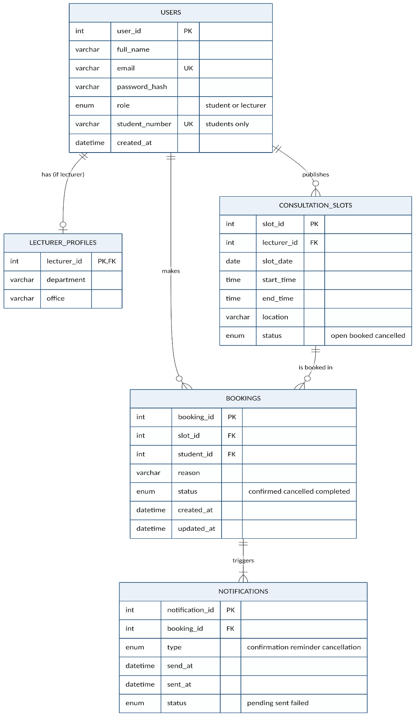
Relationships and cardinality
Relationship | Cardinality | Meaning
users to lecturer_profiles | One to zero or one | Only lecturers have a profile
users to consultation_slots | One to many | A lecturer publishes many slots
users to bookings | One to many | A student makes many bookings
consultation_slots to bookings | One to many | A slot can be booked again after a cancellation but only one booking is active at a time
bookings to notifications | One to one or more | Each booking has a confirmation and a reminder

Data dictionary
Column | Type | Null | Key | Description
users
user_id | INT UNSIGNED | No | PK | Unique number for each user
full_name | VARCHAR(120) | No |  | Name shown in the app
email | VARCHAR(150) | No | Unique | Used to log in and receive emails
password_hash | VARCHAR(255) | No |  | bcrypt hash never the real password
role | ENUM | No |  | student or lecturer
student_number | VARCHAR(20) | Yes | Unique | Required for students only
lecturer_profiles
lecturer_id | INT UNSIGNED | No | PK and FK | Links to users
department | VARCHAR(100) | No |  | Department the lecturer belongs to
office | VARCHAR(50) | Yes |  | Office or room
consultation_slots
slot_id | INT UNSIGNED | No | PK | Unique number for each slot
lecturer_id | INT UNSIGNED | No | FK | Lecturer who owns the slot
slot_date | DATE | No |  | Day of the consultation
start_time and end_time | TIME | No |  | End must be after start
location | VARCHAR(100) | No |  | Room or Teams
status | ENUM | No |  | open booked or cancelled
bookings
booking_id | INT UNSIGNED | No | PK | Unique number for each booking
slot_id | INT UNSIGNED | No | FK | Slot that was booked
student_id | INT UNSIGNED | No | FK | Student who booked
reason | VARCHAR(255) | No |  | Reason for the visit
status | ENUM | No |  | confirmed cancelled or completed
active_slot_id | INT UNSIGNED | Yes | Unique | Filled only while confirmed stops double booking
notifications
notification_id | INT UNSIGNED | No | PK | Unique number for each email
booking_id | INT UNSIGNED | No | FK | Booking the email belongs to
type | ENUM | No |  | confirmation reminder or cancellation
send_at and sent_at | DATETIME | sent_at only |  | When it is due and when it was sent
status | ENUM | No |  | pending sent or failed

Normalisation
The design is in third normal form Every table has a single column primary key and every other column depends only on that key Lecturer details sit in their own table so they are not repeated for students Lecturer and student names are stored once in users and joined when needed so changing a name never leaves old copies behind Notifications are kept apart from bookings so that one booking can have several emails without repeating booking data
Security and integrity
- Foreign keys stop a booking pointing at a slot or student that does not exist
- A unique key on active_slot_id means a slot can only ever have one confirmed booking
- Check constraints make sure end times are after start times and that students have a student number
- Passwords are stored as bcrypt hashes and each user can only reach their own bookings through the API
- Only made-up data is used during development in line with POPIA
SQL scripts
The full scripts are in the repository at database/schema.sql and database/seed.sql The part that prevents double booking is shown below
CREATE TABLE bookings (
booking_id INT UNSIGNED NOT NULL AUTO_INCREMENT,
slot_id INT UNSIGNED NOT NULL,
student_id INT UNSIGNED NOT NULL,
reason VARCHAR(255) NOT NULL,
status ENUM('confirmed','cancelled','completed') DEFAULT 'confirmed',
active_slot_id INT UNSIGNED AS (IF(status = 'confirmed', slot_id, NULL)) STORED,
PRIMARY KEY (booking_id),
UNIQUE KEY uq_one_active_booking_per_slot (active_slot_id),
CONSTRAINT fk_booking_slot FOREIGN KEY (slot_id) REFERENCES consultation_slots (slot_id),
CONSTRAINT fk_booking_student FOREIGN KEY (student_id) REFERENCES users (user_id)
);

4.5 User Interface Design
Show wireframes or prototypes and explain usability decisions.
The screens below are low fidelity wireframes that show the layout and flow of each page before it is built in React in Week 4 The numbered markers point to the design choices explained under each screen The layout follows the usability heuristics from Chapter 2 (Nielsen, 1994) and keeps every task to as few steps as possible so that booking is quicker than sending a message (Davis, 1989)
Login
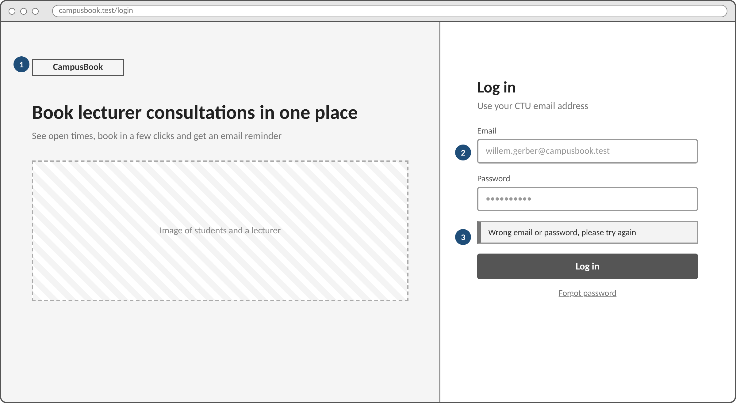
1. The left side explains in one line what CampusBook does so new users know they are in the right place
2. Labels sit above each field and the email field hints that a CTU address is needed
3. Errors appear in plain words right above the button so users can recognise and recover from a mistake
Student booking screen
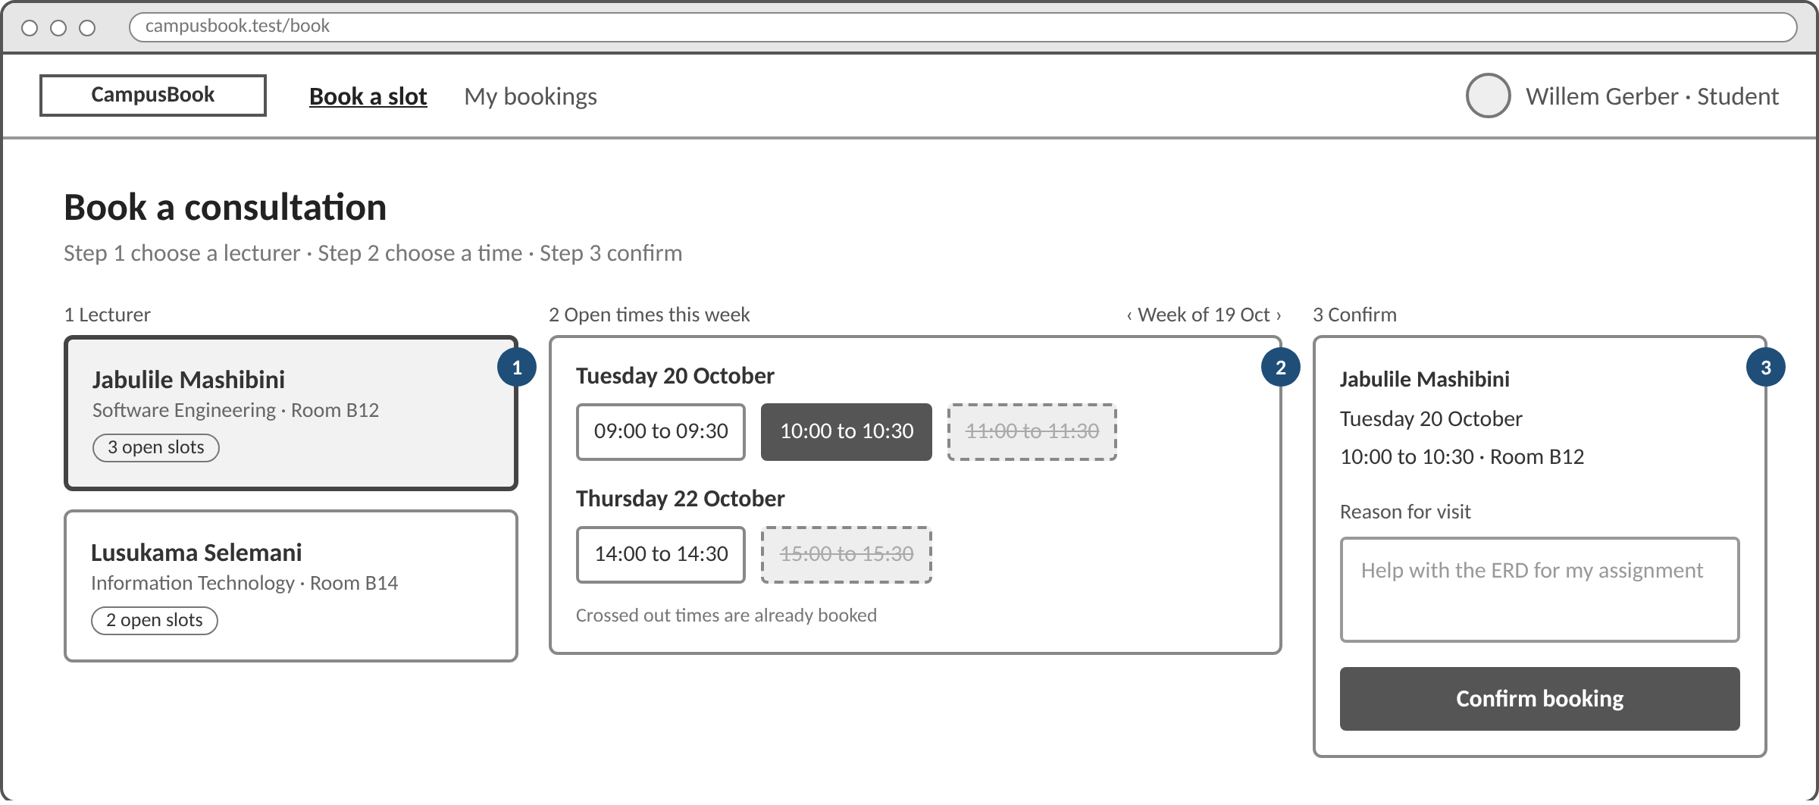
1. Lecturer cards show the department room and number of open slots so students can choose quickly
2. Open times are grouped by day and times that are already taken are crossed out instead of hidden which prevents errors
3. A summary repeats the lecturer date time and place before the student confirms and the reason for the visit is required
Lecturer slots screen
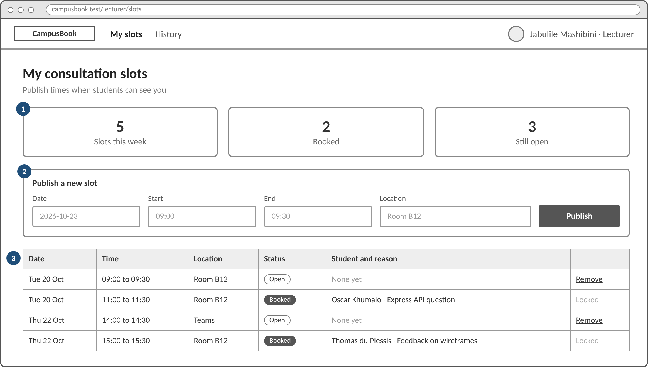
1. Three counters show the week at a glance so lecturers always know the status of the system
2. A new slot is published with four fields on one line which keeps the most common lecturer task short
3. The table lists every slot with the student and reason and booked slots are locked so a confirmed meeting cannot be removed by accident
My bookings on a phone
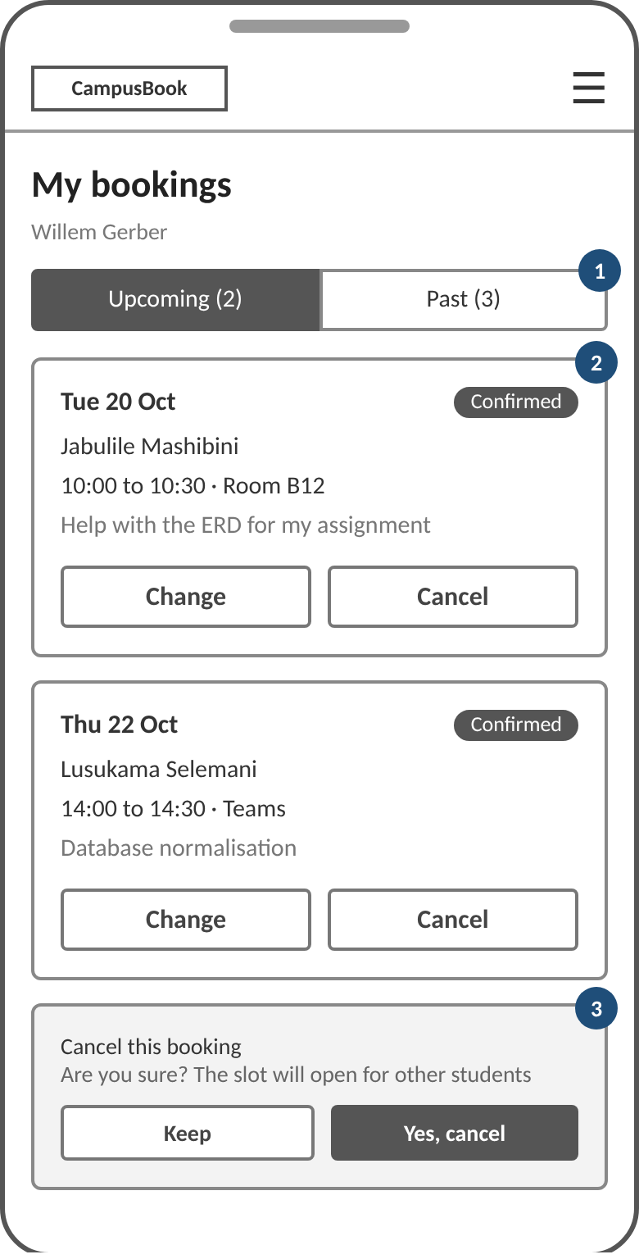
1. Upcoming and past bookings sit in two tabs so the list stays short on a small screen
2. Each card shows the date lecturer time place and reason with large buttons that are easy to tap
3. Cancelling asks for confirmation first and explains that the slot will open for other students

4.6 Development Environment
List languages, frameworks, IDE, database, libraries, cloud/services and version-control tools.
Technology stack
Part | Choice | Why it was chosen
Front end | React with Vite | Reusable components keep the four screens consistent and Vite gives fast reloads while developing
Routing | React Router | Separate pages for students and lecturers with protected routes
Back end | Node.js with Express | The whole team works in one language JavaScript and Express keeps the API small and readable
Database | MySQL 8 | Relational tables foreign keys and transactions suit bookings and the team already knows SQL
Security | bcryptjs and JSON Web Tokens | Passwords are hashed and every request carries a signed token with the user role
Email | Nodemailer and node-cron | Free email over SMTP with a scheduled job for reminders
Version control | Git and GitHub | Feature branches and pull requests show each member contribution

4.7 Implementation
Explain important modules/features and include selected code snippets only where they support the discussion.
Repository structure
CampusBook/
├── backend/ Express REST API
│ └── src/
│ ├── routes/ auth.js, slots.js, bookings.js
│ ├── middleware/ auth.js, validate.js
│ ├── services/ mailer.js
│ ├── jobs/ reminders.js
│ ├── db.js
│ └── server.js
├── frontend/ React web app
│ └── src/pages/ Login, BookSlot, MyBookings, LecturerSlots
├── database/ schema.sql, seed.sql
├── docs/ diagrams and wireframes
└── README.md
Development evidence at the end of Week 3
Item | Status | Owner
Project structure and README | Done | Willem Gerber
Database schema script | Done and tested | Gerhardus van den Berg
Test data script | Done | Gerhardus van den Berg
Login with student and lecturer roles | Planned for Week 4 | Oscar Khumalo
Slots and booking endpoints | Planned for Week 4 | Oscar Khumalo and Willem Gerber
React pages and mobile layout | Planned for Week 4 | Thomas du Plessis
Email confirmation and reminders | Planned for Week 4 | Gerhardus van den Berg

4.8 Version Control
Explain repository structure, branches, commits, pull/merge activity and team collaboration.
________________________________________________________________________________
________________________________________________________________________________
________________________________________________________________________________
________________________________________________________________________________

4.9 Chapter Summary
Summarise the implemented system and prepare for testing.
________________________________________________________________________________
________________________________________________________________________________
________________________________________________________________________________

