Three Class Pneumonia Classification Research Journal
  - Complete journal-style documentation of data preparation, augmentation, model training, ordered preprocessing, tuning, validation, and final selection
Normal | Viral Pneumonia | Bacterial Pneumonia

Report field | Final value
Status | FT-011 completed; four screening gates failed; retain FT-004 and close tuning
Final validation-selected candidate | FT-004 three-member DenseNet-201 probability ensemble
Seeds | FT-004 confirmed at 42, 123 and 2026; deployment uses three original seed-42 checkpoints
Three-seed mean validation macro F1 | 0.8530516857750923 (85.305%)
Three-seed mean balanced accuracy | 0.8492846583463107 (84.928%)
Three-seed mean accuracy | 0.8627002288329519 (86.270%)
Locked-test boundary | FT-004 remains validation-selected; earlier GE test metrics do not transfer
Generated | 13 October 2026 Asia Manila
Updated 13 October 2026 | Earlier baseline and preprocessing findings retained as historical evidence
Reporting boundary: the current validation-selected system is the FT-004 three-member DenseNet-201 ensemble. Earlier sections preserve the preceding baseline and preprocessing-only phase. FT-011 used training and validation only; the earlier DenseNet-201 plus GE test result does not transfer to FT-004. Independent external evaluation remains required.

Current decision on 13 October 2026: retain FT-004, the three-member DenseNet-201 ensemble. Earlier sections describe the preceding baseline and preprocessing phases. The final update below records FT-011; the separate fine-tuning report contains its full method, recovery details and gate evidence.

Abstract
This study developed and audited a three-class pediatric chest-radiograph classifier for Normal, Viral Pneumonia, and Bacterial Pneumonia. From 17,591 source files, the preparation pipeline identified 5,824 unique canonical images after excluding metadata, verified nested copies, source-layout anomalies, and 32 redundant exact images. Deterministic group-aware manifests assigned 4,076 images to training, 874 to validation, and 874 to the sealed test split with zero assigned exact-hash or group leakage.
Eight ImageNet-initialized classifiers were compared under matched optimization controls. DenseNet-201 and ResNet-50 then received exhaustive evaluation of the baseline plus every ordered subset of CLAHE, global histogram equalization (GE), and VIRIDIS pseudo-coloring (16 conditions per model). The three strongest seed-42 configurations were retrained at seeds 123 and 2026, producing three independent controlled runs per candidate.
Across seeds 42, 123, and 2026, DenseNet-201 + VIRIDIS -> GE -> CLAHE achieved the highest mean validation macro F1 at 84.168%, followed extremely closely by DenseNet-169 with the same pipeline at 84.142%; ResNet-50 + CLAHE -> VIRIDIS -> GE averaged 83.472%. DenseNet-201 also led mean balanced accuracy and mean accuracy, while DenseNet-169 had lower seed-to-seed variability and slightly higher mean Viral recall.
The earlier preprocessing-only phase selected DenseNet-201 + VIRIDIS -> GE -> CLAHE. Subsequent fine-tuning confirmed FT-004 as the highest-mean fully three-seed-confirmed finalist. The October FT-011 learning-rate comparison failed its screening gates, so FT-004 remains the current frozen validation-selected research system.
Keywords: chest radiography; pneumonia classification; DenseNet; ResNet; CLAHE; histogram equalization; VIRIDIS; data leakage; macro F1; transfer learning

Highlights
- The experiment ledger and dedicated comparison summaries preserve every completed full, analysis, pilot, and robustness run, including the four new competitor seed runs.
- The historical preprocessing-only winner is DenseNet-201 + VIRIDIS -> GE -> CLAHE; the current retained research system after fine-tuning is FT-004.
- DenseNet-169 was practically tied at 84.142% three-seed mean macro F1 and was more stable; ResNet-50 averaged 83.472%.
- The sealed test split was not used to choose preprocessing, architecture, seed, or checkpoint and was not reopened for the final validation-selected candidate.

Research Completion Status
Research Stage | Previous Status | New Status | Evidence/File
Baseline benchmark | Complete | Complete; 8/8 supported models verified | model/results/audits/completed_baseline_artifact_audit.json
Preprocessing ablations | 0 of 3 | Complete; 3/3 methods, 9/9 new runs | model/results/preprocessing_ablation_analysis.json
Focused comparisons | Not started | Complete; validation-only aliases, no redundant retraining | model/results/selection_resolution.json
Optuna tuning | 0 trials | Complete; 12/12 completed trials; every state retained | model/results/tuning_trials.csv
Multi-seed robustness | Not started | Complete for earlier GE study and final top-three comparison; 9/9 finalist seed-runs | model/results/top_competitor_multiseed_confirmation/summary.json
Locked-test evaluation | Not performed | Completed once for earlier frozen DenseNet-201 + GE; not reopened for staged winner | model/results/runs/final_locked_test/metrics.json
Earlier frozen/tested selection | Not established | Preserved: DenseNet-201 + GE / final_selected_s42 | model/results/final_selection.json
Explainability | Not completed | Complete; 6 post-freeze Grad-CAM cases | model/results/gradcam/gradcam_audit.json
Documentation | Partially complete | Complete; versioned Word plus Markdown/CSV/JSON evidence | model/docs and model/results
Ordered preprocessing | Not started | Complete; DenseNet-201 16/16 and ResNet-50 16/16 | model/results/staged_preprocessing_experiment/*_all_orders.csv
Winner transfer | Not started | Complete; selected DenseNet-201 pipeline evaluated on 8/8 models | model/results/staged_preprocessing_experiment/winner_cross_model_table.csv
Historical preprocessing-only selection | DenseNet-201 + GE | DenseNet-201 + VIRIDIS -> GE -> CLAHE; three-seed mean macro F1 84.168% | model/results/top_competitor_multiseed_confirmation/summary.json
Final competitor confirmation | Seed 42 only | Complete: DenseNet-201, DenseNet-169, and ResNet-50 at seeds 42/123/2026 | model/results/top_competitor_multiseed_confirmation/summary.csv

Reader Guide: How to Understand This Report
In one sentence: the project compared pediatric chest X-ray classifiers and preprocessing policies, then fine-tuning selected the FT-004 three-member DenseNet-201 ensemble; the final FT-011 learning-rate experiment did not meet its screening gates, so FT-004 remains frozen.
- A model is the learned mathematical system; an architecture is its predefined layer design; a configuration is the complete collection of model, preprocessing, and training settings.
- Seed 42, seed 123, and seed 2026 are three repeatable random training conditions. They do not mean 42, 123, or 2026 images, epochs, or percent performance.
- Macro F1 is the primary selection metric because it gives Normal, Viral, and Bacterial classes equal importance. Accuracy is reported as supporting evidence but can be influenced by the largest class.
- Validation results were used for selection. The locked test was not reopened for the newly selected candidate, so the earlier DenseNet-201 + GE test score must not be assigned to it.
- Technical terms are explained when first used and collected in Appendix B for quick lookup.

1. Repository, Source, and Locked Dataset Audit
The continuation began by auditing the supplied Word report, repository code, manifests, checkpoints, logs, metrics, and training environment. No baseline was rerun and no source image or locked manifest was modified.
Audit item | Verified value
Repository branch | codex/research-continuation-v2
Starting commit | 3dbd85ecbe8c408c858c84aa2b8e333c422f6192
Source root | C:\Users\JOHN MARK\Code\ai-research-main\model\datasets\chest_xray
Source files / bytes | 17,591 / 2,483,915,296
Inventory SHA-256 | 4ee6dd784207a910043f62cff542a5d805c312fcddafa90ce1a058d03402f734
Manifest version | three_class_seed42_3b815cf769c8
Manifest SHA-256 | 3b815cf769c85658a04748da5eb2e15b981b89d9c9b77a404e90fe23473d2774
Class order | Normal, Viral, Bacterial
Assigned leakage | 0 group leakage; 0 exact-hash leakage

1.1 Split composition
Split | Normal | Viral | Bacterial | Total | Groups
Train | 1105 | 1039 | 1932 | 4076 | 2326
Val | 237 | 223 | 414 | 874 | 228
Test | 237 | 223 | 414 | 874 | 235

The original folder split was not preserved because 264 derived patient/image groups crossed the original folders. A deterministic group-aware assignment was created without consulting image content or test metrics. Exact-hash groups were unioned before splitting.

1.2 What 'canonical image' and the duplicate counts mean
A canonical image is the selected primary representative of an intended dataset item after excluding macOS metadata, verified nested copies, unrecognized layout artifacts, and redundant byte-identical content. The source contained 5,856 valid canonical-role physical images before exact deduplication and 5,824 unique canonical images after 32 redundant exact images were excluded.
The value 5,888 in duplicate_report.csv is not the number of training images removed. It is a physical report-row count describing exact-content relationships across canonical files and verified nested copies. SHA-256/byte identity found exact duplicates. The 64-bit DCT pHash was used only to flag visually similar candidates for human review.
Duplicate/audit concept | Count | Meaning
Canonical redundant exact images excluded | 32 | Unique-data deduplication decision
Physical exact-duplicate report rows | 5,888 | Relationships including nested copies
Original folder group crossings | 264 | Reason original split was rejected
Nested-copy mismatches | 4 | Excluded source-layout anomalies
pHash candidates | 16 | Manual review queue, not automatic duplicates
Confirmed near duplicates | 0 | All 16 pairs were distinct

1.3 Manual review of all 16 pHash candidates
Five candidates crossed assigned splits. Each evidence sheet was inspected for thoracic anatomy, clavicle/rib geometry, cardiomediastinal contour, diaphragm shape, lung volume, positioning, exposure, and markers. Similar centered radiograph geometry explained the low pHash distance; no pair represented the same image.
Pair | Assigned splits | Decision | Visual basis
near_5611f5dce8b45d92 | train / train | Distinct images - retain both | Different thoracic anatomy, inspiration, positioning, and R-marker placement.
near_00f755ace402461b | test / train | Distinct images - retain both | Different thoracic contours, clavicle alignment, exposure, and diaphragm shape.
near_9baff834314599d5 | train / test | Distinct images - retain both | Different body size, positioning, lung volumes, and cardiomediastinal contours.
near_ab80f0eac1b035bd | train / train | Distinct images - retain both | Different age/body size, clavicle alignment, lung volumes, and diaphragm contours.
near_5776286b699047d0 | train / train | Distinct images - retain both | Different thoracic proportions, cardiac silhouette, inspiration, and marker placement.
near_605ba5843cd4df27 | train / train | Distinct images - retain both | Different age/body size, exposure, lung volumes, and cardiomediastinal anatomy.
near_1ba4be31eda3af8f | train / train | Distinct images - retain both | Different thoracic proportions, rotation, cardiac silhouette, and lung texture.
near_78528749b3f26e02 | train / train | Distinct images - retain both | Different thoracic anatomy, inspiration, projection, and marker placement.
near_fe8ef67898a877da | train / train | Distinct images - retain both | Different shoulder/clavicle geometry, cardiac silhouette, diaphragm, and positioning.
near_bb0271d7571b90bf | train / train | Distinct images - retain both | Different rotation, rib and clavicle geometry, cardiac contour, and exposure.
near_108295e9cc425d75 | train / val | Distinct images - retain both | Different body size, rotation, shoulder anatomy, and cardiomediastinal contours.
near_46a898efcc56e29e | val / train | Distinct images - retain both | Different infant anatomy, lung volumes, rib geometry, and cardiac silhouette.
near_03e374c0d9e71141 | train / train | Distinct images - retain both | Different exposure, thoracic proportions, lung texture, and cardiac silhouette.
near_5259cdc0ec6f4917 | train / train | Distinct images - retain both | Different body size, rib/clavicle alignment, lung texture, and diaphragm contours.
near_90cf97b9b16e2b4e | val / train | Distinct images - retain both | Different age/body size, rotation, thoracic anatomy, and cardiac silhouette.
near_1ba9cfb07901db30 | train / train | Distinct images - retain both | Different thoracic proportions, lung texture, cardiac silhouette, and positioning.

2. Preprocessing and Augmentation
Exact tensor pipeline: locked manifest -> open image -> enhancement/RGB -> training-only flip -> training-only rotation -> aspect-ratio-preserving resize-to-fill and center crop -> float32 [0,1] -> CHW -> ImageNet normalization -> 3 x 224 x 224.
Step | Operation | Exact meaning
1 | Open the original | Pillow decodes the immutable source file named by the locked manifest.
2 | Convert/enhance | Baseline converts to RGB. CLAHE/global HE convert to grayscale, enhance, then replicate to RGB. VIRIDIS maps grayscale intensity to artificial RGB.
3 | Horizontal flip (training only) | Probability 0.5. Validation/test never flip.
4 | Rotation (training only) | Uniform random angle from -5 to +5 degrees with bilinear resampling and black corner fill.
5 | Resize and crop | Pillow ImageOps.fit preserves aspect ratio, scales until 224 x 224 is filled, and center-crops excess edges. It does not pad, letterbox, or stretch.
6 | Scale pixels | Convert to float32 and divide by 255, yielding values in [0,1].
7 | Transpose | Convert H x W x C into C x H x W for PyTorch.
8 | Normalize | Subtract ImageNet means [0.485,0.456,0.406] and divide by [0.229,0.224,0.225].

2.1 Enhancement conditions
Condition | Included? | Exact implementation | Why / boundary
No enhancement | Yes; completed control | RGB conversion only | Preserves original intensity appearance and pretrained RGB contract.
CLAHE | Yes | OpenCV CLAHE; clipLimit 2.0; tileGridSize 8 x 8 on grayscale | Local contrast candidate supported partially by CXR literature; effect tested independently.
Global HE | Yes | Pillow ImageOps.equalize on grayscale | Direct pediatric CXR evidence motivates a controlled comparison.
VIRIDIS | Yes; exploratory | OpenCV COLORMAP_VIRIDIS on grayscale | No direct exact-task validation was found; cannot be described as adding clinical information.
PCA | No | No raw-image PCA | No leakage-safe, train-only feature-space representation/question was defined.
FILM | No | No implementation | No verified conditioning signal or reproducible definition existed.
SAS tuning / automated grading | No | No implementation | Undefined in repository evidence; no results fabricated.
Segmentation/ROI masking | No | No lung mask | Localization literature is Partial evidence only; adding a segmenter would change the task and error chain.
Vertical flip / large rotation | No | Excluded | Anatomically implausible or excessive for this controlled CXR study.

Enhancement is deterministic and applied before augmentation and crop. Augmentation is sampled on-the-fly during every training access; no augmented image files are written into the locked dataset. Validation and test use deterministic transforms only.
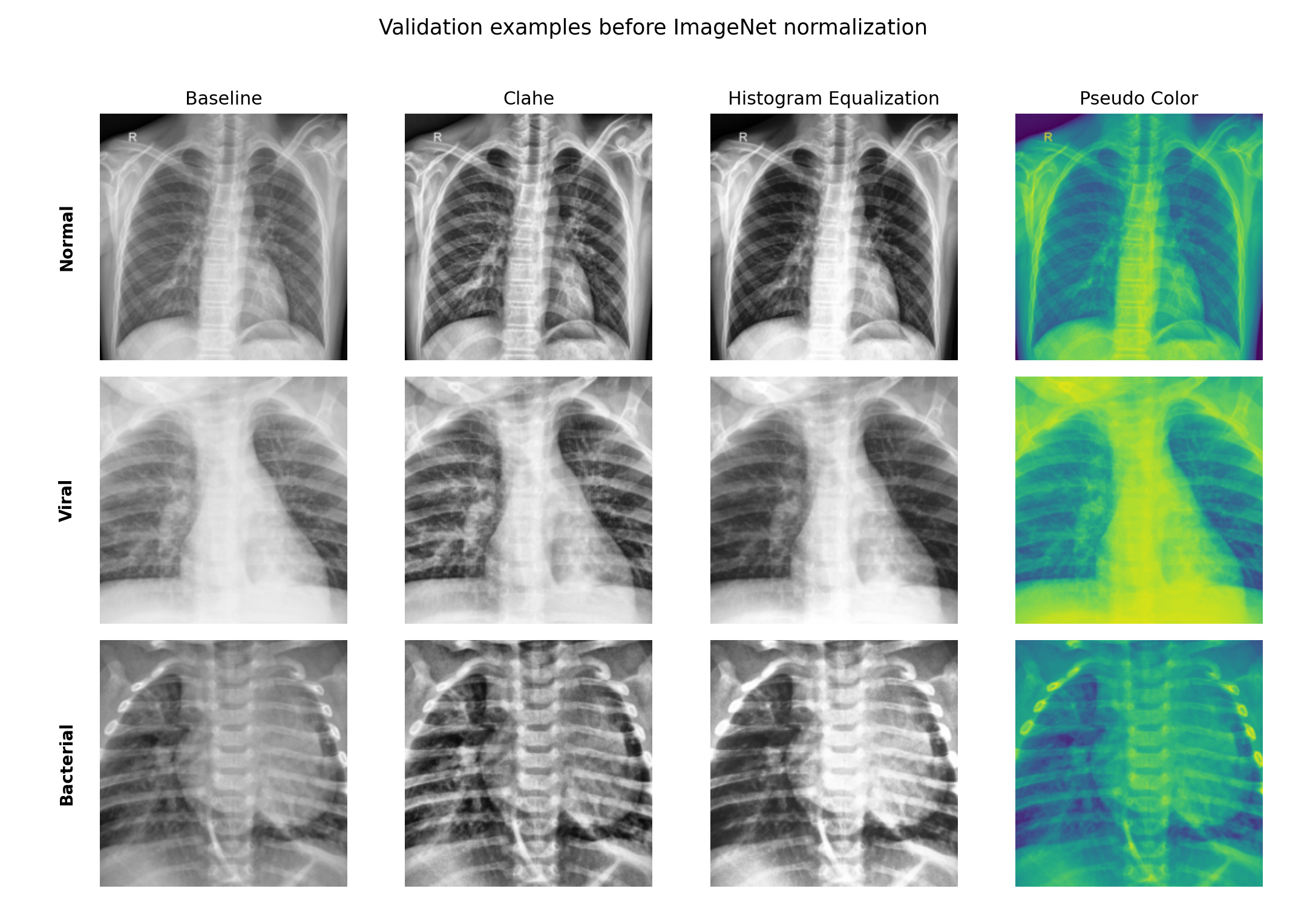
Pre-normalization examples for the four supported conditions. VIRIDIS is an exploratory artificial colormap.

3. Models and Training Procedure
Setting | Final controlled definition
Task | Single-label three-class classification: Normal, Viral, Bacterial
Weights | Official/ImageNet classification weights; classifier replaced with three logits
Fine-tuning | Full network trainable
Loss | balanced class-weighted cross entropy
Class weights | Normal 1.229563; Viral 1.307668; Bacterial 0.703244
Optimizer | AdamW; initial learning rate 0.0001; weight decay 0.0001
Scheduler | ReduceLROnPlateau on validation macro F1, factor 0.5, patience 2
Epoch ceiling | 12; best checkpoint by validation macro F1; early stopping patience 4
Mixed precision | Enabled on CUDA
Seed | 42 for controlled comparison; later robustness seeds 42, 123, 2026
Test access | Prohibited until final selection lock

3.1 Meaning of learning rate, weight decay, and 12 epochs
Learning rate 0.0001 is AdamW's initial step size. It is deliberately small for full-network fine-tuning so useful pretrained features are not destroyed by large updates. ReduceLROnPlateau halves the rate after two macro-F1 plateaus.
Weight decay 0.0001 is regularization: it gently discourages excessively large weights. It is not a second learning rate. The value is an engineering control shared by the completed comparisons, not a configuration copied blindly from another modality or paper.
Maximum 12 epochs means at most twelve complete passes through 4,076 training images. It is a ceiling. The best validation checkpoint is retained, and early stopping ends after four epochs without an improvement greater than 0.0001. Baseline best epochs ranged from 5 to 11.

3.2 How batch size was determined
Architecture-specific batch sizes were selected through actual CUDA forward/backward resource calibration on the 4 GB RTX 2050. They are the largest premeasured safe values used for each architecture. Within every preprocessing comparison, the completed control and its variants use the same batch size.
Architecture | Batch | Parameters | Weight source / scientific role
densenet169 | 12 | 12,489,475 | DenseNet architecture provenance plus exact-task transfer evidence from Rahman et al.; no located exact-task paper uniquely establishes D169 settings.
densenet201 | 8 | 18,098,691 | Rahman et al. directly evaluated DenseNet201 on the exact Normal/Viral/Bacterial task.
densenet121 | 16 | 6,956,931 | Kundu et al. (binary ensemble), Arulananth et al. (binary pediatric), and CheXNet provide Partial evidence.
resnet101 | 8 | 42,506,307 | Jaiswal et al. uses ResNet101 for CXR localization; the classification settings remain repository-controlled.
resnet50 | 16 | 23,514,179 | Bakır et al. supports ResNet feature extraction on the exact task; Jaiswal et al. uses ResNet50 for localization only.
resnet152 | 6 | 58,149,955 | ResNet architecture provenance; no supplied exact-task source uniquely establishes ResNet152 settings.
yolov5_cls | 32 | 4,176,323 | Official v7.0 classification checkpoint/head provenance; no supplied pneumonia paper establishes these exact settings.
yolov8_cls | 32 | 1,442,131 | Official v8.3.0 classification checkpoint/head provenance; no formal YOLOv8 paper or supplied pneumonia paper establishes these exact settings.

Different batch sizes are a cross-architecture limitation because batch-induced gradient noise may differ. The preprocessing ablations avoid this confound within architecture. Native Ultralytics RandomResizedCrop, RandAugment, and random erasing were not invoked only for YOLO; all eight models used the same repository transform contract.

3.3 Training and validation loss distinction
Training uses balanced class-weighted cross entropy. Saved validation/test loss is unweighted cross entropy. Checkpoints are selected by macro F1, not loss. This distinction was audited and is labeled explicitly in continuation histories and TensorBoard. The focal-loss implementation was corrected before tuning so class weights scale the focal term without distorting the target probability p_t.

4. Completed Baseline Results (Validation Only)
All eight run directories passed independent checkpoint, hash, prediction-row, metric, confusion-matrix, history, parameter-count, output-shape, and file-size verification. Original TensorBoard files were header-only, but CSV/JSON histories are valid; completed baselines were not rerun merely to populate TensorBoard.
Rank | Run | Accuracy | Macro F1 | Recall N/V/B | Best epoch | Parameters
1 | baseline_densenet169_s42 | 0.8547 | 0.8403 | 0.987 / 0.619 / 0.906 | 6 | 12,489,475
2 | baseline_densenet201_s42 | 0.8421 | 0.8387 | 0.983 / 0.700 / 0.838 | 10 | 18,098,691
3 | baseline_densenet121_s42 | 0.8547 | 0.8377 | 0.970 / 0.570 / 0.942 | 10 | 6,956,931
4 | baseline_resnet101_s42 | 0.8478 | 0.8373 | 0.992 / 0.637 / 0.879 | 9 | 42,506,307
5 | baseline_resnet50_s42 | 0.8467 | 0.8369 | 0.987 / 0.637 / 0.879 | 5 | 23,514,179
6 | baseline_resnet152_s42 | 0.8432 | 0.8333 | 0.983 / 0.641 / 0.872 | 6 | 58,149,955
7 | baseline_yolov5_cls_s42 | 0.8146 | 0.7947 | 0.979 / 0.525 / 0.877 | 11 | 4,176,323
8 | baseline_yolov8_cls_s42 | 0.7952 | 0.7734 | 0.970 / 0.498 / 0.855 | 11 | 1,442,131

DenseNet169 ranked first at validation macro F1 0.840293. DenseNet201 had the strongest Viral recall at 0.699552. Viral recall was the recurring weak point across all baselines, while Normal recall was consistently high. The small differences among DenseNet/ResNet baselines at one seed did not establish universal superiority; multi-seed evidence was required after final tuning.

5. Preprocessing Ablation Results
Three completed controls (DenseNet169, DenseNet201, ResNet50) were reused. Nine new runs evaluated CLAHE, global histogram equalization, and exploratory VIRIDIS. Primary selection used validation macro F1 with balanced accuracy, minimum class recall, log loss, size, latency, and run ID as fixed tie-breakers.
Architecture | Condition | Macro F1 | Delta vs control | Paired 95% interval | Recall N/V/B | Best epoch
densenet169 | baseline | 0.840293 | +0.000000 | [+0.0000, +0.0000] | 0.987/0.619/0.906 | 6
densenet169 | clahe | 0.833828 | -0.006464 | [-0.0293, +0.0174] | 0.983/0.668/0.850 | 5
densenet169 | histogram_equalization | 0.829458 | -0.010834 | [-0.0332, +0.0128] | 0.975/0.659/0.853 | 5
densenet169 | pseudo_color | 0.837293 | -0.003000 | [-0.0253, +0.0203] | 0.979/0.646/0.879 | 7
densenet201 | baseline | 0.838713 | +0.000000 | [+0.0000, +0.0000] | 0.983/0.700/0.838 | 10
densenet201 | clahe | 0.841733 | +0.003021 | [-0.0199, +0.0248] | 0.987/0.677/0.867 | 6
densenet201 | histogram_equalization | 0.844714 | +0.006001 | [-0.0176, +0.0289] | 0.983/0.664/0.882 | 6
densenet201 | pseudo_color | 0.837062 | -0.001651 | [-0.0256, +0.0199] | 0.983/0.570/0.935 | 6
resnet50 | baseline | 0.836919 | +0.000000 | [+0.0000, +0.0000] | 0.987/0.637/0.879 | 5
resnet50 | clahe | 0.823620 | -0.013299 | [-0.0357, +0.0080] | 0.975/0.619/0.870 | 4
resnet50 | histogram_equalization | 0.819553 | -0.017365 | [-0.0428, +0.0084] | 0.941/0.713/0.807 | 4
resnet50 | pseudo_color | 0.838547 | +0.001628 | [-0.0227, +0.0270] | 0.979/0.578/0.930 | 6

- densenet169 ranking: baseline_densenet169_s42 > ablation_densenet169_pseudo_color_s42 > ablation_densenet169_clahe_s42 > ablation_densenet169_histogram_equalization_s42
- densenet201 ranking: ablation_densenet201_histogram_equalization_s42 > ablation_densenet201_clahe_s42 > baseline_densenet201_s42 > ablation_densenet201_pseudo_color_s42
- resnet50 ranking: ablation_resnet50_pseudo_color_s42 > baseline_resnet50_s42 > ablation_resnet50_clahe_s42 > ablation_resnet50_histogram_equalization_s42
The paired class-stratified bootstrap uses 2,000 validation resamples and is descriptive uncertainty on the same selection set, not an independent confirmatory test. VIRIDIS remains exploratory regardless of rank.

6. Bounded Hyperparameter Tuning
Three validation-only Optuna TPE studies were run on the validation-best preprocessing parent for each preregistered representative: DenseNet169, DenseNet201, and ResNet50. Each study used four trials at an equal six-epoch budget. Trial 0 was the exact parent setting as a preregistered control. Input size, batch size, weights, preprocessing, and seed remained fixed.
Search dimensions were optimizer, conditional learning rate, weight decay, scheduler, cross entropy versus corrected focal loss, balanced versus unweighted loss, label smoothing, and conservative versus no augmentation. Dropout, freezing, input size, and batch size were not mixed into the small common search.
Study / trial | Parent | Status | Parameters | Macro F1 | Balanced acc. | Min recall
tuning_top1:0 | ablation_densenet201_histogram_equalization_s42 | completed | {"augmentation": "conservative", "class_weighting": "balanced", "label_smoothing": 0.0, "learning_rate_adamw": 0.0001, "loss": "cross_entropy", "optimizer": "adamw", "scheduler": "reduce_on_plateau", "weight_decay": 0.0001} | 0.844714031735541 | 0.8428140016637786 | 0.6636771300448431
tuning_top1:1 | ablation_densenet201_histogram_equalization_s42 | completed | {"augmentation": "none", "class_weighting": "none", "label_smoothing": 0.0, "learning_rate_sgd": 0.001205712628744377, "loss": "focal", "optimizer": "sgd", "scheduler": "cosine", "weight_decay": 2.9375384576328313e-06} | 0.812990025423075 | 0.8071742480478115 | 0.515695067264574
tuning_top1:2 | ablation_densenet201_histogram_equalization_s42 | completed | {"augmentation": "none", "class_weighting": "none", "label_smoothing": 0.05, "learning_rate_sgd": 0.0002814509271606064, "loss": "focal", "optimizer": "sgd", "scheduler": "reduce_on_plateau", "weight_decay": 7.4763120622522945e-06} | 0.799889695991391 | 0.7997572155500144 | 0.6322869955156951
tuning_top1:3 | ablation_densenet201_histogram_equalization_s42 | completed | {"augmentation": "conservative", "class_weighting": "balanced", "label_smoothing": 0.0, "learning_rate_adamw": 0.0001086355964087569, "loss": "cross_entropy", "optimizer": "adamw", "scheduler": "reduce_on_plateau", "weight_decay": 0.0006264278041381329} | 0.8316711403341853 | 0.8318884728985152 | 0.6502242152466368
tuning_top2:0 | baseline_densenet169_s42 | completed | {"augmentation": "conservative", "class_weighting": "balanced", "label_smoothing": 0.0, "learning_rate_adamw": 0.0001, "loss": "cross_entropy", "optimizer": "adamw", "scheduler": "reduce_on_plateau", "weight_decay": 0.0001} | 0.8402925204293371 | 0.837324318106221 | 0.6188340807174888
tuning_top2:1 | baseline_densenet169_s42 | completed | {"augmentation": "none", "class_weighting": "none", "label_smoothing": 0.0, "learning_rate_sgd": 0.001205712628744377, "loss": "focal", "optimizer": "sgd", "scheduler": "cosine", "weight_decay": 2.9375384576328313e-06} | 0.8089495099273433 | 0.8019392683304271 | 0.484304932735426
tuning_top2:2 | baseline_densenet169_s42 | completed | {"augmentation": "none", "class_weighting": "none", "label_smoothing": 0.05, "learning_rate_sgd": 0.0002814509271606064, "loss": "focal", "optimizer": "sgd", "scheduler": "reduce_on_plateau", "weight_decay": 7.4763120622522945e-06} | 0.8032148685899752 | 0.7978317861434713 | 0.5112107623318386
tuning_top2:3 | baseline_densenet169_s42 | completed | {"augmentation": "conservative", "class_weighting": "balanced", "label_smoothing": 0.0, "learning_rate_adamw": 0.0001086355964087569, "loss": "cross_entropy", "optimizer": "adamw", "scheduler": "reduce_on_plateau", "weight_decay": 0.0006264278041381329} | 0.8300251765872434 | 0.8272039423200234 | 0.6053811659192825
tuning_top3:0 | ablation_resnet50_pseudo_color_s42 | completed | {"augmentation": "conservative", "class_weighting": "balanced", "label_smoothing": 0.0, "learning_rate_adamw": 0.0001, "loss": "cross_entropy", "optimizer": "adamw", "scheduler": "reduce_on_plateau", "weight_decay": 0.0001} | 0.8385466291362813 | 0.8291099935768748 | 0.57847533632287
tuning_top3:1 | ablation_resnet50_pseudo_color_s42 | completed | {"augmentation": "none", "class_weighting": "none", "label_smoothing": 0.0, "learning_rate_sgd": 0.001205712628744377, "loss": "focal", "optimizer": "sgd", "scheduler": "cosine", "weight_decay": 2.9375384576328313e-06} | 0.7860463965151318 | 0.7800747740640285 | 0.4349775784753363
tuning_top3:2 | ablation_resnet50_pseudo_color_s42 | completed | {"augmentation": "none", "class_weighting": "none", "label_smoothing": 0.05, "learning_rate_sgd": 0.0002814509271606064, "loss": "focal", "optimizer": "sgd", "scheduler": "reduce_on_plateau", "weight_decay": 7.4763120622522945e-06} | 0.7809039091522334 | 0.7723528099276821 | 0.4304932735426009
tuning_top3:3 | ablation_resnet50_pseudo_color_s42 | completed | {"augmentation": "conservative", "class_weighting": "balanced", "label_smoothing": 0.0, "learning_rate_adamw": 0.0001086355964087569, "loss": "cross_entropy", "optimizer": "adamw", "scheduler": "reduce_on_plateau", "weight_decay": 0.0006264278041381329} | 0.8199287825636011 | 0.81829278135588 | 0.6233183856502242

All completed, failed, or interrupted trial states were retained in SQLite plus CSV/JSON exports. The locked test was not accessible to the tuning process.

7. Earlier Multi-Seed Robustness and Single Locked-Test Result
Seed | Run | Validation accuracy | Balanced accuracy | Macro F1 | Recall N/V/B | Best epoch
42 | final_selected_s42 | 0.8535 | 0.8428 | 0.8447 | 0.983/0.664/0.882 | 6
123 | final_selected_s123 | 0.8455 | 0.8325 | 0.8366 | 0.975/0.641/0.882 | 3
2026 | final_selected_s2026 | 0.8455 | 0.8325 | 0.8355 | 0.975/0.641/0.882 | 5

Validation macro F1 mean = 0.838948; sample standard deviation = 0.005024. Seed 42 was predeclared as the representative checkpoint policy and was not selected using test performance.

7.1 Locked-test metrics
Metric | Value
Accuracy | 0.798627
Balanced accuracy | 0.785812
Macro precision | 0.793321
Macro recall | 0.785812
Macro F1 | 0.788772
Weighted F1 | 0.795811
ROC AUC OVR macro | 0.889088
PR AUC macro | 0.798701
Log loss | 0.630742
ECE | 0.100402
Brier score | 0.313100

Class | Precision | Recall | Specificity | F1 | ROC AUC | PR AUC | Support
Normal | 0.9746 | 0.9705 | 0.9906 | 0.9725 | 0.9981 | 0.9959 | 237
Viral | 0.6200 | 0.5561 | 0.8833 | 0.5863 | 0.7892 | 0.5878 | 223
Bacterial | 0.7854 | 0.8309 | 0.7957 | 0.8075 | 0.8799 | 0.8124 | 414

Frozen selection file: model/results/final_selection.json. Selected run: final_selected_s42. Selection status after evaluation: locked_test_evaluated. No retraining or configuration change was permitted after observing test metrics.
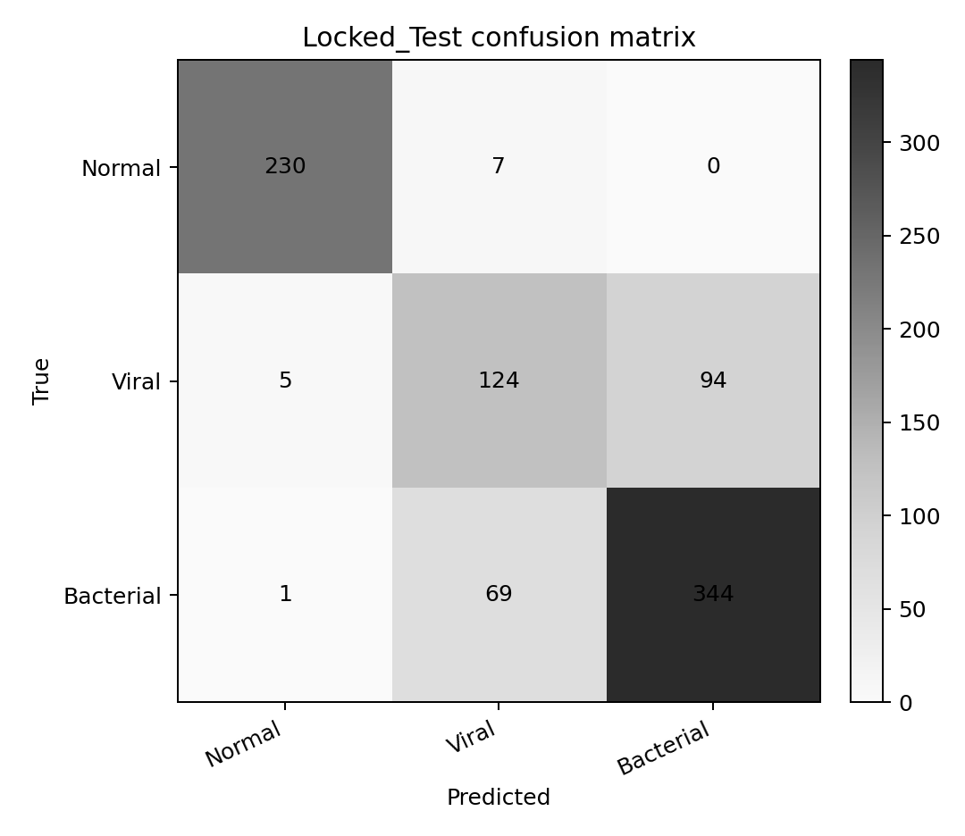
Final locked-test confusion matrix.

7.2 Final configuration table for all supported architectures
The required wide table is split into three continuation parts so every field remains readable. Rows not selected for the terminal experiment retain their verified completed-baseline configuration; the selected row reports the frozen tuned configuration actually used for the three-seed study and test.

Part A - identity, inputs, weights, and status
Model | Exact Implementation | Input Size | Pretrained Weights | Batch Size | Final Status
densenet169 | torchvision.models.densenet169; classifier Linear(...,3) | 224 | torchvision::DenseNet169_Weights.DEFAULT | 12 | Baseline + ablation + equal tuning; not final
densenet201 | torchvision.models.densenet201; classifier Linear(...,3) | 224 | torchvision::DenseNet201_Weights.DEFAULT | 8 | Final selected; tuned; three-seed retrain; locked test
densenet121 | torchvision.models.densenet121; classifier Linear(...,3) | 224 | torchvision::DenseNet121_Weights.DEFAULT | 16 | Completed baseline; outside bounded final tuning
resnet101 | torchvision.models.resnet101; fc Linear(...,3) | 224 | torchvision::ResNet101_Weights.DEFAULT | 8 | Completed baseline; outside bounded final tuning
resnet50 | torchvision.models.resnet50; fc Linear(...,3) | 224 | torchvision::ResNet50_Weights.DEFAULT | 16 | Baseline + ablation + equal tuning; not final
resnet152 | torchvision.models.resnet152; fc Linear(...,3) | 224 | torchvision::ResNet152_Weights.DEFAULT | 6 | Completed baseline; outside bounded final tuning
yolov5_cls | Ultralytics YOLOv5s-cls v7.0 + verified logits adapter; Classify Linear(...,3) | 224 | Ultralytics YOLOv5 v7.0 release::yolov5s-cls-v7.0.pt | 32 | Completed baseline; outside bounded final tuning
yolov8_cls | Ultralytics YOLOv8n-cls v8.3.0 + verified logits adapter; Classify Linear(...,3) | 224 | Ultralytics v8.3.0 asset::yolov8n-cls-v8.3.0.pt | 32 | Completed baseline; outside bounded final tuning

Part B - optimization and fine-tuning
Model | Optimizer | Backbone LR | Head LR | Weight Decay | Epoch Limit | Scheduler | Freeze Strategy | Dropout
densenet169 | ADAMW | 0.0001 | 0.0001 | 0.0001 | 12 | reduce_on_plateau | Full-network fine-tuning | No project-level override; architecture default
densenet201 | ADAMW | 0.0001 | 0.0001 | 0.0001 | 12 | reduce_on_plateau | Full-network fine-tuning | No project-level override; architecture default
densenet121 | ADAMW | 0.0001 | 0.0001 | 0.0001 | 12 | reduce_on_plateau | Full-network fine-tuning | No project-level override; architecture default
resnet101 | ADAMW | 0.0001 | 0.0001 | 0.0001 | 12 | reduce_on_plateau | Full-network fine-tuning | No project-level override; architecture default
resnet50 | ADAMW | 0.0001 | 0.0001 | 0.0001 | 12 | reduce_on_plateau | Full-network fine-tuning | No project-level override; architecture default
resnet152 | ADAMW | 0.0001 | 0.0001 | 0.0001 | 12 | reduce_on_plateau | Full-network fine-tuning | No project-level override; architecture default
yolov5_cls | ADAMW | 0.0001 | 0.0001 | 0.0001 | 12 | reduce_on_plateau | Full-network fine-tuning | No project-level override; architecture default
yolov8_cls | ADAMW | 0.0001 | 0.0001 | 0.0001 | 12 | reduce_on_plateau | Full-network fine-tuning | No project-level override; architecture default

Part C - objective, augmentation, preprocessing, and evidence
Model | Label Smoothing | Loss | Balancing | Augmentation | Preprocessing | Selection Metric | Source Basis
densenet169 | 0.0 | Cross entropy | balanced | flip p=0.5; rotation +/-5.0 deg | baseline | Validation macro F1 | DenseNet architecture provenance plus exact-task transfer evidence from Rahman et al.; no located exact-task paper uniquely establishes D169 settings.
densenet201 | 0.0 | Cross entropy | balanced | flip p=0.5; rotation +/-5.0 deg | histogram_equalization | Validation macro F1 | Rahman et al. directly evaluated DenseNet201 on the exact Normal/Viral/Bacterial task.
densenet121 | 0.0 | Cross entropy | balanced | flip p=0.5; rotation +/-5.0 deg | baseline | Validation macro F1 | Kundu et al. (binary ensemble), Arulananth et al. (binary pediatric), and CheXNet provide Partial evidence.
resnet101 | 0.0 | Cross entropy | balanced | flip p=0.5; rotation +/-5.0 deg | baseline | Validation macro F1 | Jaiswal et al. uses ResNet101 for CXR localization; the classification settings remain repository-controlled.
resnet50 | 0.0 | Cross entropy | balanced | flip p=0.5; rotation +/-5.0 deg | baseline | Validation macro F1 | Bakır et al. supports ResNet feature extraction on the exact task; Jaiswal et al. uses ResNet50 for localization only.
resnet152 | 0.0 | Cross entropy | balanced | flip p=0.5; rotation +/-5.0 deg | baseline | Validation macro F1 | ResNet architecture provenance; no supplied exact-task source uniquely establishes ResNet152 settings.
yolov5_cls | 0.0 | Cross entropy | balanced | flip p=0.5; rotation +/-5.0 deg | baseline | Validation macro F1 | Official v7.0 classification checkpoint/head provenance; no supplied pneumonia paper establishes these exact settings.
yolov8_cls | 0.0 | Cross entropy | balanced | flip p=0.5; rotation +/-5.0 deg | baseline | Validation macro F1 | Official v8.3.0 classification checkpoint/head provenance; no formal YOLOv8 paper or supplied pneumonia paper establishes these exact settings.

8. Explainability, Calibration, and Efficiency

8.1 Grad-CAM qualitative review
Grad-CAM was generated only after selection and the single locked-test evaluation were complete. For each class, a high-confidence correct case and—where available—a high-confidence error case were selected from the frozen test predictions. The target is the model's predicted class at the final convolutional feature stage.
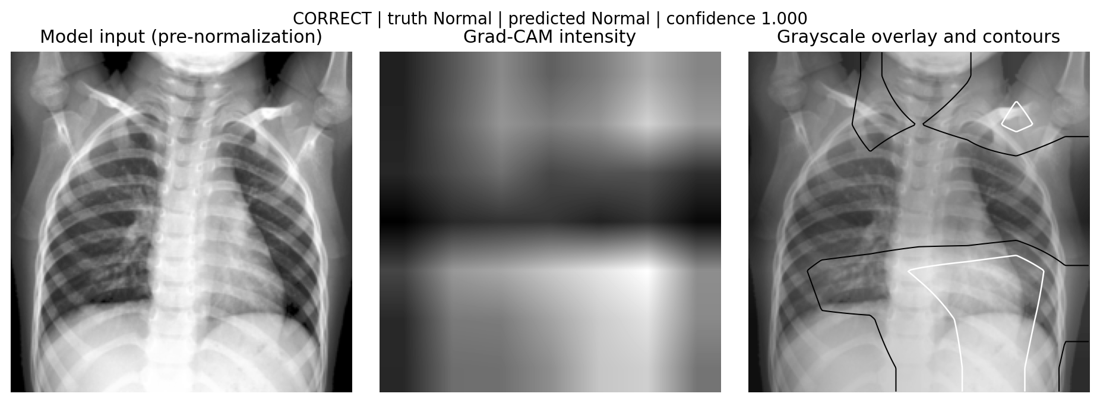
Grad-CAM correct: truth Normal, prediction Normal, confidence 1.000. Qualitative localization only.
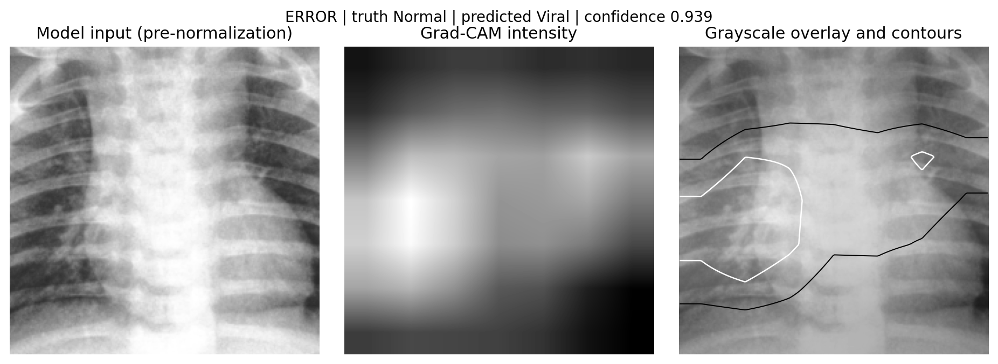
Grad-CAM error: truth Normal, prediction Viral, confidence 0.939. Qualitative localization only.
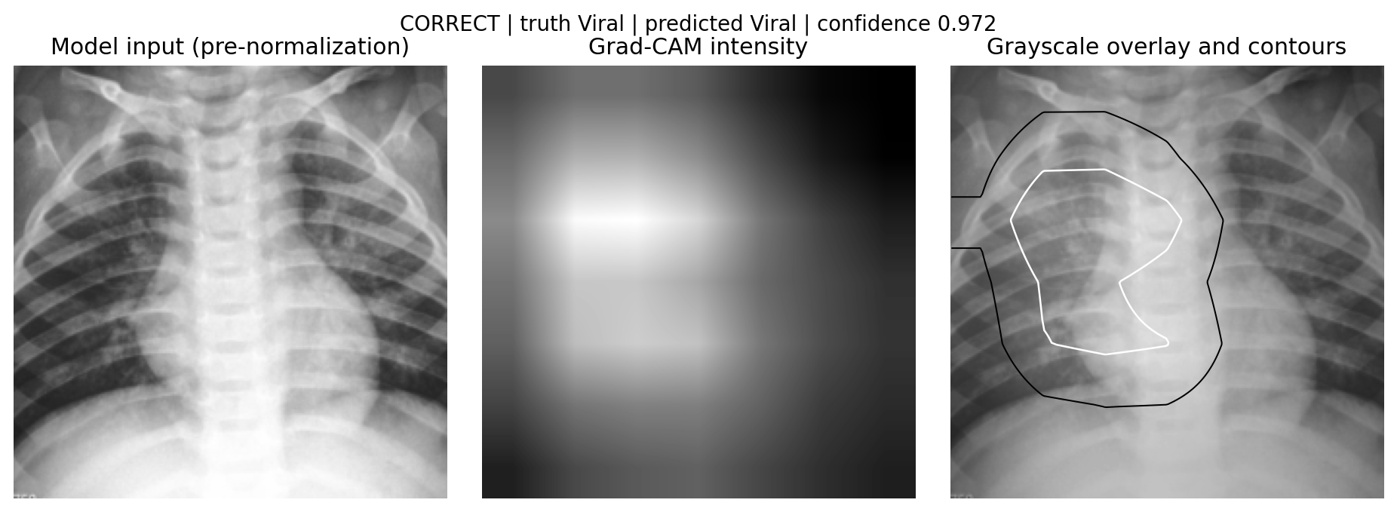
Grad-CAM correct: truth Viral, prediction Viral, confidence 0.972. Qualitative localization only.
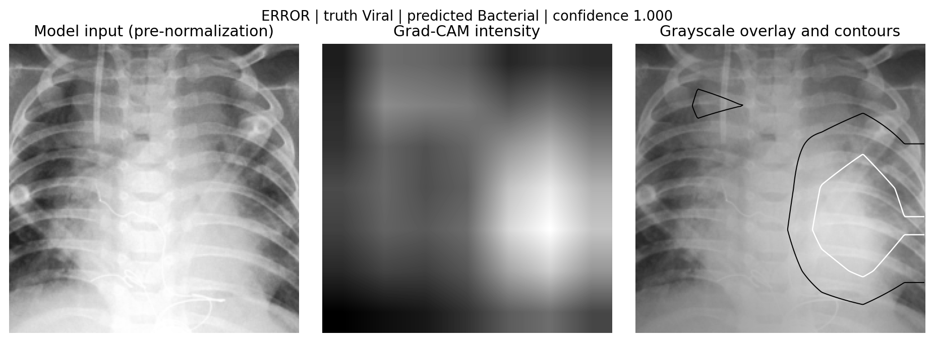
Grad-CAM error: truth Viral, prediction Bacterial, confidence 1.000. Qualitative localization only.
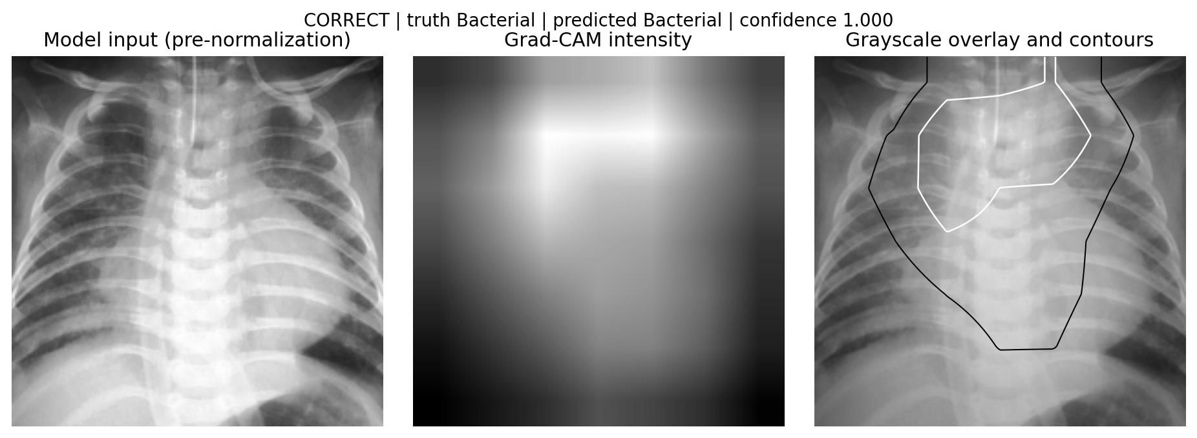
Grad-CAM correct: truth Bacterial, prediction Bacterial, confidence 1.000. Qualitative localization only.
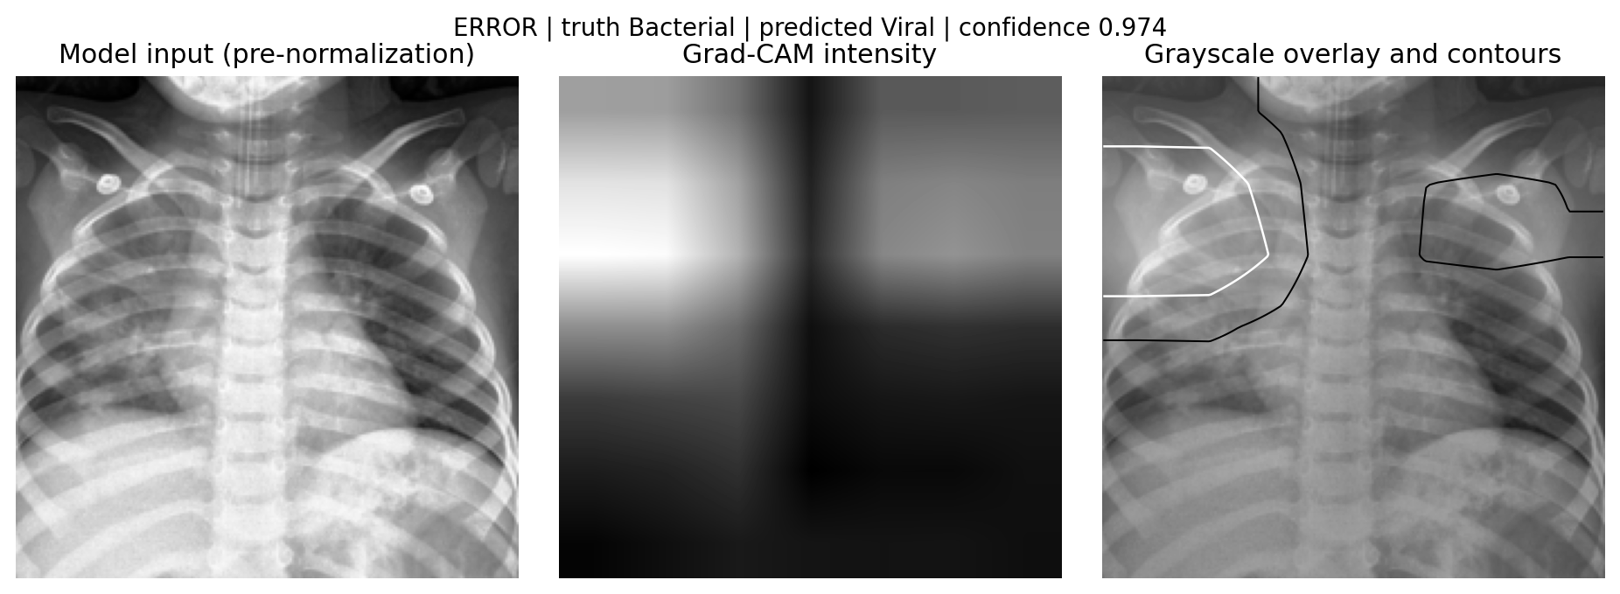
Grad-CAM error: truth Bacterial, prediction Viral, confidence 0.974. Qualitative localization only.
Qualitative localization only; not segmentation ground truth, causal proof, or clinical validation.

8.2 Temperature scaling
Split/state | Accuracy | Macro F1 | Log loss | ECE | Brier
Validation before | 0.8535 | 0.8447 | 0.3916 | 0.0494 | 0.2145
Validation after | 0.8535 | 0.8447 | 0.3704 | 0.0423 | 0.2133
Test before | 0.7986 | 0.7888 | 0.6307 | 0.1004 | 0.3131
Test after | 0.7986 | 0.7888 | 0.5391 | 0.0660 | 0.3020

Temperature = 1.405619, fit on validation probabilities only. Temperature scaling does not change class ranking, so classification accuracy and macro F1 remain unchanged.
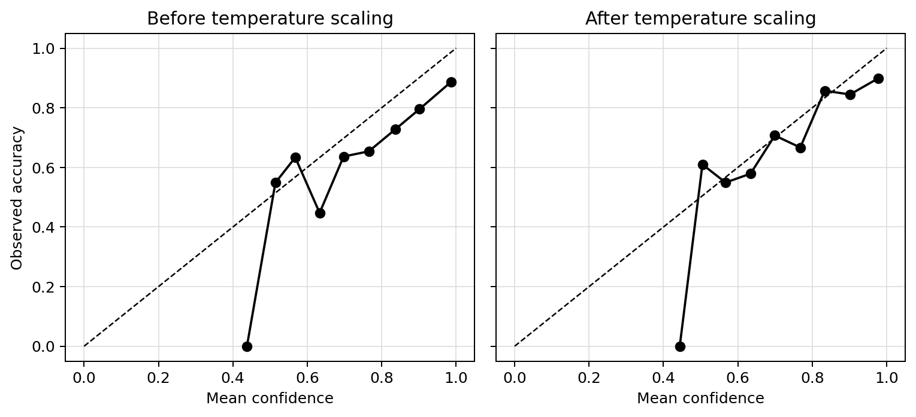
Locked-test reliability curves before and after validation-fit temperature scaling.

8.3 Efficiency
Engineering measure | Value
Hardware | NVIDIA GeForce RTX 2050
Measured images | 200
Mean end-to-end latency | 67.53 ms/image
Median / p95 | 64.61 / 102.02 ms
Throughput from mean | 14.81 images/s
Parameters | 18,098,691
Checkpoint size | 209.0 MB
Peak training GPU memory | 1060.7 MB

This is a local single-device engineering measurement, not a clinical deployment benchmark.

9. Verified RRL and Research Evidence Matrix
The supplied screenshot was treated as a supplementary reference index, not a source of truth. It displayed ten study rows and blank Reference Link cells. No original RRL spreadsheet or separate bibliography was present in the repository. Each visible study was located by exact title/authors/year and verified against a publisher, DOI, PubMed, official repository, or primary paper.
Open and verify every available reference link relevant to the eight supported models. When the link column is blank, incomplete, inaccessible, or only visible through the supplied image, locate the original publication using the exact title, authors, year, DOI, or publisher.
ID | Verified citation | Category | Result / merit | Applicability
6 | Dejun Zhang; Fuquan Ren; Yushuang Li; Lei Na; Yue Ma (2021). Pneumonia Detection from Chest X-ray Images Based on Convolutional Neural Network. | CNN chest X-ray pneumonia classification | Accuracy 96.068%; AUC 0.99107; precision 94.408%; recall 90.823%; F1 92.851%. Small deployable classifier; 97.51% fewer parameters than VGG16. | Partial: Directly concerns CXR contrast enhancement and CNN classification, but the task is binary and the architecture/split differ.
7 | Halit Bakır; Semih Oktay; Emre Tabaru (2023). Detection of Pneumonia from X-ray Images Using Deep Learning Techniques. | CNN chest X-ray pneumonia classification | Best binary ANN+MobileNet accuracy 95.67%; best exact three-class ANN+ResNet accuracy 81.67%. Demonstrates transfer-feature hybrids on the exact three clinical labels. | Direct: Uses the exact Normal/Viral/Bacterial three-class CXR task and includes a ResNet feature extractor.
4 | Tawsifur Rahman; Muhammad E. H. Chowdhury; Amith Khandakar; Khandaker R. Islam; Khandaker F. Islam; Zaid B. Mahbub; Muhammad A. Kadir; Saad Kashem (2020). Transfer Learning with Deep Convolutional Neural Network (CNN) for Pneumonia Detection Using Chest X-ray. | CNN chest X-ray pneumonia classification | 98% Normal-versus-Pneumonia accuracy; 95% Bacterial-versus-Viral accuracy; 93.3% exact three-class accuracy. Strong, directly comparable evidence for DenseNet/ResNet transfer learning on the exact label set. | Direct: Exact task and class labels; directly relevant DenseNet201 and ResNet-family transfer learning.
3 | Rohit Kundu; Ritacheta Das; Zong Woo Geem; Gi-Tae Han; Ram Sarkar (2021). Pneumonia Detection in Chest X-ray Images Using an Ensemble of Deep Learning Models. | CNN chest X-ray pneumonia classification | Accuracy 98.81% on Kermany and 86.85% on RSNA; sensitivity 98.80% and 87.02%, respectively. Weighted complementary CNN predictions outperform individual members. | Partial: Relevant DenseNet121/ResNet ensemble evidence, but task is binary and method is an ensemble.
11 | T. S. Arulananth; S. Wilson Prakash; Ramesh Kumar Ayyasamy; V. P. Kavitha; P. G. Kuppusamy; P. Chinnasamy (2024). Classification of Paediatric Pneumonia Using Modified DenseNet-121 Deep-Learning Model. | CNN chest X-ray pneumonia classification | Accuracy 97.03% with strong precision and recall. Recent DenseNet121-focused pediatric CXR evidence. | Partial: Relevant DenseNet121 pediatric CXR study, but not the exact three-class task.
5 | Amit Kumar Jaiswal; Prayag Tiwari; Sachin Kumar; Deepak Gupta; Ashish Khanna; Joel J. P. C. Rodrigues (2019). Identifying Pneumonia in Chest X-Rays: A Deep Learning Approach. | Segmentation and localization of pneumonia regions | Stage-2 scores reported as 0.183720 (ResNet50), 0.199352 (ResNet101), and 0.218051 (ensemble). Supports localization/ROI discussion and ResNet backbones. | Partial: Relevant CXR localization and ResNet backbones, but not a three-class classifier.
not yet | Fausto Milletari; Nassir Navab; Seyed-Ahmad Ahmadi (2016). V-Net: Fully Convolutional Neural Networks for Volumetric Medical Image Segmentation. | Segmentation and localization of pneumonia regions | Outperformed compared 2D approaches on the study's volumetric segmentation task. Foundational 3D segmentation architecture. | Excluded: Volumetric prostate MRI segmentation cannot determine 2D chest-X-ray classification settings.
2 | Zhenxing Huang; Xinfeng Liu; Rongpin Wang; Mudan Zhang; Xianchun Zeng; Jun Liu; Yongfeng Yang; Xin Liu; Hairong Zheng; Dong Liang; Zhanli Hu (2021 journal issue; online 2020). FaNet: Fast Assessment Network for COVID-19 Pneumonia Based on 3D CT Imaging and Clinical Symptoms. | Multimodal or non-imaging AI for pneumonia | 98.28% diagnosis accuracy; 94.83% severity accuracy. Demonstrates complementary imaging and clinical features. | Background: Provides multimodal context only and must not set the present image-classifier configuration.
1 | Katy Stokes; Rossana Castaldo; Carlo Federici; Silvio Pagliara; Alessia Maccaro; Francesco Cappuccio; Giuseppe Fico; Marco Salvatore; Monica Franzese; Leandro Pecchia (2022). The Use of AI Systems in Diagnosis of Pneumonia via Signs and Symptoms: A Systematic Review. | Multimodal or non-imaging AI for pneumonia | Most included models reported greater than 90% accuracy, with substantial inconsistency and heterogeneity. Summarizes non-imaging diagnostic approaches and reporting gaps. | Background: Useful clinical-AI context only; no direct model-configuration evidence for the image classifier.
9 | Hicham Moujahid; Bouchaib Cherradi; Mohammed Al-Sarem; Lhoussain Bahatti; Bakr Assedik Eljialy; Abdullah Alsaeedi; Faisal Saeed (2022 journal issue; online 2021). Combining CNN and Grad-CAM for COVID-19 Disease Prediction and Visual Explanation. | Explainability and Grad-CAM for respiratory imaging | Best VGG19: 96.97% accuracy; reported precision 100%, F1 100%, recall 99%. Provides respiratory-imaging Grad-CAM procedure and examples. | Partial: Supports the final explainability workflow, not the present classifier settings.

9.1 Detailed verification of the Matrix

6 — Pneumonia Detection from Chest X-ray Images Based on Convolutional Neural Network
Field | Verified detail
Authors / year | Dejun Zhang; Fuquan Ren; Yushuang Li; Lei Na; Yue Ma | 2021
Venue / DOI | Electronics 10(13):1512 | 10.3390/electronics10131512
Objective | Develop a small VGG-inspired CNN for Normal versus Pneumonia chest-X-ray classification.
Methodology | Six-layer VGG-inspired binary CNN; dynamic histogram enhancement (DHE); random 70/10/20 split of 5,786 images.
Task / dataset / model | Binary CXR classification: Normal, Pneumonia | 5,786 pediatric CXRs | Simplified VGG-inspired six-layer CNN
Preprocessing / augmentation | DHE; one-channel values scaled to [0,1] | Rotation 0-30 degrees; zoom 0.2; width/height shift 0.1; horizontal and vertical flips
Training details | Weights: Not reported; optimizer: Adam; LR: 0.001; WD: 0.0001 reported as decay; batch: Not reported; epochs: Not reported; loss: Binary cross entropy
Results | Accuracy 96.068%; AUC 0.99107; precision 94.408%; recall 90.823%; F1 92.851%.
Merit | Small deployable classifier; 97.51% fewer parameters than VGG16.
Limitations | Binary task and independent random split; does not establish settings for viral-versus-bacterial discrimination.
Applicability | Partial — Directly concerns CXR contrast enhancement and CNN classification, but the task is binary and the architecture/split differ.
Source trail | Supplied image; Publisher page
Corrections | Screenshot title was corrected to the publisher title. The >97% claim is parameter reduction, not an accuracy or generic support claim.

Verified primary/official link: https://www.mdpi.com/2079-9292/10/13/1512

7 — Detection of Pneumonia from X-ray Images Using Deep Learning Techniques
Field | Verified detail
Authors / year | Halit Bakır; Semih Oktay; Emre Tabaru | 2023
Venue / DOI | Journal of Scientific Reports-A 52:419-440 | 10.59313/jsr-a.1219363
Objective | Compare ANN and CNN-based feature-extractor combinations for pneumonia detection.
Methodology | Pretrained feature extractors including ResNet and MobileNet were combined with ANN/CNN classifiers for binary and multiclass experiments.
Task / dataset / model | Binary and three-class CXR classification; three-class includes Normal, Bacterial Pneumonia, Viral Pneumonia | Not reported | ANN/CNN hybrids with ResNet and MobileNet feature extraction
Preprocessing / augmentation | Not reported | Not reported
Training details | Weights: Not reported; optimizer: Not reported; LR: Not reported; WD: Not reported; batch: Not reported; epochs: Not reported; loss: Not reported
Results | Best binary ANN+MobileNet accuracy 95.67%; best exact three-class ANN+ResNet accuracy 81.67%.
Merit | Demonstrates transfer-feature hybrids on the exact three clinical labels.
Limitations | Different training pipeline and hybrid classifier; incomplete transferability of its hyperparameters to end-to-end fine-tuning.
Applicability | Direct — Uses the exact Normal/Viral/Bacterial three-class CXR task and includes a ResNet feature extractor.
Source trail | Supplied image; Publisher page
Corrections | Not reported

Verified primary/official link: https://dergipark.org.tr/en/pub/jsr-a/article/1219363

4 — Transfer Learning with Deep Convolutional Neural Network (CNN) for Pneumonia Detection Using Chest X-ray
Field | Verified detail
Authors / year | Tawsifur Rahman; Muhammad E. H. Chowdhury; Amith Khandakar; Khandaker R. Islam; Khandaker F. Islam; Zaid B. Mahbub; Muhammad A. Kadir; Saad Kashem | 2020
Venue / DOI | Applied Sciences 10(9):3233 | 10.3390/app10093233
Objective | Evaluate transfer-learning CNNs for Normal, Bacterial Pneumonia, and Viral Pneumonia CXR classification.
Methodology | Compared AlexNet, ResNet18, DenseNet201, and SqueezeNet using 5,247 chest radiographs.
Task / dataset / model | Binary and exact three-class CXR classification | 5,247 pediatric CXRs | AlexNet; ResNet18; DenseNet201; SqueezeNet
Preprocessing / augmentation | Not reported | Not reported
Training details | Weights: Transfer learning; optimizer: Not reported; LR: Not reported; WD: Not reported; batch: Not reported; epochs: Not reported; loss: Not reported
Results | 98% Normal-versus-Pneumonia accuracy; 95% Bacterial-versus-Viral accuracy; 93.3% exact three-class accuracy.
Merit | Strong, directly comparable evidence for DenseNet/ResNet transfer learning on the exact label set.
Limitations | Does not by itself justify the present optimizer, augmentation, split, or leakage-control protocol.
Applicability | Direct — Exact task and class labels; directly relevant DenseNet201 and ResNet-family transfer learning.
Source trail | Supplied image; Publisher page
Corrections | Screenshot omitted the exact three-class result; publisher reports 93.3%.

Verified primary/official link: https://www.mdpi.com/2076-3417/10/9/3233

3 — Pneumonia Detection in Chest X-ray Images Using an Ensemble of Deep Learning Models
Field | Verified detail
Authors / year | Rohit Kundu; Ritacheta Das; Zong Woo Geem; Gi-Tae Han; Ram Sarkar | 2021
Venue / DOI | PLOS ONE 16(9):e0256630 | 10.1371/journal.pone.0256630
Objective | Improve binary pneumonia detection through a weighted ensemble.
Methodology | Five-fold evaluation of weighted GoogLeNet, ResNet18, and DenseNet121 predictions on Kermany and RSNA data.
Task / dataset / model | Binary CXR classification | Kermany pediatric CXR and RSNA pneumonia data | Weighted GoogLeNet/ResNet18/DenseNet121 ensemble
Preprocessing / augmentation | Not reported | Not reported
Training details | Weights: Not reported; optimizer: Not reported; LR: Not reported; WD: Not reported; batch: Not reported; epochs: Not reported; loss: Not reported
Results | Accuracy 98.81% on Kermany and 86.85% on RSNA; sensitivity 98.80% and 87.02%, respectively.
Merit | Weighted complementary CNN predictions outperform individual members.
Limitations | Binary ensemble evidence does not establish single-model three-class hyperparameters.
Applicability | Partial — Relevant DenseNet121/ResNet ensemble evidence, but task is binary and method is an ensemble.
Source trail | Supplied image; Publisher page
Corrections | Not reported

Verified primary/official link: https://journals.plos.org/plosone/article?id=10.1371/journal.pone.0256630

11 — Classification of Paediatric Pneumonia Using Modified DenseNet-121 Deep-Learning Model
Field | Verified detail
Authors / year | T. S. Arulananth; S. Wilson Prakash; Ramesh Kumar Ayyasamy; V. P. Kavitha; P. G. Kuppusamy; P. Chinnasamy | 2024
Venue / DOI | IEEE Access 12:35716-35727 | 10.1109/ACCESS.2024.3371151
Objective | Improve pediatric pneumonia classification with a modified DenseNet121.
Methodology | DenseNet121 modified with batch normalization, max pooling, and dropout; trained on pediatric CXR.
Task / dataset / model | Binary pediatric CXR classification | Not reported | Modified DenseNet121
Preprocessing / augmentation | Not reported | Not reported
Training details | Weights: Not reported; optimizer: Not reported; LR: Not reported; WD: Not reported; batch: Not reported; epochs: Not reported; loss: Not reported
Results | Accuracy 97.03% with strong precision and recall.
Merit | Recent DenseNet121-focused pediatric CXR evidence.
Limitations | Binary task and modified head prevent direct hyperparameter transfer.
Applicability | Partial — Relevant DenseNet121 pediatric CXR study, but not the exact three-class task.
Source trail | Supplied image; DOAJ publisher metadata; IEEE DOI metadata
Corrections | Not reported

Verified primary/official link: https://doaj.org/article/8d40e456925949dbb8aa0b6b189f8d44

5 — Identifying Pneumonia in Chest X-Rays: A Deep Learning Approach
Field | Verified detail
Authors / year | Amit Kumar Jaiswal; Prayag Tiwari; Sachin Kumar; Deepak Gupta; Ashish Khanna; Joel J. P. C. Rodrigues | 2019
Venue / DOI | Measurement 145:511-518 | 10.1016/j.measurement.2019.05.076
Objective | Identify and localize pneumonia opacities on chest X-rays.
Methodology | Mask R-CNN with ResNet50 and ResNet101 backbones on RSNA challenge images; ensembled predictions.
Task / dataset / model | CXR opacity detection/localization | RSNA Pneumonia Detection Challenge, about 30,000 training and 4,500 test images | Mask R-CNN; ResNet50/101
Preprocessing / augmentation | Not reported | Not reported
Training details | Weights: Not reported; optimizer: Not reported; LR: Not reported; WD: Not reported; batch: Not reported; epochs: Not reported; loss: Not reported
Results | Stage-2 scores reported as 0.183720 (ResNet50), 0.199352 (ResNet101), and 0.218051 (ensemble).
Merit | Supports localization/ROI discussion and ResNet backbones.
Limitations | Detection/localization scores are not classification accuracy and do not determine classifier hyperparameters.
Applicability | Partial — Relevant CXR localization and ResNet backbones, but not a three-class classifier.
Source trail | Supplied image; Publisher page; primary paper PDF
Corrections | Replaces the screenshot's unsupported phrase 'strong localization & segmentation accuracy' with the reported challenge scores.

Verified primary/official link: https://www.sciencedirect.com/science/article/pii/S0263224119305202

not yet — V-Net: Fully Convolutional Neural Networks for Volumetric Medical Image Segmentation
Field | Verified detail
Authors / year | Fausto Milletari; Nassir Navab; Seyed-Ahmad Ahmadi | 2016
Venue / DOI | 2016 Fourth International Conference on 3D Vision (3DV), 565-571 | 10.1109/3DV.2016.79
Objective | Segment the prostate in volumetric MRI.
Methodology | 3D fully convolutional residual network optimized with Dice loss.
Task / dataset / model | 3D prostate MRI segmentation | Volumetric prostate MRI | V-Net
Preprocessing / augmentation | Nonlinear intensity transformations and histogram matching are discussed | Not reported
Training details | Weights: Not reported; optimizer: Not reported; LR: Not reported; WD: Not reported; batch: Not reported; epochs: Not reported; loss: Dice-based objective
Results | Outperformed compared 2D approaches on the study's volumetric segmentation task.
Merit | Foundational 3D segmentation architecture.
Limitations | Different modality, dimensionality, anatomy, task, loss, and output contract.
Applicability | Excluded — Volumetric prostate MRI segmentation cannot determine 2D chest-X-ray classification settings.
Source trail | Supplied image; Official repository; DOI metadata
Corrections | Not reported

Verified primary/official link: https://arxiv.org/abs/1606.04797

2 — FaNet: Fast Assessment Network for COVID-19 Pneumonia Based on 3D CT Imaging and Clinical Symptoms
Field | Verified detail
Authors / year | Zhenxing Huang; Xinfeng Liu; Rongpin Wang; Mudan Zhang; Xianchun Zeng; Jun Liu; Yongfeng Yang; Xin Liu; Hairong Zheng; Dong Liang; Zhanli Hu | 2021 journal issue; online 2020
Venue / DOI | Applied Intelligence 51(5):2838-2849 | 10.1007/s10489-020-01965-0
Objective | Combine 3D CT and clinical symptoms to diagnose COVID-19 and assess severity.
Methodology | Dual-branch 3D CNN and symptom encoding on 416 patients.
Task / dataset / model | Multimodal COVID-19 diagnosis and severity assessment | 416-patient CT plus clinical-symptom cohort | 3D CNN plus symptom branch
Preprocessing / augmentation | Not reported | Not reported
Training details | Weights: Not reported; optimizer: Not reported; LR: Not reported; WD: Not reported; batch: Not reported; epochs: Not reported; loss: Not reported
Results | 98.28% diagnosis accuracy; 94.83% severity accuracy.
Merit | Demonstrates complementary imaging and clinical features.
Limitations | 3D CT, symptom fusion, and COVID severity differ from 2D CXR image-only classification.
Applicability | Background — Provides multimodal context only and must not set the present image-classifier configuration.
Source trail | Supplied image; PubMed; Publisher DOI metadata
Corrections | Both the online-first 2020 date and 2021 journal issue are preserved.

Verified primary/official link: https://pubmed.ncbi.nlm.nih.gov/34764567/

1 — The Use of AI Systems in Diagnosis of Pneumonia via Signs and Symptoms: A Systematic Review
Field | Verified detail
Authors / year | Katy Stokes; Rossana Castaldo; Carlo Federici; Silvio Pagliara; Alessia Maccaro; Francesco Cappuccio; Giuseppe Fico; Marco Salvatore; Monica Franzese; Leandro Pecchia | 2022
Venue / DOI | Biomedical Signal Processing and Control 72A:103325 | 10.1016/j.bspc.2021.103325
Objective | Review machine-learning pneumonia diagnosis from clinical signs and symptoms rather than imaging.
Methodology | PRISMA review: 876 records screened and 16 studies included.
Task / dataset / model | Non-imaging pneumonia prediction | Not reported | Systematic review of symptom-based ML
Preprocessing / augmentation | Not reported | Not reported
Training details | Weights: Not reported; optimizer: Not reported; LR: Not reported; WD: Not reported; batch: Not reported; epochs: Not reported; loss: Not reported
Results | Most included models reported greater than 90% accuracy, with substantial inconsistency and heterogeneity.
Merit | Summarizes non-imaging diagnostic approaches and reporting gaps.
Limitations | Not an imaging model and not transferable to CXR preprocessing or architecture hyperparameters.
Applicability | Background — Useful clinical-AI context only; no direct model-configuration evidence for the image classifier.
Source trail | Supplied image; Official university repository; Publisher DOI metadata
Corrections | Not reported

Verified primary/official link: https://wrap.warwick.ac.uk/id/eprint/160069/

9 — Combining CNN and Grad-CAM for COVID-19 Disease Prediction and Visual Explanation
Field | Verified detail
Authors / year | Hicham Moujahid; Bouchaib Cherradi; Mohammed Al-Sarem; Lhoussain Bahatti; Bakr Assedik Eljialy; Abdullah Alsaeedi; Faisal Saeed | 2022 journal issue; online 2021
Venue / DOI | Intelligent Automation & Soft Computing 32(2):723-745 | 10.32604/iasc.2022.022179
Objective | Build a three-class respiratory CXR classifier and explain predictions with Grad-CAM.
Methodology | VGG16, VGG19, and MobileNetV2 with Grad-CAM; 70/15/15 split; 840 COVID, 1,341 Normal, 1,345 Pneumonia images.
Task / dataset / model | Three-class CXR classification: Normal, Pneumonia, COVID-19 | 3,526 CXRs from combined public sources | VGG16; VGG19; MobileNetV2; Grad-CAM
Preprocessing / augmentation | Not reported | No augmentation reported/applied
Training details | Weights: Not reported; optimizer: Not reported; LR: Not reported; WD: Not reported; batch: Not reported; epochs: Not reported; loss: Not reported
Results | Best VGG19: 96.97% accuracy; reported precision 100%, F1 100%, recall 99%.
Merit | Provides respiratory-imaging Grad-CAM procedure and examples.
Limitations | Different labels and pooled sources; does not justify DenseNet/ResNet/YOLO training hyperparameters.
Applicability | Partial — Supports the final explainability workflow, not the present classifier settings.
Source trail | Supplied image; Publisher page
Corrections | Both the 2021 online date and 2022 issue year are preserved.

Verified primary/official link: https://www.techscience.com/iasc/v32n2/45598/html

9.2 Additional architecture, preprocessing, validation, and calibration sources
Reference ID | Authors/year/title | Use in this project | Applicability | DOI / official link
DATA-KERMANY | Daniel S. Kermany et al. (2018). Identifying Medical Diagnoses and Treatable Diseases by Image-Based Deep Learning | Primary dataset/task provenance. | Direct: Primary evidence for the exact labels and source-domain task. | 10.1016/j.cell.2018.02.010 | https://www.sciencedirect.com/science/article/pii/S0092867418301545
ARCH-DENSENET | Gao Huang; Zhuang Liu; Laurens van der Maaten; Kilian Q. Weinberger (2017). Densely Connected Convolutional Networks | Architecture provenance for DenseNet121, DenseNet169, and DenseNet201. | Background: General architecture paper; supports model identity, not experiment settings. | Not reported | https://openaccess.thecvf.com/content_cvpr_2017/html/Huang_Densely_Connected_Convolutional_CVPR_2017_paper.html
ARCH-RESNET | Kaiming He; Xiangyu Zhang; Shaoqing Ren; Jian Sun (2016). Deep Residual Learning for Image Recognition | Architecture provenance for the three ResNet baselines. | Background: General architecture paper; supports model identity, not experiment settings. | Not reported | https://openaccess.thecvf.com/content_cvpr_2016/html/He_Deep_Residual_Learning_CVPR_2016_paper.html
CXR-CHEXNET | Pranav Rajpurkar; Jeremy Irvin; Kaylie Zhu; Brandon Yang; Hershel Mehta; Tony Duan; Daisy Ding; Aarti Bagul; Curtis Langlotz; Katie Shpanskaya; Matthew P. Lungren; Andrew Y. Ng (2017). CheXNet: Radiologist-Level Pneumonia Detection on Chest X-Rays with Deep Learning | Strong chest-radiograph precedent for DenseNet121. | Partial: Directly supports DenseNet on CXR, but not the exact classes or dataset. | Not reported | https://arxiv.org/abs/1711.05225
XAI-GRADCAM | Ramprasaath R. Selvaraju et al. (2017). Grad-CAM: Visual Explanations from Deep Networks via Gradient-Based Localization | Primary method reference for final localization heatmaps. | Partial: Directly supports explainability procedures but not classifier hyperparameters. | Not reported | https://openaccess.thecvf.com/content_iccv_2017/html/Selvaraju_Grad-CAM_Visual_Explanations_ICCV_2017_paper.html
PREP-CLAHE | Anggi Muhammad Rifai; Suwanto Raharjo; Ema Utami; Dhani Ariatmanto (2024 journal issue; online 2023). Analysis for diagnosis of pneumonia symptoms using chest X-ray based on MobileNetV2 models with image enhancement using white balance and contrast limited adaptive histogram equalization (CLAHE) | Supports a controlled CLAHE ablation on CXR. | Partial: CXR and three-class contrast enhancement are relevant, but the transform is bundled and the model differs. | 10.1016/j.bspc.2023.105857 | https://www.sciencedirect.com/science/article/pii/S1746809423012909
PREP-HE | Jose Raniery Ferreira; Diego Armando Cardona Cardenas; Ramon Alfredo Moreno; Marina de Fatima de Sa Rebelo; Jose Eduardo Krieger; Marco Antonio Gutierrez (2020). Multi-View Ensemble Convolutional Neural Network to Improve Classification of Pneumonia in Low Contrast Chest X-Ray Images | Strong task-specific rationale for a global histogram-equalization ablation. | Direct: Same CXR source-domain and target distinctions; directly motivates—but does not predetermine—the controlled HE ablation. | 10.1109/EMBC44109.2020.9176517 | https://pubmed.ncbi.nlm.nih.gov/33018211/
PREP-PSEUDOCOLOR | Morteza Heidari; Seyedehnafiseh Mirniaharikandehei; Abolfazl Zargari Khuzani; Gopichandh Danala; Yuchen Qiu; Bin Zheng (2020). Improving the performance of CNN to predict the likelihood of COVID-19 using chest X-ray images with preprocessing algorithms | Shows that information-bearing multi-channel preprocessing can help a related three-class CXR task. | Partial: Related three-class CXR pseudo-color evidence, but the construction is fundamentally different from VIRIDIS. | 10.1016/j.ijmedinf.2020.104284 | https://pubmed.ncbi.nlm.nih.gov/32992136/
BIAS-SHORTCUT | Anusua Trivedi; Caleb Robinson; Marian Blazes; Anthony Ortiz; Jocelyn Desbiens; Sunil Gupta; Rahul Dodhia; Pavan K. Bhatraju; W. Conrad Liles; Jayashree Kalpathy-Cramer; Aaron Y. Lee; Juan M. Lavista Ferres (2022). Deep learning models for COVID-19 chest x-ray classification: Preventing shortcut learning using feature disentanglement | Justifies leakage control, source-aware caution, and validation of enhancements rather than assuming benefit. | Partial: Directly relevant to CXR shortcut risk and preprocessing interpretation, not to model architecture selection alone. | 10.1371/journal.pone.0274098 | https://pubmed.ncbi.nlm.nih.gov/36201483/
VALID-CLINICAL | Jeremy Hofmeister; Nicolas Garin; Xavier Montet; Max Scheffler; Alexandra Platon; Pierre-Alexandre Poletti; Jerome Stirnemann; Marie-Pierre Debray; Yann-Erick Claessens; Xavier Duval; Virginie Prendki (2024). Validating the accuracy of deep learning for the diagnosis of pneumonia on chest x-ray against a robust multimodal reference diagnosis: a post hoc analysis of two prospective studies | Provides an essential boundary between benchmark performance and clinical diagnostic validity. | Background: Clinical-translation caution only; it constrains claims, not model configuration. | 10.1186/s41747-023-00416-y | https://pubmed.ncbi.nlm.nih.gov/38302850/
CALIBRATION | Chuan Guo; Geoff Pleiss; Yu Sun; Kilian Q. Weinberger (2017). On Calibration of Modern Neural Networks | Primary evidence for post-hoc temperature scaling and calibration reporting. | Background: Supports reliability methods but not base classifier hyperparameters. | Not reported | https://proceedings.mlr.press/v70/guo17a.html
IMPL-TORCHVISION | PyTorch/Torchvision project (torchvision 0.20.1 used by repository). Torchvision DenseNet and ResNet model/weight documentation | Verifies the exact code/weight source for six baselines. | Background: Authoritative implementation provenance; no direct medical result. | Not reported | https://docs.pytorch.org/vision/0.20/models.html
IMPL-YOLOV5 | Ultralytics (YOLOv5 v7.0 asset; classification introduced in v6.2). Ultralytics YOLOv5 classification release and repository | Verifies a genuine classification head and official checkpoint. | Background: Authoritative implementation provenance only. | Not reported | https://github.com/ultralytics/yolov5/releases
IMPL-YOLOV8 | Ultralytics (Ultralytics 8.3.168 environment; v8.3.0 checkpoint asset). Ultralytics YOLO image-classification documentation and YOLOv8 classification model | Verifies a genuine classification head, checkpoint, and the tuple-output adapter correction. | Background: Authoritative implementation provenance only. | Not reported | https://docs.ultralytics.com/tasks/classify/
EXCL-YOLOV10 | Ao Wang et al.; THU-MIG (2024). YOLOv10: Real-Time End-to-End Object Detection | Authoritative evidence for the model's actual supported task. | Excluded: Detection-only evidence cannot be relabeled as three-class image classification. | Not reported | https://github.com/THU-MIG/yolov10

9.3 Transferability rules applied
- Exact three-class Normal/Viral/Bacterial CXR evidence received highest priority.
- Binary CXR, localization, explainability, CT, multimodal, and general architecture evidence was never copied directly into classifier hyperparameters without an applicability explanation.
- V-Net was excluded from configuration evidence because it is a 3D prostate MRI segmentation architecture.
- Jaiswal/Mask R-CNN supports localization discussion but not classifier settings.
- FaNet supports multimodal context only; CT and symptom fusion do not determine 2D CXR preprocessing.
- Grad-CAM sources support explanation methods, not training configuration.
- The verified pseudo-color paper did not use VIRIDIS; the two techniques were not conflated.

10. Limitations, Reproducibility, and Audit Trail
- Single public pediatric dataset/source domain; no external hospital validation.
- Labels are dataset annotations, not a new multimodal clinical reference standard.
- Validation was used repeatedly for architecture, preprocessing, and tuning selection; final test remains the only held-out estimate.
- Group derivation is conservative and filename/hash-based because explicit patient IDs were unavailable.
- Center cropping can remove peripheral content from extreme aspect ratios.
- Horizontal flip moves laterality markers; rotation creates black corner fill.
- ImageNet normalization is retained even for enhanced intensity distributions.
- The preprocessing bootstrap interval is descriptive on the selection set.
- Grad-CAM is qualitative and can highlight non-causal or non-clinical regions.
- Local latency/VRAM results depend on this Windows/RTX 2050 environment.
- No YOLOv10 classifier, PCA, FILM, SAS tuning, or automated grading result was fabricated.

10.1 Environment
Component | Version/value
Python | 3.12.6
PyTorch | 2.5.1+cu121
Torchvision | 0.20.1+cu121
Ultralytics | 8.3.168
CUDA / cuDNN | 12.1 / 90100
GPU | NVIDIA GeForce RTX 2050
VRAM | 4,294,443,008 bytes
Manifest hash | 3b815cf769c85658a04748da5eb2e15b981b89d9c9b77a404e90fe23473d2774
Final config hash | 34b95e1f554f0ef2a4efa9e88c20bf5d3bd93ae8e135c72ef3b18b086c39c988
Repository tests | 12 passed before full continuation runs

10.2 Resume and generation commands
.venv\Scripts\python.exe model\scripts\run_benchmark.py --stage preprocessing_ablation --resume
.venv\Scripts\python.exe model\scripts\resolve_run_matrix.py --stage focused
.venv\Scripts\python.exe model\scripts\resolve_run_matrix.py --stage tuning
.venv\Scripts\python.exe model\scripts\run_tuning.py --matrix-run-id tuning_topN --parent-run-id PARENT --trials 4 --epochs 6 --resume
.venv\Scripts\python.exe model\scripts\resolve_run_matrix.py --stage robustness
.venv\Scripts\python.exe model\scripts\run_benchmark.py --stage robustness --config model\configs\final_selected.json --resume
.venv\Scripts\python.exe model\scripts\resolve_run_matrix.py --stage test
Use the single command recorded in model/results/final_selection.json for explicitly unlocked test evaluation.
.venv\Scripts\python.exe model\scripts\generate_gradcam_review.py
.venv\Scripts\python.exe model\scripts\calibrate_final_model.py
.venv\Scripts\python.exe model\scripts\measure_final_efficiency.py

10.3 Preserved resolved failures
Historical row | Resolved? | Evidence
smoke_resume_contract | true | CONTROLLED-RESUME-CONTRACT: KeyboardInterrupt — controlled interruption after epoch 1
smoke_yolov8_cls_e2e | true | ISSUE-006: AttributeError — 'tuple' object has no attribute 'shape'

The controlled resume interruption later completed epoch 2 from its checkpoint. The original YOLOv8 tuple-output failure was corrected by a classification-logits adapter and verified by completed retries. Original failure rows remain in the ledger with resolution identifiers.
End of research-complete report. Machine-readable evidence remains authoritative for exact values; this document summarizes those persisted artifacts without inventing missing results.

11. Second-Batch Training: Shared Data Flow and Complete Results
This section consolidates all 36 completed full validation-training runs from the second experimental batch. Smoke tests and the one-epoch pilot are excluded because they verify execution rather than model quality. The locked test set was not reopened for these additional ablations.

11.1 What was shared and what intentionally changed
Dataset preparation was shared, but image preprocessing and some tuning controls were intentionally varied. This distinction is important: preparing the dataset establishes trustworthy examples and splits, whereas preprocessing changes the pixels shown to a model.
- Shared across all 36 full runs: the same canonical-image audit, exact-duplicate exclusions, patient/group-aware locked manifests, class order (Normal, Viral, Bacterial), 4,076/874/874 train-validation-test counts, 224 x 224 model input, ImageNet initialization, and validation-only configuration selection.
- Shared across 30 main/control runs: random horizontal flip probability 0.5 and random rotation within +/-5 degrees, AdamW, and balanced class weighting.
- Tuning exception: six SGD/focal-loss trials deliberately disabled horizontal flip, rotation, and class weighting. Those trials are not augmentation-matched controls and are identified separately in Table 11.2.
- Intentionally varied: model architecture, preprocessing condition, architecture-safe batch size, sampled tuning hyperparameters, SAS/MFF adaptation, and the seed used in the final robustness check.

11.2 One real image through data preparation
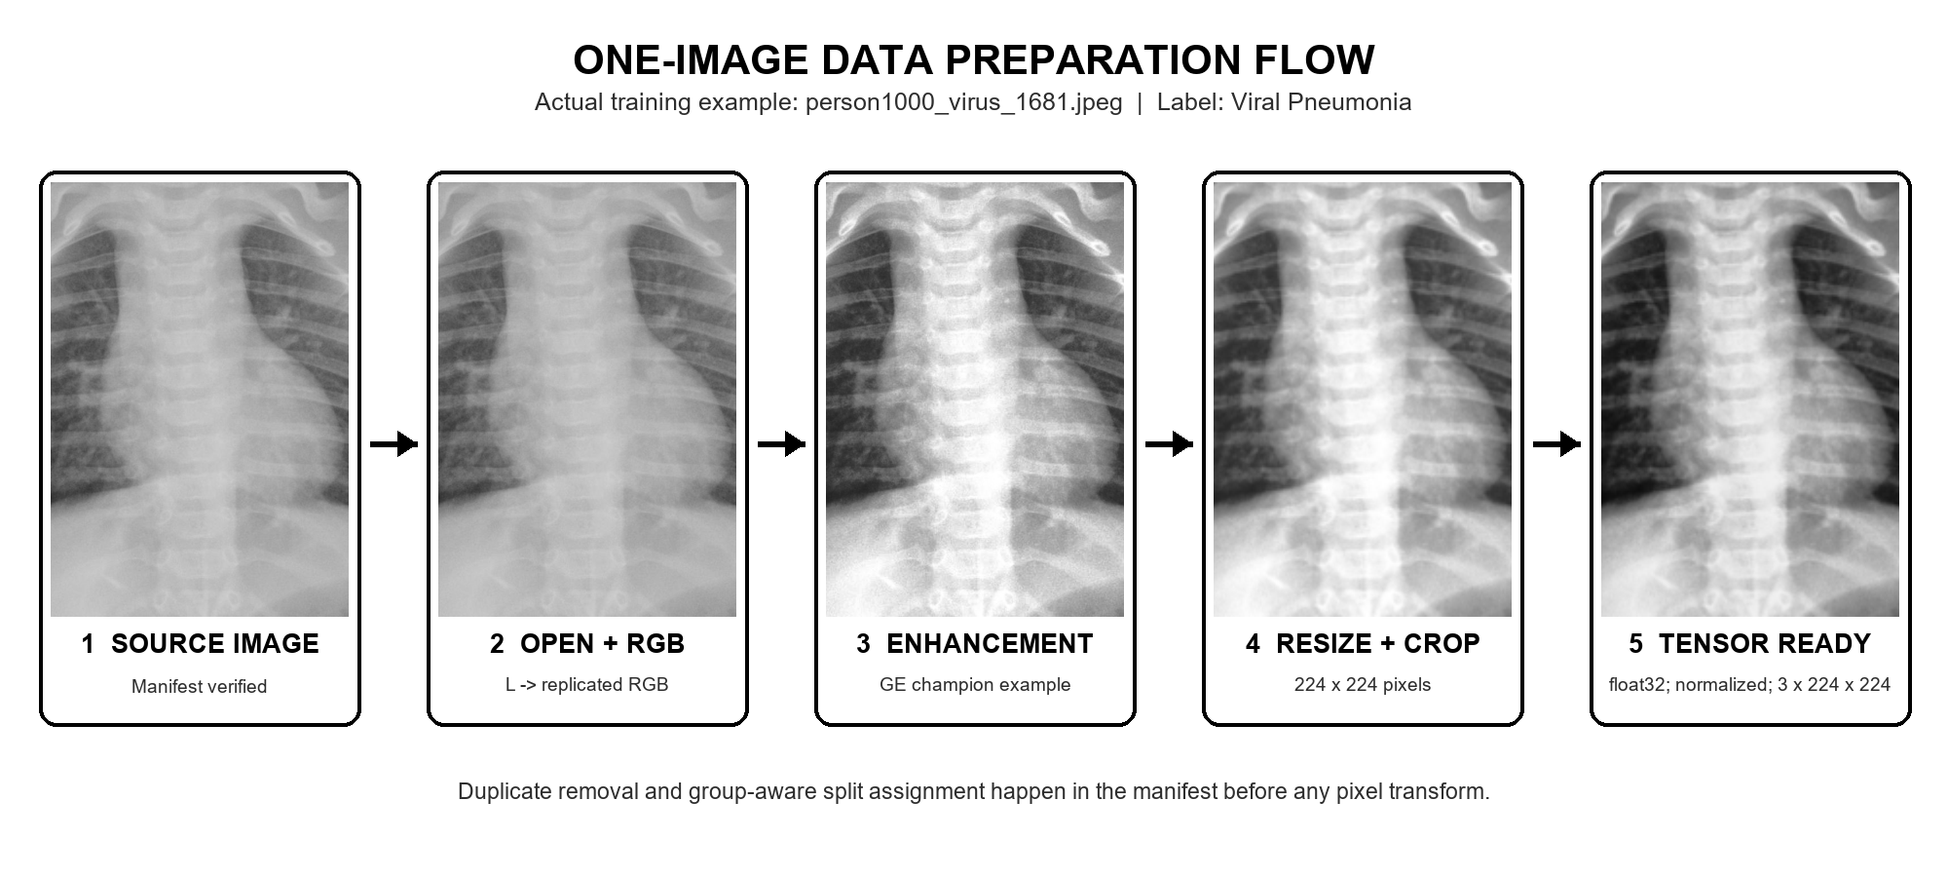
Figure 11.1. One manifest-listed Viral Pneumonia image passing through the champion global-HE input path.
Locked manifest. Confirms the approved path, class, patient/group identifier, and assigned split before loading.
Open and convert to RGB. The original grayscale image is decoded and replicated into three channels required by ImageNet-pretrained backbones.
Apply the selected preprocessing. The pictured champion path uses global histogram equalization; other experimental branches are shown in Figure 11.2.
Resize and center crop. Aspect ratio is preserved before a centered 224 x 224 crop creates the fixed spatial input.
Create the tensor. Pixels become float32 values, dimensions change from H x W x C to C x H x W, and ImageNet mean/std normalization is applied.

11.3 The same image under each preprocessing condition
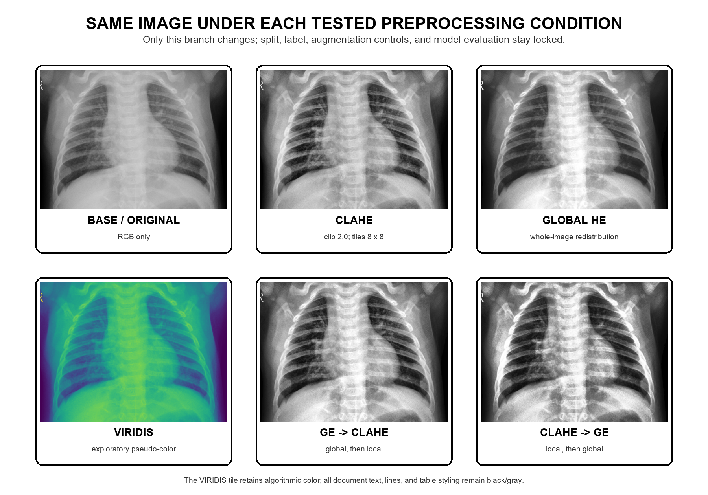
Figure 11.2. Pixel-level comparison of the six preprocessing conditions evaluated on DenseNet/ResNet representatives.
Base/original. No contrast enhancement; only RGB conversion, resizing, tensor conversion, and normalization.
CLAHE. Locally redistributes contrast in 8 x 8 tiles with clip limit 2.0, which can reveal local texture but can amplify local noise.
Global HE. Redistributes intensity using the whole image and produced the strongest single validation macro-F1.
VIRIDIS. Maps grayscale intensity to pseudo-color. It adds no new clinical information and was exploratory.
Ordered combinations. GE -> CLAHE and CLAHE -> GE are different because the second transform acts on already remapped pixels.

11.4 Training-only data augmentation
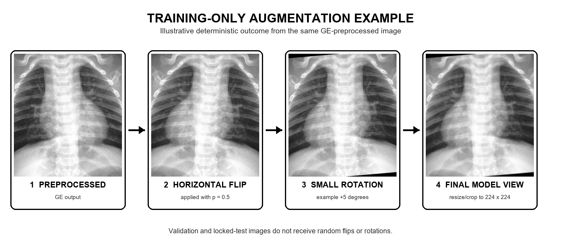
Figure 11.3. A deterministic illustration of the standard training-only flip and small-rotation sequence.
Horizontal flip (p = 0.5). During standard training, approximately half of image presentations are mirrored. The operation was retained because left-right orientation does not change the three study labels.
Small rotation (+/-5 degrees). A random angle represents modest acquisition or positioning variation without creating anatomically implausible large rotations.
Training only. Validation and locked-test images receive deterministic preprocessing, resizing, tensor conversion, and normalization, but no random flip or rotation.

11.5 End-to-end training and validation pipeline
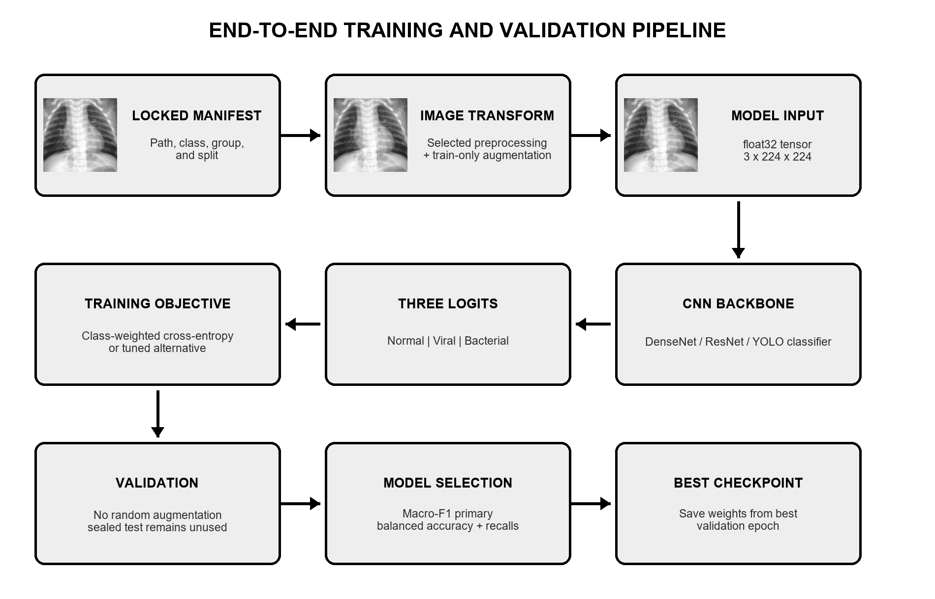
Figure 11.4. Shared experiment flow from the locked manifest to the best validation checkpoint.
Batch construction. The loader groups transformed tensors using the largest architecture-safe batch size tested on the 4 GB RTX 2050.
CNN backbone. DenseNet, ResNet, or YOLO classification features are fine-tuned from ImageNet weights; the experimental SAS/MFF module was added only to its named DenseNet-201 runs.
Three logits. The network outputs one unnormalized score for Normal, Viral, and Bacterial; probabilities are derived for evaluation.
Optimization. The standard comparison uses class-weighted cross-entropy and AdamW; loss gradients update the model after each training batch.
Validation and checkpointing. Macro-F1 is primary, with balanced accuracy and per-class recalls as safeguards. The checkpoint from the best validation epoch is retained.

11.6 Complete second-batch training results
Table 11.1 contains the 21 main architecture/preprocessing runs. A dash is unnecessary because each row records only a configuration that actually completed. Results are percentages from the best validation checkpoint; no smoke score is included.
Table 11.1. Complete main architecture and preprocessing training results (validation).
Model | Preprocessing | Accuracy | Balanced acc. | Macro-F1 | Best epoch
DenseNet-121 | Base/original | 85.469% | 82.733% | 83.775% | 10
DenseNet-169 | Base/original | 85.469% | 83.732% | 84.029% | 6
DenseNet-169 | CLAHE | 83.982% | 83.384% | 83.383% | 5
DenseNet-169 | Global HE | 83.638% | 82.884% | 82.946% | 5
DenseNet-169 | VIRIDIS | 84.668% | 83.462% | 83.729% | 7
DenseNet-201 | Base/original | 84.211% | 84.028% | 83.871% | 10
DenseNet-201 | CLAHE | 85.126% | 84.387% | 84.173% | 6
DenseNet-201 | Global HE | 85.355% | 84.281% | 84.471% | 6
DenseNet-201 | VIRIDIS | 85.469% | 82.914% | 83.706% | 6
DenseNet-201 | GE -> CLAHE | 85.355% | 83.945% | 84.317% | 6
DenseNet-201 | CLAHE -> GE | 85.584% | 83.839% | 84.396% | 6
ResNet-50 | Base/original | 84.668% | 83.445% | 83.692% | 5
ResNet-50 | CLAHE | 83.410% | 82.103% | 82.362% | 4
ResNet-50 | Global HE | 81.922% | 82.023% | 81.955% | 4
ResNet-50 | VIRIDIS | 85.355% | 82.911% | 83.855% | 6
ResNet-101 | Base/original | 84.783% | 83.585% | 83.730% | 9
ResNet-152 | Base/original | 84.325% | 83.212% | 83.328% | 6
YOLOv5-cls | Base/original | 81.465% | 79.346% | 79.471% | 11
YOLOv8-cls | Base/original | 79.519% | 77.443% | 77.340% | 11
DenseNet-201 + SAS/MFF | CLAHE | 84.439% | 83.568% | 83.859% | 11
DenseNet-201 + SAS/MFF | Global HE | 84.554% | 83.511% | 83.689% | 6

11.7 Bounded tuning and seed confirmation
The twelve bounded tuning trials tested four configurations for each of the top three parent models. Trial 0 is the validated parent control. The original control won all three searches.
Table 11.2. Bounded automated tuning trials (validation).
Candidate | Trial | Optimizer / loss | Augmentation | LR / WD | Macro-F1
DenseNet-201 + GE | 0 | ADAMW / cross entropy | Flip 0.5; rot. 5 deg | 0.0001 / 0.0001 | 84.471%
DenseNet-201 + GE | 1 | SGD / focal | Disabled | 0.00121 / 2.94e-06 | 81.299%
DenseNet-201 + GE | 2 | SGD / focal | Disabled | 0.000281 / 7.48e-06 | 79.989%
DenseNet-201 + GE | 3 | ADAMW / cross entropy | Flip 0.5; rot. 5 deg | 0.000109 / 0.000626 | 83.167%
DenseNet-169 + Base | 0 | ADAMW / cross entropy | Flip 0.5; rot. 5 deg | 0.0001 / 0.0001 | 84.029%
DenseNet-169 + Base | 1 | SGD / focal | Disabled | 0.00121 / 2.94e-06 | 80.895%
DenseNet-169 + Base | 2 | SGD / focal | Disabled | 0.000281 / 7.48e-06 | 80.321%
DenseNet-169 + Base | 3 | ADAMW / cross entropy | Flip 0.5; rot. 5 deg | 0.000109 / 0.000626 | 83.003%
ResNet-50 + VIRIDIS | 0 | ADAMW / cross entropy | Flip 0.5; rot. 5 deg | 0.0001 / 0.0001 | 83.855%
ResNet-50 + VIRIDIS | 1 | SGD / focal | Disabled | 0.00121 / 2.94e-06 | 78.605%
ResNet-50 + VIRIDIS | 2 | SGD / focal | Disabled | 0.000281 / 7.48e-06 | 78.090%
ResNet-50 + VIRIDIS | 3 | ADAMW / cross entropy | Flip 0.5; rot. 5 deg | 0.000109 / 0.000626 | 81.993%
Table 11.3. DenseNet-201 + global HE seed-confirmation runs (validation).
Seed | Accuracy | Balanced accuracy | Macro-F1 | Recall N / V / B | Best epoch
42 | 85.355% | 84.281% | 84.471% | 98.312% / 66.368% / 88.164% | 6
123 | 84.554% | 83.253% | 83.662% | 97.468% / 64.126% / 88.164% | 3
2026 | 84.554% | 83.253% | 83.551% | 97.468% / 64.126% / 88.164% | 5

11.8 Overall selection
At the close of the earlier second-batch study, DenseNet-201 + global histogram equalization was the selected validation configuration at 84.471% macro F1. The later ordered-preprocessing experiment superseded that validation ranking: DenseNet-201 + VIRIDIS -> GE -> CLAHE reached 85.294%. The earlier model remains important because it alone received the predeclared one-time locked-test evaluation.
The earlier three-seed confirmation mean of 83.895% applies only to DenseNet-201 + global HE. The newer VIRIDIS -> GE -> CLAHE candidate now has its own completed three-seed evidence: 85.294%, 83.570%, and 83.640% macro F1, with a mean of 84.168%.

12. Final Ordered-Preprocessing Study and Updated Validation Selection
The final repository ledger contains 119 completed entries: 95 full or analysis entries and 24 smoke/pilot checks. One historical failed row is preserved with its resolution trail. The ordered-preprocessing controller completed all 16 DenseNet-201 conditions, all 16 ResNet-50 conditions, and transfer of the DenseNet-201 winner to all eight supported architectures. Every selection in this section is validation-only.

12.1 Experimental design and why order is a real variable
Each of CLAHE (C), global histogram equalization (G), and VIRIDIS (V) appears at most once. The resulting design contains the baseline, three one-operation pipelines, six ordered two-operation pipelines, and six ordered three-operation pipelines: 16 conditions per exhaustively tested architecture. All target configurations were derived from the architecture's seed-42 baseline so optimizer, learning rate, weight decay, augmentation, epoch budget, loss, scheduler, manifests, and class definitions remained matched.
Table 12.1. Controlled variables and intentionally varied factors in the ordered-preprocessing study.
Component | Controlled or varied | Implementation
Dataset and split | Controlled | Locked group-aware manifests: 4,076 train; 874 validation; 874 sealed test
Random seed | Controlled | 42 for every ordered-preprocessing comparison
Training augmentation | Controlled | Horizontal flip p=0.5; rotation uniformly sampled within +/-5 degrees
Optimization | Controlled | AdamW; LR 0.0001; weight decay 0.0001; balanced class-weighted cross-entropy
Training budget | Controlled | Maximum 12 epochs; early-stopping patience 4; ReduceLROnPlateau factor 0.5/patience 2
Architecture | Varied by phase | DenseNet-201 exhaustive; ResNet-50 exhaustive; winner transferred to eight architectures
Enhancement sequence | Varied | All ordered subsets of CLAHE, GE, and VIRIDIS
Selection | Controlled | Maximum validation macro F1; balanced accuracy and accuracy as tie-breakers
Order matters because every operation consumes the output of the prior operation. In this implementation, CLAHE and GE convert their input to grayscale and then replicate it to RGB. VIRIDIS also begins by converting its input to grayscale before applying the color map. Therefore, a pipeline that ends in GE or CLAHE is finally grayscale-replicated even if VIRIDIS appeared earlier; VIRIDIS can still change the intensity mapping that later grayscale operations receive. The observed order effects are algorithmic interactions, not evidence that artificial color adds new clinical information.

12.2 Completed six-condition screening across all eight architectures
Table 12.2. Validation macro F1 (%) for the completed six-condition screening matrix.
Model | Base | CLAHE | GE | VIRIDIS | GE -> CLAHE | CLAHE -> GE
DenseNet-121 | 83.775% | 82.758% | 82.517% | 83.474% | 83.876% | 82.273%
DenseNet-169 | 84.029% | 83.383% | 82.946% | 83.729% | 84.351% | 83.908%
DenseNet-201 | 83.871% | 84.173% | 84.471% | 83.706% | 84.317% | 84.396%
ResNet-50 | 83.692% | 82.362% | 81.955% | 83.855% | 84.579% | 84.283%
ResNet-101 | 83.730% | 83.295% | 80.581% | 82.389% | 82.308% | 81.810%
ResNet-152 | 83.328% | 82.157% | 80.223% | 81.750% | 81.782% | 82.883%
YOLOv5 | 79.471% | 77.901% | 76.828% | 79.041% | 75.157% | 74.133%
YOLOv8 | 77.340% | 77.777% | 75.502% | 78.275% | 75.502% | 73.143%
The six-condition screen shows that preprocessing is architecture-dependent. GE -> CLAHE improved ResNet-50 from 83.692% to 84.579% macro F1, but ResNet-101 and ResNet-152 remained strongest at baseline. YOLOv5 also remained strongest at baseline, while YOLOv8's best screened condition was VIRIDIS.

12.3 Complete DenseNet-201 and ResNet-50 order tables
Table 12.3. DenseNet-201: all 16 completed preprocessing orders (validation).
Order | Macro F1 | Balanced acc. | Accuracy | Best epoch
Base | 83.871% | 84.028% | 84.211% | 10
CLAHE | 84.173% | 84.387% | 85.126% | 6
GE | 84.471% | 84.281% | 85.355% | 6
VIRIDIS | 83.706% | 82.914% | 85.469% | 6
GE -> CLAHE | 84.317% | 83.945% | 85.355% | 6
CLAHE -> GE | 84.396% | 83.839% | 85.584% | 6
CLAHE -> VIRIDIS | 82.891% | 82.499% | 84.096% | 5
VIRIDIS -> CLAHE | 83.696% | 83.330% | 84.897% | 5
GE -> VIRIDIS | 84.029% | 83.870% | 84.783% | 8
VIRIDIS -> GE | 84.590% | 85.009% | 84.783% | 6
CLAHE -> GE -> VIRIDIS | 84.609% | 84.098% | 85.584% | 11
CLAHE -> VIRIDIS -> GE | 82.488% | 83.111% | 83.410% | 2
GE -> CLAHE -> VIRIDIS | 84.431% | 84.335% | 85.469% | 6
GE -> VIRIDIS -> CLAHE | 83.362% | 83.192% | 84.897% | 6
VIRIDIS -> CLAHE -> GE | 84.149% | 84.238% | 85.011% | 5
VIRIDIS -> GE -> CLAHE | 85.294% | 84.546% | 86.613% | 6

Table 12.4. ResNet-50: all 16 completed preprocessing orders (validation).
Order | Macro F1 | Balanced acc. | Accuracy | Best epoch
Base | 83.692% | 83.445% | 84.668% | 5
CLAHE | 82.362% | 82.103% | 83.410% | 4
GE | 81.955% | 82.023% | 81.922% | 4
VIRIDIS | 83.855% | 82.911% | 85.355% | 6
GE -> CLAHE | 84.579% | 84.609% | 85.011% | 5
CLAHE -> GE | 84.283% | 83.366% | 85.584% | 10
CLAHE -> VIRIDIS | 83.002% | 82.511% | 84.211% | 5
VIRIDIS -> CLAHE | 83.321% | 82.821% | 84.554% | 5
GE -> VIRIDIS | 83.106% | 82.902% | 83.638% | 4
VIRIDIS -> GE | 83.046% | 82.419% | 84.668% | 9
CLAHE -> GE -> VIRIDIS | 82.966% | 82.793% | 83.753% | 5
CLAHE -> VIRIDIS -> GE | 84.663% | 84.416% | 85.584% | 11
GE -> CLAHE -> VIRIDIS | 83.590% | 83.174% | 84.897% | 11
GE -> VIRIDIS -> CLAHE | 82.550% | 82.545% | 83.181% | 4
VIRIDIS -> CLAHE -> GE | 83.163% | 82.678% | 84.325% | 4
VIRIDIS -> GE -> CLAHE | 82.587% | 82.487% | 83.295% | 4
DenseNet-201 selected VIRIDIS -> GE -> CLAHE at 85.294%. ResNet-50 selected CLAHE -> VIRIDIS -> GE at 84.663%. DenseNet-201 leads the best ResNet-50 result by +0.630 pp.

12.4 Transfer of the DenseNet-201 winning pipeline
Table 12.5. Cross-model transfer of VIRIDIS -> GE -> CLAHE (validation).
Model | Pipeline | Macro F1 | Balanced acc. | Accuracy | Status
DenseNet-121 | VIRIDIS -> GE -> CLAHE | 83.013% | 82.858% | 83.638% | Completed
DenseNet-169 | VIRIDIS -> GE -> CLAHE | 84.742% | 84.523% | 85.698% | Completed
DenseNet-201 | VIRIDIS -> GE -> CLAHE | 85.294% | 84.546% | 86.613% | Completed
ResNet-50 | VIRIDIS -> GE -> CLAHE | 82.587% | 82.487% | 83.295% | Completed
ResNet-101 | VIRIDIS -> GE -> CLAHE | 81.968% | 81.990% | 83.410% | Completed
ResNet-152 | VIRIDIS -> GE -> CLAHE | 84.146% | 84.034% | 85.126% | Completed
YOLOv5 | VIRIDIS -> GE -> CLAHE | 76.113% | 76.394% | 78.604% | Completed
YOLOv8 | VIRIDIS -> GE -> CLAHE | 75.158% | 75.675% | 77.803% | Completed
The winning DenseNet-201 order did not transfer uniformly. It ranked second overall on DenseNet-169 (84.742%) but reduced ResNet-50 to 82.587%, below both its baseline and its architecture-specific winner. This is why one model's best preprocessing cannot be assumed to be optimal for another architecture.

12.5 Overall ranking of distinct completed validation configurations
Table 12.6. Top 12 distinct completed seed-42 validation configurations after configuration-alias deduplication.
Rank | Model | Preprocessing | Macro F1 | Balanced | Accuracy | Epoch
1 | DenseNet-201 | VIRIDIS -> GE -> CLAHE | 85.294% | 84.546% | 86.613% | 6
2 | DenseNet-169 | VIRIDIS -> GE -> CLAHE | 84.742% | 84.523% | 85.698% | 6
3 | ResNet-50 | CLAHE -> VIRIDIS -> GE | 84.663% | 84.416% | 85.584% | 11
4 | DenseNet-201 | CLAHE -> GE -> VIRIDIS | 84.609% | 84.098% | 85.584% | 11
5 | DenseNet-201 | VIRIDIS -> GE | 84.590% | 85.009% | 84.783% | 6
6 | ResNet-50 | GE -> CLAHE | 84.579% | 84.609% | 85.011% | 5
7 | DenseNet-201 | GE | 84.471% | 84.281% | 85.355% | 6
8 | DenseNet-201 | GE -> CLAHE -> VIRIDIS | 84.431% | 84.335% | 85.469% | 6
9 | DenseNet-201 | CLAHE -> GE | 84.396% | 83.839% | 85.584% | 6
10 | DenseNet-169 | GE -> CLAHE | 84.351% | 83.764% | 86.041% | 8
11 | DenseNet-201 | GE -> CLAHE | 84.317% | 83.945% | 85.355% | 6
12 | ResNet-50 | CLAHE -> GE | 84.283% | 83.366% | 85.584% | 10
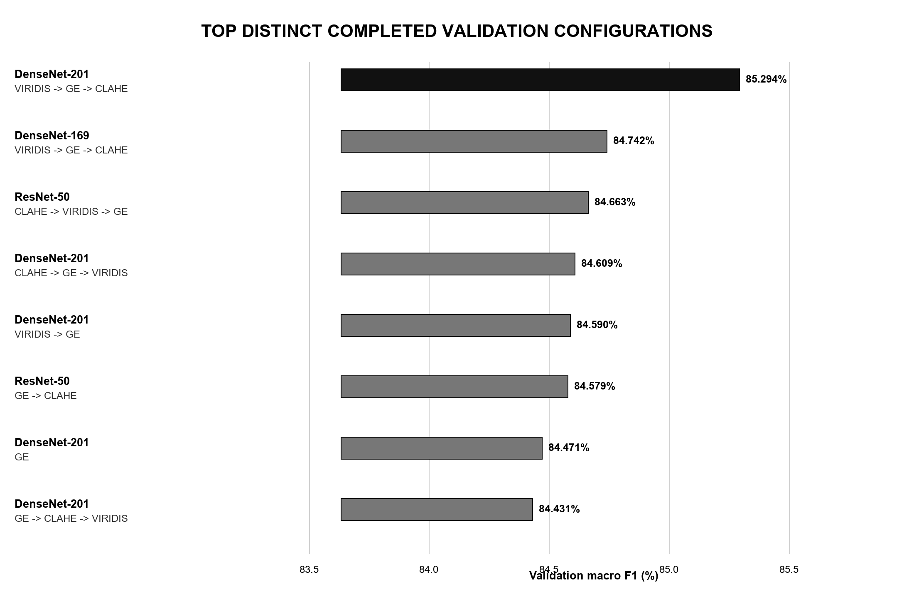
Figure 12.1. Highest distinct completed validation configurations ranked by macro F1.

12.6 Top-two overall comparison
The top two distinct completed configurations use the same preprocessing order but different DenseNet depths. DenseNet-201 leads DenseNet-169 by +0.551 pp in macro F1 and +0.915 pp in accuracy. Balanced accuracy differs by only +0.023 pp, indicating that their average class recalls are nearly identical.
Table 12.7. Detailed comparison of the top two overall validation configurations.
Metric | DenseNet-201 | DenseNet-169 | D201 - D169
Validation macro F1 | 85.294% | 84.742% | +0.551 pp
Balanced accuracy | 84.546% | 84.523% | +0.023 pp
Accuracy | 86.613% | 85.698% | +0.915 pp
Macro precision | 87.188% | 85.270% | +1.918 pp
Macro ROC AUC | 94.306% | 94.024% | +0.282 pp
Macro PR AUC | 88.910% | 88.434% | +0.476 pp
Expected calibration error | 0.0611 | 0.0578 | +0.0033
Brier score | 0.2134 | 0.2172 | -0.0038
Parameters | 18,098,691 | 12,489,475 | +5,609,216
Model file size | 209.0 MiB | 144.4 MiB | +64.6 MiB
Batch-1 model latency | 35.80 ms | 23.01 ms | +12.79 ms
Training duration | 95.8 min | 90.0 min | +5.8 min
Best epoch | 6 | 6 | same
Table 12.8. Per-class validation metrics for the top two configurations.
Class | Model | Precision | Recall | F1 | ROC AUC | PR AUC
Normal | DenseNet-201 | 95.492% | 98.312% | 96.881% | 99.836% | 99.582%
Normal | DenseNet-169 | 94.332% | 98.312% | 96.281% | 99.890% | 99.728%
Viral | DenseNet-201 | 82.738% | 62.332% | 71.100% | 89.192% | 77.102%
Viral | DenseNet-169 | 76.684% | 66.368% | 71.154% | 88.534% | 76.001%
Bacterial | DenseNet-201 | 83.333% | 92.995% | 87.900% | 93.890% | 90.045%
Bacterial | DenseNet-169 | 84.793% | 88.889% | 86.792% | 93.648% | 89.573%
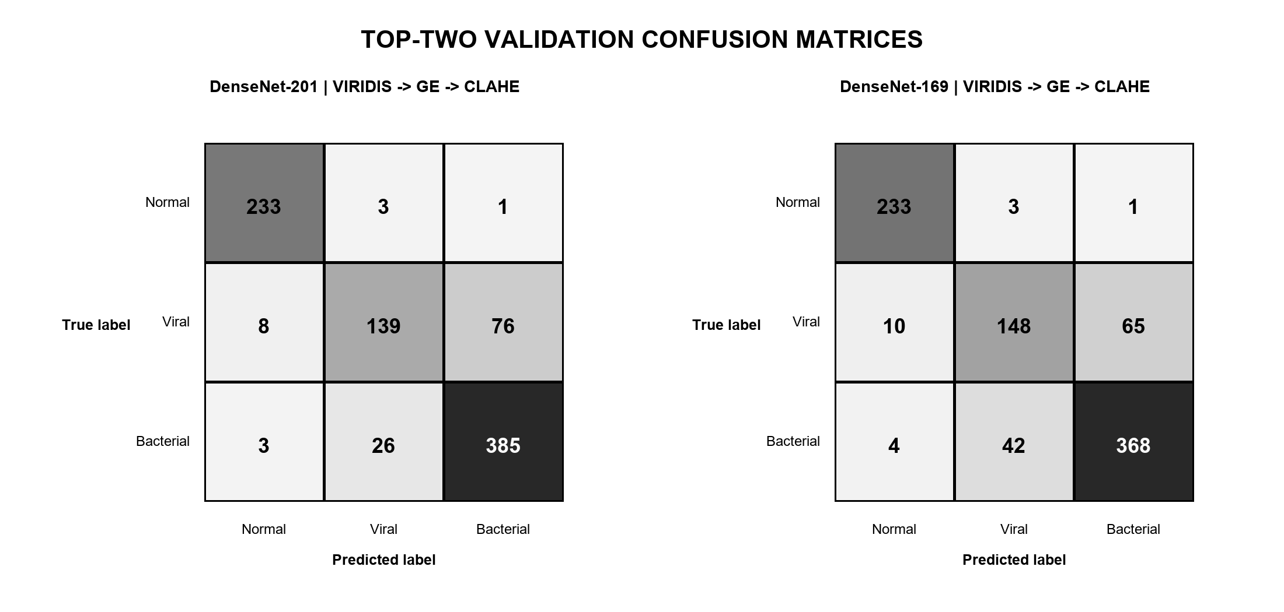
Figure 12.2. Validation confusion matrices for the top two overall configurations.
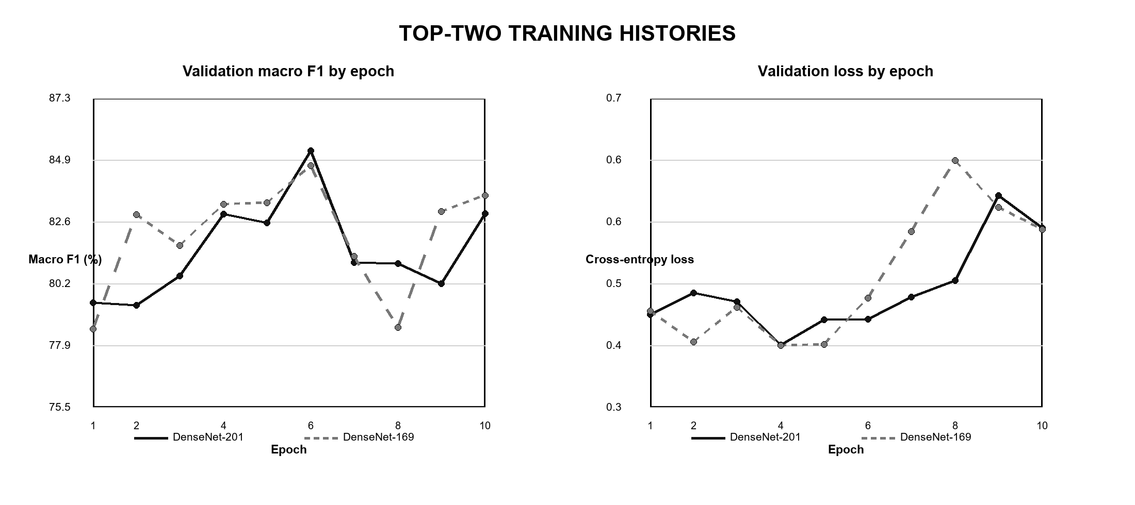
Figure 12.3. Validation macro F1 and validation loss across epochs for the top two configurations.

12.7 Configuration comparison of the leading models
Table 12.9. Configuration and result comparison: overall top two plus the ResNet-50 exhaustive winner.
Field | DenseNet-201 | DenseNet-169 | ResNet-50
Architecture | DenseNet-201 | DenseNet-169 | ResNet-50
Preprocessing | VIRIDIS -> GE -> CLAHE | VIRIDIS -> GE -> CLAHE | CLAHE -> VIRIDIS -> GE
ImageNet initialization | imagenet | imagenet | imagenet
Input | 3 x 224 x 224 | 3 x 224 x 224 | 3 x 224 x 224
Batch size | 8 | 12 | 16
Optimizer | adamw | adamw | adamw
Initial learning rate | 0.0001 | 0.0001 | 0.0001
Weight decay | 0.0001 | 0.0001 | 0.0001
Loss | balanced weighted cross-entropy | balanced weighted cross-entropy | balanced weighted cross-entropy
Maximum epochs | 12 | 12 | 12
Early stopping patience | 4 | 4 | 4
Scheduler | ReduceLROnPlateau | ReduceLROnPlateau | ReduceLROnPlateau
Augmentation | flip p=0.5; rotation +/-5 degrees | same | same
Mixed precision | True | True | True
Seed | 42, 123, 2026 | 42, 123, 2026 | 42, 123, 2026
Mean validation macro F1 | 84.168% | 84.142% | 83.472%
Macro F1 sample SD | 0.975 pp | 0.532 pp | 1.057 pp
Mean balanced accuracy | 83.932% | 83.804% | 83.207%
Mean accuracy | 85.202% | 85.088% | 84.477%
Mean Viral recall | 64.275% | 64.873% | 63.528%

12.8 Relationship to tuning, SAS/MFF, and seed robustness
Table 12.10. Completed experimental DenseNet-201 + SAS/MFF comparisons (validation).
Architecture | Preprocessing | Macro F1 | Balanced | Accuracy | Epoch
DenseNet-201 + SAS/MFF | CLAHE | 83.859% | 83.568% | 84.439% | 11
DenseNet-201 + SAS/MFF | GE | 83.689% | 83.511% | 84.554% | 6
The bounded Optuna studies had already shown that the original AdamW, balanced cross-entropy, conservative augmentation, learning rate 0.0001, and weight decay 0.0001 controls outperformed the tested SGD/focal alternatives for each parent candidate. The SAS/MFF additions also did not exceed standard DenseNet-201. These findings justified retaining the controlled optimization recipe while varying preprocessing order. Independent seeds 123 and 2026 have now been completed for the leading DenseNet-201, DenseNet-169, and ResNet-50 configurations.

12.9 Locked-test result and current selection boundary
Table 12.11. The only locked-test evaluation, retained for context but not reassigned to the new winner.
Evaluated model | Test macro F1 | Balanced acc. | Accuracy | Viral F1 | Status
DenseNet-201 + GE (earlier frozen model) | 78.877% | 78.581% | 79.863% | 58.629% | Single sealed evaluation
The 78.877% locked-test macro F1 belongs to DenseNet-201 + GE, not to DenseNet-201 + VIRIDIS -> GE -> CLAHE. Reporting the old test score as the newly selected candidate's performance would be incorrect. The new candidate was selected using validation evidence only. Any additional access to the existing test set must be documented as a second access and must not trigger further tuning; independent external validation remains preferable.

12.10 Completed Three-Seed Confirmation
The same selected configuration for each finalist was trained under seeds 42, 123, and 2026. A seed initializes controlled pseudo-random choices such as the new layer weights, training-batch order, horizontal-flip decisions, and small rotation angles. The dataset manifests, preprocessing order, architecture, optimizer, learning rate, weight decay, loss, epoch limit, and early-stopping rules remained fixed within each candidate. Multiple seeds test whether a result is repeatable rather than the product of one favorable random sequence.
Table 12.12. Per-seed validation results for the three final candidates. Viral recall is shown because Viral Pneumonia was the most difficult class.
Model | Preprocessing | Seed | Macro F1 | Balanced | Accuracy | Viral recall | Best epoch
DenseNet-201 | VIRIDIS -> GE -> CLAHE | 42 | 85.294% | 84.546% | 86.613% | 62.332% | 6
DenseNet-201 | VIRIDIS -> GE -> CLAHE | 123 | 83.570% | 83.746% | 84.325% | 66.816% | 3
DenseNet-201 | VIRIDIS -> GE -> CLAHE | 2026 | 83.640% | 83.505% | 84.668% | 63.677% | 9
DenseNet-169 | VIRIDIS -> GE -> CLAHE | 42 | 84.742% | 84.523% | 85.698% | 66.368% | 6
DenseNet-169 | VIRIDIS -> GE -> CLAHE | 123 | 83.956% | 83.457% | 85.469% | 60.090% | 10
DenseNet-169 | VIRIDIS -> GE -> CLAHE | 2026 | 83.728% | 83.431% | 84.096% | 68.161% | 7
ResNet-50 | CLAHE -> VIRIDIS -> GE | 42 | 84.663% | 84.416% | 85.584% | 65.022% | 11
ResNet-50 | CLAHE -> VIRIDIS -> GE | 123 | 82.648% | 82.354% | 83.410% | 65.471% | 4
ResNet-50 | CLAHE -> VIRIDIS -> GE | 2026 | 83.105% | 82.852% | 84.439% | 60.090% | 4
DenseNet-201 winner multi-seed summary | model/results/winner_multiseed_confirmation/summary.json
Top-three multi-seed comparison | model/results/top_competitor_multiseed_confirmation/summary.json
Top-three per-seed comparison CSV | model/results/top_competitor_multiseed_confirmation/summary.csv
Table 12.13. Aggregate validation comparison. SD means sample standard deviation across the three seeds; pp means percentage points.
Rank | Model | Preprocessing | Mean F1 | F1 SD | Mean balanced | Mean accuracy | Mean Viral recall
1 | DenseNet-201 | VIRIDIS -> GE -> CLAHE | 84.168% | 0.975 pp | 83.932% | 85.202% | 64.275%
2 | DenseNet-169 | VIRIDIS -> GE -> CLAHE | 84.142% | 0.532 pp | 83.804% | 85.088% | 64.873%
3 | ResNet-50 | CLAHE -> VIRIDIS -> GE | 83.472% | 1.057 pp | 83.207% | 84.477% | 63.528%
DenseNet-201 and DenseNet-169 were practically tied: their mean macro F1 values differed by only 0.026 percentage points. DenseNet-169 was more stable and had slightly higher mean Viral recall. DenseNet-201 nevertheless ranked first under the declared primary metric and also ranked first in mean balanced accuracy and mean accuracy.

12.11 Final Model Decision and Why It Was Chosen
Historical conclusion for the earlier preprocessing-only phase. The current retained system is FT-004; see the final October update.
Final selection: DenseNet-201 + VIRIDIS -> GE -> CLAHE. The decision follows the predefined rule rather than a subjective preference: first compare mean validation macro F1 across seeds; use balanced accuracy and accuracy as supporting evidence; retain per-class recall and variability as limitations. DenseNet-201 finished first on all three aggregate performance measures. The small margin means the wording must be 'selected final validation candidate,' not 'proven substantially superior model.'
- Primary evidence: highest three-seed mean macro F1, 84.168%.
- Secondary evidence: highest mean balanced accuracy, 83.932%, and highest mean accuracy, 85.202%.
- Close-comparison limitation: DenseNet-169 averaged 84.142% macro F1, only 0.026 percentage points lower, and had lower variability.
- Checkpoint rule: the seed-42 best checkpoint at epoch 6 is the documented single-checkpoint representative because seed 42 was the original screening condition, not because of any test result.
- Test boundary: the new candidate has not been evaluated on the locked test; the previous DenseNet-201 + GE test result cannot be reassigned to it.

13. Discussion

13.1 Why DenseNet-201 is the final validation-selected candidate
DenseNet-201 + VIRIDIS -> GE -> CLAHE is the final validation-selected candidate because it achieved the highest mean macro F1 across the three prespecified seeds: 84.168%. Macro F1 gives equal weight to Normal, Viral, and Bacterial F1 scores, making it more appropriate than accuracy alone for the imbalanced class distribution. DenseNet-201 also produced the highest mean balanced accuracy (83.932%) and mean accuracy (85.202%) among the three finalists.
The decision is close rather than absolute. DenseNet-201 exceeded DenseNet-169 by only 0.026 percentage points in three-seed mean macro F1. DenseNet-169 had lower seed-to-seed standard deviation (0.532 versus 0.975 percentage points), slightly higher mean Viral recall, fewer parameters, a smaller file, and lower measured model-only latency. DenseNet-201 is selected because it ranks first under the predefined primary metric and the two principal aggregate secondary metrics; DenseNet-169 remains a practically comparable and more efficient alternative.

13.2 Why preprocessing order changed the result
Histogram operations are nonlinear and non-commutative: applying A then B does not generally equal applying B then A. CLAHE redistributes local contrast under a clip limit, GE redistributes the whole-image histogram, and VIRIDIS maps intensity to artificial RGB before later operations may convert that output back to luminance. Consequently, each order presents a different pixel distribution to the pretrained network even though it uses the same source radiograph.
The strongest evidence for architecture interaction is ResNet-50. DenseNet-201's winner scored 82.587% on ResNet-50, whereas CLAHE -> VIRIDIS -> GE reached 84.663% on the same ResNet-50 architecture under matched controls. The data therefore support testing preprocessing jointly with architecture instead of treating preprocessing as a universal front end.

13.3 Interpretation of accuracy, macro F1, and balanced accuracy
Accuracy counts all correct predictions and is influenced most by the largest class. Macro F1 computes F1 separately for each class and averages the three values equally, so weak Viral performance cannot be hidden by strong Bacterial performance. Balanced accuracy averages the three recalls and answers a complementary question: how much of each class was found. The selection rule therefore prioritizes macro F1, uses balanced accuracy and accuracy as tie-breakers, and reports per-class precision and recall to expose the clinical error pattern.

13.4 Limitations
- The dataset is a single public pediatric chest-X-ray source; external hospitals, devices, age groups, and prevalence patterns were not tested.
- The final three candidates now have completed seeds 42, 123, and 2026. Only three seeds were evaluated, so the means and standard deviations remain estimates based on a small replication count.
- The final validation-selected candidate emerged after the earlier one-time locked-test evaluation of DenseNet-201 + GE. It must not inherit that earlier model's 78.877% test macro F1.
- The ordered preprocessing study tested pixel transformations but did not add lung segmentation, ROI masks, PCA, FiLM conditioning, or a new SAS/MFF architecture to every backbone.
- VIRIDIS is exploratory and adds no clinical information. When it precedes GE/CLAHE, the final image becomes grayscale-replicated; the gain is an empirical intensity-remapping effect, not proof that color is clinically meaningful.
- Grad-CAM, calibration, and complete end-to-end efficiency measurements were produced for the earlier frozen model and have not yet been regenerated for the newly selected DenseNet-201 + VIRIDIS -> GE -> CLAHE checkpoint.
- No statistical significance claim is made for the 0.026-percentage-point three-seed mean difference between DenseNet-201 and DenseNet-169. Three seeds are insufficient for a strong distributional claim.
- This work is an engineering research benchmark and not a medical device, diagnosis, treatment recommendation, or prospective clinical validation.

13.5 Recommended next validation sequence
- Freeze DenseNet-201 + VIRIDIS -> GE -> CLAHE as the final validation-selected configuration and preserve the three completed seed checkpoints.
- Use the seed-42 best checkpoint at epoch 6 as the documented single-checkpoint representative because seed 42 was the original screening seed; do not choose a checkpoint using test results.
- If the existing locked test is accessed again, evaluate the frozen representative once, label the event as a second test access, and prohibit further configuration changes.
- Prefer an independent external dataset for stronger generalization evidence across hospitals, devices, age groups, and prevalence patterns.
- Regenerate Grad-CAM, calibration, and true end-to-end latency for the final frozen DenseNet-201 checkpoint.

14. Conclusion
Historical conclusion for the earlier preprocessing-only phase. The current retained system is FT-004; see the final October update.
The repository now provides a leakage-controlled comparison of eight supported classifiers, exhaustive ordered preprocessing for DenseNet-201 and ResNet-50, cross-model transfer of the leading pipeline, bounded hyperparameter trials, and completed three-seed confirmation of the top DenseNet-201, DenseNet-169, and ResNet-50 configurations. DenseNet-201 + VIRIDIS -> GE -> CLAHE averaged 84.168% macro F1, 83.932% balanced accuracy, and 85.202% accuracy across seeds 42, 123, and 2026.
DenseNet-201 + VIRIDIS -> GE -> CLAHE is therefore selected as the final validation candidate under the predefined primary metric of three-seed mean macro F1. DenseNet-169 was practically tied at 84.142%, more stable across seeds, and more efficient, so the report does not claim substantial or statistically significant superiority. The selected candidate still requires a properly governed locked-test evaluation or, preferably, independent external validation before any clinical interpretation.

15. Verified References
The repository evidence matrix contains 25 verified primary or official sources: 4 Direct, 10 Partial, 9 Background, and 2 Excluded. The following author-year bibliography preserves the verified title, venue, DOI, and official link recorded in that matrix.
Amit Kumar Jaiswal; Prayag Tiwari; Sachin Kumar; Deepak Gupta; Ashish Khanna; Joel J. P. C. Rodrigues (2019). Identifying Pneumonia in Chest X-Rays: A Deep Learning Approach. Measurement 145:511-518. DOI: 10.1016/j.measurement.2019.05.076. https://www.sciencedirect.com/science/article/pii/S0263224119305202
Anggi Muhammad Rifai; Suwanto Raharjo; Ema Utami; Dhani Ariatmanto (2024 journal issue; online 2023). Analysis for diagnosis of pneumonia symptoms using chest X-ray based on MobileNetV2 models with image enhancement using white balance and contrast limited adaptive histogram equalization (CLAHE). Biomedical Signal Processing and Control 105857. DOI: 10.1016/j.bspc.2023.105857. https://www.sciencedirect.com/science/article/pii/S1746809423012909
Anusua Trivedi; Caleb Robinson; Marian Blazes; Anthony Ortiz; Jocelyn Desbiens; Sunil Gupta; Rahul Dodhia; Pavan K. Bhatraju; W. Conrad Liles; Jayashree Kalpathy-Cramer; Aaron Y. Lee; Juan M. Lavista Ferres (2022). Deep learning models for COVID-19 chest x-ray classification: Preventing shortcut learning using feature disentanglement. PLOS ONE 17(10):e0274098. DOI: 10.1371/journal.pone.0274098. https://pubmed.ncbi.nlm.nih.gov/36201483/
Ao Wang et al.; THU-MIG (2024). YOLOv10: Real-Time End-to-End Object Detection. NeurIPS 2024; official THU-MIG repository. https://github.com/THU-MIG/yolov10
Chuan Guo; Geoff Pleiss; Yu Sun; Kilian Q. Weinberger (2017). On Calibration of Modern Neural Networks. ICML 2017, PMLR 70:1321-1330. https://proceedings.mlr.press/v70/guo17a.html
Daniel S. Kermany et al. (2018). Identifying Medical Diagnoses and Treatable Diseases by Image-Based Deep Learning. Cell 172(5):1122-1131.e9. DOI: 10.1016/j.cell.2018.02.010. https://www.sciencedirect.com/science/article/pii/S0092867418301545
Dejun Zhang; Fuquan Ren; Yushuang Li; Lei Na; Yue Ma (2021). Pneumonia Detection from Chest X-ray Images Based on Convolutional Neural Network. Electronics 10(13):1512. DOI: 10.3390/electronics10131512. https://www.mdpi.com/2079-9292/10/13/1512
Fausto Milletari; Nassir Navab; Seyed-Ahmad Ahmadi (2016). V-Net: Fully Convolutional Neural Networks for Volumetric Medical Image Segmentation. 2016 Fourth International Conference on 3D Vision (3DV), 565-571. DOI: 10.1109/3DV.2016.79. https://arxiv.org/abs/1606.04797
Gao Huang; Zhuang Liu; Laurens van der Maaten; Kilian Q. Weinberger (2017). Densely Connected Convolutional Networks. CVPR 2017:4700-4708. https://openaccess.thecvf.com/content_cvpr_2017/html/Huang_Densely_Connected_Convolutional_CVPR_2017_paper.html
Halit Bakır; Semih Oktay; Emre Tabaru (2023). Detection of Pneumonia from X-ray Images Using Deep Learning Techniques. Journal of Scientific Reports-A 52:419-440. DOI: 10.59313/jsr-a.1219363. https://dergipark.org.tr/en/pub/jsr-a/article/1219363
Hicham Moujahid; Bouchaib Cherradi; Mohammed Al-Sarem; Lhoussain Bahatti; Bakr Assedik Eljialy; Abdullah Alsaeedi; Faisal Saeed (2022 journal issue; online 2021). Combining CNN and Grad-CAM for COVID-19 Disease Prediction and Visual Explanation. Intelligent Automation & Soft Computing 32(2):723-745. DOI: 10.32604/iasc.2022.022179. https://www.techscience.com/iasc/v32n2/45598/html
Jeremy Hofmeister; Nicolas Garin; Xavier Montet; Max Scheffler; Alexandra Platon; Pierre-Alexandre Poletti; Jerome Stirnemann; Marie-Pierre Debray; Yann-Erick Claessens; Xavier Duval; Virginie Prendki (2024). Validating the accuracy of deep learning for the diagnosis of pneumonia on chest x-ray against a robust multimodal reference diagnosis: a post hoc analysis of two prospective studies. European Radiology Experimental 8:20. DOI: 10.1186/s41747-023-00416-y. https://pubmed.ncbi.nlm.nih.gov/38302850/
Jose Raniery Ferreira; Diego Armando Cardona Cardenas; Ramon Alfredo Moreno; Marina de Fatima de Sa Rebelo; Jose Eduardo Krieger; Marco Antonio Gutierrez (2020). Multi-View Ensemble Convolutional Neural Network to Improve Classification of Pneumonia in Low Contrast Chest X-Ray Images. 2020 42nd Annual International Conference of the IEEE Engineering in Medicine & Biology Society, 1238-1241. DOI: 10.1109/EMBC44109.2020.9176517. https://pubmed.ncbi.nlm.nih.gov/33018211/
Kaiming He; Xiangyu Zhang; Shaoqing Ren; Jian Sun (2016). Deep Residual Learning for Image Recognition. CVPR 2016:770-778. https://openaccess.thecvf.com/content_cvpr_2016/html/He_Deep_Residual_Learning_CVPR_2016_paper.html
Katy Stokes; Rossana Castaldo; Carlo Federici; Silvio Pagliara; Alessia Maccaro; Francesco Cappuccio; Giuseppe Fico; Marco Salvatore; Monica Franzese; Leandro Pecchia (2022). The Use of AI Systems in Diagnosis of Pneumonia via Signs and Symptoms: A Systematic Review. Biomedical Signal Processing and Control 72A:103325. DOI: 10.1016/j.bspc.2021.103325. https://wrap.warwick.ac.uk/id/eprint/160069/
Morteza Heidari; Seyedehnafiseh Mirniaharikandehei; Abolfazl Zargari Khuzani; Gopichandh Danala; Yuchen Qiu; Bin Zheng (2020). Improving the performance of CNN to predict the likelihood of COVID-19 using chest X-ray images with preprocessing algorithms. International Journal of Medical Informatics 144:104284. DOI: 10.1016/j.ijmedinf.2020.104284. https://pubmed.ncbi.nlm.nih.gov/32992136/
Pranav Rajpurkar; Jeremy Irvin; Kaylie Zhu; Brandon Yang; Hershel Mehta; Tony Duan; Daisy Ding; Aarti Bagul; Curtis Langlotz; Katie Shpanskaya; Matthew P. Lungren; Andrew Y. Ng (2017). CheXNet: Radiologist-Level Pneumonia Detection on Chest X-Rays with Deep Learning. arXiv:1711.05225. https://arxiv.org/abs/1711.05225
PyTorch/Torchvision project (torchvision 0.20.1 used by repository). Torchvision DenseNet and ResNet model/weight documentation. Official torchvision documentation. https://docs.pytorch.org/vision/0.20/models.html
Ramprasaath R. Selvaraju et al. (2017). Grad-CAM: Visual Explanations from Deep Networks via Gradient-Based Localization. ICCV 2017:618-626. https://openaccess.thecvf.com/content_iccv_2017/html/Selvaraju_Grad-CAM_Visual_Explanations_ICCV_2017_paper.html
Rohit Kundu; Ritacheta Das; Zong Woo Geem; Gi-Tae Han; Ram Sarkar (2021). Pneumonia Detection in Chest X-ray Images Using an Ensemble of Deep Learning Models. PLOS ONE 16(9):e0256630. DOI: 10.1371/journal.pone.0256630. https://journals.plos.org/plosone/article?id=10.1371/journal.pone.0256630
T. S. Arulananth; S. Wilson Prakash; Ramesh Kumar Ayyasamy; V. P. Kavitha; P. G. Kuppusamy; P. Chinnasamy (2024). Classification of Paediatric Pneumonia Using Modified DenseNet-121 Deep-Learning Model. IEEE Access 12:35716-35727. DOI: 10.1109/ACCESS.2024.3371151. https://doaj.org/article/8d40e456925949dbb8aa0b6b189f8d44
Tawsifur Rahman; Muhammad E. H. Chowdhury; Amith Khandakar; Khandaker R. Islam; Khandaker F. Islam; Zaid B. Mahbub; Muhammad A. Kadir; Saad Kashem (2020). Transfer Learning with Deep Convolutional Neural Network (CNN) for Pneumonia Detection Using Chest X-ray. Applied Sciences 10(9):3233. DOI: 10.3390/app10093233. https://www.mdpi.com/2076-3417/10/9/3233
Ultralytics (Ultralytics 8.3.168 environment; v8.3.0 checkpoint asset). Ultralytics YOLO image-classification documentation and YOLOv8 classification model. Official Ultralytics documentation/software. https://docs.ultralytics.com/tasks/classify/
Ultralytics (YOLOv5 v7.0 asset; classification introduced in v6.2). Ultralytics YOLOv5 classification release and repository. Official GitHub software release. https://github.com/ultralytics/yolov5/releases
Zhenxing Huang; Xinfeng Liu; Rongpin Wang; Mudan Zhang; Xianchun Zeng; Jun Liu; Yongfeng Yang; Xin Liu; Hairong Zheng; Dong Liang; Zhanli Hu (2021 journal issue; online 2020). FaNet: Fast Assessment Network for COVID-19 Pneumonia Based on 3D CT Imaging and Clinical Symptoms. Applied Intelligence 51(5):2838-2849. DOI: 10.1007/s10489-020-01965-0. https://pubmed.ncbi.nlm.nih.gov/34764567/

Appendix A. Reproducibility and Artifact Index
Table A.1. Primary reproducibility artifacts used in this manuscript.
Artifact | Repository-relative path
Locked split summary | model/data_manifests/split_summary.json
Dataset source snapshot | model/data_manifests/dataset_source_snapshot.json
Complete experiment ledger | model/results/experiment_ledger.csv
Six-condition comparison | model/results/staged_preprocessing_experiment/current_six_column_table.csv
DenseNet-201 all orders | model/results/staged_preprocessing_experiment/densenet201_all_orders.csv
ResNet-50 all orders | model/results/staged_preprocessing_experiment/resnet50_all_orders.csv
Cross-model winner transfer | model/results/staged_preprocessing_experiment/winner_cross_model_table.csv
DenseNet-201 winner record | model/results/staged_preprocessing_experiment/densenet201_winner.json
ResNet-50 winner record | model/results/staged_preprocessing_experiment/resnet50_winner.json
Tuning trials | model/results/tuning_trials.csv
Seed robustness | model/results/seed_robustness.csv
Earlier frozen selection/test | model/results/final_selection.json
Verified RRL matrix | model/results/evidence/research_evidence_matrix.csv
Training journal | model/docs/TRAINING_JOURNAL.md
Reproduction environment: Windows, Python 3.12.6, PyTorch 2.5.1+cu121, Torchvision 0.20.1+cu121, Ultralytics 8.3.168, CUDA 12.1, and an NVIDIA GeForce RTX 2050 with 4 GB VRAM. The manifest version is three_class_seed42_3b815cf769c8. Configuration hashes, status files, best checkpoints, per-epoch histories, predictions, confusion matrices, and metric JSON files are retained inside each run directory.

Appendix B. Plain-Language Glossary of Technical Terms
This glossary is written for readers who are new to medical imaging and machine learning. A term may have a broader meaning elsewhere; each definition below explains how the term is used in this project.

B.1 Medical and imaging terms
Chest radiograph or chest X-ray. A two-dimensional image produced with X-rays to show structures inside the chest, especially the lungs, ribs, and heart.
Pneumonia. An infection or inflammatory condition that affects the lungs and can create visible opacity patterns on a chest radiograph.
Normal. The project label for an image without the dataset's labeled pneumonia finding. It does not guarantee that the patient has no other medical condition.
Viral Pneumonia. The project label for pneumonia associated with a viral cause in the source dataset.
Bacterial Pneumonia. The project label for pneumonia associated with a bacterial cause in the source dataset.
Pediatric. Relating to children. The principal public dataset used in this experiment contains pediatric chest radiographs.
Clinical information. Patient information that has medical meaning, such as symptoms, age, laboratory findings, or radiographic evidence. VIRIDIS does not create new clinical information.
Diagnostic system. A system intended to support or make a medical diagnosis. This experiment is a research classifier and has not been prospectively validated as a diagnostic medical device.

B.2 Dataset preparation and leakage-control terms
Dataset. The organized collection of images and labels used for training and evaluation.
Source file. A file found in the original dataset folders before auditing, filtering, or duplicate removal.
Canonical image. The one retained representative when identical copies of the same underlying image are discovered. Redundant copies point to the same canonical item and are not treated as separate evidence.
Duplicate. A second file that contains the same image content as another file. Exact duplicates were identified using content hashes and audited before removal.
SHA-256 hash. A long digital fingerprint calculated from exact file bytes. Identical SHA-256 values provide strong evidence that two files are byte-for-byte identical.
Perceptual hash or pHash. A compact fingerprint designed to find images that look similar even when their file bytes differ. pHash produces candidates that still require verification.
Manifest. A locked CSV record listing each image path, class label, split, group, and audit identity used by the experiment.
Locked manifest. A manifest that is not changed after the experimental protocol begins. Locking prevents quiet movement of images between training, validation, and test sets.
Group-aware split. A split procedure that keeps related images or duplicates in one partition so related evidence cannot appear on both sides of an evaluation.
Training split. The images used to calculate gradients and update model parameters.
Validation split. The separate images used to compare configurations, select the best epoch, and make model-selection decisions. Their labels do not directly update weights.
Test split. A held-out set intended for final evaluation after all model-selection decisions have been frozen.
Locked test. The test split protected from routine access so it cannot influence architecture, preprocessing, tuning, seed, or checkpoint decisions.
Data leakage. Information from validation or test data improperly influencing training or model selection, causing performance to look better than it will be on truly unseen data.
Class imbalance. A condition in which the classes contain different numbers of images. Accuracy may then be dominated by the largest class.
Support. The number of real examples of a particular class included in an evaluation.

B.3 Image preprocessing and augmentation terms
Preprocessing. A deterministic image transformation applied before the model receives an image. The same selected preprocessing is used for training, validation, and later inference.
Augmentation. A random training-only modification that creates varied views of existing images. It is not applied to validation images in this experiment.
Pipeline. The ordered sequence of operations applied to an image or used to train and evaluate a model.
Operation order. The exact sequence in which preprocessing operations run. Order matters because each operation consumes the previous operation's output.
RGB. A three-channel image representation containing red, green, and blue channels. Grayscale information can be copied into all three channels.
Grayscale. An image represented by intensity or brightness rather than natural color.
Global Histogram Equalization or GE. A whole-image contrast operation that redistributes intensity values using the image's overall histogram.
CLAHE. Contrast Limited Adaptive Histogram Equalization. It improves local contrast in small regions while limiting amplification through a clip limit.
VIRIDIS pseudo-coloring. A mapping that converts grayscale intensity values into artificial colors from the VIRIDIS color map. It adds no new anatomy or clinical evidence.
Histogram. A count of how many pixels occur at each intensity level.
Contrast. The visual separation between darker and brighter image regions.
Resize. Changing image dimensions so the model receives a standard input size.
Center crop. Keeping a central region after aspect-ratio-preserving resizing so the final image is exactly 224 by 224 pixels.
Horizontal flip. A left-to-right mirror transformation applied randomly to training images with probability 0.5.
Random rotation. A small training-only turn between approximately -5 and +5 degrees, used to reduce sensitivity to minor positioning differences.
ImageNet normalization. Subtracting the ImageNet channel means and dividing by the ImageNet channel standard deviations so inputs match the scale expected by pretrained networks.
Float32. A 32-bit floating-point number format. Pixel values are converted from integers to decimal values before normalization.
Tensor. A multidimensional numeric array used by PyTorch. Each input image becomes a tensor with shape 3 by 224 by 224.
ROI or region of interest. A selected anatomical area, such as the lungs. This experiment did not require an ROI mask for the final classifier.
Segmentation. Assigning pixels to anatomical or disease regions. It is different from assigning one class to the entire image.
PCA. Principal Component Analysis, a dimensionality-reduction method. It was not part of the final image-classification pipeline.
FiLM. Feature-wise Linear Modulation, a method that conditions features using another input. It was not part of the selected final configuration.

B.4 Model and architecture terms
Artificial intelligence or AI. A broad term for computer systems that perform tasks associated with human intelligence. Machine learning is one approach within AI.
Machine learning or ML. A method in which a computer learns patterns from examples rather than following only manually written decision rules.
Deep learning. Machine learning that uses neural networks with many computational layers.
Neural network. A connected set of mathematical operations containing learned weights that transform an input into an output.
CNN. Convolutional Neural Network. A neural-network family that learns spatial image features using convolution operations.
Architecture. The predefined arrangement of model layers and connections, such as DenseNet-201, DenseNet-169, or ResNet-50.
DenseNet. Densely Connected Convolutional Network. Each layer receives feature maps from earlier layers, encouraging feature reuse.
DenseNet-201. The selected architecture depth used for the final candidate. The name identifies the DenseNet design variant; it does not mean 201 classes or 201 images.
DenseNet-169. A shallower DenseNet variant with fewer parameters than DenseNet-201 and practically comparable validation performance in this study.
ResNet. Residual Network. It uses shortcut or skip connections that help information and gradients pass through deep networks.
ResNet-50. A 50-layer residual-network variant evaluated as one of the principal competitors.
YOLO classification. The classification variants of YOLOv5 and YOLOv8 used to assign one class to an entire image. This is different from YOLO object detection boxes.
Parameter. A learned numeric value, usually a weight or bias, that the optimizer changes during training.
Weight. A learned multiplier controlling how strongly one feature influences later computations.
Bias. A learned offset added by a layer.
Trainable parameter. A parameter allowed to receive gradients and change during training.
Hyperparameter. A setting chosen by the researcher, such as learning rate, batch size, weight decay, or maximum epochs.
Classifier head. The final model component that converts learned image features into scores for Normal, Viral, and Bacterial classes.
Backbone. The main feature-extraction portion of a pretrained neural network.
ImageNet weights. Parameters learned previously from the large ImageNet dataset and used as the starting point for transfer learning.
Transfer learning. Starting from knowledge learned on another dataset and adapting the model to the current task.
Fine-tuning. Continuing training so pretrained parameters adapt to the pneumonia classes.
Freeze backbone. Preventing backbone parameters from changing. It was set to false, so the selected network was fully fine-tuned.
SAS. Spatial Attention Superposition, the project's classification attention adaptation, not lung segmentation. It was not part of the selected standard DenseNet-201 model.
MFF. Multilayer Feature Fusion: the project's channel-ranking, global-pooling and 1D-convolution adaptation, not fusion of separately extracted network depths. It did not exceed the selected standard model.

B.5 Training terms
Training. The repeated process of making predictions, calculating error, computing gradients, and updating parameters.
Epoch. One complete pass through the available training images. Twelve epochs was the maximum, not a guarantee that every run would use all twelve.
Batch. A small group of images processed together before one optimizer update.
Batch size. The number of images in a batch. The final DenseNet-201 configuration used eight images per batch because of GPU-memory constraints.
Iteration or step. One batch-level forward-and-backward update within an epoch.
Forward pass. The calculation that turns an input image into class scores and a prediction.
Loss. A numeric measure of prediction error used to guide parameter updates. Lower loss is generally better when comparing the same definition.
Cross-entropy. The classification loss used in the selected configuration. It penalizes assigning low probability to the correct class.
Class weighting. Giving errors from less-represented classes more influence in the training loss.
Gradient. A calculated direction showing how each trainable parameter should change to reduce the loss.
Backpropagation. The procedure used to compute gradients from the loss backward through the neural network.
Optimizer. The algorithm that uses gradients to update model parameters.
AdamW. The selected optimizer. It adapts update sizes for individual parameters and applies decoupled weight decay.
Learning rate. The initial scale of each optimizer update. The selected value was 0.0001.
Weight decay. A regularization setting that discourages excessively large parameter values. The selected value was 0.0001.
Regularization. A technique intended to reduce overfitting and improve performance on unseen images.
Scheduler. A rule that changes the learning rate during training.
ReduceLROnPlateau. The scheduler used here. It reduces the learning rate when validation macro F1 stops improving for the configured patience.
Early stopping. Ending training when validation performance fails to improve sufficiently for a defined number of epochs.
Patience. The number of non-improving epochs tolerated before early stopping or a scheduler action. Early-stopping patience was four.
Checkpoint. A saved package containing model parameters and training state.
Best checkpoint. The checkpoint from the epoch with the highest validation macro F1 under the configured minimum-improvement rule.
Mixed precision or AMP. Training with a controlled mixture of numeric precisions to reduce GPU memory and improve speed while maintaining stable calculations.
Overfitting. Learning patterns too specific to the training data, producing strong training performance but weaker unseen-data performance.
Seed. An integer that initializes pseudo-random sequences. Seeds 42, 123, and 2026 represent three different controlled training conditions.
Deterministic. Configured to repeat the same random sequence and GPU behavior as closely as supported by the same software and hardware.
Reproducibility. The ability to repeat the documented procedure and obtain the same or closely comparable results.

B.6 Evaluation and statistical terms
Prediction. The class selected by the model for an input image.
Probability. The model's numeric confidence allocation across the three possible classes.
Accuracy. The proportion of all evaluated images classified correctly. It can be influenced by the largest class.
Precision. Among images predicted as one class, the proportion that truly belong to that class.
Recall or sensitivity. Among real examples of one class, the proportion correctly found by the model.
Specificity. Among examples that are not a class, the proportion correctly rejected as not belonging to that class.
F1 score. The harmonic mean of precision and recall for one class. It is high only when both precision and recall are reasonably high.
Macro F1. The arithmetic mean of the Normal, Viral, and Bacterial F1 scores, giving each class equal weight regardless of class size.
Balanced accuracy. The arithmetic mean of recall across the three classes.
Weighted F1. An average of class F1 scores weighted by how many examples each class contains.
Confusion matrix. A table counting each combination of true class and predicted class, showing the exact types of correct decisions and mistakes.
ROC AUC. Area Under the Receiver Operating Characteristic Curve. It summarizes how well a class score ranks positive examples above negative examples across thresholds.
PR AUC. Area Under the Precision-Recall Curve. It summarizes the precision-recall tradeoff across thresholds and is useful for imbalanced classes.
Calibration. Agreement between predicted confidence and observed correctness.
Expected Calibration Error or ECE. A binned summary of the difference between confidence and accuracy. Lower values indicate better calibration under that calculation.
Brier score. The mean squared difference between predicted probabilities and the true one-hot labels. Lower is better.
Log loss. A probability-sensitive loss that strongly penalizes confident incorrect predictions. Lower is better.
Mean. The arithmetic average. Three-seed mean macro F1 is the sum of the three seed results divided by three.
Standard deviation or SD. A measure of how spread out the seed results are around their mean. Lower SD means the observed seed results were more consistent.
Percentage point or pp. The direct difference between two percentages. For example, 84.168% minus 84.142% is 0.026 percentage points.
Primary metric. The measurement declared most important for model selection. This study used mean validation macro F1 across three seeds.
Tie-breaker. A secondary criterion used when primary results are equal or practically indistinguishable. Balanced accuracy and accuracy were considered secondary evidence.
Statistical significance. Evidence that an observed difference is unlikely under a defined chance model. No claim of statistically significant superiority is made for the very small DenseNet-201 versus DenseNet-169 mean difference.

B.7 Experiment, interpretation, and deployment terms
Baseline. The reference configuration without an added enhancement operation.
Ablation study. A controlled comparison that changes or removes one component to measure its effect.
Controlled comparison. An experiment in which relevant settings are held fixed while the factor under study is changed.
Configuration. The complete set of model, preprocessing, training, and evaluation settings defining one run.
Run. One execution of a configuration at one seed, producing checkpoints, histories, and metrics.
Smoke test. A short, small-sample check used to verify that code and hardware work. Smoke-test scores are not scientific model results.
Optuna. The automated tuning library used for the bounded hyperparameter studies.
TPE. Tree-structured Parzen Estimator, the Optuna sampling method used to propose tuning trials based on earlier observations.
Grad-CAM. Gradient-weighted Class Activation Mapping, an explanation method that highlights image regions influencing a model's class score.
Explainability. Methods that help people inspect why a model produced an output. Explainability does not prove that the reasoning is medically correct.
Inference. Using a trained model to produce a prediction for a new image without updating its parameters.
Latency. The measured time required to process an input under a stated measurement boundary.
Throughput. The number of inputs processed per unit of time.
Final validation-selected candidate. The system chosen using validation comparisons. The current retained system is FT-004, a three-member DenseNet-201 ensemble; the earlier preprocessing-only winner was the single VIRIDIS -> GE -> CLAHE model.
Frozen configuration. A configuration that will not be changed after selection, especially after any test labels are viewed.
External validation. Evaluation on a genuinely independent dataset from another source, institution, population, or acquisition setting.
Generalization. The ability to perform well on unseen data rather than only on the images used during development.
Research limitation. A boundary that restricts how broadly a result can be interpreted, such as one public pediatric dataset or lack of prospective clinical testing.

FT 011 Final Controlled Experiment and Selected Model
Updated 13 October 2026 Asia Manila. Decision: retain FT-004. FT-011 completed seed 42, failed four of five screening gates, and closed this tuning phase. Seeds 123 and 2026 were not run. We retain the existing frozen three-member DenseNet-201 ensemble rather than replace it with the new single-network candidate.

Current selected system
FT-004 uses three original seed-42 DenseNet-201 checkpoints with VIRIDIS -> GE -> CLAHE, VIRIDIS -> GE, and GE. The equal mean of their Normal, Viral and Bacterial probability vectors defines the prediction. Historical three-seed means are macro F1 85.305%, accuracy 86.270%, balanced accuracy 84.928% and Viral recall 66.517%. This is validation-selected research evidence, not independent external performance.

Completed FT 011 result
The fresh ImageNet candidate changed only the backbone initial rate to 0.00001 while its classifier remained 0.0001. It completed nine epochs and selected epoch five. Accuracy was 83.410%, balanced accuracy 81.731%, macro F1 82.028%, Normal recall 98.734%, Viral recall 58.296% and Bacterial recall 88.164%. Normal recall passed its screening gate; the other four failed. Seeds 123 and 2026 were therefore not run.
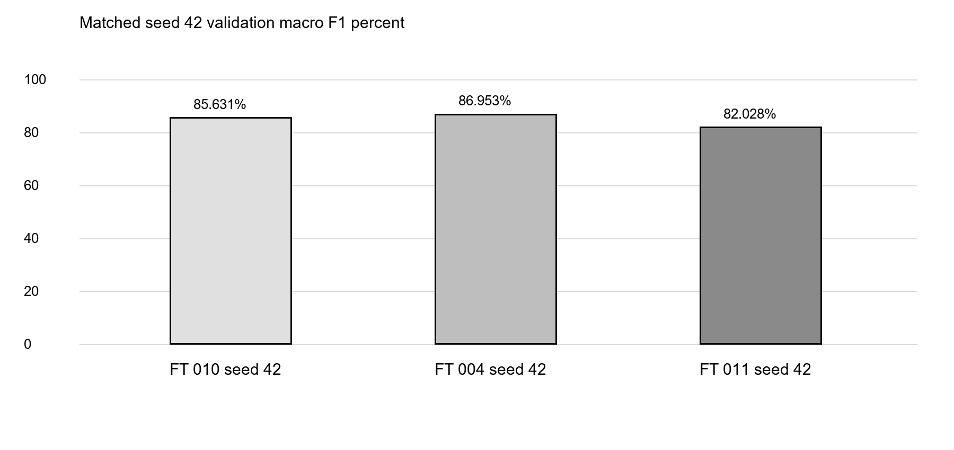
Figure 1 Matched seed 42 comparison for the final controlled experiment

Protection and next step
Active training took 69 minutes 45 seconds; wall time was 71 minutes 51 seconds. Peak GPU temperature was 51 C, with no actual overheating or thermal throttling. A telemetry-file write failure caused a complete-state protective pause; recovery followed two healthy minutes. The first low-RAM smoke was archived; the repeated protected smoke passed before fresh training.
The fine-tuning report contains full methods and evidence. The portable package is model/artifacts/ft004; the website is unchanged. Independently evaluate frozen FT-004. Another configuration's earlier test scores do not apply.

