Motorway Madness: Simulating traffic using a Cellular Automaton model

By: Gergely Eory, 16014073

# Abstract

A cellular automaton model was introduced to simulate the movement of vehicles in freeway traffic. Monte Carlo simulations of the model showed characteristic features of real life traffic for increasing traffic density. Via varying certain parameters, simulations were created for single and multilane traffic, both with single or multiple types of vehicles. Results show how the throughput of the road varies with modifying the road parameters.

# Background

A Cellular Automaton is a discrete mathematical model, which consists of a grid of cells. Each cell is in one of a finite number of possible states at the initial timestep. At each timestep, the grid of cells is updated according to an update function applied to each cell. The result of the update function depends on the current state of the cell, and the states of the cells in its neighbourhood. At the next timestep the cell will be in the state resulting from the update function. Studies of CA have shown that very simple update functions can give rise to remarkable complexity.

Monte Carlo methods are computational algorithms, which make use of repeated random sampling to generate numerical results to probabilistic calculations. Running simulations multiple times and averaging the results enables the investigation of specific trends and relationships in the data. Such methods make it possible to investigate the relationships between given independent parameters and the trends in the quantity investigated.

# Introduction

Traffic is part of commuters’ everyday life, from the morning rush hour on the highway, through being late to an appointment, to missing a flight, cursing away on the M25. Traffic jams on the highway usually develop via a simple mechanism. Small disturbances in the speed of some cars cause the car behind them to brake a little harder to make sure they avoid collision. Then the car behind them brakes yet a little harder, until some of the cars end up coming to a halt and bunching up behind each other. This process might seem counterintuitive, but surprisingly, it is very realistic. In cases when there are no lane closures or accidents, this mechanism is responsible for most of the highway traffic jams, and roads developing stop-and-go traffic in the morning rush hours, even though seemingly there is nothing to cause them.

To counteract these effects and reduce congestion, authorities have a variety of options at their disposal. It is possible to change certain parameters of the road, like the speed limit on a given section, or the types of vehicles allowed on the road. This project was concerned with determining the relationship between road parameters and the shape of resulting traffic.

# Method

In this project, a one-dimensional Cellular Automaton model was used to simulate traffic flow.

The model, adapted from a paper by Kai Nagel and Michael Schreckenberg in 1992[1], starts with a road consisting of n number of cells. Cars are randomly placed in the cells, such that the density of traffic, given by (Number of cars / length of the road) matches the desired value.

Then each car is assigned a starting speed randomly selected between 1 and the specified speed limit. The speed of each car specifies how many cells it has advanced from left to right in the previous timestep. From the point of view of the simulation it is irrelevant but interesting to note, that the initial speeds of the cars are randomly generated, and therefore might be unrealistic. This is corrected in the first iteration of the update function.





**Figure 1:** Initial state of the road, with positions and speeds of cars.

The state of the road is then updated according to the following update function being applied to each car:

1. If the speed *v* of the car is lower than the speed limit, increase the speed by one to *v+1*.
2. If a driver of a car at position *i* sees the next vehicle at position *(i + j),* and *j < v*, the driver reduces the speed *v* to *j - 1* to avoid collision.
3. If the speed *v* of a car is greater than zero, its speed is reduced by one to *v - 1* with a probability p.
4. Each car advances by *v* sites.

Step 1 mimics the tendency of real drivers who, when the traffic allows, aim to travel at the maximum allowed speed limit.

Step 2 is where all the cars adjust their speeds to avoid collisions. It is important to note, that the resulting speed of each car only depends on the state of the road in the current timestep. The drivers only consider their speed and the position of the car in front of them. They do not attempt to predict how many sites the car in front would advance, but instead they always change their speed to avoid collision even if the car in front remains stationary. The choice of such a seemingly unnatural update step might seem counterintuitive but, as we will later see, it leads to realistic simulations of traffic jams and stop-and-go traffic.

Step 3 introduces an element of randomness to the model, where each car has a small probability p to slow down by a small amount. This step, mimics the behaviour of human drivers on real roads. In real life, there might be many reasons for such a slowdown - dodging a pothole, waning attention of the driver, a gust of headwind, etc. Later on, these miniscule effects lead to an accumulation of traffic on roads and may cause huge traffic jams.

Step 4 updates the state of the road, with each car advancing by v sites. This step assumes a circular road, with cars leaving at the end of the road appearing at the beginning again with the same speed. This keeps the density of the traffic constant, and counters probabilistic effects arising from new cars being fed in the beginning of the road with randomised speeds.

The update function outputs a road in the same format as the original, therefore successive updates can be generated from a single starting position.

# 1. Single Lane Traffic with One Type of Vehicle

The simplest case investigated was a single lane road with only one type of vehicle, thus all with the same maximum speed. This is similar to some narrow single lane country roads, where overtaking is not allowed or not feasible due to oncoming traffic. Out of the independent variables, the brake probability, the density of the traffic and the maximum allowed speed, the latter is the only one directly controllable by authorities. Therefore, the aim of the investigation of the single lane case was to determine how to optimally choose the speed limit.

## 1.1 “And yet it moves”

Figure 2 shows 6 traffic plots, where each line corresponds to the updated state of the road from the line above. In the plots we can see that for low density, all the cars are able to travel at the maximum allowed speed on the road, and there are no build-ups of cars anywhere. As the density increases, more and more cars are forced to reduce their speed to avoid collisions with the car in front. In the 3rd plot at 20% density, we see one single traffic jam where cars coming from behind must reduce their speed drastically until they get through the congestion, but after they are able to accelerate and continue their journey at close to the maximum allowed speed.

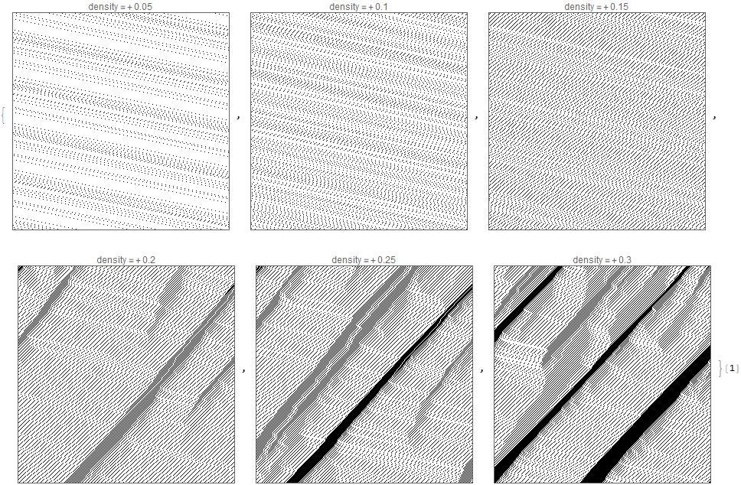

**Figure 2:** Tables of traffic with different densities

Plots in Figure 2 show the same behaviour that is described in the introduction, cars having to reduce their speeds and eventually coming to a halt, then continuing their journey at higher speeds after they get through the traffic jam. It illustrates how the remarkably simple model can be used to model real life traffic flow.

## 1.2 Measuring throughput

The most important metric measured was the total throughput of the road, which is the average of how many cells do all the cars advance in each iteration of the simulation. In a physical sense, the throughput is analogous to the flux of cars passing thorough the road. Measuring the throughput gave us a metric to quantify the effects of the traffic jams, and their impact on commuters. It is important to note that since the initial state of the road and the instances when cars were braking were randomly generated, therefore the simulations needed to be run multiple times and the outputs were averaged to get a more reliable result. For the following plot, each simulation was run 10 times, with a road length of track=200 and a brake probability of p=0.1 over 200 iterations. The density of traffic was varied between 0.01 to 0.50 in steps of 0.01.

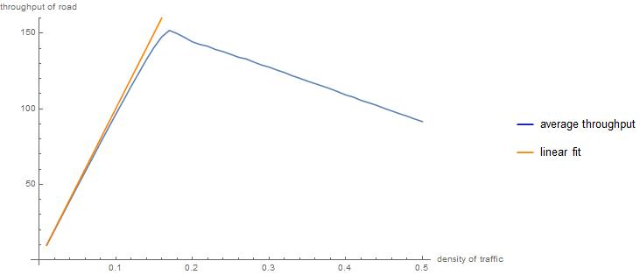

**Figure 3:** Single lane throughput and linear fit

The shape of the throughput graph in Figure 3 matches what we were expecting based on the 6 plots showing the traffic for different densities (Fig 2). At low densities, where all the cars travel at the maximum speed, we see a linear increase of throughput with traffic density. The slope of the line is the speed limit – which all the cars travel at – times the length of the road. These low-density results are said to be in the "linear regime", where increasing the density of traffic results in a linear increase of throughput.

The graph shows a sharp cut-off at a certain density, where the total throughput of the road starts to decrease with new cars being added to the road. This happens above the critical density, where cars start piling up behind each other. The higher the density, the more time cars spend in stop-and-go traffic with a very low average speed, therefore reducing the throughput.

## 1.3 Are we going too slow?

Another metric measured was the average speed of the vehicles in the same traffic as before. The value of the average speed was calculated as the ratio of the total throughput and the number of cars on the road. This is an important factor for most motorists on the road, because if the speed of the cars is decreased, they feel as there is a traffic jam, even if the throughput of the road with more cars added is still increasing.

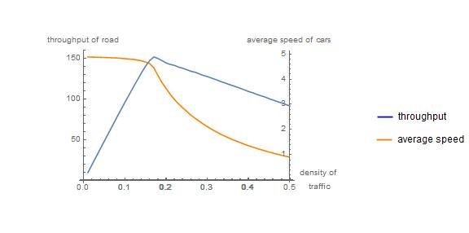

**Figure 4:** throughput of the road and average speed with same parameters

Figure 4 shows the throughput of the road, and the average speed of cars for the same density. It clearly seems that they both begin to fall at the same point when the road reaches its critical density. Based on this result the decision was made to only investigate the average throughput of the road, as the average speed of cars starts to fall at the same density of traffic for the same road parameters.

## 1.4 To brake, or not to brake?

A large source of random errors in the simulations was the fact that cars brake with a certain probability in each timestep. For this reason, it was investigated how the throughput of the road changes with the brake probability at different densities.

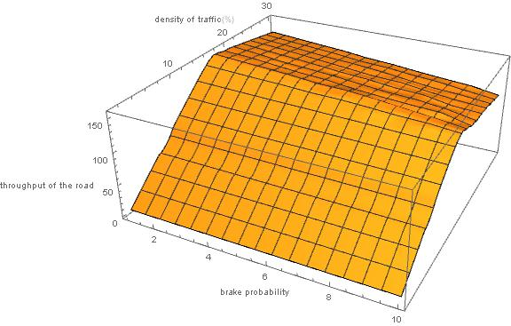

**Figure 5:** Throughput of road for different brake probabilities between 0% and 30%

Simulating multiple traffic data with different values of brake probability ranging from 0.00 to 0.30, lead to the conclusion that the throughput of the road depends linearly on the brake probability. This relationship is illustrated in Figure 5. As the brake probability increases, the total throughput of the road decreases, because more cars have their speed randomly reduced in each iteration of the simulation. However, the shape of the cross-section perpendicular to the brake probability axis was not changed, leading to the conclusion that for qualitative analysis the effects of different brake probability can be disregarded. For this reason, in latter simulations, a constant value of 0.1 were used for brake probability without further consideration.

Another visible change was that the throughput function became less smooth at higher brake probabilities, which is a result of the data being randomly generated. To get rid of such variations, a higher number of iterations can be generated and averaged, if sufficient computing capacity is available.

## 1.5 Don’t rush! – to conclusions

Finally, the relationship between the maximum speed and the maximum throughput of the road was investigated, to help us determine an optimal speed limit. Maximum speed is a quantity easily adjustable by regulatory bodies, therefore finding an optimal value for it can aid the efficient utilisation of the road. To investigate this relationship, the total throughput of the road was calculated for traffic densities ranging from 1% to 25% in increments of 1%, and with maximum speed of vehicles ranging from 1 to 8 cells/iteration.

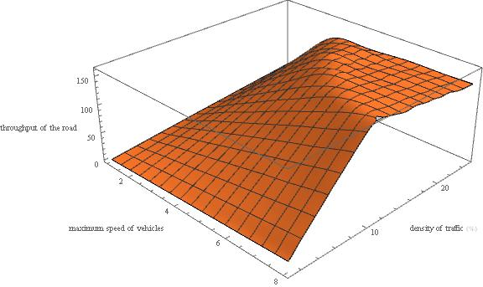

**Figure 6:** Throughput as a function of maximum speed and traffic density

Figure 6 shows how the throughput of the road varies with traffic density and maximum speed. The shape of the cross sections perpendicular to the maximum speed axis have the shame shape for each setting as seen in Figure 3, illustrated below in Figure 7. In the linear regime, the slope of the function corresponds to the maximum allowed speed, therefore lower speed limits show a less steep increase of throughput with traffic density. On the other hand, the highest throughput of the road is very similar for each setting, and it occurs just before the traffic leaves the linear regime and traffic jams start to develop. The density corresponding to the peak throughput shows an inverse relationship with the speed limit, meaning that higher speed roads start developing traffic jams at lower densities. At densities higher than the peak, the plot formed a plateau where the throughput slowly decreases with more cars being added to the road, and traffic jams develop.

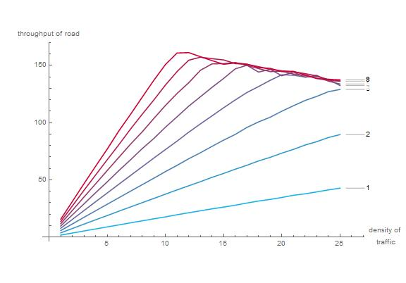

**Figure 7:** Cross sections of Figure 6 for each speed limit

From the results above, it was concluded that authorities setting the speed limit need to consider the expected density of traffic. The comparison of average speed and throughput, illustrated in Figure 4, clearly shows that the average speed drops rapidly after leaving the linear regime, while the total throughput only decreases slightly. Therefore, if authorities aim not to increase individual travel times, the simulation suggests that they should aim to keep the traffic in the linear regime. Comparing that aim with Figure 7, the suggestion based on the simulation is to pick the highest value of maximum speed, such that the peak throughput is not reached at the anticipated density. Conversely, if the road is expected to have busier traffic, authorities can reduce the speed limit to increase the number of cars that can pass through in steady traffic, without congestion.

# 2. Single Lane Traffic with Trucks

In the next part of the investigation, the CA model was extended to handle multiple types of vehicles, which all move according to the same update function as before, but each with different speed limits. A common example from reality is trucks having a lower speed limit than cars on the motorway, usually for safety reasons. The two specific questions investigated were how the throughput depends on the ratio of trucks to all vehicles, and whether the speed limit for cars matters in a single lane environment which does not allow overtaking trucks.

## 2.1 Stuck behind an 18-wheeler

The first step of the investigation was to determine whether the general shape of the traffic has changed due to the introduction of trucks. Throughput of the road was measured for a maximum speed of 4 for trucks and 6 for cars, with 20% of all vehicles replaced by trucks.

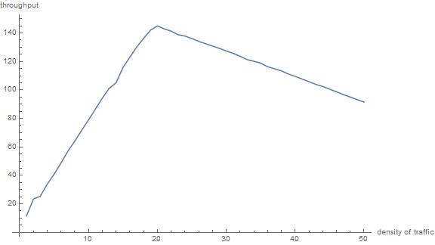

**Figure 8:** Throughput of road with trucks

Figure 8 shows that the general shape of the throughput curve does not change with the introduction of trucks. A linear regime is followed by a peak, then a slow decay with increasing density. The only change observable is that at very low densities, the slope of the linear increase is larger before the first truck gets introduced on the road. This lead to the investigation whether the maximum allowed speed of cars matters, if they cannot overtake the trucks. Traffic data was generated for densities between 1% and 30%, with a constant brake probability of 0.1, a truck ratio of 20% and a truck speed limit of 5 cells/iteration, shown in Figure 9.

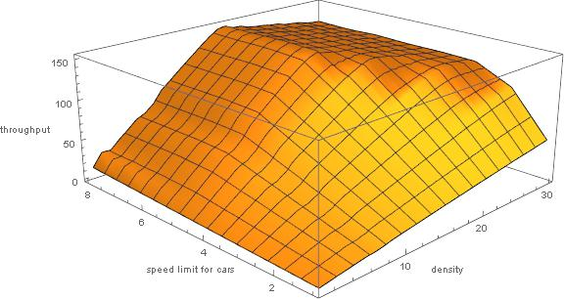

**Figure 9:** Throughput as a function of density and car speed limit

From the data plotted in Figure 9, it was concluded that when the maximum speed for cars is lower or equal to the speed limit for trucks, the measured throughput is equivalent to that of Figure 6 with only one type of vehicle. On the other hand, when the equal speed limit is reached, further increasing the speed limit for cars does not increase the throughput of the road. This result matches with the heuristic expectations of cars being stuck behind trucks, as there is no opportunity to overtake them in this model.

## 2.2 One truck, two trucks, three trucks, four…

From the previous result, since the cars get stuck behind the trucks after a few iterations of the simulation, the hypothesis was that the throughput does not depend on the ratio of trucks to total vehicles. Instead, the traffic would progress at an effective speed limit equal to the maximum allowed speed for trucks. For this investigation, traffic data was simulated with speed limits 6 cell/iteration for cars and 4 for trucks. The proportion of trucks was varied between 0% and 30% in steps of 1, with traffic densities changing between 1% and 30% as before.

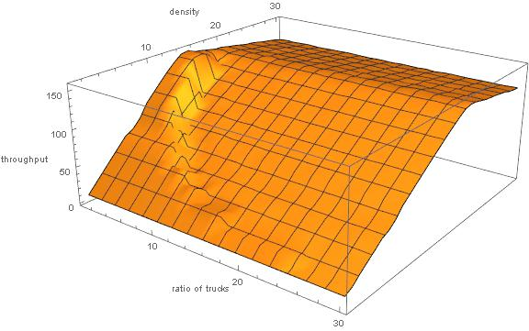

**Figure 10:** dependence of throughput on truck ratio

The results of the simulation, plotted in Figure 10, show that the throughput does not depend on the ratio of trucks. The exact number of trucks is determined as the integer part of the expression

In cases where both the density and the truck ratio are low, not a single truck is on the road, and the traffic moves at the speed limit for cars in the linear regime. As the ratio of trucks increases, the first truck gets introduced on the road, and the slope of the function decreases, similarly to Figure 8. A clear step-up is visible at every value of truck ratio, and that ratio occurs at lower densities with increasing truck ratio, where the product determining . This result confirms the hypothesis that the throughput of the single lane road does not depend on the proportion of trucks and cars, if at least one truck is on the road.

# 3. Multiple Lane Madness

In real life, roads rarely have only one lane, or they allow for overtaking slow vehicles in some way. The model was extended to handle multiple lanes side by side where in each iteration, cars can change to an adjacent lane or stay in their current one. Which lane to progress in was determined by calculating the largest distance a given car could progress in each of the lanes available. In case of equal possible distances, preference was given to staying in the current lane, then to move to the lane to the right, mimicking the highway rule to keep right on European highways. When changing lanes, safety is also important to avoid cutting in front of another motorist coming from behind. In the updated multilane model cars were advancing one by one, therefore if they cut in front of each other, the car behind would see the change and chose its path and speed accordingly to avoid collision.

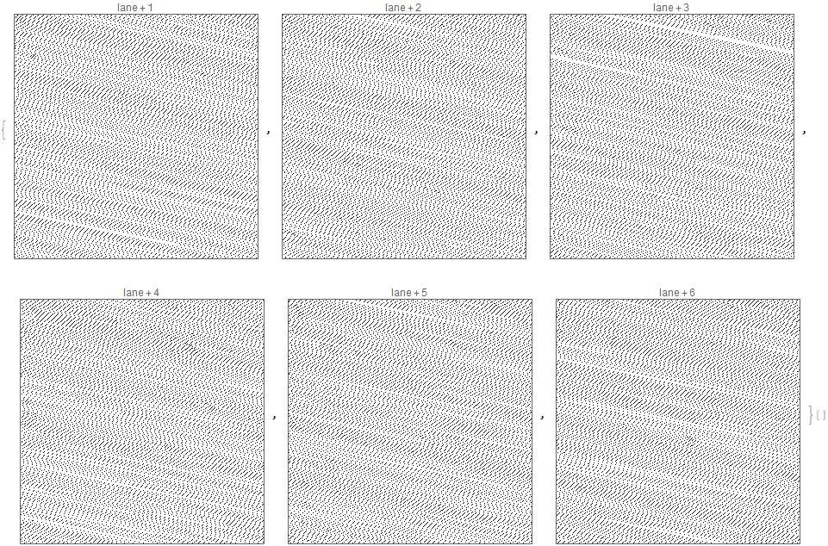

**Figure 11:** plots showing single lane traffic, each representing a lane of a 6-lane road

Figure 11 shows that on roads with multiple lanes and only cars, the traffic flowed smoothly in each of the lanes, greatly increasing the total throughput of the road. The shape of the traffic in each lane is similar to Figure 2, illustrating the single lane case.

## 3.1 The more, the better

The aim of the first simulation was to investigate how the throughput of the road depends on the number of lanes, without trucks. Simulations were run with the number of lanes ranging from 1 to 6, and the maximum speed set to 5 cell/iteration and traffic density to 15%. As seen in Figure 7, this setup lies in the linear regime.

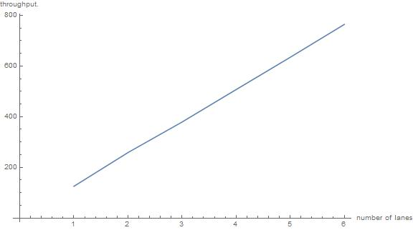

**Figure 12:** Dependence of throughput on number of lanes in the linear regime

The result is plotted in Figure 12, showing a clear linear increase of throughput with each lane added to the road. Figure 13 shows the throughput for traffic densities ranging from 1% to 30%, and confirms that this result also holds for traffic with higher density than the linear regime. More interestingly, the multilane plot does not show the decrease of throughput at densities above the linear regime, which was a characteristic feature of all previous single lane results. Instead, the simulations show a steady throughput above the linear regime. This result was confirmed by simulations up to a density of 60%.

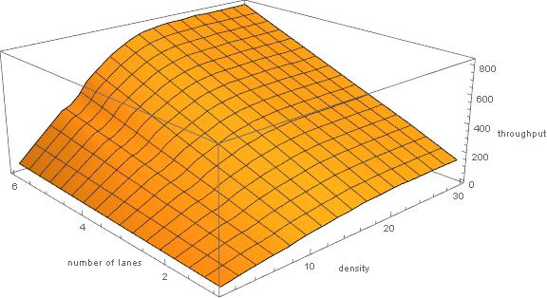

**Figure 13:** multilane throughput as a function of density

## 3.2 Denser! Better! Faster! Stronger?

Similar results were obtained when plotting the throughput of the road against values of speed limit ranging from 1 to 8 cells/iteration. After reaching the critical density, the throughput of the road did not decrease with additional cars being added. Moreover, the throughput for each maximum speed value was approaching the same limit, as opposed to Figure 7, where the peak throughput increased with increasing speed limit.

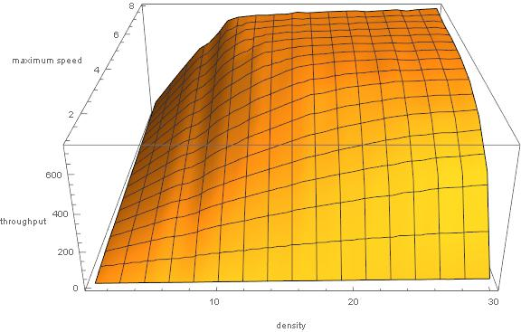

**Figure 14:** multilane throughput as a function of speed limit

Considering the results illustrated in Figures 13 and 14, choosing a speed limit for a multilane road is a more complex exercise. With densities above the linear regime, individual travel times still increase as traffic jams form. On the other hand, the total throughput of the road does not decrease with a denser traffic. Therefore, choosing a speed limit to keep the traffic in the linear regime at expected load is still desirable, but the model shows that roads can also handle an increased demand without hurting the throughput.

# 4. Multiple Lane Madness with Trucks

Having multiple lanes leads to a more interesting investigation when trucks were reintroduced on the road. In this case, cars had the opportunity to overtake and potentially increase their average speed. To make the simulation more realistic, an additional constraint was added to the seed generation: in the beginning, trucks were only placed in the 2 rightmost lanes. After the start, they were free to move in any lane according to the same update function as used in Section 3.



**Figure 15:** six lane traffic with trucks

Figure 15 shows a simulation of 6-lane traffic with a truck ratio of 20%. It is interesting to note that over 500 iterations only 1 truck switched to lane 5, and left after about a hundred iterations. Moreover, no truck has made it to lane 6, leaving the cars to move undisturbed at higher speeds.

In this investigation, the two questions from Section 2 were revisited: how the speed limit for cars affects the throughput of the road with trucks, and if the proportion of trucks change the throughput.

## 4.1 Living life in the fast lane

For measuring the dependence of the throughput with trucks, simulations were run with two independent variables, the maximum speed for cars ranging from 1 to 7, and density varying from 1% to 30% as before. The two rightmost lanes of a 6-lane road started with a truck ratio of 20%, the rest were populated with cars only. The speed limit for trucks was 4 cells/iteration, and the brake probability was set to 0.1. Throughput was measured for each speed limit – density pair 20 times and averaged for a more reliable result, shown in Figure 16. It is important to note that random variations are still visible in the graph, and a much higher number of iterations would be desirable to get a smoother result. Unfortunately, necessary processing power was not available.

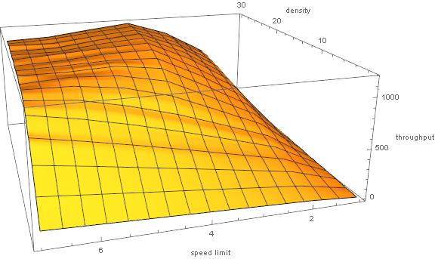

**Figure 16:** Throughput of a six/lane road with trucks

Figure 16 shows multiple features worth pointing out. The shape of the plot is similar to Figure 6, which investigated the relationship of the same 3 variables, but on a single lane road with cars only. After reaching the critical density and leaving the linear regime, the throughput stays constant with increasing density, similarly to multilane roads without trucks. The peak throughput was reached when the speed limit for cars and trucks was the same, 4 cells/iteration. Interestingly, increasing the car speed limit above the maximum allowed speed for trucks lead to a small but significant decrease in throughput.

## 4.2 “Mack, wait for me!”

The final investigation was concerned with how the proportion of trucks on a multilane road influences throughput. The simulation from the previous chapter was modified to have a speed limit of 4 cell/iteration for trucks and 6 for cars. The ratio of trucks in the 2 rightmost lanes was modified between 1% and 30% in steps of 1%.

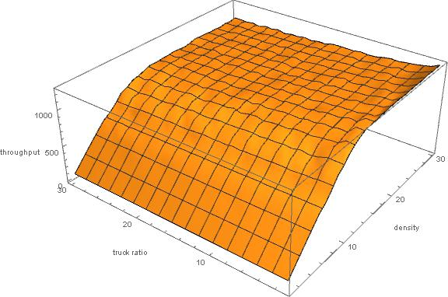

**Figure 17:** Throughput of a six/lane road with trucks, as a function of truck ratio

Figure 17 shows the calculated throughput as a function of traffic density and truck ratio. The results match with the conclusions drawn from Figure 10 for the single lane case. After the first truck was introduced on the road, increasing the ratio of trucks leads to a very slow decrease in throughput. However, this decrease is slower than in Figure 10, leading to the conclusion that trucks hold up traffic in the lanes closer to the right side of the road, but in the left lanes cars can move along with a higher speed. Based on this result, authorities are suggested to ban trucks from the inner lanes of a multilane highway, therefore providing cars with opportunity to overtake, smoothing out the step in the differences in their speed limits.

# Summary and conclusions

Section one was concerned with choosing the optimal speed limit for a single lane road. After determining what factors did or did not influence the throughput of the road, the conclusion was derived that the speed limit should be determined considering the expected traffic density on the road. It is desirable to pick the highest possible speed limit for which the traffic stays in the linear regime at the expected density.

Section two introduced trucks on the road with lower speed limits. The simulation results indicated that on a single lane road, where vehicles cannot overtake, the separate speed limits of trucks and cars does not matter. Instead, only the lower value of the speed limit will determine the flow of traffic, as faster cars get stuck behind the slower trucks.

Section three investigated how the introduction of multiple lanes and lane-switching affected the throughput. The results showed that in absence of trucks, irrespective of traffic density, the throughput of the road increases linearly with the number of lanes. Furthermore, the throughput of the road does not decrease even at higher densities after traffic jams form.

Finally, Section four reintroduced trucks on the multilane road. The conclusion was reached that increasing the ratio of trucks decreases the total throughput, but similarly to Section 2, it does not change the shape of the throughput plot. Finally, it was shown that the maximum theoretical throughput can be reached if trucks and cars have the same speed limit, but if cars are allowed to move faster, they can reach a higher average speed in the inner lanes.

# Further work, extensions

Although the project has lead to many interesting and significant results, the model still has potential for further investigations. Some possible modifications might worth exploring include:

* Varying density of traffic – It Is possible to change the density of traffic by changing from a circular road design to a feed-in system, where cars get added at the beginning of the road, and they simply disappear at the end. By choosing the frequency at which new cars are added, temporal transitions from linear to nonlinear traffic can be investigated.
* Restricting trucks to a few lanes – This modification draws from highway rules, where trucks are not allowed to overtake past the second lane. This change is simple to implement but requires the modification of the multilane update function.
* Road blocks, traffic lamps, Accidents. – By making some lanes/cells temporarily or permanently unavailable for cars, the effects of traffic lights or lane closures can be simulated. Especially in the multilane case, this could introduce very complex variations in the flow of traffic that could lead to interesting results.

# Contents

Abstract 1

Background 2

Introduction 2

Method 3

1. Single Lane Traffic with One Type of Vehicle 4

1.1 “And yet it moves” 4

1.2 Measuring throughput 5

1.3 Are we going too slow? 5

1.4 To brake, or not to brake? 6

1.5 Don’t rush! – to conclusions 7

2. Single Lane Traffic with Trucks 8

2.1 Stuck behind an 18-wheeler 9

2.2 One truck, two trucks, three trucks, four… 10

3. Multiple Lane Madness 10

3.1 The more, the better 11

3.2 Denser! Better! Faster! Stronger? 12

4. Multiple Lane Madness with Trucks 13

4.1 Living life in the fast lane 14

4.2 “Mack, wait for me!” 14

Summary and conclusions 15

Further work, extensions 16

Contents 17

1. Kai Nagel, Michael Schreckenberg, 1992, A cellular automaton model for freeway traffic, Journal de Physique 1, December 1992, Page 2221