1- How many pods exist on the system?

**- “kubectl get pods”**

2- How many Nodes exist on the system?

**- “kubectl get nodes”**

3- Create a new pod with the nginx image.

Image name: nginx

**- “kubectl run nginx --image=nginx”**

4- Which nodes are these pods placed on?

**- “kubectl describe pod nginx”**

**OR**

**- “kubectl get pods -o wide”**

5- Create pod from the below yaml using kubectl apply command

apiVersion: v1

kind: Pod

metadata:

name: webapp

namespace: default

spec:

containers:

- image: nginx

imagePullPolicy: Always

name: nginx

- image: agentx

imagePullPolicy: Always

name: agentx

6- How many containers are part of the pod webapp

- 2 containers (nginx and agentx)

7- What images are used in the new webapp pod?

- nginx image

- agentx image

8- What is the state of the container agentx in the pod webapp

- waiting state

9- Why do you think the container agentx in pod webapp is in error?

**- because there is no image named agentx so he can’t pull it**

10- Delete the webapp Pod.

**“kubectl delete pod webapp”**

11- Create a new pod with the name redis and with the image redis123.

* Name: redis
* Image Name: redis123

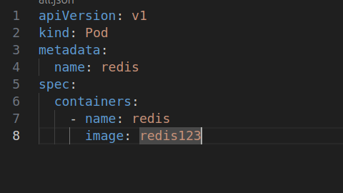

12- Now change the image on this pod to redis.

Once done, the pod should be in a running state.

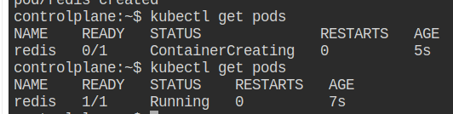

13- Create a pod called my-pod of image nginx:alpine

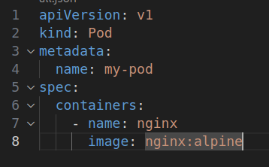

14- Delete the pod called my-pod

