Problem1 :

Problem 2

▪ Run container centos or ubuntu in an interactive

Mode docker run -it ubuntu

▪ Run the following command in the container

“echo docker ” echo “hello world”

▪ Open a bash shell in the container and touch a file named hello-docker touch hello-docker

▪ Stop the container and remove it. Write your comment about the file hello-docker

The file will be removed because we removed the container

Mkdir html

Cd html

Touch indix.html

I pasted the html code in it

amr@vm:~$ sudo docker run --name apache -d -v /home/amr/html:/usr/local/apache2/htdocs -p 9898:80 httpd

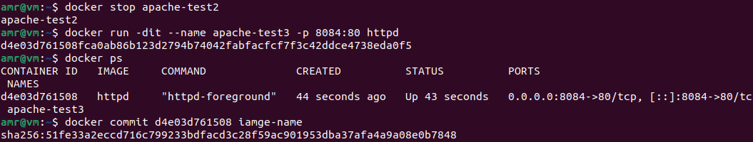

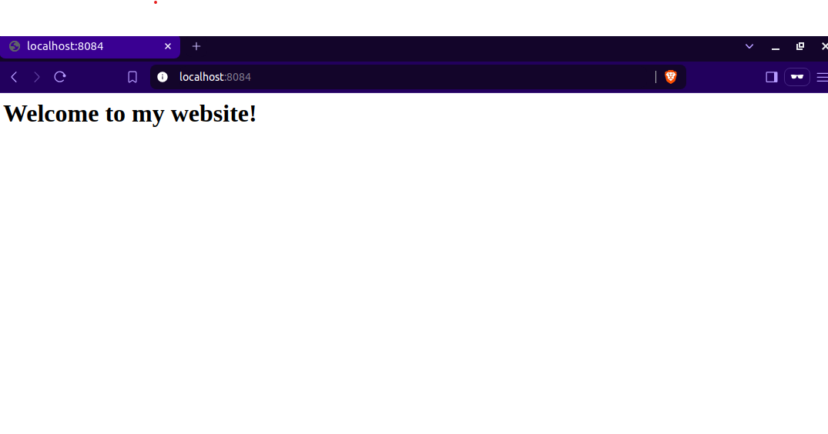

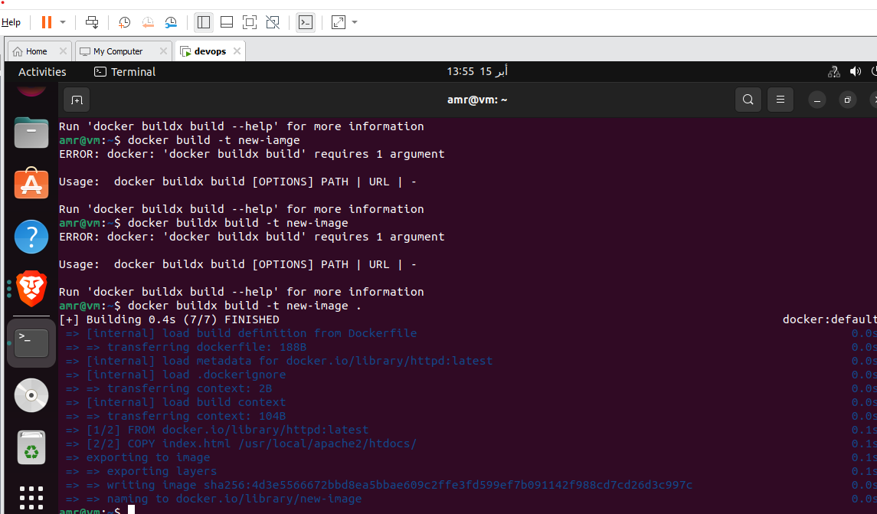

Problem 5 :

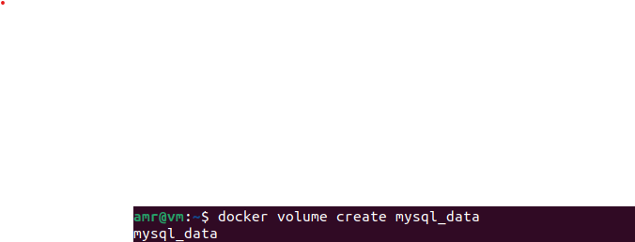



Task 1 :

# 

