PHASE 1

LockedMe.com

Developer

Gerhard Allamani

Purpose

Purpose is to provide a solution for the required application by Lockers Pvt. Ltd on file management.

Project Scope

There is a limited scope for LockedMe.com which will only include file management. The application will allow users to interact by doing different operations on files such as searching, adding, deleting and retrieving files in an ascending order.

Project Details

Users will not have to log in in order to use the application and user interaction will be via command line. Log in and adding UX/UI for an improved appearance of the program can be further enhancements that can be implemented to the project after its initial release.

The flow of the program is uncomplicated. After opening the program there will be some welcoming information and main screen options. From that screen user will be able to list all the files in an ascending order, open the second screen or exit the application. The second screen contains 4 options. The user can add a new file, delete a file, search if a file exists or go back to main menu. The flow and the functionality of the program can be observed from the flowchart and the diagrams below.

Scrum

For this project Scrum methodology is used and Jira as the scrum tool. During spring planning the project backlog was finalized and 3 one-week sprints planned.

First sprint product backlog contains creating the GitHub repository, main menu template and screen.

Second sprint backlog consist of creating the second menu and add, delete and search operations.

Third sprint task is to finalize list file operation and test the application.

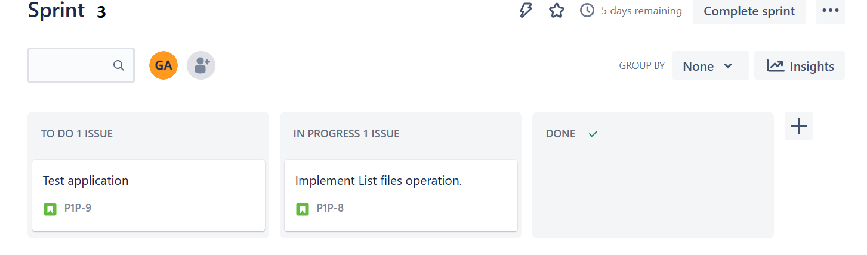

**Flowchart**

**Use case**

**Sequence diagram**

**State diagram**

Code

The language used for this program is Java without any additional framework. Main core concepts used:

String handling, switches, if conditions, loops, classes, exceptions, sorting, collection, file management, scanner, classes, methods and data structure such as binary search while searching for a specific file for an optimization of the program in time. The code functionality will be shown via comments inside the source code in the GitHub repository.

Conclusion

As stated at the start, the application can be enhanced by adding extra functionality such as an interface with a UX/UI and frontend technologies for a better user interaction. Also, a log in can be implemented so every user can have its own account. This would allow us to implement a way for each user to have its specific files, hide sensitive files for other users, open file content or modify file inside the program as extra functionality. Search by category function that would allow files to be categorized so the user can search only the files from a category that they desire.

The unique selling points of the application are that is very fast and efficient but, in the future, as a USP, an enhancement can be added where the categorized functionality that was suggested can be made via machine learning that would check each file for specific words and try to base its categorization by those words.

GitHub link