end product mapping

German Silva

4/13/2022

rasterdf <- function(x, aggregate = 1) {  
 resampleFactor <- aggregate   
 inputRaster <- x   
 inCols <- ncol(inputRaster)  
 inRows <- nrow(inputRaster)  
 # Compute numbers of columns and rows in the new raster for mapping  
 resampledRaster <- raster(ncol=(inCols / resampleFactor),   
 nrow=(inRows / resampleFactor))  
 # Match to the extent of the original raster  
 extent(resampledRaster) <- extent(inputRaster)  
 # Resample data on the new raster  
 y <- resample(inputRaster,resampledRaster,method='ngb')  
  
 # Extract cell coordinates into a data frame  
 coords <- xyFromCell(y, seq_len(ncell(y)))  
 # Extract layer names  
 dat <- stack(as.data.frame(getValues(y)))  
 # Add names - 'value' for data, 'variable' to indicate different raster layers  
 # in a stack  
 names(dat) <- c('value', 'variable')  
 dat <- cbind(coords, dat)  
 dat  
}  
  
class(rasterdf)

## [1] "function"

nov17 <- drop_na(rasterdf(raster(x = here("data", "final predictions", "nov_2017_envi.envi"), xy=TRUE)))  
jan18 <- drop_na(rasterdf(raster(x = here("data", "final predictions", "jan_2018_envi_clipped"), xy=TRUE)))  
nov18 <- drop_na(rasterdf(raster(x = here("data", "final predictions", "nov_2018_envi_clipped"), xy=TRUE)))  
nov20 <- drop_na(rasterdf(raster(x = here("data", "final predictions", "nov_2020_envi.envi"), xy=TRUE)))  
  
nov18 <- filter(nov18, value != 0)  
jan18 <- filter(jan18, value != 0)  
  
nov17 <- nov17 %>%   
 mutate(value = case_when(  
 value == 1 ~ "Bare Soil",  
 value == 2 ~ "Mid Marsh",  
 value == 3 ~ "High Marsh",  
 value == 4 ~ "Senesced",  
 value == 5 ~ "Water/Subtidal"))  
  
jan18 <- jan18 %>%   
 mutate(value = case_when(  
 value == 1 ~ "Bare Soil",  
 value == 2 ~ "Mid Marsh",  
 value == 3 ~ "High Marsh",  
 value == 4 ~ "Senesced",  
 value == 5 ~ "Water/Subtidal"))  
  
nov18 <- nov18 %>%   
 mutate(value = case_when(  
 value == 1 ~ "Bare Soil",  
 value == 2 ~ "Mid Marsh",  
 value == 3 ~ "High Marsh",  
 value == 4 ~ "Senesced",  
 value == 5 ~ "Water/Subtidal"))  
  
nov20 <- nov20 %>%   
 mutate(value = case_when(  
 value == 1 ~ "Bare Soil",  
 value == 2 ~ "Mid Marsh",  
 value == 3 ~ "High Marsh",  
 value == 4 ~ "Senesced",  
 value == 5 ~ "Water/Subtidal"))

PreM <- ggplot()+  
 geom_raster(data= nov17, aes(x=x, y=y, fill= value))+  
 scale_fill_manual(values= rev(cal_palette("bigsur2", n=5, type = "continuous")))+  
 labs(title="Pre: November 2017",  
 y="",  
 x="",  
 fill = "Landcover")+  
 coord_quickmap()+  
 annotation_scale()+  
 theme(plot.title = element_text(color = "#5b4f41", size = 16, hjust = 0.45),  
 plot.background = element_rect("white"),  
 panel.background = element_rect("#f8f8f8"),  
 panel.grid = element_line(linetype= "longdash", color = "#f0ece1"),  
 axis.text = element_text(color = "#5b4f41", size = 7),  
 axis.title = element_text(color = "#5b4f41"),  
 strip.background = element_rect("white"),  
 axis.line = element_line(color = "#5b4f41"),  
 plot.caption = element_text(size = 9, hjust = -0.1))  
PreM

## Using plotunit = 'm'

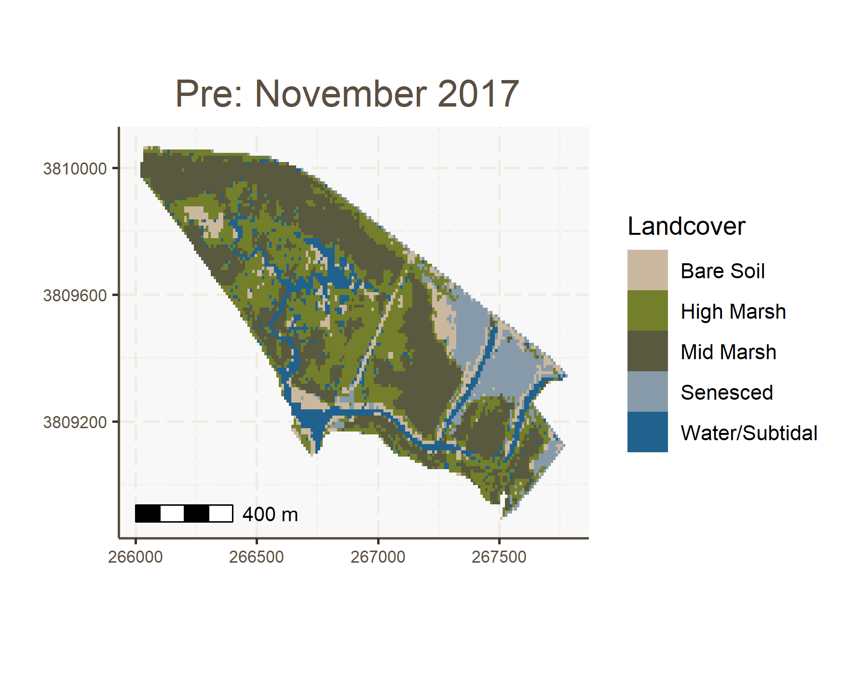

DurM <- ggplot()+  
 geom_raster(data= jan18, aes(x=x, y=y, fill=value))+  
 labs(title="During: January 2018",  
 y="",  
 x="",  
 fill = "Landcover")+  
 scale_fill_manual(values= rev(cal_palette("bigsur2", n=5, type = "continuous")))+  
 coord_quickmap()+  
 annotation_scale()+  
 theme(plot.title = element_text(color = "#5b4f41", size = 16, hjust = 0.45),  
 plot.background = element_rect("white"),  
 panel.background = element_rect("#f8f8f8"),  
 panel.grid = element_line(linetype= "longdash", color = "#f0ece1"),  
 axis.text = element_text(color = "#5b4f41", size = 7),  
 axis.title = element_text(color = "#5b4f41"),  
 strip.background = element_rect("white"),  
 axis.line = element_line(color = "#5b4f41"),  
 plot.caption = element_text(size = 9, hjust = -0.1))  
DurM

## Using plotunit = 'm'

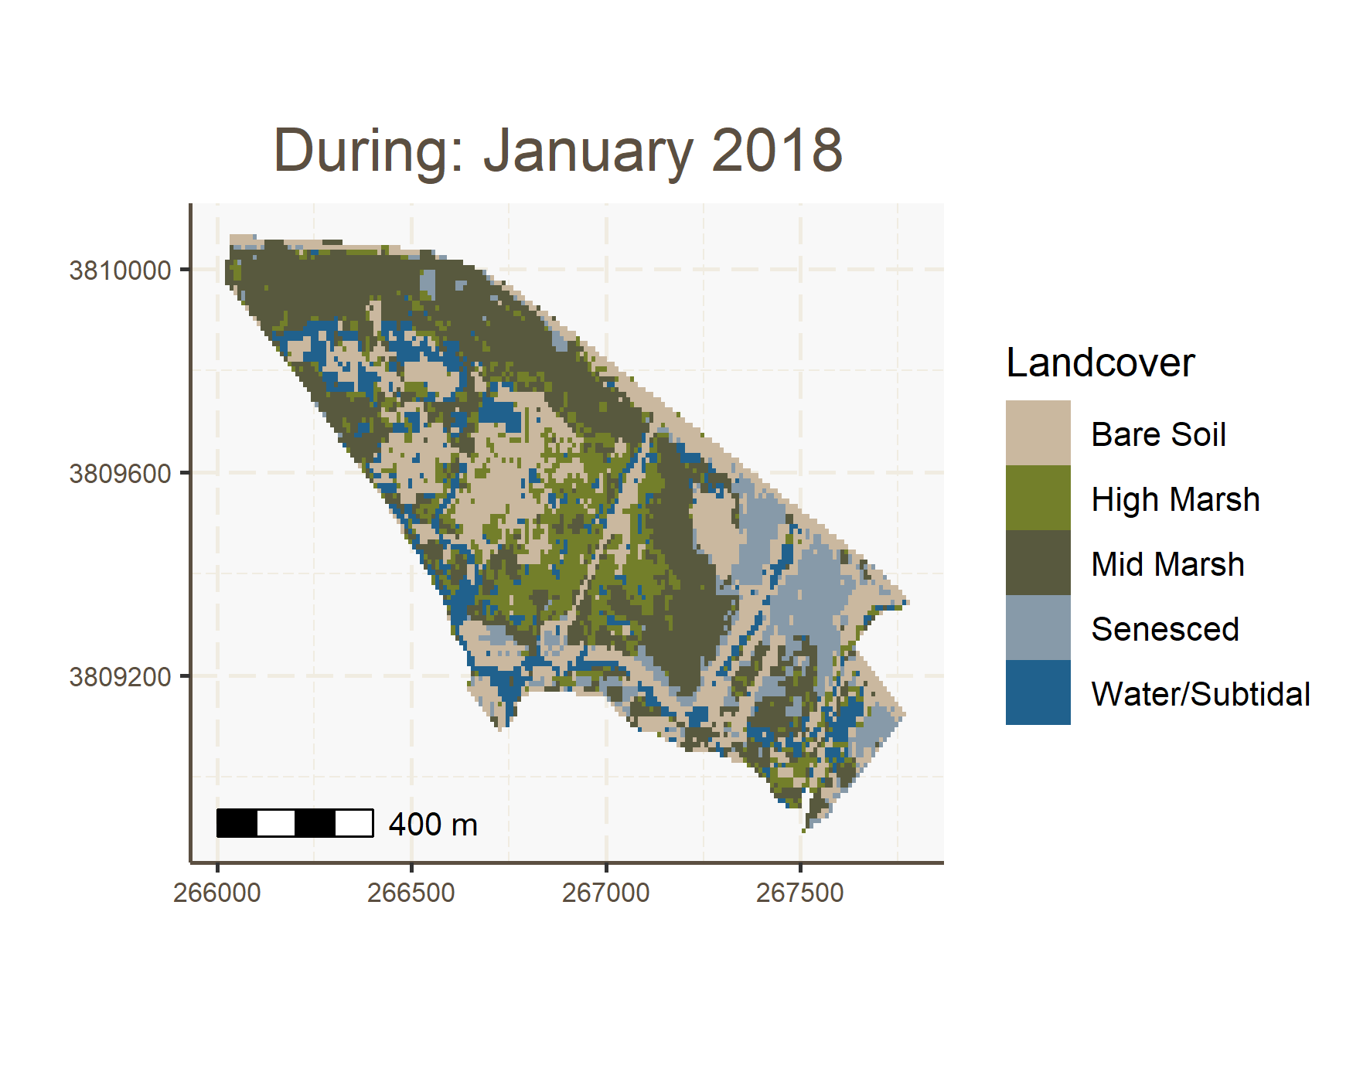

RecM1 <- ggplot()+  
 geom_raster(data= nov18, aes(x=x, y=y, fill= value))+  
 labs(title="Post: November 2018",  
 y="",  
 x="",  
 fill = "Landcover")+  
 scale_fill_manual(values= rev(cal_palette("bigsur2", n=5, type = "continuous")))+  
 coord_quickmap()+  
 annotation_scale()+  
 theme(plot.title = element_text(color = "#5b4f41", size = 16, hjust = 0.45),  
 plot.background = element_rect("white"),  
 panel.background = element_rect("#f8f8f8"),  
 panel.grid = element_line(linetype= "longdash", color = "#f0ece1"),  
 axis.text = element_text(color = "#5b4f41", size = 7),  
 axis.title = element_text(color = "#5b4f41"),  
 strip.background = element_rect("white"),  
 axis.line = element_line(color = "#5b4f41"),  
 plot.caption = element_text(size = 9, hjust = -0.1))  
RecM1

## Using plotunit = 'm'

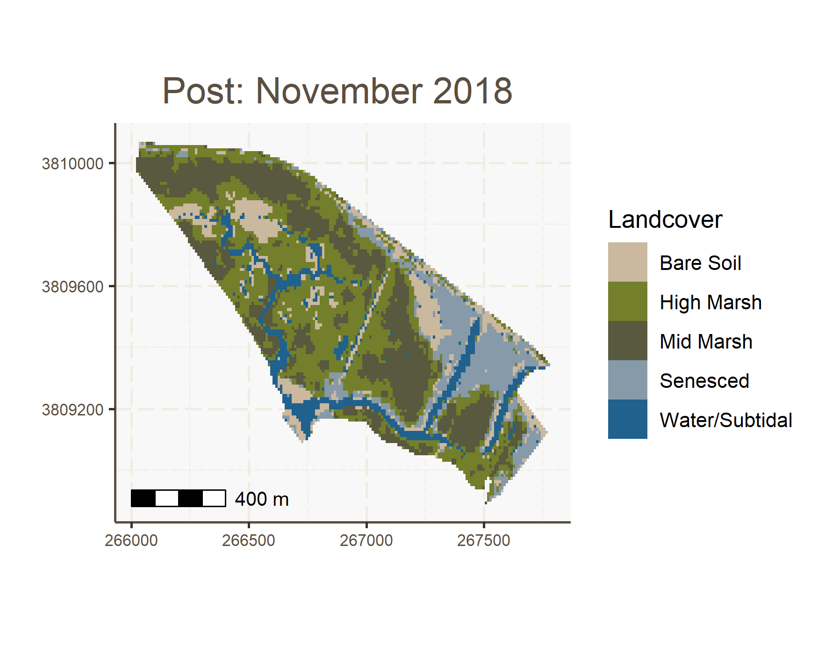

RecM2 <- ggplot()+  
 geom_raster(data= nov20, aes(x=x, y=y, fill= value))+  
 labs(title="Post: November 2020",  
 y="",  
 x="",  
 fill = "Landcover")+  
 scale_fill_manual(values= rev(cal_palette("bigsur2", n=5, type = "continuous")))+  
 coord_quickmap()+  
 annotation_scale()+  
 theme(legend.position = "right",  
 plot.title = element_text(color = "#5b4f41", size = 16, hjust = 0.45),  
 plot.background = element_rect("white"),  
 panel.background = element_rect("#f8f8f8"),  
 panel.grid = element_line(linetype= "longdash", color = "#f0ece1"),  
 axis.text = element_text(color = "#5b4f41", size = 7),  
 axis.title = element_text(color = "#5b4f41"),  
 strip.background = element_rect("white"),  
 axis.line = element_line(color = "#5b4f41"),  
 plot.caption = element_text(size = 9, hjust = -0.1))  
RecM2

## Using plotunit = 'm'

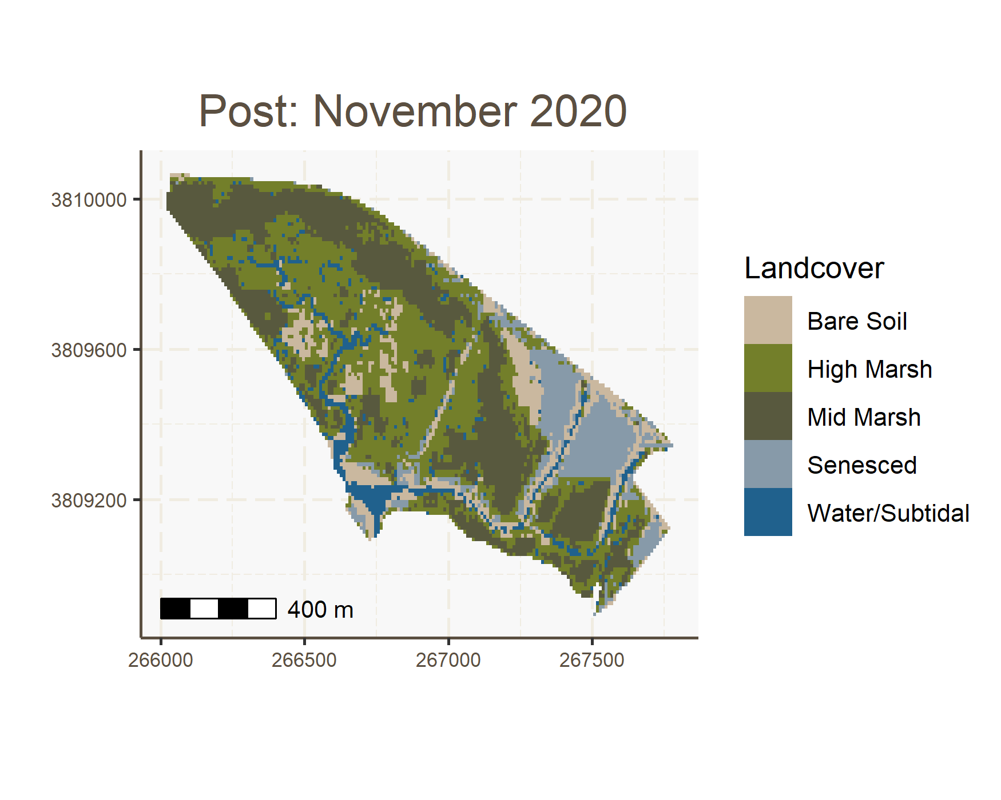

patch <- (PreM + DurM)/ (RecM1 + RecM2)  
  
patch+  
 plot_annotation(caption = "Fig. 4 Maps produced by the random forest classification. Maps depict the extent of bare soil,\nhigh marsh, mid marsh, senesced vegetation, and subtidal/water landcover. Top to bottom,\nleft to right: November 2017, January 2018, November 2018, and November 2020",   
 theme = theme(plot.caption = element_text(size = 9, hjust = 0.5)))

## Using plotunit = 'm'  
## Using plotunit = 'm'  
## Using plotunit = 'm'  
## Using plotunit = 'm'

