**Problem type 1:**

Write down the equation of a circle with radius 8 and center http://tutorial.math.lamar.edu/Classes/Alg/Circles_files/eq0010MP.gif

**Problem type 2:**

Determine the center and radius of the circle described by “x^2 + y^2 -3x +10y – 1 = 0”. Sketch a graph of this circle

**Type 3:**

Suppose the radius of a circle is 3. What is its area?

**Type 4:**

A circle has a circumference of 8. It has an arc of length 5/3. What is the central angle of this arc, in degrees?

**Type 5:**

A circle with area 25pi has a sector with a central angle of pi/2 radians. What is the area of the sector?

**Type 6:**

A circle is centered on point B. Points, A, C, and D lie on its circumference. The length of line segment AD is equal to the circle’s diameter. If angle ABC measures 96 degrees, what does angle ADC measure?

**Type 7:**

Find the radius of a circle,  if the tangent segment to the circle is of  15  units long and the endpoint of the tangent line is located in the distance of  17  units from   
the center of the circle.

**Type 8:**

Find the equation of the line tangent to the circle x^2+y^2 = 18 that passes through the point (3,3)

**Type 9:**

Find the equation of the line tangent to the circle x^2+y^2 = 18 that passes through the point (6,0)

**Type 10:**

A quadrilateral  **ABCD**  is inscribed in a circle  (**Figure 2a**).   
The arcs  **AB**  and  **CD**  are of  80°  and  50°  respectively.   
Find the angle between the sides  **AD**  and  **BC**  of the                     
quadrilateral.   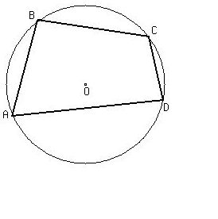

**Type 11:**  
The chords  **AB**  and  **CD**  are intersecting at the point  **E**  inside the circle   
(**Figure 2**).  The lengths of the parts  **AE**,  **BE**, and  **CE**  are shown in the                   
**Figure**.  Find the length of the segment  **DE**. 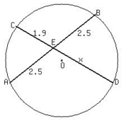

**Type 12:**

The secants  **PA**  and  **PB**  intersect at the point  **P**  outside the circle   
(**Figure 2**),  where  **A**  and  **B**  are the secants' distant intersection   
points at the circle.  The lengths of the parts  **AC**,  **PC**, and  **PD**  are                    
shown in the  **Figure**,  where  **C**  and  **D**  are closest to  **P**  intersection   
points at the circle.   
  
Find the length of the secant  **PB**. 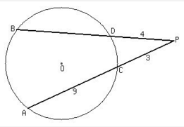

**Type 13:**

Find the length of the tangent segment to the circle if the secant                     
released from the same point has the measure of 10 units and its   
external part has the measure of 4 units

**Type 14:**

Convert   http://www.regentsprep.org/regents/math/algtrig/atc1/circle10.gif into center-radius form.

**Type 15:**

Write the equation of a circle whose diameter has endpoints (4, -1) and (-6, 7)