**STATE UNIVERSITY OF INTELLIGENT TECHNOLOGIES AND TELECOMMUNICATIONS**

Faculty of Information Technology and Cybersecurity

Software Engineering Department

**Final Project**

on the topic of

**"IT solution and services for Green Plant Market"**

Completed by:

4th-year student, group SE 4.2.01TE

Yaroslav Holota

Head of the project Prof. Chepok A.O.

National scale __________________

Number of points ___ ECTS grade ___

Odesa – 2023

CONTENTS

DEFINITIONS AND TERMS 3

INTRODUCTION 4

1 REQUIREMENTS OF THE INFORMATIONAL SYSTEM 5

2 INFORMATIONAL SYSTEM ARCHITECTURE 10

2.1 High-level overview 10

2.2 Business logic layer architecture 10

2.3 Presentation layer architecture 13

3 MODELING OF THE DOMAIN OF INFORMATIONAL SYSTEM 15

4 AGGREGATE WORKFLOWS 20

5 USED TECHNOLOGIES AND SOFTWARE 22

6 STRUCTURE OF THE APPLICATION 23

6.1 Backend architecture 23

6.2 Frontend architecture 25

7 APPLICATION IMPLEMENTATION 26

7.1 Backend 26

7.2 Frontend 30

8 USER GUIDE WITH ILLUSTRATIONS 34

8.1 Consumer 34

8.2 Producer 38

8.3 Manager 43

CONCLUSIONS 44

REFERENCES 45

APPENDIX A Domain Diagram 46

APPENDIX B Domain library Source Code 47

APPENDIX C Shared frontend modules 48

APPENDIX D Page Navigation 49

# DEFINITIONS AND TERMS

MVU – Model View Update design pattern.

REST – Representational state transfer and an architectural style for distributed hypermedia systems.

JSON – Javascript object notation.

JWT – JSON web token.

SPA – Single page application.

CQRS – Command Query Responsibility Segregation.

DDD – Domain Driven Design.

# INTRODUCTION

Informational Systems are a driving force behind the movement of automatization of business processes, due to the fact that they allow businesses to streamline and greatly improve the efficiency of delivery of value and as such in increase in income.

The goal of the business is to sell and care for plants. Following from that, following tasks arise:

1. Care for the plants in preparation for their sale.
2. Put plants for sale and organize delivery through the postal service.
3. Provide customers and employees with instructions for plant care.
4. Track the history of orders and payments and present them in a form that would enhance management’s decision making.

Following from the goal and tasks of the business the goal of this course work is to automate the process of plant selling and care. Following from this goal, the tasks of this project are as follows:

1. Analyze business domain and create a logical framework of this application, specified roles of actors, map business aggregates and the use cases that arise in-between them.
2. Select fitting software components.
3. Create Workflow descriptions that would solve implement those use cases.
4. Organize application architecture.
5. Create User Interface.

Additionally, due to auditability reasons, less-standard application architecture would be used, so the comparison between it and a more standard approach would be produced. The categories of performance, complexity of the implementation, and talent recruitment would be used for comparison.

# 1 REQUIREMENTS OF THE INFORMATIONAL SYSTEM

The business process that is being automated by this application has three main roles of actors: consumer, producer and manager. Table 1.1 includes the use cases as well as correspondence of input and output data related to them.

Table 1.1 – System Use Cases

|  |  |  |  |  |
| --- | --- | --- | --- | --- |
| Number | Use Case | Explanation | Input | Output |
|  | Consumer, Producer, Manager | | | |
| S1 | Access the system. |  | Login  Password | Session |
| S2 | Update your Password | User should only be able to update their own password and no other. | New Password | New Session |
|  | Consumer, Producer | | | |
| A1 | Search for plants that can be ordered. | Consumers have this task to be able to order plants. Producers have this task for analysis of posted plants. | Plant Groups  Plant Soils  Plant Regions  Price Range  Plant Name  Plant Age | Plants that specify search requirements |
| A2 | Search for instructions for plants. | If some input parameter has not been provided than there should be no filtering performed on that field. | Plant Group  Instruction Title  Instruction Description | Instructions:  Title  Description  Cover  Content |

Continuation of Table 1.1

|  |  |  |  |  |
| --- | --- | --- | --- | --- |
| Number | Task | Explanation | Input | Output |
| A3 | See detailed information for posted plant. | Consumer can do this to be able to perform more informed decision about ordering. | Plant Id | Plant Name  Description  Price  Groups  Soils  Regions  Plant Images  Age  Seller Credentials  Caretaker Credentials |
|  | Consumer | | | |
| B1 | Order plant. |  | Post Id  Delivery Address | Order Id |
| B2 | See previously used addresses on order. | This would speed up delivery process and improve user experience. |  | Addresses:  City  Location |
| B3 | Confirm order to be delivered. | This step may be automatically triggered when the postal system notifies package receival | Order Id |  |

Continuation of Table 1.1

|  |  |  |  |  |
| --- | --- | --- | --- | --- |
| Number | Task | Explanation | Input | Output |
|  | Producer, Manager | | | |
| C1 | Find plants that are being prepared for post. |  | Limit to Cared | Plants:  Plant Name  Plant Description  Is cared flag |
| C2 | Edit plant information. |  | Plant Id  New Plant | New Plant |
| C3 | Create plant. |  | Name  Description  Plant Regions  Soils  Groups  Pictures  Age | Plant Id |
| C4 | See plant prepared for sale. | Seeing the plant as a client would see it before it is posted would allow producer to create better posts. | Plant Id | Plant Post with no price specified |
| C5 | Post plant for sale. |  | Plant Id  Price | Post Id |
| C6 | Create Instruction. |  | Group  Cover  Title  Description  Content | Instruction Id |

Continuation of Table 1.1

|  |  |  |  |  |
| --- | --- | --- | --- | --- |
| Number | Task | Explanation | Input | Output |
| C7 | Find users. | This allows managers to manage producers and producers to manage | Name  Phone Number | Users:  Name  Phone Number  Roles |
| C8 | Invite users. |  | Login  Roles  Email  Name  Phone Number | User created and email with temporary password send. |
| C9 | Update user roles. | Only for roles with lesser priority than current user’s. | Login  Role |  |
| C10 | Remove post. | For producers this is limited to their posts. | Post Id |  |
| C11 | Update instruction. |  | Instruction Id  New Instruction | New Instruction |
| C12 | Reject order. |  | Order Id |  |
| С13 | Start Order delivery. |  | Order Id  Tracking Number | Delivery Id |

Continuation of Table 1.1

|  |  |  |  |  |
| --- | --- | --- | --- | --- |
|  | Manager | | | |
| D1 | See popularity for plants based on their group. |  |  | Plant Groups:  Income  Stock Number  Instructions |
| D2 | See financial info for plant based on their group. |  | Time Range | Plant Groups:  Income  Sales Number  Sold Percent |
| D3 | See the history of changes performed to any item | This is needed for the reasons of transparency and auditing that is legally required from the business. |  | Changes list:  User that performed changes  Time  Payload |

# 2 INFORMATIONAL SYSTEM ARCHITECTURE

## 2.1 High-level overview

Requirements of the application that were provided before create a need for architecture that would allow them to be possible. In this case, we would be using three-tier architecture, whose diagram can be seen on fig. 2.1.

C:\Users\korov\Downloads\Untitled Diagram.drawio.png

Figure 2.1 – Thee-tier architecture

Three-tier architecture allows us to segregate responsibilities of our architecture into parts in such a fashion that it is much easier to understand and modify them. The main advantage of such architecture over two-tier architecture is separation of client presentation and business logic, which allows us to create multiple versions of client presentations, such as mobile and desktop applications, that use the same business logic component.

## 2.2 Business logic layer architecture

Based on the requirements of having the projections of data in form of statistics and aggregations of data from many aggregates, the business logic would implement CQRS. It would allow the business logic to use both highly normalized data sets, which are beneficial for write operations, and highly de-normalized data sets, which are beneficial for read operations. While using this concept the command-query duality arises, where command is any operation that modifies the state of the system and query is an operation that requests the state of the system.

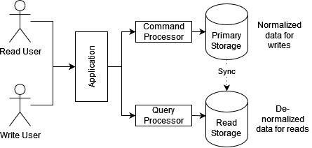

Figure 2.2 – CQRS implementation

Additionally, based on the requirements for traceability and discoverability that were imposed upon the system we would be taking an approach of Event Sourcing. The main idea of it consists in considering the events that led to the current state of the system as the source as opposed to considering the projection itself as the source of truth. Combining this idea with the CQRS, we may arrive at the architectural depicted on the fig. 2.3

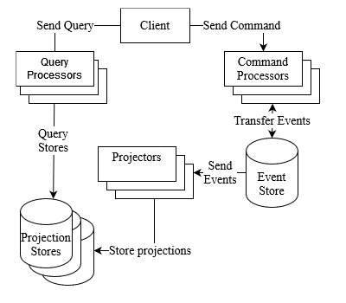

Figure 2.3 – Business layer architecture

Here, we separate reads and writes by the entry point, which results in us having a separate range of Command Processors and Query Processors. Command Processors are responsible for processing commands with the usage of the events stored with the Event Store. This is important due to concept from Event Sourcing that considers events as the Source of Truth, so all projection that are needed to perform a command should happen on-the-fly from the set of events that appeared previously. So, after the command was processed some events may be produced in response to it. This would be picked up by the projectors, which would project the data into various Projection Stores for feature consumption. Due to this type of handling, we can use several projection stores that have their own benefits and drawbacks, so that we only use corresponding storage system in areas that are their strong points. As an example of that, we may use one data storage system for its search capabilities and use some other data storage system for its key lookup capabilities. Correspondingly, the query processor would identify proper projection store to query for the resource requested by the client. Correspondingly, the query processor would identify proper projection store to query for the resource requested by the client.

As we can clearly see there, we also have three deployable component groups:

* Command Processors
* Query Processors
* Projectors

Each of those also needs an internal architectural and compositional structure to use. For that the clean architecture would be used as business layer architecture. Its main goal is to separate the actual business logic of the backend application from infrastructural logic that includes sending emails, querying database and interacting with file system. Its diagram can be seen on a fig. 2.4.

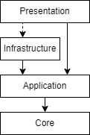

Figure 2.4 – Clean architecture

Here, we can see four structural layers:

* Core - the base of application and contains system-wide concerns and business entities representation
* Application - business logic
* Infrastructure - external dependencies
* Presentation - a medium for information transfer

Clean architecture has been chosen to allow for separation of business concerns and the actual infrastructure. This is achieved by Presentation layer components providing Infrastructure layer implementations for Application layer dependencies.

## 2.3 Presentation layer architecture

As a pattern for development of presentation layer MVU pattern would be used. Here, model is an unambiguous and flat representation of all the information that is needed for the application, view is a function that renders model and convenes user interactions, update is a function that receives a model and a message and produces new model and optionally commands, side-effects externally processes commands and posts messages.

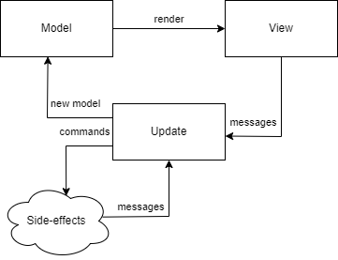

Figure 2.5 – MVU pattern

The MVU has been used to allow for predictable and deterministic user interface design, which allows us to save on doing testing.

Additionally, it is a form of the architectural structure of Event Sourcing that is already in use on the backend, which would cut down the number of concepts required from any developer working on the system.

# 3 MODELING OF THE DOMAIN OF INFORMATIONAL SYSTEM

To model the domain of informational system we would be using the concepts of aggregates, entities and values objects from the DDD. Both aggregate and the entity are identifiable collections of fields that have a schema. The difference is in aggregates being considered as a Unit of Work which means that an entity exists within aggregate and may not be modified outside of it. On the other hand, value object are collections of data with some internal consistency logic that are not identifiable. Both aggregates and entities are identifiable by definition, so they would have an implicit surrogate id.

The full Domain Diagram is provided via Attachment A. Otherwise, aggregates, entities and their constraints in tabular form are presented in table 3.1.

Table 3.1 – Aggregates and their constraints

|  |  |  |
| --- | --- | --- |
| Field | Description | Constraints |
| “User” aggregate | | |
| FirstName | First name of the user | NOT NULL |
| LastName | Last name of the user | NOT NULL |
| PhoneNumber | Phone number of the user | NOT NULL |
| Login | User-friendly identifier of the user | NOT NULL, UNIQUE |
| Roles | Role that the user has permissions for | NOT NULL, NOT EMPTY |
| PlantsCared | Number of plants cared for by the user | NOT NULL, NOT NEGATIVE |
| PlantsSold | Number of plants sold by the user | NOT NULL, NOT NEGATIVE |
| InstructionsCreated | Number of instructions created by the user | NOT NULL, NOT NEGATIVE |

Continuation of Table 3.1

|  |  |  |
| --- | --- | --- |
| UsedAddresses | Delivery addresses previously used by the user | NOT NULL |
| “Delivery Address” value object | | |
| City | City of the delivery | NOT NULL |
| MailNumber | Number of postal location | NOT NULL |
| “PlantStock” aggregate | | |
| CaretakerId | Identitfier of User that is the caretaker | NOT NULL |
| PlantName | Name of the Plant | NOT NULL |
| Description | Description of the Plant | NOT NULL |
| RegionNames | Names of the regions | NOT EMPTY |
| SoilNames | Names of the soils | NOT EMPTY |
| GroupNames | Names of groups | NOT EMPTY |
| Pictures | Pictures of the plant | NOT NULL |
| CreatedTime | Approximate time the plant was created in the real world | NOT NULL |
| “Picture” entity | | |
| Location | Url from which the picture may be downloaded | NOT NULL |
| “PlantPost” aggregate | | |
| StockId | Identifier of the Stock | NOT NULL |
| SellerId | Identifier of the User that is the Seller | NOT NULL |
| Price | Price of the posted item | NOT NULL, NOT NEGATIVE |

Continuation of Table 3.1

|  |  |  |
| --- | --- | --- |
| “PlantOrder” aggregate | | |
| PostId | Identifier of the Post | NOT NULL |
| BuyerId | Identifier of the User that is the buyer | NOT NULL |
| DeliveryAddress | Address of the delivery | NOT NULL |
| OrderTime | Time of order being requested | NOT NULL |
| DeliveryStartedTime | Time at which the delivery was started |  |
| TrackingNumber | Tracking number for the delivery |  |
| DeliveredTime | Time at which the order was delivered |  |
| “Plant Instruction” aggregate | | |
| GroupName | Name of the plant group for which the instruction is created | NOT NULL |
| Text | Content of the instruction | NOT NULL |
| Title | Title of the instruction | NOT NULL |
| Description | Description of the instruction | NOT NULL |
| Cover | Cover image | NOT NULL |
| “PlantsInformation” aggregate | | |
| GroupNames | Used group names so far | NOT NULL |
| RegionNames | Used region names so far | NOT NULL |
| SoilNames | Used soil names so far | NOT NULL |
| TotalStats | Stats so far | NOT NULL |
| DailyStats | Day to the stats | NOT NULL |

Continuation of Table 3.1

|  |  |  |
| --- | --- | --- |
| “PlantStats” value object | | |
| GroupName | Name of group for which stats are collected | NOT NULL |
| PlantsCount | Number of stock items added | NOT NULL, NOT NEGATIVE |
| InstructionsCount | Number of instructions created | NOT NULL, NOT NEGATIVE |
| PostedCount | Number of posts created | NOT NULL, NOT NEGATIVE |
| SoldCount | Number of orders delivered | NOT NULL, NOT NEGATIVE |
| Income | Combined income for period | NOT NULL, NOT NEGATIVE |

Additional constraints are presented in table 3.2

Table 3.2 – Additional constraints

|  |  |
| --- | --- |
| Aggregate | Constraints |
| PlantStock | Cannot be updated if post record exists that references it. Age of the plant cannot be edited under any condition. |
| PlantPost | Cannot be deleted by anyone except a manager or the producer that created it. |
| PlantOrder | Cannot be deleted by anyone except a manager or the producer that created underlying post. Cannot be created for plants that are in a planning stage – their creation dates are after current date. Cannot be confirmed to be received by anyone outside of customer that ordered it. |

There are two types of relationships between aggregates, entities and value objects:

* One-to-one
* One-to-many

“One-to-one” relationship exists between following items:

* PlantStock and User
* PlantPost and Stock
* PlantPost and User
* PlantOrder and PlantPost
* PlantOrder and DeliveryAddress

“One-to-many” relationship exists between following items:

* User and DeliveryAddress
* PlantStock and Picture
* PlantsInformation and PlantStats

# 4 AGGREGATE WORKFLOWS

Workflows combine use cases and aggregates, defining proper relations between those and introducing limits for order of execution.

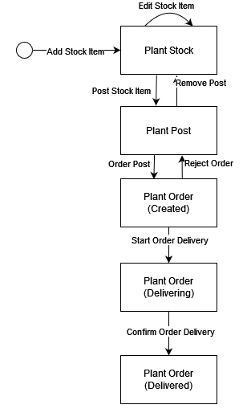

Figure 4.1 – Plant workflow

Plant Stock can be added via Add Stock Item use case, optionally edited via Edit Stock Item use case, and then posted via Post Stock Item use case after which Edit Stock Item Use Case becomes unavailable.

Plant Post may be removed via Remove Post use case by seller, going back to Plant Stock, or ordered via Order Post use case by a buyer.

Plant Order may be rejected, going back to Plant Post, or delivered which happens in two stages – start delivery from seller and configured delivery from buyer, which should appear in that order.

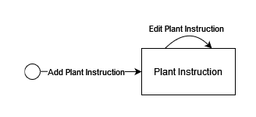

Figure 4.2 – Instruction workflow

Instruction may be added and then edited with no limitations outside of aggregates limitations.

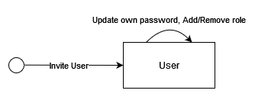

Figure 4.2 – User workflow

User may get invited, change their own password and have a role granted to them or revoked from them by a Producer or Manager.

# 5 USED TECHNOLOGIES AND SOFTWARE

The informational system is composed of three parts:

* Data Access layer is built with the usage of EventStore for Event Store system and MongoDb combined with ElasticSearch for Projection Stores
* Application Layer is built with ASP.NET Core framework
* Presentation Layer is built with Elm, React and Bootstrap 5.\

The EventStore was chosen as the Event Store for the following reason:

* Supports user-level access control.
* Throughout documentation.
* Actively supported and developed.
* Support for arbitrary data.

Two Projection Store of MongoDb and ElasticSearch were chosen for their performant key lookup and search queries and their support for user-level access control.

The ASP.NET Core framework for backend application has been selected for well-crafted database access packages, advanced support for creation of REST-full APIs and Microsoft support.

The frontend uses Bootstrap 5 for cross-platform support, accessibility and consistency of the user interface, Elm for its support of zero exception runtime and the guarantee of impossibility of undefined state of User Interface and React for its support for Single Page Application development. All of those frameworks are used within Node JS environment that uses Parcel bundler as a build tool for its support for minimization of static files. Build application is being distributed using Nginx web-host through nginx alpine docker image for its support for caching of static files.

# 6 STRUCTURE OF THE APPLICATION

The frontend application would be structured as one homogeneous application, where all users use one and the same application. However, only options that they would be able to execute are visible to them. This would not be used for defining access as the client would still be able to call all of those options through the Web API, where the access that the client should have would be forwarded to the corresponding event or projection store.

## 6.1 Backend architecture

The communication between frontend and backend would be organized through the REST-full API, whose diagram is presented in fig. 5.1.

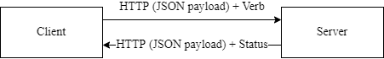

Figure 6.1 - REST API diagram

The authorization would be organized through the usage of JWT, which would be using two-way encryption to encode the data so that only the server that has private key is able to read it.

Each of the three deployable components would use the Dependency Injection system to implement the abstraction replacement defined in the Clear Architecture, which would mean that the service itself would operate with the usage abstractions to implement its business logic, while the infrastructural dependencies, such as storage systems, file system, http servers, etc would be supplied through the infrastructure ports. A diagram of such interaction may be seen on fig. 6.2 and an example of it from the Projection component may be seen on the fig 6.3

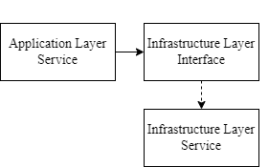

Figure 6.2 – Dependency Injection diagram

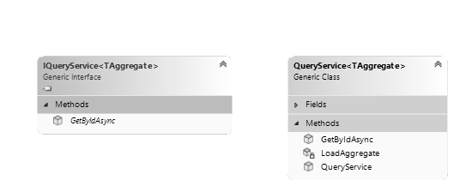

Figure 6.3 – Query service example

The events and commands should work with the strongly-types system, deriving from base Event and Command classes respectively. All of the aggregates should derive from AggregateBase, which would allow the support of high-level event handlers, command handlers and access controls. The event handlers should be attached through IEventHandler interface directly to an aggregate. They should be discovered on startup by the Domain library and be invoked when loading aggregates using the domain library. Command Handlers should be separated in pure and impure ones. Pure ones should be defined directly on the aggregate and use IDomainCommandHandler interface, whilst impure ones should use ICommandHandler and be defined externally, but both should also be automatically discovered.

## 6.2 Frontend architecture

The frontend application is structured as many MVU applications that represent a singular page of the application that acts as a SPA by wrapping pages with a SPA router.

There would be base application for MVU applications that would handle cases of unauthorized access and no login info being available.

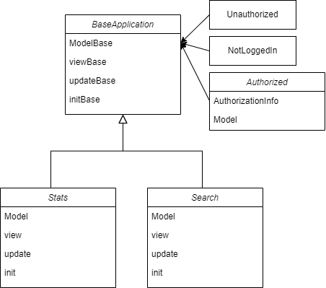

Figure 5.6 – Frontend architecture

# 7 APPLICATION IMPLEMENTATION

## 7.1 Backend

The backend takes a heavy advantaged from the Domain library that contains all of the basic definitions and abstractions. Its source code would be available in Attachment B. However, the most important interface would be considered here.

Basic definition for the base aggregate may be seen in the listing 7.1.

public abstract class AggregateBase

{

public AggregateBase(Guid id)

{

Id = id;

Metadata = new(GetType().Name, new());

}

public Guid Id { get; }

public AggregateMetadata Metadata { get; private set; }

public void Record(OneOf<Command, Event> newRecord)

{

Metadata.Record(newRecord);

}

}

Listing 7.1 – AggregateBase definition

Definitions for Command and Event base classes may be seen in listing 7.2

public abstract record Command(CommandMetadata Metadata);

public sealed record CommandMetadata(Guid Id, AggregateDescription Aggregate, DateTime Time, string Name, string UserName, /*this is needed for subscriptions*/AggregateDescription? InitialAggregate = null);

public abstract record Event(EventMetadata Metadata);

public sealed record EventMetadata(Guid Id, AggregateDescription Aggregate, Guid CommandId, DateTime Time, string Name, ulong EventNumber = ulong.MaxValue);

public record FailEvent(EventMetadata Metadata, string[] Reasons, bool IsException) : Event(Metadata);

public record CommandProcessedEvent(EventMetadata Metadata) : Event(Metadata);

Listing 7.2 – Command and Event definition

Command and event handler definitions can be seen in listing 7.3

public interface ICommandHandler<T> where T : Command

{

Task<CommandForbidden?> ShouldForbidAsync(T command, IUserIdentity userIdentity, CancellationToken token = default);

Task<IEnumerable<Event>> HandleAsync(T command, CancellationToken token = default);

}

public interface IDomainCommandHandler<T> where T : Command

{

CommandForbidden? ShouldForbid(T command, IUserIdentity userIdentity);

IEnumerable<Event> Handle(T command);

}

/// <summary>

/// This is supposed to be applied to the aggregate

/// </summary>

public interface IEventHandler<T> where T : Event

{

void Handle(T @event);

}

Listing 7.3 – Command and Event Handler

A PlantPost aggregate that uses all those abstractions may be seen in the listing 7.4

[Allow(Consumer, Read)]

[Allow(Consumer, Write)]

[Allow(Producer, Read)]

[Allow(Producer, Write)]

[Allow(Manager, Read)]

[Allow(Manager, Write)]

public class PlantPost : AggregateBase, IEventHandler<StockItemPostedEvent>,

IDomainCommandHandler<RemovePostCommand>, IEventHandler<PostRemovedEvent>,

IDomainCommandHandler<OrderPostCommand>, IEventHandler<PostOrderedEvent>,

IEventHandler<RejectedOrderEvent>

{

public PlantPost(Guid id) : base(id)

{

}

public decimal Price { get; private set; }

public PlantStock Stock { get; private set; }

public User Seller { get; private set; }

public bool IsRemoved { get; private set; }

public bool IsOrdered { get; private set; }

public void Handle(StockItemPostedEvent @event)

{

Metadata.Referenced.Add(new(@event.Metadata.Aggregate.Id, nameof(PlantStock)));

Metadata.Referenced.Add(new(@event.SellerUsername.ToGuid(), nameof(User)));

IsRemoved = false;

IsOrdered = false;

Price = @event.Price;

}

public CommandForbidden? ShouldForbid(RemovePostCommand command, IUserIdentity user) =>

(user.HasRole(Manager).Or(user.HasRole(Producer).And(IsSeller(user))))

.And(IsNotRemoved)

.And(IsNotOrdered);

private CommandForbidden? IsNotRemoved() =>

(IsRemoved is false).ToForbidden("Already removed");

private CommandForbidden? IsNotOrdered() =>

(IsOrdered is false).ToForbidden("Already ordered");

private CommandForbidden? IsSeller(IUserIdentity user) =>

(user.UserName == Seller.Login).ToForbidden("Cannot remove somebody elses post");

public IEnumerable<Event> Handle(RemovePostCommand command) =>

new[]

{

new PostRemovedEvent(EventFactory.Shared.Create<PostRemovedEvent>(command))

};

public void Handle(PostRemovedEvent @event)

{

IsRemoved = true;

}

public CommandForbidden? ShouldForbid(OrderPostCommand command, IUserIdentity user) =>

user.HasAnyRoles(Manager, Consumer).And(IsNotRemoved).And(IsNotOrdered);

public IEnumerable<Event> Handle(OrderPostCommand command) =>

new[]

{

new PostOrderedEvent(EventFactory.Shared.Create<PostOrderedEvent>(command), command.Address, command.Metadata.UserName)

};

public void Handle(PostOrderedEvent @event)

{

IsOrdered = true;

}

public void Handle(RejectedOrderEvent @event)

{

IsOrdered = false;

}

}

Listing 7.4 – PlantsPost aggregate

Client-side usage of Command and Query service from the Domain library may be seen in the listing 7.5 and listing 7.6 correspondingly

var result = await _command.SendAndNotifyAsync(

factory => factory.Create<PostStockItemCommand, PlantStock>(id),

meta => new PostStockItemCommand(meta, price),

token);

Listing 7.5 – Post Stock Item command invocation

var result = await _search.SearchAsync(new PlantStockParams(false), new SearchAll(), token);

Listing 7.6 – Search Stock items example

## 7.2 Frontend

The base functions for creating an MVU application can be seen in the listing 8.4.

initBase : List UserRole -> model -> (AuthResponse -> Cmd msg) -> Maybe AuthResponse -> ( ModelBase model, Cmd msg )

initBase requiredRoles initialModel initialCmd response =

case response of

Just resp ->

if intersect requiredRoles resp.roles then

( Authorized resp initialModel, initialCmd resp )

else

( Unauthorized, Cmd.none )

Nothing ->

( NotLoggedIn, Cmd.none )

type ModelBase model

= Unauthorized

| NotLoggedIn

| Authorized AuthResponse model

viewBase : (AuthResponse -> model -> Html msg) -> ModelBase model -> Html msg

viewBase authorizedView modelB =

case modelB of

Unauthorized ->

div [] [ text "You are not authorized to view this page!" ]

NotLoggedIn ->

div []

[ text "You are not logged into your account!"

, a [ href "/login" ] [ text "Go to login" ]

]

Authorized resp authM ->

authorizedView resp authM

Listing 7.4 – base initialization, view functions and model structure

The definition of base application can be seen on listing 8.5.

mainInit : (Maybe AuthResponse -> D.Value -> ( model, Cmd msg )) -> D.Value -> ( model, Cmd msg )

mainInit initFunc flags =

let

authResp =

case D.decodeValue decodeFlags flags of

Ok res ->

Just res

Err _ ->

Nothing

in

initFunc authResp flags

type alias AuthResponse =

{ token : String

, roles : List UserRole

, username : String

}

type alias ApplicationConfig model msg =

{ init : Maybe AuthResponse -> D.Value -> ( model, Cmd msg )

, view : model -> Html msg

, update : msg -> model -> ( model, Cmd msg )

, subscriptions : model -> Sub msg

}

baseApplication : ApplicationConfig model msg -> Program D.Value model msg

baseApplication config =

Browser.element

{ init = mainInit config.init

, view = config.view

, update = config.update

, subscriptions = config.subscriptions

}

Listing 7.5 – base application

The router of routing single page application can be seen on listing 8.6.

const App = () => (

<BrowserRouter>

<Routes>

<Route path="/login" element={<Login

Page isNew={false} />} />

<Route path="/login/new" element={<LoginPage isNew={true} />} />

<Route path="/stats" element={<StatsPage />} />

<Route path="/search" element={<SearchPage />} />

<Route path="/notPosted" element={<NotPostedPage />} />

<Route path="/plant/:plantId" element={<PlantPage isOrder={false} />} />

<Route

path="/plant/:plantId/order"

element={<PlantPage isOrder={true} />}

/>

<Route path="/notPosted/:plantId/post" element={<PostPlantPage />} />

<Route path="/notPosted/add" element={<AddEditPage isEdit={false} />} />

<Route

path="/notPosted/:plantId/edit"

element={<AddEditPage isEdit={true} />}

/>

<Route path="/orders" element={<OrdersPage isEmployee={false} />} />

<Route

path="/orders/employee"

element={<OrdersPage isEmployee={true} />}

/>

<Route path="/user" element={<UsersPage />} />

<Route path="/user/add" element={<AddUserPage />} />

<Route path="/instructions" element={<SearchInstructionsPage />} />

<Route

path="/instructions/add"

element={<AddInstructionPage isEdit={false} />}

/>

<Route

path="/instructions/:id/edit"

element={<AddInstructionPage isEdit={true} />}

/>

<Route path="/instructions/:id" element={<InstructionPage />} />

<Route path="/profile" element={<ProfilePage />} />

<Route path="*" element={<NotFound />} />

</Routes>

</BrowserRouter>

);

Listing 7.6 – application router

All of the pages are applications that use base application template, as shown in the listing 7.7 with the model, view, update and main function of Login page.

type alias Model =

{ username : String

, password : String

, status : Maybe (WebData CredsStatus)

}

view : Model -> Html Msg

view model =

Grid.containerFluid [ style "height" "100vh" ]

[ Grid.row [ Row.attrs (fillParent ++ flexCenter) ]

[ Grid.col [] []

, Grid.col [] []

, Grid.col [ Col.middleXs ]

[ viewForm model

, viewBackground

]

, Grid.col [] []

, Grid.col [] []

]

]

type Msg

= UsernameUpdated String

| PasswordUpdate String

| Submitted

| SubmitRequest (Result Http.Error AuthResponse)

update : Msg -> Model -> ( Model, Cmd Msg )

update msg model =

case msg of

UsernameUpdated login ->

( { model | username = login, status = Nothing }, Cmd.none )

PasswordUpdate pass ->

( { model | password = pass, status = Nothing }, Cmd.none )

Submitted ->

( { model | status = Just Loading }, submit model )

SubmitRequest (Ok response) ->

( { model | status = Just <| Loaded GoodCredentials }, notifyLoggedIn <| encodeResponse response )

SubmitRequest (Err err) ->

( { model | status = Just <| Loaded BadCredentials }, Cmd.none )

main : Program D.Value Model Msg

main =

baseApplication

{ init = init

, view = view

, update = update

, subscriptions = subscriptions

}

Listing 7.7 – login page components

The main module and other cross-page modules can be found in Appendix C. The navigational diagram for pages can be found in Appendix D.

# 8 USER GUIDE WITH ILLUSTRATIONS

This section explores achievement of user tasks through the application user interface.

## 8.1 Consumer

The initial page of the application is the login page. Its illustration can be seen on fig.8.1. It contains two fields for login and password. There is no way of performing registration, because the system is invite-only. Your credentials should be passed to you through email.

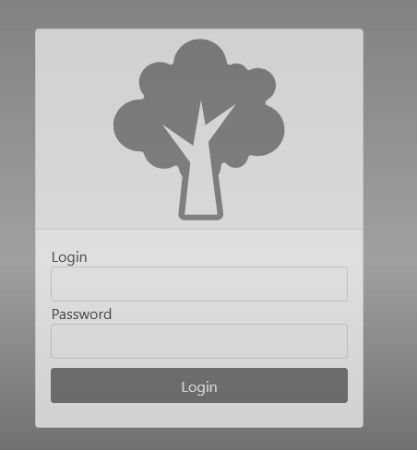

Figure 8.1 – Login Page

The page that you would be forwarded to is the search page. Its illustration can be seen on the fig 8.2. This page contains left-sided navigational bar that is used for the majority of navigation within the application. On the top of the page there are a few inputs for various properties for a plant you are looking for. Upon selecting any of them found list that is displayed below selectors would get updated. From this page you can navigate to order and plant pages by selecting specified buttons of the search result item accordingly.

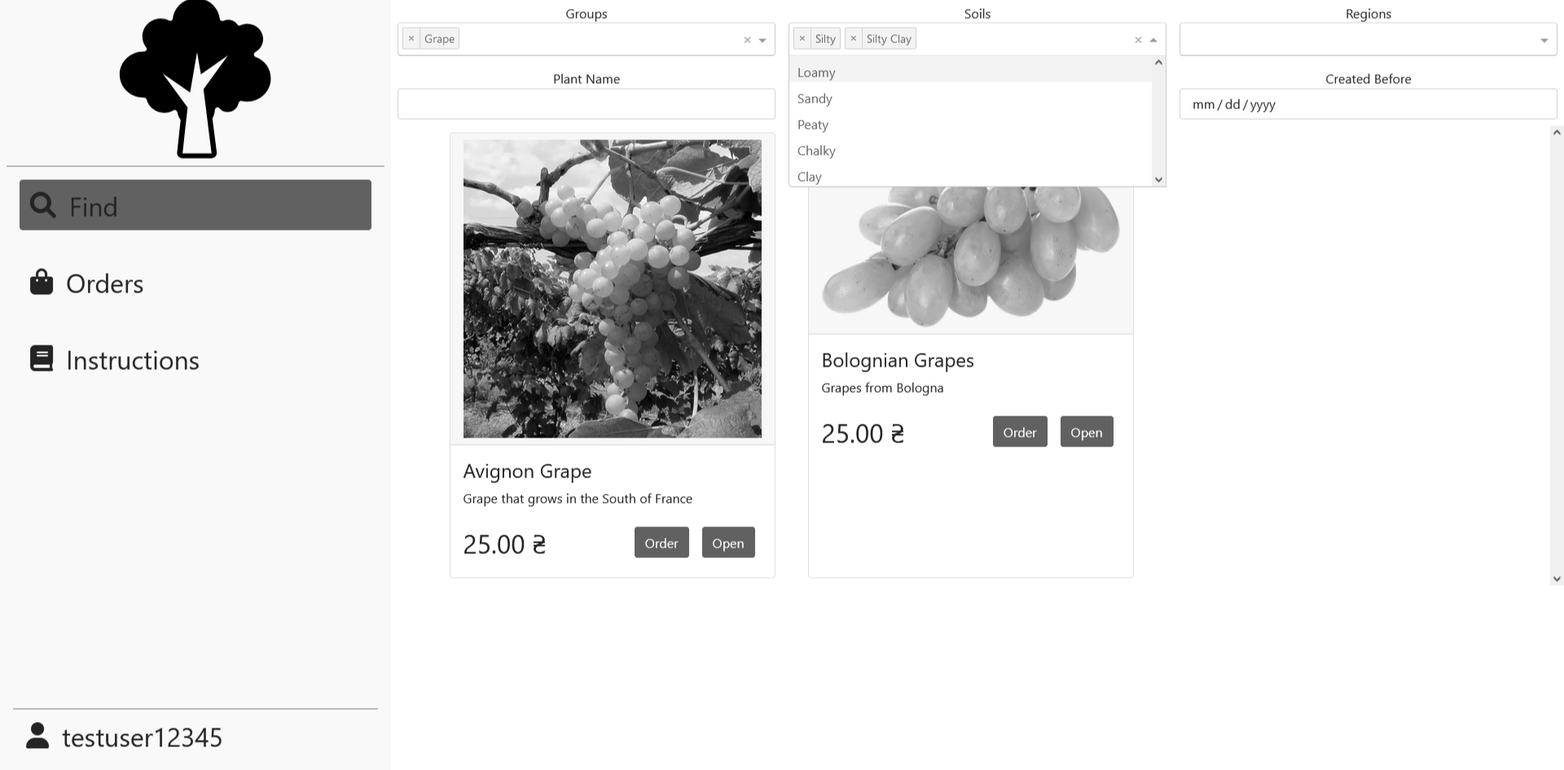

Figure 8.2 – Consumer Search page

Page with the detailed plant information can be accessed through search page. Its diagram can be found on fig 8.3. It displays information about plants region, group, age and soil as well as information about its caretaker and seller. From this page you can navigate to ordering page.

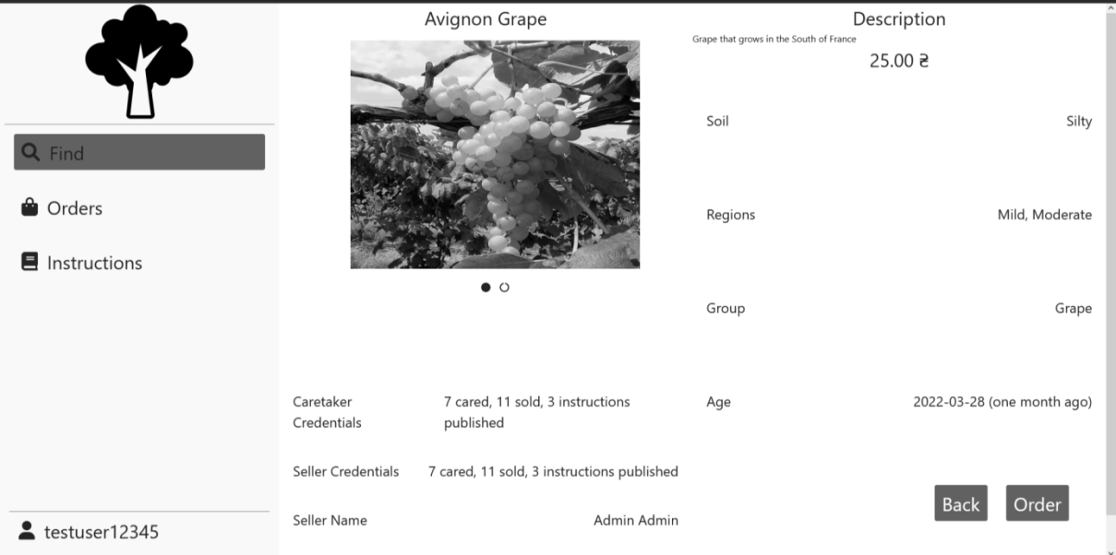

Figure 8.3 – Plant page

Order page displays most important information about plant and allows customer to select payment method as well as delivery address. Its illustration can be found in fig. 8.4. Delivery can be selected out of the list of existing or created on the fly. Upon selecting confirm order an order would be created. The order can found on Orders page that can be accessed through left navigational bar.

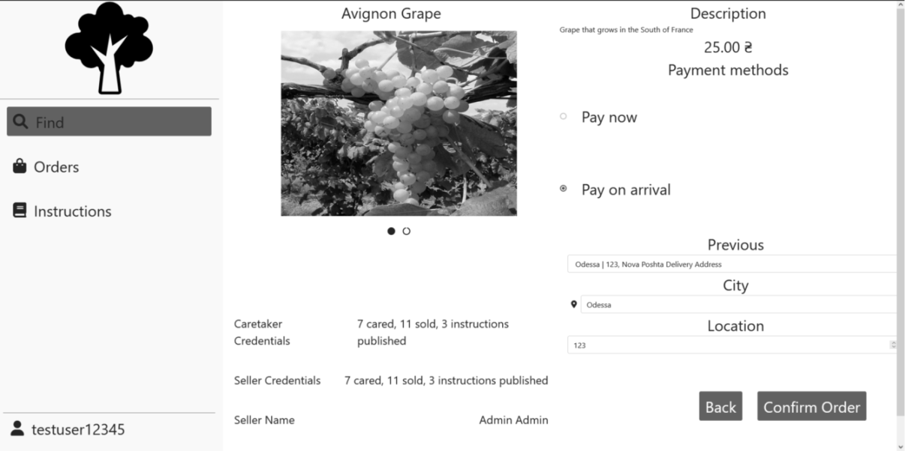

Figure 8.4- Order page

Orders page displays all of the orders that have been made by current customer and allows the customer to confirm the delivery of some order. Its illustration can be seen on fig. 8.5. The status of the plant can have following values:

1. Created – order have not started the delivery
2. Delivering – order have started delivery.
3. Delivered – order have been delivered.

An interaction of confirming delivery can only be performed on delivering status orders. This page allows you to hide delivered orders by checking top-left checkbox.

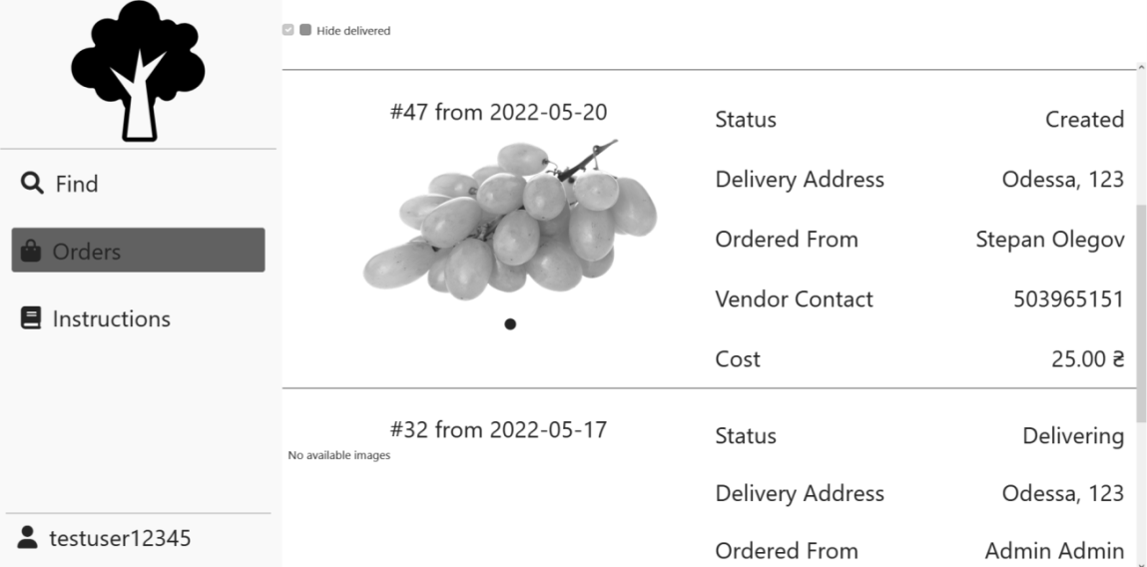

Figure 8.5 – Consumer Orders page

The instructions page is accessible through the left navigational bar and it displays a search page for instructions that acts the same way as plants search page does. Its illustration can be found on fig. 8.6. This page allows you to change filtering options and then open one for the full view.

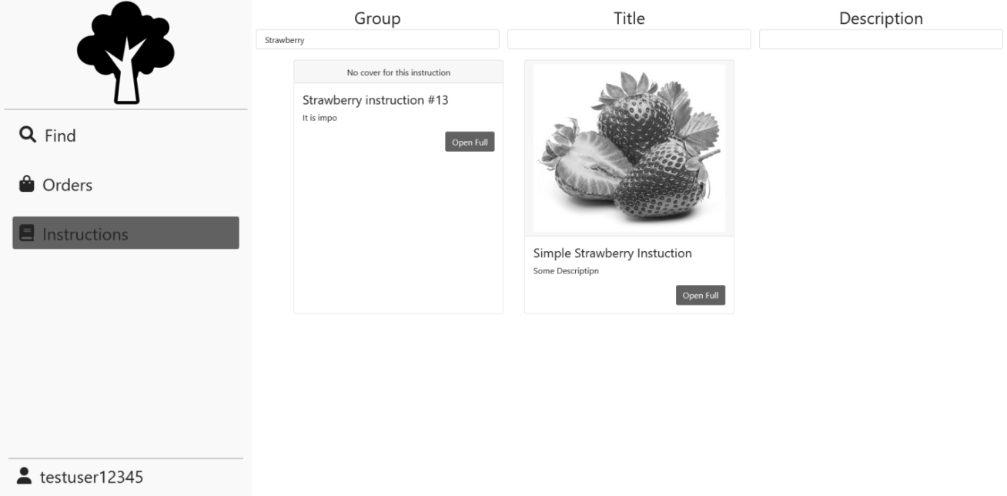

Figure 8.6 – Instructions page

Upon opening instruction for the full view you would see Instruction page that displays all of the relevant information about instruction including its main text that is richly formatted. Its illustration can be seen on fig 9.7. The only interaction is going back to the search page.

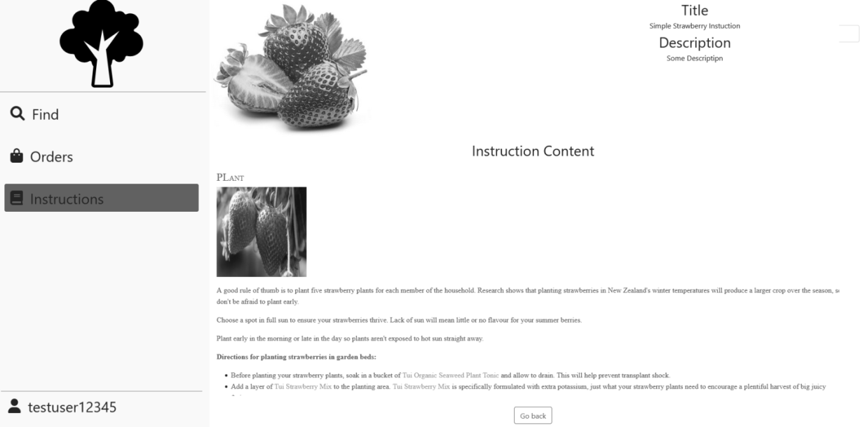

Figure 8.7 – Instruction page

Profile page can be accessed through left-sided navigational bar and it allows the user to change their password or logout of the system. Its illustration can be seen on fig 8.8.

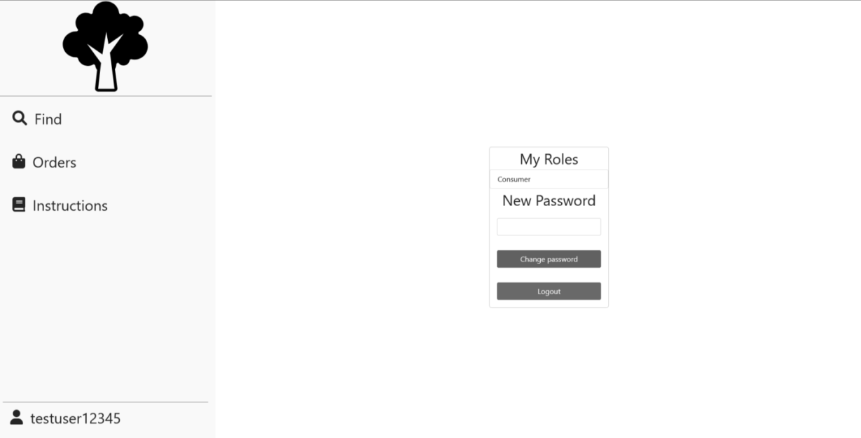

Figure 8.8 – Profile page

## 8.2 Producer

Producer can access the search page alongside consumer, but the producer would not be able to order the plant. Instead of that producer has interaction to remove the post. This can only be performed for posts that have been created by current producer or by manager. Its illustration can be seen on fig 8.9.

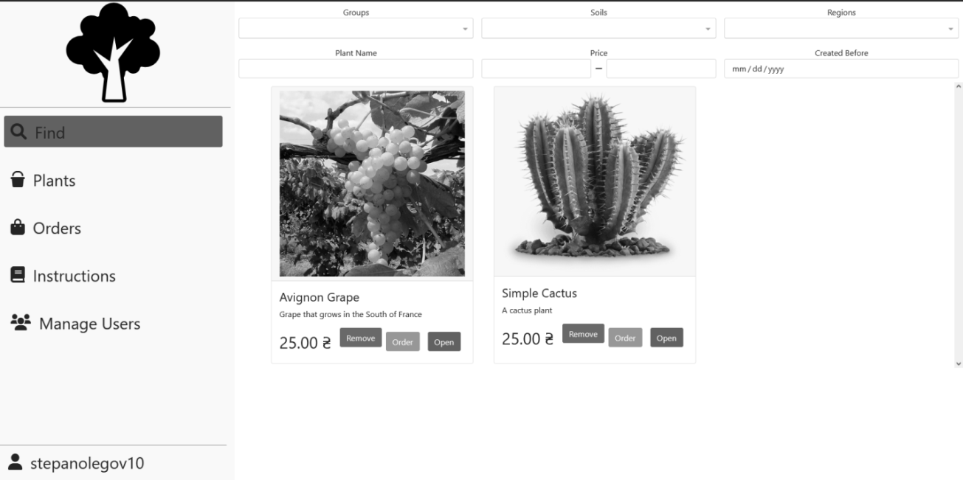

Figure 8.9 – Producer Search page

Plants page can be accessed through the left-sided navigational bar. It allows the producer to find all of the plants that are being current cared for before they are old enough to be posted for sale. Its illustration can be seen on fig 8.10. It has an option to hide all plants that are being cared for by other producers. It allows producer to add, edit and post a plant that opens corresponding pages.

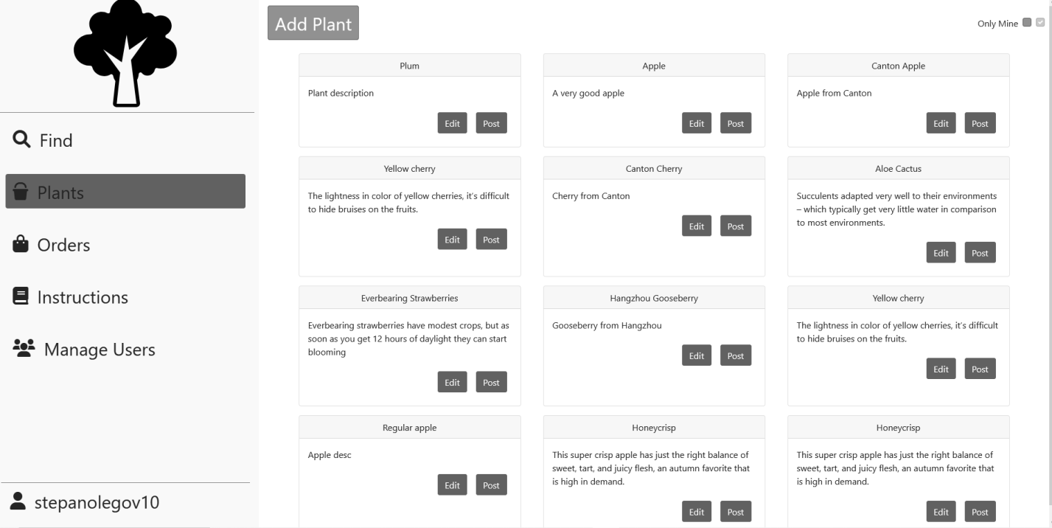

Figure 8.10 – Plants page

Add plant page can be accessed by selecting add plant in plants page. It allows the producer to input all of the information for the plant. Its illustration can be seen on fig 8.11.

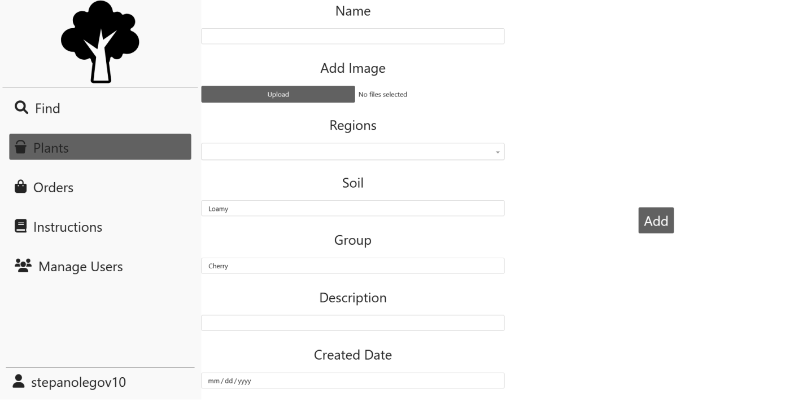

Figure 8.11 – Add plant

Edit plant page is accessible through selecting edit on plant from plants page. Its illustration can be seen on fig 8.12. It allows the producer to change the information about the plant with the limitation of Created Date not being editable. Upon clicking Save Changes the changes would apply.

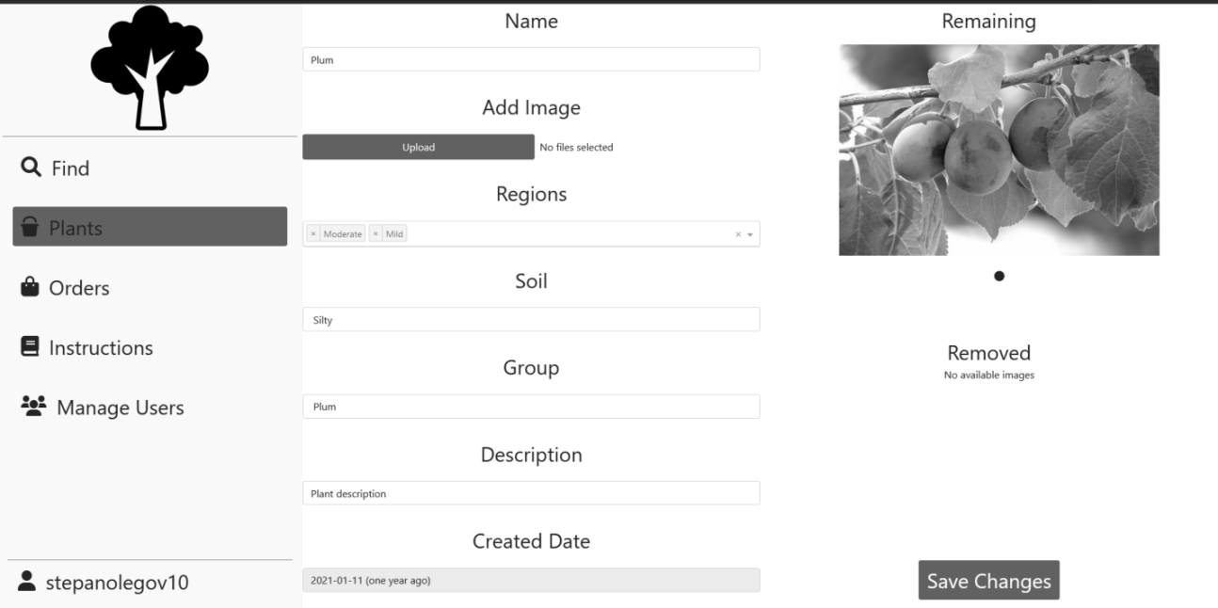

Figure 8.12 – Edit plant

Add instruction page can be accessed through Instruction page for producers, it allows the producer to create an instruction. Its illustration can be seen on fig 8.13. Upon clicking on edit text a full-screen text editor would be opened. After clicking on Create an instruction would be created.

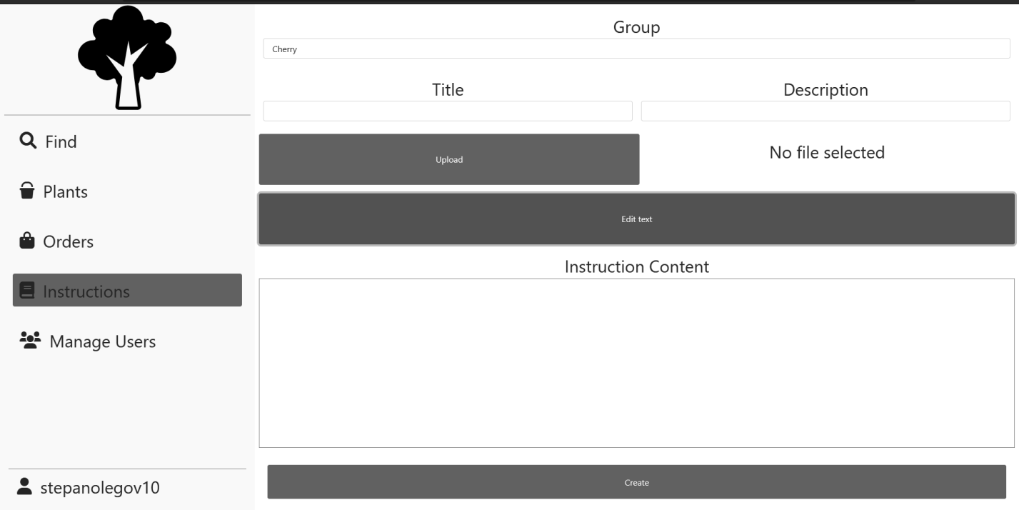

Figure 8.13 – Add instruction

Edit instruction page is accessible through instructions page by clicking on edit on an instruction. Its illustration can be seen on fig 8.14. It allows the producer to change any information about an instruction.

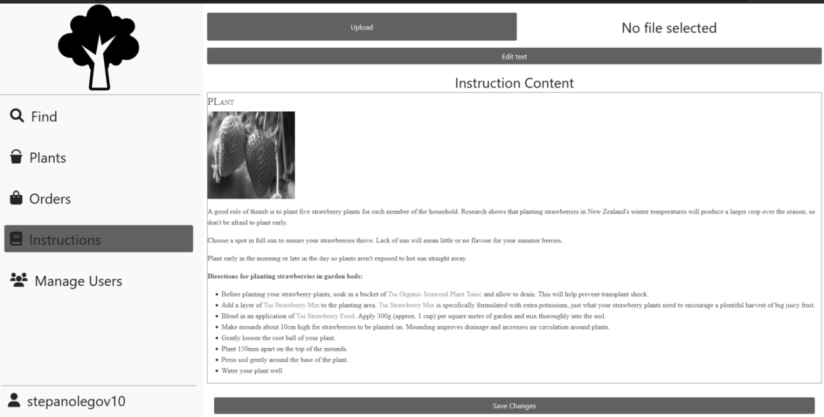

Figure 8.14 – Edit instruction

Orders page is accessible through left navigational bar. Its illustration can be seen on fig 8.15. It displays all of the orders that have been created so far with their statuses being the same as for consumer. However, for producer the interaction is with Created status orders – a producer can decided to reject it or confirm it as being sent by providing a delivery tracking number.

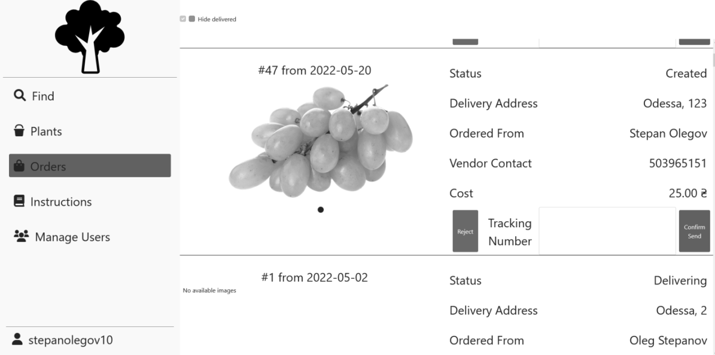

Figure 8.15 – Producer Orders page

Users page can be accessed through left navigational bar. Its illustration can be seen on fig 8.16. It displays a search by users and it allows a producer to grant producer role to some customer or to revoke customer access as well as an ability to create a user.

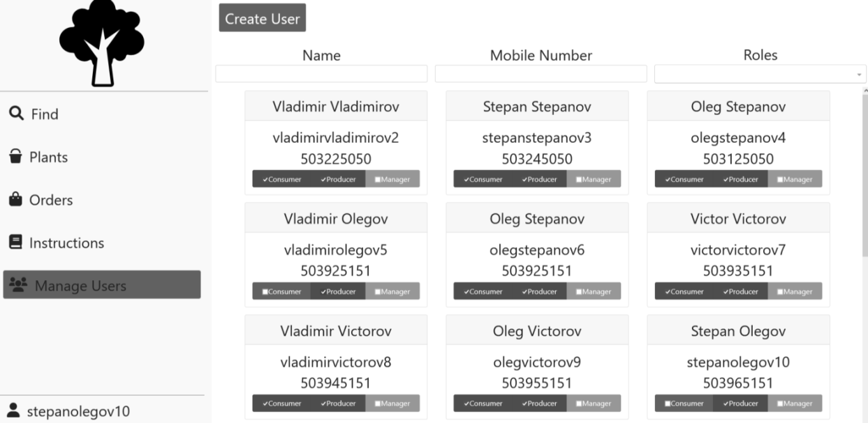

Figure 8.16 – Users page

Add user page displays information required to create a user. Its illustration can be seen on fig 8.17. Upon selecting all of the information and clicking on invite an invite would get send to the selected email.

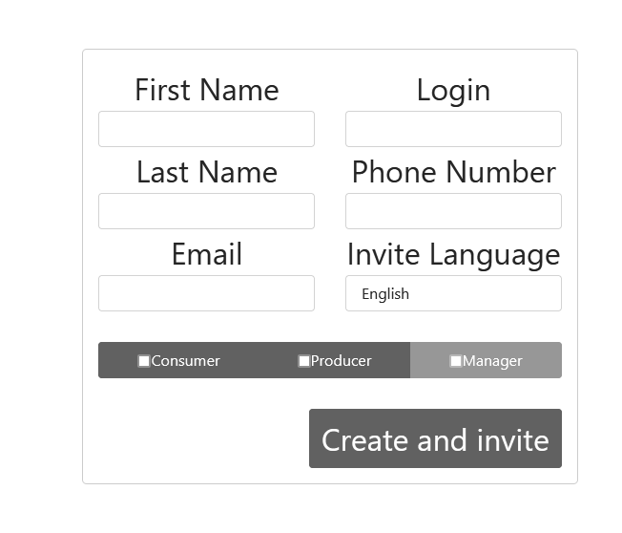

Figure 8.17 – Add user page

## 8.3 Manager

Managers have access to statistics pages that can be accessed through left sided navigational bar. There are two statistics pages: totals statistic page that can be found on fig. 8.18 and financial statistic page that can be found on fig 9.19. Those pages display pie charts for information plant information based on the plant group. Upon selecting a group on pie chart detailed information on it would get displayed in a table below it. Besides that, a manager has access to granting and removing more roles than producer and can remove any post or order.

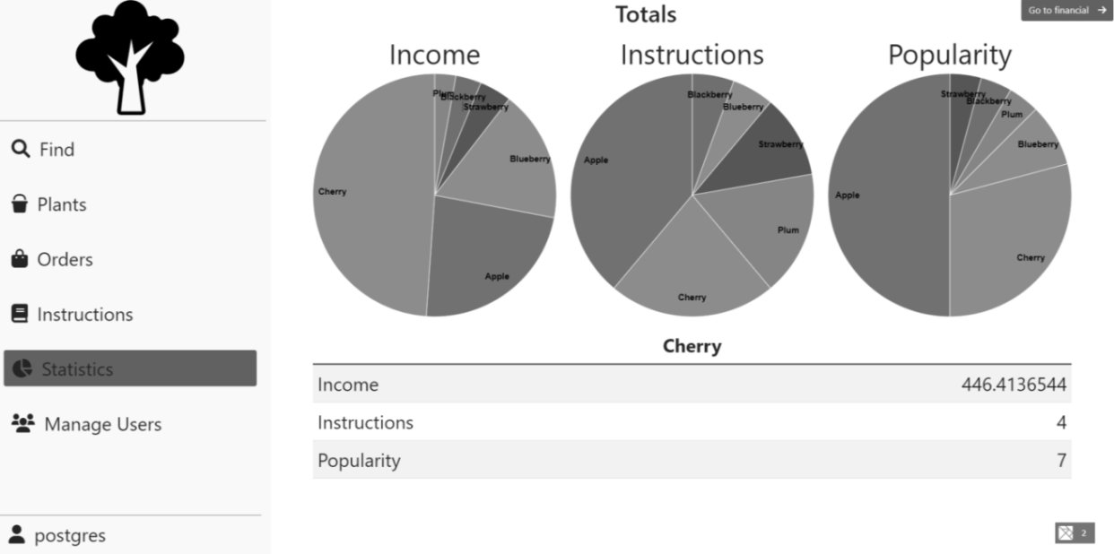

Figure 8.18 – Total statistics page

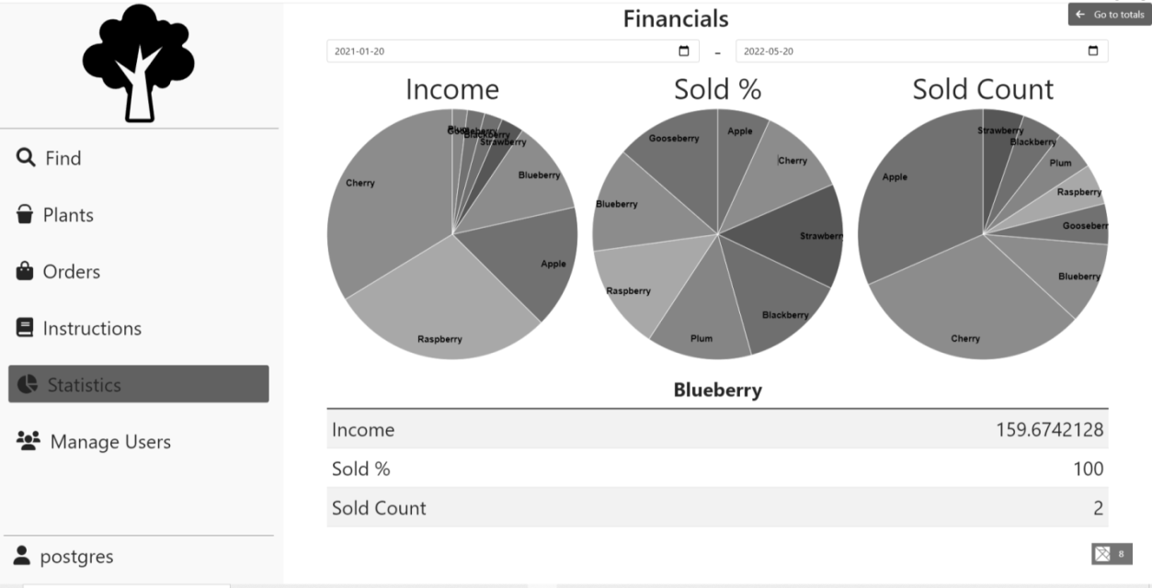

Figure 8.19 – Financial statistics page

In addition to Statistics page, users that are Managers would also see additional “View History” button in many places. Example of such buttons may be seen on fig. 8.20 and 8.21.

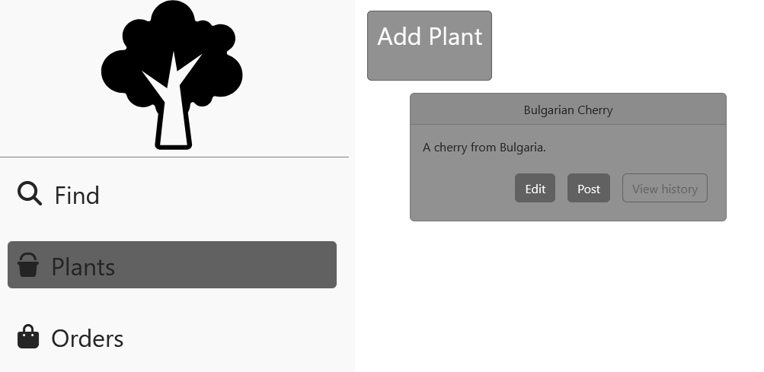

Figure 8.20 - Stock page with history button visible

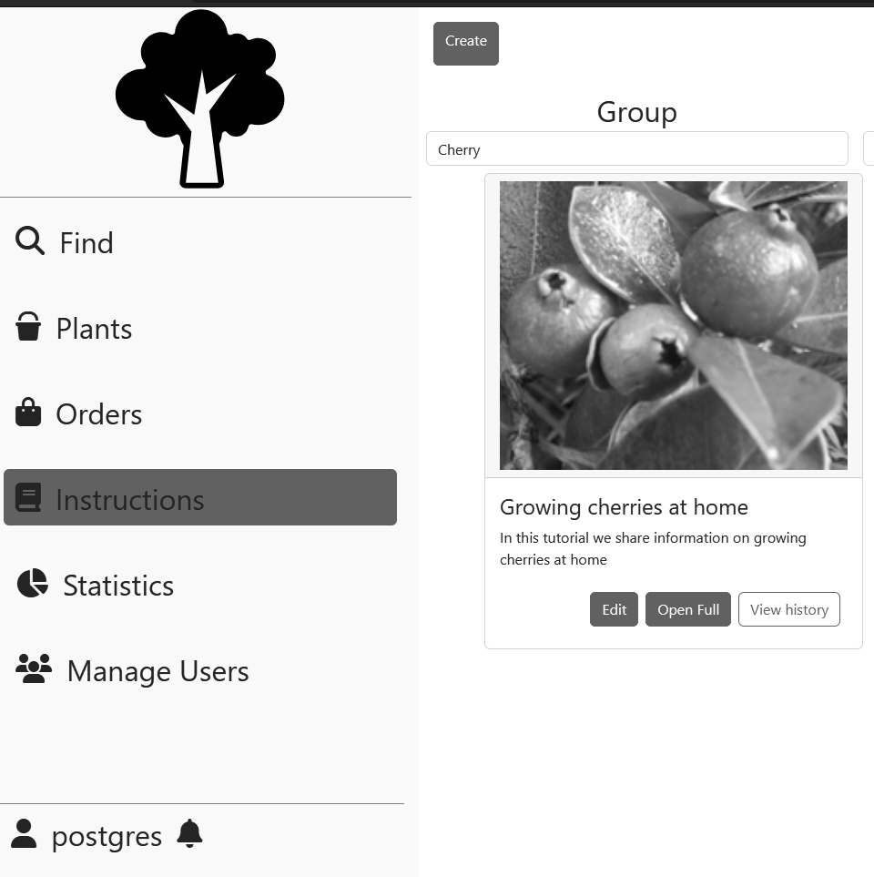

Figure 8.21 – Instructions page with history button visible

Upon clicking on “View History” button, the use would be transported to the history page that may be seen on fig. 8.22. It is showing all of the operations perform with this aggregation in the historical order. The user may reverse the order by checking “Reverse order” checkbox or limit the operations to ones that happened before the specified time. Upon clicking on any of visible commands in would be expanded to the view that may be seen on fig. 8.23.

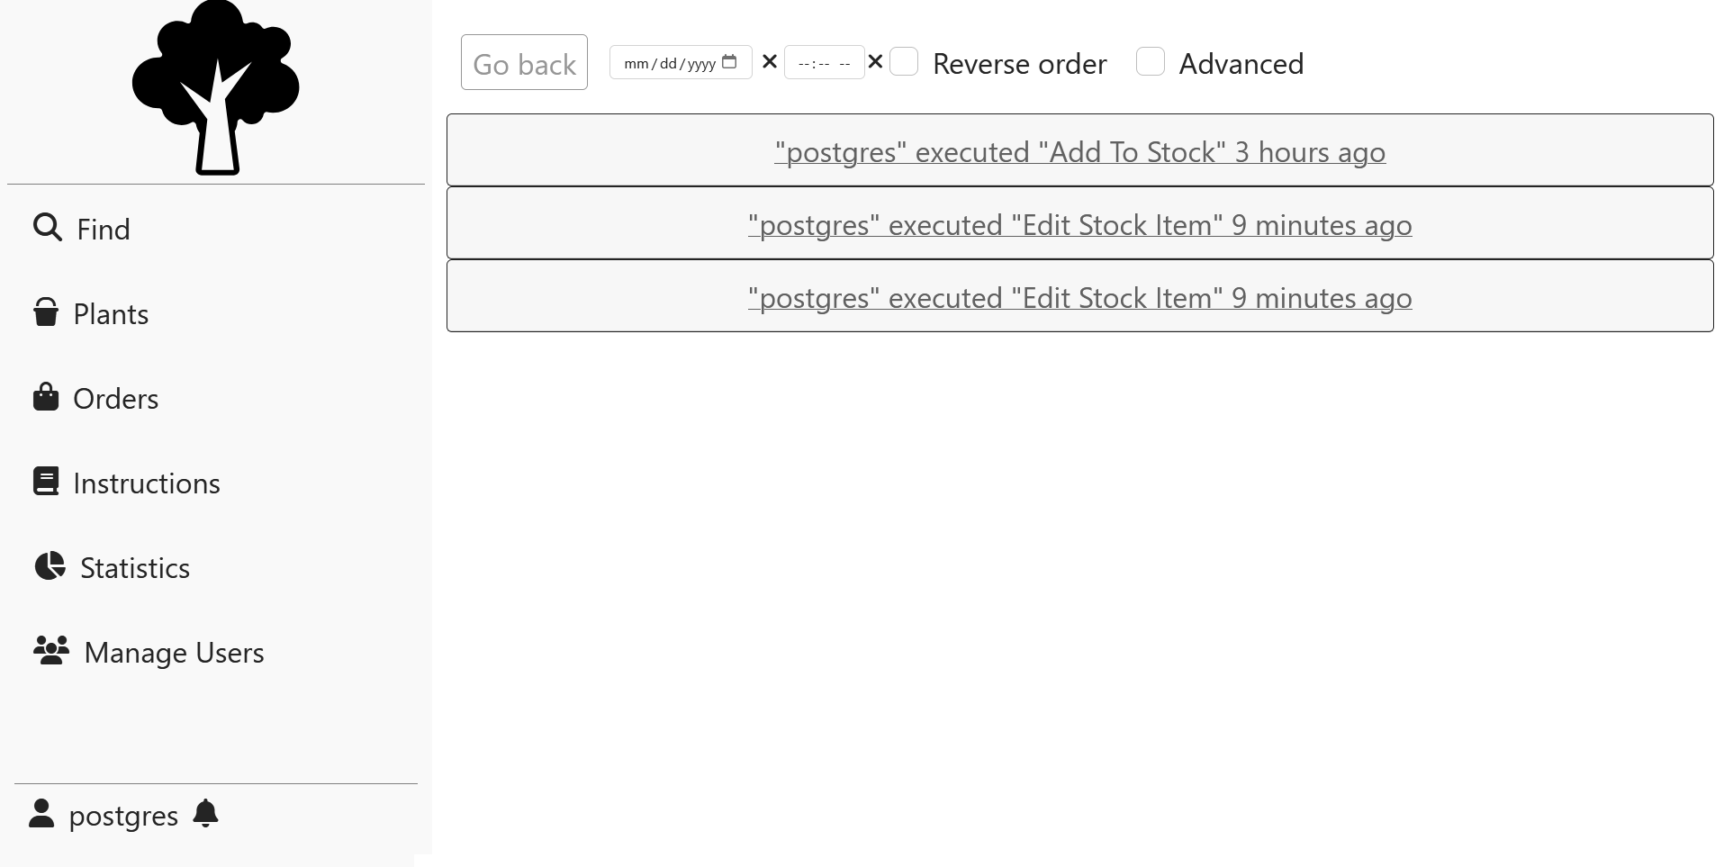

Figure 8.22 – History page

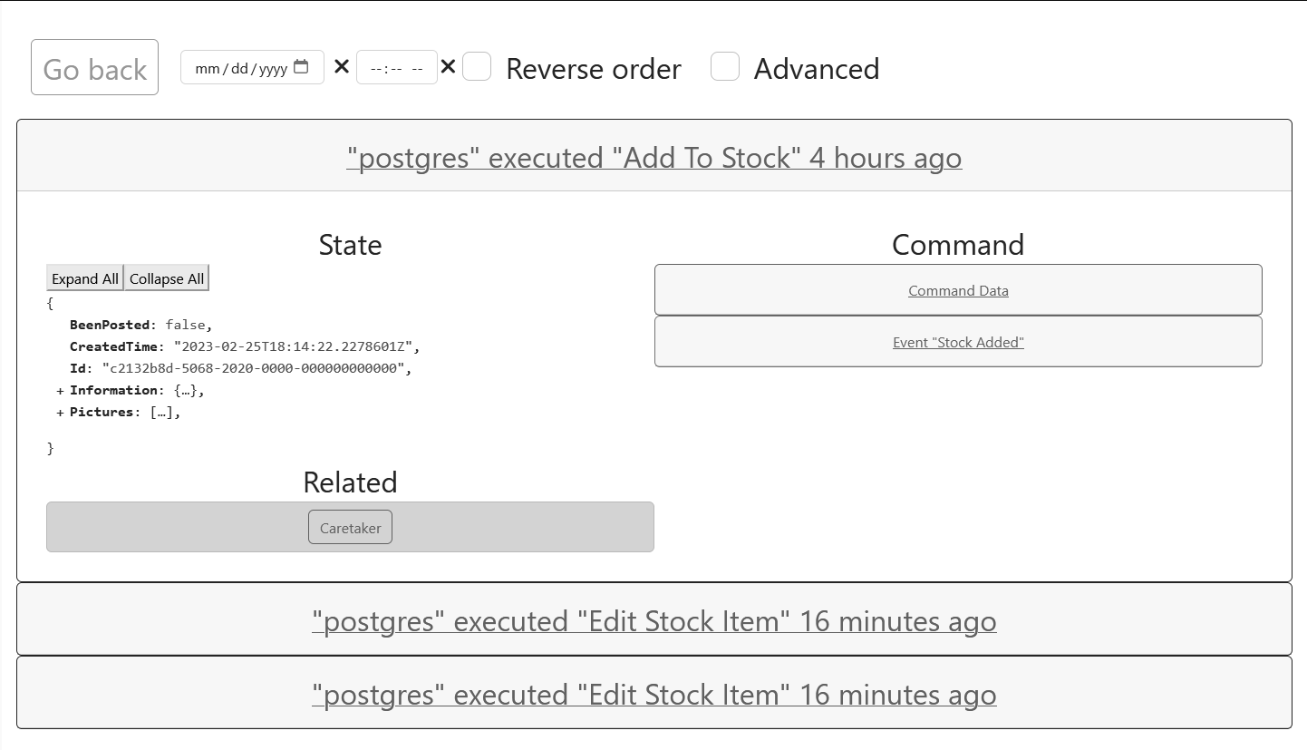

Figure 8.23 – History page with expanded operation

Once expanded, each operation would contain the state of the aggregate after the operation under the State column, related aggregates list that upon clicking on them would lead to the history of specified user and data related the request that was made by the user labeled as Command Data and results that were produced by the system labeled as Event with some name. Both command and event data may be expanded as is visible on fig. 8.24. That data for state, event and command may be expanded or collapsed by clicking on Expand/Collapse All or clicking on the field of interest.

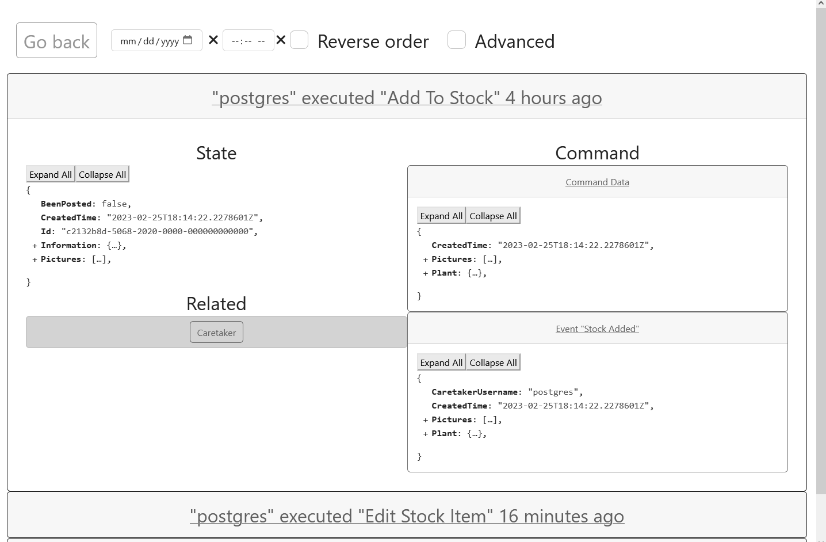

Figure 8.24 – Expanded Command and Event views

There is also checkbox that enables advanced mode, which is labeled with “Advanced” tag. Once checked, it would display additional Metadata button for State, Event and Command as is show on the fig. 8.25. Once clicked the button would display some additional information regarding each of those items in an overlaid windows, as may be seen on fig. 8.26.

# CONCLUSIONS

In this course work, the business process has been automated that included creating software requirements, determining business entities and determining the architecture.

The backend, frontend and the database have been created, which constituted a fully-functional prototype of the software project that fulfilled all of the business requirements as well as being adherent to the laid out architectural requirements.

Potential venues of expansion may include:

* Implementation of bulk operations for ordering and posting
* Rating and comment system
* Addition of client-producer messaging service
* Additional of new payment methods

The technological choices were able to fulfill business requirements, but they were using less-standard approaches had its advantages and disadvantages. On the category of performance the result is inconclusive and depends on the context – in single user single deployable instance scenario the standard approach would have a better response time and would perform less operations overall. However, the event-driven approach has a better scaling ability, which increases multi-processing capabilities of the system. On the category of complexity of implementation the event-driven approach is much more complex as it requires much more infrastructure, and there is a larger disconnect between infrastructure to application layer. On the category of talent recruitment the conventional database-driven approach is a better choice, due to developers already having experience with such technologies. Additionally, I would add that event-driven approach has its benefits in form of having easier experience with tracing and producing historical data. Overall, the technological and architectural choices were a mixed success.

# REFERENCES

1. Lock A. ASP.NET Core in Action – Manning, 2018. – 278 p.
2. Evans E. Domain-Driven Design: Tackling Complexity in the Heart of Software, 2003 – 560 p.
3. Garofolo E. Practical Microservices: Build Event-Driven Architectures with Event Sourcing and CQRS – 292 p.
4. Common web application architectures: Microsoft Docs - <https://docs.microsoft.com/en-us/dotnet/architecture/modern-web-apps-azure/common-web-application-architectures>.
5. Elm Architecture Documentation - <https://guide.elm-lang.org/architecture>.

# APPENDIX A Domain Diagram

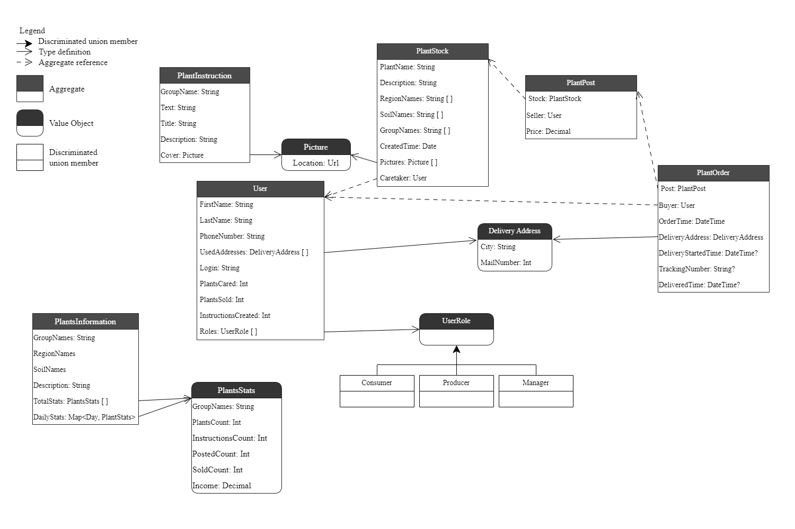

Figure A.1 – Domain Diagram

# APPENDIX B Domain library Source Code

//todo: add me

# APPENDIX C Shared frontend modules

//todo: add me

# APPENDIX D Page Navigation

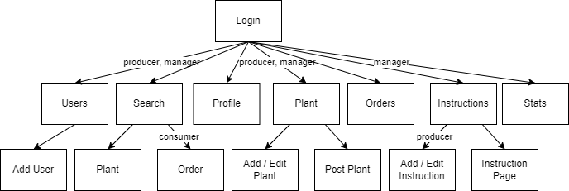

Figure D.1 – Page navigation diagram