Informe Exploratorio — Dataset (No encuesta)

Dataset: Calidad del Aire
Archivo: Calidad del Aire.csv
Fecha: 2026-03-04 16:35

Resumen general
Filas: 9357 | Columnas: 15
Missing global: 4.7% | Duplicados: 45
Numéricas: 15 | Categóricas: 0 | Fechas: 0

Insights automáticos
Filas: 9357, Columnas: 15. Missing global: 4.7%.
Columnas con más faltantes:
• AH: 48.7% missing
• RH: 13.1% missing
• T: 4.7% missing
• S5: 3.9% missing
• S4: 0.8% missing
Correlaciones fuertes (|r| ≥ 0.70):
• CO vs S2: r=0.942
• S1 vs S3: r=0.871
• NMHC vs C6H6: r=-0.717
• CO vs C6H6: r=-0.712

Columnas con más faltantes
Columna | Missing (%)
AH | 48.7%
RH | 13.1%
T | 4.7%
S5 | 3.9%
S4 | 0.8%

Correlaciones fuertes (|r| ≥ 0.70)
Variable A | Variable B | r
CO | S2 | 0.942
S1 | S3 | 0.871
NMHC | C6H6 | -0.717
CO | C6H6 | -0.712

Resumen por variable

Date (numeric)
N total: 9357 | N válido: 9357 | N faltante: 0 (0.0%)
Media: -110.89024259912365 | Mediana: -200.0 | Min: -200.0 | Max: 1189.0 | Std: 148.4549867789031

Time (numeric)
N total: 9357 | N válido: 9357 | N faltante: 0 (0.0%)
Media: 26.54953510740622 | Mediana: 7.0 | Min: -200.0 | Max: 1852.0 | Std: 165.2227486733817

CO (numeric)
N total: 9357 | N válido: 9357 | N faltante: 0 (0.0%)
Media: 276.8726087421182 | Mediana: 7.0 | Min: -200.0 | Max: 1889.0 | Std: 457.0069469103602

S1 (numeric)
N total: 9357 | N válido: 9357 | N faltante: 0 (0.0%)
Media: 645.02340493748 | Mediana: 744.0 | Min: -200.0 | Max: 2214.0 | Std: 490.92708907162944

NMHC (numeric)
N total: 9357 | N válido: 9357 | N faltante: 0 (0.0%)
Media: 389.5367104841295 | Mediana: 273.0 | Min: -200.0 | Max: 2331.0 | Std: 388.8868035630142

C6H6 (numeric)
N total: 9357 | N válido: 9357 | N faltante: 0 (0.0%)
Media: 563.5759324569841 | Mediana: 652.0 | Min: -200.0 | Max: 2683.0 | Std: 483.7778777320203

S2 (numeric)
N total: 9357 | N válido: 9357 | N faltante: 0 (0.0%)
Media: 527.450999251897 | Mediana: 137.0 | Min: -200.0 | Max: 2684.0 | Std: 679.2695095211537

Nox (numeric)
N total: 9357 | N válido: 9357 | N faltante: 0 (0.0%)
Media: 1200.1025969862135 | Mediana: 1268.0 | Min: -200.0 | Max: 2775.0 | Std: 537.3403054283632

S3 (numeric)
N total: 9357 | N válido: 9357 | N faltante: 0 (0.0%)
Media: 655.903174094261 | Mediana: 692.0 | Min: -200.0 | Max: 2523.0 | Std: 600.8119180826801

NO2 (numeric)
N total: 9357 | N válido: 9357 | N faltante: 0 (0.0%)
Media: 7.136047878593566 | Mediana: 12.0 | Min: -200.0 | Max: 84.0 | Std: 43.655894100115255

S4 (numeric)
N total: 9357 | N válido: 9282 | N faltante: 75 (0.8%)
Media: 14.952811893988365 | Mediana: 7.0 | Min: -200.0 | Max: 8288.0 | Std: 115.17929102062558

S5 (numeric)
N total: 9357 | N válido: 8989 | N faltante: 368 (3.9%)
Media: 75.95883858048727 | Mediana: 30.0 | Min: 0.0 | Max: 9827.0 | Std: 573.9079282032508

T (numeric)
N total: 9357 | N válido: 8913 | N faltante: 444 (4.7%)
Media: 410.67609110288345 | Mediana: 3.0 | Min: 0.0 | Max: 9996.0 | Std: 1593.2763523616836

RH (numeric)
N total: 9357 | N válido: 8133 | N faltante: 1224 (13.1%)
Media: 1956.9048321652526 | Mediana: 1.0 | Min: 0.0 | Max: 9989.0 | Std: 3092.6723666960015

AH (numeric)
N total: 9357 | N válido: 4802 | N faltante: 4555 (48.7%)
Media: 4805.041232819658 | Mediana: 4857.0 | Min: 1.0 | Max: 9998.0 | Std: 3091.3818667112714

Gráficos exploratorios
ds10_corr_heatmap.png
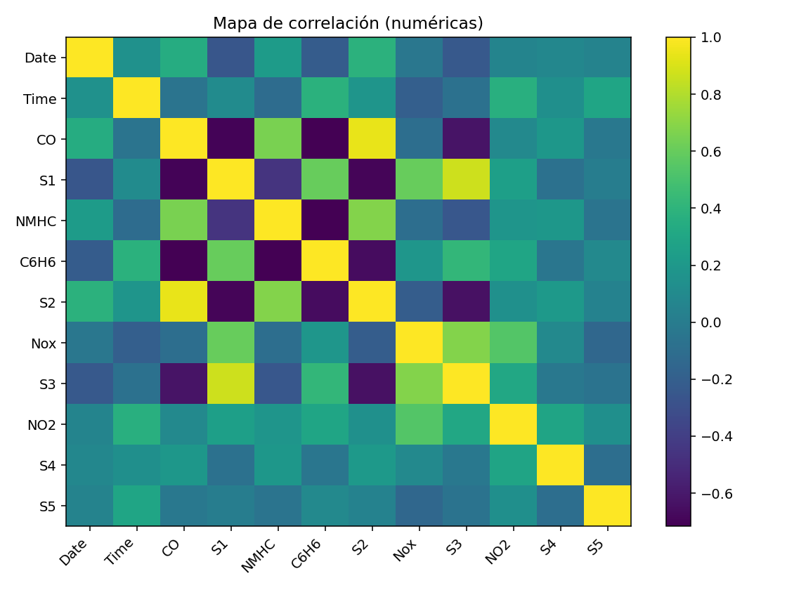

ds10_box_outliers.png
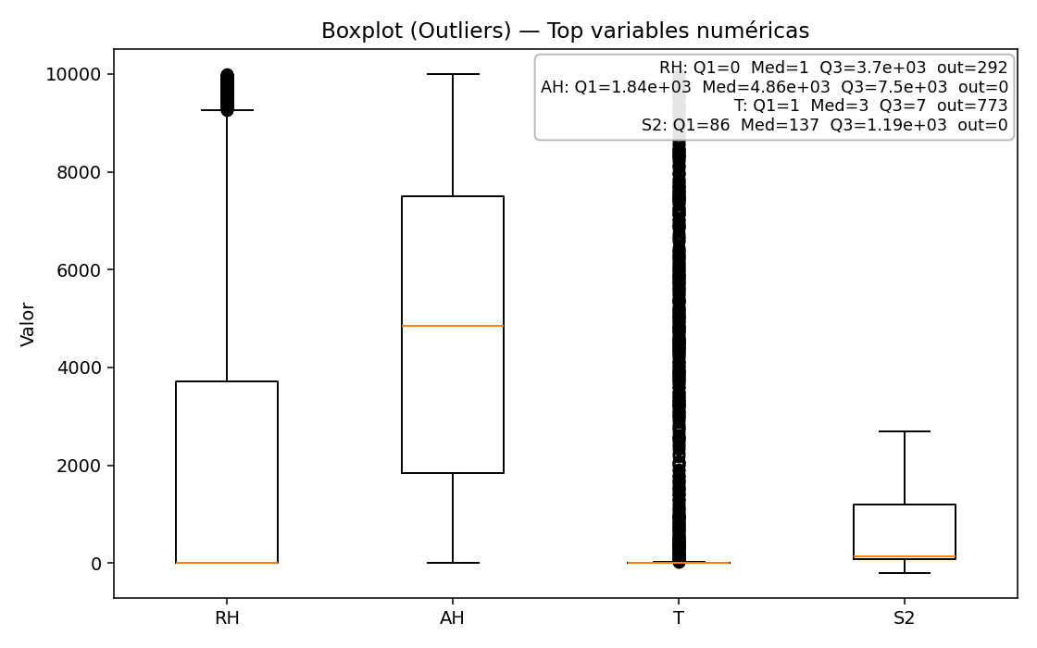

ds10_corr_heatmap.png


ds10_hist_C6H6.png
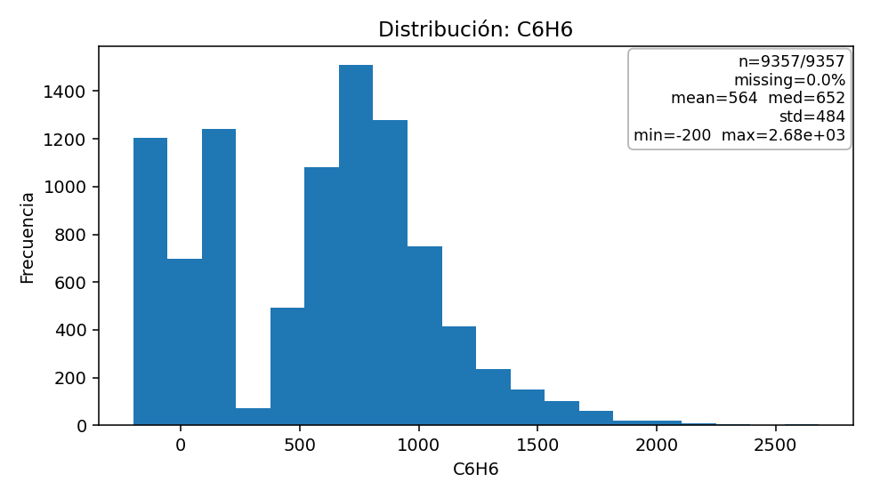

ds10_hist_CO.png
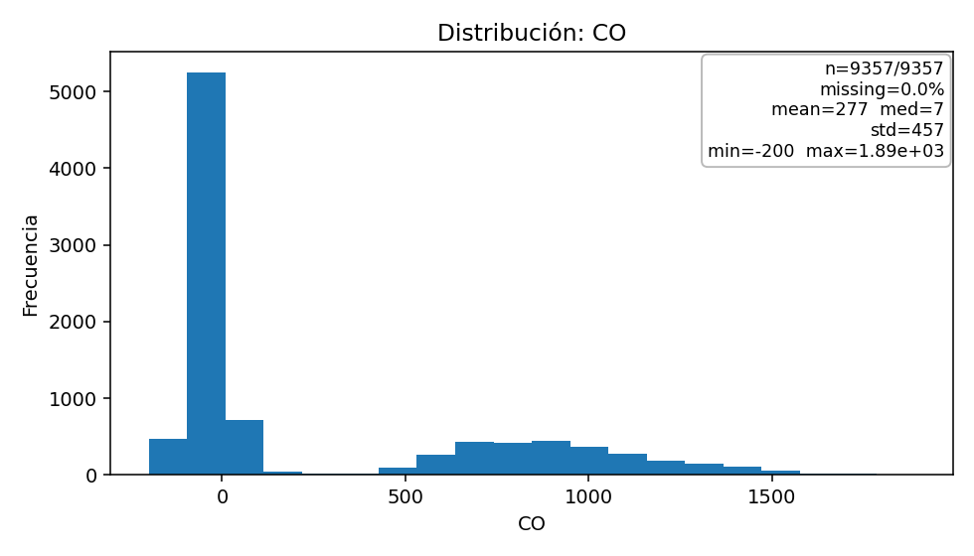

ds10_hist_Date.png
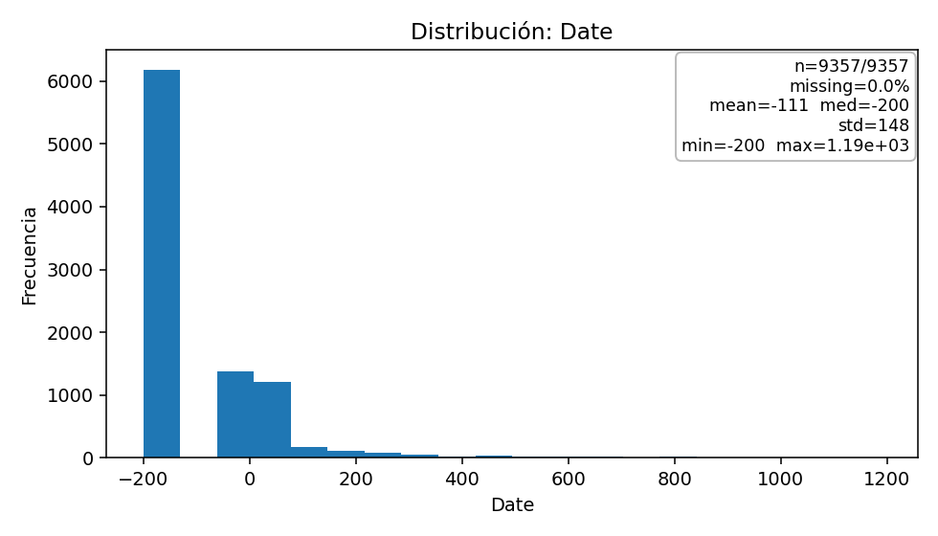

ds10_hist_NMHC.png
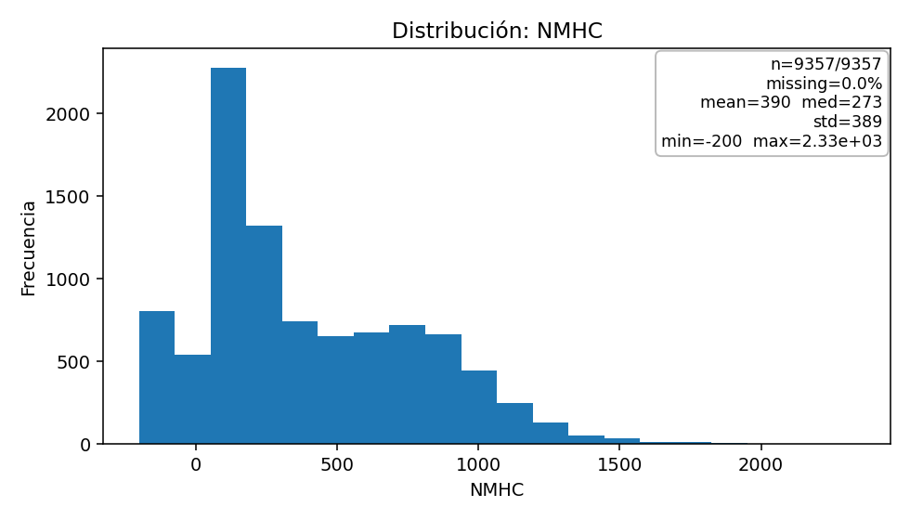

ds10_hist_S1.png
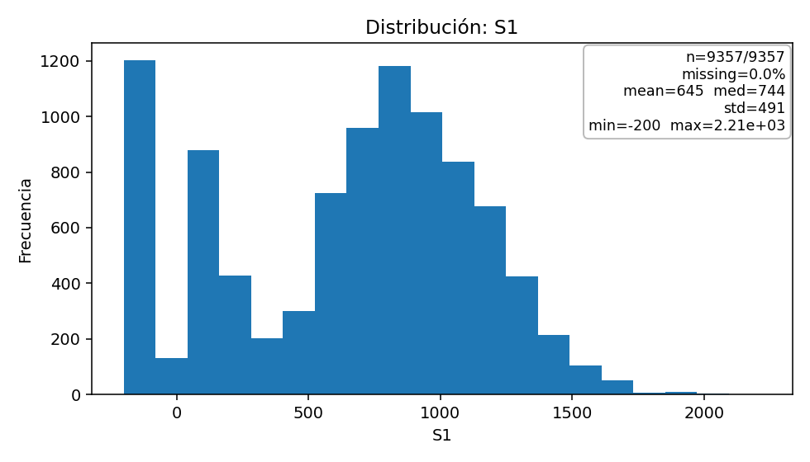

ds10_hist_Time.png
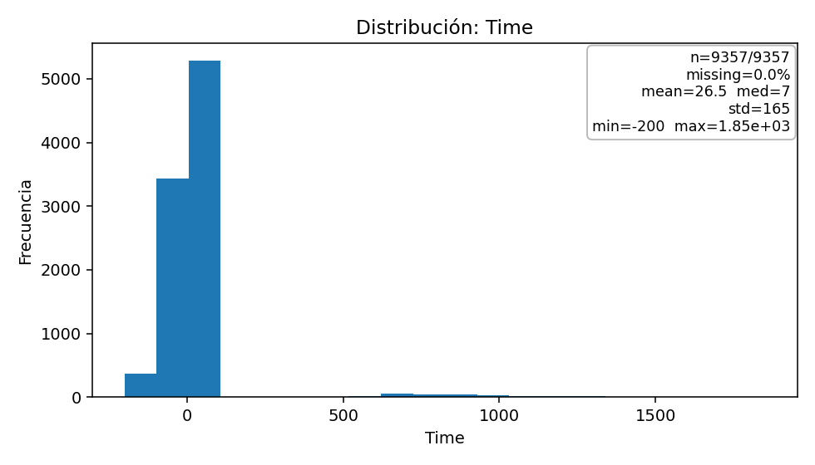

ds10_missing.png
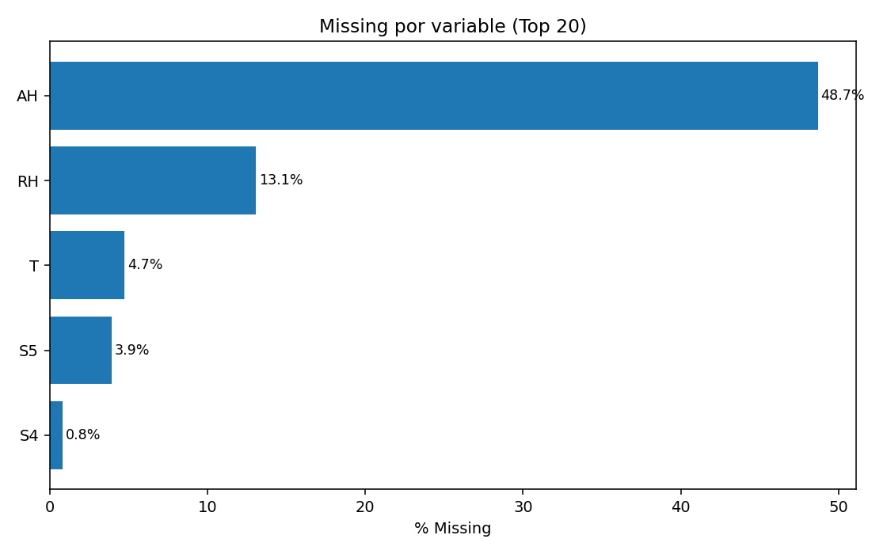

ds10_scatter_CO_vs_C6H6.png
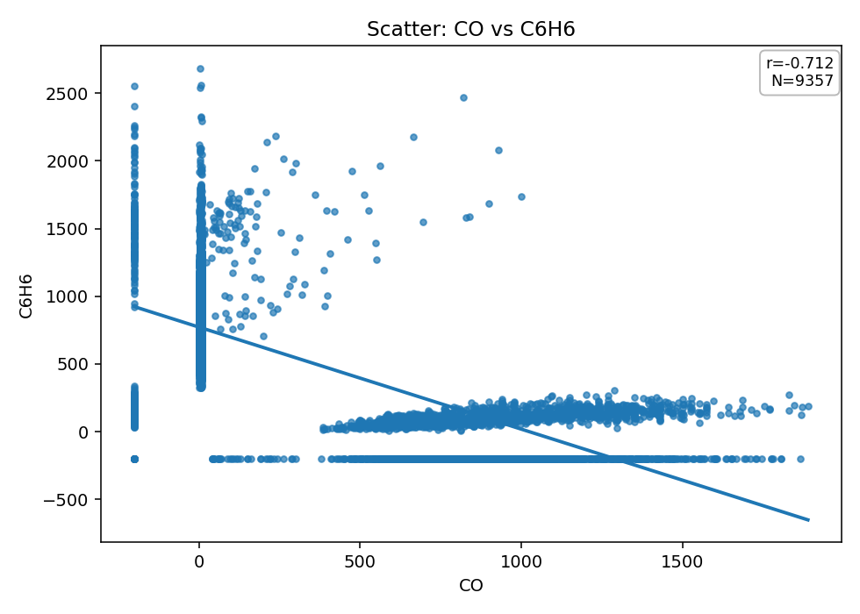

ds10_scatter_CO_vs_S2.png
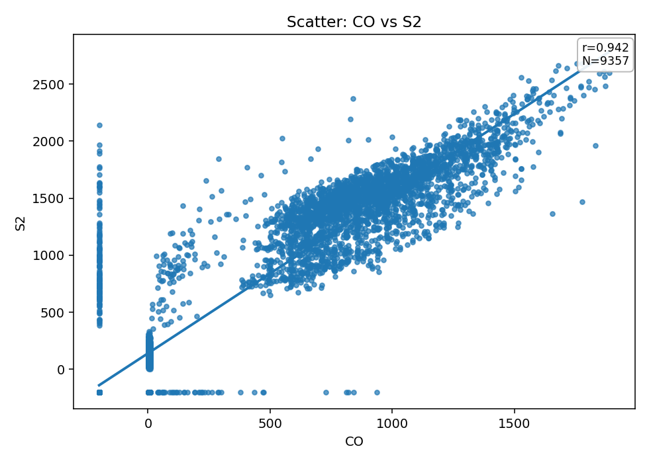

ds10_scatter_NMHC_vs_C6H6.png
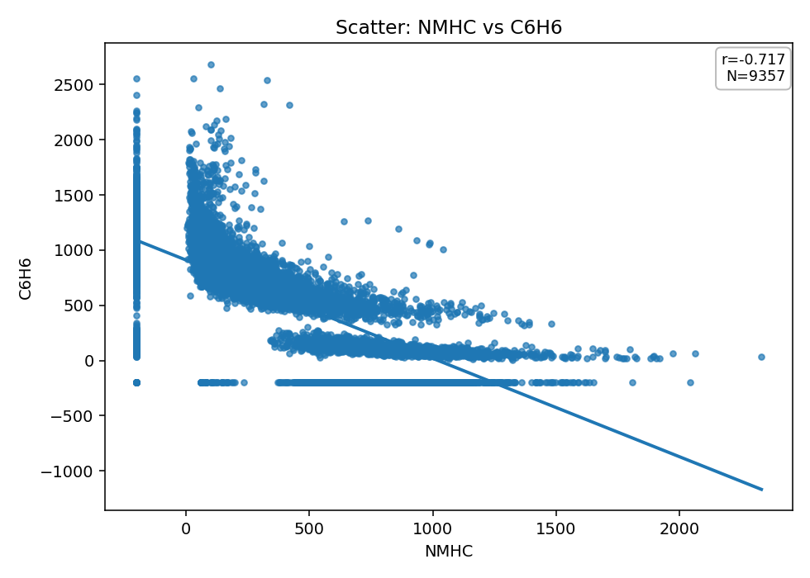

ds10_scatter_S1_vs_S3.png
