Name: Gernene Tan

Matric Number: A0227762Y

Github: <https://github.com/Gernene/OTOT-A1>

Instructions:

A1.1:

1. Enter app directory: cd app
2. Build the image: docker build . -t gernene/otot-a1
3. Run image: docker run -p 49160:8080 -d gernene/otot-a1
4. View localhost:49160

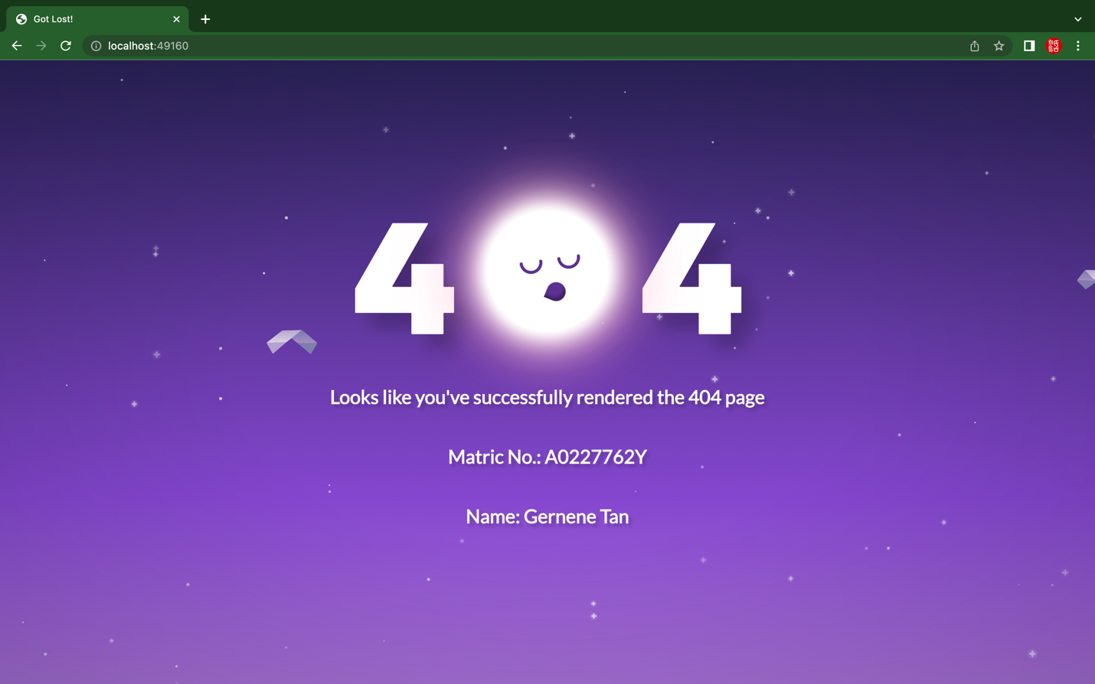

A1.2:

1. Enter directory: cd nginx-sample
2. docker build -t otot-a1-2-nginx-img .
3. docker run --name otot-a1-2 -p 80:80 -d otot-a1-2-nginx-img
4. View localhost:80

A1.3:

1. Enter directory (root of git repo)
2. docker-compose up –build
3. View localhost:5000