Materia Optativa I

Examen Unidad 2. Manejo de errores

NOMBRE: Montes Barreras Luis Geronimo GRUPO: 401

Instrucciones: Puede apoyarse de MSExcel o el Programa con el método BP.

1. Definir los pesos iniciales de la RNA Color (Fondo y Texto).

|  |  |  |  |
| --- | --- | --- | --- |
| **l1>H1** | **l2>H1** | **I3>H1** | **B1>H1** |
| **w1** | **w2** | **w3** | **w4** |
| **-0.07** | **0.22** | **0.35** | **-0.46** |
| **l1>H2** | **l2>H2** | **I3>H2** | **B1>H2** |
| **w5** | **w6** | **w7** | **w8** |
| **0.94** | **0.46** | **0.5** | **0.1** |
| **I1>H3** | **I2>H3** | **I3>H3** | **B1>H3** |
| **w9** | **w10** | **w11** | **w12** |
| **-0.26** | **0.5** | **0.36** | **-0.4** |
| **H1>O1** | **H2>O1** | **H3>O1** | **B2>O1** |
| **w13** | **w14** | **w15** | **w16** |
| **-0.22** | **0.58** | **0.5** | **0.78** |

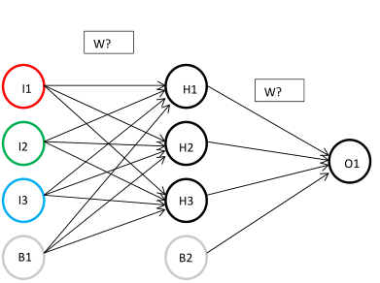

1. **Aplicar el método BackPropagation para entrenar la RNA Color para las entradas y el ideal. Las variables Learning Rate =0.7 y Momentum = 0.3. El entrenamiento concluye cuando el MSE = 0.0006. Defina los nuevos pesos.**

|  |  |  |  |
| --- | --- | --- | --- |
| **l1>H1** | **l2>H1** | **I3>H1** | **B1>H1** |
| **w1** | **w2** | **w3** | **w4** |
| **1.04083391** | **6.10010003** | **-1.2643751** | **-3.449718** |
| **l1>H2** | **l2>H2** | **I3>H2** | **B1>H2** |
| **w5** | **w6** | **w7** | **w8** |
| **0.96458306** | **0.14459189** | **0.59884813** | **0.26223729** |
| **I1>H3** | **I2>H3** | **I3>H3** | **B1>H3** |
| **w9** | **w10** | **w11** | **w12** |
| **-0.5194843** | **-0.5920392** | **0.3784602** | **-0.1444936** |
| **H1>O1** | **H2>O1** | **H3>O1** | **B2>O1** |
| **w13** | **w14** | **w15** | **w16** |
| **-8.5694856** | **0.5767354** | **1.20222947** | **3.49914418** |

1. **Presentar los resultados de O1, E y MSE con la RNA Color.**

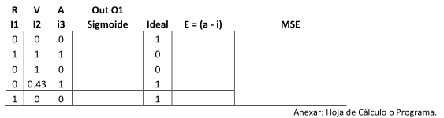

|  |  |  |  |  |  |  |  |  |  |
| --- | --- | --- | --- | --- | --- | --- | --- | --- | --- |
| ENTRADA | | | | | **Out O1** | | **Ideal** | **E =(a - i)** | **MSE** |
|  |
| **I1** | **I2** | **I3** | **B1** | **B2** | **dotProduct** | **Sigmoide** |  |
| **0.00** | **0.00** | **0.00** | **1.00** | **1.00** | 4.119123210 | **0.984001354** | 1 | -0.01599865 | 0.000600285 |  |
| **1.00** | **1.00** | **1.00** | **1.00** | **1.00** | -3.515697286 | **0.02886888** | 0 | 0.02886888 |  |
| **0.00** | **1.00** | **0.00** | **1.00** | **1.00** | -3.769584143 | **0.0225418** | 0 | 0.0225418 |  |
| **0.00** | **0.43** | **1.00** | **1.00** | **1.00** | 3.564453234 | **0.972467064** | 1 | -0.02753294 |  |
| **1.00** | **0.00** | **0.00** | **1.00** | **1.00** | 3.646721872 | **0.974586231** | 1 | -0.02541377 |  |