Hi Adnan,

How have you been.

In this Document I have a set of requirments I need to get done in a blazor wasm app.

I included my project in a repository on github

***My current situation.***

I have a project, blazor wasm client. I want to dynamically change the base href when the application is starts up:

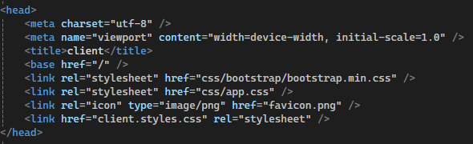

I have in the appsettings.json this:

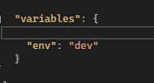

A env variable.

This wasm app Is being hosted on a docker system. With a load balancer is changes to friendly to forexample. /dev/test/index

Dev meaning the env and /test/ meaning the app.

What do I want.?

Well I want the basehref to change according to the env variable.

Forexample: If it’s the dev env, that variable is being read in de appsettings, I want the link to be /dev/test/.

If the env is uat, I want it to change to /uat/test. And if its prd I just want it to say /test/.

I want the navigation to be able to react to these changes as well.

The navigation link should then be, /dev/test/index forexample

