<https://www.eastsensor.com/product/ess3-high-stable-oem-piezoresistive-pressure-sensor/>

[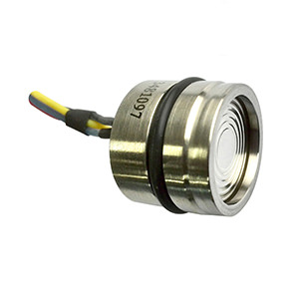](https://eastsensor-51bcgdiywfhf.netdna-ssl.com/wp-content/uploads/ESS319-Universal-Piezoresistive-Pressure-Sensor.jpg)

[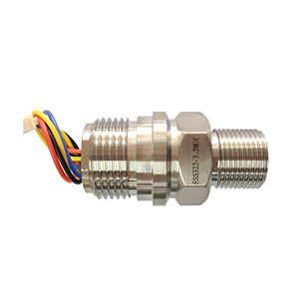](https://eastsensor-51bcgdiywfhf.netdna-ssl.com/wp-content/uploads/ESS322-Welded-Piezoresistive-Pressure-Sensor.jpg)

[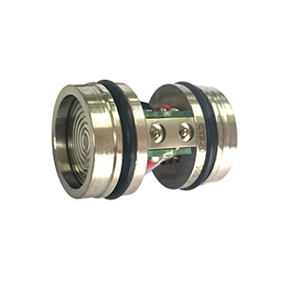](https://eastsensor-51bcgdiywfhf.netdna-ssl.com/wp-content/uploads/ESS320-Differential-Piezoresistive-Pressure-Sensor.jpg)

[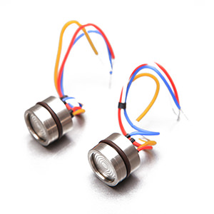](https://eastsensor-51bcgdiywfhf.netdna-ssl.com/wp-content/uploads/ESS312-%CE%A612-Compact-Size-Piezoresistive-Pressure-Sensor-.jpg)

1. 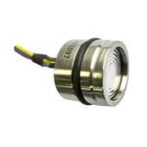
2. 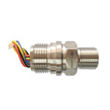
3. 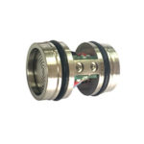
4. 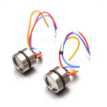

# ESS3 High Stable OEM Piezoresistive Pressure Sensor

Bovenkant formulier

|  |  |
| --- | --- |
| Range |  |
| Pressure Type |  |
| Electric connection | [Clear](https://www.eastsensor.com/product/ess3-high-stable-oem-piezoresistive-pressure-sensor/) |

Onderkant formulier

SKU: N/A Category: [Pressure Sensor](https://www.eastsensor.com/product-category/pressure-sensor/) Tags: [OEM Sensor](https://www.eastsensor.com/product-tag/oem-sensor/), [Piezoresistive Sensor](https://www.eastsensor.com/product-tag/piezoresistive-sensor/), [Pressure Sensor](https://www.eastsensor.com/product-tag/pressure-sensor/)

[Facebook](https://www.eastsensor.com/#facebook)[Twitter](https://www.eastsensor.com/#twitter)[Google+](https://www.eastsensor.com/#google_plus)[LinkedIn](https://www.eastsensor.com/#linkedin)

* [**Description**](https://www.eastsensor.com/product/ess3-high-stable-oem-piezoresistive-pressure-sensor/#tab-description)

* [**Data Sheet Download**](https://www.eastsensor.com/product/ess3-high-stable-oem-piezoresistive-pressure-sensor/#tab-data-sheet-download)

* [**Product Enquiry**](https://www.eastsensor.com/product/ess3-high-stable-oem-piezoresistive-pressure-sensor/#tab-product_enquiry)

## ESS3 High Stable OEM Piezoresistive Pressure Sensor

ESS3 Series OEM Piezoresistive Pressure Sensor is the most economical and stable sensing element for pressure/level measurement process. It has isolated construction and wide range temperature compensation, ESS3 Series OEM Piezoresistive Pressure Sensor uses high stable silicon die to transmit the measured pressure through inner filled silicone oil and SS316 housing which sealed with a concentrically corrugated diaphragm.

With high accuracy, long term stability, good repeatability, ESS3 Series  has been wildly requested by a variety of industry process. We provide different size for ESS3 series with diameter from 11mm to 19mm, height from 5mm to 15mm. [Click here to Download](https://eastsensor-51bcgdiywfhf.netdna-ssl.com/wp-content/uploads/General-Instruction-and-Datasheet-ESS319-GID-3-EV02.pdf) ESS3 Series Data sheet

## Features

* Pressure range -100kPa～10kPa…100MPa
* Gauge, Differential, Absolute, Sealed gauge
* Constant Current/Voltage power supply
* Isolated construction, measure various media
* Φ11~ Φ19mm OEM Pressure Sensor
* Full Stainless Steel 316
* Wide temperature compensation -10℃～80℃
* Long-term stability ±0.1%FS/year

[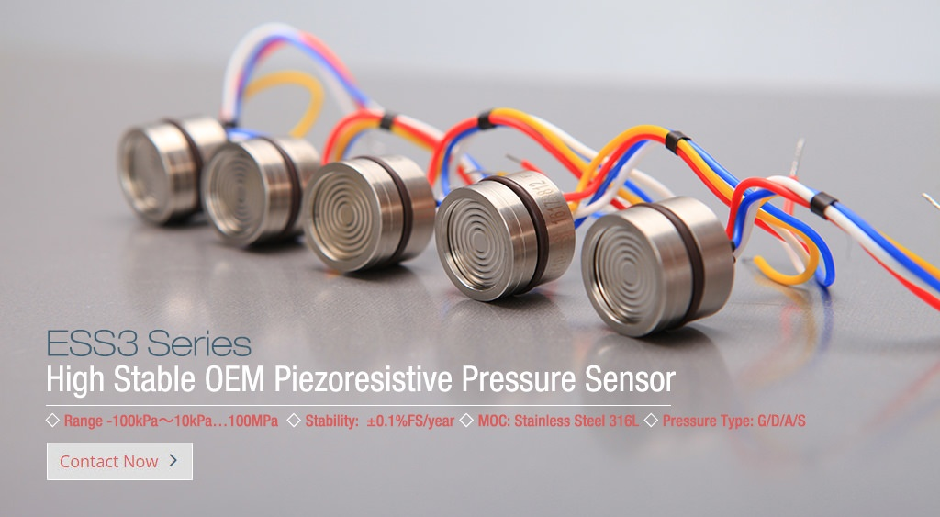](https://www.eastsensor.com/contact-eastsensor/)

| **Measuring Range & Output** | | |  |  |
| --- | --- | --- | --- | --- |
| Range | Overload Pressure | Output/F.S (mV) | Typical Value(mV) | Pressure Type |
| 0~10 kPa | 300% | 35~60 | 45 | G/D |
| 0~20 kPa | 300% | 70~110 | 90 | G/D |
| 0~35 kPa | 300% | 55~80 | 70 | G/A/D |
| 0~70 kPa | 300% | 55~80 | 60 | G/A/D |
| 0~100 kPa | 300% | 60~85 | 75 | G/A/D |
| 0~200 kPa | 300% | 60~85 | 75 | G/A/D |
| 0~400 kPa | 300% | 60~80 | 70 | G/A/D |
| 0~600 kPa | 200% | 90~120 | 100 | G/A/D |
| 0~1.0 MPa | 200% | 125~185 | 150 | G/A/D |
| 0~1.6 MPa | 200% | 80~120 | 100 | G/A/D |
| 0~2.0 MPa | 200% | 50~70 | 60 | G/A/D |
| 0~3.5 MPa | 200% | 100~120 | 110 | G/A/D |
| 0~7.0 MPa | 200% | 120~150 | 135 | A |
|  |  |  |  |  |
|  |  |  |  |  |
|  |  |  |  |  |
|  |  |  |  |  |
|  |  |  |  |  |
| **Notes:**G for Gauge pressure; A for Absolute pressure; D for Differential pressure; S for Sealed gauge. | | |  |  |
| **Technical Parameters - Range -100kPa~100MPa** | | | |  |
| Parameters | | Typ. | Max. | Unit |
| Nonlinearity | | 0.2 | 0.5 | %FS |
| Hysteresis | | 0.05 | 0.1 | %FS |
| Repeatability | | 0.05 | 0.1 | %FS |
| Zero Output | | ±1 | ±2 | mV DC |
| FS output | | 100 |  | mV DC |
| Input/ Output Impedance | | 2.6 | 3.8 | kΩ |
| Zero Temperature Drift* | | ±0.15 | ±0.8 | %FS,@25℃ |
| Sensitivity Temperature Drift* | | ±0.2 | ±0.7 | %FS,@25℃ |
| Long-term Stability | | 0.1 |  | %FS/year |
| *The typical value of 0~10kPa & 0~20kPa's zero temperature drift is 0.4%FS@25℃, max value is 1.6%FS@25℃ | | | |  |
| *The typical value of 0~10kPa & 0~20kPa's sensitivity temperature drift is 0.4%FS@25℃, max value is 1.6%FS@25℃ | | | |  |

| **Construction Performance** | |
| --- | --- |
| Diaphragm | Stainless Steel 316L |
| Housing | Stainless Steel 316L |
| Pressure leading tube | Stainless Steel 316L |
| O Ring | Φ16*1.8mm(nitrile rubber or viton) |
| Measuring Medium | Which is compatible with SS316L, viton, nitrile rubber |
| Packing Medium | Silicon Oil |
| Net weight | 36g |
| **Electric & Environment Performance** | |
| Power supply | 1.5mA (Max input voltage is 10VDC) |
| Insulation Resistance | 500MΩ@500VDC |
| Overpressure | 1.5~3 times FS |
| Vibration(20~500Hz) | 20G |
| Useful Time(25℃) | >1*100 Million Times @Pressure Circulation(80%FS) |
| Response Time | ≤1ms |
| Storage Temp. | -40~+125℃ |
| Operating Temp. | -40~+85℃ |
| Compensation Temp. | 0~50℃; -10~80℃ |