Twenty Years of ijCSCL: A Computational Trend Analysis (2006–2025)

1) Project overview
This project analyzed the International Journal of Computer-Supported Collaborative Learning (ijCSCL) corpus across two decades using a reproducible pipeline that combines language-model coding with statistical trend testing. The goal was to characterize how the journal's thematic, methodological, and conceptual profile changed over time.
The workflow produced standardized article summaries, semantic embeddings, unsupervised clusters, category labels, six-dimension primary/secondary coding, and multiple trend-significance analyses.

2) Data and scope
The working corpus contains 470 articles (including editorials). For trend analyses, editorials were excluded to reduce confounding from front-matter changes. Most statistical trend tests were run on non-editorial records from 2006–2025, yielding 20 yearly data points.

3) Summary generation
Summaries were used as a normalized representation of each article for coding and semantic analysis.
Summarization prompt used in the pipeline:
You are an expert in computer-supported collaborative learning. Write a concise 50-60 word summary of the article's central claim or finding. Focus on the main research question, method type, and conclusion. Do not mention that you are summarizing. Return only the summary text.

4) Embedding semantic vectors and clustering
Article summaries (summary_haiku) were embedded with all-MiniLM-L6-v2 (384 dimensions). KMeans clustering was applied, and silhouette-based model selection identified k=2 as the strongest global split, with useful secondary granularity near k=7.
Cluster trend outputs were generated as yearly line charts and tabular counts, including dedicated exports for k=2, k=5, and k=7 analyses.

Interpretive themes in the seven-cluster solution (k=7)
Cluster IDs 0–6 are arbitrary numeric labels, not ranked categories. Interpretations are inferred from article titles and summary_haiku, not from stored cluster names.
- 0 (68): collaborative knowledge building and assessment—knowledge-building communities, inquiry, portfolios, reflective assessment, analytics.
- 1 (105): teacher support and orchestration—dashboards, group awareness, engagement monitoring, regulation, scaffolding.
- 2 (31): collaboration scripts and learner regulation—script design, learner appropriation/adaptation, guidance.
- 3 (75): online discourse and argumentation—dialogic/argumentative discussion, perspective-taking, discourse analysis.
- 4 (94): CSCL field and foundations—editorials, foundational concepts, methodologies, controversies, field development.
- 5 (60): embodied and immersive collaboration—gestures, spatial interaction, AR/MR, place-based learning.
- 6 (37): collaborative mathematics learning—geometry, algebra, mathematical discourse/argumentation, worked examples and scaffolding.
Caveat: cluster sizes are uneven, and clusters 2 and 6 are small. Cluster 4 includes many editorials/field discussions, while cluster 6 has some heterogeneous records; these labels are interpretive summaries, not exhaustive definitions.

5) Category coding
Legacy categories were recomputed using summary_haiku via Claude Haiku with explicit support for a new category g (CSCL theory). A rule-based override assigned category e to any article with a non-null editorial field.
Final category counts after reclassification: a=105, b=58, c=116, d=52, e=83, f=1, g=55.

Interpreting the category codes
Appendix A provides the canonical definitions; those are the formal coding meanings. The following profiles summarize how the categories manifest in this corpus, and the categories are broader than narrow topic clusters.
- a (105): design of collaboration; often scripts, orchestration, and adaptive pedagogical support.
- b (58): design of technology to support learning; tools, interfaces, scaffolds, feedback.
- c (116): analysis of interaction among students; discourse, interaction processes, distributed cognition, knowledge construction.
- d (52): measurement of learning; outcomes, assessment, comparisons, analytics/computational measures.
- e (83): editorial; predominantly editorial or field-level/conceptual pieces, with a small number of other record types.
- f (1): none of the above; one correction/erratum in the current corpus.
- g (55): CSCL theory; theoretical, methodological, philosophical, or framework-oriented work.
Category profiles are corpus tendencies, not mutually exclusive subjects. Category e is mostly editorial, category f has just one record, and a–g are categorical codes, not cluster IDs.

6) Six-dimension coding (primary and secondary)
Each article was coded across six dimensions: methodology, unit of analysis, pedagogy, technology, theory, and AI/LLM involvement. For each dimension, one primary value and up to two secondary values were assigned from controlled taxonomies, along with evidence_span, coding_confidence, and coding_notes.
Coding used summary_haiku as the primary source, with full-text fallback when needed. All 470 articles were successfully coded and written back to the canonical store.

7) Trend analyses conducted
- Linear count trends with multiple-testing correction (BH-FDR).
- Linear share trends (proportion per year) with BH-FDR correction.
- Mann–Kendall monotonic trend tests with Theil–Sen robust slope estimation.
- Segmented regression (era-sensitive piecewise slopes, with knots at 2016 and 2020).
- Embedding drift analysis via centroid cosine distance and within-year semantic dispersion.
- Editor-era transition diagnostics using chi-square distribution tests across eras.

8) Main findings and significance
Across robust, FDR-controlled tests, two convergent longitudinal trends were identified: (1) decline in methodology_primary = ethnographic_case_study, significant in count-based, share-based, and Mann–Kendall/Theil–Sen analyses; and (2) increase in cluster_haiku_summary = 1, significant in share-based and Mann–Kendall/Theil–Sen analyses.
Embedding-based measures showed only modest, non-monotonic change in the corpus's average semantic content: distance from the 2006 baseline rose slightly through 2023 but returned to earlier levels by 2025. Because no significance test was applied and yearly samples are small, this is weak, suggestive evidence at most.

9) Interpretation
The combined evidence suggests a gradual methodological and thematic reconfiguration of the ijCSCL corpus over the 20-year period. The strongest quantitative evidence points to reduced prevalence of ethnographic-case-study labeling and increased prevalence of one dominant semantic cluster profile. Era transition checks further indicate shifts in method, pedagogy, and technology distributions aligned with editorial periods, though these remain exploratory unless confirmed in fully preregistered models.

10) Limitations and next steps
Because the coding pipeline uses model-assisted labels, reliability checks remain important. Recommended next steps include human adjudication on a stratified sample, compositional trend models for share data, formal change-point models at editor transitions, and expanded embedding-drift diagnostics with confidence intervals.

Appendix A. Coding options
Legacy category coding (single letter):
- a = design of collaboration
- b = design of technology to support learning
- c = analysis of interaction among students
- d = measurement of learning
- e = editorial
- f = none of the above
- g = CSCL theory

Appendix B. Dimension taxonomy (controlled values)

ai_llm_involvement (ai_llm_involvement)
Order | Option | Gloss
1 | none | No AI or LLM involvement in the study design or technology
2 | ai_supported_non_llm | AI mechanisms used (e.g., rule-based agents, recommender systems, ML classifiers) but not LLMs
3 | llm_supported_writing | LLM used by participants to draft, edit, or generate text
4 | llm_supported_feedback | LLM provides automated formative feedback to learners
5 | llm_supported_assessment | LLM used to score, classify, or evaluate learning artifacts
6 | llm_supported_orchestration | LLM acts as a conversational agent, tutor, or discussion partner
7 | llm_supported_analytics | LLM or AI used for analysis, coding, or pattern detection in research
8 | llm_as_learning_partner | LLM is the primary collaborator or interlocutor for learners
9 | other | Does not fit any above; explain in coding_notes

methodology (analysis_methodology)
Order | Option | Gloss
1 | descriptive_statistics | Frequencies, means, distributions; no inferential testing
2 | inferential_statistics | Hypothesis testing, ANOVA, regression, correlation with significance
3 | multilevel_modeling | Hierarchical or mixed-effects models accounting for nested data
4 | social_network_analysis | Graph-based analysis of interaction ties and centrality
5 | discourse_analysis | Linguistic or rhetorical analysis of talk and text
6 | interaction_analysis | Micro-analytic coding of moment-by-moment collaborative episodes
7 | computational_linguistics_nlp | Automated text processing: topic models, embeddings, NLP pipelines
8 | sequence_process_mining | Temporal or sequential pattern extraction from log/trace data
9 | learning_analytics | Trace data from digital platforms used to model or predict learning
10 | experimental_quasi_experimental | Controlled or quasi-controlled comparison of conditions or groups
11 | design_based_research | Iterative design and study of an intervention in naturalistic settings
12 | ethnographic_case_study | In-depth qualitative study of a bounded context with observation or interview
13 | mixed_methods | Combines quantitative and qualitative data collection and analysis
14 | content_analysis | Systematic coding of documents, posts, or artifacts using a scheme
15 | other | Does not fit any above; explain in coding_notes

pedagogy (pedagogical_approach)
Order | Option | Gloss
1 | knowledge_building | Scardamalia & Bereiter model: community-driven idea improvement
2 | collaboration_scripts | Structured roles, turn sequences, or scripts regulating collaboration
3 | inquiry_problem_based_learning | Open-ended questions or problems drive learning activity
4 | argumentation | Explicit construction, critique, or negotiation of claims and evidence
5 | peer_review_feedback | Students give or receive structured feedback on each other's work
6 | teacher_orchestrated_discussion | Teacher actively shapes whole-class or small-group dialogue
7 | self_peer_regulation | Students monitor, plan, or regulate their own or each other's learning
8 | community_of_practice | Learning through participation in an authentic professional community
9 | other | Does not fit any above; explain in coding_notes

technology (technological_support)
Order | Option | Gloss
1 | asynchronous_forum | Discussion boards, blogs, or thread-based tools used across time
2 | synchronous_chat_video | Real-time text chat, video conferencing, or live messaging
3 | wiki_knowledge_base | Collaboratively edited knowledge repositories (e.g., Knowledge Forum, wikis)
4 | shared_workspace_canvas | Co-editing tools, shared whiteboards, or collaborative document spaces
5 | tabletop_tangible_interface | Physical or tangible computing surfaces supporting face-to-face collaboration
6 | awareness_dashboard | Tools that display group activity or progress to learners or teachers
7 | collaboration_scripting_tools | Software that enacts roles, sequences, or prompts for structured collaboration
8 | multimodal_sensors_eye_tracking | Physiological, gaze, gesture, or movement sensors capturing embodied interaction
9 | none_minimal_technology | Technology is not the focus; collaboration is face-to-face or technology-peripheral
10 | other | Does not fit any above; explain in coding_notes

theory (theoretical_framework)
Order | Option | Gloss
1 | sociocultural | Vygotsky-lineage: learning as socially and culturally mediated activity
2 | dialogic | Bakhtin-lineage: meaning made through multi-voiced dialogue and uptake
3 | socio_cognitive | Piaget-influenced: collaborative conflict and explanation drive cognitive change
4 | knowledge_building_theory | Scardamalia & Bereiter: progressive discourse advances collective knowledge
5 | activity_theory | Engeström: contradictions within activity systems drive development
6 | communities_of_practice | Lave & Wenger: learning through legitimate peripheral participation
7 | distributed_cognition | Hutchins: cognition is spread across people, artifacts, and environment
8 | information_processing | Cognitive load, working memory, schema; individual mental architecture
9 | critical_pragmatic | Power, equity, or justice lens on participation and knowledge
10 | other | Does not fit any above; explain in coding_notes

unit_of_analysis (unit_of_analysis)
Order | Option | Gloss
1 | individual_learner | Outcomes or behaviors of single students
2 | dyad_small_group | Pairs or groups of 2–6 collaborating learners
3 | classroom_cohort | A whole class or cohort treated as the analytical unit
4 | teacher_facilitation | Teacher moves, awareness, or orchestration decisions
5 | community_network | Large-scale community, online network, or population of actors
6 | artifact_discourse_trace | Documents, posts, scripts, or logs analyzed as the primary object
7 | cross_level_multilevel | Simultaneously analyzes individual and group (or group and class) levels
8 | other | Does not fit any above; explain in coding_notes

Appendix C. Significant trend results (summary)
Family | Field | Value | Direction | Effect | q (FDR)
count_linear | methodology_primary | ethnographic_case_study | down | slope=-0.1579 | 0.02306
embedding_drift | embedding_haiku_summary | centroid_distance_to_2006 | up | 2006=0; 2025=0.09785; delta=0.09785
mann_kendall_theilsen | cluster_haiku_summary | 1 | up | tau=0.5752; theil=0.01317 | 0.01981
mann_kendall_theilsen | methodology_primary | ethnographic_case_study | down | tau=-0.5669; theil=-0.007946 | 0.01981
share_linear | methodology_primary | ethnographic_case_study | down | share_slope=-0.007861 | 0.02366
share_linear | cluster_haiku_summary | 1 | up | share_slope=0.01361 | 0.03447

Appendix D. Non-editorial and non-erratum trends (2006-2025)
These figures exclude records marked as editorial, corrected, or book review, records with article number 0, and category e/f records. The category chart shows annual shares; the other charts show annual counts or embedding distances.

Category share by year
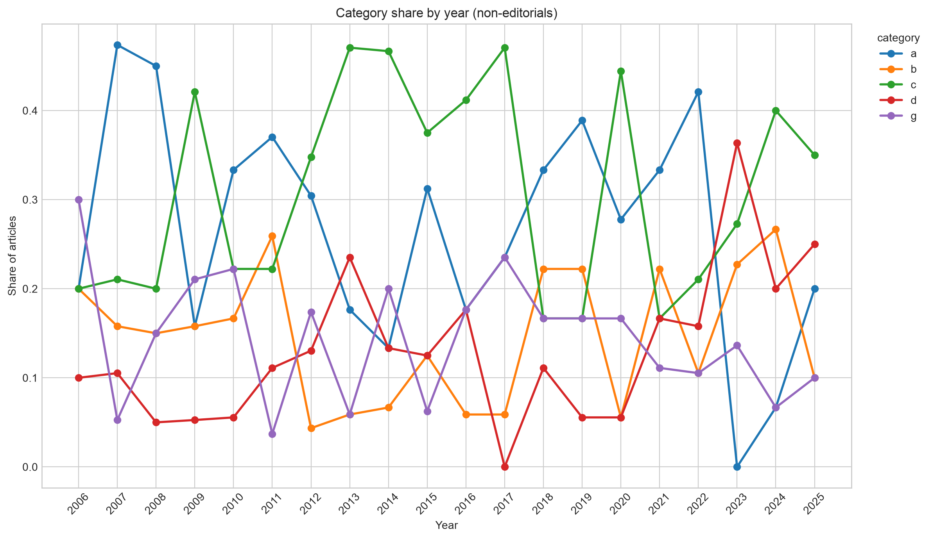

Semantic cluster counts by year (k=7)
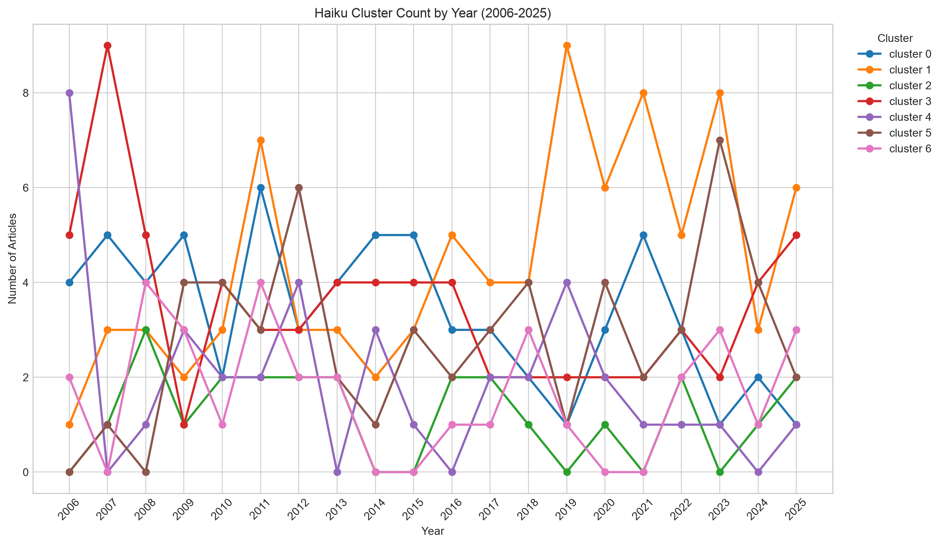

Primary methodology by year
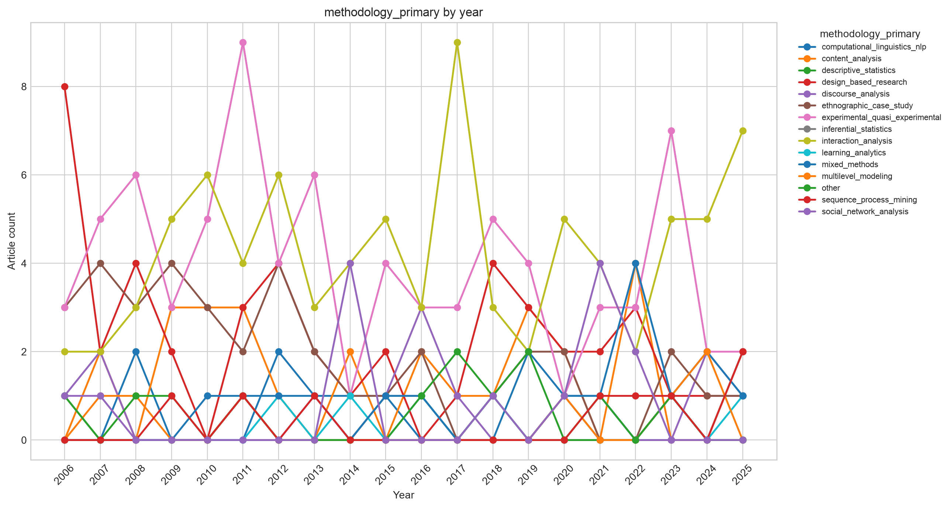

Primary unit of analysis by year
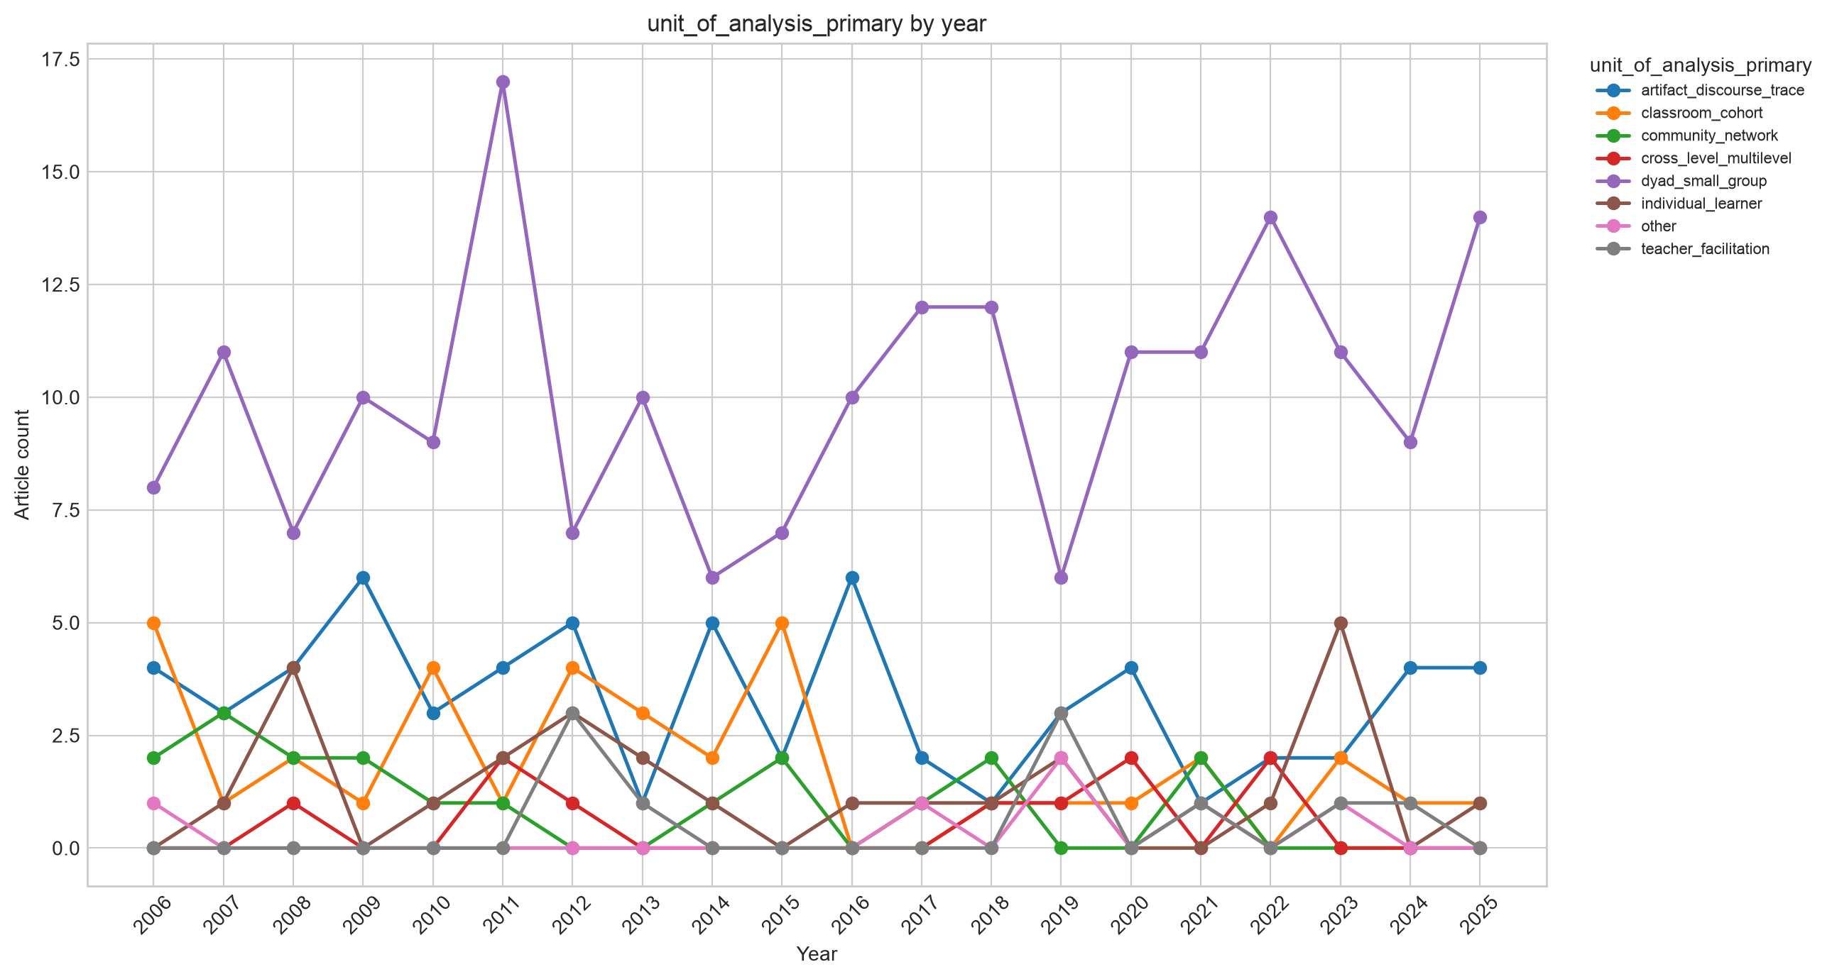

Primary pedagogy by year
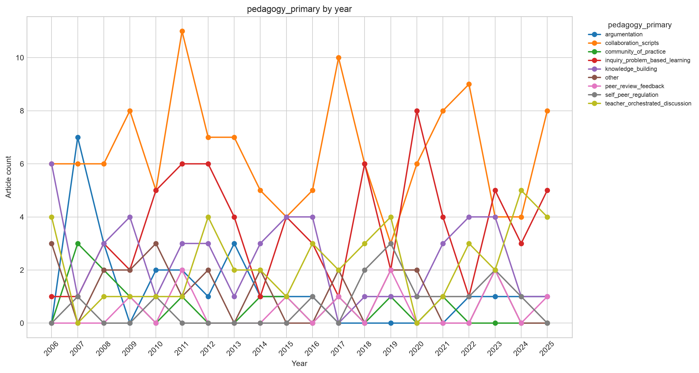

Primary technology by year
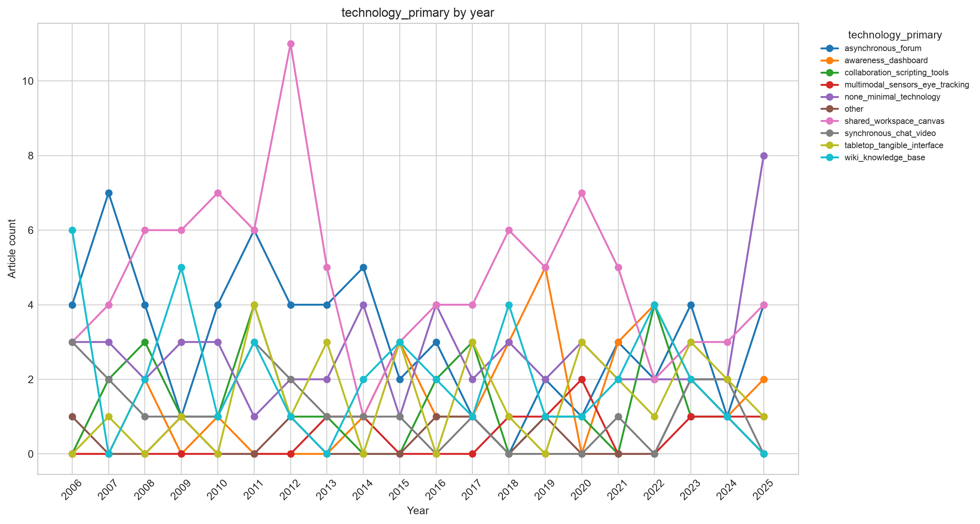

Primary theoretical framework by year
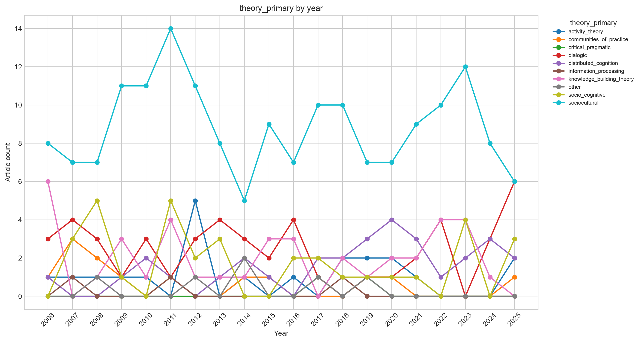

Primary AI/LLM involvement by year
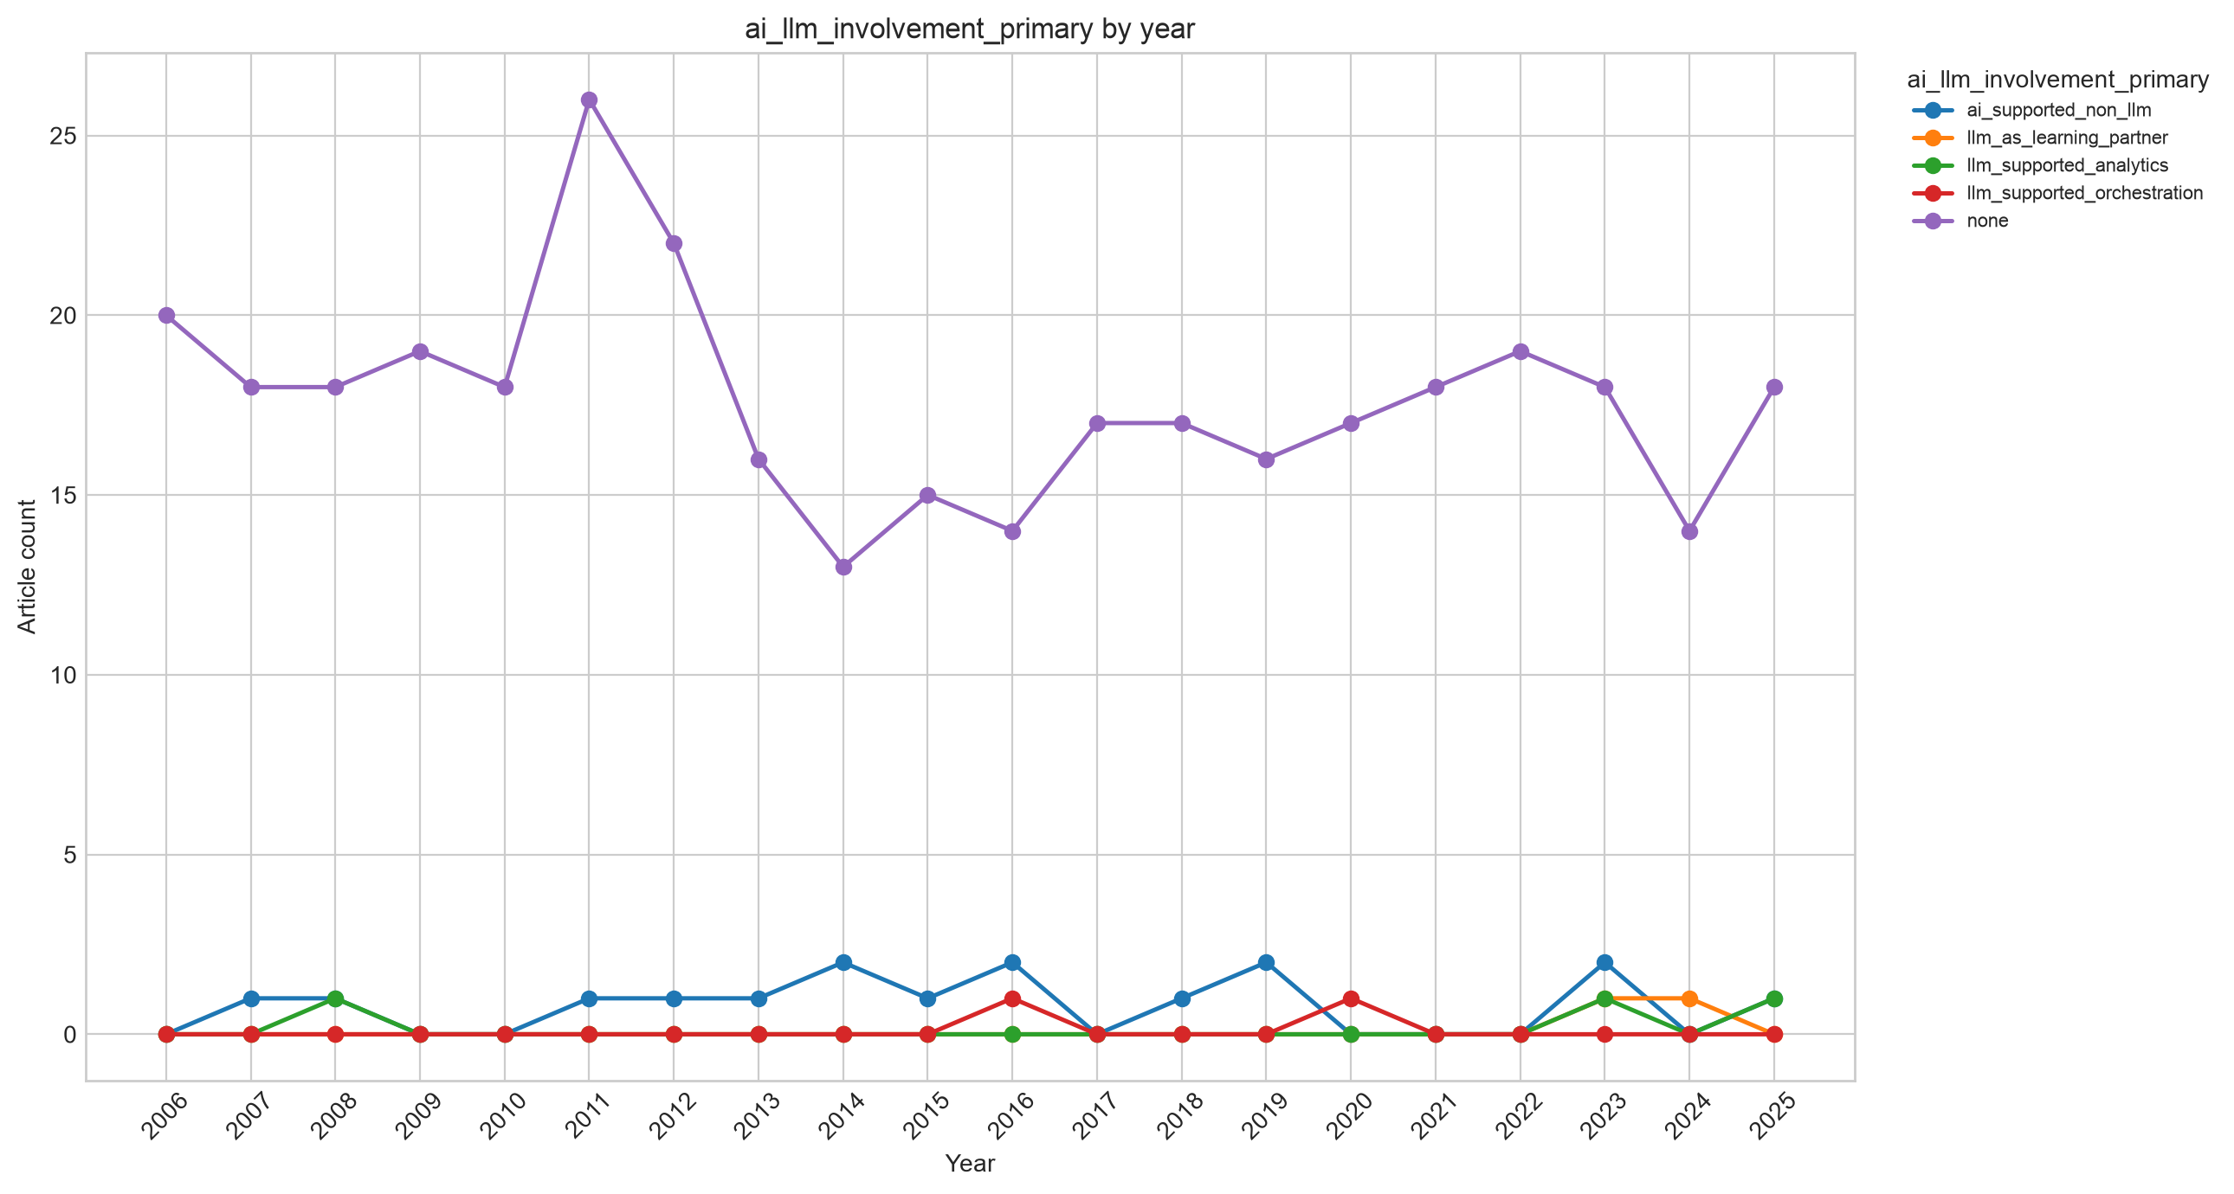

Embedding drift indicators by year


