ACTU302_ID.R
GERSHON TETTEH YAW
2024-07-18
### (a). Descriptive statistics
### reading dataset into r
library(openxlsx)
data <- read.xlsx("Raw dataset.xlsx")
#library(readxl)
#data <- read_excel("Raw dataset.xlsx")
# selecting the average wind speed variable
windspeed <- na.omit(data$μ)
summary(windspeed)
## Min. 1st Qu. Median Mean 3rd Qu. Max.
## 0.925 1.875 2.392 2.637 3.400 6.400
hist(windspeed,
main = "",
xlab = "Mean annual wind speed, μ, in m/s")
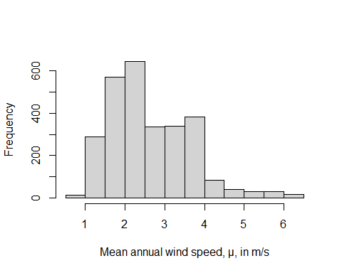
par(mar = c(4,4,1,1))
boxplot(windspeed,
ylab = "Mean annual wind speed, μ, in m/s")
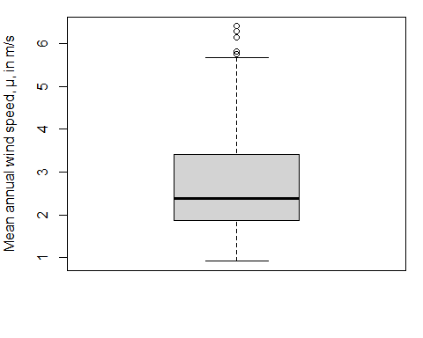
### (b) log-likelihood function
log_likelihood <- function(x,parameters)
{
alpha <- parameters[1]; s <- parameters[2]
pdf <- ((alpha*x^(alpha-1))/s^alpha)*exp(-(x/s)^alpha)
log_like <- sum(log(pdf))
return(-log_like)
}
### (c) Fitting the Weibull distribution to the sample data on wind speed.
weibull.fit <- optim(par = c(2,3),
fn = log_likelihood,
method = "Nelder-Mead",
x = windspeed);weibull.fit
## $par
## [1] 2.766691 2.964861
##
## $value
## [1] 3900.877
##
## $counts
## function gradient
## 49 NA
##
## $convergence
## [1] 0
##
## $message
## NULL
### (d) Exceedance probabilities
alpha <- weibull.fit$par[1]
s <- weibull.fit$par[2]
pweibull(q =6,shape = alpha,scale = s,lower.tail = FALSE)
## [1] 0.0008840947
exceed.prob <- exp(-(6/s)^alpha)
emp_exceed.prob <- length(windspeed[windspeed>6])/length(windspeed)
### (e) supperimposing densities on the histogram of the average wind speed data
hist(windspeed,
main = "",
xlab = "Mean annual wind speed, μ, in m/s",
freq = FALSE)
### for normal
x<- sort(windspeed)
lines(x,
y = dnorm(x ,
mean = mean(x),
sd = sd(x)),
col = "red",
lwd = 2)
wei.density <- ((alpha*x^(alpha-1))/s^alpha)*exp(-(x/s)^alpha)
lines(x,
y = wei.density,
col = "blue",
lwd = 2)
legend("topright",legend = c("Normal","Weibull"), col = c("red","blue"),lwd = c(2,2))
