ACTU_302_10967696.R
2024-07-18
### (a) reading the dataset into r
#install.packages("openxlsx")
library(openxlsx)
data <- read.xlsx("Raw dataset.xlsx")
### Displaying few observations
head(data)
## Code Group Family Species P50 KS AL/.AS D
## 1 510 Gym Pinaceae Abies alba -3.710000 NA NA 20.42761
## 2 622 Gym Pinaceae Abies balsamea NA 0.2200855 0.2136752 20.00000
## 3 965 Gym Pinaceae Abies balsamea -1.995803 3.2118270 NA 28.97518
## 4 2055 Gym Pinaceae Abies concolor -4.831500 NA NA NA
## 5 2540 Gym Pinaceae Abies fabri NA NA 0.6330156 NA
## 6 2560 Gym Pinaceae Abies fabri NA NA 0.4769127 NA
## WD Height μ MAT MAP VPD MI TS
## 1 0.4581269 30.0 3.283333 9.5506667 707 0.5621208 0.9201 581.9456
## 2 NA 2.0 2.700000 7.4136667 1078 0.5221427 1.0586 1001.7569
## 3 0.4467858 1.5 3.250000 2.6071667 486 0.3867455 0.6551 1095.9092
## 4 NA NA 3.425000 6.0613333 533 1.0478634 0.6447 818.5885
## 5 NA NA 2.091667 3.6983334 847 15.3554876 0.9333 618.9011
## 6 NA NA 2.300000 0.7773333 828 15.3554876 0.9958 691.6901
## PS MTCM PDM Latitude Longitude
## 1 27.566586 -3.024 37 45°43' N 3°3' E
## 2 9.327823 -13.848 70 42°53' N 72°19' W
## 3 68.913518 -20.428 15 53°25' N 113°45' W
## 4 19.860021 -11.524 29 40°48' N 111°46' W
## 5 93.378892 -9.944 5 29°25'N 101°55'E
## 6 92.748188 -13.508 4 29°22'N 101°55'E
## References
## 1 Cochard, 2006, Comptes Rendus Physique
## 2 Ewers & Zimmermann, 1984a, Physiologia Plantarum
## 3 Hacke & Jansen, 2009, New Phytologist
## 4 Sperry & Ikeda, 1997, Tree Physiology
## 5 Xu, 2020, New Phytologist
## 6 Xu, 2020, New Phytologist
## Location Country
## 1 Clermont-Ferrand France
## 2 Petersham, Massachusetts (MA) USA
## 3 25 km southwest of Edmonton Canada
## 4 Utah USA
## 5 Sichuan province China
## 6 Sichuan province China
windspeed <- data$μ
head(windspeed)
## [1] 3.283333 2.700000 3.250000 3.425000 2.091667 2.300000
### Descriptive statistics
#install.packages("psych")
library(psych)
describe(windspeed)
## vars n mean sd median trimmed mad min max range skew kurtosis se
## X1 1 2780 2.64 1.01 2.39 2.56 0.99 0.93 6.4 5.48 0.84 0.72 0.02
hist(windspeed,
main = "")
### (b) loglikelihood function
log_likelihood <- function(x,parameters)
{
alpha <- parameters[1];s <- parameters[2]
survival <- exp(-((x/s)^alpha))
pdf <- (alpha*x^(alpha-1)/(s^alpha))*(exp(-((x/s)^alpha)))
log_lik <- sum(log(pdf))
return(-log_lik)
}
### (c) Fiting the Windspeed data to the Weibul distribution
### Taking off the NA responses from the windspeed
windspeed <- windspeed[!is.na(windspeed)]
mle <- optim(par = c(2,3),
fn = log_likelihood,
method = "Nelder-Mead",
x = windspeed);mle
## $par
## [1] 2.766691 2.964861
##
## $value
## [1] 3900.877
##
## $counts
## function gradient
## 49 NA
##
## $convergence
## [1] 0
##
## $message
## NULL
### (d)
alpha <- mle$par[1];s <- mle$par[2]
exceed_prob <- exp(-((6/s)^alpha))
emp_exceed_prob <- length(windspeed[windspeed>6])/length(windspeed)
### For normal
lines(x = sort(windspeed),
pnorm(q = sort(windspeed),mean = mean(windspeed),sd = sqrt(var(windspeed))),
lwd = 2,
col = "red")
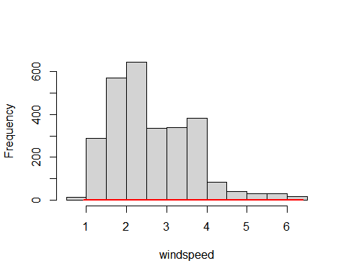
### for Weibil
density <- 1 - exp(-((sort(windspeed)/s)^alpha))
#lines(x = sort(windspeed,
# y = density))

