ACTU 302 ASSIGNMENT
ID: 10844471
2025-07-31
### Question 1
library(insuranceData)
data("AutoClaims")
### Sampling 200 observations
set.seed(321)
Autoclaim_sampled <- AutoClaims[sample(x = 1:nrow(AutoClaims),size = 200,replace = FALSE),]
head(Autoclaim_sampled)

## STATE CLASS GENDER AGE PAID
## 5302 STATE 15 C11 F 54 473.25
## 4082 STATE 07 C7B M 58 5696.74
## 333 STATE 12 C1B F 83 2683.16
## 1017 STATE 01 C6 F 77 422.30
## 5976 STATE 06 C1A F 52 90.64
## 5072 STATE 06 C7A F 54 7312.72
### Fitting the gamma distribution
Estimates <- function(x, parameters)
{
alpha <- parameters[1];beta <- parameters[2]
Moment <- function(x)
{
alpha <- (mean(x)^2)/var(x)
beta <- mean(x)/var(x)
mom <- c(alpha,beta)
names(mom) <- c("alpha","beta")
return(mom)
}
moment <- Moment(x)
log_likelihood <- function(x,parameters)
{
alpha <- parameters[1];beta <- parameters[2]
log_like <- sum(log(dgamma(x,alpha,beta)))
return(-log_like)
}
mle <- optim(par = c(alpha,beta),
fn = log_likelihood,
method = "SANN",
x = x)
Table <- data.frame(moment = moment,
mle = mle$par)
return(Table)
}
fit_mom_mle <- Estimates(x = Autoclaim_sampled$PAID,
parameters = c(2,5));fit_mom_mle

## moment mle
## alpha 0.7594465280 0.9217652208
## beta 0.0004000988 0.0003697555
### Fitting a density function
hist(Autoclaim_sampled$PAID,
main = "",
xlab = "Amount paid to settle and close a claim ",
freq = FALSE)
### for the moment estimation
mom.shape <- fit_mom_mle[1,1]
mom.rate <- fit_mom_mle[2,1]
lines(x = sort(Autoclaim_sampled$PAID),
y = dgamma(x = sort(Autoclaim_sampled$PAID),
rate = mom.rate,
shape = mom.shape), col = "red")
### for the maximum likelihood estimation
mle.shape <- fit_mom_mle[1,2]
mle.rate <- fit_mom_mle[2,2]
lines(x = sort(Autoclaim_sampled$PAID),
y = dgamma(x = sort(Autoclaim_sampled$PAID),
rate = mle.rate,
shape = mle.shape), col = "blue")
legend("topright",
legend = c("moment", "maximum likelihood"),
col = c("red","blue"),
lwd = c(2,2))

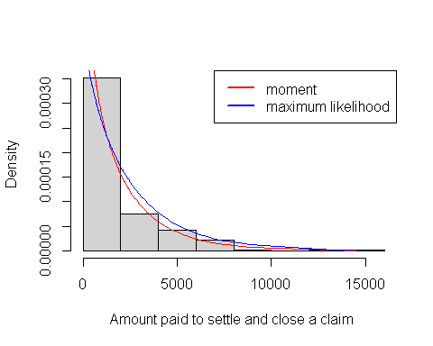
Figure 1:Superimposing the density of mle and moment on the histogram of the sample
### the moment estimate provides the best fit since the density curve of the moment estimate touches the histogram better than that of the maximum likelihood
### Question 2
samp <- sample(x = Autoclaim_sampled$PAID,size = 200,replace = TRUE)
head(samp)

## [1] 700.00 968.80 873.08 2502.72 6180.88 1704.54
"MOm.MLE" <- function(x)
{
alpha <- 1
n <- length(x)
mom <- alpha/mean(x)
MLE <- mean(x)/alpha
est <- c(mom, MLE)
names(est) <- c("Mom", "MLE")
return(est)
}
MOm.MLE(samp)

## Mom MLE
## 5.222089e-04 1.914942e+03
#### Generating several samples
n <- 200; alpha <- 1; beta <- 2; R <- 1000
Msamp <- sapply(1:R,
function(i)rgamma(n = n,shape = 1,rate = 2))
### Monti Carlo simulation
###
### Compute the estimates using the function
parameters <- c(1,2)
par.est <- apply(Msamp,
2,
MOm.MLE)
### biase
BiaseMSE <- function(theta.hat ,theta)
{
bias <- mean(theta.hat)-theta
MSE <- mean((theta.hat-theta)^2)
Tab <- data.frame(bias,MSE)
return(Tab)
}
### compute bias / mse for each row
apply(par.est,
MARGIN = 1,
function(x)BiaseMSE(theta.hat = x, theta = beta))
## Mom
## bias MSE
## 0.01016643 0.02215221
##
## MLE
## bias MSE
## -1.499816 2.250812

