EXERCISE 1
2024-06-20
NAMES | IDS
GERSHON TETTEH AMANOR | 10967696
ANGMORTEY SYLVESTER TETTEH | 10965548
JOHN EVORDA | 10971696
SYLVESTER SADASCO NKRUMAH | 10964940
NANA ASIEDU AKROFI | 10986678

Studying the functions ExpQQ and ParetoQQ in the R package ReIns.
library(ReIns)
?ExpQQ
?ParetoQQ

(i). Explaining what the outputs show functions, ExpQQ and ParetoQQ.
Exponential quantile plot (ExpQQ) Computes the empirical quantiles of a data vector and the theoretical quantiles of the standard exponential distribution. These quantiles are then plotted in an exponential QQ-plot with the theoretical quantiles on the x-axis and the empirical quantiles on the y-axis.
Pareto quantile plot (ParetoQQ) Computes the empirical quantiles of the log-transform of a data vector and the theoretical quantiles of the standard exponential distribution. These quantiles are then plotted in a Pareto QQ-plot with the theoretical quantiles on the x-axis and the empirical quantiles on the y-axis.
(ii). Generating a number of observations from a normal distribution with mean 20, variance 4 (standard deviation of 2)
set.seed(2)
X_Norm <- rnorm(n = 100 ,mean = 20, sd = 2)

Plotting the graphs for the ExpQQ and ParetoQQ functions
par(mar=c(4,4,1,1))
par(mfrow = c(1,2))
ExpQQ(X_Norm)
ParetoQQ(X_Norm)
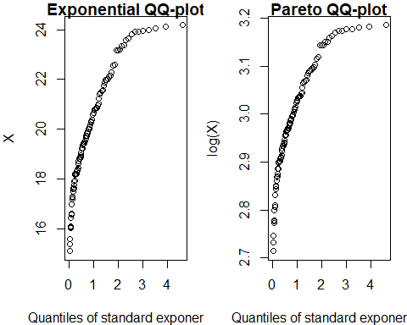

Plotting the graphs for the ExpQQ and ParetoQQ functions but without tittle
par(mar=c(4,4,1,1))
par(mfrow = c(1,2))
plot_3 <- ExpQQ(X_Norm, main = "")
plot_4 <- ParetoQQ(X_Norm, main = "")
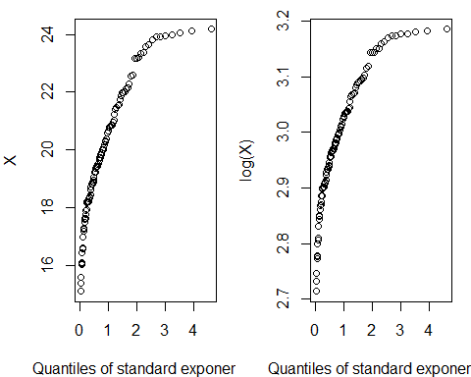

(iii). The CDF and the inverted CDFs of Exponential and Pareto distributions
CDFs of exponential and pareto
$$F{\left(x\right)}_{exponential}=1-e^{-λx};x>0,λ>0$$
$$F{\left(x\right)}_{pareto}=1-{\left(\frac{β}{x}\right)}^{α};β,α,x>0$$
Inverse CDFs of exponential and pareto
$$F^{-1}{\left(F\left(x\right)\right)}_{exponential}=X=\frac{-1}{λ}log\left(1-p\right);x>0,λ>0$$
$$F^{-1}{\left(F\left(x\right)\right)}_{pareto}=X=β{\left(1-p\right)}^{\frac{-1}{α}};β,α,x>0$$

(iv). Writing a function to produce the plots in (ii) based on the inverse CDFs of exponential and Pareto
ExpQQparQQ <- function(data, lambda=1, beta=1, alpha=3)
{
X <- sort(data)
n <- length(X)
p <- (1:n)/(n+1)
### Quantiles of exponential
Exponential <- (-1/lambda)*log(1-p)
### Quantiles of pareto
Pareto <- beta*(1-p)^(-1/alpha)
par(mar= c(4,4,1,1))
par(mfrow = c(1,2))
plot(y = X, x = Exponential)
plot(y = X,x = Pareto)
}
ExpQQparQQ(X_Norm)

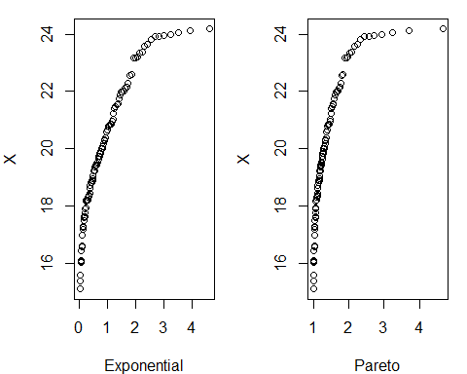

Comparing the graphs in (ii) with the ones in (iv)
The Exponential QQ plot is the same for both (ii) and (iv) but the pareto QQ plot in (ii) fits a little better than the one in (iv) since the one in (ii) is more diagonal along the origin relative to the one in (iv).
(v). Simulating 100 observations from the exponential distribution with mean of 4 (rate of 1/4) and then plot it with the function written in (iv)
library(dplyr)
rexp(n=100, rate = 1/4) |>
ExpQQparQQ()

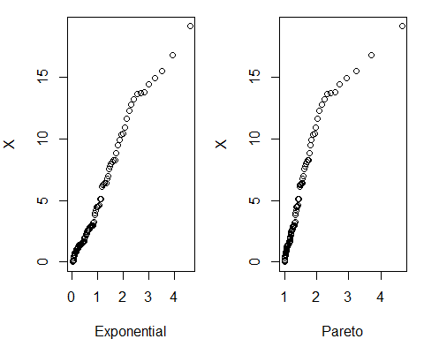

The exponential quantile plot fits the dataset better than the pareto since the exponential quantile is more diagonal along the origin.
(vi). Reading The Society of Actuaries (SOA) Group Medical Insurance data studied in Minkah et al. (2021) found at https://raw.githubusercontent.com/rminkah/DataSets/main/SOA.txt into R
link <- "https://raw.githubusercontent.com/rminkah/DataSets/main/SOA.txt"
SOA_DATA <- read.table(link)
Claims <- SOA_DATA$V1
Reproducing the plots concerning the claims data on the left panel Figure 10 Minkah et al. (2021, pg. 16) and left panel of Figure 11 Minkah et al. (2021, pg.17).
par(mar = c(4,4,1,1))
par(mfrow = c(1,3))
plot(Claims)
n <- length(Claims)
i <- 1:n
plot(x = -log(1-i/(n+1)),
y = Claims)
plot(x = -log(1-i/(n+1)),
y = log(Claims))

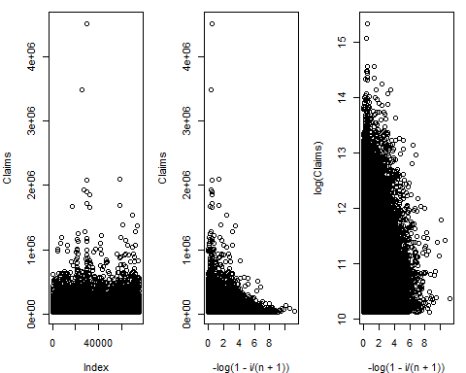
Comment on the fit of the distributions.
All the plots show great deviation from linearity.

