EXERCISE V
DEPARTMENT OF STATISTICS AND ACTUARIAL SCIENCE
COLLEGE OF BASIC AND APPLIED SCIENCES
UNIVERSITY OF GHANA
ACTU 302: INTRODUCTION TO ACTUARIAL COMPUTING
#Considering a random variable X which has a gamma distribution with parameters α and β.
### i. Writing our own function that will return the moment and maximum likelihood estimates of the parameters (α and β).
Estimates <- function(x, parameters)
{
alpha <- parameters[1];beta <- parameters[2]
Moment <- function(x)
{
alpha <- (mean(x)^2)/var(x)
beta <- mean(x)/var(x)
mom <- c(alpha, beta)
names(mom) <- c("alpha","beta")
return(mom)
}
moment <- Moment(x)
log_likelihood <- function(x,parameters)
{
alpha <- parameters[1];beta <- parameters[2]
log_like <- sum(log(dgamma(x,alpha,beta)))
return(-log_like)
}
mle <- optim(par = c(alpha, beta),
fn = log_likelihood,
method = "L-BFGS-B",
x = x)
Table <- data.frame(moment = moment,
mle = mle$par)
return(Table)
}

### ii. Simulating samples of different sizes to investigate the empirical consistency of the estimators.
# 10 samples
Estimates (x = rgamma (10, shape =1,rate = 2),parameters = c(1,2))
## moment mle
## alpha 0.6832731 0.5235102
## beta 1.2338812 0.9453755
# 100 samples
Estimates (x = rgamma (100,1,2), parameters = c(1,2))
## moment mle
## alpha 0.8304701 0.8831548
## beta 1.7232069 1.8325267
# 1000 samples
Estimates (x = rgamma (1000,1, rate = 2), parameters = c(1,2))
## moment mle
## alpha 0.9486862 0.9809547
## beta 1.8373091 1.8998034
It’s clear that as the sample size increases, the estimated parameters approaches the population parameters.
### iii. Fitting the Loss incurred in the AutoBi data from package InsuranceData with the gamma distribution using the two methods.
library(insuranceData)
data("AutoBi")
library(fitdistrplus)
## Loading required package: MASS
## Loading required package: survival
# for the moment estimation
fitmme <- fitdist (data = AutoBi$LOSS,
distr = "gamma",
method = "mme",
discrete = FALSE)
# for the maximum likelihood estimation
fitmle <- fitdist (data = AutoBi$LOSS,
distr = "gamma",
method = "mle",
discrete = FALSE)

### iv. Superimposing the densities of the two methods on the histogram of the loss data. Which method provides a better fit? Explain.
hist(AutoBi$LOSS,
main = "",
xlab = "Loss incurred ",
freq = FALSE)
### for the moment estimation
mme.shape <- (fitmme$estimate)[1]
mme.rate <- (fitmme$estimate)[2]
lines(x = sort(AutoBi$LOSS),
y = dgamma(x = sort(AutoBi$LOSS),
rate = mme.rate,
shape = mme.shape), col = "red")
### for the maximum likelihood estimation
mle.shape <- (fitmle$estimate)[1]
mle.rate <- (fitmle$estimate)[2]
lines(x = sort(AutoBi$LOSS),
y = dgamma(x = sort(AutoBi$LOSS),
rate = mle.rate,
shape = mle.shape), col = "blue")
legend("topright", legend = c("moment", "maximum likelihood"), col = c("red","blue"),lwd = c(2,2))

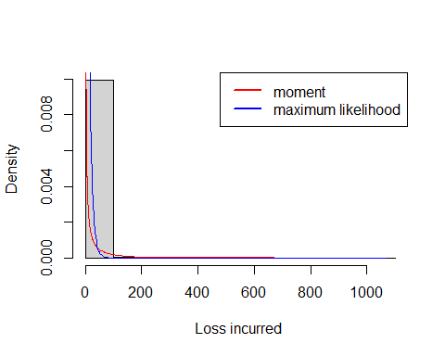
Figure 1:A histogram of the loss data with densities superimposed
From figure 1, the moment estimate provides the best fit since the density curve of the moment estimate touches the histogram better than that of the maximum likelihood.

### v. Computing the probability of recording losses greater than 95th, 99th and 99.9th percentiles of the data using the estimates of the parameters from (iii).
### Check these values with the relative exceedance frequencies from the data and comment on the results.
### computing the quantiles (95th, 99th and 99.9th) of the LOSS in the AutoBi data
quantiles <- quantile(AutoBi$LOSS,probs = c(0.95,0.99,0.999))
### For moment estimation
pgamma(quantiles,rate = mme.rate, shape = mme.shape,lower.tail = F)
## 95% 99% 99.9%
## 0.062686192 0.024757685 0.003966203
### For maximum likelihood estimation
pgamma (quantiles, rate = mle.rate, shape = mle.shape,lower.tail = F)
## 95% 99% 99.9%
## 1.055331e-01 6.499002e-04 2.984198e-11
#### computing the exceedance probability for the data
exceedance_prob <- c()
for(i in 1:3){exceedance_prob[i] <- sum(AutoBi$LOSS>quantiles[i])/length(AutoBi$LOSS)}
names(exceedance_prob) <- c("95%","99%","99.9");exceedance_prob
## 95% 99% 99.9
## 0.050000000 0.010447761 0.001492537
We can conclude that the moment estimates model the loss data in the AutoBi better than the maximum likelihood since the probabilities computed using the moment estimates are closer to the exceedance probabilities relative to the probabilities computed by the maximum likelihood estimates.

