class-exercise
10967696
10971696
10982573
10905296
# generate observations fro gamma 100, shape = 2, scale = 5
Claim_size <- rgamma(n = 100, shape = 2, scale = 5)
par(mar = c(4,4,1,1))
hist(Claim_size,
xlab = " Claim Sixe",
main = "")

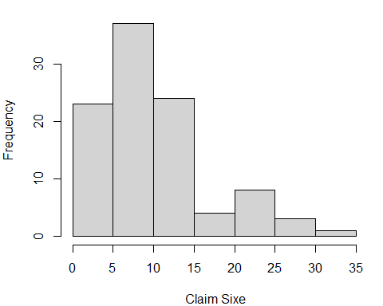
Figure 1: Histogram of claims data

There are few large claims than small claims making it an advantage for the insurance company.

