

DEPARTMENT OF COMPUTER SCIENCE
AND APPLICATIONS

IBM FINAL PROJECT
EMPLOYEE ATTRITION ANALYSIS
Submitted by
GERSSON CHADHWICK B S (222511513)
GUNA M (2225115)
DEEPIKA V (2225115)

BACHELOR OF SCIENCE IN COMPUTER
SCIENCE WITH DATA SCIENCE

Under the guidance of
MR. DEEPAK P.M- Corporate Trainer

2026 - 2027

DECLARATION

WE GERSSON CHADHWICK B.S, GUNA.M, DEEPIKA.V A, hereby declare that this project report on “EMPLOYEE ATTRITION ANALYSIS” submitted to the University of Madras in partial fulfillment of the requirement for the award of the Degree Bachelor of Computer Science with Data Science under the guidance of MRS GANGA., HEAD OF DEPARTMENT and MR. DEEPAK P.M has not been submitted earlier to any other university or institute for the award of any degree.

GERSSON CHADHWICK B S
GUNA M
DEEPIKA V

Place: PADUR
Date: 21/08/2026

BONAFIDE CERTIFICATE

This is to certify that the project titled “EMPLOYEE ATTRITION ANALYSIS” is the bona fide work done by GERSSON CHADHWICK,GUNA,DEEPIKA. A hereby and second-year student of Jeppiaar College of Arts and Science, Padur, Chennai in partial fulfillment of the requirement for the award of the Degree of Bachelor of Computer Science with Data Science 2026-2027.

PROJECT GUIDE: HEAD OF THE DEPARTMENT:
MR. DEEPAK P.M MRS.GANGA
Date: 21/08/2026

CONTENTS:
- INTRODUCTION
- PROBLEM STATEMENT
- OBJECTIVE
- DATASET DESCRIPTION
- TOOLS & TECHNOLOGIES
- DATA CLEANING & PREPROCESSING
- DATA VISUALIZATION
- SOURCE CODE SCEERNSHOT
- OUTPUT SCEERNSHOT
- FUTURE SCOPE
- CONCLUSION
- REFERENCE

Introduction
Employee Attrition Analysis is a Data Science project that focuses on understanding why employees leave an organization. Employee turnover can increase recruitment costs, reduce productivity, and affect overall organizational performance. By analyzing employee-related factors such as age, job role, salary, overtime, job satisfaction, work-life balance, and years of experience, organizations can identify patterns associated with employee attrition.

Problem Statement
Organizations often face the problem of employees leaving their jobs, which can increase recruitment and training costs and affect productivity. However, it can be difficult to identify the main reasons behind employee turnover.
This project aims to analyze employee data and identify the key factors influencing attrition, such as job satisfaction, overtime, salary, job role, work-life balance, and years at the company. The analysis will help organizations identify employees or factors associated with higher attrition and develop effective employee retention strategies.

Objective
- To identify the major factors influencing employee attrition.
- To analyze employee characteristics such as age, job role, income, overtime, job satisfaction, and experience.
- To compare employees who stayed with employees who left the organization.
- To identify patterns and employee groups with higher attrition.
- To provide recommendations to reduce employee turnover.
- To support better employee retention and management decisions.

Dataset Description
Dataset: Employee Attrition Dataset
The dataset contains various employee-related attributes, including:
- Age
- Gender
- Department
- Job Role
- Monthly Income
- Job Satisfaction
- Years at Company
- Overtime
- Work-Life Balance
- Job Involvement
- Performance Rating

Target Variable: Attrition
The Attrition variable indicates whether an employee has left the organization:
- Yes – Employee left the organization
- No – Employee stayed in the organization

Tools & Technologies Used

Tool / Technology | Purpose
Python | Programming and data analysis
Pandas | Data loading, cleaning, and manipulation
NumPy | Numerical operations
Matplotlib | Data visualization
Seaborn | Statistical visualization
Jupyter Notebook | Development and analysis environment
CSV Dataset | Data source

Data Cleaning & Preprocessing
The following steps were performed to prepare the dataset for analysis:
- Loaded the dataset using Pandas.
- Checked for missing values.
- Removed duplicate records.
- Checked and corrected data types.
- Identified categorical and numerical variables.
- Checked for inconsistent or invalid values.
- Converted categorical data into suitable formats where required.
- Examined the distribution of important variables.
- Prepared the cleaned dataset for visualization and analysis.

Data Visualizations
Visualization 1: Attrition Distribution
A bar chart or pie chart can be used to compare employees who stayed and employees who left.
Purpose:
To understand the overall distribution of employee attrition.
Visualization 2: Attrition by Overtime
Compare employee attrition between employees who work overtime and those who do not.
Purpose:
To determine whether overtime is associated with higher employee turnover.

Visualization 3: Attrition by Job Satisfaction
Analyze attrition across different levels of job satisfaction.
Purpose:
To understand whether lower job satisfaction is related to higher employee attrition.
Visualization 4: Attrition by Job Role
Compare employee attrition across different job roles.
Purpose:
To identify job roles that may have relatively higher employee turnover.
Visualization 5: Monthly Income vs Attrition
Analyze the relationship between employee income and attrition.
Purpose:
To determine whether income differences may be associated with employees leaving the organization.
Visualization 6: Years at Company vs Attrition
Analyze employee tenure and compare it with attrition.
Purpose:
To identify whether employees with shorter or longer periods of service have different attrition patterns.

Source code sceernshot
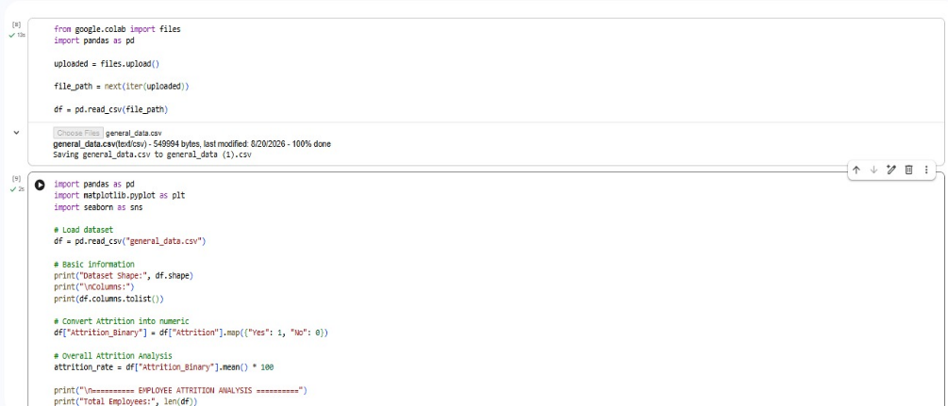

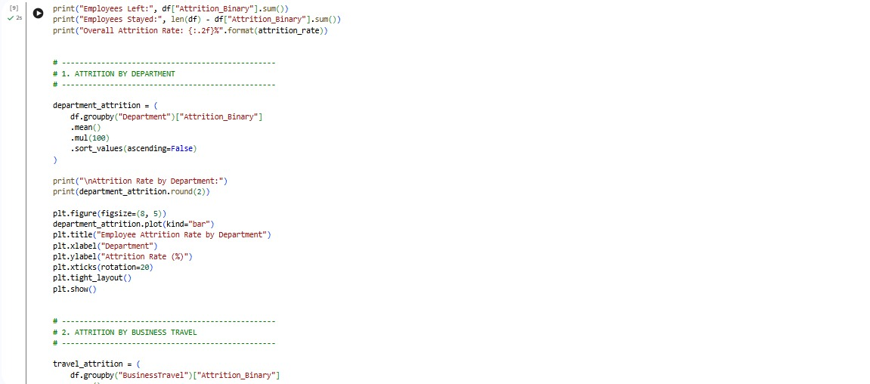
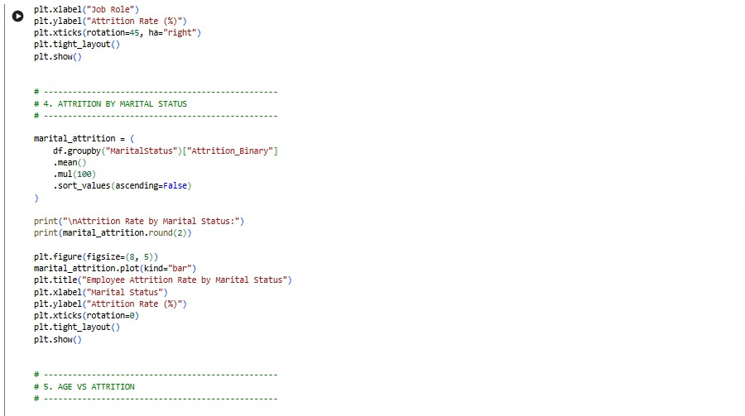
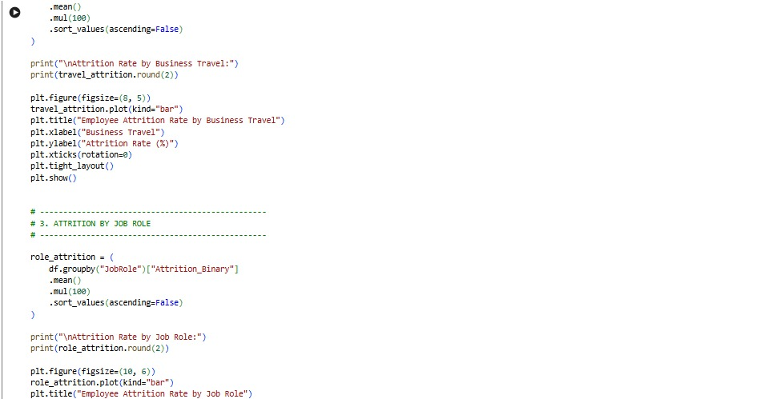

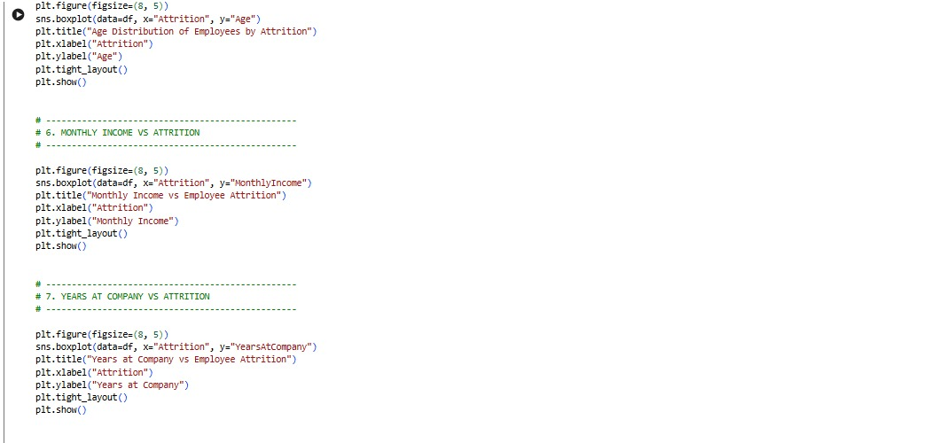
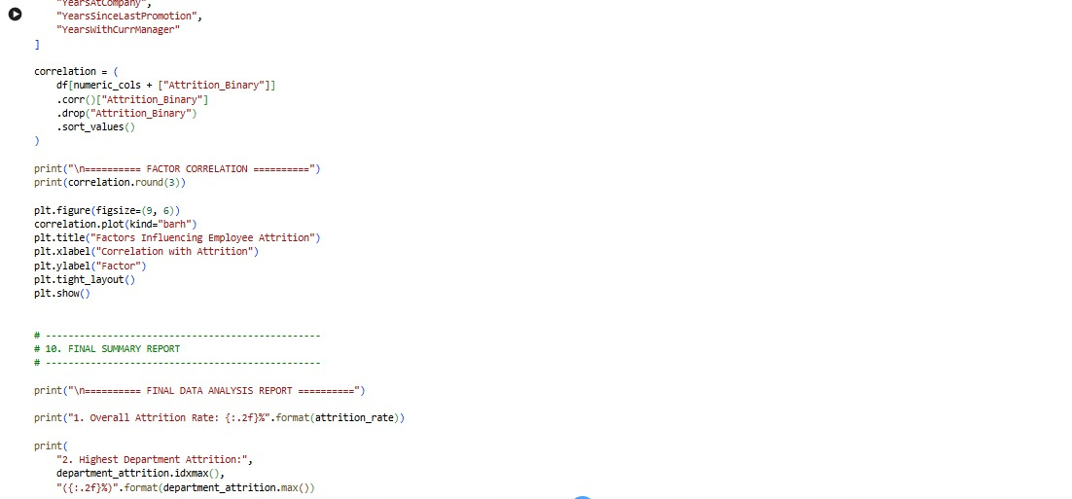
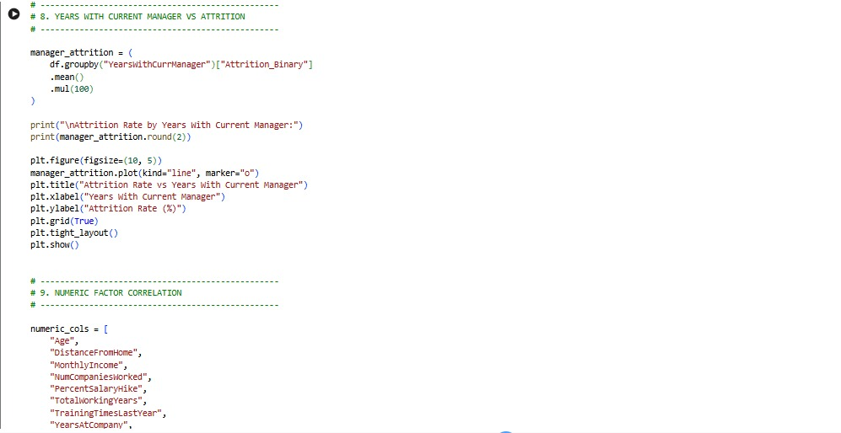

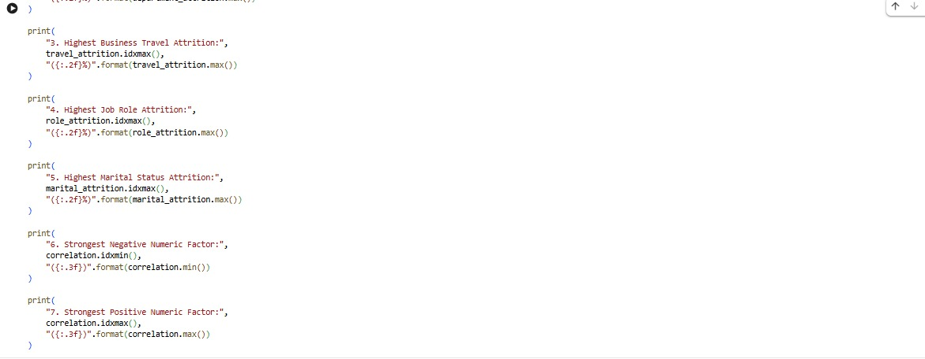

Output sceernshot
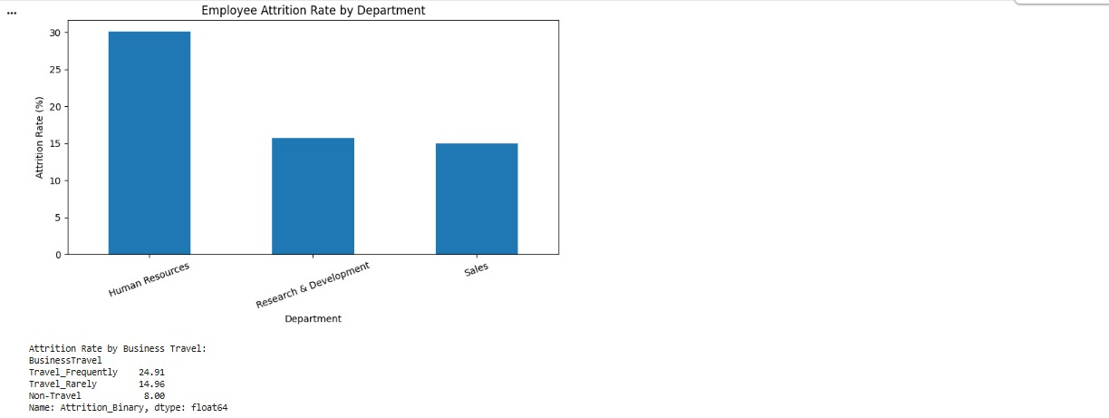
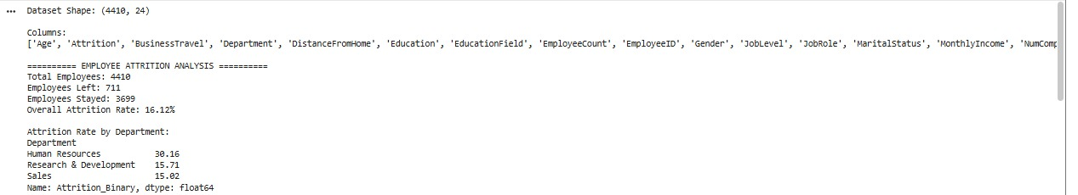

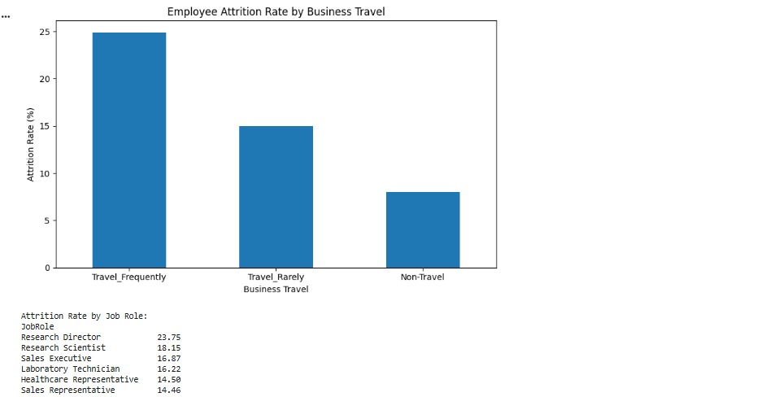
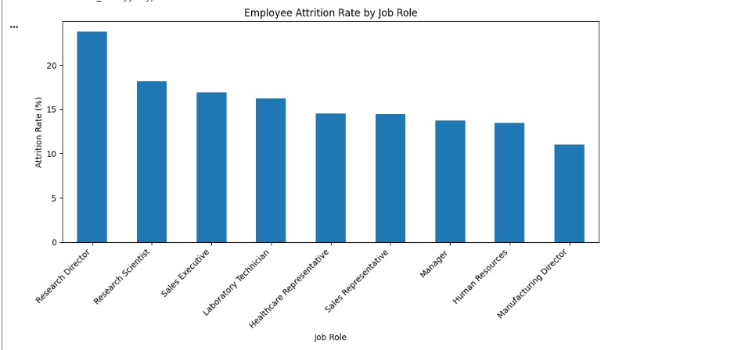

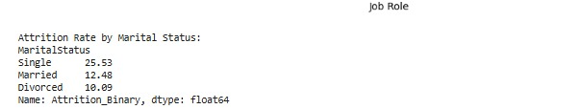

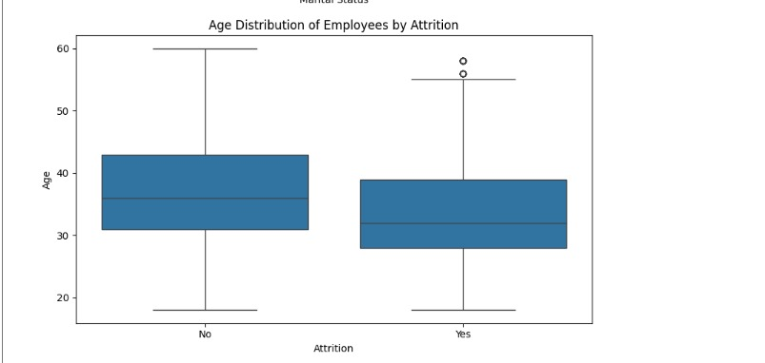
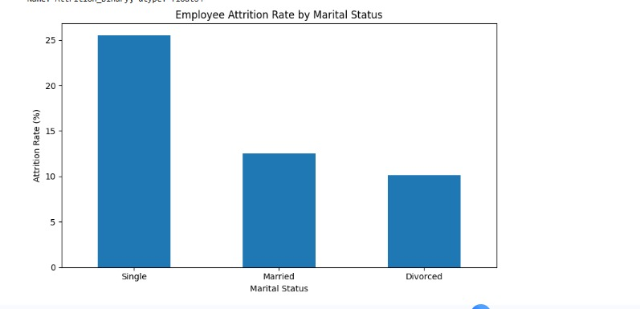

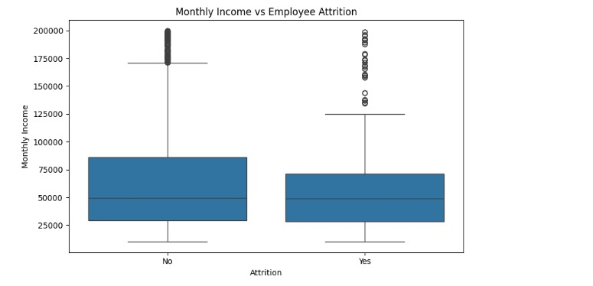

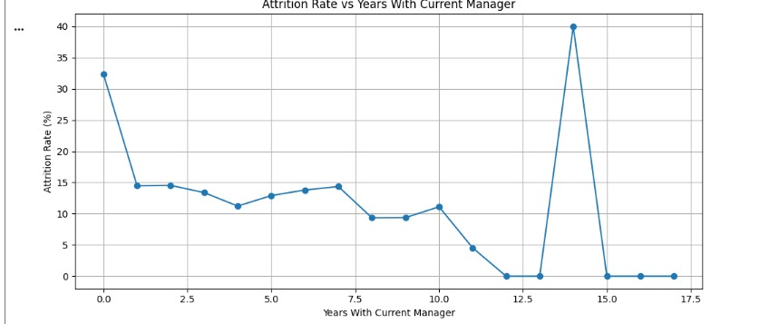


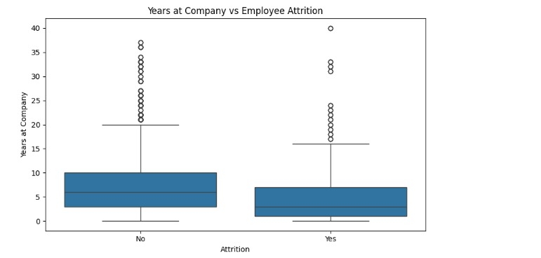



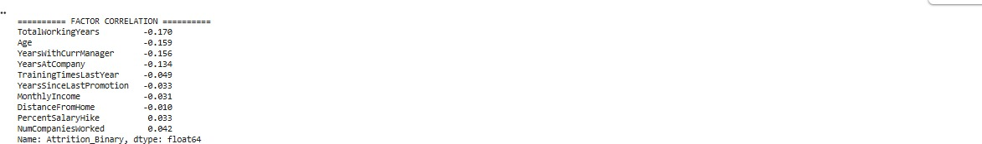

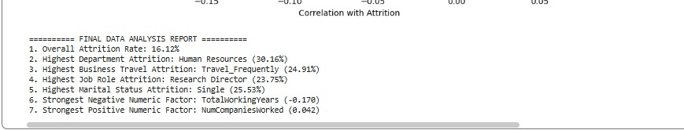

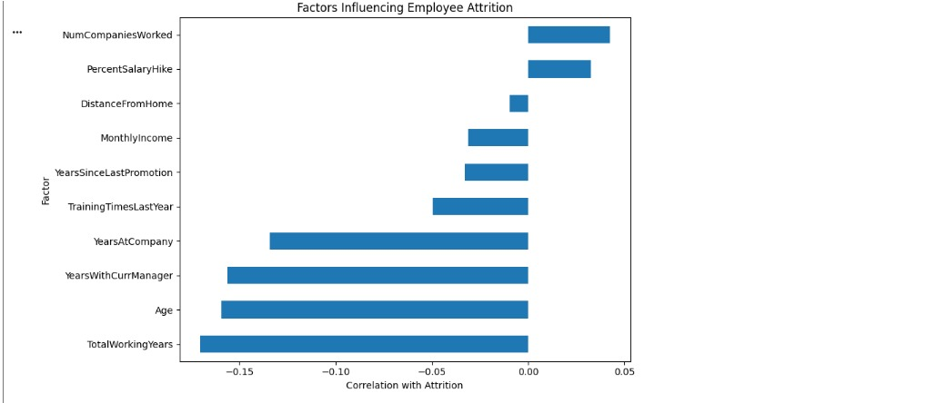

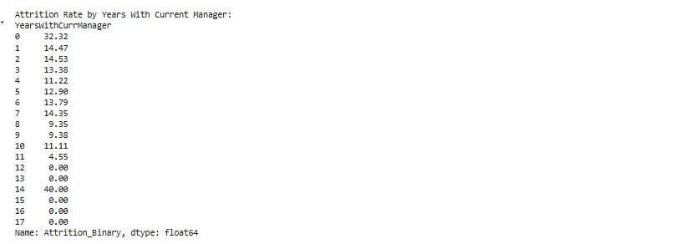

Future Scope
The project can be further improved by introducing advanced Data Science and Machine Learning techniques.
- Machine Learning Prediction: Develop Machine Learning models to predict which employees are more likely to leave.
- Real-Time Dashboard: Create an interactive dashboard for HR managers to monitor attrition trends.
- Employee Risk Score: Generate an attrition risk score for individual employees.
- Additional Factors: Include salary growth, promotion history, attendance, training, work environment, and career development data.
- Early Warning System: Automatically identify high-risk employees and notify the HR team.
- Automated Recommendations: Provide personalized employee retention recommendations.
Advanced Machine Learning: Apply different classification algorithms and compare their performance

- Continuous Monitoring: Update the dataset regularly and monitor changes in employee attrition patterns.

Conclusion
Employee Attrition Analysis helps organizations understand the major factors that influence employees' decisions to leave.
- Data analysis can identify important patterns related to overtime, job satisfaction, income, job role, and experience.
- Identifying these factors allows organizations to take preventive actions.
- Data-driven insights can help improve employee satisfaction and retention.
- The project demonstrates how Data Science and visualization can support better HR decision-making.
- In the future, Machine Learning can be used to predict employee attrition and provide early warnings.

Rerference

Dataset-link for Dataset
Github-Link for github

