An Introduction to z80 Assembly

Introduction:
At last, the time has come. Before this day is done, our epic journey will have culminated with one final undertaking. Alas, some calculators may lie in ruin, and some men will be quelled with frustration, but still we must face this deed with courage, dignity, and, above all, patience. Let us go then, you and I…

The most important thing in this tutorial is to follow the instructions exactly unless I tell you that you can do something else. Assembly is a very hard language until you get used to it, so we won’t be getting too far into the actual programming (though we will actually write and execute a program). The purpose of this tutorial is mainly to get everything set up so that you can use someone else’s tutorials if you want to learn z80 Assembly.

What you need:
1) A computer (Obviously you already have this. Windows is preferable.)
2) A word processor (Notepad is preferable. You can find it in Windows XP by clicking Start, All Programs, Accessories, Notepad.)
3) An assembler (We’ll get to this later)
4) A calculator (TI-83+ or 84+)
5) An Ion compatible shell (I prefer MirageOS. Download it from ticalc.org.)
6) A link cable (If you have an 84+, this should have come with your calc. If you have an 83+, buy the TI Connectivity Kit.)

Creating our first program

1) Download the assembler
a) First, create a new directory (just another term for folder) somewhere on your computer and name it “ASM”.
b) Next, go here and extract the contents of the .zip file to the directory that you just created. In that directory there should be seven things: Devpac83.com and Tasm.exe (these two applications will assemble your programs); asmguru.hlp and ig.hlp (these are help files for learning assembly); ion.inc (this is an include file that defines many different things, including ROM calls and memory areas); IGv1.0.txt (simply a readme for IonGuru); and finally asm.bat (this gets the assembler running). You will also need to copy TASM80.TAB there, which is included with these tutorials.

2) Set up your computer a bit
In the directory window, go to Tools, then select Folder Options. Click the View tab, then uncheck the box that says “Hide extensions for known file types” if it is checked. Next, click the File Types tab and click New. Type “z80” into the box, then click Advanced>> and set the Associated File Type to Text Document. Click Close.

3) Write a program
a) While in the ASM directory, right-click, select New, then select Text Document. Name the file hello.z80 and then open it using Notepad or another word processor.
b) Enter the code below, then save it. Note: It’s important that you enter everything exactly how it is shown here, including the tabs (copying and pasting may not display all characters correctly, so it’s best to enter the code by hand). If you don’t, you risk getting errors when you assemble the program or worse, crashing your calculator. Anything on a line that follows a colon (;) is a comment and is not read by the assembler.

#include "ion.inc" ; Include Ion include file

#ifdef TI83P ; Program header begins here
.org progstart-2
.db $BB,$6D
#else
.org progstart
#endif
xor a
jr nc,start
title: .db "Hello World!",0 ; Title of program will appear in MirageOS
; Program header ends here
start: ; Program will begin executing here
bcall(_clrlcdf) ; Clears the screen
bcall(_indicatoroff) ; Turns the run indicator off
ld a,3 ; Load 3 to register a
ld (CURROW),a ; Load register a to cursor row
ld a,2 ; Load 2 to register a
ld (CURCOL),a ; Load register a to cursor column
ld hl,txt ; Load text at label “txt” to register hl
bcall(_puts) ; Display the text
bcall(_getkey) ; Pause until a key is pressed
ret ; End program execution
txt:
.db “Hello World!”,0 ; Text that will be displayed
.end ; Tells the assembler this is
END ; the end of the program

4) Assemble the program
a) This part actually may be the most confusing until you get familiar with it. Open the command prompt (in Windows XP click Start, All Programs, Accessories, Command Prompt). Now you must navigate to the directory containing the assembler and your program using DOS Commands (mostly cd, which stands for “change directory”). I have provided a screenshot as an example, but your navigation path may be different depending on where you created the ASM directory. If you want to follow the example exactly, create a new directory directly off the C: drive and name it “my documents”, then create a directory in that called “ASM” and copy the contents of the old ASM directory into it.
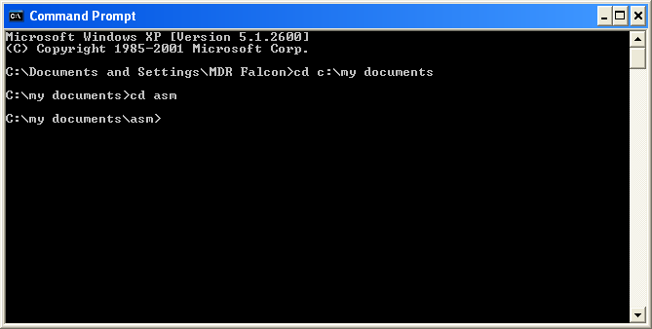

b) Now that you’ve navigated to the proper directory (hopefully), it’s time to actually assemble the program. To do this, simply type “asm”, then the name of the program you want to assemble (in this case “hello”), then hit Enter.
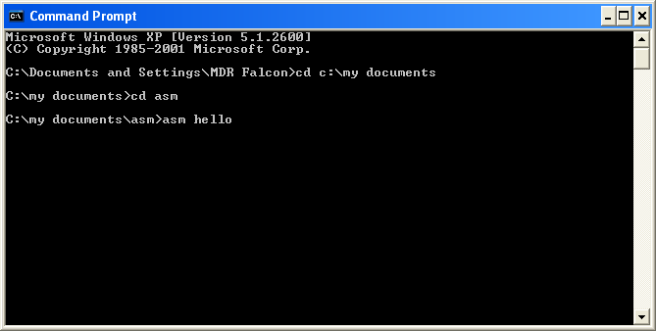

If everything goes well, you should get a screen like the following, meaning that the program was successfully assembled.

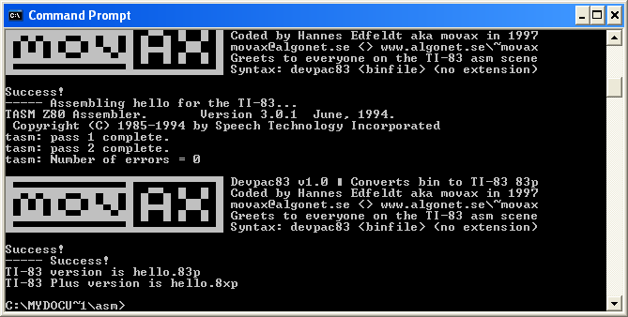

If you didn’t get this screen, you messed up somewhere. If it says that it couldn’t find the file or that “asm is not recognizable as an internal or external command, operable program, or batch file,” then either you are in the wrong directory or you are missing something (such as TASM80.TAB or asm.bat).

5) Send and run the program
a) Now, you need to send the program to your calc. First, you should make sure that you have a driver installed on your computer to send the program. If you have an 84+, TI Connect should have come with it. TI Connect also comes with the TI Connectivity Kit. If you don’t have TI Connect, you can download a driver from ticalc.org. Assuming you have TI Connect, connect your calculator to your PC via the USB port, then right-click on the newly-created hello.8xp and select Send To TI Device…, then click Send to Device.
b) Before we go any further, we need to do a couple things. First, we need to backup the calculator. Even though we didn’t get any errors when we assembled the program, that doesn’t mean there aren’t any bugs. Unlike BASIC, assembly is allowed access to some of the deepest reaches of the calculator’s memory, meaning that one small bug could crash your calculator. TI Connect has an option to backup your calc, so take advantage of it before testing an assembly program on your calc! If you haven’t already done so, install MirageOS or another Ion compatible shell on your calculator.
c) Once you’ve backed-up your calc and you have MirageOS installed, you can now run the program. Enter MirageOS or another Ion compatible shell and execute program HELLO. The output should be identical to the screenshot.


Output:

If your calculator crashes:
If you copied the source code correctly, your calculator shouldn’t crash. You’ll know if it has because either it will freeze, the screen will go blank, or strange things will happen on the screen. In the event of a crash, do the following things in order, but only proceed to the next step a step doesn’t work:
a) If a message is displayed that says “RAM cleared,” you don’t need to do anything else
b) Press and hold [ON] and [CLEAR] at the same time
c) Take out an AAA battery, then reinsert it.
d) Take out all batteries (including the backup), then reinsert them
e) Take out all batteries (including the backup) and let the calculator sit for a period of at least 24 hours, then reinsert the batteries

The most I’ve ever had to do is take out a single battery, then reinsert it. Don’t let crashes discourage you from assembly programming because they will not permanently mess up your calc unless it is already defective in the first place. However, always remember to archive important programs and/or backup your calc when running assembly programs. To avoid crashes entirely, you can use an emulator, which we’ll get to later.

The source code explained:
Finally, we’ve gotten to the explanation of the code. The very first line, #include “ion.inc”, is a directive to the assembler that tells it to look in the file ion.inc in order to define some of the commands we will be using. The next several lines (#ifdef TI83P to title: .db “Hello World!”,0) are simply more directives to the compiler that you don’t need to concern yourself with. This portion of the program is called the header and needs to be placed at the beginning of every program. In the line title: .db “Hello World!”,0 you may replace Hello World with the title of your program when you write other programs.

The line start: is where our program will actually begin executing. Notice that the next two lines begin with bcall. Commands in this format are called ROM calls. ROM calls are locations in the calculator’s memory where specific, basic functions are stored, such as clearing the screen. In this program, _clrlcdf clears the screen and _indicatoroff turns off the run indicator in the upper right of the screen. ROM calls are defined in ion.inc. Technically, you can name a ROM call anything you want, but you must first define it (which is what ion.inc is for).

In the next four lines of code, the location of the cursor is stored and the label for the text is stored. CURROW and CURCOL are variables defined in ion.inc that store the position of the cursor on the calculator’s screen. In z80 assembly, you can’t store a value directly to a variable, but must instead store a value to a register and then store the register to the variable. A register is similar to a variable, but it is only reliable for very short-term data storage. In the program, we load the value 3 to register a, then load register a to variable CURROW, essentially loading 3 to variable CURROW. Next we load the value 2 to register a, then load register a to variable CURCOL, which, similar to the previous two lines, essentially loads 2 to variable CURCOL. The line ld hl,txt loads the location of our text to register hl.

The next two lines are more ROM calls. To display our text, we use _puts. This ROM call tells the calculator to display text from the location stored in register hl. In this case, that location is at the label txt. The next ROM call, _getkey, tells the calculator to pause until a key is pressed. When a key is pressed, the program proceeds to the next line, ret, which returns the calculator to its normal mode. Below this is the label where our text is defined. .db simply indicates that what follows is data and the 0 signifies the end of the string.

At the very bottom of the program, .end and END simply tell the assembler that it has reached the end of the program. Like the header, these two lines are required in every program.

You probably noticed that it took six lines of code to set the cursor position and display our text, while in BASIC it could have been done in only one. This is because assembly is a low-level language and BASIC is a high-level language. In a low-level language, each command represents a single instruction to the microprocessor, but in a high-level language each command may represent several instructions to the microprocessor. Thus, with TI-BASIC’s Output( command, a single command actually loads the cursor position using the arguments input by the programmer and then uses a ROM call to output the text on the screen, which actually amounts to several microprocessor instructions. The fact that assembly is a low-level language is the reason why it is difficult to learn compared to languages like BASIC or C++.

Advantages of z80 assembly over BASIC:
-It’s über-fast
-Assembly programs generally take up less memory than BASIC programs
-You can do things in assembly that absolutely cannot be done in BASIC

Disadvantages of z80 assembly over BASIC:
-It’s a difficult language to learn, let alone master
-The risk of crashing your calc (this, however, can be overcome)
Learning assembly:
If you want to learn assembly, I would recommend starting off with Jeff Chai’s tutorials, which can be found at http://www.ftp83plus.net/Tutorials/TI83pAsmTutA.htm. You can probably skip most of the first few tutorials because we covered setup here, but you should at least skim them. Do use the header that we learned about in this tutorial if you want your programs to show up in Ion compatible shells (more about this is covered in Jeff’s “Tutorial 23 - Using Ion”). After you get the basics down, you can move on to Sean McLaughlin’s “Learn TI-83 Plus Assembly in 28 Days” found at http://dragonfire.nwps.ws/Asmin28/lesson/toc.html. These tutorials are very in-depth, but may be difficult to understand if you don’t have experience in languages besides TI-BASIC. You could also use J. Matthews’ ASM Guru tutorials and Matthew Hernandez’s IonGuru tutorials, which you should have already downloaded. However, you should be aware that the ASM Guru tutorials were written for the TI-83, so memory locations are different. One more resource is the official TI Software Development Kit, which is available for download at the TI website (somewhere…).

Emulators:
If you would prefer to avoid crashing your calc, I would suggest that you download an emulator. A popular one is Virtual TI, which can be downloaded at ticalc.org, but I would personally recommend PTI if you have a TI-83+. Unfortunately, there are not many emulators out there compatible with the 84+, and the ones that do exist are difficult to set up.

To use an emulator, you must first obtain a ROM image from your calculator. The best program to do this is rom8x.

Conclusion:
That’s it. I hope that everything has gone well and that you have enjoyed my tutorials. Give it a shot at assembly. It’s hard, but when you get frustrated, just think about games like Galaxian and other classics that have defined a part of our culture. Best wishes. Auf wiedersehen.

-MDR Falcon
1/20/07

