W.R. Wilcox, Clarkson University, 16 March 2006

3. Use of MATLAB to fit data to a polynomial

We begin with the figure produced in 2. Plotting data using MATLAB. If you have closed MATLAB since making this plot, then load it using the File, Open in MATLAB's Command window.

Merely displaying data on a graph is not sufficient. You must also find an equation that "fits" the data, i.e. that produces a curve passing near all the data points. The simplest type of equation is a polynomial, which here takes the form:

P = a₀ + a₁T + a₂T² + a₃T³ .... etc. (3.1)

Fitting data to a polynomial is easily done in MATLAB by using the Basic Fitting Interface. Use the Index in MATLAB Help to find a description of the Basic Fitting Interface. (Alternately, you can use the polyfit command; Search polyfit in MATLAB Help.)

In the Figure window, click on Tools, Basic Fitting to open the Basic Fitting Interface. Click on linear, Show equations, 4 Significant digits, Plot residuals, Show norm of residuals. MATLAB finds the straight line best fitting the data using the least-squares method. The following equation is produced:

y = 3.101e+004*x - 2.038e+006 (3.2)

which signifies:

P = - 2.038 x 10⁶ + 3.101 x 10⁴ T (3.3)

While this is the equation of a straight line for Cartesian coordinates (both the x-axis and the y-axis linear), you see that it is definitely not a straight line on your semi-log plot. (See Figure 3.1 on the next page). In fact, at lower temperatures the red correlating line gives negative values of P, which cannot be displayed on a logarithmic scale. The residuals plot shows the differences between the values of P predicted by the correlation, equation (3.3), and the experimental values of P. The norm of the residuals, here 1617059, is a measure of the deviation between the correlation and the data. A lower norm signifies a better fit.

To understand what MATLAB has done here, let us consider n data points, each consisting of the value x_{i} of the independent variable and the corresponding value y_{i} of the dependent variable. In our correlating equation (here, a straight line) we have a predicted value y_{pi} corresponding to each x_{i}. That is, if the correlation is expressed as a function y = f(x), then y_{pi} = f(x_{i}). For each value of x_{i} we define the residual as d_{i} ≡ y_{i} - y_{pi}. The residual plot is d_{i} versus x_{i}. You will now prepare the same residual plot yourself.

>> Pp = - 2.038e6 + 3.101e4*T; d = P – Pp;
>> figure(2), bar(T,d), xlabel('Temperature (K)'), ylabel('Residual (Pa)')
>> title('Residuals for linear fit to CO vapor pressure data')

The figure(2) command names the next figure Figure 2, and avoids having it displace the previous Figure 1. Note that your residual plot has blue bars rather than red bars. To change them to another color, click on the Edit Plot arrow icon at the top of the Figure window, then double click on one of the blue bars. This opens the Property Editor – Bar series. Click on the paint-can icon to select a different color for the bars.
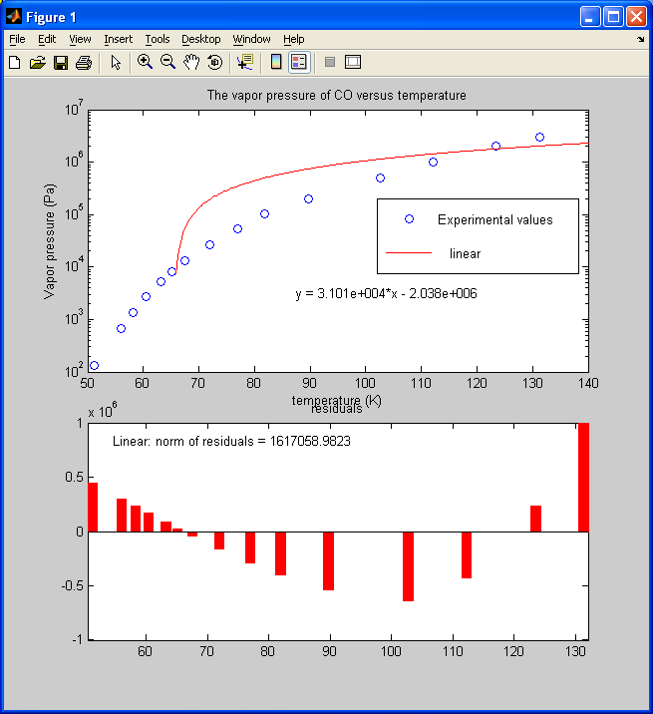
Figure 3.1. Linear fit to the CO vapor pressure data.
A residual is the difference between the experimental value and the value predicted by the correlation equation (Equation 3.3). "Norm of the residuals" is a measure of the goodness of the fit, i.e. a lower norm signifies a better fit.

Now let us examine the meaning of "norm of residuals." From MATLAB Help we find that it is defined as:
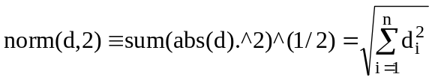 (3.4)

What MATLAB does in fitting to a polynomial, including a straight line, is to minimize the norm of the residuals. Note that the square of norm(d,2) is just the sum of the squares of the differences between the predicted values and the actual values, i.e. the sum of the squares of the residuals. That is, MATLAB finds the values of the constants giving the "least squares." A more common measure of the "goodness" of a correlation than the norm is the correlation coefficient r. The square of r is the fraction of the variance in the dependent variables that is explained by the correlation. In mathematical form:

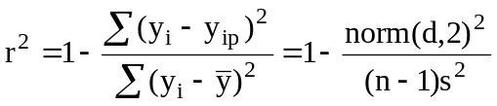 (3.5)

where Σ is the summation of all values for i from 1 to n, 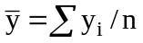is the mean (average) of all the y values, and 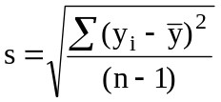is the standard deviation (as calculated in MATLAB). In the Figure window, click on Tools, Data Statistics to find that the standard deviation of the CO vapor pressure values is s = std = 9.035e005 = 9.035x10⁵. Using >> length(P) we find n = 15, so 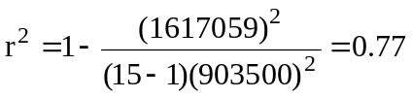, which indicates that a linear fit only explains 77% of the variation in P. Looking at your plot, that is hardly surprising. Now use MATLAB to calculate r² yourself directly from the data:

>> r2 = 1 - sum(d.^2) / sum((P - mean(P)).^2)

Return to your semilog plot of P versus T, and test higher-order polynomials for fitting the data using the Basic Fitting interface. Note that none of these fit the data well at the lowest temperatures, although it appears that the 9th degree does the best, except for the funny bump between the first and second point.

There are two problems with higher order polynomial fits:

- They reveal nothing of the underlying physics. They can neither be compared to theory nor used to create a theory.
- The fit is usable only within the domain of the data. Beyond that, polynomials blow up.

This latter point is an extremely important limitation that must be kept in mind whenever polynomial fits are used. To illustrate it, return to your graph with the 9th degree polynomial fit. In the Basic Fitting Interface window click off Plot residuals and Show norm of residuals. In the Figure window, click on Edit, Axes Properties. Change the Y Axis to Linear with limits of -10,000,000 to 10,000,000. Change the X limits to 30 to 160. These changes produce the figure shown on the next page. Note that your 9th-degree polynomial predicts a negative vapor pressure below about 50 K. A negative vapor pressure is physically impossible!! It would be unsafe to use this correlation beyond the range of the reasonable fit to the experimental values. To do so could lead to a serious accident. If we need to operate beyond the range of our data, we must have a correlation with some theoretical basis. That we do next in 4. Using theory to correlate data.

As an exercise, prepare a residual plot for the 9th-degree polynomial fit and calculate r².

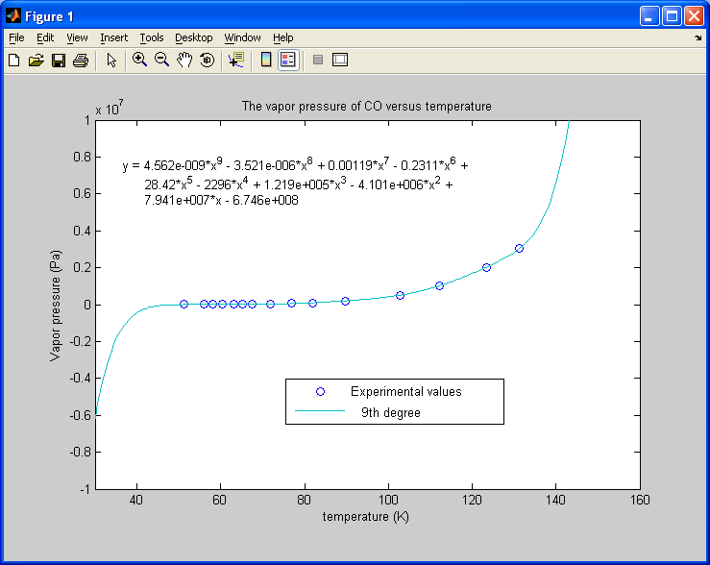
Figure 3.2.
Plot of the 9th-order polynomial fit to the CO vapor pressure data,
illustrating how polynomial fits are valid only within the domain of the data.

