Algemeen
Tegen volgende les: PE: Subnetting/VLSM + Pakket tracer(zker Chapters 2, 8.5, 10, 16.4.4)
woensdag 18 september 2024
20:14
Cisco vids nog bekijken
Ctrl-shift-6 abort de connectie sequence als cli bzg is na verkeerd cmd
Basic device config

1508 byes max per pakketje

Headers worden niet versleuteld …?(examenvraag)
Instanties herkennen(bv ieee , H3.4)
MOET 42% OP DEEL 1 HALEN DAN HEB IK 50% totaal..

H16 17 moet nie voor examen

Multicast = eigen netwerk
Anycast = ander netwerk
Link local adres = verkorte eigen adress FE80::/10
Router moet statisch ipv6 adress, de rest genereerd het normaal.
Dhcpdiscover > dhcpoffer > dhcprequest > dhcpack

HTTP - Hypertext Transfer Protocol (tcp port 80,8080)
HTTPS - HTTP Secure(TCP, UDP 443)
FTP - 21
ARP = Address resolution protocol
Unshielded Twisted-Pair (UTP)
Shielded Twisted-Pair (STP)
Logical Link Control (LLC, IEEE 802.2)
Media Access Control (MAC)
NIC (network interface card)
IEEE 802.3 ethernet(kabel)
IEEE 802.11 wifi
IEEE 802.15 bluetooth
Goodput (data zonder headers)
Troughput (alles)
VLSM (variable lenght subnet mask(ing)
MTU (maximum transmission unit)
ND (Neighbor Discovery(ipv6))
Stateless Address Auto-configuration (SLAAC)
Internet Control Message Protocols (ICMP)

Www | Pxl | .be | .
 | Second level | Top level | Root level
01-00-5E-xx-xx-xx (multicast mac adress)

Goodput is throughput minus traffic overhead for establishing sessions, acknowledgments, encapsulation, and retransmitted bits

# | OSI MODEL
7 | Application | Data HTTP(80),HTTPS(443)
6 | Presentation | SSL, TLS (de/en)cryptie
5 | Session | Opzetten en verbreken verbinding per pakket?
4 | Transport | Tcp is reliable, flow control, number & track data segments, bevestiging geven. connection oriented .udp is unreliable not same order delivery snel zonder controle. Zodra de poorten ervoor staan is het een Segment
3 | Network | Ip van end to end netwerken. Poorten ervoor noemt Packet, encapsulation?
2 | Data Link | LLC software | mac layer physical adress(source/destination mac). Poorten ervoor noemt Frame(ethernet protocol) ook gebruikt voor  Dhcpdiscover(mac broadcast)
1 | Physical | Bits 011000110
ACK - Acknowledgment flag used in connection establishment and session termination
SYN - Synchronize sequence numbers used in connection establishment
FIN - No more data from sender and used in session termination

Osi: APST NDP
Tcp/ip: ATIN

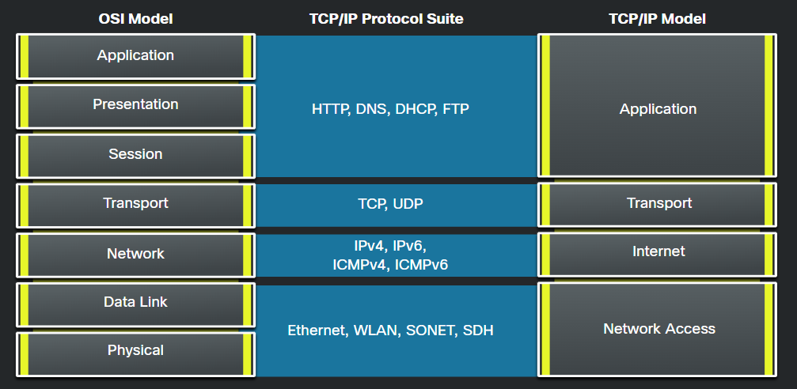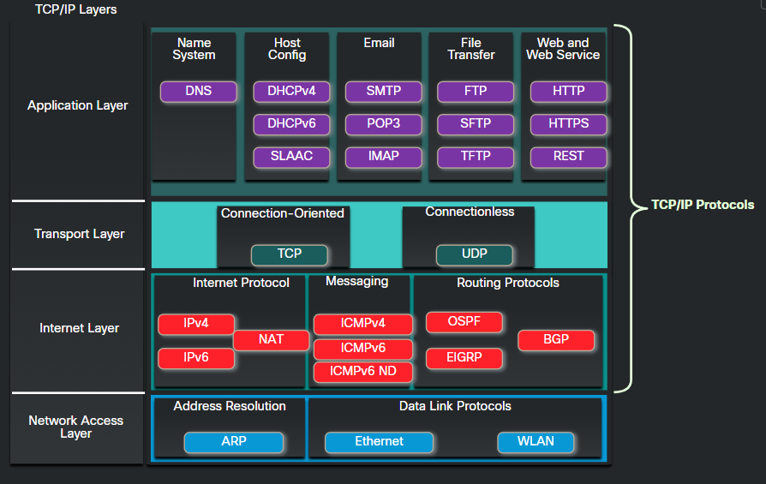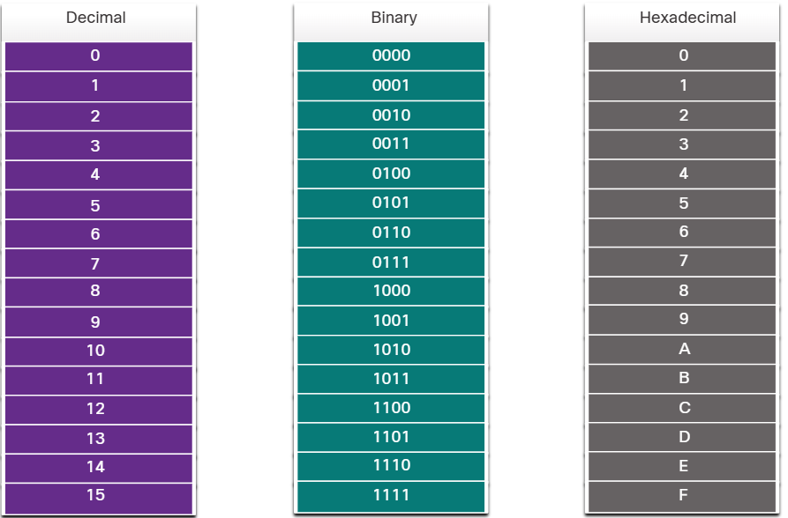

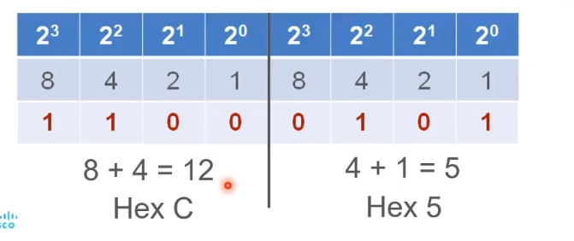

Packet Tracer
dinsdag 1 oktober 2024
12:04

Dynamische routing protocol kijkt naar zijn buren voor meerdere routes

? voor command/parameter opties
show ip interface brief
Secure console access:
S1(config)# line console 0
S1(config-line)# password pxl
S1(config-line)# login
Secure privileged access:
S1(config)# enable secret pxl (encrypted)
of minder veilig/legacy :
S1(config)# enable password pxl (plain)
Encrypt plain passwords:
S1(config)# service password-encryption
Banner MOTD:
S1(config)# banner motd "text"
Save/Load config to NVRAM:
S1# copy run start / S1# copy start run
Hostname:
S1(config)# hostname naam
Interface IP+Mask:
S1(config)# interface vlan 1 / gig0/0 / fa0/1
S1(config-if)# ip address 192.168.1.253 255.255.255.0
S1(config-if)# no shutdown
Default Gateway:
S1(config)# ip default-gateway 192.168.0.1
Telnet met Password:
S1(config)# line vty 0 4 (0-15)
S1(config-line)# password pxl
SSH:
S1(config)# hostname naam (geen default name)
S1(config)#ip domain-name PXL.be
S1(config)#crypto key generate rsa (prompt: 1024 fzo)
S1(config)#username admin password PXL
S1(config)#line vty 0 15
S1(config-line)#transport input ssh
S1(config-line)#login local

Switch(config)# interface range fa0/4 - 24
Switch(config-if-range)# shutdown
Basic Config:
S>enable
S#config t
S(config)#hostname S1
S1(config)#service password-encryption
S1(config)#enable secret PXL
S1(config)# line console 0
S1(config-line)# password pxl
S1(config-line)# login

Verwijder ww:
from global configuration mode:
no enable password
line con 0
no login
no password
end

R1(config)# ipv6 unicast-routing
R1(config)# interface vlan 1 / gig0/0 / fa0/1
R1(config-if)# ipv6 address 2001:db8:1:1::1/64
R1(config-if)# ipv6 address fe80::1 link-local
R1(config-if)# no shutdown

R1# show ipv6 interface brief
R1(config-if)# no ipv6 address 2001:db8:1:5::1/64(oude verwijderen)
Erase startup-config
fe80::1 (ipv6 gateway, user config)
Mss handig:
C:\>apr -d
C:\>ipconfig /renew
C:\>Dhcp renew
show ip int brief
Router(config-if)#mac-address 0000.0000.00C1
no username Lode
username student secret pxl
show ip route
show ip arp
Showrun?
Cmd: nslookup

(config)# int gigabitethernet 0/0.10(vlan nummer = subif)
Encapsulation dot1Q 10
Ip adress ip mask

Switch(config-if)# description Verbinding naar Server

TCP/IP - VLSM subnetting
dinsdag 1 oktober 2024
12:04
Easy Subnet Chart
Mask | 128 | 192 | 224 | 240 | 248 | 252 | 254 | 255
Bits | /25 | /26 | /27 | /28 | /29 | /30 | /31 | /32
Hosts-2 | 128 | 64 | 32 | 16 | 8 | 4 | 2 | 1
Subs | 2 | 4 | 8 | 16 | 32 | 64 | 128 | 256
Subnet Mask | Network Bits | Host Bits | Subnets | Host/Subnet
255.0.0.0 | /8 | 24 | 1 | 16,777,214
255.128.0.0 | /9 | 23 | 2 | 8,388,606
255.192.0.0 | /10 | 22 | 4 | 4,194,302
255.224.0.0 | /11 | 21 | 8 | 2,097,150
255.240.0.0 | /12 | 20 | 16 | 1,048,574
255.248.0.0 | /13 | 19 | 32 | 524,286
255.252.0.0 | /14 | 18 | 64 | 262,142
255.254.0.0 | /15 | 17 | 128 | 131,070
255.255.0.0 | /16 | 16 | 256 | 65,534
255.255.128.0 | /17 | 15 | 512 | 32,766
255.255.192.0 | /18 | 14 | 1,024 | 16,382
255.255.224.0 | /19 | 13 | 2,048 | 8,190
255.255.240.0 | /20 | 12 | 4,096 | 4,094
255.255.248.0 | /21 | 11 | 8,192 | 2,046
255.255.252.0 | /22 | 10 | 16,384 | 1,022
255.255.254.0 | /23 | 9 | 32,768 | 510
255.255.255.0 | /24 | 8 | 65,536 | 254
255.255.255.128 | /25 | 7 | 131,072 | 126
255.255.255.192 | /26 | 6 | 262,144 | 62
255.255.255.224 | /27 | 5 | 524,288 | 30
255.255.255.240 | /28 | 4 | 1,048,576 | 14
255.255.255.248 | /29 | 3 | 2,097,152 | 6
255.255.255.252 | /30 | 2 | 4,194,304 | 2

 | N²
1 | 0
2 | 1
4 | 2
8 | 3
16 | 4
32 | 5
64 | 6
128 | 7
256 | 8
512 | 9
1024 | 10
2048 | 11
Examen vragen:
Welk netwerk id heb je?
Welk ip range heb je?
Zit dit in de range?
Verschil vlsm en subnetting
Bij subnetting krijg je aantal netwerken > eentjes en subnetten
Bij vlsm krijg je aantal hosts > nulletjes

Class full 8 bitjes
Classless meer dan 8 bitjes
ANDing = and logic gate (1 + 0 = 0)
Segmentation
Reassembly
Encapsulation
Decapsulation

/24 = class full? 24 eentjes

2n >/ # netwerken
N = 2
00 = 0(host), range = 1-62 /26(63 is broadcast 11111..)
01 = 64(host), range = 65-126 /26(127 broadcast)
10 = 128(host), range = 129-190 /26 (191 broadcast)
11 = 192(host), range = 193-254 /26 (255broadcast)
0000 = 0 | 1-14
0001 = 16 | 17-30
0010 = 32 | 33-46
0100 = 48 | 49-62

0100 = 64 | 65-78
0101 = 80 | 81-94
0110 = 96 | 97-110
0111 = 112 | 113-126

1000 = 128 | 129-142
1001 = 144 | 145-158
1010 = 160 | 161-174
1011 = 176 | 177-190

1100 = 192 | 193-206
1101 = 208 | 209-222
1110 = 224 | 225-238
1111 = 240 | 241-254
172.16.0.0/16 32 netwerken
00000 = 0 | 1-6
00001 = 8 | 9-14
00010 = 16 | 17-22
00011
000 = 0 | 1-30
001 = 32 | 33-62
010 = 64 | 65-94
011 = 96 | 97-126
100 = 128 | 129-158
101 = 160 | 161-190
110 = 192 | 193-222
111 = 224 | 225-254

