CLOUD ESSENTIALS

AWS CLI
Je navigeert naar deze map:
C:\Users\12100514\.aws
Hier vind je 2 documenten, config laat je zijn maar je credentials ga je aanpassen.
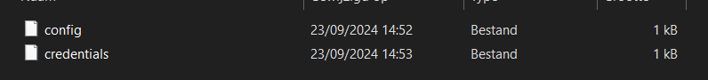
Je gaat naar uw lab en zit daar AWS CLI staan. Die cred ga je in het bestand steken
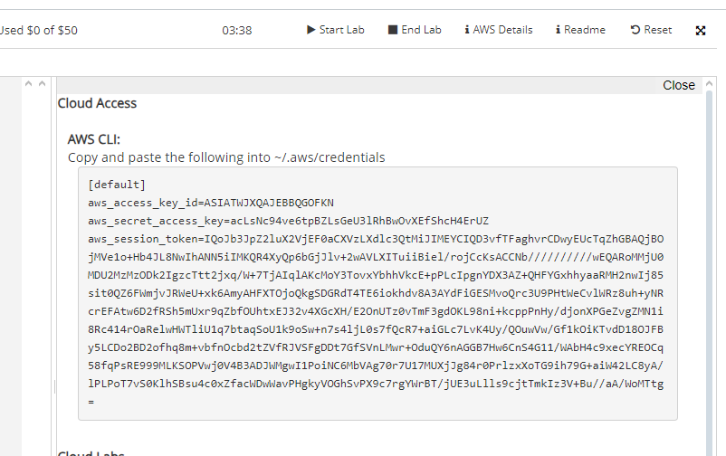
Nu kan je in powershell werken.

Cloud Computing
Amazon Elastic compute cloud (Amazon EC2) : provides resizable compute capacity as virtual machines in the cloud.

LAB 1
Deze commands gerund
- wget https://2tin-cloudessentials-resources.github.io/cloud-essentials-labs/debuglabs/2_1.yml -outFile 2_1.yml
- aws cloudformation deploy --template-file ./2_1.yml --stack-name ch2ex1
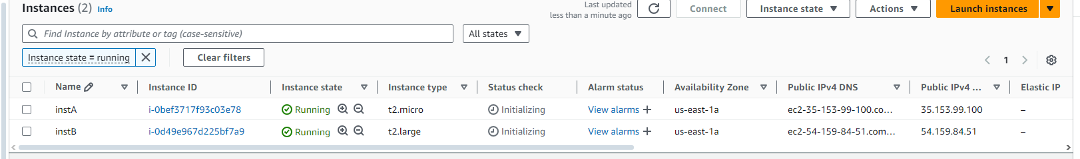
What are the names of the 2 instances created?
instA, instB
What is the name of the AMI that is used for both instances?
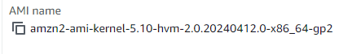
What is the instance type for both machines?
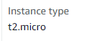
What is the public IPv4 address for InstA?
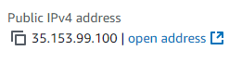
What is the private IPv4 address for InstB?
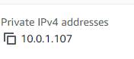
What is the name for the keypair linked to both machines?
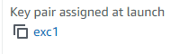
Search for a linked security group. What is the name of this group?
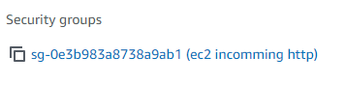
What rules are present in this security group?
Inbound rule to allow incoming HTTP traffic on port 80
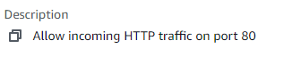
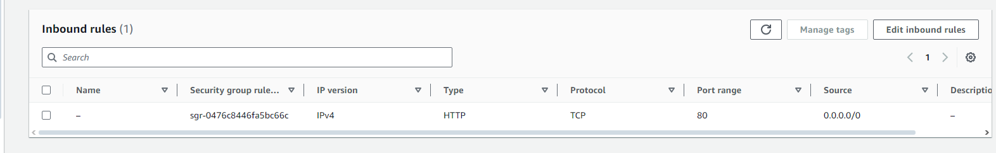
Our customer is complaining that the costs for his EC2 instances are expensive. What causes this issue and how would you fix this?
?

Used this command to shut them down: aws cloudformation delete-stack --stack-name ch2ex1

LAB 2
Commands
- $ wget https://2tin-cloudessentials-resources.github.io/cloud-essentials-labs/debuglabs/2_2.yml -outFile 2_2.yml
- $ aws cloudformation deploy --template-file ./2_2.yml --stack-name ch2ex2

The commands above set up an EC2 instance named "imbroken". The instance uses a UserData script to install a default webserver but something went wrong. Using the cloud-init status command and cloud-init-output.log file try to figure out what went wrong. You can use the vockey to connect to the instance.
- Click on connect
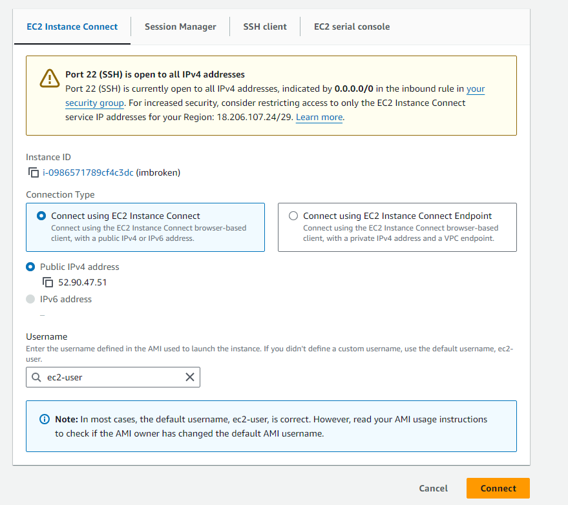

Using This documentation page(https://docs.aws.amazon.com/AmazonRDS/latest/UserGuide/CHAP_Tutorials.WebServerDB.CreateWebServer.html) , try to fix the issue and start the webserver. You should be able to see a web page when you visit the public IP address of the instance.
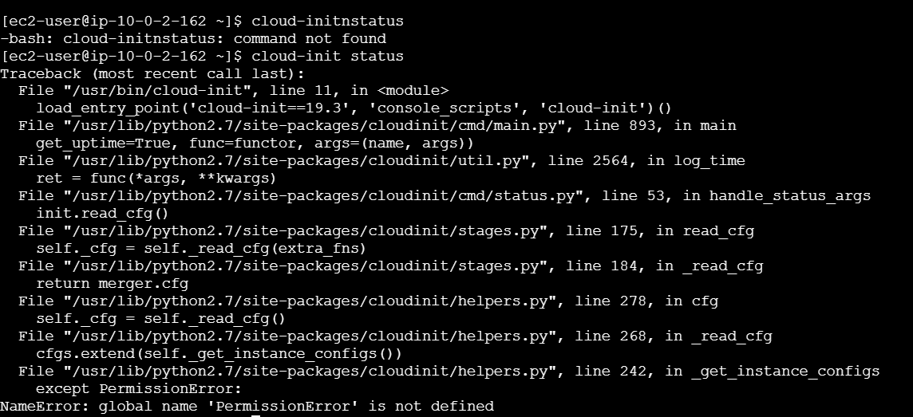
Used these commands
- sudo systemctl start httpd
- sudo systemctl enable httpd(makes the serve start with each boot)
the server didn’t start up with the boot

LAB 3
Dit in de user data scrhijven:
- sudo yum update -y
- sudo amazon-linux-extras install docker -y
- sudo service docker start
- sudo usermod -a -G docker ec2-user
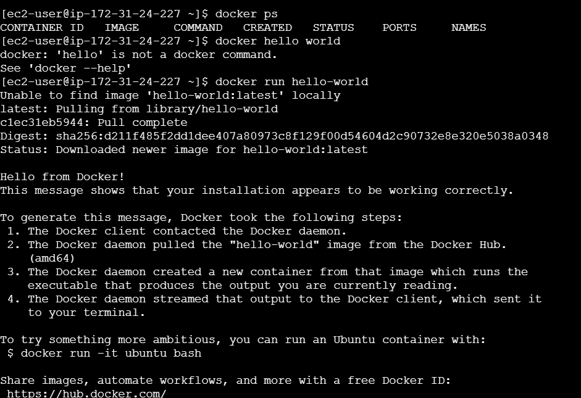
IT WORKS

LAB 4
docker pull itzg/minecraft-server
docker run -d -p 25565:25565 --name mc -v mc-data:/data itzg/minecraft-server
and it should work on ip:25565

Storage

Lab 1
In the bucket overview, create a folder named "logs".
Upload a file (e.g., a zip file) from your laptop into the logs folder via the AWS Console.
After uploading, notice that the file appears in the bucket, and you can view its S3 and HTTP endpoints.
Verify in CLI
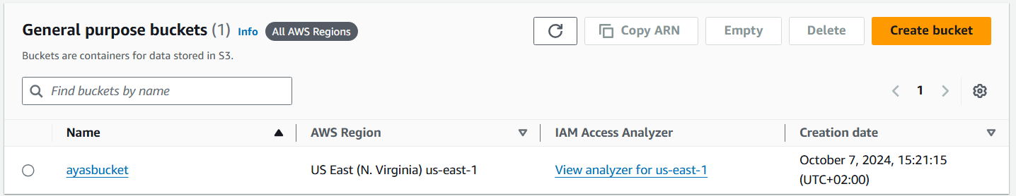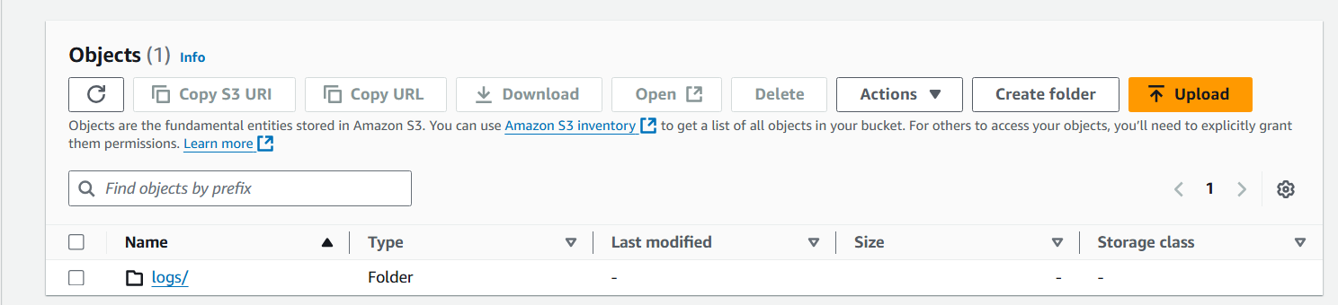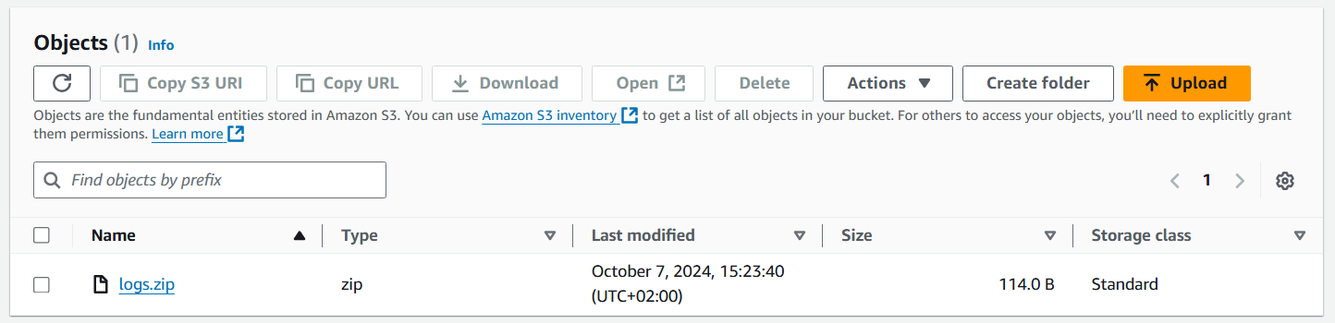
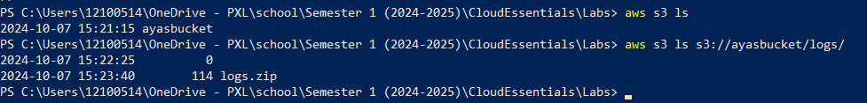

LAB 2
Create a new S3 bucket Use the AWS CLI to create a new bucket with a name of your choice. This will host your static website.
Enable Static Website Hosting Enable static site hosting using the AWS CLI with the aws s3 website command. Tip: You can configure error and redirect rules, but we will skip those for this lab.
Disable Block Public Access Since public access is blocked by default, use the CLI to disable this setting so the static site can be publicly accessed. Tip: Use the aws s3api put-public-access-block command to modify the access settings.
https://docs.aws.amazon.com/cli/latest/reference/s3api/put-public-access-block.html
aws s3api put-public-access-block -bucket ayas-website-bucket --public-access-block-configuration"BlockPublicAcls=false,IgnorePublicAcls=false,BlockPublicPolicy=false,RestrictPublicBuckets=false"
aws s3api put-bucket-policy --bucket ayas-website-bucket --policy '{ "Version": "2012-10-17", "Statement": [ { "Sid": "PublicReadGetObject", "Effect": "Allow", "Principal": "", "Action": "s3:GetObject", "Resource": "arn:aws:s3:::ayas-website-bucket/" } ] }'

- normal is het dat command maar het wil niet werken voior mij dus ik zithier vast :’)
Upload Your Website Content Create a simple index.html file (e.g., "Hello, world!") and sync it to your bucket using the AWS CLI.
maak dan een index.html
<!DOCTYPE html>
<html lang="en">
<head>
<meta charset="UTF-8">
<meta name="viewport" content="width=device-width, initial-scale=1.0">
<title>My Static Website</title>
</head>
<body>
<h1>Hello, world!</h1>
</body>
</html>

aws s3 cp index.html s3://your-bucket-name/index.html
Test Your Static Website After the file is uploaded, visit the website URL provided by the S3 bucket to view your static website. You should see your index.html content displayed.

Networking

LAB 1
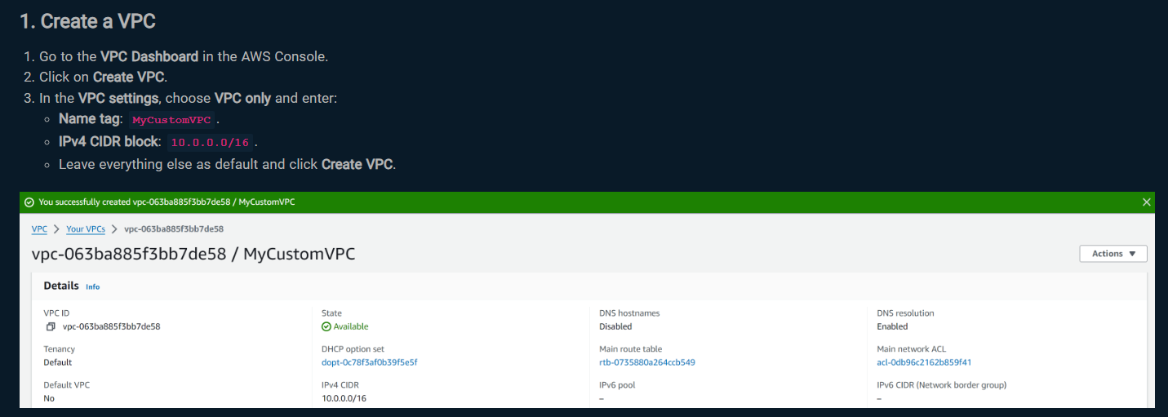
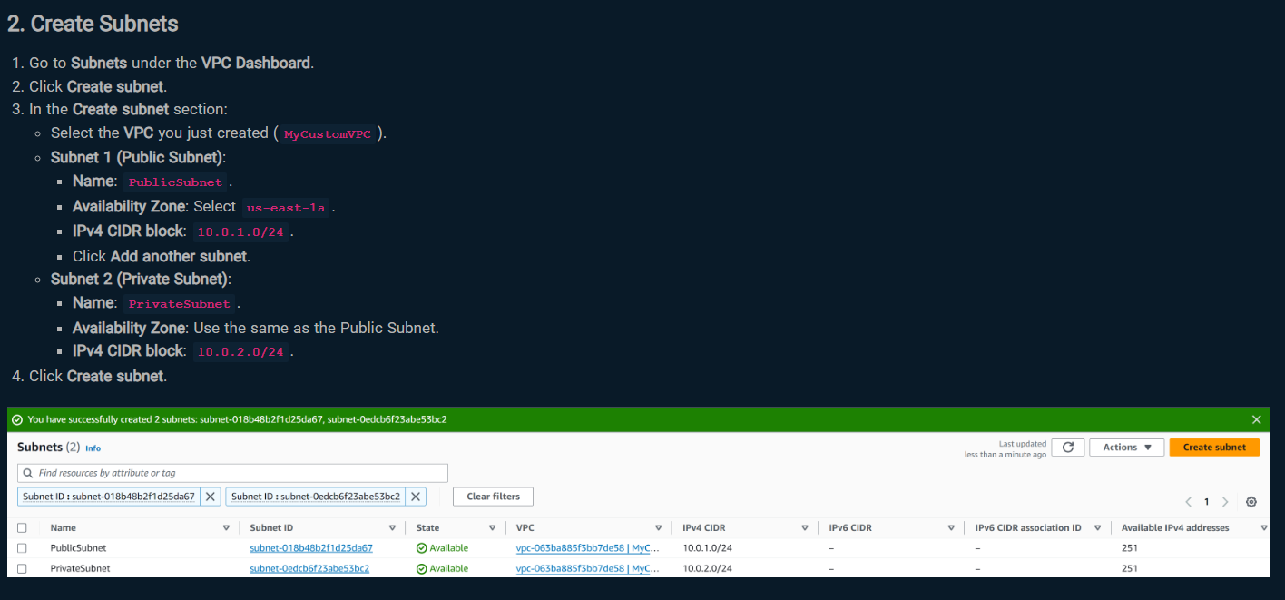
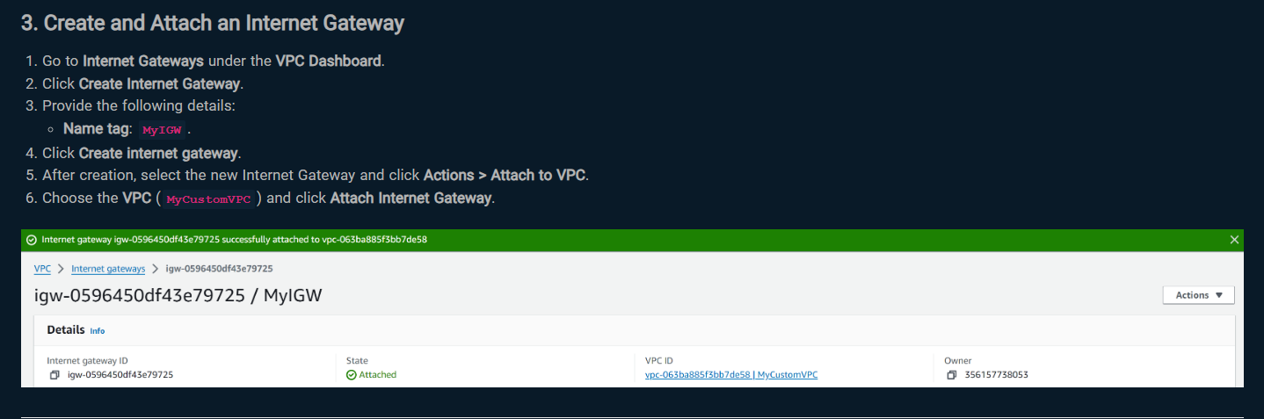
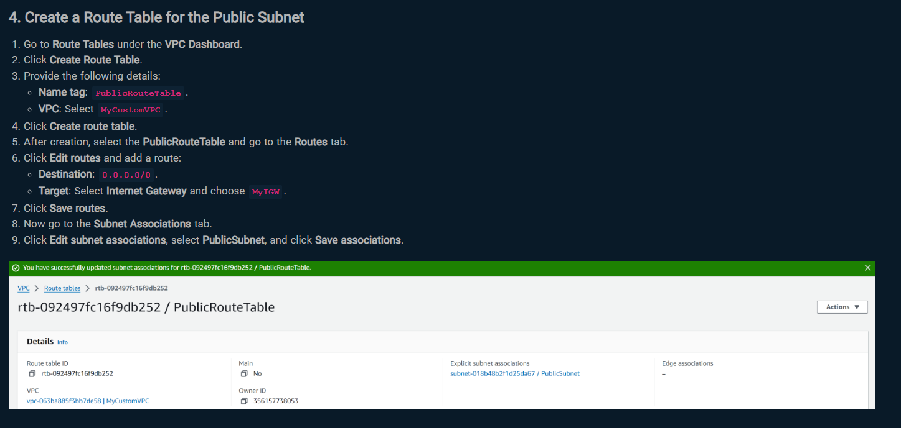
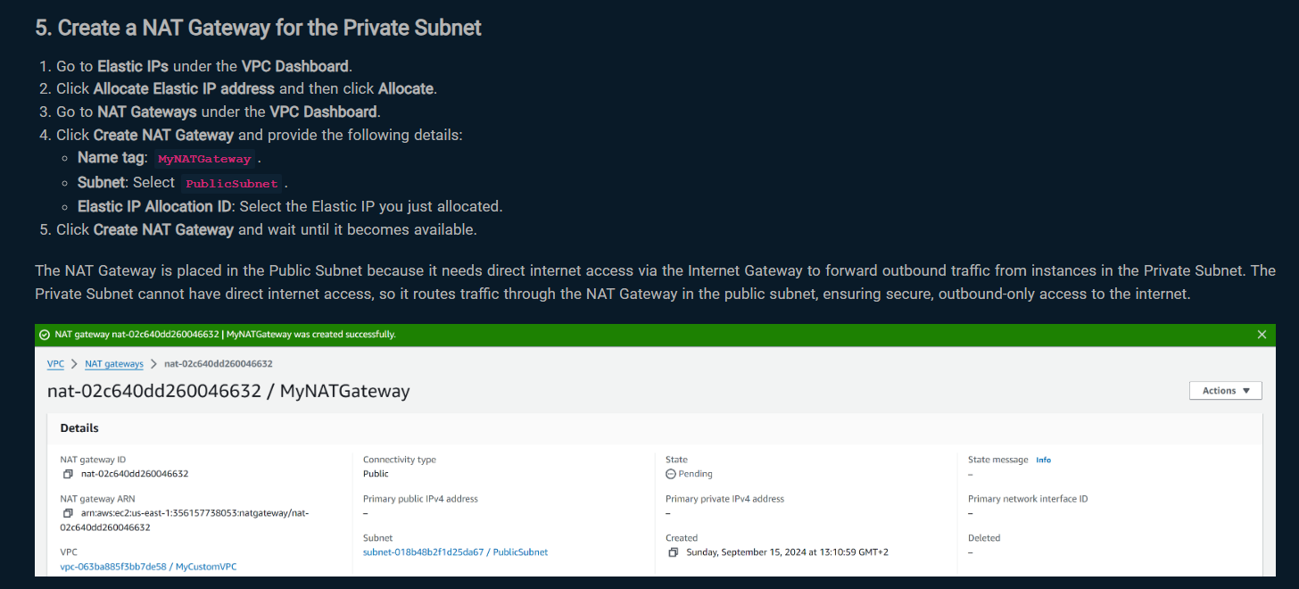
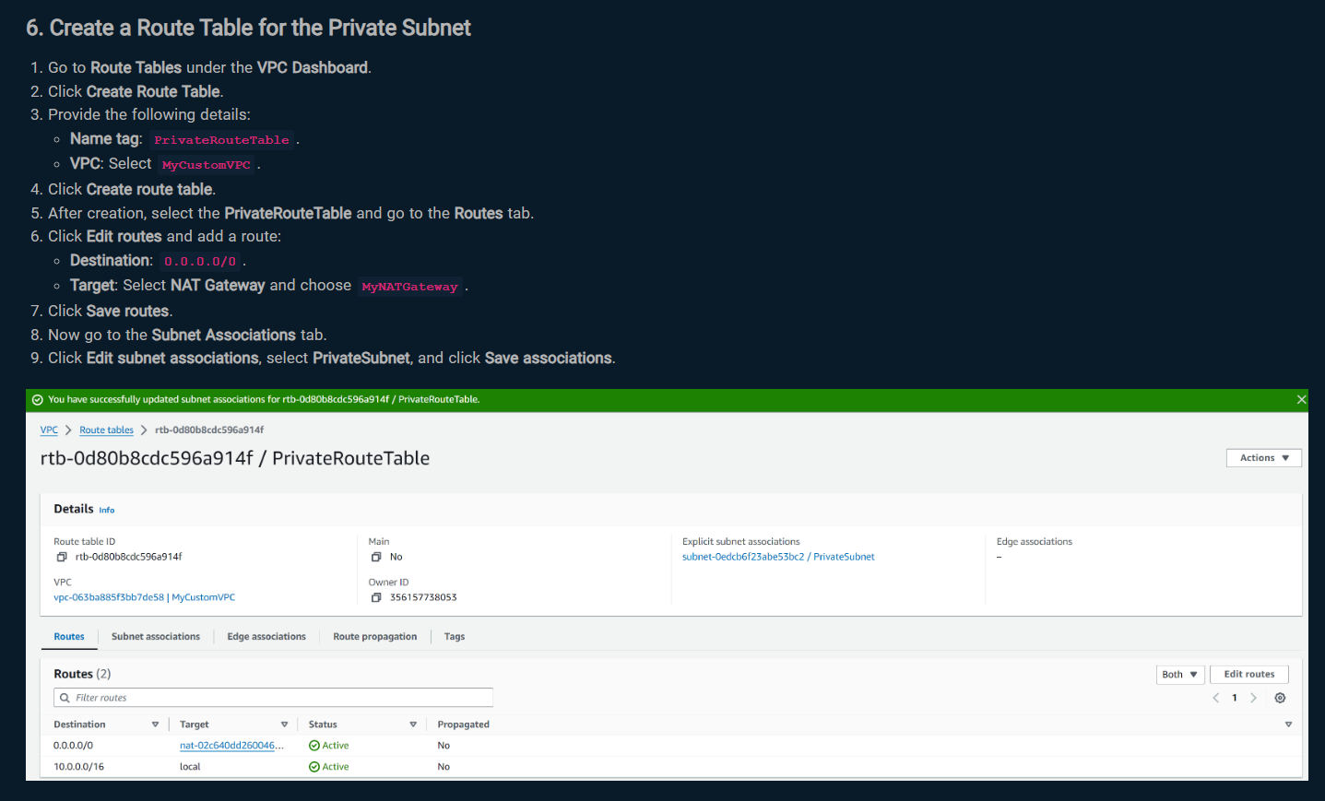
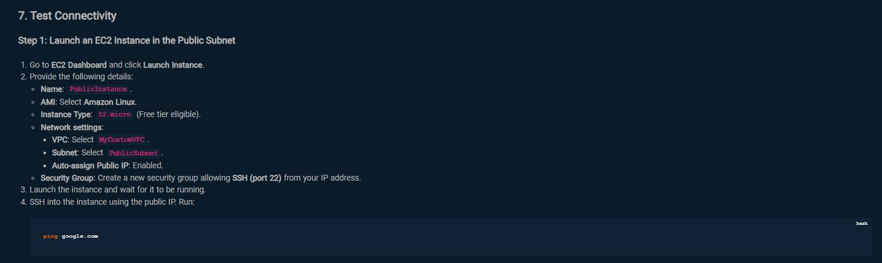
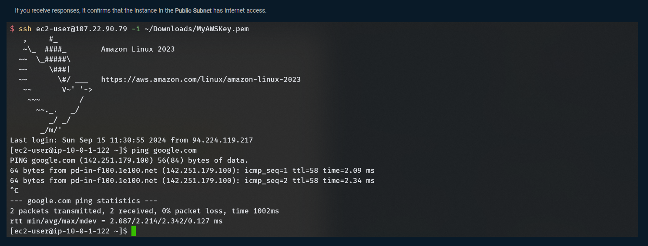

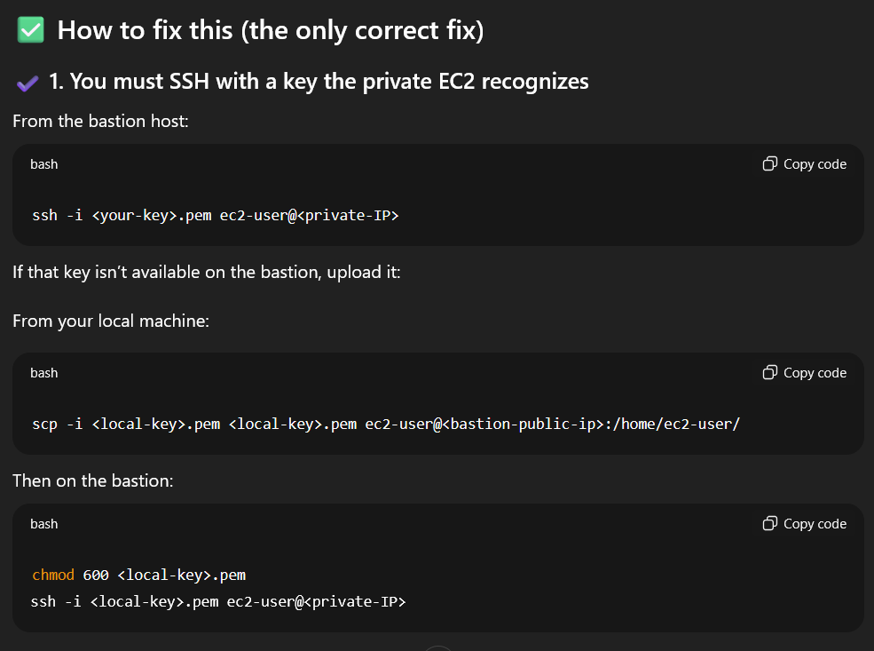
When unable to ssh into private instance, do this.

NETWORKING I

Lab 1
Configuring Security Groups for a Web Server
Configure security groups to control traffic to an EC2 instance acting as a web server.

Instructions:
- Launch an EC2 instance in the PublicSubnet:
- Name: WebServerInstance.
- AMI: Amazon Linux 2.
- Instance Type: t2.micro.
- Subnet: PublicSubnet.
- Auto-assign Public IP: Enabled.
- Configure the security group for the instance:
  - Allow HTTP (port 80) traffic from anywhere (0.0.0.0/0).
  - Allow SSH (port 22) only from your IP address.
- Install a web server:
  - SSH into the instance and run:
sudo yum update -y
sudo yum install httpd -y
sudo systemctl start httpd
sudo systemctl enable httpd
Verify the web server is running by accessing the instance’s public IP in a browser: http://<public-ip>.
Test: Ensure that the HTTP traffic is accessible publicly but SSH is restricted to your IP.

