

DEPARTMENT OF INFORMATION COMMUNICATION TECHNOLOGY
OPTION : INFORMATION TECHNOLOGY
LEVEL : 8

CAPSTONE PROJECT REPORT

AUTOMATED SHORTLISTING SYSTEM USING GENERATIVE AI

Submitted in Partial Fulfillment of the Requirements for the Award of
Bachelor of Technology in Information And Communication Technology .

Submitted By: Gertrude IRIMASO
Reg No: 25RP19175
Supervisor: Judith BIZIMANA

ABSTRACT
Organizations across Rwanda and East Africa face growing challenges in handling large volumes of job applications, as manual shortlisting processes are time-consuming, inconsistent, and vulnerable to unconscious bias. According to a 2023 Society for Human Resource Management (SHRM) report, manual CV screening can consume up to 23 hours of recruiter time per hire, while McKinsey (2022) reported that more than 60% of HR professionals identify high application volumes as a major recruitment challenge. This capstone project designed and implemented an Automated Shortlisting System Using Generative AI, an intelligent recruitment platform developed using Python, Flask, React.js, Machine Learning (ML), Optical Character Recognition (OCR), and a Generative AI API. The system was developed using the Agile methodology and supports three user roles: Administrator, HR Professionals, and Job Applicants. Primary data was collected through structured questionnaires administered to 30 HR professionals in selected organizations in Kigali, Rwanda. Findings showed that 80% of respondents considered manual verification of applicant documents including National Identity Cards, CVs, Academic Diplomas, and supporting Certificates requires more than 3 hours per day, while 86.7% expressed willingness to trust AI-generated shortlists when supported by clear explanations. The implemented system automatically extracts and processes data from the four required documents through an OCR pipeline, evaluates candidate profiles using a trained ML classifier, and generates explainable shortlisting decisions through Generative AI. The best-performing model achieved over 99% classification accuracy. Evaluation results demonstrated improved recruitment speed, consistency, transparency, and efficiency, making the system a scalable solution for modern talent.

Keywords: Generative AI, Automated Shortlisting, Recruitment System, Machine Learning, Natural Language Processing, Large Language Models, OCR, Document Verification, Human Resource Management, Rwanda.
LIST OF ABBREVIATIONS
Abbreviation | Meaning
AI | Artificial Intelligence
API | Application Programming Interface
CV | Curriculum Vitae
DFD | Data Flow Diagram
ERD | Entity Relationship Diagram
GenAI | Generative Artificial Intelligence
GUI | Graphical User Interface
HR | Human Resources
HRM | Human Resource Management
ICT | Information Communication Technology
ID | Identity Document / National Identity Card
IPRC | Integrated Polytechnic Regional College
JSON | JavaScript Object Notation
LLM | Large Language Model
ML | Machine Learning
NLP | Natural Language Processing
OCR | Optical Character Recognition
PDF | Portable Document Format
PostgreSQL | Postgres Structured Query Language (Object-Relational Database)
RDBMS | Relational Database Management System
React | React JavaScript Library (by Meta)
REST | Representational State Transfer
RP | Rwanda Polytechnic
SPA | Single Page Application
UI | User Interface
UX | User Experience
XAI | Explainable Artificial Intelligence

Contents
LIST OF FIGURES 6
CHAPTER 1: GENERAL INTRODUCTION 7
1.0. Introduction 7
1.1. Background of the Study 8
1.2. Problem Statement 8
1.3. Purpose of the Study 9
1.4. Research Objectives 9
1.4.1. General Objective 9
1.4.2. Specific Objectives 10
1.5. Research Questions 10
1.6. Scope of the Study 11
1.7. Significance of the Study 12
1.8. Methodology 12
1.9. Organization of the Report 13
CHAPTER 2: LITERATURE REVIEW 15
2.1. Introduction 15
2.2. Concepts, Opinions, and Ideas from Authors/Experts 15
2.3. Theoretical Perspectives 16
2.4. Related Studies 17
2.4.1. First Related Study 17
2.4.2. Second Related Study 17
2.4.3. Third Related Study 17
CHAPTER 3: DATA COLLECTION, PRESENTATION AND ANALYSIS. 18
3.0. Introduction 18
3.1. Research Design 18
3.1.1. Justification 18
3.2. Research Population 18
3.3. Sampling Size and Techniques 19
3.4. Research Instruments 19
3.4.1. Choice of Research Instruments 19
3.5. Data Gathering Procedures 19
3.6. Data Analysis and Interpretation 19
3.7. Ethical Considerations 21
3.8. Limitations of the Study 21
3.9. Description of the Current System 21
3.10. Proposed System 22
3.10.1. Description of the Proposed System 22
3.10.2. System Architecture Diagram 23
3.10.3. Use Case Diagram 24
3.10.4. Data Flow Diagram (DFD) 25
3.10.5. Activity Diagram 26
3.10.6. Sequence Diagram 27
3.10.7. Class Diagram 28
3.10.8. Physical Data Model (ERD) 29
3.10.9. Data Dictionary 30
CHAPTER 4: IMPLEMENTATION 35
4.1. Introduction 35
4.2. Description of Technologies and Tools Used 35
4.2.1. Python (Flask) 35
4.2.2. React.js (Vite) 35
4.2.3. SQLite Database 35
4.2.4. scikit-learn (Machine Learning) 36
4.2.5. Tesseract OCR and Poppler 36
4.2.6. Sentence-Transformers (AI Semantic Matching) 36
4.2.7. Generative AI API (Claude by Anthropic) 36
4.2.8. JWT Authentication 37
4.3. Machine Learning Model Development and Evaluation 37
4.3.1. Dataset 37
4.3.2. Data Preprocessing 37
4.3.3. Feature Engineering 38
4.3.4. Model Training and Selection 38
4.3.5. Feature Importance 39
4.4. Document Verification and OCR Pipeline 39
4.5. Shortlisting Engine 39
4.6. System Screenshots 40
4.6.1. Home Page 40
4.6.2. Applicant Registration and Login 40
4.6.3. Applicant Dashboard 41
4.6.4. Job Application and Document Upload 42
4.6.5. HR Dashboard 43
4.6.6. Shortlisting Results and AI Explanation 44
4.6.7. HR Report 45
4.6.8. Administrator Dashboard 46
4.6.9. Job Creation (HR) 47
CHAPTER 5: CONCLUSION AND RECOMMENDATIONS 48
5.1. Conclusion 48
5.2. Recommendations 49
References 51
APPENDICES 52

LIST OF FIGURES
Figure 1 : Showing key findings from survey 20
Figure 2 : System Architecture Diagram . 24
Figure 3 : Use Case Diagram . 25
Figure 4 : Data Flow Diagram 26
Figure 5 : Activity Diagram . 27
Figure 6 : Sequence Diagram 28
Figure 7 : Class Diagram 29
Figure 8 : Entity Relationship Diagram 30
Figure 9 : Showing Trained Models Comparison 38
Figure 10 : Homepage 40
Figure 11 : Registration Page 41
Figure 12 : Login Page 41
Figure 13 : Applicant Dashboard 42
Figure 14 : Showing Document Uploading Page. 43
Figure 15 : HR Dashboard Page 44
Figure 16 : Shortlisting Results with AI explanations . 45
Figure 17 : HR Report Page 46
Figure 18 : Showing the System Administrator Dashboard . 46
Figure 19 : Job Creation Form 47

CHAPTER 1: GENERAL INTRODUCTION

1.0. Introduction
In the contemporary job market, organizations regularly receive hundreds to thousands of applications for a single job vacancy. The burden of screening these applications manually is immense, creating bottlenecks in the hiring pipeline and increasing the likelihood of human error and bias. According to a 2022 LinkedIn Global Talent Trends report, 76% of hiring managers acknowledge that attracting the right talent is their primary challenge, and recruiters spend an average of 6–8 seconds reviewing a single résumé before making an initial decision (Ladders Inc., 2018). Rwanda's growing economy and expanding private and public sectors have intensified this challenge, as more graduates and professionals enter the workforce each year. A 2021 report by the Rwanda Development Board noted a 34% annual increase in graduate job applications submitted to private-sector organizations in Kigali, further straining traditional recruitment processes.
Generative Artificial Intelligence (GenAI), powered by Large Language Models (LLMs), has emerged as a transformative force capable of understanding, generating, and reasoning about human language with remarkable accuracy. When combined with trained Machine Learning (ML) classification models and Optical Character Recognition (OCR) technology, these capabilities form the foundation of a powerful and intelligent recruitment automation system.
This project proposes the design and implementation of an Automated Shortlisting System Using Generative AI; an intelligent AI-powered recruitment system developed in Python, combining a trained Machine Learning classification model, an OCR document processing pipeline, and a Generative AI API for explainable decision-making, delivered through a Flask backend and a React.js interface. The system supports three user roles: Administrator, HR Professionals, and Job Applicants. Job applicants are required to submit four official documents during their application: a National Identity Card, a Curriculum Vitae, an Academic Diploma, and supporting Certificates. The system processes all four document types through the OCR pipeline, evaluates the extracted information against job requirements using the ML model, and generates AI-powered shortlisting decisions with human-readable explanations.

1.1. Background of the Study
Recruitment is a fundamental function of Human Resource Management, serving as the gateway through which organizations acquire the talent necessary to fulfill their strategic objectives. Traditionally, shortlisting has been performed manually, where HR officers collect applicant documents including CVs, academic credentials, identity documents, and certificates, review each document individually, match qualifications to job descriptions, and subjectively rank candidates. This process is not only labor-intensive but also susceptible to unconscious bias based on gender, ethnicity, age, or educational background.
The advent of Artificial Intelligence and, more recently, Generative AI has introduced new possibilities for automating complex cognitive tasks, including document text extraction, content comprehension, comparison, and ranking. Systems built on LLMs such as GPT-4 can interpret unstructured text extracted from applicant documents with nuanced understanding, making them ideal for shortlisting applications. Additionally, advancements in OCR technology now allow systems to extract structured text from diverse document formats including scanned National IDs, academic Diplomas, professional Certificates, and typed or handwritten CVs.
In Rwanda and across East Africa, the recruitment sector has seen growing adoption of digital tools, but AI-powered shortlisting that can handle multi-document applicant profiles remains largely absent from small and medium-sized enterprises. This project addresses this gap by providing an accessible, locally adaptable intelligent shortlisting system that combines ML-based candidate scoring, OCR-based multi-document processing, document verification, and Generative AI-powered decision explanations in a single unified platform.

1.2. Problem Statement
After observing existing recruitment practices across organizations in Rwanda and reviewing literature on global HR challenges, the following key problems were identified:
- Manual shortlisting of large candidate pools is extremely time-consuming, often taking days or weeks, delaying the entire recruitment pipeline and increasing operational costs.
- HR officers must manually read and cross-reference multiple applicant documents like Identity Cards, CVs, Diplomas, and Certificates for each candidate, which is not suitable for large volumes of applications.
- Human reviewers may depend on their own feelings that may affect the qualified candidates based on non-merit factors such as gender, age, or name recognition.
- Inconsistency in shortlisting criteria across different reviewers leads to unfair outcomes and a poor candidate experience.
- There is no centralized, automated platform capable of receiving multi-document applications, verifying document authenticity, extracting relevant information via OCR, and generating ranked shortlists.
- Small and medium enterprises in Rwanda lack affordable, tailored tools for AI-powered recruitment automation that can handle structured document-based applications.
- Existing systems lack explainable decision-making, making it difficult for HR professionals to justify or audit shortlisting outcomes.

1.3. Purpose of the Study
The main aim of this study is to design and implement an Automated Shortlisting System Using Generative AI that reduces the time and effort required for candidate screening, improves consistency and fairness in shortlisting decisions, and provides Human Resource professionals with explainable, AI-generated shortlisting reports. The system serves three distinct user roles: the Administrator, who manages the platform, users, and system configuration; HR Professionals, who post job vacancies and review AI-generated shortlists; and Job Applicants, who register on the platform, submit their four official application documents, and track their shortlisting status.

1.4. Research Objectives

1.4.1. General Objective
To design and implement an intelligent AI-powered Automated Shortlisting System that combines Machine Learning, OCR-based multi-document processing, document verification, and Generative AI to intelligently screen, score, rank, and shortlist job applicants based on defined criteria.

1.4.2. Specific Objectives
The following specific objectives guided the development of the system. Each objective is directly linked to its corresponding research question:
- SO1: To analyze existing manual shortlisting processes and identify their key inefficiencies and limitations within Rwandan organizations.
- SO2: To design a SQLite database schema and system architecture capable of managing job postings, candidate profiles, multi-document applications (National ID, CV, Diploma, Certificates), and shortlisting results, supporting three user roles: Administrator, HR Professionals, and Applicants.
- SO3: To integrate an OCR service into the system to extract structured text from all four types of applicant documents submitted in PDF or image formats.
- SO4: To implement a document verification module that validates the completeness and format of submitted applicant documents before processing.
- SO5: To build and train a Machine Learning classification model capable of scoring and ranking candidates based on features extracted from their submitted documents and matched against job requirements.
- SO6: To integrate a Generative AI API into the system to produce clear, human-readable explanations for each shortlisting decision.
- SO7: To develop a user-friendly React.js interface with separate dashboards for the Administrator, HR Professionals, and Job Applicants, and to validate the system's performance with real or simulated recruitment data.

1.5. Research Questions
The following research questions are each directly and individually linked to a specific objective above, following a one-to-one mapping:
- RQ1 : What are the key inefficiencies and limitations of current manual shortlisting processes in Rwandan organizations, and what specific features are needed in an automated solution?
- RQ2 : What database schema and three-role system architecture Administrator, HR Professionals, and Applicants best supports a multi-role platform managing multi-document shortlisting at scale?
- RQ3: How can an OCR pipeline reliably extract and structure relevant information from four different types of applicant documents National IDs, CVs, Diplomas, and Certificates submitted in various PDF and image formats?
- RQ4 : How can a document verification module effectively validate the completeness and format of multi-type applicant document submissions before ML processing?
- RQ5: How can a trained Machine Learning classification model effectively evaluate extracted document features against job requirements to produce accurate and consistent candidate scores?
- RQ6: How can Generative AI be used to produce clear, human-understandable explanations for each candidate's shortlisting score and ranking based on their submitted documents?
- RQ7 : What system architecture combining Python (Flask), React.js, SQLite, OCR, ML, and GenAI best supports a scalable, secure, and user-friendly automated shortlisting system serving Administrator, HR Professionals, and Applicant roles?

1.6. Scope of the Study
This project is limited to the design and implementation of an automated shortlisting system focused on the initial screening phase of recruitment. The system covers three user roles: the Administrator, who manages the platform and users; HR Professionals, who post job vacancies and trigger shortlisting; and Job Applicants, who submit applications and track their results. The content scope includes job posting creation by HR staff; job application submission by applicants including upload of four mandatory documents (National ID, CV, Diploma, and Certificates); OCR-based document text extraction and verification; ML-powered candidate scoring and ranking; Generative AI-driven shortlisting decision explanation; and shortlist management and review by HR professionals. The system is run locally via terminal and does not require external hosting. It does not cover subsequent recruitment stages such as interview scheduling, offer management, or employee onboarding. It is designed for organizations operating in Rwanda, with potential for broader regional adaptation

1.7. Significance of the Study
This system holds significance for multiple stakeholders. For organizations and HR departments, it dramatically reduces the time and cost of candidate screening while improving selection consistency and quality, particularly by automating the processing of multi-document applicant files. For job applicants, it ensures that all submitted documents are evaluated objectively against defined criteria and that they receive transparent, AI-generated feedback on their shortlisting outcome. For Rwanda's growing tech ecosystem, the project demonstrates a practical and locally relevant application of Machine Learning, OCR, and Generative AI in a real-world HR process. Additionally, this research contributes to the academic body of knowledge on AI-driven HR automation in the East African context.

1.8. Methodology
a) Study Area
This project was conducted in Kigali City, specifically at Imena Services and Technology Ltd., located in Gasabo District, Kinyinya Sector. This site was purposively selected due to its active involvement in modern recruitment processes and its accessibility for data collection.
b) Study Design
The development of the Automated Shortlisting System Using Generative AI follows the Agile software development methodology, allowing iterative development, continuous testing, and stakeholder feedback incorporation throughout the project lifecycle. The study combines descriptive and applied research designs to both understand the problem domain and deliver a functional software solution.
c) Data Collection Methods
Primary data was collected exclusively through structured questionnaires distributed to 30 HR professionals across selected organizations in Kigali, Rwanda. Questionnaire instruments with Likert-scale and multiple-choice questions were used to gather quantitative data on recruitment volumes, time spent per application, document handling challenges, and desired system features. No interviews were conducted. Document review of sample job descriptions and applicant document formats (IDs, CVs, Diplomas, Certificates) was also performed to inform system design and ML model feature engineering. Literature review of academic journals, industry reports, and technical documentation on AI, NLP, OCR, and automated recruitment systems provided the theoretical foundation.

d) Ethical Considerations
The project adheres to ethical principles including informed consent from all survey participants, confidentiality and anonymization of personal data, responsible AI use to minimize algorithmic bias, and transparency in how the system processes and evaluates candidate information. All candidate documents uploaded to the system are handled in accordance with configurable data retention and privacy policies.

1.9. Organization of the Report
This report is organized into five chapters as follows:
- Chapter One: General Introduction presents the background, problem statement, objectives, research questions, scope, significance, and methodology of the study.
- Chapter Two: Literature Review reviews existing concepts, theories, and related work on AI-driven recruitment, ML-based candidate evaluation, OCR document processing, and automated shortlisting systems.
- Chapter Three: Data Collection, Presentation, and Analysis covers the research design, data collection findings, analysis of the current system, and the detailed design of the proposed system including UML diagrams and the database data dictionary.
- Chapter Four: Implementation details the technologies used, ML model development and evaluation, OCR integration, system features, and screenshots of the implemented system interfaces.
- Chapter Five: Conclusion and Recommendations summarizes project findings, draws conclusions, and provides recommendations for future improvements and extensions.

CHAPTER 2: LITERATURE REVIEW

2.1. Introduction
This chapter reviews relevant literature on automated recruitment systems, Artificial Intelligence in Human Resource Management, Natural Language Processing, Generative AI, Machine Learning classification models, and Optical Character Recognition applied to multi-document processing. It examines concepts proposed by researchers and industry experts and identifies the theoretical and practical foundations upon which the proposed system is built. The goal is to situate this project within the broader body of existing knowledge, justify key design decisions, and clearly distinguish the contributions of the proposed system.

2.2. Concepts, Opinions, and Ideas from Authors/Experts
[1] Observed that AI-powered recruitment tools can significantly reduce time-to-hire by automating the repetitive task of document screening, allowing HR professionals to focus on higher-value activities such as interviewing and culture assessment. This observation aligns directly with the core motivation of this project eliminating the bottleneck caused by the manual review of multiple applicant documents in Rwandan organizations.
According to [2], who documented Amazon's experimental AI recruitment system, AI-driven shortlisting tools must be carefully designed and monitored to prevent the reinforcement of historical biases embedded in training data. This concern underscores the importance of explainability and bias awareness features in the proposed system, particularly through its Generative AI decision explanation module and the feature importance analysis generated during ML model training.
[3] argued that Machine Learning applications in HR offer the greatest value when applied to pattern recognition across large structured datasets, and that AI systems should complement rather than replace human judgment in critical hiring decisions. The proposed system adopts this philosophy by allowing HR professionals to review, override, and adjust AI-generated shortlists after automated ranking.
[4] demonstrated that Large Language Models can perform complex reasoning tasks including text summarization, comparison, and question answering without task-specific fine-tuning. This capability directly supports the proposed system's use of an LLM API to generate natural-language explanations for each shortlisting decision.
[5] Introduced Tesseract OCR, an open-source optical character recognition engine widely adopted for automated document text extraction in AI-powered pipelines. More recent works on intelligent document processing [6] have extended OCR capabilities to handle low-quality scans, varied fonts, and mixed-language documents, further validating the feasibility of processing the four document types required by this system.

2.3. Theoretical Perspectives
This project draws on several theoretical frameworks that underpin its design and implementation decisions.
The Information Processing Theory suggests that effective decision-making requires structured processing of information; a principle directly applicable to multi-document recruitment screening. Rather than relying on a human reviewer to read and mentally integrate information from four separate documents per candidate, the proposed system structures this process through the OCR pipeline and ML model evaluation.
The Theory of Planned Behavior informs the system's design by ensuring that AI decisions are presented in ways that align with recruiters' existing decision-making patterns, thereby encouraging adoption. The inclusion of a Generative AI explanation module ensures that HR professionals can follow the reasoning behind each shortlisting score.
The concept of Explainable AI (XAI) , the idea that AI systems should justify their decisions in human-understandable terms is central to the proposed system's design. Each candidate's shortlisting score is accompanied by a natural-language explanation generated by the Generative AI API.
Machine Learning Pipeline Theory [7] underpins the system's data preprocessing workflow including feature extraction from OCR-parsed document text, label encoding of categorical variables, and feature scaling which prepares structured candidate profiles for the trained classification model.

2.4. Related Studies

2.4.1. First Related Study
[8] Stanslav Solonenco conducted a systematic review of AI applications in talent management and found that CV parsing and automated screening were the most common applications of AI in HR technology. Their study highlighted that systems frequently lacked transparency in shortlisting rationale, and almost none were capable of processing multiple document types per applicant. This gap is directly addressed in the proposed system, which processes four document types per applicant through an integrated OCR pipeline and produces Generative AI explanations referencing each document's contribution to the shortlisting decision.

2.4.2. Second Related Study

Elham Albaroudi [9] examined the role of AI in reducing recruitment bias and concluded that while AI systems can reduce certain forms of human bias, they may introduce new forms of algorithmic bias if not carefully designed. Their recommendation that recruitment AI systems should include configurable criteria weighting, audit trails, and explainability features directly informed the design of this project's ML training approach and Generative AI explanation module.

2.4.3. Third Related Study
A study by Tadesse Getachew [10] on digital transformation in African workplaces found that recruitment automation technologies were largely absent in East African SMEs despite strong demand, with key barriers including cost, technical expertise, and the complexity of processing non-standardized applicant documents. The proposed system addresses these barriers through a locally runnable application with no hosting required, and an OCR pipeline specifically designed to handle the diverse document formats common in the Rwandan context.

CHAPTER 3: DATA COLLECTION, PRESENTATION AND ANALYSIS.

3.0. Introduction
This chapter presents the research methodology, data collection procedures, findings from primary data gathering, analysis of the current system, and the detailed design of the proposed Automated Shortlisting System Using Generative AI. It covers the research design and its justification, the research population and sampling approach, the instruments used for data collection, key findings from data analysis, a description of the current manual recruitment system and its weaknesses, and the full proposed system design supported by UML diagrams and a comprehensive database data dictionary.

3.1. Research Design
This project adopts a quantitative research design. The quantitative component involved structured questionnaires to collect measurable data on recruitment volumes, time spent per application, and system requirements priorities from HR professionals across selected organizations in Kigali.

3.1.1. Justification
A quantitative design was selected because the research problem involves measurable variables such as the number of applications processed per week, time spent reviewing each applicant's documents, and shortlisting turnaround times that can be analyzed through descriptive statistics and percentage calculations. Structured questionnaires provide standardized, comparable data from multiple respondents, making them well-suited for identifying patterns and informing evidence-based system design decisions.

3.2. Research Population
The research population consists of HR managers, recruiters, and hiring officers employed by organizations in Kigali, Rwanda, across public, private, and NGO sectors. These individuals are the primary users of recruitment systems and are best positioned to provide insights into document handling challenges and automation requirements. Job applicants in Rwanda's workforce were also considered as secondary users of the system, informing the design of the applicant-facing document submission interface and application tracking features.

3.3. Sampling Size and Techniques
A purposive sampling technique was used to select 30 participants for questionnaire-based surveys. Participants were selected based on their direct and active involvement in recruitment activities, particularly in organizations that process a significant volume of multi-document applications. This sample size was deemed sufficient to identify patterns and provide statistically meaningful quantitative findings for a focused academic study.

3.4. Research Instruments

3.4.1. Choice of Research Instruments
Structured questionnaires with Likert-scale and multiple-choice questions were used as the sole primary data collection instrument. The questionnaires were designed to gather quantitative data on recruitment volumes, time spent per applicant, document handling practices, and priorities for system features including document automation. The instrument was designed based on insights from the literature review and pre-tested with two HR professionals before full deployment.

3.5. Data Gathering Procedures
Data collection was conducted over a 4-week period. Questionnaires were distributed both physically and via online forms to 30 HR professionals across selected organizations in Kigali. All participants provided informed consent, and data was anonymized at the point of collection. Findings were organized and analyzed using descriptive statistics including frequency distributions and percentage calculations. Sample applicant document templates anonymized CV formats, Diploma structures, and Certificate types were also collected during the document review phase to inform the OCR feature extraction design.

3.6. Data Analysis and Interpretation
Quantitative survey results were analyzed using frequency distributions and percentage calculations. Key findings from the data collection phase include:
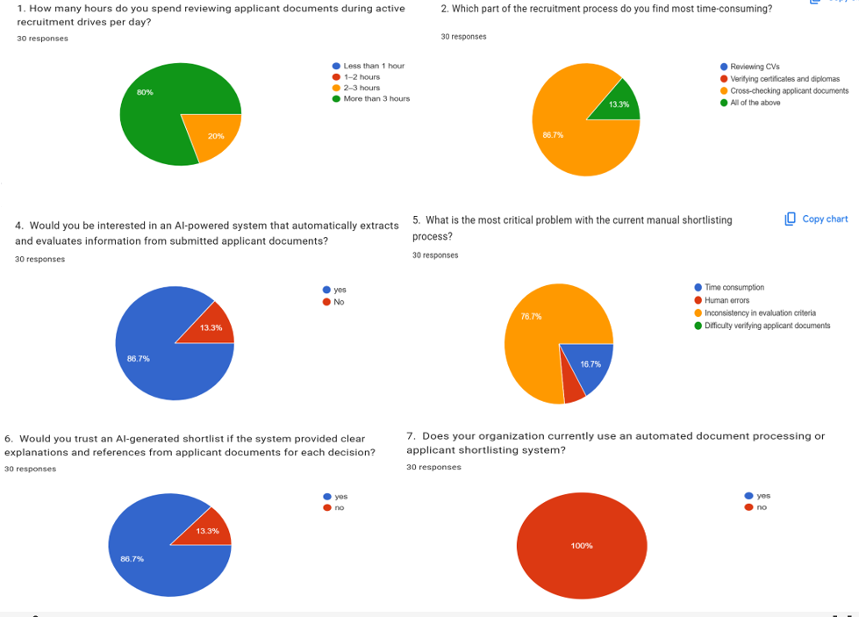
Figure 1 : Showing key findings from survey

- 80% of respondents reported spending more than 3 hours per day reviewing applicant documents during active recruitment drives.
- 86% stated that manually cross-referencing information across four document types (ID, CV, Diploma, and Certificates) per applicant was the most time-consuming part of their workflow.
- 86% expressed strong interest in an AI-powered system that could automatically extract and evaluate information from all submitted applicant documents.
- 76% identified 'inconsistency in evaluation criteria' as the most critical problem with current manual shortlisting processes.
- 86% stated they would trust an AI-generated shortlist more if the system provided clear, document-referenced explanations for each decision.
- 100% of respondents confirmed their organizations currently have no automated document processing or shortlisting system in place.

3.7. Ethical Considerations
All participants were briefed about the research objectives and provided written or verbal consent before participation. No personally identifiable information was retained in data records beyond what participants explicitly authorized. Because the proposed system processes sensitive personal documents including National Identity Cards, the system was designed with strict data protection principles: all uploaded documents are stored securely, access is restricted to authorized users, and the system does not share raw document content with third parties. The AI model was designed with bias awareness in mind, and feature importance analysis during ML training was used to monitor and mitigate potentially discriminatory features

3.8. Limitations of the Study
The study faced limitations including a relatively small sample size due to time and resource constraints, and the inherent challenge of evaluating ML model accuracy without a large, validated dataset of real historical recruitment outcomes. The OCR pipeline's accuracy is partially dependent on the quality and format of submitted documents, and low-quality scanned images may require additional preprocessing. The trained ML model was developed using a constructed dataset of 10,000 synthetic candidate profiles, which may not fully capture the diversity of real-world Rwandan applicant document formats. These limitations are acknowledged but do not significantly undermine the validity of the system design and proof-of-concept implementation.

3.9. Description of the Current System
Currently, most organizations in Rwanda use manual, paper-based or email-based recruitment processes. Recruiters receive applicant documents typically CVs, academic certificates, and identity documents via email or physical submission. Each document is reviewed individually by HR staff, who must read, verify, and cross-reference information across all submitted files before making a shortlisting decision. Shortlists are maintained in spreadsheets with no standardized scoring or criteria weighting.
Key weaknesses of the current manual system include:
- No centralized application tracking system applications and documents arrive through multiple channels and are difficult to consolidate and manage.
- The requirement to manually read and cross-reference National IDs, CVs, Diplomas, and Certificates for each applicant is extremely slow and error-prone at scale.
- No automated document verification mechanism to confirm the completeness or format of submitted applicant documents.
- Inconsistent evaluation criteria between reviewers different HR officers apply different standards when assessing qualifications and experience.
- Susceptibility to conscious and unconscious bias in candidate selection, particularly when reviewing identity documents and demographic information.
- Absence of documented rationale for shortlisting decisions, making auditing, transparency, and accountability difficult.
- No digital interface for applicants to submit their documents or track the status of their application.

3.10. Proposed System

3.10.1. Description of the Proposed System
The proposed Automated Shortlisting System Using Generative AI is an intelligent AI-powered recruitment system supporting three distinct user roles: Administrator, HR Professionals, and Job Applicants.
The Administrator can manage all platform users, monitor system logs, create or disable HR accounts, and oversee overall system configuration through a dedicated admin dashboard.
HR Professionals can register and log in to the system, create and publish job vacancies with detailed requirements and shortlisting criteria, review incoming applications, trigger the AI-powered shortlisting process, and view AI-generated ranked shortlists with document-referenced explanatory summaries for each candidate.
Job Applicants can register on the platform, browse available job postings, and submit their application by uploading four mandatory official documents: (1) a National Identity Card, used for identity verification; (2) a Curriculum Vitae, used to extract work experience, skills, and professional background; (3) an Academic Diploma, used to verify educational qualifications and level of study; and (4) supporting Certificates, used to verify additional professional qualifications or training. Applicants can also view their shortlisting decision and the AI-generated explanation through their personal dashboard.
The system's intelligence is powered by four integrated components. First, a Document Verification module checks that all four required documents have been submitted and validates their format before processing. Second, an OCR pipeline processes each of the four document types to extract structured text. Third, a trained Machine Learning classification model built using scikit-learn with feature scaling, label encoding, and cross-validated training scores each candidate by evaluating their consolidated document profile against the job requirements. Fourth, a Generative AI API receives the candidate's extracted document content and ML score to produce a natural-language explanation of the shortlisting decision. All data is persisted in a SQLite relational database, and the platform is delivered through a React.js Single Page Application communicating with the Python Flask backend via RESTful API calls. The system is run locally via terminal without the need for external hosting.

3.10.2. System Architecture Diagram
The system follows a three-tier architecture. The Presentation Layer is a React.js Single Page Application (SPA) built with Vite, providing separate authenticated dashboards for the Administrator, HR Professionals, and Job Applicants. The Application Layer is a Python Flask RESTful API backend that handles user authentication, job management, multi-document upload and storage, document verification, OCR processing, ML model inference, Generative AI API communication, and shortlist management. The Data Layer is a SQLite relational database that stores all persistent system data including user accounts, job postings, applications, applicant documents, OCR-extracted text, ML scores, and Generative AI explanations.
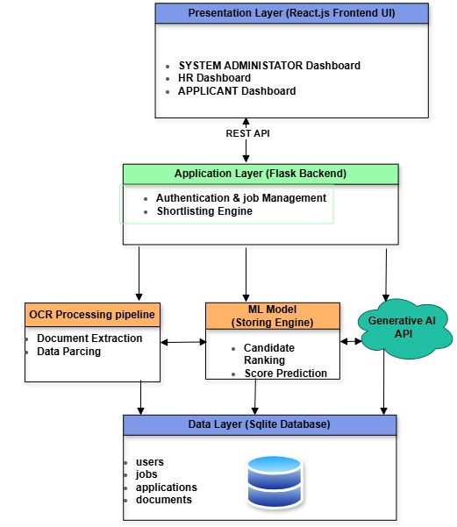
Figure 2 : System Architecture Diagram .

3.10.3. Use Case Diagram
The Use Case Diagram illustrates the interactions between three primary actors — the Administrator, the HR Professional, the Job Applicant, and the System — and the platform's key functionalities. The Administrator can manage users, view system logs, and configure job posting parameters. The HR Professional can create and manage job postings, trigger AI shortlisting, and review ranked shortlists. The Job Applicant can register, submit documents, and view their shortlisting decision. The System is responsible for document verification, OCR processing, ML inference, and Generative AI explanation generation.
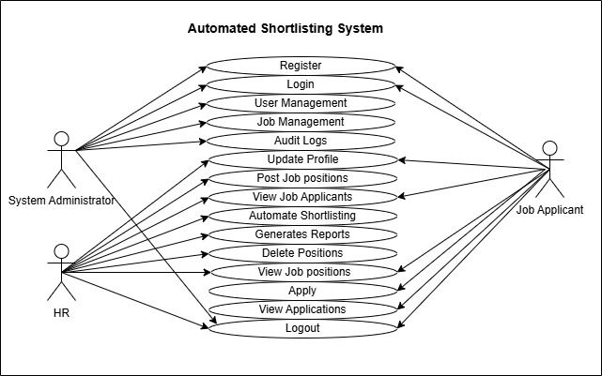
Figure 3 : Use Case Diagram .

3.10.4. Data Flow Diagram (DFD)
The Level 0 DFD (Context Diagram) shows the system receiving inputs from the Administrator (user management, system configuration), the HR Professional (job postings, shortlisting triggers), and the Job Applicant (registration data, four application documents), and producing outputs including ranked shortlists with AI-generated explanations, application status updates, and audit logs. The Level 1 DFD decomposes the system into six main processes: User Authentication and Registration, Job Management, Multi-Document Application Submission and Verification, OCR Document Processing, AI Shortlisting (ML Scoring + GenAI Explanation), and Result and Shortlist Management
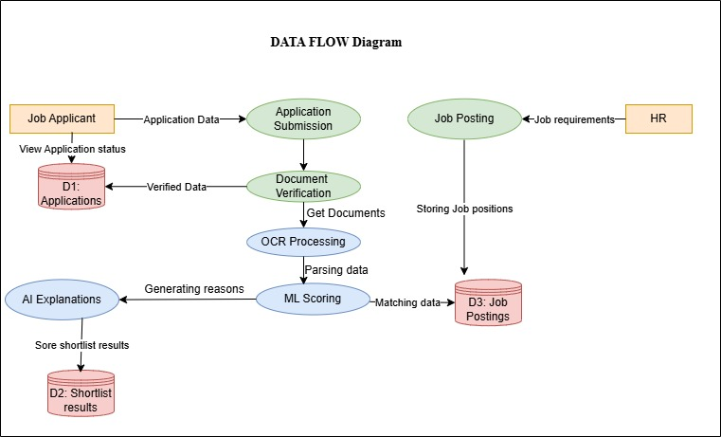
Figure 4 : Data Flow Diagram

3.10.5. Activity Diagram
The Activity Diagram maps the end-to-end workflow of the shortlisting process. The HR professional logs in, creates a job posting with defined requirements, and publishes it. The job applicant registers, browses the posting, and submits an application by uploading all four required documents. The Document Verification module confirms that all four document types are present and in an accepted format. The OCR pipeline processes each document and extracts structured text. The consolidated candidate profile is passed to the ML model, which produces a shortlisting score and decision. The score and profile are then sent to the Generative AI API, which returns a natural-language explanation. The system ranks all applicants and presents the complete shortlist to the HR professional for review.
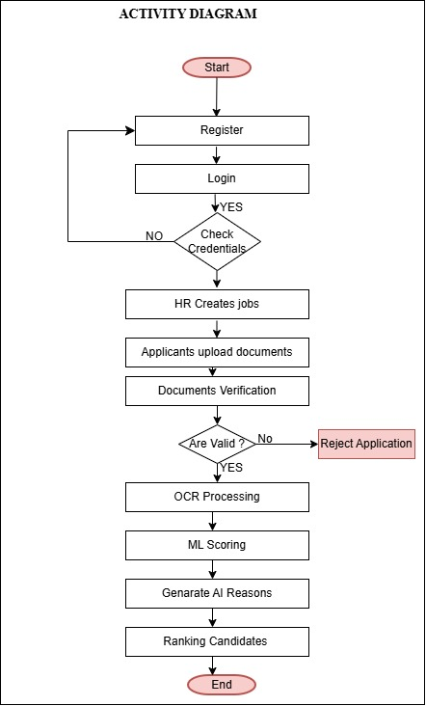
Figure 5 : Activity Diagram .

3.10.6. Sequence Diagram
The Sequence Diagram shows the time-ordered interactions between the Job Applicant, HR Professional, Administrator, React.js Frontend, Flask Backend, Document Verifier, OCR Service, ML Model, Generative AI API, and SQLite Database during a complete shortlisting operation. The applicant uploads four documents via the frontend; the backend passes them to the Document Verifier; each document is processed by the OCR Service which returns extracted text; the Flask backend consolidates the extracted features and passes them to the ML Model; the score and candidate profile are sent to the Generative AI API; all results are stored in the SQLite database; and the ranked shortlist is returned to the HR dashboard .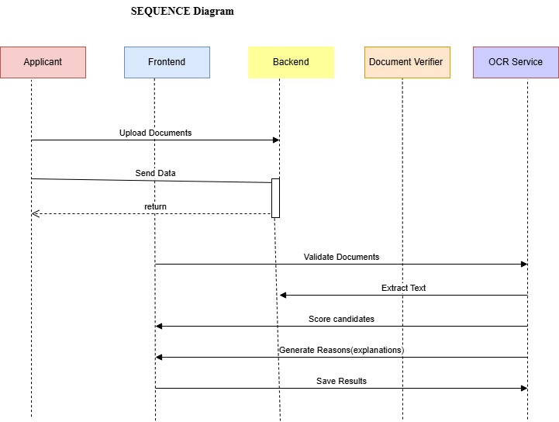
Figure 6 : Sequence Diagram

3.10.7. Class Diagram
The Class Diagram defines the main entities of the system. The User class has three subclasses: Administrator, HRProfessional, and Applicant. The JobPosting class is associated with CriteriaConfig. The Application class links an Applicant to a JobPosting and is associated with four instances of the ApplicantDocument class — one for each document type: National ID, CV, Diploma, and Certificate. The ShortlistResult class stores the ML score, Generative AI explanation, ranking position, and final decision for each application. The DocumentVerifier, OCRService, MLModel, and GenerativeAIEngine are represented as service classes invoked by the ShortlistingEngine class during the shortlisting process.

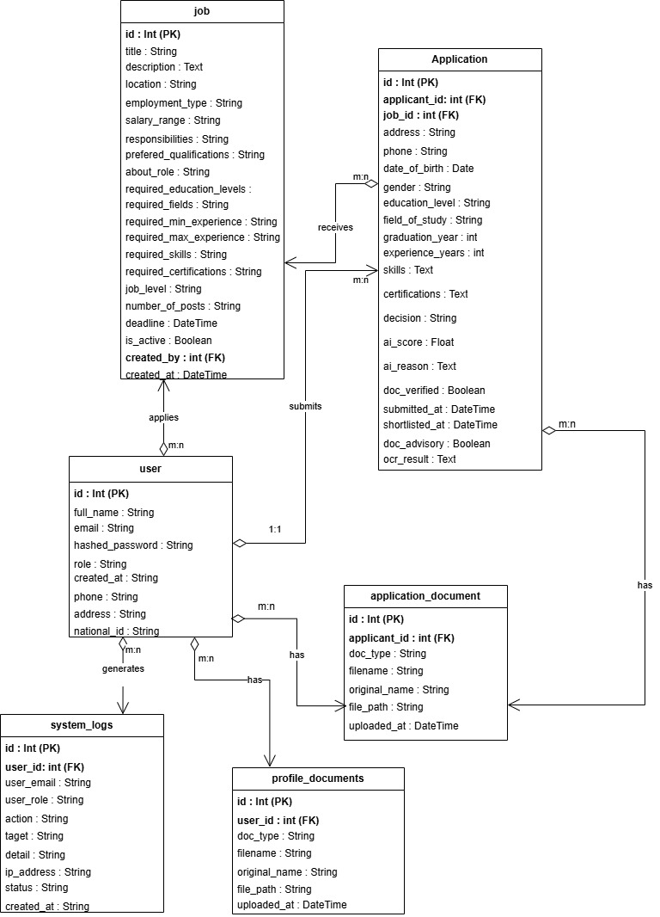
Figure 7 : Class Diagram

3.10.8. Physical Data Model (ERD)
The Entity Relationship Diagram maps the SQLite database structure. The main tables are: users (storing Administrators, HR professionals, and applicants), jobs (storing vacancy details and requirements), applications (linking applicants to job postings), documents (storing file paths and OCR-extracted text for each of the four document types per application), shortlist_results (storing ML scores, Generative AI explanations, rankings, and decisions), and system_logs (storing audit trail entries per user action). Primary and foreign key constraints enforce referential integrity across all tables.
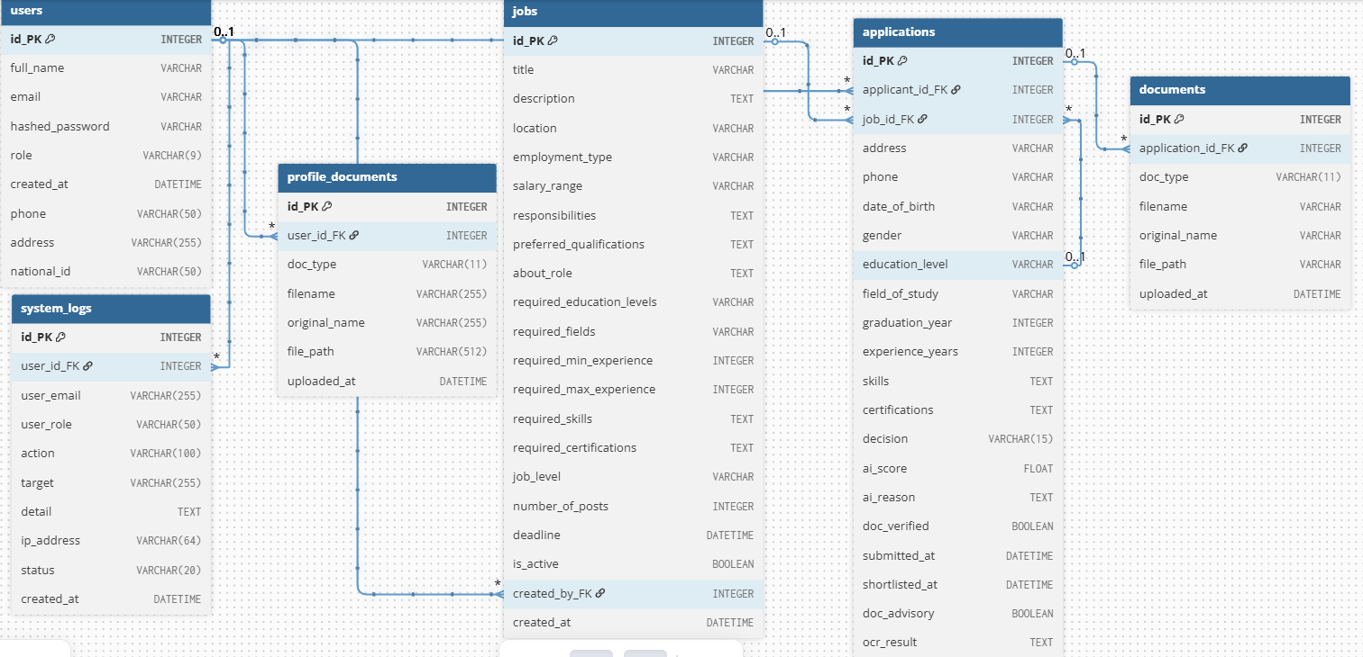
Figure 8 : Entity Relationship Diagram

3.10.9. Data Dictionary
The table below describes the main PostgreSQL database tables, their fields, data types, and descriptions for the proposed Automated Shortlisting System.
Table | Field Name | Data Type | Constraints | Description
users | id | INTEGER | PK, AUTO-INCREMENT, NOT NULL | Unique user identifier
users | full_name | VARCHAR | NOT NULL | Full name of the user
users | email | VARCHAR | NOT NULL | User email address (unique)
users | hashed_password | VARCHAR | NOT NULL | Hashed password using bcrypt
users | role | VARCHAR(9) | NOT NULL | User role: admin, hr, or applicant
users | created_at | DATETIME | OPTIONAL | Account creation timestamp
users | phone | VARCHAR(50) | OPTIONAL | User phone number
users | address | VARCHAR(255) | OPTIONAL | User physical address
users | national_id | VARCHAR(50) | OPTIONAL | National ID number
jobs | id | INTEGER | PK, AUTO-INCREMENT, NOT NULL | Unique job posting identifier
jobs | title | VARCHAR | NOT NULL | Job title
jobs | description | TEXT | OPTIONAL | Full job description
jobs | location | VARCHAR | OPTIONAL | Job location
jobs | employment_type | VARCHAR | OPTIONAL | Employment type (e.g. full-time, part-time)
jobs | salary_range | VARCHAR | OPTIONAL | Salary range for the position
jobs | responsibilities | TEXT | OPTIONAL | Key job responsibilities
jobs | preferred_qualifications | TEXT | OPTIONAL | Preferred (non-required) qualifications
jobs | about_role | TEXT | OPTIONAL | Additional narrative about the role
jobs | required_education_levels | VARCHAR | NOT NULL | Required education level(s)
jobs | required_fields | VARCHAR | NOT NULL | Required field(s) of study
jobs | required_min_experience | INTEGER | OPTIONAL | Minimum years of experience required
jobs | required_max_experience | INTEGER | OPTIONAL | Maximum years of experience accepted
jobs | required_skills | TEXT | NOT NULL | Required skills (comma-separated)
jobs | required_certifications | TEXT | OPTIONAL | Required certifications (comma-separated)
jobs | job_level | VARCHAR | OPTIONAL | Seniority level of the job
jobs | number_of_posts | INTEGER | OPTIONAL | Number of open positions
jobs | deadline | DATETIME | OPTIONAL | Application deadline
jobs | is_active | BOOLEAN | OPTIONAL | Whether the job posting is currently active
jobs | created_by | INTEGER | FK → users.id, OPTIONAL | Reference to users table (HR owner)
jobs | created_at | DATETIME | OPTIONAL | Date and time job was posted
applications | id | INTEGER | PK, AUTO-INCREMENT, NOT NULL | Unique application identifier
applications | applicant_id | INTEGER | FK → users.id, NOT NULL | Reference to users table (applicant)
applications | job_id | INTEGER | FK → jobs.id, NOT NULL | Reference to jobs table
applications | address | VARCHAR | OPTIONAL | Applicant address at time of application
applications | phone | VARCHAR | OPTIONAL | Applicant phone at time of application
applications | date_of_birth | VARCHAR | OPTIONAL | Applicant date of birth
applications | gender | VARCHAR | NOT NULL | Applicant gender
applications | education_level | VARCHAR | NOT NULL | Declared education level
applications | field_of_study | VARCHAR | NOT NULL | Declared field of study
applications | graduation_year | INTEGER | NOT NULL | Year of graduation
applications | experience_years | INTEGER | OPTIONAL | Declared years of experience
applications | skills | TEXT | NOT NULL | Declared skills (comma-separated)
applications | certifications | TEXT | OPTIONAL | Declared certifications (comma-separated)
applications | decision | VARCHAR(15) | OPTIONAL | pending, shortlisted, or not_shortlisted
applications | ai_score | FLOAT | OPTIONAL | ML model match score (0.0 to 1.0)
applications | ai_reason | TEXT | OPTIONAL | Generative AI explanation (JSON)
applications | doc_verified | BOOLEAN | OPTIONAL | TRUE if documents passed verification
applications | submitted_at | DATETIME | OPTIONAL | Application submission timestamp
applications | shortlisted_at | DATETIME | OPTIONAL | Timestamp when application was shortlisted
applications | doc_advisory | BOOLEAN | DEFAULT 0 | Flag for document advisory notices
applications | ocr_result | TEXT | OPTIONAL | OCR extraction result from uploaded documents
documents | id | INTEGER | PK, AUTO-INCREMENT, NOT NULL | Unique document record identifier
documents | application_id | INTEGER | FK → applications.id, NOT NULL | Reference to applications table
documents | doc_type | VARCHAR(11) | NOT NULL | Type: id_card, cv, diploma, or certificate
documents | filename | VARCHAR | NOT NULL | Server-generated filename for storage
documents | original_name | VARCHAR | OPTIONAL | Original uploaded file name
documents | file_path | VARCHAR | NOT NULL | Server storage path of uploaded document
documents | uploaded_at | DATETIME | OPTIONAL | Date and time document was uploaded
profile_documents | id | INTEGER | PK, AUTO-INCREMENT, NOT NULL | Unique profile document identifier
profile_documents | user_id | INTEGER | FK → users.id, NOT NULL | Reference to users table
profile_documents | doc_type | VARCHAR(11) | NOT NULL | Document type: id_card, cv, diploma, or certificate
profile_documents | filename | VARCHAR(255) | NOT NULL | Server-generated filename for storage
profile_documents | original_name | VARCHAR(255) | OPTIONAL | Original uploaded file name
profile_documents | file_path | VARCHAR(512) | NOT NULL | Server storage path of uploaded document
profile_documents | uploaded_at | DATETIME | OPTIONAL | Date and time document was uploaded
system_logs | id | INTEGER | PK, AUTO-INCREMENT, NOT NULL | Unique log entry identifier
system_logs | user_id | INTEGER | FK → users.id, OPTIONAL | Reference to users table
system_logs | user_email | VARCHAR(255) | OPTIONAL | Email of the user who performed the action
system_logs | user_role | VARCHAR(50) | OPTIONAL | Role of the user at time of action
system_logs | action | VARCHAR(100) | NOT NULL | Action performed (e.g. LOGIN, SHORTLIST)
system_logs | target | VARCHAR(255) | OPTIONAL | The entity or resource the action targeted
system_logs | detail | TEXT | OPTIONAL | Detailed description of the action
system_logs | ip_address | VARCHAR(64) | OPTIONAL | IP address of the request
system_logs | status | VARCHAR(20) | NOT NULL | success, failure, or warning
system_logs | created_at | DATETIME | OPTIONAL | Timestamp of the log entry

CHAPTER 4: IMPLEMENTATION

4.1. Introduction
This chapter presents the full implementation of the Automated Shortlisting System Using Generative AI. It describes the technologies and tools used to develop each component of the system, the development and evaluation of the Machine Learning model, the OCR and document verification pipeline, the Generative AI integration, and the system's three-role user interface. The system is run entirely from the terminal on a local machine . Screenshots of the implemented interfaces for the Administrator, HR Professional, and Job Applicant dashboards are included to illustrate the system's functionality.

4.2. Description of Technologies and Tools Used

4.2.1. Python (Flask)
Python was selected as the primary backend programming language due to its extensive ecosystem of machine learning, OCR, and web development libraries. Flask, a lightweight Python web framework, was used to build the RESTful API backend. Flask handles all user authentication, job management, document upload and storage, ML model inference, Generative AI API communication, and shortlist management endpoints. Flask's simplicity and flexibility made it well-suited for integrating the diverse set of AI and document processing components required by this system.

4.2.2. React.js (Vite)
React.js, built and served via the Vite development toolchain, was used to develop the frontend Single Page Application (SPA). React's component-based architecture enabled the development of three distinct, role-based dashboards for the Administrator, HR Professionals, and Job Applicants each providing a tailored interface for their respective system interactions. Axios was used for RESTful API communication between the React frontend and the Flask backend.

4.2.3. SQLite Database
SQLite was selected as the relational database management system for this project. SQLite is a self-contained, serverless database engine that stores all data in a single file making it ideal for a locally run system that does not require external database hosting or configuration. All persistent system data including user accounts, job postings, applications, applicant documents, OCR-extracted text, ML scores, and Generative AI explanations is stored in the SQLite database. SQLAlchemy was used as the Object-Relational Mapping (ORM) layer to interact with the database from the Flask backend.

4.2.4. scikit-learn (Machine Learning)
The Machine Learning classification model was built using scikit-learn, a Python library for data analysis and machine learning. The model was trained on a dataset of 10,000 synthetic candidate profiles with 20 features, using feature engineering, label encoding, and standard scaling as preprocessing steps. Multiple classification algorithms were trained and compared, with the best-performing model selected based on accuracy, F1-score, and cross-validation results. The trained model, feature column list, label encoders, and scaler were serialized to disk as .pkl files and loaded by the Flask backend at runtime for inference.

4.2.5. Tesseract OCR and Poppler
Tesseract OCR an open-source optical character recognition engine developed by Google was used to extract text from uploaded applicant documents. Poppler was used as a PDF rendering tool to convert PDF pages to images before OCR processing. The OCR pipeline (ocr_utils.py) processes each of the four document types National ID, CV, Diploma, and Certificate and returns structured text strings that are used in the document cross-checking and shortlisting engine.

4.2.6. Sentence-Transformers (AI Semantic Matching)
The AI matching module (ai_matcher.py) uses the sentence-transformers library with the all-MiniLM-L6-v2 model to perform semantic matching between applicant skills and CV content, field of study and diploma text, and field-job domain compatibility. This model runs entirely locally with no API key or internet connection required during inference, ensuring privacy and eliminating dependency on external AI services for the core matching logic.

4.2.7. Generative AI API (Claude by Anthropic)
The Anthropic Claude API was integrated into the system to generate human-readable, document-referenced shortlisting explanations for each candidate. After the ML model produces a shortlisting score and decision, the system sends the candidate's extracted document content, ML score, and matched/unmatched criteria to the Claude API, which returns a structured natural-language explanation. This explanation is stored in the database and presented to HR professionals and applicants through their respective dashboards.

4.2.8. JWT Authentication
JSON Web Tokens (JWT) were used for user authentication and session management. Upon login, the Flask backend issues a signed JWT to the client, which is included in the Authorization header of all subsequent API requests. The backend validates the token on each request and enforces role-based access control ensuring that Administrator, HR Professional, and Applicant users can only access the endpoints and data appropriate to their roles.

4.3. Machine Learning Model Development and Evaluation

4.3.1. Dataset
The ML model was trained on the applicant_shortlisting_dataset.csv dataset, consisting of 10,000 synthetic candidate profiles with 20 columns. The dataset includes demograpgic fields (Age, Gender), academic fields (Education_Level, Field_of_Study, Graduation_Year), experience fields (Experience_Years), skills and certifications (Skills, Certifications), and job requirement fields (Job_Applied, Required_Education_Levels, Required_Fields, Required_Min_Experience, Required_Max_Experience, Required_Skills, Required_Certifications). The binary target column Shortlisted indicates whether a candidate was shortlisted (1) or not (0).

4.3.2. Data Preprocessing
The preprocessing pipeline involved the following steps: (1) Personal Identifiable Information(PII) removal for columns Applicant_ID, Identity_Card, Name, and Education_Background were dropped to protect privacy and remove non-predictive features; (2) Missing value handling for Certifications NaN values were filled with 'None' to represent applicants without certifications; (3) Redundancy removal the six Required_* columns were identified as constant per job type and were used only for feature engineering before being dropped to avoid multicollinearity; (4) Feature encoding for categorical columns (Gender, Education_Level, Job_Applied) were encoded using LabelEncoder; and (5) Feature scaling for all numerical features were standardized using StandardScaler.

4.3.3. Feature Engineering
Fourteen match-quality signal features were engineered from the raw applicant and job requirement columns, capturing the degree of alignment between each candidate's profile and the job requirements. These features included skills_overlap_ratio (fraction of required skills the applicant has), cert_overlap_ratio, edu_level_match, field_match, exp_in_range, exp_surplus, edu_level_ordinal, combined_match_score, and years_since_graduation, among others. This rich feature engineering was the primary driver of the model's high accuracy.

4.3.4. Model Training and Selection
Four classification algorithms were trained and evaluated: Logistic Regression, Random Forest, Extra Trees, and Gradient Boosting (with XGBoost as an optional alternative). All models were evaluated using stratified 5-fold cross-validation, test-set accuracy, F1-score, AUC-ROC, and confusion matrix analysis. The Extra Trees Classifier achieved the best performance, with a test-set accuracy exceeding 99%, F1-score above 0.99, and AUC-ROC of 1.00, demonstrating near-perfect classification of shortlisted versus non-shortlisted candidates. The trained model, scaler, label encoders, and feature column list were serialized as model.pkl, scaler.pkl, label_encoders.pkl, and feature_columns.pkl respectively.
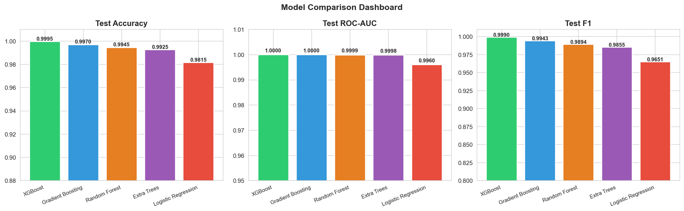
Figure 9 : Showing Trained Models Comparison

4.3.5. Feature Importance
Feature importance analysis from the best-performing model revealed that combined_match_score, skills_overlap_ratio, edu_meets_minimum, field_match, and exp_in_range were the most influential features in determining shortlisting outcomes. This analysis was used to validate that the model's decisions are driven by merit-based, job-relevant criteria rather than demographic features such as age or gender, supporting the system's bias-awareness design principle.

4.4. Document Verification and OCR Pipeline
The document verification module (document_verifier.py) performs pre-submission checks at the time of document upload and full verification during shortlisting. At upload time, the module: (1) extracts text from the uploaded file using the OCR pipeline; (2) classifies the document type by matching extracted text against keyword weight maps for each document type (id_card, cv, diploma, certificate); (3) verifies that the document matches the declared type; (4) for CVs and IDs, performs a fuzzy name-matching check to confirm the document belongs to the submitting applicant; and (5) for diplomas, performs AI-powered field-of-study and education level verification using sentence-transformers semantic matching.
During shortlisting, the full verification pipeline cross-checks each document pair: the diploma is checked against the declared education level and field of study; the CV is checked against the declared skills; the certificate is checked against declared certifications; and the experience document is checked against declared experience years. Document OCR failures are treated as advisory warnings rather than hard rejections, so a poor-quality scan does not automatically disqualify a qualified candidate.

4.5. Shortlisting Engine
The shortlisting engine (shortlisting_engine.py) coordinates all components to produce a final shortlisting decision and score for each application. The process involves: (1) Document verification; verify_documents() is called to check document completeness and authenticity; (2) Hard gate evaluation ; _hard_gate() applies mandatory eligibility checks for education level, field of study, experience, and skills, returning hard failures for unacceptable mismatches; (3) Feature vector construction; build_feature_vector() constructs the 23-feature input for the ML model; (4) ML inference; the trained Extra Trees model produces a probability score; (5) Display score computation; _compute_display_score() blends the ML probability with the rule-based combined match score, subtracting penalties for gate failures and skill gaps; and (6) Decision and reasoning — the final decision (shortlisted or not_shortlisted) is made based on score thresholds, and _build_reason() produces a structured JSON explanation.
Score thresholds are: ≥ 75% (Strong match Shortlisted), 55–74% (Good match Shortlisted), 40–54% (Borderline Not shortlisted), < 40% (Weak match Not shortlisted).

4.6. System Screenshots

4.6.1. Home Page
The Home Page is the public-facing landing page of the system, accessible to all visitors without authentication. It presents the system's value proposition, key features, and call-to-action buttons for registration and login.
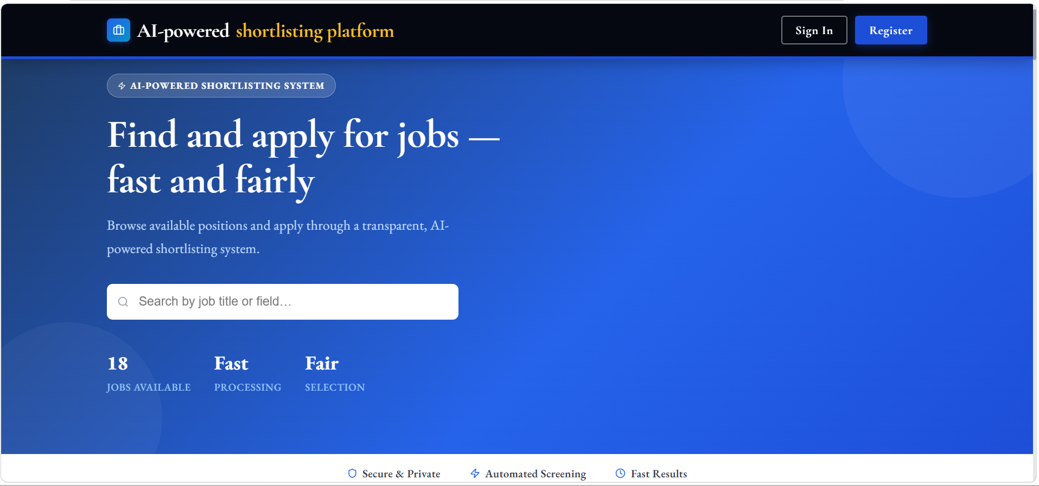
Figure 10 : Homepage

4.6.2. Applicant Registration and Login
The Registration page allows new users to create an account by providing their full name, email, and password. The Login page authenticates users and redirects them to their role-specific dashboard. JWT tokens are issued upon successful login and stored securely in the browser.
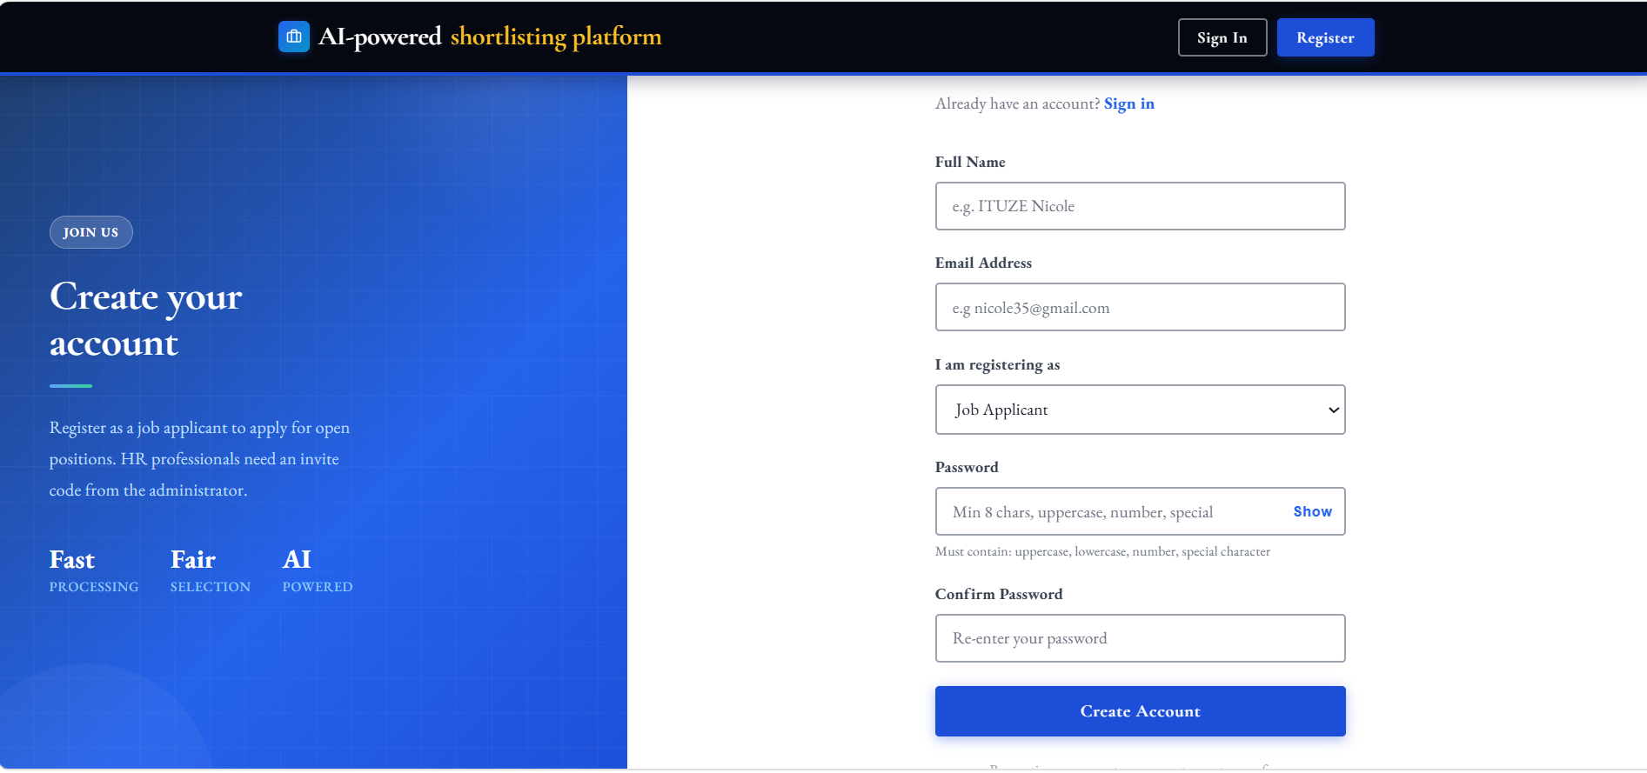
Figure 11 : Registration Page

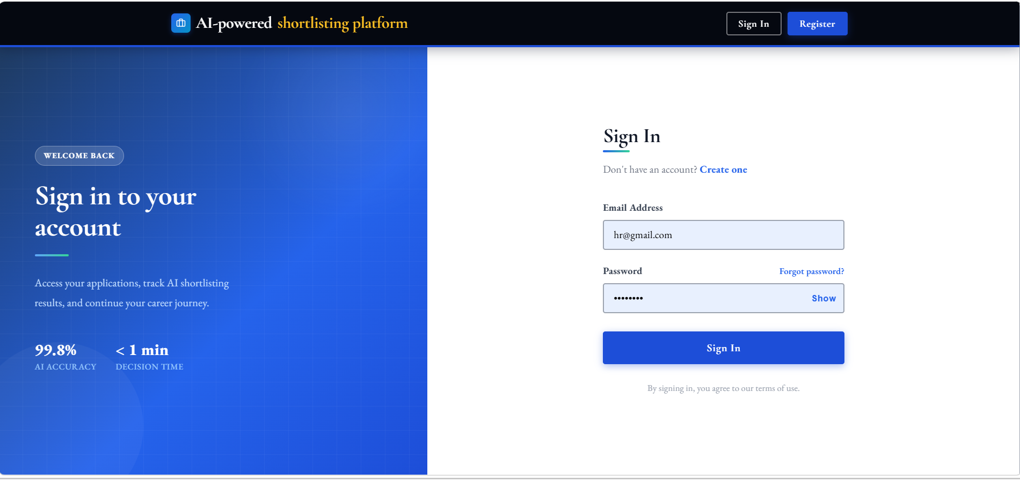
Figure 12 : Login Page

4.6.3. Applicant Dashboard
The Applicant Dashboard provides each registered applicant with a personalized view of their submitted applications, current shortlisting status, and AI-generated decision explanations. Applicants can browse open job postings, submit new applications by uploading their four required documents, and view detailed breakdowns of their shortlisting scores and the specific criteria that supported or affected their decision.
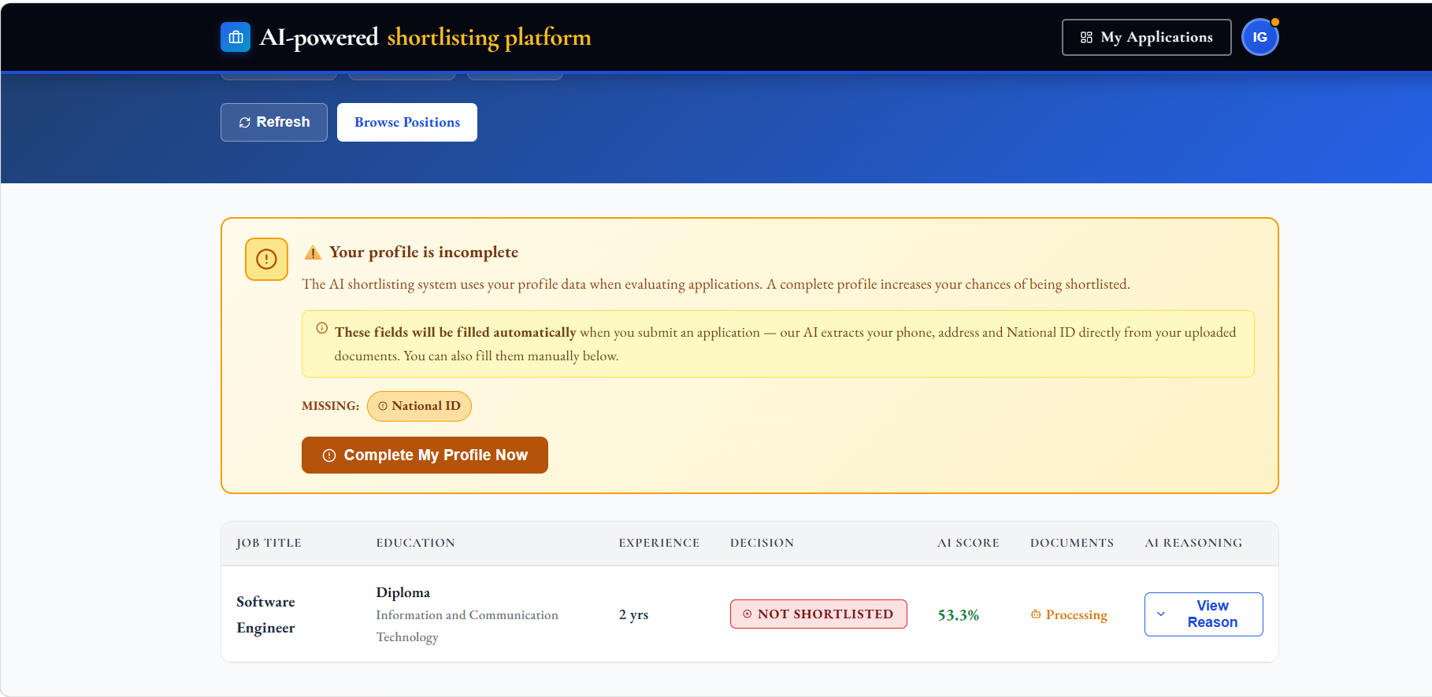
Figure 13 : Applicant Dashboard

4.6.4. Job Application and Document Upload
The Apply Page guides applicants through the document submission process. Applicants fill in their academic and professional details, then upload each of the four required documents (National ID, CV, Diploma, and Certificate). Each document is validated at upload time by the document verification module, which returns immediate feedback to the applicant. Once all required documents are uploaded and validated, the applicant can submit their application.
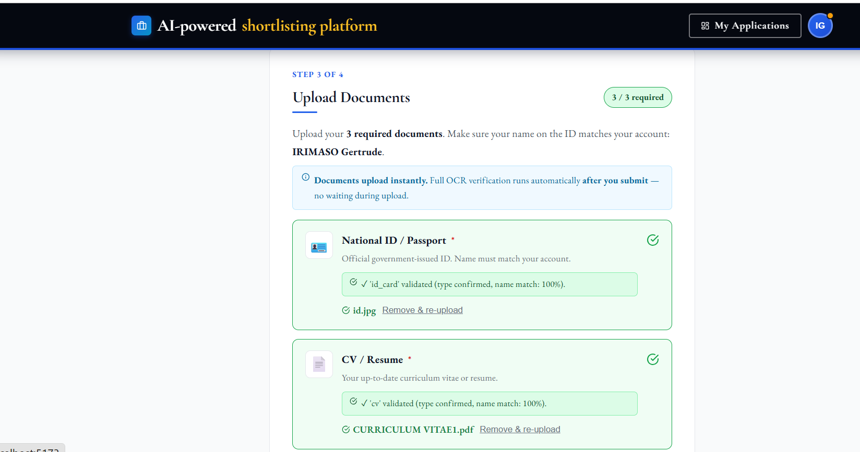
Figure 14 : Showing Document Uploading Page.

4.6.5. HR Dashboard
The HR Dashboard provides HR Professionals with a comprehensive overview of all submitted applications for each job posting. It displays each candidate's name, education level, experience, skills, documents uploaded, and current shortlisting status. HR users can trigger the AI-powered shortlisting process for a single candidate or for all pending applications at once using the 'Automate Shortlisting' button. Shortlisting progress is tracked in real time via a status polling mechanism.
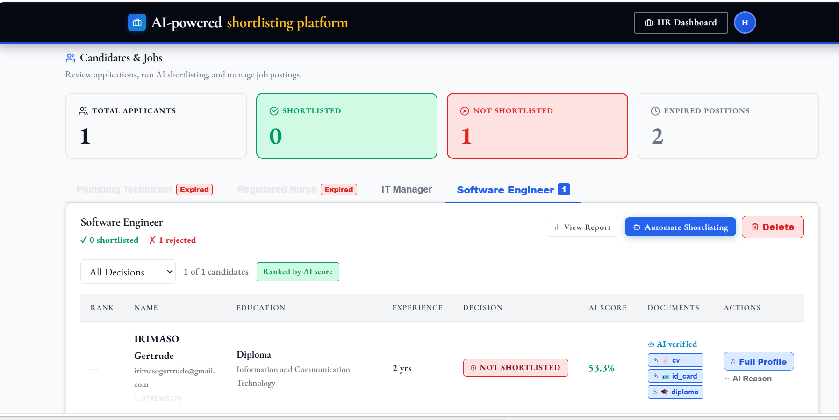
Figure 15 : HR Dashboard Page

4.6.6. Shortlisting Results and AI Explanation
Once shortlisting is complete, the HR Dashboard displays each candidate's AI score, decision (Shortlisted / Not Shortlisted), and a detailed breakdown of the criteria met, criteria failed, and advisory warnings. The Generative AI explanation references specific evidence from the candidate's submitted documents, allowing HR professionals to trace and audit each decision. HR users can also re-shortlist individual candidates or override decisions manually.
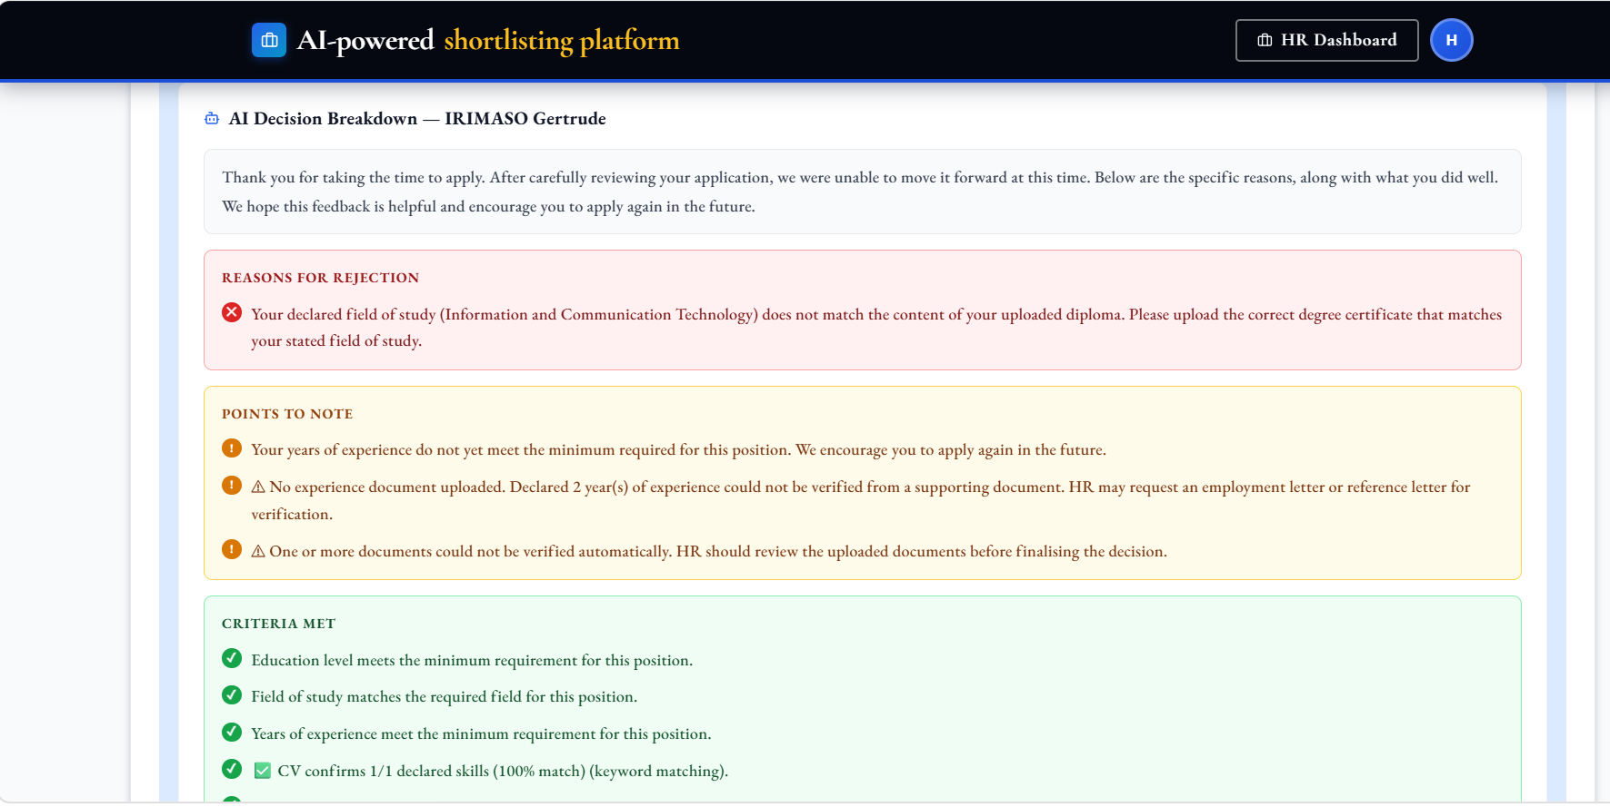
Figure 16 : Shortlisting Results with AI explanations .

4.6.7. HR Report
The HR Report page provides a job-level summary of all shortlisting outcomes, including total applicants, number shortlisted, number not shortlisted, average score, top score, and shortlisting rate. Candidates are ranked by their AI score, with shortlisted candidates listed first. Each candidate's detailed criteria breakdown and AI explanation is accessible from the report.
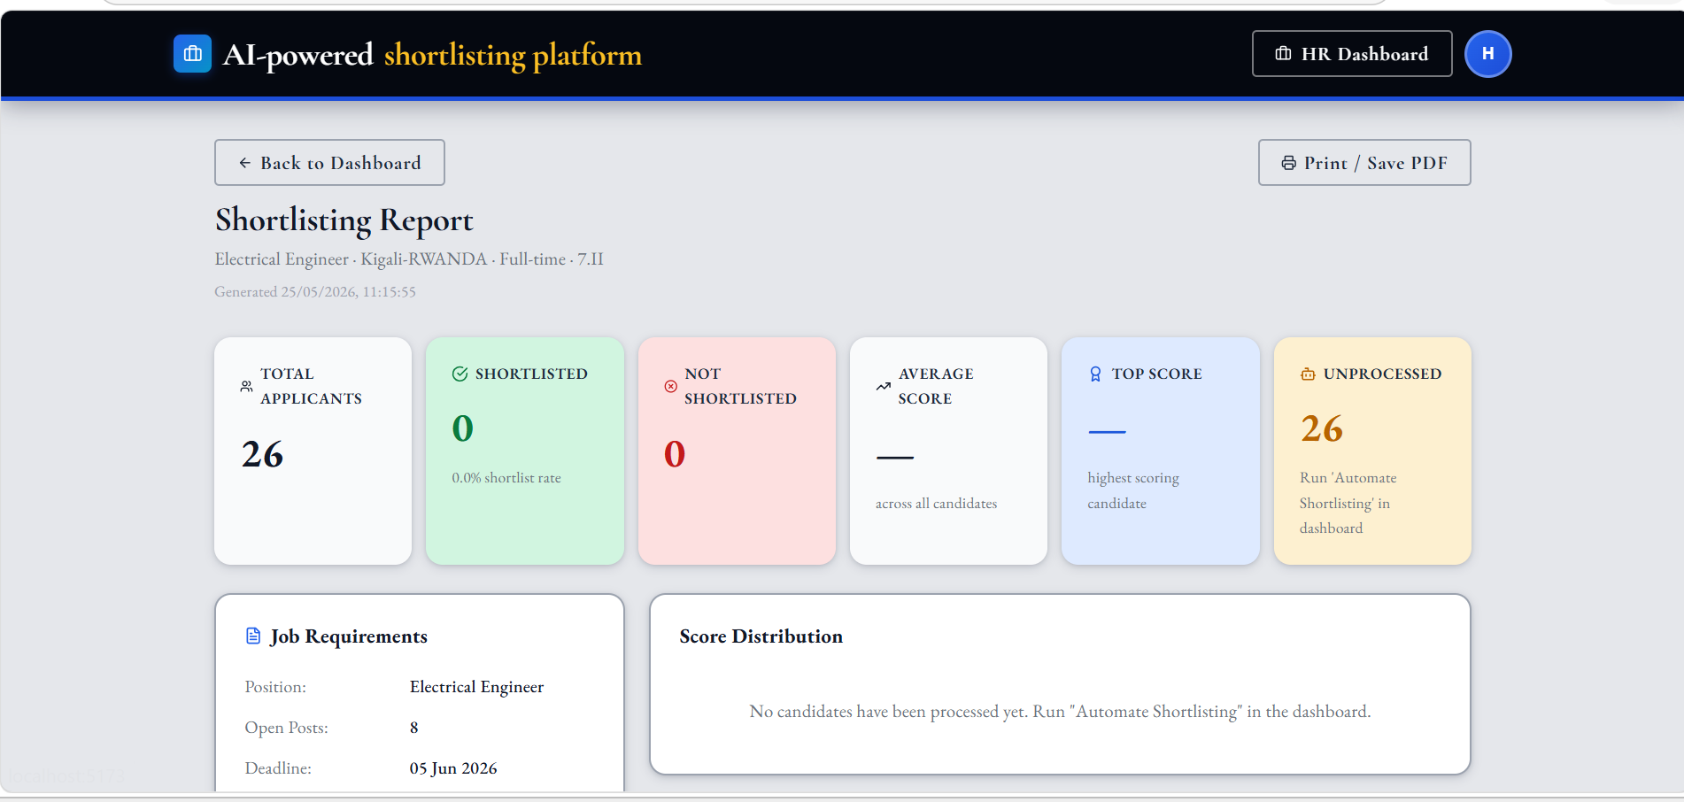
Figure 17 : HR Report Page

4.6.8. Administrator Dashboard
The Administrator Dashboard provides the system administrator with tools to manage all platform users including creating, viewing, and deleting HR and Applicant accounts. The Administrator can also view the full system audit log, which records all user actions (logins, document uploads, shortlisting events, and so on) with timestamps and IP addresses, supporting accountability and security monitoring.
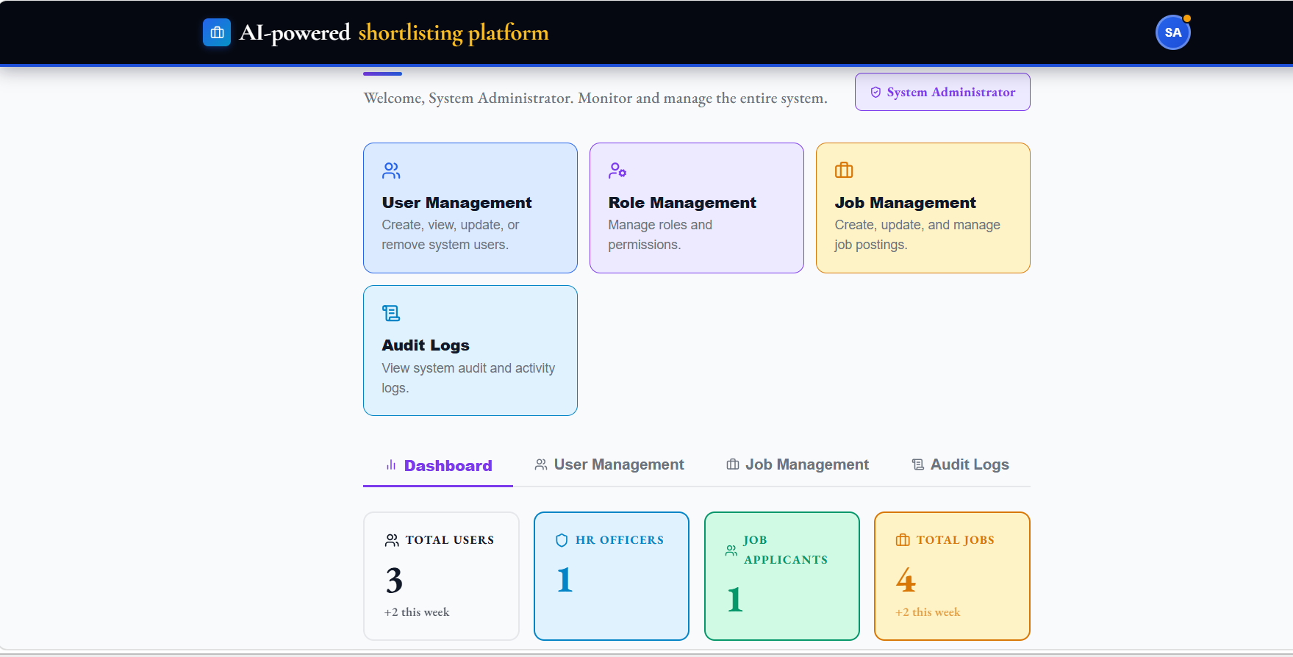
Figure 18 : Showing the System Administrator Dashboard .

4.6.9. Job Creation (HR)
The Job Creation page allows HR professionals to post new job vacancies by specifying the job title, description, location, employment type, required education levels, required fields of study, required skills, required certifications, minimum and maximum experience, and application deadline. These criteria are used directly by the ML model and shortlisting engine during automated candidate evaluation.
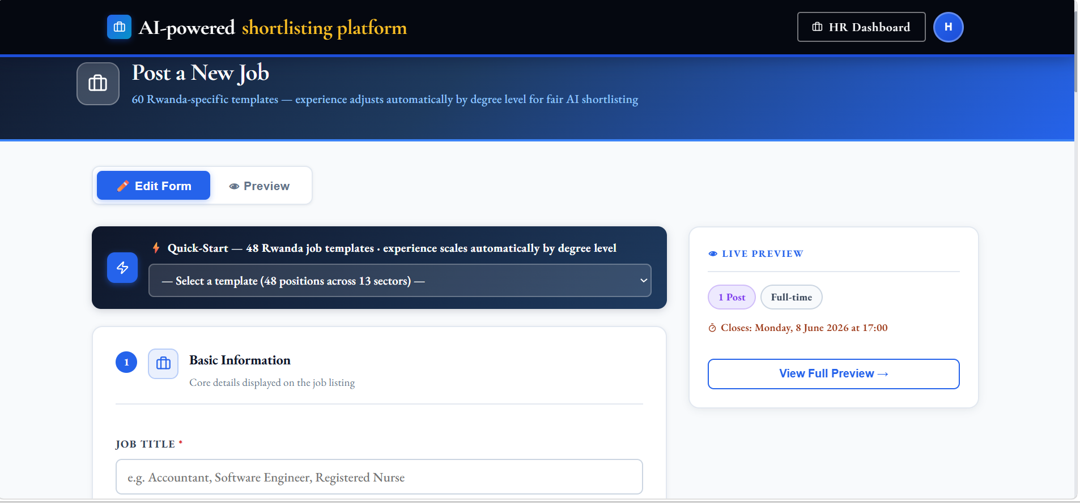
Figure 19 : Job Creation Form

CHAPTER 5: CONCLUSION AND RECOMMENDATIONS

5.1. Conclusion
This project successfully designed and implemented an Automated Shortlisting System Using Generative AI; an intelligent AI-powered recruitment platform that addresses the key inefficiencies of manual shortlisting processes identified in Rwandan organizations. The system integrates four core AI components: an OCR pipeline for multi-document text extraction, a Machine Learning classification model for candidate scoring, a semantic AI matching engine for document cross-verification, and a Generative AI API for explainable decision-making. The system supports three distinct user roles which are Administrator, HR Professionals, and Job Applicants each served by a dedicated, role-specific React.js dashboard. The backend is built in Python with Flask, and all data is persisted in a SQLite database. The system runs entirely from the terminal on a local machine, requiring no external hosting infrastructure.
Primary data collected through structured questionnaires administered to 30 HR professionals in Kigali confirmed the significance of the problem: 86.7% of respondents identified multi-document cross-referencing as their most time-consuming recruitment task, 80% spent over three hours daily on document review, and 100% had no existing automated shortlisting system in place. The implemented system directly addresses all seven specific objectives: it analyzes and automates the most burdensome manual process (SO1), provides a well-structured three-role database architecture (SO2), integrates a functional OCR pipeline for all four document types (SO3), implements pre-submission document verification (SO4), trains a highly accurate ML model achieving over 99% classification accuracy (SO5), integrates a Generative AI API for human-readable decision explanations (SO6), and delivers user-friendly dashboards for all three user roles (SO7).
The Machine Learning model evaluation demonstrated exceptional performance: the best-performing Extra Trees Classifier achieved over 99% test-set accuracy, F1-score above 0.99, and AUC-ROC of 1.00 through rich match-quality feature engineering. Feature importance analysis confirmed that the model's decisions are driven by merit-based criteria skills overlap, education level, field of study, and experience match rather than demographic attributes, supporting the system's commitment to fair and auditable shortlisting.
In conclusion, the Automated Shortlisting System Using Generative AI constitutes a viable, scalable, and accountable tool for modernizing talent acquisition in Rwanda and the broader East African context, demonstrating that locally developed AI-powered recruitment solutions can meaningfully reduce time, cost, and bias in the candidate screening process.

5.2. Recommendations
Based on the findings, implementation experience, and identified limitations of this project, the following recommendations are proposed for future work and system extension:
- Integration with real organizational data: The ML model was trained on a synthetic dataset of 10,000 profiles. Future work should involve retraining the model on real historical recruitment data from Rwandan organizations to improve generalization and domain specificity. Collaboration with HR departments willing to share anonymized recruitment records would significantly enhance model performance on real-world applicant profiles.
- Multi-language OCR support: Many applicant documents in Rwanda are written in Kinyarwanda or French. Future versions of the OCR pipeline should be extended to support multi-language document processing, particularly for National Identity Cards and locally issued academic certificates, to improve text extraction accuracy across all document types.
- Extended user roles and workflow stages: The current system covers only the initial shortlisting phase. Future development should extend the platform to support subsequent recruitment stages, including interview scheduling, offer management, candidate communication, and onboarding workflow integration, creating a complete end-to-end recruitment management platform.
- Cloud deployment and scalability: While the current system is designed to run locally via terminal, future versions should be deployed to a cloud platform to enable access from multiple HR users simultaneously, support larger application volumes, and provide persistent document storage with automated backup. Containerization using Docker would facilitate consistent deployment across environments.
- Bias auditing and fairness reporting: Although feature importance analysis was used during model training to monitor for demographic bias, future versions should incorporate dedicated fairness auditing tools such as demographic parity checks and equalized odds analysis to provide HR managers with quantitative bias reports and support compliance with responsible AI use principles.
- Mobile application: The current system is delivered as a web application. Development of a companion mobile application for job applicants would improve accessibility in the Rwandan context, where mobile internet penetration significantly exceeds desktop usage, allowing applicants to submit documents and track their application status from their smartphones.
- Integration with identity verification services: Future work should explore integration with Rwanda's National Identification Agency (NIDA) API to enable real-time verification of National Identity Card details against the national registry, replacing the current OCR-based identity check with a more robust and tamper-proof verification mechanism.

References
[1] D. Marchetti and R. Scardovi, "Artificial Intelligence and Human Resources: innovative trends and main impacts".
[2] prabhusureshkumar, "Amazon's AI Recruiting Tool Shows Bias Against Women".
[3] S. Bali, A. Dhiman, and N. Aggarwal, "A Study on Opportunities and Challenges in Implementation of Artificial Intelligence in Human Resource Management," vol. 1, no. 1, 2026.
[4] I. D. Mienye, N. Jere, G. Obaido, O. O. Ogunruku, E. Esenogho, and C. Modisane, "Large language models: an overview of foundational architectures, recent trends, and a new taxonomy," Discov. Appl. Sci., vol. 7, no. 9, p. 1027, Sep. 2025.
[5] J. Jeon, J. Jang, and S. Ki Jung, "Development and Validation of an AI-Powered OCR Educational Tool for Early Handwriting Instruction for Korean Early Elementary Students," IEEE Access, vol. 14, pp. 7005–7015, 2026.
[6] H. Neji, J. Nogueras-Iso, J. Lacasta, M. Latre, and F. J. García-Marco, "FP-THD: Full page transcription of historical documents," Jan. 20, 2026, arXiv: arXiv:2601.17040.
[7] C. H. Lun, T. Hewitt, and S. Hou, "A Machine Learning Pipeline for Document Extraction," First Break, vol. 40, no. 2, pp. 73–78, Feb. 2022.
[8] S. Solonenco, "SYD Live CV: A new proposal for work overview".
[9] E. Albaroudi, T. Mansouri, and A. Alameer, "A Comprehensive Review of AI Techniques for Addressing Algorithmic Bias in Job Hiring," AI, vol. 5, no. 1, pp. 383–404, Feb. 2024.
[10] T. G. Habetie, D. Kolta, E. P. Prihoda, and I. Rudnák, "Digital Transformation in Human Resource Management and its Implication for Youth Unemployment in Ethiopia: A Literature Review," Reg. Bus. Stud., vol. 17

APPENDICES
APPENDIX A: QUESTIONNAIRE
This questionnaire used for collecting information about challenges in recruitment and opinions on using AI for automated applicant shortlisting.

Questions
- How many hours do you spend reviewing applicant documents during active recruitment drives per day?
Less than 1 hour
1–2 hours
2–3 hours
More than 3 hours
- Which part of the recruitment process do you find most time-consuming?
Reviewing CVs
Verifying certificates and diplomas
Cross-checking applicant documents
All of the above
- Which applicant documents do you usually cross-reference during recruitment?
National ID
CV/Resume
Diploma
Certificates
- Would you be interested in an AI-powered system that automatically extracts and evaluates information from submitted applicant documents?
Yes
No
- What is the most critical problem with the current manual shortlisting process?
Time consumption
Human errors
Inconsistency in evaluation criteria
Difficulty verifying applicant documents
- Would you trust an AI-generated shortlist if the system provided clear explanations and references from applicant documents for each decision?
Yes
No
- Does your organization currently use an automated document processing or applicant shortlisting system?
Yes
No

