

DEPARTMENT OF INFORMATION COMMUNICATION TECHNOLOGY
OPTION : INFORMATION TECHNOLOGY
LEVEL : 8

CAPSTONE PROJECT REPORT

AUTOMATED SHORTLISTING SYSTEM USING GENERATIVE AI

Submitted in Partial Fulfillment of the Requirements for the Award of
Bachelor of Technology in Information And Communication Technology .

Submitted By: Gertrude IRIMASO
Reg No: 25RP19175
Supervisor: Judith BIZIMANA

ABSTRACT
The recruitment and selection process in modern organizations is increasingly overwhelmed by large volumes of job applications, placing significant strain on Human Resource departments. Traditional manual shortlisting methods are time-consuming, prone to unconscious bias, and inconsistent, resulting in inefficiencies that negatively affect both employers and qualified candidates.
This capstone project proposes, designs, and implements an Automated Shortlisting System Using Generative AI an intelligent AI-powered recruitment system developed in Python, combining a trained Machine Learning classification model, an OCR document processing pipeline, and a Generative AI API for explainable decision-making, delivered through a Flask backend and a React.js interface. When applying for a job, each candidate is required to submit four official documents: a National Identity Card, a Curriculum Vitae, an Academic Diploma, and supporting Certificates. The integrated OCR pipeline processes all four document types to extract and verify structured information, which is then evaluated by the ML model to produce a ranked shortlist with AI-generated explanatory rationale for each decision.
The system was developed following the Agile software development methodology and built using Python (Flask) as the backend, React.js as the frontend, and PostgreSQL as the relational database. Primary data was collected through interviews and questionnaires administered to HR professionals across selected organizations in Rwanda, complemented by a thorough review of existing literature on AI-driven recruitment solutions.
The system demonstrates significant improvements in shortlisting speed, consistency, and transparency compared to manual processes. It provides both HR recruiters and job applicants with dedicated dashboards, configurable job postings, explainable AI-driven shortlisting decisions, and a seamless multi-document application workflow. The proposed system positions itself as a practical, scalable tool for organizations seeking to modernize their talent acquisition processes while maintaining fairness and accountability.

Keywords: Generative AI, Automated Shortlisting, Recruitment System, Machine Learning, Natural Language Processing, Large Language Models, OCR, Document Verification, Human Resource Management, Rwanda.
LIST OF ABBREVIATIONS
Abbreviation | Meaning
AI | Artificial Intelligence
API | Application Programming Interface
CV | Curriculum Vitae
DFD | Data Flow Diagram
ERD | Entity Relationship Diagram
GenAI | Generative Artificial Intelligence
GUI | Graphical User Interface
HR | Human Resources
HRM | Human Resource Management
ICT | Information Communication Technology
ID | Identity Document / National Identity Card
IPRC | Integrated Polytechnic Regional College
JSON | JavaScript Object Notation
LLM | Large Language Model
ML | Machine Learning
NLP | Natural Language Processing
OCR | Optical Character Recognition
PDF | Portable Document Format
PostgreSQL | Postgres Structured Query Language (Object-Relational Database)
RDBMS | Relational Database Management System
React | React JavaScript Library (by Meta)
REST | Representational State Transfer
RP | Rwanda Polytechnic
SPA | Single Page Application
UI | User Interface
UX | User Experience
XAI | Explainable Artificial Intelligence

Contents
CHAPTER 1: GENERAL INTRODUCTION 5
1.0. Introduction 5
1.1. Background of the Study 5
1.2. Problem Statement 6
1.3. Purpose of the Study 7
1.4. Research Objectives 7
1.4.1. General Objective 7
1.4.2. Specific Objectives 8
1.5. Research Questions 8
1.6. Scope of the Study 9
1.7. Significance of the Study 9
1.8. Methodology 9
1.9. Organization of the Report 10
CHAPTER 2: LITERATURE REVIEW 12
2.1. Introduction 12
2.2. Concepts, Opinions, and Ideas from Authors/Experts 12
2.3. Theoretical Perspectives 13
2.4. Related Studies 14
2.4.1. First Related Study 14
2.4.2. Second Related Study 14
2.4.3. Third Related Study 15
CHAPTER 3: DATA COLLECTION, PRESENTATION AND ANALYSIS 16
3.0. Introduction 16
3.1. Research Design 16
3.1.1. Justification 16
3.2. Research Population 16
3.3. Sampling Size and Techniques 17
3.4. Research Instruments 17
3.4.1. Choice of Research Instruments 17
3.5. Data Gathering Procedures 17
3.6. Data Analysis and Interpretation 18
3.7. Ethical Considerations 18
3.8. Limitations of the Study 19
3.9. Description of the Current System 19
3.10. Proposed System 20
3.10.1. Description of the Proposed System 20
3.10.2. System Architecture Diagram 21
3.10.3. Use Case Diagram 21
3.10.4. Data Flow Diagram (DFD) 22
3.10.5. Activity Diagram 22
3.10.6. Sequence Diagram 23
3.10.7. Class Diagram 23
3.10.8. Physical Data Model (ERD) 24
3.10.9. Data Dictionary 24

CHAPTER 1: GENERAL INTRODUCTION

1.0. Introduction
In the contemporary job market, organizations regularly receive hundreds to thousands of applications for a single job vacancy. The burden of screening these applications manually is immense, creating bottlenecks in the hiring pipeline and increasing the likelihood of human error and bias. Rwanda's growing economy and expanding private and public sectors have intensified this challenge, as more graduates and professionals enter the workforce each year.

Generative Artificial Intelligence (GenAI), powered by Large Language Models (LLMs), has emerged as a transformative force capable of understanding, generating, and reasoning about human language with remarkable accuracy. When combined with trained Machine Learning (ML) classification models and Optical Character Recognition (OCR) technology, these capabilities form the foundation of a powerful and intelligent recruitment automation system.

This project proposes the design and implementation of an Automated Shortlisting System Using Generative AI an intelligent AI-powered recruitment system developed in Python, combining a trained Machine Learning classification model, an OCR document processing pipeline, and a Generative AI API for explainable decision-making, delivered through a Flask backend and a React.js interface. Job applicants are required to submit four official documents during their application: a National Identity Card, a Curriculum Vitae, an Academic Diploma, and supporting Certificates. The system processes all four document types through the OCR pipeline, evaluates the extracted information against job requirements using the ML model, and generates AI-powered shortlisting decisions with human-readable explanations. The system aims to save time, reduce subjectivity, and improve the overall recruitment experience for both HR professionals and job applicants.

1.1. Background of the Study
Recruitment is a fundamental function of Human Resource Management, serving as the gateway through which organizations acquire the talent necessary to fulfill their strategic objectives. Traditionally, shortlisting has been performed manually HR officers collect applicant documents including CVs, academic credentials, identity documents, and certificates, review each document individually, match qualifications to job descriptions, and subjectively rank candidates. This process is not only labor-intensive but also susceptible to unconscious bias based on gender, ethnicity, age, or educational background.

The advent of Artificial Intelligence and, more recently, Generative AI has introduced new possibilities for automating complex cognitive tasks, including document text extraction, content comprehension, comparison, and ranking. Systems built on LLMs such as GPT-4 can interpret unstructured text extracted from applicant documents with nuanced understanding, making them ideal for shortlisting applications. Additionally, advancements in OCR technology now allow systems to extract structured text from diverse document formats including scanned National IDs, academic Diplomas, professional Certificates, and typed or handwritten CVs, greatly expanding the scope of automated document processing.

In Rwanda and across East Africa, the recruitment sector has seen growing adoption of digital tools, but AI-powered shortlisting that can handle multi-document applicant profiles remains largely absent from small and medium-sized enterprises. This project addresses this gap by providing an accessible, locally adaptable intelligent shortlisting system that combines ML-based candidate scoring, OCR-based multi-document processing, document verification, and Generative AI-powered decision explanations in a single unified platform.

1.2. Problem Statement
After observing the existing recruitment practices across organizations in Rwanda and reviewing literature on global HR challenges, the following key problems were identified:

- Manual shortlisting of large candidate pools is extremely time-consuming, often taking days or weeks, delaying the entire recruitment pipeline and increasing operational costs.
- HR officers must manually read and cross-reference multiple applicant documents including Identity Cards, CVs, Diplomas, and Certificates for each candidate, which is unsustainable at scale.
- Human reviewers are prone to unconscious biases that may disadvantage qualified candidates based on non-merit factors such as gender, age, or name recognition.
- Inconsistency in shortlisting criteria across different reviewers leads to unfair outcomes and a poor candidate experience.
- There is no centralized, automated platform capable of receiving multi-document applications, verifying document authenticity, extracting relevant information via OCR, and generating ranked shortlists.
- Small and medium enterprises in Rwanda lack affordable, tailored tools for AI-powered recruitment automation that can handle structured document-based applications.
- Existing tools lack explainable decision-making, making it difficult for HR professionals to justify or audit shortlisting outcomes.

1.3. Purpose of the Study
The main aim of this study is to design and implement an Automated Shortlisting System Using Generative AI that reduces the time and effort required for candidate screening, improves consistency and fairness in shortlisting decisions, and provides Human Resource professionals with explainable, AI-generated shortlisting reports. The system serves two distinct user roles: HR managers, who post job vacancies and review AI-generated shortlists; and job applicants, who register on the platform, submit their four official application documents (National ID, CV, Diploma, and Certificates), and track their shortlisting status.

1.4. Research Objectives

1.4.1. General Objective
To design and implement an intelligent AI-powered Automated Shortlisting System that combines Machine Learning, OCR-based multi-document processing, document verification, and Generative AI to intelligently screen, score, rank, and shortlist job applicants based on defined criteria.

1.4.2. Specific Objectives
- To analyze existing manual shortlisting processes and identify their key inefficiencies and limitations within Rwandan organizations.
- To design a PostgreSQL database schema and system architecture capable of managing job postings, candidate profiles, multi-document applications (National ID, CV, Diploma, Certificates), and shortlisting results.
- To integrate an OCR service into the system to extract structured text from all four types of applicant documents submitted in PDF or image formats.
- To implement a document verification module that validates the completeness and format of submitted applicant documents before processing.
- To build and train a Machine Learning classification model capable of scoring and ranking candidates based on features extracted from their submitted documents and matched against job requirements.
- To integrate a Generative AI API into the system to produce clear, human-readable explanations for each shortlisting decision.
- To develop a user-friendly React.js interface with separate dashboards for HR professionals and job applicants, and to validate the system's performance with real or simulated recruitment data.

1.5. Research Questions
- How can an OCR pipeline reliably extract and structure relevant information from four different types of applicant documents National IDs, CVs, Diplomas, and Certificates submitted in various PDF and image formats?
- How can a trained Machine Learning classification model effectively evaluate extracted document features against job requirements to produce accurate and consistent candidate scores?
- How can Generative AI be used to produce clear, human-understandable explanations for each candidate's shortlisting score and ranking based on their submitted documents?
- What system architecture combining Python (Flask), React.js, PostgreSQL, OCR, ML, and GenAI best supports a scalable, secure, and user-friendly automated shortlisting system?

1.6. Scope of the Study
This project is limited to the design and implementation of an automated shortlisting system focused on the initial screening phase of recruitment. The system covers job posting creation by HR staff; job application submission by applicants including upload of four mandatory documents (National ID, CV, Diploma, and Certificates); OCR-based document text extraction and verification; ML-powered candidate scoring and ranking; Generative AI-driven shortlisting decision explanation; and shortlist management and review by HR professionals. The system does not cover subsequent recruitment stages such as interview scheduling, offer management, or employee onboarding. It is designed for organizations operating in Rwanda, with potential for broader regional adaptation.

1.7. Significance of the Study
This system holds significance for multiple stakeholders. For organizations and HR departments, it dramatically reduces the time and cost of candidate screening while improving selection consistency and quality, particularly by automating the processing of multi-document applicant files. For job applicants, it ensures that all submitted documents are evaluated objectively against defined criteria and that they receive transparent, AI-generated feedback on their shortlisting outcome. For Rwanda's growing tech ecosystem, the project demonstrates a practical and locally relevant application of Machine Learning, OCR, and Generative AI in a real-world HR process. Additionally, this research contributes to the academic body of knowledge on AI-driven HR automation in the East African context.

1.8. Methodology
a) Study Area
This project was conducted in Kigali City and its surrounding areas, where digital recruitment practices are highly prevalent and access to relevant participants was feasible. The study was specifically carried out at Imena Services and Technology Ltd., located in Gasabo District, Kinyinya Sector. This site was purposively selected due to its active involvement in modern recruitment processes and its accessibility for data collection. Consequently, it provided a suitable and practical setting for achieving the objectives of the study.

b) Study Design
The development of the Automated Shortlisting System Using Generative AI follows the Agile software development methodology, allowing iterative development, continuous testing, and stakeholder feedback incorporation throughout the project lifecycle. The study combines descriptive and applied research designs to both understand the problem domain and deliver a functional software solution.

c) Data Collection Methods
- Interviews: Structured interviews conducted with HR managers, recruiters, and hiring officers to understand current shortlisting workflows, document handling practices, and pain points.
- Questionnaires: Survey instruments distributed to HR professionals across selected organizations to gather quantitative data on recruitment volumes, time spent per application, and desired system features.
- Document Review: Analysis of sample job descriptions, applicant document formats (IDs, CVs, Diplomas, Certificates), and existing recruitment policy documents to inform system design and ML model feature engineering.
- Literature Review: Review of academic journals, industry reports, and technical documentation on AI, NLP, OCR, document processing, and automated recruitment systems.

d) Ethical Considerations
The project adheres to ethical principles including informed consent from all interview and survey participants, confidentiality and anonymization of personal data including applicant identity documents, responsible AI use to minimize algorithmic bias, and transparency in how the system processes and evaluates candidate information. All candidate documents uploaded to the system are handled in accordance with configurable data retention and privacy policies. Data collected during research is used solely for system development and academic purposes.

1.9. Organization of the Report
This report is organized into five chapters as follows:

- Chapter One: General Introduction presents the background, problem statement, objectives, research questions, scope, significance, and methodology of the study.
- Chapter Two: Literature Review reviews existing concepts, theories, and related work on AI-driven recruitment, ML-based candidate evaluation, OCR document processing, and automated shortlisting systems.
- Chapter Three: Data Collection, Presentation, and Analysis covers the research design, data collection findings, analysis of the current system, and the detailed design of the proposed system including UML diagrams and the PostgreSQL data dictionary.
- Chapter Four: Implementation details the technologies used, ML model development and evaluation, OCR integration, system features, and screenshots of the implemented system interfaces.
- Chapter Five: Conclusion and Recommendations summarizes project findings, draws conclusions, and provides recommendations for future improvements and extensions.

CHAPTER 2: LITERATURE REVIEW

2.1. Introduction
This chapter reviews relevant literature on automated recruitment systems, Artificial Intelligence in Human Resource Management, Natural Language Processing, Generative AI, Machine Learning classification models, and Optical Character Recognition applied to multi-document processing. It examines concepts proposed by researchers and industry experts and identifies the theoretical and practical foundations upon which the proposed system is built. The goal is to situate this project within the broader body of existing knowledge, justify key design decisions, and clearly distinguish the contributions of the proposed system.

2.2. Concepts, Opinions, and Ideas from Authors/Experts
[1] Observed that AI-powered recruitment tools can significantly reduce time-to-hire by automating the repetitive task of document screening, allowing HR professionals to focus on higher-value activities such as interviewing and culture assessment. This observation aligns directly with the core motivation of this project eliminating the bottleneck caused by the manual review of multiple applicant documents (National IDs, CVs, Diplomas, and Certificates) in Rwandan organizations.

According to [2] , who documented Amazon's experimental AI recruitment system, AI-driven shortlisting tools must be carefully designed and monitored to prevent the reinforcement of historical biases embedded in training data. This concern underscores the importance of explainability and bias awareness features in the proposed system, particularly through its Generative AI decision explanation module and the feature importance analysis generated during ML model training.

[3] argued that Machine Learning applications in HR offer the greatest value when applied to pattern recognition across large structured datasets. They further noted that AI systems should complement rather than replace human judgment in critical hiring decisions. The proposed system adopts this philosophy by allowing HR professionals to review, override, and adjust AI-generated shortlists even after the automated ranking has been produced.

[4] In their landmark paper on GPT-3, demonstrated that Large Language Models can perform complex reasoning tasks including text summarization, comparison, and question answering without task-specific fine-tuning. This capability directly supports the proposed system's use of an LLM API to generate natural-language explanations for each shortlisting decision based on the candidate's extracted document content and ML score.

[5] Introduced Tesseract OCR, an open-source optical character recognition engine, which has since been widely adopted for automated document text extraction in AI-powered pipelines. Its ability to process diverse document formats including scanned identity cards, academic certificates, and typed CVs makes it a suitable foundation for the multi-document OCR pipeline in the proposed system. More recent works on intelligent document processing [6] have extended OCR capabilities to handle low-quality scans, varied fonts, and mixed-language documents, further validating the feasibility of processing the four document types required by this system.

2.3. Theoretical Perspectives
This project draws on several theoretical frameworks that underpin its design and implementation decisions.

The Information Processing Theory suggests that effective decision-making requires structured processing of information , a principle directly applicable to multi-document recruitment screening. Rather than relying on a human reviewer to read and mentally integrate information from four separate documents per candidate, the proposed system structures this process by having the OCR pipeline extract and normalize information from each document type, and the ML model evaluate the consolidated candidate profile against job requirements in a consistent, repeatable manner.

The Theory of Planned Behavior informs the system's design by ensuring that AI decisions are presented in ways that align with recruiters' existing decision-making patterns, thereby encouraging adoption. The inclusion of a Generative AI explanation module ensures that HR professionals can follow the reasoning behind each shortlisting score, maintaining their sense of control and trust in the automated outcomes.

The concept of Explainable AI (XAI) , the idea that AI systems should be able to justify their decisions in human-understandable terms , is central to the proposed system's design. Each candidate's shortlisting score is accompanied by a natural-language explanation generated by the Generative AI API that references the specific document content (qualifications from the Diploma, experience from the CV, identity verification from the ID) that influenced the decision.

Machine Learning Pipeline Theory, [7], underpins the system's data preprocessing workflow , including feature extraction from OCR-parsed document text, label encoding of categorical variables, and feature scaling , which prepares structured candidate profiles for the trained classification model. The system's ML pipeline produces both a shortlisting decision and a confidence score that reflect the holistic evaluation of all submitted documents.

2.4. Related Studies

2.4.1. First Related Study
[8] Stanslav Solonenco conducted a systematic review of AI applications in talent management and found that CV parsing and automated screening were the most common applications of AI in HR technology, with adoption rates growing significantly . Their study highlighted that while accuracy in skill matching improved with AI, systems frequently lacked transparency in shortlisting rationale, and almost none were capable of processing multiple document types per applicant. This gap is directly addressed in the proposed system, which not only processes four document types per applicant through an integrated OCR pipeline but also produces Generative AI explanations that reference each document's contribution to the shortlisting decision.

2.4.2. Second Related Study
Elham Albaroudi [9] examined the role of AI in reducing recruitment bias and concluded that while AI systems can reduce certain forms of human bias, they may introduce new forms of algorithmic bias if not carefully designed. Their recommendation that recruitment AI systems should include configurable criteria weighting, audit trails, and explainability features directly informed the design of this project. The system's ML model training incorporates feature importance analysis to identify and monitor which document-derived features most influence shortlisting outcomes, and the Generative AI explanation module ensures that HR professionals can audit any decision by tracing it back to specific content in the applicant's submitted documents.

2.4.3. Third Related Study
A study by Tadesse Getachew [10] on digital transformation in African workplaces found that recruitment automation technologies were largely absent in East African SMEs despite strong demand, with key barriers including cost, technical expertise, and the complexity of processing non-standardized applicant documents. The proposed system addresses these barriers through a web-accessible React.js interface that requires no local installation, cloud-based AI API integration that eliminates on-premise infrastructure costs, and an OCR pipeline specifically designed to handle the diverse formats and quality levels of identity documents, academic credentials, and certificates common in the Rwandan context.

CHAPTER 3: DATA COLLECTION, PRESENTATION AND ANALYSIS.

3.0. Introduction
This chapter presents the research methodology, data collection procedures, findings from primary data gathering, analysis of the current system, and the detailed design of the proposed Automated Shortlisting System Using Generative AI. It covers the research design and its justification, the research population and sampling approach, the instruments used for data collection, key findings from data analysis, a description of the current manual recruitment system and its weaknesses, and the full proposed system design supported by UML diagrams, system architecture description, and a comprehensive PostgreSQL data dictionary.

3.1. Research Design
This project adopts a mixed-methods research design combining qualitative and quantitative approaches. The qualitative component involved semi-structured interviews with HR professionals to gather in-depth insights into current shortlisting challenges, multi-document handling workflows, and feature expectations for an automated system. The quantitative component involved structured questionnaires to collect measurable data on recruitment volumes, time spent per application, and system requirements priorities.

3.1.1. Justification
A mixed-methods design was selected because the research problem involves both quantitative variables such as the number of applications processed per week, time spent reviewing each applicant's documents, and shortlisting turnaround times and qualitative dimensions, including recruiter experience with multi-document review, bias concerns, and desired system features. This combined approach provides a more comprehensive understanding of the problem space and informs richer, evidence-based system design decisions that neither a purely quantitative nor purely qualitative approach could achieve alone.

3.2. Research Population
The research population consists of HR managers, recruiters, and hiring officers employed by organizations in Kigali, Rwanda, across public, private, and NGO sectors. These individuals are the primary users of recruitment systems and are best positioned to provide insights into document handling challenges and automation requirements. Job applicants in Rwanda's workforce were also considered as secondary users of the system, informing the design of the applicant-facing document submission interface and application tracking features.

3.3. Sampling Size and Techniques
A purposive sampling technique was used to select 30 participants: 15 for in-depth interviews and 15 for questionnaire-based surveys. Participants were selected based on their direct and active involvement in recruitment activities, particularly in organizations that process a significant volume of multi-document applications. This sample size was deemed sufficient to identify patterns and achieve saturation in qualitative data while providing statistically meaningful quantitative findings for a focused academic study.

3.4. Research Instruments

3.4.1. Choice of Research Instruments
Two primary instruments were used. First, semi-structured interview guides were used to explore HR professionals' experiences with manual multi-document review processes, their key pain points particularly around verifying and cross-referencing National IDs, CVs, Diplomas, and Certificates and their expectations for an automated solution. Second, structured questionnaires with Likert-scale and multiple-choice questions were used to gather quantitative data on recruitment volumes, time spent per applicant, and priorities for system features including document automation. Both instruments were designed based on insights from the literature review and pre-tested with two HR professionals before full deployment.

3.5. Data Gathering Procedures
Data collection was conducted over a six-week period. Interviews were conducted in-person or via video call, lasting approximately 30 to 45 minutes each. Questionnaires were distributed both physically and via online forms. All participants provided informed consent, and data was anonymized at the point of collection. Findings were recorded, transcribed, and organized using thematic analysis for qualitative data and descriptive statistics for quantitative data. Sample applicant document templates (anonymized CV formats, Diploma structures, and Certificate types) were also collected during the document review phase to inform the OCR feature extraction design.

3.6. Data Analysis and Interpretation
Qualitative interview data was analyzed using thematic coding to identify recurring themes such as 'time pressure from high document volumes,' 'difficulty verifying document authenticity,' 'inconsistent evaluation standards,' 'lack of transparency in decisions,' and 'need for automated document processing.' Quantitative survey results were analyzed using frequency distributions and percentage calculations. Key findings from the data collection phase include:

- 80% of respondents reported spending more than 3 hours per day reviewing applicant documents during active recruitment drives.
- 92% stated that manually cross-referencing information across four document types (ID, CV, Diploma, and Certificates) per applicant was the most time-consuming part of their workflow.
- 90% expressed strong interest in an AI-powered system that could automatically extract and evaluate information from all submitted applicant documents.
- 75% identified 'inconsistency in evaluation criteria' as the most critical problem with current manual shortlisting processes.
- 85% stated they would trust an AI-generated shortlist more if the system provided clear, document-referenced explanations for each decision.
- All respondents confirmed their organizations currently have no automated document processing or shortlisting system in place.

3.7. Ethical Considerations
All participants were briefed about the research objectives and provided written or verbal consent before participation. No personally identifiable information was retained in data records beyond what participants explicitly authorized. Because the proposed system processes sensitive personal documents including National Identity Cards , the system was designed with strict data protection principles: all uploaded documents are stored in encrypted form, access is restricted to authorized HR users, and the system does not share raw document content with third parties. The AI model was designed with bias awareness in mind, and feature importance analysis during ML training was used to monitor and mitigate potentially discriminatory features. All candidate data is processed in accordance with configurable data retention policies.

3.8. Limitations of the Study
The study faced limitations including a relatively small sample size due to time and resource constraints, limited access to some organizations' HR departments for security reasons, and the inherent challenge of evaluating ML model accuracy without a large, validated dataset of real historical recruitment outcomes with ground-truth shortlisting decisions. The OCR pipeline's accuracy is also partially dependent on the quality and format of submitted documents, and low-quality scanned images of IDs or handwritten certificates may require additional preprocessing. The trained ML model was developed using a constructed dataset of synthetic and publicly available candidate profiles, which may not fully capture the diversity of real-world Rwandan applicant document formats. These limitations are acknowledged but do not significantly undermine the validity of the system design and proof-of-concept implementation.

3.9. Description of the Current System
Currently, most organizations in Rwanda use manual, paper-based or email-based recruitment processes. Recruiters receive applicant documents typically a combination of CVs, academic certificates, and identity documents via email or physical submission. Each document is reviewed individually by HR staff, who must read, verify, and cross-reference information across all submitted files before making a shortlisting decision. Shortlists are maintained in spreadsheets with no standardized scoring or criteria weighting. The process is further hampered by high application volumes and the significant effort required to verify credentials across multiple documents per applicant.

Key weaknesses of the current manual system include:
- No centralized application tracking system applications and documents arrive through multiple channels and are difficult to consolidate and manage.
- The requirement to manually read and cross-reference National IDs, CVs, Diplomas, and Certificates for each applicant is extremely slow and error-prone at scale.
- No automated document verification mechanism to confirm the completeness or format of submitted applicant documents.
- Inconsistent evaluation criteria between reviewers different HR officers apply different standards when assessing qualifications and experience.
- Susceptibility to conscious and unconscious bias in candidate selection, particularly when reviewing identity documents and demographic information.
- Absence of documented rationale for shortlisting decisions making auditing, transparency, and accountability difficult.
- No digital interface for applicants to submit their documents or track the status of their application.

3.10. Proposed System

3.10.1. Description of the Proposed System
The proposed Automated Shortlisting System Using Generative AI is an intelligent AI-powered recruitment system with two distinct user roles: HR Professionals and Job Applicants.

HR Professionals can register and log in to the system, create and publish job vacancies with detailed requirements and shortlisting criteria, review incoming applications, trigger the AI-powered shortlisting process, and view AI-generated ranked shortlists with document-referenced explanatory summaries for each candidate.

Job Applicants can register on the platform, browse available job postings, and submit their application by uploading four mandatory official documents: (1) a National Identity Card, which is used for identity verification and to extract personal details; (2) a Curriculum Vitae, which is used to extract work experience, skills, and professional background; (3) an Academic Diploma, which is used to verify educational qualifications and level of study; and (4) supporting Certificates, which are used to verify additional professional qualifications, training, or achievements relevant to the job. Applicants can also view their shortlisting decision and the AI-generated explanation for that decision through their personal dashboard.

The system's intelligence is powered by four integrated components. First, a Document Verification module checks that all four required documents have been submitted and validates their format before processing. Second, an OCR pipeline processes each of the four document types to extract structured text personal information from the ID, experience and skills from the CV, qualification level and field from the Diploma, and relevant credentials from the Certificates. Third, a trained Machine Learning classification model built using scikit-learn with feature scaling, label encoding, and cross-validated training scores each candidate by evaluating their consolidated document profile against the job requirements. Fourth, a Generative AI API receives the candidate's extracted document content and ML score to produce a natural-language explanation of the shortlisting decision, referencing specific evidence from the submitted documents. All data is persisted in a PostgreSQL relational database, and the platform is delivered through a React.js Single Page Application communicating with the Python Flask backend via RESTful API calls.

3.10.2. System Architecture Diagram
The system follows a three-tier architecture. The Presentation Layer is a React.js Single Page Application (SPA) built with Vite, providing separate authenticated dashboards for HR Professionals and Job Applicants. The Application Layer is a Python Flask RESTful API backend that handles user authentication, job management, multi-document upload and storage, document verification, OCR processing, ML model inference, Generative AI API communication, and shortlist management. The Data Layer is a PostgreSQL relational database that stores all persistent system data including user accounts, job postings, applications, applicant documents (National ID, CV, Diploma, Certificates), OCR-extracted text, ML scores, and Generative AI explanations.
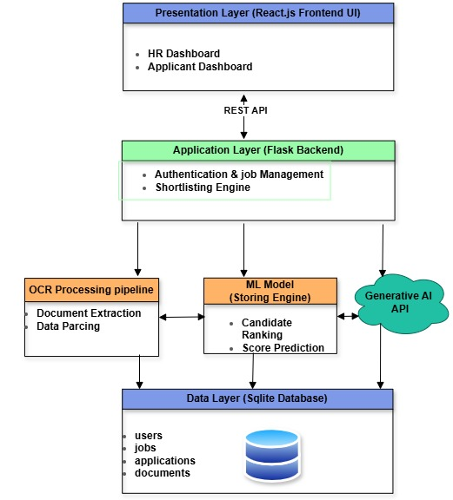
Figure 1 : System Architecture Diagram .

3.10.3. Use Case Diagram
The Use Case Diagram illustrates the interactions between three primary actors the HR Professional, the Job Applicant, and the System and the platform's key functionalities. The HR Professional can: register and log in, create and manage job postings with shortlisting criteria, view all submitted applications, trigger AI-powered shortlisting, review AI-generated ranked shortlists with document-based explanations, and override or adjust shortlisting decisions. The Job Applicant can: register and log in, browse available job postings, submit an application by uploading the four required documents (National ID, CV, Diploma, and Certificates), and view their application status and AI-generated shortlisting decision. The System is responsible for: verifying submitted document completeness, processing all four document types through the OCR pipeline, running ML model inference, generating Generative AI explanations, and ranking candidates.
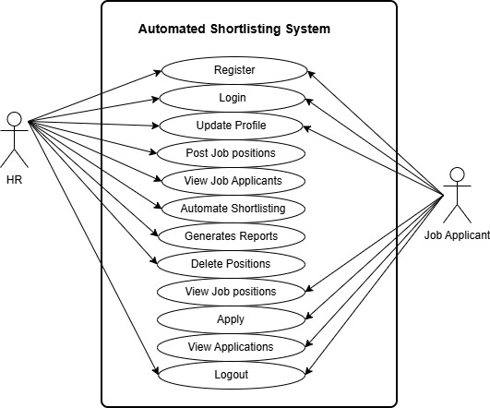
Figure 2 : Use Case Diagram .

3.10.4. Data Flow Diagram (DFD)
The Level 0 DFD (Context Diagram) shows the system as a single process receiving inputs from the HR Professional (job postings, shortlisting criteria, shortlisting triggers) and the Job Applicant (registration data, four application documents: National ID, CV, Diploma, and Certificates), and producing outputs including ranked shortlists with AI-generated explanations and application status updates. The Level 1 DFD decomposes the system into six main processes: User Authentication and Registration, Job Management, Multi-Document Application Submission and Verification, OCR Document Processing, AI Shortlisting (ML Scoring + GenAI Explanation), and Result and Shortlist Management.
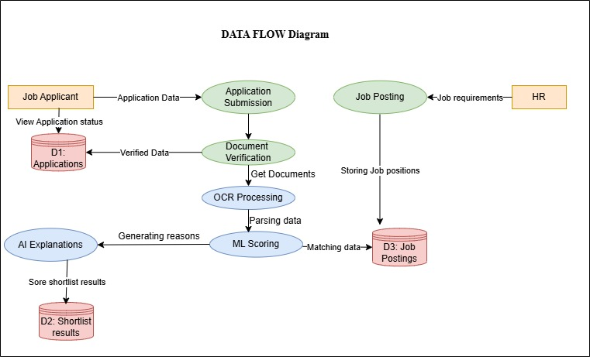
Figure 3 : Data Flow Diagram

3.10.5. Activity Diagram
The Activity Diagram maps the end-to-end workflow of the shortlisting process. The HR professional logs in, creates a job posting with defined requirements and criteria weights, and publishes it. The job applicant registers, browses the posting, and submits an application by uploading all four required documents. The Document Verification module confirms that all four document types are present and in an accepted format. The OCR pipeline then processes each document: extracting personal details and identity verification data from the National ID; extracting work experience, skills, and professional background from the CV; extracting educational qualification level and field from the Diploma; and extracting additional credentials and training records from the Certificates. The consolidated candidate profile is passed to the ML model which produces a shortlisting score and decision. The score and profile are then sent to the Generative AI API, which returns a natural-language explanation referencing specific document evidence. The system ranks all applicants and presents the complete shortlist to the HR professional for review, adjustment, and action.
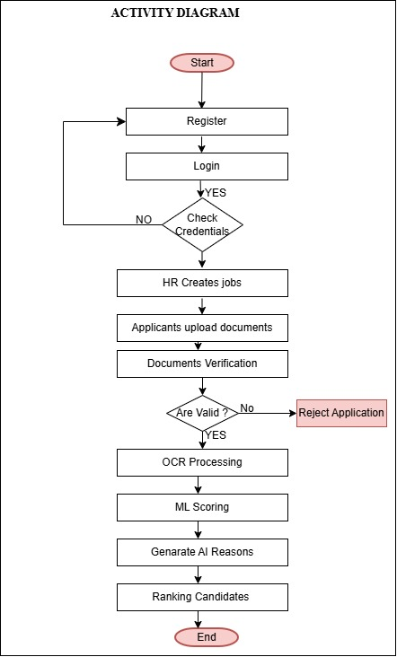
Figure 4 : Activity Diagram .

3.10.6. Sequence Diagram
The Sequence Diagram shows the time-ordered interactions between the Job Applicant, the HR Professional, the React.js Frontend, the Flask Backend, the Document Verifier, the OCR Service, the ML Model, the Generative AI API, and the PostgreSQL Database during a complete shortlisting operation. The applicant uploads four documents via the frontend; the backend passes them to the Document Verifier which confirms completeness and format; each document is then processed by the OCR Service which returns extracted text; the Flask backend consolidates the extracted features and passes them to the ML Model which returns a shortlisting score and decision; the score and candidate profile are sent to the Generative AI API which returns a natural-language explanation; all results are stored in the PostgreSQL database; and the ranked shortlist is returned to the HR professional's dashboard for review.
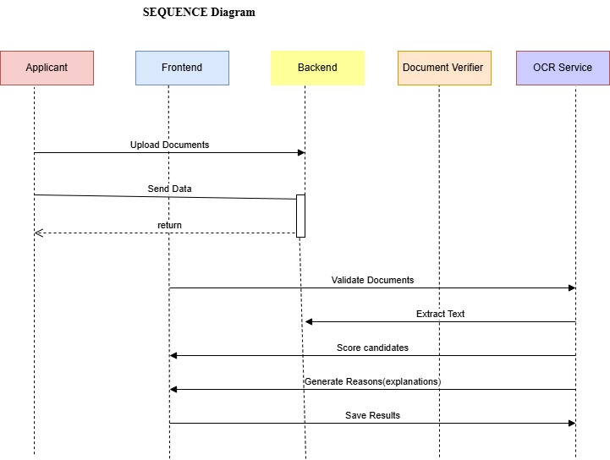
Figure 5 : Sequence Diagram

3.10.7. Class Diagram
The Class Diagram defines the main entities of the system. The User class has subclasses HRProfessional and Applicant. The JobPosting class is associated with CriteriaConfig. The Application class links an Applicant to a JobPosting and is associated with four instances of the ApplicantDocument class one for each document type: National ID, CV, Diploma, and Certificate. The ApplicantDocument class has a document_type attribute that distinguishes between the four types, and a parsed_text attribute populated by the OCR Service. The ShortlistResult class stores the ML score, Generative AI explanation, ranking position, and final decision for each application. The DocumentVerifier, OCRService, MLModel, and GenerativeAIEngine are represented as service classes invoked by the ShortlistingEngine class during the shortlisting process.

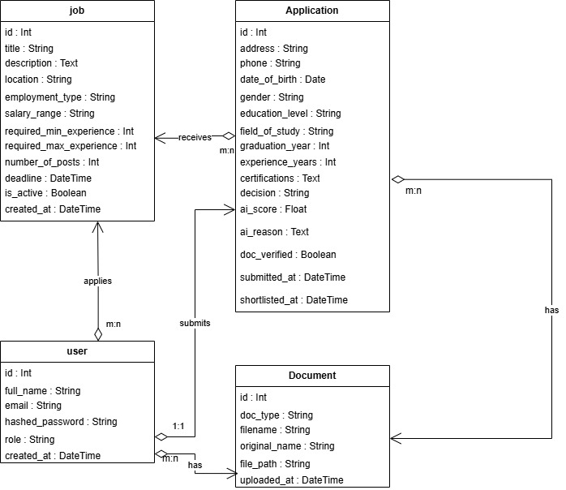
Figure 6 : Class Diagram

3.10.8. Physical Data Model (ERD)
The Entity Relationship Diagram maps the PostgreSQL database structure. The main tables are: users (storing HR professionals and applicants), job_postings (storing vacancy details and requirements), applications (linking applicants to job postings), applicant_documents (storing file paths and OCR-extracted text for each of the four document types per application), shortlist_results (storing ML scores, Generative AI explanations, rankings, and decisions), and criteria_weights (storing configurable shortlisting criteria and their percentage weights per job posting). Primary and foreign key constraints enforce referential integrity across all tables.
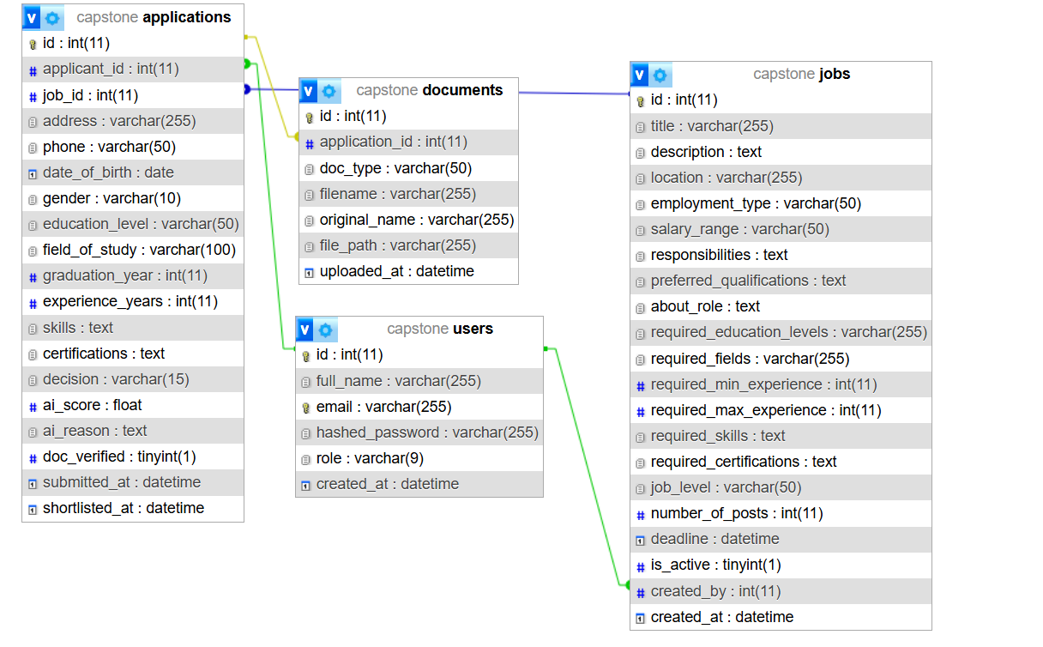
Figure 7 : Entity Relationship Diagram

3.10.9. Data Dictionary
The table below describes the main PostgreSQL database tables, their fields, data types, and descriptions for the proposed Automated Shortlisting System.

Table Name | Field Name | Data Type | Description
users | user_id | SERIAL (PK) | Unique user identifier (auto-increment)
users | full_name | VARCHAR(150) | Full name of the user
users | email | VARCHAR(150) | User email address (unique)
users | password_hash | VARCHAR(255) | Hashed password using bcrypt
users | Role | VARCHAR(20) | User role: hr_professional or applicant
users | created_at | TIMESTAMP | Account creation date and time
job_postings | job_id | SERIAL (PK) | Unique job posting identifier
job_postings | hr_user_id | INT (FK) | Reference to users table — HR owner
job_postings | title | VARCHAR(200) | Job title
job_postings | description | TEXT | Full job description
job_postings | requirements | TEXT | Required qualifications, experience, skills
job_postings | status | VARCHAR(20) | Job status: open or closed
job_postings | created_at | TIMESTAMP | Date and time job was posted
applications | application_id | SERIAL (PK) | Unique application identifier
applications | job_id | INT (FK) | Reference to job_postings table
applications | applicant_id | INT (FK) | Reference to users table applicant
applications | submitted_at | TIMESTAMP | Application submission date and time
applications | status | VARCHAR(20) | Application status: pending, processing, complete
applicant_documents | document_id | SERIAL (PK) | Unique document record identifier
applicant_documents | application_id | INT (FK) | Reference to applications table
applicant_documents | document_type | VARCHAR(30) | Type: national_id, cv, diploma, or certificate
applicant_documents | file_path | VARCHAR(255) | Server storage path of uploaded document
applicant_documents | file_format | VARCHAR(10) | File format: pdf, jpg, or png
applicant_documents | parsed_text | TEXT | OCR-extracted text content from the document
applicant_documents | verified | BOOLEAN | TRUE if document passed format verification
applicant_documents | uploaded_at | TIMESTAMP | Date and time document was uploaded
shortlist_results | result_id | SERIAL (PK) | Unique shortlist result identifier
shortlist_results | application_id | INT (FK) | Reference to applications table
shortlist_results | ml_score | DECIMAL(5,2) | ML model match score (0 to 100)
shortlist_results | decision | VARCHAR(20) | Shortlisted, Reserve, or Rejected
shortlist_results | rank_position | INT | Candidate ranking position (1 = highest)
shortlist_results | ai_explanation | TEXT | Generative AI natural-language rationale
shortlist_results | created_at | TIMESTAMP | Date and time result was generated
criteria_weights | criteria_id | SERIAL (PK) | Unique criteria record identifier
criteria_weights | job_id | INT (FK) | Reference to job_postings table
criteria_weights | criteria_name | VARCHAR(100) | E.g. Education, Experience, Certifications, Identity Verification
criteria_weights | weight_percent | INT | Weight percentage — all criteria sum to 100%

References
[1] D. Marchetti and R. Scardovi, “Artiﬁcial Intelligence and Human Resources: innovative trends and main impacts”.
[2] “prabhusureshkumar.”
[3] S. Bali, A. Dhiman, and N. Aggarwal, “A Study on Opportunities and Challenges in Implementation of Artificial Intelligence in Human Resource Management,” vol. 1, no. 1, 2026.
[4] I. D. Mienye, N. Jere, G. Obaido, O. O. Ogunruku, E. Esenogho, and C. Modisane, “Large language models: an overview of foundational architectures, recent trends, and a new taxonomy,” Discov. Appl. Sci., vol. 7, no. 9, p. 1027, Sep. 2025, doi: 10.1007/s42452-025-07668-w.
[5] J. Jeon, J. Jang, and S. Ki Jung, “Development and Validation of an AI-Powered OCR Educational Tool for Early Handwriting Instruction for Korean Early Elementary Students,” IEEE Access, vol. 14, pp. 7005–7015, 2026, doi: 10.1109/ACCESS.2026.3651759.
[6] H. Neji, J. Nogueras-Iso, J. Lacasta, M. Latre, and F. J. García-Marco, “FP-THD: Full page transcription of historical documents,” Jan. 20, 2026, arXiv: arXiv:2601.17040. doi: 10.48550/arXiv.2601.17040.
[7] C. H. Lun, T. Hewitt, and S. Hou, “A Machine Learning Pipeline for Document Extraction,” First Break, vol. 40, no. 2, pp. 73–78, Feb. 2022, doi: 10.3997/1365-2397.fb2022016.
[8] S. Solonenco, “SYD Live CV: A new proposal for work overview.”.
[9] E. Albaroudi, T. Mansouri, and A. Alameer, “A Comprehensive Review of AI Techniques for Addressing Algorithmic Bias in Job Hiring,” AI, vol. 5, no. 1, pp. 383–404, Feb. 2024, doi: 10.3390/ai5010019.
[10] T. G. Habetie, D. Kolta, E. P. Prihoda, and I. Rudnák, “Digital Transformation in Human Resource Management and its Implication for Youth Unemployment in Ethiopia: A Literature Review,” Reg. Bus. Stud., vol. 17, no. 2, pp. 49–65, Dec. 2025, doi: 10.33568/rbs.6827.

