College of Science and Technology On 02/08/2022

School of ICT

Department of CSE

Web Technology Module

Project Title: FaveChefs Restaurant

Project by: IMFURA Gershom

Reg No: 220014748

**FaveChefs Restaurant Project Report**

**FaveChefs Restaurant?**

FaveChefs Restaurant is an online food ordering system that aims at improving its services by adding an option of ordering food and getting your ordered lunch box delivered to your hostel doorstep wherever you are in Butare.

**Problem Statement**

FaveChefs Restaurant is located in Huye District, near Butare University Campus. It targets university students as its primary clients. Its main obstacle throughout its daily business transactions is that this restaurant is a little bit further from the campus, and as a result, students find it hard to reach out to this restaurant. Thus, wasting time while trying to cover the distance in between, and despite its tasty food and coffees, they needed a system that would simplify the ordering of food and drinks for either lunch or dinner.

**Objectives**

FaveChefs online food ordering system has the following identified main objectives:

* To increase profitability of FaveChefs Restaurant
* To record its day-to-day customers as they have to have an account in the system
* To make things a lot easier for its customers(university students)

**The benefits of this project**

This project is going to benefit different individuals across the system as indicated below:

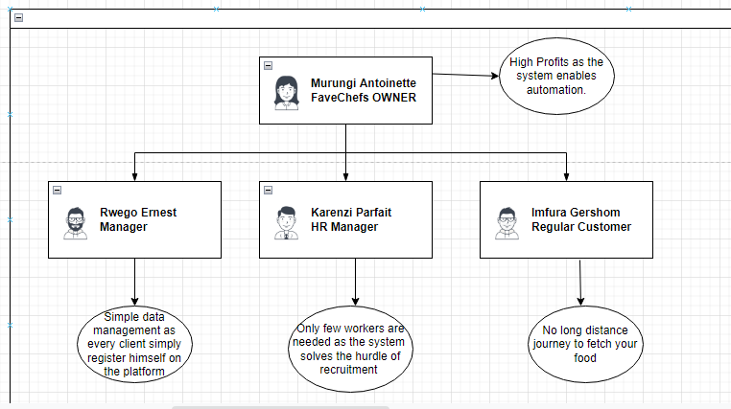

**Methodologies and Methods**

**Data collection methodology**

I realized the problem when I first visited FaveChefs restaurant, its service was superb plus the tasty and delicious food they offered. It was not until the next day, I really had this unrealistic crave for its food and then I figured it was far from me and wondered if there was a service that could help me in ordering the food I desired and get it delivered to me in that moment. Therefore, I would say that I collected the data with a lot of observation and a little bit of asking some relevant questions their manager Ernest.

**Hardware tools to used**

This project only needed simple and usual hardware tools for it to be implemented which are listed below:

* Computer (A simple Desktop)
* Point of Sale(POS) Machine

**Software tools to used**

This project only needed simple and usual software tools for it to be implemented which are listed below:

* Xampp(A localhost server and database management system-PHPmyAdmin)
* Figma(front-End Designing tool)
* Visual Studio Code(Used as runtime environment tool)
* Canva.com(graphic design tool)

**System Analysis and Design**

In this section, we analyse the functional requirements of the system, which includes user authentication modules and user registration module. They are illustrated here in the screenshots as follows:

**User authentication module**

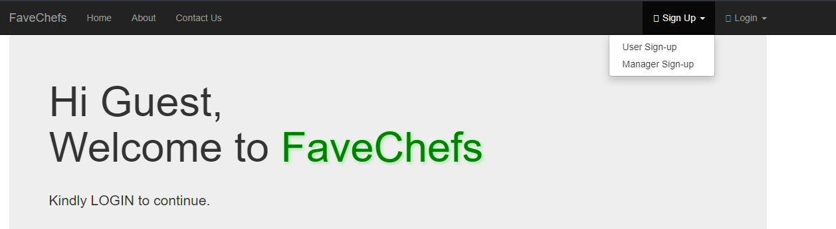

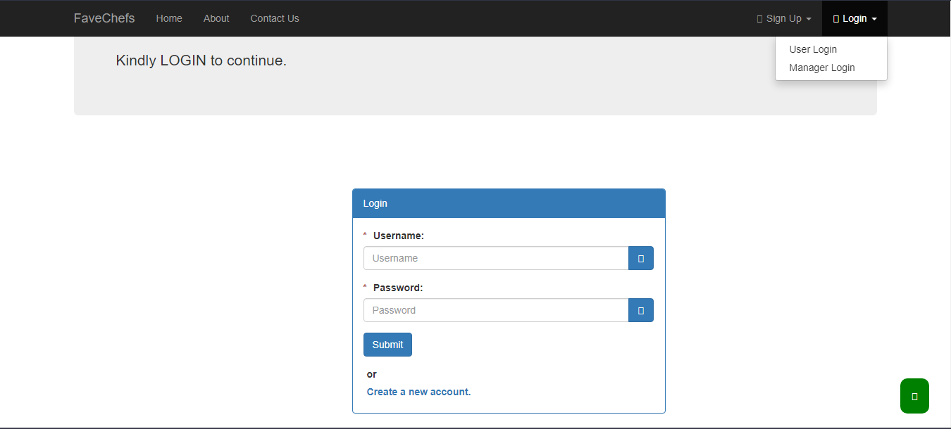

**User Registration modules**

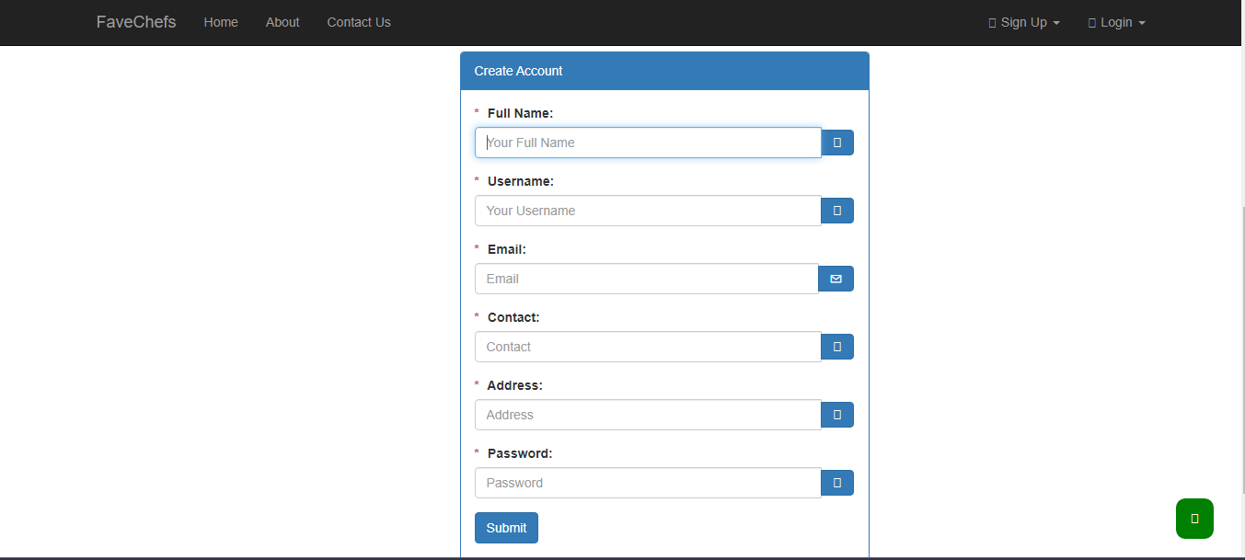

We will also need a dashboard for admin in which he/she will need to add new items, edit, delete and update the product status. Moreover, for this, we need to authenticate the system administrator who can be either the manager or the FaveChefs Restaurant owner.

**Admin Authentication Login**

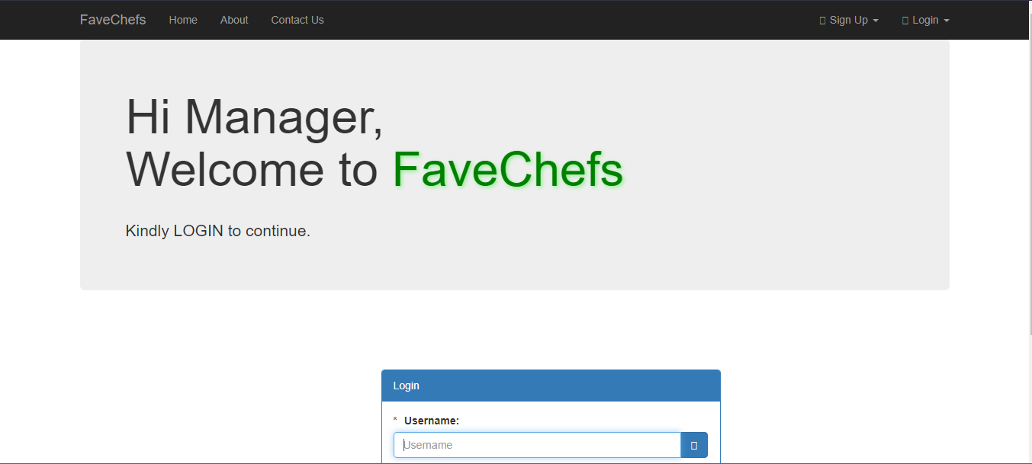

**Manager Control Panel (Dashboard)**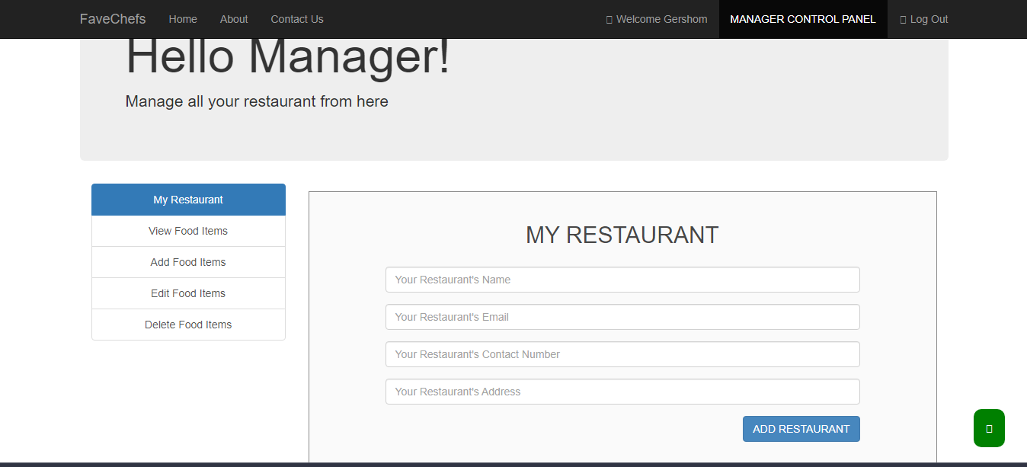

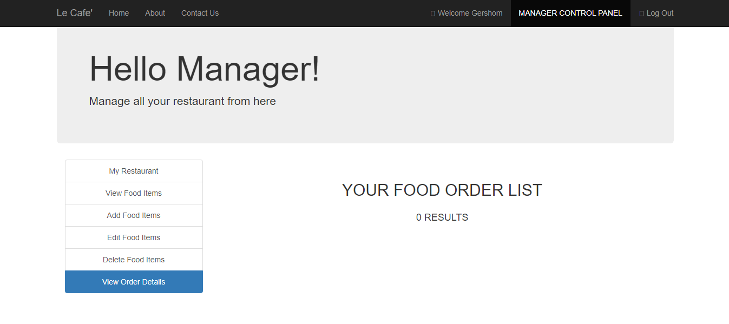

**Data Requirements Specifications**

Here we need the data, which are inserted into the tables and identify the relationships between these tables and the data stored in them.

Therefore, we need the implementation of Entity Relationship Diagram that is illustrated here below:

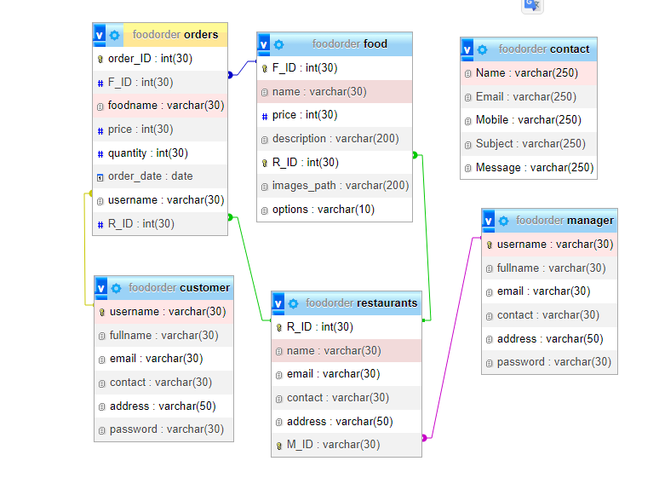

**User Requirements Specifications**

Here, FaveChefs system will need the following main actors:

* Administrator(FaveChefs Restaurant Owner)
* A regular/Guest customer
* A manager(Human resource/financial)

**System Design**

**System Overall Architecture**

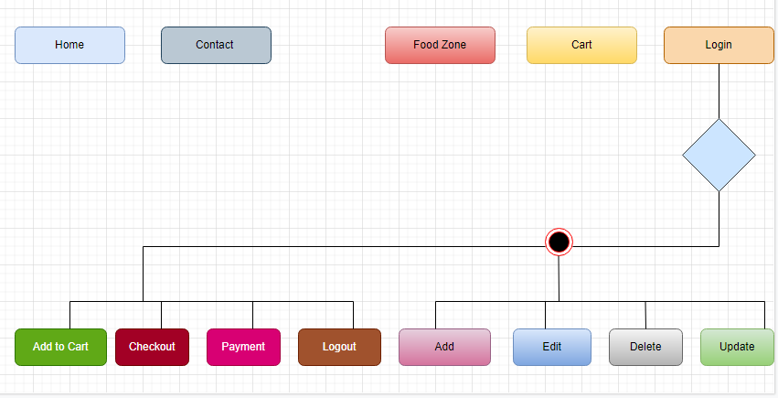

**System Implementation**

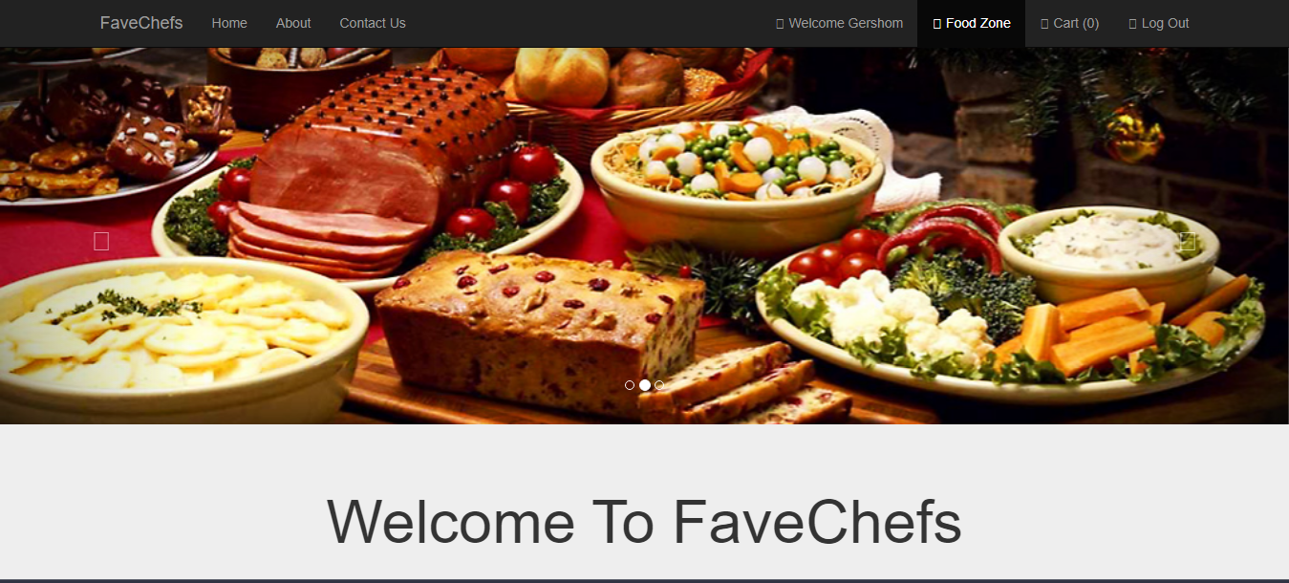

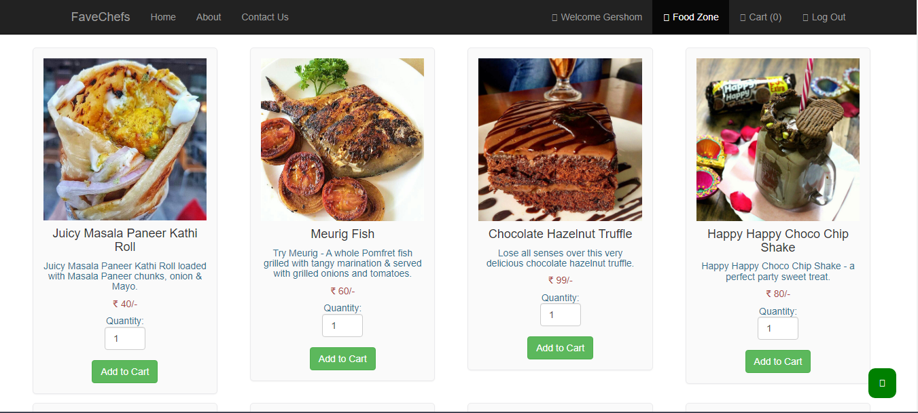

A Prompt that displays when the customer cart is deleted!

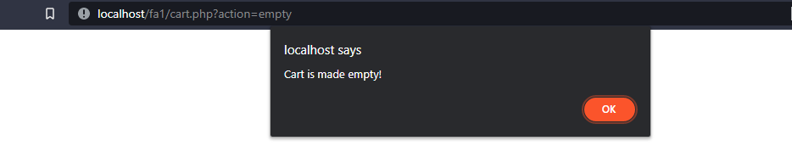

And this is the page which encourages the user to add something to the cart!

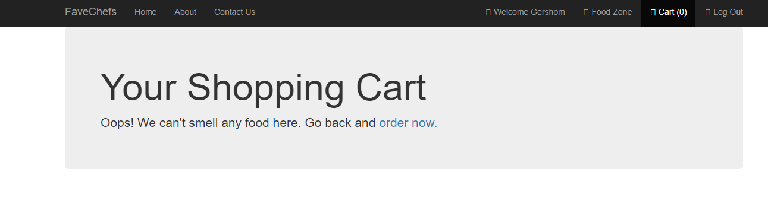

Moreover, there is a page that displays when the customer has added some products to the cart; this is done before allowing to go the checkout page on which he/she can see the total payment due for the food and drinks added in the cart.

**Adding to cart and Checkout Page**

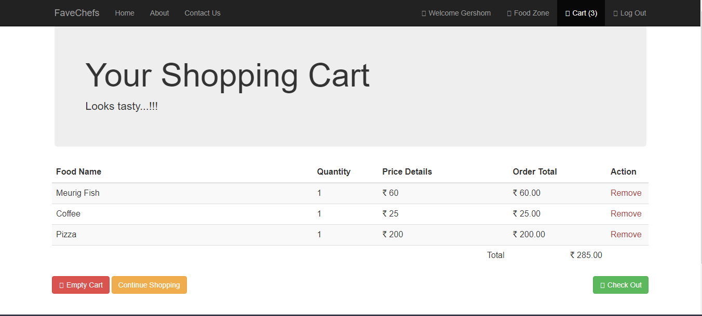

In addition, you are given the payment options including namely:

* Paying Online(Debit/Credit card)
* Cash on Delivery

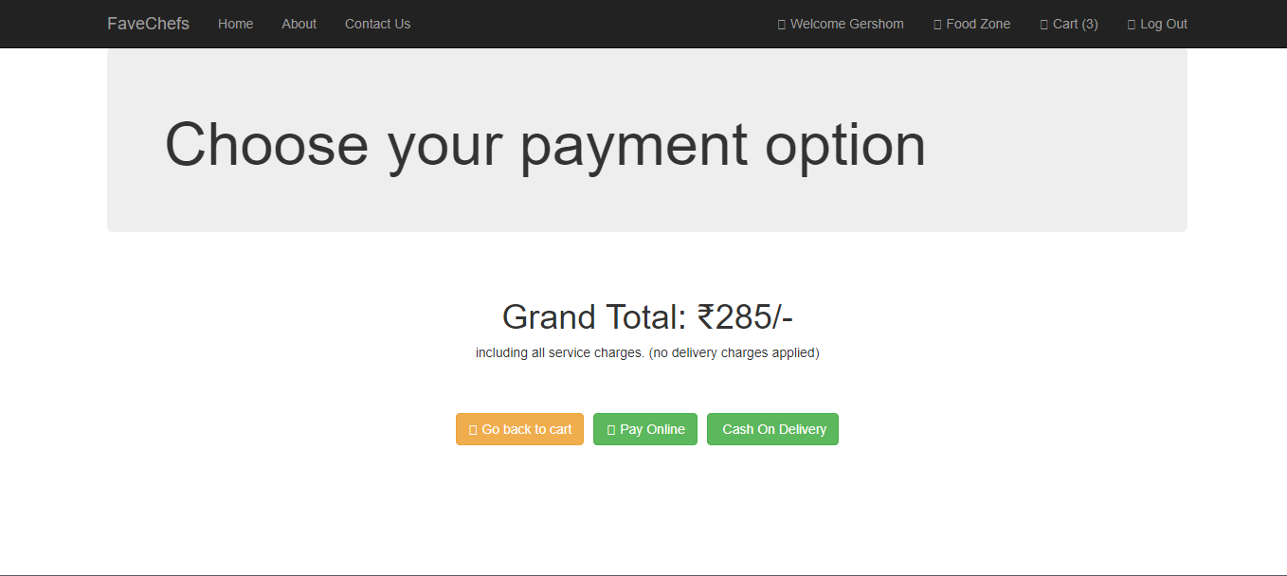

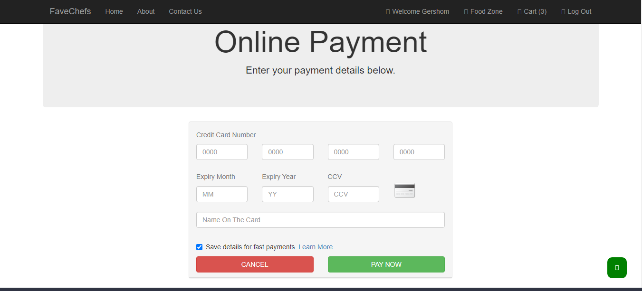

Moreover, when the order is successfully completed, the user is taken to the following page:

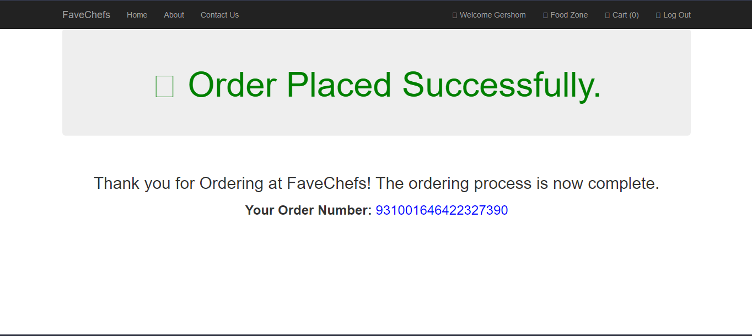

And there is a way to get in touch the FaveChefs Restaurant Management Members: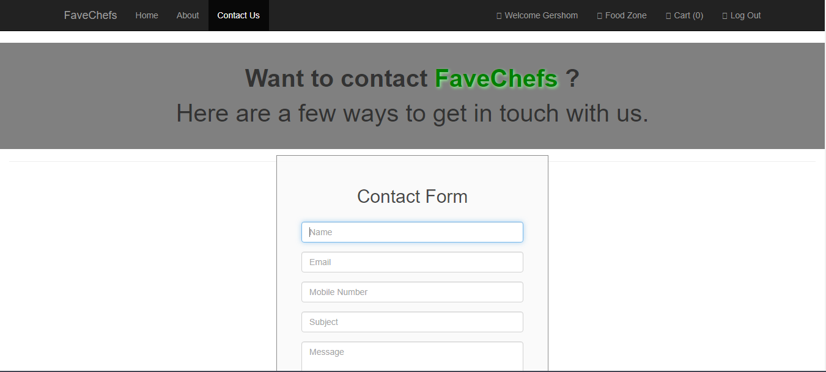

**As Conclusion,**

Based on the deadline I was given,

I was able to implement my project by 80%,

The remaining 20% is because I was not able to use JavaScript and css alone without much use of bootstraps and other similar frameworks.

However, I will continue to do some implementations and testing of the system in order to deliver this project to FaveChefs Restaurant and host it publicly so that they may starts to use it in the near future.

**Lessons I Learned:**

* To Learn fast and in the quickest way possible.
* I have been able to interact with back-end database and php using Xampp and phpMyadmin.
* I have learnt a lot in Web design, php and JavaScript.

**Appendix:**

**Here is the link to my GitHub repository:**

**<https://github.com/Geryfrey/favechefs>**