**Data Visualization CIA 2**  
Geshna Garga  
3BScDS  
2341433

The global community faces the urgent challenge of transitioning to sustainable energy systems to meet the targets set by the United Nations Sustainable Development Goals (SDG) 7.3 and 7.a,b by 2030. These targets include improving energy efficiency (SDG 7.3), increasing renewable energy capacity, and ensuring financial flows to support clean energy in developing countries (SDG 7.a,b). However, many countries, particularly developing nations, continue to face barriers such as high energy intensity, low renewable energy-generating capacity, and inadequate access to clean fuels and electricity.

**Problem Statement**  
This project aims to analyse the current global progress towards these goals, focusing on energy intensity in relation to GDP, financial flows for clean energy, renewable energy capacity, and the disparity between developed and developing countries, with a special emphasis on India’s performance. The analysis will assess whether countries with greater renewable energy capacity experience lower CO2 emissions and whether financial investments are sufficiently supporting clean energy transitions in developing nations**.**

**Introduction**

Sustainable energy is critical for global economic growth and environmental sustainability. The world’s reliance on fossil fuels has significantly contributed to greenhouse gas emissions, leading to the climate crisis. Achieving SDG 7—focused on ensuring access to affordable, reliable, sustainable, and modern energy for all—means transforming energy systems towards renewables and increasing energy efficiency.

Energy efficiency is measured through energy intensity, which looks at how much energy is consumed per unit of GDP. Lowering energy intensity is essential for reducing energy demand while supporting economic growth.

The shift to renewable energy sources, such as wind, solar, and hydropower, is essential for reducing carbon emissions. These changes align with global targets like the Paris Climate Agreement, which aims to keep global temperature rise well below 2°C by reducing the carbon footprint.

For developing nations, sustainable energy systems offer opportunities for economic growth, improved public health, poverty alleviation, and energy security. Renewable energy access also ensures a stable and clean energy supply, key for long-term sustainable development.

**Need for addressing the Problem Statement**

Addressing the energy challenge is critical as energy production and consumption remain the leading contributors to global greenhouse gas emissions. To meet the Paris Agreement targets and limit global warming, a significant transition towards renewable energy and improvements in energy efficiency are necessary.

Developing countries hold great potential in making the leap from fossil fuels to clean energy sources. However, they often lack the financial support required to make this transition. To realize this potential, international financial flows must be directed towards clean energy infrastructure in these countries.

Using the global-data-on-sustainable-ener dataset, which provides figures on global energy consumption and fossil fuel usage, we can identify the urgency in shifting towards sustainable energy sources and the financial resources needed to facilitate this transition.

**Objectives**1. Analyse energy intensity in relation to GDP

2. Understand the financial flows supporting clean energy

3. Evaluate renewable energy capacity across countries

4. Correlate renewable energy share with CO2 emissions

5. Compare energy use patterns between developed and developing countries

6. Examine access to electricity and clean fuels across regions

7. Explore the relationship between GDP growth and energy intensity

8. Analyse trends in low-carbon electricity generation

9. Assess the role of private investments in renewable energy development

10. Track CO2 emissions by source (fossil fuels, renewables)

11. Evaluate India's standing in renewable energy growth compared to other countries

**Analysis**

This section presents a detailed analysis of India’s energy trends and compares them with global trends. We will look at how India is performing in terms of energy intensity, renewable energy adoption, CO2 emissions, and financial flows, in comparison to other countries. This analysis is critical for understanding India’s unique position in the global energy landscape.

Scatter Plot: Energy Intensity vs. GDP Growth

Line Chart: Energy Intensity Over Time for Selected Countries

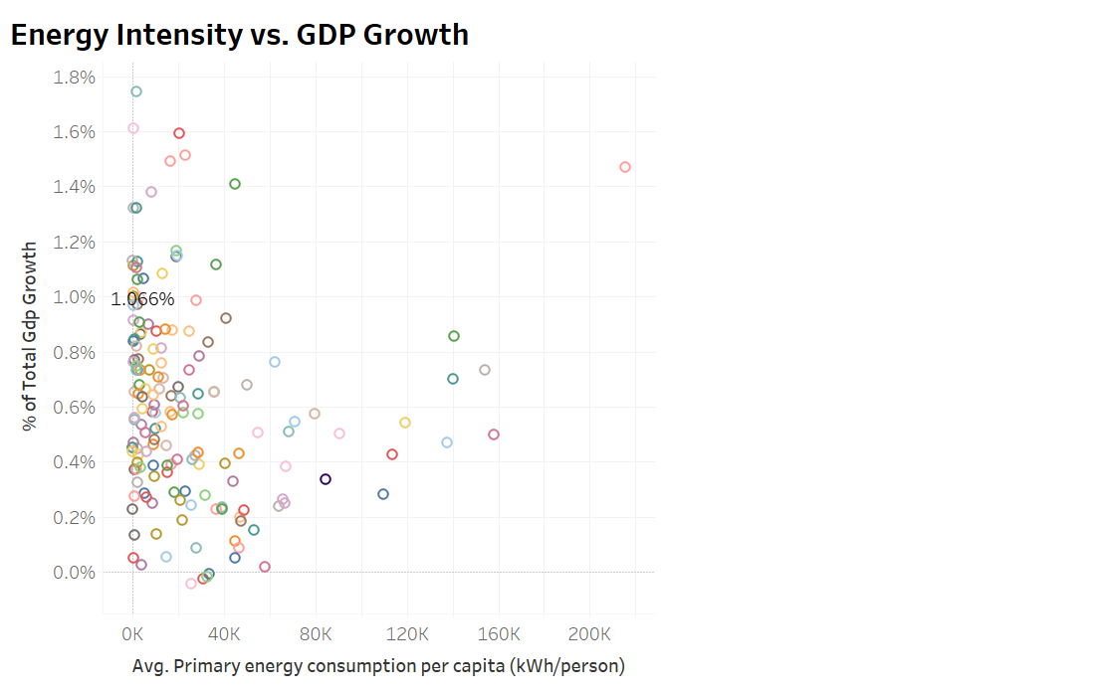

This chart illustrates the relationship between economic growth and energy efficiency across various country groups, highlighting differences between developed and developing nations.

We observe that India’s energy intensity (energy consumption per unit of GDP) has increased over the last few decades, showing a positive correlation between GDP growth and energy intensity. This suggests that as the economy grows, energy efficiency is also improving, although at a slower rate than desired.

Compared to global averages, India's energy intensity is higher, but the trend is similar to other emerging economies, indicating common challenges in balancing economic growth and energy efficiency.

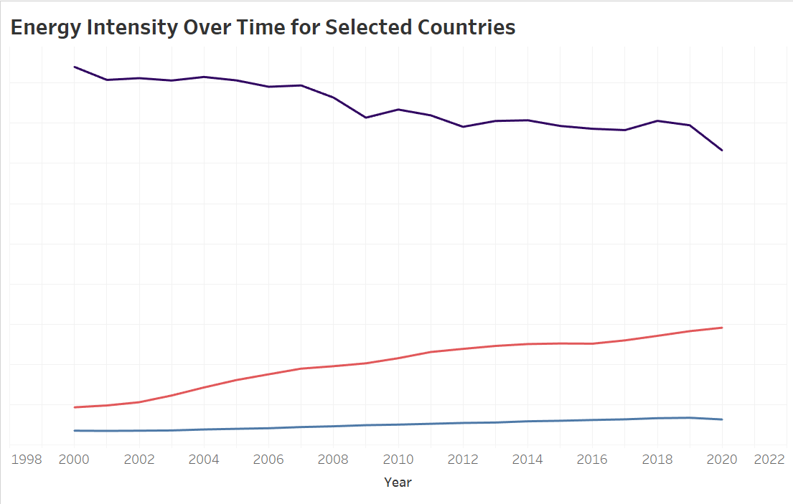

This chart shows historical changes in energy intensity over time, comparing India’s trajectory with selected countries.

India’s energy intensity has shown fluctuations over the decades, with improvements observed in recent years, especially after adopting more energy-efficient technologies. However, the slight decline in 2020 can be attributed to the economic slowdown during the pandemic.

Globally, energy intensity has decreased for most countries, reflecting advancements in energy-saving technologies and cleaner energy sources, but the rate of improvement varies significantly.

Scatter Plot: Renewable Energy Share vs. CO2 Emissions per Capita

Line Chart: Renewable Energy Share and CO2 Emissions Over Time

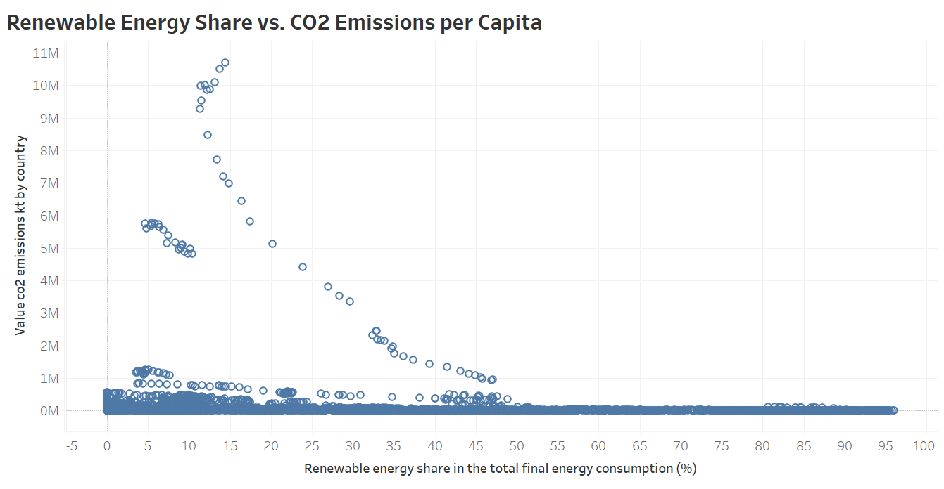

This plot explores the relationship between renewable energy adoption and CO2 emissions reduction.

India’s renewable energy share has grown significantly, particularly over the last decade, but the expected decrease in CO2 emissions has not fully materialized. CO2 emissions per capita have increased despite higher renewable energy adoption, which may be due to continued reliance on fossil fuels for certain sectors.

A similar global trend can be seen, where increased renewable energy shares have helped curb emissions but are often insufficient to fully offset the rising demand for energy.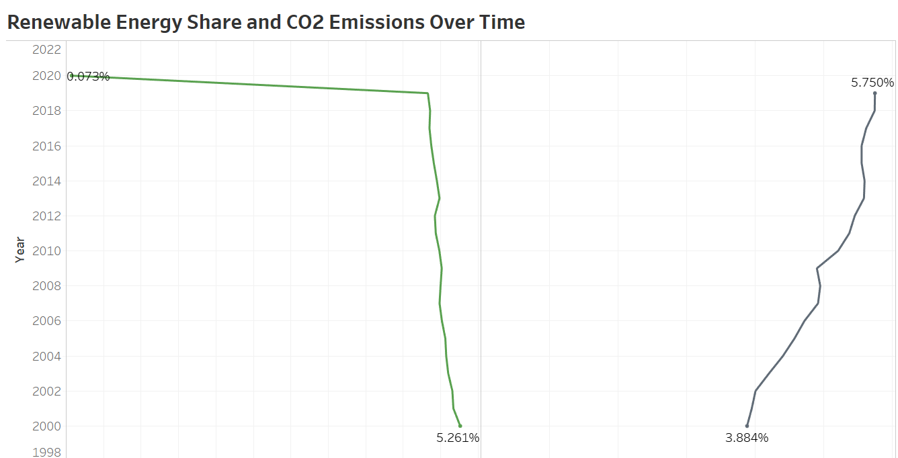

Tracks the correlation between rising renewable energy shares and CO2 emissions over time.

While India’s renewable energy share has increased, particularly after 2015, a sharp decline in 2020 is observed, likely due to disruptions caused by the pandemic. CO2 emissions, however, have continued to grow, though at a slower rate, signalling that more aggressive renewable adoption is needed to meet emission reduction targets.

Map: Financial Flows to Clean Energy vs. GDP Per Capita

Stacked Bar Chart: Financial Flows to Developed vs. Developing Countries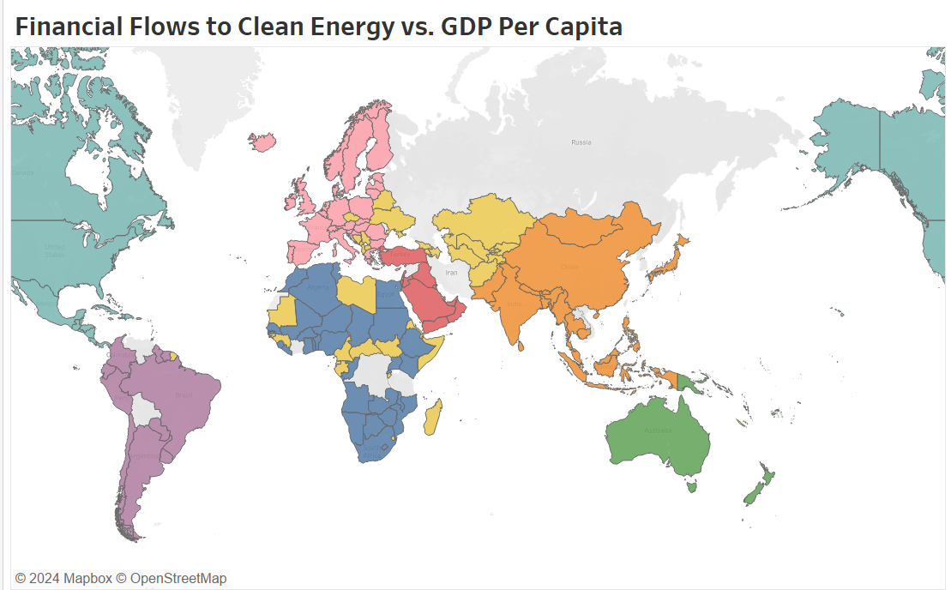

Highlights countries where financial flows are supporting clean energy development.

India has seen significant financial investments in its clean energy sector, with investments ramping up in recent years. While developed countries generally lead in these investments, India's financial inflows are catching up, reflecting its growing renewable energy market.

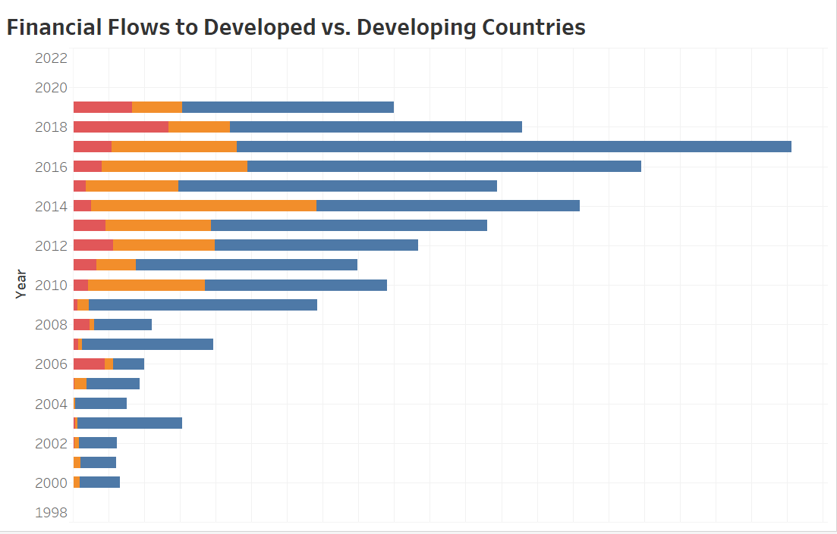

Shows the distribution of financial flows over time between developed and developing countries.

Although developed countries still receive the majority of clean energy investments, developing nations like India are starting to attract more attention from international investors. This trend indicates a shift towards financing renewable energy in emerging economies, crucial for global sustainability goals.

Line Chart: GDP Growth Rate and Energy Intensity for India

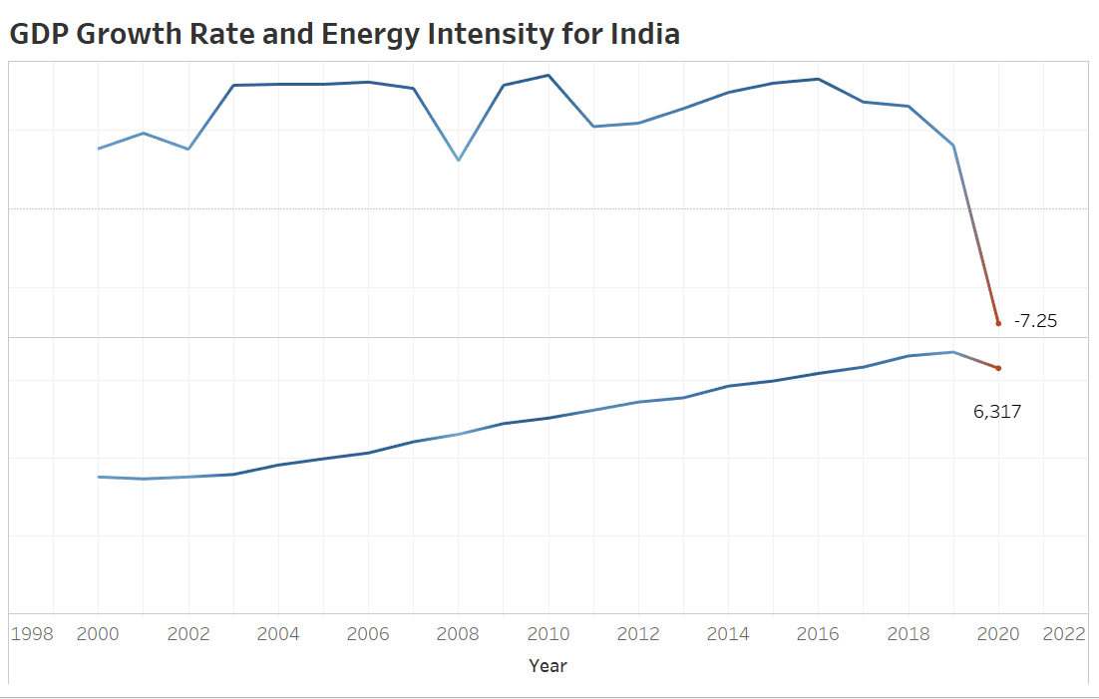

Shows how energy efficiency is improving or declining with GDP growth in India.

Over the past few years, India's GDP growth rate has declined, while energy intensity has shown a rapid growth, with a notable decline in 2020. This indicates that while India’s economic growth is slowing, efforts to reduce energy intensity are also lagging, which may hinder long-term sustainability.

Stacked Area Chart: CO2 Emissions by Source

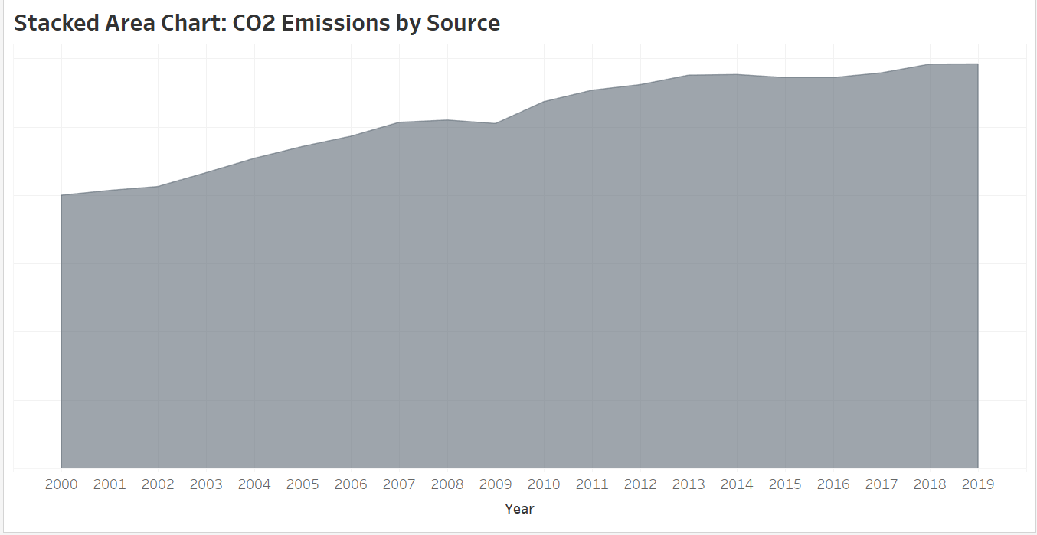

Shows the contribution of various energy sources (fossil fuels, renewables, etc.) to total CO2 emissions.

In India, fossil fuels remain the dominant source of CO2 emissions, although renewable energy is starting to make a dent. However, total emissions continue to grow year-on-year, reflecting the challenges of transitioning away from coal and other high-carbon sources.

Bar Chart: Top Countries in Renewable Energy Capacity

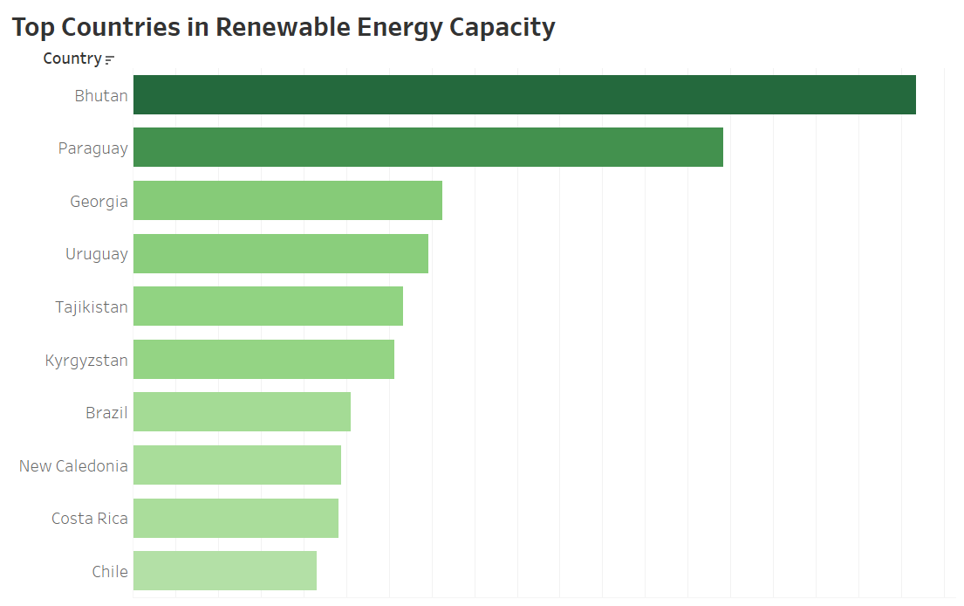

Identifies global leaders in renewable energy capacity.

While countries like Bhutan, Paraguay, and Georgia lead the list with the highest percentage of renewable energy capacity, India ranks among the top for absolute capacity growth, positioning itself as a key player in global renewable energy.

Map: Access to Electricity by Country

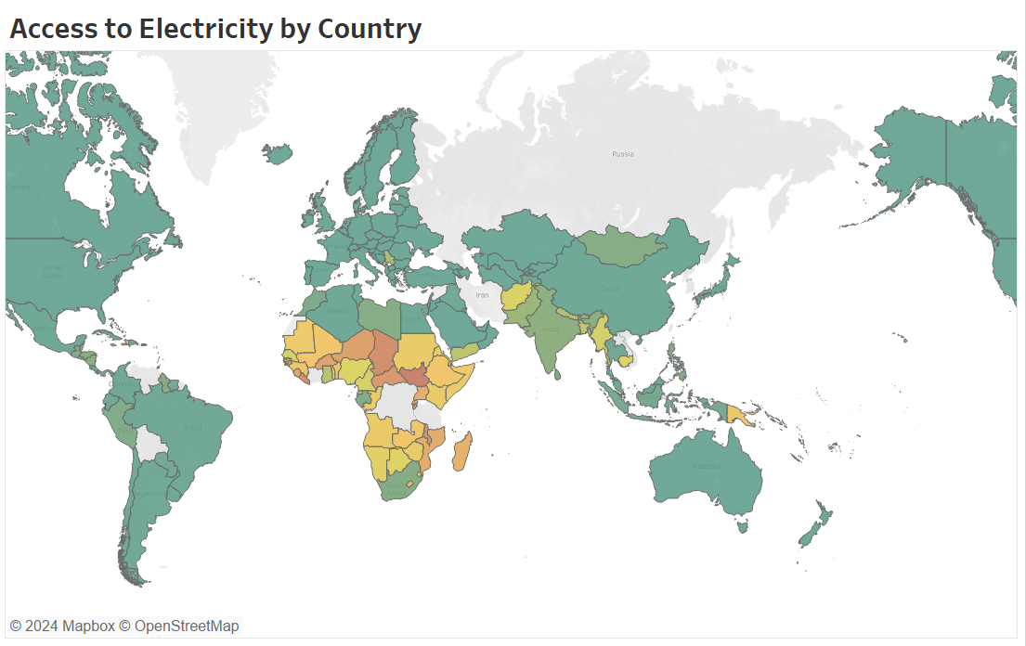

Highlights global disparities in electricity access.

African and Southeast Asian countries face severe electricity shortages, while most developed countries have universal access. India has made considerable progress in providing electricity access, although rural areas still face challenges in ensuring reliable energy supplies.

Map: Energy Consumption (Developed vs. Developing Countries)

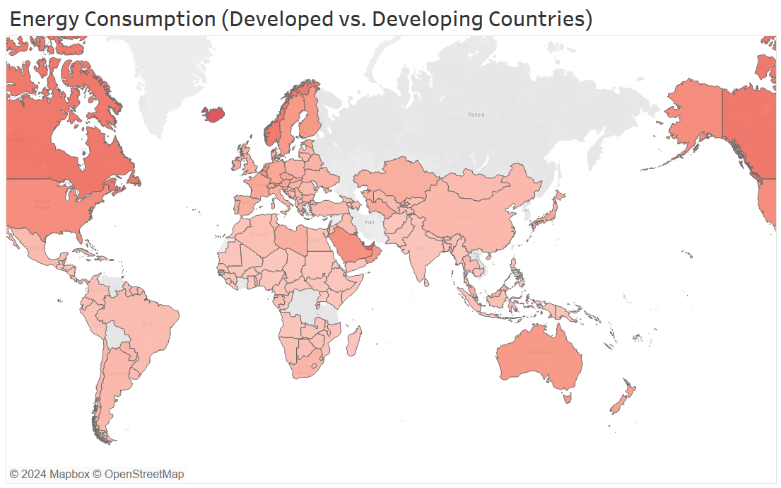

Highlights differences in energy consumption between developed and developing regions.

Energy consumption is highest in developed regions, reflecting their greater access to resources and infrastructure. Developing regions like India, while consuming less energy per capita, are seeing rapid growth in energy demand as industrialization progresses.

Bar Chart: Private Investments in Renewable Energy by Country

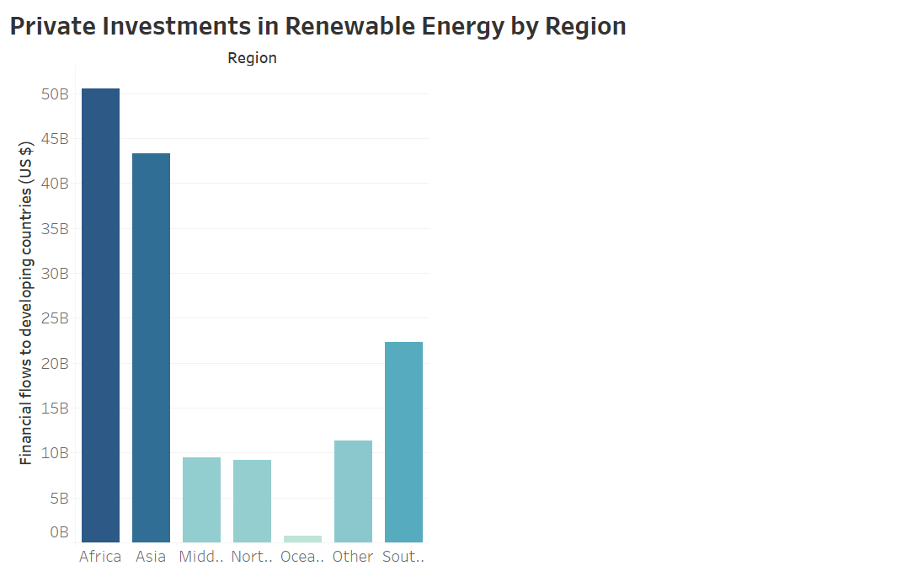

Showcases regions leading in private investment for renewable energy.

Africa and Asia are seeing a significant increase in private investments for renewable energy, signalling a shift in focus towards developing regions. India, being a key player in the Asian market, is benefiting from this investment influx.

Clustering: Grouping Countries Based on Energy Access and Investment Patterns

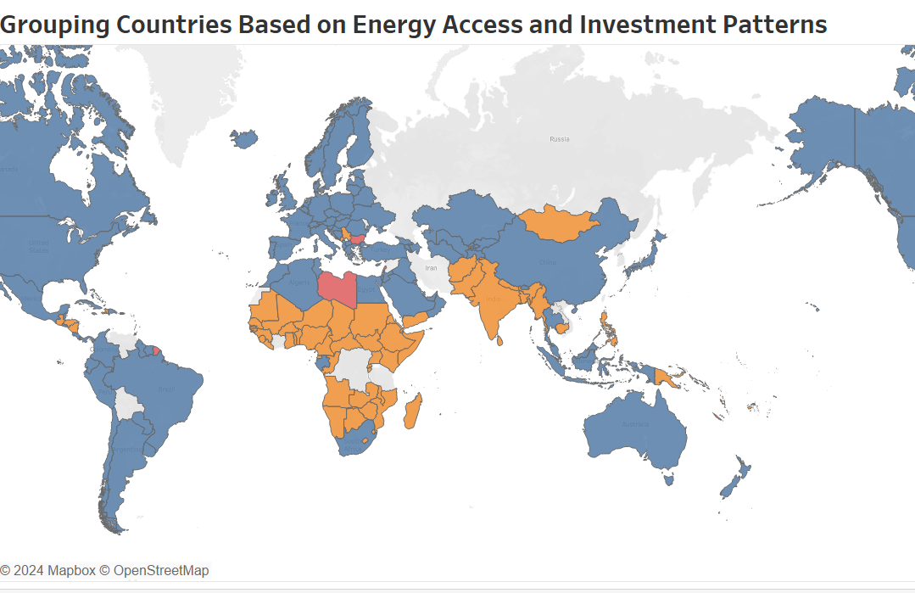

Group countries based on key variables like energy consumption, electricity access, clean fuel access, and renewable energy investments.

Countries with high energy consumption and access to electricity (marked in blue) are primarily developed nations, while developing countries (marked in orange) show lower consumption and access levels, emphasizing the need for increased investments.

Analysing the Impact of Energy Investments on Economic Development

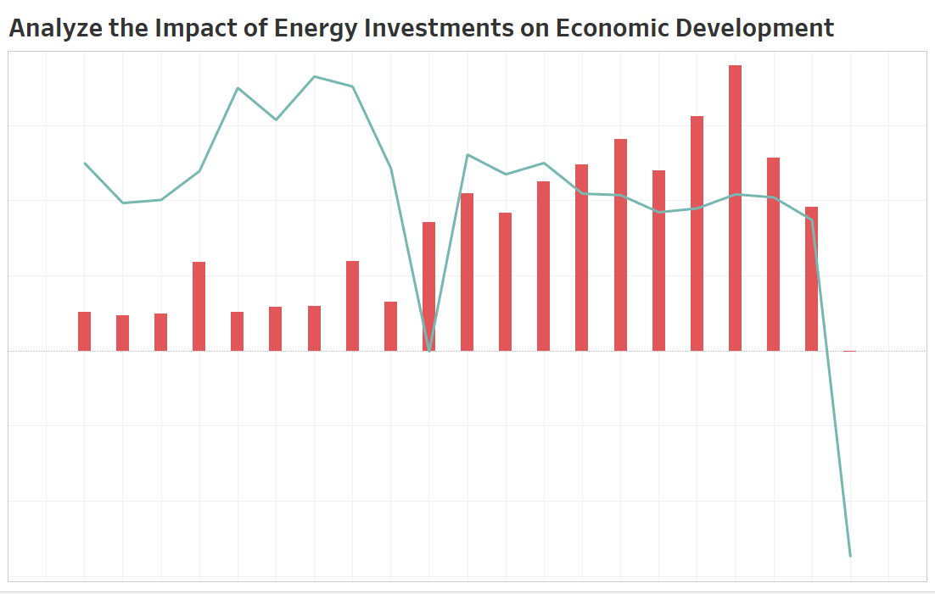

Examines how investments in renewable energy contribute to economic development.

Despite increased investments in energy projects, GDP growth remains stable, with exceptions during global crises like 2009 and 2020. This highlights that while energy investments are crucial, they must be coupled with broader economic reforms to maximize growth.

Dashboards

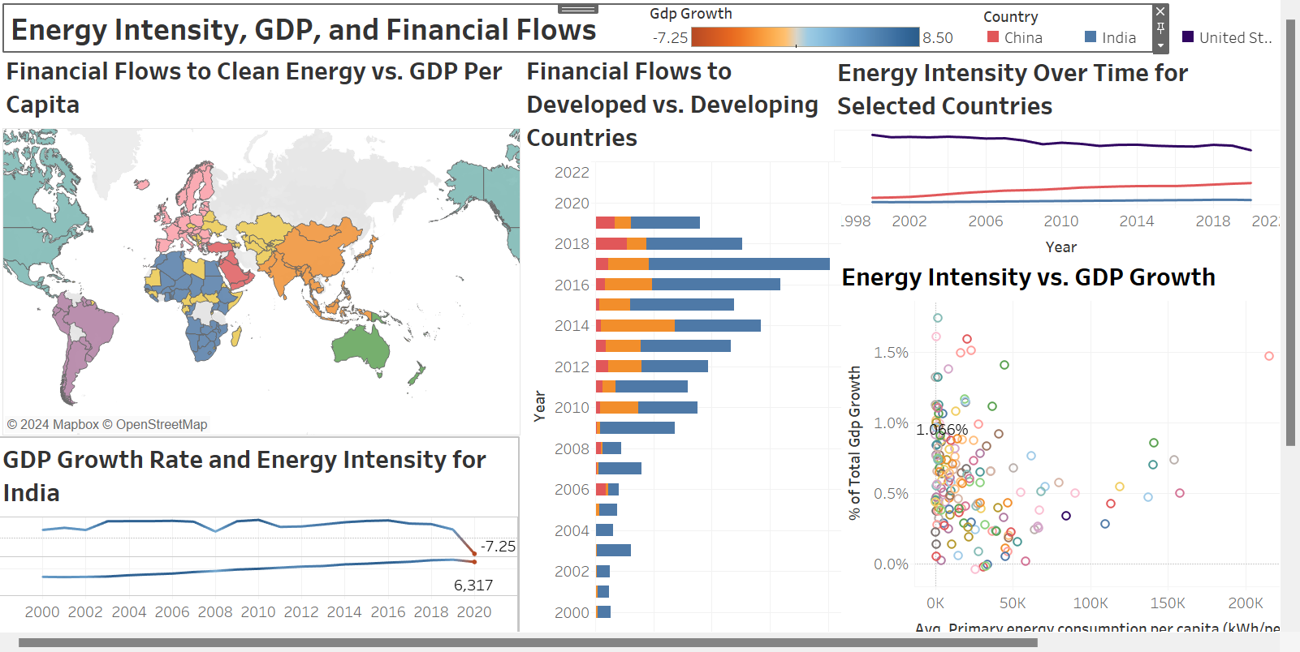 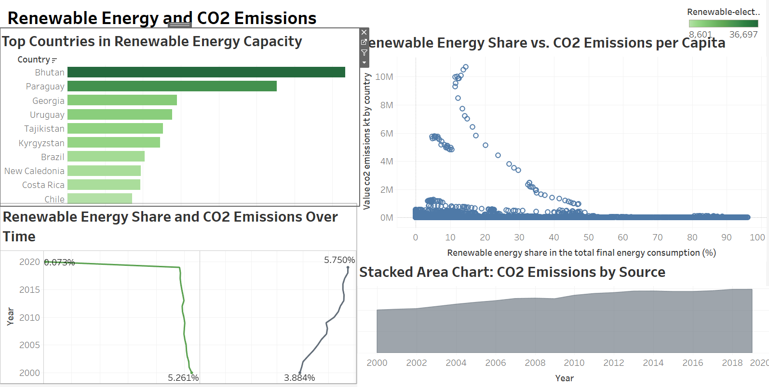 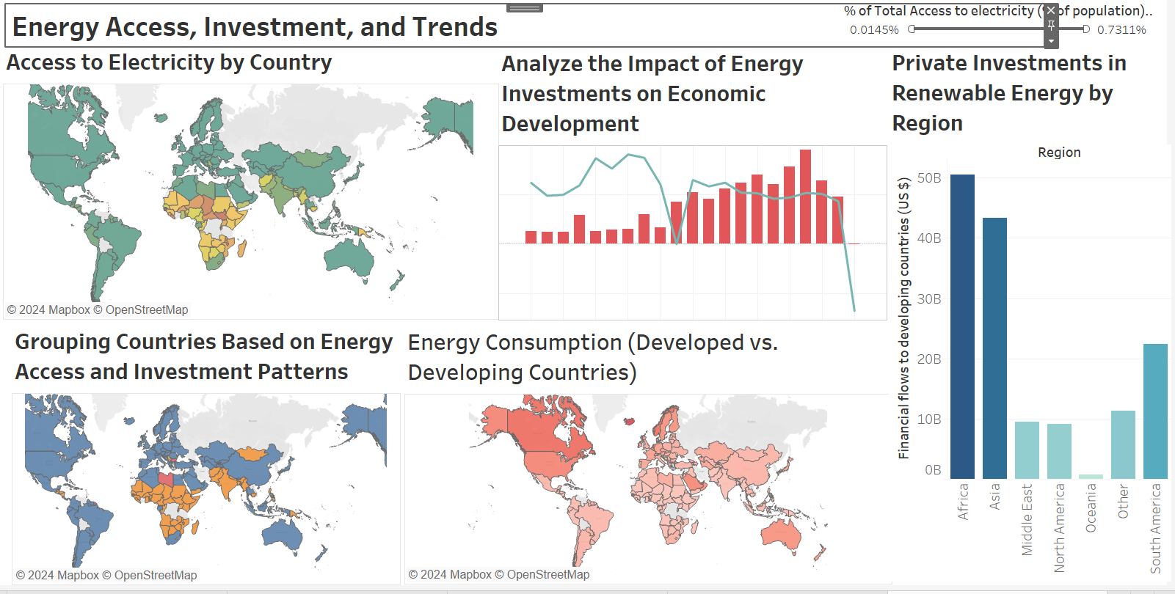

**Interpretation**

The analysis of global energy trends, with a specific focus on India, reveals key insights into the progress toward achieving the targets of the United Nations Sustainable Development Goals (SDG) 7.3 and 7.a,b. By examining relationships between energy intensity, renewable energy capacity, CO2 emissions, and financial flows, several patterns emerge that reflect the ongoing transition toward sustainable energy.

1. **Energy Intensity vs. GDP Growth**: The positive correlation between GDP growth and energy intensity suggests that as economies grow, their energy efficiency tends to improve. In India's case, energy intensity has seen both growth and fluctuations, with a slight dip in 2020 due to the global slowdown caused by the pandemic. However, overall, India has seen significant improvements in energy efficiency, aligning with global trends toward reducing energy consumption per unit of GDP.
2. **Renewable Energy Share vs. CO2 Emissions**: Despite the substantial increase in renewable energy capacity, particularly in India, CO2 emissions per capita have not shown a corresponding decline. This indicates that while renewable energy is becoming a larger part of the energy mix, it has not yet reached a scale large enough to offset the increasing energy demand from economic growth and industrialization. This trend is reflected globally, with the share of renewables rising but overall emissions still growing.
3. **Financial Flows to Clean Energy**: Financial investments in clean energy projects in developing countries like India have been catching up to those in developed nations. However, there remains a gap in the financial flows needed to accelerate the clean energy transition in many developing countries. India has attracted significant investments, which is a promising indicator of future growth in renewable capacity, but financial inequality between countries still persists.
4. **CO2 Emissions by Source**: The analysis of emissions by energy source highlights the continued dominance of fossil fuels as contributors to CO2 emissions. Although renewable energy sources are growing, fossil fuel use remains substantial across the globe, contributing to the increasing trend in emissions year after year. This emphasizes the need for more aggressive policies and investments in clean energy to curb the rise in emissions.
5. **Global Disparities in Energy Access**: The maps showing access to electricity and energy consumption highlight stark inequalities between developed and developing countries. Many African and Southeast Asian nations continue to struggle with access to reliable electricity, while developed regions consume significantly more energy. This disparity underscores the challenge of ensuring energy equity while promoting sustainability.
6. **Private Investments in Renewable Energy**: The clustering analysis reveals that countries with high renewable energy investments tend to also have higher energy access and consumption rates. This highlights the critical role that private investments play in driving energy transitions in both developing and developed regions. Regions like Africa and Asia have seen increased private investments, while Oceania and other regions lag behind.
7. **Energy Investments and Economic Development**: Investments in renewable energy have shown a positive impact on economic development in various regions. Countries with higher investments in energy projects tend to have more stable GDP growth, although economic shocks like the 2009 financial crisis and the 2020 pandemic caused downturns globally. This demonstrates the resilience of economies that are actively investing in clean energy projects.

**Conclusion**

The analysis provides valuable insights into the global energy landscape, highlighting the progress made and the challenges that remain in transitioning to sustainable energy systems. India's energy sector, in particular, has shown significant improvements in energy efficiency and renewable energy capacity, yet there is still a long way to go in achieving the SDG targets by 2030.

1. **Energy Intensity and Renewable Energy**: While energy intensity is improving globally, and renewable energy capacity is growing, the reductions in CO2 emissions are not happening at the necessary rate to combat climate change. This indicates that energy efficiency and renewable capacity alone are not enough, and a more comprehensive approach to reducing overall energy demand and fossil fuel reliance is essential.
2. **Financial Support**: The disparity in financial flows between developed and developing countries continues to pose a challenge for global sustainability goals. Greater international collaboration and investment are needed to bridge this gap and enable developing countries to adopt clean energy technologies at a faster pace.
3. **Policy Implications**: Policymakers need to focus on incentivizing renewable energy adoption, improving access to electricity in underserved regions, and securing investments for clean energy infrastructure. Additionally, countries like India should continue to prioritize sustainable energy development to meet both domestic and global climate goals.
4. **Future Directions**: Increased private and public investments in renewable energy, combined with policies aimed at reducing fossil fuel consumption, will be critical in ensuring the energy transition is both equitable and effective. The results of this study should serve as a foundation for future research and policy planning in the areas of sustainable energy, economic development, and climate change mitigation.

**Bibliography**

* <https://www.iea.org/reports/world-energy-outlook-2022>
* <https://sdgs.un.org/goals/goal7>
* <https://trackingsdg7.esmap.org/>
* <https://www.irena.org/publications/2022/Mar/Renewable-Capacity-Statistics-2022>
* <https://www.undp.org/publications/financing-clean-energy-transition>
* <https://www.iied.org/energy-access-developing-countries>
* <https://powermin.gov.in/en/content/national-energy-policy>