**SMART WATER FOUNTAINS**

There are several water fountains which unconditionally sprinkle water with some interesting lighting effects. So I wandered about designing an innovative water fountain which can respond to external music and sprinkle water depending on the music beats. Isn’t it sound interesting?

The basic idea of this **Arduino Water Fountain** is to take an input from any external sound source like mobile, iPod, PC etc., sample the sound and break it down to different voltage ranges, then use the output to turn on various Relay. We first used a condenser mic based **sound sensor module** to perform on the sound source to split the sounds into different voltage ranges. Then the voltage will be fed to op-amp to compare sound level with a particular limit. The higher voltage range will correspond to a relay switch ON which comprises a musical water fountain operating to the beats and rhythms of the song. So here we are building this **Musical Fountain using Arduino and sound sensor.**

### Material required

1. Arduino Nano
2. Sound sensor Module
3. 12V Relay Module
4. DC Pump
5. LEDs
6. Connecting wires
7. Vero board or Breadboard

Working of a Sound sensor

Sound Sensor Module

The Sound sensor module is a simple electret microphone based electronic board used to sense external sound from the environment. It is based on the LM393 power amplifier and an electret microphone, it can be used to detect whether there is any sound beyond the set threshold limit. The module output is a digital signal which indicates that the sound is greater or lesser than the threshold.

The potentiometer can be used to adjust the sensitivity of the sensor module. The module output is HIGH/LOW when the sound source is Lower/higher than the threshold set by the potentiometer. Same sound sensor module can also be used for measuring the sound level in decibel.

### Sound Sensor Circuit Diagram

As we know that in a sound sensor module, the basic input device is the microphone which converts the sound signals to electrical signals. But as the electrical signal output of the sound sensor is so small in magnitude which is very difficult to analyse, so we have used a [NPN transistor](https://circuitdigest.com/article/npn-transistors) amplifier circuit which will amplify it and feed the output signal to the non-inverting input of the Op-amp. Here LM393 OPAMP is used as a comparator which compares the electrical signal from the microphone and the reference signal coming from the [voltage divider circuit](https://circuitdigest.com/electronic-circuits/potential-voltage-divider-circuit-diagram). If the input signal is greater than the reference signal then the output of the OPAMP will be high and vice versa.

You can follow [Op-amp circuits](https://circuitdigest.com/op-amp-circuits) sections to learn more about its working.

### Musical Water Fountain Circuit Diagram

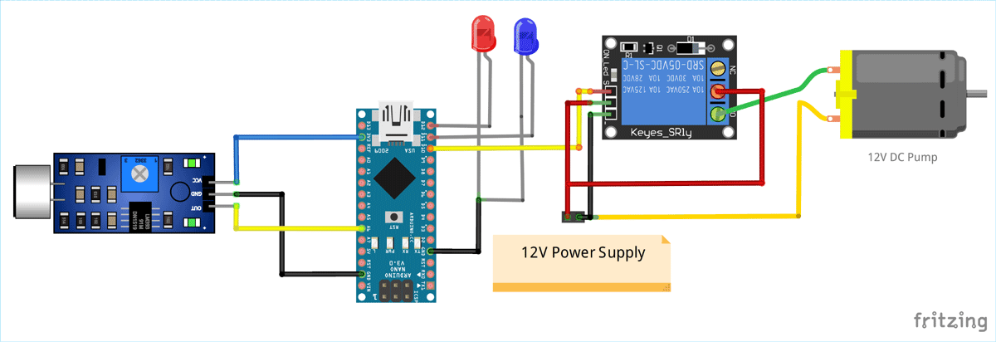

As shown in the above **musical fountain circuit diagram**, the sound sensor is powered with 3.3V supply of Arduino Nano and the output pin of the sound sensor module is connected to the analog input pin (A6) of Nano. You can use any of the analog pin, but make sure to change that in the program. The relay module and DC pump is powered by an external 12VDC power supply as shown in the figure. The input signal of relay module is connected to digital output pin D10 of Nano. For lighting effect I chose two different colours of LED and connected them to two digital output pins (D12, D11) of Nano.

Here the Pump is connected in such a way that when a HIGH pulse is given to the input of [Relay module](https://circuitdigest.com/electronic-circuits/relay-driver-module-circuit-pcb), the COM contact of the relay is get connected to the NO contact and the current gets a closed circuit path to flow across the pump to activate the water flow. Otherwise the pump will remain OFF. The HIGH/LOW pulses are generated from Arduino Nano depending on the sound input.

After soldering the complete circuit on perfboard, it will look like below:

Here the Pump is connected in such a way that when a HIGH pulse is given to the input of [Relay module](https://circuitdigest.com/electronic-circuits/relay-driver-module-circuit-pcb), the COM contact of the relay is get connected to the NO contact and the current gets a closed circuit path to flow across the pump to activate the water flow. Otherwise the pump will remain OFF. The HIGH/LOW pulses are generated from Arduino Nano depending on the sound input.

After soldering the complete circuit on perfboard, it will look like below:

Here we used a **plastic box as fountain container** and mini **5v pump** to act as a fountain, we used this pump previously in [fire-fighting robot](https://circuitdigest.com/microcontroller-projects/arduino-fire-fighting-robot-code):

**Code**

import time

from pyfirmata import Arduino, util

# Define pins

sensor_pin = "A6"

red_led_pin = 12

green_led_pin = 11

pump_pin = 10

REF = 700

# Initialize Arduino board

board = Arduino('/dev/ttyACM0') # Adjust the port as needed

# Set pin modes

board.digital[red_led_pin].mode = pyfirmata.OUTPUT

board.digital[green_led_pin].mode = pyfirmata.OUTPUT

board.digital[pump_pin].mode = pyfirmata.OUTPUT

while True:

# Read sensor value

sensor_value = board.analog[sensor_pin].read()

if sensor_value > REF:

board.digital[red_led_pin].write(1)

board.digital[green_led_pin].write(1)

board.digital[pump_pin].write(1)

time.sleep(0.07)

else:

board.digital[red_led_pin].write(0)

board.digital[green_led_pin].write(0)

board.digital[pump_pin].write(0)

time.sleep(0.07)