AWS BSCNE Capstone
Functionality Report
Student Name: Brad Herrinton
WGU Student ID: 001204103
WGU Student Email bherr35@wgu.edu

Test Case #1: Local Networks — Basic Network Segmentation at Layer 2 via VLANs and 802.1q

Functionality
To isolate the different departmental and functional areas of the Openframe Studios network, it is divided into four VLANs at layer 2. The Production department resides on VLAN 10 and exists in 192.168.10.0/24 space. Post-Production utilizes VLAN 20 in the 192.168.20.0/24 space. Business Administration is located on VLAN 30 in the 192.168.30.0/24 space, and the network for Guest/Contractor is logically isolated on its own VLAN 40 in 192.168.40.0/24 space. A management VLAN is also implemented as VLAN 1 in the 192.168.1.0/24 space. All of these are terminated on FW-01, the VyOS firewall/router, which performs the inter-VLAN routing. This is accomplished with sub-interfaces on eth0 (see Figure 1.2).

The GNS3 Ethernet Switch (SW-CORE) provides L2 VLAN separation. Port 0 is configured as an 802.1q/DOT1Q trunk to FW-01. Ports 1, 15, and 16 are all members of VLAN 1 (Management); Ports 2–5 are members of VLAN 10 (Production). Ports 6–10 are members of VLAN 20 (Post-Production). Ports 11–12 are members of VLAN 30 (Business/Admin). Ports 13–14 are members of VLAN 40 (Guest/Contractor). All access ports carry only their respective VLANs (IEEE, 2022).

Network Diagram or Segment
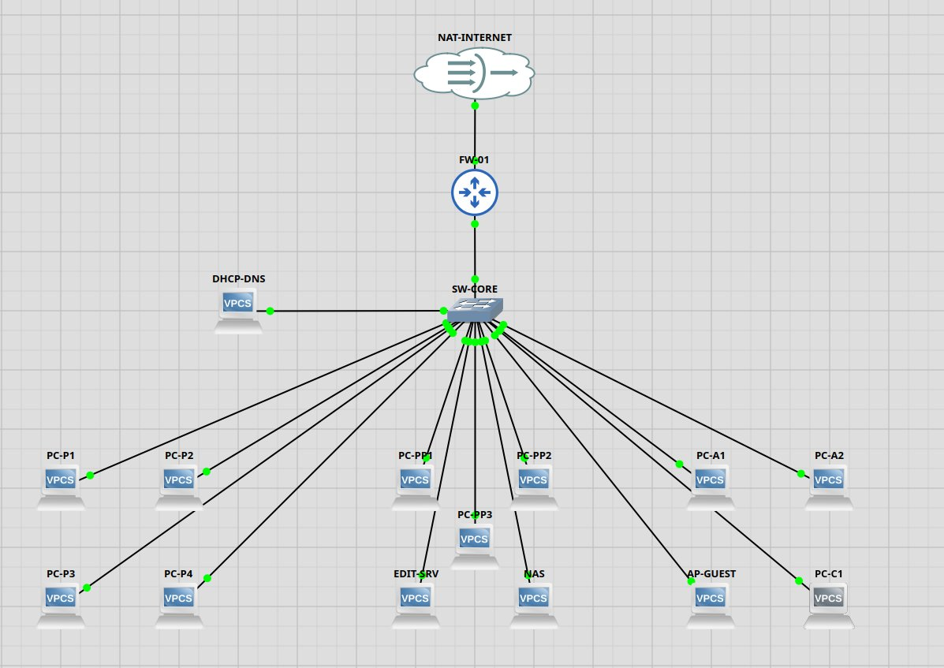
Figure 1.1 — Full GNS3 topology showing all on-premises devices connected through SW-CORE to FW-01
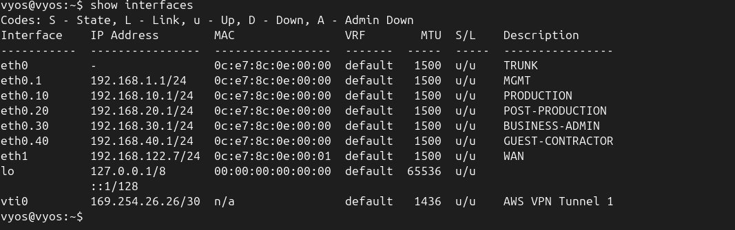
Figure 1.2 — VyOS FW-01 show interfaces output confirming all four VLAN sub-interfaces are up with correct IP addresses

Testing Method
To check the VLAN configuration, the port configuration of the SW-CORE in GNS3 is examined to verify that port 0 is in dot1q trunk mode and that all other access ports are in the configured VLANs. Then, the interface table on FW-01 is checked with the show interfaces command to confirm that all VLAN sub-interfaces (eth0.10, eth0.20, eth0.30, eth0.40) are up and have the correct IP configuration. The metric of success is that all sub-interfaces are in state u/u (up/up) and have the correct IP configuration according to the network design.

Process List
1. Open GNS3 and launch the New_Openframe_Studios_Capstone project.
2. Double-click SW-CORE to open the Node Properties dialog.
3. Verify Port 0 is set to Type: dot1q (trunk) connected to FW-01 eth0.
4. Verify port 1 and ports 15–16 are set to access VLAN 1 (Management/DHCP-DNS).
5. Verify ports 2–5 are set to access VLAN 10 (Production).
6. Verify ports 6–10 are set to access VLAN 20 (Post-Production).
7. Verify ports 11–12 are set to access VLAN 30 (Business/Admin).
8. Verify ports 13–14 are set to access VLAN 40 (Guest/Contractor).
9. Open the FW-01 console and log in with credentials vyos/vyos.
10. Run the command: show interfaces
11. Confirm that eth0.10, eth0.20, eth0.30, and eth0.40 all show status u/u with their correct IP addresses.

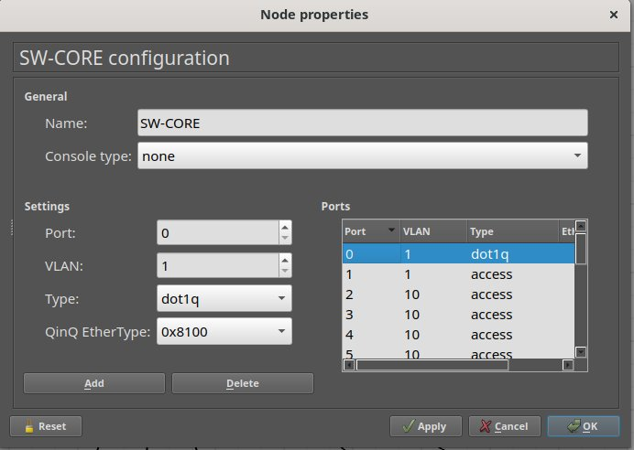
Figure 1.3 — SW-CORE port configuration showing Port 0 as a dot1q trunk and ports 1–5 as access VLANs
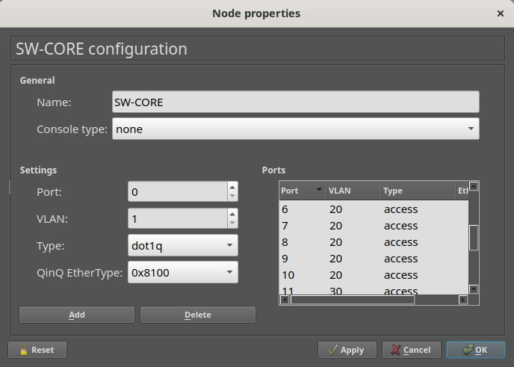
Figure 1.4 — SW-CORE port configuration showing ports 6–11 assigned to VLANs 20 and 30
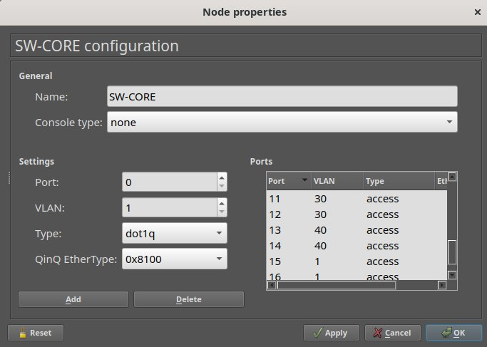
Figure 1.5 — SW-CORE port configuration showing ports 11–16, including VLAN 40 and additional VLAN 1 management ports

Test Case #2: Local Networks — Accessing External Resources — Routing and Traffic Security

Functionality
All client stations on each of the four VLANs are configured to obtain their IP addresses dynamically via DHCP. The firewall FW-01 functions as a DHCP server for each of the four VLANs with a DHCP pool defined for each of the four subnets (VyOS, n.d.-b). The range for each DHCP pool is .100 to .200 in each respective subnet, with the default gateway and DNS server correctly configured.

Two devices have static IP addresses, as they are infrastructure assets: the EDIT-SRV (Edit/Rendering Server) with 192.168.20.10 and the NAS (Network Attached Storage) with 192.168.20.11. Both devices have static IP addresses because they need to remain consistently accessible to hosts and services throughout the network.

Network Diagram or Segment
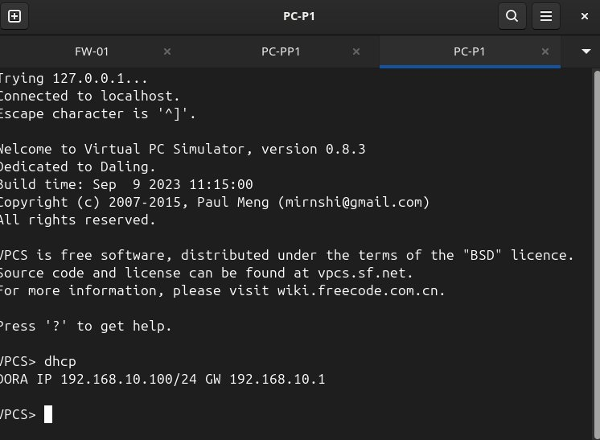
Figure 2.1 — PC-P1 successfully receives a DHCP address via the full DORA process: IP 192.168.10.100/24, GW 192.168.10.1
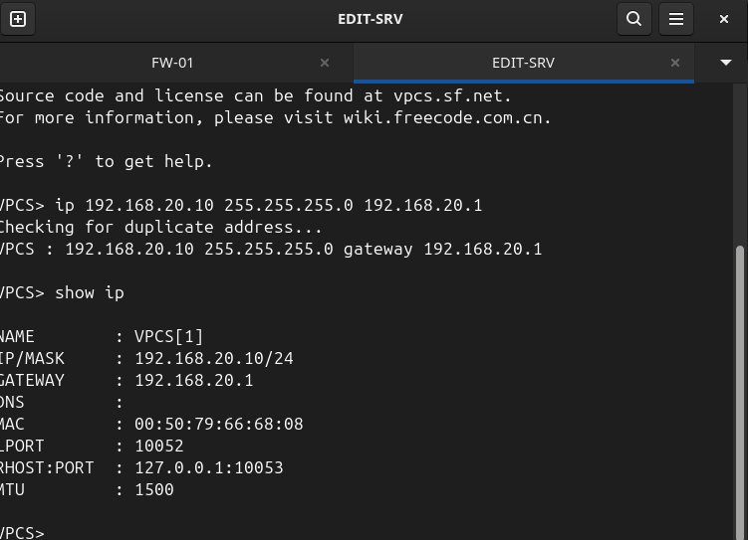
Figure 2.2 — EDIT-SRV configured with static IP 192.168.20.10/24, gateway 192.168.20.1
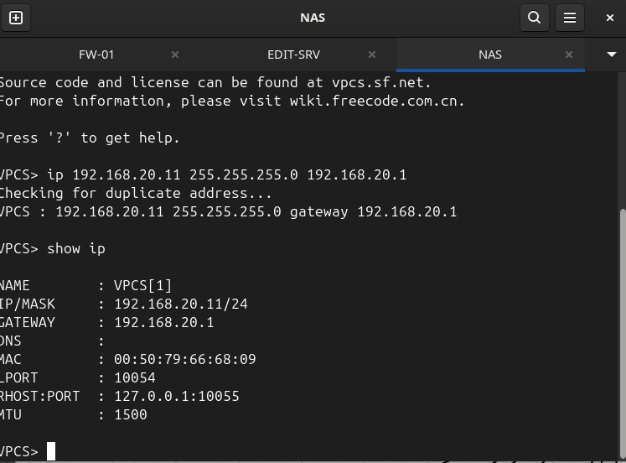
Figure 2.3 — NAS configured with static IP 192.168.20.11/24, gateway 192.168.20.1

Testing Method
To confirm DHCP operation, the console of a VPCS node in each VLAN is opened and the dhcp command is run. A successful DORA exchange (Discover, Offer, Request, Acknowledge) results in the node receiving an IP address within the configured pool range, the correct default gateway, and the correct DNS server address. To confirm a static assignment, the static IP address is assigned to the interface using the ip command in VPCS, then the show ip command is run to validate. The measure of success is that the DHCP nodes are assigned addresses in the .100 to .200 range, and that the static devices display their assigned IP addresses.

Process List
1. Start all nodes in the GNS3 topology.
2. Open the console for PC-P1 (VLAN 10 Production workstation).
3. Run the command: dhcp
4. Confirm the DORA exchange completes and the node receives an IP address in the 192.168.10.100–200 range with gateway 192.168.10.1.
5. Repeat the dhcp command on one device from each remaining VLAN (PC-PP1 for VLAN 20, PC-A1 for VLAN 30, PC-C1 for VLAN 40).
6. Open the console for EDIT-SRV and run: ip 192.168.20.10 255.255.255.0 192.168.20.1
7. Run show ip on EDIT-SRV and confirm IP/MASK shows 192.168.20.10/24.
8. Open the console for NAS and run: ip 192.168.20.11 255.255.255.0 192.168.20.1
9. Run show ip on NAS and confirm IP/MASK shows 192.168.20.11/24.

Test Case #3: Local Networks — Device Discovery and Reachability

Functionality
Inter-VLAN routing is performed by the FW-01 firewall, which allows selected inter-VLAN communication and blocks the rest. The VyOS router forwards packets between VLANs by default. However, using filter rules in the forward filter chain blocks specific inter-VLAN traffic (VyOS, n.d.-c). Specifically, the Production VLAN (VLAN 10) cannot communicate with the Business/Admin VLAN (VLAN 30) to keep the production environment separate from business data. The Guest/Contractor VLAN (VLAN 40) cannot communicate with any internal VLAN. This is enforced using VyOS firewall rules that match the inbound interface.

Network Diagram or Segment
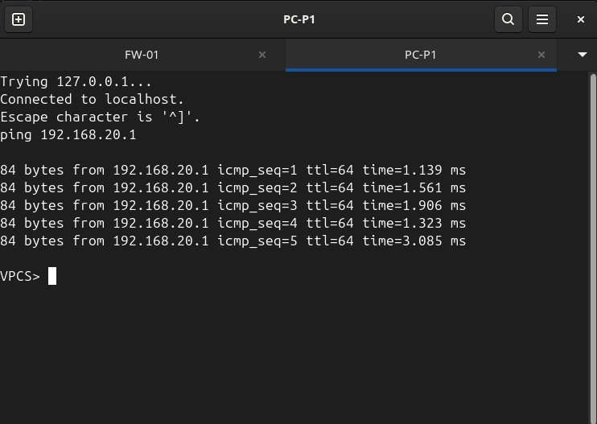
Figure 3.1 — PC-P1 (VLAN 10) successfully pings 192.168.20.1 (VLAN 20 gateway), confirming inter-VLAN routing is operational between Production and Post-Production
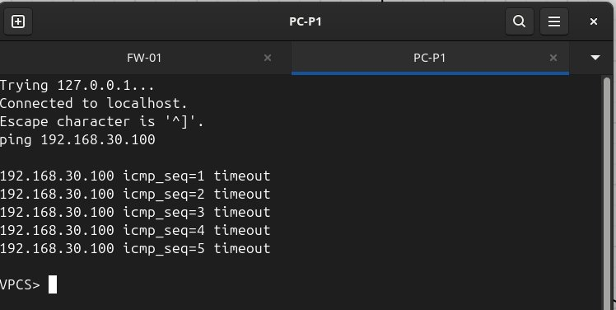
Figure 3.2 — PC-P1 (VLAN 10) cannot reach 192.168.30.100 (VLAN 30 host), confirming the Production-to-Admin ACL is enforced

Testing Method
For allowed traffic, ICMP ping is used to verify that a device on VLAN 10 can reach the VLAN 20 gateway interface (192.168.20.1). This confirms that inter-VLAN routing is operational and that FW-01 is forwarding traffic between those segments. Host-to-host cross-VLAN connectivity is further demonstrated in Test Case #8, where PC-PP1 on VLAN 20 successfully reaches the NAS at 192.168.20.11. For denied traffic, pinging a device on a restricted VLAN produces five consecutive ICMP timeouts. The success criteria are successful replies for allowed traffic and consistent timeouts for denied traffic.

Process List
1. Ensure all VPCS nodes have IP addresses (run dhcp on each, or set static IPs on EDIT-SRV and NAS).
2. Open the console for PC-P1 (VLAN 10, 192.168.10.100).
3. Run: ping 192.168.20.1 — confirm successful replies to the VLAN 20 gateway, confirming inter-VLAN routing is operational.
4. Open the console for PC-A1 (VLAN 30) and run dhcp to obtain 192.168.30.100.
5. Return to PC-P1 and run: ping 192.168.30.100 — confirm ICMP timeouts (blocked by firewall rule 40).
6. Open the console for PC-C1 (VLAN 40) and run dhcp to obtain 192.168.40.100.
7. From PC-C1, run: ping 192.168.10.100 — confirm ICMP timeouts (VLAN 40 isolation rule).
8. From PC-C1, run: ping 8.8.8.8 — confirm successful internet access (VLAN 40 internet is permitted by default allow rule).

Test Case #4: Cloud Networks — Network Segmentation

Functionality
In the cloud, the Openframe Studios hybrid network runs on AWS in the us-west-2 (Oregon) region in a VPC named Openframe-Studios-VPC with the CIDR block 10.0.0.0/16 (Amazon Web Services, n.d.-a). Two subnets are provisioned in the VPC: one to host EC2 resources that need to be accessed from the internet, and the other for EC2 resources that should not have direct internet access.

The public subnet (Openframe-Public-Subnet, 10.0.1.0/24) is attached to the internet via an Internet Gateway and hosts the EC2 instance used for video transcoding. The private subnet (Openframe-Private-Subnet, 10.0.2.0/24) does not have direct access to the internet, as no Internet Gateway or NAT Gateway route was added for this subnet, and it hosts the EC2 instance used for backups.

A separate route table is used for each subnet. The route table for the public subnet routes all non-VPC internet-bound traffic to the Internet Gateway and all on-premises-bound traffic to the Virtual Private Gateway. Both subnets have a security group associated with them that defines inbound traffic rules for EC2 instances hosted on each subnet.

Network Diagram or Segment
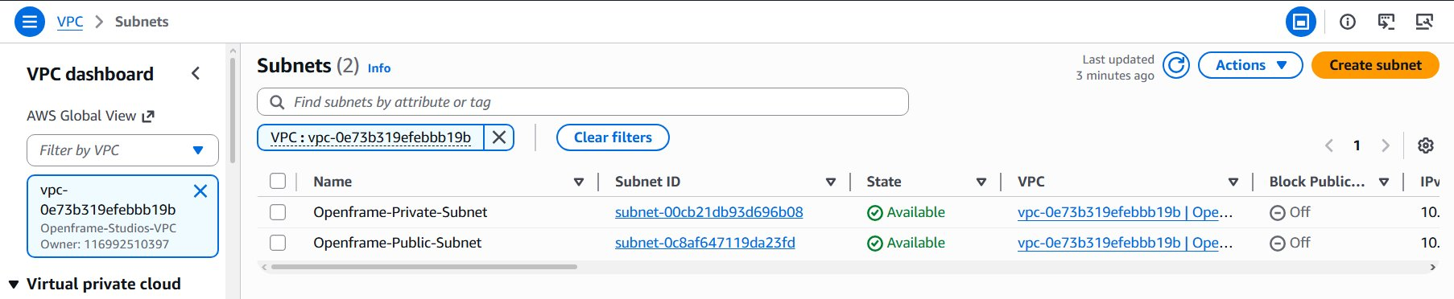
Figure 4.1 — AWS VPC console showing both subnets (Openframe-Public-Subnet and Openframe-Private-Subnet) within the Openframe-Studios-VPC
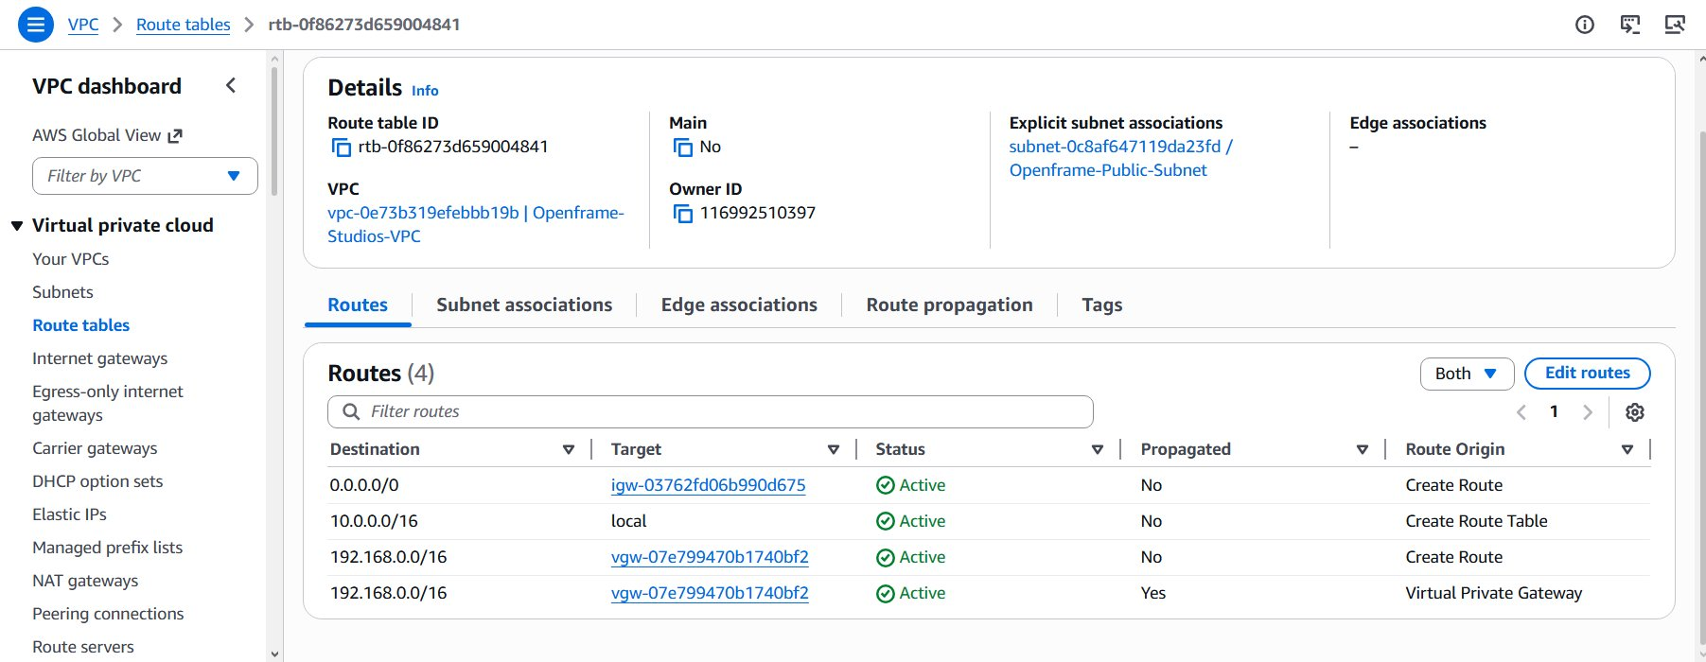
Figure 4.2 — Public route table showing routes for internet access (IGW), local VPC traffic, and on-premises routing via the Virtual Private Gateway
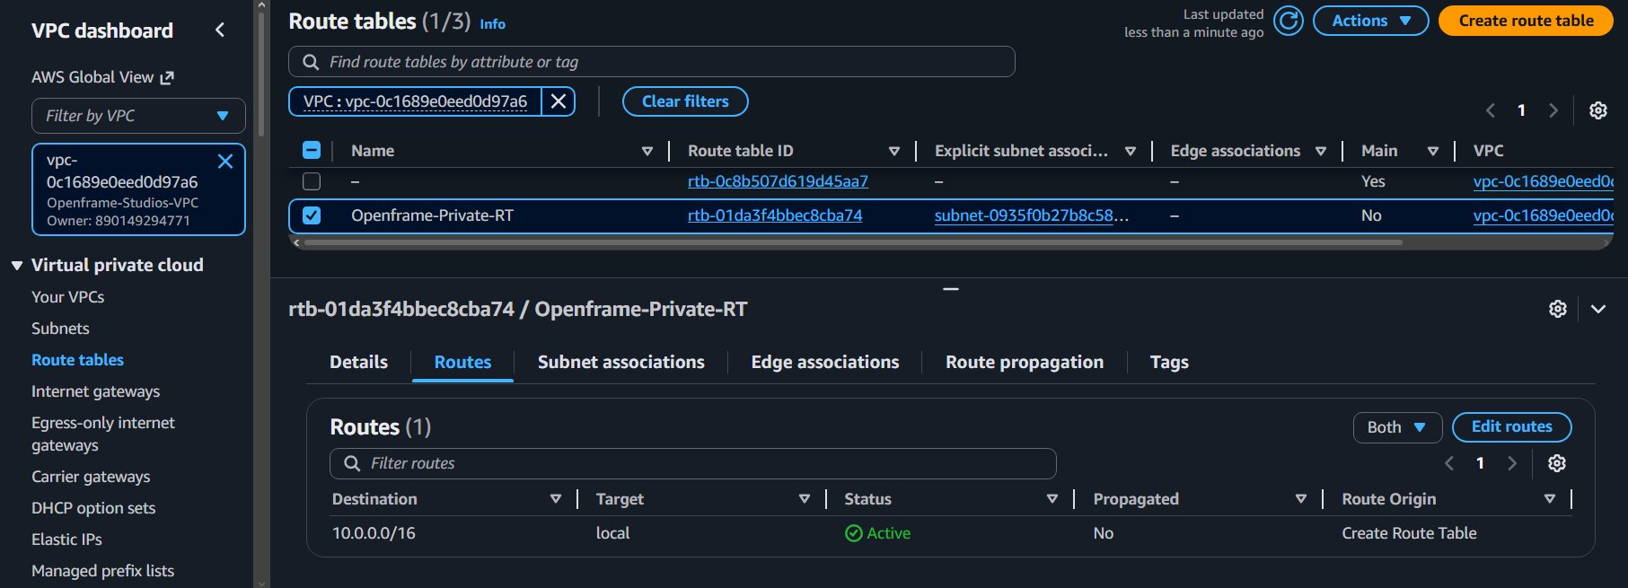
Figure 4.3 — Private route table showing only the local VPC route (10.0.0.0/16), with no internet gateway route, confirming the private subnet has no direct internet access

Testing Method
Cloud network segmentation is verified in the AWS Management Console, where the VPC, subnet, and route table configurations are examined. The public subnet has a route to the Internet Gateway for 0.0.0.0/0, while the private subnet does not — only the local VPC route exists. Both subnets have the 192.168.0.0/16 route set to the Virtual Private Gateway so that traffic can reach the on-premises network via the VPN tunnel. The metric of success is that route tables are properly configured with the expected routes for each subnet.

Process List
1. Log into the AWS Management Console and navigate to the VPC service in us-west-2.
2. Click Your VPCs and confirm Openframe-Studios-VPC exists with CIDR 10.0.0.0/16.
3. Click Subnets and filter by the Openframe-Studios-VPC to confirm both subnets are present and available.
4. Click Route Tables and select Openframe-Public-RT.
5. Click the Routes tab and confirm the following routes are active: 0.0.0.0/0 via Internet Gateway, 10.0.0.0/16 local, 192.168.0.0/16 via Virtual Private Gateway.
6. Select Openframe-Private-RT and confirm the subnet association with Openframe-Private-Subnet.
7. Click the Routes tab on the private route table and confirm only the 10.0.0.0/16 local route is present, with no 0.0.0.0/0 internet route.

Test Case #5: Cloud Networks — Accessing External Resources — Routing and Traffic Security

Functionality
In the Openframe Studios AWS environment, the IP address rules are the same as on-premises. All resources that require a fixed address have a static address; all others are platform-assigned. The EC2 transcoding instance (Openframe-EC2-Transcoding) has an Elastic IP (EIP) (Amazon Web Services, n.d.-a), which remains associated with the instance and persists across stops and starts. This is necessary because the EC2 instance provides the transcoding service as a client-facing delivery endpoint and, as such, must have a consistent IP address for external clients to connect to.

The EC2 instance in the private subnet (Openframe-EC2-Backup) has only a platform-assigned private IP (10.0.2.35) with no public IP address, as expected for an internal backup and disaster recovery resource that should not be accessible from the public internet.

Network Diagram or Segment
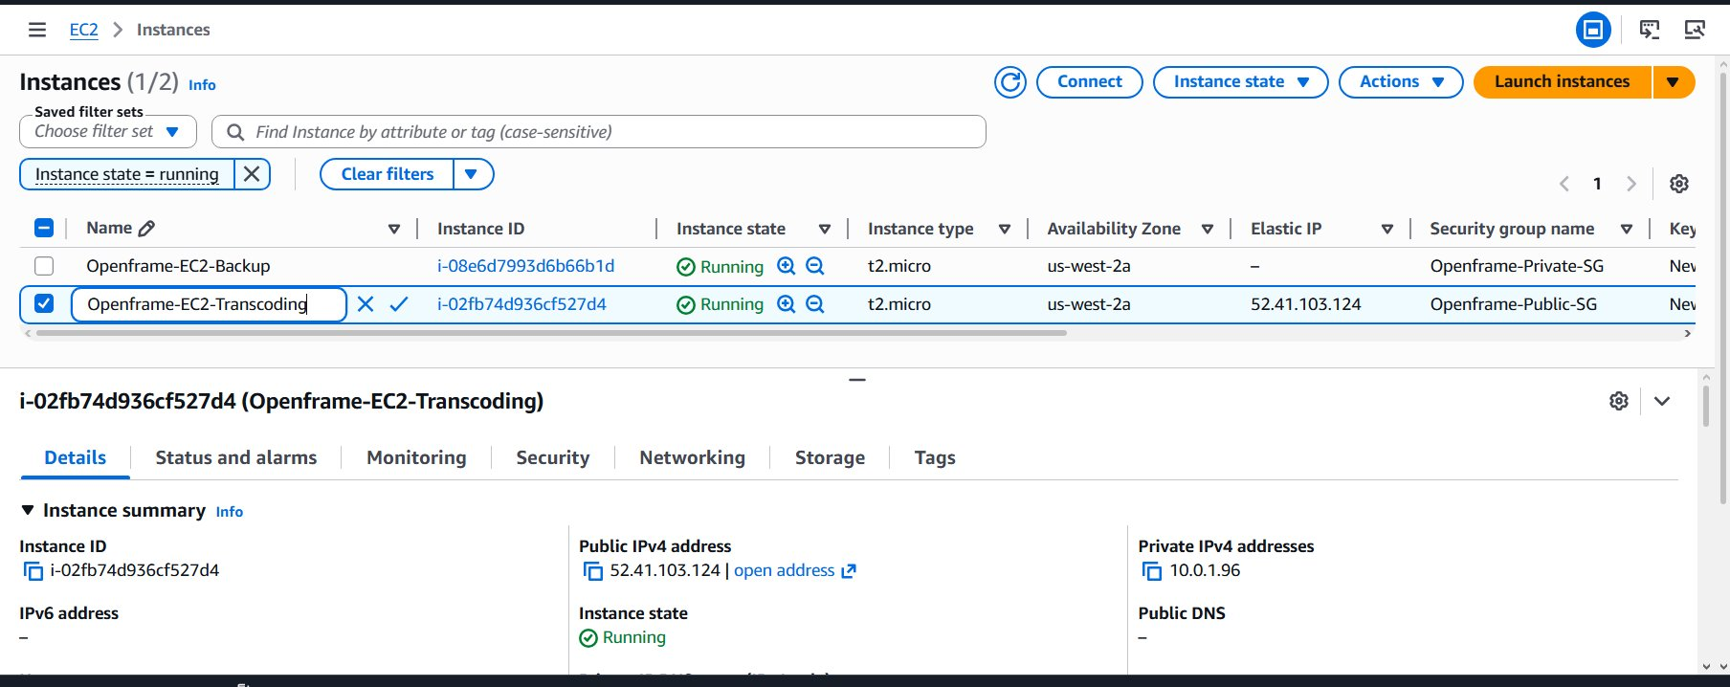
Figure 5.1 — Openframe-EC2-Transcoding instance details showing Elastic IP 52.41.103.124 (static public) and private IP 10.0.1.96
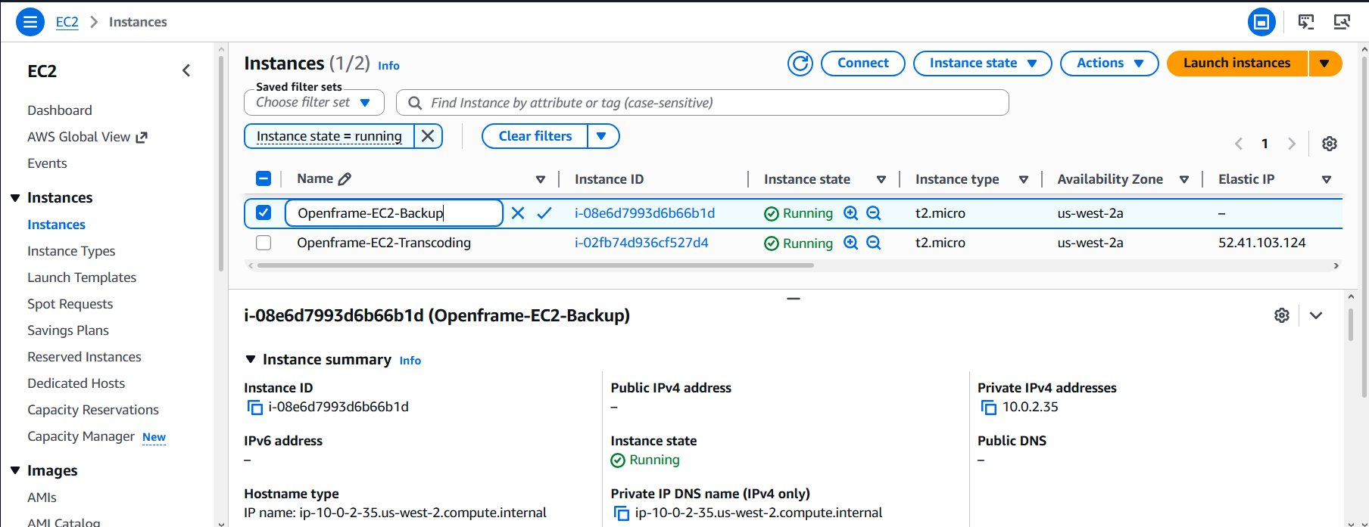
Figure 5.2 — Openframe-EC2-Backup instance details showing platform-assigned private IP 10.0.2.35 only, with no public IP assigned

Testing Method
The EC2 console is checked for both EC2 instances to confirm that the transcoding instance has an EIP, while the backup instance has only a platform-assigned private IP and no public IP. The success criteria is for the transcoding instance to have a static EIP and the backup instance to only have a private IP in the 10.0.2.0/24 range and no public IP.

Process List
1. Log into the AWS Management Console and navigate to EC2 in us-west-2.
2. Click Instances and filter by running state to show both EC2 instances.
3. Click on Openframe-EC2-Transcoding and view the Details tab.
4. Confirm the Public IPv4 address field shows the Elastic IP and the Private IPv4 address shows 10.0.1.96.
5. Navigate to Elastic IPs in the left sidebar and confirm the Elastic IP is associated with the transcoding instance.
6. Return to Instances and click on Openframe-EC2-Backup.
7. Confirm the Public IPv4 address field shows a dash (no public IP) and the Private IPv4 address shows 10.0.2.35.

Test Case #6: Cloud Networks — Device Discovery and Reachability

Functionality
The two EC2 instances in the Openframe Studios VPC are located in separate subnets with different security profiles, but still need to communicate with each other — for example, the transcoding instance needs to copy its output assets to the backup instance. The security group assigned to the backup instance, Openframe-Private-SG, accepts incoming ICMP connections from the VPC CIDR (10.0.0.0/16) as well as any incoming connections from the on-premises network (192.168.0.0/16) (Amazon Web Services, n.d.-c). This permits the transcoding instance in the public subnet to connect to the backup instance in the private subnet. Subnet-to-subnet communication within the VPC is handled by local routing in the VPC route tables and does not require any additional gateways to be configured.

Network Diagram or Segment
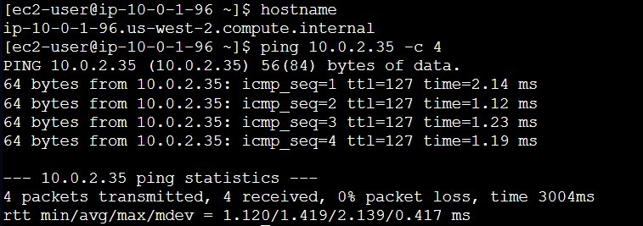
Figure 6.1 — From the Openframe-EC2-Transcoding instance (10.0.1.96), successful ping to Openframe-EC2-Backup (10.0.2.35) confirms inter-subnet connectivity within the VPC

Testing Method
EC2 Instance Connect is used to connect to the EC2 transcoding instance and ping the backup instance's private IP address using the ping command. Four ping replies with 0% packet loss indicates success: the instances can communicate with each other across different subnets within the same VPC.

Process List
1. Log into the AWS Management Console and navigate to EC2.
2. Select the Openframe-EC2-Transcoding instance and click Connect.
3. Choose EC2 Instance Connect and click Connect to open a browser-based terminal.
4. Note: Before proceeding, verify that the Openframe-Private-SG inbound rules include an All ICMP - IPv4 rule sourced from 10.0.0.0/16 to permit ping traffic from the public subnet. This rule was added to enable the inter-subnet connectivity test.
5. Run the command: hostname — confirm the output shows ip-10-0-1-96.us-west-2.compute.internal.
6. Run the command: ping 10.0.2.35 -c 4
7. Confirm 4 packets transmitted, 4 received, 0% packet loss.

Test Case #7: VPN — Bridging Networks

Custom Test Case
Openframe Studios uses this secure, encrypted tunnel to transfer files between its production environment and the cloud, as well as to provide secure remote access to the cloud and facilitate cloud-based rendering. The Post-Production team uses the VPN to connect to the cloud from the production network (VLAN 20), and the VPN enables Openframe Studios' cloud-based services to connect to on-premises servers for backup and synchronization. The VPN ensures that all data in transit is protected from eavesdropping.

Functionality
A site-to-site IPSec VPN tunnel was established between FW-01 (VyOS) and the AWS Virtual Private Gateway (Openframe-VGW) (Amazon Web Services, n.d.-b). The IKEv1 key management protocol, the AES-128-CBC encryption algorithm, the HMAC-SHA1 authentication algorithm, and the Diffie-Hellman Group 2 key exchange protocol were used. A tunnel interface (vti0) was configured on FW-01 for the connection with an inside address in the 169.254.0.0/16 link-local range and the outside IP address of the AWS VPN endpoint, which is assigned by AWS when a VPN connection is created. A static route on FW-01 for all 10.0.0.0/16 networks to route through the tunnel via the inside IP address of the AWS VPN connection was also configured. Route propagation was also enabled on both AWS route tables to allow the VGW to automatically propagate the on-premises network (192.168.0.0/16) to the VPC.

Note: When an AWS Site-to-Site VPN connection is created, two redundant VPN tunnels are established for high availability, one for each endpoint of the VGW. In normal operation, one tunnel is in an up state, and the other is in a standby (down) state. Should the active tunnel go down, the VPN connection automatically switches to the standby tunnel (Amazon Web Services, n.d.-b). The configuration was tested and confirmed to be functioning correctly by successfully pinging AWS resources from on-premises VPCS nodes and pinging on-premises gateway IPs from the AWS EC2 instance (VyOS, n.d.-a).

Network Diagram or Segment
Figure 7.1 — VyOS show vpn ipsec sa output showing AWS-TUNNEL-1-vti in the up state with AES_CBC_128/HMAC_SHA1_96 encryption. AWS provisions two tunnels for redundancy; the secondary tunnel shows as down, which is normal standby behavior.
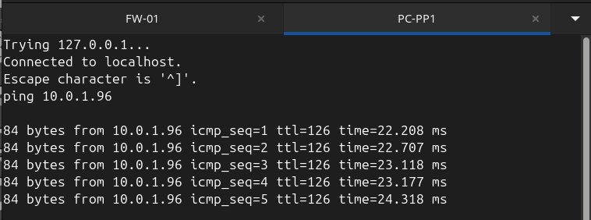
Figure 7.2 — PC-PP1 (VLAN 20, on-premises) successfully pings EC2 instance through the VPN tunnel
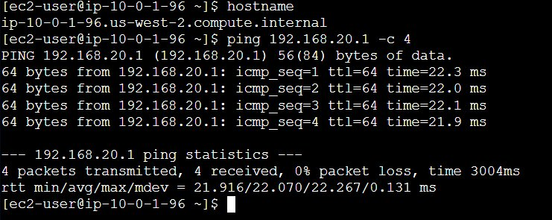
Figure 7.3 — Openframe-EC2-Transcoding successfully pings on-premises VLAN 20 gateway 192.168.20.1 through the VPN tunnel

Testing Method
The VPN tunnel is confirmed using the show vpn ipsec sa command in VyOS, which displays the security association state, the time the SA has been up, the remote address of the tunnel, and the encryption proposal. Connectivity over the VPN tunnel is tested by pinging the private IP address of the EC2 instance from PC-PP1 on the on-premises VPCS node on VLAN 20, and then by connecting to the EC2 instance using EC2 Instance Connect and pinging the gateway of VLAN 20 (192.168.20.1). The success metric is for the tunnel to show up in the SA table and to receive successful ICMP replies from both sides.

Note: The tunnel IP addresses and pre-shared key shown in the VyOS configuration are generated by AWS when the VPN connection is created. They are unique to each deployment. When replicating this test, download the VPN configuration file from the AWS Site-to-Site VPN console to obtain the correct tunnel parameters for the specific deployment.

Process List
1. Start FW-01 in GNS3 and restore the full VyOS configuration, including VPN settings.
2. From the VyOS operational mode prompt (not configure mode), run: sudo swanctl --initiate --child AWS-TUNNEL-1-vti. This command instructs the underlying StrongSwan IPSec daemon to initiate the tunnel negotiation with AWS. Note: The tunnel peer name and child SA name are defined during VPN configuration and may differ if configured differently.
3. Wait for the tunnel to establish and run: show vpn ipsec sa
4. Confirm AWS-TUNNEL-1-vti shows State: up with the correct remote address and encryption proposal. Note that two tunnel entries will appear — one up (active) and one down (standby), which is normal AWS VPN behavior.
5. Start all VPCS nodes and open the console for PC-PP1 (VLAN 20).
6. Run dhcp to obtain an IP address in the 192.168.20.0/24 subnet.
7. Run: ping 10.0.1.x (where x is the EC2 transcoding instance private IP) — confirm successful replies from the AWS EC2 transcoding instance.
8. In the AWS console, connect to Openframe-EC2-Transcoding via EC2 Instance Connect.
9. Run: ping 192.168.20.1 -c 4 — confirm successful replies from the on-premises VLAN 20 gateway.
10. Screenshot both ping results and the VPN SA status as evidence of bidirectional encrypted connectivity.

Test Case #8: Hybrid Network Security

Custom Test Case
Openframe Studios handles confidential, unreleased content and client information across its hybrid network. The security model must provide complete isolation between departments, ensure the NAS is not accessible to unauthorized users, and ensure that cloud services are accessible only to the intended parties. This test case validates the entire security model, both on-premises and in the cloud.

Functionality
The on-premises and cloud security of this network is managed with a combination of VyOS firewall rules and AWS security groups (Amazon Web Services, n.d.-c). The three critical on-premises security controls are:

1. The isolation of the Guest/Contractor network (VLAN 40) from all other internal networks, and its allowed access to the internet via the default allow rule (VyOS rules 10, 20, and 30).

2. The restriction of the Production network (VLAN 10) from accessing the Business/Admin network (VLAN 30) via rule 40, due to the sensitive nature of the business data stored on that network, in addition to the creative assets stored on the production network.

3. The protection of the NAS server (192.168.20.11) that is accessible only from the Post-Production network (VLAN 20), via rules 50, 60, and 70, which drop any attempted connections to the NAS from all other networks.

In the cloud, the fourth critical control is the application of the Openframe-Public-SG security group, which restricts SSH and ICMP connectivity to only the on-premises network (192.168.0.0/16) and allows unrestricted HTTP and HTTPS access from the internet for client asset delivery. Additionally, Openframe-Private-SG restricts access to the backup instance to only MySQL from the public subnet and all connectivity from the on-premises network via VPN, preventing any other unsolicited incoming connections from the internet.

Network Diagram or Segment
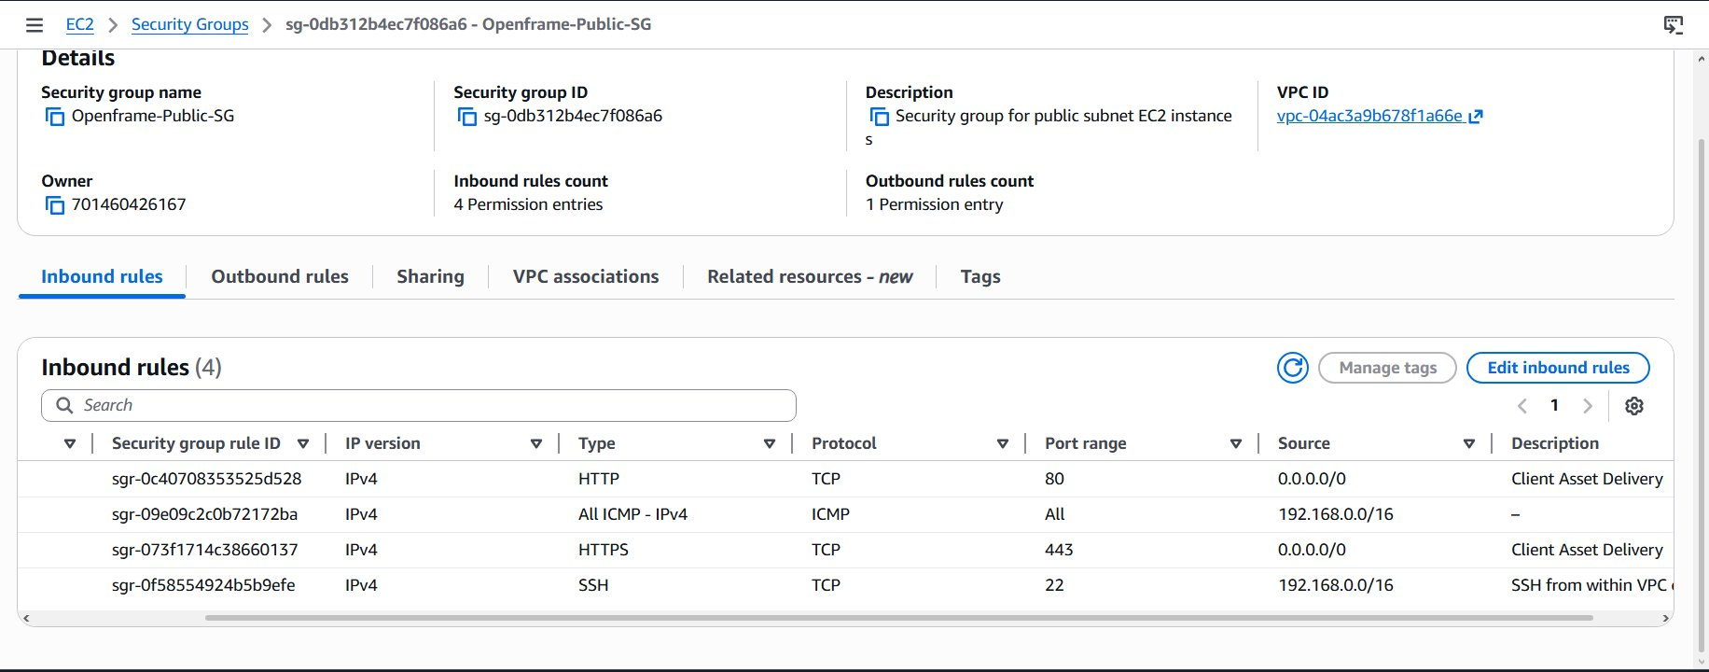
Figure 8.1 — Openframe-Public-SG inbound rules: HTTP/HTTPS open for client delivery; SSH and ICMP restricted to 192.168.0.0/16
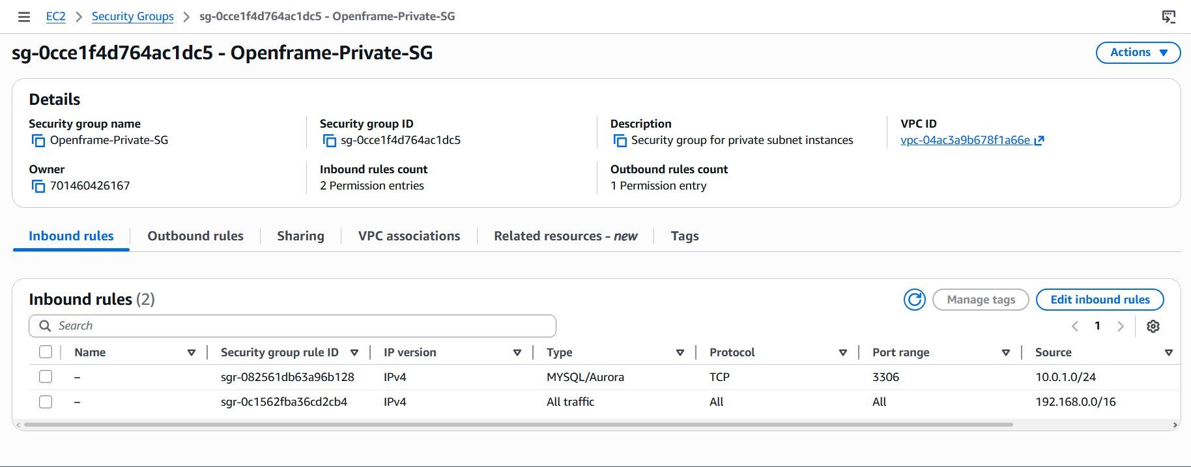
Figure 8.2 — Openframe-Private-SG inbound rules: MySQL from public subnet only; all traffic from on-premises network via VPN
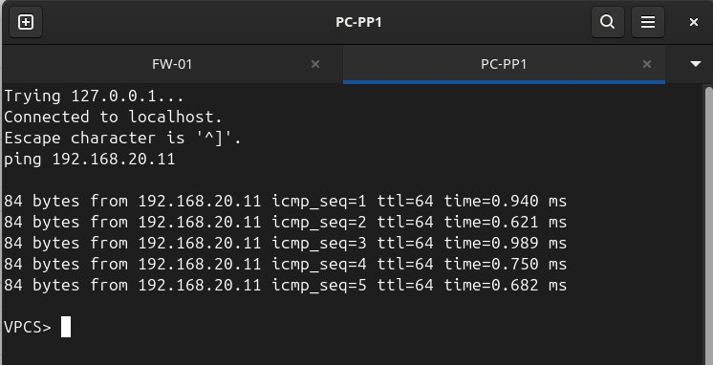
Figure 8.3 — PC-PP1 (VLAN 20) successfully pings NAS at 192.168.20.11 — access from VLAN 20 is permitted
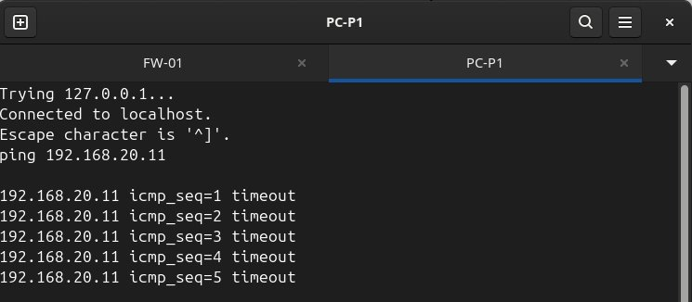
Figure 8.4 — PC-P1 (VLAN 10) cannot reach NAS at 192.168.20.11 — blocked by firewall rule 50
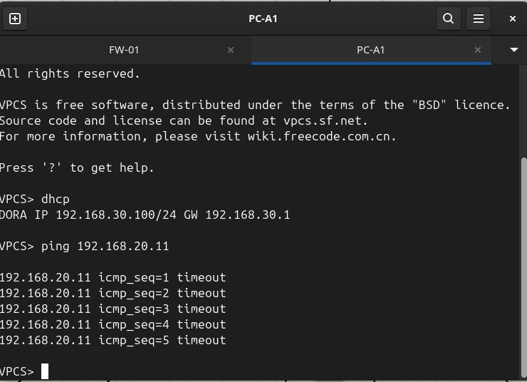
Figure 8.5 — PC-A1 (VLAN 30) cannot reach NAS at 192.168.20.11 — blocked by firewall rule 60
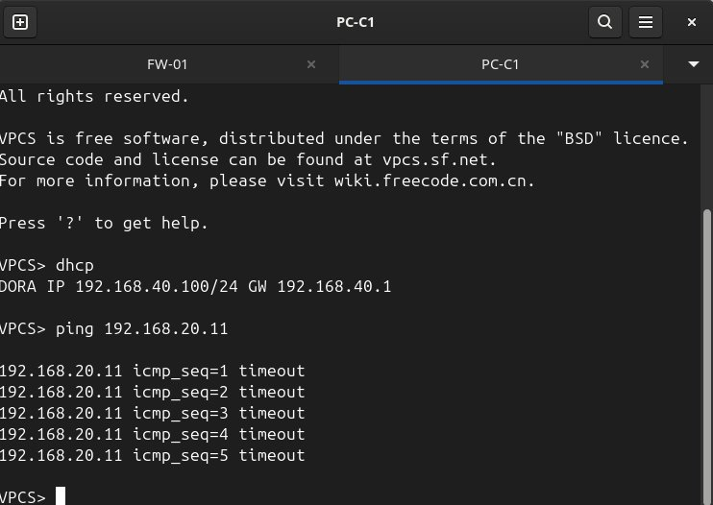
Figure 8.6 — PC-C1 (VLAN 40) cannot reach NAS at 192.168.20.11 — blocked by firewall rule 70
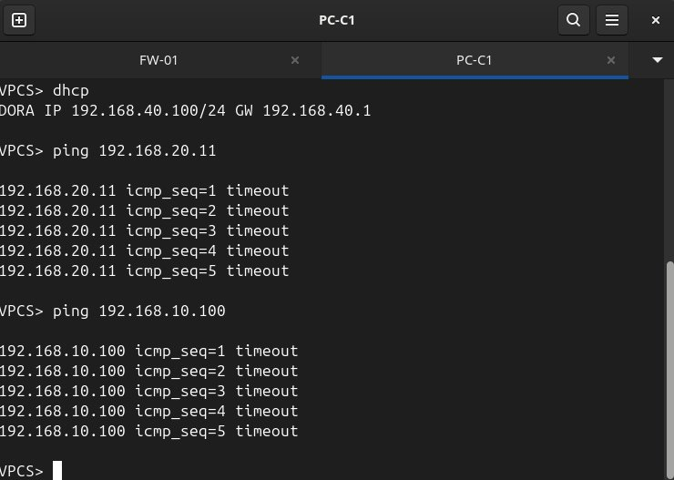
Figure 8.7 — PC-C1 (VLAN 40) cannot reach VLAN 10 hosts — VLAN 40 full isolation confirmed
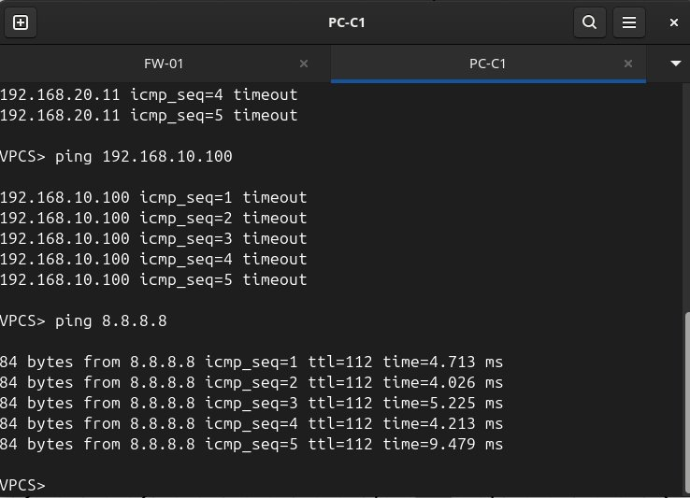
Figure 8.8 — PC-C1 (VLAN 40) successfully pings 8.8.8.8 — internet access for contractors is permitted

Testing Method
ICMP ping test results between VPCS nodes in each VLAN and the NAS IP address (192.168.20.11), as well as restricted VLAN devices, are used to validate on-premises access controls. Successful ping replies indicate allowed traffic; five consecutive ICMP timeouts indicate denied traffic. AWS security is validated by examining the inbound security group rules of each security group in the AWS console. The success criterion is that timeouts occur for all denied paths and that successful ping replies occur for all permitted paths, with the AWS security group rules matching the designed access policy.

Process List
1. Open the console for PC-PP1 (VLAN 20) and run: ping 192.168.20.11 — confirm successful replies to NAS (allowed).
2. Open the console for PC-P1 (VLAN 10) and run: ping 192.168.20.11 — confirm ICMP timeouts (blocked by rule 50).
3. Open the console for PC-A1 (VLAN 30), run dhcp to get an IP, then run: ping 192.168.20.11 — confirm ICMP timeouts (blocked by rule 60).
4. Open the console for PC-C1 (VLAN 40), run dhcp to get an IP (192.168.40.100), then run: ping 192.168.20.11 — confirm ICMP timeouts (blocked by rule 70).
5. From PC-C1, run: ping 192.168.10.100 — confirm ICMP timeouts (VLAN 40 isolation, rule 10).
6. From PC-C1, run: ping 8.8.8.8 — confirm successful internet access (default allow rule 1000).
7. In the AWS console, navigate to EC2 > Security Groups.
8. Select Openframe-Public-SG and review the Inbound rules tab — confirm HTTP/HTTPS open to 0.0.0.0/0 and SSH/ICMP restricted to 192.168.0.0/16.
9. Select Openframe-Private-SG and review the Inbound rules tab — confirm MySQL from 10.0.1.0/24 and all traffic from 192.168.0.0/16 only.
10. Screenshot all security group rules and ping test results as evidence.

Network Troubleshooting
A variety of network issues were encountered and solved during the design, testing, and implementation of the hybrid network for Openframe Studios. The majority of the troubleshooting involved ICMP ping tests, interface status checks, examination of the routing table, and inspection of system logs.

During the initial phase of the project, a Cisco IOS C7200 router was used. Internet access from the VPCS nodes was not possible, even after NAT had been configured. To troubleshoot this issue, I first tested whether the router could ping 8.8.8.8, and it could. Therefore, the issue was not related to routing but to NAT. Then, by running the show running-config command, I noticed that the ip nat inside command had been applied to the parent interface, FastEthernet0/0, but not to the sub-interfaces (FastEthernet0/0.10–0.40) on which the incoming VLANs were configured. Adding the ip nat inside command to each sub-interface solved the problem. Later in the project, when VyOS was used instead of IOS because the C7200 router image was no longer available in the lab, the same issue presented itself. In VyOS, the problem was solved by verifying that the interface referenced by the NAT masquerade rule (eth1) was correct, and that the source network (192.168.0.0/16) included all VLANs. Having this issue present itself in two different contexts — on two different router platforms — gave me a deeper understanding of how NAT inside/outside designation interacts with sub-interfaces on a router.

Another issue in this project was the WGU lab's stateless nature. At the end of each lab session, the WGU lab VM reboots, and all GNS3 device configurations, SSH keys, and Git credentials are lost. To mitigate this issue, I developed a routine to run at the start of each lab session. First, I generated a new SSH key and then added it to my GitHub account. Then I pulled down the latest version of the project files. Finally, I pasted prepared blocks of configuration into the FW-01 VyOS router, in the order listed below:
• Interfaces
• NAT
• Static routes
• DHCP pools
• Firewall rules
• VPN

The FW-01 configuration was stored in a GitHub repository so that it could be pulled down and reconfigured at the beginning of each lab session.

The most complicated issue to troubleshoot was establishing the VPN tunnel. The initial attempt to bring up the IPSec tunnel failed because the pre-shared key was configured with the public IP address of the lab VM as the identity. However, VyOS was attempting to connect using its configured GNS3 NAT address (192.168.122.7). Upon inspecting the StrongSwan logs, I found the following message: no shared key found for 192.168.122.7. After reconfiguring the PSK's identity to the local address (192.168.122.7), the Phase 1 negotiation completed. Later in the project, an additional complication arose. After the lab was rebooted at the end of a session, the lab VM's public IP address changed, and new IPSec tunnel parameters were generated. To resolve these issues, I created a new Customer Gateway in AWS with the new public IP address and updated the VyOS IPSec configuration with the new pre-shared key and tunnel endpoint IP addresses for each session.

Finally, a nuance in the verification of the firewall rules also came to light. Initially, when attempting to verify the rules using ICMP pings, I was targeting the gateway interface IP addresses (e.g., 192.168.10.1) rather than the IP addresses of actual VPCS nodes. In doing so, I was not actually testing the forward filter rules, because traffic destined for the router itself does not pass through the forward chain. Once I understood the difference, I adjusted my ping tests to target the IP addresses of the VPCS nodes themselves (e.g., 192.168.10.100), which verified that the forward filter rules were successfully rejecting the intended traffic flows (VyOS, n.d.-c).

References
Amazon Web Services. (n.d.-a). What is Amazon VPC? AWS Documentation. https://docs.aws.amazon.com/vpc/latest/userguide/what-is-amazon-vpc.html

Amazon Web Services. (n.d.-b). AWS Site-to-Site VPN. AWS Documentation. https://docs.aws.amazon.com/vpn/latest/s2svpn/VPC_VPN.html

Amazon Web Services. (n.d.-c). Security groups for your VPC. AWS Documentation. https://docs.aws.amazon.com/vpc/latest/userguide/VPC_SecurityGroups.html

GNS3. (n.d.). GNS3 documentation. GNS3. https://docs.gns3.com/

IEEE. (2022). IEEE 802.1Q — Bridges and Bridged Networks. Institute of Electrical and Electronics Engineers. https://standards.ieee.org/ieee/802.1Q/10323/

VyOS. (n.d.-a). VyOS documentation: IPsec site-to-site VPN. VyOS Project. https://docs.vyos.io/en/latest/configuration/vpn/ipsec.html

VyOS. (n.d.-b). VyOS documentation: DHCP server. VyOS Project. https://docs.vyos.io/en/latest/configuration/service/dhcp-server.html

VyOS. (n.d.-c). VyOS documentation: Firewall. VyOS Project. https://docs.vyos.io/en/latest/configuration/firewall/index.html

