**Geshiyaro Mass Drug Administration Treatment Summary 2019**

April 2019

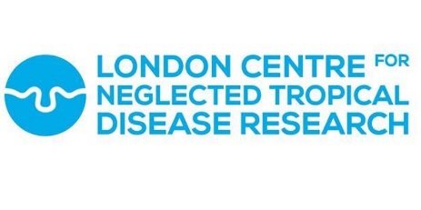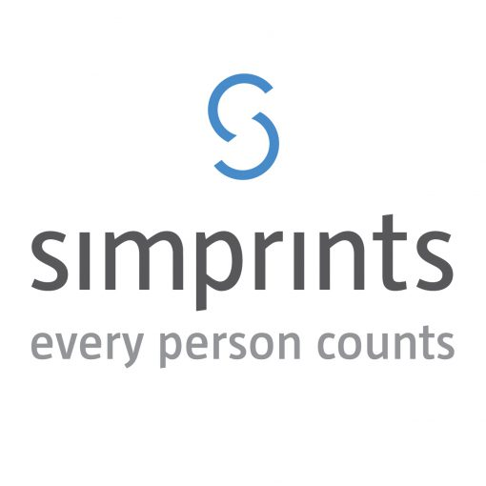

Simprints

The Bradfield Centre

Cambridge Science Park

Cambridge

Imperial College London

St Mary’s Campus

Norfolk Place

London

Ethiopian Public Health Institute

Gulelle Arbegnoch Street

Gulelle Sub City

Addis Ababa

© 2019 Imperial College London

Contents

1 Executive Summary 4

2 Background 4

3 Treatment data collection methods 4

3.1 Individual Treatment Records - Field Methods 4

3.2 Ethical considerations 5

4 Data cleaning 5

4.1 Data cleaning summary – Individual treatment records 5

5 Population denominators 6

6 Results – Individual treatment records 6

6.1 Coverage estimates and drug acceptance 6

6.1.1 Age stratified coverage 7

6.1.2 Kebele coverage and acceptance estimates 9

6.1.3 Reasons for treatment refusal 13

6.2 Method of identification/registration 13

6.2.1 Summary of identifications at MDA 13

6.2.2 Biometric identification at MDA 14

6.2.3 Biometric mop-up registrations at MDA 14

6.3 Operations – form time duration 15

7 Discussion 15

7.1 Treatment results 15

7.2 Treatment of preschool-age children (preSAC) 16

7.3 Method of treatment record identification/registration 16

7.3.1 ‘New registrations’ at MDA 16

7.3.2 ‘Registration refusals’ at MDA 16

7.4 Presenting for treatment vs. drug acceptance 16

7.5 Benefits and challenges of biometrics 17

7.5.1 Biometric uptake 17

7.5.2 Biometric acceptance 18

7.5.3 Biometric accuracy 20

7.5.4 Added value of biometrics 20

8 Appendix I: Associated documentation 21

8.1 Cleaning workflow 21

8.2 Breakdown of data capture by identification/registration workflow 22

8.3 Appendix I – ALB treatment by age and kebele 23

8.4 Appendix II – PZQ treatment by age and kebele 24

8.5 Appendix III – Method of data documentation (identification/registration) 25

**Use of Sponsor Names:**

This project is sponsored by The Children’s Investment Fund Foundation (CIFF) and is implemented in partnership with World Vision Ethiopia and the Federal Ministry of Health.

**Version Control**

|  |  |  |  |
| --- | --- | --- | --- |
| **Version** | **Date** | **Description of Version** | **Version** |
| **No** |  |  | **Valid Through** |
| 1 | April 2019 | 1st Draft of MDA report | 26th April 2019 |
| 2 | May 2019 | 2nd Draft of MDA report | 23rd May 2019 |

# Executive Summary

Preventative chemotherapy (PCT) for soil-transmitted helminth (STH) and schistosome (SCH) infections occurred between January and March 2019. Albendazole (ALB) was administered for STH infection and Praziquantel (PZQ) for SCH infection. A total of 130,806 individuals were offered treatment, captured through individual registration, with 118,949 individuals treated (accepted) with ALB and 116,178 with PZQ. Coverage of ALB in the target population, individuals aged 1 and older, is estimated to be between 74.9% and 84.4 and coverage of PZQ in the target population, individuals aged 4 and older, estimated to be between 77.2% and 87.1%.

# Background

National deworming programmes rely on mass drug administration (MDA) to control SCH and STH parasitic infections. The Geshiyaro project aims to eliminate intestinal worms in Wolayita zone through drug treatment, with a goal of 80-90% treatment coverage, in combination with improved water, sanitation, and hygiene (WaSH).

The purpose of an electronic treatment form is to record accurate drug coverage (ALB, PZQ) within the population who live in the Wolayita zone. The form uses two methods of identification (i) biometric fingerprint and (ii) Geshiyaro study ID cards to determine how many individuals have received deworming tablets at MDA. Unique identification will allow for accurate coverage estimates, when used in combination with the Geshiyaro census data, and identify certain demographic groups not receiving PCT (systematic non-compliers). In Year 1, while the overall project’s coverage goal is 80-90% treatment coverage, the initial gating target was minimum 75% treatment coverage.

Typically, national control programmes report PCT coverage data based on reported coverage rates, which are calculated by aggregating drug distributors’ (typically Health Extension Workers or HEW in Ethiopia) records and dividing by the estimated population (typically an extrapolated denominator taken from a dated national census) requiring PCT. This method is prone to errors due to inaccurate population estimates. Treatment Coverage Validation (TCV) surveys are recommended by the World Health Organization (WHO) and are widely used by national programmes to verify reported MDA coverage, however, they rely on participants memory recall and honesty.

# Treatment data collection methods

## Individual Treatment Records - Field Methods

Round 1 of MDA training occurred January 9-13th 2018 (2 days training of trainers, 3 days step-down training to HEWs and HWs) for 96 HEW/HWs and supervisors from the health bureau. Training including discussing good practice for drug administration, as well as the rationale behind individual drug compliance data capture and associated methods. Sessions included theory as well as practicals outlining the identification and registration of individuals workflows (Figure 1) through SurveyCTO and Simprints on the phones.

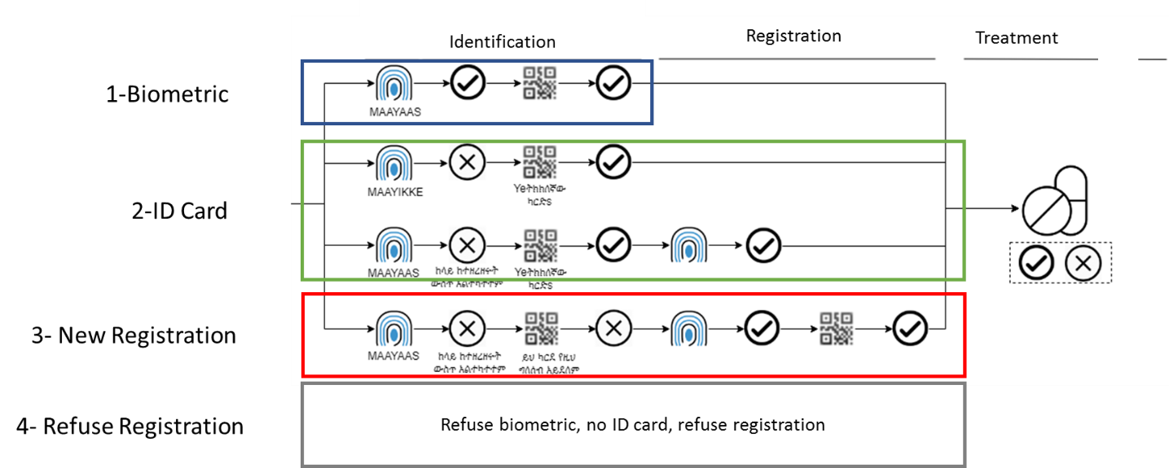

1 Identification and registration pathways at treatment

HEWs were responsible for their standard catchment population, with HWs assigned to a particular kebele within their health centre (HC) cluster.

A refresher training course occurred again prior to Round 2 February MDA, where supervisors were re-trained on all workflows (February 13th 2019) before a full practical refresher workshop for all HEW/HWs (February 14-15th 2019).

## Ethical considerations

Ethical approval for data collection at MDA was obtained as part of the Evaluation protocol for the Geshiyaro programme. Verbal consent was obtained for individual treatment registration and biometric identification/registration separately.

# Data cleaning

## Data cleaning summary – Individual treatment records

All treatment records uploaded onto SurveyCTOfrom January 21st, 2019 onwards were considered (n = 142,213). Form submissions were deduplicated according to the subject ID, woreda code, kebele code, and individual barcode on the study ID card. 103,720 submissions contained unique codes, while 24,777 submissions were duplicates. A further 13,716 submissions were ‘registration refusal’ submissions therefore do not contain identifiers.

For submissions from duplicated subject ID codes, name and demographic details were cross-referenced to create two categories of duplicated entries:

1. Entries with the same subject details (i.e. name, age, and sex) - true duplicates (n = 14,815)
2. Entries with different subject details – likely different subjects with same barcode (n – 9,962)

For the full cleaning workflow see Appendix I ‘8.1 - Cleaning Workflow’.

Further cleaning is currently underway prior to the next round of MDA. New registrations at MDA are being linked to records from the census where names are cross-referenced between the two datasets (i) census and (ii) new registrations at MDA, by age and sex. This exercise hopes to link treatment data to census data.

# Population denominators

The denominator used is composed of three components:

1. Population registered at census (ID card and/or biometric): 132,364 individuals
2. People declining registration at the census - population estimate: 11,145 individuals
3. Population from ‘potentially missing’ households – population estimate: 18,410 individuals

Component 2 is calculated from the number of declining households in the kebele multiplied by the average number of people per household, as defined in the Geshiyaro census. Component 3 is the difference between the number of households censused in Geshiyaro (consenting and declining) and the Health Bureau household estimates for each kebele, multiplied by the Geshiyaro census number of people per household. We cannot be confident that these households do or do not exist, or that redistricting has not led to errors in kebele level household counts (e.g. Hembecho Health Centre catchment).

See table 1 below for a breakdown of the population into registration, decline, and potentially missing components.

Table 1 Individual data capture at census

|  |  |  |  |  |
| --- | --- | --- | --- | --- |
| **Registered Population** | | **Household Decline Population (no registration)** | **Potentially ‘missing’ population** | **Total** |
| **Biometric and Study ID card** | **Study ID card** |
| 74,708 | 57,656 | 11,145 | 18,410 | 161,919 |

For the purposes of this report we define two population estimates, the first the most conservative estimate (n = 161,919) and the second based on households contacted during the Geshiyaro census (n = 143,509). The reality is likely to lie between the two estimates.

For the purposes of this report, we will present two coverage estimates, those with all three components listed above and with only component 1 and 2. Following the census-MDA registration harmonisation the Geshiyaro denominator will be updated to a single figure to include all new and deduplicated MDA registrations. We anticipate that the post-MDA denominator will be between the 143,509 and 161,919.

# Results – Individual treatment records

A total of 130,806 individuals were offered treatment at MDA, captured through unique, individual treatment records. 118,949 individuals were treated (accepted) ALB and 116,178 were treated with PZQ.

## Coverage estimates and drug acceptance

Two coverage estimates are presented: a more conservative ‘Coverage Estimate 1’ using the highest possible population denominator (N=161,919) and ‘Coverage Estimate 2’ (N=143,509).

Table 2 Coverage estimates and drug acceptance rates

|  |  |  |  |  |  |  |
| --- | --- | --- | --- | --- | --- | --- |
|  | **Coverage Estimate 1** | | **Coverage Estimate 2** | | **Acceptance** | |
|  | ALB | PZQ | ALB | PZQ | ALB | PZQ |
| Whole Population1 | 73.5%  (118949/161919) | 71.7%  (116178/161919) | 82.9% (118949/143509) | 80.9% (116178/143509) | 90.9%  (118949/130806) | 88.8%  (116178/130806) |
| Eligible Population2 | 74.9%  (118649/158484) | 77.2%  (114350/148022) | 84.4%  (118649/140490) | 87.1%  (114350/131197) | 91.3%  (118649/129916) | 91.5%  (114350/125024) |

1 Whole population meaning submissions from all ages irrespective of treatment guidelines  
2 Eligible population for treatment with ALB aged 1+ years and 4+ years for PZQ

### Age stratified coverage

The data presented below is **only for form submissions with age data**. See ‘Appendix I – ALB treatment by age and kebele’ and ‘Appendix II – PZQ treatment by age and kebele’.

Table 3 Coverage of treatment by age group

|  |  |  |  |  |
| --- | --- | --- | --- | --- |
|  | **Coverage Estimate 1** | | **Coverage Estimate 2** | |
| Age (years) | Coverage ALB | Coverage PZQ | Coverage ALB | Coverage PZQ |
| 0-1 | 12% | 7% | 14% | 8% |
| 2-4 | 33% | 21% | 37% | 24% |
| 5-14 | 70% | 69% | 79% | 78% |
| 15-20 | 68% | 68% | 76% | 76% |
| 21-35 | 83% | 82% | 93% | 93% |
| 36+ | 75% | 74% | 84% | 84% |

When aggregated by age and sex, similar coverage is observed between sexes under the age of 20 (Figure 2). However, working (20 to 39 years) male coverage estimates are markedly higher than female estimates. This is likely due to underrepresentation of working-age men in the Geshiyaro census.

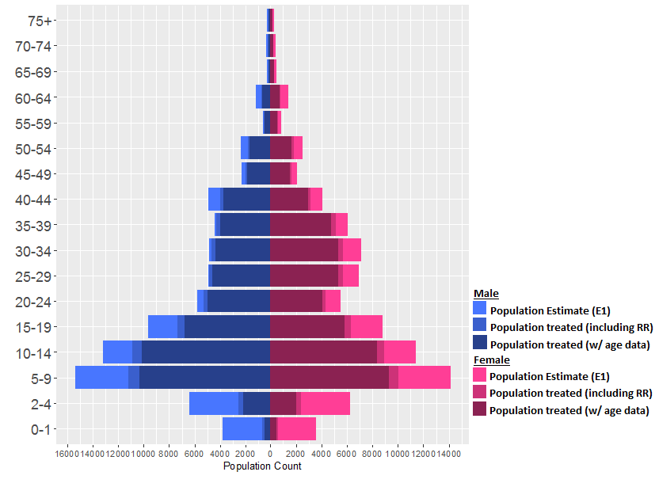

2 Population age pyramid outlining the (i) total population in Bolosso Sore (denominator estimate 1), (ii) the total estimated* population treated with ALB, including registration refusals (RR), and (iii) the total population treated with ALB with age data

Note: The age pyramid (Figure 2) presents two figures for population treated, due to the fact we cannot be sure of the age of a subject in a ‘registration refusal’ (RR) form as no age data is collected.

1. Full estimate of the population treated in the age band – this includes all records received through identification and registration, in addition to the number of treatment records from RR estimates to fall within the age band
2. Total population treated in the age band, from treatment records obtained through identifications or registrations (i.e. with age data)

*The estimate of RR forms within an age band is defined as:

$$\frac{population in age band i \left(Geshiyaro census\right)}{total population \left(Geshiyaro census\right)}×RR treatment records×treatment acceptance rate in RR population$$

### Kebele coverage and acceptance estimates

Treatment coverage and drug acceptance rates (treatment eligible population) have been included at the kebele level in the table below using denominator Estimate 1. **Please note that Gurumo Koysha and Gurumo Koysha Mazegaja are presented together in the table below as ‘GK/GKM’. Further, 34 treatment forms were documented for participants from outside of Bolosso Sore, which are included in the total treatment offered count of 130,806 but not included in the tables below.**

Table 4A ALB treatment coverage and drug acceptance by kebele

|  |  |  |  |  |  |  |  |
| --- | --- | --- | --- | --- | --- | --- | --- |
| Kebele | Total Population | Treatment Eligible Population | N with Form (offered treatment) | % with form (offered treatment) | N treated (Treatment Eligible) | Coverage | Acceptance |
| Achura Mazegaja | 4672 | 4592 | 3507 | 76% | 3097 | 67% | 88% |
| Adama Mino | 7612 | 7395 | 6412 | 87% | 5514 | 75% | 86% |
| Admancho Arfita | 7019 | 6936 | 7271 | 105% | 6950 | 100% | 96% |
| Afama Adila | 3792 | 3712 | 3308 | 89% | 2916 | 79% | 88% |
| Afama Bancha | 7279 | 7105 | 6033 | 85% | 5336 | 75% | 88% |
| Afama Garo | 5375 | 5218 | 4989 | 96% | 4468 | 86% | 90% |
| Basa Gofara | 6423 | 6336 | 5339 | 84% | 5282 | 83% | 99% |
| Chambo Hembecho | 4626 | 4537 | 4668 | 103% | 4472 | 99% | 96% |
| Dache Gofara | 5327 | 5269 | 4652 | 88% | 4600 | 87% | 99% |
| Dangara Madalcho | 5281 | 5155 | 3141 | 61% | 3000 | 58% | 96% |
| Dangara Salata | 5114 | 4983 | 3170 | 64% | 2897 | 58% | 91% |
| Doge Woybo | 2841 | 2760 | 2317 | 84% | 2049 | 74% | 88% |
| Dola | 4905 | 4804 | 5191 | 108% | 4830 | 101% | 93% |
| Dubbo | 2407 | 2345 | 1812 | 77% | 1480 | 63% | 82% |
| Gara Goda | 7199 | 7121 | 4871 | 68% | 4832 | 68% | 99% |
| Genet Achura | 3379 | 3302 | 2966 | 90% | 2683 | 81% | 91% |
| Giddo Homba | 5566 | 5458 | 3911 | 72% | 3197 | 59% | 82% |
| GK/GKM | 6631 | 6498 | 7744 | 119% | 6555 | 101% | 85% |
|  | Total Population | Treatment Eligible Population | N with Form (offered treatment) | % with form (offered treatment) | N treated (Treatment Eligible) | Coverage | Acceptance |
| Hajo Salata | 3865 | 3781 | 3238 | 86% | 2244 | 59% | 69% |
| Hembecho Mazegja | 6567 | 6431 | 4795 | 75% | 4766 | 74% | 99% |
| Korke Doge | 6829 | 6654 | 4551 | 68% | 4044 | 61% | 89% |
| Legama | 5114 | 4976 | 3558 | 72% | 3297 | 66% | 93% |
| Matala Hembecho | 4810 | 4687 | 3119 | 67% | 3100 | 66% | 99% |
| Shuye Homba | 5950 | 5864 | 3500 | 60% | 3404 | 58% | 97% |
| Sore Homba | 5674 | 5519 | 4374 | 79% | 4056 | 73% | 93% |
| Tadisa | 4022 | 3920 | 2983 | 76% | 2859 | 73% | 96% |
| Takiso Goddo | 4017 | 3897 | 4485 | 115% | 3534 | 91% | 79% |
| Tiyo Hembecho | 5188 | 5077 | 4288 | 84% | 3888 | 77% | 91% |
| Wormmuma | 5195 | 5096 | 3814 | 75% | 3704 | 73% | 97% |
| Woybo Woga | 3610 | 3542 | 2251 | 64% | 2193 | 62% | 97% |
| Yukara (Ukara) | 5630 | 5514 | 3624 | 66% | 3371 | 61% | 93% |
|  | **161919** | 158484 | 129882 |  | 118618 |  |  |

Table 4B PZQ treatment coverage and drug acceptance by kebele

|  |  |  |  |  |  |  |  |
| --- | --- | --- | --- | --- | --- | --- | --- |
| Kebele | Total Population | Treatment Eligible Population | N with Form (offered treatment) | % with form (offered treatment) | N treated (Treatment Eligible) | Coverage | Acceptance |
| Achura Mazegaja | 4672 | 4257 | 3434 | 81% | 3029 | 71% | 88% |
| Adama Mino | 7612 | 6940 | 6097 | 88% | 5209 | 75% | 85% |
| Admancho Arfita | 7019 | 6513 | 6985 | 107% | 6816 | 105% | 98% |
| Afama Adila | 3792 | 3449 | 3137 | 91% | 2864 | 83% | 91% |
| Afama Bancha | 7279 | 6676 | 5640 | 84% | 5154 | 77% | 91% |
| Afama Garo | 5375 | 4899 | 4739 | 97% | 4303 | 88% | 91% |
| Basa Gofara | 6423 | 5937 | 5213 | 88% | 5149 | 87% | 99% |
| Chambo Hembecho | 4626 | 4220 | 4430 | 105% | 4108 | 97% | 93% |
| Dache Gofara | 5327 | 4926 | 4530 | 92% | 4496 | 91% | 99% |
| Dangara Madalcho | 5281 | 4814 | 2985 | 62% | 2816 | 58% | 94% |
| Dangara Salata | 5114 | 4661 | 3071 | 66% | 2775 | 60% | 90% |
| Doge Woybo | 2841 | 2608 | 2209 | 85% | 1888 | 72% | 86% |
| Dola | 4905 | 4416 | 4966 | 112% | 4578 | 104% | 92% |
| Dubbo | 2407 | 2192 | 1700 | 78% | 1414 | 65% | 83% |
| Gara Goda | 7199 | 6655 | 4752 | 71% | 4714 | 71% | 99% |
| Genet Achura | 3379 | 3077 | 2848 | 93% | 2570 | 84% | 90% |
| Giddo Homba | 5566 | 5094 | 3785 | 74% | 3135 | 62% | 83% |
| GK/GKM | 6631 | 5989 | 7554 | 126% | 6401 | 107% | 85% |
| Hajo Salata | 3865 | 3537 | 3090 | 87% | 2163 | 61% | 70% |
| Hembecho Mazegja | 6567 | 6015 | 4719 | 78% | 4495 | 75% | 95% |
| Korke Doge | 6829 | 6241 | 4339 | 70% | 3977 | 64% | 92% |
| Legama | 5114 | 4674 | 3460 | 74% | 3190 | 68% | 92% |
| Matala Hembecho | 4810 | 4362 | 3045 | 70% | 3023 | 69% | 99% |
|  | Total Population | Treatment Eligible Population | N with Form (offered treatment) | % with form (offered treatment) | N treated (Treatment Eligible) | Coverage | Acceptance |
| Shuye Homba | 5950 | 5423 | 3342 | 62% | 3186 | 59% | 95% |
| Sore Homba | 5674 | 5163 | 4204 | 81% | 3929 | 76% | 94% |
| Tadisa | 4022 | 3685 | 2897 | 79% | 2799 | 76% | 97% |
| Takiso Goddo | 4017 | 3660 | 4314 | 118% | 3472 | 95% | 81% |
| Tiyo Hembecho | 5188 | 4765 | 4162 | 87% | 3795 | 80% | 91% |
| Wormmuma | 5195 | 4753 | 3728 | 78% | 3600 | 76% | 97% |
| Woybo Woga | 3610 | 3317 | 2192 | 66% | 2067 | 62% | 94% |
| Yukara (Ukara) | 5630 | 5104 | 3423 | 67% | 3204 | 63% | 94% |
|  | **161919** | 148022 | 124990 |  | 114319 |  |  |

### Reasons for treatment refusal

As expected, the refusal count for PZQ was greater than for ALB given the minor side effects expected. HEWs were instructed to complete a treatment form for every participant, even if they were underage, and this is reflected in the large number of refusals captured as ‘underage’. Almost 20% of ALB refusals and 30% of PZQ refusals were due to participants not trusting the treatment or believing that they did not need the treatment.

Table 5 Reasons for treatment refusal for ALB and PZQ

|  |  |  |  |  |  |  |  |
| --- | --- | --- | --- | --- | --- | --- | --- |
|  | N refusal | Sick | Pregnant | Underage | Do not think they need the treatment | Do not trust the treatment | Other |
| ALB | 11,857 | 516 (4.4%) | 1463 (12.3%) | 4974 (42.0%) | 2031 (17.1%) | 2299 (19.4%) | 574 (4.8%) |
| PZQ | 14,628 | 533 (3.7%) | 1555 (10.6%) | 7503 (51.3%) | 2051 (14.0%) | 2417 (16.5%) | 569 (3.9%) |

## Method of identification/registration

Table 6 Method of identification/registration at treatment

|  |  |  |  |  |
| --- | --- | --- | --- | --- |
|  | Biometric Identification | Study ID card identification | New registration (biometric and/or study ID card) | Registration refusal |
| Overall | 15,281 (12%) | 56,910 (44%) | 44,898 (34%) | 13,716 (10%) |
| January MDA | 8,919 (16%) | 31,813 (58%) | 13,428 (24%) | 672 (1%) |
| February MDA | 6,203 (8%) | 24,273 (33%) | 31,193 (42%) | 13,013 (17%) |

A full breakdown of the pathways through which treatment data was collected (identification/registration) is found in Appendix I ‘8.2 - Breakdown of data capture by identification/registration workflow’. See ‘Appendix III – Method of data documentation (identification/registration)’ for the kebele specific breakdown of data collection method.

### Summary of identifications at MDA

In total 72,191 individuals from the Geshiyaro census had treatment records. This equates to 54.5% individuals registered at census having linked treatment data.

Table 7 Method of identification of census registered individuals at MDA

|  |  |  |
| --- | --- | --- |
| Identified by biometric | Identified by study ID card* | Total individuals identified |
| 15,281 (21%) | 56,910 (79%) | 72,191 (55%) |

Of the 15,281 individuals who were successfully identified via biometric at MDA, 82% (n = 12,598) brought a study ID card to MDA of which n = 10,966 brought the correct study ID card, while the remaining participants (n = 1632) brought another ID card. *Biometric verification suggests that 7,398 (13%) individuals who were identified by study ID card may have been linked to the wrong census record.

### Biometric identification at MDA

Of the 130,805 treatment records captured in SurveyCTO, only half include a Simprints ID session. The other half of the time, biometric identification was not completed by the HEW.

There are discrepancies between the SurveyCTO database, which suggests that 67,145 (51%) individuals were offered biometric identification, and the Simprints database, which suggests that 62,856 (48%) individuals were offered biometric identification. Data may have been lost by HEWs deleting the app before records were synced. For the following analysis, we used the 62,856 records on the Simprints database.

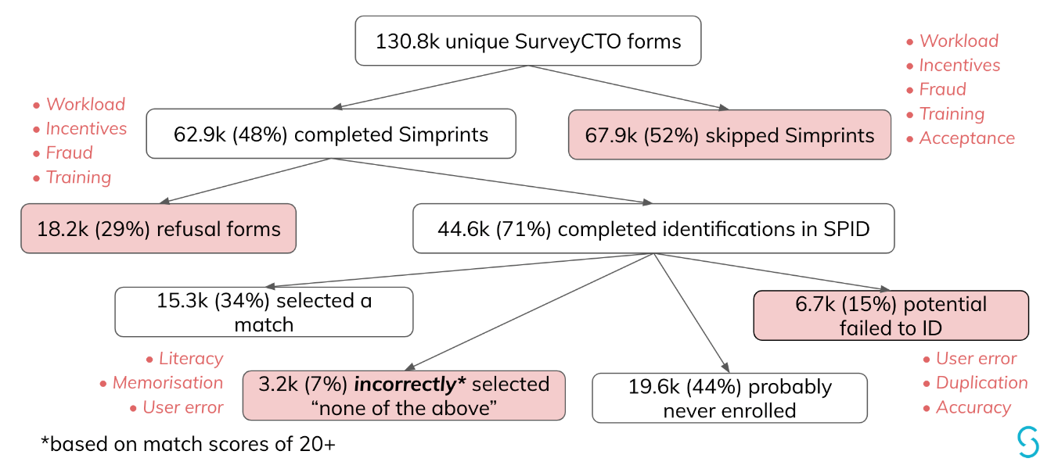

Of the 62,856 times that Simprints ID was used, a refusal form was submitted in 18,219 (29%) instances. 44,637 (71%) instances resulted in a completed identification session. Of those, 15,278 (34%) instances resulted in the HEW selecting a name from the list of potential matches.

Since only 56% of the estimated population was enrolled at census using the biometric fingerprint, it was anticipated that 44% of biometric identifications attempted at MDA would not result in a selected match.

Simprints ran an ex-post analysis to identify instances in which an HEW selected no match, but a high-probability match (match score >=20) was returned. There were 3,200 such instances, i.e. 7% of completed identifications.

The remaining 15% of unsuccessful completed identifications are potentially due to user error (e.g. poor finger placement), duplication (e.g. fingerprinting the same individual multiple times at census and/or MDA), and/or poor technical accuracy.

Some potential explanations and solutions are proposed in the discussion section below.

### Biometric mop-up registrations at MDA

Of the 33,648 individuals who were not successfully identified with biometrics at MDA, 13,061 (39%) were registered.

## Operations – form time duration

The median form duration on the first day of MDA in January (January 212019) was 138 seconds (2 minutes and 18 seconds), this declined to 56 seconds by February 1, Figure 3. A similar pattern is observed in the data from the February MDA with form duration decreasing from 152 seconds to 50 seconds. The ‘interim’ is the period during which MDA was not officially ongoing, but the phones remained in possession of the HEWs. Median form duration is used to account for extreme outliers; when HEWs did not finalise the form upon exiting.

The median form duration for a HEW/HW ranged from 39 to 221 seconds (3 minutes 41 seconds).[1]



3 Median form duration across MDA implementation, for days with at least 10 forms.

# Discussion

## Treatment results

Estimates of treatment coverage in the target population range from 74.9% (most conservative denominator) to 84.4% (population contacted at census) for ALB, and 77.2% to 87.1% for PZQ. The use of two denominators throughout this report is to account for the population who was ‘potentially missing’ at census, based on the Zonal Health Bureau’s estimate of households per kebele. Households on the perimeter of a kebele may have been missed due to geography, redistricting, or household refusals may not have been recorded.

## Treatment of preschool-age children (preSAC)

PreSAC were treated with mebendazole as part of the nutrition programme in late 2018, which resulted in a lack of focus on ensuring that preSAC were treated as part of the Geshiyaro MDA programme in January. This can be observed in the low treatment acceptance rates in children under 5 years. However, from February there was a push to ensure preSAC received ALB treatment through Geshiyaro. In future this age group will be treated through Geshiyaro.

## Method of treatment record identification/registration

Within this report coverage estimates are summarised for both rounds of MDA as a whole. As described in Section 1.2 and Table 6, however, the proportion of treatment records by identification method (biometric or study ID card) decreased in the February MDA compared to January, and there was a marked increase in the proportion of new registrations and ‘registration refusals’ recorded. This change in workflow use across time becomes particularly pronounced for a subset of users.

### ‘New registrations’ at MDA

We have 72,191 treatment forms where individuals were identified (biometric or ID card) at MDA, as registered at census. There are a further 44,898 treatment records for ‘new registrations’ – these may be true ‘new’ or these individuals may simply have lost, misplaced, or not remembered to bring their ID card to treatment. Through May/June, we will cross-reference MDA new registration records with census data to remove duplicates with similar identifiers (i.e. name, age, sex, kebele).

### ‘Registration refusals’ at MDA

A substantial number of forms (n = 13,716) are for treatment records of individuals who did not consent to registration, and therefore no age data is available. At present all records submitted under this method have been treated as if they are in the eligible population for treatment. It is important to note that treatment acceptance is much lower in the registration non-consenting group at 67.1%, compared to identified/registered individuals (93.7% acceptance). This is a necessary pathway to include in the data collection form, however it also has the highest propensity for misuse.

It is also important to note that during the re-training in February, the HEW were re-trained in how to record individuals who did not consent to registration in the census. During the same re-training there was also discussions on rewards for “high performing HEWs”. Treatment forms submitted using this pathway jumped from 1% of all January MDA form submissions, to 17% in February MDA.

This pathway contains no identifiers and as such there is no good method to check the validity of the entry or link it to treatment at subsequent MDA rounds. These individuals have not been added to the denominator, as it is likely that they are already captured in the most conservative denominator (estimate 1). Additional questions regarding reason for biometric refusal at census, as well asking at MDA if a participant has previously declined enrolment at census will be added to the census in Year 2.

## Presenting for treatment vs. drug acceptance

One interesting biproduct of individual treatment records is the ability to differentiate between low treatment uptake due to poorly utilised distribution sites and low treatment acceptance. In kebeles with low coverage of treatment there exist two groups, (i) those with low form coverage meaning that HEWs are not reaching the target population but good drug acceptance if they are reached, and (ii) those who reach a large portion of the target population but there is poor drug acceptance leading to low treatment coverage. For example, 85% of Hajo Salata’s population has a treatment form recorded in the database (i.e. presenting for treatment), however the drug acceptance is quite low at around 70%. Conversely, kebeles Shuye Homba and Woybo Woga have low form coverage in their respective populations (59 and 62%), but high drug acceptance in those that do present for treatment (>95% for ALB, >90% for PZQ).

## Benefits and challenges of biometrics

### Biometric uptake

Simprints was only used by HEWs in 48-51% of MDA treatments. The low uptake of biometrics could be related to a variety of issues, including (a) workload burden, (b) incentives, (c) potential fraud, (d) insufficient training or understanding of the workflow, and (e) low acceptability of the technology among HEWs.

With regards to (a) workload burden, HEWs were expected, on average, to treat approximately 150 people per day during the Jan MDA period and 100 people per day during the Feb MDA period. However, at an estimated 3-5 minutes per treatment (including use of both SurveyCTO and Simprints), that amounts to 5 to 12.5 hours per day of continuous, back-to-back treatments. These calculations do not account for time needed to travel between distribution points, for community mobilisation, for breaks, to attend religious service, for routine responsibilities, or for “market days”. A [2016 study by Tilahun et al.](https://academic.oup.com/heapol/article/32/3/320/2555444) found that HEWs worked, on average, six hours a day and spent only 12.8% of their time providing health education or services. Thus, HEWs may have chosen to skip Simprints in order to make the treatment targets more feasible.

|  |  |  |  |
| --- | --- | --- | --- |
| **Period** | **Target** | **3 minutes/treatment** | **5 minutes/treatment** |
| Jan | 150 treatments/day | 7.5 hours/day | 12.5 hours/day |
| Feb | 100 treatments/day | 5 hours/day | 8.3 hours/day |

HEWs have raised concerns about (b) incentives, noting that census enumerators received a higher daily per diem than they did. The issue was brought up during planning periods and cut into training time in both January and February. Insufficient incentives may have led HEWs to skip Simprints to minimise their workload.

The number of duplicate forms submitted, as well as forms being submitted at odd hours and outside of Bolosso Sore, indicates that there was (c) potential fraud during the MDA, with “fraud” referring to HEWs pretending to have conducted more treatments than they actually did. Because biometric characteristics are very difficult to fake, some HEWs may have bypassed Simprints to prevent fraudulent forms from being flagged.

Another possible factor for the low uptake of Simprints is (d) insufficient training and understanding of the workflow. The overall MDA workflow was quite complex, with 8 potential pathways for identification and mop-up registration (see diagram 9.2). In addition, some HEWs deleted Simprints ID and other applications, which may have prevented them from being able to use biometric identification.

Lastly, some HEWs have (e) expressed reservations to adopting digital technologies (both smartphones and biometrics), preferring instead to use paper registers.

Proposed mitigations to address the uptake challenges include:

* Ensuring that enough HEWs and HWs are mobilised for future MDAs and that the MDA period is sufficiently long so that daily treatment targets are feasible;
* Ensuring that all HEWs and HWs have at least one assistant throughout the MDA;
* Conducting meetings with HEWs in advance to understand their concerns and discuss appropriate incentivisation strategies;
* Making Simprints mandatory in the workflow so HEWs can’t skip it to facilitate fraudulent behaviour;
* Extending the training and ensuring all administrative issues (e.g. per diem) are resolved in advance so they do not take away from training time; and
* Placing greater emphasis on the role and benefits of using smartphone and biometric technology in Geshiyaro and, more broadly, for potential public health benefits.

### Biometric acceptance

The high rate (27.1%) of refusal forms submitted during the MDA were unexpected. Almost all anecdotal reports and observations from the field throughout the period were that biometric acceptance was high and had improved between the census activity and MDA delivery. Specifically, HEWs noted that community members were more open to being fingerprinted by them because they are known and respected members of the community. Moreover, several kebeles that had high refusal rates during the census were reportedly accepting of biometrics during the MDA. Unfortunately, the quantitative data does not align with the qualitative data.

Simprints investigated the refusal forms submitted and found that 5.8% of refusal forms were submitted after clicking “accept” on the consent form. Another 2.1% were submitted after encountering a Bluetooth error. These are both unlikely to be true beneficiary refusals. We believe HEWs may be pressing the back button and submitting a refusal form in order to move forward in the workflow. A small percentage (2.9%) of the refusal texts we received indicated that HEWs also submitted refusal forms because they did not understand that being pregnant or elderly does not preclude biometric identification.

While it is possible that there was a resurgence of biometric resistance in some communities, the spike in refusals between Jan and Feb may also be attributed to the same factors as those described in the biometric uptake section above. During the Feb MDA, there was greater pressure on HEWs to hit the treatment targets. Therefore, some HEWs may have used the refusal form as a way to skip fingerprinting and save time. 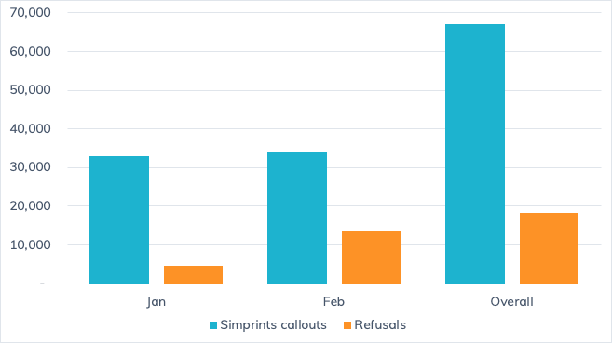Additionally, it seems that refusals are concentrated among a small fraction of users, and not widespread across the woreda. 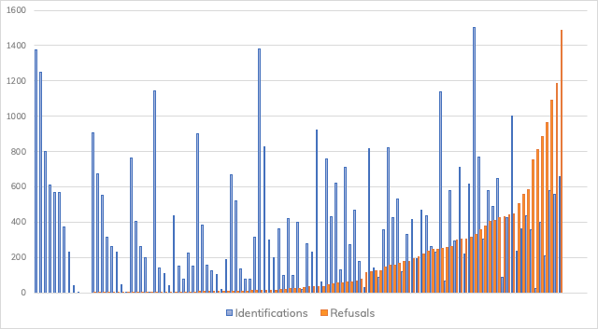Proposed mitigations to address the acceptance challenges, in addition to the ones proposed for increasing uptake, include:

* Enhancing the refusal form and Bluetooth troubleshooting sections of the training;
* Clarifying the protocol for fingerprinting people who may be pregnant, ill, elderly, etc.; and
* Re-designing the refusal form to make it easier to capture other reasons for refusal.

It is important to note that by making Simprints mandatory in the workflow, we may see an increase in refusal rates, as under-motivated HEWs will no longer be able to skip Simprints entirely and may resort to using the refusal form to bypass fingerprinting. However, we would be able to monitor HEWs who are submitting high rates of refusal forms and support the FMoH with data to target community sensitisation activities, refresher trainings, or disciplinary action as needed.

### Biometric accuracy

Across age groups, mean and median match scores are above the threshold (20) required for a good match. As expected, average match scores are lowest among young children under 5 years and adults over 50. Match scores are also a bit lower than average in the 36-49 age range, which may be related to the predominance of manual labour in rural areas.

|  |  |  |  |
| --- | --- | --- | --- |
| **Age group** | **Mean match score** | **Median match score** | **n** |
| All | 31 | 27 | 8810 |
| 2-4 | 25 | 22 | 285 |
| 5-14 | 33 | 29 | 3458 |
| 15-20 | 36 | 33 | 1017 |
| 21-35 | 30 | 27 | 2541 |
| 36-49 | 28 | 24 | 1234 |
| 50+ | 26 | 23 | 275 |

### Added value of biometrics

45% of the individuals who presented at MDA did not bring a study ID card, and 13% of those who brought a study ID card brought the *wrong* study ID card. Therefore, barcodes were an unreliable method of identification for about 60% of the population that presented at MDA.

If Simprints is used consistently and correctly in future rounds of MDAs, biometric identification will be a more reliable method of linking treatment data longitudinally. Biometrics are also important for identifying duplicates or potential fraudulent data (8% of submitted SurveyCTO forms) and will also help deter fraud once Simprints is made mandatory.

# Appendix I: Associated documentation

## Cleaning workflow

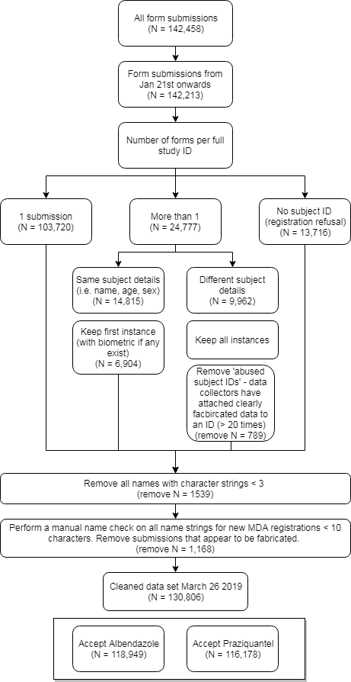

## Breakdown of data capture by identification/registration workflow

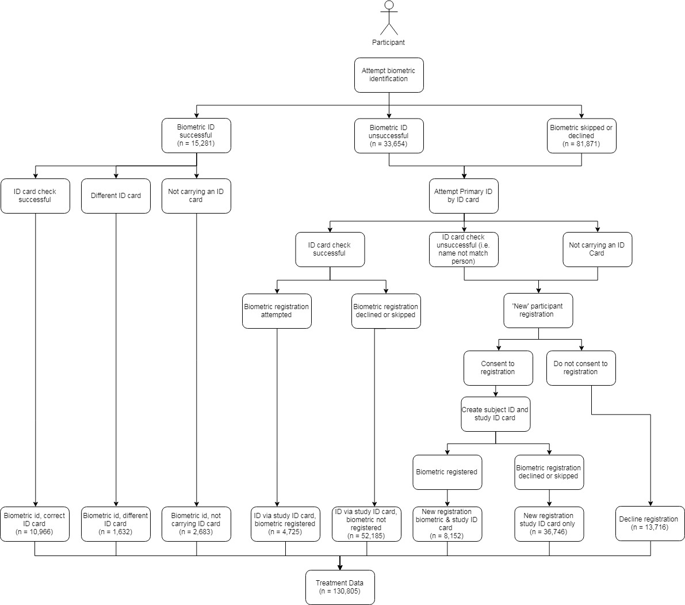

## Appendix I – ALB treatment by age and kebele

**Please note that Gurumo Koysha and Gurumo Koysha Mazegaja are presented together in the table below as ‘GK/GKM’.**

|  |  |  |  |  |  |  |  |  |  |  |  |  |  |
| --- | --- | --- | --- | --- | --- | --- | --- | --- | --- | --- | --- | --- | --- |
| **Kebele** | **0-1** | **2-4** | **5-14** | **15-20** | **21-35** | **36+** | **Registration Refusal** | **Total Treated** | | **% Population** | |  | |
| Achura Mazegaja | 13 | 96 | 845 | 476 | 552 | 378 | 738 | 3098 | | 66% | |  | |
| Adama Mino | 52 | 252 | 1923 | 630 | 1160 | 1022 | 499 | 5538 | | 73% | |  | |
| Admancho Arfita | 52 | 176 | 1628 | 1124 | 2306 | 1371 | 309 | 6966 | | 99% | |  | |
| Afama Adila | 20 | 56 | 1068 | 488 | 725 | 558 | 11 | 2926 | | 77% | |  | |
| Afama Bancha | 21 | 150 | 1889 | 861 | 1305 | 1034 | 85 | 5345 | | 73% | |  | |
| Afama Garo | 65 | 173 | 1585 | 595 | 1060 | 740 | 273 | 4491 | | 84% | |  | |
| Basa Gofara | 29 | 172 | 1537 | 1047 | 1603 | 904 | 1 | 5293 | | 82% | |  | |
| Chambo Hembecho | 61 | 283 | 1448 | 631 | 1036 | 672 | 358 | 4489 | | 97% | |  | |
| Dache Gofara | 35 | 167 | 1537 | 743 | 1298 | 827 | 1 | 4608 | | 87% | |  | |
| Dangara Madalcho | 53 | 221 | 965 | 410 | 657 | 485 | 240 | 3031 | | 57% | |  | |
| Dangara Salata | 5 | 88 | 1185 | 327 | 719 | 555 | 20 | 2899 | | 57% | |  | |
| Doge Woybo | 31 | 112 | 752 | 302 | 475 | 369 | 16 | 2057 | | 72% | |  | |
| Dola | 49 | 228 | 1149 | 550 | 1010 | 522 | 1338 | 4846 | | 99% | |  | |
| Dubbo | 17 | 73 | 511 | 254 | 393 | 237 | 4 | 1489 | | 62% | |  | |
| Gara Goda | 36 | 205 | 1490 | 881 | 1399 | 826 | 2 | 4839 | | 67% | |  | |
| Genet Achura | 10 | 113 | 790 | 393 | 622 | 336 | 422 | 2686 | | 79% | |  | |
| Giddo Homba | 21 | 97 | 897 | 419 | 852 | 577 | 340 | 3203 | | 58% | |  | |
| GK/GKM | 15 | 164 | 1547 | 728 | 2043 | 1082 | 969 | 6548 | | 99% | |  | |
| Hajo Salata | 8 | 78 | 800 | 259 | 543 | 465 | 92 | 2245 | | 58% | |  | |
| Hembecho Mazegja | 17 | 112 | 1248 | 611 | 953 | 568 | 1262 | 4771 | | 73% | |  | |
| Korke Doge | 12 | 61 | 1482 | 612 | 1030 | 829 | 19 | 4045 | | 59% | |  | |
| Legama | 32 | 125 | 1033 | 393 | 834 | 572 | 323 | 3312 | | 65% | |  | |
| Matala Hembecho | 34 | 85 | 1243 | 507 | 769 | 468 | 5 | 3111 | | 65% | |  | |
| Shuye Homba | 71 | 192 | 1254 | 491 | 651 | 531 | 227 | 3417 | | 57% | |  | |
| Sore Homba | 26 | 125 | 1367 | 500 | 1247 | 589 | 209 | 4063 | | 72% | |  | |
| Tadisa | 29 | 67 | 870 | 473 | 669 | 432 | 327 | 2867 | | 71% | |  | |
| Takiso Goddo | 14 | 63 | 1344 | 426 | 798 | 533 | 362 | 3540 | | 88% | |  | |
| Tiyo Hembecho | 19 | 95 | 1205 | 595 | 734 | 691 | 556 | 3895 | | 75% | |  | |
| Wormmuma | 11 | 84 | 1272 | 575 | 988 | 651 | 128 | 3709 | | 71% | |  | |
| Woybo Woga | 5 | 106 | 804 | 373 | 465 | 401 | 40 | 2194 | | 61% | |  | |
| Yukara (Ukara) | 13 | 130 | 1294 | 489 | 881 | 538 | 32 | 3377 | | 60% | |  | |
| Form submissions missing age data | | | | | | | | | 20 | |  | |  | |
|  |  |  |  |  |  |  |  | **118918** | |  | |  | |

## Appendix II – PZQ treatment by age and kebele

**Please note that Gurumo Koysha and Gurumo Koysha Mazegaja are presented together in the table below as ‘GK/GKM’.**

|  |  |  |  |  |  |  |  |  |  |
| --- | --- | --- | --- | --- | --- | --- | --- | --- | --- |
| **Kebele** | **0-1** | **2-4** | **5-14** | **15-20** | **21-35** | **36+** | **Registration Refusal** | **Total Treated** | **% Population** |
| Achura Mazegaja | 12 | 90 | 844 | 476 | 548 | 378 | 747 | 3095 | 66% |
| Adama Mino | 13 | 105 | 1860 | 627 | 1149 | 1018 | 498 | 5270 | 69% |
| Admancho Arfita | 48 | 160 | 1627 | 1124 | 2303 | 1370 | 310 | 6942 | 99% |
| Afama Adila | 10 | 39 | 1056 | 487 | 725 | 558 | 11 | 2886 | 76% |
| Afama Bancha | 9 | 45 | 1841 | 860 | 1301 | 1034 | 85 | 5175 | 71% |
| Afama Garo | 26 | 117 | 1576 | 593 | 1052 | 739 | 280 | 4383 | 82% |
| Basa Gofara | 28 | 154 | 1528 | 1046 | 1598 | 904 | 1 | 5259 | 82% |
| Chambo Hembecho | 25 | 140 | 1419 | 630 | 1030 | 666 | 292 | 4202 | 91% |
| Dache Gofara | 21 | 135 | 1537 | 741 | 1297 | 828 | 0 | 4559 | 86% |
| Dangara Madalcho | 41 | 125 | 965 | 409 | 656 | 485 | 236 | 2917 | 55% |
| Dangara Salata | 1 | 35 | 1132 | 326 | 719 | 555 | 20 | 2788 | 55% |
| Doge Woybo | 11 | 31 | 713 | 298 | 470 | 369 | 15 | 1907 | 67% |
| Dola | 24 | 213 | 1147 | 549 | 1000 | 520 | 1293 | 4746 | 97% |
| Dubbo | 10 | 52 | 505 | 249 | 392 | 234 | 4 | 1446 | 60% |
| Gara Goda | 36 | 183 | 1492 | 881 | 1399 | 827 | 2 | 4820 | 67% |
| Genet Achura | 8 | 86 | 783 | 393 | 619 | 336 | 404 | 2629 | 78% |
| Giddo Homba | 15 | 92 | 893 | 419 | 851 | 577 | 346 | 3193 | 57% |
| GK/GKM | 12 | 105 | 1528 | 729 | 2044 | 1084 | 967 | 6469 | 98% |
| Hajo Salata | 1 | 30 | 781 | 259 | 543 | 465 | 91 | 2170 | 56% |
| Hembecho Mazegja | 9 | 55 | 1239 | 611 | 953 | 568 | 1103 | 4538 | 69% |
| Korke Doge | 11 | 50 | 1470 | 610 | 1029 | 829 | 19 | 4018 | 59% |
| Legama | 22 | 96 | 1011 | 393 | 835 | 573 | 325 | 3255 | 64% |
| Matala Hembecho | 29 | 74 | 1240 | 505 | 770 | 467 | 5 | 3090 | 64% |
| Shuye Homba | 59 | 148 | 1215 | 491 | 646 | 530 | 223 | 3312 | 56% |
| Sore Homba | 12 | 41 | 1366 | 500 | 1246 | 588 | 208 | 3961 | 70% |
| Tadisa | 12 | 61 | 869 | 472 | 668 | 432 | 321 | 2835 | 70% |
| Takiso Goddo | 9 | 39 | 1336 | 421 | 796 | 531 | 364 | 3496 | 87% |
| Tiyo Hembecho | 18 | 74 | 1201 | 595 | 732 | 690 | 542 | 3852 | 74% |
| Wormmuma | 8 | 23 | 1258 | 575 | 984 | 647 | 126 | 3621 | 70% |
| Woybo Woga | 4 | 30 | 782 | 373 | 462 | 401 | 31 | 2083 | 58% |
| Yukara (Ukara) | 2 | 18 | 1252 | 488 | 880 | 538 | 32 | 3210 | 57% |
| Form submissions missing age data | |  |  |  |  |  |  | 20 |  |
|  |  |  |  |  |  |  |  | **116147** |  |

## Appendix III – Method of data documentation (identification/registration)

**Please note that Gurumo Koysha and Gurumo Koysha Mazegaja are presented together in the table below as ‘GK/GKM’.**

|  |  |  |  |  |  |
| --- | --- | --- | --- | --- | --- |
| **Kebele** | **Biometric ID** | **Study ID Card ID** | **New Registration** | **Registration Refusal** | **Total Forms** |
| Achura Mazegaja | 13 | 903 | 1453 | 1140 | 3509 |
| Adama Mino | 1581 | 2259 | 1772 | 861 | 6473 |
| Admancho Arfita | 251 | 3551 | 3188 | 317 | 7307 |
| Afama Adila | 461 | 2258 | 575 | 53 | 3347 |
| Afama Bancha | 77 | 3087 | 2839 | 115 | 6119 |
| Afama Garo | 828 | 2973 | 905 | 378 | 5084 |
| Basa Gofara | 247 | 2069 | 3026 | 9 | 5351 |
| Chambo Hembecho | 1352 | 1864 | 1045 | 441 | 4702 |
| Dache Gofara | 519 | 2254 | 1893 | 3 | 4669 |
| Dangara Madalcho | 591 | 2002 | 247 | 344 | 3184 |
| Dangara Salata | 1084 | 1484 | 580 | 48 | 3196 |
| Doge Woybo | 304 | 870 | 1031 | 133 | 2338 |
| Dola | 40 | 2115 | 1459 | 1622 | 5236 |
| Dubbo | 531 | 917 | 276 | 122 | 1846 |
| Gara Goda | 161 | 1671 | 3044 | 3 | 4879 |
| Genet Achura | 142 | 1594 | 613 | 630 | 2979 |
| Giddo Homba | 351 | 1191 | 1498 | 885 | 3925 |
| GK/GKM | 1322 | 671 | 3810 | 1944 | 7747 |
| Hajo Salata | 440 | 1796 | 867 | 179 | 3282 |
| Hembecho Mazegja | 144 | 1770 | 1615 | 1276 | 4805 |
| Korke Doge | 1264 | 2578 | 723 | 33 | 4598 |
| Legama | 548 | 1083 | 1427 | 521 | 3579 |
| Matala Hembecho | 40 | 2478 | 604 | 8 | 3130 |
| Shuye Homba | 577 | 2210 | 434 | 294 | 3515 |
| Sore Homba | 150 | 1076 | 2832 | 344 | 4402 |
| Tadisa | 165 | 1408 | 1065 | 363 | 3001 |
| Takiso Goddo | 86 | 921 | 2905 | 598 | 4510 |
| Tiyo Hembecho | 423 | 1891 | 1187 | 815 | 4316 |
| Wormmuma | 348 | 2535 | 801 | 148 | 3832 |
| Woybo Woga | 714 | 990 | 505 | 47 | 2256 |
| Yukara (Ukara) | 527 | 2441 | 650 | 37 | 3655 |
| Kebele outside Bolosso Sore |  |  |  |  | 34 |
|  | | | | | **130806** |

1. For all forms submitted in the January MDA, interim, and February MDA. Users with less than 15 forms submitted across MDA were removed (n users = 11).