**Geshiyaro Year 2 Sentinel Site Report**

April 2020



Imperial College London

St Mary’s Campus

Norfolk Place

London

Ethiopian Public Health Institute

Gulelle Arbegnoch Street

Gulelle Sub City

Addis Ababa

Contents

1 Executive Summary 3

1 Introduction 4

2 Methods 4

3 Sentinel site baseline (26 sites) results 6

3.1 Distribution of sentinel site sample collection by demographic data 6

3.2 Overall intestinal parasite data 7

3.3 Overall urine anaylsis 10

4 Sentinel site Year 1 and 2 (Bolosso Sore only) results 11

4.1 Overall intestinal parasite data 11

4.2 Overall urine anaylsis 11

Annex: Additional data 19

**Executive Summary**

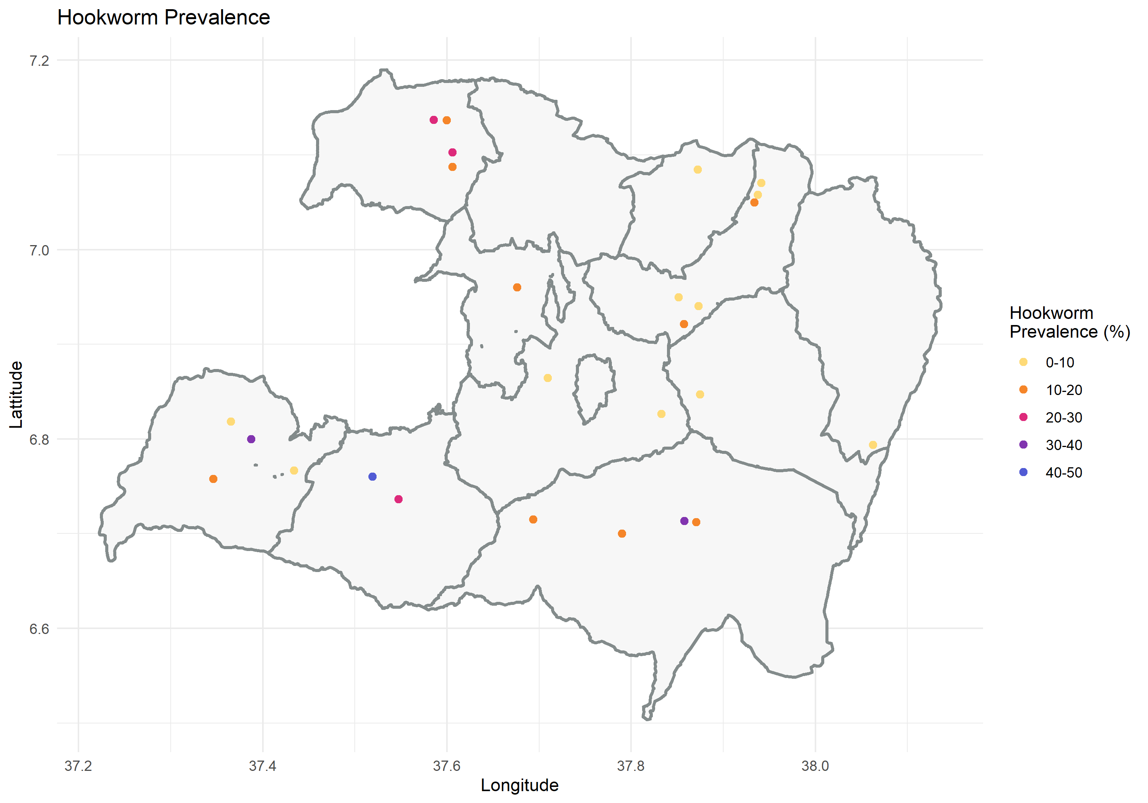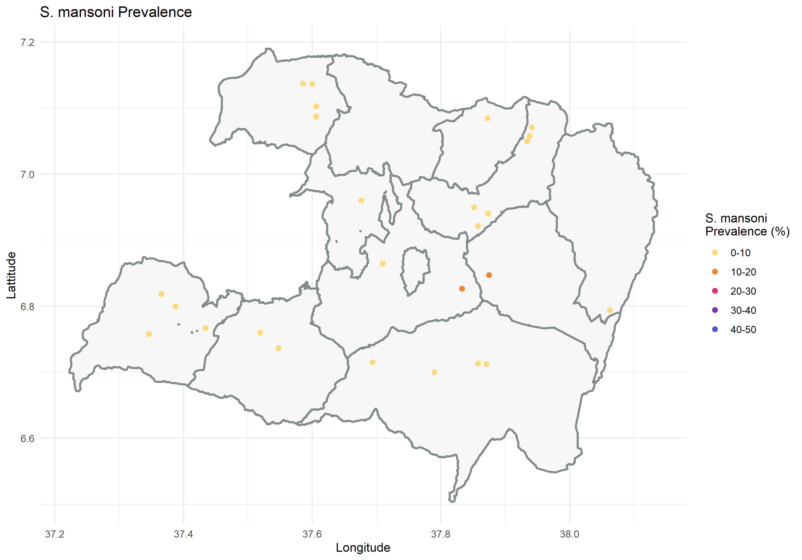**The Geshiyaro intervention impact will be measuring through annual, longitudinal parasitological sentinel site surveillance across approximately 15% of all kebeles. The data presented here are baseline data from 3,926 individuals sampled in 26 sentinel sites between January and March 2020. In each site prevalence and intensity of *Schistosoma mansoni*, Hookworm, *Trichuris*, *Ascaris* and *Schistosoma haematobium* were investigated within the community from pre-school aged children (SAC) until adults. The overall prevalence of *Schistosoma mansoni* was low (3.02% by Kato Katz; 14% by trace -ve POC-CCA; and 21% by trace +ve POC-CCA), with an arithmetic mean intensity of infection of 0.88 eggs per gram (epg). Furthermore, very few heavy infections (0.7%) were detected. Equally, the prevalence of Hookworm*, Trichuris and Ascaris* was low at 12.5%, 3.02% and 13.0%, with an arithmetic mean intensity of infection of 22.4 epg, 16.8%, and 224 epg, respectively. Heavy infections were only detected in hookworm at low levels (0.08%). This lack of heavy infections in both species is important and promising for transmission break since there are very few individuals harbouring heavy egg burdens to maintain transmission in a community. This is also the first data on schistosomiasis and STH infection rates among adults in Ethiopia and demonstrates the importance of community level treatment.**

|  |  |
| --- | --- |
|  |  |
|  |  |

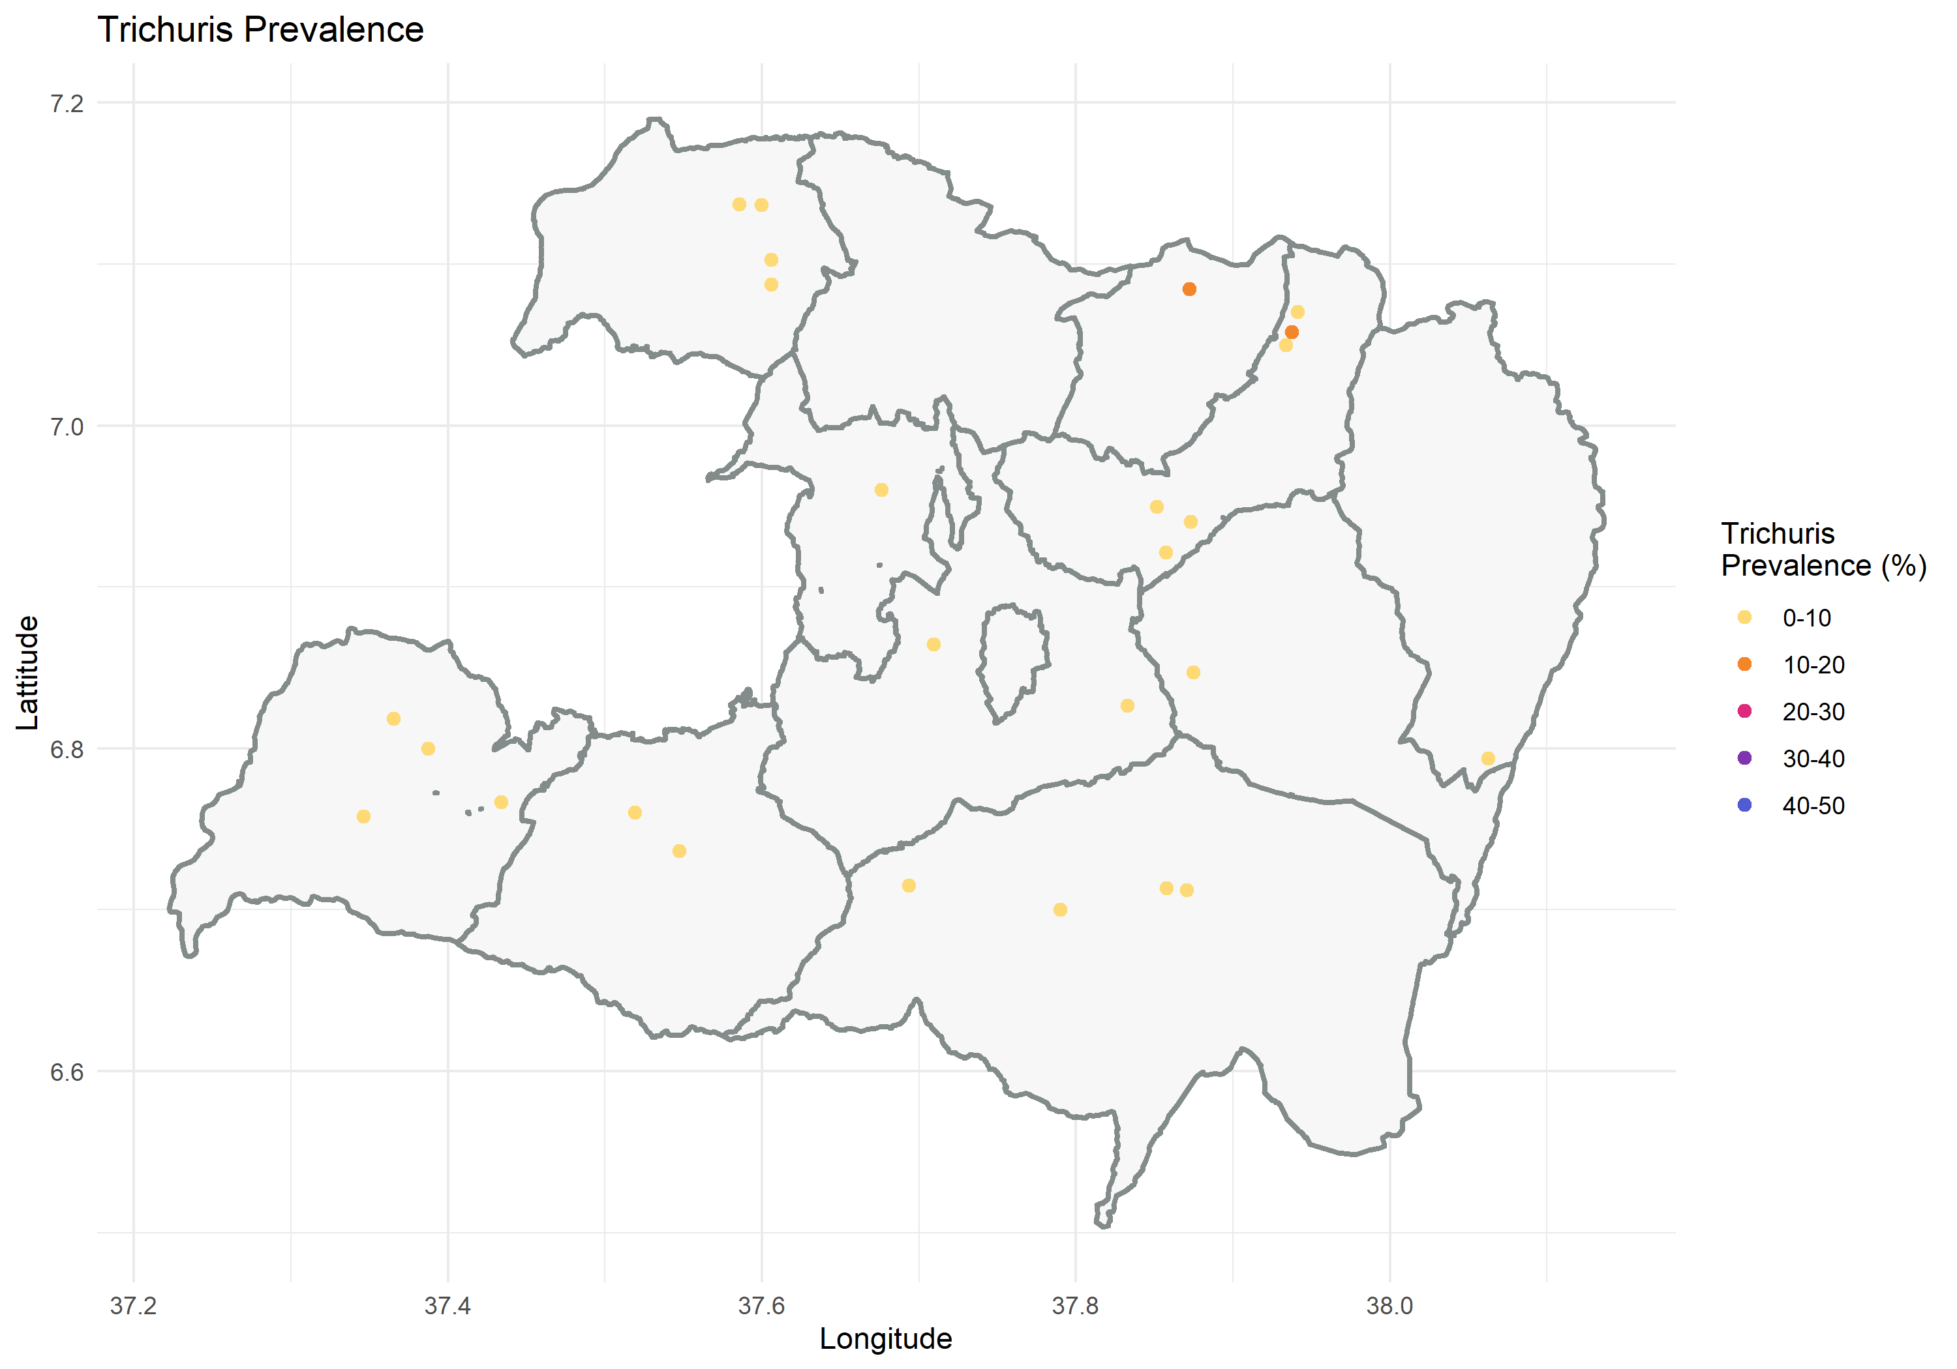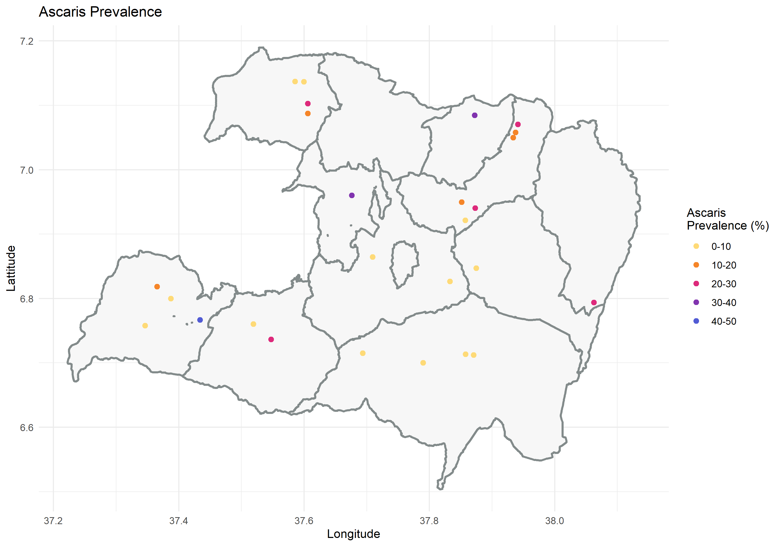

1. **Introduction**

The impact of the Geshiyaro project will be evaluated through longitudinal parasitological surveys of Soil-transmitted Helminth (STH) and Schistosomiasis (SCH), among a random selection of individuals sampled each year, for a duration of five years. In summary:

* Annual longitudinal surveys conducted for five years in the same 45 sentinel sites (kebeles), where 15 sites have been randomly selected from each Geshiyaro intervention arm:
  1. Expanded MDA + WaSH and BCC
  2. Expanded MDA + government OneWaSH programme
  3. School-based MDA + government OneWaSH programme *outside of Wolaita*
* Random sampling of 150 individuals from each site with 30 individuals sampled from each of the following five age groups: pre-school aged children (SAC) aged 1-4 years, SAC aged 5-14 years, 15-20. 21-35, 35+.
* Kato Katz will be used for the diagnosis of both STH and *Schistosoma mansoni*.
* Haemastix will be used to test for haematuria; if a sample is positive for blood in urine then filtration will be carried out for microscopic examination of *S. haematobium* eggs. POC-CCA will also be used for *S. mansoni* (-ve, trace, +, ++, +++).

1. **Methods**

The data presented in this report will be from 30 sites in wolaita from Arm 1 and 2. In those kebeles where there is a census, individuals were identified and verified with their biometric fingerprint or study ID card. In those kebeles where a census has not taken place, there was a registration process.

**Selecting households - Village Family Folders:** One individual was selected at random from each randomly sampled household (HH)**.** Sampling was performed using the village family folder, which is when every *h* HHs in the village are sampled,the initial HH being a random number between 1 and *h*, where *h* is the sampling fraction.

**Selecting Individuals within a kebele:** A total of 150 random individuals were selected at random in each kebele, with 30 individuals sampled from each of the five age groups (pre-SAC, SAC, 15-20, 21-35, 35+).

**Selecting school-aged children:** Where school enrolment was more than 75% in a kebele, SAC were sampled in the school. If less than 75%, SAC were sampled in the kebele.

**Sample Collection:**

* Identification of individuals enrolled in census (biometric or ID cards) in Census Sites.
* Registration of individuals not enrolled in census or individuals from non-census sites.
* Verify or register demographic data (age, sex, location, and WaSH information in new individuals)

**Lab Diagnostics:**

• Hookworm, *Ascaris lumbricoides*, *Trichuris trichiura* and *S. mansoni*: eggs per gram of faeces using Kato-Katz (2 slides per day, repeated over 2 days).

• POC-CCA for *S. mansoni* in urine (1 sample per day on one day only).

• Microhaematuria: Blood in urine detected with haemastix.

• *S. haematobium*: eggs per 10ml of urine using urine filtration (2 slides on one day)

* Prevalence and intensity of infection for each STH and SCH species were based on egg counts.

The following sentinel sites were sampled from census (blue) and non-census (red) kebeles:

|  |  |
| --- | --- |
| **Sentinel Kebele** | **Woreda** |
| Ajora | Bolosso Bombe |
| Bombe 01 | Bolosso Bombe |
| Fara Wache | Bolosso Bombe |
| Gido Matala | Bolosso Bombe |
| Gido Homba | Bolosso Sore |
| Hajo Salata | Bolosso Sore |
| Afama Garo | Bolosso Sore |
| Korke Doge | Bolosso Sore |
| Bugie Town | Damot Gale |
| Wegera | Damot Gale |
| Tabba | Damot Gale |
| Shasha Gale | Damot Gale |
| Abala Longena | Abela Abaya |
| Abala zagire | Abela Abaya |
| Girara Mazegeja | Damot Woyide |
| Ambe Girara | Damot Woyide |
| Gidicho | Damot Pulasa |
| Lera | Damot Pulasa |
| Doge Hanchucho | Damot Sore |
| Hanchuch Chawkare | Damot Sore |
| Bilate Chericho | Duguna Fango |
| Ela Kebela | Humbo |
| Sere Tawureta | Humbo |
| KindoMadina | Kindo Didaye |
| Mogisa | Kindo Didaye |
| OfaChewukare | Kindo Didaye |
| Gilobishare | Sodo Zuria |
| Wajashoya | Sodo Zuria |
| Zamo | Offa |
| Yakima | Offa |

**Figure 1: Map of the sentinel site locations**

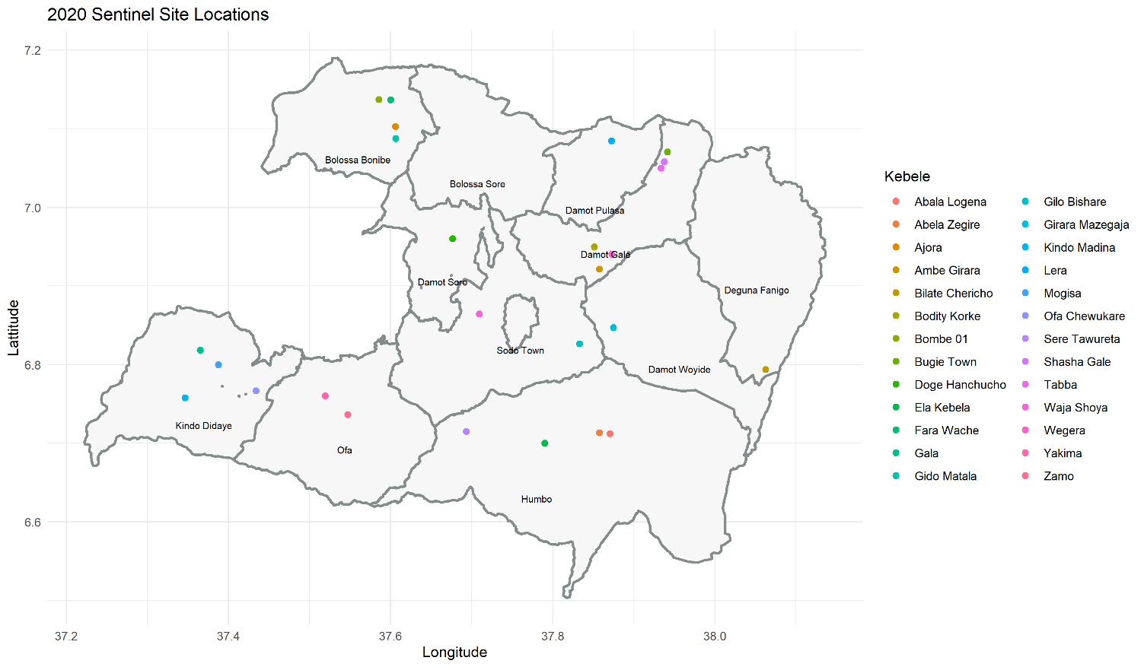

1. **Sentinel site baseline (26 sites) results**

From January to March 2020, 3,926 individuals were sampled from 26 sentinel sites (individual kebeles). In each site, prevalence and intensity of *Schistosoma mansoni*, Hookworm, *Trichuris*, *Ascaris* and *Schistosoma haematobium* were investigated among 30 each of children pre-SAC (aged 1–4 years), SAC (aged 9–12 years), adolescents (aged 15-21 years), young adults (aged 22-35 years) and adults (35+ years).

**3.1. Distribution of sentinel site sample collection by demographic data**

The target was to sample 3,900 individuals across the 26 sites, with a 50:50 males to female ratio. Furthermore, there was a target of 780 (20%) individuals from each of the five age categories. There was oversampling among SAC (24.7%) and under representation of adolescents aged 15-21 years (16.7%). See Table 3.1 for distribution of sample collection and Annex for details of age/sex distribution of sampling by sentinel site/kebele.

**Table 3.1: Distribution of sentinel site sample collection by sex and age**

|  |  |  |  |  |  |  |  |
| --- | --- | --- | --- | --- | --- | --- | --- |
| **Kebele** |  | **Age Category (years)** | | | | | Total |
|  | **Sex** | 1 to 4 | 5 to 14 | 15 to 21 | 22 to 35 | 35+ |
| **TOTAL** | **Male** | 372 | 543 | 305 | 347 | 369 | 1,936 (49.3%) |
| **Female** | 367 | 426 | 349 | 478 | 370 | 1,990 (50.7%) |
| **TOTAL** | **739** (18.8%) | **969** (24.7%) | **654** (16.7%) | **825** (21.0%) | **739** (18.8%) | **3,926** |

**3.2 Overall** **intestinal parasite data**

A total sample of 3,926 individuals were sampled to take part in the 26 sentinel sites. Of these 3,837individualsprovided stool and urine samples. Of these, prevalence of infection was 3.02% *Schistosoma mansoni* by Kato-Katz, 12.5% Hookworm, 3.02% *Trichuris*, and 13% *Ascaris* (Table 3.2.1). The majority of all intestinal parasite infections were light intensity.

**Table 3.2.1: Prevalence and intensity of infection by *S. mansoni* and STH**

|  |  |  |  |  |  |
| --- | --- | --- | --- | --- | --- |
| **Intensity** | **Total no. individuals infected (%)** | **Arithmetic mean intensity** | **Light n (%)** | **Moderate**  **n (%)** | **Heavy n (%)** |
| *S.mansoni\** | 117 (3.02) | 0.88 | 82 (2.12) | 8 (0.21) | 27 (0.70) |
| Hookworm** | 483 (12.5) | 22.4 | 479 (12.4) | 1 (0.03) | 3 (0.08) |
| *Trichuris\*\*\** | 117 (3.02) | 16.9 | 94 (2.43) | 23 (0.59) | 0 (0.00) |
| *Ascaris\*\*\*\** | 503 (13.0) | 224 | 467 (2.05) | 1. (0.93) | 0 (0.00) |

* Light-intensity 1-99 epg, Moderate-intensity 100–399 epg, Heavy-intensity infection >400 epg

** Light-intensity 1-1 999 epg, Moderate-intensity 2 000–3 999 epg, Heavy-intensity infection >3,999 epg

*** Light-intensity 1–999 epg, Moderate-intensity 1 000–9 999 epg, Heavy-intensity infection >10 000 epg

**** Light-intensity 1–4 999 epg, Moderate-intensity 5 000–49 999 epg, Heavy-intensity >50 000 epg

***Schistosoma mansoni***

The overall prevalence of *Schistosoma mansoni* was 3.02% (n=117) by Kato-Katz with an arithmetic mean intensity of infection of 0.88 epg. Heavy infections were detected in 0.7% (n=27). Table 3.2.2 examines infection by age and sex where there was no evidence of a difference between males (2.65%) than females (2.25%). SAC (aged 5-14) had the highest prevalence (4%) and intensity of infection (1.45 epg) with respect to the other age groups, although numbers of those infected was low (Table 3.2.2). Most infections were light intensity (Table 3.2.3).

*Schistosoma mansoni* infections are typically focal in nature, so prevalence and intensity were disaggregated by kebele to try and determine hot spots of infection (Table 3.2.3). Prevalence was over 10% in two kebeles (by kato-katz), which is categorised as “moderate-risk” areas as per WHO guidelines. One of these Girara Mazegeja (prevalence of 18.9%) is an Arm 1 sites that will receive WaSH interventions to aid schistosomiasis control. Gilo Bisha is a non- Geshiyaro WaSH intervention site (prevalence 15.23%) so it will be interesting therefore to see how SCH infection progresses in these communities over time.

**Soil-transmitted helminths**

Prevalence of Hookworm*, Trichuris and Ascaris* was 12.5% (n=483), 3.02% (n=117) and 13.0% (n=503), respectively, with an arithmetic mean intensity of infection of 22.4, 16.9, and 224 epg. Heavy infections were detected in 0.08% of hookworm infections and zero *Trichuris* and *Ascaris* infections (Table 3.2.1). The majority of infections were light intensity (Table 3.2.3)

Across all STH there was an equal infection in females as males. Prevalence and intensity of infection varied across the age groups by STH species. Adolescents and adults had the highest infection rates for hookworm; SAC (aged 5-14) for Trichuris; and pre-SAC in Ascaris (Table 3.2.2).

Kebele prevalence indicated that higher endemic areas were clustered together by geographical region, as is typical of STH infection (see kebele data in Annex).

This is the first study looking at schistosomiasis and STH infection rates among adults in Ethiopia. Table 3.2.2 demonstrates substantial numbers of adults infected, if the prevalence here is truly representative of the wider population then this would suggest a notable number of infected adults that would normally be omitted from the national school-based MDA program.

**Table 3.2.2: Prevalence and intensity of intestinal parasite infection among those examined, by sex and age group (pre-SAC, SAC, 15-21, 22-35 and adults aged 35+ years) at baseline**

|  |  |  |  |  |  |  |  |  |  |
| --- | --- | --- | --- | --- | --- | --- | --- | --- | --- |
| **Sex** | **No. of indiv examined** | ***S. mansoni*** | | **Hookworm** | | ***Trichuris*** | | ***Ascaris*** | |
| **No. indiv infected (%)** | **Arithmetic mean intensity** | **No. indiv infected (%)** | **Arithmetic mean intensity** | **No. indiv infected (%)** | **Arithmetic mean intensity** | **No. indiv infected (%)** | **Arithmetic mean intensity** |
| **Both sexes** | | | | | | | | | |
| 1-4 | 721 | 8 (1.10) | 0.64 | 80 (11.1) | 11.1 | 18 (2.50) | 8.48 | 108 (15.0) | 288.5 |
| 5-14 | 927 | 38 (4.0) | 1.45 | 77 (8.1) | 7.99 | 36 (3.80) | 22.8 | 131 (13.8) | 252.9 |
| 15-21 | 637 | 24 (3.80) | 1.22 | 94 (14.8) | 27.4 | 17 (2.70) | 30.7 | 80 (12.6) | 245.1 |
| 22-35 | 800 | 14 (1.80) | 0.53 | 120 (15.0) | 21.1 | 22 (2.80) | 5.79 | 95 (11.9) | 177.2 |
| 35+ | 732 | 10 (1.40) | 0.5 | 109 (14.9) | 50.4 | 21 (2.90) | 18.3 | 77 (10.5) | 144.3 |
| **TOTAL** | **3837** | **94 (2.40)** | **0.88** | **480 (12.5)** | **22.4** | **114 (3.0)** | **16.8** | **491 (12.8)** | **224.0** |
| **Female** | | | | | | | | | |
| 1-4 | 351 | 5 (1.42) | 1.03 | 38 (10.8) | 8.86 | 10 (2.85) | 5.4 | 49 (14.0) | 226.12 |
| 5-14 | 429 | 15 (3.50) | 1.32 | 46 (10.7) | 10.04 | 17 (3.96) | 24.46 | 64 (14.9) | 288.55 |
| 15-21 | 340 | 10 (2.94) | 0.97 | 42 (12.4) | 32.65 | 9 (2.65) | 26.81 | 43 (12.7) | 243.46 |
| 22-35 | 464 | 9 (1.94) | 0.63 | 60 (12.9) | 15.58 | 12 (2.59) | 4.44 | 58 (12.5) | 236.22 |
| 35+ | 368 | 5 (1.36) | 0.28 | 50 (13.6) | 50.76 | 14 (3.8) | 21.51 | 42 (11.4) | 186.64 |
| **TOTAL** | **1952** | **44 (2.25)** | **0.85** | **236 (12.1)** | **241.0** | **62 (3.18)** | **16.1** | **256 (13.1)** | **237.8** |
| **Males** | | | | | | | | | |
| 1-4 | 370 | 3 (0.81) | 0.28 | 42 (11.4) | 13.17 | 8 (2.16) | 11.4 | 59 (16.0) | 347.58 |
| 5-14 | 518 | 23 (4.44) | 1.55 | 31 (5.98) | 6.29 | 19 (3.67) | 21.5 | 67 (12.9) | 223.39 |
| 15-21 | 297 | 14 (4.71) | 1.49 | 52 (17.5) | 21.41 | 8 (2.69) | 35.17 | 37 (12.5) | 246.99 |
| 22-35 | 336 | 5 (1.49) | 0.39 | 60 (17.9) | 28.64 | 10 (2.98) | 7.66 | 37 (11.0) | 95.64 |
| 35+ | 364 | 5 (1.37) | 0.73 | 59 (16.2) | 50.06 | 7 (1.92) | 14.95 | 35 (9.62) | 101.51 |
| **TOTAL** | **1885** | **50 (2.65)** | **0.93** | **244 (12.9)** | **161.1** | **52 (2.72)** | **17.9** | **235 (12.5)** | **205.1** |

**3.3** **[Overall](#_Toc21951197)** **urine anaylsis**

Overall, 21.9% and 14.3% of samples were trace+ve and trace-ve, respectively, for *Schistosoma mansoni*. As expected, this is higher than the Kato Katz prevalence result of 3.02%.

A total of 131 (2.41%) of samples were positive (trace haemolysed and above) for haematuria and therefore underwent urine filtration, of these only 1.3% were positive by visible eggs.

**Table 3.3.1: Proportion (n(%)) of samples by POC-CCA result**

|  |  |  |  |  |
| --- | --- | --- | --- | --- |
| Negative | Trace | + | ++ | +++ |
| 3013 (78.1) | 292 (7.6) | 240 (6.2) | 189 (4.9) | 1. (3.2) |

**Table 3.3.2: Proportion (n(%)) of samples by haemastix result**

|  |  |  |  |  |  |
| --- | --- | --- | --- | --- | --- |
| None | trace non-haemolysed | trace haemolysed | + | ++ | +++ |
| 3694 (95.8) | 31 (0.8) | 19 (0.5) | 40 (1.0) | 35 (0.9) | 1. (1.0) |

**Table 3.3.3: Proportion (n(%)) of average counts of *Schistosoma haematobium***

|  |  |  |
| --- | --- | --- |
| S. Haematobium Count | 0 | 5 |
| Number of urine samples | 1. (8.7) | 2 (1.3) |

**4 Sentinel site Year 1 and 2 (Bolosso Sore only) results**

From 575 individuals enrolled at baseline (Year 1), of which 402 individuals were followed up to Year 2 across all four sentinel sites. Of these 383individualsprovided stool and urine samples.

**Table 4.1: Distribution of sentinel sites by year**

|  |  |  |  |  |
| --- | --- | --- | --- | --- |
| Kebele  (kebele code) | Number of individuals enrolled in Year 1 | Number of individuals enrolled in Year 2 | Number of individuals followed up over year 1 and 2 | N individuals without lab forms |
| Afama Garo (27) | 133 | 142 | 100 | 2 |
| Gido Homba (4) | 151 | 137 | 96 | 2 |
| Hajo Salata (20) | 147 | 170 | 86 | 3 |
| Korke Doge (8) | 144 | 176 | 120 | 12 |

**4.1. Distribution of sentinel site sample collection by demographic data**

The target was to sample 150 in each site, with a 50:50 male to female ratio. Furthermore, there was a target of 120 (20%) individuals from each of the five age categories. There was oversampling among SAC (33.2%) and under representation of pre-SAC (4.9%) and adolescents aged 15-21 years (9.1%). See Table 4.1.1 for distribution of sample collection.

**Table 4.1.1: Distribution of sentinel site sample collection by sex and age**

|  |  |  |  |  |  |  |  |  |  |  |  |
| --- | --- | --- | --- | --- | --- | --- | --- | --- | --- | --- | --- |
| Kebele  (code) | N Individuals (% males) | Pre-SAC  1-4 | | SAC  5-14 | | Adolescents 15-20 | | Adults 21-35 | | Adults 36+ | |
| M | F | M | F | M | F | M | F | M | F |
| Afama Garo (27) | 98 (40.0) | 1 | 2 | 15 | 19 | 2 | 5 | 6 | 19 | 15 | 14 |
| Gido Homba (4) | 94 (34.2) | 1 | 1 | 14 | 17 | 1 | 7 | 9 | 22 | 7 | 15 |
| Hajo Salata (20) | 83 (49.1) | 5 | 4 | 15 | 12 | 3 | 6 | 5 | 7 | 13 | 13 |
| Korke Doge (8) | 108 (37.3) | 3 | 2 | 19 | 16 | 5 | 6 | 6 | 27 | 7 | 17 |
| **TOTAL** | **383 (40.0)** | **19** | | **127** | | **35** | | **101** | | **101** | |

**4.2 Overall** **parasite data**

Overall, prevalence of infection was 2.9% *Schistosoma mansoni* by Kato-Katz, 17.5% Hookworm, 10.4% *Trichuris*, and 23.8% *Ascaris* (Table 4.2.1). The majority of all intestinal parasite infections were light intensity, with only one case of heavy *Ascaris* infection.

**Table 4.2.1: Prevalence and intensity of infection by *S. mansoni* and STH (Kato-Katz only)**

|  |  |  |  |  |  |
| --- | --- | --- | --- | --- | --- |
| **Intensity** | **Total no. individuals infected (%)** | **Arithmetic mean intensity** | **Light n (%)** | **Moderate**  **n (%)** | **Heavy n (%)** |
| *S.mansoni\** | 11 (2.9) | 1.2 | 10 (2.6) | 1 (0.3) | 0 |
| Hookworm** | 67 (17.5) | 21.4 | 67 (17.5) | 0 | 0 |
| *Trichuris\*\*\** | 40 (10.4) | 56.8 | 36 (9.4) | 4 (1.0) | 0 |
| *Ascaris\*\*\*\** | 91 (23.8) | 921.6 | 72 (18.8) | 18 (4.7) | 1 (0.3) |

* Light-intensity 1-99 epg, Moderate-intensity 100–399 epg, Heavy-intensity infection >400 epg

** Light-intensity 1-1 999 epg, Moderate-intensity 2 000–3 999 epg, Heavy-intensity infection >3,999 epg

*** Light-intensity 1–999 epg, Moderate-intensity 1 000–9 999 epg, Heavy-intensity infection >10 000 epg

**** Light-intensity 1–4 999 epg, Moderate-intensity 5 000–49 999 epg, Heavy-intensity >50 000 epg

**Schistosomiasisprevalence**

The overall prevalence of *Schistosoma mansoni* was 0.35% in Year 1 by Kato-Katz, 2.57% by POC trace-ve and 6.95% by POC trace +ve. In Year 2 prevalence was 2.6% by Kato-Katz, 9.51% by POC trace-ve and 14.3% by POC trace +ve. *S.mansoni* infection increased in all kebeles, except Korke Doge (Table 4.2.2 and Figure 2). The overall prevalence of *Schistosoma haematobium* was 1.69% in Year 1 by haemastix. In Year 2 prevalence was 10.7%, with an increase in blood in urine seen across all kebeles (Table 4.2.2). With regards to SCH it is important to note that the Year 1 sentinel sites took place in January 2019, five months after the end of the rainy season, whereas Year 2 sampling occurred in September 2019 at the end of the rains. There is a potential environmental confounding affect.

The age-stratified prevalence figures, with the average in grey, demonstrates that SCH has a highest prevalence in pre-SAC which then decreases in SAC into adulthood (Figure 3).

**Table 4.2.2: Prevalence % of Schistosomiasis infection by diagnostic over time by site**

|  |  |  |  |  |  |  |  |  |
| --- | --- | --- | --- | --- | --- | --- | --- | --- |
| Kebele  (kebele code) | Year 1 Kato Katz | Year 2 Kato Katz | Year 1 POC-Tr -ve | Year 2 POC-Tr -ve | Year 1 POC-Tr +ve | Year 2 POC-Tr +ve | Haematuria Year 1 | Haematuria Year 2 |
| Afama Garo (27) | 0.00 | 1.06 | 1.05 | 3.19 | 2.11 | 3.19 | 2.11 | 8.51 |
| Gido Homba (4) | 0.00 | 5.10 | 3.09 | 27.55 | 3.09 | 39.80 | 4.12 | 14.29 |
| Hajo Salata (20) | 0.00 | 1.06 | 1.05 | 3.19 | 2.11 | 3.19 | 2.11 | 8.51 |
| Korke Doge (8) | 0.00 | 3.70 | 3.36 | 2.78 | 15.97 | 10.19 | 0.00 | 9.26 |

Note: All egg counts were zero on those urine samples that were filtered.

**Figure 2: Prevalence of *Schistosoma mansoni* infection by POC-CCA over time**

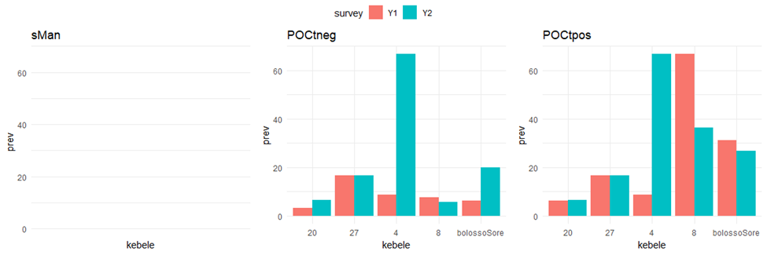

**Figure 3: Age-stratified prevalence of infection**

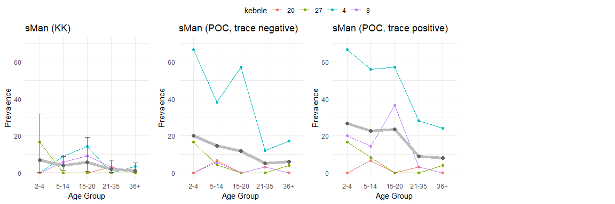

**Soil-transmitted helminths prevalence**

Prevalence of Hookworm*, Ascaris* and *Trichuris* was 6.06%, 28.6%, and 9.20%, respectively in Year 1. In Year 2 prevalence was 17.5%, 23.8%, and 10.4%, respectively. STH infection levels decreased in Afama Garo across all species. STH decreased overall in Gido Homba, with an increase in Hookworm only. All STH increased in Hajo Salata (Table 4.2.3 and Figure 4). Hookworm are notoriously difficult to diagnose using microscopy, with infections missed if the slides are left too long before being read. As a result, we believe this result is more likely to be the product of poor lab technician performance in Year 1 than a genuine increase in Hookworm infection. This is not the case with *S. mansoni* or other STH.

The age-stratified prevalence figures, with the average in grey, demonstrates that STH has a highest prevalence in pre-SAC which then decreases in SAC and adolescents, potentially a result of years of school-based deworming, with an increase in young adults (Figure 5). The 100% ‘anySTH’ for Hajo Salata (kebele 20) is due to one individual in that age band, who was positive for hk infection.

**Table 4.2.3: Prevalence % of STH infection over time by site**

|  |  |  |  |  |  |  |  |  |
| --- | --- | --- | --- | --- | --- | --- | --- | --- |
| Kebele  (kebele code) | Any STH Year 1 | Any STH Year 2 | *Ascaris* Year 1 | *Ascaris* Year 2 | *Trichuris* Year 1 | *Trichuris* Year 2 | Hookworm Year 1 | Hookworm Year 2 |
| Afama Garo (27) | 67.44 | 43.37 | 50.00 | 31.33 | 15.12 | 9.64 | 26.74 | 18.07 |
| Gido Homba (4) | 26.00 | 26.53 | 25.00 | 19.39 | 8.00 | 1.02 | 1.00 | 8.16 |
| Hajo Salata (20) | 12.50 | 30.85 | 8.33 | 13.83 | 1.04 | 10.64 | 3.12 | 12.77 |
| Korke Doge (8) | 42.50 | 57.41 | 41.67 | 30.56 | 17.50 | 19.44 | 2.50 | 29.63 |

**Figure 4: Prevalence of STHinfection (KK) over time (n=383)**



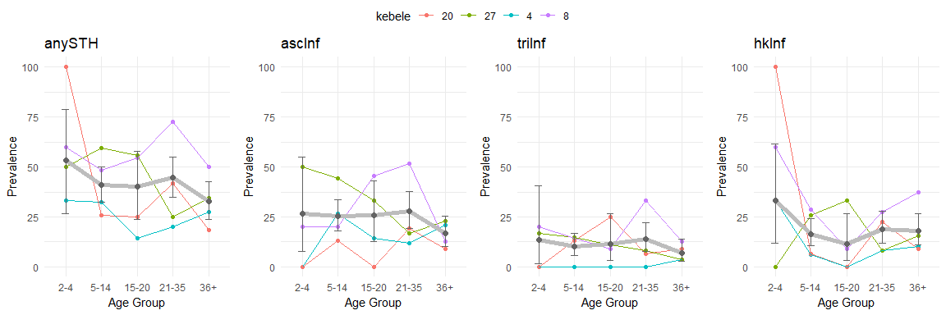**Figure 5: Age-stratified prevalence of infection**

**Intensity of STH and *Schistosoma mansoni* infection**

Morbidity caused by STH and SCH are directly related to the number of worms (intensity of infection) and the duration of infection. There was an increase in infection intensity over time (Table 4.2.4 and Figure 6) across all STH and SCH species.

**Table 4.2.4: Prevalence % of intensity over time by site**

|  |  |  |  |  |  |  |  |  |
| --- | --- | --- | --- | --- | --- | --- | --- | --- |
| Kebele  (kebele code) | Year 1 *Ascaris* mean epg | Year 2 *Ascaris* mean epg | Year 1 *Trichuris* mean epg | Year 2 *Trichuris* mean epg | Year 1 Hookworm mean epg | Year 2 Hookworm mean epg | Year 1 *S.mansoni* mean epg | Year 2 *S.mansoni* mean epg |
| Afama Garo (27) | 816.5 | 1605.9 | 37.2 | 24.2 | 11.4 | 21.0 | 0.1 | 0.1 |
| Gido Homba (4) | 55.0 | 284.2 | 2.4 | 39.8 | 0.5 | 2.8 | 0.0 | 2.5 |
| Hajo Salata (20) | 14.9 | 623.4 | 0.2 | 101.6 | 6.1 | 23.9 | 0.0 | 0.3 |
| Korke Doge (8) | 1193.6 | 1233.6 | 27.8 | 58.3 | 0.8 | 36.6 | 0.0 | 1.8 |

**Figure 6: Infection intensity by diagnostic over time**

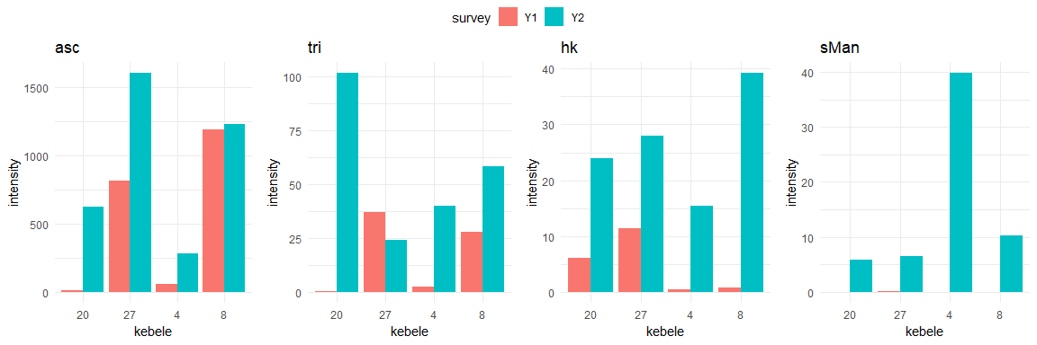

**Individual infection data, over time**

For Figures 7 to 10 plots below, individual cohort members with parasitology results for Y1 and Y2 are displayed where:

* Grey - those with no infection at both time points
* Blue - those *positive in Y1 and negative in Y2*
* Red - those *negative at Y1 and positive at Y2*
* Orange - those positive at both time points

Those in blue who become negative, we can assume were successfully treated. Those in red may have been exposed to infection, and not treated, over the year or were misdiagnosed at baseline. Orange we ass

**Figure 7: Individual prevalence of *Schistosoma mansoni* infection over time**

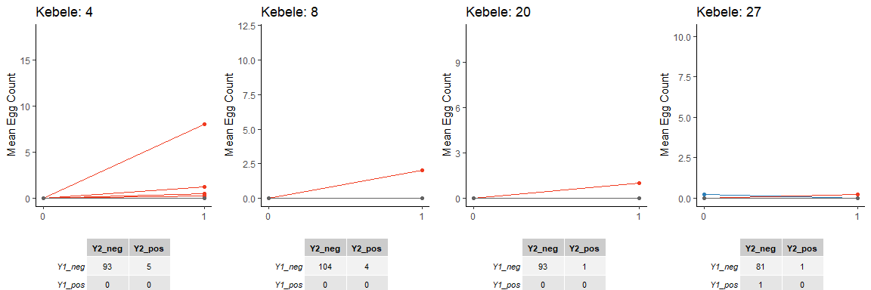

**Figure 8: Individual prevalence of Hookworm infection over time**

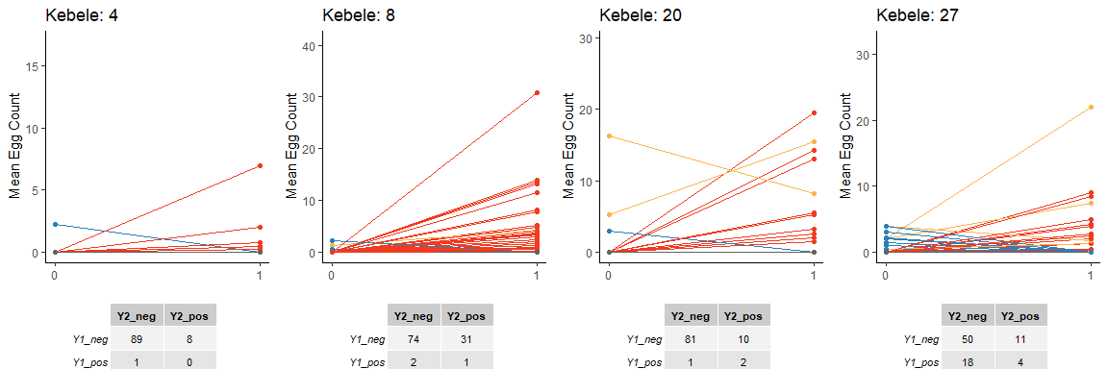

**Figure 9: Individual prevalence of *Trichuris* infection over time**

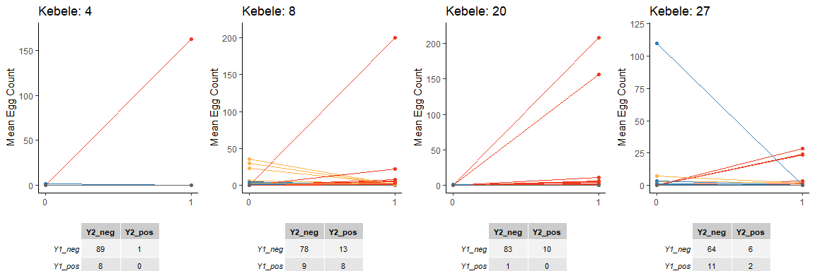

**Figure 10: Individual prevalence of *Ascaris* infection over time**

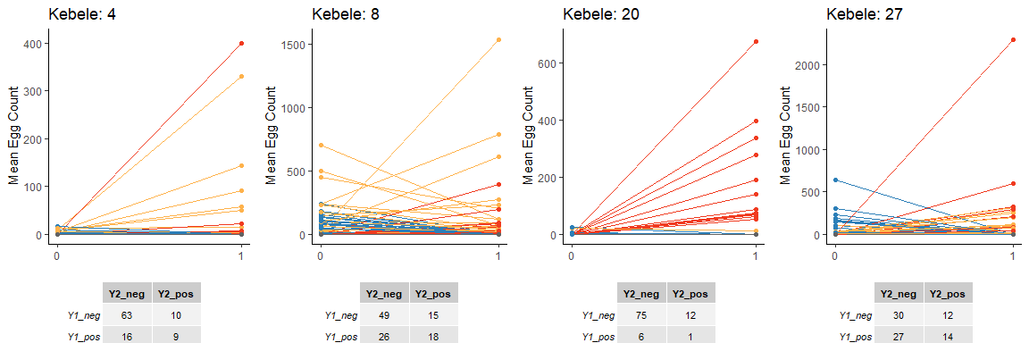

**Treatment vs. infection**

When looking at STH infection by treatment, there variation between Ascaris/Trichuris and Hookworm, due to the possible hookworm timing to read error.

**Table 4.2.5: *Ascaris***

From simple observation, the appearance of 'missing forms' increases from 20% in the neg-neg grouping to 41% in the pos-pos grouping. Compliance to treatment looks similar in the neg-neg (69%) and neg-pos and pos-neg groupings (63%), but it is lower in the pos-pos grouping at 49% (number of samples across the groups does differ dramatically from neg-neg to pos-pos obviously).

|  |  |  |  |  |  |  |
| --- | --- | --- | --- | --- | --- | --- |
|  | n Missing Treatment forms | % | n Decline ALB | % | n Accept ALB | % |
| neg-neg | 44 | 20.6 | 23 | 10.7 | 147 | 68.7 |
| neg-pos | 13 | 28.3 | 4 | 8.7 | 29 | 63 |
| pos-neg | 22 | 30.6 | 4 | 5.6 | 46 | 63.9 |
| pos-pos | 16 | 41 | 4 | 10.2 | 19 | 48.7 |

**Table 4.2.6: *Trichuris***

In the *Trichuris* groupings, treatment coverage looks consistent across the four positivity groupings (60% in pos-pos, 65% in neg-neg and pos-neg, and 70% in the neg-pos grouping). The number of missing treatment records across the groups is similar for all but neg-pos; in the neg-pos group they have 'more' (very relative terms) treatment declines compared to the other groups, but also less 'missing' treatment records, and the highest treatment compliance within the *Trichuris* infection groupings.

|  |  |  |  |  |  |  |
| --- | --- | --- | --- | --- | --- | --- |
|  | n Missing Treatment forms | % | n Decline ALB | % | n Accept ALB | % |
| neg-neg | 81 | 26.6 | 27 | 8.9 | 197 | 64.6 |
| neg-pos | 4 | 13.3 | 5 | 16.7 | 21 | 70 |
| pos-neg | 7 | 26.9 | 2 | 7.7 | 17 | 65.4 |
| pos-pos | 3 | 30 | 1 | 10 | 6 | 60 |

**Table 4.2.7: Hookworm**

Hookworm pos-pos individuals (n = 6), however, have the most consistent treatment compliance. Documented compliance looks similar across the other groups (neg-neg, neg-pos, pos-neg), between 64% (neg-neg) and 68% in pos-neg. The neg-pos grouping has 12% individuals that declined treatment.

|  |  |  |  |  |  |  |
| --- | --- | --- | --- | --- | --- | --- |
|  | n Missing Treatment forms | % | n Decline ALB | % | n Accept ALB | % |
| neg-neg | 75 | 26.3 | 27 | 9.5 | 183 | 64.2 |
| neg-pos | 13 | 22.4 | 7 | 12.1 | 38 | 65.5 |
| pos-neg | 6 | 27.3 | 1 | 4.5 | 15 | 68.2 |
| pos-pos | 1 | 16.7 | 0 | 0 | 5 | 83.3 |

**Annex: Additional Data**

**Prevalence and intensity of intestinal parasite infection by kebele**

|  |  |  |  |  |  |  |  |  |  |
| --- | --- | --- | --- | --- | --- | --- | --- | --- | --- |
| **Kebele** | **No. of indiv examined** | ***S. mansoni*** | | **Hookworm** | | ***Trichuris*** | | ***Ascaris*** | |
| **No. indiv infected (%)** | **Arithmetic mean** | **No. indiv infected (%)** | **Arithmetic mean** | **No. indiv infected (%)** | **Arithmetic mean** | **No. indiv infected (%)** | **Arithmetic mean** |
| Bodity Korke | 149 | 1 (0.67) | 0.36 | 8 (5.37) | 6.65 | 5 (3.36) | 50.42 | 24 (16.11) | 194.0 |
| Fara Wache | 146 | 1 (0.68) | 0.33 | 21 (14.38) | 20.55 | 3 (2.05) | 2.59 | 5 (3.42) | 99.5 |
| Ajora | 149 | 10 (6.71) | 0.89 | 29 (19.46) | 14.62 | 1 (0.67) | 0.32 | 31 (20.81) | 108.0 |
| Gido Matala | 153 | 0 (0.0) | 0.00 | 17 (11.11) | 14.43 | 1 (0.65) | 0.35 | 20 (13.07) | 130.9 |
| Bombe 01 | 146 | 1 (0.68) | 0.04 | 29 (19.86) | 8.84 | 7 (4.79) | 0.58 | 5 (3.42) | 21.8 |
| Tabba | 133 | 0 (0.0) | 0 | 14 (10.53) | 4.11 | 8 (6.02) | 5.73 | 25 (1.88) | 309.70 |
| Wegera | 145 | 0 (0.0) | 0 | 1 (0.69) | 0.12 | 7 (4.83) | 42.91 | 42 (28.97) | 209.96 |
| Shasha Gale | 142 | 1 (0.7) | 0.04 | 6 (4.23) | 1.39 | 15 (10.56) | 50.32 | 23 (1.62) | 405.08 |
| Bugie Village | 114 | 0 (0.0) | 0 | 4 (3.51) | 1.74 | 5 (4.39) | 62.32 | 29 (25.44) | 409.84 |
| Gola | 150 | 0 (0.0) | 0 | 3 (2.0) | 0.44 | 3 (2.0) | 7.04 | 22 (14.67) | 302.88 |
| Lera | 150 | 1 (0.67) | 0.32 | 3 (2.0) | 1.04 | 20 (13.33) | 6.80 | 48 (32.0) | 935.48 |
| Doge Hanchucho | 152 | 0 (0.0) | 0 | 14 (9.21) | 18.51 | 11 (7.24) | 34.70 | 52 (34.21) | 817.62 |
| Ambe Girara | 151 | 6 (3.97) | 1.51 | 17 (11.26) | 17.21 | 1 (0.66) | 0.12 | 11 (7.28) | 54.83 |
| Girara Mazegaja | 162 | 30 (18.52) | 11.52 | 0 (0.0) | 0 .00 | 2 (1.23) | 0.37 | 0 (0.0) | 0 |
| Bilate Chericho | 150 | 0 (0.0) | 0 | 3 (2.0) | 20.16 | 4 (2.67) | 66.0 | 37 (24.67) | 99.80 |
| Abela Zegire | 150 | 1 (0.67) | 0.36 | 50 (33.33) | 84.12 | 0 (0.0) | 0 | 0 | 0 |
| Abala Logena | 148 | 0 (0.0) | 0 | 20 (13.51) | 15.32 | 6 (4.05) | 49.14 | 5 (3.38) | 162.6 |
| Ela Kebele | 151 | 10 (6.62) | 2.54 | 26 (17.22) | 19.99 | 2 (1.32) | 28.57 | 4 (2.65) | 33.89 |
| Sera Tawureta | 176 | 3 (1.7) | 0.10 | 23 (13.07) | 18.14 | 2 (1.14) | 0.21 | 0 (0.0) | 0 |
| KindoMadina | 148 | 2 (1.35) | 0.24 | 20 (13.51) | 5.43 | 1 (0.68) | 8.15 | 6 (4.05) | 34.14 |
| Mogisa | 151 | 0 (0.0) | 0 | 58 (38.41) | 77.84 | 4 (2.65) | 0.56 | 5 (3.31) | 32.46 |
| Offa Chewukare | 149 | 0 (0.0) | 0 | 0 (0.0) | 0 | 2 (1.34) | 34.39 | 72 (48.32) | 1142.26 |
| Yakima | 152 | 0 (0.0) | 0 | 72 (47.37) | 193.93 | 3 (1.97) | 0.59 | 6 (3.95) | 82.93 |
| Zamo | 150 | 0 (0.0) | 0 | 31 (20.67) | 25.68 | 2 (1.33) | 0.28 | 29 (19.33) | 328.84 |
| WajaShoya | 157 | 4 (2.55) | 0.61 | 9 (5.73) | 3.82 | 1 (0.64) | 0.12 | 1 (0.64) | 0.04 |
| GiloBishare | 151 | 23 (15.23) | 2.78 | 5 (3.31) | 0.48 | 1 (0.66) | 3.54 | 1 (0.66) |  |

**Table 3.3: Mean (sd) number of eggs per gram for STH and *S.mansoni* by woreda**

|  |  |  |  |  |  |  |  |  |  |
| --- | --- | --- | --- | --- | --- | --- | --- | --- | --- |
| **Woreda** | **No. individuals Sampled** | ***S. Mansoni*** | |  | **Hookworm** | ***Trichuris*** | | ***Ascaris*** | |
| **No. individuals infected (%)** | **Mean (sd)** | **No. individuals infected (%)** | **Mean (sd)** | **No. individuals infected (%)** | **Mean (sd)** | **No. individuals infected (%)** | **Mean (sd)** |
| Bodity | 149 | 1 (0.67) | 0.36 (4.42) | 8 (5.37) | 6.68 (36.78) | 5 (3.36) | 50.42 (352.97) | 24 (16.11) | 194.70 (1063.32) |
| Boloso Bombe | 594 | 12 (2.02) | 0.31 (2.76) | 96 (16.16) | 14.61 (74.10) | 12 (2.02) | 0.95 (11.28) | 61 (10.27) | 90.63 (560.50) |
| Damot Gale | 534 | 1 (0.19) | 0.01 (0.30 | 25 (4.68) | 1.80 (9.15) | 35 (6.55) | 39.76 (342.93) | 119 (22.28) | 329.36 (1228.71) |
| DamotPulasa | 300 | 1 (0.33) | 0.16 (2.77) | 6 (2.0) | 0.74 (6.44) | 23 (7.67) | 6.92 (50.31) | 70 (23.33) | 619.18 (1686.09) |
| Damot Sore | 152 | 0 (0.0) | 0 (0.00) | 14 (9.21) | 18.5316 (97.05) | 11 (7.24) | 34.70 (279.09) | 52 (34.21) | 817.62 (2386.01) |
| DamotWoydie | 313 | 36 (11.5) | 6.70 (21.76) | 17 (5.43) | 8.30 (40.74) | 3 (0.96) | 0.25 (2.60) | 11 (3.51) | 26.45 (261.82) |
| DigunaFango | 150 | 0 (0.0) | 0 90.00) | 3 (2.0) | 20.16 (172.30) | 4 (2.67) | 66 (568.95) | 37 (24.67) | 99.80 (563.60) |
| Abela Abaya | 625 | 14 (2.24) | 0.73 (5.65) | 119 (19.04) | 33.75 (164.27) | 10 (1.60) | 18.60 (214.91) | 9 (1.44) | 46.69 (469.50) |
| KindoDidaye | 448 | 2 (0.45) | 0.08 (1.20) | 78 (17.41) | 28.03 (210.41) | 7 (1.56) | 14.32 (203.64) | 83 (18.53) | 402.12 (1137.60) |
| Offa | 302 | 0 (0.0) | 0 (0.00) | 103 (34.11) | 110.36 (611.08) | 5 (1.66) | 0.44 (3.67) | 35 (11.59) | 205.07 (1274.42) |
| SodoZuria | 308 | 27 (8.77) | 1.68(7.10) | 14 (4.55) | 2.18 (28.20) | 2 (0.65) | 1.79 (30.44) | 2 (0.65) | * 1. (273.50) |

**Table 3.2.3: Infection category by sex and age**

|  |  |  |  |  |  |  |  |  |  |  |  |  |
| --- | --- | --- | --- | --- | --- | --- | --- | --- | --- | --- | --- | --- |
| **Sex** | ***S. mansoni*** | | | **Hookworm** | | | ***Trichuris*** | | | ***Ascaris*** | | |
| **Light** | **Moderate** | **Heavy** | **Light** | **Moderate** | **Heavy** | **Light** | **Moderate** | **Heavy** | **Light** | **Moderate** | **Heavy** |
| **Both Sexes** | | | | | | | | | | | | |
| 1-4 | 14 (1.94) | 1 (0.14) | 3 (0.42) | 80 (11.10) | 0 (0.0) | 0 (0.0) | 15 (2.08) | 3 (0.42) | 0 (0.0) | 101 (14.01) | 7 (0.97) | 0 (0.0) |
| 5-14 | 23 (2.43) | 4 (0.42) | 9 (0.95) | 77 (8.13) | 0 (0.0) | 0 (0.0) | 28 (2.96) | 8 (0.84) | 0 (0.0) | 121 (12.78) | 10 (1.06) | 0 (0.0) |
| 15-21 | 10 (1.57) | 0 (0.0) | 7 (1.10) | 92 (14.44) | 1 (0.16) | 1 (0.16) | 11 (1.73) | 6 (0.94) | 0 (0.0) | 71 (11.15) | 9 (1.41) | 0 (0.0) |
| 22-35 | 18 (2.25) | 2 (0.25) | 2 (0.25) | 120 (15.0) | 0 (0.0) | 0 (0.0) | 20 (2.50) | 2 (0.25) | 0 (0.0) | 89 (11.13) | 6 (0.75) | 0 (0.0) |
| 35+ | 14 (1.91) | 1 (0.14) | 6 (0.82) | 107 (14.62) | 0 (0.0) | 2 (0.27) | 17 (2.32) | 4 (0.55) | 0 (0.0) | 75 (10.25) | 2 (0.27) | (0.0) |
| **TOTAL** | **79 (2.06)** | **8 (0.21)** | **27 (0.70)** | **476 (12.41)** | **1 (0.03)** | **3 (0.08)** | **91 (2.37)** | **23 (0.60)** | **0 (0.0)** | **457 (11.91)** | **34 (0.89)** | **0 (0.0)** |
| **Females** | | | | | | | | | | | | |
| 1-4 | 8 (2.3) | 1 (0.3) | 1 (0.3) | 38 (10.8) | 0 (0.0) | 0 (0.0) | 9 (2.6) | 1 (0.3) | 0 (0.0) | 47 (13.4) | 2 (0.6) | 0 (0.0) |
| 5-14 | 13 (3.0) | 2 (0.5) | 2 (0.5) | 46 (10.7) | 0 (0.0) | 0 (0.0) | 15 (3.5) | 2 (0.5) | 0 (0.0) | 58 (13.5) | 6 (1.4) | 0 (0.0) |
| 15-21 | 5 (1.5) | 0 (0.0) | 4 (1.2) | 40 (11.8) | 1 (0.3) | 1 (0.3) | 6 (1.8) | 3 (0.9) | 0 (0.0) | 38 (11.2) | 5 (1.5) | 0 (0.0) |
| 22-35 | 10 (2.2) | 1 (0.2) | 1 (0.2) | 60 (12.9) | 0 (0.0) | 0 (0.0) | 11 (2.4) | 1 (0.2) | 0 (0.0) | 53 (11.4) | 5 (1.1) | 0 (0.0) |
| 35+ | 9 (2.4) | 1 (0.3) | 4 (1.1) | 49 (13.3) | 0 (0.0) | 1 (0.3) | 11 (3.0) | 3 (0.8) | 0 (0.0) | 40 (10.9) | 2 (0.5) | 0 (0.0) |
| **TOTAL** | **45 (2.31)** | **5 (0.26)** | **12 (0.61)** | **233 (11.94)** | **1 (0.05)** | **2 (0.10)** | **52 (2.66)** | **10 (0.51)** | **0 (0.0)** | **236 (12.09)** | **20 (1.03)** | **(0.0)** |
| **Males** | | | | | | | | | | | | |
| 1-4 | 6 (1.6) | 0 (0.0) | 2 (0.5) | 43 (11.6) | 0 (0.0) | 0 (0.0) | 6 (1.6) | 2 (0.5) | 0 (0.0) | 56 (15.1) | 5 (1.4) | 0 (0.0) |
| 5-14 | 10 (1.9) | 2 (0.4) | 7 (1.4) | 31 (6.0) | 0 (0.0) | 0 (0.0) | 13 (2.5) | 6 (1.2) | 0 (0.0) | 63 (12.2) | 4 (0.8) | 0 (0.0) |
| 15-21 | 5 (1.7) | 0 (0.0) | 3 (1.0) | 52 (17.5) | 0 (0.0) | 0 (0.0) | 5 (1.7) | 3 (1.0) | 0 (0.0) | 33 (11.1) | 4 (1.3) | 0 (0.0) |
| 22-35 | 8 (2.4) | 1 (0.3) | 1 (0.3) | 60 (17.9) | 0 (0.0) | 0 (0.0) | 9 (2.7) | 1 (0.3) | 0 (0.0) | 36 (10.7) | 1 (0.3) | 0 (0.0) |
| 35+ | 10 (2.7) | 0 (0.0) | 2 (0.5) | 58 (15.9) | 0 (0.0) | 1 (0.3) | 6 (1.6) | 1 (0.3) | 0 (0.0) | 35 (9.6) | 0 (0.0) | 0 (0.0) |
| **TOTAL** | **34 (1.80)** | **3 (0.16)** | **15 (0.8)** | **243 (12.89)** | **0 (0.0)** | **1 (0.05)** | **39 (2.07)** | **13 (0.69)** | **0 (0.0)** | **221 (11.72)** | **14 (0.74)** | **0 (0.0)** |

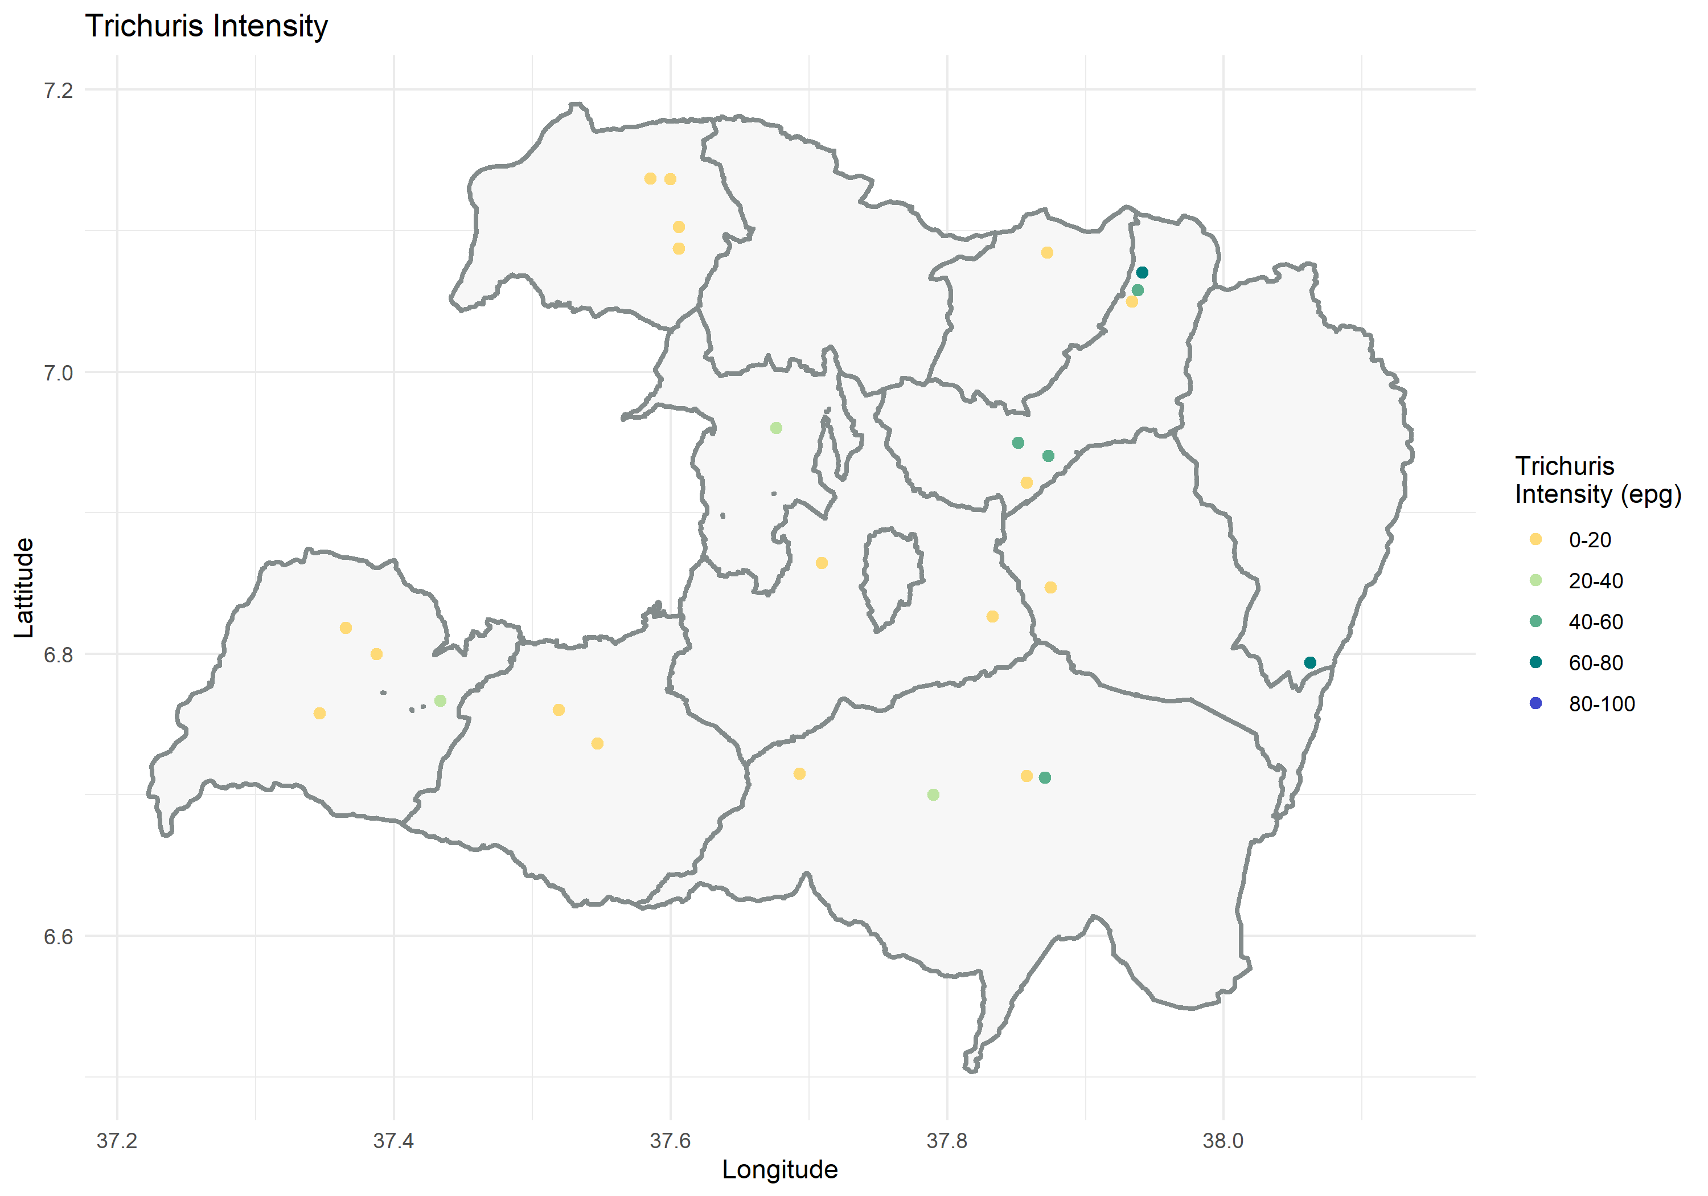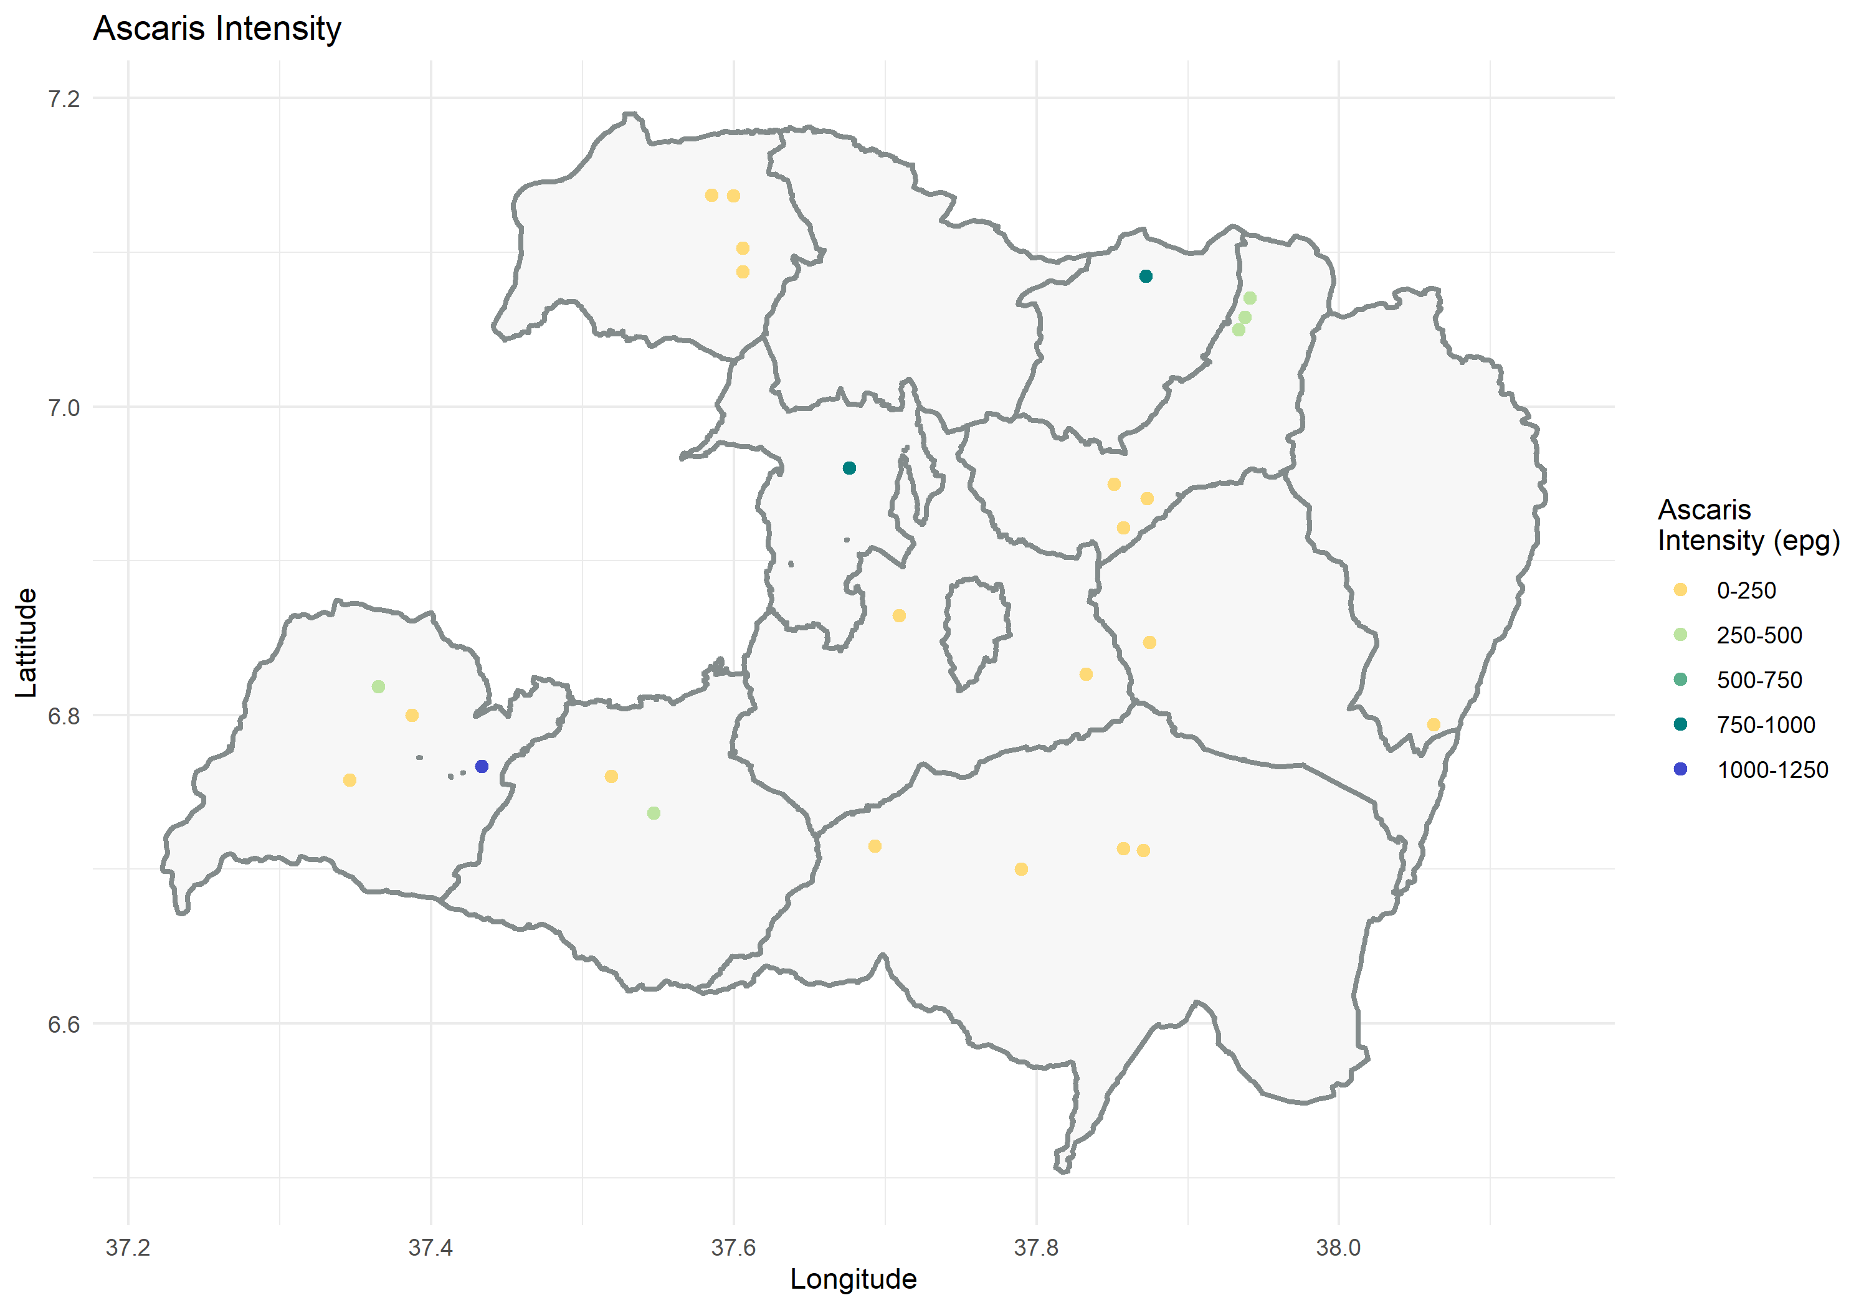**Figure 12: Maps of infection intensity**

|  |  |
| --- | --- |
|  |  |

**Table 1.13: Over all prevalence for STH and *S.mansoni* by by sex and Age group across Woredas**

|  |  |  |  |  |  |  |  |  |  |  |
| --- | --- | --- | --- | --- | --- | --- | --- | --- | --- | --- |
| Woreda | Intensity | Age Group | *S.mansoni* | | Hookworm | | *Trichuris* | | *Ascaris* | |
|  | Male | Female | Male | Female | Male | Female | Male | Female |
| Bodity | Light | 1 to 4 | 0 (0.0) | 1 (6.25) | 2 (14.29) | 2 (12.5) | 0 (0.0) | 1 (6.25) | 2 (14.29) | 3 (18.75) |
| 5 to 14 | 0 (0.0) | 0 (0.0) | 0 (0.0) | 2 (11.11) | 0 (0.0) | 0 (0.0) | 3 (15.0) | 3 (16.67) |
| 15 to 20 | 0 (0.0) | 0 (0.0) | 0 (0.0) | 0 (0.0) | 0 (0.0) | 0 (0.0) | 2 (22.22) | 4 (26.67) |
| 21 to 35 | 1 (5.26) | 0 (0.0) | 1 (0.0) | 0 (0.0) | 1 (5.26) | 0 (0.0) | 3 (15.79) | 1 (6.67) |
| 35+ | 0 (0.0) | 0 (0.0) | 0 (0.0) | 1 (7.14) | 0 (0.0) | 0 (0.0) | 1 (11.11) | 0 (0.0) |
| Moderate | 1 to 4 | 0 (0.0) | 0 (0.0) | 0 (0.0) | 0 (0.0) | 1 (14.29) | 0 (0.0) | 0 (0.0) | 0 (0.0) |
| 5 to 14 | 0 (0.0) | 0 (0.0) | 0 (0.0) | 0 (0.0) | 0 (0.0) | 0 (0.0) | 0 (0.0) | 0 (0.0) |
| 15 to 20 | 0 (0.0) | 0 (0.0) | 0 (0.0) | 0 (0.0) | 0 (0.0) | 1 (6.67) | 0 (0.0) | 1 (6.67) |
| 21 to 35 | 0 (0.0) | 0 (0.0) | 0 (0.0) | 0 (0.0) | 0 (0.0) | 0 (0.0) | 0 (0.0) | 1 (6.67) |
| 35+ | 0 (0.0) | 0 (0.0) | 0 (0.0) | 0 (0.0) | 0 (0.0) | 0 (0.0) | 0 (0.0) | 0 (0.0) |
| Heavy | 1 to 4 | 1 (14.29) | 0 (0.0) | 0 (0.0) | 0 (0.0) | 0 (0.0) | 0 (0.0) | 0 (0.0) | 0 (0.0) |
| 5 to 14 | 1 (5.0) | 0 (0.0) | 0 (0.0) | 0 (0.0) | 0 (0.0) | 0 (0.0) | 0 (0.0) | 0 (0.0) |
| 15 to 20 | 0 (0.0) | 1 (6.67) | 0 (0.0) | 0 (0.0) | 0 (0.0) | 0 (0.0) | 0 (0.0) | 0 (0.0) |
| 21 to 35 | 0 (0.0) | 0 (0.0) | 0 (0.0) | 0 (0.0) | 0 (0.0) | 0 (0.0) | 0 (0.0) | 0 (0.0) |
| 35+ | 0 (0.0) | 0 (0.0) | 0 (0.0) | 0 (0.0) | 0 (0.0) | 0 (0.0) | 0 (0.0) | 0 (0.0) |

|  |  |  |  |  |  |  |  |  |  |  |
| --- | --- | --- | --- | --- | --- | --- | --- | --- | --- | --- |
| Woreda | Intensity | Age Group | *S.mansoni* | | Hookworm | | *Trichuris* | | *Ascaris* | |
|  | Male | Female | Male | Female | Male | Female | Male | Female |
| Boloso  Bombe | Light | 1 to 4 | 1 (1.85) | 0 (0.0) | 10 (18.51) | 7 (11.67) | 1 (1.85) | 0 (0.0) | 3 (5.56) | 5 (8.33) |
| 5 to 14 | 2 (2.38) | 2 (2.86) | 6 (7.14) | 10 (14.29) | 2 (2.38) | 3 (4.29) | 10 (11.90) | 9 (12.86) |
| 15 to 20 | 0 (0.0) | 0 (0.0) | 8 (24.24) | 3 (7.32) | 0 (0.0) | 0 (0.0) | 4 (12.12) | 5 (12.20) |
| 21 to 35 | 2 (3.57) | 3 (3.70) | 16 (28.57) | 14 (17.28) | 2 (3.57) | 4 (4.94) | 5 (8.93) | 10 (12.35) |
| 35+ | 0 (0.0) | 0 (0.0) | 10 (15.63) | 12 (24.0) | 0 (0.0) | 0 (0.0) | 7 (10.94) | 2 (4.0) |
| Moderate | 1 to 4 | 0 (0.0) | 0 (0.0) | 0 (0.0) | 0 (0.0) | 0 (0.0) | 0 (0.0) | 0 (0.0) | 0 (0.0) |
| 5 to 14 | 0 (0.0) | 1 (1.43) | 0 (0.0) | 0 (0.0) | 0 (0.0) | 0 (0.0) | 0 (0.0) | 1 (1.43) |
| 15 to 20 | 0 (0.0) | 0 (0.0) | 0 (0.0) | 0 (0.0) | 0 (0.0) | 0 (0.0) | 0 (0.0) | 0 (0.0) |
| 21 to 35 | 0 (0.0) | 1 (1.23) | 0 (0.0) | 0 (0.0) | 0 (0.0) | 0 (0.0) | 0 (0.0) | 0 (0.0) |
| 35+ | 0 (0.0) | 0 (0.0) | 0 (0.0) | 0 (0.0) | 0 (0.0) | 0 (0.0) | 0 (0.0) | 0 (0.0) |
| Heavy | 1 to 4 | 0 (0.0) | 0 (0.0) | 0 (0.0) | 0 (0.0) | 0 (0.0) | 0 (0.0) | 0 (0.0) | 0 (0.0) |
| 5 to 14 | 0 (0.0) | 0 (0.0) | 0 (0.0) | 0 (0.0) | 0 (0.0) | 0 (0.0) | 0 (0.0) | 0 (0.0) |
| 15 to 20 | 0 (0.0) | 0 (0.0) | 0 (0.0) | 0 (0.0) | 0 (0.0) | 0 (0.0) | 0 (0.0) | 0 (0.0) |
| 21 to 35 | 0 (0.0) | 0 (0.0) | 0 (0.0) | 0 (0.0) | 0 (0.0) | 0 (0.0) | 0 (0.0) | 0 (0.0) |
| 35+ | 0 (0.0) | 0 (0.0) | 0 (0.0) | 0 (0.0) | 0 (0.0) | 0 (0.0) | 0 (0.0) | 0 (0.0) |

|  |  |  |  |  |  |  |  |  |  |  |
| --- | --- | --- | --- | --- | --- | --- | --- | --- | --- | --- |
| Woreda | Intensity | Age Group | s. Mansoni | | hookworm | | trichuris | | ascaris | |
|  | Male | Female | Male | Female | Male | Female | Male | Female |
| Damot Gale | Light | 1 to 4 | 1 (2.08) | 3 (7.32) | 1 (2.08) | 3 (7.32) | 1 (2.08) | 4 (9.76) | 12 (25.0) | 15 (36.59) |
| 5 to 14 | 3 (3.30) | 4 (6.67) | 0 (0.0) | 4 (6.67) | 3 (3.30) | 4 (6.67) | 16 (17.58) | 8 (13.33) |
| 15 to 20 | 2 (7.41) | 1 (3.23) | 2 (7.41) | 1 (3.23) | 2 (7.41) | 1 (3.23) | 3 (11.11) | 5 (16.13) |
| 21 to 35 | 2 (5.88) | 1 (1.45) | 1 (2.94) | 4 (5.80) | 2 (5.88) | 1 (1.45) | 8 (23.53) | 10 (14.49) |
| 35+ | 3 (6.38) | 3 (5.45) | 4 (8.51) | 2 (3.64) | 4 (8.51) | 4 (7.27) | 10 (21.28) | 14 (25.45) |
| Moderate | 1 to 4 | 0 (0.0) | 1 (2.44) | 0 (0.0) | 0 (0.0) | 0 (0.0) | 1 (2.44) | 1 (2.08) | 2 (4.88) |
| 5 to 14 | 0 (0.0) | 0 (0.0) | 0 (0.0) | 0 (0.0) | 2 (2.20) | 0 (0.0) | 0 (0.0) | 1 (1.67) |
| 15 to 20 | 0 (0.0) | 0 (0.0) | 0 (0.0) | 0 (0.0) | 1 (3.70) | 1 (3.23) | 1 (3.70) | 0 (0.0) |
| 21 to 35 | 0 (0.0) | 0 (0.0) | 0 (0.0) | 0 (0.0) | 1 (2.94) | 0 (0.0) | 0 (0.0) | 1 (1.45) |
| 35+ | 0 (0.0) | 0 (0.0) | 0 (0.0) | 0 (0.0) | 1 (2.13) | 0 (0.0) | 0 (0.0) | 0 (0.0) |
| Heavy | 1 to 4 | 0 (0.0) | 1 (2.44) | 0 (0.0) | 0 (0.0) | 0 (0.0) | 0 (0.0) | 0 (0.0) | 0 (0.0) |
| 5 to 14 | 2 (2.20) | 0 (0.0) | 0 (0.0) | 0 (0.0) | 0 (0.0) | 0 (0.0) | 0 (0.0) | 0 (0.0) |
| 15 to 20 | 1 (3.70) | 1 (3.23) | 0 (0.0) | 0 (0.0) | 0 (0.0) | 0 (0.0) | 0 (0.0) | 0 (0.0) |
| 21 to 35 | 1 (2.94) | 0 (0.0) | 0 (0.0) | 0 (0.0) | 0 (0.0) | 0 (0.0) | 0 (0.0) | 0 (0.0) |
| 35+ | 2 (4.26) | 1 (1.82) | 0 (0.0) | 0 (0.0) | 0 (0.0) | 0 (0.0) | 0 (0.0) | 0 (0.0) |

|  |  |  |  |  |  |  |  |  |  |  |
| --- | --- | --- | --- | --- | --- | --- | --- | --- | --- | --- |
| Woreda | Intensity | Age Group | s. Mansoni | | hookworm | | trichuris | | ascaris | |
|  | Male | Female | Male | Female | Male | Female | Male | Female |
| DamotPulasa | Light | 1 to 4 | 2 (6.25) | 3 (10.34) | 0 (0.0) | 0 (0.0) | 2 (6.25) | 3 (10.34) | 6 (18.75) | 8 (27.59) |
| 5 to 14 | 3 (9.38) | 3 (10.0) | 1 (3.13) | 0 (0.0) | 5 (15.63) | 4 (13.33) | 7 (21.88) | 10 (33.33) |
| 15 to 20 | 1 (3.70) | 1 (3.23) | 4 (14.81) | 0 (0.0) | 1 (3.70) | 2 (6.45) | 6 (22.22) | 7 (22.58) |
| 21 to 35 | 0 (0.0) | 3 (9.68) | 1 (3.33) | 0 (0.0) | 0 (0.0) | 3 (9.68) | 3 (10.0) | 5 (16.13) |
| 35+ | 0 (0.0) | 2 (6.67) | 0 (0.0) | 0 (0.0) | 0 (0.0) | 3 (10.0) | 2 (7.14) | 5 (16.67) |
| Moderate | 1 to 4 | 0 (0.0) | 0 (0.0) | 0 (0.0) | 0 (0.0) | 0 (0.0) | 0 (0.0) | 2 (6.25) | 0 (0.0) |
| 5 to 14 | 2 (6.25) | 1 (3.33) | 0 (0.0) | 0 (0.0) | 0 (0.0) | 0 (0.0) | 1 (3.13) | 2 (6.66) |
| 15 to 20 | 0 (0.0) | 0 (0.0) | 0 (0.0) | 0 (0.0) | 0 (0.0) | 0 (0.0) | 2 (7.41) | 2 (6.45) |
| 21 to 35 | 0 (0.0) | 0 (0.0) | 0 (0.0) | 0 (0.0) | 0 (0.0) | 0 (0.0) | 0 (0.0) | 1 (3.23) |
| 35+ | 0 (0.0) | 1 (3.33) | 0 (0.0) | 0 (0.0) | 0 (0.0) | 0 (0.0) | 0 (0.0) | 1 (3.33) |
| Heavy | 1 to 4 | 0 (0.0) | 0 (0.0) | 0 (0.0) | 0 (0.0) | 0 (0.0) | 0 (0.0) | 0 (0.0) | 0 (0.0) |
| 5 to 14 | 0 (0.0) | 0 (0.0) | 0 (0.0) | 0 (0.0) | 0 (0.0) | 0 (0.0) | 0 (0.0) | 0 (0.0) |
| 15 to 20 | 0 (0.0) | 1 (3.70) | 0 (0.0) | 0 (0.0) | 0 (0.0) | 0 (0.0) | 0 (0.0) | 0 (0.0) |
| 21 to 35 | 0 (0.0) | 0 (0.0) | 0 (0.0) | 0 (0.0) | 0 (0.0) | 0 (0.0) | 0 (0.0) | 0 (0.0) |
| 35+ | 0 (0.0) | 0 (0.0) | 0 (0.0) | 0 (0.0) | 0 (0.0) | 0 (0.0) | 0 (0.0) | 0 (0.0) |

|  |  |  |  |  |  |  |  |  |  |  |
| --- | --- | --- | --- | --- | --- | --- | --- | --- | --- | --- |
| Woreda | Intensity | Age Group | s. Mansoni | | hookworm | | trichuris | | ascaris | |
|  | Male | Female | Male | Female | Male | Female | Male | Female |
| Damot Sore | Light | 1 to 4 | 2 (11.11) | 0 (0.0) | 1 (5.56) | 1 (8.33) | 2 (11.11) | 0 (0.0) | 9 (50.0) | 7 (58.33) |
| 5 to 14 | 1 (5.56) | 1 (5.56) | 0 (0.0) | 1 (5.56) | 1 (5.56) | 1 (5.56) | 4 (22.22) | 5 (27.78) |
| 15 to 20 | 0 (0.0) | 2 (14.29) | 1 (7.69) | 3 (21.43) | 0 (0.0) | 2 (14.29) | 4 (15.38) | 2 (14.29) |
| 21 to 35 | 1 (7.69) | 0 (0.0) | 4 (30.77) | 0 (0.0) | 2 (15.38) | 0 (0.0) | 3 (23.08) | 4 (25.0) |
| 35+ | 1 (5.88) | 0 (0.0) | 2 (11.76) | 1 (7.69) | 1 (5.88) | 0 (0.0) | 4 (23.53) | 4 (30.77) |
| Moderate | 1 to 4 | 0 (0.0) | 0 (0.0) | 0 (0.0) | 0 (0.0) | 0 (0.0) | 0 (0.0) | 1 (5.56) | 0 (0.0) |
| 5 to 14 | 0 (0.0) | 0 (0.0) | 0 (0.0) | 0 (0.0) | 0 (0.0) | 0 (0.0) | 1 (5.56) | 1 (5.56) |
| 15 to 20 | 0 (0.0) | 0 (0.0) | 0 (0.0) | 0 (0.0) | 1 (7.69) | 1 (7.14) | 0 (0.0) | 1 (7.14) |
| 21 to 35 | 1 (7.69) | 0 (0.0) | 0 (0.0) | 0 (0.0) | 0 (0.0) | 0 (0.0) | 0 (0.0) | 1 (6.25) |
| 35+ | 0 (0.0) | 0 (0.0) | 0 (0.0) | 0 (0.0) | 0 (0.0) | 0 (0.0) | 0 (0.0) | 1 (7.69) |
| Heavy | 1 to 4 | 0 (0.0) | 0 (0.0) | 0 (0.0) | 0 (0.0) | 0 (0.0) | 0 (0.0) | 0 (0.0) | 0 (0.0) |
| 5 to 14 | 0 (0.0) | 0 (0.0) | 0 (0.0) | 0 (0.0) | 0 (0.0) | 0 (0.0) | 0 (0.0) | 0 (0.0) |
| 15 to 20 | 1 (7.69) | 1 (7.14) | 0 (0.0) | 0 (0.0) | 0 (0.0) | 0 (0.0) | 0 (0.0) | 0 (0.0) |
| 21 to 35 | 0 (0.0) | 0 (0.0) | 0 (0.0) | 0 (0.0) | 0 (0.0) | 0 (0.0) | 0 (0.0) | 0 (0.0) |
| 35+ | 0 (0.0) | 0 (0.0) | 0 (0.0) | 0 (0.0) | 0 (0.0) | 0 (0.0) | 0 (0.0) | 0 (0.0) |

|  |  |  |  |  |  |  |  |  |  |  |
| --- | --- | --- | --- | --- | --- | --- | --- | --- | --- | --- |
| Woreda | Intensity | Age Group | s. Mansoni | | hookworm | | trichuris | | ascaris | |
|  | Male | Female | Male | Female | Male | Female | Male | Female |
| DamotWoydie | Light | 1 to 4 | 0 (0.0) | 0 (0.0) | 1 (3.13) | 0 (0.0) | 0 (0.0) | 0 (0.0) | 1 (3.13) | 0 (0.0) |
| 5 to 14 | 1 (2.13) | 0 (0.0) | 3 (6.38) | 4 (10.82) | 1 (2.13) | 0 (0.0) | 3 (6.38) | 2 (5.41) |
| 15 to 20 | 0 (0.0) | 0 (0.0) | 1 (5.88) | 2 (9.09) | 0 (0.0) | 0 (0.0) | 1 (5.88) | 0 (0.0) |
| 21 to 35 | 1 (4.55) | 0 (0.0) | 1 (4.55) | 3 (6.12) | 1 (4.55) | 0 (0.0) | 1 (4.55) | 2 (4.08) |
| 35+ | 0 (0.0) | 0 (0.0) | 1 (3.45) | 1 (3.57) | 0 (0.0) | 0 (0.0) | 0 (0.0) | 1 (3.57) |
| Moderate | 1 to 4 | 0 (0.0) | 0 (0.0) | 0 (0.0) | 0 (0.0) | 0 (0.0) | 0 (0.0) | 0 (0.0) | 0 (0.0) |
| 5 to 14 | 0 (0.0) | 0 (0.0) | 0 (0.0) | 0 (0.0) | 0 (0.0) | 0 (0.0) | 0 (0.0) | 0 (0.0) |
| 15 to 20 | 0 (0.0) | 0 (0.0) | 0 (0.0) | 0 (0.0) | 0 (0.0) | 0 (0.0) | 0 (0.0) | 0 (0.0) |
| 21 to 35 | 0 (0.0) | 0 (0.0) | 0 (0.0) | 0 (0.0) | 0 (0.0) | 0 (0.0) | 0 (0.0) | 0 (0.0) |
| 35+ | 0 (0.0) | 0 (0.0) | 0 (0.0) | 0 (0.0) | 0 (0.0) | 0 (0.0) | 0 (0.0) | 0 (0.0) |
| Heavy | 1 to 4 | 0 (0.0) | 0 (0.0) | 0 (0.0) | 0 (0.0) | 0 (0.0) | 0 (0.0) | 0 (0.0) | 0 (0.0) |
| 5 to 14 | 0 (0.0) | 0 (0.0) | 0 (0.0) | 0 (0.0) | 0 (0.0) | 0 (0.0) | 0 (0.0) | 0 (0.0) |
| 15 to 20 | 0 (0.0) | 0 (0.0) | 0 (0.0) | 0 (0.0) | 0 (0.0) | 0 (0.0) | 0 (0.0) | 0 (0.0) |
| 21 to 35 | 0 (0.0) | 0 (0.0) | 0 (0.0) | 0 (0.0) | 0 (0.0) | 0 (0.0) | 0 (0.0) | 0 (0.0) |
| 35+ | 0 (0.0) | 0 (0.0) | 0 (0.0) | 0 (0.0) | 0 (0.0) | 0 (0.0) | 0 (0.0) | 0 (0.0) |

|  |  |  |  |  |  |  |  |  |  |  |
| --- | --- | --- | --- | --- | --- | --- | --- | --- | --- | --- |
| Woreda | Intensity | Age Group | s. Mansoni | | hookworm | | trichuris | | ascaris | |
|  | Male | Female | Male | Female | Male | Female | Male | Female |
| DigunaFango | Light | 1 to 4 | 0 (0.0) | 0 (0.0) | 0 (0.0) | 0 (0.0) | 0 (0.0) | 0 (0.0) | 0 (0.0) | 4 (28.57) |
| 5 to 14 | 0 (0.0) | 0 (0.0) | 0 (0.0) | 0 (0.0) | 0 (0.0) | 0 (0.0)) | 2 | 6 (37.5) |
| 15 to 20 | 0 (0.0) | 1 (5.88) | 0 (0.0) | 0 (0.0) | 0 (0.0) | 1 (5.88 | 0 (0.0) | 3 (18.75) |
| 21 to 35 | 0 (0.0) | 1 (7.69) | 0 (0.0) | 0 (0.0) | 0 (0.0) | 1 (7.69) | 2 (13.33) | 3 (23.08) |
| 35+ | 0 (0.0) | 0 (0.0) | 2 (15.38) | 1 (6.67) | 0 (0.0) | 0 (0.0) | 17.69) | 5 (33.33) |
| Moderate | 1 to 4 | 0 (0.0) | 0 (0.0) | 0 (0.0) | 0 (0.0) | 0 (0.0) | 0 (0.0) | 0 (0.0) | 0 (0.0) |
| 5 to 14 | 0 (0.0) | 0 (0.0) | 0 (0.0) | 0 (0.0) | 0 (0.0) | 2 (12.5) | 0 (0.0) | 0 (0.0) |
| 15 to 20 | 0 (0.0) | 0 (0.0) | 0 (0.0) | 0 (0.0) | 0 (0.0) | 0 (0.0) | 0 (0.0) | 0 (0.0) |
| 21 to 35 | 0 (0.0) | 0 (0.0) | 0 (0.0) | 0 (0.0) | 0 (0.0) | 0 (0.0) | 0 (0.0) | 0 (0.0) |
| 35+ | 0 (0.0) | 0 (0.0) | 0 (0.0) | 0 (0.0) | 0 (0.0) | 0 (0.0) | 0 (0.0) | 0 (0.0) |
| Heavy | 1 to 4 | 0 (0.0) | 0 (0.0) | 0 (0.0) | 0 (0.0) | 0 (0.0) | 0 (0.0) | 0 (0.0) | 0 (0.0) |
| 5 to 14 | 0 (0.0) | 2 (12.5) | 0 (0.0) | 0 (0.0) | 0 (0.0) | 0 (0.0) | 0 (0.0) | 0 (0.0) |
| 15 to 20 | 0 (0.0) | 0 (0.0) | 0 (0.0) | 0 (0.0) | 0 (0.0) | 0 (0.0) | 0 (0.0) | 0 (0.0) |
| 21 to 35 | 0 (0.0) | 0 (0.0) | 0 (0.0) | 0 (0.0) | 0 (0.0) | 0 (0.0) | 0 (0.0) | 0 (0.0) |
| 35+ | 0 (0.0) | 0 (0.0) | 0 (0.0) | 0 (0.0) | 0 (0.0) | 0 (0.0) | 0 (0.0) | 0 (0.0) |

|  |  |  |  |  |  |  |  |  |  |  |
| --- | --- | --- | --- | --- | --- | --- | --- | --- | --- | --- |
| Woreda | Intensity | Age Group | s. Mansoni | | hookworm | | trichuris | | ascaris | |
| Male | Female | Male | Female | Male | Female | Male | Female |
| Abela Abaya | Light | 1 to 4 | 0 (0.0) | 0 (0.0) | 10 (19.61) | 9 (16.07) | 0 (0.0) | 0 (0.0) | 0 (0.0) | 1 (1.79) |
| 5 to 14 | 0 (0.0) | 2 (2.60) | 7 (8.64) | 11 (14.29) | 0 (0.0) | 2 (2.60) | 2 (2.47) | 0 (0.0) |
| 15 to 20 | 1 (1.82) | 0 (0.0) | 12 (21.82) | 13 (22.81) | 1 (1.82) | 0 (0.0) | 1 (1.82) | 0 (0.0) |
| 21 to 35 | 0 (0.0) | 0 (0.0) | 12 (21.05) | 16 (20.78) | 0 (0.0) | 0 (0.0) | 0 (0.0) | 2 (2.60) |
| 35+ | 0 (0.0) | 1 (1.72) | 15 (27.78) | 13 (22.41) | 0 (0.0) | 1 (1.72) | 0 (0.0) | 3 (5.17) |
| Moderate | 1 to 4 | 0 (0.0) | 0 (0.0) | 0 (0.0) | 0 (0.0) | 0 (0.0) | 0 (0.0) | 0 (0.0) | 0 (0.0) |
| 5 to 14 | 0 (0.0) | 0 (0.0) | 0 (0.0) | 0 (0.0) | 2 (2.47) | 0 (0.0) | 0 (0.0) | 0 (0.0) |
| 15 to 20 | 0 (0.0) | 0 (0.0) | 0 (0.0) | 1 (1.75) | 1 (1.82) | 0 (0.0) | 0 (0.0) | 0 (0.0) |
| 21 to 35 | 0 (0.0) | 0 (0.0) | 0 (0.0) | 0 (0.0) | 0 (0.0) | 1 (1.60) | 0 (0.0) | 0 (0.0) |
| 35+ | 0 (0.0) | 0 (0.0) | 0 (0.0) | 0 (0.0) | 0 (0.0) | 2 (3.45) | 0 (0.0) | 0 (0.0) |
| Heavy | 1 to 4 | 0 (0.0) | 0 (0.0) | 0 (0.0) | 0 (0.0) | 0 (0.0) | 0 (0.0) | 0 (0.0) | 0 (0.0) |
| 5 to 14 | 2 (2.47) | 0 (0.0) | 0 (0.0) | 0 (0.0) | 0 (0.0) | 0 (0.0) | 0 (0.0) | 0 (0.0) |
| 15 to 20 | 1 (1.82) | 0 (0.0) | 0 (0.0) | 0 (0.0) | 0 (0.0) | 0 (0.0) | 0 (0.0) | 0 (0.0) |
| 21 to 35 | 0 (0.0) | 1 (1.60) | 0 (0.0) | 0 (0.0) | 0 (0.0) | 0 (0.0) | 0 (0.0) | 0 (0.0) |
| 35+ | 0 (0.0) | 2 (3.45) | 0 (0.0) | 0 (0.0) | 0 (0.0) | 0 (0.0) | 0 (0.0) | 0 (0.0) |

|  |  |  |  |  |  |  |  |  |  |  |
| --- | --- | --- | --- | --- | --- | --- | --- | --- | --- | --- |
| Woreda | Intensity | Age Group | s. Mansoni | | hookworm | | trichuris | | ascaris | |
|  | Male | Female | Male | Female | Male | Female | Male | Female |
| Kindo Didaye | Light | 1 to 4 | 0 (0.0) | 0 (0.0) | 7 (15.22) | 6 (17.14) | 0 (0.0) | 0 (0.0) | 11 (23.91) | 3 (8.57) |
| 5 to 14 | 0 (0.0) | 0 (0.0) | 7 (12.28) | 4 (9.09) | 0 (0.0) | 0 (0.0) | 7 (12.28) | 11 (25.0) |
| 15 to 20 | 0 (0.0) | 0 (0.0) | 6 (13.95) | 9 (17.65) | 0 (0.0) | 0 (0.0) | 8 (18.60) | 9 (17.65) |
| 21 to 35 | 0 (0.0) | 1 (2.04) | 10 (29.41) | 9 (18.37 | 0 (0.0) | 1 (2.04) | 7 (20.59) | 12 (6.12) |
| 35+ | 1 (2.33) | 2 (4.35) | 10 (23.26) | 9 (19.57) | 1 (2.33) | 2 (4.35) | 5 (11.63) | 5 (10.87) |
| Moderate | 1 to 4 | 0 (0.0) | 0 (0.0) | 0 (0.0) | 0 (0.0) | 1 (2.17) | 0 (0.0) | 0 (0.0) | 0 (0.0) |
| 5 to 14 | 0 (0.0) | 0 (0.0) | 0 (0.0) | 0 (0.0) | 1 (1.75) | 0 (0.0) | 2 (3.51) | 0 (0.0) |
| 15 to 20 | 0 (0.0) | 0 (0.0) | 0 (0.0) | 0 (0.0) | 0 (0.0) | 0 (0.0) | 0 (0.0) | 1 (1.96) |
| 21 to 35 | 0 (0.0) | 0 (0.0) | 0 (0.0) | 0 (0.0) | 0 (0.0) | 0 (0.0) | 1 (2.94 | 1 (2.04) |
| 35+ | 0 (0.0) | 0 (0.0) | 0 (0.0) | 0 (0.0) | 0 (0.0) | 1 (2.17) | 0 (0.0) | 0 (0.0) |
| Heavy | 1 to 4 | 1 (2.17) | 0 (0.0) | 0 (0.0) | 0 (0.0) | 0 (0.0) | 0 (0.0) | 0 (0.0) | 0 (0.0) |
| 5 to 14 | 1 (1.75) | 0 (0.0) | 0 (0.0) | 0 (0.0) | 0 (0.0) | 0 (0.0) | 0 (0.0) | 0 (0.0) |
| 15 to 20 | 0 (0.0) | 0 (0.0) | 0 (0.0) | 1 (1.96) | 0 (0.0) | 0 (0.0) | 0 (0.0) | 0 (0.0) |
| 21 to 35 | 0 (0.0) | 0 (0.0) | 0 (0.0) | 0 (0.0) | 0 (0.0) | 0 (0.0) | 0 (0.0) | 0 (0.0) |
| 35+ | 0 (0.0) | 1 (2.17) | 0 (0.0) | 0 (0.0) | 0 (0.0) | 0 (0.0) | 0 (0.0) | 0 (0.0) |

|  |  |  |  |  |  |  |  |  |  |  |
| --- | --- | --- | --- | --- | --- | --- | --- | --- | --- | --- |
| Woreda | Intensity | Age Group | s. Mansoni | | hookworm | | trichuris | | ascaris | |
|  | Male | Female | Male | Female | Male | Female | Male | Female |
| Offa | Light | 1 to 4 | 0 (0.0) | 1 (3.13) | 10 (33.33) | 9 (28.13) | 0 (0.0) | 1 (3.13) | 7 (21.88) | 0 (0.0) |
| 5 to 14 | 0 (0.0) | 1 (2.78) | 6 (19.35) | 9 (29.03) | 0 (0.0) | 1 (2.78) | 5 (16.13) | 4 (12.90) |
| 15 to 20 | 1 (3.45) | 0 (0.0) | 14 (48.28) | 9 (29.03) | 1 (3.45) | 0 (0.0) | 1 (3.45) | 3 (9.68 |
| 21 to 35 | 1 (3.57) | 1 (2.94) | 12 (42.86) | 13 (38.24) | 1 (3.57) | 1 (2.94) | 4 (14.29) | 4 (11.76) |
| 35+ | 0 (0.0) | 0 (0.0) | 12 (41.38) | 7 (25.93) | 0 (0.0) | 0 (0.0) | 3 (10.34) | 1 (3.70) |
| Moderate | 1 to 4 | 0 (0.0) | 0 (0.0) | 0 (0.0) | 0 (0.0) | 0 (0.0) | 0 (0.0) | 1 (3.33 | 0 (0.0) |
| 5 to 14 | 0 (0.0) | 0 (0.0) | 0 (0.0) | 0 (0.0) | 0 (0.0) | 0 (0.0) | 0 (0.0) | 1 (3.23) |
| 15 to 20 | 0 (0.0) | 0 (0.0) | 0 (0.0) | 0 (0.0) | 0 (0.0) | 0 (0.0) | 1 (3.45) | 0 (0.0) |
| 21 to 35 | 0 (0.0) | 0 (0.0) | 0 (0.0) | 0 (0.0) | 0 (0.0) | 0 (0.0) | 0 (0.0) | 0 (0.0) |
| 35+ | 0 (0.0) | 0 (0.0) | 0 (0.0) | 0 (0.0) | 0 (0.0) | 0 (0.0) | 0 (0.0) | 0 (0.0) |
| Heavy | 1 to 4 | 0 (0.0) | 0 (0.0) | 0 (0.0) | 0 (0.0) | 0 (0.0) | 0 (0.0) | 0 (0.0) | 0 (0.0) |
| 5 to 14 | 0 (0.0) | 0 (0.0) | 0 (0.0) | 0 (0.0) | 0 (0.0) | 0 (0.0) | 0 (0.0) | 0 (0.0) |
| 15 to 20 | 0 (0.0) | 0 (0.0) | 0 (0.0) | 0 (0.0) | 0 (0.0) | 0 (0.0) | 0 (0.0) | 0 (0.0) |
| 21 to 35 | 0 (0.0) | 0 (0.0) | 0 (0.0) | 0 (0.0) | 0 (0.0) | 0 (0.0) | 0 (0.0) | 0 (0.0) |
| 35+ | 0 (0.0) | 0 (0.0) | 1 (3.45) | 1 (3.70) | 0 (0.0) | 0 (0.0) | 0 (0.0) | 0 (0.0) |

|  |  |  |  |  |  |  |  |  |  |  |
| --- | --- | --- | --- | --- | --- | --- | --- | --- | --- | --- |
| Woreda | Intensity | Age Group | s. Mansoni | | Hookworm | | trichuris | | ascaris | |
|  | Male | Female | Male | Female | Male | Female | Male | Female |
| SodoZuria | Light | 1 to 4 | 0 (0.0) | 0 (0.0) | 0 (0.0) | 1 (3.33) | 0 (0.0) | 0 (0.0) | 0 (0.0) | 1 (3.33) |
| 5 to 14 | 0 (0.0) | 0 (0.0) | 1 (2.38) | 1 (2.63) | 1 (2.38) | 0 (0.0) | 1 (2.38) | 0 (0.0) |
| 15 to 20 | 0 (0.0) | 0 (0.0) | 4 (14.29) | 0 (0.0) | 0 (0.0) | 0 (0.0) | 0 (0.0) | 0 (0.0) |
| 21 to 35 | 0 (0.0) | 0 (0.0) | 2 (7.14) | 1 (3.33) | 0 (0.0) | 0 (0.0) | 0 (0.0) | 0 (0.0) |
| 35+ | 0 (0.0) | 1 (3.13) | 2 (6.45) | 2 (6.25) | 0 (0.0) | 1 (3.13) | 0 (0.0) | 0 (0.0) |
| Moderate | 1 to 4 | 0 (0.0) | 0 (0.0) | 0 (0.0) | 0 (0.0) | 0 (0.0) | 0 (0.0) | 0 (0.0) | 0 (0.0) |
| 5 to 14 | 0 (0.0) | 0 (0.0) | 0 (0.0) | 0 (0.0) | 0 (0.0) | 0 (0.0) | 0 (0.0) | 0 (0.0) |
| 15 to 20 | 0 (0.0) | 0 (0.0) | 0 (0.0) | 0 (0.0) | 0 (0.0) | 0 (0.0) | 0 (0.0) | 0 (0.0) |
| 21 to 35 | 0 (0.0) | 0 (0.0) | 0 (0.0) | 0 (0.0) | 0 (0.0) | 0 (0.0) | 0 (0.0) | 0 (0.0) |
| 35+ | 0 (0.0) | 0 (0.0) | 0 (0.0) | 0 (0.0) | 0 (0.0) | 0 (0.0) | 0 (0.0) | 0 (0.0) |
| Heavy | 1 to 4 | 0 (0.0) | 0 (0.0) | 0 (0.0) | 0 (0.0) | 0 (0.0) | 0 (0.0) | 0 (0.0) | 0 (0.0) |
| 5 to 14 | 1 (2.38) | 0 (0.0) | 0 (0.0) | 0 (0.0) | 0 (0.0) | 0 (0.0) | 0 (0.0) | 0 (0.0) |
| 15 to 20 | 0 (0.0) | 0 (0.0) | 0 (0.0) | 0 (0.0) | 0 (0.0) | 0 (0.0) | 0 (0.0) | 0 (0.0) |
| 21 to 35 | 0 (0.0) | 0 (0.0) | 0 (0.0) | 0 (0.0) | 0 (0.0) | 0 (0.0) | 0 (0.0) | 0 (0.0) |
| 35+ | 0 (0.0) | 0 (0.0) | 0 (0.0) | 0 (0.0) | 0 (0.0) | 0 (0.0) | 0 (0.0) | 1. (0.0) |