Table of Contents
Chapter 1—Project Overview 1
1.1. Product Overview 1
1.2. Project Site 1
1.3. Background of the Client 1
1.4. Proposed Solution 1
1.4.1. Product Summary 1
1.4.2. List of Features 2
Chapter 2—The Company 2
2.1. Company Profile 2
2.2. Company Logo 3
2.3. Company Vision 3
2.4. Company Mission 3
2.5. Company Goals 3
2.6. Company Organizational Structure 3
2.6.1. Overall Team Structure 3
2.6.2. Management Team 4
2.6.3. Analysis and Design Team 4
2.6.4. Development Team 4
2.6.5. Testing Team 4
2.6.6. Training Team 5
2.6.7. Documentation Team 5
2.7. Company Policy 5
2.7.1. Management Rules 5
2.7.2. Technical Rules 5
2.7.3. Funding 6
2.7.4. Penalties 6
2.7.5. Expulsion 6
2.8. Company Agreement 7
2.9. Client Agreement 8
Chapter 3 – Project Plan and Schedule 9
3.1. Action Plan 9
3.2. Work Breakdown Structure 14
3.3. Network Diagram 15
16
16
16
3.4. Milestones and Deliverables 17
3.5. Gantt Chart 20
Chapter 4 – Project Cost 21
4.1. Cost of Project Resources 21
4.1.1. Effort Cost 21
4.1.2. Hardware Cost 21
4.1.3. Software Cost 21
4.1.4. Miscellaneous Cost 22
4.1.5. Overall Cost 22
4.2. Return-On-Investment 22
4.3. Intangible Benefits 23
Chapter 5 – Project Feasibility 24
5.1. Candidate Solution Matrix 24
5.2. Technology Gap Analysis 25
5.3. Feasibility Study 25
5.3.1. Operational Feasibility 25
5.3.2. Technical Feasibility 26
5.3.3. Schedule Feasibility 27
5.3.4. Economic Feasibility 29
5.3.5. Cultural Feasibility 32
5.3.6. Legal Feasibility 32
5.4. Feasibility Analysis Matrix 33
Chapter 6– System Requirements 34
6.1. Functional Requirements 34
6.2. Non-Functional Requirements 54

List of Tables
Table 1: Action Plan 13
Table 2: Milestones and Deliverables 19
Table 3: Effort Cost 21
Table 4: Hardware Cost 21
Table 5: Software Cost 21
Table 6: Miscellaneous Cost 22
Table 7: Overall Cost 22
Table 8: Development Cost 22
Table 9: Operational Cost 23
Table 10: Benefits 23
Table 11: Candidate Solution Matrix 24
Table 12: Technology Gap Analysis 25
Table 13: People Resources 27
Table 14: Feasibility Analysis Matrix 33

List of Figures
Figure I: The EFIXXO Logo 3
Figure II: EFIXXO Overall Structure 3
Figure III: EFIXXO Management Team 4
Figure IV: EFIXXO Analysis and Design Team 4
Figure V: EFIXXO Development Team 4
Figure VI: EFIXXO Testing Team 4
Figure VII: EFIXXO Training Team 5
Figure VIII: EFIXXO Documentation Team 5
Figure IX: EFIXXO Work Breakdown Structure 14
Figure X: EFIXXO Network Diagram 16
Figure XI: EFIXXO Gantt Chart 20
Figure XII: Implementation Plan 27

Chapter 1—Project Overview

1.1. Product Overview

Small, family-run cake shops, like our client’s depend on efficient inventory and transaction management to thrive. Many rely on handwritten logbooks and manual point-of-sale (POS) systems, leading to inefficiencies, errors in stock tracking, and slow transaction processing. CakeTrack is a web-based solution designed to modernize operations for our client’s cake shop, streamlining inventory, transactions, and order management to enhance customer service and operational efficiency.
This shop face challenges with manual systems, including stock miscalculations, inaccurate sales records, and difficulty tracking customer orders. CakeTrack addresses these issues with a user-friendly system featuring real-time inventory tracking, a modern POS, and dedicated interfaces for clients, bakers, and cashiers. By digitizing processes, it reduces errors, improves transparency, and supports business growth, allowing owners to focus on creating delightful customer experiences.

1.2. Project Site

The client’s cake shop, located at Boalan, MCLL Highway, Zamboanga City, Philippines, has been operating for six months and is steadily growing. Known for its welcoming environment and custom cakes, the shop creates a delightful experience for customers. However, its reliance on handwritten logs for orders, inventory, and transactions leads to inefficiencies and risks of data loss. Without a digital system, tracking purchase histories and custom orders is challenging, reducing transparency between the owner and staff.
CakeTrack modernizes these processes with tailored interfaces such as a client-facing UI for placing orders, a baker’s UI for managing transactions and inventory, and a cashier’s POS interface. Features like real-time inventory tracking and custom order management streamline operations while preserving the shop’s customer-focused approach, supporting its growth and success.

1.3. Background of the Client

Ms. Michelle, a skilled baker, owns a growing cake shop in Boalan, MCLL Highway, Zamboanga City, Philippines. Renowned for her custom cakes and welcoming shop atmosphere, she has built loyal customers in no time. Managing all operations—baking, inventory, and order coordination—using handwritten logs leads to inefficiencies and errors. So, Ms. Michelle seeks to implement CakeTrack to streamline operations with real-time inventory tracking, a POS system, and digital order management, including custom orders. This will enhance transparency, improve customer interactions, and allow her to focus on baking while supporting her shop’s growth.

1.4. Proposed Solution

1.4.1. Product Summary

CakeTrack is a user-friendly, web-based system tailored to our client, Ms. Michelle. It replaces inefficient paper-based processes with digital solutions for inventory, transactions, and order management. Designed to align with the shop’s workflow, CakeTrack enhances efficiency while maintaining its welcoming, customer-centric atmosphere.

The system features three distinct interfaces: a client UI for placing custom orders, a baker UI for managing inventory, transactions, and orders, and a cashier UI for processing sales via an integrated POS. With real-time inventory tracking, custom order capabilities, CakeTrack reduces errors, improves transparency, and supports informed decision-making, empowering owners and staff to manage operations effectively.

1.4.2. List of Features

Client Interface
- Choose preset cakes and pastries via selection feature
- Add custom order requirements
- Save customer info and order history for personalized service
Baker Interface
- Monitor stock, usage, and receive auto-updates
- View all past sales and orders
- Process orders and access customer details via CRM
- Inventory Tracking
Cashier Interface (POS)
- Fast, accurate checkout via POS
- Real-time tracking replaces manual logs
- Monitor sales per item and order
Customer-Relationship Management (CRM)
- Register new customers with custom intake forms
- Digitally store personal and contact information

Chapter 2—The Company

2.1. Company Profile

Born from innovation and teamwork, EFIXXO is a forward-thinking software development company founded on August 14, 2025, by five passionate information technology students from the College of Computing Studies at Western Mindanao State University. Dedicated to using efficiency to ease out complexity, we craft solutions that make technology work seamlessly for people.

EFIXXO is a combination of the words 'Ef,' which relates to efficiency, a core value of the company in producing streamlined and easy-to-use solutions, and '-xo,' which comes from 'execution' and 'optimization,' representing the company's commitment to precision and continuous development.

From streamlining workflows to modernizing traditional methods, our solutions aim to bring simplicity and efficiency to everyday tasks. Whether it is helping businesses shift to digital tools or building apps that make life easier, we at EFIXXO focus on creating practical, reliable, and user-friendly tech.


2.2. Company Logo

Figure I: The EFIXXO Logo
The logo uses a hexagonal form with embedded “E” and “F” to reflect EFIXXO’s focus on efficiency and simplifying complexity. Orange conveys energy and action; blue represents trust and clarity—together symbolizing reliable, user-friendly solutions.

2.3. Company Vision

To see through a better technological experience across different clients, both traditional and advanced. We strive to bridge the gap between old and new systems with solutions that are simple, effective, and user-friendly.

2.4. Company Mission

EFIXXO commits to provide a seamless shift from traditional approaches to a more digital, networked platform, ensuring that technology is usable, efficient, and never intimidating for our customers.

2.5. Company Goals

- To improve human experience through the effective use of technology.
- To secure life through modern innovation; and
- To contribute to human progress through advancements in digital technology.

2.6. Company Organizational Structure

2.6.1. Overall Team Structure
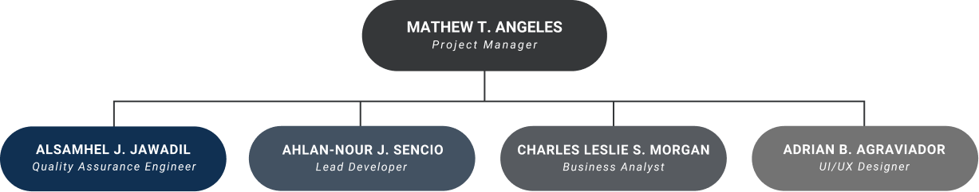
Figure II: EFIXXO Overall Structure

2.6.2. Management Team
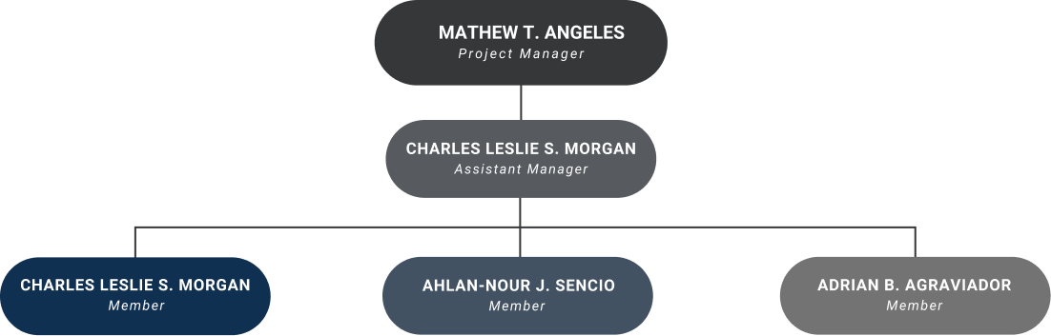
Figure III: EFIXXO Management Team

2.6.3. Analysis and Design Team
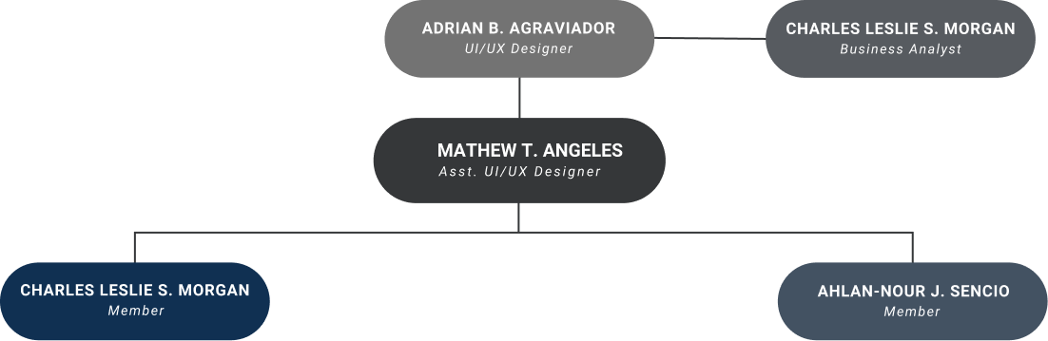Figure IV: EFIXXO Analysis and Design Team

2.6.4. Development Team
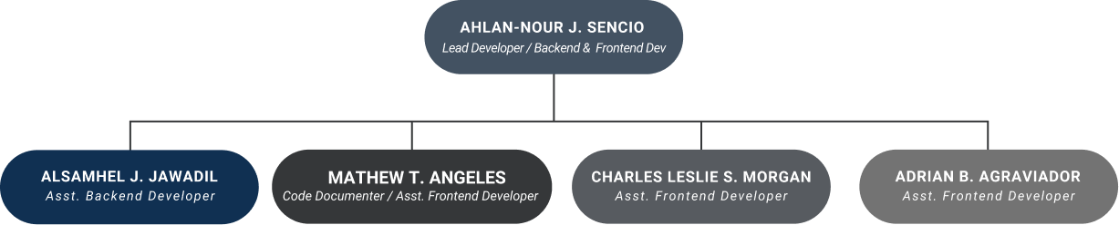
Figure V: EFIXXO Development Team

2.6.5. Testing Team
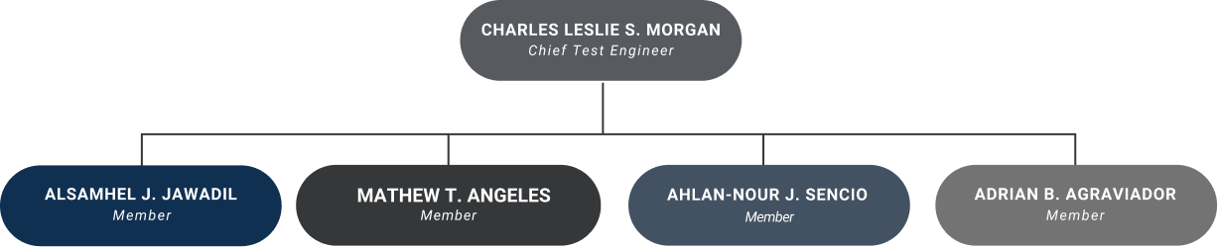
Figure VI: EFIXXO Testing Team

2.6.6. Training Team
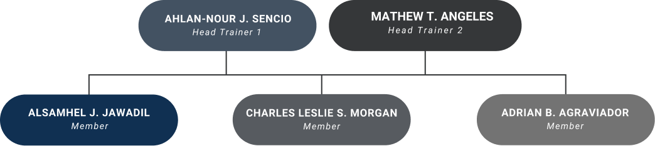
Figure VII: EFIXXO Training Team

2.6.7. Documentation Team
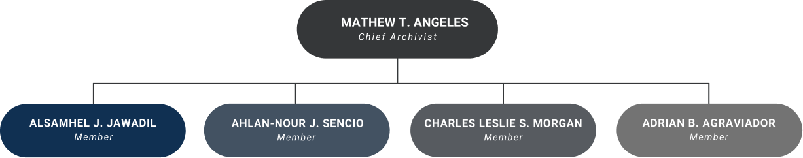
Figure VIII: EFIXXO Documentation Team

2.7. Company Policy

2.7.1. Management Rules

- Every 6 pm, members shall check the GC and say present. They should also read the previous conversation, reply to messages if needed, chat or say what they have in mind, or give short status updates regarding the project.
- Every Tuesday and Friday, every member should update the GC regarding their given task, which will be subject to review and opinions. Both the management and the technical team should offer advice on the updates.
- Every once a week or two whichever is decided upon, the entire team should deliver updates with the adviser, external adviser, and the client for them to be able to track the project and offer insights, advice, and possible changes.

2.7.2. Technical Rules

- Every task given to a specific member will be given a time for said member to develop. The time will be based on the difficulty and length of such task or feature.
  - If the member completes the task ahead of schedule, they may either take a rest or proceed to the next task. He can only advance up to 3 times before being forced to take a rest.
  - If the member has difficulties with the task at hand, he may refer to the lead technical member for advice and tutorials, as well as provide a heads-up to the project manager.
- The member will be given a mercy time of up to 3 days of delay, if the member can provide proper details for the delay.
  - If the member cannot provide the complete update after the 3-day mercy, he will be subject to a positional change.

2.7.3. Funding

- Target fundable assets: Meeting funds, hosting websites, paid assets and more.
- Fund collection: Each member is required to contribute ₱8.00 per day to support the funding of our upcoming student-led software project. Contributions will be collected on Monday, Tuesday, Wednesday, Thursday, and Saturday, regardless of holidays. Additionally, every end of the month, an extra ₱50.00 will be collected from each member alongside the daily contributions.
- An Emergency Fund Collection will also be done if the situation calls for it. Before the collection happens, an emergency meeting will be held to talk about the amount that will be collected.

2.7.4. Penalties

- For a 3-day delay, the member will be given a different task within the company to see if his strengths and capabilities lie elsewhere. And he will pay ₱50.00, which will be used for the funding.

2.7.5. Expulsion

- If a member who accumulates excessive unexcused absences—such as 5 in a row, two instances of 4 in a row, or three instances of 3 in a row—may face expulsion at the discretion of the PM and Lead Developer.

2.8. Company Agreement

CONTRACT OF AGREEMENT

We, the undersigned, hereby understood and abide the rules and regulations, policies, and penalties set by the EFIXXO Company. Signed this September 1, 2025 at the College of Computing Studies, Western Mindanao State University, Normal Road, Baliwasan, Zamboanga City, Philippines, 7000.

Angeles, Mathew T.
Project Manager
Sencio, Ahlan-nour J.
Lead Developer
Morgan, Charles Leslie S.
Business Analyst
Jawadil, Alsamhel J.
Quality Assurance Engineer
Agraviador, Adrian B.
UI/UX Designer

Ms. Justine Ann Albay-Arip
Instructor

Noted by:

Mr. Sherard Chris B. Banquerigo
Instructor

2.9. Client Agreement

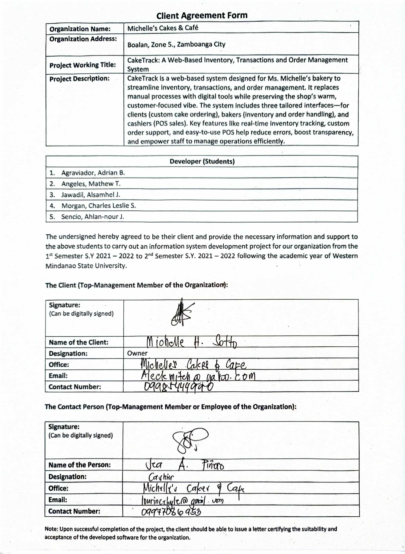

Chapter 3 – Project Plan and Schedule

3.1. Action Plan

Activity |  | Time Estimates |  |  | Required Resources | Dependencies | Person-in-Charge
# |  | Duration | Start | End | Required Resources | Dependencies | Person-in-Charge
Phase 1 – Planning
1.1 | Create a company | 1 Day | Aug. 14, 2025 | Aug. 14, 2025 | - | - | All
1.2 | Design a company logo | 3 Days | Aug. 15, 2025 | Aug. 17, 2025 | Internet, Computer | 1.1 | Agraviador & Angeles
1.3 | Define company mission, vision, and goals | 2 Days | Aug. 18, 2025 | Aug. 19, 2025 | Internet, Computer | 1.1 | All
1.4 | Define company organizational structure | 2 Days | Aug. 18, 2025 | Aug. 19, 2025 | Internet, Computer | 1.1 | All
1.5 | Define company policies and penalties | 2 Days | Aug. 20, 2025 | Aug. 21, 2025 | Internet, Computer | 1.4 , 1.3, 1.2 | All
1.6 | Establish and promote company | 2 Days | Aug. 22, 2025 | Aug. 23, 2025 | Internet, Computer | 1.5 | All
1.7 | Close a deal with a client | 8 Days | Aug. 24, 2025 | Aug. 31, 2025 | Vehicle | 1.6 | All
1.8 | Secure Project Approval | 7 Days | Sept. 1, 2025 | Sept. 7, 2025 | Attendance | 1.7 | All
1.9 | Create project action plan | 4 Days | Sept. 11, 2025 | Sept. 14, 2025 | Internet, Computer | 1.8 | Angeles
1.10 | Determine project milestones and deliverables | 2 days | Sept. 15, 2025 | Sept. 16, 2025 | Internet, Computer | 1.9 | Angeles
1.11 | Create workbreakdown structure | 11 days | Sept. 17, 2025 | Sept. 27, 2025 | Internet, Computer | 1.10 | Angeles
1.12 | Create an online project board | 11 days | Sept. 17, 2025 | Sept. 27, 2025 | Internet, Computer | 1.9 | Angeles & Morgan
1.13 | Create an online Gantt Chart | 11 days | Sept. 17, 2025 | Sept. 27, 2025 | Internet, Computer | 1.9 | Angeles & Morgan
1.14 | Create Activity Network Diagram | 6 days | Sept. 17, 2025 | Sept. 22, 2025 | Internet, Computer | 1.9 | Angeles
1.15 | Determine project critical path and slack time | 5 days | Sept. 23, 2025 | Sept. 27, 2025 | Internet, Computer | 1.14 | Angeles
1.16 | Collate project documentation for Phase 1 | 6 Days | Sept. 29, 2025 | Oct. 4, 2025 | Internet, Computer | 1.15, 1.13, 1.12, 1.11 | Angeles
Phase 2 – Analysis
2.1 | Identify data collection method | 2 Days | Oct. 4, 2025 | Oct. 5, 2025 | Internet, Computer | - | All
2.2 | Conduct initial data gathering | 2 Days | Oct. 5, 2025 | Oct. 6, 2025 | Vehicle | 2.1 | All
2.3 | Transcribe and analyze collected data | 3 Days | Oct. 6, 2025 | Oct. 8, 2025 | Internet, Computer | 2.2 | All
2.4 | Identify risks and think of contingency plans | 2 Days | Oct. 9, 2025 | Oct. 10, 2025 | Internet, Computer | 2.3 | All
2.5 | Establish mode of communication for client relations | 2 Days | Oct. 10, 2025 | Oct. 11, 2025 | Internet, Computer | 2.3 | All
2.6 | Propose initial solution for the project | 8 Days | Oct. 11, 2025 | Oct. 18, 2025 | Internet, Computer | 2.3 | All
2.7 | Determine project cost | 8 Days | Oct. 11, 2025 | Oct. 18, 2025 | Internet, Computer | 2.3 | All
2.8 | Conduct feasibility study | 8 Days | Oct. 11, 2025 | Oct. 18, 2025 | Internet, Computer | 2.3 | All
2.9 | List initial project requirements | 4 Days | Oct. 18, 2025 | Oct. 21, 2025 | Internet, Computer | 2.3 | All
2.10 | Determine hardware requirements | 5 Days | Oct. 21, 2025 | Oct. 25, 2025 | Internet, Computer | 2.9 | All
2.11 | Determine software requirements | 5 Days | Oct. 21, 2025 | Oct. 25, 2025 | Internet, Computer | 2.9 | All
2.12 | Determine network requirements | 5 Days | Oct. 21, 2025 | Oct. 25, 2025 | Internet, Computer | 2.9 | All
2.13 | Determine database requirements | 5 Days | Oct. 21, 2025 | Oct. 25, 2025 | Internet, Computer | 2.9 | Sencio
2.14 | Identify software specifications | 3 Days | Oct. 25, 2025 | Oct. 27, 2025 | Internet, Computer | 2.10, 2.11, 2.12, 2.13 | Sencio
2.15 | Create Process Map | 3 Days | Oct. 25, 2025 | Oct. 27, 2025 | Internet, Computer | 2.3 | Morgan
2.16 | List product features | 3 Days | Oct. 25, 2025 | Oct. 27, 2025 | Internet, Computer | 2.3 | All
2.17 | List product attributes | 3 Days | Oct. 25, 2025 | Oct. 27, 2025 | Internet, Computer | 2.3 | All
2.18 | Create product mockups | 4 Days | Oct. 27, 2025 | Oct. 30, 2025 | Internet, Computer | 2.3 | All
2.19 | Finalize documentation for Phase II | 4 Days | Oct. 27, 2025 | Oct. 30, 2025 | Internet, Computer | 2.18, 2.17, 2.16, 2.14 | Angeles
Phase 3 – Design
3.1 | Determine system architecture | 4 Days | Oct. 27, 2025 | Oct. 30, 2025 | Internet, Computer | - | Sencio
3.2 | Analyze graphical or visual materials for research | 4 Days | Oct. 27, 2025 | Oct. 30, 2025 | Internet, Computer | - | All
3.3 | Create business use case | 4 Days | Oct. 27, 2025 | Oct. 30, 2025 | Internet, Computer | 3.1 | Morgan & Angeles
3.4 | Create context and data flow diagram | 4 Days | Oct. 27, 2025 | Oct. 30, 2025 | Internet, Computer | 3.1 | Morgan & Angeles
3.5 | Design system models | 4 Days | Oct. 27, 2025 | Oct. 30, 2025 | Internet, Computer | 3.4 | Sencio
3.6 | Design user interface | 30 Days | Nov. 1, 2025 | Nov. 30, 2025 | Internet, Computer | 3.2 | All
3.7 | Create product prototype | 30 Days | Nov. 1, 2025 | Nov. 30, 2025 | Internet, Computer | 3.2 | All
3.8 | Finalize documentation for Phase III | 3 Days | Nov. 30, 2025 | Dec. 2, 2025 | Internet, Computer | 3.7 | Angeles
Phase 4 – Coding
4.1 | Write System Module 1 – [POS Module] | 7 Days | Jan. 18, 2026 | Jan. 24, 2026 | Internet, Computer | - | Sencio
4.2 | Write System Module 2 – [Record Submodule] | 7 Days | Jan. 25, 2026 | Jan. 31, 2026 | Internet, Computer | 4.1 | Sencio
4.3 | Get feedback from a consultant 1 | 7 Days | Feb. 1, 2026 | Feb. 7, 2026 | Internet, Computer | 4.2 | All
4.4 | Debug, fix bugs, and update modules | 7 Days | Feb. 1, 2026 | Feb. 7, 2026 | Internet, Computer | 4.3 | Sencio & Jawadil
4.5 | Write System Module 3 – [Inventory Module] | 18 Days | Feb. 8, 2026 | Feb. 25, 2026 | Internet, Computer | 4.4 | All
4.6 | Write System Module 4 – [Custom Order Module] | 18 Days | Feb. 8, 2026 | Feb. 25, 2026 | Internet, Computer | 4.4 | All
4.7 | Write System Module 5 – [Recipe Management Module] | 18 Days | Feb. 8, 2026 | Feb. 25, 2026 | Internet, Computer | 4.4 | All
4.8 | Integrate System Modules | 3 Days | Feb. 26, 2026 | Feb. 28, 2026 | Internet, Computer | 4.5, 4.6, 4.7 | All
4.9 | Get feedback from a consultant 2 | 3 Days | Feb. 26, 2026 | Feb. 28, 2026 | Internet, Computer | 4.5, 4.6, 4.7 | All
4.10 | Debug, fix bugs, and update modules | 2 Days | Mar. 1, 2026 | Mar. 2, 2026 | Internet, Computer | 4.9 | Sencio & Jawadil
4.11 | Conduct unit testing | 2 Days | Mar. 3, 2026 | Mar. 4, 2026 | Internet, Computer | 4.9 | Jawadil
4.12 | Finalize product design and coding | 3 Days | Mar. 5, 2026 | Mar. 7, 2026 | Internet, Computer | 4.10 | All
Phase 5 – Testing
5.1 | Create testing plan | 2 Days | Apr. 1, 2026 | Apr. 2, 2026 | Internet, Computer | - | Angeles & Sencio
5.2 | Create test cases | 2 Days | Apr. 3, 2026 | Apr. 4, 2026 | Internet, Computer | 5.1 | Jawadil
5.3 | Conduct alpha testing | 3 Days | Apr. 5, 2026 | Apr. 7, 2026 | Internet, Computer | 5.1 | All
5.4 | Conduct beta testing | 4 Days | Apr. 8, 2026 | Apr. 11, 2026 | Internet, Computer | 5.1 | All
5.5 | Fix system errors | 3 Days | Apr. 12, 2026 | Apr. 14, 2026 | Internet, Computer | 5.4 | Sencio
5.6 | Conduct software/product attributes testing | 3 Days | Apr. 12, 2026 | Apr. 14, 2026 | Internet, Computer | 5.4 | Jawadil
5.7 | Conduct user acceptance testing | 3 Days | Apr. 15, 2026 | Apr. 17, 2026 | Internet, Computer | 5.4 | All
5.8 | Create migration plan | 3 Days | Apr. 15, 2026 | Apr. 17, 2026 | Internet, Computer | 5.4 | All
5.9 | Deploy system/product to client’s site | 8 Days | Apr. 18, 2026 | Apr. 25, 2026 | Internet, Computer | 5.7 | All
Phase 6 – Maintenance
6.1 | Create product manual | 7 Days | May 10, 2026 | May. 16, 2026 | Internet, Computer | - | All
6.2 | Gather and analyze customer feedback | 7 Days | May 10, 2026 | May. 16, 2026 | Internet, Computer | 6.1 | All
6.3 | Perform corrective maintenance | 7 Days | May 17, 2026 | May. 23, 2026 | Internet, Computer | 6.2 | Sencio & Jawadil
6.4 | Perform perfective maintenance | 7 Days | May 17, 2026 | May. 23, 2026 | Internet, Computer | 6.2 | Sencio & Jawadil
6.5 | Perfom adaptive maintenance | 7 Days | May 17, 2026 | May. 23, 2026 | Internet, Computer | 6.2 | Sencio & Jawadil
6.6 | Finalize project documentation | 4 Days | May 24, 2026 | May. 27, 2026 | Internet, Computer | 6.1 | Angeles & Charles
6.7 | Turn-over project to client and close the project | 3 Days | May 28, 2026 | May. 30, 2026 | Vehicle, Computer | 6.7 | All
Table 1: Action Plan

3.2. Work Breakdown Structure
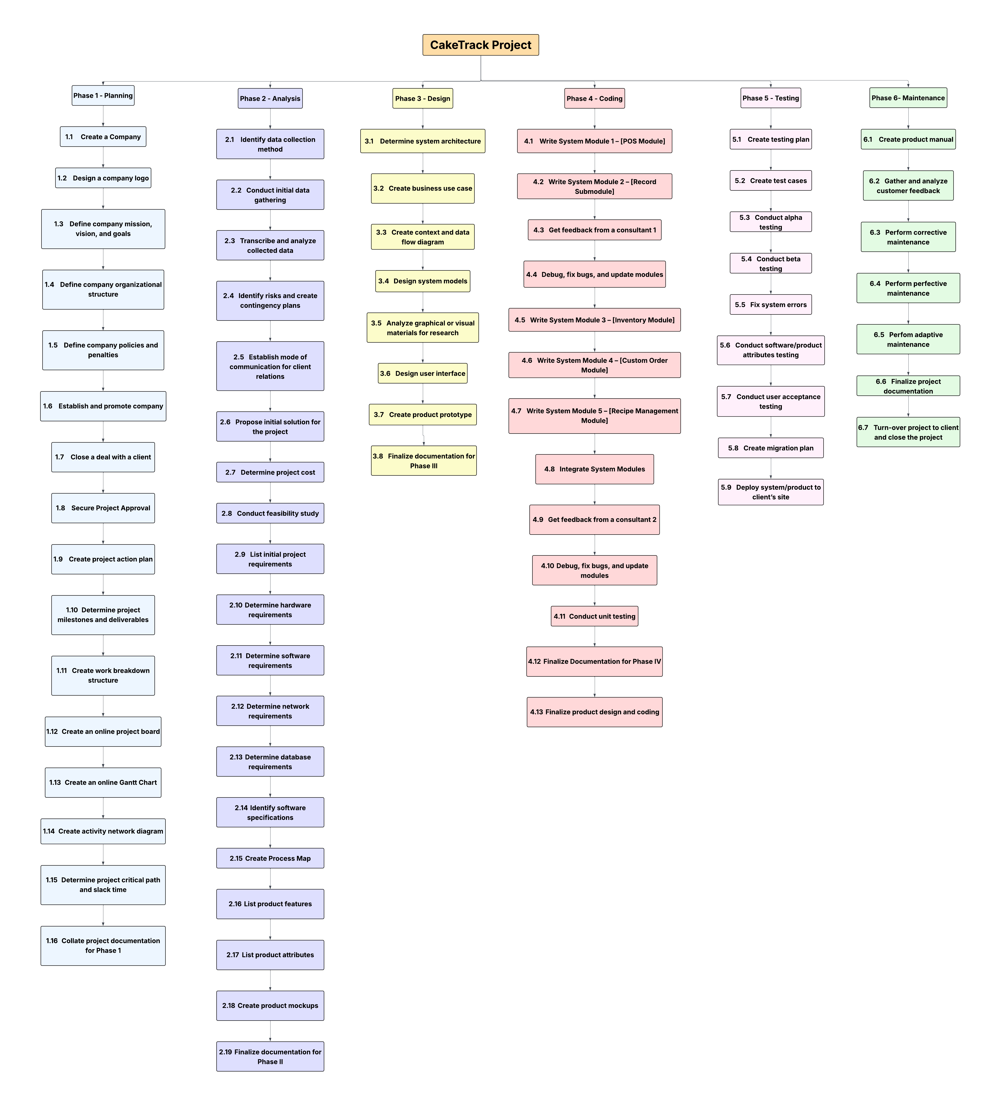

Figure IX: EFIXXO Work Breakdown Structure

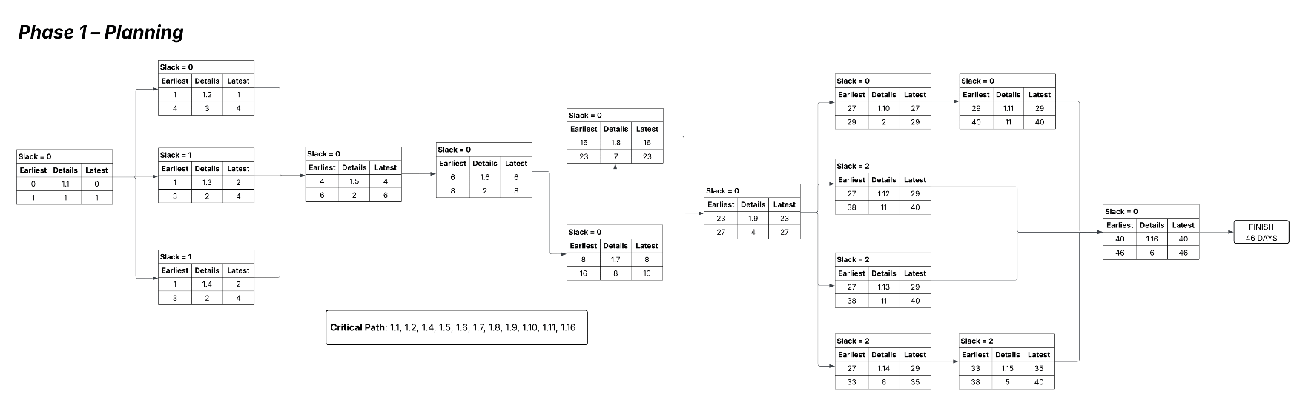
3.3. Network Diagram

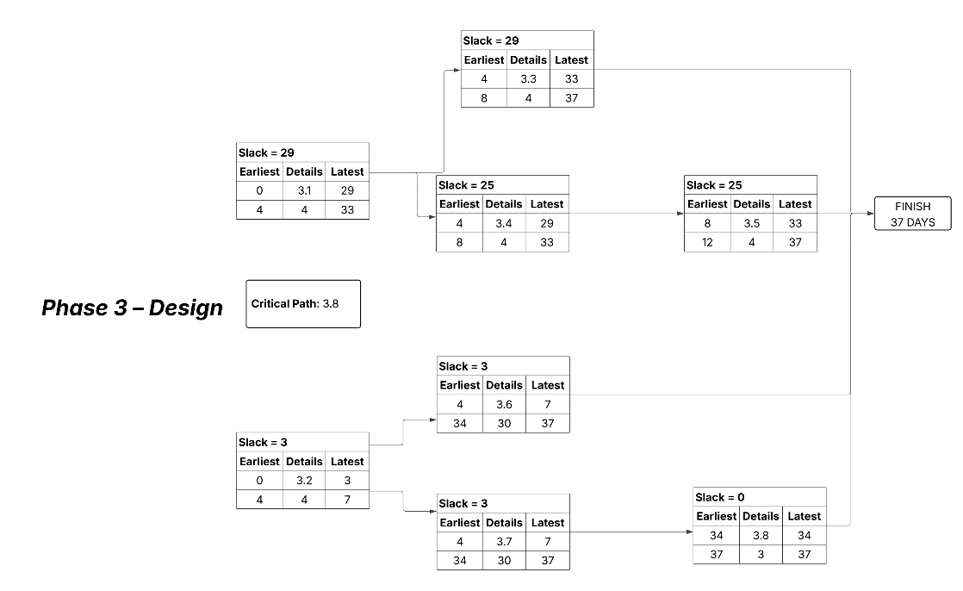
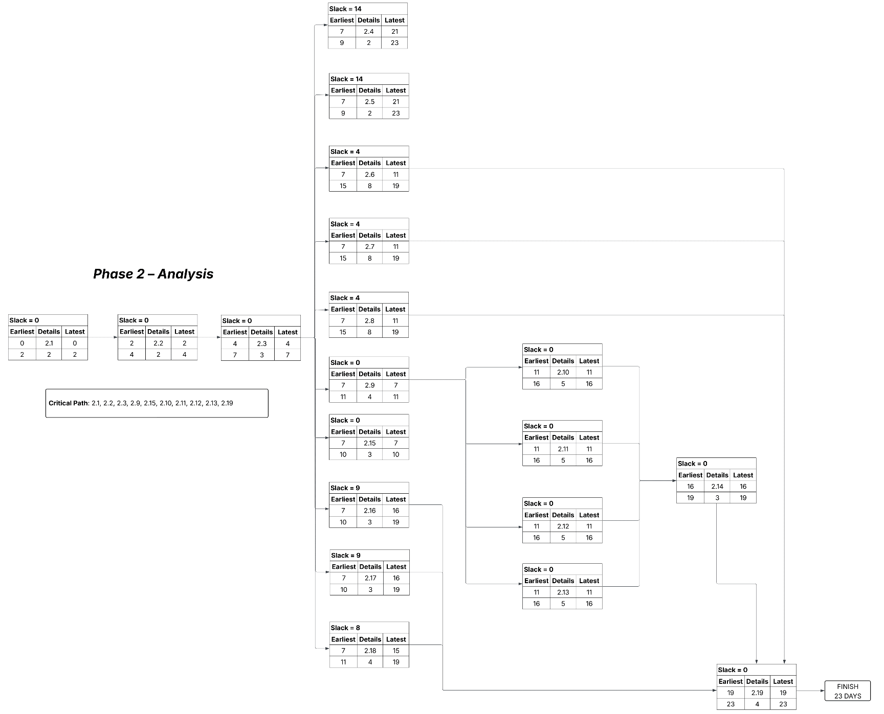
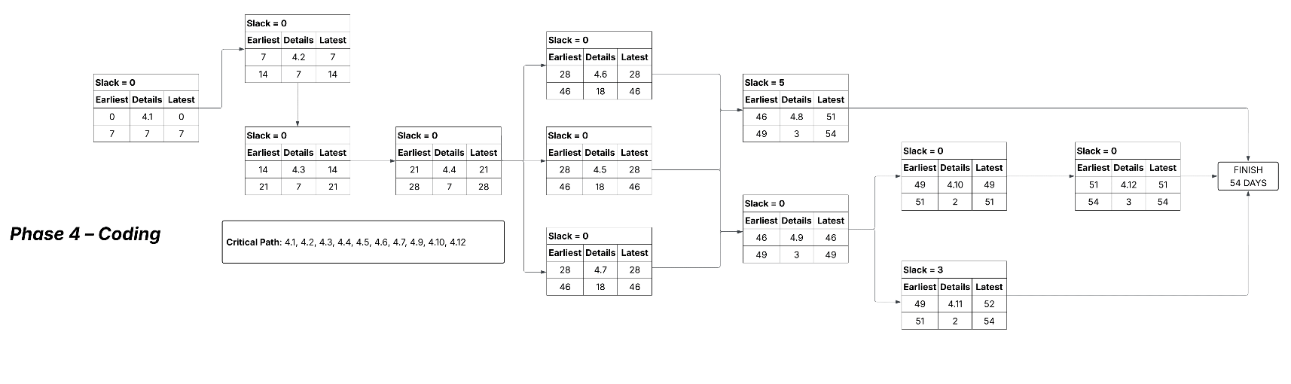

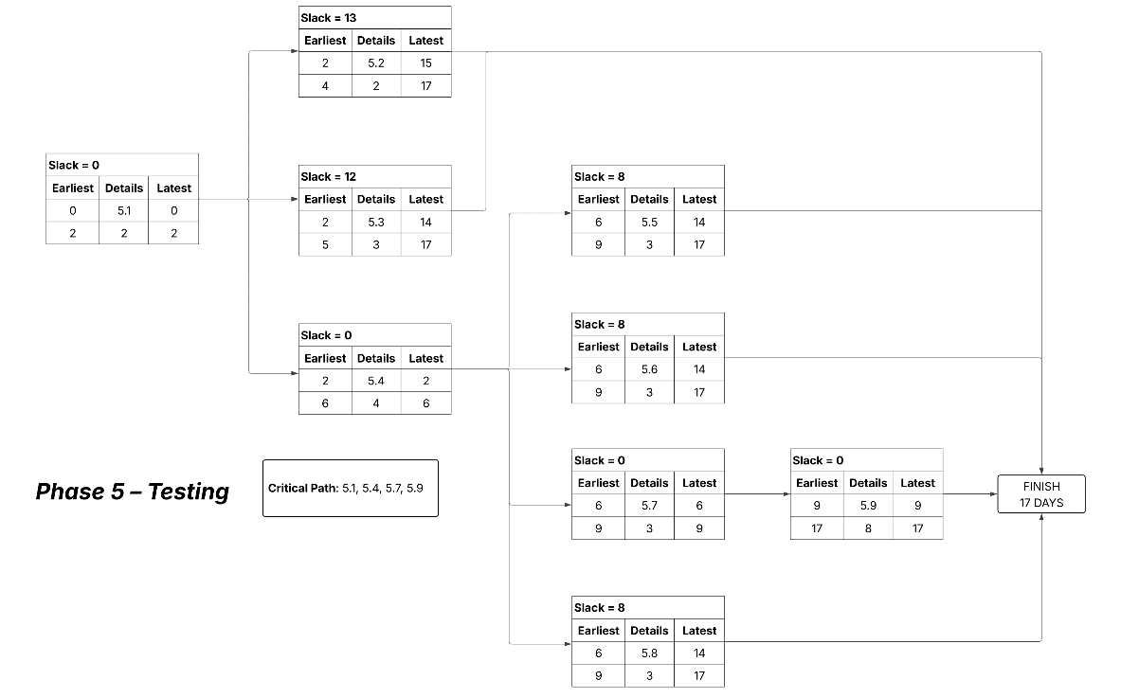

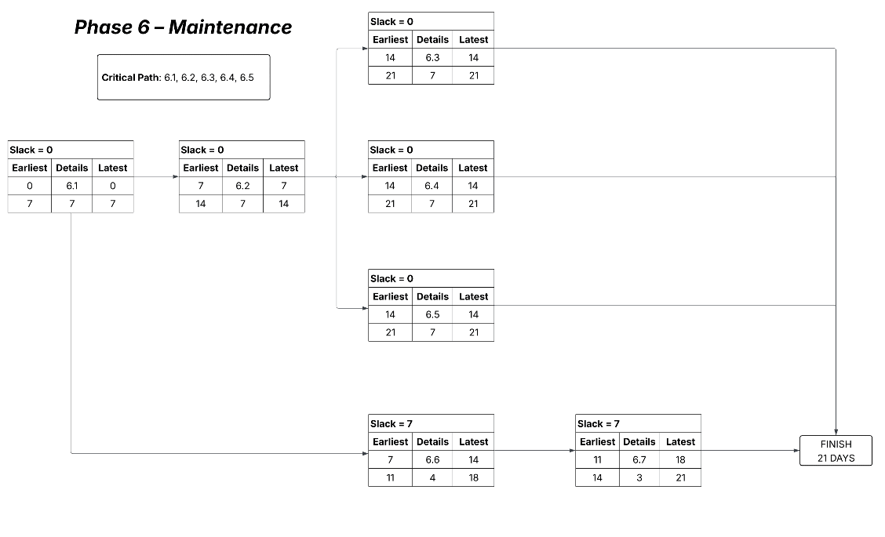

Figure X: EFIXXO Network Diagram

3.4. Milestones and Deliverables

Activity # | Milestone | Deliverables
Phase 1 – Planning
1.1 | Create a company | Development of Company Profile
1.2 | Design a company logo | Development of Company Profile
1.3 | Define company mission, vision, and goals | Development of Company Profile
1.4 | Define company organizational structure | Development of Company Profile
1.5 | Define company policies and penalties | Development of Company Profile
1.6 | Establish and promote company | Development of Company Profile
1.7 | Close a deal with a client | Client Verbal Agreement
1.8 | Secure Project Approval | Project Approval
1.9 | Create project action plan | Action Plan
1.10 | Determine project milestones and deliverables | Project Milestones and Deliverables
1.11 | Create work breakdown structure | Work breakdown Structure
1.12 | Create an online project board | Project Board
1.13 | Create an online Gantt Chart | Gantt Chart
1.14 | Create Activity Network Diagram | Activity Network Diagram
1.15 | Determine project critical path and slack time | Project Critical Path and Slack Time
1.16 | Collate project documentation for Phase 1 | Documentation
Phase 2 – Analysis
2.1 | Identify data collection method | Pick a Chosen Method
2.2 | Conduct initial data gathering | Data acquired from Client
2.3 | Transcribe and analyze collected data | Insights on Gathered Data
2.4 | Identify risks and create contingency plans | Risks and Contingency Plan
2.5 | Establish mode of communication for client relations | Client-Team GC
2.6 | Propose initial solution for the project | Project Solutions
2.7 | Determine project cost | Insights on Project Cost
2.8 | Conduct feasibility study | Insights on Project Feasibility
2.9 | List initial project requirements | Insights on Initial Requirements
2.10 | Determine hardware requirements | Insights on Hardware needs
2.11 | Determine software requirements | Insights on Software needs
2.12 | Determine network requirements | Insights on Networking needs
2.13 | Determine database requirements | Insights on Database needs
2.14 | Identify software specifications | Insights on Software Specification
2.15 | Create Process Map | Process Map
2.16 | List product features | Product Features
2.17 | List product attributes | Product Attributes
2.18 | Create product mockups | Product Mockups
2.19 | Finalize documentation for Phase II | Documentation
Phase 3 – Design
3.1 | Determine system architecture | System Architecture
3.2 | Create business use case | Business Use Case
3.3 | Create context and data flow diagram | Context and Data Flow Diagram
3.4 | Design system models | System Models
3.5 | Analyze graphical or visual materials for research | Inspiration and Ideas on UI
3.6 | Design user interface | UI Interface
3.7 | Create product prototype | High-Fidelity Figma Prototype
3.8 | Finalize documentation for Phase III | Documentation
Phase 4 – Coding
4.1 | Write System Module 1 – [POS Module] | POS Module
4.2 | Write System Module 2 – [Record Submodule] | Record Submodule
4.3 | Get feedback from a consultant 1 | Feedback from Client
4.4 | Debug, fix bugs, and update modules | Modules Updated
4.5 | Write System Module 3 – [Inventory Module] | Inventory Module
4.6 | Write System Module 4 – [Custom Order Module] | Custom Order Module
4.7 | Write System Module 5 – [Recipe Management Module] | Recipe Management Module
4.8 | Integrate System Modules | Integrated Modules
4.9 | Get feedback from a consultant 2 | Feedback from Client
4.10 | Debug, fix bugs, and update modules | Modules Updated
4.11 | Conduct unit testing | Unit testing completed
4.12 | Finalize product design and coding | Finalized Product
Phase 5 – Testing
5.1 | Create testing plan | Testing Plan
5.2 | Create test cases | Test Cases
5.3 | Conduct alpha testing | Alpha Testing
5.4 | Conduct beta testing | Beta Testing
5.5 | Fix system errors | Fixed System Errors
5.6 | Conduct software/product attributes testing | Product attribute testing
5.7 | Conduct user acceptance testing | User acceptance testing
5.8 | Create migration plan | Migration Plan
5.9 | Deploy system/product to client’s site | Deployed Product
Phase 6 – Maintenance
6.1 | Create product manual | Product Manual
6.2 | Gather and analyze customer feedback | Summarized Feedback
6.3 | Perform corrective maintenance | Software Maintenance
6.4 | Perform perfective maintenance | Software Maintenance
6.5 | Perfom adaptive maintenance | Software Maintenance
6.6 | Finalize project documentation | Documentation
6.7 | Turn-over project to client and close the project | Close Project
Table 2: Milestones and Deliverables

3.5. Gantt Chart
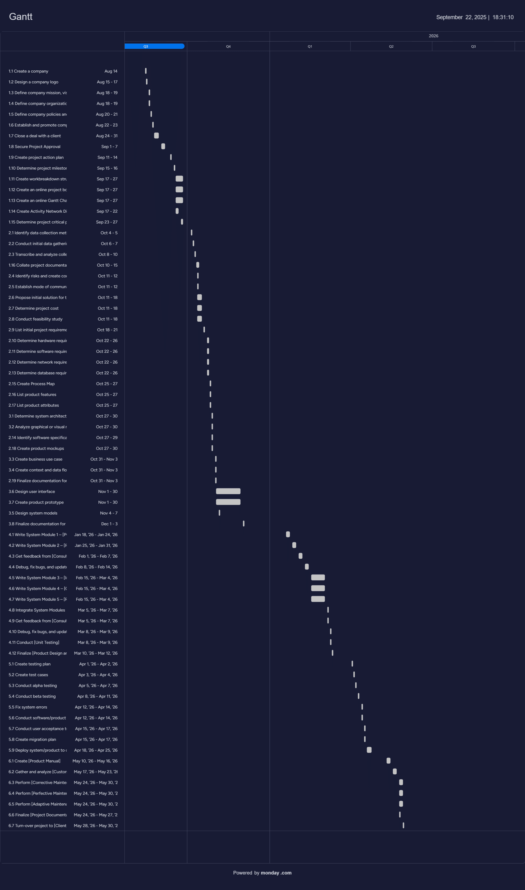
Figure XI: EFIXXO Gantt Chart

Chapter 4 – Project Cost

4.1. Cost of Project Resources

4.1.1. Effort Cost
Effort Cost
Member | Hours/Day | Rate/Hour | Total Working  Days | Total
Agraviador | 8 | PHP 150 | 242 | PHP 290,400
Angeles | 8 | PHP 150 | 242 | PHP 290,400
Jawadil | 8 | PHP 150 | 242 | PHP 290,400
Morgan | 8 | PHP 150 | 242 | PHP 290,400
Sencio | 8 | PHP 150 | 242 | PHP 290,400
 |  |  | Total | PHP 1,452,000
Table 3: Effort Cost

4.1.2. Hardware Cost

Hardware Cost
Item | Unit | Price/Unit | Quantity | Total
Tablet | pc | PHP 10, 000 | 1 | PHP 10, 000
Thermal Printer | unit | PHP 1,000 | 1 | PHP 1,000
 |  |  | Total | PHP 11,000
Table 4: Hardware Cost

4.1.3. Software Cost
Software Cost
Item | Unit | Price/Unit | Quantity | Total
Software for Development (HTML, CSS, JavaScript,  Python, Django, PostgreSQL) | License | FREE | 5 | FREE
 |  |  | Total | FREE
Table 5: Software Cost

4.1.4. Miscellaneous Cost

Miscellaneous
Item | Total
Hosting Service (Hostinger - Business Plan Package) | PHP 259/month
Domain (Namecheap - .com) | PHP 55/month
Database Deployment (Hostinger - Business Plan Package) | FREE
SSL Certificate (Hostinger - Business Plan Package) | FREE
Paper (for Thermal Printer) | PHP 120/month
Wi-Fi Monthly Payment | PHP 1,699/month
One-time Developer Account Fee (Play Store Publishing) | PHP 1,450
Monthly Total | PHP 2,133/month
Yearly Total | PHP 27,046/year
Table 6: Miscellaneous Cost

4.1.5. Overall Cost

Overall Cost
Expenses | Total
Effort Cost | PHP 1,452,000
Hardware Cost | PHP 11,000
Software Cost | N/A
Miscellaneous | PHP 27,046
Total | PHP 1,490,046
Table 7: Overall Cost

4.2. Return-On-Investment
Development Cost
Type of Cost | Year |  |  |  | Total
Type of Cost | 2025 | 2026 | 2027 | 2028 | Total
Salary | PHP 1,452,000 | 0 | 0 | 0 | PHP 1,452,000
Hardware | PHP 11,000 | 0 | 0 | 0 | PHP 11,000
Software | N/A | 0 | 0 | 0 | N/A
Miscellaneous | PHP 27,046 | 0 | 0 | 0 | PHP 27,046
Total | PHP 1,490,046 | 0 | 0 | 0 | PHP 1,490,046
Table 8: Development Cost

Operational Cost
Type of Cost | Year |  |  |  | Total
Type of Cost | 2025 | 2026 | 2027 | 2028 | Total
Maintenance | 0 | PHP 10,000 | PHP 20,000 | PHP 30,000 | PHP 60,000
Repairs | 0 | PHP 10,000 | PHP 20,000 | PHP 30,000 | PHP 60,000
Upgrades | 0 | PHP 10,000 | PHP 20,000 | PHP 40,000 | PHP 70,000
Utility | 0 | PHP 10,000 | PHP 10,000 | PHP 10,000 | PHP 30,000
Total | 0 | PHP 40,000 | PHP 70,000 | PHP 110,000 | PHP 220,000
Table 9: Operational Cost

Benefits
Type of  Benefits | Year |  |  |  | Total
Type of  Benefits | 2025 | 2026 | 2027 | 2028 | Total
Reduce Office  Supplies | 0 | PHP 80,000 | PHP 100,000 | PHP 110,000 | PHP 290,000
Increase Sales | 0 | PHP 300,000 | PHP 400,000 | PHP 580,000 | PHP 1,280,000
Reduce Wages | 0 | PHP 100,000 | PHP 100,000 | PHP 100,000 | PHP 300,000
Improve Accuracy | 0 | PHP 40,000 | PHP 60,000 | PHP 80,000 | PHP 180,000
Reduce Waste | 0 | PHP 50,000 | PHP 60,000 | PHP 80,000 | PHP 190,000
Total | 0 | PHP 570,000 | PHP 720,000 | PHP 950,000 | PHP 2,240,000
Table 10: Benefits
ROI = (benefits-(total cost))/total cost x 100
ROI = (benefits-(development + operational))/total cost x 100
ROI = (2,240,000-(1,490,046 + 220,000))/1,710,596 x 100
ROI = (2,240,000-1,710,596)/1,710,596 x 100
ROI = 531,404/1,710,596 x 100
ROI = 0.3110 x 100
ROI = 30.98% in 3 years after the development Project resulted to positive ROI.

4.3. Intangible Benefits
- Streamlined order tracking & Centralized records
- Improved staff coordination
- Enhanced customer satisfaction
- Digitized inventory awareness
- Recipe preservation
- Role-based access control
- Reduced manual errors

Chapter 5 – Project Feasibility

5.1. Candidate Solution Matrix

Characteristics | Open-Source (ERPNext) | New Development | Paid/Subscription-Based
Portion of System Computerized | Self-hosted and customizable. May require technical setup and professional help | Self-hosted and customizable bakery system integrating POS, Inventory, and Custom Orders | Cloud-based system and vendor-dependent
Benefits | Free to use for a Trial, but takes time to set up | Tailor-fit for Cafe workflow; simplified interface; integrates all modules | Quick setup and ready to use
Servers and Workstations | Dedicated or cloud-based server | Cloud Server | Cloud-based and vendor-managed
Software Tools Needed | ERPNext code, MySQL | HTML, CSS, JavaScript,  Python, Django, PostgreSQL | Not applicable (vendor handled)
Application Software | Open-source ERP or POS system | Custom POS, Inventory, and Custom Order modules | Packaged and generic solution
Method of Data Processing | Online and real-time | Online and real-time w/ Offline contingency | Online and real-time
Output Devices and Implications | Monitors, printers | Monitors and receipt printers | Monitors and receipt printers
Input Devices and Implications | Keyboard and mouse | Touchscreen, Keyboard, and mouse | Keyboard, mouse, and touchscreen
Storage Devices and Implications | MySQL database, scalable | PostgreSQL database, scalable | Vendor-controlled and subscription-based
Table 11: Candidate Solution Matrix

5.2. Technology Gap Analysis
Top Features or Characteristics | CakeTrack  (New Development) | ERPNext | Square POS
Ease of Use | Easy | Moderate-Hard | Easy
Performance | 5/5 | 5/5 | 4/5
Participants | Multiple users but limited roles | Multiple users (cashier, baker, customer) | Multiple users but limited access
POS Features | Supports sales and receipts | Supports in-store sales and receipt printing | Full POS features, but heavily depends on the internet
Inventory | Manual linking to POS | Auto-deducts ingredients when a custom order is accepted | Built-in but limited recipe tracking
Custom Order Handling | Not available or requires plug-ins | Built-in—accepts and tracks custom cake orders | Available but not bakery-focused
Integration | Requires manual setup | Can connect modules (POS + Inventory + Orders) | Has integrations but vendor dependent
Table 12: Technology Gap Analysis

5.3. Feasibility Study

5.3.1. Operational Feasibility
The implementation of the CakeTrack System, a bespoke POS, Inventory, and Custom Order Management System, will streamline the client’s bakery operations by allowing staff to record in-store sales efficiently, monitor ingredient stocks in real time, and manage custom cake orders through a centralized platform. The system reduces the manual workload of tracking ingredients and order details by automating inventory deductions once a custom order is accepted, while the POS feature ensures accurate recording of daily sales and easier generation of performance reports. Designed specifically for one bakery client, CakeTrack is tailored to fit their existing workflow, ensuring smooth adoption with minimal disruption to daily operations. Overall, it enhances accuracy, saves time, and improves coordination among baker and cashiers, resulting in a more efficient and well-organized business process.
Success Factors:
    - Requires short training for bakery staff to familiarize themselves with the system’s features.
    - Establish a simple support process for troubleshooting and technical assistance.
    - User interface must remain simple and intuitive for non-technical users.
    - Regular feedback collection from users to improve functionality and workflow fit.

5.3.2. Technical Feasibility

Hardware Resources
- Development
  - Laptop/PC
- Deployment
  - Tablet for POS Staff use
  - Receipt Printer
Software Resources
- PostgreSQL – database
- Python & Django - for backend code
- HTML & CSS and JavaScript - for frontend code

People Resources
Members | Functions
Mathew Angeles  CakeTrack Project Manager | - Oversees the entire CakeTrack project and ensures all modules (POS, Inventory, and Custom Order) are aligned with project goals.  - Prepares and documents the project plan, system flow, and development schedule.  - Coordinates communication between all members and ensures milestones are met.  - Sets project guidelines and ensures the system follows data privacy and security standards.  - Reviews project progress and handles decision-making for major features and implementations.
Ahlan-nour Sencio  CakeTrack Lead Developer | - Leads the technical development of CakeTrack’s POS, Inventory, and Custom Order modules.  - Guides the development team in coding standards, testing, and debugging.  - Ensures that all technical solutions are efficient, secure, and maintainable.  - Ensures smooth integration between system modules.  - Reviews system architecture and recommends improvements to enhance performance and reliability.
Adrian Agraviador  CakeTrack UI/UX Designer | - Designs CakeTrack’s user interface and ensures a user-friendly experience for bakers and staff.  - Gathers and analyzes user requirements to create intuitive layouts for the POS, Inventory, and Custom Order screens.  - Develops wireframes, mockups, and prototypes for testing and feedback.  - Ensures consistent design standards, colors, and navigation across all system modules.  - Collaborates with developers to translate designs into functional interfaces.
Alsamhel Jawadil  CakeTrack Quality Assurance Engineer | - Ensures the quality and stability of CakeTrack through thorough testing.  - Performs manual and automated testing for POS transactions, inventory deductions, and custom order features.  - Identifies bugs, documents issues, and collaborates with developers to resolve them.  - Conducts testing before every major release.  - Ensures the final product meets system requirements and user expectations.
Charles Leslie Morgan  CakeTrack Business Analyst | - Analyzes bakery business processes and defines system requirements for CakeTrack.  - Gathers and documents user needs from bakers, staff, and customers.  - Translates business requirements into technical specifications for the development team.  - Evaluates workflows to improve efficiency within POS, Inventory, and Custom Order processes.  - Prepares reports and ensures the system aligns with business goals and client expectations.
Table 13: People Resources

5.3.3. Schedule Feasibility
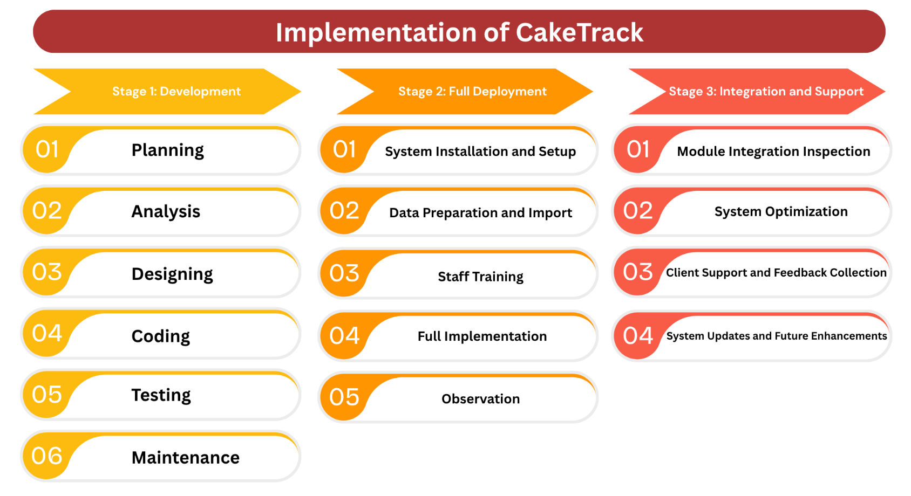
A long-term approach on the implementation of CakeTrack.

Figure XII: Implementation Plan

3 Stages of the Implementation of CakeTrack

Stage 1: Development
In this stage, the development team will design and build the CakeTrack System tailored specifically to the client’s bakery operations. The process includes requirement gathering, system design, development of the POS, Inventory, and Custom Order modules, followed by system testing and maintenance planning.
1. Phase I – Planning
2. Phase II – Analysis
3. Phase III – Design
4. Phase IV – Coding
5. Phase V – Testing
6. Phase VI – Maintenance

Stage 2: Full Deployment
In this stage, the system will be installed, configured, and rolled out for the bakery’s day-to-day operations. The team will also train the bakery staff to ensure smooth adoption and system familiarity. This will span beyond the perceived action plan when needed.
1. Phase I – System Installation and Setup
2. Phase II – Data Preparation and Import
3. Phase III – Staff Training
4. Phase IV – Full Implementation
5. Phase V – Observation

Stage 3: Integration and Support
In this stage, the development team ensures that all modules (POS, Inventory, and Custom Orders) are fully synchronized. Updates and support will be provided to enhance the system’s performance and scalability when needed.
1. Phase I – Module Integration Inspection
2. Phase II – System Optimization
3. Phase III – Client Support and Feedback Collection
4. Phase IV – System Updates and Future Enhancements

Project Duration: 242 days or 10 months
Success Factors:
a. On-time procurement of hardware resources.
b. On-time schedule of CakeTrack training and development.

5.3.4. Economic Feasibility

Effort Cost
Effort Cost
Member | Hours/Day | Rate/Hour | Total Working  Days | Total
Agraviador | 8 | PHP 150 | 242 | PHP 290,400
Angeles | 8 | PHP 150 | 242 | PHP 290,400
Jawadil | 8 | PHP 150 | 242 | PHP 290,400
Morgan | 8 | PHP 150 | 242 | PHP 290,400
Sencio | 8 | PHP 150 | 242 | PHP 290,400
 |  |  | Total | PHP 1,452,000

Hardware Cost
Hardware Cost
Item | Unit | Price/Unit | Quantity | Total
Tablet | pc | PHP 10, 000 | 1 | PHP 10, 000
Thermal Printer | unit | PHP 1,000 | 1 | PHP 1,000
 |  |  | Total | PHP 11,000

Software Cost
Software Cost
Item | Unit | Price/Unit | Quantity | Total
Software for Development (HTML, CSS, JavaScript,  Python, Django, PostgreSQL) | License | FREE | 5 | FREE
 |  |  | Total | FREE

Miscellaneous
Miscellaneous
Item | Total
Hosting Service (Hostinger - Business Plan Package) | PHP 259/month
Domain (Namecheap - .com) | PHP 55/month
Database Deployment (Hostinger - Business Plan Package) | FREE
SSL Certificate (Hostinger - Business Plan Package) | FREE
Paper (for Thermal Printer) | PHP 120/month
Wi-Fi Monthly Payment | PHP 1,699/month
One-time Developer Account Fee (Play Store Publishing) | PHP 1,450
Monthly Total | PHP 2,133/month
Yearly Total | PHP 27,046/year

Overall Cost
Expenses | Total
Effort Cost | PHP 1,452,000
Hardware Cost | PHP 11,000
Software Cost | N/A
Miscellaneous | PHP 25,596
Total | PHP 1,490,046

Return-on-Investment (ROI)
Development Cost
Type of Cost | Year |  |  |  | Total
Type of Cost | 2025 | 2026 | 2027 | 2028 | Total
Salary | PHP 1,452,000 | 0 | 0 | 0 | PHP 1,452,000
Hardware | PHP 11,000 | 0 | 0 | 0 | PHP 11,000
Software | N/A | 0 | 0 | 0 | N/A
Miscellaneous | PHP 27,046 | 0 | 0 | 0 | PHP 27,046
Total | PHP 1,490,046 | 0 | 0 | 0 | PHP 1,490,046

Operational Cost
Type of Cost | Year |  |  |  | Total
Type of Cost | 2025 | 2026 | 2027 | 2028 | Total
Maintenance | 0 | PHP 10,000 | PHP 20,000 | PHP 30,000 | PHP 60,000
Repairs | 0 | PHP 10,000 | PHP 20,000 | PHP 30,000 | PHP 60,000
Upgrades | 0 | PHP 10,000 | PHP 20,000 | PHP 40,000 | PHP 70,000
Utility | 0 | PHP 10,000 | PHP 10,000 | PHP 10,000 | PHP 30,000
Total | 0 | PHP 40,000 | PHP 70,000 | PHP 110,000 | PHP 220,000

Benefits
Type of  Benefits | Year |  |  |  | Total
Type of  Benefits | 2025 | 2026 | 2027 | 2028 | Total
Reduce Office  Supplies | 0 | PHP 80,000 | PHP 100,000 | PHP 110,000 | PHP 290,000
Increase Sales | 0 | PHP 300,000 | PHP 400,000 | PHP 580,000 | PHP 1,280,000
Reduce Wages | 0 | PHP 100,000 | PHP 100,000 | PHP 100,000 | PHP 300,000
Improve Accuracy | 0 | PHP 40,000 | PHP 60,000 | PHP 80,000 | PHP 180,000
Reduce Waste | 0 | PHP 50,000 | PHP 60,000 | PHP 80,000 | PHP 190,000
Total | 0 | PHP 570,000 | PHP 720,000 | PHP 950,000 | PHP 2,240,000

ROI = (benefits-(total cost))/total cost x 100
ROI = (benefits-(development + operational))/total cost x 100
ROI = (2,240,000-(1,490,046 + 220,000))/1,710,596 x 100
ROI = (2,240,000-1,710,596)/1,710,596 x 100
ROI = 531,404/1,710,596 x 100
ROI = 0.3110 x 100
ROI = 30.98% in 3 years after the development Project resulted to positive ROI.

Intangible Benefits
- Streamlined order tracking & Centralized records
- Improved staff coordination
- Enhanced customer satisfaction
- Digitized inventory awareness
- Recipe preservation
- Role-based access control
- Reduced manual errors

5.3.5. Cultural Feasibility

The implementation of the CakeTrack System will promote productivity and efficiency within the bakery’s daily operations. It introduces a system-aided workplace where sales, inventory tracking, and custom cake orders are managed in one integrated platform. This cultural shift from manual recording to automated processing will help streamline communication between staff and improve work consistency.

Success Factors:
    - Requires short but focused training for bakers, cashiers, and managers.
    - Awareness for end-users (Custom Order Customers)
    - Consistent use of the system must be encouraged to prevent reverting to manual methods.

5.3.6. Legal Feasibility

A primary legal concern in implementing CakeTrack is data privacy and security, as the system stores transaction details, customer orders, and inventory records. Since CakeTrack is a bespoke system, data handling can be fully managed by the bakery and the development team, ensuring secure access and compliance with applicable laws. Most of the development tools and frameworks used are open-source.
Success Factors:
    - Requires a basic understanding or consultation on IT security best practices.
    - Compliance with the Data Privacy Act of 2012 (Republic Act No. 10173) and other applicable Philippine laws.
    - Compliance with business and accounting regulations for transactions.

5.4. Feasibility Analysis Matrix

Feasibility Criteria | Weight | Open Source | New Development | Paid/ Subscription- Based
Operational | 30% | Most features support CakeTrack requirements | Fully supports Client/System requirements | One feature supportss CakeTrack requirements
 |  | 90 | 100 | 50
Technical | 10% | A bit complex in setting up from scratch | Comfortable in setting up from scratch | Vendor dependent
 |  | 70 | 100 | 60
Economic | 30% | Cost for own storage and hardware | Cost for own domain and hardware | Cost per buyer
 |  | 70 | 70 | 90
Schedule | 30% | Weeks to months | Take several months, 10-11 months | Weeks to months
 |  | 85 | 80 | 85
Ranking | 100% | 80.5 | 85 | 73.5
Table 14: Feasibility Analysis Matrix

Chapter 6– System Requirements

6.1. Functional Requirements
Requirement #: | 1
Description: | The system shall allow café employees and the owner to sign up and create accounts for working purposes
Rationale: | To ensure secure, personalized access to employee functions
Fit Criterion: | Upon successful sign-up, the system shall store the employee’s account.
Originator: | Owner
Customer Satisfaction | 5
Customer Dissatisfaction | 5
Priority | 5

Requirement #: | 2
Description: | The system shall allow registered café employees and the owner to log in using the created accounts.
Rationale: | To ensure secure access to employee-specific features such as POS and Records.
Fit Criterion: | Once the employee successfully logs in, the system shall only allow access to features meant for employees. If the login fails, the system shall display an error message.
Originator: | Owner
Customer Satisfaction | 5
Customer Dissatisfaction | 5
Priority | 5

Requirement #: | 3
Description: | The system shall provide a search bar that retrieves results within the active interface.
Rationale: | Supports modular navigation and prevents confusion, ensuring users receive relevant results based on their current interface.
Fit Criterion: | When a user enters a keyword into the search bar, the system shall return results only from the currently active interface.
Originator: | Owner
Customer Satisfaction | 5
Customer Dissatisfaction | 1
Priority | 5

Requirement #: | 4
Description: | The system shall provide a vertical navigation bar with icons for accessing core modules such as POS, Queue, and Inventory.
Rationale: | Enables fast access to system modules.
Fit Criterion: | Each icon shall route the user to its respective interface and update the active view.
Originator: | Owner
Customer Satisfaction | 5
Customer Dissatisfaction | 1
Priority | 5

Requirement #: | 5
Description: | The system shall allow users to access an account page to view and edit profile information.
Rationale: | Supports personalization.
Fit Criterion: | Clicking the user avatar or name shall open the account page with editable fields.
Originator: | Owner
Customer Satisfaction | 5
Customer Dissatisfaction | 1
Priority | 5

Requirement #: | 6
Description: | The system shall allow users to securely log out of their session from any interface.
Rationale: | Ensures session and user control.
Fit Criterion: | Selecting the Log Out icon shall open a decision modal whether one is sure to log out or not and then terminate the session if clicked yes and redirect the user to the login screen.
Originator: | Owner
Customer Satisfaction | 5
Customer Dissatisfaction | 1
Priority | 5

Requirement #: | 7
Description: | The system shall provide a burger icon that collapses or expands the navigation bar for space optimization.
Rationale: | Enhances usability on smaller screens and declutters the interface.
Fit Criterion: | Clicking the burger icon shall toggle the visibility of navigation labels while preserving icon access.
Originator: | Owner
Customer Satisfaction | 5
Customer Dissatisfaction | 1
Priority | 5

Requirement #: | 8
Description: | The system shall allow authorized users to add new items to the digital menu via the POS interface.
Rationale: | Enables dynamic menu updates for new, seasonal or custom offerings.
Fit Criterion: | A new item added through the "+ Add Item" button shall appear in the menu grid with image, name, and price.
Originator: | Owner
Customer Satisfaction | 4
Customer Dissatisfaction | 1
Priority | 3

Requirement #: | 9
Description: | The system shall provide a modal interface for adding new items to the digital menu, including fields for product image upload, product name, category selection, and price input.
Rationale: | Enables structured and user-friendly item creation for inventory and menu updates, ensuring consistency across product cards.
Fit Criterion: | When the user clicks the "+ Add Item" button, a modal shall appear with:  - An image upload field  - A text field for product name  - A dropdown for category selection  - A numeric field for price input  - “Cancel” and “Add Item” buttons to confirm or discard the entry
Originator: | Owner
Customer Satisfaction | 4
Customer Dissatisfaction | 1
Priority | 3

Requirement #: | 10
Description: | The system shall provide a cash payment modal that allows employees to input received cash amounts, view total due.
Rationale: | Ensures accurate cash handling and prevents underpayment errors during checkout.
Fit Criterion: | When the user initiates a cash payment:  - The modal shall display the total amount due and a field for entering the received amount  - If the received amount is insufficient, the system shall display a warning with the shortfall  - “Cancel” and “Complete Payment” buttons shall allow the user to exit or finalize the transaction
Originator: | Owner
Customer Satisfaction | 5
Customer Dissatisfaction | 2
Priority | 1

Requirement #: | 11
Description: | The system shall allow employees to view the café’s digital menu in a grid format, displaying item images, names, and prices.
Rationale: | Supports efficient order-taking and visual confirmation.
Fit Criterion: | All menu items shall be visible in the POS interface, with consistent formatting and pricing.
Originator: | Owner
Customer Satisfaction | 5
Customer Dissatisfaction | 2
Priority | 2

Requirement #: | 12
Description: | The system shall allow employees to add or subtract items from the current order using item selection and quantity controls.
Rationale: | Ensures accurate order customization and billing.
Fit Criterion: | The "Current Order" panel shall update item count and total price in real time.
Originator: | Owner
Customer Satisfaction | 4
Customer Dissatisfaction | 1
Priority | 2

Requirement #: | 13
Description: | The system shall allow employees to clear all items from the current order.
Rationale: | Prevents accidental charges and supports order cancellation.
Fit Criterion: | Selecting the “Clear” option shall cleat all items, reset the item count and total to ₱0.00.
Originator: | Owner
Customer Satisfaction | 4
Customer Dissatisfaction | 2
Priority | 4

Requirement #: | 14
Description: | The system shall allow employees to filter menu items using a dropdown selector.
Rationale: | Improves navigation and speeds up order-taking.
Fit Criterion: | Selecting a category shall update the menu grid to show only items within that category.
Originator: | Owner
Customer Satisfaction | 4
Customer Dissatisfaction | 1
Priority | 4

Requirement #: | 15
Description: | The system shall display the total amount of the current order.
Rationale: | Ensures the accuracy of order taking.
Fit Criterion: | The field shall update dynamically as items are added, subtracted or removed.
Originator: | Owner
Customer Satisfaction | 5
Customer Dissatisfaction | 2
Priority | 5

Requirement #: | 16
Description: | The system shall allow employees to select between “Dine In” and “Take Out” options for each order.
Rationale: | Supports order routing and service type tracking.
Fit Criterion: | The selected option shall be visually highlighted and stored with the order.
Originator: | Owner
Customer Satisfaction | 5
Customer Dissatisfaction | 1
Priority | 3

Requirement #: | 17
Description: | The system shall automatically record completed orders in the Records submodule after payment is processed.
Rationale: | Ensures traceability of transactions for auditing, performance tracking, and financial reporting.
Fit Criterion: | Upon successful payment:  - The system shall log the transaction alongside its details  - The entry shall appear in the “Receipt History” view
Originator: | Owner
Customer Satisfaction | 4
Customer Dissatisfaction | 1
Priority | 4

Requirement #: | 18
Description: | The system shall automatically calculate the total prices of the orders.
Rationale: | Accurate total price calculation is essential for generating complete and reliable receipts, supporting customer transparency and backend reconciliation.
Fit Criterion: | Whenever the cashier adds or removes items from an order, the system shall automatically recalculate the total amount in real time.
Originator: | Owner
Customer Satisfaction | 4
Customer Dissatisfaction | 1
Priority | 3

Requirement #: | 19
Description: | The system shall allow input of discounts during order processing.
Rationale: | Enables flexible pricing for promotions, loyalty rewards, senior citizens and manual adjustments.
Fit Criterion: | During order entry, the cashier shall be able to apply a discount to the total order and will automatically calculate the price.
Originator: | Owner
Customer Satisfaction | 5
Customer Dissatisfaction | 2
Priority | 3

Requirement #: | 20
Description: | The system shall allow the owner/baker to view the list of inventory ingredient items including item name, quantity, purchase date, expiration date, and status.
Rationale: | Enables real-time tracking of ingredient availability and condition.
Fit Criterion: | The inventory table shall display all items with sortable columns and status indicators.
Originator: | Owner
Customer Satisfaction | 4
Customer Dissatisfaction | 1
Priority | 2

Requirement #: | 21
Description: | The system shall allow owner/baker to add new inventory items.
Rationale: | Supports the addition of new ingredients.
Fit Criterion: | The modal shall include fields for item name, quantity, purchase date, expiration date, and category, with “Add” and “Cancel” buttons.
Originator: | Owner
Customer Satisfaction | 4
Customer Dissatisfaction | 2
Priority | 2

Requirement #: | 22
Description: | The system shall allow the owner/baker to edit existing inventory items to update quantity, dates, or status.
Rationale: | Ensures accuracy and flexibility in inventory management.
Fit Criterion: | Selecting the “Edit” action shall open a modal with editable fields and a save option.
Originator: | Owner
Customer Satisfaction | 5
Customer Dissatisfaction | 1
Priority | 4

Requirement #: | 23
Description: | The system shall allow users to delete inventory items from the list.
Rationale: | Prevents clutter and supports removal of obsolete or incorrect entries.
Fit Criterion: | Selecting the “Delete” action shall prompt a confirmation and remove the item from the inventory table.
Originator: | Owner
Customer Satisfaction | 4
Customer Dissatisfaction | 2
Priority | 2

Requirement #: | 24
Description: | The system shall allow users to filter inventory items based on status.
Rationale: | Improves visibility and speeds up decision-making.
Fit Criterion: | Selecting a filter shall update the inventory table to show only matching items.
Originator: | Owner
Customer Satisfaction | 4
Customer Dissatisfaction | 2
Priority | 4

Requirement #: | 25
Description: | The system shall display summary cards showing counts of items by statuses such as: In Stock, Out of Stock, Running Low, and Expired.
Rationale: | Provides a quick visual overview of stock health.
Fit Criterion: | Each card shall display a count and icon, updating dynamically as inventory changes.
Originator: | Owner
Customer Satisfaction | 4
Customer Dissatisfaction | 2
Priority | 1

Requirement #: | 26
Description: | The system shall provide a modal interface for adding new inventory items, including fields for item name, amount, unit, purchase date, and expiration date.
Rationale: | Supports structured and user-friendly inventory management, ensuring consistent data entry and traceable stock updates.
Fit Criterion: | When the user selects “Add Item”, a modal shall appear with input fields for:  - Name  - Amount  - Unit  - Purchase Date  - Expiration Date  - The modal shall include “Cancel” and “Add Item” buttons to discard or confirm the entry  - Upon confirmation, the new item shall appear in the inventory table.
Originator: | Owner
Customer Satisfaction | 4
Customer Dissatisfaction | 1
Priority | 3

Requirement #: | 27
Description: | The system shall display the due date for each custom order.
Rationale: | To help the baker or owner manage time effectively and ensure all custom orders are completed on or before the customer’s requested date.
Fit Criterion: | When a customer places a custom order, the system shall show the specified due date on the queue module.
Originator: | Owner
Customer Satisfaction | 4
Customer Dissatisfaction | 1
Priority | 4

Requirement #: | 28
Description: | The system shall allow customers to create custom orders
Rationale: | Enables personalized cake ordering
Fit Criterion: | Customers shall be able to:  - Input or select flavor/type of product  - Specify shape  - Select a preferred due date  - Optionally add notes or customization requests such as inscription
Originator: | Owner
Customer Satisfaction | 4
Customer Dissatisfaction | 1
Priority | 4

Requirement #: | 29
Description: | The system shall categorize and display custom orders based on their placement dates, allowing the baker or owner to view the oldest and newest orders separately.
Rationale: | To help the baker or owner prioritize which orders to prepare first and efficiently manage order schedules.
Fit Criterion: | When viewing the custom order list, the system must provide filtering options that organize orders by date — showing either the oldest or the newest orders first.
Originator: | Owner
Customer Satisfaction | 4
Customer Dissatisfaction | 2
Priority | 1

Requirement #: | 30
Description: | The system shall allow customers to view the details and status of their submitted custom cake orders.
Rationale: | Enhances transparency, builds trust, and improves customer experience by keeping them informed about their order progress.
Fit Criterion: | Customers shall be able to:  - View their submitted orders  - See current status (e.g., Pending, , Accepted, Completed)
Originator: | Owner
Customer Satisfaction | 4
Customer Dissatisfaction | 1
Priority | 3

Requirement #: | 31
Description: | The system shall allow customers to sign up with their account on the custom order mobile application.
Rationale: | Enables secure and personalized access to order features and within the mobile app.
Fit Criterion: | The mobile app shall include a sign-up interface that allows customers to sign in to their accounts
Originator: | Owner
Customer Satisfaction | 4
Customer Dissatisfaction | 1
Priority | 4

Requirement #: | 32
Description: | The system shall allow customers to specify the cake’s details, such as shape, inscription, and flavor when placing a custom order.
Rationale: | To enable customers to fully personalize their cake orders according to their preferences, ensuring satisfaction and clarity in order details.
Fit Criterion: | When filling out the custom order form, the customer must be able to select or input their preferred cake details such as cake shape (e.g., round, sheet), icing type (e.g., frosting, fondant), and flavor (e.g., chocolate, vanilla, yema). These details must then be displayed on the baker or owner’s side for order preparation.
Originator: | Owner
Customer Satisfaction | 4
Customer Dissatisfaction | 1
Priority | 3

Requirement #: | 33
Description: | The system shall require customers to fill out their personal details and contact information in the ordering process.
Rationale: | To ensure that the bakery has accurate customer information for order identification and communication.
Fit Criterion: | Before submitting a custom order, the system must prompt the customer to provide required personal and contact details, such as name, contact number, email address. The system should only allow the order to proceed once all mandatory fields are completed.
Originator: | Owner
Customer Satisfaction | 4
Customer Dissatisfaction | 2
Priority | 3

Requirement #: | 34
Description: | The system shall provide a navigation bar within the Queue module that allows the owner or baker to switch between Overview, Pending, Accepted, and Completed order views.
Rationale: | Supports streamlined workflow management and allows organization across stages.
Fit Criterion: | Clicking a tab shall update the active view and load the corresponding order data.
Originator: | Owner
Customer Satisfaction | 4
Customer Dissatisfaction | 2
Priority | 4

Requirement #: | 35
Description: | The system shall display a dashboard view summarizing Pending orders, Due Soon orders, Inventory Status, and Accepted orders in the queue module.
Rationale: | Provides a centralized snapshot of operational priorities.
Fit Criterion: | The dashboard shall include:  - A Pending panel listing upcoming orders  - A Due Soon panel showing orders nearing their due date  - Inventory status card (Ready, Running Low, Expired, Out of Stock)  - A table of accepted orders
Originator: | Owner
Customer Satisfaction | 4
Customer Dissatisfaction | 1
Priority | 4

Requirement #: | 36
Description: | The system shall display all customer-submitted orders that have not yet been accepted.
Rationale: | Enables review of incoming custom orders.
Fit Criterion: | Each order shall include the client name, flavor, placement date, and due date, with an option to accept or reject.
Originator: | Owner
Customer Satisfaction | 4
Customer Dissatisfaction | 1
Priority | 4

Requirement #: | 37
Description: | The system shall display all orders that have been accepted by the owner or baker.
Rationale: | Tracks active commitments and supports production planning.
Fit Criterion: | Once an order is accepted from the Pending page, it shall automatically appear in the Accepted page with full details.
Originator: | Owner
Customer Satisfaction | 4
Customer Dissatisfaction | 1
Priority | 4

Requirement #: | 38
Description: | The system shall display all orders marked as completed for record-keeping and review.
Rationale: | Preserves transaction history and supports tracking.
Fit Criterion: | Once an order is marked as done, it shall move from the Accepted page to the Completed page.
Originator: | Owner
Customer Satisfaction | 4
Customer Dissatisfaction | 2
Priority | 2

Requirement #: | 39
Description: | The system shall allow the owner/baker to accept or decline orders in the queue module.
Rationale: | Enables controlled intake of custom orders and preserves decision-making authority for the baker or owner.
Fit Criterion: | Each order in the Pending view shall include “Accept” and “Decline” options.  - Accepted orders shall move to the Accepted page.  - Declined orders shall be removed from the active queue.
Originator: | Owner
Customer Satisfaction | 4
Customer Dissatisfaction | 1
Priority | 2

Requirement #: | 40
Description: | The system shall allow the owner/baker to click done or cancel order in the queue module inside the accepted page.
Rationale: | Supports workflow completion and ensures accurate record-keeping.
Fit Criterion: | Each order in the Accepted view shall include “Done” and “Cancel” buttons.  - Clicking “Done” shall move the order to the Completed page with a timestamp.  - Clicking “Cancel” shall remove the order from active tracking.
Originator: | Owner
Customer Satisfaction | 4
Customer Dissatisfaction | 2
Priority | 4

Requirement #: | 41
Description: | The system shall allow the owner/baker to view the details of orders.
Rationale: | Enables informed decision-making and ensures clarity when managing custom orders or communicating with clients.
Fit Criterion: | Selecting an order from Pending and Accepted shall open a detailed view or modal containing order details.
Originator: | Owner
Customer Satisfaction | 5
Customer Dissatisfaction | 1
Priority | 2

Requirement #: | 42
Description: | The system shall allow the owner or baker to view a list of saved recipes.
Rationale: | Supports reference and reuse of standardized recipes for consistent production.
Fit Criterion: | The recipe list shall display each recipe.
Originator: | Owner
Customer Satisfaction | 4
Customer Dissatisfaction | 1
Priority | 4

Requirement #: | 43
Description: | The system shall allow the owner to update or edit product information such as name, price, and category in the Digital Menu.
Rationale: | To ensure flexibility when products or prices change.
Fit Criterion: | The POS or admin panel must allow editing existing product entries and saving changes in real-time.
Originator: | Owner
Customer Satisfaction | 4
Customer Dissatisfaction | 2
Priority | 4

Requirement #: | 44
Description: | The system shall allow the owner or baker to add new recipes to the system.
Rationale: | Preserves recipes and ensures consistent baking creation.
Fit Criterion: | Users shall be able to input a recipe name and add one or more ingredients with quantity, unit, and name fields.
Originator: | Owner
Customer Satisfaction | 5
Customer Dissatisfaction | 1
Priority | 4

Requirement #: | 45
Description: | The system shall provide a modal interface for adding recipes, including structured input fields for name and ingredients.
Rationale: | Ensures user-friendly and consistent recipe entry.
Fit Criterion: | The modal shall include:  - A recipe name field  - Ingredient input fields (quantity, unit dropdown, ingredient name)  - “Cancel” and “Add Recipe” buttons
Originator: | Owner
Customer Satisfaction | 5
Customer Dissatisfaction | 1
Priority | 4

6.2. Non-Functional Requirements

Look and Feel Requirements
  - The interface shall use a warm, Café and bakery-inspired palette—cream, brown, and chocolate tones—with modern accents.
  - Buttons shall be large enough for touchscreen use for workplace environments.
Usability and Humanity Requirements
  - All modals (e.g., Add Item, Add Recipe, Order Details) shall include clear labels, tooltips, and confirmation buttons (“Add,” “Cancel,” “Done,” “Decline”).
  - Navigation tabs in the modules shall highlight the active view and load corresponding data without page reloads.
  - The interfaces shall support structured input with dropdowns for units and dynamic ingredient rows when needed.
Performance Requirements
- Dashboard panels (Pending, Due Soon, Inventory Status, Accepted Orders) shall load as fast as it can under normal conditions.
- Recipe addition and editing shall reflect changes in real time across relevant modules.
Operational and Environmental Requirements
- CakeTrack shall maintain uptime, excluding maintenance.
- The system shall operate on Windows 11 and browsers used by the staff
Maintainability and Support Requirements
- Documentation shall include guides for inventory management, custom order workflows, recipe entry, and queue navigation.
Security Requirements
- Role-based access shall restrict recipe editing, inventory management, and order acceptance to authorized users (owner/baker).
Cultural Requirements
- Custom order forms shall support local cake types (e.g., yema, ube, mocha), shapes (e.g., round, sheet), and icing styles (e.g., frosting, fondant).
Legal Requirements
- CakeTrack shall comply with the Philippine Data Privacy Act and other relevant local data protection laws.

