**Approver**

**Dashboard**

1) Click on “**Dashboard**” from Side Menu.

2) “**Pending Sign-off**” Contains Number of Approved Contracts.

3) Click on “**Pending Sign-off**” navigates to Approved and Pending for sign-off table.

4) “**Pending Approval**” Contains Numbers of Pending Approval Contracts.

5) Click on “**Pending Approval**” navigates to Pending Approval table.

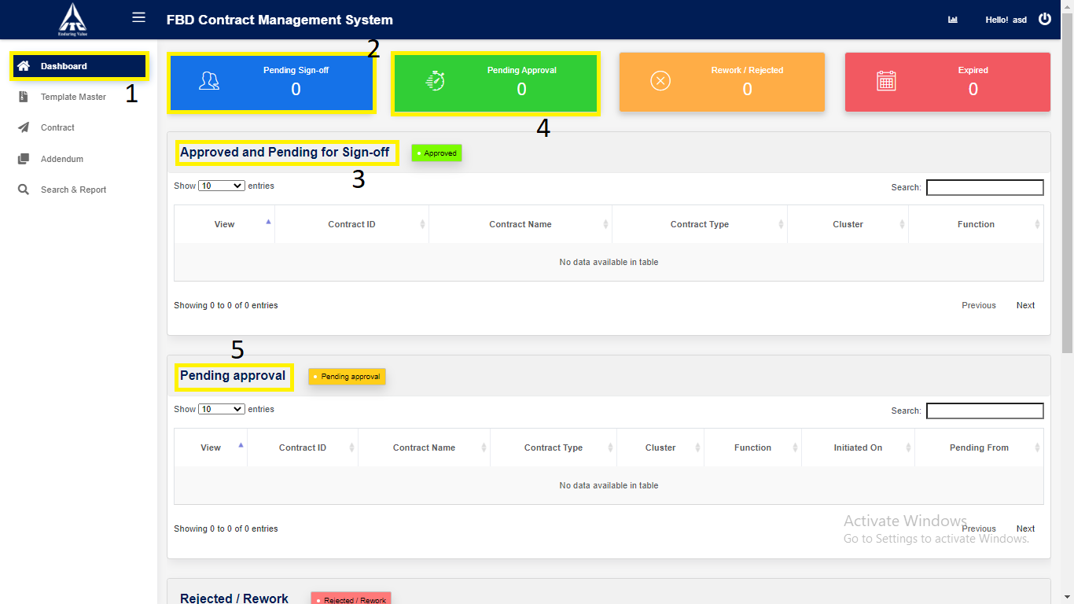

6) “**Rework/Reject**” Contains Number of Rejected or Rework Contracts.

7) Click on “**Rework/Reject**” navigates to Rejected or Rework table.

8) “**Expired**” Contains Number of Expired Contracts.

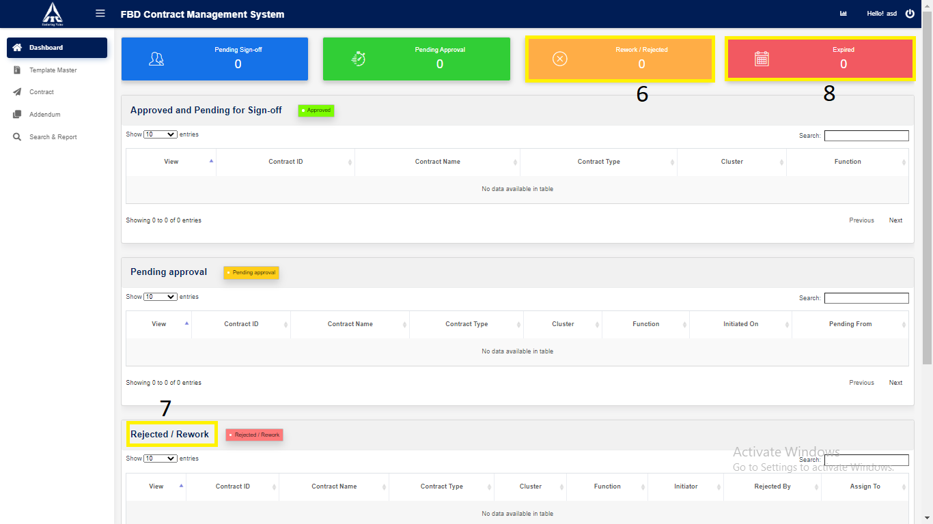

9) Click on “**Expired**” navigates to Expired table.

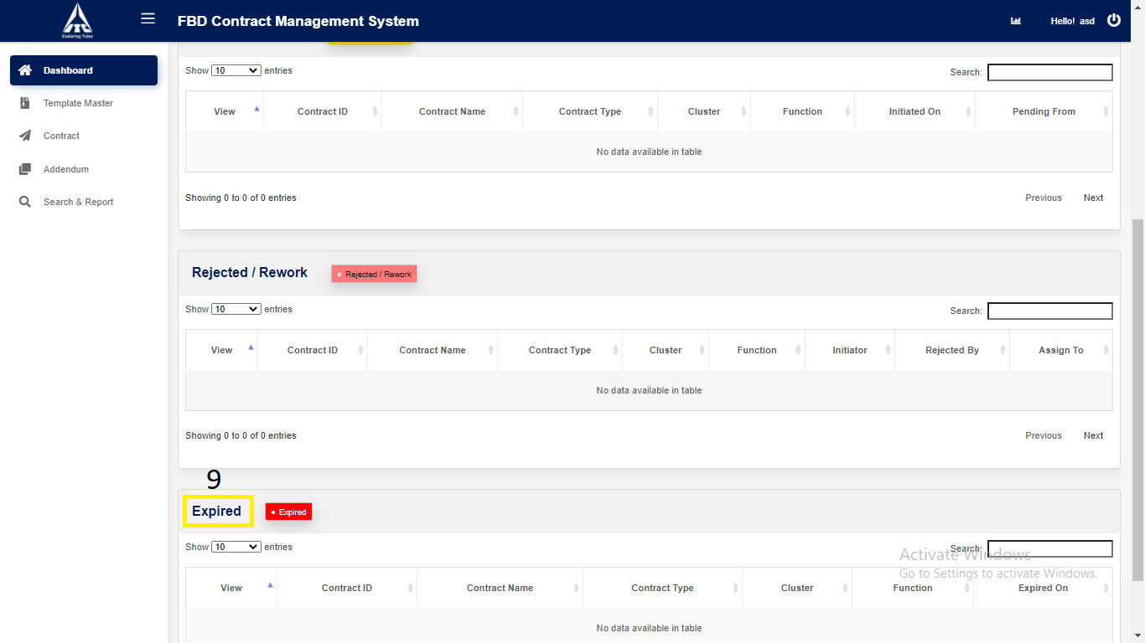

10) Click on “**Analytics**”.

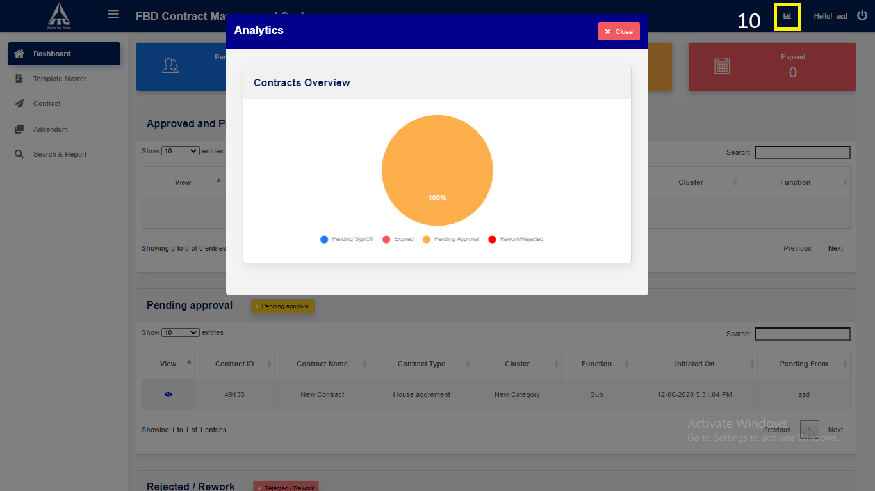

*Graphical representation*

**Contract**

1. **Contract Approval : Approver**
2. Click on “**Contract**” in side menu.
3. Click on “**Pending Approvals**” navigation link for **pending approval** table.
4. Click on **View** icon to **view** the contract details.

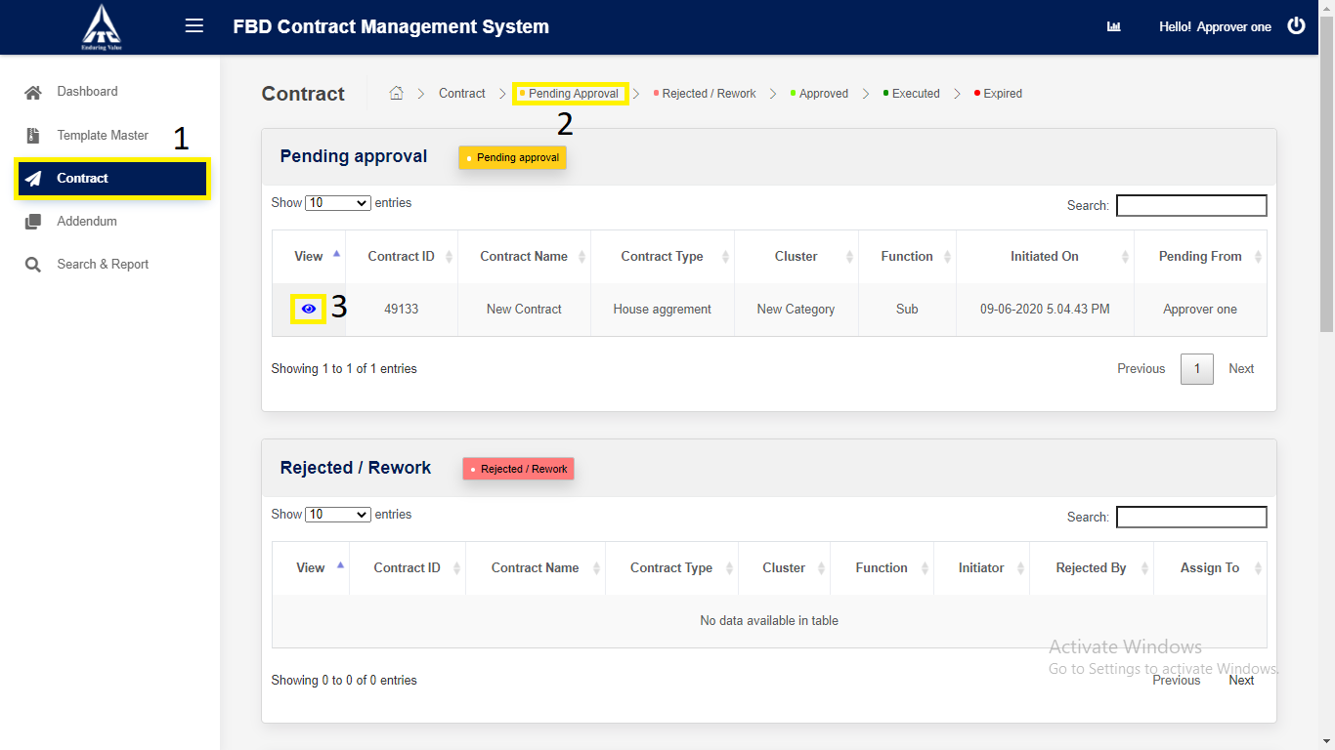

*Application will redirect to “****Contract Details****” page.*

1. Click on “**Next**” button.

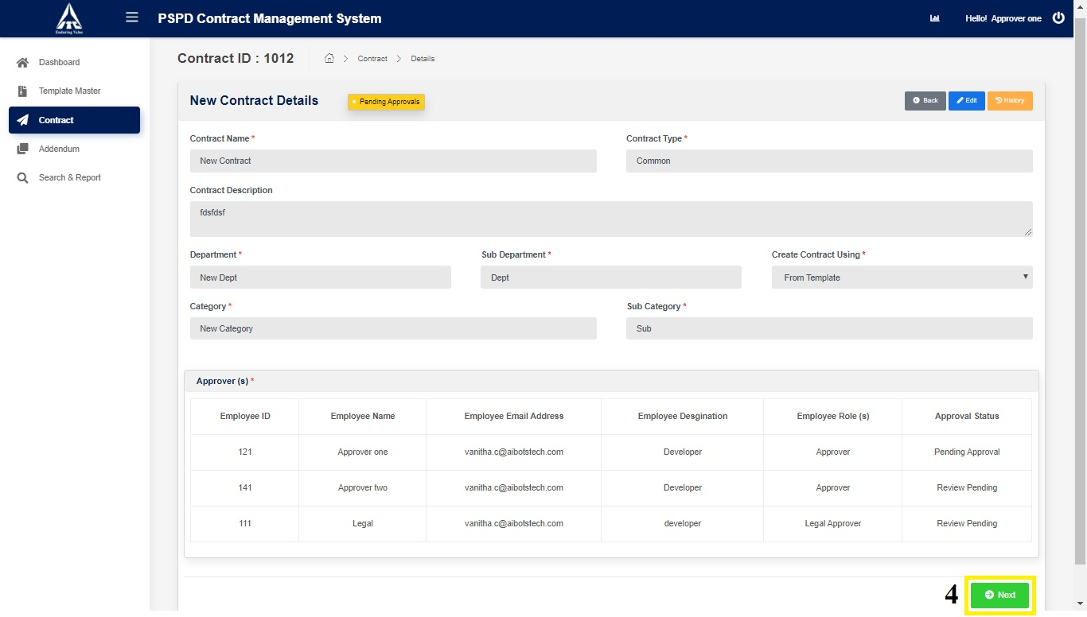

*Application will redirect to “****Contract Draft View****” page.*

1. Click on “Version Compare”.

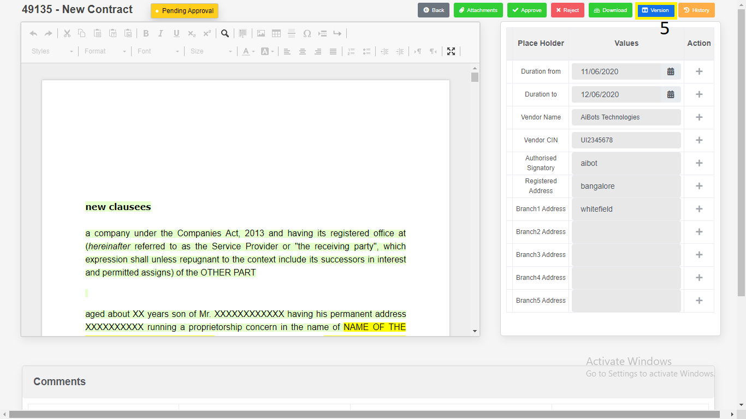

1. Select the “**Version”**.

2. Click on “**Download**”.

a) Download as “**PDF**”.

b) Download as “**Word Document**”.

3. Click on “**Close”.**

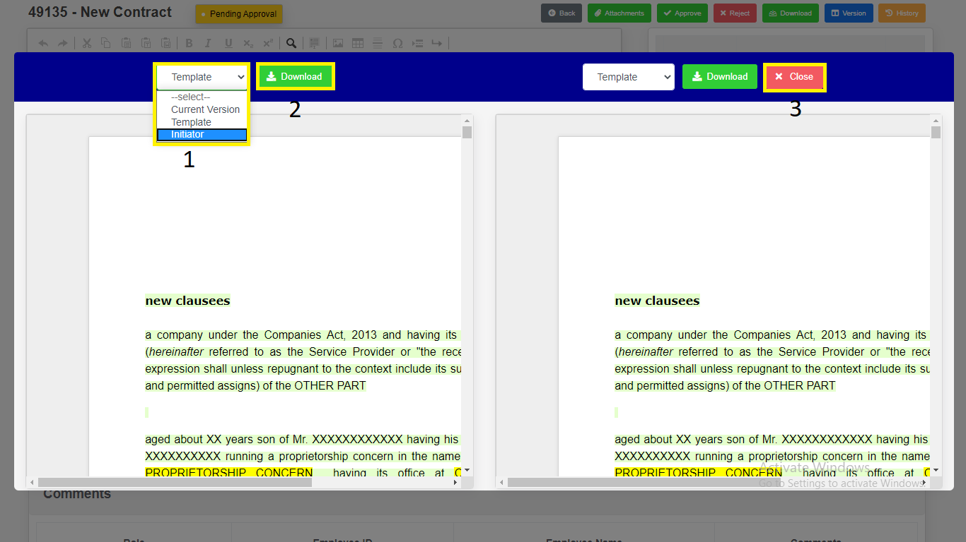

*Modal will redirect to “****Contract Draft View****” Page.*

1. Click on “**Approve**” button to **approve** the contract.
2. Enter Comments.
3. Click on “**Yes, Approve**” button to **approve** the Contract.

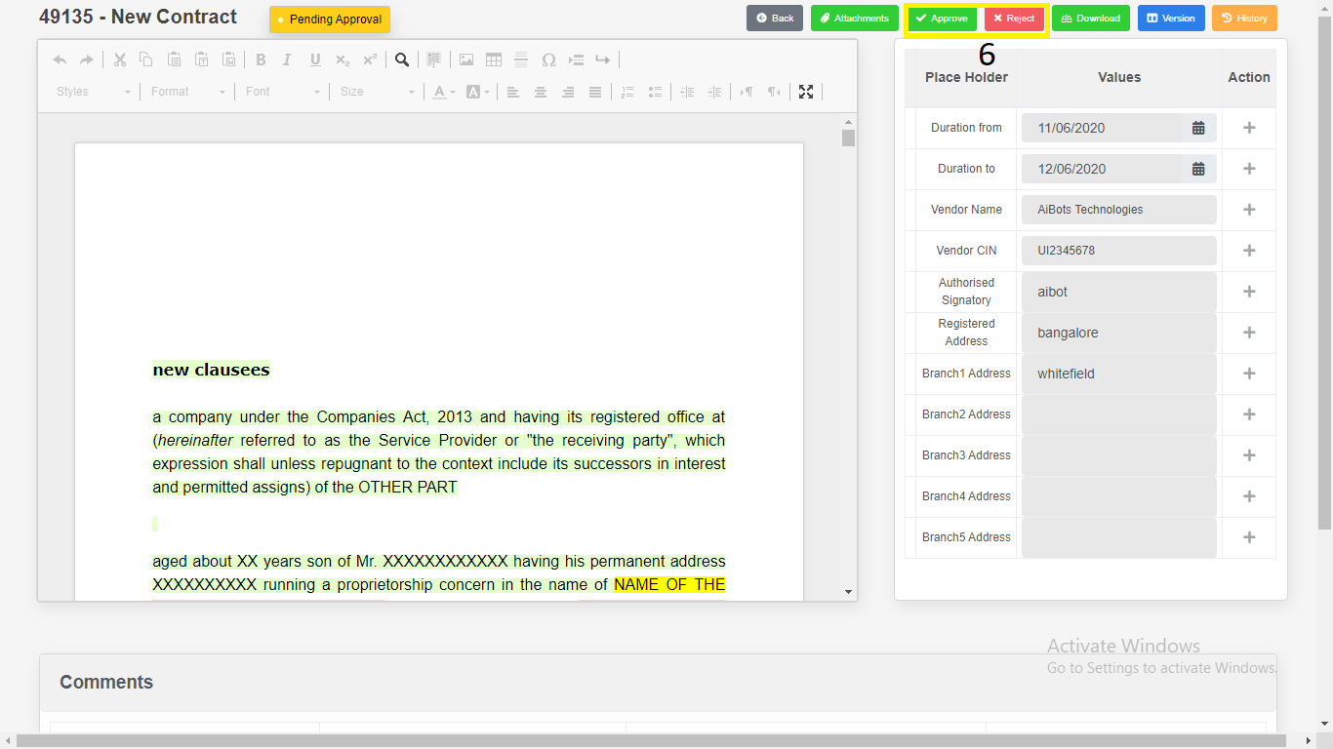

***Or***

Click on “**Reject**” button to **reject** the Contract.

1. Enter Comments.
2. Click on “**Yes, Reject**” button to **reject** the Contract.

*Application will redirect to same page.*

1. Click on “**Download**”.

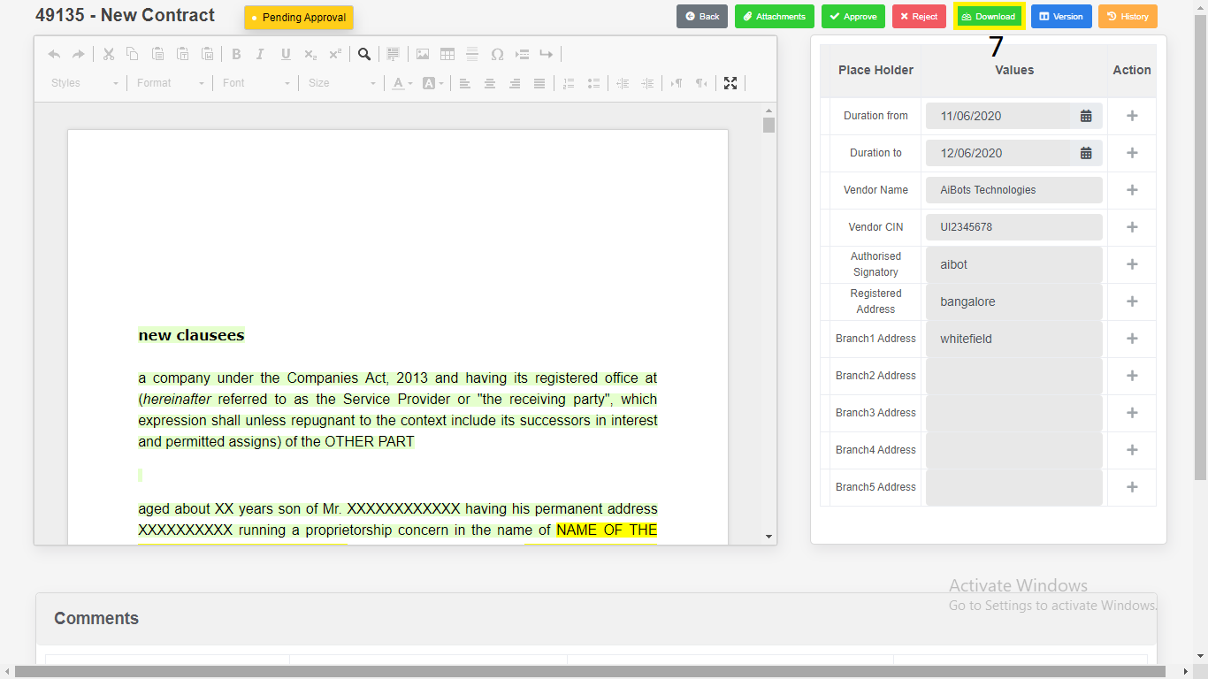

1) Download as “**PDF**”.

2) Download as “**Word Document**”.

3) Click on “**Close**”.

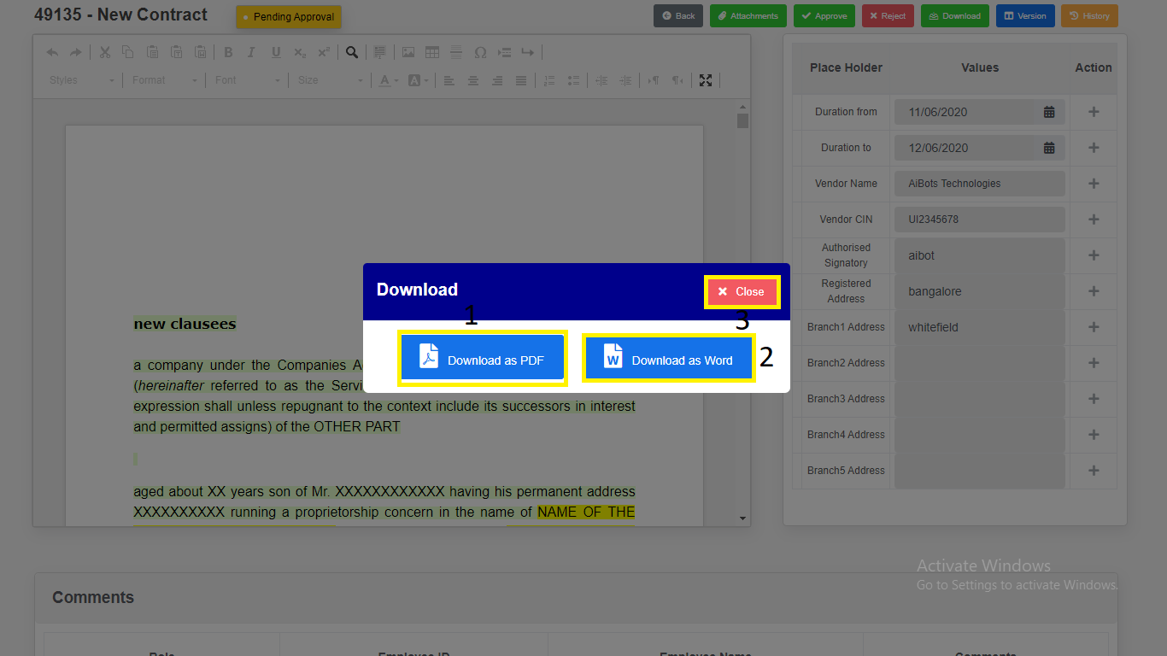

*Modal will redirect to “****Contract Draft View****” Page.*

1. Click on “**History**”. Changes done in the Contract will be recorded in history.

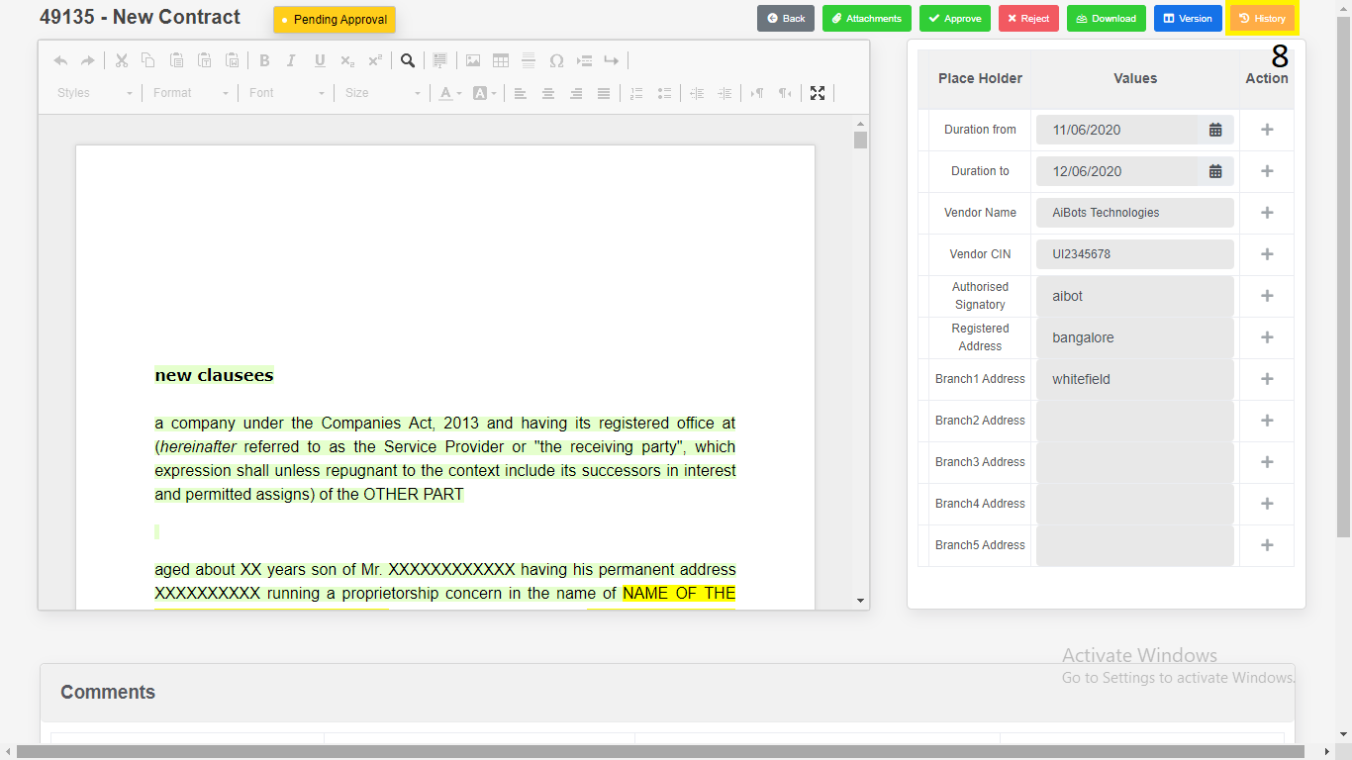

**Contract Addendum**

1. **Contract Addendum Approval : Approver**
2. Click on “**Addendum**” in side menu.
3. Click on “**Pending Approvals**” navigation link for **pending approval** table.
4. Click on **View** icon to **view** the contract details.

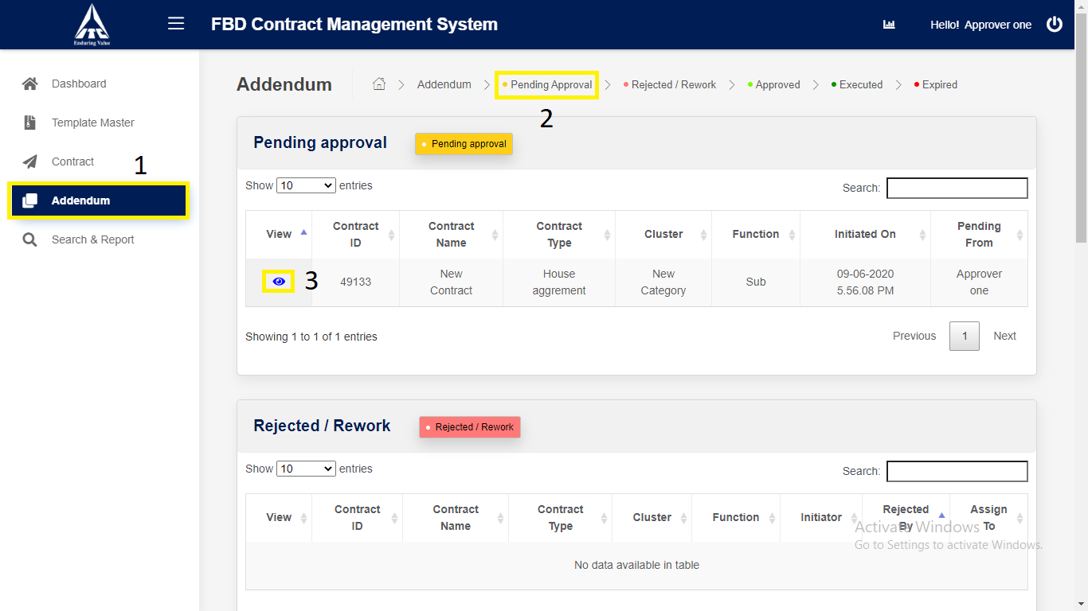

*Application will redirect to “****Contract Details****” page.*

1. Click on “**Next**” button.

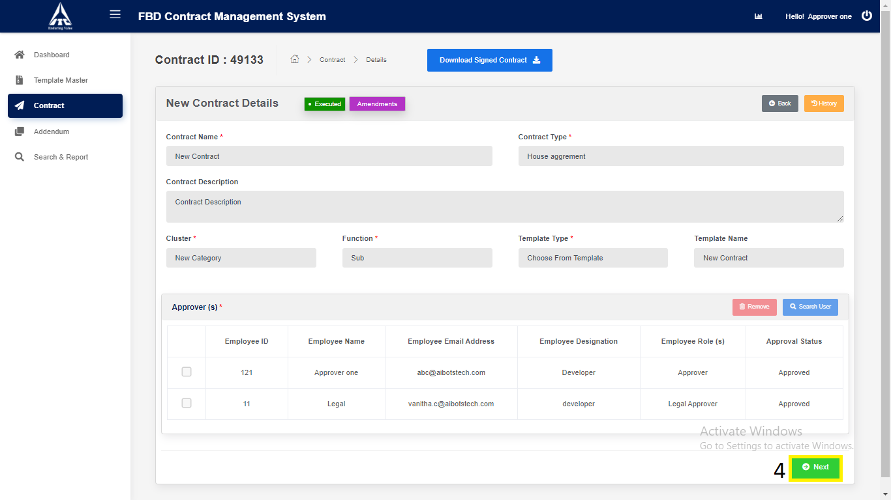

*Application will redirect to “****Contract Draft View****” page.*

1. Click on **Addendum type** button to navigate to Contract Addendum Draft view page.

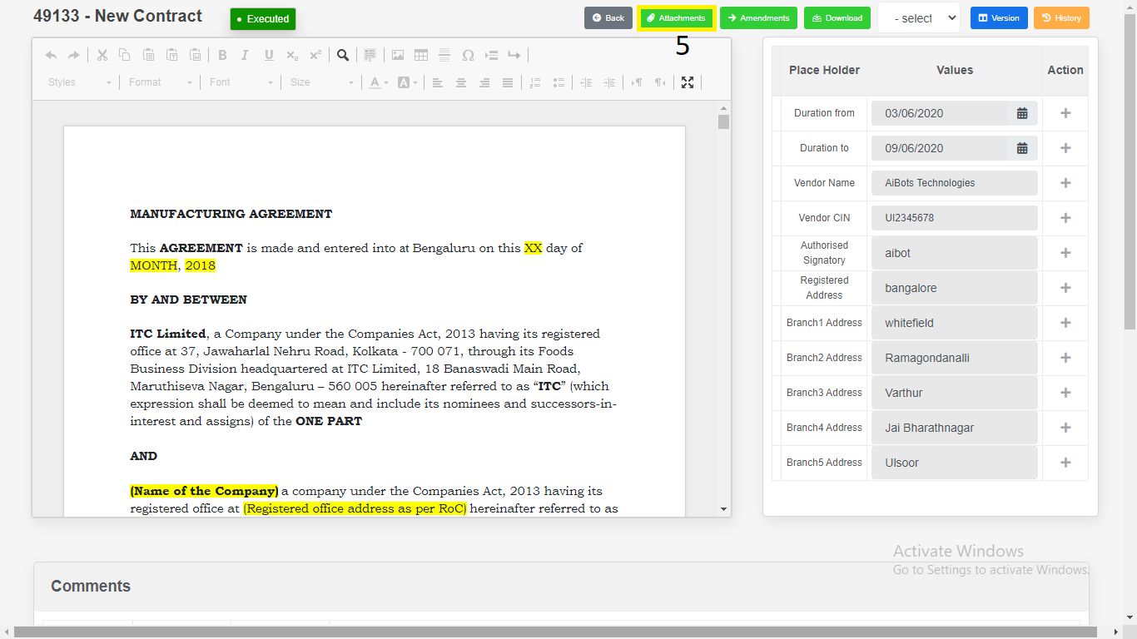

*Application will redirect to “****Contract Addendum Draft View****” page.*

1. Click on “Version Compare”.

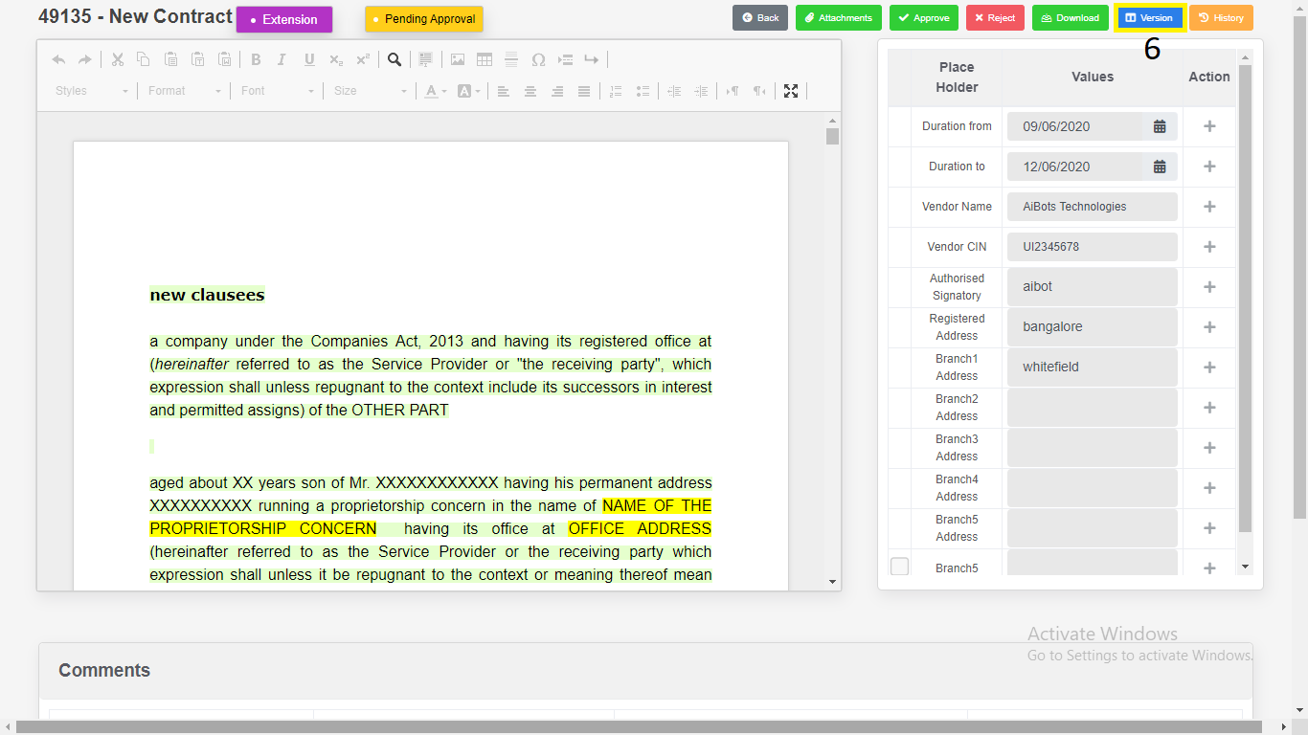

1. Select the “**Version”**.

2. Click on “**Download**”.

a) Download as “**PDF**”.

b) Download as “**Word Document**”.

3. Click on “**Close”.**

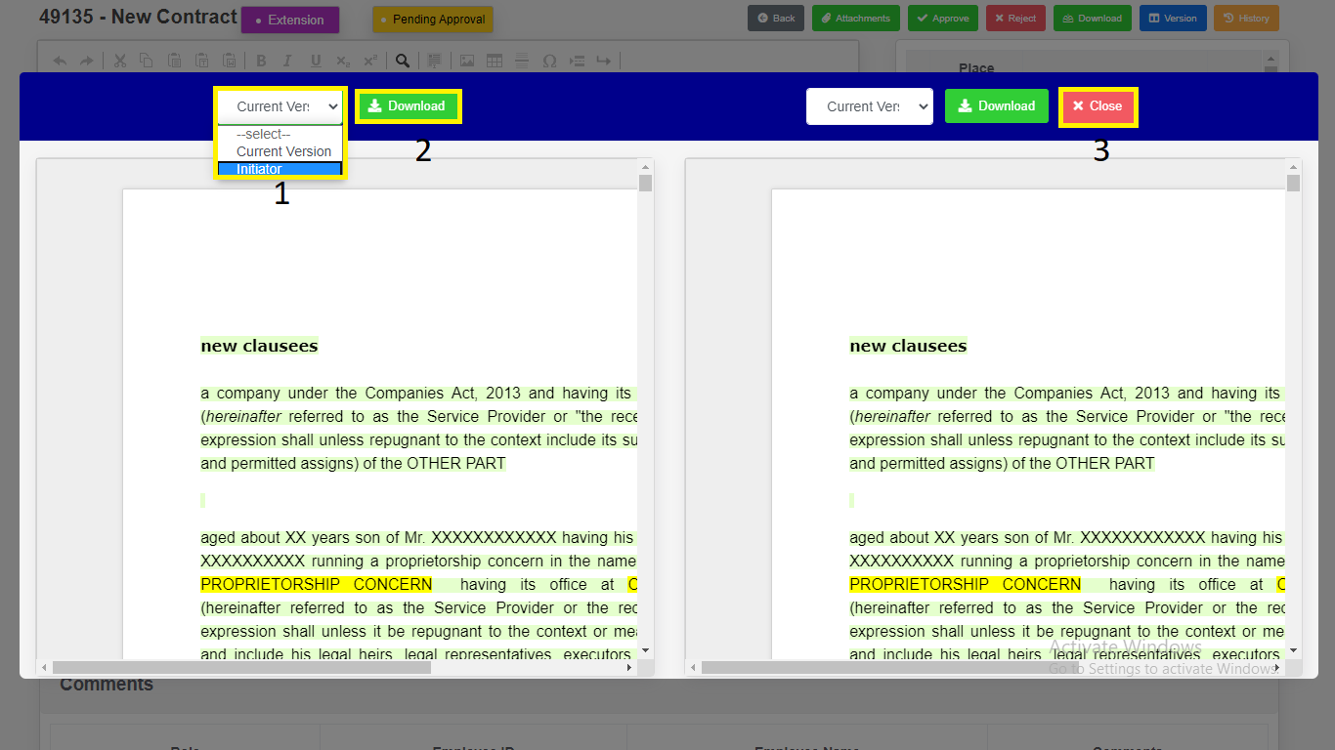

*Modal will redirect to “****Contract Addendum Draft View****” Page.*

1. Click on “**Approve**” button to **approve** the contract.
2. Enter Comments.

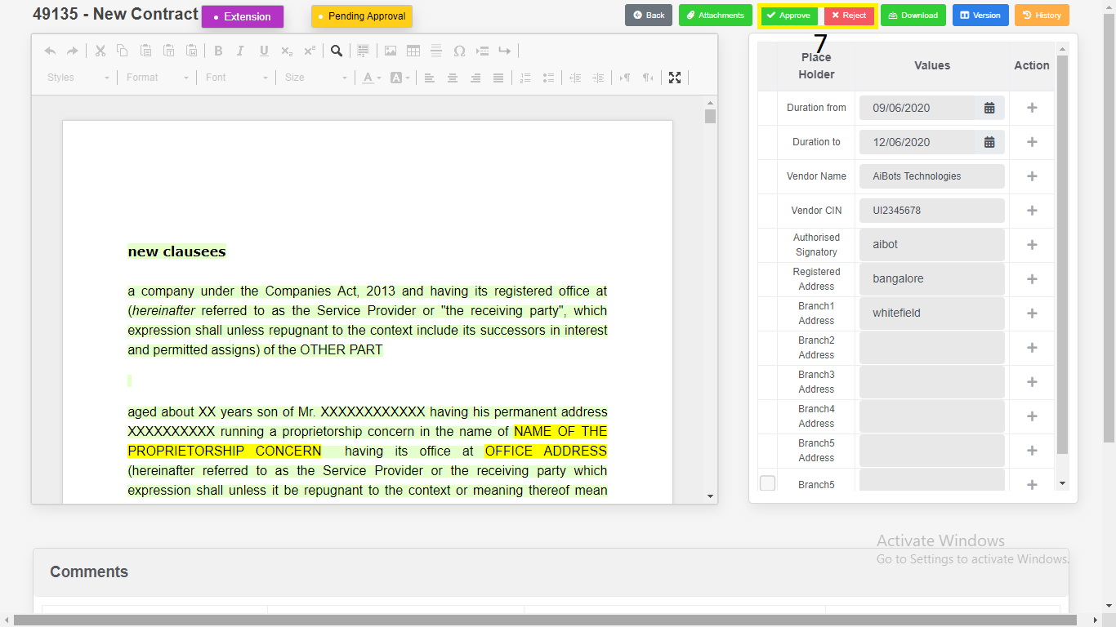

1. Click on “**Yes, Approve**” button to **approve** the Contract.

***Or***

Click on “**Reject**” button to **reject** the Contract.

1. Enter Comments.
2. Click on “**Yes, Reject**” button to **reject** the Contract.

*Application will redirect to same page.*

1. Click on “**Download**”.

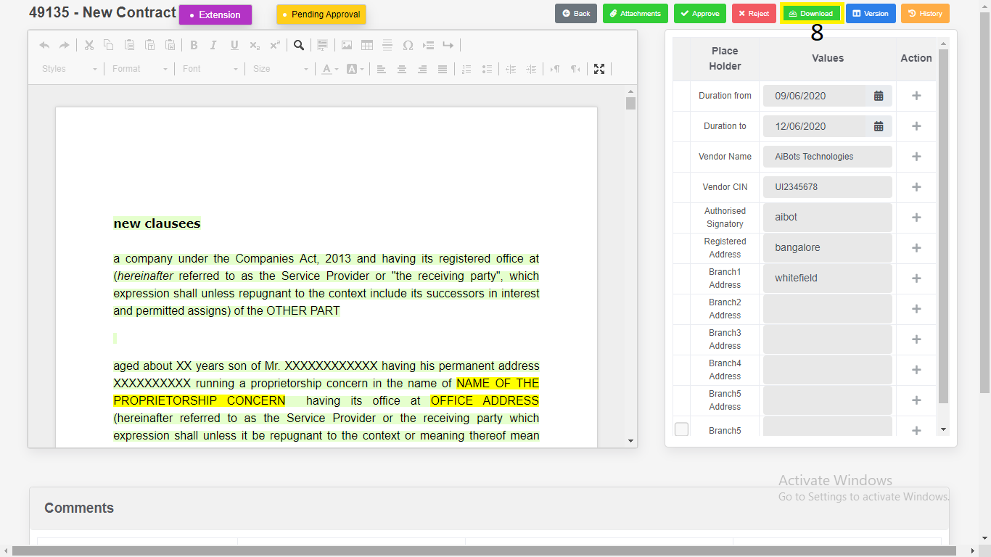

1) Download as “**PDF**”.

2) Download as “**Word Document**”.

3) Click on “**Close**”.

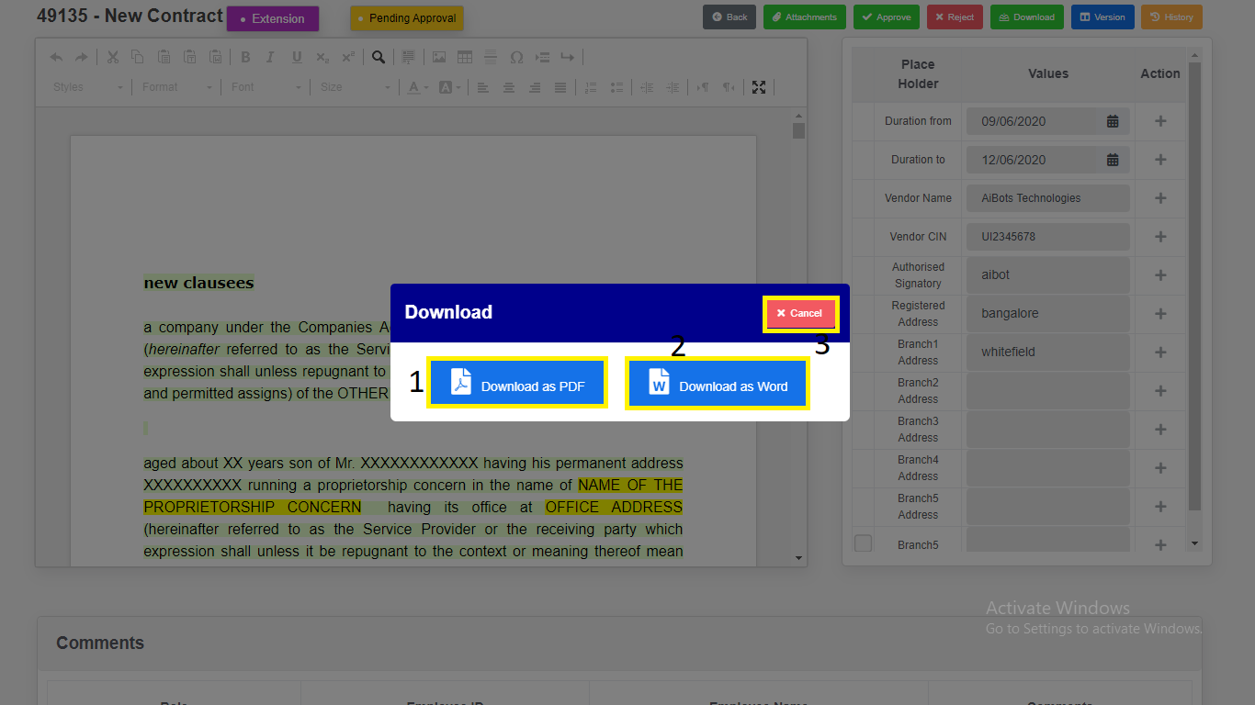

*Modal will redirect to “****Contract Addendum Draft View****” Page.*

1. Click on “**History**”. Changes done in the Contract will be recorded in history.

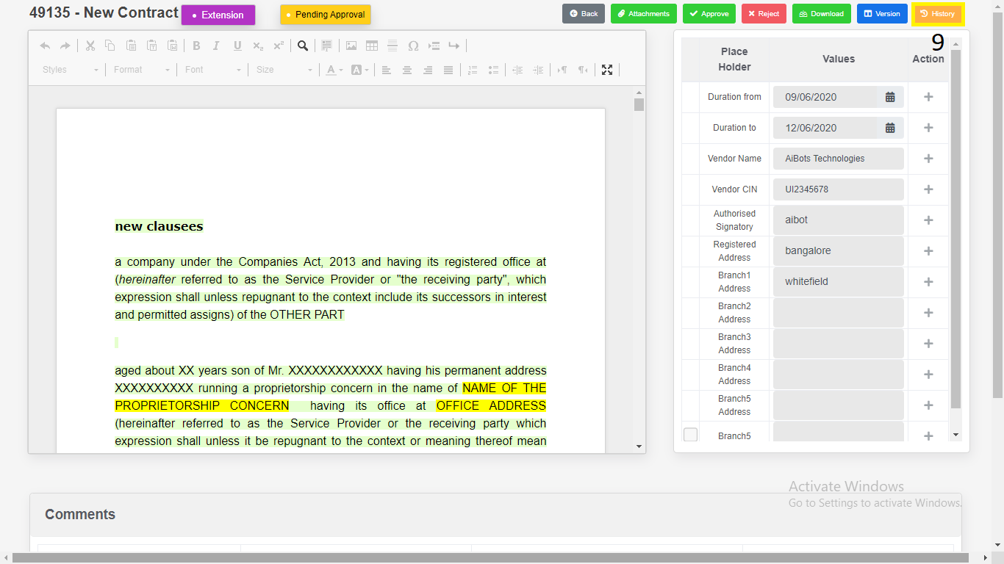

**Search & Report**

1. Click on “**Search & Report**” from Side Menu (Access to Admin Only).

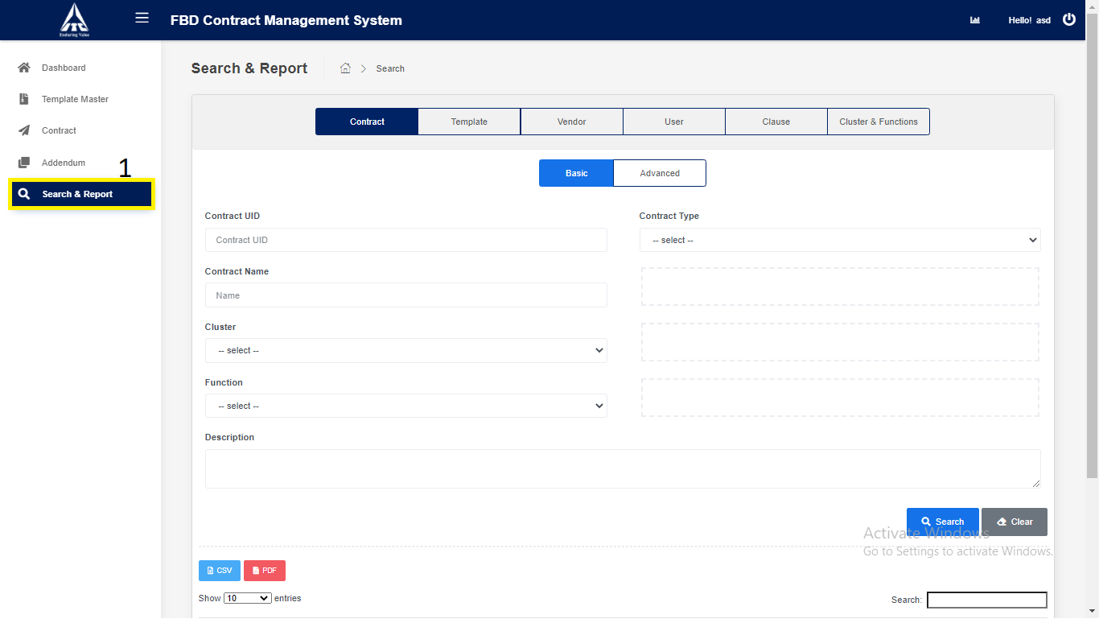

1. Click on “**Contract**” tab.

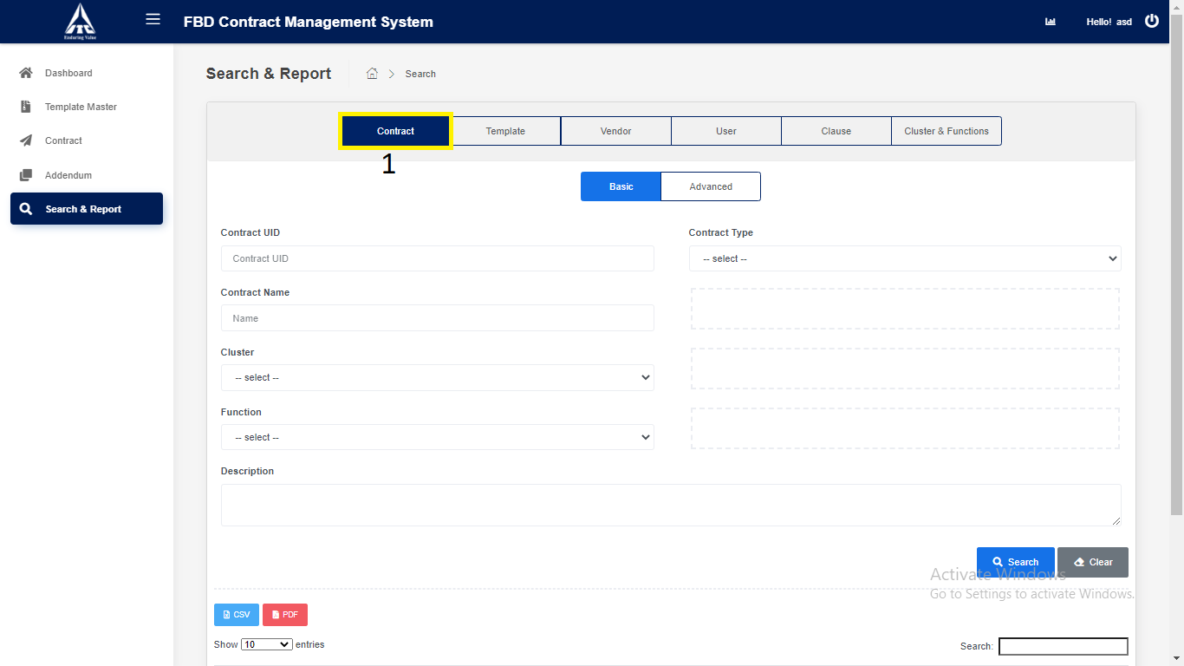

1. Click on Basic Contract.
2. Enter Basic Contract Details.
3. Enter **“Contract UID”** *(Only Numbers are allowed).*
4. Enter **“Contract Name”** *(Only Characters are allowed).*
5. Select **“Contract Type”***.*
6. Select “**Cluster**”.
7. Select “**Function**”.
8. Click on “**Search**”.
9. Search the contract details and displays in the contract table.
10. Click on “**CSV**”.
11. **CSV** downloads the contract details in Excel format.
12. **PDF** downloads the contract details in PDF format.
13. Click on **“Clear”.**

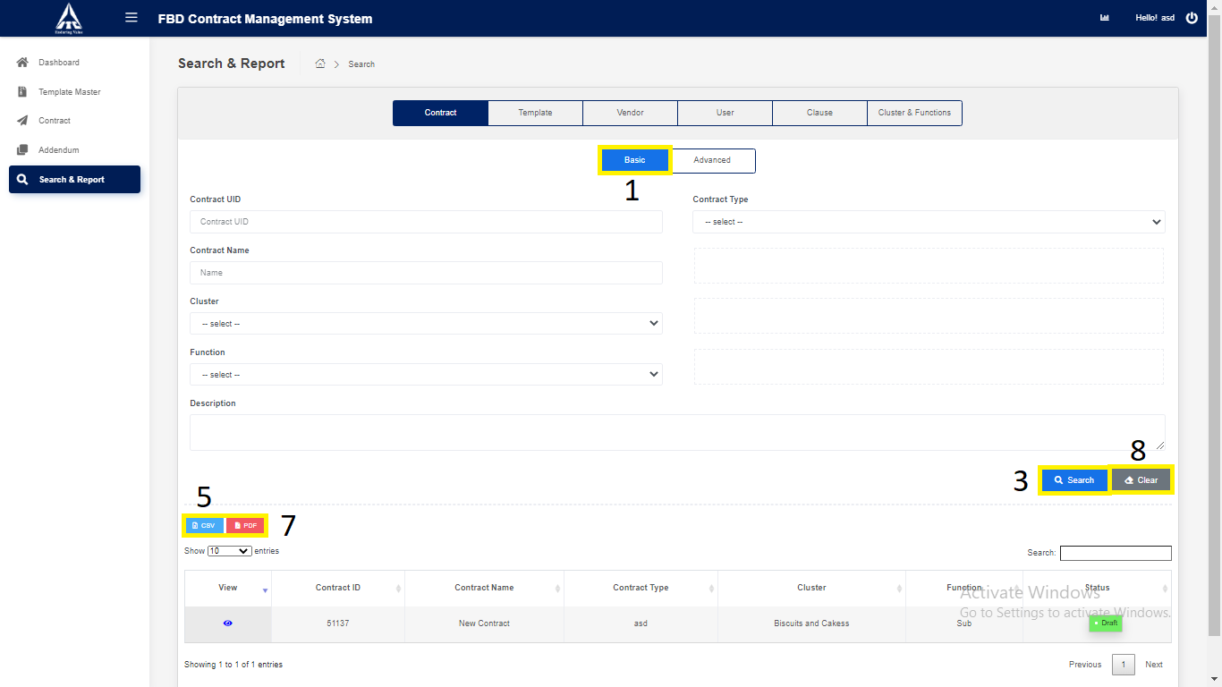

*Application will redirect to “****Search & Report****” page.*

1. Click on “**Advance**” Contract.
2. Enter Advance Contract Details.
3. Enter **“Contract UID”** *(Only Numbers are allowed).*
4. Enter **“Contract Name”** *(Only Characters are allowed).*
5. Select **“Contract Type”***.*
6. Select “**Cluster**”.
7. Select “**Function**”.
8. Select “**Vendor Name**”.
9. Enter “**Execution** Date”.
10. Enter “**Termination** Date”.
11. Enter “**Description**” *(Only Characters & Numbers are allowed).*
12. Click on “**Search**”.
13. Search the contract details and displays in the contract table.
14. Click on “**CSV**”.
15. **CSV** downloads the contract details in Excel format.
16. **PDF** downloads the contract details in PDF format.
17. Click on **“Clear”.**

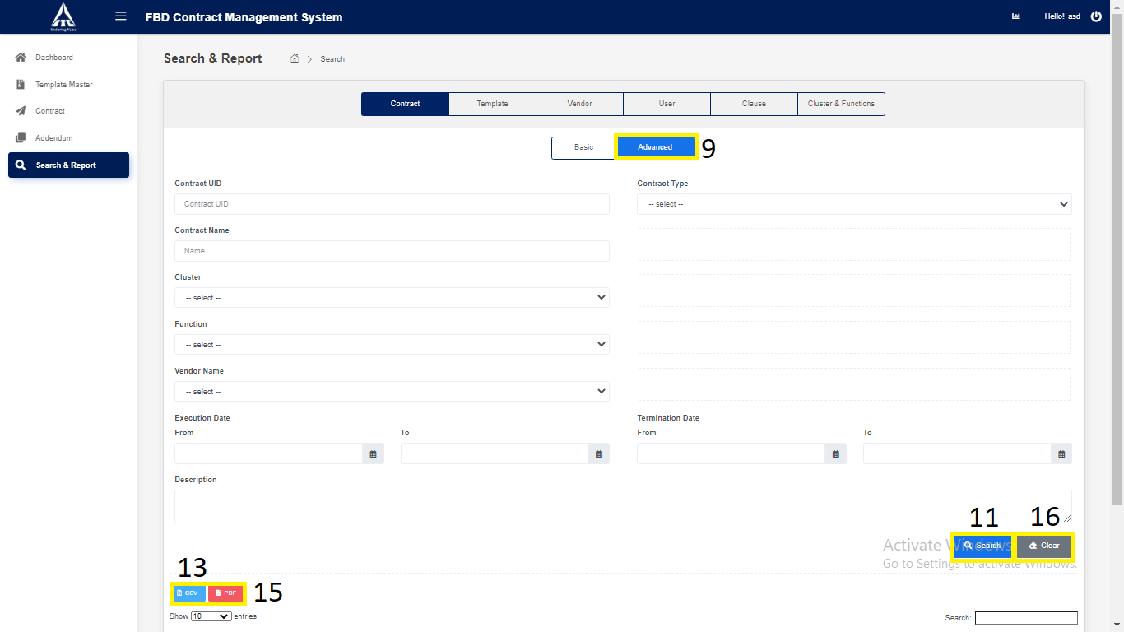

*Application will redirect to “****Search & Report****” page.*

1. Click on “**Template**” tab.

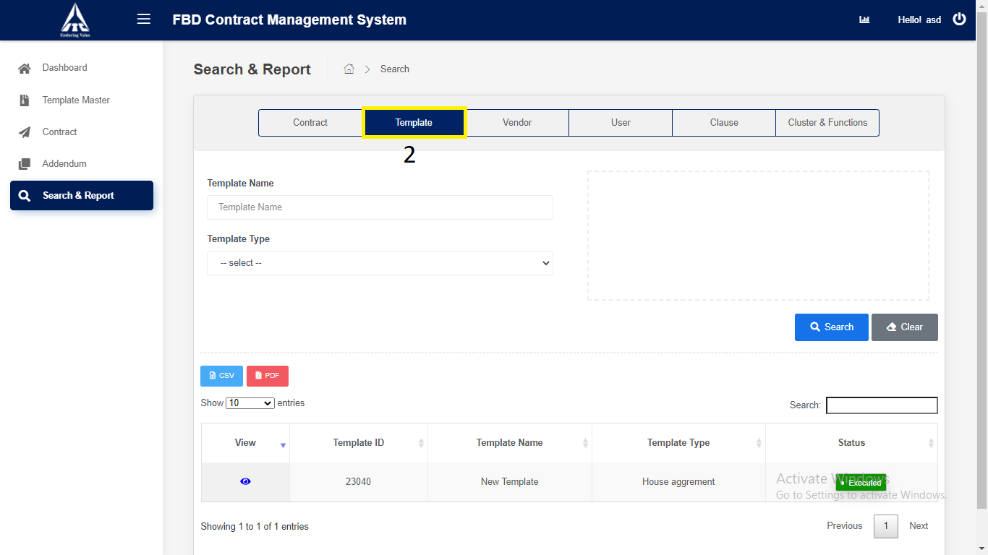

1. Click on “**Template**”.
2. Enter Basic Template Details.
3. Enter “Template Name”.
4. Enter “Template Type”.
5. Click on “**Search**”.
6. Search the Template details and displays in the Template table.
7. Click on “**CSV**”
8. **CSV** downloads the Template details in Excel format.
9. Click on **“PDF”** downloads the Template details in PDF format.
10. Click on **“Clear”.**

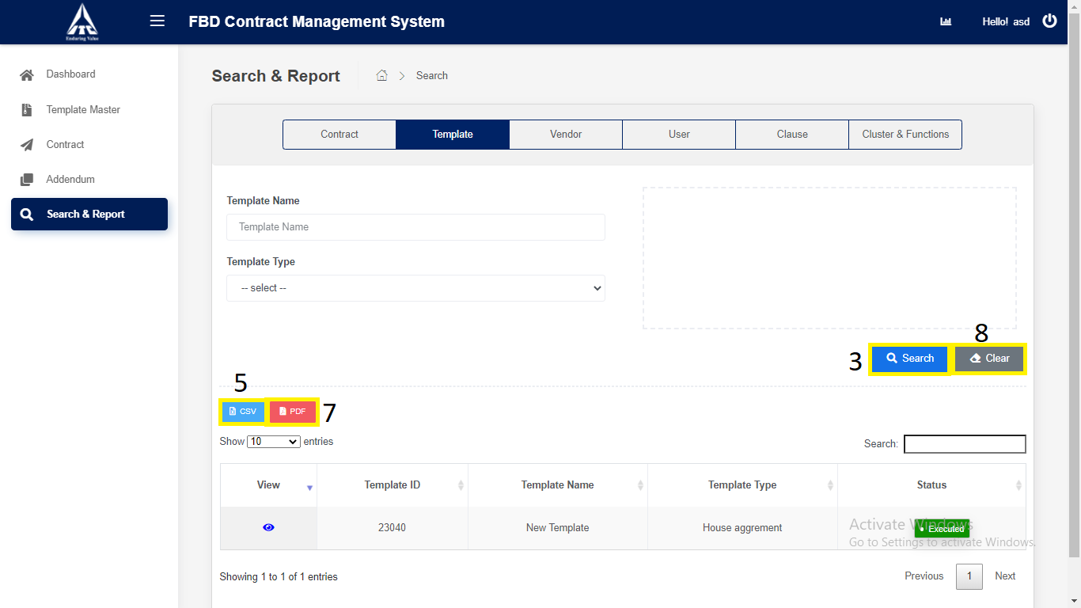

*Application will redirect to “****Search & Report****” page.*

1. Click on “**Vendor**” tab.

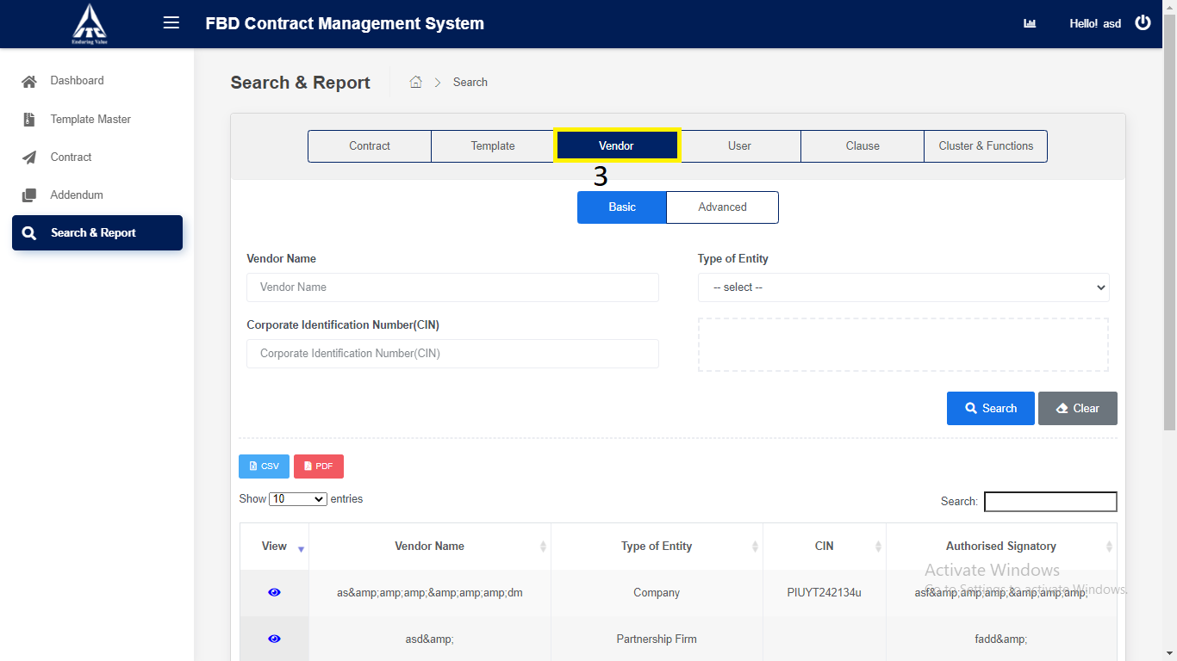

1. Click on “**Basic**” Vendor.
2. Enter Basic Vendor Details.
3. Enter “Vendor Name”.
4. Select “Type of entity”.
5. Enter “Corporate Identification Number(CIN)”
6. Click on “**Search**”.
7. Search the Vendor details and displays in the Vendor table.
8. Click on “**CSV**”.
9. **CSV** downloads the Vendor details in Excel format.
10. Click on **“PDF”** downloads the Vendor details in PDF format.
11. Click on **“Clear”.**

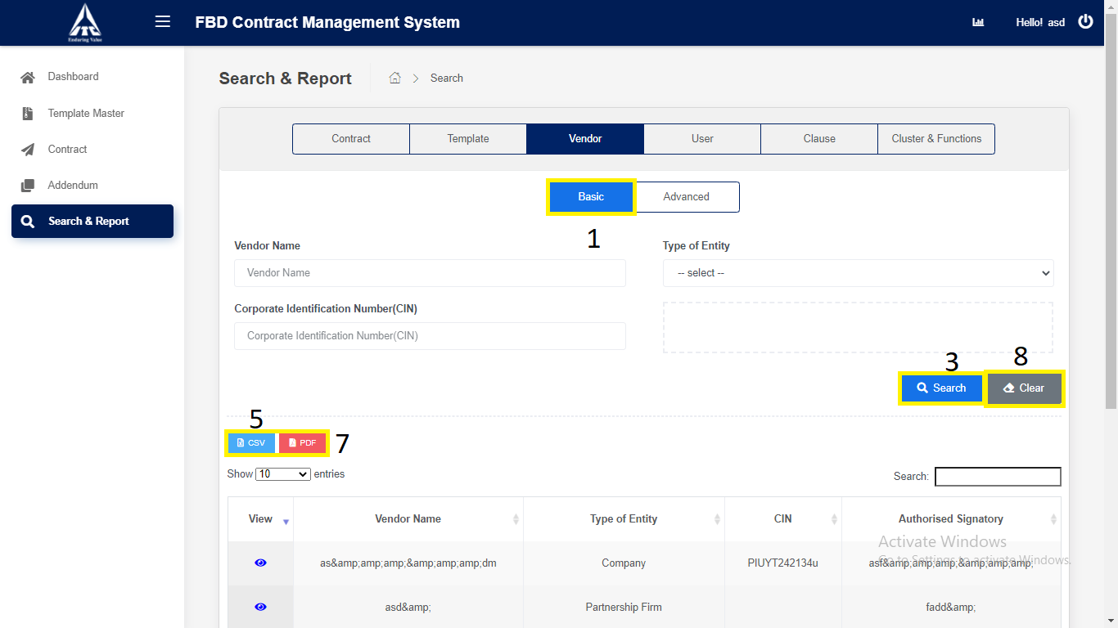

*Application will redirect to “****Search & Report****” page.*

1. Click on “**Advance**” Vendor.
2. Enter Advance Vendor Details.
3. Enter “Vendor Name”.
4. Select “Type of entity”.
5. Enter “Corporate Identification Number(CIN)”
6. Enter “Authorized Signature”.
7. Enter “Address”.
8. Click on “**Search**”.
9. Search the Vendor details and displays in the Vendor table.
10. Click on “**CSV**”.
11. **CSV** downloads the Vendor details in Excel format.
12. Click on **“PDF”** downloads the Vendor details in PDF format.
13. Click on **“Clear”.**

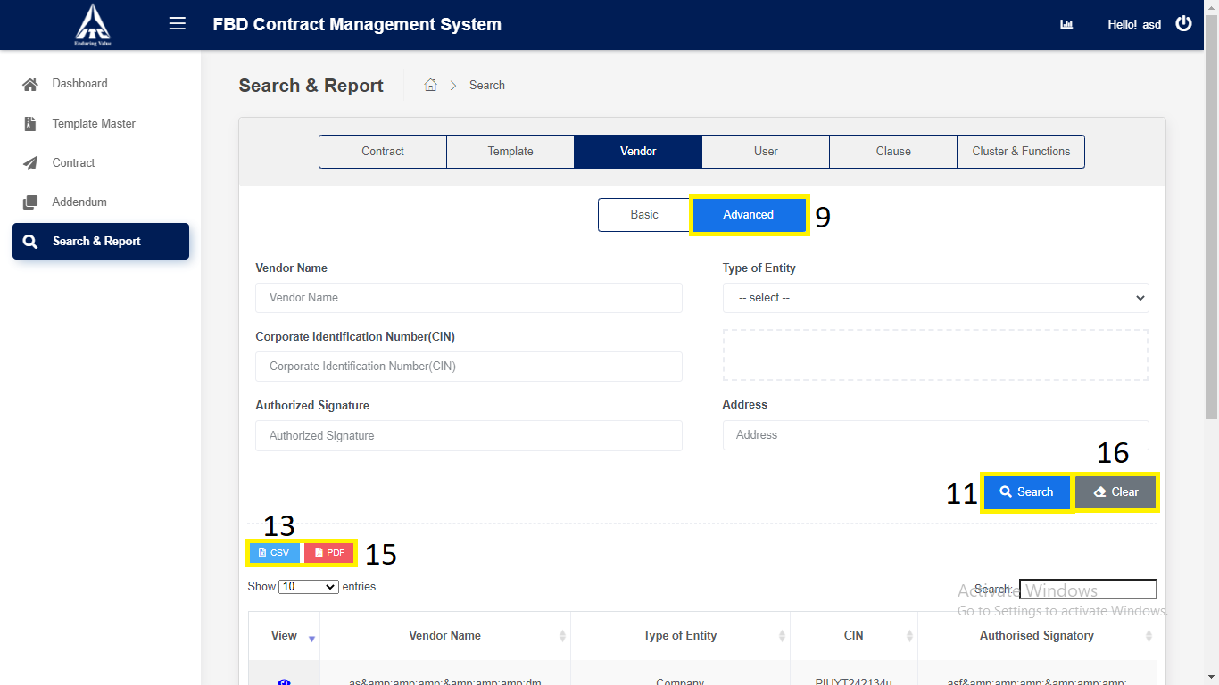

*Application will redirect to “****Search & Report****” page.*

1. Click on “**User**” tab.

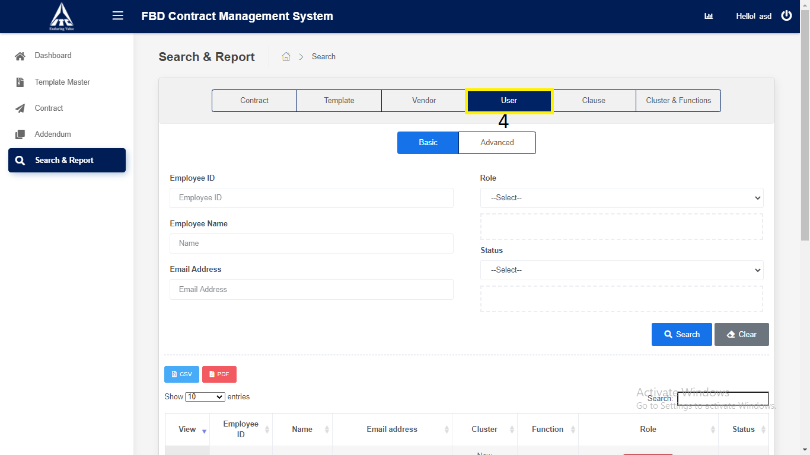

1. Click on “**Basic**” User.
2. Enter Basic User Details.
3. Enter “Employee ID”.
4. Enter “Employee Name”.
5. Select “Role”.
6. Enter “Email Address”.
7. Select “Status”.
8. Click on “**Search**”.
9. Search the User details and displays in the User table.
10. Click on “**CSV**”.
11. **CSV** downloads the User details in Excel format.
12. Click on **“PDF”** downloads the User details in PDF format.
13. Click on “**Clear**”.

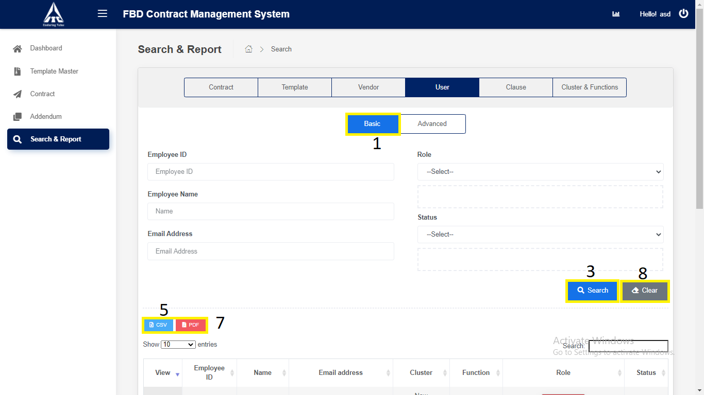

*Application will redirect to “****Search & Report****” page.*

1. Click on “**Advance**” User.
2. Enter Advance User Details.
3. Enter “Employee ID”.
4. Select “Cluster”.
5. Select “Function”.
6. Select “Role”.
7. Enter “Employee Name”.
8. Enter “Email Address”.
9. Select “Designation”.
10. Select “Status”.
11. Click on “**Search**”.
12. Search the User details and displays in the User table.
13. Click on “**CSV**”.
14. **CSV** downloads the User details in Excel format.
15. Click on **“PDF”** downloads the User details in PDF format.
16. Click on “**Clear**”.

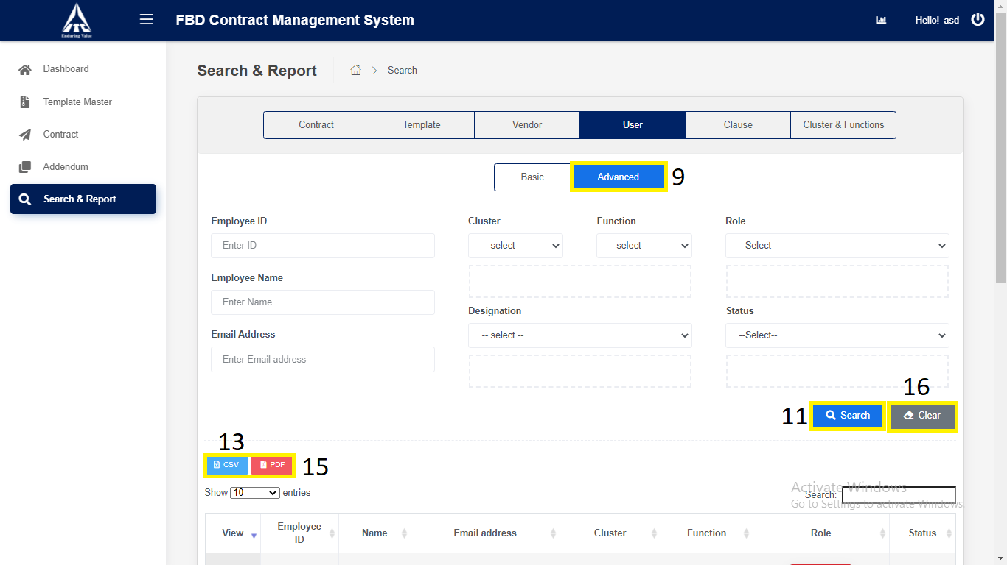

*Application will redirect to “****Search & Report****” page.*

1. Click on “**Clause**” tab.

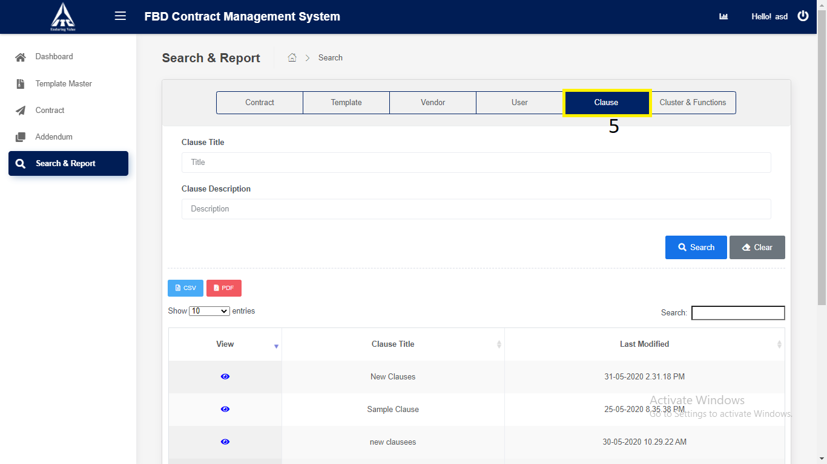

1. Click on “**Clause**”.
2. Enter Clause Details.
3. Enter “Clause Tittle”.
4. Enter “Clause Description”.
5. Click on “**Search**”.
6. Search the Clause details and displays in the Clause table.
7. Click on “**CSV**”.
8. **CSV** downloads the Clause details in Excel format.
9. Click on **“PDF”** downloads the Clause details in PDF format.
10. Click on “**Clear**”.

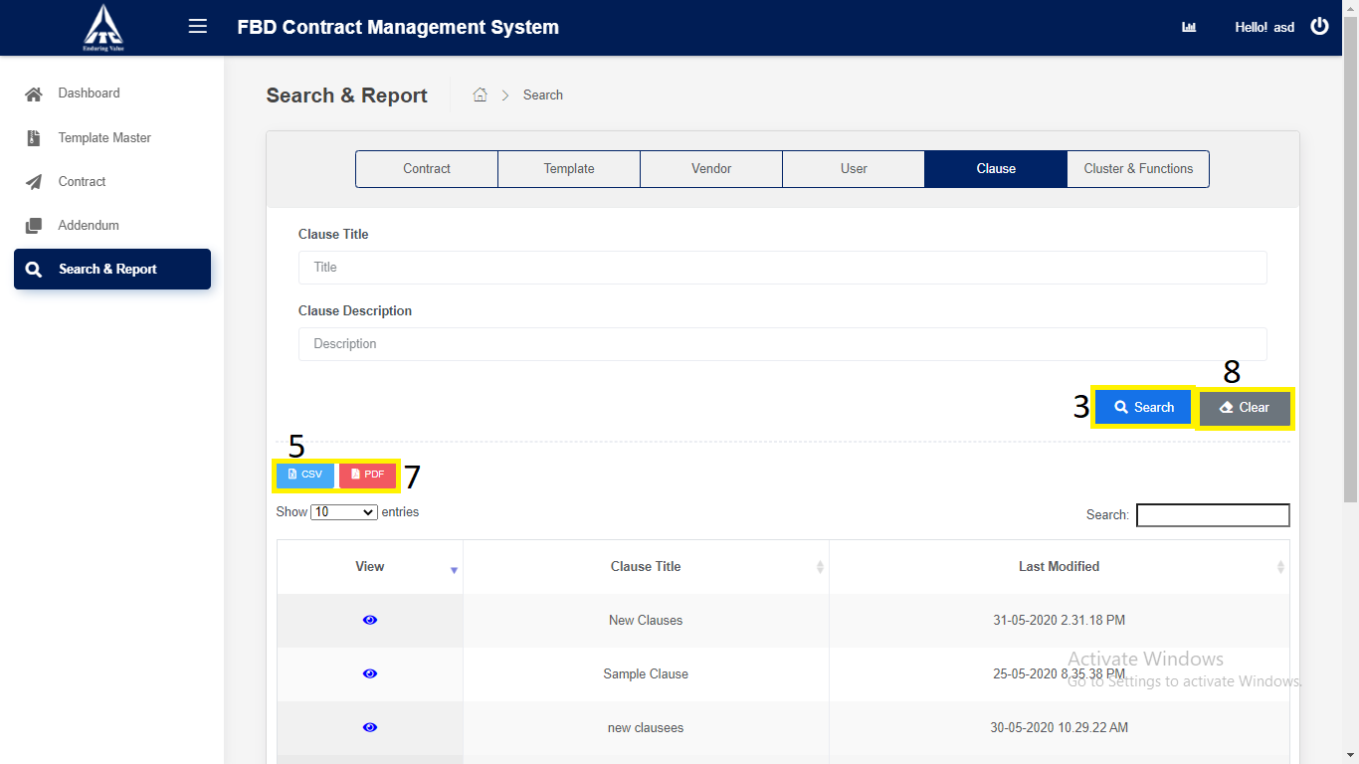

*Application will redirect to “****Search & Report****” page.*

1. Click on “**Cluster & Function**” tab.

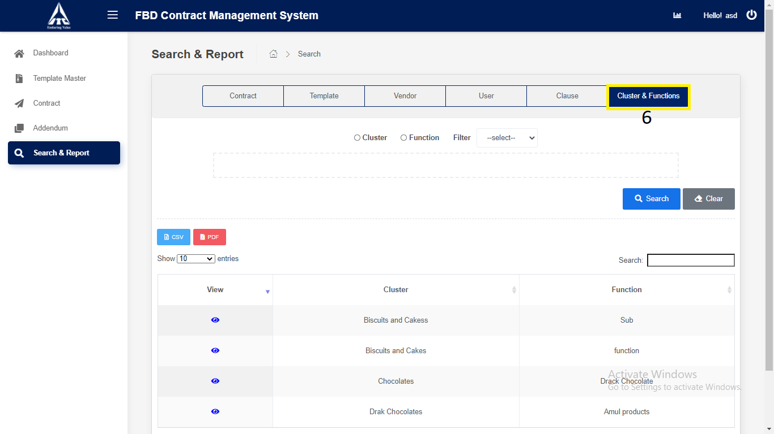

1. Click on “**Cluster and Function**”.
2. Enter Cluster and Function Details.
3. Select “**Cluster**”.

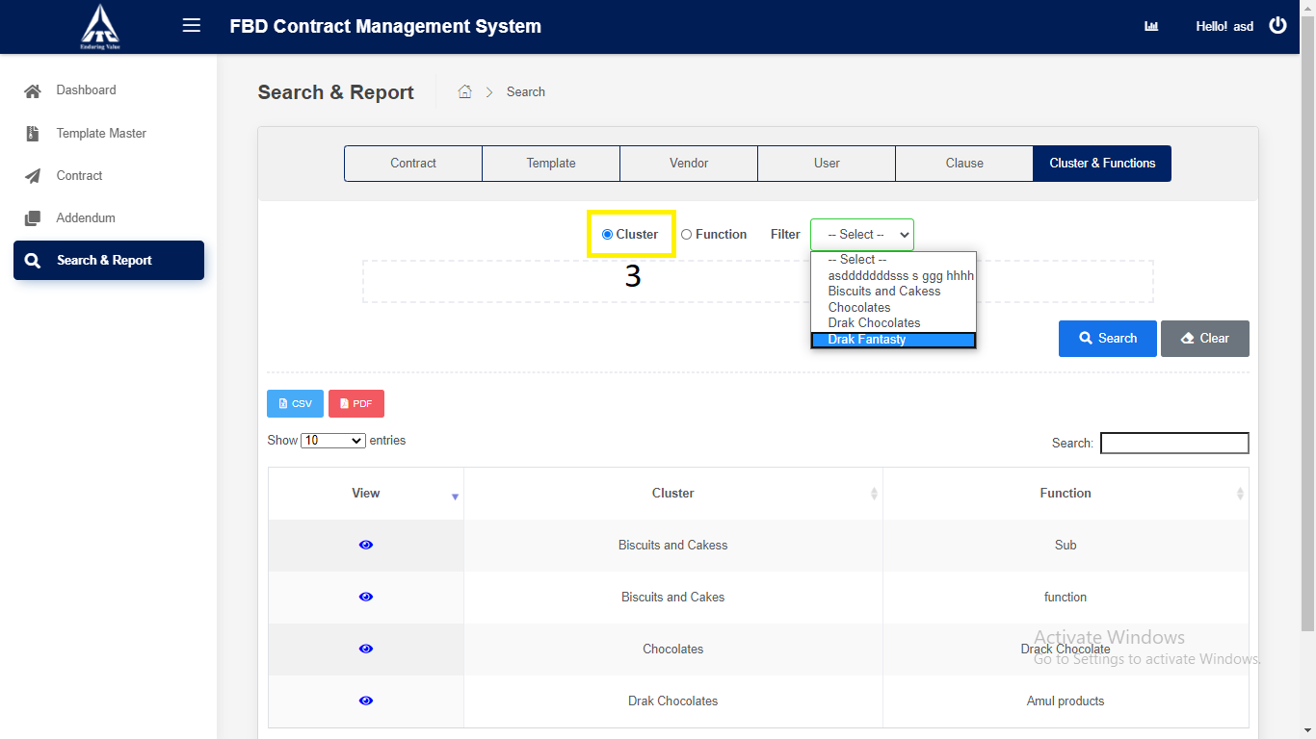

1. Select “**Function**”.

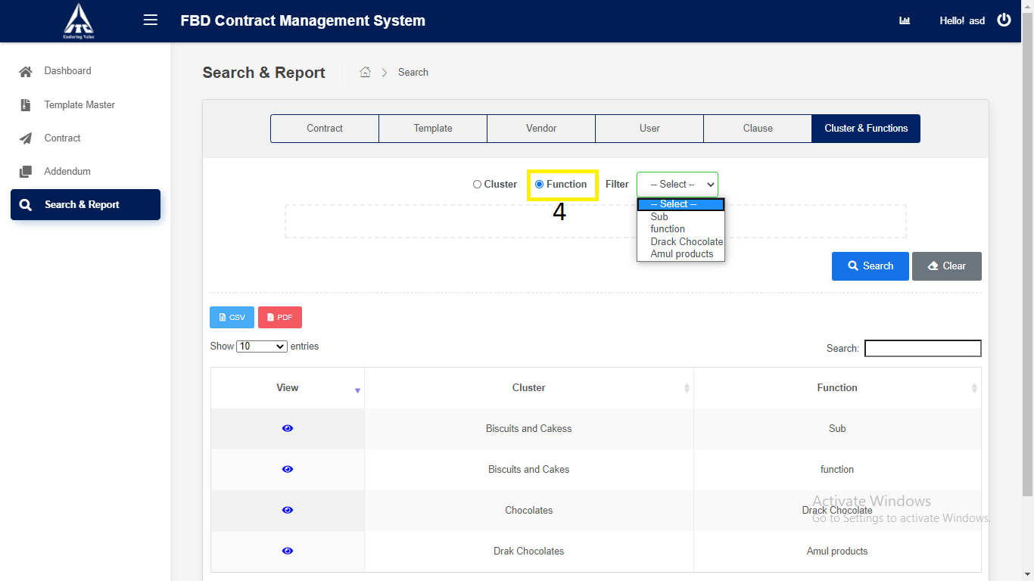

1. Click on “**Search**”.
2. Search the Cluster and Function details and displays in the Cluster and Function table.
3. Click on “**CSV**”.
4. **CSV** downloads the Cluster and Function details in Excel format.
5. Click on **“PDF”** downloads the Cluster and Function details in PDF format.
6. Click on “**Clear**”.

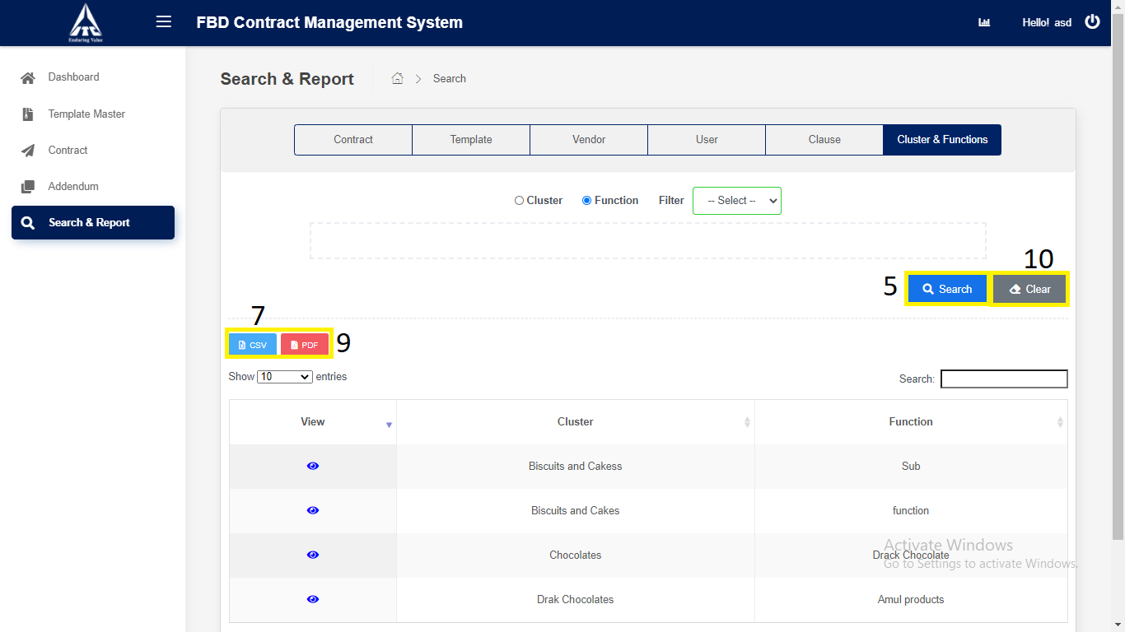

*Application will redirect to “****Search & Report****” page.*