**Initiator**

**Dashboard**

1) Click on “**Dashboard**” from Side Menu.

2) “**Pending Sign-off**” Contains Number of Approved Contracts.

3) Click on “**Pending Sign-off**” navigates to Approved and Pending for sign-off table.

4) “**Pending Approval**” Contains Numbers of Pending Approval Contracts.

5) Click on “**Pending Approval**” navigates to Pending Approval table.

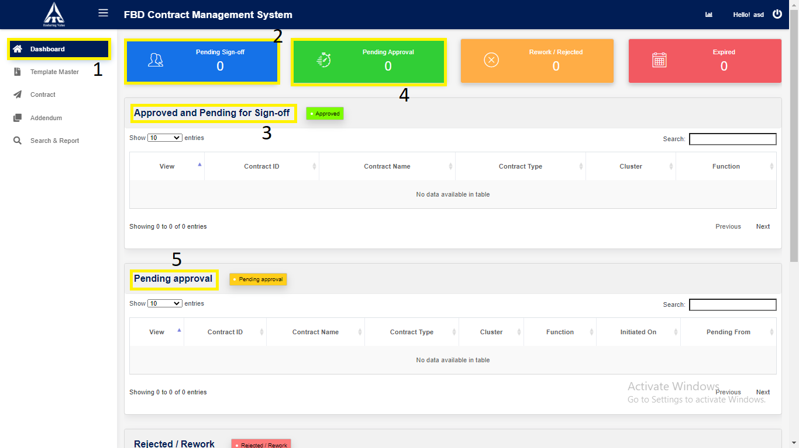

6) “**Rework/Reject**” Contains Number of Rejected or Rework Contracts.

7) Click on “**Rework/Reject**” navigates to Rejected or Rework table.

8) “**Expired**” Contains Number of Expired Contracts.

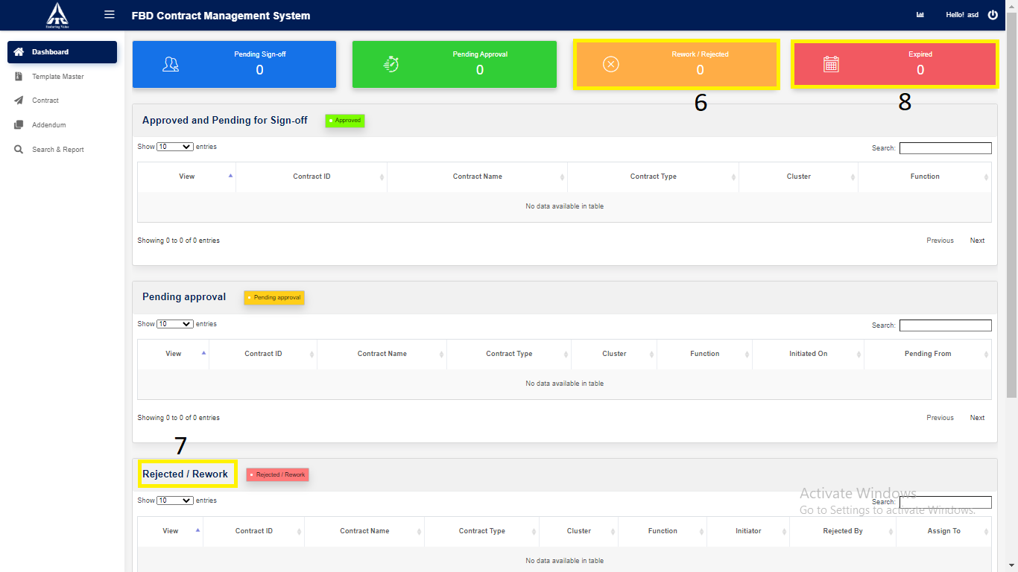

9) Click on “**Expired**” navigates to Expired table.

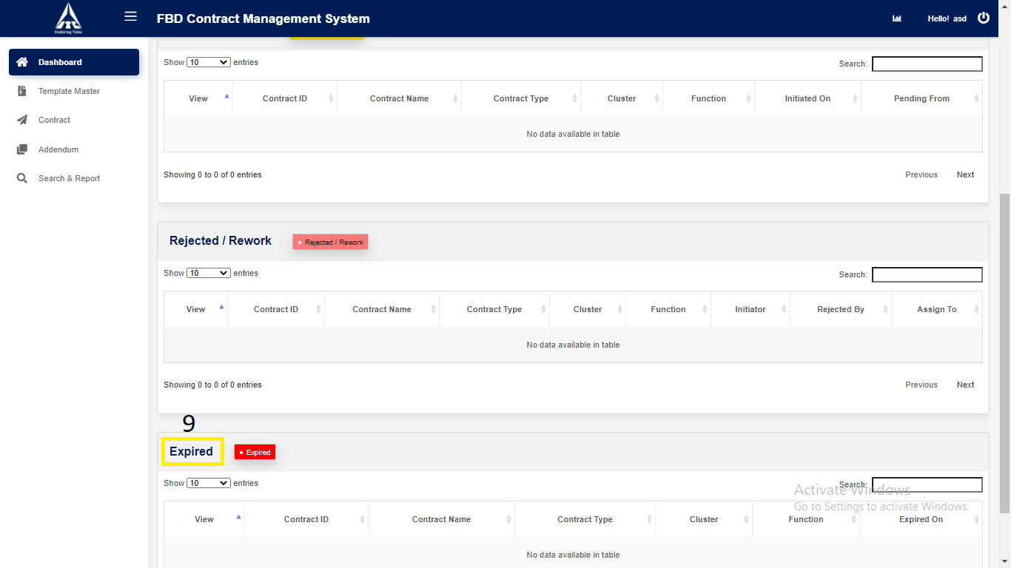

10) Click on “**Analytics**”.

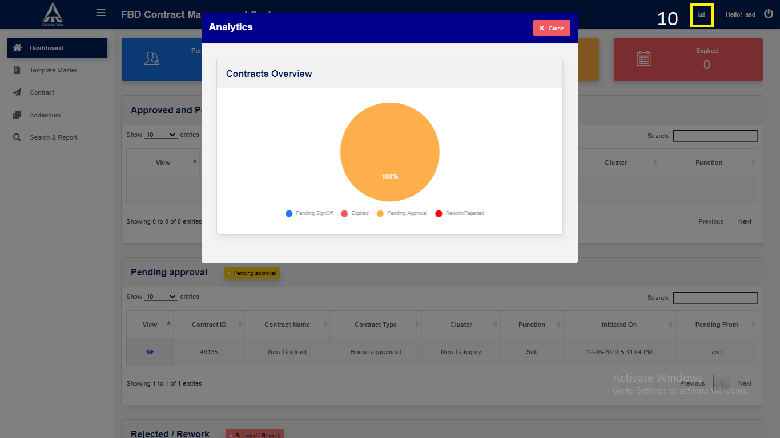

*Graphical representation*

**Template**

1. **Existing Template Master:**
2. Click on “**Template**” in side menu.
3. Click on **View** icon to **view** the Template which is in **Executed.**

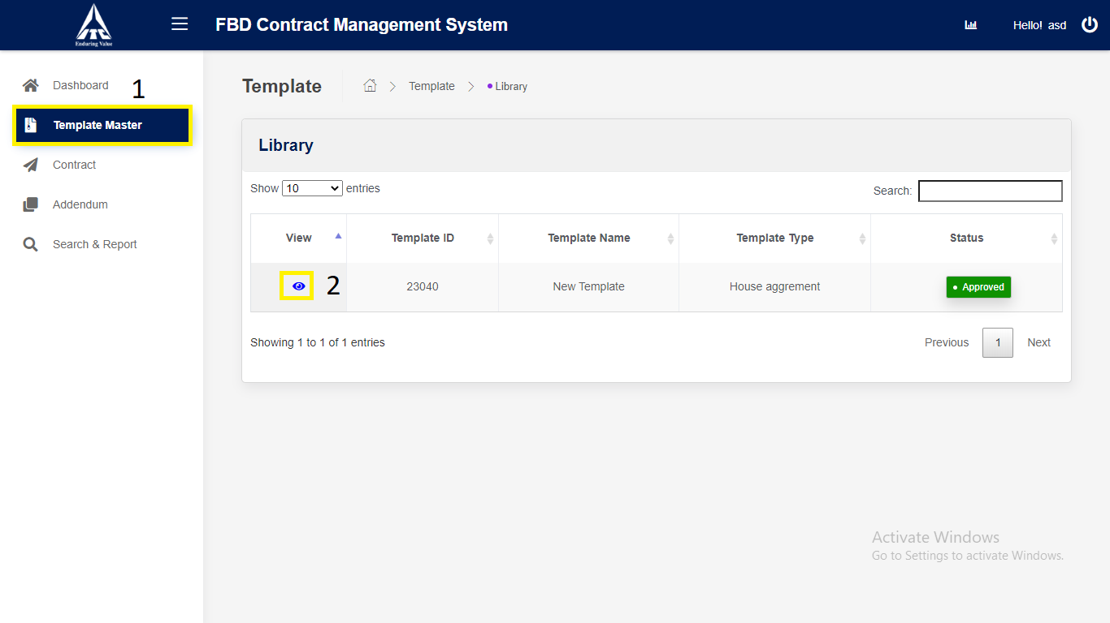

*Application will redirect to “****Template Details****” page.*

1. Click on “**Next**”.

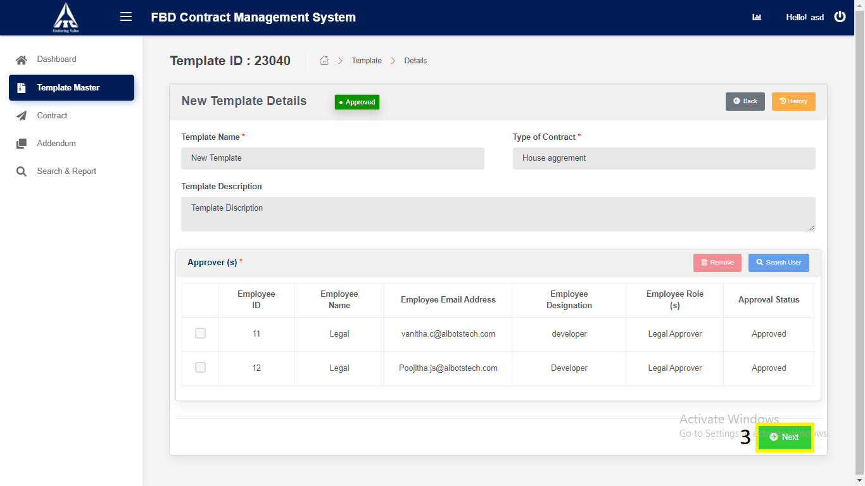

*Application will redirect to “****Template Draft view****” page.*

1. Click on “Version Compare”.

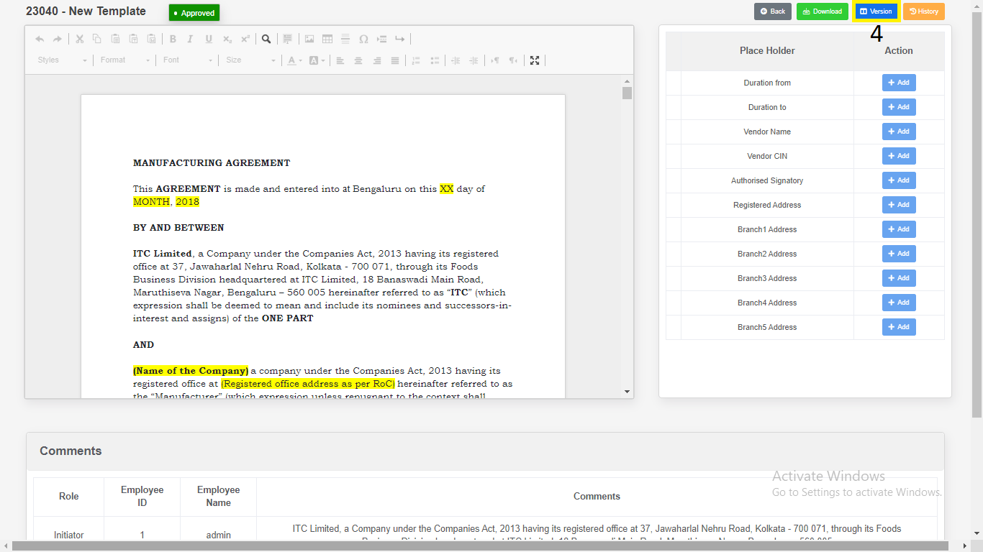

1. Select the “**Version”**.
2. Click on “**Download**”.

a) Download as “**PDF**”.

b) Download as “**Word Document**”.

1. Click on “**Close**”.

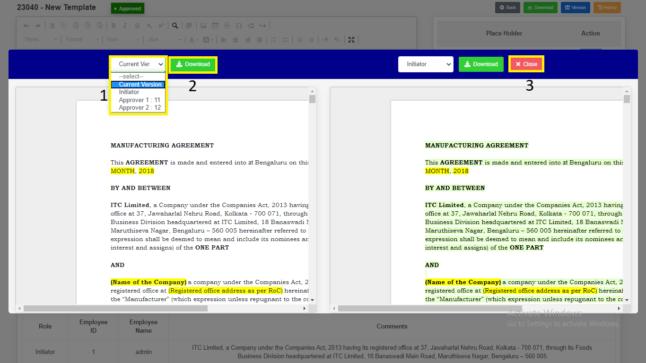

1. Click on “**Download”.**

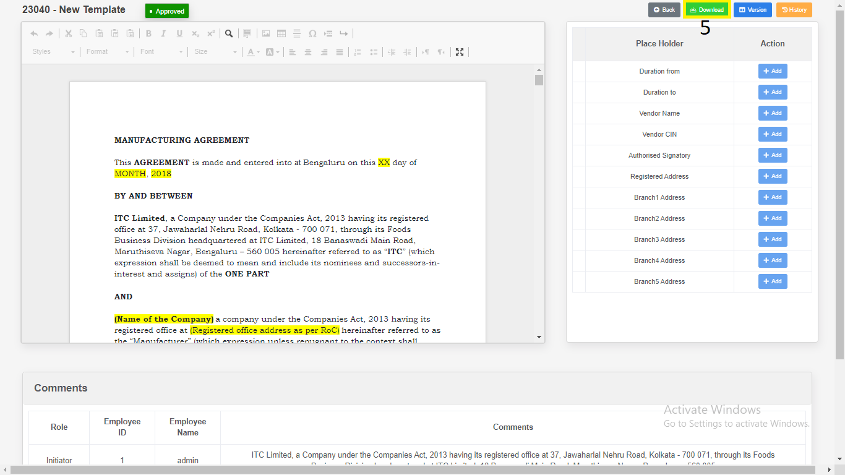

1. Download as “**PDF**”.

2. Download as “**Word Document**”.

3. Click on “**Close”.**

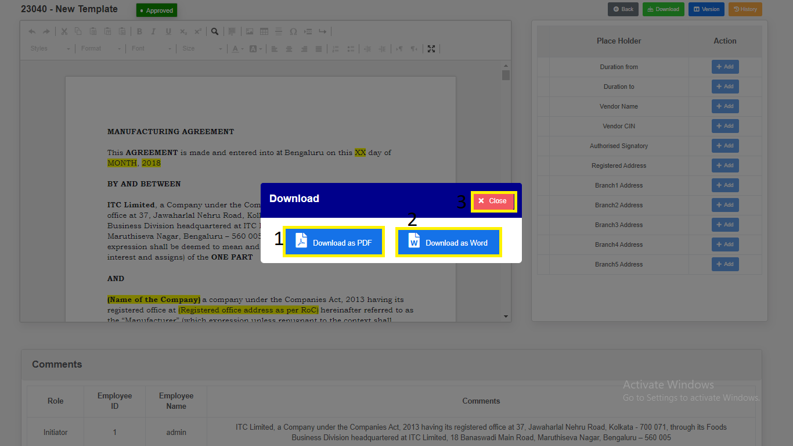

*Modal will redirect to “****Template Draft View****” Page.*

1. Click on “**History**”. Changes done in the template will be recorded in history.

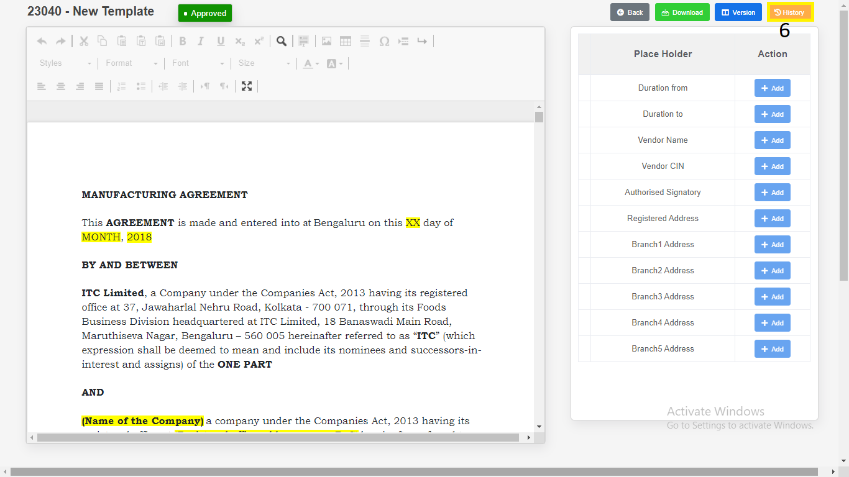

**Contract**

1. **Contract Creation**
2. Click on “**Contract**” in side menu.
3. Click on “**Create New Contract**” button to **create** new Contract

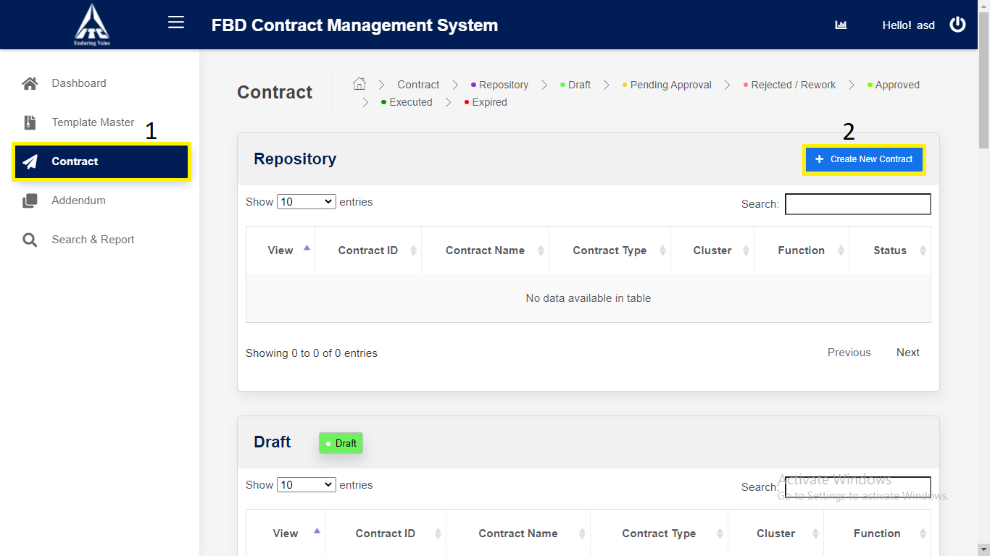

*Application will redirect to “****New Contract****” page.*

1. Enter **Contract** details,
2. Enter “**Contract Name**”. *(Alphabets and Space only).*
3. Enter “**Contract Type**”. *(Alphabets and Space only).*
4. **Approval Workflow** will auto generate based on Department and Sub Department.
5. Choose **Create Contract Using**.
6. Select **Category**.
7. Select **Sub Category**.
8. Click on “**Search**”:

1. Reporting Manager **ID** (*Numbers Only*).

2. Reporting Manager **Name** (*Characters Only*).

3. Reporting Manager **Email** (*Characters Numbers and Email validation only*).

1. Select the “**Checkbox**”
2. Click on “**Remove**” Approval fields will be removed.
3. Click on “**Save and Continue**” button to **save** the new Contract.

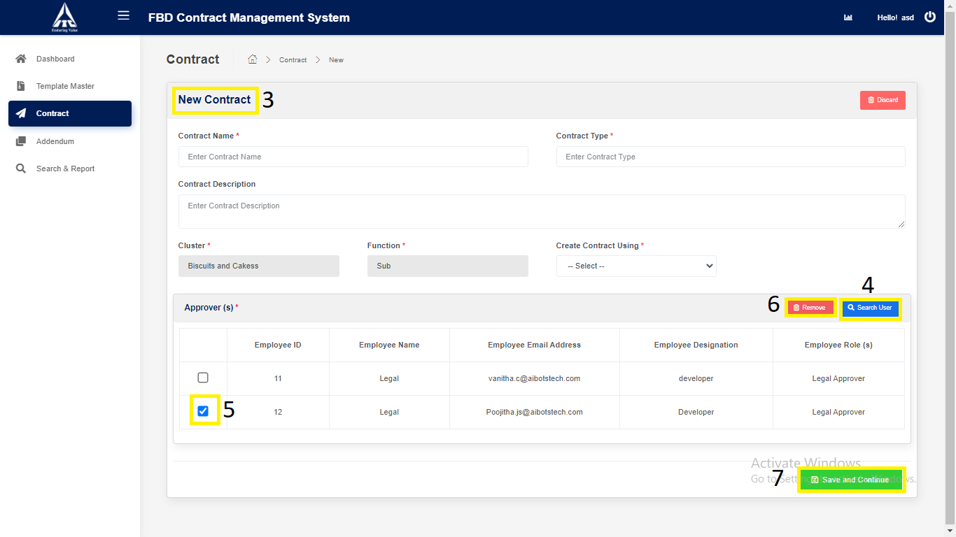

*Application will redirect to “****Contract Draft View****” page.*

1. **Contract Initiate**
2. Click on “**Edit Content**” button to **edit** the Contract.
3. Click on “**Draft**” button to **draft** the Contract.
4. Click on “**Attachments**” button to **Upload** supporting files.

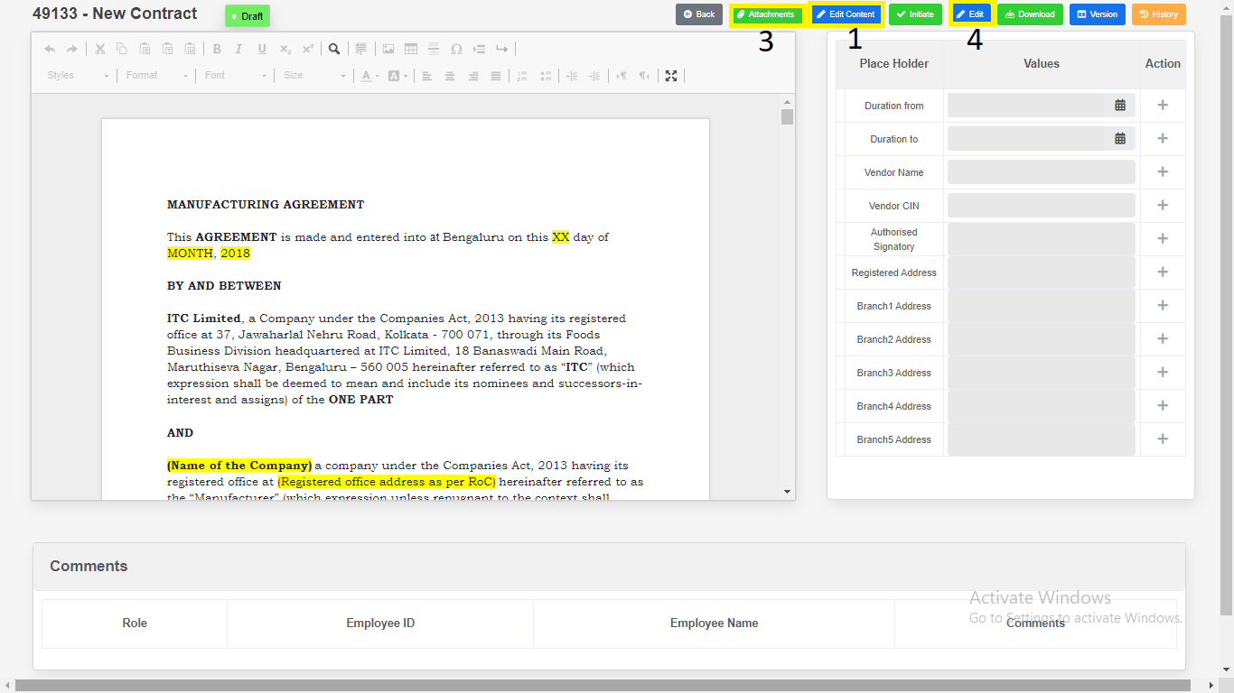

1. Click on “**Edit**” button to  **edit**  the Variables.
2. Click on “**Draft**” button to **save** the Variables.

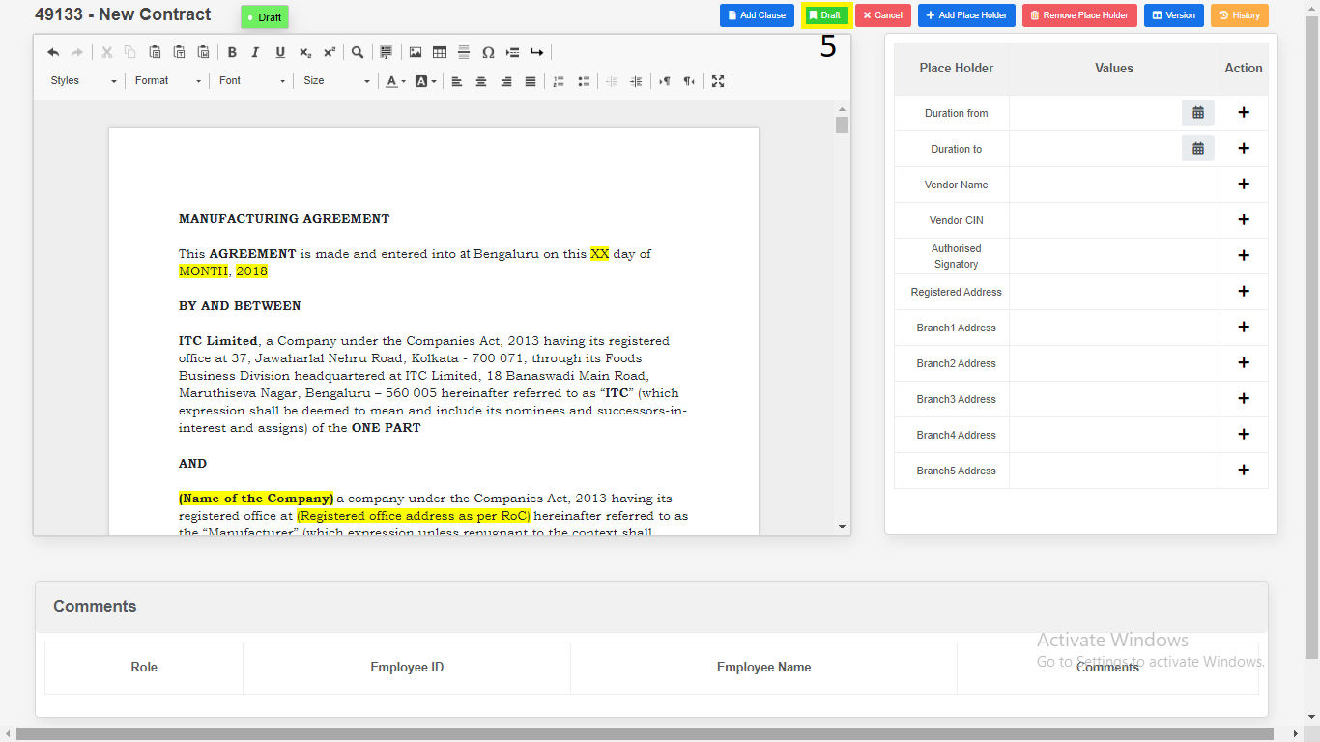

1. Place Holders

1. Click on “**Add Place Holder**”.

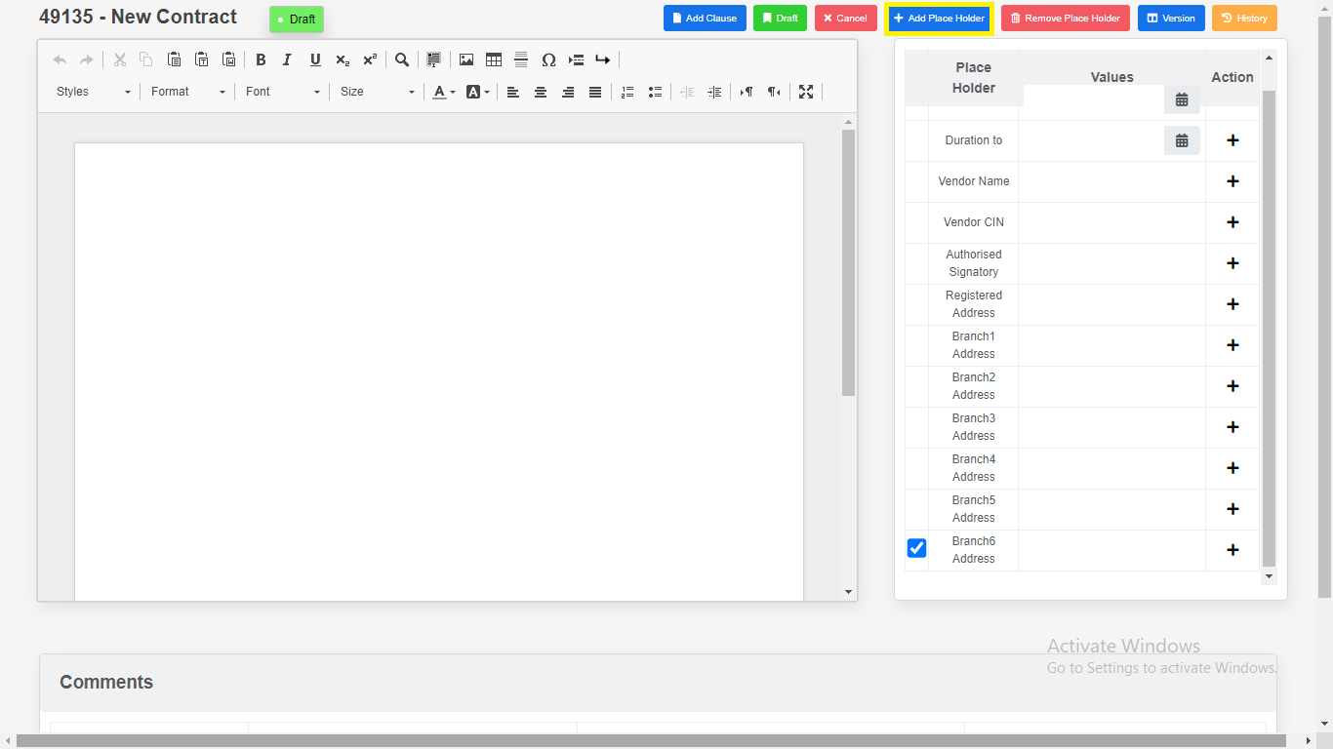

2. Enter “**Place Holder**”.

3. Click on “**Add**”. New variables will be add in place holder table.

4. Click on “**Cancel**”.

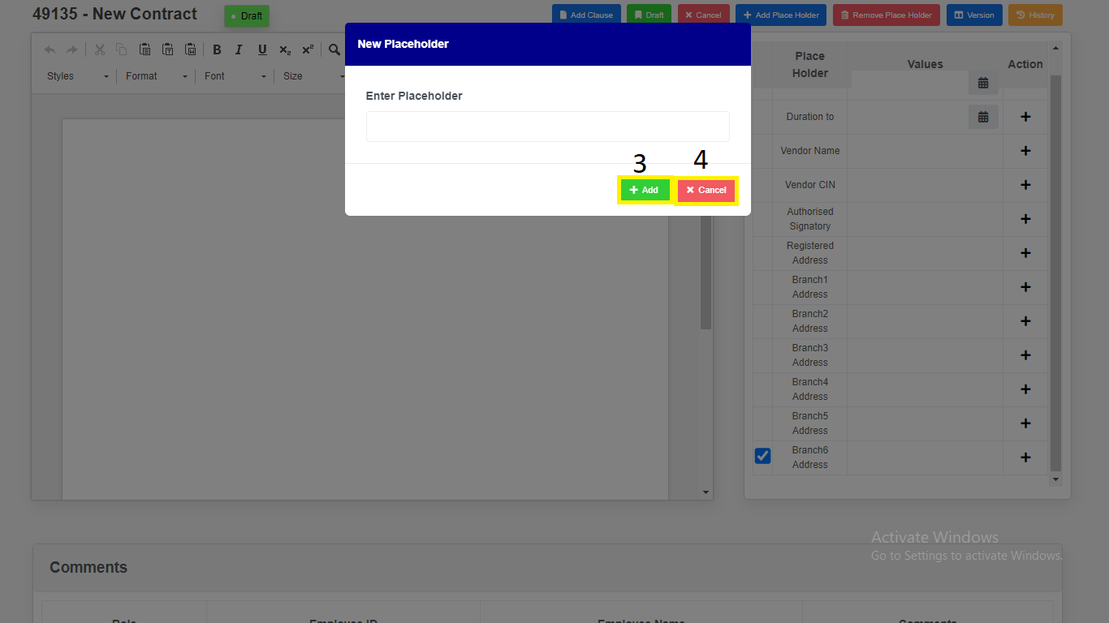

*Modal will redirect to “****Contract Draft view****” page.*

1. Remove Place Holders.

1. Select Checkbox.

2. Click on “**Remove Placeholders**” variables will be removed.

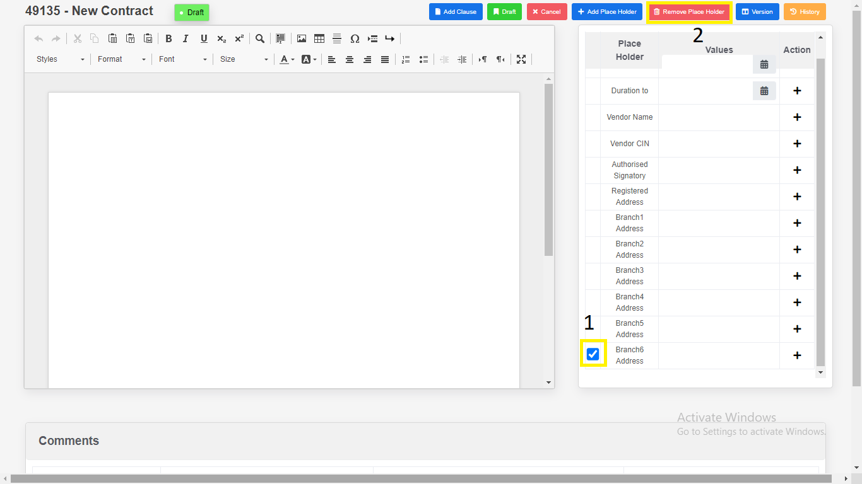

1. Click on “Version Compare”.

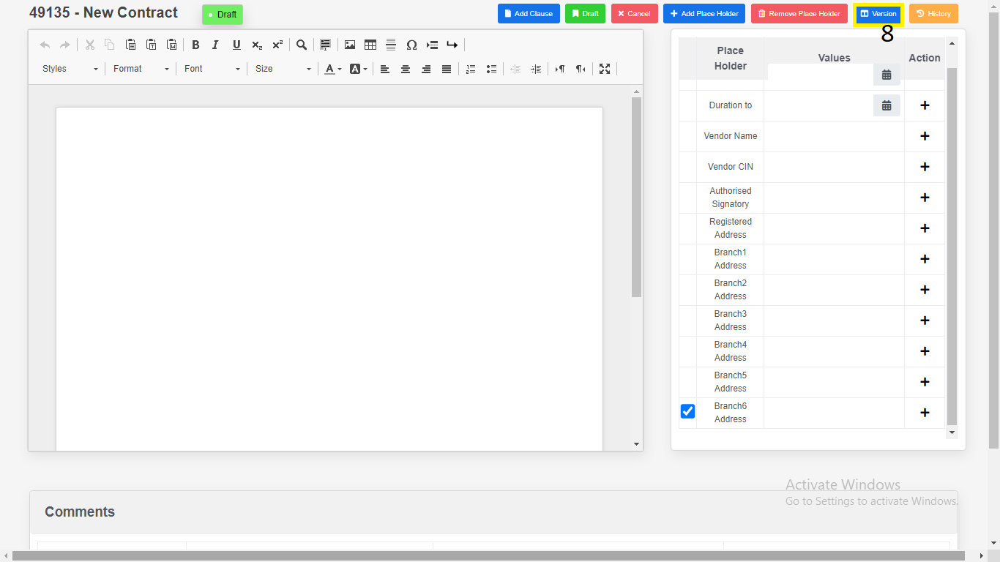

1. Select the “**Version”**.
2. Click on “**Download**”.

a) Download as “**PDF**”.

b) Download as “**Word Document**”.

1. Click on “**Close”.**

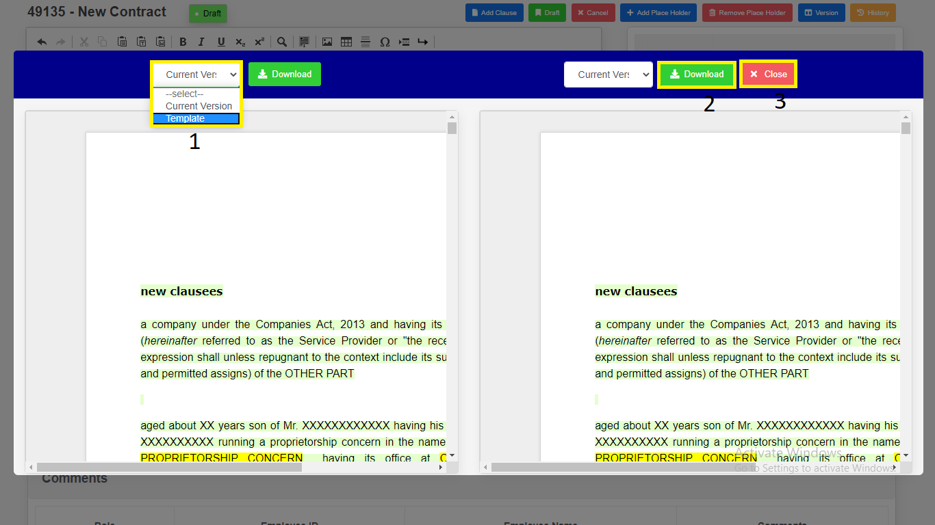

*Modal will redirect to “****Contract Draft View****” Page.*

1. Click on “**Attachments**”.

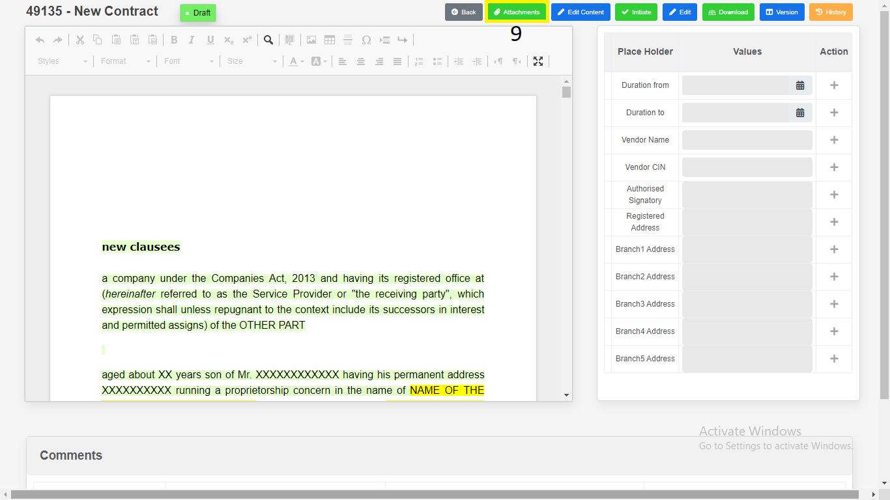

10) Click on “**choose file**”.

1. “**Upload**”.

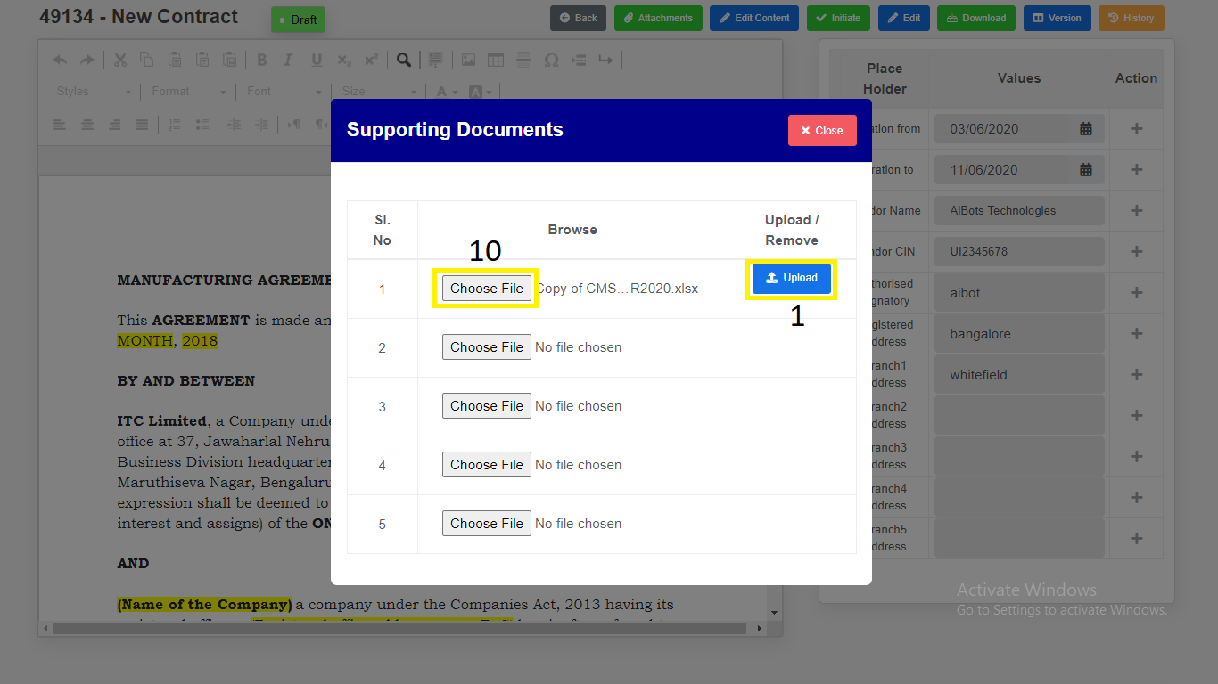

2. “**Download**”.

3. “**Remove**”.

4. “**Close**”.

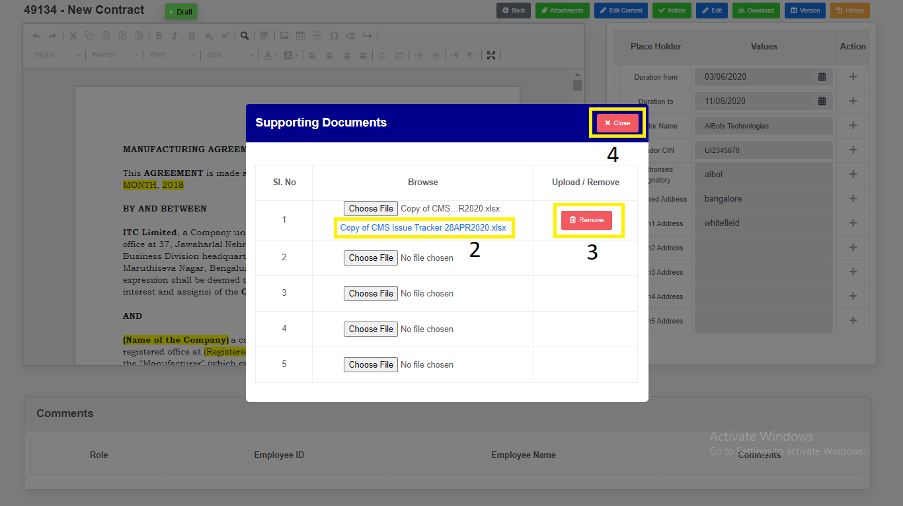

1. Click on “**Add Clause**” Clause Details can be added to contract.

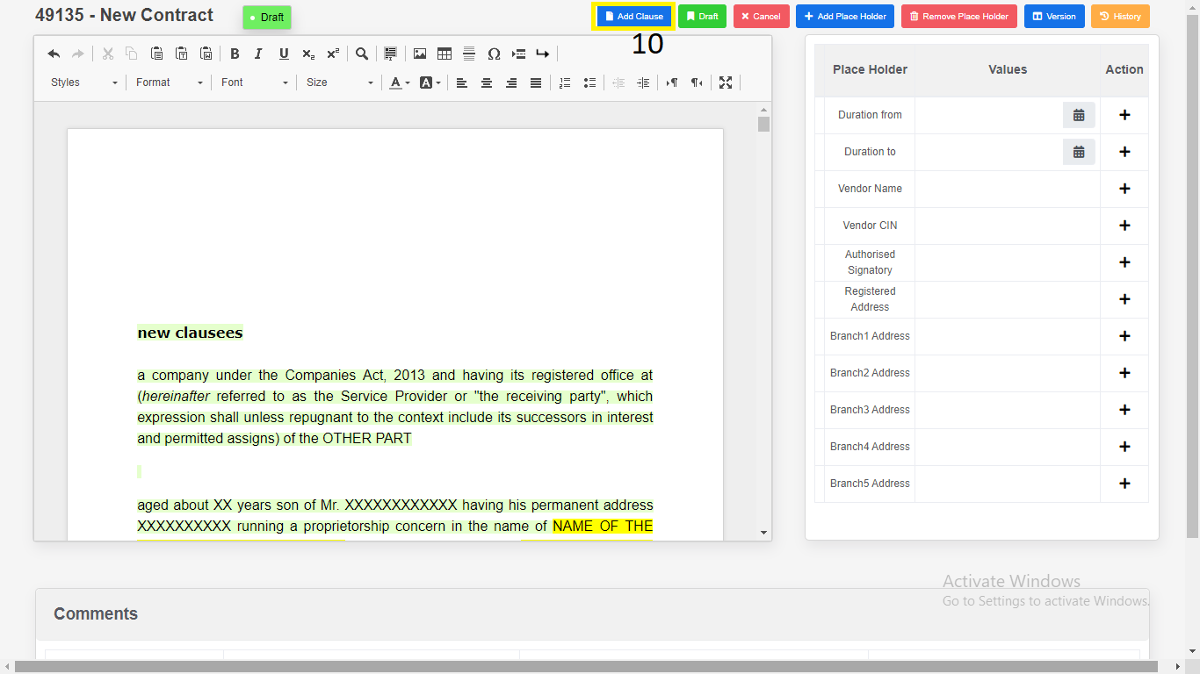

1. “**Preview**”.

2. “**Select**”.

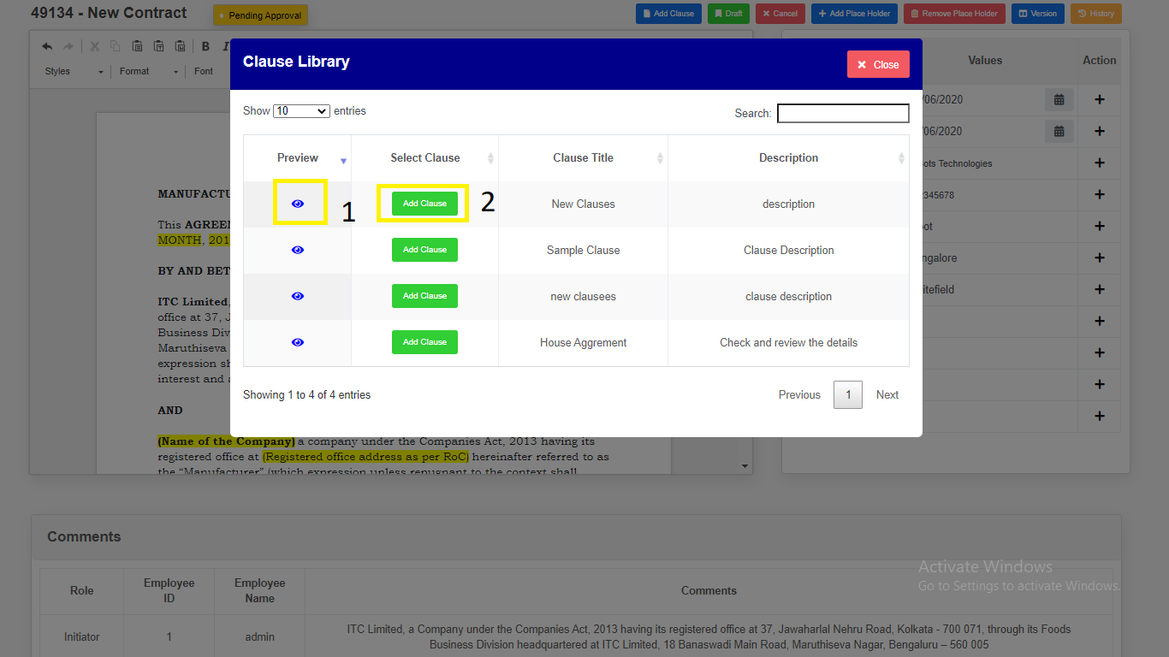

12) Click on “**Initiate**’ button to **initiate** the Contract.

13) Enter the Comments.

14) Click on “**Yes, Initiate**” button to **initiate** the Contract.

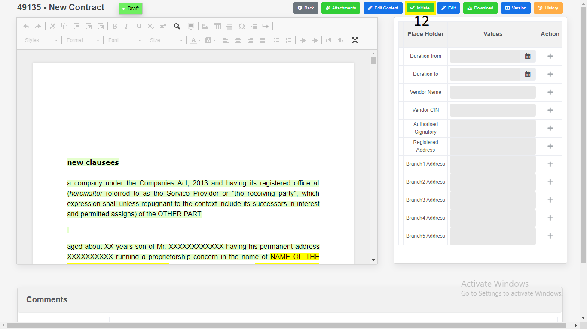

*Application will redirect to same page.*

15) Click on “**Download**”.

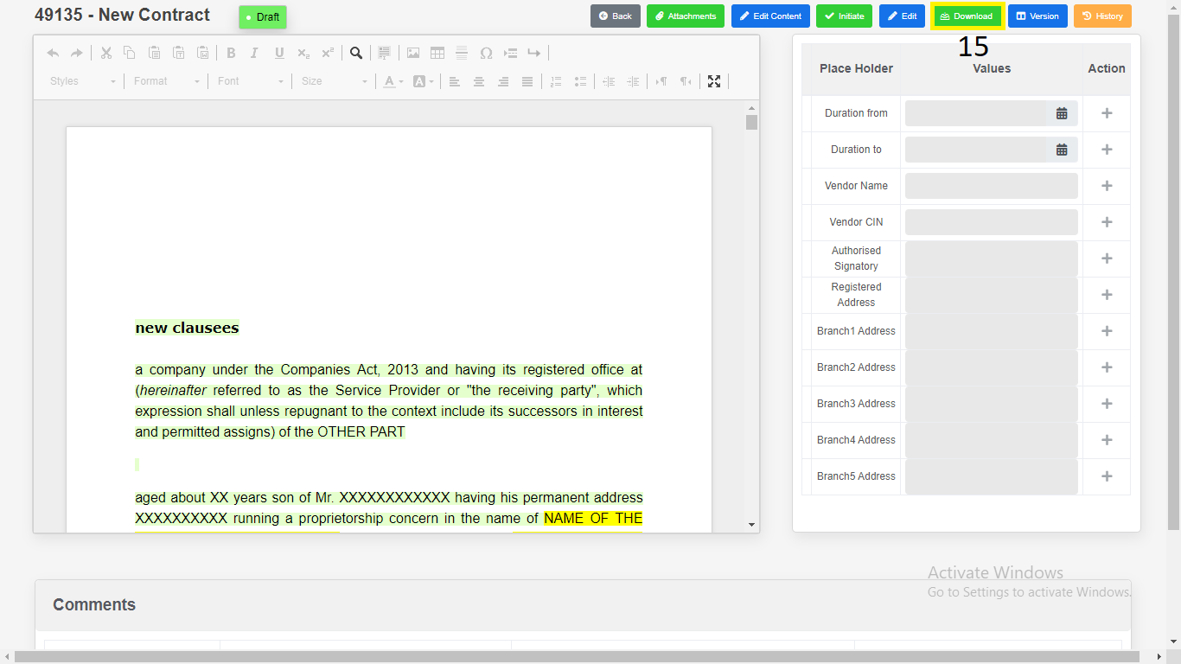

1) Download as “**PDF**”.

2) Download as “**Word Document**”.

3) Click on “**Close**”.

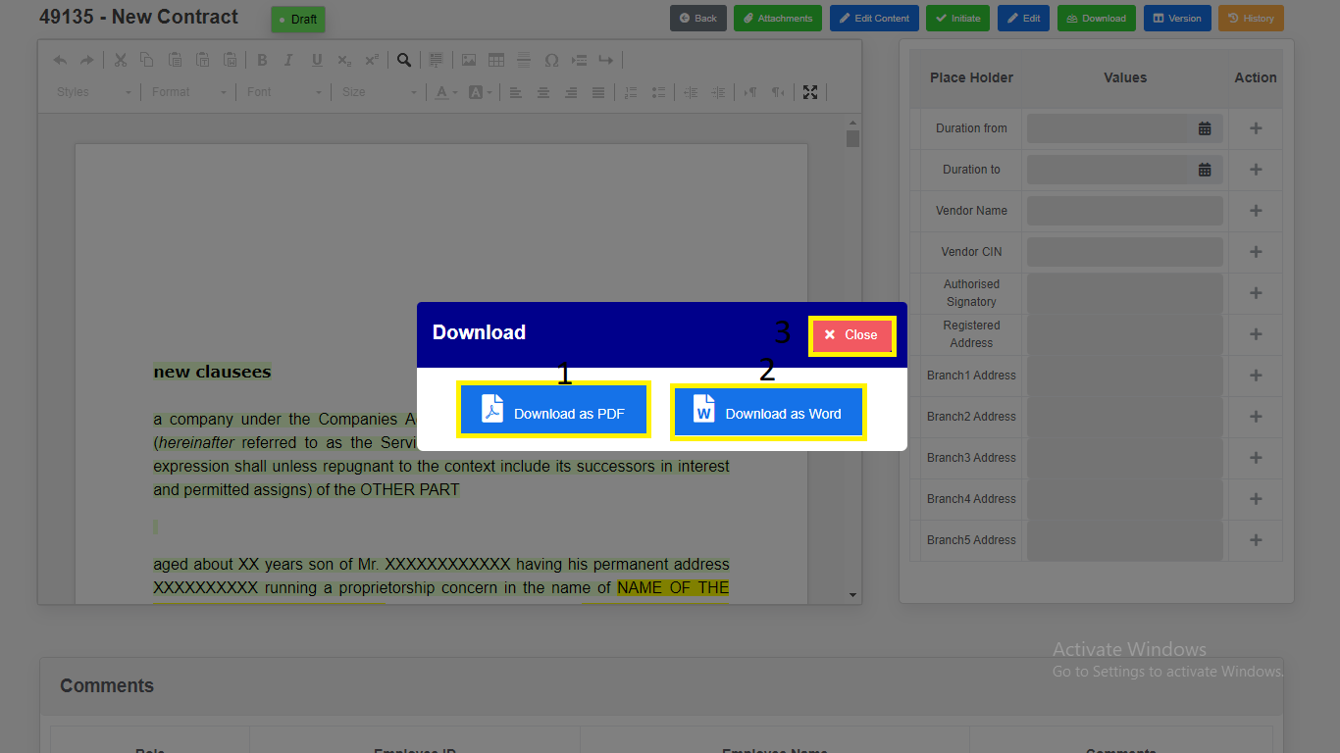

*Modal will redirect to “****Contract Draft View****” Page.*

16) Click on “**History**”. Changes done in the contract will be recorded in

History.

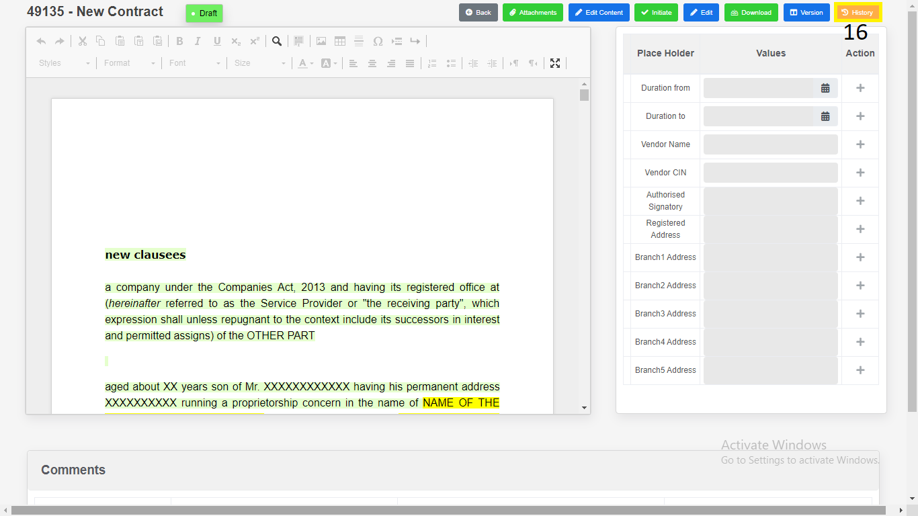

**Contract - Addendum**

1. **Contract Addendum Creation:**
2. Click on “**Contract**” in side menu.
3. Click on “**Executed**” navigational link for **Executed** table.
4. Click on **View** icon to **view** the Contract which is in **Executed.**

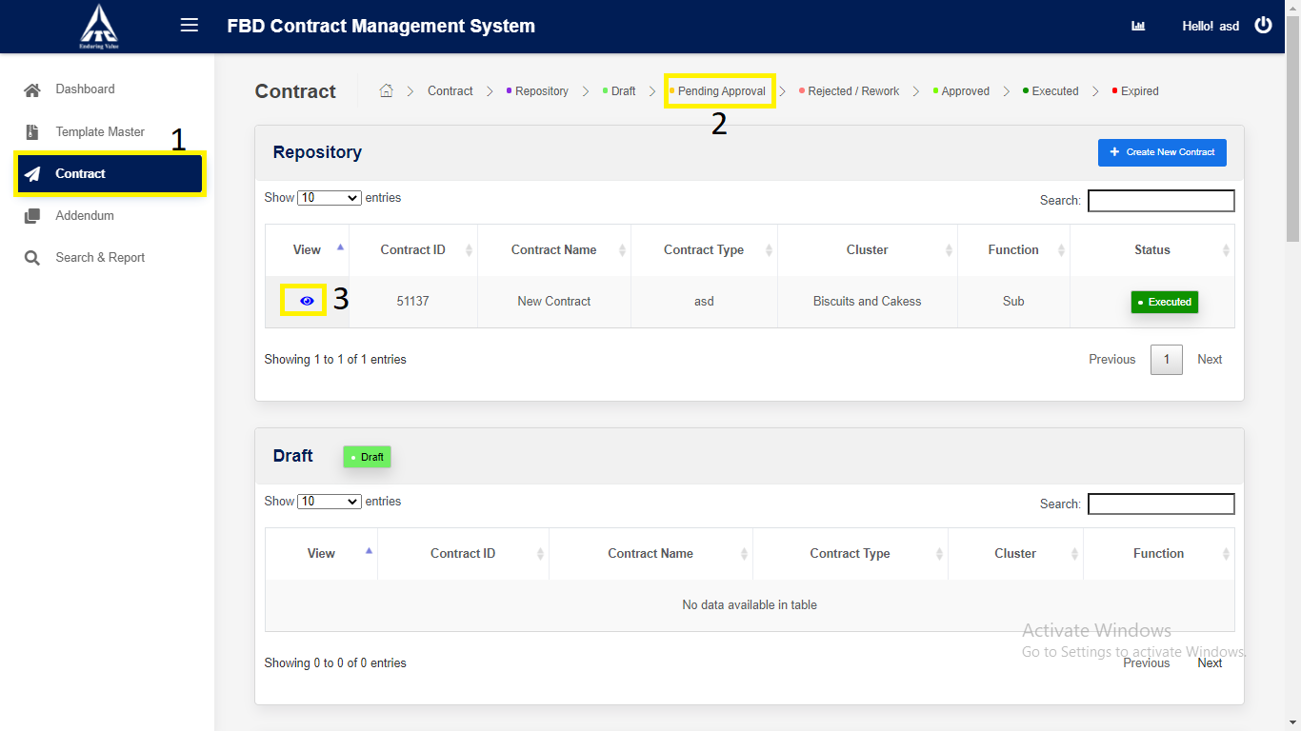

*Application will redirect to “****Contract Details****” page.*

1. Click on “**Next**” button.

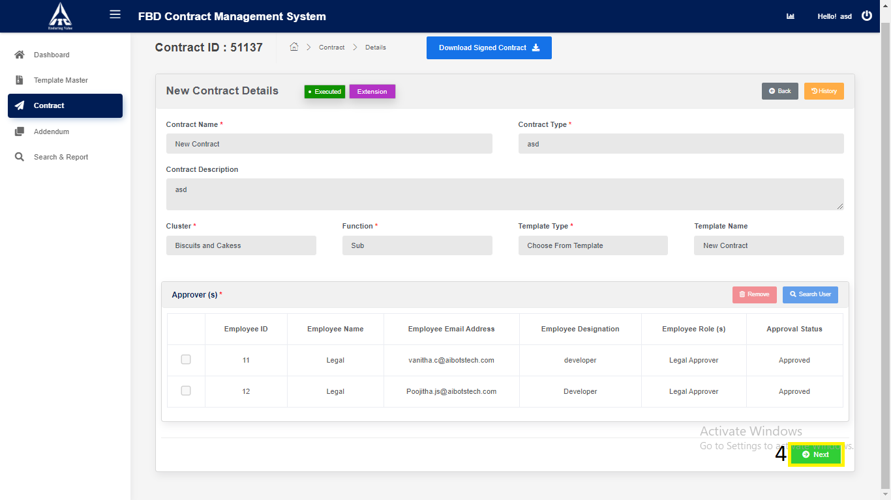

*Application will redirect to “****Contract Draft View****” page.*

1. Click on **select** dropdown and choose type of **Addendum.**
2. Click on selected **Addendum type** button.

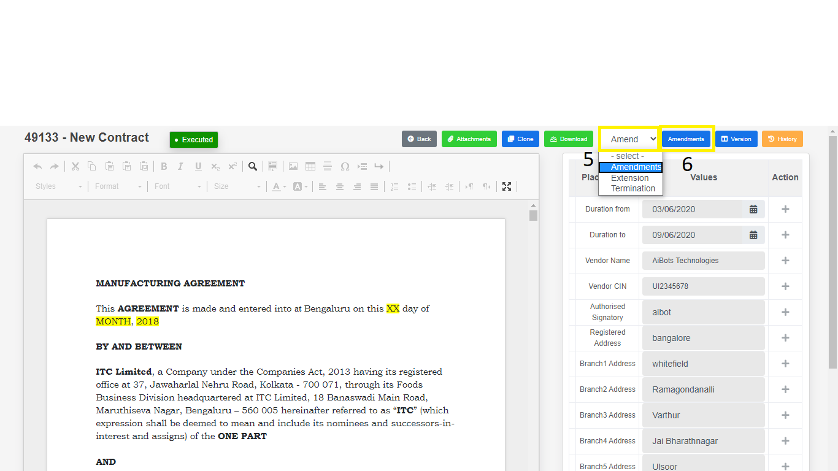

*Application will redirect to “****Contract Addendum Draft View****” page.*

1. Click on “**Edit Content**” button to **edit** the Contract.
2. Click on “**Draft**” to **draft** the Contract.

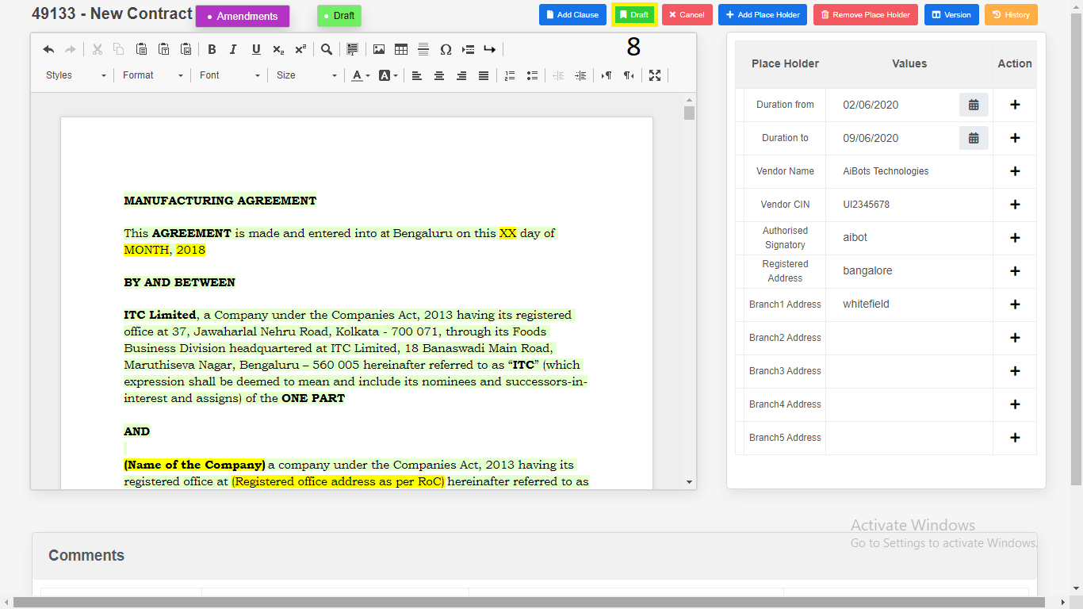

1. Place Holders

1. Click on “**Add Place Holder**”.

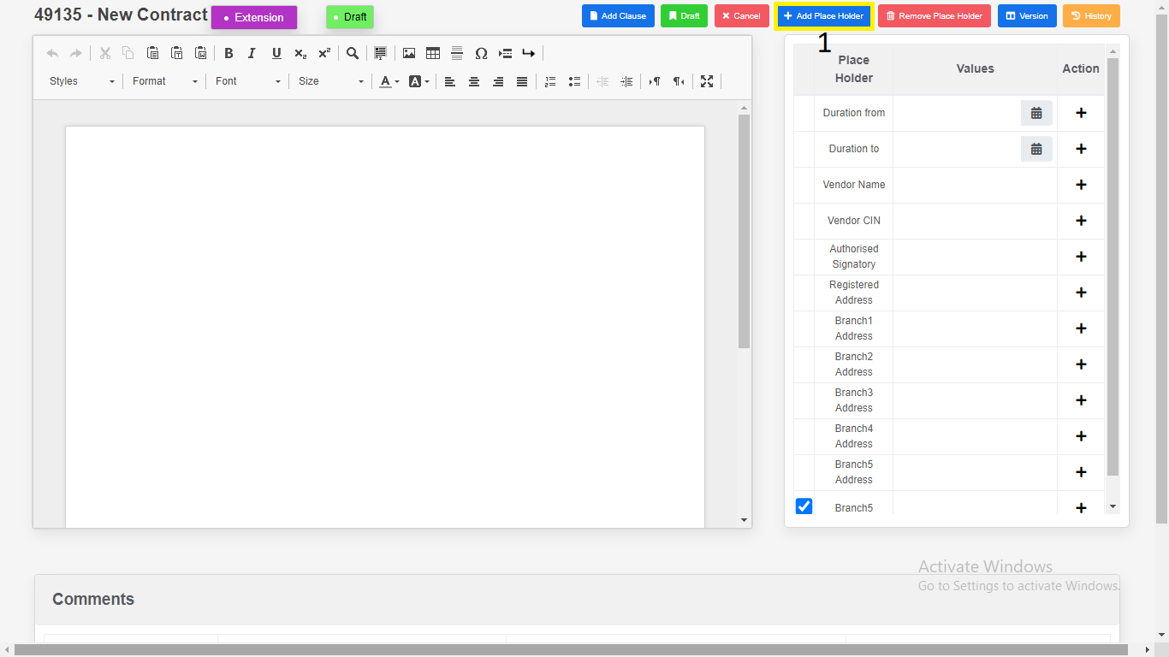

2. Enter “**Place Holder**”.

3. Click on “**Add**”. New variables will be add in place holder

table.

1. Click on “**Cancel**”.

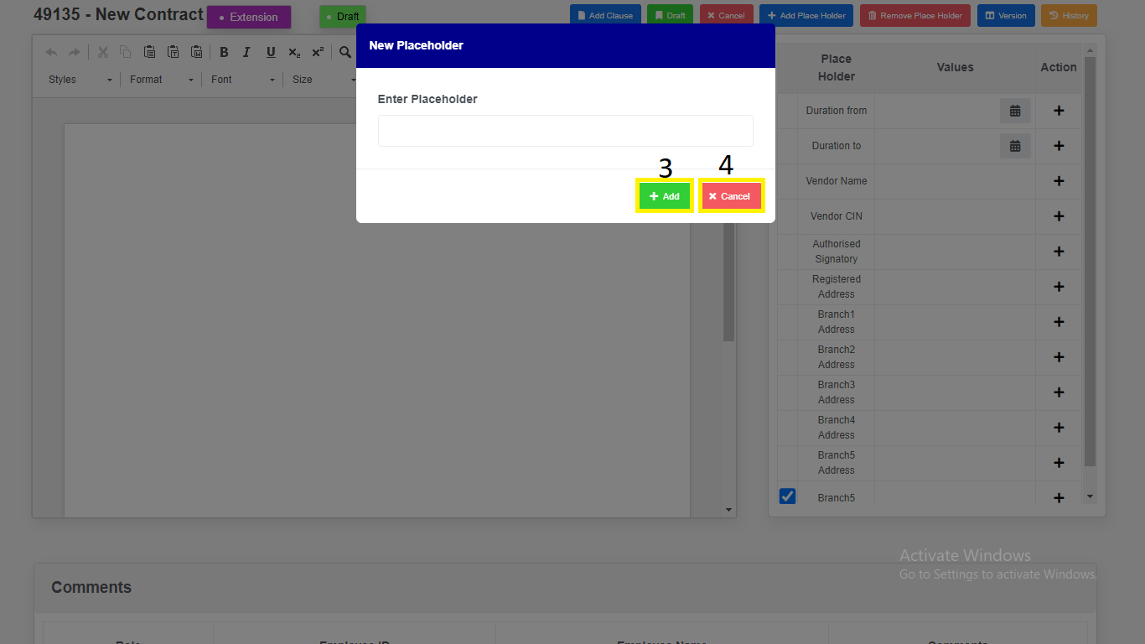

*Modal will redirect to “****Contract Addendum Draft view****” page.*

1. Remove Place Holders.

1. Select Checkbox.

2. Click on “**Remove Placeholders**” variables will be removed.

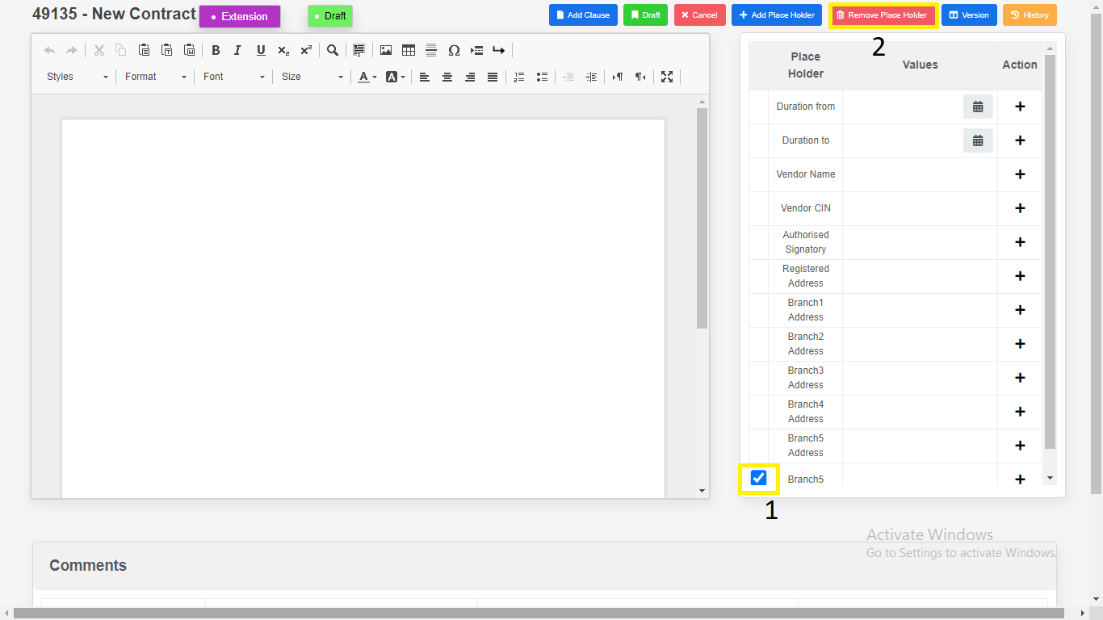

1. Click on “Version Compare”.

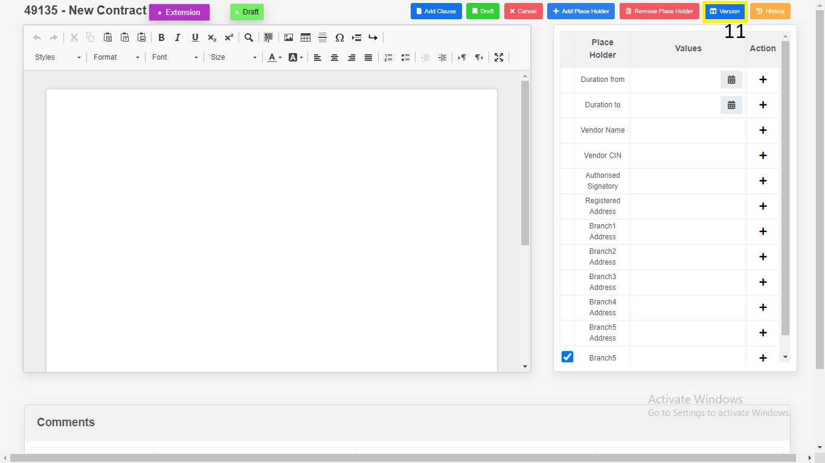

1. Select the “**Version”**.

2. Click on “**Download**”.

a) Download as “**PDF**”.

b) Download as “**Word Document**”.

3. Click on “**Close”.**

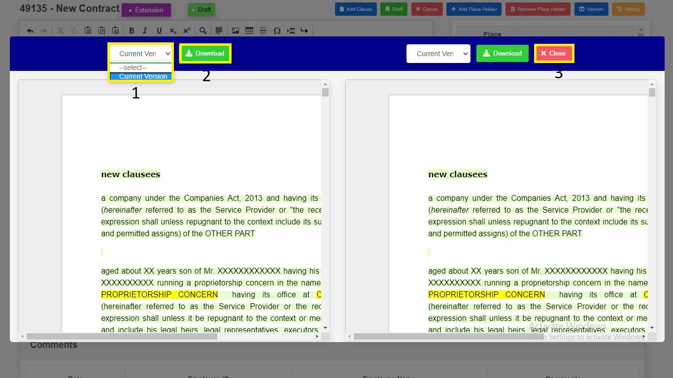

*Modal will redirect to “****Contract Addendum Draft View****” Page.*

1. Click on “**Initiate**” button to **initiate** the Modified Contract.
2. Enter the Comments.
3. Click on “**Yes, Initiate**” button to **initiate** the Modified Contract.

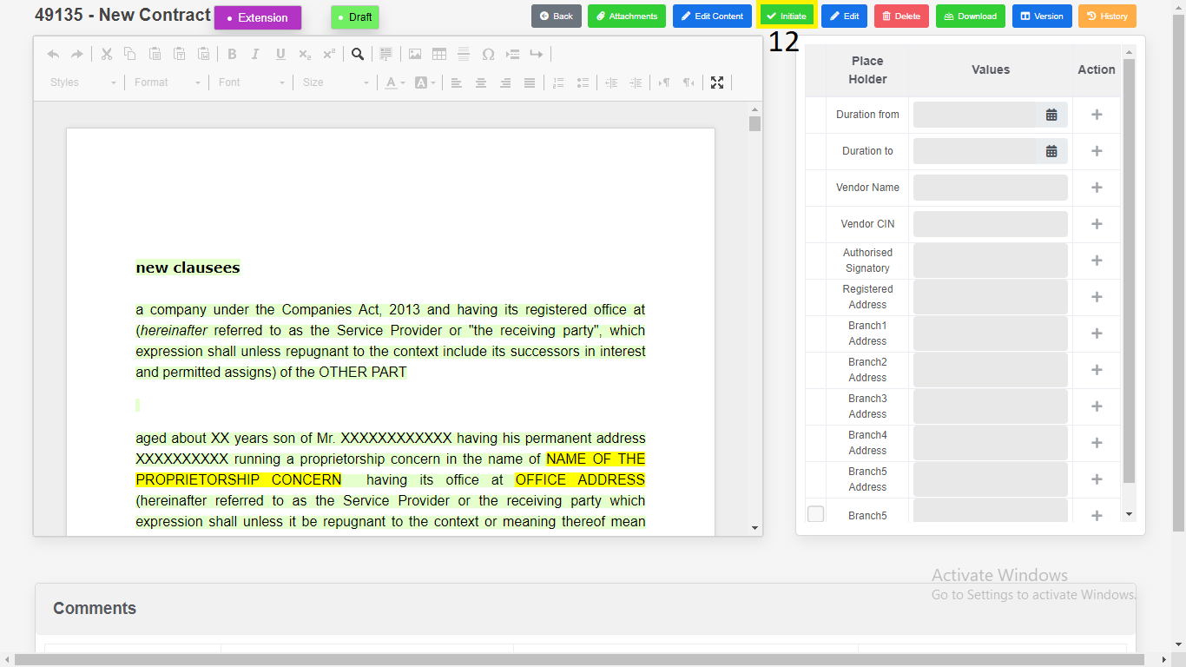

*Application will redirect to same page.*

1. Click on “**Download**”.

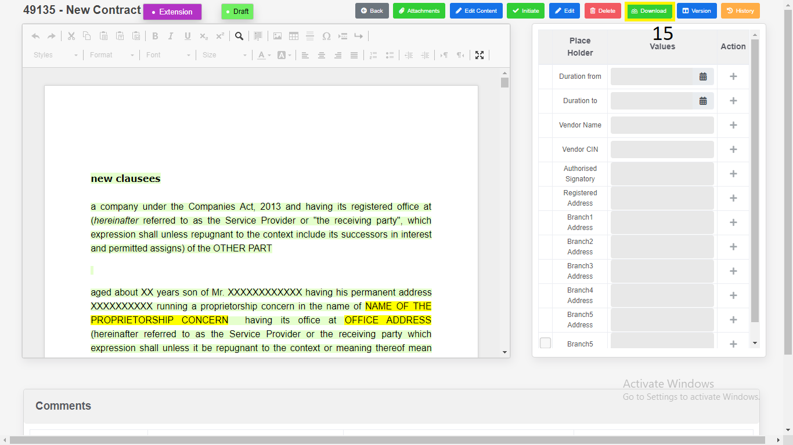

1) Download as “**PDF**”.

2) Download as “**Word Document**”.

3) Click on “**Close**”.

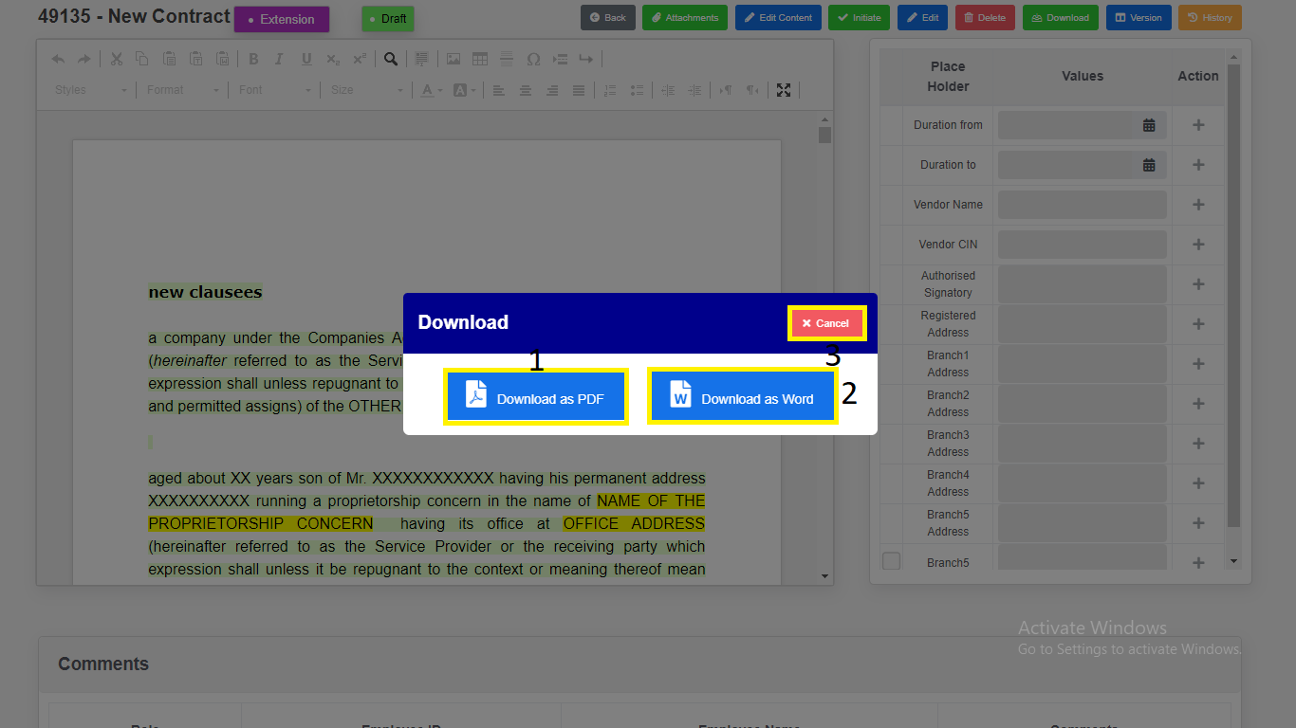

*Modal will redirect to “****Contract Addendum Draft View****” Page.*

1. Click on “**History**”. Changes done in the Contract will be recorded in history.

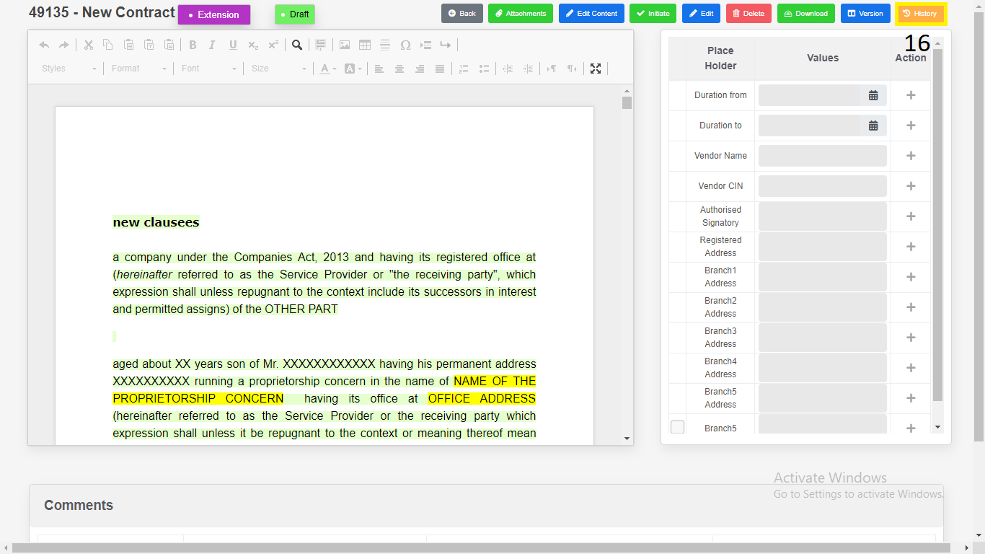

**Search & Report**

1. Click on “**Search & Report**” from Side Menu (Access to Admin Only).

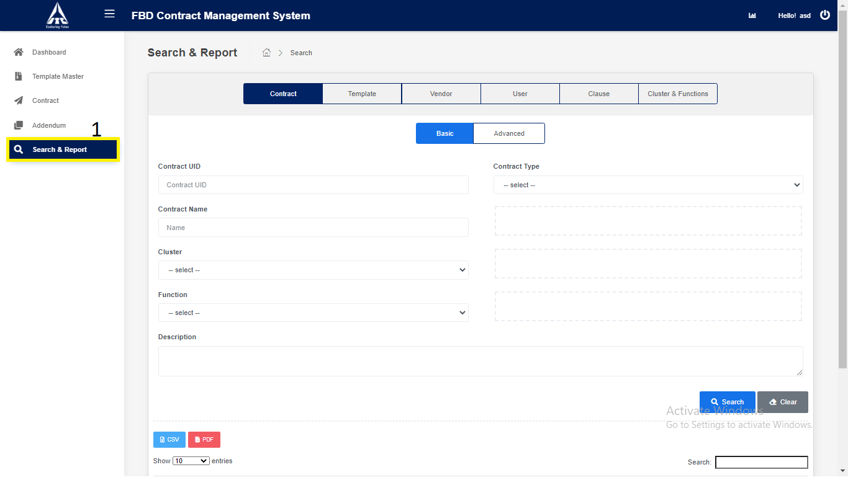

1. Click on “**Contract**” tab.

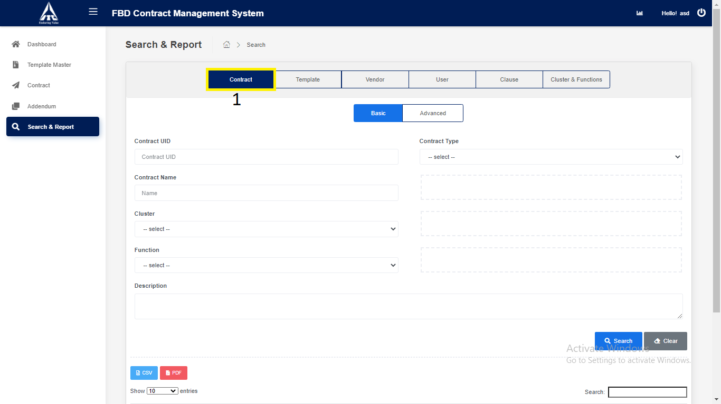

1. Click on Basic Contract.
2. Enter Basic Contract Details.
3. Enter **“Contract UID”** *(Only Numbers are allowed).*
4. Enter **“Contract Name”** *(Only Characters are allowed).*
5. Select **“Contract Type”***.*
6. Select “**Cluster**”.
7. Select “**Function**”.
8. Click on “**Search**”.
9. Search the contract details and displays in the contract table.
10. Click on “**CSV**”.
11. **CSV** downloads the contract details in Excel format.
12. **PDF** downloads the contract details in PDF format.
13. Click on **“Clear”.**

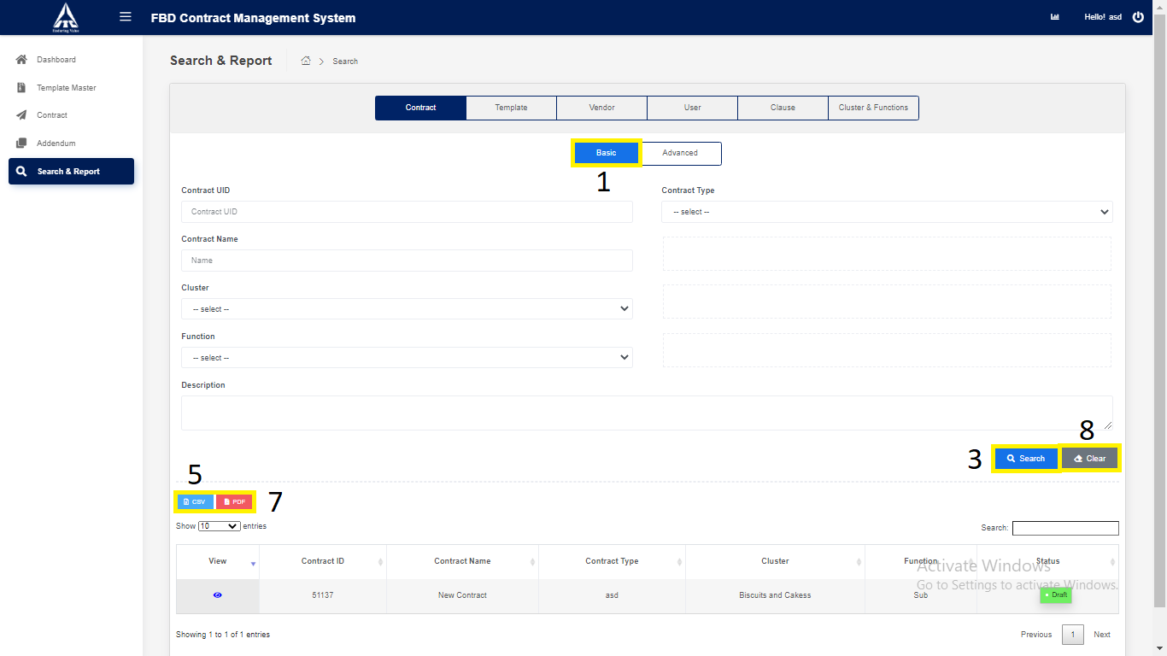

*Application will redirect to “****Search & Report****” page.*

1. Click on “**Advance**” Contract.
2. Enter Advance Contract Details.
3. Enter **“Contract UID”** *(Only Numbers are allowed).*
4. Enter **“Contract Name”** *(Only Characters are allowed).*
5. Select **“Contract Type”***.*
6. Select “**Cluster**”.
7. Select “**Function**”.
8. Select “**Vendor Name**”.
9. Enter “**Execution** Date”.
10. Enter “**Termination** Date”.
11. Enter “**Description**” *(Only Characters & Numbers are allowed).*
12. Click on “**Search**”.
13. Search the contract details and displays in the contract table.
14. Click on “**CSV**”.
15. **CSV** downloads the contract details in Excel format.
16. **PDF** downloads the contract details in PDF format.
17. Click on **“Clear”.**

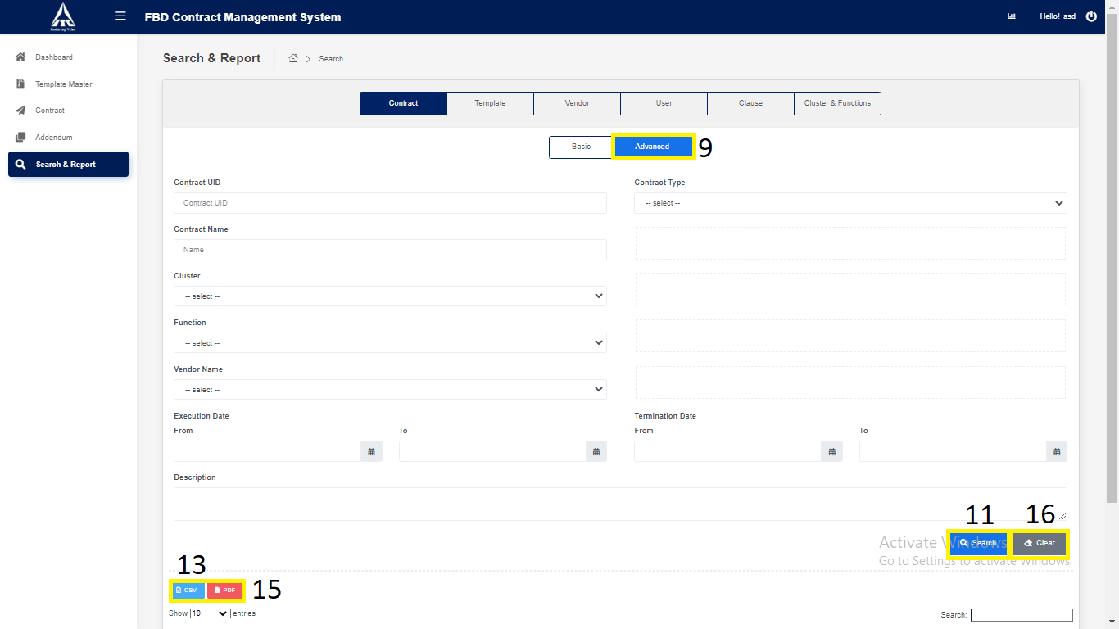

*Application will redirect to “****Search & Report****” page.*

1. Click on “**Template**” tab.

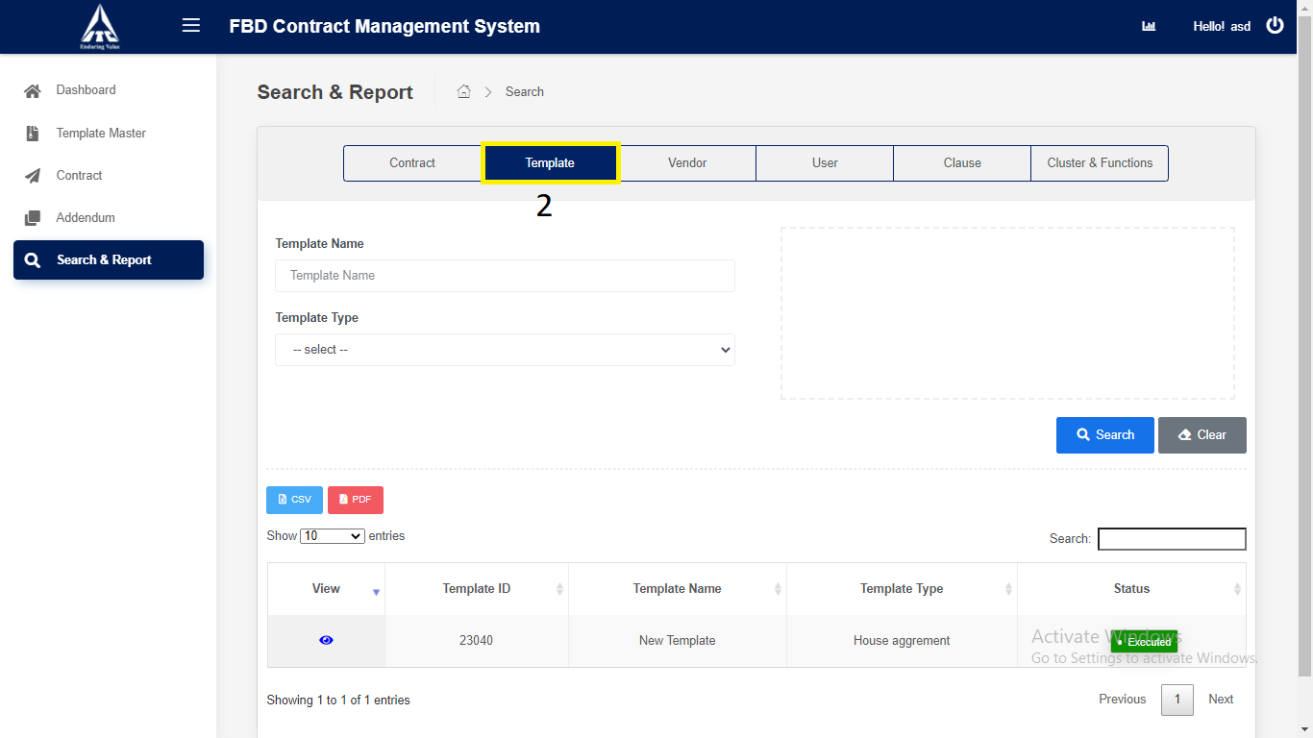

1. Click on “**Template**”.
2. Enter Basic Template Details.
3. Enter “Template Name”.
4. Enter “Template Type”.
5. Click on “**Search**”.
6. Search the Template details and displays in the Template table.
7. Click on “**CSV**”
8. **CSV** downloads the Template details in Excel format.
9. Click on **“PDF”** downloads the Template details in PDF format.
10. Click on **“Clear”.**

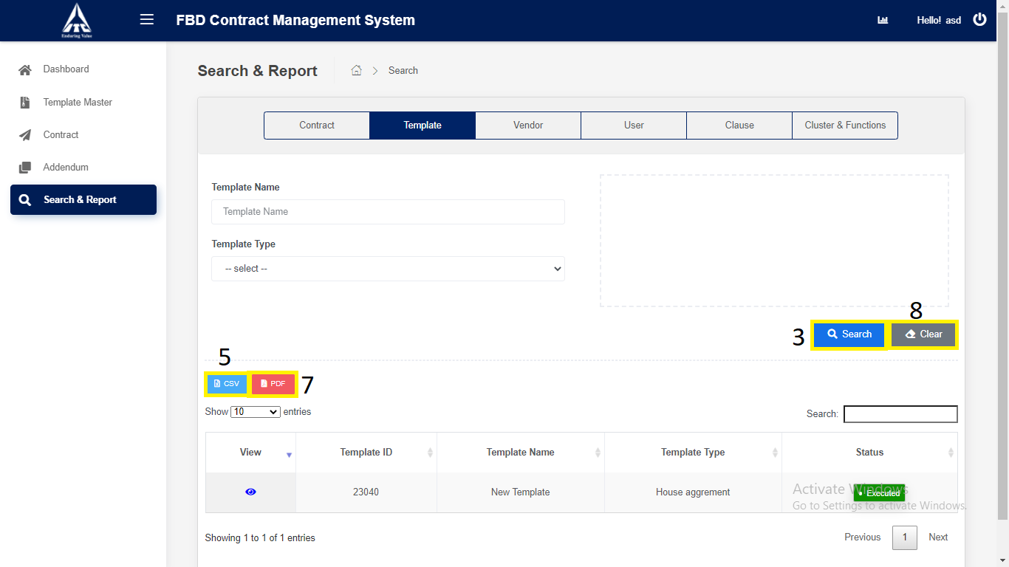

*Application will redirect to “****Search & Report****” page.*

1. Click on “**Vendor**” tab.

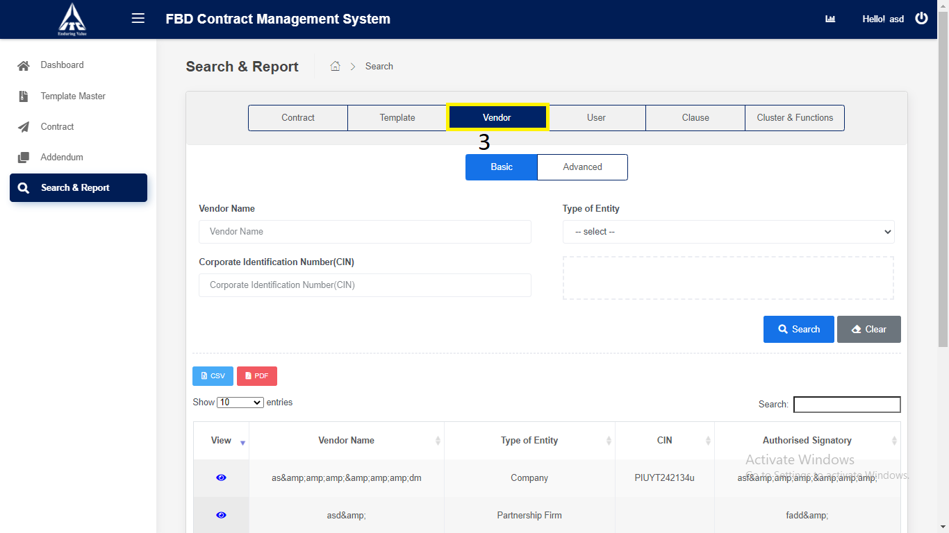

1. Click on “**Basic**” Vendor.
2. Enter Basic Vendor Details.
3. Enter “Vendor Name”.
4. Select “Type of entity”.
5. Enter “Corporate Identification Number(CIN)”
6. Click on “**Search**”.
7. Search the Vendor details and displays in the Vendor table.
8. Click on “**CSV**”.
9. **CSV** downloads the Vendor details in Excel format.
10. Click on **“PDF”** downloads the Vendor details in PDF format.
11. Click on **“Clear”.**

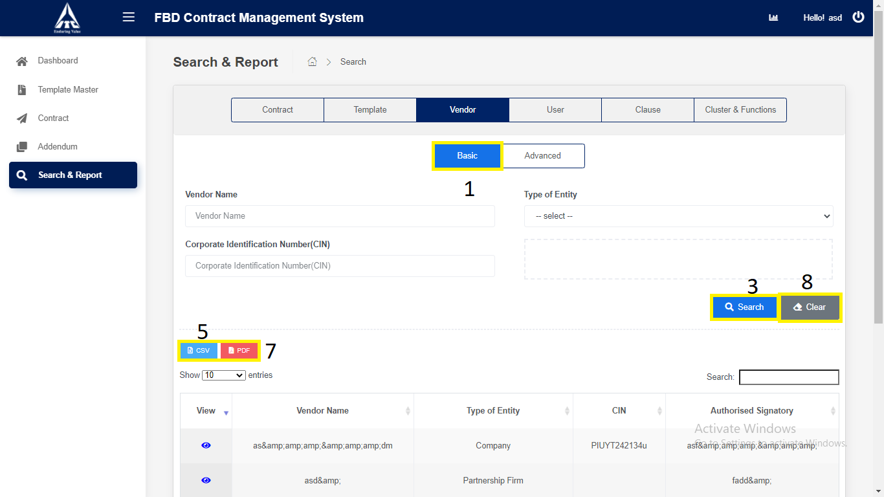

*Application will redirect to “****Search & Report****” page.*

1. Click on “**Advance**” Vendor.
2. Enter Advance Vendor Details.
3. Enter “Vendor Name”.
4. Select “Type of entity”.
5. Enter “Corporate Identification Number(CIN)”
6. Enter “Authorized Signature”.
7. Enter “Address”.
8. Click on “**Search**”.
9. Search the Vendor details and displays in the Vendor table.
10. Click on “**CSV**”.
11. **CSV** downloads the Vendor details in Excel format.
12. Click on **“PDF”** downloads the Vendor details in PDF format.
13. Click on **“Clear”.**

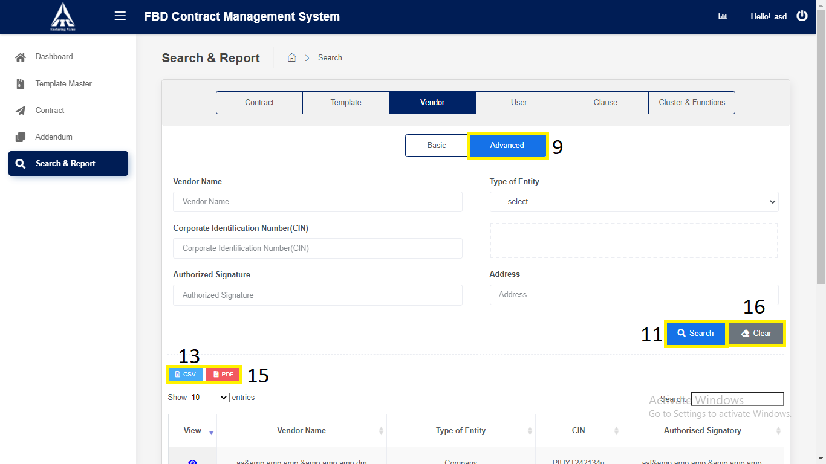

*Application will redirect to “****Search & Report****” page.*

1. Click on “**User**” tab.

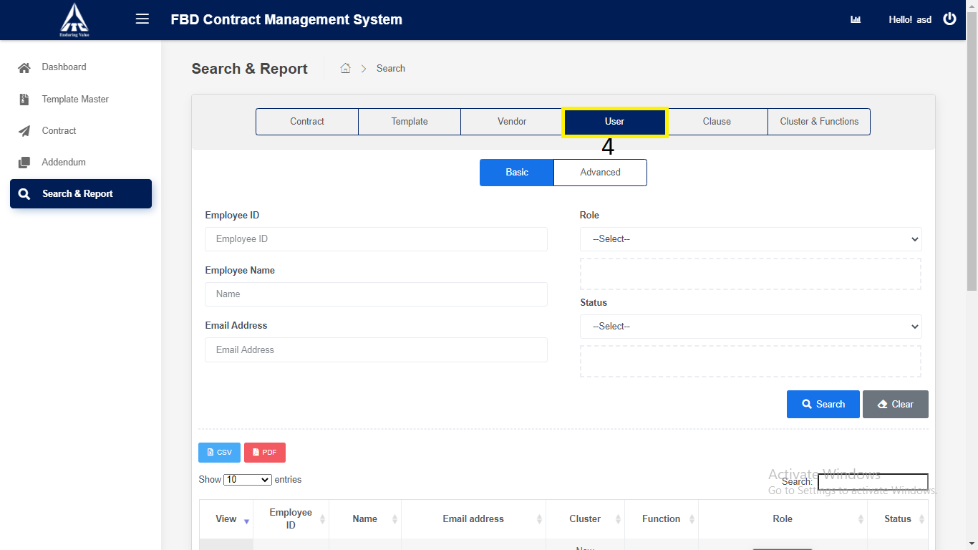

1. Click on “**Basic**” User.
2. Enter Basic User Details.
3. Enter “Employee ID”.
4. Enter “Employee Name”.
5. Select “Role”.
6. Enter “Email Address”.
7. Select “Status”.
8. Click on “**Search**”.
9. Search the User details and displays in the User table.
10. Click on “**CSV**”.
11. **CSV** downloads the User details in Excel format.
12. Click on **“PDF”** downloads the User details in PDF format.
13. Click on “**Clear**”.

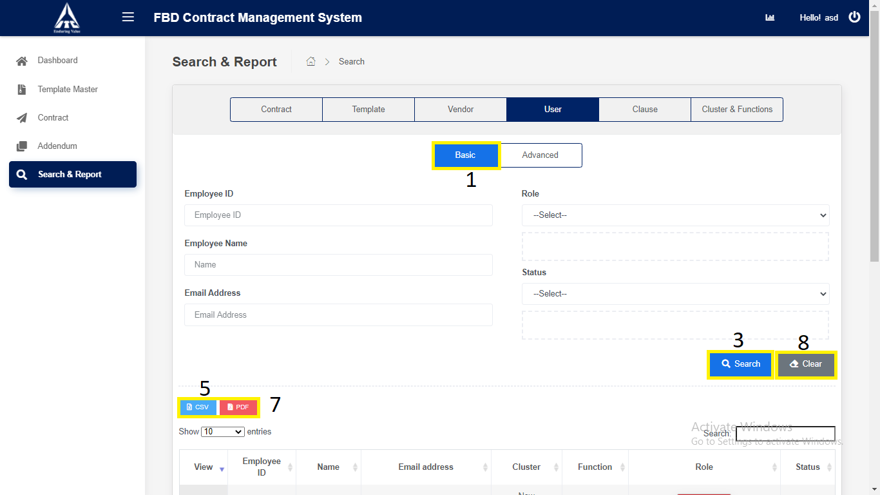

*Application will redirect to “****Search & Report****” page.*

1. Click on “**Advance**” User.
2. Enter Advance User Details.
3. Enter “Employee ID”.
4. Select “Cluster”.
5. Select “Function”.
6. Select “Role”.
7. Enter “Employee Name”.
8. Enter “Email Address”.
9. Select “Designation”.
10. Select “Status”.
11. Click on “**Search**”.
12. Search the User details and displays in the User table.
13. Click on “**CSV**”.
14. **CSV** downloads the User details in Excel format.
15. Click on **“PDF”** downloads the User details in PDF format.
16. Click on “**Clear**”.

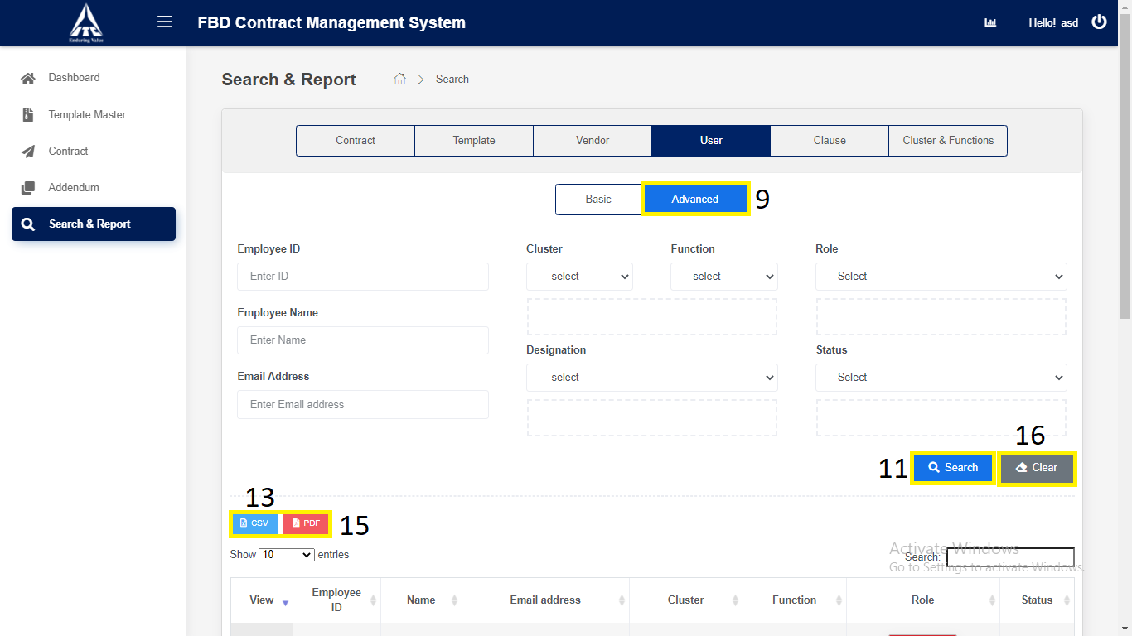

*Application will redirect to “****Search & Report****” page.*

1. Click on “**Clause**” tab.

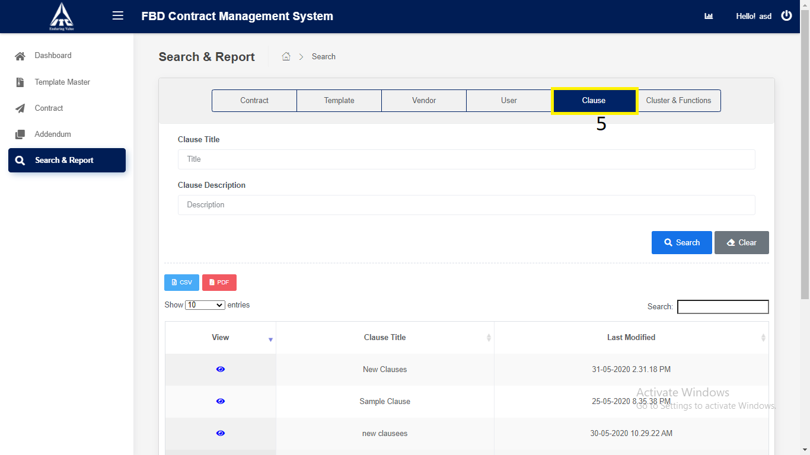

1. Click on “**Clause**”.
2. Enter Clause Details.
3. Enter “Clause Tittle”.
4. Enter “Clause Description”.
5. Click on “**Search**”.
6. Search the Clause details and displays in the Clause table.
7. Click on “**CSV**”.
8. **CSV** downloads the Clause details in Excel format.
9. Click on **“PDF”** downloads the Clause details in PDF format.
10. Click on “**Clear**”.

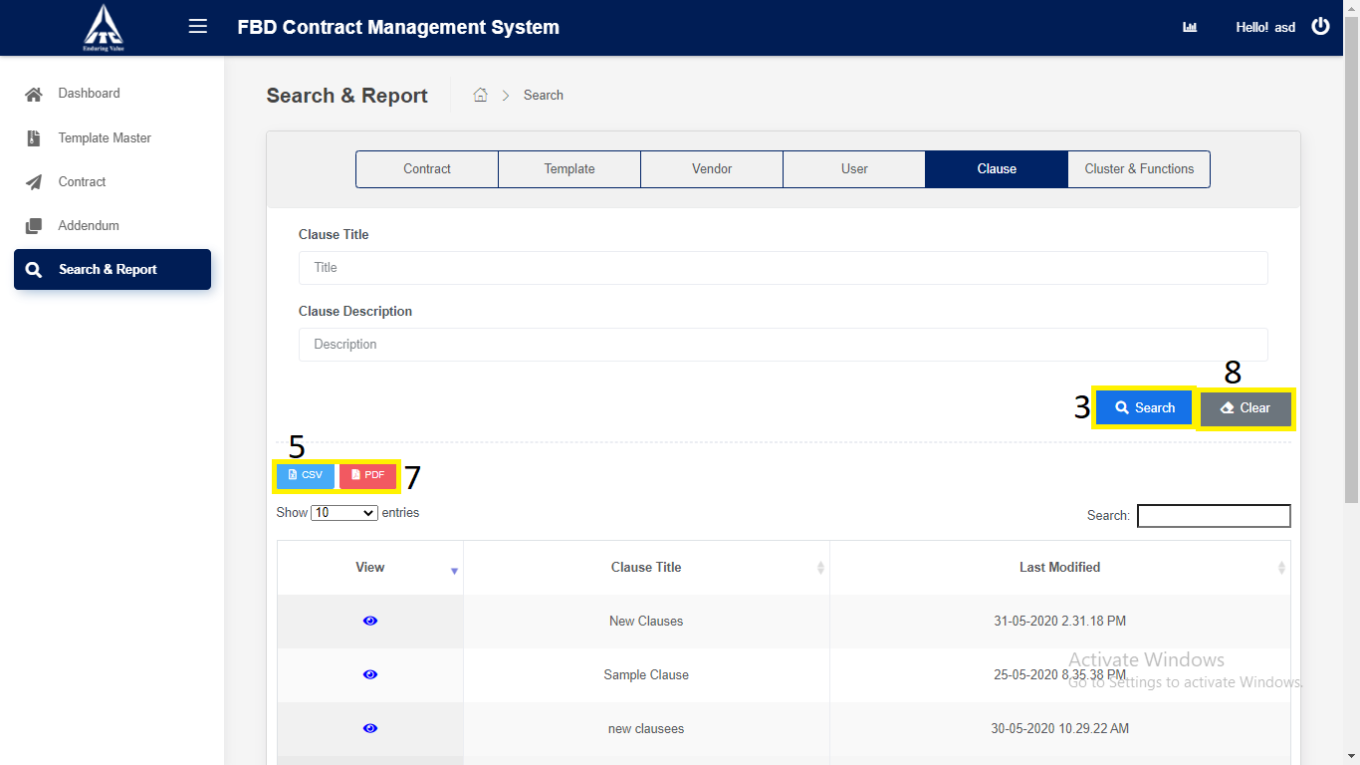

*Application will redirect to “****Search & Report****” page.*

1. Click on “**Cluster & Function**” tab.

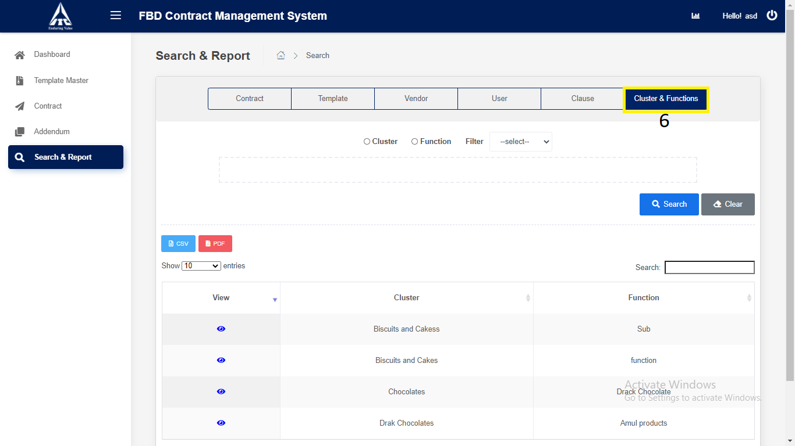

1. Click on “**Cluster and Function**”.
2. Enter Cluster and Function Details.
3. Select “**Cluster**”.

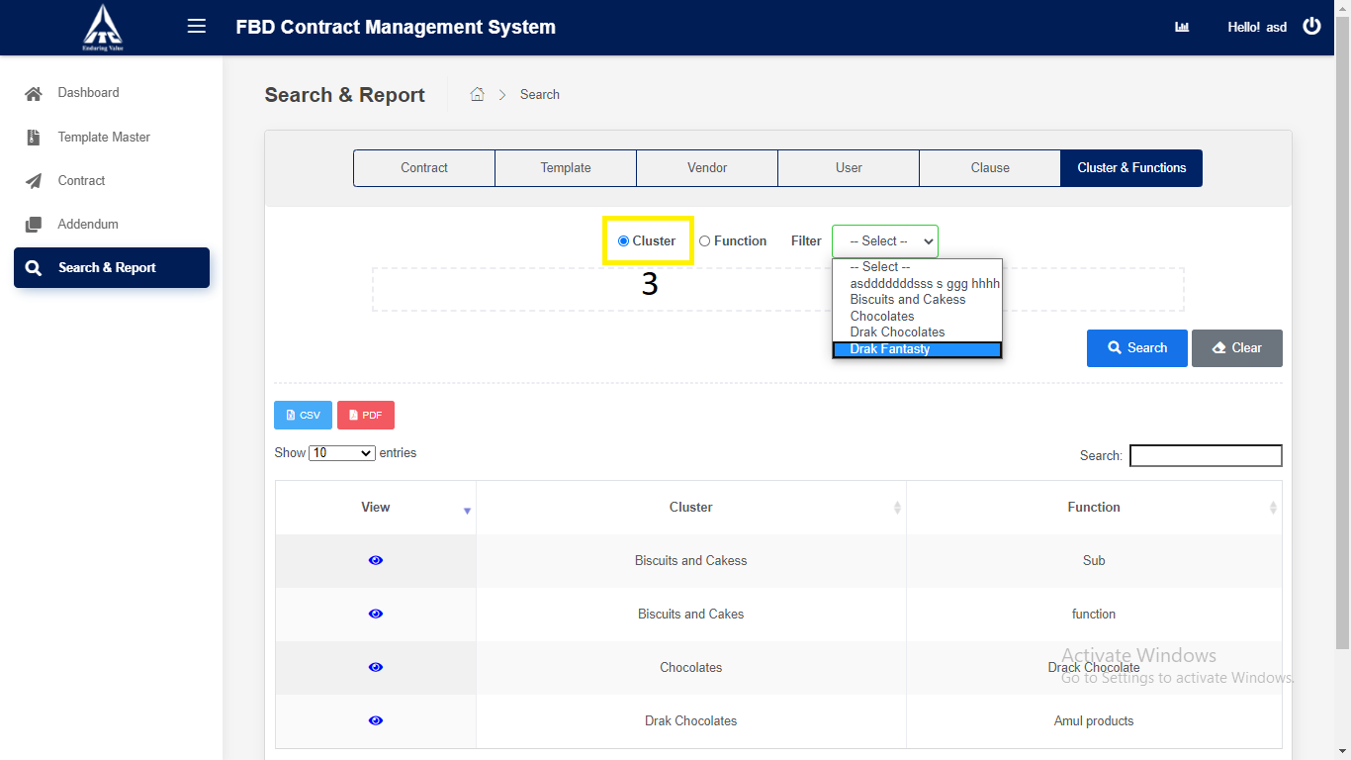

1. Select “**Function**”.

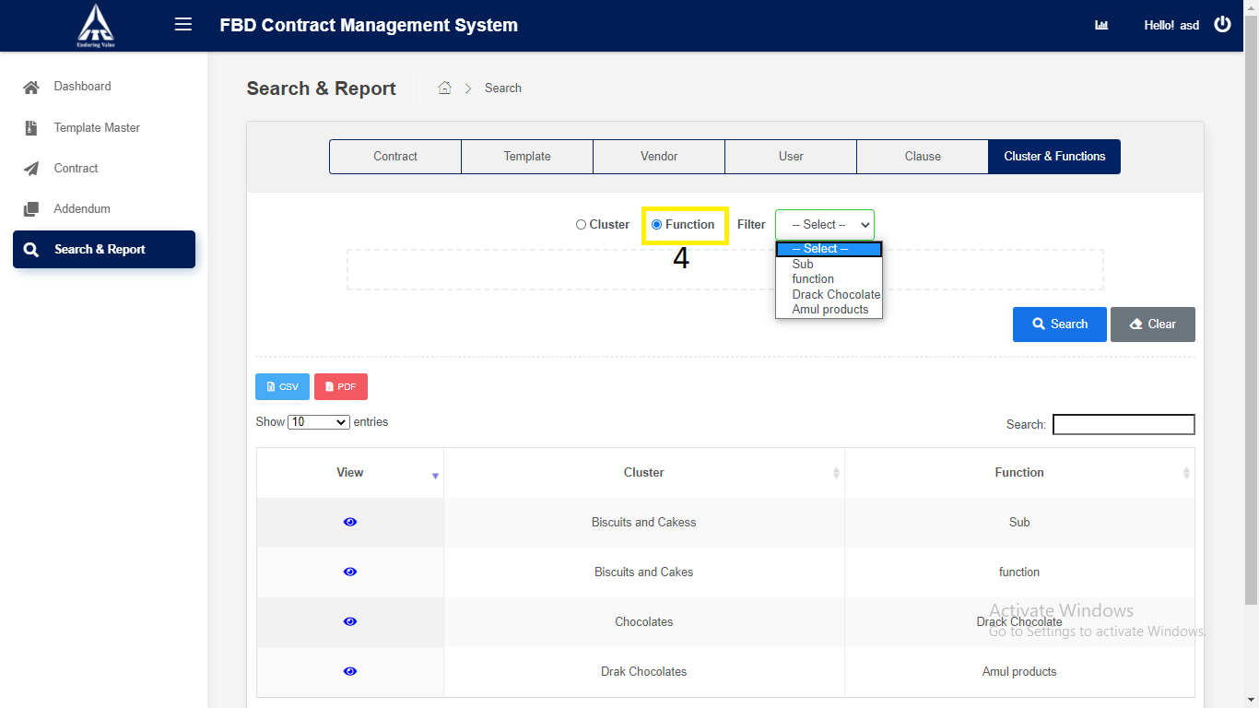

1. Click on “**Search**”.
2. Search the Cluster and Function details and displays in the Cluster and Function table.
3. Click on “**CSV**”.
4. **CSV** downloads the Cluster and Function details in Excel format.
5. Click on **“PDF”** downloads the Cluster and Function details in PDF format.
6. Click on “**Clear**”.

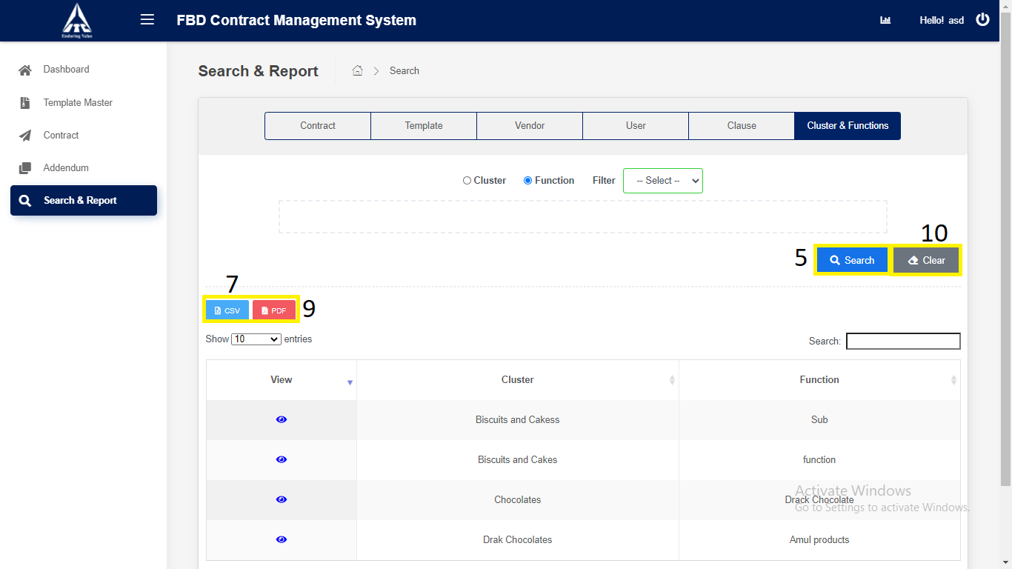

*Application will redirect to “****Search & Report****” page.*