**Reviewer**

**Contract**

1. Click on “**Contract**” in side menu.
2. Click on **View** icon to navigate to the **details** page.

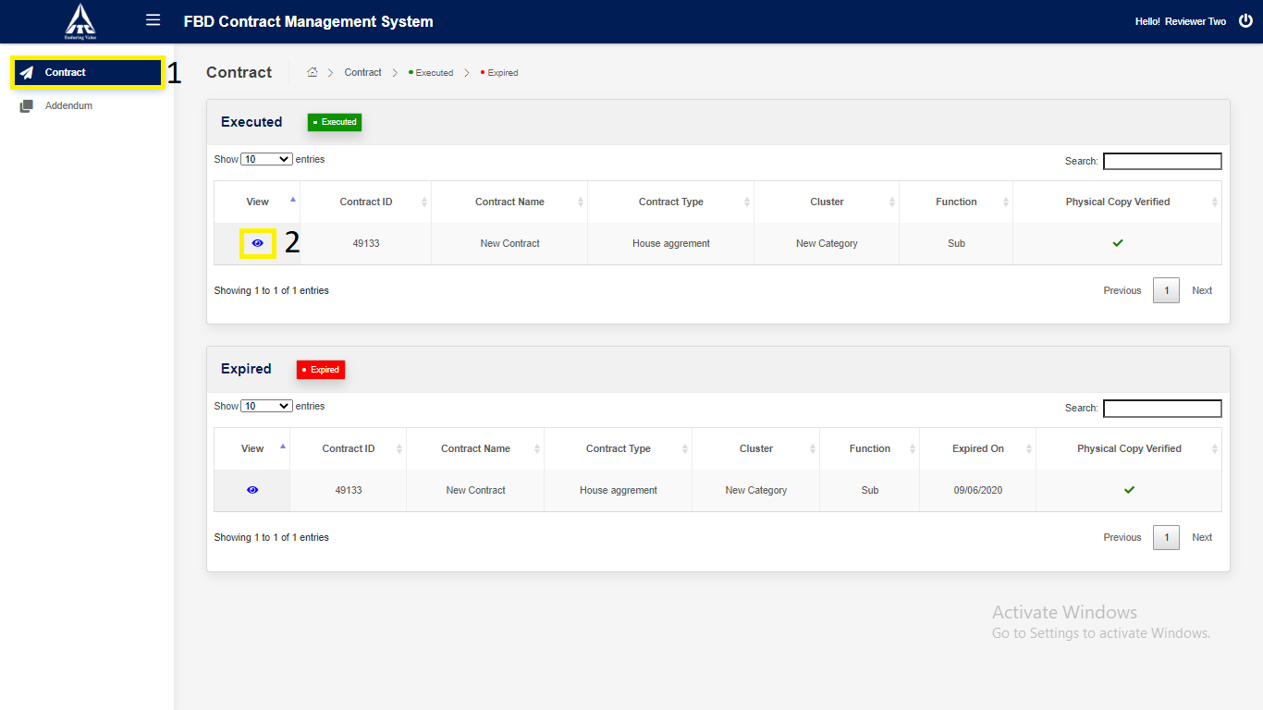

*Application will redirect to “****Contract Details****” page.*

1. Click on “**Next**” button.

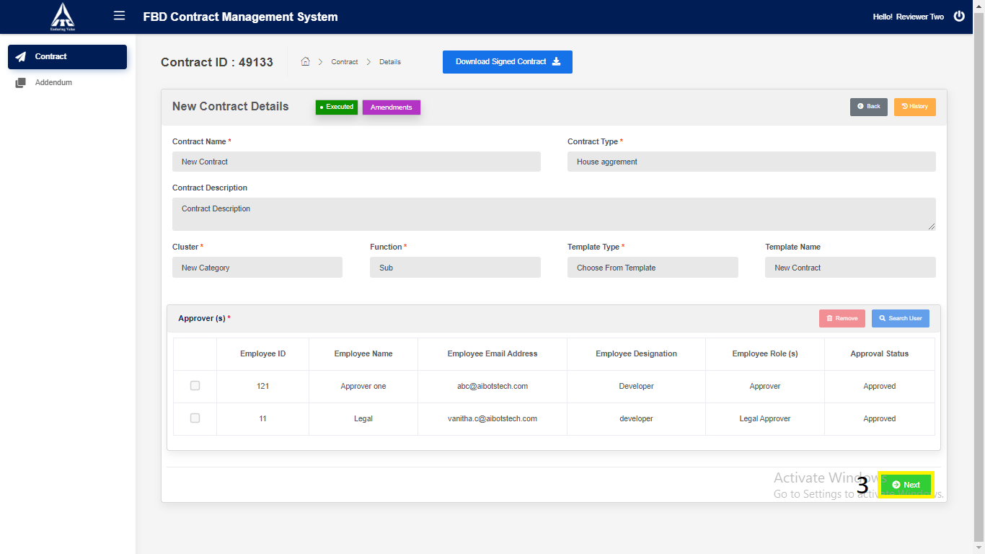

*Application will redirect to “****Contract Draft View****” page.*

1. Enter the Details,
   1. Enter “**Physical Document Location**”.
   2. Enter “**Reviewer Comments**”.
2. Click on “**Save**” button.

Save Reviewer details.

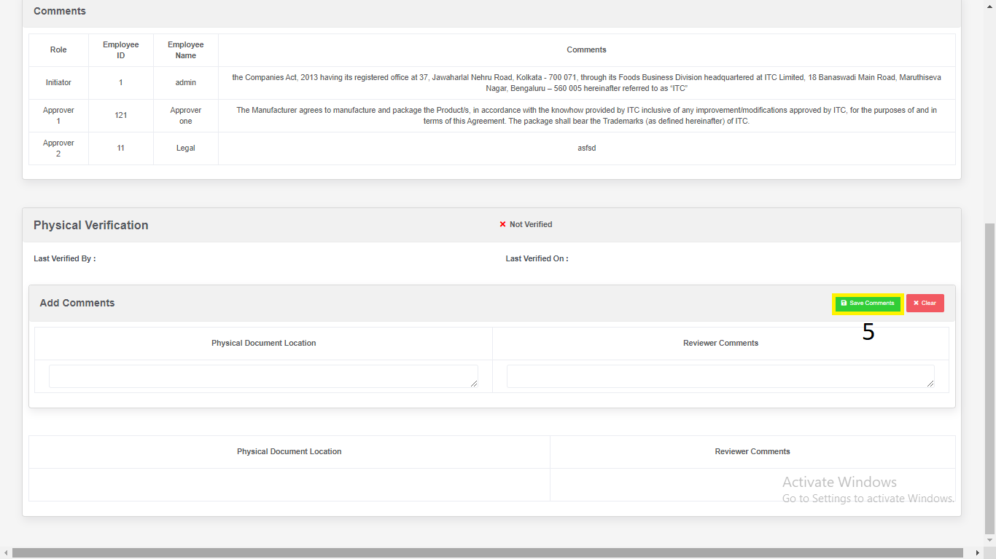

1. Click on “Clear” button

Clears all Reviewer Comments.

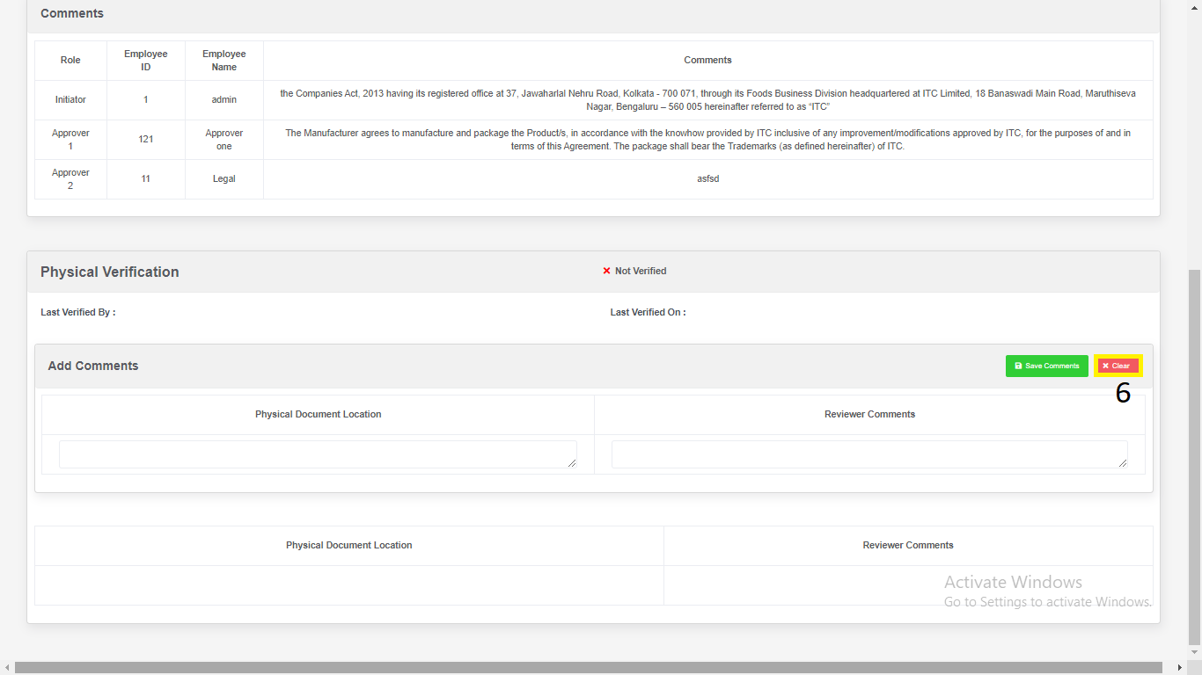

1. Contract is Physically Verified.

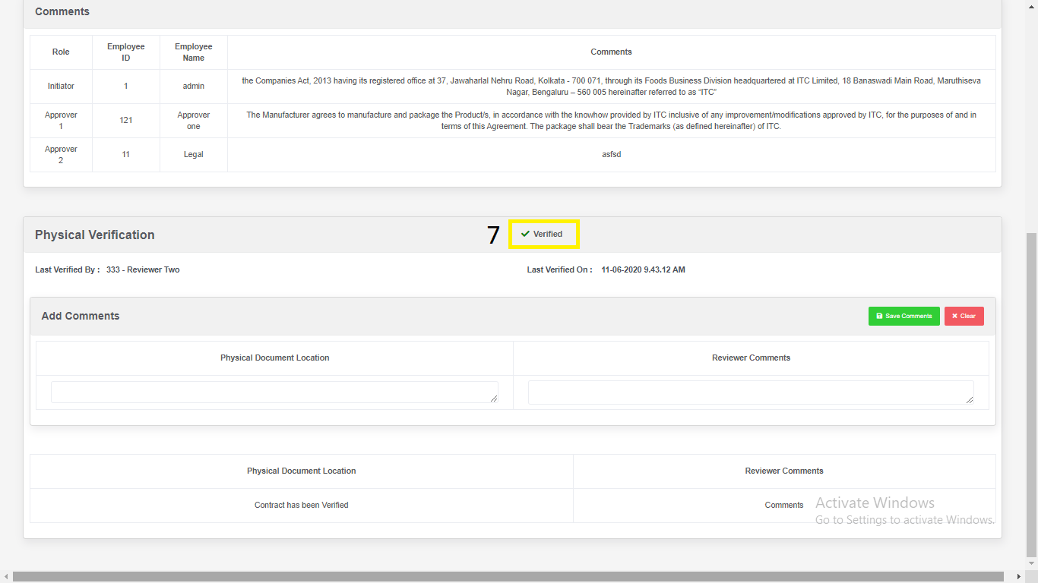

**Addendum**

1. Click on “**Addendum**” in side menu.
2. Click on **View** icon to navigate to the **details** page.

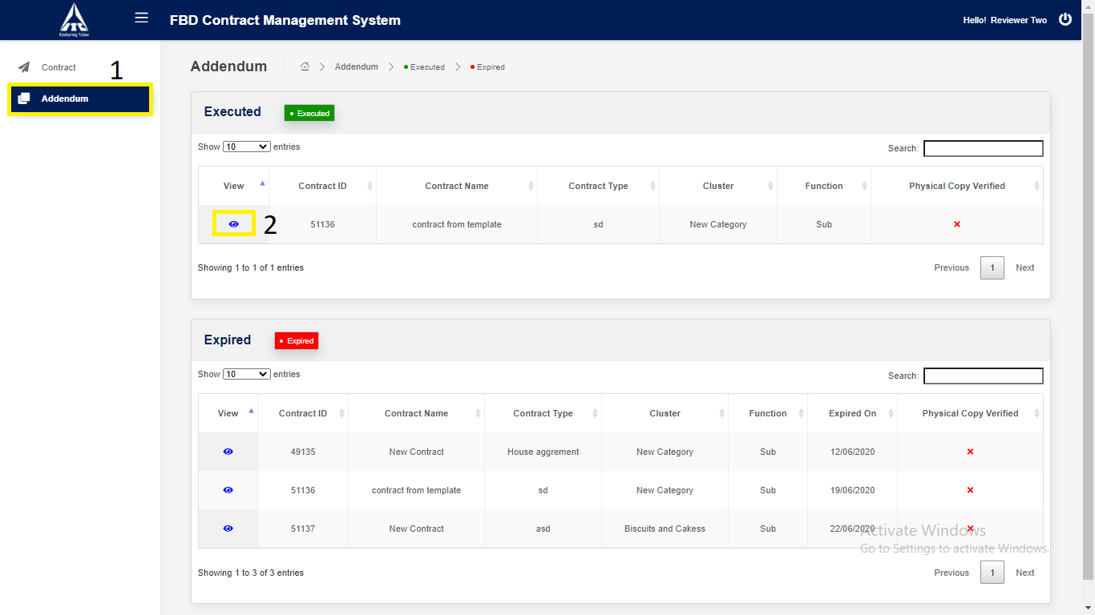

*Application will redirect to “****Contract Details****” page.*

1. Click on “**Next**” button.



1. Click on “**Amendments**” button.

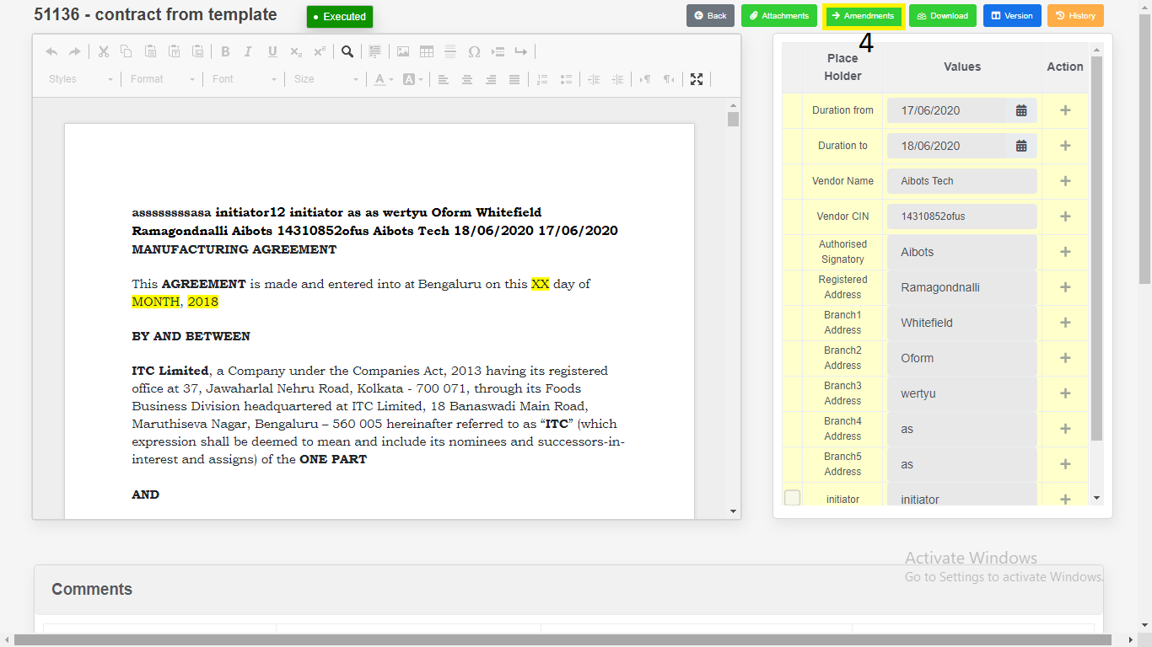

1. Enter the Details,
2. Enter “**Physical Document Location**”.
   1. Enter “**Reviewer Comments**”.
3. Click on “**Save**” button.

Save Reviewer details.

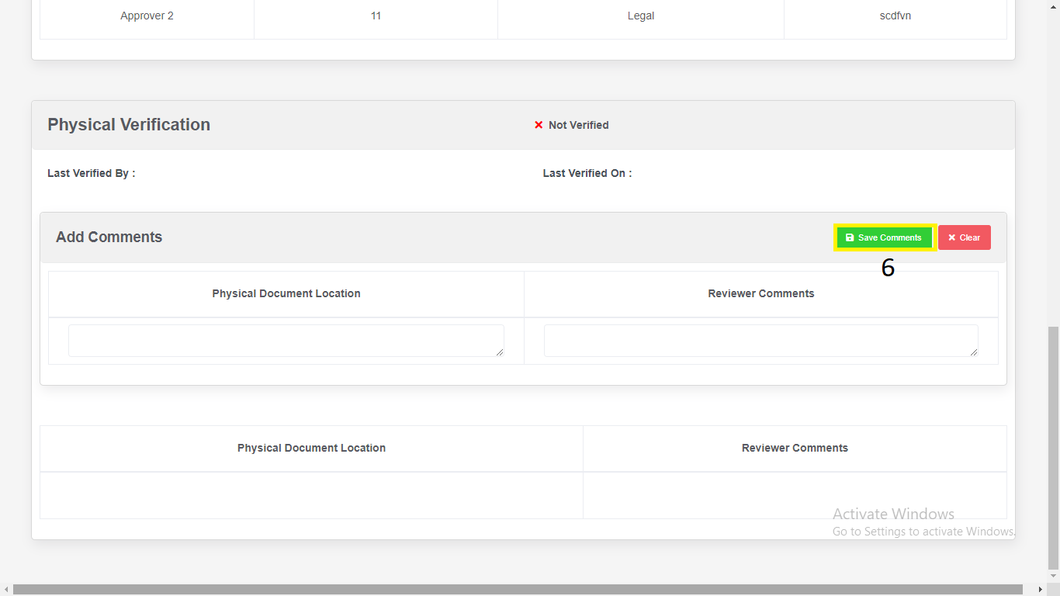

1. Click on “Clear” button

Clears all Reviewer Comments.

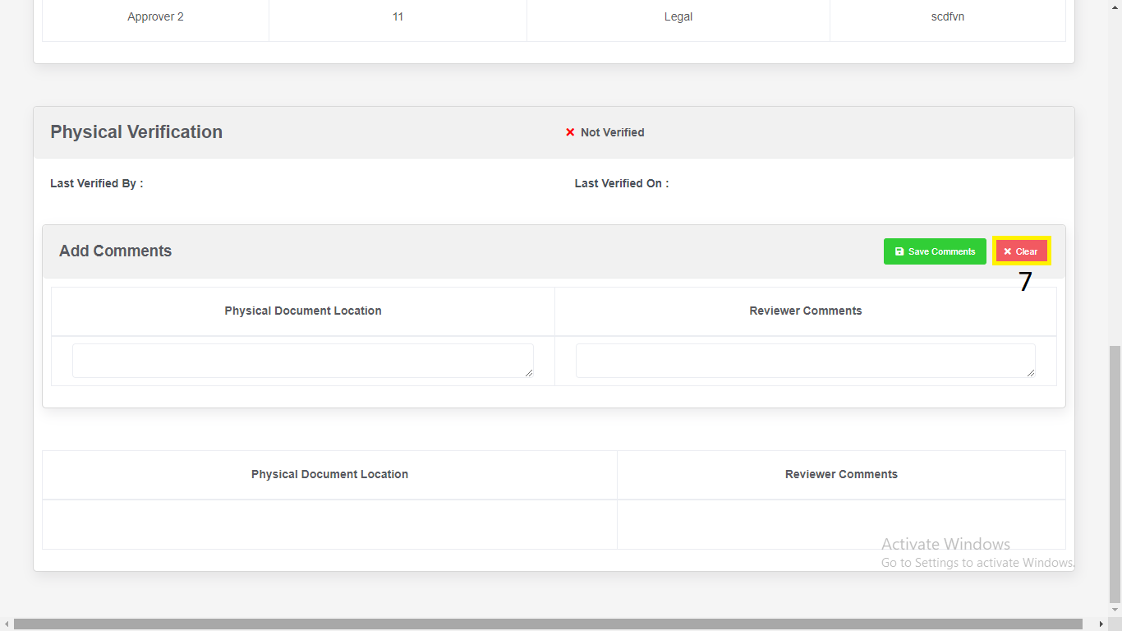

1. Contract is Physically Verified.

