BibleStudy-Crafter: The Complete Guide
An ELI10 Guide to Exploring, Learning, and Crafting Faith Studies Grounded in Scripture
★ CORE PHILOSOPHY: SCRIPTURE COMES FIRST
In BibleStudy-Crafter, the Holy Scripture always comes FIRST. We never want anyone's commentary—whether written by an author or generated by an AI—to pollute or distract from the pure Word of God. You read the Word in its full, unaltered beauty before encountering any outside reflections.

1. What You Can Do in an Already Created Study
When you open an existing study—like Study #5: Empowered for Mission (Day 1)—you enter a peaceful, focused sanctuary designed to help you deeply understand God's Word.
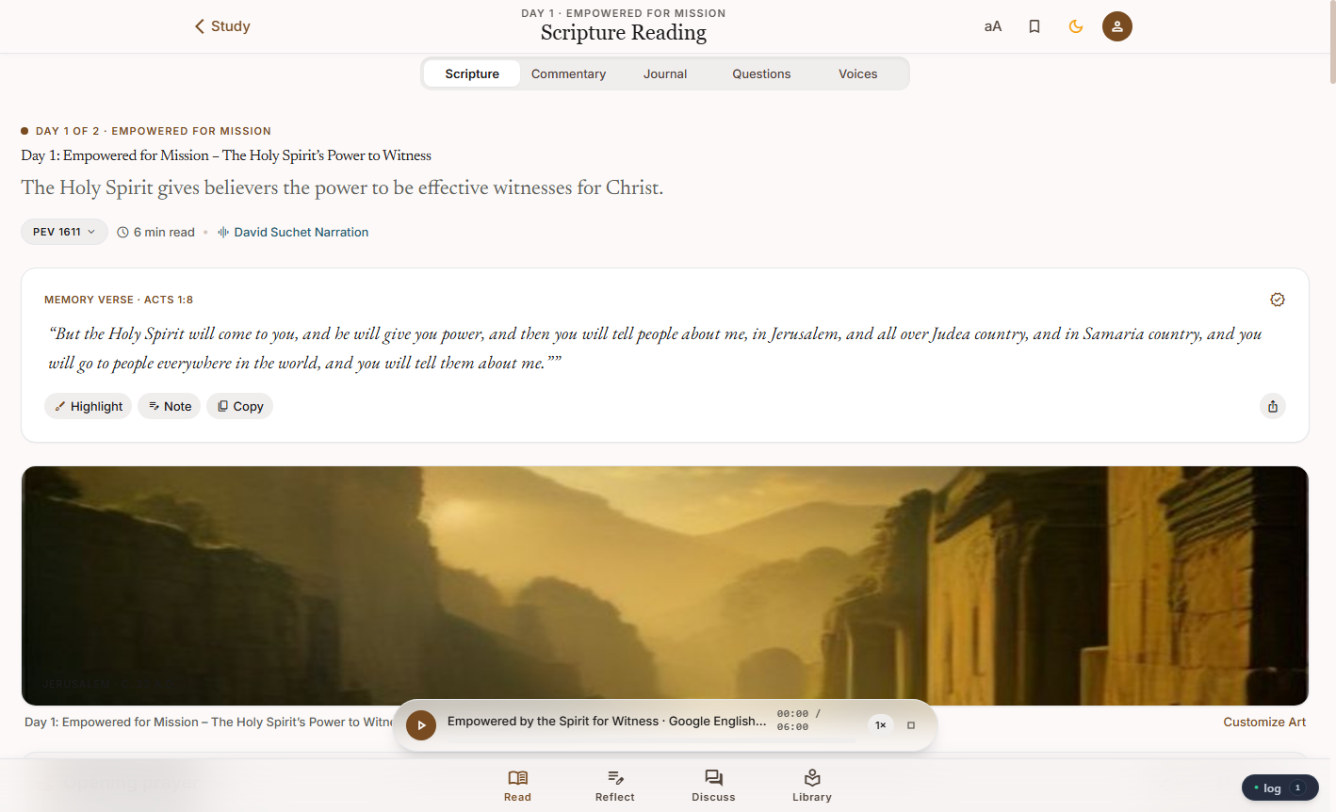
Figure 1: The Scripture Sanctuary — Pure Bible Text, Memory Verses, Translation Switchers, and Audio.

A. Pure Scripture Reading & Memory Verses
• Memory Verse Card: Every day highlights a central anchor verse (such as Acts 1:8). You can highlight key words, add personal notes, or copy the verse with one click.
• Translation Switcher: Compare translations side-by-side (KJV, ASV, PEV, WEB, etc.) to see how different scholars translate ancient Hebrew and Greek phrases.
• Audio Narration Player: A floating player at the bottom lets you listen to the passage narrated in high-quality speech (such as David Suchet). You can even adjust the speed from 1.0× to 1.5×.

B. Guided Prayer & AI Reflection
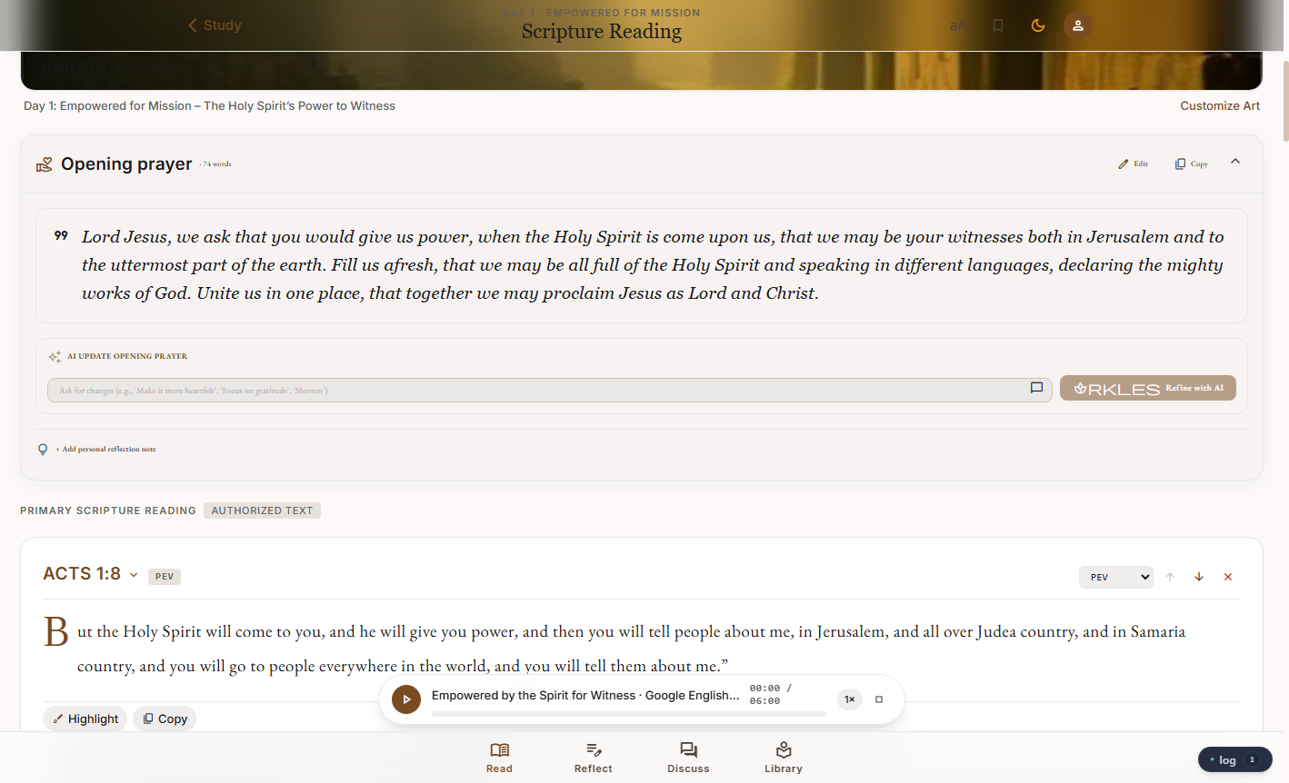
Figure 2: Opening and Closing Prayers with the 'Refine with AI' wand and illuminated scripture text.
• Opening & Closing Prayers: Grounded liturgical and pastoral prayers help prepare your heart before reading and surrender your thoughts before continuing your day.
• The 'Refine with AI' Wand: Want the prayer to focus on forgiveness? Or shorter for a child? Type your prompt (e.g., 'Make it more heartfelt and focus on gratitude') and tap 'Refine with AI' to customize the prayer.

C. Reflection Questions & Personal Study Journal
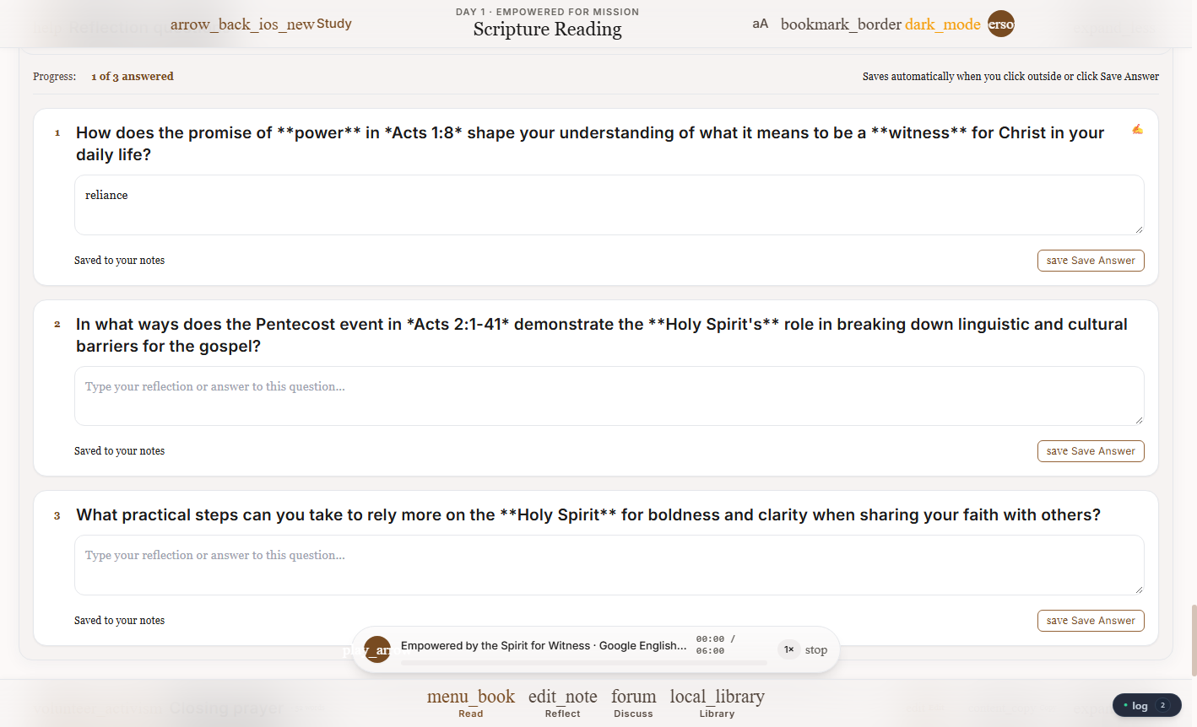
Figure 3: Interactive Reflection Questions with private cloud-synced text answers.
Each day gives you 3 deep questions to ponder. You can type your answers directly into the journal fields. They are automatically saved to your account so you can track your spiritual growth over weeks and months.

2. The 'Voices on Verses' Section: Breaking Silos & Echo Chambers
★ WHY WE NEED DIVERSE VOICES
Why is the 'Voices' section essential? Modern social media algorithms and news feeds are engineered to silo people into echo chambers, stoking outrage and keeping people divided. In contrast, true Christian discipleship and spiritual maturity require considering what others think and say. Others may have very different impressions and life experiences. By exploring diverse viewpoints while remaining firmly anchored in prayer and Scripture, we avoid blind spots, build genuine empathy, and develop a holistic, grounded understanding of Truth.

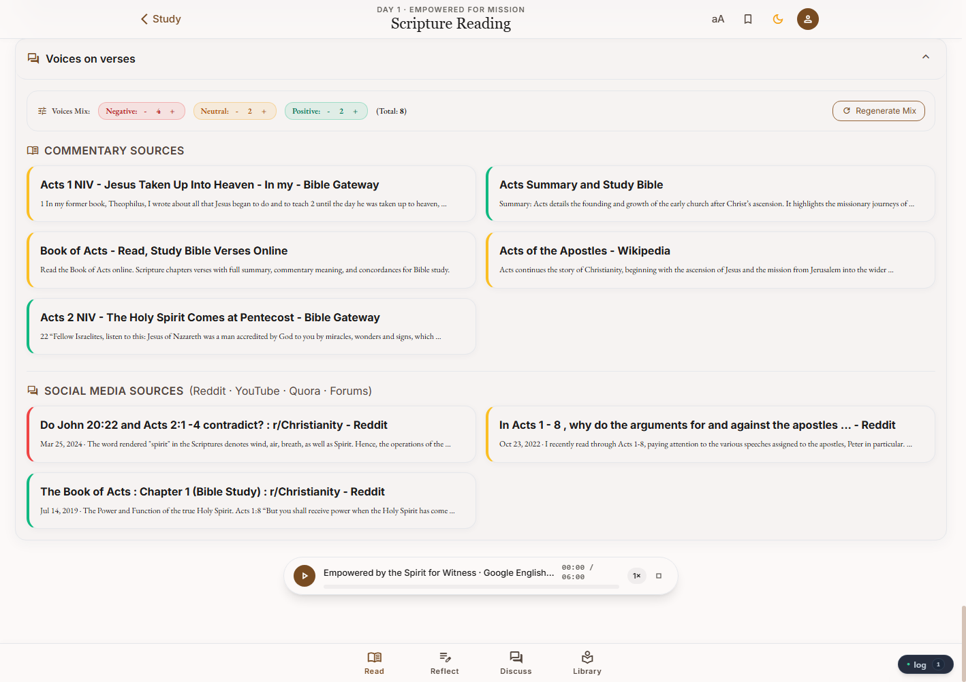
Figure 4: Voices on Verses — Tunable Sentiment Quota Bar, Commentary Sources, and Real Social Media Discussions.
Here is how the Voices section works and why it changes the way you study:
1. The Tunable Voices Mix Bar (Sentiment Controls):
You can adjust how many viewpoints of each type you want to see:
• Red (Negative / Skeptical): Critiques, difficult questions, skeptics, and apparent contradictions (e.g. 'Do John 20:22 and Acts 2:1-4 contradict?'). Addressing honest objections strengthens our faith.
• Amber (Neutral / Scholarly): Linguistic analysis, historical contexts, archaeological data, and unbiased summaries.
• Green (Positive / Devotional): Traditional, faith-filled, encouraging interpretations from saints and pastors.
2. Real Cited Sources & Community Discussions:
Rather than inventing fake opinions, BibleStudy-Crafter pulls cited commentaries (Bible Gateway, Study Bibles, historical encyclopedias) and real community forums (Reddit r/Christianity, theological boards). Clicking any source card opens an in-depth reader so you can examine the context yourself.
3. Humility and Wisdom in Dialogue:
When you understand the questions and objections other people wrestle with, you speak and witness with far greater gentleness, wisdom, and charity (1 Peter 3:15).

3. How to Create an Account
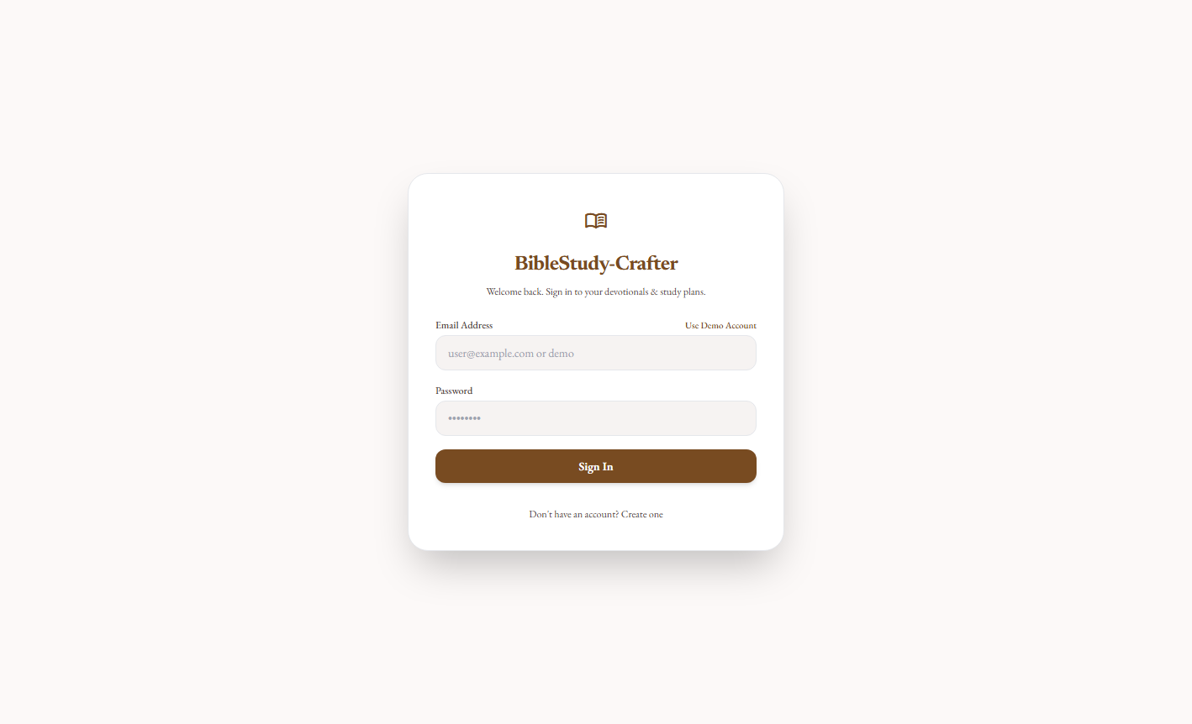
Figure 5: Sign In and Account Registration Screen with Instant Demo Access.
Getting started takes less than 30 seconds:
1. Visit the app URL in your browser: https://biblestudy-crafter-uc2dhzwjsa-uc.a.run.app/
2. Click 'Don't have an account? Create one'
3. Enter your Name, Email Address, and a secure Password (at least 6 characters).
4. Click Create Account.
💡 Quick Tip: If you are just exploring, click 'Use Demo Account' to instantly sign in without filling out any forms.

4. How to Get a Free Google Gemini API Key
To generate new customized studies, the app needs access to an AI model. Google provides a 100% free Google Gemini API key with generous daily limits so anyone can study without subscription costs.
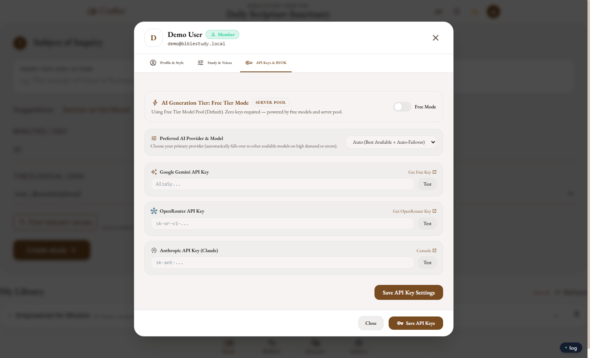
Figure 6: Profile & BYOK (Bring Your Own Key) Settings Modal.
Step-by-Step Instructions:
1. Open https://aistudio.google.com/app/apikey in a new browser tab.
2. Sign in with your standard Google or Gmail account.
3. Click the blue button that says '+ Create API key'.
4. Copy the generated key (it looks like a long string starting with AIzaSy...).
5. Back in BibleStudy-Crafter, tap your Profile Avatar 👤 in the upper right.
6. Click the API Keys & BYOK tab.
7. Paste your key into the Google Gemini API Key field and click Test.
8. Click Save API Key Settings. You are now ready to generate limitless studies!

5. How to Create a Brand New Study Plan
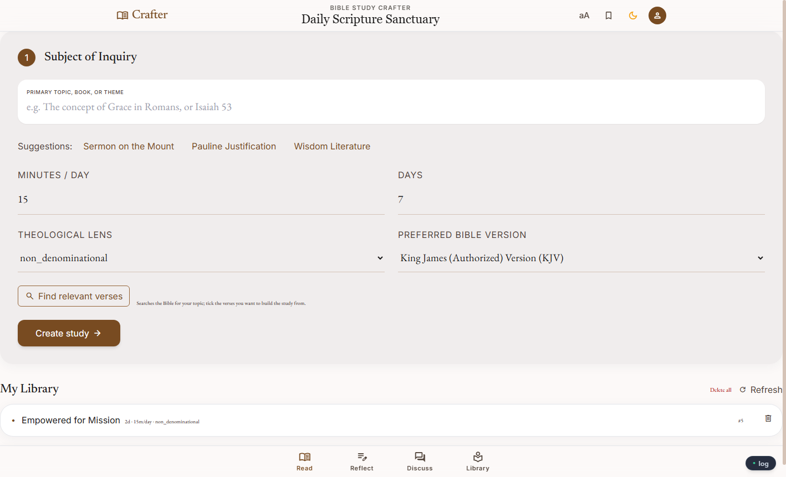
Figure 7: Sanctuary Crafter — Subject of Inquiry & Study Generation Dashboard.
Now you can design any study plan tailored to your personal walk or group:
• Step 1: Subject of Inquiry: Type your topic, book, or theme in the main input box (e.g., 'The Beatitudes', 'Justification by Faith', 'Gideon's Calling', or click a suggested topic chip).
• Step 2: Time Commitment: Choose how many minutes you want to spend each day (e.g., 15 minutes) and how many total days the study should last (e.g., 3, 5, 7, or 14 days).
• Step 3: Theological Lens & Bible Version: Choose your preferred theological lens (Non-denominational, Reformed, Catholic, Orthodox, etc.) and your primary Bible version (KJV, ASV, BBE, WEB).
• Step 4: Find Relevant Verses: Click 'Find relevant verses' to search the Bible database. You can pick and choose the exact chapters and verses you want included.
• Step 5: Craft Study: Click 'Create study ➔'. The system automatically assembles each day's pure scripture reading, multi-voice commentary, reflection questions, guided prayers, and audio narration!

Summary: BibleStudy-Crafter Workflow at a Glance
Stage | What You Do | Why It Matters
1. Scripture First | Read the pure text & listen to narration without bias. | Protects the Word from being diluted by human or AI commentary.
2. Voices on Verses | Explore skeptical, neutral, and devotional viewpoints. | Breaks algorithmic silos, explores diverse mindsets, builds empathy.
3. Reflect & Pray | Answer journaling prompts & pray guided prayers. | Internalizes God's Word into daily lifestyle, character, and action.
4. Craft & Share | Create tailored multi-day plans on any topic. | Equips individuals, families, and study groups with personalized plans.

