< INTERNAL COMMENTS TO BE DELETED>

1. Deadline : May 10th

2. Page or text limit: None 0
3. How the proposal or application should be submitted (electronic, postal mail, hand delivered): Email
4. Supplementary information or annexes that are required: None but provide links to videos, images, formal reports, posters, banners etc.
5. The person responsible for submitting the final doc: Chandeep (Ranga to attend to formating and changes)

COMMENTS

Tanya Keen ✆  to Chandeep, Chandeep, Chandeep | show details Mar 9
Hello Chandeep!

I am reaching out to you to check in on your Google.org GeoChallenge Grant project. Our records show that your final report for this project is due in May, so you may have already finished your project work, or are likely reaching your finished point.

We are very excited about your project, and are always looking for ways to promote great projects like yours on our Google blogs and websites.

I would love to get an update on your project, where it exists now and in what state, so that I can discuss with our team here at Google how we can best promote it. Would you mind e-mailing me a quick summary of your project, including links to websites, files, documents, etc.?

Thanks so much,
Tanya

Chandeep Corea ✆  to tanya | show details Mar 9
Hi Tanya,

We were just getting a report ready to update you on the progress. Things are going well and we presented the Beta version at a conference in South Africa last month. I will email you a detailed update shortly. For now please see https://docs.google.com/present/edit?id=0AfqWjQdmJ9U5ZGNidGs1Y3JfODVmZ3RxMjhnZw&hl=en

Thanks for the support,

Chandeep Corea ✆  to Ranga, Ranga | show details Mar 15
Dear Ranga D,

Thanks for the update.

What we need is a brief update (similar to the press release you first
wrote when we started the project) to send to the funding agency
updating them on the progress, highlighting the IEF presentations etc.

Ranga Dabarera ✆  to Chandeep, Ranga | show details 19:13 (20 hours ago)
Dear Chandeep,
I have tested the Bulls-Prime database with the existing implementation and the rate of identification was around 68% - 74%. That's great. So it means we can tweak this system rather than carrying out more research into new methods and focus now on the portal and implementation portions of the project -Chandeep Corea 4/7/10 3:46 PM Taking that result as the reference of the current accuracy of the system I have prepared the draft version of the report to be send to Google (which is attached herewith). I would be much obliged if you could go through it suggest me any modifications to be done.

Thank you,

Best regards,
Ranga Dabarera.

<END INTERNAL COMMENTS>

Sri Lanka Wildlife Conservation Society
eleID Project -
Summary Report (April 2009-April 2010)
An Automated Elephant Recognition System

Sri Lanka Wildlife Conservation Society
4/6/2010

Contents
Introduction. 3
Global Aspect of the Project. 3
eleID system, In brief. 3
Methodology. 3
Experiments and Results. 4
Related Issues. 4
Current Direction. 4
Assistance Needed from Google. 4
Assistance required from Google Team in regard to First Module. 5
Assistance required from Google Team in regard to Second Module. 5
Future Work. 5
Conclusion. 6
Publications. 6

Ranga -pls check the grammar in this with Dr. Ranga. I have only commented on the content. -Chandeep Corea 4/21/10 9:39 AM

Introduction

Our goal
For the conservation and management of elephants, having an efficient mechanism of habitat monitoring and distribution calculation are important. However most of such existing mechanisms are expensive, not open to easy collaboration and take a long time. Others are invasive methods which can adversely affect the natural life style of elephants. Our goal is to come up with a non-invasive and efficient mechanism to, identify and track elephants for the purpose of conservation.

Objective of the project

The Project ‘eleID’ a non-invasive computer vision based mechanism to identify and track individual elephants. People from all around the world can contribute to this and involve in this via a web portal, which will be integrated with Google Earth.

eleID system, In brief.
The eleID system carries out individual elephant recognition utilizing user input images and direct user inputs, to develop a constantly updated habitat monitoring mechanism. As the system evolves, the logged data will help to extract demographic and behavioural information on elephants which are crucial for elephant habitat protection and to mitigate human elephant conflicts, and it will be merged with elePortal, which will form a user community for people interested in elephant conservation. The method of automated elephant identification is stand on the texture based technique of eigenfaces for recognition.

Methodology
eleID recognizes elephants by combining two pieces of information, automatic elephant recognition, and direct user inputs. When an image of an elephant is uploaded into the system, an image based algorithm searches for and matches the image with an existing annotated elephant database. If it is a previously identified individual, then the system will match isn't it better to say "will give a best match choice" for the user to select if it is actually the correct one based on secondary info that will also be shown to them. This way we can also keep a running db of how good the system is at matching individuals which can be used for reports and tweaking the system -Chandeep Corea 4/7/10 3:49 PM the image with information available for that particular elephant. Along with this closest match the system will allow the user to the verify, whether the best match is correct or the next possible is the best candidate. If the elephant is confirmed to be identified then, the database gets updated with the last observed location and the date. If the elephant is previously unidentified, then the system issues a new identity. Utilizing the Google Earth API, researchers and the general public from all around the world will be able to contribute to this process by uploading frontal images of elephants that they have observed. Along with the images through the elePortal users can give additional information about the elephant, such as relative tail length, tail tuft information, and details of primary and secondary ear folds. This additional information of an elephant is used with an evidence combining mechanism to recognize individual elephants. elePortal will also include secondary data such as socio-economic and HEC[1] information that is tagged to geographic locations so that users can analyse trends and use the system for research and development needs.

We have adopted a vision based mechanism to identify elephants from their frontal face. The vision algorithm is based on Principal Component Analysis (PCA) more specifically known as Eigenface based process. Getting the direct correlation between each and every elephant face image is a cumbersome exercise which is not much efficient. Due to that reason here we do a dimensionality reduction by applying PCA to elephant images. This gives us only the essential (orthogonal) dimensions which are required to distinguish one elephant image from another. These orthogonal vectors or the principal dimensions are known as Eigenvectors in the vision community. For each elephant face image we can get the weight to it from each and every eigenvector. Once we get the weights from each eigenvector for a particular image, we can use that weight vector (which is just an array of floating point values) to find the relationship between elephant images. In other words here we try to find the nearest neighbor to a particular elephant face image. If the distance to the nearest neighbor is very low, then we there is a higher possibility that those neighbors corresponding to the same elephant. After presenting the result to the user we can get a verification in regard to the accuracy of the result. But if the nearest neighbor is not so close to a particular elephant face image which need to be identified we could say that there is a higher possibility of elephant shown in the image being a newly identified one. This has also to be verified by the user.

you need to add much more info here as in the presentation for IEF -give the theory and explanation behind Eigenfaces etc -Chandeep Corea 4/8/10 1:06 PM

Experiments and Results
Our eigenface based identification mechanism for elephant identification was tested on frontal face images obtained from a database of African Elephants. The accuracy of identification using only the frontal images was around seventy percent (Error percentage of the accuracy rate ± 3%). be speciefic and give an error level -Chandeep Corea 4/7/10 3:56 PM pls add a table -Chandeep Corea 4/21/10 9:37 AM

Related Issues
In the initial, purely individual image based elephant identification mechanism, the reliability of the identification process relied 'ied' use past tense -Chandeep Corea 4/7/10 3:57 PM mainly on the quality and exact frontal face images of elephants. The above test was carried using all the images without any modification and once we processed them the accuracy can be further improved. Even the frontal image is taken that should represent an average view of the elephant face without having any strange poses, which is hard to fulfill in practical situation. Another crude assumption is illumination invariance, because particularly in field, capturing an image of a wild elephant under uniform illumination is impractical.

The following is a sample of the frontal elephant images that we give to the recognition algorithm. As mentioned earlier these images have taken without any modification. Intuitively we can say that, if we do some preprocessing we can improve the recognition accuracy.

When it comes to users all around the world uploading images and other data related to elephants via elePortal, we cannot always assure the reliability of the data even the image quality can be handled up to some extent by our image based identifier itself. In order to make the system robust these issues have to be handled.

Current Direction
Currently we are focusing on two parallel paths. In one path we are working on improving the accuracy of the identifier. This includes some specific preprocessing stages prior to identification. In the second parallel path our objective is to come up with a working online system. So by the time we come up with an enhanced identifier we will be ready to run it online in very short time.

As a solution to handle scaling and rotation issues we are asking the user to select the eye positions of the elephant in the image. Through this the system can identify the elephant in the user given image, even in situations like there are multiple elephants in the same image. Also if we try to automatically detect the elephant faces in images, it will give us the additional risk of false negatives (not detecting the elephat face which is actually in the image) and false positives (false detection of elephant faces when there are actually no elephants in the image), which in turn affects the overall accuracy of the system negatively. The following images show some of the results that has taken from an intermediate stage (these images are in gray-scale). At present we are working on adding more preprocessing stages so that it will increase the accuracy.

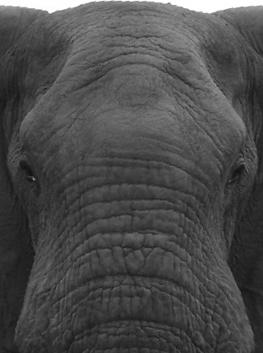
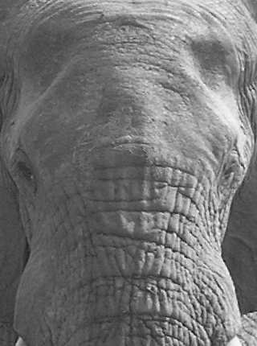
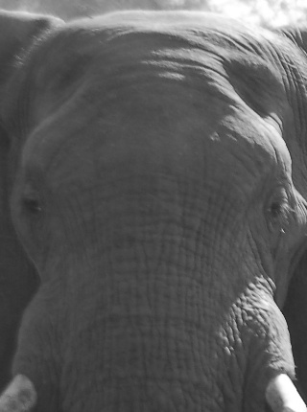
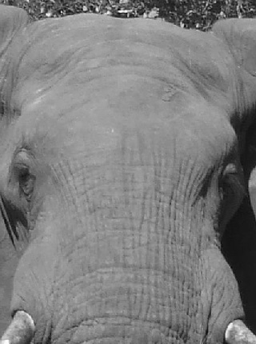
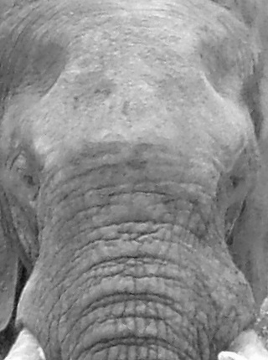
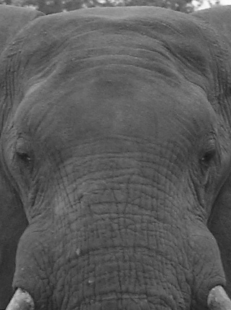

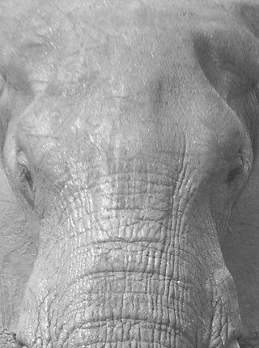

Assistance Needed from Google.
In this project, we would be much appreciated for any support from Google Team in making the system running online. So far we have completed a core system, which can be used to test the online system. The figure shown below gives the overall idea of the system. the grammar in this line is confusing -please re-write -Chandeep Corea 4/7/10 3:58 PM

please add in image -Chandeep Corea 4/7/10 3:58 PM

Elephant image and information database
Server
Client
1. User Upload the image
2. Identified Elephant
For training and testing

The core of this project consists of two basic modules. One module has been implemented (in C++ using OpenCV library) and it handles the image acquisition part, where it does all the transformation including rotation, scaling along with other pre-processing stages.

Assistance required from Google Team in regard to First Module.
Coming up with a Google Earth API based system to integrate this module to it, so that users can upload images from anywhere. One of the most important functionalities this requires is the ability to get the user interactions (with mouse clicks on two eyes of the elephant in the image being uploaded). This can be done in two ways. One is having this module running as a small applet at the client side. The second approach is to get the raw image directly to the server side and listening to the mouse call-backs directly.
The same interface is used to get the additional information of the elephant like observed data and location along with special marks.
After getting the manipulated image from the first module, the second module is responsible of identifying the elephant in the given image. The initial system is an eigenface based method and all it needs to have by the time of identification are the eigenscores (which are unique per image). The initial analysing system has been completed and tested using Matlab and depending on the requirement of the online system this could be re-implemented in C++.

Assistance required from Google Team in regard to Second Module.
This module is to be run at the server side and we appreciate the assistance in giving us the directions in making this operating online and the consultancy in the ways we can generate the results so that we can give our results (identified elephant images along with details of the identified elephant).

Future Work
The facial appearance and identifiability depend as much on shape as they do on color or texture. Shape information can be obtained by manually tracing the contours of facial features and the use those contours to normalize (warp) each image to a canonical shape.
In addition to using the image based evidence to identify individual elephants, additional user input data as relative tail length, nature of primary, secondary ear folds along with the shape of ear bottom, presence of tusks, tail tuft, special markings like rips, holes and notches can be incorporated for identification task. For this to be done, a proper evidence combining mechanism has to be used. When using such evidence combining mechanism, human errors can also be minimised by analysing the user capabilities and reliability of the given data.

Conclusion
Due to its accessibility to a large number of users from around the globe who can upload images to it from anywhere, the eleID system is open to citizen science and eliminates one of the major deficiencies in manual image based elephant identification. In manual methods, the researchers or the team involved in the identification task have to recognize from memory each and every individual elephant identified. Such a method is time consuming and hard to use for collaborative work. As a future direction, this system can be easily adapted to help gather habitat and population information of other endangered species, for their conservation and management.
Once we have a working online system it would be easy for any person to contribute to this project. In future enhanced identification algorithms can be developed and replace the existing core, to increase the accuracy of the identifier.

Publications and Collaborations

- April 2010 - Summary Report (this document)
- Feb 2010 - Initial collaboration discussions with International Elephant Foundation, Elephants for Africa, Save the Elephants, Elephants without Borders, GRASP - UNEP/UNESCO Great Ape Survival Partnership and Bristol University (Penguin ID project).
- Jan 2010 - Presented at International Elephant Conservation and Research Symposium in South Africa .https://docs.google.com/present/edit?id=0AfqWjQdmJ9U5ZGNidGs1Y3JfODVmZ3RxMjhnZw&hl=en
- Dec 2009 - Video by Greenermedia -http://www.kickstarter.com/projects/greenermedia/asian-elephant-conservation-documentary?pos=1
- Sept 2009 - Poster displayed at SLWCS 10th Anniversary Celebrations - www.slwcs.org/downloads/posters/leID-Poster-Sept2009.jpg and www.slwcs.org/downloads/posters/elePortal-Poster-Sept2009.jpg
- Aug 2009 - Press release https://docs.google.com/View?docID=0AfqWjQdmJ9U5ZGNidGs1Y3JfNmM0bnJkdGdo&revision=_latest
- July 2009 - mini Presenation at IUCN, AsESG, Human Elephant Conflict Task Force Workshop and Society for Conservation Biology Annual sessions in Bejing, China. add link -Chandeep Corea 4/7/10 4:24 PM
- Jan 2009 - SLWCS 2007-2008 Annual Report

Milestones I have added some of the old notes, you need to add in the main milestones after you started working on the system -Chandeep Corea 4/7/10 4:11 PM
April 2010 - A Vision based elephant identification method has developed and tested add the mid points when we changed from facial recog type system to eigne etc. -Chandeep Corea 4/21/10 9:42 AM
Aug 2009 - A Vision based literature survey has been done in regard to elephant recognition
June 2009 - Mr. Ranga Dabbare: hired to work on project full time for his MSc on the eleID system
June 2009 - Ms Ayesha Matarage: hired part time to work on the elePortal part of project (3 months)
May 2009 - Tides Foundation and Google Earth finalize grant to begin work on system
Nov 2008 - Initial discussion with University of Moratuwa to develop system
Sept 2006 - Dec 2007 - volunteer team initiates work using facial recognition systems (VB system developed)
July 2006 - SLWCS Board and Volunteer biologist start to develop basis for ID.
Aug 2006 - Initial automated system conceptualized by Chandeep Corea based on facial recognition, pattern matching type algorithms.

[1] HEC stands for Human Elephant Conflict

