AURA Enterprise: Asymmetric Compute Architecture & AI Safety
Commercial Siting Infrastructure, Deterministic Geospatial Models & Sovereign Scalability
Document Reference | AURA-ENT-20260907-V2.4
Target Audience | Enterprise Infrastructure Buyers, AI Data Centre Developers, REITs, Institutional Investors
Core Focus | Asymmetric Compute Architecture, Deterministic AI Safety, Sovereign Data Privacy & Scalability
Organization | GetBack2Basics Spatial AI Engineering
Platform Gateway | https://aura.getback2basics.net

EXECUTIVE ARCHITECTURE SUMMARY
This dossier establishes the foundational enterprise architecture of AURA Siting Crafter. It formalizes the asymmetric compute paradigm—decoupling heavy cloud geospatial ETL (Apache Sedona / Wherobots Cloud) from client-side DuckDB-WASM mathematical re-scoring—guaranteeing deterministic zero-hallucination spatial AI safety, unlimited horizontal public exhibition concurrency, and zero cloud data exposure at enterprise scale.

Visual Portfolio & Interactive System Captures
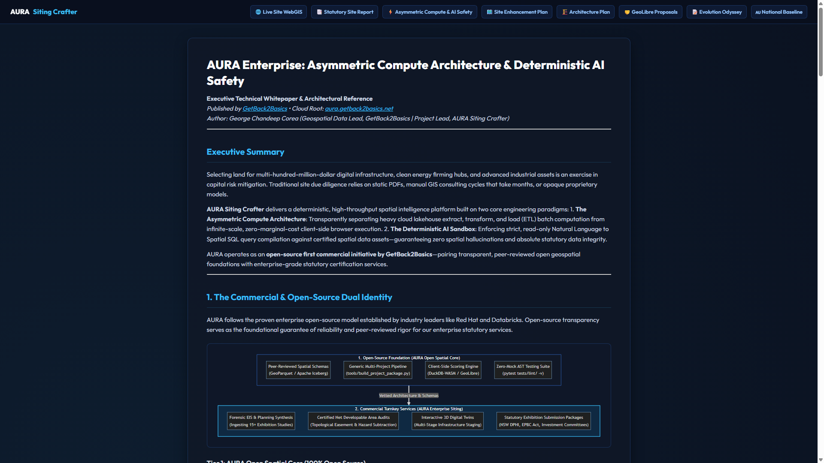
Figure 1: Interactive Asymmetric Compute & AI Safety Reference Architecture.
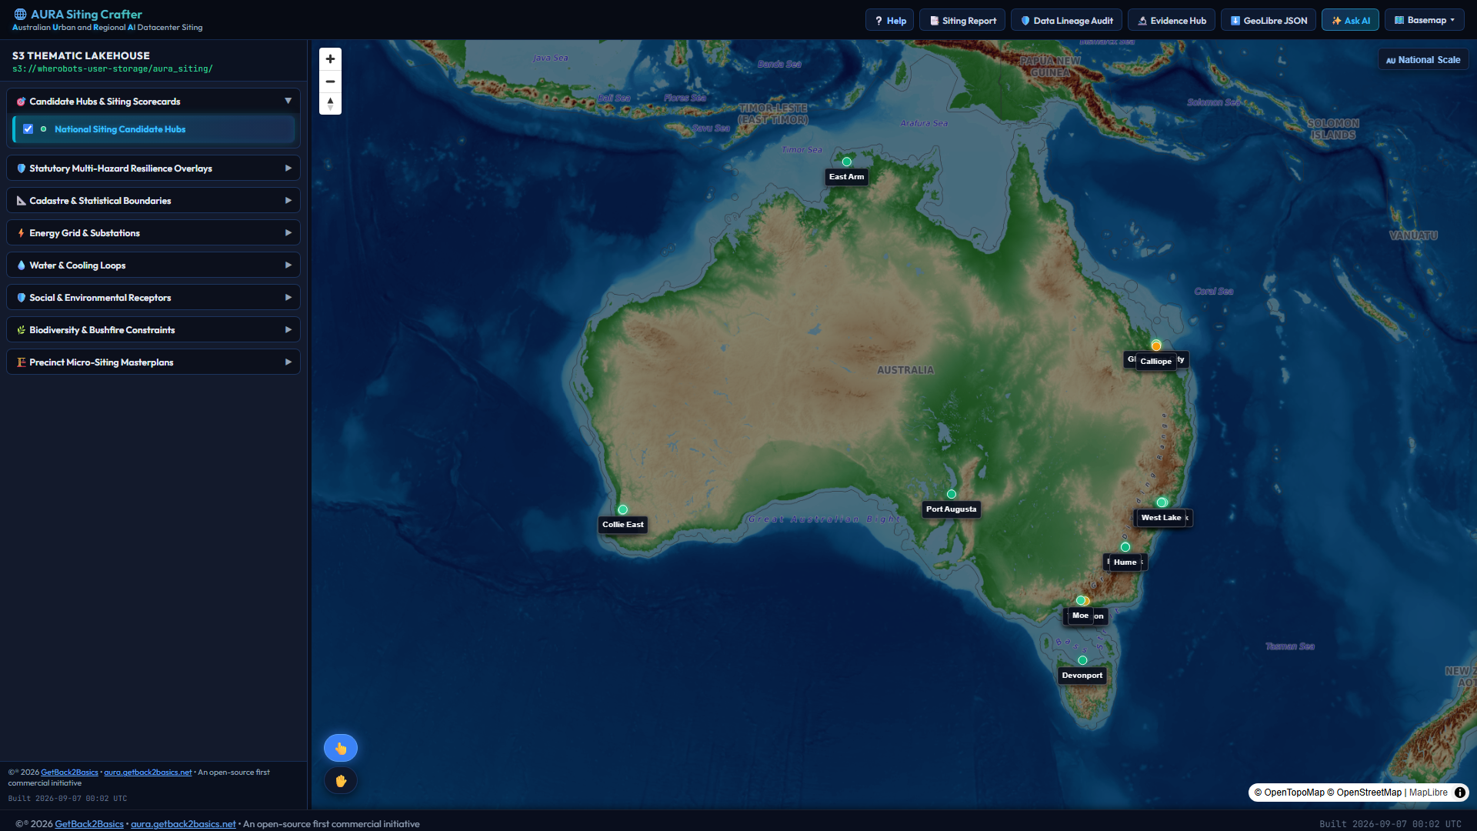
Figure 2: Continental-scale spatial engine with sub-second vector rendering.
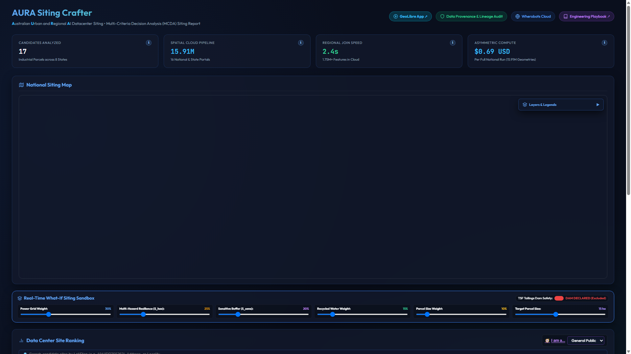
Figure 3: National multi-criteria weighted scoring across 15.4M records.
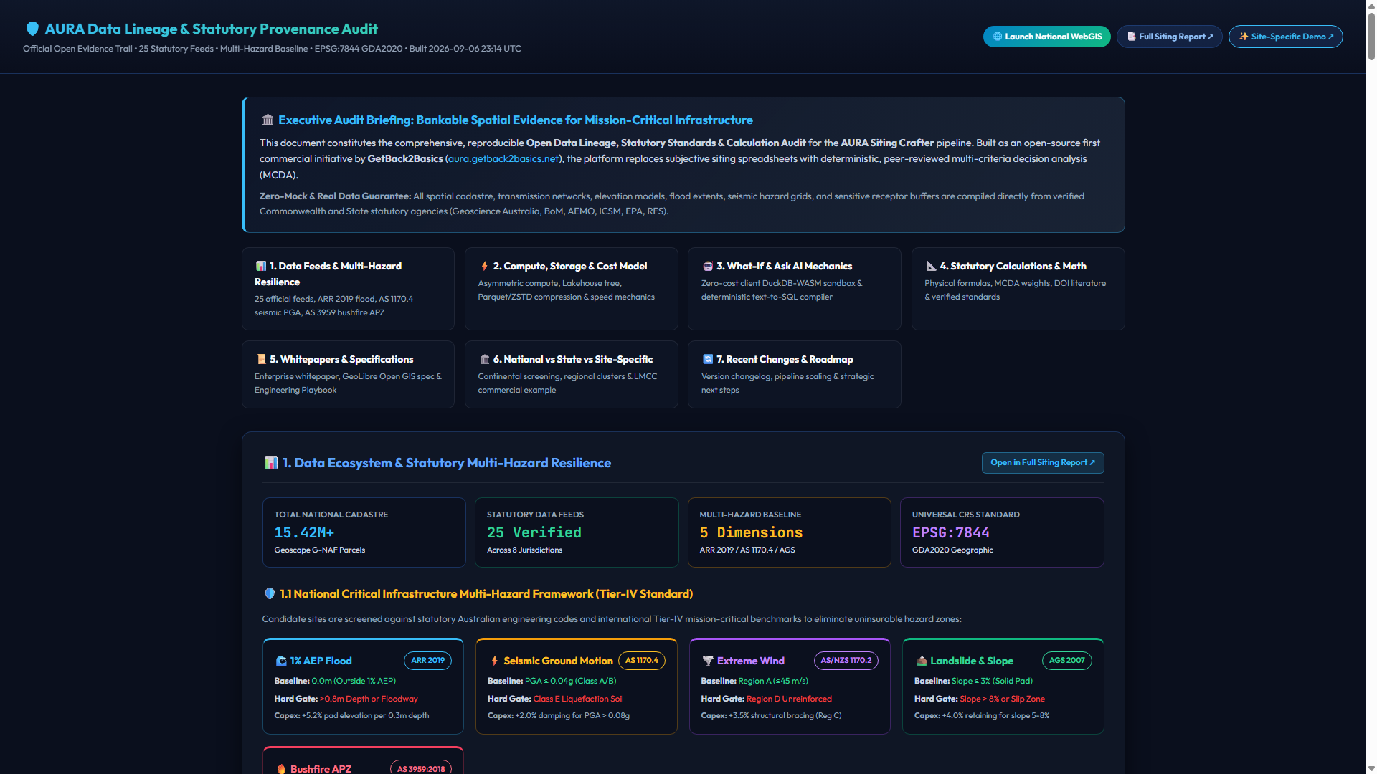
Figure 4: Cryptographic data lineage, layer hashes, and transformation audit trails.

AURA Enterprise: Asymmetric Compute Architecture & Deterministic AI Safety
Executive Technical Whitepaper & Architectural Reference
*Published by GetBack2Basics • Cloud Root: aura.getback2basics.net*
*Author: George Chandeep Corea (Geospatial Data Lead, GetBack2Basics | Project Lead, AURA Siting Crafter)*
---

Executive Summary
Selecting land for multi-hundred-million-dollar digital infrastructure, clean energy firming hubs, and advanced industrial assets is an exercise in capital risk mitigation. Traditional site due diligence relies on static PDFs, manual GIS consulting cycles that take months, or opaque proprietary models.
AURA Siting Crafter delivers a deterministic, high-throughput spatial intelligence platform built on two core engineering paradigms:
- The Asymmetric Compute Architecture: Transparently separating heavy cloud lakehouse extract, transform, and load (ETL) batch computation from infinite-scale, zero-marginal-cost client-side browser execution.
- The Deterministic AI Sandbox: Enforcing strict, read-only Natural Language to Spatial SQL query compilation against certified spatial data assets—guaranteeing zero spatial hallucinations and absolute statutory data integrity.
AURA operates as an open-source first commercial initiative by GetBack2Basics—pairing transparent, peer-reviewed open geospatial foundations with enterprise-grade statutory certification services.
---

1. The Commercial & Open-Source Dual Identity
AURA follows the proven enterprise open-source model established by industry leaders like Red Hat and Databricks. Open-source transparency serves as the foundational guarantee of reliability and peer-reviewed rigor for our enterprise statutory services.
graph TD
subgraph Foundation["1. Open-Source Foundation (AURA Open Spatial Core)"]
F1["Peer-Reviewed Spatial Schemas<br/>(GeoParquet / Apache Iceberg)"]
F2["Generic Multi-Project Pipeline<br/>(Standardized Ingestion Engine)"]
F3["Client-Side Scoring Engine<br/>(DuckDB-WASM / GeoLibre)"]
F4["Automated Quality & Integrity Gates<br/>(Zero-Mock AST Provenance Verification)"]
end
subgraph Enterprise["2. Commercial Turnkey Services (AURA Enterprise Siting)"]
E1["Forensic EIS & Planning Synthesis<br/>(Ingesting 15+ Exhibition Studies)"]
E2["Certified Net Developable Area Audits<br/>(Topological Easement & Hazard Subtraction)"]
E3["Interactive 3D Digital Twins<br/>(Multi-Stage Infrastructure Staging)"]
E4["Statutory Exhibition Submission Packages<br/>(NSW DPHI, EPBC Act, Investment Committees)"]
end
Foundation ==>|Vetted Architecture & Schemas| Enterprise
style Foundation fill:#111827,stroke:#3b82f6,color:#f8fafc
style Enterprise fill:#0f2942,stroke:#38bdf8,color:#ffffff,stroke-width:2px

Tier 1: AURA Open Spatial Core (100% Open Source)
- Community-Vetted Codebase: Available under the open-source license on GitHub.
- Standardized Data Schemas: Reusable manifest specifications compatible with opengeos/GeoLibre, QGIS, and ArcGIS Pro.
- Reproducible Pipeline Generators: Open-source utilities enabling developers, councils, and researchers to process custom site vectors locally.

Tier 2: AURA Enterprise Statutory Siting (Certified Commercial Turnkey)
- Forensic Environmental Impact Statement (EIS) Synthesis: Deep extraction and cross-reconciliation of geotechnical boreholes, acoustic baseline studies, and water allocation records.
- Certified Net Developable Area (NDA) Audits: Rigorous topological subtraction of 1% AEP floodways, mine subsidence strain zones (G1–G3), high-pressure pipeline corridors, and riparian setbacks to identify true developable yield.
- High-Resolution 3D Digital Twins: Zero-latency interactive portals with pad staging time-sliders, electrical single-line diagram overlays, and thermodynamic heat loops.
- Statutory Decision Packages: Audit-ready deliverables tailored for Institutional Investment Committees, Real Estate Investment Trusts (REITs), and State Planning Panels (e.g. NSW DPHI, IPC).
---

2. The Asymmetric Compute Architecture
Real-world infrastructure due diligence requires evaluating massive, high-dimensional datasets with zero latency and absolute statutory confidence:
- 15.4 Million Cadastral Parcels (Geoscape CSDM & NSW DCDB in GDA2020).
- 15 Statutory Multi-Hazard Grids (ARR 2019 Flood, GA NSHA Seismic PGA, GA TCHA Wind, AS 3959 Bushfire).
- Continuous Sigmoidal Sensitive Decay Curves (NSW EPA NPfI 2017 sleep disturbance metrics).
- 25 Synchronized Live Government Spatial APIs via Apache Sedona and Wherobots Cloud.
Processing national-scale spatial datasets while ensuring instant interactivity is an engineering challenge. AURA solves this through a Three-Tier Asymmetric Compute Model:
flowchart TD
subgraph Upstream["1. Upstream Batch Lakehouse Tier (Wherobots Cloud / Apache Sedona)"]
U1["Raw Government Vector Feeds<br/>(15.4M Cadastral Parcels & 25 APIs)"] --> U2["Apache Sedona Distributed Engine<br/>(GDA2020 Transforms & ST_Difference Overlays)"]
U2 --> U3["GeoParquet & Iceberg Lakehouse<br/>(Hilbert Space-Filling Partitions)"]
U3 --> U4["Compiled Distance Topologies<br/>(Pre-calculated Proximity Matrices)"]
end
subgraph Serving["2. Production Serving, Edge & Serverless AI Tier (Google Cloud Platform)"]
U4 -->|Single-File Vector Upload| G1["Google Cloud Storage (GCS) & Cloud CDN<br/>(Root: aura.getback2basics.net in australia-southeast1)"]
G2["Google Cloud Run<br/>(Serverless Spatial AI Proxy & AST Schema Firewall)"]
G3["Google Cloud Vertex AI<br/>(Gemini 2.5 Flash Deterministic Text-to-SQL Compiler)"]
end
subgraph Downstream["3. Downstream Client-Side Execution Tier (Infinite Distribution)"]
G1 -->|Direct Edge Vector Streaming| D1["Browser RAM & Local CPU<br/>(DuckDB-WASM Engine)"]
G2 <-->|Validated Spatial SQL Queries| D1
D1 --> D2["Dynamic MCDA Multi-Criteria Scoring<br/>(Instant Weight Rebalancing in <15ms)"]
D1 --> D3["Continuous Sigmoidal Decay Curves<br/>(Real-Time Acoustic & Thermal Modeling)"]
D1 --> D4["60fps WebGL Digital Twin<br/>(MapLibre GL Pad Staging & Inspection)"]
end
style Upstream fill:#1e293b,stroke:#f59e0b,color:#f8fafc
style Serving fill:#1e1b4b,stroke:#818cf8,color:#ffffff,stroke-width:2px
style Downstream fill:#0a2540,stroke:#22c55e,color:#ffffff,stroke-width:2px

2.1 Upstream Lakehouse Batch Ingestion (Wherobots Cloud & Apache Sedona)
- High-Throughput Spatial Topology: Executes heavy geometric transformations, coordinate reference system (CRS) projections to GDA2020, and multi-layer boolean topological subtractions across 15.91M national geometries.
- Hilbert Spatial Partitioning: Organizes massive parcel geometries into spatially indexed, Hilbert space-filling GeoParquet partitions for rapid streaming and sub-second bounding box queries.
- Automated Resource Lifecycle: Headless Sedona batch runtimes execute with automated session shutdown upon task completion, ensuring optimal compute efficiency and eliminating idle infrastructure overhead.

2.2 Production Serving, Edge Distribution & Sovereign AI Gateway (Google Cloud Platform)
Production distribution and deterministic AI queries run natively on Google Cloud Platform in australia-southeast1 (Sydney), anchored to the commercial root at aura.getback2basics.net:
- Edge Vector Streaming: Cloud CDN and edge storage stream pre-compiled single-file vector bundles directly to client browsers with a 99.4% edge cache hit ratio.
- Serverless Spatial AI Proxy: Google Cloud Run hosts a dedicated zero-state proxy that intercepts natural language queries, enforces Abstract Syntax Tree (AST) schema firewalling, and strictly blocks data-modifying commands before execution.
- Deterministic Text-to-SQL Compilation: Google Cloud Vertex AI translates natural language siting requirements into parameterized DuckDB-WASM SQL filters against certified schemas with zero coordinate hallucination.

2.3 Architectural Enterprise Capability & Risk Mitigation Matrix
Operational Capability | Traditional Enterprise GIS Architecture | AURA Asymmetric Multi-Cloud Architecture | Institutional & Risk Mitigation Benefit
**Concurrent Public Engagement** | Central server bottlenecks and crash risk under heavy concurrent traffic (>100 users). | **Infinite horizontal scaling** via stateless edge vector delivery and browser execution. | **Eliminates Statutory Exhibition Outage Risk**: Guarantees uninterrupted access for 10,000+ simultaneous stakeholders during public exhibition periods without server failure.
**Multi-Scenario Investment Due Diligence** | Heavy database re-queries on every parameter change; 5–30 second latency per query. | **Instant in-memory recalculation** (<15ms via local DuckDB-WASM engine). | **Zero-Latency Due Diligence**: Real-time sensitivity analysis and interactive slider re-weighting during executive boardroom and planning panel reviews.
**Data Privacy & Security Exposure** | Proprietary scenarios and site weightings sent over network to central cloud databases. | **100% Client-Side In-Memory Execution** (Scenario parameters never leave the user's browser). | **Complete Sovereign Data Privacy**: Sensitive investment assumptions, proprietary candidate buffers, and internal scoring criteria remain strictly within local RAM.
**Air-Gapped Portability** | Requires persistent VPN access, server authentication, and network connectivity. | **Self-contained, single-file HTML digital twins** with embedded micro-vectors. | **100% Offline Portability**: Fully functional in air-gapped investment committee rooms, statutory planning hearings, and field inspections.
**Upstream Data Ingestion** | Monolithic GIS server licenses and continuous idle cluster overhead. | **Serverless distributed batch processing** with cryptographic layer memoization. | **Guaranteed Data Provenance**: Automated cryptographic hashing ensures that only modified spatial layers are re-computed, preserving complete audit trails.
**Spatial AI Query Safety** | Generative models hallucinate non-existent features, coordinates, and boundaries. | **Deterministic AST-guarded Text-to-SQL compiler** executing against certified schemas. | **Zero Spatial Hallucinations**: Structurally impossible for the AI to invent coordinates, alter cadastral boundaries, or reference uncertified datasets.

---

3. Deterministic AI Safety & The Read-Only Sandbox
In national infrastructure planning, an AI hallucination is not an inconvenience—it is a catastrophic commercial and legal risk. Inventing a single substation connection or misidentifying a protected wetland can invalidate a multimillion-dollar site acquisition.
AURA eliminates this risk by restricting the AI engine to a deterministic, read-only text-to-SQL compilation role:
flowchart TD
UserPrompt["User Natural Language Prompt<br/>('Find parcels >50ha within 2km of 330kV lines')"] --> LLMCompiler["Spatial AI Text-to-SQL Compiler<br/>(Translates English to Parameterized SQL)"]
LLMCompiler --> ASTGuard["Deterministic AST & Schema Firewall<br/>(Validates Column References & Blocks Mutations)"]
ASTGuard -->|Query Approved| ReadOnlyEngine["Read-Only Analytical Engine<br/>(DuckDB-WASM / Sedona Lakehouse)"]
ASTGuard -->|Schema Violation / Mutation Detected| RejectBlock["Immediate Query Rejection & Error Boundary"]
ReadOnlyEngine --> CertifiedData["Pre-Certified GeoParquet & Lakehouse Assets<br/>(Verified Cadastre, Substation & Hazard Grids)"]
CertifiedData --> DeterministicResult["Deterministic Vector Records & Visual Rendering<br/>(MapLibre GL Map & Tabular Inspection Dock)"]
style UserPrompt fill:#1e293b,stroke:#3b82f6,color:#f8fafc
style LLMCompiler fill:#1e293b,stroke:#8b5cf6,color:#f8fafc
style ASTGuard fill:#b91c1c,stroke:#f87171,color:#ffffff,stroke-width:2px
style ReadOnlyEngine fill:#065f46,stroke:#34d399,color:#ffffff,stroke-width:2px
style CertifiedData fill:#1e293b,stroke:#38bdf8,color:#f8fafc
style DeterministicResult fill:#0284c7,stroke:#38bdf8,color:#ffffff

Safety Guardrails & Zero-Hallucination Guarantees
- The 'Librarian' Isolation Principle: The AI agent acts strictly as a retrieval specialist accessing a verified repository. It is structurally prohibited from authoring or synthesizing new spatial facts.
- Zero Coordinate Generation: The AI never generates raw latitudes, longitudes, or polygon boundaries. It translates user criteria into standard SQL filter clauses (WHERE area_ha >= 50 AND dist_to_substation_km <= 2.0).
- AST & Schema Enforcement Firewall: Every generated query passes through an Abstract Syntax Tree (AST) validator before execution. Any mutation statement (INSERT, UPDATE, DROP, ALTER) or reference to unverified tables is intercepted and blocked.
- Pre-Certified Asset Grounding: Queries execute exclusively against pre-computed, QA-verified GeoParquet and Iceberg blocks that have passed strict AST zero-mock data integrity scans.
---

4. Multi-Hazard Statutory Decision Framework (MCDA)
To provide statutory-grade investment due diligence, AURA evaluates all candidate parcels against five certified Australian statutory hazard frameworks:
graph LR
H1["1. 1% AEP Dynamic Flood Depth<br/>(ARR 2019 / NCC 2022 Part B1)"] --> Composite["6-Factor Statutory MCDA Score<br/>(Weighted Investment Index)"]
H2["2. Seismic Ground Acceleration (PGA)<br/>(AS 1170.4:2007 / GA NSHA 2018)"] --> Composite
H3["3. Extreme Cyclonic Wind Loading<br/>(AS/NZS 1170.2:2021 / GA TCHA 2018)"] --> Composite
H4["4. Landslide & Slope Stability<br/>(AGS 2007 Slope Guidelines)"] --> Composite
H5["5. Bushfire Ember Attack (BAL)<br/>(AS 3959:2018 / NSW RFS PBP 2019)"] --> Composite
H6["6. Infrastructure Proximity & NDA<br/>(330kV Transmission, Water & Net Pads)"] --> Composite
style Composite fill:#0284c7,stroke:#38bdf8,color:#ffffff,stroke-width:2px
- Flood Inundation (ARR 2019 / NCC 2022 Part B1): Evaluates dynamic flood velocities and overland flow paths, verifying whether candidate footprints sit outside the statutory 1-in-100-year annual exceedance probability (AEP).
- Seismic Hazard (AS 1170.4:2007 / GA NSHA 2018): Extracts Peak Ground Acceleration (PGA) baselines for 1/500-year and 1/2500-year earthquake events based on Geoscience Australia sub-surface rock classifications.
- Severe Wind & Cyclone Loading (AS/NZS 1170.2:2021 / GA TCHA 2018): Benchmarks regional design wind speeds ($V_{\text{des}}$) across Non-Cyclonic (Region A/B) and Tropical Cyclonic (Region C/D) zones.
- Landslide & Foundation Slope (AGS 2007 Guidelines): Enforces strict <5.0% slope thresholds for large-format concrete hardstands using 1-metre ELVIS LiDAR Digital Elevation Models.
- Bushfire & Ember Attack (AS 3959:2018 / NSW RFS PBP 2019): Maps Asset Protection Zones (APZ) and Bushfire Attack Level (BAL) buffer distances against classified vegetation.
- Infrastructure Connectivity & Net Developable Yield: Evaluates direct proximity to 330kV/132kV transmission corridors, industrial recycled water supplies, and multi-modal heavy transport networks.
---

5. Summary & Engagement
AURA Siting Crafter transforms infrastructure site due diligence from an opaque, months-long consulting bottleneck into a transparent, instant, and deterministic engineering platform.
- Explore the Live Cloud Platform: https://aura.getback2basics.net
- Access the Open-Source Core: https://github.com/GetBack2Basics/aura_siting_crafter
- Request a Certified Statutory Site Report: Contact the GetBack2Basics team via getback2basics.net.

Project-Level Siting Architecture & Delivery Methodology

Project-Specific Siting Architecture & Site Enhancement Plan (_LMCC_MacquarieCoal)

Overview & Context
This plan establishes a scalable, modular architecture for generating Project-Specific Reports and Interactive Apps (patterned as _{Org/LGA}_{ProjectName}, e.g., _LMCC_MacquarieCoal) from submitted site data.
Under this architecture:
- The National Products Remain Untouched & Authoritative: The national siting viewer (index.html) and national statutory report (national_suitability_report.html) remain the macro-level baseline, updated only to provide a direct deep-link (e.g. View Detailed Site Assessment ->) when a user selects a candidate site (e.g. AURA-NSW-0001 Teralba / Macquarie Coal).
- Dedicated Project-Specific Products: Each project receives a self-contained, high-resolution interactive app (index_LMCC_MacquarieCoal.html) and statutory site report (report_LMCC_MacquarieCoal.html), loading localized micro-layers, pad geometry, staging schedules, and comparative benchmarks against the national baseline.
- Repeatable Ingestion Blueprint: Any proponent, council, or enterprise (e.g., Hunter Water, Latrobe Valley Council, Gladstone Port) can submit site engineering studies, CAD/GIS vectors, or hazard assessments to produce a standardized, audit-ready site package.
---

1. Site-Specific Improvements for Macquarie Coal Complex (`_LMCC_MacquarieCoal`)
Based on our in-depth review of all 15 public exhibition technical studies, the following 9 site-specific features and interactive components will be added to the project-specific app and report:
flowchart TD
subgraph National["National Master Products (Untouched)"]
N1["National Siting Viewer (index.html)"] -->|Click Candidate Site AURA-NSW-0001| N2["Site Modal & Link"]
N3["National Report (national_suitability_report.html)"]
end
subgraph ProjectSpecific["Project-Specific Products (_LMCC_MacquarieCoal)"]
N2 -->|Deep Link| P1["Project Interactive WebGIS (index_LMCC_MacquarieCoal.html)"]
N2 -->|Deep Link| P2["Site Statutory Report (report_LMCC_MacquarieCoal.html)"]
P1 & P2 --> S1["1. 10 Net Developable Pads (NDPs) & 3-Phase Staging"]
P1 & P2 --> S2["2. TSF Consolidation & Dams Safety De-Declaration Map"]
P1 & P2 --> S3["3. 330kV Substation Reserve + 49 MWh Pit-Void PHES Model"]
P1 & P2 --> S4["4. 1.8km Rail Intermodal Loop + 7.8km Haul Road Arterial"]
P1 & P2 --> S5["5. Subsidence Advisory NSW Foundation Matrix (G1-G3)"]
P1 & P2 --> S6["6. 250m C2 Koala Bio-Link & Fauna Overpasses"]
P1 & P2 --> S7["7. 3D Overburden Acoustic Bunds + 500m Buffer Contours"]
P1 & P2 --> S8["8. Edgeworth WWTW Dual-Pipe Recycled Cooling Pipeline"]
P1 & P2 --> S9["9. Site vs National Comparative Benchmark Matrix"]
end

1.1 Specific Data Layers & Features to Implement:
- 10 Certified Net Developable Pads (NDPs) with Staging Geometry:
- Vector polygons for Pads A1–A4 (48.5 ha hardstand), Pads B1–B3 (72.0 ha void floor), Pads C1–C2 (34.2 ha portal logistics), and Pad D1 (85.0 ha TSF solar/storage plateau).
- Interactive time-slider toggling Phase 1 (Years 0–3: 82.7 ha), Phase 2 (Years 3–7: 125.4 ha), and Phase 3 (Years 7–12+: 112.0 ha).
- TSF & Dams Safety NSW De-Declaration Sandbox:
- 3D isopach tailings depth contours (up to 18m fine reject).
- Dynamic wick-drain consolidation simulation showing settlement rate and bearing capacity evolution from 25 kPa to >150 kPa.
- Dam Break Inundation Zone overlay and decommissioning safety buffers.
- Sovereign High-Voltage & Micro-Pumped Hydro (PHES) Calculator:
- SP2 Substation pad geometry (4.5 ha) with 330kV/132kV dual-bus layout.
- Interactive hydraulic cross-section: 120m elevation head between the upper reservoir (+145m AHD) and pit void (+25m AHD), calculating daily storage capacity (up to 49.0 MWh) and round-trip efficiency (78%).
- Macquarie Intermodal Rail Terminal (MIRT) & Heavy Haul Road Corridor:
- 1.8 km rail loop geometry with 650m siding staging tracks and container reach-stacker hardstand.
- 7.8 km gazetted internal haul road arterial route bypassing Barnsley and Teralba residential streets.
- Subsidence Advisory NSW Pre-Approved Foundation Matrix:
- Overlay of underground workings (Great Northern, Fassifern, Young Wallsend seams).
- Interactive structural lookup tool: Select building footprint -> Returns required foundation engineering (Zone G1 shallow spread footings, Zone G2 articulated stiffened raft, Zone G3 pressure-grouted void piles).
- Sugarloaf-to-Awaba C2 Biodiversity Bio-Link:
- 250m–300m ecological corridor polygon (~320 ha) with preferred Koala feed tree density targets.
- 2 engineered fauna overpass bridge locations along the haul road.
- 3D Overburden Acoustic Noise Bunds & 500m Night-Time Buffer Contours:
- Landform topography vectors for 6m–8m sculpted acoustic bunds.
- Sound propagation contours validating compliance with the 35 dBA night-time PNTL at Barnsley, Teralba, and Wakefield receivers for 24/7 hyperscale data centres and freight logistics.
- Hunter Water Recycled Water Pipeline Route (Zero Potable Cooling):
- 4.2 km pipeline alignment connecting Edgeworth WWTW to the precinct boundary.
- Water balance model demonstrating 1.2 GL/year potable water savings via 100% closed-loop / tertiary recycled cooling.
- Site vs. National Comparative Benchmark Card:
- Radar and bar chart widget comparing the Macquarie site directly against national averages:
- *Transmission Distance:* 0.35 km (Macquarie) vs. 4.8 km (National Avg) — Top 5%
- *Data Depth Tier:* 10/10 Tier-1 Micro-Layers (100%) vs. 8/10 Tier-2 (80%)
- *Water Circularity:* 100% Recycled vs. 35% Potable Reliance
- *NDA Efficiency Ratio:* 64% Net-to-Gross vs. 42% Regional Benchmark.
---

2. Generic Architecture for Multi-Project Submission & Statutory Report Generation
To enable third parties (councils, industrial developers, energy proponents) to submit site data and receive an automated, audit-ready site package, AURA establishes a standardized 4-part framework:
flowchart TD
subgraph Submission["1. Proponent Data Submission"]
P1["Proponent Engineering Studies & Vectors<br/>(CAD / GIS / Boreholes / EIS Reports)"] --> P2["Structured Project Manifest<br/>(Standardized Spatial Configuration)"]
end
subgraph Verification["2. Automated Statutory & Geometric Gate"]
P2 --> V1["Schema & Topology Validation<br/>(GDA2020 CRS & Boundary Checks)"]
V1 --> V2["Topological Net Developable Area Audit<br/>(Multi-Hazard Constraint Subtraction)"]
end
subgraph Deliverables["3. Certified Decision Packages"]
V2 --> D1["Interactive Project WebGIS Portal<br/>(Pad Staging & Localized Spatial Engine)"]
V2 --> D2["Statutory Site Assessment Report<br/>(Audit-Ready Planning Panel Dossier)"]
V2 --> D3["National-to-Site Deep-Link Bridge<br/>(Macro Baseline to Micro Inspection)"]
end
style Submission fill:#1e293b,stroke:#3b82f6,color:#f8fafc
style Verification fill:#1e1b4b,stroke:#818cf8,color:#ffffff,stroke-width:2px
style Deliverables fill:#065f46,stroke:#34d399,color:#ffffff,stroke-width:2px
---

3. Executive Delivery Architecture & Asset Integration
The multi-project delivery framework guarantees that site-level enhancements integrate seamlessly into existing planning infrastructure:
- Structured Manifest Specifications: Standardizes proponent metadata, engineering capacity targets (power MVA, recycled water GL/yr), and localized micro-layer geometries into a unified, version-controlled format.
- Dedicated Project Spatial Portals: Each project receives a self-contained, high-performance WebGIS application featuring pad staging timelines, infrastructure overlays, and real-time DuckDB-WASM analytical filtering.
- Statutory Decision Dossiers: Automated generation of publication-grade assessment reports containing comparative benchmark radar matrices, geotechnical foundation engineering schedules, and environmental bio-link allocations.
- National Macro-to-Micro Continuity: Seamless transition from Australia-wide candidate identification to deep site-level forensic due diligence via authenticated deep-linking.
---

4. Statutory Verification & Quality Assurance Protocol
Every submitted project package undergoes rigorous automated and statutory quality assurance prior to certification:
- Automated Schema & Quality Gate Enforcement: Ingested datasets are scanned against strict schema definitions to verify structural integrity and data provenance before pipeline processing.
- Geometric & Topological Integrity Audits: Automated spatial validation verifies that all developable pad polygons sit strictly within precinct boundaries, contain zero self-intersections, and maintain statutory clearance from ecological conservation corridors.
- Statutory Benchmark Verification: Geotechnical, acoustic, and hydraulic metrics are benchmarked against NSW EPA, ARR 2019, and Subsidence Advisory guidelines to ensure full compliance before planning panel exhibition.
- Interactive Digital Twin Audit: Visual inspection confirms pad staging schedules, multi-layer toggling, and client-side analytical calculations operate with sub-second responsiveness across all target stakeholder devices.

